In situ helium isotope micro-imaging of meteorites
Ken-ichi Bajo¹*, Noriyuki Kawasaki¹, Isao Sakaguchi², Taku T. Suzuki², Satoru Itose³, Miyuki Matsuya³, Morio Ishihara⁴, Kiichiro Uchino⁵, and Hisayoshi Yurimoto¹
¹Department of Earth and Planetary Sciences, Faculty of Science, Hokkaido University, Sapporo 060-0810, Japan. ²National Institute for Materials Science, Tsukuba 305-0044, Japan. ³JEOL Ltd., Akishima 196-8558, Japan. ⁴Department of Physics, Graduate School of Science, Osaka University, Toyonaka 560-0043, Japan. ⁵Interdisciplinary Graduate School of Engineering Sciences, Kyushu University, Kasuga 816-8580, Japan.
ABSTRACT: Isotope imaging is commonly used to investigate the localization of trace elements and their isotopes. In situ noble gas analysis of meteorites revealed the distribution of primordial noble gases that were trapped in the building blocks of asteroids and planets during the early stage of the Solar System evolution. Solar wind noble gases are among the primordial gases present in meteorites and were trapped through exposure to solar wind. Micrometer resolution in situ noble gas analysis has not been achieved due to the lack of sensitivity and spatial resolution. Microscale imaging technique is crucial for identifying the carrier phase of the solar wind noble gases. We have developed ⁴He isotope imaging utilizing secondary neutral mass spectrometry with strong field post-ionization. This technique achieved a lateral resolution of 2 µm and a ⁴He detection limit of 2 × 10¹⁷ cm^{–3}. This development allows for the study of a solar wind gas-rich meteorite, Northwest Africa 801 carbonaceous chondrite, with micrometer resolution. The solar wind ⁴He carriers are fine-grained particles and are sparsely scattered in the matrix region.

INTRODUCTION
Noble gas isotopes have been used as tracers for solar wind to facilitate understanding of the chemical abundance of the sun and the physical properties of solar wind, owing to their chemically inert nature and extremely low solubility in solid materials. In situ noble gas analysis of minerals has been performed using conventional noble gas mass spectrometers with laser ablation^{1–3} to study noble gas distributions in rock samples. This approach can identify the carrier phases of the trapped noble gases. The ablation pits, i.e., the spatial resolution, are limited to ~50 μm in width and 50–500 μm in depth, primarily because of the scarcity of noble gases in minerals. In situ helium measurements with a lateral resolution of ~25 μm have been performed using secondary ion mass spectrometry (SIMS),⁴ while solar wind He is concentrated on the surface (<100 nm) of the particles because the typical energy of solar wind ⁴He is ~4 keV.⁵ The carriers of the abundant ⁴He are preserved in regolithic rocks, which were exposed to the solar wind on the meteorite parent body.⁶ The small regolith particles are the main reservoirs of solar wind because their large surface-to-volume ratio increases the efficiency of solar wind implantation. Thus, the spatial resolution of >20 μm by conventional SIMS is too large to study the distribution of the solar wind in the particles. Furthermore, the detection limit of conventional SIMS is ~10¹⁹ cm^{–3},⁴ while the most abundant bulk ⁴He concentration in meteorites is ~10^{–2} cm³ STP g^{–1},^{7, 8} corresponding to a ⁴He concentration of ~10¹⁸ cm^{–3}. Therefore, conventional SIMS is insufficient for identifying solar wind He in meteorites. Helium-4 imaging with higher spatial resolution and sensitivity has the potential to reveal the location of the solar wind noble gases.
We developed a secondary neutral mass spectrometry technique using laser post-ionization and a focused ion beam, to examine the micrometer- and nanometer-scale noble gas distributions.^{5,9–17} The lateral resolution of the ⁴He measurements was ~3 µm and the detection limit was 3 × 10¹⁸ cm^{–3},⁵ which is close to the highest ⁴He concentration observed in meteorites. If the ⁴He distribution in meteorites is homogeneous, then the concentration is below the detection limit, and it is difficult to observe ⁴He there. Therefore, the detection limit of ⁴He needs to be improved for in situ noble gas analysis of the meteorites. In this study, we reduced the ⁴He detection limit by improving the vacuum and laser systems. Using the improved systems, we conducted two-dimensional (2D) mapping of ⁴He on the polished surface of a solar wind gas-rich meteorite, Northwest Africa 801 (NWA 801) Renazzo-type carbonaceous chondrite (CR chondrite).⁷

INSTRUMENTAL MODIFICATIONS
A time-of-flight secondary neutral mass spectrometer (TOF-SNMS) with a femtosecond (fs) laser, (Laser Ionization MAss nanoScope, LIMAS, JEOL) at Hokkaido University was used in this study.^{5,11–17} The instrumental and analytical conditions of LIMAS were modified to improve the He analysis as follows. The ionization efficiency for He in the laser focus region (φ30 × 100 μm in length) was ~10% with the previous laser system of 3 mJ and 40 fs (Integra-C. USP, Quantronix).¹² In this study, we upgraded the high-power Ti-sapphire fs laser (Astrella, Coherent, Inc.) to 6 mJ per 30 fs pulse to increase the post-ionization efficiency for He. The timing of laser irradiation for the sputtered neutral plume was also tuned based on Bajo et al.¹³ because the number of particles in the plume that interact with the pulsed laser beam depends on the timing between sputtering by the pulsed primary beam and laser irradiation. After modification, the ionization efficiency of He increased to 70%, primarily because of the higher laser power density.¹⁶
In addition, the vacuum system was improved to reduce the residual He in the sample chamber, which is the direct cause of background He for the LIMAS measurements, by replacing a 300 L s^{–1} ion pump and a 400 L s^{–1} non-evaporable getter (NEG) pump with a 410 L s^{–1} ion pump StarCell element (Vaclon Plus 500, Agilent) and a 1300 L s^{–1} NEG pump (CapaciTorr B1300, SAES getters). Consequently, the vacuum in the sample chamber improved from 2 × 10^{–8} to 4 × 10^{–9} Pa.

MATERIAL AND METHOD
The NWA 801 meteorite is known as one of the most noble gas-rich meteorites,⁷ where the matrix preserves a large amount of solar wind noble gases (e.g. ~10¹⁸ ⁴He cm^{–3}). However, the noble gas carrier phases in the matrix have not yet been determined. The chip of NWA 801 was sliced to prepare a polished section measuring 5 × 6 mm². The sample was polished using an automatic polishing machine (MA-200e, Musashino Denshi) at Hokkaido University. The sample was attached to the holder of the polishing machine using a thermoplastic adhesive. Diamond slurry containing polycrystalline diamond particles of ~3 μm dissolved in ethylene glycol sprayed onto a copper polishing plate was used on the sample to obtain a flat surface. Then, ~1 μm diamond slurry sprayed onto a tin-antimony alloy polishing plate and that on a polishing cloth were used to perform final polishing. These procedures provided a sufficiently flat surface for the LIMAS measurements. The polished section was coated with a thin gold film of ~10 nm thickness using a vacuum evaporator (JEE-400, JEOL). Prior to isotope imaging using LIMAS, backscattered electron (BSE) images of the section were obtained using field-emission scanning electron microscope (FE-SEM: JSM-7000F, JEOL) at Hokkaido University. After isotope imaging with LIMAS, BSE images, secondary electron images and X-ray elemental maps were obtained for the isotope imaging areas to evaluate the texture and chemical composition. X-ray elemental mapping was performed using scanning electron microscopy with energy-dispersive X-ray spectroscopy (SEM-EDS), achieved by installing an energy-dispersive X-ray spectrometer (X-Max 150, Oxford) on the FE-SEM instrument. A 15 keV electron beam probe with a current of 10 nA was used. The SEM-EDS system was also used to determine the quantitative Si concentrations in the minerals, as listed in Table 1.
A polished section of San Carlos olivine grains with a forsterite content (= Mg / (Mg + Fe) × 100) of ~89 mol % was prepared and irradiated with 4 keV ⁴He at a fluence of 1 × 10¹⁵ cm^{–2} (hereafter referred to as He-Ol) to quantify the ⁴He concentration in the meteorite using a relative sensitivity factor (RSF). Although the fluence was a nominal value, we estimated the systematic uncertainty of the true value to be about 10%. To determine the background level of ⁴He in the depth profiling, we measured a polished section of San Carlos olivine without ⁴He ion implantation (blank-Ol).
We used a 30 keV ⁶⁹Ga⁺ probe with 30–45 nA as the primary ion beam of LIMAS. The primary beam was pulsed to widths of 200–400 ns. The beam was corrected for spherical aberration by the aberration-correcting optics,^{12,13,17} and focused to 2 µm on the sample surface, which is defined by the 16-84% criterion using line scans.¹⁷ The angle of incidence of the primary beam on the sample was set to 55°, which was formed by the optical axis of the primary beam and the sample surface. The neutrals sputtered from the surface were ionized using the fs laser. The laser beam was focused to 30 µm in diameter at ~50 µm above the point of primary beam irradiation. Ionized particles within the m/z ranges of 3.5 to 4.5, 11.5 to 13.5, and 27.5 to 28.5 were introduced into the multiturn TOF-MS system of LIMAS, MULTUM-II,^{12–15} by activating ion gate deflectors in order. This was done to measure the ⁴He⁺ signals and the major element signals of the meteorite (²⁴Mg²⁺, ²⁸Si⁺ and ⁵⁶Fe²⁺) (Figure 1a). The flight time in MULTUM-II was set such that the mass-resolving power was calculated to be ~13,000 in a 1% valley for m/z 4 with 93 laps of ⁴He⁺. Under these conditions, ¹²C³⁺ and ¹⁶O⁴⁺ ions were in flight as interferences before ⁴He⁺. The interference was removed using the ion gate deflector within the ion trajectory of the MULTUM-II. Therefore, no interference is observed in the ⁴He⁺ peak (Figure 1b). These conditions were applied to the imaging and depth profiling analyses.
The background signal of ⁴He is produced by the ionization of the residual ⁴He gas (hereafter, blank ⁴He) in the ultrahigh vacuum sample chamber. Thus, we measured the blank ⁴He after each measurement with irradiation of the fs laser pulse without primary beam irradiation. The average blank ⁴He signal was defined as the detection limit for the measurements. A total of 400,000 TOF spectrum scans were carried out for blank ⁴He measurements. The blank ⁴He was (5 ± 2) × 10^{–5} cpms (ion counts per mass spectrum scan), of which the error is expressed as the standard deviation (1SD) of 7 blank measurements. The standard deviation was approximately equal to the statistical error of ion counting.

Depth profiling
The RSF for meteorite analysis was obtained by depth profiling of He-Ol. The imaging area of He-Ol was 18 × 25 μm² consisting of 30 × 30 pixels. The pulse width of the primary beam was set to 400 ns. The longer pulse width compared with the imaging analysis for meteorites accelerated the sputtering rate per pulse for cratering. The depth profile was obtained from the center of an 8 × 8 pixel to avoid crater edge effects. A total of 200 TOF mass spectra were collected and stored to construct a single pixel. The imaging analysis was repeated continuously on the same imaging area to obtain three-dimensional images by sputtering. After depth profiling, crater depths were measured using a confocal laser microscope (VK-X200, Keyence). The measurement conditions for blank-Ol were identical to those for He-Ol.

Isotope imaging
Two areas in the NWA 801 section were imaged using scanning with the primary beam of LIMAS. This primary beam with a pulse width of 200 ns was utilized on the sample surface to perform 2D analysis. The primary beam had a diameter of 2 µm and was scanned on the sample using a pattern of 80 × 60 pixels with the scan interval of 580 nm horizontally and 820 nm vertically. As a result, the imaging area measured 46 × 49 μm². A total of 200 TOF mass spectra were collected for each pixel. After the imaging analysis, blank ⁴He was measured.
Long-term measurements of small areas were performed for selected regions of interest (ROI) in isotope imaging to obtain precise ⁴He abundances. The ROIs were set to 10 × 10 pixels, with a scan interval of 100 nm horizontally and 160 nm vertically. The data accumulation sequence for the ROI was a 10 × 10 pixel image repeated 20 times. As the primary beam was 2 µm and the angle of the incidence was 55°, the area of the ROI was an ellipse of 3 × 5 μm². After the ROI analysis, blank ⁴He was measured.

RESULTS AND DISCUSSION
Quantification of ⁴He concentration
The depth profiles of ⁴He⁺ and ²⁸Si⁺ for He-Ol are shown in Figure 2. The crater depth was 238 nm for 160 measurement layers. Assuming a constant sputtering rate during the measurement, each measurement layer was converted to a depth from surface. The implantation profile of ⁴He is observed from the surface to a depth of ~100 nm. The background signal of ⁴He⁺, ⁴He⁺_{BG}, is to be 1.6 × 10^{–4} cpms.
To convert ⁴He intensities to ⁴He concentrations, ion intensity ratios are typically used for the calibration method.⁵ Assuming that the RSF of ⁴He⁺ against ²⁸Si⁺, RSF^{He,Si}, is independent of its concentration, the RSF is defined as:
RSF^{He,Si} = ([⁴He]/[²⁸Si])/(⁴He⁺/²⁸Si⁺)_{meas}, (1)
where [⁴He] and [²⁸Si] are the concentrations of ⁴He and ²⁸Si in the sample, respectively, and (⁴He⁺/²⁸Si⁺)_{meas} is the corresponding ⁴He⁺/²⁸Si⁺ intensity ratio.
For the He-Ol standard, the integrated value of the ⁴He⁺/²⁸Si⁺ ratios from the surface to a given depth, Σ(⁴He⁺/²⁸Si⁺)_{meas}, is given by the following equation:
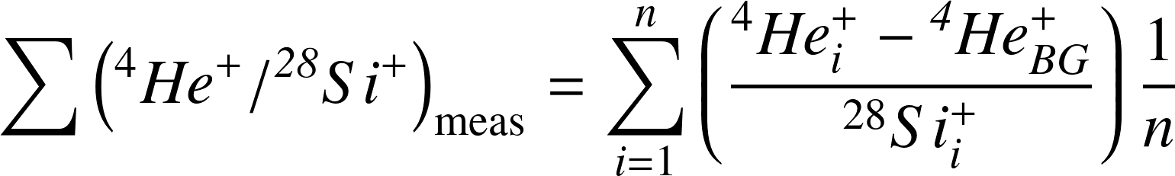, (2)
where ⁴He_{i}⁺ and ²⁸Si_{i}⁺ are the ion intensities of ⁴He and ²⁸Si in the measurement layers, respectively, and i is the number of measurement layers on the surface. If the n is sufficiently large, the [⁴He] of the integration region corresponds to Φ/d, where Φ is the fluence of ⁴He implantation into the He-Ol and d is the depth corresponding to the n. Therefore, Equation (1) is transformed into the following equation:
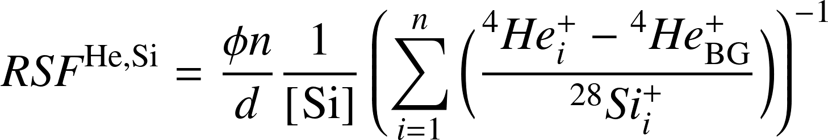. (3)
The [²⁸Si] is 1.24 × 10²² cm^{–3} for olivine. Φ is the ⁴He fluence of 1 × 10¹⁵ cm^{–2}. As the integration depth appears sufficient up to the depth of 100 nm (Figure 2), the RSF^{He,Si} is calculated to be 0.79 ± 0.01 (1σ) for olivine. The uncertainty of the RSF^{He,Si} was calculated by counting statistics for ⁴He⁺ and ²⁸Si⁺. Therefore, the ⁴He concentration ([⁴He]^{He,Si} (cm^{–3})) of the olivine was estimated using the following equation:
[⁴He]^{He,Si} (cm^{–3}) = RSF^{He,Si} × [Si] × (⁴He_{i}⁺/²⁸Si_{i}⁺)_{meas}. (4)
To apply Equation (4), the Si concentration at each measurement point must be determined. However, meteorites consist of various minerals with different Si concentrations, ranging from 0% (e.g., Fe metal) to ~50% (e.g., silicates) in the imaging areas in this study. It is difficult to accurately determine the Si concentrations for all pixels in a 2D analysis at a resolution of one pixel. Post-ionization by a focused fs laser suppresses the matrix effect for element quantification because the ionization efficiency is nearly 100% for all ions.¹² If the sputtering rate is not very different between minerals, we can directly estimate the ⁴He concentration from ⁴He_{i}⁺ as follows. Removing normalization terms from Equation (3),
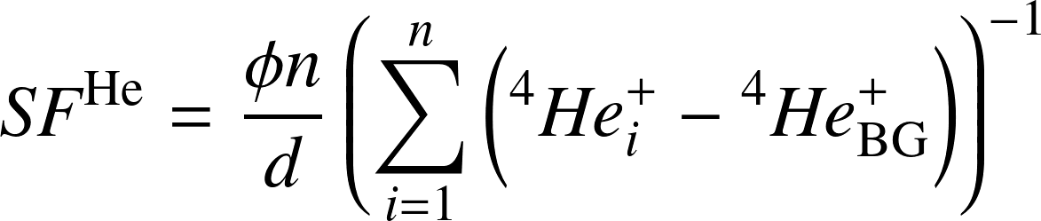. (5)
Then,
[⁴He]^{He} (cm^{–3}) = SF^{He} × ⁴He_{i}⁺. (6)
The sensitivity factor (SF) is calculated to be 1.03 ± 0.02 × 10²² (cm^{–3} cpms^{–1}) by duplicate measurements of the He-Ol standard.
Using Equations (4) and (6), the ion intensities of the depth profiles were converted into ⁴He concentrations (Figure 2).

Detection limit of ⁴He
The blank ⁴He value of (6 ± 1) × 10^{–5} cpms, which is calculated to be (2.1 ± 0.3) × 10¹⁷ cm^{–3} using Equation (6). The detection limit was improved by approximately one order of magnitude compared with that reported in previous study (3 × 10¹⁸ cm^{–3}).⁵
The detection limit for depth profiling (Figure 2) corresponds to the concentration at the bottom of the crater (> 150 nm), which is (5.5 ± 0.4) × 10¹⁷ cm^{–3} ((1.6 ± 0.1) × 10^{–4} cpms). The ion intensity of ⁴He⁺ for blank-Ol is (1.5 ± 0.2) × 10^{–4} cpms, which is the same within the error to that of the He-Ol measurement and ~2.6 times greater than that of the blank ⁴He. This indicates that the ⁴He intensity was increased by the irradiation of the sample by the primary beam. The ⁴He from the crater bottom in the depth profiling was likely generated from the adsorbed ⁴He on the sample surface during the intervals between the primary beam pulses, in addition to the residual He gas in the sample chamber. The detected adsorbed ⁴He was comparable to the residual ⁴He under these measurement conditions.

Texture and isotope imaging of NWA 801
The NWA 801 meteorite consists of millimeter-sized chondrules and millimeter-to-sub-millimeter- sized grains of olivine, low-Ca pyroxene, and Fe-Ni metal (Figure 3). The chondrules and Fe-Ni metals are embedded in a fine-grained matrix composed mainly of sub-micrometer-sized phyllosilicates.¹⁸ We obtained ion images of ⁴He, ²⁴Mg²⁺, ²⁸Si⁺, and ⁵⁶Fe²⁺ from matrix areas A and B, as shown in Figures 4 and 5, respectively. The ⁴He concentrations in the ⁴He images were calculated using Equation (6) with SF^{He}. Olivine, pyroxene, metal fragments, and a fine-grained matrix can be distinguished in the ²⁴Mg²⁺, ²⁸Si⁺ and ⁵⁶Fe²⁺ images shown in Figures 4 and 5.

Comparison between RSF and SF for He quantification
We measured four small areas (spots) for the silicate phases, as shown in Figure 4a, to compare the two [⁴He] conversion methods using Equations (4) and (6) because the ion image cannot accurately determine Si concentrations for all pixels. Table 1 summarizes the ion intensities of the spot analysis, the Si concentrations for the spots with SEM-EDS analysis, and ⁴He concentrations obtained by the two conversion methods. Spots #1 and #2 were dominated by phyllosilicates enclosing the mineral particles of metals, sulfides, and pyroxene. Spots #3 and #4 consisted of phyllosilicates and monomineralic olivine, respectively. Figure 6 shows the correlations between [⁴He]^{He}, and [⁴He]^{He,Si}. Both concentrations are plotted on the slope-1 line, suggesting agreement between the two quantification methods, regardless of the differences in the matrix phases. This also suggests that the sputtering rates were similar among these minerals.

⁴He concentration maps of NWA 801
Helium is highly concentrated and sparsely scattered (Figures 4a and 5a). Helium-4 signals above 10¹⁹ cm^{–3} are observed from the phyllosilicates and in the matrix, and are not detected in coarser mineral fragments such as olivine and pyroxene. The highest ⁴He concentrations shown in Figures 4a and 5a are ~1 × 10²¹ cm^{–3}. This is identical to the saturation concentration of the silicates.¹⁶ Because almost all the ⁴He in NWA 801 is solar wind He,⁷ the high ⁴He concentration can be explained by solar wind ion implantation. In the black colored pixels in Figures 4a and 5a, the ⁴He concentrations are lower, with concentrations of ~10¹⁸ cm^{–3} or less.
The ⁴He isotope imaging technique revealed a sparsely scattered ⁴He distribution in the NWA 801 matrix. The ⁴He-enriched portions are composed of fine particles of sub-micrometer phyllosilicates enclosing mineral particles of metal, sulfide, and pyroxene. The presence of solar wind ⁴He in the fine particles indicates that these particles were exposed on the surface of the parent body for a longer period than the ⁴He-poor fine particles.
The ⁴He images in Figure 7 were generated from Figures 4 and 5 to compare the changes in spatial resolution between the previous (~20 μm) and this study (2 μm). The generation method is that a window consisting of the 40 × 25 pixels (23 × 20 μm²) in the original images was prepared. The window was scanned in the x- and y-directions with steps of 6.2 and 6.5 μm, respectively. The intensities in the window were averaged to a single pixel to generate a 5 × 6 pixel image. As a result, the spatial resolution of the images in Figure 7 becomes equivalent to the spatial resolution of images taken with a ~20 μm primary ion beam, which is the highest resolution of previous studies. This process increases the count intensity by a factor of approximately 1000 and lowers the detection limit of ⁴He to approximately 1/30. Therefore, the color scale in Figure 7 was set to lower than in Figures 4b and 5b. The low spatial resolution images in Figure 7 do not show the distribution of concentrated and sparsely scattered ⁴He, as shown in Figures 4a and 5a. This study is the first to demonstrate distribution of solar wind ⁴He implanted in individual minerals (phases), which has not been determined by previous studies.^{1–4} Using this imaging technique, we can explore the processes through which the solar wind is incorporated into asteroids and how its components become distributed into their asteroidal interiors.

CONCLUSIONS
The fs laser and vacuum system of LIMAS were improved, resulting in an increase in the ⁴He ion count rate and a reduction in the ⁴He background. The revision of the vacuum resulted in an improvement of the blank ⁴He from 3 × 10¹⁸ cm^{–3} to 2 × 10¹⁷ cm^{–3}. The detection limit for ⁴He was reduced by one order of magnitude. We succeeded in obtaining in situ microscale images of the ⁴He distribution in a solar wind gas-rich meteorite. The ⁴He isotope images showed the active movement of fine particles on the asteroid surface.

AUTHOR INFORMATION
Corresponding Author
*Ken-ichi Bajo, Department of Earth and Planetary Sciences, Faculty of Science, Hokkaido University, Sapporo 060-0810, Japan; e-mail: k-bajo@eis.hokudai.ac.jp orcid.org/0000-0002-9013-2730
Authors
Noriyuki Kawasaki, Department of Earth and Planetary Sciences, Faculty of Science, Hokkaido University, Sapporo 060-0810, Japan. orcid.org/0000-0001-6502-6488
Isao Sakaguchi, National Institute for Materials Science, Tsukuba 305-0044, Japan.
Taku T. Suzuki, National Institute for Materials Science, Tsukuba 305-0044, Japan.
Satoru Itose, JEOL Ltd., Akishima 196-8558, Japan
Miyuki Matsuya, JEOL Ltd., Akishima 196-8558, Japan
Morio Ishihara, Department of Physics, Graduate School of Science, Osaka University, Toyonaka 560-0043, Japan.
Kiichiro Uchino, Interdisciplinary Graduate School of Engineering Sciences, Kyushu University, Kasuga 816-8580, Japan.
Hisayoshi Yurimoto, Department of Earth and Planetary Sciences, Faculty of Science, Hokkaido University, Sapporo 060-0810, Japan. orcid.org/0000-0003-0702-0533

AUTHOR CONTRIBUTIONS
The manuscript was written through contributions of all authors. All authors have given approval to the final version of the manuscript.

ACKNOWLEDGEMENTS
We thank associate editor Dr. Scott A. McLuckey for editorial handling and three anonymous reviewers for their constructive comments. We thank Drs. Kosuke Nagata and Azusa Tonotani for their assistance in modifying the LIMAS system. We would like to thank Editage (www.editage.jp) for English language editing.

REFERENCES
(1) Nakamura, T.; Nagao, K.; Takaoka, N. Microdistribution of primordial noble gases in CM chondrites determined by in situ laser microprobe analysis: Decipherment of nebular processes. Geochem. Cosmochem. Acta. 1999, 63, 241–255. DOI: 10.1016/S0016-7037(98)00275-0
(2) Okazaki, R.; Takaoka, N.; Nagao, K.; Sekiya, M.; Nakamura, T. Noble-gas-rich chondrules in an enstatite meteorite. Nature 2001, 412, 795–798. DOI: 10.1038/35090520
(3) Sumino, H.; Ikehata, K.; Shimizu, A.; Nagao, K.; Nakada, S. Magmatic processes of Unzen volcano revealed by excess argon distribution inzero-age plagioclase phenocrysts. J. Volcanol. Geotherm. Res. 2008, 175, 189–207. DOI: 10.1016/j.jvolgeores.2008.03.027
(4) Gnaser, H.; Oechsner, H. Novel Detection Scheme for the Analysis of Hydrogen and Helium by Secondary Ion Mass Spectrometry. Surf. Interface Anal. 1991, 17, 646–649. DOI: 10.1002/sia.740170906
(5) Bajo, K.; Olinger, C. T.; Jurewicz, A. J. G.; Burnett, D. S.; Sakaguchi, I.; Suzuki, T. T.; Itose, S.; Ishihara, M.; Uchino, K.; Wieler, R.; Yurimoto, H. Depth profiling analysis of solar wind helium collected in diamond-like carbon film from Genesis. Geochem. J. 2015, 49, 559–566. DOI: 10.2343/geochemj.2.0385
(6) Wieler, R.; Baur, H.; Pedroni, A.; Signer, P.; Pellas, P. Exposure history of the regolithic chondrite Fayetteville: I. Solar-gas-rich matrix. Geotherm. Res. 1989, 53, 1441–1448. DOI: 10.1016/0016-7037(89)90076-8
(7) Obase, T.; Nakashima, D.; Choi, J.; Enokido, Y.; Matsumoto, M.; Nakamura, T. Water-susceptible primordial noble gas components in less-altered CR chondrites: A possible link to cometary materials. Geochem. Cosmochem. Acta. 2021, 312, 75–105. DOI: 10.1016/j.gca.2021.08.012
(8) Bogard, D. D.; Johnson, P. Trapped noble gases indicate lunar origin for Antarctic meteorite. Geophys. Res. Lett. 1983, 10, 801–803. DOI: 10.1029/GL010i009p00801
(9) Mibuka, R.; Hassaballa, S.; Uchino, K.; Yurimoto, H.; Todokoro, R.; Kumondai, K; Ishihara, M. Characteristics of post-ionization using a femto-second laser. Appl. Surf. Sci. 2008, 255, 1595–1598. DOI: 10.1016/j.apsusc.2008.05.003
(10) Ishihara, M.; Ebata, S.; Kumondai, K.; Mibuka, R.; Uchino, K; Yurimoto, H. (2010) Ultra-high performance multi-turn TOF-SIMS system with a femto-second laser for post-ionization: investigation of the performance in linear mode. Surf. Interface Anal. 2010, 42, 1598–1602. DOI: 10.1002/sia.3611
(11) Itose, S., Matsuya, M., Uno, S., Yamashita, K., Ebata, S., Ishihara, M., Uchino, K., Yurimoto, H., Sakaguchi, K. and Kudo, M. An Aberration Corrected FIB for Nano-Area Mass Spectrometry. Microscopy and Microanalysis, 2011, 17, 654–655. DOI:10.1017/S1431927611004144
(12) Ebata, S.; Ishihara, M.; Uchino, K.; Itose, S.; Matsuya, M.; Kudo, M.; Bajo, K.; Yurimoto H. Development of Laser Ionization Mass Nanoscope:"LIMAS". Surf. Interface Anal. 2012, 44, 635–640. DOI: 10.1002/sia.4857
(13) Bajo, K.; Itose, S.; Matsuya, M.; Ishihara, M.; Uchino, K.; Kudo, M.; Sakaguchi, I.; Yurimoto, H. High spatial resolution imaging of helium isotope by TOF-SNMS. Surf. Interface Anal. 2016, 48, 1190–1193. DOI: 10.1002/sia.6085
(14) Tonotani, A.; Bajo, K.; Itose, S.; Ishihara, M.; Uchino, K.; Yurimoto, H. Evaluation of multi-turn time-of-flight mass spectrum of laser ionization mass nanoscope. Surf. Interface Anal. 2016, 48, 1122–1126. DOI: 10.1002/sia.6112
(15) Bajo, K.; Fujioka, O.; Itose, S.; Ishihara, M.; Uchino, K.; Yurimoto, H. Electronic data acquisition and operational control system for time-of-flight sputtered neutral mass spectrometer. Surf. Interface Anal. 2019, 51, 35-39. DOI: 10.1002/sia.6541
(16) Yurimoto, H.; Bajo, K.; Sakaguchi, I.; Suzuki, T. T.; Jurewicz, A. J. G.; Itose, S.; Uchino, K.; Ishihara, M. Quantitative analysis of helium by post-ionization method using femtosecond laser technique. Surf. Interface Anal. 2016, 48, 1181–1184. DOI: 10.1002/sia.6119
(17) Nagata, K.; Bajo, K.; Itose, S.; Matsuya, M.; Ishihara, M.; Uchino, K.; Yurimoto H. Aberration-corrected focused ion beam for time-of-flight secondary neutral mass spectrometry. Appl. Phys. Exp. 2019, 12, 085005. DOI: 10.7567/1882-0786/ab30e4
(18) Connolly, H.C., Jr.; Smith, C., Benedix, G., Folco, L., Righter, K., Zipfel, J., Yamaguchi, A. and Aoudjehane, H.C. The Meteoritical Bulletin, No. 92, 2007 September. Meteorit. Planet. Sci. 2007, 42, 1647–1694. DOI: 10.1111/j.1945-5100.2007.tb00596.x

FIGURES AND TABLE
Figure 1. (a) TOF spectrum of point #1 of NWA 801 sample shown in Figure 4a. The arrows are assigned to the measured ion species. The numbers in parentheses indicate the numbers of laps for each ion in MULTUM-II. (b) TOF spectrum of m/z 4 of the point #1. The peak positions of ¹⁶O⁴⁺ and ¹²C³⁺ which are removed by the ion gate are indicated by arrows.
Figure 2. (a) Depth profiles of ⁴He⁺ and ²⁸Si⁺ from the He-Ol sample. Silicon intensity is shown in tenths. The ⁴He concentration calculated by Equation (4) is shown on the right axis. (b) Depth profiles of ⁴He⁺/²⁸Si⁺ from the He-Ol sample. The ⁴He concentration on the right axis is calculated using Equation (6).

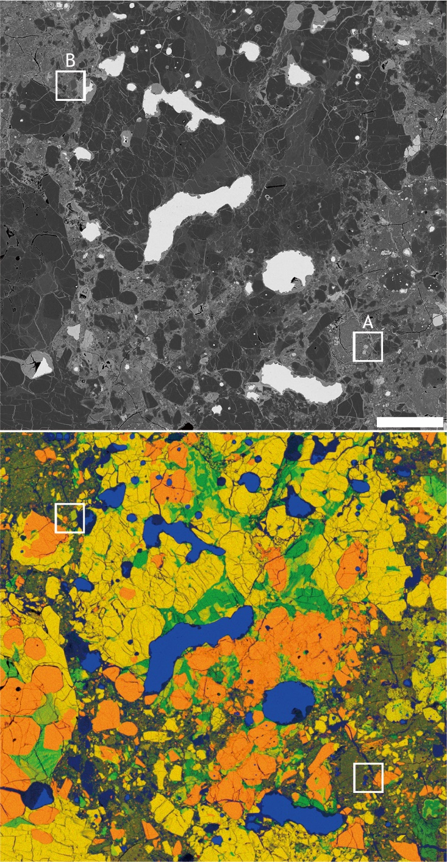
Figure 3. (a) BSE image of NWA 801. (b) Combined X-ray elemental map of (a). Mg: Red, Si: Green, and Fe: Blue. The scale bar represents 100 μm for all images. The area contains chondrules, lithic and mineral fragments, metal particles, and fine-grained minerals. Matrix is defined as aggregates of solids of smaller than micrometer size. The two matrix areas of A and B are measured by isotope imaging as shown in Figures 4 and 5, respectively.

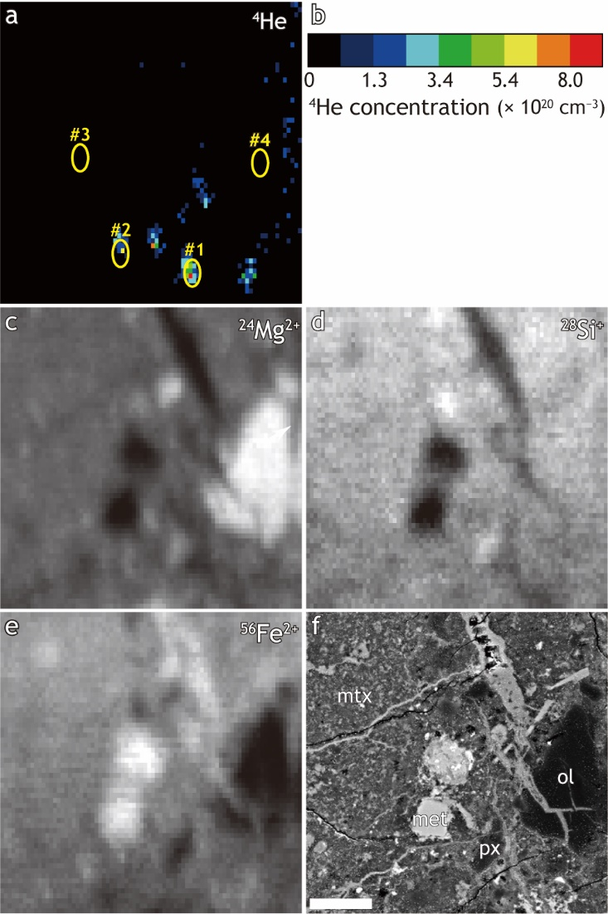
Figure 4. Isotope images from area A. (a) ⁴He image. Four yellow ellipses (#1–4) indicate points measured by the spot analysis. The white arrow in #1 indicates the data point used in Figure 1. (b) Color scale of ⁴He concentration. (c) ²⁴Mg²⁺, (d) ²⁸Si⁺, and (e) ⁵⁶Fe²⁺ images. (f) BSE image for comparison. The scale bar represents 10 μm for all images. Labels px, ol, met, and mtx indicate pyroxene, olivine, metal, and fine-grained matrix, respectively.
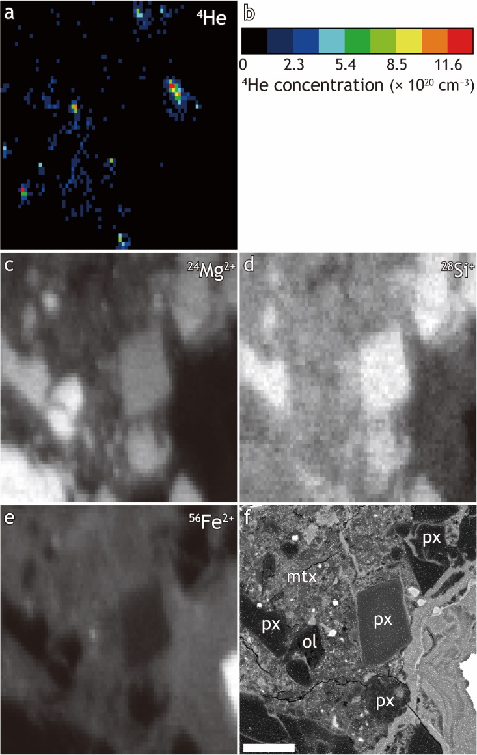
Figure 5. Isotope images of area B. (a) ⁴He image. (b) Color scale of ⁴He concentration. (c) ²⁴Mg²⁺, (d) ²⁸Si⁺, and (e) ⁵⁶Fe²⁺ images. (f) BSE image for comparison. The scale bar represents 10 μm for all images. Labels px, ol, and mtx indicate pyroxene, olivine, and fine-grained matrix, respectively.

Figure 6. Correlation between ⁴He concentrations using SF^{He} ([⁴He]^{He}) and RSF^{He,Si} ([⁴He]^{He,Si}) for the spot analysis. The dotted line represents the slope-1 line.

Figure 7. Computer-simulated ⁴He isotope images. (a) Low spatial resolution image of Figure 4a. (b) Low spatial resolution image of Figure 5a. The color scale is set to one-tenth from Figure 4b and 5b. A window consisting of the 40 × 25 pixel (23 × 20 μm²) in the original images are averaged to a single pixel to generate a 5 × 6 pixel images. The scale bars represent 10 μm.

Table 1. Blank-corrected ⁴He⁺, ²⁴Mg²⁺, ²⁸Si⁺, ⁵⁶Fe²⁺ intensities, Si, and ⁴He concentrations for the spot analysis.
 | ⁴He⁺ | ²⁴Mg²⁺ | ²⁸Si⁺ | ⁵⁶Fe²⁺ | ⁴He⁺/²⁸Si⁺ | Si* | [⁴He]^{He,Si} | [⁴He] ^{He}
 | cpms |  |  |  | 10⁻³ | mol% | 10¹⁹ cm⁻³
#1 | 0.0222 (2) | 5.15 | 0.65 | 2.56 | 34 (2) | 11.3 | 26.4 (3) | 22.7 (2)
#2 | 0.0065 (1) | 8.37 | 0.80 | 2.53 | 8.1 (4) | 11.3 | 6.31 (14) | 6.62 (13)
#3 | 0.00012 (3) | 6.77 | 1.01 | 3.72 | 0.10 (3) | 13.1 | 0.10 (2) | 0.12 (3)
#4 | 0.00007 (2) | 22.15 | 1.18 | 0.42 | 0.06 (1) | 14.0 | 0.06 (2) | 0.07 (2)
Uncertainties in the last decimal places of listed numbers are enclosed in parentheses: for example, 0.0222 (2) indicates 0.0222 ± 0.0002. The uncertainty in the intensity of ⁴He⁺ represents a statistical error in the overall ⁴He⁺ count. [⁴He]^{He,Si} and [⁴He]^{He} denote ⁴He concentrations calculated using Equations (4) and (6), respectively.
* Si concentrations were calculated using Oxford AZtec software with the SEM-EDS system.

