Tomography-based Micromagnetic Simulations of
Nd-Fe-B Hot-Deformed Magnets
Anton Bolyachkin^{1,2}, Ekaterina Dengina^{1,3}, Nikita Kulesh¹, Xin Tang^{1,2},
Hossein Sepehri-Amin^{1,3}, Tadakatsu Ohkubo¹, and Kazuhiro Hono^{1,3}
¹Research Center for Magnetic and Spintronic Materials, National Institute for Materials Science, Tsukuba, Japan
²International Center for Young Scientists, National Institute for Materials Science, Tsukuba, Japan
³Graduate School of Science and Technology, University of Tsukuba, Tsukuba, Japan

Modern trends in developing new magnetic materials or improving existing ones are focused on fine-tuning their microstructure. Therefore, detailed physical models elucidating the relationships between microstructural features and macroscopic magnetic properties are highly relevant. Micromagnetic finite element models (FEM) which can accurately replicate the actual microstructure are especially beneficial, as it was recently demonstrated for quasi-2D systems such as FePt granular media and SmFe₁₂-based thin films [1,2]. Here we present our next step in the development of realistic 3D micromagnetic models that was realized for Nd-Fe-B hot-deformed magnets based on tomographic data.

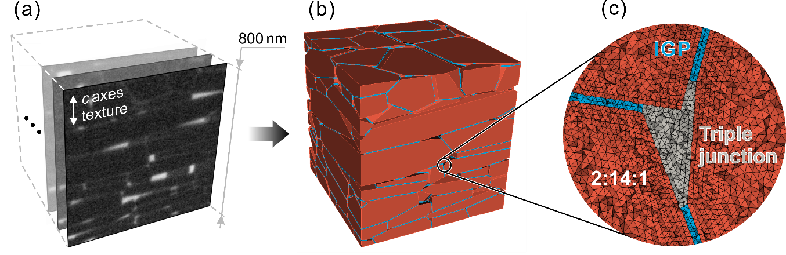
Figure 1: (a) A series of FIB-SEM images obtained for a hot-deformed Nd-Fe-B magnet. (b) Micromagnetic model created from the tomographic data with three types of regions: (c) Nd₂Fe₁₄B-based grains (2:14:1), localized thin ferromagnetic intergranular phase (IGP), and the phase forming triple junctions (hidden in (b)).

The tomographic data were obtained as a series of scanning electron microscopy (SEM) images collected while a focused ion beam (FIB) was polishing out the magnet’s surface (Fig. 1(a)). The SEM images were segmented and processed so that each grain was represented by a uniform cloud of points. 3D volumes of the grains were then created using support vector machines resulting in convex close-packed polyhedra, as it is shown in Figure 1(b). We developed an algorithm to reconstruct the thin intergranular phase (IGP) in localized areas between adjacent grains (3.5-nm-thick blue regions in Figure 1(b)). This approach also introduced triple junctions as an individual region with a complex net-like structure (Fig. 1(c)). Finally, in order to discretize such a model in a high-quality mesh, we realized the algorithms of revising small geometric entities, i.e., small curves, small and narrow surfaces. The developed micromagnetic model of Nd-Fe-B magnets was able to reproduce the coercivity close to its experimental value. Moreover, the angular dependence of coercivity demonstrated a behaviour close to the pinning-type Kondorsky model without introducing a defective grain.
Methodological details behind the tomography-based FEMs and new insights into the coercivity mechanism of hot-deformed Nd-Fe-B magnets revealed by micromagnetic simulations will be presented in a report.

References
[1] A. Bolyachkin, H. Sepehri-Amin, I. Suzuki, H. Tajiri, Y.K. Takahashi, K. Srinivasan, H. Ho, H. Yuan, T. Seki, A. Ajan, and K. Hono: Transmission electron microscopy image based micromagnetic simulations for optimizing nanostructure of FePt-X heat-assisted magnetic recording media. Acta Mater., 227, 117744 (2022).
[2] A. Bolyachkin, H. Sepehri-Amin, M. Kambayashi, Y. Mori, T. Ohkubo, Y.K. Takahashi, T. Shima, and K. Hono: Coercivity engineering in Sm(Fe_{0.8}Co_{0.2})₁₂B_{0.5} thin films by Si grain boundary diffusion. Acta Mater., 227, 117716 (2022).

