Correlation between Electrolyte Concentration and Lithium Morphology during Lithium Bis(fluorosulfonyl)amide–Tetraglyme Electrolyte Deposition–Dissolution Reactions

Go Kamesuiª, Kei Nishikawa^{b, c}, Mikito Uedaª, Hisayoshi Matsushima^{a*}

ª Faculty of Engineering, Hokkaido University, Kita 13 Nishi 8,
Sapporo, Hokkaido 060-8628, Japan
*Corresponding Author: matsushima@eng.hokudai.ac.jp
Tel. and Fax: +81-11-7066352

^{b} Rechargeable Battery Materials Group, Research Center for Energy and Environmental Materials, National Institute for Materials Science, 1-1 Namiki, Tsukuba, Ibaraki 305-0044, Japan

^{c} Advanced Battery Collaboration, Research Center for Energy and Environmental Materials, National Institute for Materials Science, 1-1 Namiki, Tsukuba, Ibaraki 305-0044, Japan

Abstract
Electrodeposition and chemical dissolution reactions of Li are strongly affected by the electrolyte concentration at the electrode surface. In this study, we investigated the processes involved in the formation of Li deposits at various electrolyte concentrations and different numbers of deposition–dissolution cycles. Growth of the deposits during the cycles was assessed using a digital microscope. The thickness of the fibrous layer was strongly dependent on the electrolyte solute–solvent molar ratio. The thickness of the fibrous layer increased as the number of cycles increased when the electrolyte solute–solvent molar ratio was low but decreased when the molar ratio was high. Temporal changes in the electrolyte concentration and in the diffusion layers near the electrode were identified using a laser interference microscope. The results led us to conclude that there are three fibrous Li deposit growth models that occur at different solvent–solute molar ratios.

Keywords
Li electrodeposition, Deposition morphology, Solvate ionic liquids, Mass transfer

Introduction
High energy-density batteries have recently increased in importance because of more electric vehicles and renewable energy being produced.¹ However, Li ion battery capacity limits will soon be reached,² meaning there is an urgent need for new battery materials to be developed for use in next-generation batteries.³
In 2014, Yamada et al. discovered that high-concentration electrolytes (HCEs) have unique electrochemical properties. The electrolyte concentration is three times higher in a HCE battery than a conventional Li ion battery.⁴ In a HCE, almost all of the solvent molecules are coordinated to cations. This unique structure increases the energy level of the lowest unoccupied molecular orbital of the solvent⁵ and causes a stable anion-based solid–electrolyte interphase to form. HCEs used in Li batteries can give outputs of 4–5 V and high energy densities.^{5,6} A solvate ionic liquid (a type of HCE) consists of ion pairs of solvated cations and anions at room temperature. Solvate ionic liquids have high ionic conductivities and are very thermally stable.⁷
An anode-free battery (AFB) is a type of next-generation battery in which the current collector is also the negative electrode, allowing a higher energy density to be achieved than in conventional batteries.⁸ However, inactive Li can form on the negative electrode surface of an AFB. Inactive Li does not take part in charge–discharge reactions.⁹ The formation of inactive Li therefore decreases the coulombic efficiency of a battery. Extensive deposits of inactive Li may cause short circuiting between the electrodes and therefore pose a fire hazard. The mechanisms involved in Li deposition need to be identified to allow safe AFBs with high coulombic efficiencies to be developed.
Li deposition reactions at the negative electrode cause the Li⁺ concentration at the negative electrode surface to decrease. The concentration gradient between the electrode surface and the bulk electrolyte drives Li⁺ diffusion from the bulk electrolyte toward the electrode.¹⁰ During electrochemical dissolution of Li, the Li⁺ concentration at the negative electrode surface increases and the concentration gradient between the electrode surface and the bulk electrolyte drives Li⁺ diffusion from the electrode toward the bulk electrolyte.¹¹ The morphology of a Li deposit will be affected by the Li⁺ concentration at the electrode surface, C_{s}, which will depend on the initial Li⁺ concentration in and Li⁺ transport characteristics of the bulk electrolyte.¹² However, the relationship between Li⁺ mass transfer and Li deposit morphology during charge–discharge cycles in a HCE battery is poorly understood.
The measurement of metal ion concentration distribution in electrolytes has been performed using techniques such as scanning electrochemical microscopy (SECM) ¹³, magnetic resonance imaging (MRI) ¹⁴, and laser interferometry^{15,16}. SECM can visualize concentration distributions. However, the probe may interfere with the ion flow. MRI allows for non-contact and non-destructive measurements, but it requires an electrode distance larger than 5 mm. Laser Interferometry can measure without contacting the sample. It allows observation at narrow electrode distances less than 1 mm, enabling the acquisition of transport phenomenon data in cells that replicates the battery environment.
We have previously used laser interferometry to investigate changes in electrolyte concentrations near the electrodes of batteries.^{10,17–19} Laser interferometry has been used to detect changes in electrolyte concentrations for more than half a century.^{20–22} Laser interferometry allows the electrolyte concentration to be measured in situ without disturbing the electrolyte or decomposing the components of the electrolyte liquid. In previous studies, we successfully estimated diffusion coefficients and transference numbers by performing non-steady-state diffusion mode analyses.¹¹ In the study described here, we used in situ interferometry to measure C_{s}. Li deposits during electrodeposition and chemical dissolution were observed in situ by digital microscopy (DM) and the morphologies of the deposits were assessed ex situ by scanning electron microscopy (SEM). Correlations between C_{s} and Li morphology were investigated.

Experimental
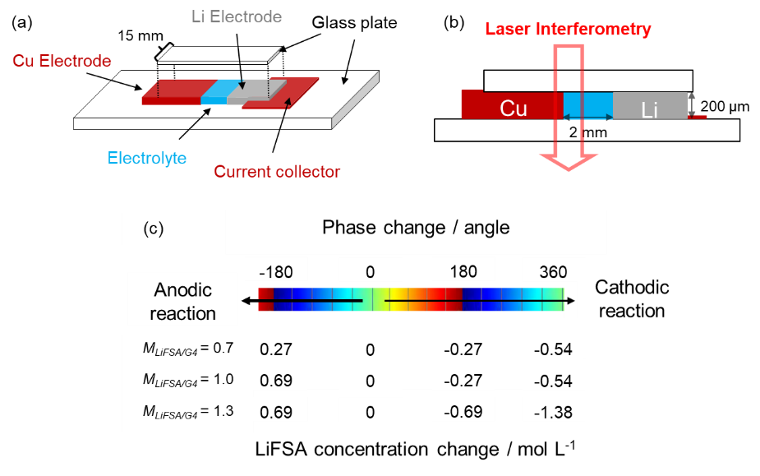
Fig. 1 (a) Overview and (b) cross-sectional view of the electrochemical cell for interferometry and digital microscopy. (c) Relationship between the phase and concentration changes.

The electrochemical cell is shown schematically in Fig. 1(a) and 1(b). A Cu plate (99.99% pure; Nilaco, Japan) and Li foil (99.9% pure; Honjo Metal, Japan) were used as the working and counter electrodes, respectively. Each electrode was 15 mm long and 200 µm wide. The inter-electrode distance was 2 mm. Cu foil 2 µm thick was placed under the Li electrode to act as a current collector. The surfaces of the electrodes were parallel to each other. A quasi-two-dimensional cell configuration was used to suppress natural convection in the electrolyte. Before use, the Cu plate was polished with waterproof abrasive paper of grades #800, #1200, and then #3000. The oxide film on the electrode surface was then removed using 0.1 mol L⁻¹ nitric acid. The electrode surface was then washed with acetone, ethanol, and pure water, in that order. The top and bottom of the electrode were then coated with silicone (FC-112RTV; Fine Chemical, Japan) to insulate the electrode sides. The electrolyte was then injected between the two electrodes, and then the injection ports were sealed with epoxy resin.
The electrolyte was prepared by mixing lithium bis(fluorosulfonyl)amide (LiFSA; 99.9% pure; Nippon Shokubai, Japan) and tetraglyme (G4; 98% pure; Kishida Chemical, Japan) at 50 °C on a hot plate with stirring. The LiFSA to G4 molar ratio is later labeled M_{LiFSA/G4}. Five electrolyte solutions were used in the experiments. The M_{LiFSA/G4}s of the five electrolyte solutions were 0.7, 0.85, 1.0, 1.15, and 1.3 and the LiFSA concentrations were 2.52, 2.91, 3.27, 3.59, and 3.89 mol L⁻¹, respectively.¹¹ The electrochemical cell and electrolyte solutions were all prepared in a dry room with a dew point < −50 °C.
Each electrochemical experiment was performed at 23 °C. The Li electrodeposition and chemical dissolution experiments were performed at 3 mA cm⁻² using a potentiostat (HZ-Pro S12; Hokuto Denko, Japan). The deposition and dissolution times were both 200 s. The cut-off voltage was ±3 V.
Li deposition and dissolution on the Cu electrode surface was observed in situ using a DM instrument (VHX-1000; Keyence, Japan) using a magnification of 500×. The DM image acquired at each selected time point was trisected horizontally and the largest Li deposit in each region was measured.¹⁷
The morphologies of the Li deposits on the Cu electrode after the first and sixth deposition processes were assessed using a field emission SEM instrument (JSM-7800F; JEOL, Tokyo, Japan). The electrochemical cell was disassembled at the end of the deposition process, and the electrode to be assessed was carefully washed with G4 and transferred to the SEM instrument in an air-tight holder.
Changes in the electrolyte concentration near the electrode during the deposition–dissolution processes were measured using a digital holographic interferometer (DHM T1000; Lyncée Tec, Switzerland). The wavelength of the laser beam was 683.6 nm. The optical path length was 200 µm. The objective lens magnification was 5×. The holograms produced by the digital holographic interferometer were analyzed using Koala software (Lyncée Tec) to get the LiFSA concentration profile in the electrolyte. The relationship between the phase shift and the changes in LiFSA concentration is shown in Fig. 1(c). The procedure for calculating the LiFSA concentration from the phase change was explained in a previous publication.¹¹

Results and Discussion
Li deposition and dissolution on the electrode surfaces in the experiments with M_{LiFSA/G4}s of 0.7, 1.0, and 1.3 recorded by DM are shown in Movies S1(a), S1(b), and S1(c), respectively. When electrodeposition in the experiment with M_{LiFSA/G4} = 0.7 started, fibrous silver-colored deposits started to be produced and eventually covered the entire electrode surface. DM was focused on the electrode edge, so the view of the deposits in the depth direction was blurred. Needle-like deposits protruded from various points on the deposit surfaces. When dissolution started, the deposits stopped growing and the deposits became darker in color. This color change was probably caused by changes in the way light was reflected as the deposits dissolved. The needles became thinner and dissolved. When electrodeposition resumed, the deposits became silver-colored again and became thicker. The deposits grew by pushing the residues that had not fully dissolved during the dissolution reaction in the direction of the bulk solution. Needles again grew from the same locations as before dissolution. When dissolution recommenced, less shadowing occurred than in the previous cycle. Some needles became broken and lay horizontally on the deposit surfaces. Similar dynamic behaviors were observed on both the anode and cathode surfaces during repeated cycles. However, fewer needles formed in the later cycles. The deposits appeared to be slightly coarser in the experiment with M_{LiFSA/G4} = 1.0 than with M_{LiFSA/G4} = 0.7.
In the experiment with M_{LiFSA/G4} = 1.3, thick silver-colored deposits formed during electrodeposition but were in specific areas rather than uniformly distributed like in the experiments with M_{LiFSA/G4} = 0.7 and 1.0. The fibers were large, and some deposits broke as they grew and formed loop-like structures. During dissolution, the deposits dissolved from the tips, shrank, and eventually lay horizontally. The deposits were darker at the end of the dissolution process than at the onset of dissolution. When electrodeposition resumed, silver-colored deposits formed again. The deposits grew by filling in the gaps between undissolved fibers. The deposit became unevenly shaped because many loop-like deposits formed. Dissolution caused the deposits to shrink. Undissolved fibers became subsumed by the layered deposit. The old layer gradually became uneven.
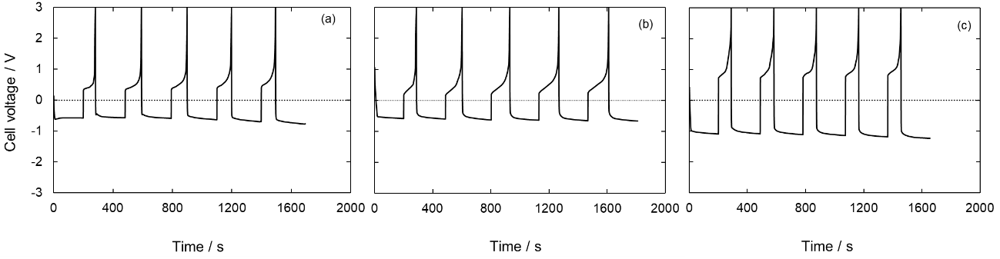
Fig. 2 Voltage profiles during the Li electrodeposition and chemical dissolution experiments with M_{LiFSA/G4} = (a) 0.7, (b) 1.0, and (c) 1.3.

Changes in the cell voltage during the deposition–dissolution cycles are shown in Fig. 2(a)–2(c). When a cathodic current was applied, the cell voltage remained almost constant for 200 s whatever the M_{LiFSA/G4} and cycle number. This indicated that reduction of Li⁺ occurred continually. The cell voltage increased as M_{LiFSA/G4} increased. When the direction of the applied current was reversed, the cell voltage became positive. The voltage increased over time at all M_{LiFSA/G4}s. The voltage increased sharply until the reactive deposits were almost completely dissolved. We calculated the coulombic efficiency (CE), defined as the deposition time to dissolution time ratio. The CEs for the first cycle in the experiments with M_{LiFSA/G4} = 0.7, 1.0, and 1.3 were 41%, 45%, and 44%, respectively. The mean CEs for the second to fifth cycles in the experiments with M_{LiFSA/G4} = 0.7, 1.0, and 1.3 were 51%, 65%, and 46%, respectively. The relationship between the electrolyte concentration and CE is discussed below.
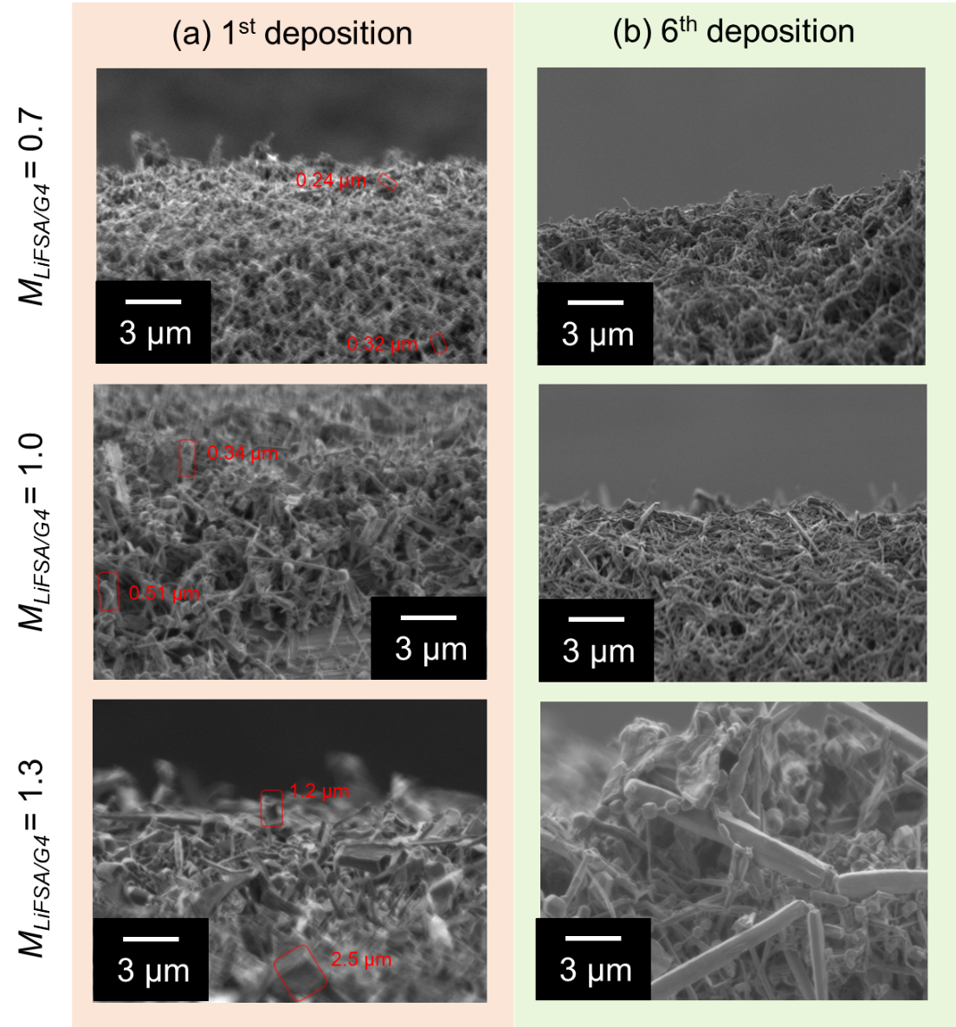
Fig. 3 Scanning electron microscopy images of the electrode surfaces after the (a) first and (b) sixth deposition processes.

For the experiments with M_{LiFSA/G4} = 0.7, 1.0, and 1.3, SEM images of the electrode surfaces after the (a) first and (b) sixth deposition processes are shown in Fig. 3. In all of these experiments, needle-like or fibrous Li deposits covered the electrode surfaces. The morphologies of the deposits did not depend strongly on the cycle number. The SEM images clearly indicated that thick fibers with large diameters formed when M_{LiFSA/G4} was high. SEM images of the electrode edges were acquired, like for the DM movies. The lower part of each SEM image therefore shows the area near the substrate surface and the upper part shows the area in contact with the electrolyte. The diameters of the deposits in the red boxes were measured. The deposits near the substrates had larger diameters than the deposits near the surfaces. This tendency became more pronounced as M_{LiFSA/G4} increased. The diameters of the deposits near the substrates and surfaces were 0.32 and 0.24 µm, respectively, at M_{LiFSA/G4} = 0.7, 0.51 and 0.34 µm, respectively, at M_{LiFSA/G4} = 1.0, and 2.5 and 1.2 µm, respectively, at M_{LiFSA/G4} = 1.3. The deposits near the substrates formed characteristic morphologies early in the cycling process. The direct supply of Li⁺ from the bulk solution probably caused the deposits to be larger near the substrates than near the surfaces. The deposits in the deposition layer grew as the number of cycles increased. Li⁺ was supplied to these deposits through spaces between undissolved fibers. As the cycle number increased, undissolved fibers accumulated on the substrate. This accumulation probably reduces the flux of Li⁺ supplied from the bulk to the electrode surface, as the fibers obstruct the flow. Consequently, the Li⁺ flux may decrease with the number of cycles. This decrease in Li⁺ flux is likely to promote the formation of smaller diameter deposits, resulting in a porous deposition layer with larger pore size.

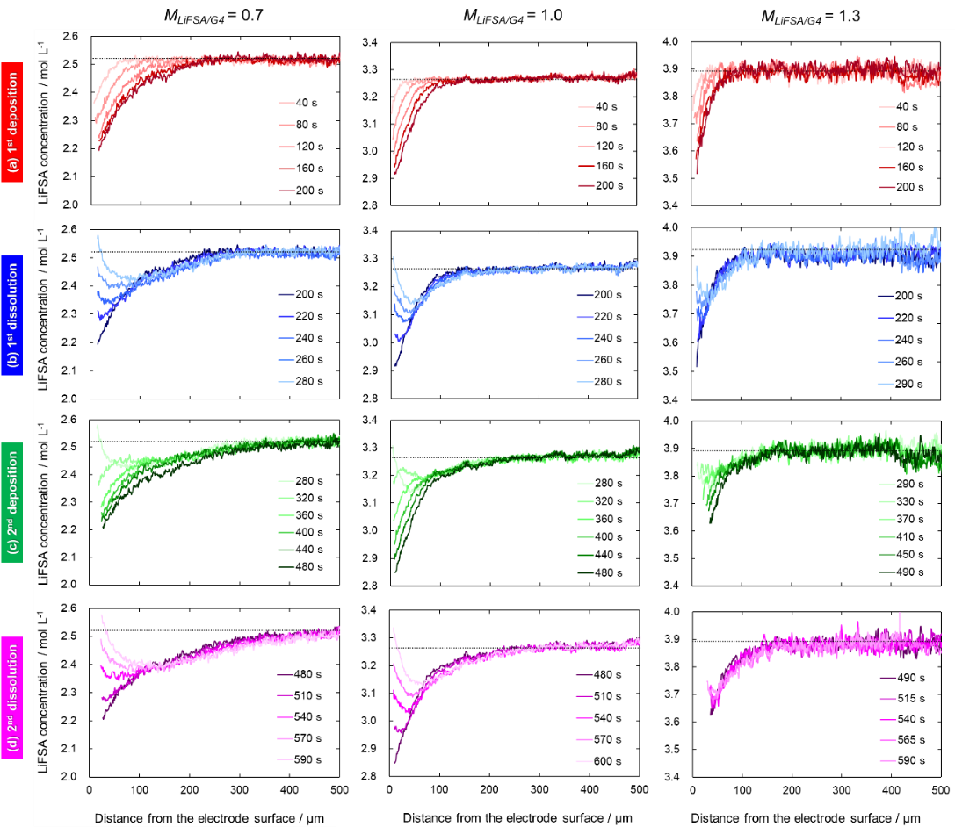
Fig. 4 Concentration profiles near the electrodes during (a) the first deposition process, (b) the first dissolution process, (c) the second deposition process, and (d) the second dissolution process

Temporal changes in the concentrations near the electrodes during the Li deposition–dissolution cycles, determined by interferometry (Movies S2(a)-(c)), are shown in Fig. 4(a)–4(d). During the first deposition process, Li⁺ was consumed at the electrode surface and C_{s} decreased. Li⁺ diffused from the bulk solution toward the electrode surface because of the concentration gradient. When the direction of the applied current was reversed, the Li deposits started to be dissolved and C_{s} increased. A concave concentration profile was found near the electrode. When the current direction was reversed again, Li electrodeposition occurred and C_{s} again decreased, resulting in a positive concentration gradient. During the second dissolution process, a concave concentration profile formed again. These changes in the concentration gradient were consistent with the results of a previous study.¹¹
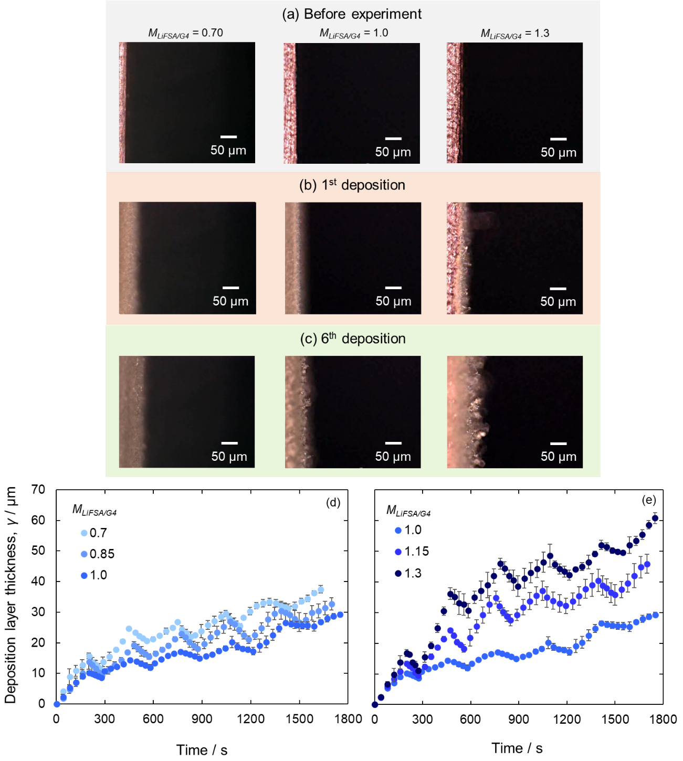
Fig. 5 Digital microscopy images acquired near the electrodes (a) before the experiment and after the (b) first and (c) sixth deposition processes. Temporal changes in the deposition layer thickness at M_{LiFSA/G4} = (d) 0.7–1.0 and (e) 1.0–1.3 during the Li deposition–dissolution cycles.

Some DM images acquired near the electrodes (a) before the experiment and after the (b) first and (c) sixth deposition processes are shown in Fig. 5(a)–5(c). The DM images confirmed that the diameters of the deposits increased as M_{LiFSA/G4} increased. The deposition layer thickness, γ, increased as the number of cycles increased.
Plots of γ against time for the experiments at different M_{LiFSA/G4}s are shown in Fig. 5(d)–5(e). At all M_{LiFSA/G4}s, γ increased as the number of cycles increased. The increase in γ during deposition was not completely lost during dissolution, suggesting that inactive Li formed during the dissolution process. The lowest γ values throughout the cycles were found at M_{LiFSA/G4} = 1.0. At M_{LiFSA/G4} ≤ 1, γ increased as M_{LiFSA/G4} decreased. At M_{LiFSA/G4} ≥ 1, γ increased as M_{LiFSA/G4} increased. The trends in γ found during the first electrodeposition process recurred in the second cycle.
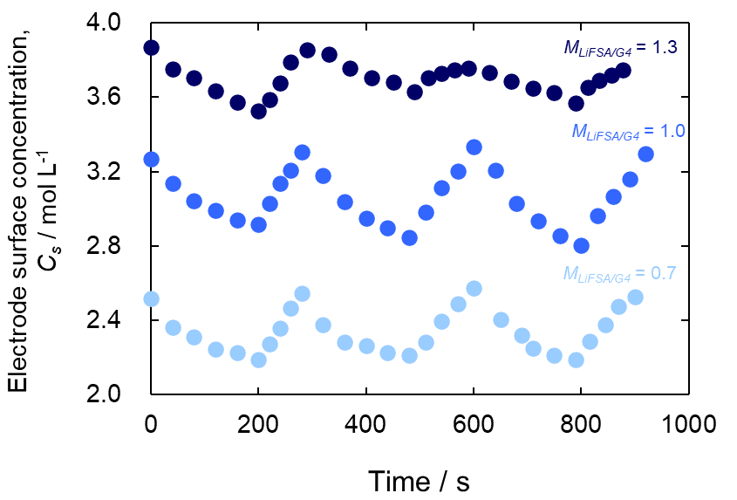
Fig. 6 Changes in the electrode surface concentrations during the deposition–dissolution reaction cycles.

Temporal variations in C_{s} for the first–third deposition–dissolution cycles are shown in Fig. 6. In the first cycle, the maximum changes in C_{s} (ΔC_{s}) at M_{LiFSA/G4} = 0.7, 1.0, and 1.3 were 0.33, 0.35, and 0.34 mol L⁻¹, respectively. Generally, in a binary salt–solvent electrolyte, the lower the diffusion coefficient of the salt, the higher the ΔC_{s} during electrolysis. However, the higher the cation transference number for the electrolyte, the smaller was ΔC_{s}. We previously found LiFSA diffusion coefficients of 1.6×10⁻⁷, 1.2×10⁻⁷, and 1.1×10⁻⁷ cm² s⁻¹ and Li⁺ transference numbers of 0.39, 0.53, and 0.72 for the LiFSA–G4 electrolyte at M_{LiFSA/G4} = 0.7, 1.0, and 1.3, respectively.¹¹ ΔC_{s} was very similar for M_{LiFSA/G4} = 0.7, 1.0, and 1.3, possibly because of the trade-off between the diffusion coefficient and transference number.
In the first–third cycles, the C_{s} ranges at M_{LiFSA/G4} = 0.7, 1.0, and 1.3 did not overlap. ΔC_{s} remained almost constant during each cycle at each M_{LiFSA/G4}. This was consistent with the morphologies of the deposits remaining unchanged between the first and sixth deposition processes. The DM and SEM images confirmed that the morphologies of the deposits at M_{LiFSA/G4} = 0.7, 1.0, and 1.3 were different. The dependence of the deposit morphology on the concentration was attributed to the electrode surfaces being exposed to different C_{s}s at different M_{LiFSA/G4}s.
As M_{LiFSA/G4} increased, C_{s} also increased, supplying more Li⁺ to the deposits surface. This led to the formation of deposits with larger diameters. As the deposition reaction progressed, C_{s} decreased, resulting in a reduced supply of Li⁺ to the surface. Consequently, the diameter of the deposits near the surface became smaller.
In the early stages of deposition, Li first deposited onto the substrate surface. As the deposition reaction progressed, a layer of deposits accumulated. Over time, C_{s} decreases, causing the diameter of the deposits to decrease as they approach the surface layer. When C_{s} was high, a greater amount of Li⁺ was supplied to the tip of the deposits, leading to the formation of larger deposits near the substrate. In particular, when M_{LiFSA/G4} was 1.3, larger deposits formed near the substrate. In contrast, near the electrolyte surface, C_{s} was lower than in the early stages of deposition. As a result, the supply of Li⁺ decreased, leading to smaller deposit diameters.
We previously found that the viscosity of the binary LiFSA–G4 electrolyte increased exponentially as M_{LiFSA/G4} increased above 1.0, being 81, 127, and 376 mPa s at M_{LiFSA/G4} = 0.7, 1.0, and 1.3, respectively.¹¹ The lower the electrolyte viscosity the more the deposits could swing during the growth process. Deposit swinging was also found in a previous study²³ and was indicated by our DM movies.
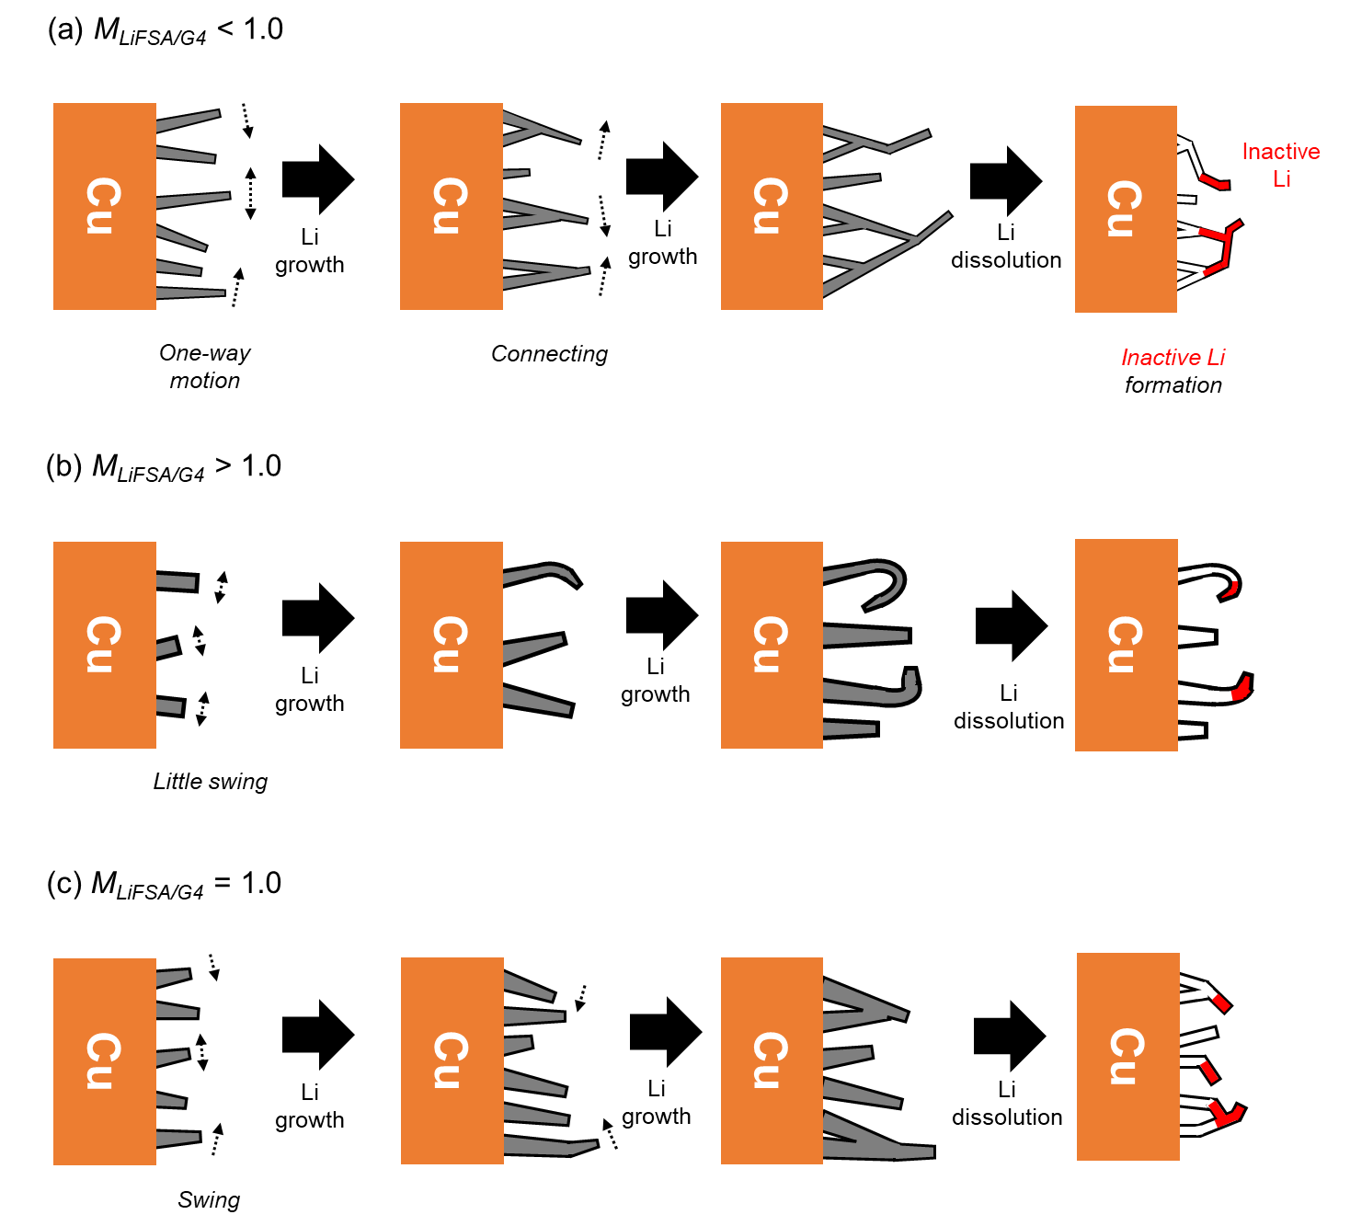
Fig. 7 Li deposition–dissolution mechanisms at (a) M_{LiFSA/G4} < 1.0, (b) M_{LiFSA/G4} > 1.0, and (c) M_{LiFSA/G4} = 1.0.

Different Li deposition–dissolution behaviors were found for M_{LiFSA/G4} ≤ 1.0 and M_{LiFSA/G4} ≥ 1.0. Here, we discuss the mechanisms at M_{LiFSA/G4} < 1.0, M_{LiFSA/G4} > 1.0, and M_{LiFSA/G4} = 1.0.

I. Li Deposition–Dissolution Mechanism at M_{LiFSA/G4} < 1.0 (Fig. 7(a))
For M_{LiFSA/G4} < 1.0, Li deposits are smaller than for M_{LiFSA/G4} > 1.0. ²⁴ These deposits are able to grow in a more dynamic manner due to the low electrolyte viscosity, leading to more pronounced, one-way motion as they grow. The dynamic growth results in neighboring deposits connecting with each other, which causes a reticulated and porous deposition layer.
During dissolution, the movement of these interconnected deposits becomes less controlled. As the Li dissolves, the deposits lose contact with the electrode, and their swinging motion results in the disconnection of the tips from the electrode. This leads to the formation of inactive Li, as these disconnected portions are no longer electrochemically accessible. ²⁵ The high porosity and loss of electrical contact contribute to the increased formation of inactive Li, explaining why the CE is lower at M_{LiFSA/G4} < 1.0 compared to higher concentrations.

II. Li Deposition–Dissolution Mechanism at M_{LiFSA/G4} > 1.0 (Fig. 7(b))
At M_{LiFSA/G4} > 1.0, the higher electrolyte viscosity limits the motion of the Li deposits. As a result, fewer but larger deposits are formed during the deposition process. These deposits grow in a more rigid and constrained manner, making it less likely for neighboring deposits to interact with each other. Instead of connecting, the deposits tend to grow outward from the electrode surface toward the bulk solution.
The limited swinging motion during deposition also affects the dissolution process. The rigid and thick deposits bend slightly during dissolution, but they remain mostly intact, with only small portions of the deposits becoming inactive. However, due to the limited flexibility and larger size of the deposits, inactive Li still forms at the tips and stems of the deposits. The increased viscosity also reduces the mobility of ions, which can lead to electrolyte decomposition, ^{17,26} further lowering the CE at M_{LiFSA/G4} > 1.0.

III. Li Deposition–Dissolution Mechanism at M_{LiFSA/G4} = 1.0 (Fig. 7(c))
At M_{LiFSA/G4} = 1.0, the viscosity of the electrolyte is moderate, allowing Li deposits to exhibit a controlled swinging behavior. The deposits swing but in a way that maintains connection with neighboring deposits, leading to a dense and compact deposition layer. The swinging motion allows for uniform growth and prevents excessive accumulation of inactive Li during the dissolution process. As a result, the deposition layer exhibits the minimum thickness. The balance between electrolyte viscosity and the mobility of the Li deposits leads to the most efficient deposition and dissolution, resulting in the smallest overall layer thickness.

Conclusions
The concentration dependence of the morphologies of Li deposits formed during Li deposition–dissolution reactions at 3 mA cm⁻² were investigated by DM and laser interferometry. Transient changes in concentration at the electrode surface and in the electrolyte changed the thickness of the deposition layer and the diameter of the deposits. The Li deposit diameters increased as the electrolyte concentration increased. The dependence of the deposit morphology on the electrolyte concentration was confirmed by the deposit diameters at depth and at the surface of the deposition layer. The Li deposition–dissolution mechanism changed at M_{LiFSA/G4} = 1.0. Increases in the deposition layer thickness were most strongly suppressed at M_{LiFSA/G4} = 1.0. The morphologies of the deposits and the deposition layer thicknesses led us to conclude that an equimolar LiFSA–G4 mixture is an appropriate electrolyte for AFBs. Further suppression of increases in the deposition layer thickness will be essential for further development of AFBs.

Acknowledgments
This work was partly supported by a Japan Science and Technology Agency COI-NEXT grant (grant number JPMJPF2016) and JSPS KAKENHI grants (grant numbers JP20H00399 and 23KJ0054). SEM was performed at the NIMS Battery Research Platform.

References
1. X. Shen, H. Liu, X.-B. Cheng, C. Yan, and J.-Q. Huang, Energy Storage Materials, 12, 161–175 (2018).
2. P. K. Nayak, L. Yang, W. Brehm, and P. Adelhelm, Angew Chem Int Ed, 57, 102–120 (2018).
3. F. Lionetto et al., Journal of Energy Storage, 84, 110849 (2024).
4. Y. Yamada et al., J. Am. Chem. Soc., 136, 5039–5046 (2014).
5. Y. Yamada and A. Yamada, Journal of The Electrochemical Society, 162, A2406 (2015).
6. S. Ko, Y. Yamada, and A. Yamada, Joule, 5, 998–1009 (2021).
7. T. Mandai, K. Yoshida, K. Ueno, K. Dokko, and M. Watanabe, Physical chemistry chemical physics, 16, 8761–8772 (2014).
8. S. Nanda, A. Gupta, and A. Manthiram, Advanced Energy Materials, 11, 2000804 (2021).
9. C.-J. Huang et al., ACS Nano, 17, 13241–13255 (2023).
10. A. Miki et al., Journal of Materials Chemistry A, 9, 14700–14709 (2021).
11. G. Kamesui, K. Nishikawa, M. Ueda, and H. Matsushima, J. Electrochem. Soc., 171, 040519 (2024).
12. P. Bai, J. Li, F. R. Brushett, and M. Z. Bazant, Energy & Environmental Science, 9, 3221–3229 (2016).
13. C. Gabrielli et al., Electrochemistry communications, 7, 962–968 (2005).
14. A. A. Wang et al., ACS Energy Lett., 6, 3086–3095 (2021).
15. F. R. McLarnon, R. H. Muller, and C. W. Tobias, JOSA, 65, 1011–1018 (1975).
16. I. Arise, Y. Fukunaka, F. R. McLarnon, and T. Abe, Journal of The Electrochemical Society, 168, 080509 (2021).
17. G. Kamesui, K. Nishikawa, M. Ueda, and H. Matsushima, ACS Energy Lett., 7, 4089–4097 (2022).
18. G. Kamesui, K. Nishikawa, H. Matsushima, and M. Ueda, Journal of The Electrochemical Society, 168, 031507 (2021).
19. G. Kamesui, K. Nishikawa, M. Ueda, and H. Matsushima, Electrochemistry Communications, 151, 107506 (2023).
20. F. R. McLarnon, R. H. Muller, and C. W. Tobias, Electrochimica Acta, 21, 101–105 (1976).
21. R. N. O’Brien and K. S. V. Santhanam, J Appl Electrochem, 20, 427–437 (1990).
22. K. Wang, Y. Chen, X. Dou, and Y. Han, Advanced Powder Technology, 32, 1766–1773 (2021).
23. T. Nishida, K. Nishikawa, M. Rosso, and Y. Fukunaka, Electrochimica acta, 100, 333–341 (2013).
24. Y. Chen et al., Nat Commun, 14, 2655 (2023).
25. J. Steiger, D. Kramer, and R. Mönig, Electrochimica Acta, 136, 529–536 (2014).
26. M. Metzger et al., Journal of The Electrochemical Society, 167, 160522 (2020).

