Supplemental Material for
Unconventional Spin Hall Magnetoresistance in Non-Collinear Antiferromagnet/Heavy Metal Stacks

Tomohiro Uchimura, Jiahao Han*, Ping Tang*, Ju-Young Yoon, Yutaro Takeuchi, Yuta Yamane, Shun Kanai, Gerrit E. W. Bauer, Hideo Ohno, and Shunsuke Fukami*

*jiahao.han.c8@tohoku.ac.jp; tang.ping.a2@tohoku.ac.jp; s-fukami@riec.tohoku.ac.jp

Section 1. Additional characterizations
In the (0001)-oriented Mn₃Sn (15 nm)/Pt sample, additional phases such as the MnPt alloy is not observed from the X-ray diffraction (XRD) measurement [Fig. S1(a)]. We also measure the magnetic hysteresis loops of this sample after zero-field cooling (ZFC) and field cooling (FC) processes [Fig. S1(b)]. The sample is cooled from 400 to 300 K. An in-plane magnetic field of 7 T is applied during FC. The loops exhibit a coercivity <30 mT and a weak net magnetization of 18 mT that is fully switched at the alignment field of 0.5 T, in agreement with previous studies on Mn₃Sn thin films with the same orientation [1]. Thus, the applied magnetic field of several teslas during the MR measurements is strong enough to fully rotate the chiral-spin structure in the kagome plane. Similar loops of ZFC and FC confirm that the exchange bias is negligibly small and absence of secondary ferromagnetic phases at the Mn₃Sn/Pt interface. Moreover, the angle-dependent MR of W/Ta/$(1\overline{1}00)$-oriented Mn₃Sn, which is without the tendency to form ferromagnetic alloys [2], is consistent with that of the Pt-capped sample [Figs. 2(b) and 2(f)]. This further confirms that our Mn₃Sn/heavy metal samples are a clean platform to study the SMR of non-collinear antiferromagnets. The thickness of Mn₃Sn ensures the desired magnetic properties including the existence of the non-collinear antiferromagnetic phase and the moderate values of coercivity and alignment field that allow the MR measurements by standard experimental setups.
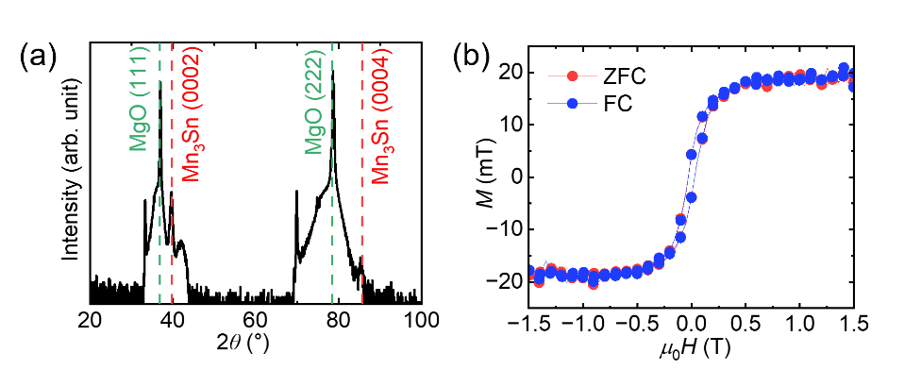
Fig. S1. (a). Out-of-plane XRD of Ru (5 nm)/Mn₃Sn (15 nm)/Pt (5 nm) on a MgO (111) substrate. (b) In-plane magnetic hysteresis loops of Ru (5 nm)/Mn₃Sn (15 nm)/Pt (5 nm) after ZFC (red) and FC (blue) protocols. In (b), the linear component (containing the paramagnetic signal from the metallic layers and the applied field-induced additional canting of the chiral-spin structure in Mn₃Sn) and the contribution from the MgO substrate have been subtracted.

Section 2. Mn₃Sn thickness dependence of the MR
We measure the Mn₃Sn thickness $t_{Mn3Sn}$ dependence of the SMR in the yz scan of W/Ta/$(1\overline{1}00)$-oriented Mn₃Sn. We choose this configuration because the measured MR is not contaminated by the chiral anomaly arising from the Weyl semimetal state in the xy scan of $(0001)$-oriented Mn₃Sn/Pt. The coercivity obtained from anomalous Hall effect measurements varies from 0.2 to 0.4 T with increasing $t_{Mn3Sn}$ [Fig. S2(a)].
The SMR in Fig. S2(b) decreases by ~50% when increasing $t_{Mn3Sn}$ from 15 to 25 nm. This reduced magnitude can be understood by considering the shunting of the current in the W/Ta heavy metal layers by the conducting Mn₃Sn layer [2], which in a parallel resistance model amounts to a reduction by ~60% in the 25 nm sample compared to the 15 nm sample. The reduced SMR at larger $t_{Mn3Sn}$ in Fig. S2(b) is consistent with the short-circuit mechanism since the sample-dependent variations of the interfacial magnetic structures and the approximations in the SMR model for conducting magnets [4] may account for remaining small differences.
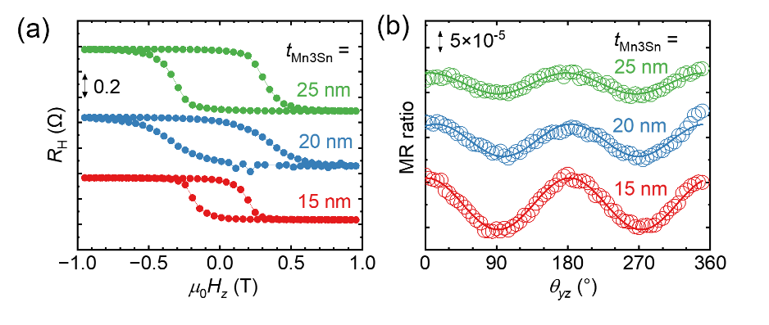
Fig. S2. Mn₃Sn thickness dependence of (a) anomalous Hall effect and (b) angle-dependent MR in W/Ta/$(1\overline{1}00)$-oriented Mn₃Sn samples. The lines in (b) are fits to $-\sin^{2}θ_{yz}$. The magnetic field in (b) is kept at 7 T.

Section 3. Angle-dependent MR in all rotational planes for the (0001) and $(1\overline{1}00)$-oriented Mn₃Sn/heavy metal samples
$(0001$)-oriented Mn₃Sn/Pt (Fig. S3)
xy scan: We explained in the main text and show again here in Fig. S3(b) that the magnetic field is sufficiently strong to fully rotate the net magnetization in the kagome plane; the SMR reaches its maximum (minimum) when the field is parallel (perpendicular) to the current direction. yz scan: The resistance decreases when the magnetic field rotates from z to y [Fig. S3(c)], because the field increases the y-component of the net magnetization that controls the SMR. Due to the (0001) easy-plane anisotropy of Mn₃Sn, a magnetic field along z induces a weaker net magnetization than the field in the (0001) xy plane [3]. Consequently, the yz scan exhibits a weaker SMR than the xy scan. zx scan: When the magnetic field fully aligns the net magnetization (as in FMs), the magnet should absorb the injected spins from the heavy metal equally for fields along z and x. However, Fig. S3(d) shows that the field along z reduces the resistance. This result is consistent with the SMR model once we consider the easy-plane anisotropy that, for a constant applied field strength, renders the magnetization along z weaker compared to that along x.
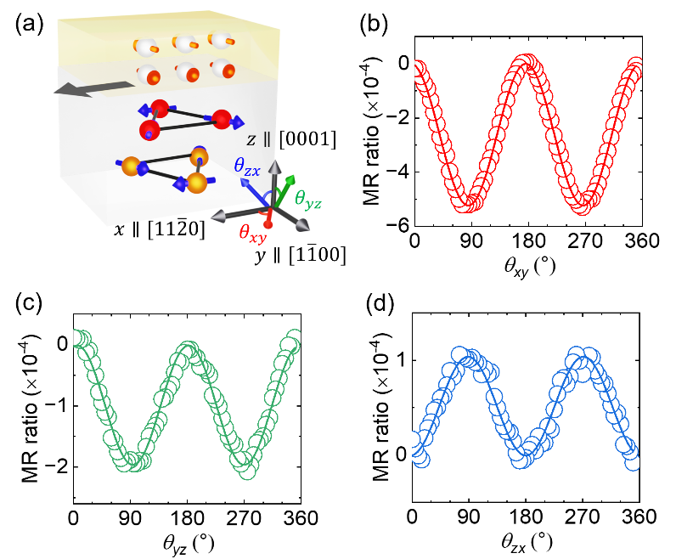
Fig. S3. Angle-dependent MR in the (0001)-oriented Mn₃Sn/Pt sample. (a) Schematic of the measurement setup. (b–d) Angle-dependent MR in xy, yz and zx planes, where the lines are fits to $-\sin^{2}θ_{xy}$, $-\sin^{2}θ_{yz}$ and $\sin^{2}θ_{zx}$, respectively. The magnetic field is kept at 9 T. We note that the MR in Fig. S3(b) is slightly larger than the sum of those in Fig. S3(c) and S3(d), which is likely caused by an imperfect alignment of the sample during the three rounds of measurements.

W/Ta/$(1\overline{1}00)$-oriented Mn₃Sn (Fig. S4)
xy and yz scans: The MR in Figs. S4(b) and S4(c) agrees with our proposed SMR model when taking into account the additional magnetic easy axis along z that is induced by the interfacial strain for the $(1\overline{1}00)$-oriented Mn₃Sn film with a primary easy plane $(1\overline{1}00)⊥x$ [5]. The MR amplitudes of xy and yz scans are the same, because the net magnetization under a field along x maintains a finite z-component that absorbs the injected spins from the heavy metal, while a field along z leads to the same absorption. The vanishing SMR in the zx scan in Fig. S4(d) can be explained analogously.
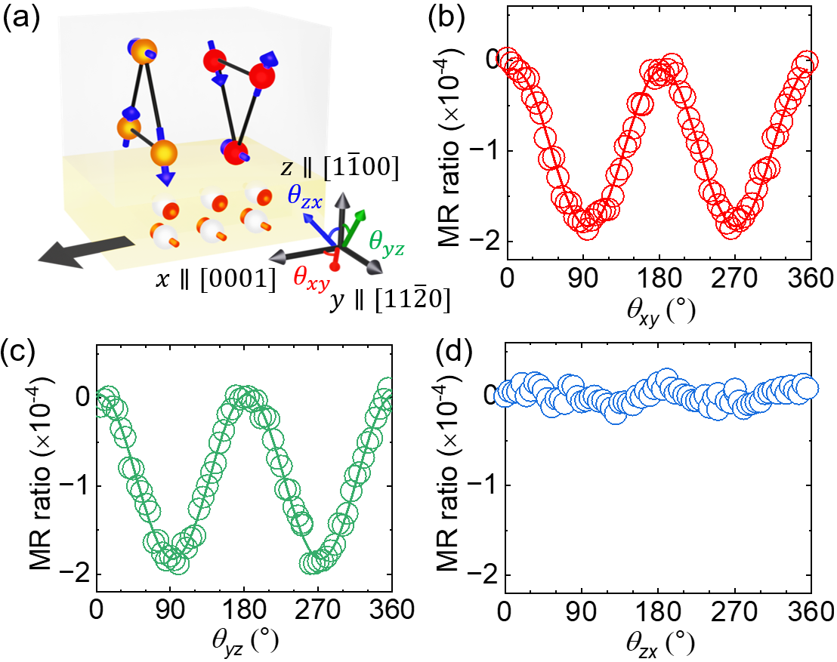
Fig. S4. Angle-dependent MR in the W/Ta/$(1\overline{1}00)$-oriented Mn₃Sn sample. (a) Schematic of the measurement setup. (b–d) angle-dependent MR in xy, yz and zx planes, respectively. The lines in (b) and (c) are fits to $-\sin^{2}θ_{xy,yz}$. The magnetic field is kept at 9 T.

Summarizing, the angle-dependent MR in the yz/zx plane of (0001)-oriented Mn₃Sn/Pt and the xy/zx plane of W/Ta/$(1\overline{1}00)$-oriented Mn₃Sn is consistent with the SMR caused by a field-induced canting of magnetic sublattices out of the kagome plane. These results indicate that the net magnetization plays a critical role in the SMR of Mn₃Sn/heavy metal stacks.

Section 4. Theory of the unconventional SMR in Mn₃Sn/heavy metal
In Mn₃Sn/heavy metal (such as Pt), the spin current generated by the spin Hall effect of Pt establishes a non-uniform spin density s along the thickness (z) direction and experiences a torque $T_{s}$ by the three sublattice moments at the Mn₃Sn/Pt interface (z = 0). The stationary-state spin continuity equation in Pt reads
$$∂_{z}j_{s}= -\frac{s}{τ_{sf}}+T_{s}, (1)$$
where s is expressed by $s=\frac{ℏ}{2}N_{F}μ_{S}$, with $ℏ$ the reduced Planck’s constant, $N_{F}$ the density of states per unit volume at the Fermi level (in the unit of ${(eV)}^{-1}m^{-3}$), and $μ_{s}$ the spin chemical potential. $τ_{sf}$ is the spin relaxation time. The spin current density including both diffusion and drift terms reads
$$j_{s}=\frac{ℏ}{2e}\left(-\frac{1}{eρ_{0}}∂_{z}μ_{s}+\frac{θ_{SH}E\hat{y}}{ρ_{0}}\right), (2)$$
where $e=\left|e\right|$ is the magnitude of electron charge, $ρ_{0}$ and $θ_{SH}$ are the resistivity and the spin Hall angle of Pt, and E is the applied electric field along x.
The interfacial s-d exchange interaction $-\frac{J_{sd}}{ℏ}\sum_{ν}{m_{ν}}∙s$ (the unit of $J_{sd}$ is eVm) between the conduction electrons and the magnetic moments of Mn₃Sn leads to the precession of the electron spin around the collective local exchange fields of the chiral-spin structure. It is described by a field-like torque on the electron spin as
$$T_{s}=\frac{J_{sd}}{ℏ}δ\left(z\right)\sum_{ν}{s×m_{ν}}. (3)$$
where $δ\left(z\right)$ is the delta function to indicate the torque exists near the interface due to the spin dephasing effect of Mn₃Sn. The spin accumulation in the Pt layer with a thickness of d and a spin diffusion length of $λ$ reads
$$μ_{s}\left(z\right)=Ae^{-z/λ}+Be^{z/λ}. (4)$$
The boundary conditions of the spin current density [Eq. (2)] at the lower and higher interfaces are
$$j_{s}\left(0^{+}\right)=\frac{J_{sd}}{ℏ}\sum_{ν}{s\left(0^{+}\right)×m_{ν}}, (5)$$
$$j_{s}\left(d\right)=0. (6)$$
Substituting Eqs. (4) to (6) to Eq. (2) leads to
$$\frac{1}{eλ_{sf}ρ_{0}}\left(Ae^{-\frac{d}{λ}}-Be^{\frac{d}{λ}} \right)+\frac{θ_{SH}E\hat{y}}{ρ_{0}}=0, (7)$$
$$\frac{1}{eλρ_{0}}\left(A-B \right)+\frac{θ_{SH}E\hat{y}}{ρ_{0}}=\frac{e}{ℏ}J_{sd}N_{F}\sum_{ν}{\left(A+B\right)×m_{ν}}, (8)$$
from which we obtain
$$A=-\frac{eλθ_{SH}E\left(1-e^{-d/λ}\right)}{\left(1-e^{-{2d}/λ}\right)}\left(\hat{y}∙\hat{m}\right)\hat{m}+ξeλθ_{SH}E\frac{{\left(1-e^{-d/λ}\right)}^{2}}{{\left(1-e^{-{2d}/λ}\right)}^{2}+ξ^{2}{\left(1+e^{-{2d}/λ}\right)}^{2}}\hat{m}×\hat{y}+eλθ_{SH}E\frac{ξ^{2}\left(1+e^{-{2d}/λ}\right)e^{-d/λ}+\left(1-e^{-{2d}/λ}\right)\left(1-e^{-d/λ}\right)}{{\left(1-e^{-{2d}/λ}\right)}^{2}+ξ^{2}{\left(1+e^{-{2d}/λ}\right)}^{2}} \hat{m}×\left(\hat{m}×\hat{y}\right), (9)$$
$$B=Ae^{-{2d}/λ}+eλ_{sf}θ_{SH}Ee^{-d/λ}\hat{y}, (10)$$
where $\hat{m}$ is the unit vector of $m=m_{A}+m_{B}+m_{C}$, $ξ=\frac{2e^{2}}{ℏ}ρ_{0}λ_{sf}{\tilde{G}}_{i}$ is a unitless parameter, and ${\tilde{G}}_{i}=\frac{1}{2}J_{sd}N_{F}\left|m\right|$ is a “field-like” spin-mixing conductance.
The y-component of the spin accumulation contributes to a feedback longitudinal charge current $δj_{c}$ in the electric field direction (x) through the inverse spin Hall effect,
$$δj_{c}=-\frac{θ_{SH}}{d}\int_{0}^{d}{dz\frac{1}{eρ_{0}}}∂_{z}\left(μ_{s}∙\hat{y}\right), (11)$$
which leads to the longitudinal resistivity including the SMR term as
$$ρ= ρ_{0}-\frac{ρ_{0}λθ_{SH}^{2}}{d}\left[ \frac{ξ^{2}\tanh^{2}{\frac{d}{2λ}coth}\frac{d}{λ}}{1+ξ^{2}\coth^{2}{\frac{d}{λ}}}{\left(\hat{m}∙\hat{y}\right)}^{2}+\frac{ξ^{2}coth\frac{d}{λ}e^{-d/λ}+\left(1-e^{-d/λ}\right)}{1+ξ^{2}\coth^{2}{\frac{d}{λ}}} \tanh{\frac{d}{2λ}}\right]. (12)$$
The last term of Eq. (12) is independent from the orientation of the chiral-spin structure (i.e., direction of $\hat{m}$). By further considering $d≫λ$, Eq. (12) reduces to Eq. (2) of the main text. Eq. (5) can be expressed as
$$j_{s}\left(0^{+}\right)=\frac{ℏ}{2e}θ_{SH}j_{c}\left[\frac{ξ\tanh{\frac{d}{2λ}}}{1+ξ^{2}\coth^{2}{\frac{d}{λ}}}\hat{m}×\hat{y}-\frac{ξ^{2}\coth{\frac{d}{λ}\tanh{\frac{d}{2λ}} }}{1{+ξ}^{2}\coth^{2}{\frac{d}{λ}}}\hat{m}×\left(\hat{m}×\hat{y}\right)\right]. (13)$$
While $j_{s}(0^{+})$ originates from the spin-precession field-like torque between $\left\{m_{ν}\right\}$ and $s\left(0^{+}\right)$, it contains both field-like and damping-like terms with respect to the incident spin polarization $\hat{y}$. This is a natural result of the electron spin precession, which makes $s\left(0^{+}\right)$ deviate from $\hat{y}$.

Section 5. Calculation of the field-dependent MR
In the xy scan of the (0001)-oriented Mn₃Sn/Pt sample, the total MR consists of the SMR and the contribution from the chiral anomaly, both depending on the magnetic field strength. Theoretically, the chiral anomaly gives rise to a reduced resistance when the applied magnetic field is parallel with the current; the MR should depend quadratically on the applied magnetic field [6]. The comparison between Ru/Mn₃Sn/Pt and Ru/Mn₃Sn/MgO [Figs. 2(b) and (c)] indicates that the chiral anomaly contributes –10% to the total MR at 9 T in Ru/Mn₃Sn/Pt when taking into account the current shunting in a parallel resistance model and the measured resistivity, $ρ_{Ru}≈ρ_{Pt}≈0.1ρ_{Mn3Sn}$). From this experimental result, we calculate the chiral anomaly-induced MR as a function of the field strength in Fig. S5. The calculated total MR in the full stack of Ru/Mn₃Sn/Pt is the sum of the SMR (major contribution), which is determined by Eq. (2) of the main text and the calculated orientation of $\left\{m_{ν}\right\}$ in Fig. 3(d), and the chiral anomaly-induced MR.
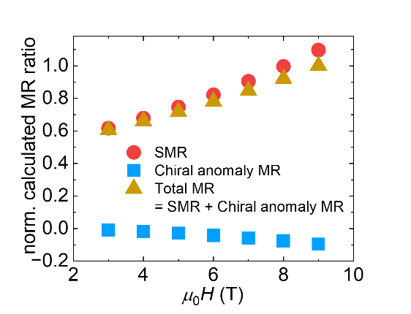
Fig. S5. Calculated SMR (red, plotted with a positive sign), chiral anomaly-induced MR (blue) and their sum (yellow, also plotted in Fig. 4(d)) as a function of the magnetic field in the Ru/Mn₃Sn/Pt full stack. The data are normalized by the total MR at 9 T.

The calculated MR at different magnetic field strengths are compared with the measured ones in Fig. 4(d). The good agreement between experiment and calculation above 3 T supports the validity of our model. The minor difference in the low field region can be attributed to the inevitable magnetic pinning at the device edges, which is suppressed at the high fields used in our MR measurements.

Section 6. Temperature dependence of the MR
We measure the angle-dependent MR at reduced temperatures in the (0001) and $(1\overline{1}00)$-oriented Mn₃Sn/heavy metal samples (Fig. S6). Except for the plot of (0001)-oriented Mn₃Sn/Pt at 100 K, the results do not exhibit obvious distortions from $-\sin^{2}θ_{xy/yz}$, which indicates that the applied magnetic field of 7 T here is sufficient to overcome the magnetic anisotropy effects and fully rotate the chiral-spin structure as assumed in our SMR model.
The decrease of the SMR amplitude is a consequence of the temperature-dependent spin Hall angle, spin diffusion length, interfacial spin-mixing conductance [7] and the reduced magnetization of Mn₃Sn at low temperatures [8]. We note that the main focus of this work is the unconventional SMR in Mn₃Sn that fails to follow the existing SMR picture based on the damping-like torque, which has been primarily elucidated by period of the angle-dependent MR in experiments (Fig. 2) and model calculations (Fig. 3). Quantitative determination of every detailed parameter is beyond the scope of this work.
The opposite sign observed in the (0001)-oriented Mn₃Sn/Pt at 100 K can be correlated to the magnetic phase transition of Mn₃Sn from the chiral-spin structure to another with distinct spin alignments [8]. The transition depends on the substrate-induced strain that varies by different crystal orientations [9,10]. On one hand, the suppressed SMR at low temperatures facilitates observation of the chiral anomaly [11]. On the other hand, if the MR at 100 K is attributed to the SMR, it changes to that expected for a conventional antiferromagnet. To our knowledge, the spin alignment in the low-temperature phase is still unclear, preventing us to interpret the result below 100 K. As the community is pursuing for a comprehensive understanding of the magnetic phase transition in Mn₃Sn, we should be able to understand the observed change in the future.
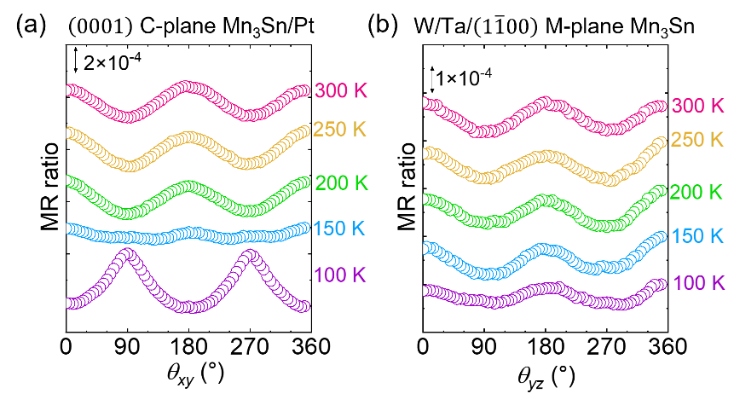
Fig. S6. Temperature dependence of the angle-dependent MR in (a) xy scan of (0001)-oriented Mn₃Sn/Pt and (b) yz scan of W/Ta/$(1\overline{1}00)$-oriented Mn₃Sn. The magnetic field is kept at 7 T.

References
- B. K. Hazra, B. Pal, J.-C. Jeon, R. R. Neumann, B. Göbel, B. Grover, H. Deniz, A. Styervoyedov, H. Meyerheim, I. Mertig, S.-H. Yang, and S. S. P. Parkin, Generation of out-of-plane polarized spin current by spin swapping, Nat. Commun. 14, 4549 (2023).
- J. Yoon, Y. Takeuchi, R. Itoh, S. Kanai, S. Fukami, and H. Ohno, Crystal orientation and anomalous Hall effect of sputter-deposited non-collinear antiferromagnetic Mn₃Sn thin films, Appl. Phys. Express 13, 013001 (2020).
- S. Nakatsuji, N. Kiyohara, and T. Higo, Large anomalous Hall effect in a non-collinear antiferromagnet at room temperature, Nature 527, 212 (2015).
- J. Kim, P. Sheng, S. Takahashi, S. Mitani, and M. Hayashi, Spin Hall magnetoresistance in metallic bilayers, Phys. Rev. Lett. 116, 097201 (2016).
- J.-Y. Yoon, P. Zhang, C.-T. Chou, Y. Takeuchi, T. Uchimura, J. T. Hou, J. Han, S. Kanai, H. Ohno, S. Fukami, and L. Liu, Handedness anomaly in a non-collinear antiferromagnet under spin–orbit torque, Nat. Mater. 22, 1106 (2023).
- D. T. Son, and B. Z. Spivak, Chiral anomaly and classical negative magnetoresistance of Weyl metals, Phys. Rev. B 88, 104412 (2013).
- S. Meyer, M. Althammer, S. Geprägs, M. Opel, R. Gross, and S. T. B. Goennenwein, Temperature dependent spin transport properties of platinum inferred from spin Hall magnetoresistance measurements, Appl. Phys. Lett. 104, 242411 (2014).
- T. Higo, D. Qu, Y. Li, C. L. Chien, Y. Otani, and S. Nakatsuji, Anomalous Hall effect in thin films of the Weyl antiferromagnet Mn₃Sn, Appl. Phys. Lett. 113, 202402 (2018).
- J. M. Taylor, A. Markou, E. Lesne, P. K. Sivakumar, C. Luo, F. Radu, P. Werner, C. Felser, and S. S. P. Parkin, Anomalous and topological Hall effects in epitaxial thin films of the noncollinear antiferromagnet Mn₃Sn, Phys. Rev. B 101, 094404 (2020).
- J.-Y. Yoon, Y. Takeuchi, S. DuttaGupta, Y. Yamane, S. Kanai, J. Ieda, H. Ohno, and S. Fukami, Correlation of anomalous Hall effect with structural parameters and magnetic ordering in Mn_{3+x}Sn_{1−x} thin films, AIP adv. 11, 065318 (2021).
- K. Kuroda, T. Tomita, M.-T. Suzuki, C. Bareille, A. A. Nugroho, P. Goswami, M. Ochi, M. Ikhlas, M. Nakayama, S. Akebi, R. Noguchi, R. Ishii, N. Inami, K. Ono, H. Kumigashira, A. Varykhalov, T. Muro, T. Koretsune, R. Arita, S. Shin, T. Kondo, and S. Nakatsuji, Evidence for magnetic Weyl fermions in a correlated metal, Nat. Mater. 16, 1090 (2017).

