Theoretical Study of Lattice Dynamics Effect on Damping Constant of FePt at Finite Temperature
Ivan Kurniawan^{a,b}, Yoshio Miura^{a,c,}, Guangzong Xingª, Terumasa Tadanoª, Kazuhiro Hono^{a,b}
ª Research Center for Magnetic and Spintronics Materials, National Institute for Materials Science (NIMS), 1-2-1 Sengen, Tsukuba 305-0047, Japan
^{b} Graduate School of Science and Technology, University of Tsukuba, Tsukuba 305-8577, Japan
^{c} Center for Spintronics Research Network (CSRN), Graduate School of Engineering Science, Osaka University, Machikaneyama 1-3, Toyonaka, Osaka 560-8531, Japan
ABSTRACT
Understanding magnetic damping behavior at finite temperatures is crucial for magnetization reversal, especially in heat-assisted magnetic recording media (HAMR). In this work, we calculated the intrinsic magnetic damping of L1₀-FePt, which is the prospective HAMR media, based on the Kambersky torque correlation model and the modified frozen thermal lattice disorder approach. Using the temperature-dependent scattering rate, the magnetic damping showed nonmonotonic behavior and slightly increased with increasing temperature, indicating that the lattice vibration enhances the inter-band transition around the Fermi level. Comparison of our results with the previous theoretical and experimental works clarified that because the intrinsic damping of L1₀-FePt was always enhanced at the high temperature, the reduction of the damping around Curie temperature in the recent experiment emphasizes the importance of extrinsic contributions of damping for HAMR application.

- Introduction
Magnetic damping constant α, which represents the energy and spin angular momentum dissipation rate of a local spin moment in magnetic systems, is a crucial parameter for magnetic storage and spintronics applications [1]. The critical current density of the spin-transfer torque (STT) switching in magnetic random-access memories (MRAM) is proportional to α. Thus, low-damping material is required to enable magnetization switching with low energy consumption [2]. Furthermore, the voltage-controlled magnetic anisotropy (VCMA) switching also requires low magnetic damping for the reduction of write error rate during magnetization reversal [3]. Contrary to this, in magnetic recording technology such as heat-assisted magnetic recording (HAMR), high magnetic damping is preferred to improve the signal-to-noise ratio [4] and obtain a faster writing time [5], not only at ambient temperature but also at elevated temperatures characteristic to the writing process [6].
L1₀-FePt nano-granular medium [7,8] was developed in response to the increasing demand for high areal density storage in the next generation of HAMR. It has large magnetocrystalline anisotropy (7 $×$ 10⁷ erg/cc) [9], which allows us to shrink and thermally stabilize the grains. Relatively low Curie temperature (750 K) [10] and large damping (α > 0.05) [11–14] are also beneficial for the easier writing process by heating the medium almost up to T_{C}. Therefore, understanding the temperature dependence of magnetic damping is essential to improve the switching properties of HAMR media. Unfortunately, the damping behavior of L1₀-FePt at finite temperature is still unclear, both from experimental and theoretical points of view. The present paper hopefully clarifies this question in part.
Reported values of experimentally-measured magnetization damping coefficient vary significantly from one publication to another, even for the same material studied at room temperature. Mizukami et al. reported the lowest effective Gilbert damping constant of 0.055 in the L1₀-FePt epitaxial thin films [11], while Becker et al. obtained α = 0.1 for the granular structure [12] and much larger values were also reported by Lee et al. (0.2) [13] and Kim et al. (0.26) [14]. Note that aside from the intrinsic damping contribution, measured damping also includes the equipment-dependent extrinsic damping component, which complicates the physical interpretation of the results [15].
On the other hand, the first-principles approach offers the intrinsic damping constant originating from the spin-orbit interaction (SOI) in magnetic systems [16–23]. Formulation of the intrinsic damping constant was proposed by Kambersky [16] based on the torque correlation model within the linear response theory, where damping torque acting in the opposite direction to the STT comes from the magnetic friction between local moments and conduction electrons due to the SOI. By using the torque correlation model, Gilmore et al. evaluated the damping constant for simple transition metals such as Fe, Co, and Ni and its dependence on the phenomenological parameter for the scattering rate δ [24]. Even with the semi-empirical approach, their results agree well with the temperature dependence of experimental magnetic damping [25], demonstrating the indirect relation between the scattering rate parameter and temperature.
However, at high temperatures, spin fluctuation and atomic vibration effects become inevitably important in magnetic systems [26]. Therefore, including these effects will deepen our understanding of the behavior of intrinsic damping at finite temperatures. Recently, unpredicted reduction of near-T_{C} damping of FePt with temperature extracted from ferromagnetic resonance (FMR) linewidth measurement is reported by Richardson et al [27]. This significant reduction may be disadvantageous for HAMR applications, especially leading to slower switching time and a smaller signal-to-noise ratio [6]. Recent theoretical works only consider spin fluctuation as the finite temperature effect on the damping of FePt [28,29]. In order to calculate the damping, Hiramatsu et al. treated the spin fluctuation in the framework of the disordered local moment and included the small finite value of the impurity scattering rate δ based on residual resistance representing temperature-independent scattering rate [29]. It is found that the low-temperature damping value is significantly affected by these parameters, although its temperature dependence still qualitatively resembles the scattering rate dependence of magnetic damping of Fe at the ground state reported by Gilmore et al. [24]. These nonmonotonic behavior predicted by the torque correlation model can be explained by the fact that the scattering rate is somewhat enhanced by spin fluctuation at finite temperatures.
Contrary to this, the lattice dynamics effect via atomic vibrations on the FePt damping constant remains unclear. Previously, Liu et al. introduced the so-called “frozen thermal lattice disorder” to incorporate atomic vibration into the damping calculation in the framework of the scattering theory [30]. Since experimental FMR and phonon frequency are much smaller than the frequency corresponding to typical electronic Fermi velocity, the motion timescale can be separated, and the electrons responsible for transport properties moved around the frozen phonons. The frozen phonon is expressed by shifting atomic position randomly and rigidly from the equilibrium coordinate following the Gaussian distribution of a particular value of the root-mean-square displacement, which is indirectly related to temperature. They found that the nonmonotonic behavior of damping in Fe, Co, and Ni can be reproduced by this simple model. However, they did not explicitly determine the atomic displacements at a given temperature, even though it could be done using phonon dispersion information. Hence, in this study, we investigated the lattice dynamics effect on the damping constant of FePt at finite temperatures with the Kambersky torque correlation model and an improved frozen thermal lattice disorder approach.
- The computational procedure
We performed first-principles density-functional calculations using the Vienna ab initio simulation package (VASP) [31] to obtain electronic structures and phonon dispersions of L1₀-FePt together with the projection onto local atomic orbitals. The projector augmented-wave (PAW) potential was used to describe the behavior of core electrons [32]. Generalized gradient approximation (GGA) proposed by Perdew, Burke, and Ernzerhof was adopted for the exchange and correlation energies [33]. The 2 $×$ 2 $×$ 2 supercell containing 8 Fe and 8 Pt atoms was constructed using the tetragonal unit cell with a = 5.4563 Å and c = 7.5579 Å for phonon and damping calculations. We used the plane-wave cutoff energy of 335 eV for the wavefunction expansion and 10 $×$ 10 $×$ 10 k-points mesh for wavevector integration in the first Brillouin zone. Note that the relatively sparse k-points mesh for damping calculations was used since the purpose of this study is to offer an insight into the temperature dependence of damping due to the atomic vibrations. We confirm that the qualitative feature of the scattering rate dependence of the damping constant has been converged by the present k-point density (See FIG. S1 in Supplementary Material S1 [34]).
Magnetic damping constant based on the torque correlation model can be described by the correlation function of the spin torque operator $η^{-}$,
 | $η^{-}=\left[S^{-},H_{0}\right]-ΩS^{-}$. | (1)
Here, $S^{-}$ is the spin operator, $Ω$ is the frequency of uniform precession motions of local spin moments, and $H_{0}$ is the Hamiltonian, which includes the usual spin-independent term, the ferromagnetic exchange potential, the SOI, and the potential deformation terms induced by finite temperature effects such as lattice vibrations. The picture of the torque correlation model is closely related to the Brownian motion of particles in water, where the random collision of water molecules with particles leads to friction that affects the random motion of the particles. Analog to this model, local spin moments and conductive electrons in magnetic systems correspond to the particles and water molecules in Brownian motion, respectively. Thus, the generalized Langevin equation can be used to describe the spin dynamics:
 | $$\frac{dS^{-}\left(t\right)}{dt}=-iΩS^{-}\left(t\right)-iη^{-}\left(t\right)-\frac{1}{μ_{s}}\int_{0}^{t}{{〈\left[η^{-}\left(t^{'}\right),η^{+}\right]〉}_{0}S^{-}\left(t-t^{'}\right)dt^{'},}$$ | (2)
where the precession motion of local spin moments is described by the first term $(-iΩS^{-})$, random spin-orbit torque from conductive electrons due to SOI by the second term ($iη^{-}$), and damping motion by the last term. $μ_{s}$ is the spin magnetic moment, and ${〈⋯〉}_{0}$ indicates the thermal average for $H_{0}$. After implementing Laplace transform to solve this equation, we obtain the microscopic magnetic susceptibility as:
 | $$χ^{+}\left(ω\right)=\frac{μ_{0}{(gμ_{B})}^{2}}{ℏV}\frac{-μ_{s}}{ω+i0-Ω+∆-{μ_{s}}^{-1}F(ω+i0)},$$ | (3)
where $∆$, V and $g$ are the exchange splitting, unit-cell volume, and $g$-factor of the present system, respectively. $F(ω+i0)$ is the Green’s function of the torque operator and represents the damping constant in its imaginary form
 | $$F\left(ω+i0\right)=-i\int_{-∞}^{∞}{{〈\left[η^{-}\left(t^{'}\right),η^{+}\right]〉}_{0}θ\left(t\right)e^{i\left(ω+i0\right)t}dt}.$$ | (4)
If we consider that the low-frequency limit of $Ω$, and the coupling between the spin moment and the potential deformation due to lattice vibrations are negligible as the first-order approximation, the torque operator in Eq. (1) is equivalent to the spin-orbit torque given by,
 | $$η^{-}=η_{0}^{-}=\left[S^{-},H_{SO}\right],$$ | (5)
where $H_{SO}=\sum_{I}{ξ_{I}L∙S}$ is the spin-orbit Hamiltonian with $ξ_{I}$ being the spin-orbit constant at the site I. $L=\left(L_{x},L_{y},L_{z}\right)$ and $S=\left(S_{x},S_{y},S_{z}\right)$ are the orbital and spin angular momentum operators, respectively.
The macroscopic approach for computing damping contribution can also be derived from the Landau-Lifshitz-Gilbert (LLG) equation:
 | $$\frac{dM}{dt}=-γM×H_{eff}+α\frac{M}{M_{s}}×\frac{dM}{dt},$$ | (6)
where the first term of Eq. (6) describes magnetization precession around the direction of external effective magnetic field $H_{eff}$, and the second term represents the damping motion of local moment $M$. Note that the $α$, $M_{s}$, and $γ$ correspond to the damping coefficient, saturation magnetization, and gyromagnetic ratio, respectively. By considering the precession of magnetization due to an external magnetic field $H_{eff}$ of the right-hand circular polarization, the susceptibility is expressed as
 | $χ^{+}\left(ω\right)=-\frac{γM_{s}}{ω-γH_{eff}+iαω}$. | (7)
Comparison between equations (3) and (7) will give the expression of the damping constant as
 | $$α=-\lim_{ω→0}{\frac{γ}{ℏμ_{0}VM_{s}}}Im\left[\frac{1}{ω}F\left(ω+i0\right)\right]$$ | (8)
By evaluating the matrix elements of the spin-orbit torque operator for the wave function with SOI, the damping constant can be calculated via an ab initio method using the equation below:
 | $$α=\frac{g}{πM_{s}}\sum_{k}{W_{k}\sum_{nn^{'}}{{\left|Γ_{nn^{'}}^{-}(k)\right|}^{2}\frac{δ}{{(E_{F}-ε_{nk})}^{2}+δ^{2}}\frac{δ}{{(E_{F}-ε_{n'k})}^{2}+δ^{2}}}},$$ | (9)
where the $Γ_{nn'}^{-}\left(k\right)=\left\langle n,k\right|\left[S^{-},H_{SO}\right]\left|n',k\right\rangle$ is matrix element for wavevector $k$ between bands $n$ and $n^{'}$ induced by the spin-orbit torque operator $η_{0}^{-}=\left[S^{-},H_{SO}\right]=\sum_{I}{ξ_{I}\left(S^{-}L^{z}-S^{z}L^{-}\right)}$. These matrix elements are numerically integrated over all wavevector k with the weight of $W_{k}$ and band states together with electron spectral functions, which are Lorentzian centered at the band energy $ε_{nk}$ and broadened by the electron-lattice scattering rate δ. Note that the band states $\left|n,k\right\rangle$, Fermi energy $E_{F}$ and $ε_{nk}$ are easily obtained from the output of the ab-initio calculations. In addition, we also confirmed that using a larger supercell did not significantly affect the qualitative trend of the Lorentzian function; hence, the $2×2×2$ supercell should be sufficient for the present calculation (see FIG. S2 in Supplementary Material S2 [34]).
Although we neglected the spin-phonon coupling in the correlation function of the spin torque, we incorporate the atomic vibration effect via phonon dispersion as “modified frozen thermal lattice disorder,” where the atomic displacement is explicitly determined from the phonon dispersion information. First, we confirmed that there is no negative phonon mode for the FePt structure calculated by PHONOPY [35], which implies the ground state is dynamically stable. The atomic displacements $u_{κl}^{α}$ in the supercell can be obtained from the normal mode coordinates ($Q_{qν}$) in the reciprocal space as
 | $$u_{κl}^{α}=\frac{1}{\sqrt{M_{κ}N_{q}} }\sum_{qν}{Q_{qν}e_{α}}\left(κ;qν\right)e^{iq⋅r \left(l\right)}$$ | (10)
where $α$ is the Cartesian coordinate index, $M_{κ}$is the mass of the $κ$-th atom in the unit cell, $l$ is the unit cell index in the supercell, and $N_{q}$ is the number of q points commensurate with the supercell. The polarization vector $e_{α}(κ;qν)$ gives the direction in which each atom moves with the wavevector q and the mode index $ν$. To generate structural snapshots relevant at each temperature, we randomly sample $Q_{qν}$ from the Gaussian (normal) distribution with the deviation $σ_{qν}$, which is given as [36]:
 | $$σ_{qν}^{2}=〈Q_{qν}Q_{qν}^{*}〉=\frac{ℏ}{2ω_{qυ}}\left(2n_{qν}+1\right) ,$$ | (11)
where $ω_{qν}$is the harmonic phonon frequency, and $n_{qν}\left(ω,T\right)={(e^{{ℏω}/{k_{B}}T}-1)}^{-1}$ being the Bose-Einstein occupation function. Therefore, we calculate the damping value of each “snapshot” using the Kambersky model and do averaging to obtain the damping value over hundreds of “snapshots” at each temperature. We confirmed that the averaging over 100 “snapshots” is enough to obtain the converged magnetic damping at finite temperatures up to 900 K.
The scattering rate δ in Eq. (9) was estimated from the imaginary part of the Fan-Migdal (FM) self-energy defined as [37]
$$Γ_{nk}=ImΣ_{nk}^{FM}\left(ϵ_{nk}\right)=\frac{π}{N_{q}}\sum_{mqν}{{\left|g_{nmν}\left(k,q\right)\right|}^{2}×\left[\left(1-f_{mk+q}+n_{qν}\right)δ\left(ε_{nk}-ℏω_{qν}-ε_{mk+q}\right)+\left(f_{mk+q}+n_{qν}\right)δ\left(ε_{nk}+ℏω_{qν}-ε_{mk+q}\right)\right],}$$ | (12)
where $g_{nmν}\left(k,q\right)$ is the electron-phonon coupling constant and $f_{nk}={\left(e^{{(ε}_{nk}-μ)/k_{B}T}+1\right)}^{-1}$is the Fermi-Dirac distribution function. We used dense 100 $×$ 100 $×$ 100 k- and q-point grids for the summation of Eq. (12). To that end, the electron-phonon coupling constants were first computed based on density functional perturbation theory (DFPT) for the 2 $×$ 2 $×$ 2 q points along with the 12 $×$ 12 $×$ 12 k points and subsequently interpolated to the dense grids using the Wannier interpolation. The DFT and DFPT calculations were performed under a collinear magnetic state using the Quantum ESPRESSO package [38], where the GBRV ultrasoft pseudopotentials [39] were used with the kinetic energy cutoffs of 90 Ry and 1080 Ry, respectively, for the wavefunction and charge density. The maximally localized Wannier functions were constructed using the Wannier90 code [40], where the outer energy window of [-10:8] eV relative to the Fermi level was used. The calculation of $Γ_{nk}$ was performed using the Perturbo code [41].
- The results and discussion
Before we include the finite temperature effect in the damping calculation, we need to validate our calculation in the ground state condition. It is known that the spectral shape of damping has a similar pattern with the density of states (DOS) around the Fermi level [16,24]. In FIG. 1, it is shown that our calculation for FePt maintains this similarity, suggesting that the main contribution to magnetization damping processes comes from electron states located near the Fermi level [Eq. (9)].
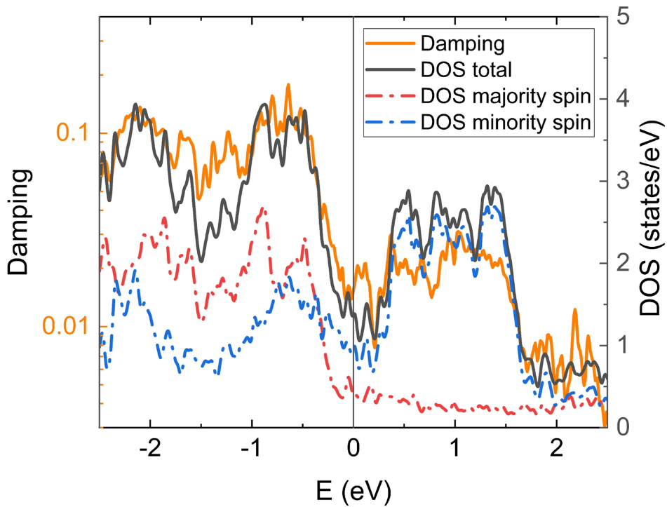
FIG. 1. The total damping and DOS (total, majority-spin, minority-spin) for the L1₀-FePt at 0 K as a function of energy measured from the Fermi level. The left axis is the damping, and the right axis is the DOS.
The total intrinsic damping is the sum of the intra-band and inter-band contributions. While the intra-band contribution decreases with increasing the scattering rate (conductivity-like), the inter-band contribution is proportional to the scattering rate (resistivity-like) and dominates the total damping in the strongly-scattered region. The difference in the scattering rate parameter $δ$ dependence between the intra-band and inter-band contribution implicitly shows the nonmonotonic behavior of temperature dependence of damping. The FIG. 2 demonstrates this behavior, where we confirm the good agreement in the qualitative trend previous calculation reported by Qu et al. [42].
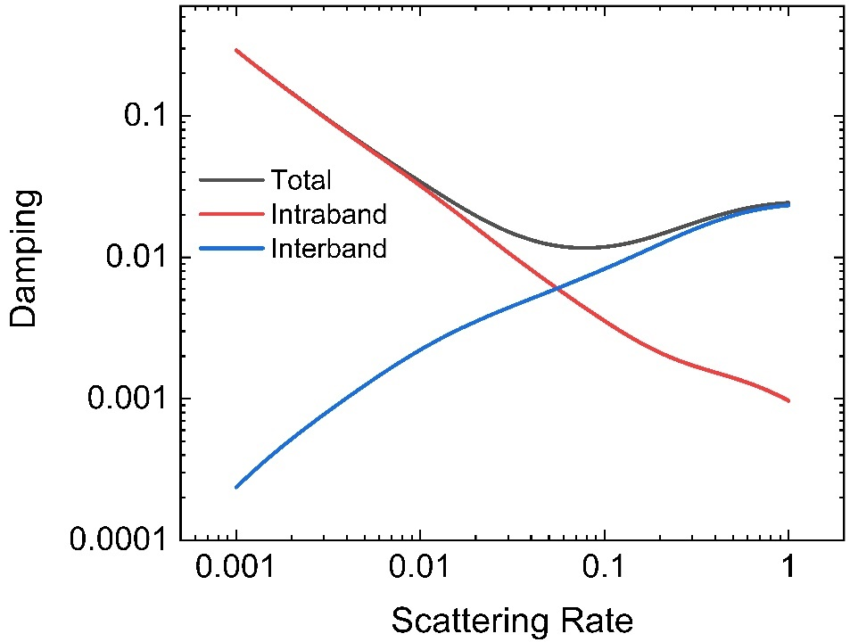
FIG. 2. The total, intra-band, and inter-band damping dependence on the scattering rate parameter computed for the L1₀-FePt at 0 K.
In FIG. 3(a), we show the total damping computed with various scattering rates after averaging over 100 “snapshots” according to Eqs. (10) and (11) to include the effect of atomic vibrations for each temperature. It is found that the intra-band and inter-band damping are dominantly contributed in the low and high scattering regions, respectively. However, the nearly-overlapped curve shown at the elevated temperature (300-900 K) may imply that the effect of atomic vibrations on the magnetic damping is not significant, especially at high temperatures. Figure 3(b) contains the same information as FIG. 3(a) but shows the temperature dependence of damping using a constant scattering rate $δ$. The range of the scattering rate $δ$ was chosen based on the values considered in the previous reports (0.0272-0.10 eV) [29,42]. When a relatively low scattering rate $δ$=0.03-0.04 eV is used, the temperature dependence of the damping value shows an approximately monotonic decrease followed by saturation of damping at high temperatures. However, the use of scattering rates $δ$=0.05-0.10 eV increases damping at high temperatures; hence a nonmonotonic behavior is clearly demonstrated.
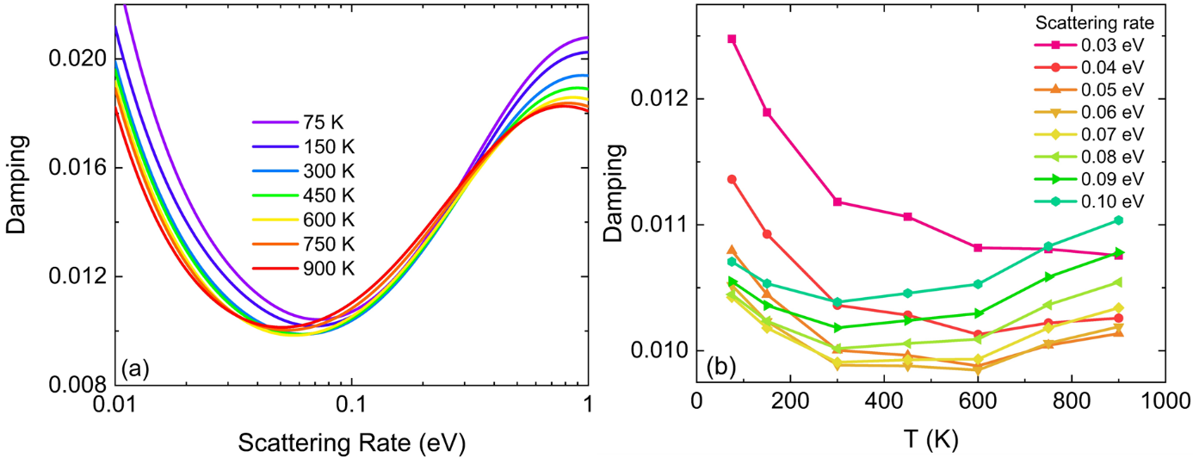
FIG. 3(a) The scattering rate dependence of total damping with varying temperature (b) The temperature dependence of total damping with varying scattering rate of L1₀-FePt.
Since the results in FIG. 3 show that scattering rate plays an important role in the quantitative evaluation of the magnetic damping over the temperature range, we are motivated to evaluate the magnetic damping using calculated temperature-dependent scattering rates. To begin with, it is intuitive that the scattering rate increases at higher temperatures due to an enhanced electron-phonon scatterings. Since the electron-phonon scattering gives the dominant contribution to the temperature dependence of the total scattering rate, we estimate $δ$ from the imaginary part of the FM self-energy [Eq. (12)]. In FIG. 4, we plot the calculated $δ$ values as a function of temperature T. Here, the calculated imaginary parts were averaged over the Kohn-Sham states in the range of $E_{F}±0.3$ eV because the bands around the Fermi level dominantly contribute to the damping. We confirmed that the averaged $δ$ value was not sensitive to the window energy when it is reasonably small, i.e., ~0.05–0.5 eV. It is seen from FIG. 4 that the scattering rate $δ$ increases as the temperature rises, in accord with the aforementioned intuitive picture. The extrapolation of the $δ$ values gives a nonzero value at 0 K (~0.007 eV). Interestingly, this value is within the magnitude range of temperature-independent impurity scattering rate $δ$ estimated from residual resistivity by Hiramatsu et al. (0.0027-0.027 eV) [29].
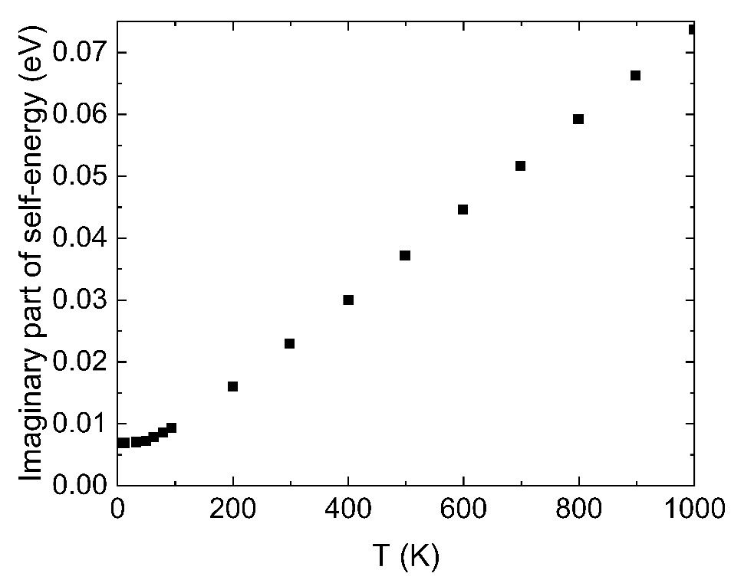
FIG. 4. Temperature dependence of $δ$ calculated from the imaginary part of the FM self-energy.
Using the obtained imaginary part of the FM self-energy as the temperature-dependent scattering rate, we calculated the temperature dependence of damping. Since the spin fluctuation effect is excluded, there is no Curie temperature in this study, hence magnetization value is constant and damping value up to 900 K can be obtained. However, it is important to note that actual HAMR writing operation is carried out around 670-685 K (10-25 K below experimental Curie temperature), and our results just show that the phonon excitation hardly affects the magnetic damping in this temperature range. In FIG. 5, the temperature dependence of damping due to the atomic vibration is shown by the red line-point together with the previous study of the temperature dependence of damping due to spin fluctuation reported by Hiramatsu et al. [29] (the black line-point). Our calculation shows a weak nonmonotonic behavior, which confirms that atomic vibration slightly enhances the high-temperature damping. However, this magnitude of the change in the damping due to atomic vibrations is not as large as the effect of spin fluctuation reported by Hiramatsu et al. [29]. This could be explained because the damping constant is inversely proportional to the magnetic moment, as shown in Eq. (9). Since the magnetization rapidly decreases near the Curie temperature, the calculated damping due to the spin fluctuation will be drastically enhanced. On the other hand, we confirmed that the atomic vibration hardly affects the magnetization value even at high temperatures.
In FIG. 5, we also plot the reported experimental results of FePt damping taken from Refs [27,43] by the blue and green line-points. In the experiment, they measure the FMR linewidth, which is directly proportional to the damping under the assumption of a negligible contribution of inhomogeneity line broadening. Thus, the damping value can be extracted from FMR linewidth and plotted together with the calculated temperature dependence of damping. Previously, Richardson et al. reported the reduction of FMR linewidth in the L1₀-FePt granular sample, which correspond to the strong reduction of damping (blue dashed line) [27]. Since we and Hiramatsu et al. separately reported that the intrinsic damping of FePt will increase at high temperatures due to the atomic vibration and spin fluctuation [29], respectively, we can rule out the intrinsic damping as an origin of the experimental reduction of FMR linewidth (damping) observed by Richardson et al [27]. Although the contributions from phonon excitation and spin fluctuation at finite temperatures are not additive in a quantitative manner as shown by Ebert et al. [26], our results emphasize that the phonon excitation effect is not detrimental for intrinsic damping at high temperatures, similar with the spin fluctuation effect in a qualitative manner [29]. In addition, recently published work by Liu et al. reported that the FMR linewidth of continuous thin films of cubic A1-FePt significantly increases near the Curie temperature (green dashed line) [43]. This qualitative behavior in cubic A1-FePt shows good agreement with the spin fluctuation effect on damping of tetragonal L1₀-FePt reported by Hiramatsu et al [29] due to the small extrinsic contribution. Note that the rapid increase of damping of A1-FePt reported by Liu et al. happens at a lower temperature than that predicted by Hiramatsu et al. for L1₀-FePt due to lower experimental T_{C} of A1-FePt (575 K) [43] compared to the calculated T_{C} of L1₀-FePt using disordered local moment (DLM) method (820 K) [29]. In addition, it is also important to note that the DLM method usually overestimates the Curie temperature, where the experimental T_{C} of L1₀-FePt is 695 K as reported by Richardson et al. [27]. While the continuous A1-FePt thin films have fewer defects and smaller extrinsic contribution, the granular structure of L1₀-FePt media investigated by Richardson et al. has more defects due to the grain boundary, resulting in the stronger extrinsic contribution to the damping [27,43]. Hence, the comparison of these results leads to the two major findings: (1) the temperature dependence of intrinsic damping due to the atomic vibration and also the spin fluctuation is nonmonotonic, and the damping always increases with increasing the temperature near the Curie temperature, (2) the extrinsic contribution will play an important role behind the possible reduction of FePt damping in the experiment.
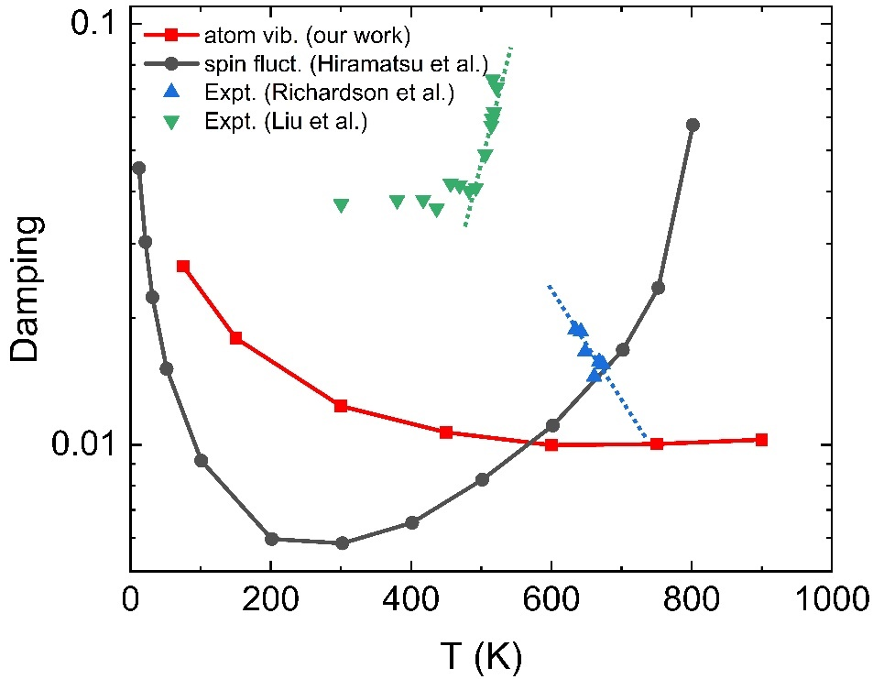
FIG. 5. Atomic vibration effect on the temperature dependence of the damping of L1₀-FePt calculated using the imaginary part of FM self-energy as temperature-dependent scattering rate. For comparison, the spin fluctuation effect on the temperature dependence of damping constant of L1₀-FePt calculated by Hiramatsu et al. [29], experimental damping constant extracted from FMR linewidth of L1₀-FePt granular media by Richardson et al. [27] and A1-FePt continuous thin films by Liu et al. [43] are plotted together. Dashed line corresponds to the trend of the temperature dependence of experimental damping constant near Curie temperature.
We split the spin-orbit torque operator $η_{0}^{-}=\left[S^{-},H_{SO}\right]=\sum_{I}{ξ_{I}\left(S^{-}L^{z}-S^{z}L^{-}\right)}$ into two parts, one is the spin-conserving term $S^{z}L^{-}$ and the other is the spin-flip term $S^{-}L^{z}.$In FIG. 6, we show separately the contributions of damping into spin-conserving transitions and spin-flip transitions using the calculated temperature-dependent $δ$ values. We found that the spin-conserving ($S^{z}L^{-}$) contribution is much larger than the spin-flip ($S^{-}L^{z}$) contribution. This can be attributed to two possible reasons. First, the small majority-spin DOS compared to the minority-spin DOS at the Fermi level due to the exchange splitting of FePt (See FIG. 1) will lead to the small contribution of the spin-flip transition from the occupied majority-spin states to the unoccupied minority-spin states. Second, the matrix elements of the spin flip $\left\langle n,k\right|S^{-}L^{z}\left|n',k\right\rangle$ only allows the nonzero value for the 6 combinations of atomic orbitals with same magnetic quantum number, where the spin conserving $\left\langle n,k\right|S^{z}L^{-} \left|n',k\right\rangle$ give the nonzero value for the 16 combinations of atomic orbitals with a different magnetic quantum number [44]. Note that different prerequisites for nonzero value in spin-flip and spin-conserving matrix element also provide justification to separately analyze the spin-flip and spin-conserving contribution to the total damping (see FIG. S3 in Supplementary Material S3 [34]). The temperature dependence of the two contributions is also different. The spin-conserving part of damping shows a rather monotonic decrease. On the other hand, the spin-flip part shows more pronounced nonmonotonic behavior, which is similar to the total damping in FIG. 5. Previously, it was understood that nonmonotonic behavior of damping is attributed to the competition between the intra-band (conductivity-like) and inter-band (resistivity-like) contribution. While the spin-flip term in the intra-band contribution is almost negligible due to the assumption of a pure spin state, the strong spin-flip contribution from the inter-band transition may be the origin of the enhancement of damping at high temperatures.
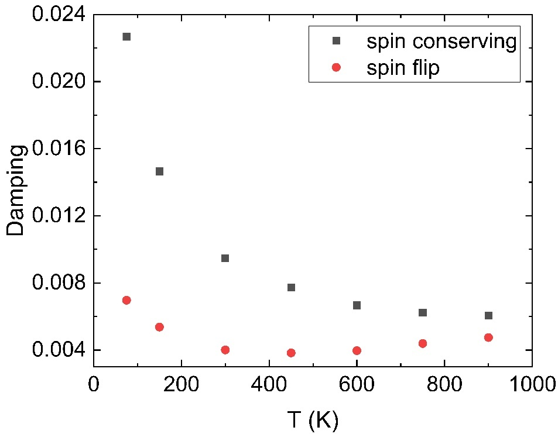
FIG. 6. Temperature dependence of the spin-conserving and spin flip contribution to damping calculated using the imaginary part of FM self-energy as temperature-dependent scattering rate.
It is difficult to obtain perfect samples experimentally due to introduction of impurities, formation of dislocations, etc. It is expected that low concentration of impurities does not affect the electronic structure and magnetic properties significantly. Therefore, we assumed that impurity concentration is proportional to the constant scattering rate due to impurities $Λ_{imp}$. In FIG. 7, we show the spin-conserving and spin-flip damping as a function of temperature for different impurity scattering rates $Λ_{imp}$. We found that the enhancement of the spin-flip damping at high temperatures is more pronounced with increasing $Λ_{imp}$. On the other hand, the spin-conserving damping hardly increases at high temperatures with increasing $Λ_{imp}$. This result implies that the presence of impurities in FePt may be beneficial by preventing undesirable damping coefficient reduction at high temperatures. Based on this simplified picture, impurities will act as local scattering centers which enhance the spin-flip transition process. However, this contribution can be less significant than spin fluctuation because the damping is explicitly dependent on the magnetization. Since the magnetic impurities having d orbitals may change the electronic structures of FePt and negatively impact the other important properties of HAMR such Curie temperature and anisotropy, nonmagnetic impurities without d orbitals such carbon and boron can be considered as possible candidates. 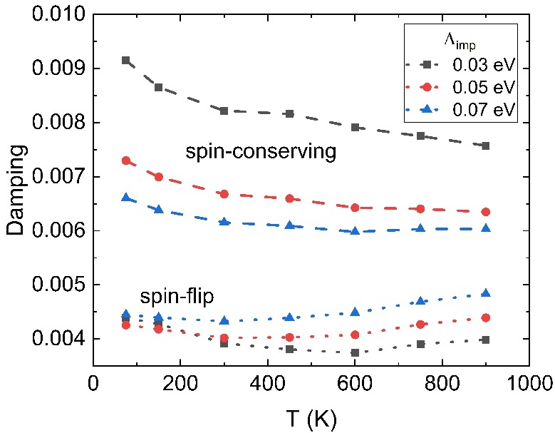
FIG. 7. Temperature dependence of damping by varied constant impurity scattering rate $Λ_{imp}$
Finally, to understand how each phonon mode affects the damping behavior, we created modulated structures by displacing the atoms along the specified normal modes with different amplitudes at the commensurate q-points. The $κ$-th atom displacements in the defined supercell with total $N$ atoms are defined as:
 | $$\frac{A}{\sqrt{NM_{κ}}}Re[\exp\left(iϕ\right)e_{α}\left(κ;qυ\right)\exp\left(iq∙r_{κl}\right)],$$ | (14)
where $A$ is the amplitude in the unit of $u^{1/2}Å$, and $ϕ$ is the phase. We created supercells with displacements due to the phonon mode for each commensurate q-point. In the primitive L1₀-FePt unit cell, there are 2 atoms, yielding 6 phonon modes at each $q$ point. Since the 2 $×$ 2 $×$ 2 supercell is used, there are 8 different commensurate $q$ points labeled as follows: Γ (0,0,0), Z (0,0,-0.5), X (0,-0.5,0), R (0,-0.5,-0.5), X’ (-0.5,0,0), R’ (-0.5,0,-0.5), M (-0.5,-0.5,0), and A (-0.5,-0.5,-0.5). Note that X(X’) and R(R’) are equivalent points in the phonon dispersion calculation.
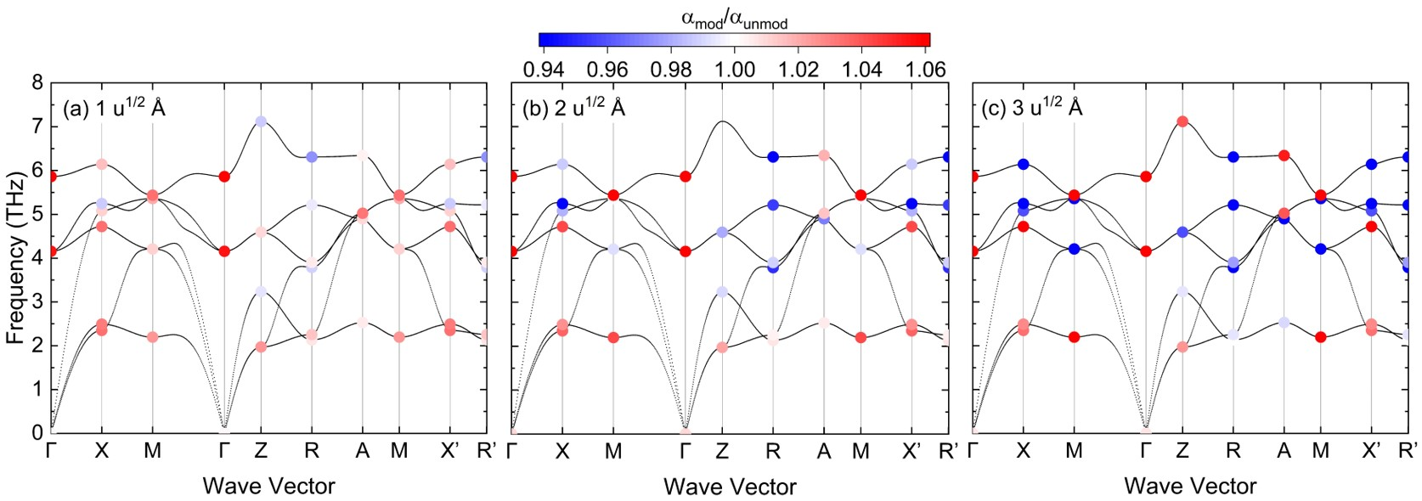
FIG. 8.(a)-(c) The mode-decomposed normalized damping $α_{mod}/α_{unmod}$ of L1₀-FePt with amplitudes 1, 2, and 3 $u^{1/2}Å$ at constant scattering rate 0.05 eV, respectively.
In the FIG. 8(a)-(c), we showed how each phonon mode affects the ratio of the damping in the modulated structure $α_{mod}$ to the damping in the unmodulated (perfect supercell) structure $α_{unmod}$ ($α_{mod}/α_{unmod}$) with changing the amplitude of atomic displacements. The constant scattering rate of 0.05 eV was used. Red (blue) points correspond to the phonon mode that enhances (weakens) the damping value compared to the unmodulated structure. The presence of both red and blue phonon modes indicates two competing contributions to the temperature dependence of damping, which may explain its nonmonotonic behavior.
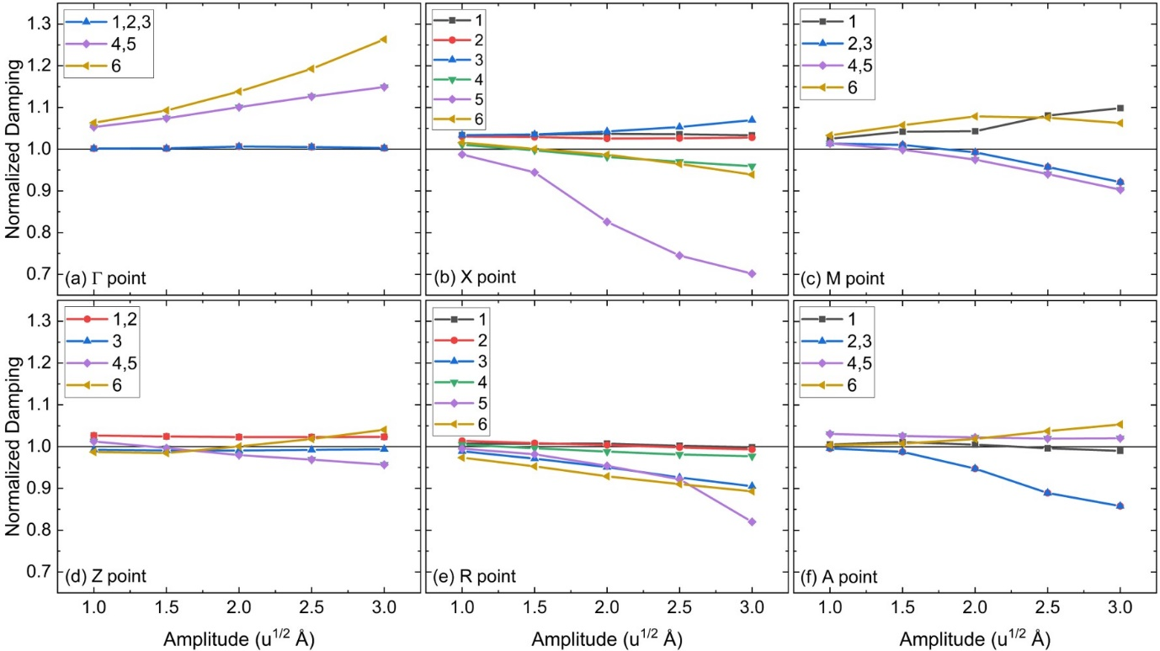
FIG. 9.(a)-(f) The amplitude dependence of normalized damping $α_{mod}/α_{unmod}$ of L1₀-FePt due to phonon mode at q-point: Γ (0,0,0), X (0,-0.5,0), M (-0.5,-0.5,0), Z (0,0,-0.5), R (0,-0.5,-0.5), and A (-0.5,-0.5,-0.5), respectively. Every plot contained the contribution of each phonon mode indexed from lowest to highest frequency.
At higher temperatures, a larger amplitude of displacements is expected, and higher-frequency phonon modes will be more occupied. We show in FIG. 9(a)-(f) the amplitude dependence of the normalized damping $α_{mod}/α_{unmod}$ of L1₀-FePt due to phonon modes at various commensurate q-points. Larger amplitude and higher-frequency phonon mode generally result in a larger change in the magnitude of $α_{mod}/α_{unmod}$. In particular, the high-frequency phonon mode at Γ point has always enhanced the damping, which may be a dominant contribution to the slight increase of damping at high temperatures due to the atomic vibration effect in FIG. 5.
- Conclusions
We carried out a theoretical study of the lattice dynamics effects on the damping constants of L1₀-FePt at finite temperatures based on the Kambersky torque correlation model and the improved frozen thermal lattice disorder approach. Using the imaginary part of the Fan-Migdal self-energy as the temperature-dependent scattering rate, we showed the weak nonmonotonic behavior of the temperature dependence of the damping. As a result, the damping slightly increases at high temperatures due to the effect of atomic vibrations, although the magnitude is not as large as that of the spin fluctuation effect. Thus, our results rule out lattice dynamics as the exclusive origin of the observed temperature-induced decrease in the damping constant. The comparison with the reported experimental results emphasizes the importance of the extrinsic contribution to the possible reduction of damping in L1₀-FePt granular media for HAMR application. Furthermore, we found that the increase of the damping at high temperatures is due to the spin-flip ($S^{-}L^{z}$) contribution, which can be enhanced by the larger impurity scattering rate. These results suggest that in practical applications the inclusion of impurities such as carbon and boron may suppress the observed reduction in damping due to the extrinsic contribution at high temperature. Although the effect of lattice dynamics on the magnetic damping around the Curie temperature was not significant compared to the spin fluctuation, its effects will be more important for understanding the temperature dependence of the magnetic damping, if we include the spin-phonon coupling in the torque correlation model. In the future, we would like to consider the spin-phonon coupling directly in the correlation function of the torque correlation model for intrinsic damping calculations.
Acknowledgements
We are grateful to Y. Takahashi, Y. Sasaki, and K. Masuda of NIMS for valuable discussions on this work. IK acknowledges NIMS for the provision of a NIMS junior research assistantship. This work was partly supported by Grants-in-Aid for Scientific Research (Grant Nos. JP17H06152, JP20H00299, JP20H02190, and JP22H04966) from the Japan Society for the Promotion of Science, Center for Spintronics Research Network (CSRN) of Osaka University, the Cooperative Research Project Program of the Research Institute of Electrical Communication in Tohoku University. The computations were performed on a Numerical Materials Simulator at NIMS.
Reference
[1] A. Hirohata, K. Yamada, Y. Nakatani, L. Prejbeanu, B. Diény, P. Pirro, and B. Hillebrands, J. Magn. Magn. Mater. 509, 166711 (2020).
[2] B. Dieny and M. Chshiev, Rev. Mod. Phys. 89, 025008 (2017).
[3] Y. Shiota, T. Nozaki, S. Tamaru, K. Yakushiji, H. Kubota, A. Fukushima, S. Yuasa, and Y. Suzuki, Appl. Phys. Express 9, 013001 (2016).
[4] N. A. Natekar, Z. Liu, S. Hernandez, and R. H. Victora, AIP Adv. 8, 056513 (2018).
[5] R. Kikuchi, J. Appl. Phys. 27, 1352 (1956).
[6] M. Strungaru, S. Ruta, R. F. L. Evans, and R. W. Chantrell, Phys. Rev. Appl. 14, 014077 (2020).
[7] L. Zhang, Y. K. Takahashi, A. Perumal, and K. Hono, J. Magn. Magn. Mater. 322, 2658 (2010).
[8] D. Weller, G. Parker, O. Mosendz, A. Lyberatos, D. Mitin, N. Y. Safonova, and M. Albrecht, J. Vac. Sci. Technol. B, Nanotechnol. Microelectron. Mater. Process. Meas. Phenom. 34, 060801 (2016).
[9] T. Shima, K. Takanashi, Y. K. Takahashi, and K. Hono, Appl. Phys. Lett. 81, 1050 (2002).
[10] A. Kußmann and G. G. v. Rittberg, Int. J. Mater. Res. 41, 470 (1950).
[11] S. Mizukami, S. Iihama, N. Inami, T. Hiratsuka, G. Kim, H. Naganuma, M. Oogane, and Y. Ando, Appl. Phys. Lett. 98, 052501 (2011).
[12] J. Becker, O. Mosendz, D. Weller, A. Kirilyuk, J. C. Maan, P. C. M. Christianen, T. Rasing, and A. Kimel, Appl. Phys. Lett. 104, 152412 (2014).
[13] K. D. Lee, H. S. Song, J. W. Kim, H. S. Ko, J. W. Sohn, B. G. Park, and S. C. Shin, Appl. Phys. Express 7, 113004 (2014).
[14] J. W. Kim, H. S. Song, J. W. Jeong, K. D. Lee, J. W. Sohn, T. Shima, and S. C. Shin, Appl. Phys. Lett. 98, 092509 (2011).
[15] Z. Xu, K. Zhang, and J. Li, Phys. Rev. B 104, 224404 (2021).
[16] V. Kamberský, Czechoslov. J. Phys. 26, 1366 (1976).
[17] A. Sakuma, J. Phys. Soc. Japan 81, 084701 (2012).
[18] R. J. Elliott, Phys. Rev. 96, 266 (1954).
[19] Y. Yafet, in Solid State Physics - Advances in Research and Applications, Vol. 14 (Academic Press, 1963), pp. 1–98.
[20] P. Fulde and A. Luther, Phys. Rev. 175, 337 (1968).
[21] V. Korenman and R. E. Prange, Phys. Rev. B 6, 2769 (1972).
[22] F. Beuneu and P. Monod, Phys. Rev. B 18, 2422 (1978).
[23] A. Singh and Z. Teanović, Phys. Rev. B 39, 7284 (1989).
[24] K. Gilmore, Y. U. Idzerda, and M. D. Stiles, Phys. Rev. Lett. 99, 027204 (2007).
[25] S. M. Bhagat and P. Lubitz, Phys. Rev. B 10, 179 (1974).
[26] H. Ebert, S. Mankovsky, K. Chadova, S. Polesya, J. Minár, and D. Ködderitzsch, Phys. Rev. B 91, 165132 (2015).
[27] D. Richardson, S. Katz, J. Wang, Y. K. Takahashi, K. Srinivasan, A. Kalitsov, K. Hono, A. Ajan, and M. Mingzhong, Phys. Rev. Appl. 10, 054046 (2018).
[28] D. Ozaki, D. Miura, and A. Sakuma, IEEE Trans. Magn. 53, (2017).
[29] R. Hiramatsu, D. Miura, and A. Sakuma, Appl. Phys. Express 15, 013003 (2021).
[30] Y. Liu, A. A. Starikov, Z. Yuan, and P. J. Kelly, Phys. Rev. B - Condens. Matter Mater. Phys. 84, 014412 (2011).
[31] G. Kresse and J. Furthmüller, Phys. Rev. B 54, 11169 (1996).
[32] P. E. Blöchl, Phys. Rev. B 50, 17953 (1994).
[33] J. P. Perdew, K. Burke, and M. Ernzerhof, Phys. Rev. Lett. 77, 3865 (1996).
[34] See Supplemental Material at [URL will be inserted by publisher] for scattering rate dependence of damping with variation of number k-points; estimation of temperature dependence of damping constant at 4x4x4 supercell; and contribution of cross-term., (unpublished).
[35] A. Togo and I. Tanaka, Scr. Mater. 108, 1 (2015).
[36] Y. N. Wu, W. A. Saidi, J. K. Wuenschell, T. Tadano, P. Ohodnicki, B. Chorpening, and Y. Duan, J. Phys. Chem. Lett. 11, 2518 (2020).
[37] F. Giustino, Rev. Mod. Phys. 89, 015003 (2017).
[38] P. Giannozzi, O. Andreussi, T. Brumme, O. Bunau, M. B. Nardelli, M. Calandra, R. Car, C. Cavazzoni, D. Ceresoli, M. Cococcioni, and others, J. Phys. Condens. Matter 29, 465901 (2017).
[39] K. F. Garrity, J. W. Bennett, K. M. Rabe, and D. Vanderbilt, Comput. Mater. Sci. 81, 446 (2014).
[40] G. Pizzi, V. Vitale, R. Arita, S. Blügel, F. Freimuth, G. Géranton, M. Gibertini, D. Gresch, C. Johnson, T. Koretsune, J. Ibañez-Azpiroz, H. Lee, J.-M. Lihm, D. Marchand, A. Marrazzo, Y. Mokrousov, J. I. Mustafa, Y. Nohara, Y. Nomura, L. Paulatto, S. Poncé, T. Ponweiser, J. Qiao, F. Thöle, S. S. Tsirkin, M. Wierzbowska, N. Marzari, D. Vanderbilt, I. Souza, A. A. Mostofi, and J. R. Yates, J. Phys. Condens. Matter 32, 165902 (2020).
[41] J.-J. Zhou, J. Park, I.-T. Lu, I. Maliyov, X. Tong, and M. Bernardi, Comput. Phys. Commun. 264, 107970 (2021).
[42] T. Qu and R. H. Victora, Appl. Phys. Lett. 106, 072404 (2015).
[43] C. Liu, K. Srinivasan, A. Ajan, E. McCollum, A. Kalitsov, V. Kalappattil, and M. Wu, J. Magn. Magn. Mater. 563, 169988 (2022).
[44] C. Liu, C. K. A. Mewes, M. Chshiev, T. Mewes, and W. H. Butler, Appl. Phys. Lett. 95, 022509 (2009).

Corresponding author: miura.yoshio@nims.go.jp

