Bias voltage induced - electrical conductivity at electrode interfaces of a rutile TiO₂ single crystal: two diﬀerent mechanisms depending on temperature

T.T. Suzuki ∗, Y. Yamashita, I. Sakaguchi

National Institute for Materials Science, 1-1 Namiki, Tsukuba, Ibaraki 305-0044, Japan

Abstract
The electric ﬁeld-induced conductivity of TiO₂ is important in various emerging practical applications, including the recently proposed selective trace hydrogen sens- ing. In the present study, the bias voltage-induced electrical characteristics were investigated between 295 K (ambient temperature) and 600 K for a semi-insulated rutile TiO₂ single crystal. The appearance of conductivity by elevating the tem- perature was shown to be due to the electromigration of mobile dopants including defects. It was found that there are two diﬀerent mechanisms causing the conductiv- ity depending on the temperature. At low temperature, close to room temperature, hydrogen migrating primarily along the open [001] channel triggers the conductiv- ity. On the other hand at high temperature above 450 K, the migration of oxygen vacancy (V_{O}) perpendicular to [001] induces the conductivity. It is proposed that V_{O} is injected at the anode interface, which then migrates to the cathode interface and aggregates there. It was observed that the V_{O} injection is not accompanied by the formation of the Magn`eli phase. The proposed mechanism was examined by spectroscopic techniques such as time-of-ﬂight secondary ion mass spectrometry and hard X-ray photoemission spectroscopy.

Key words: Rutile TiO₂, Oxygen vacancy, Electrolytic coloration, Electric ﬁeld-induced diﬀusion, Resistive switching

∗ Corresponding author.
Email address: suzuki.taku@nims.go.jp (T.T. Suzuki).

Preprint submitted to Elsevier Science 10 November 2023

Introduction

Electrochemical-based-novel functions at the electrode interface of metal-oxides have attracted attention in recent years.[1] Those functions basically arise from the electric ﬁeld induced-motion of the constituent ions including de- fects, dopants, and their complexes at the electrode-metal oxide interface. The newly emerging material properties by such an ion electromigration have been studied for various technological applications. For example, the constituent ion migration at the electrode interface has been applied to the artiﬁcial synapse formation imitating biological system[2]. Similar applications have also been demonstrated for voltage-control of ferromagnetic ﬁlm magnetism[3], electric-ﬁeld control of interfacial magnetism[4], the ion-dynamic capacitance of electrolytes[5], and modulation of superconducting transitions[6]. We have also recently proposed the electromigration of oxygen vacancies at the elec- trode/rutile TiO₂ interface can be applied to selective and sensitive hydrogen sensing.[7]

The electric ﬁeld-induced motion of the constituent ion often causes ion in- jection from the metal-oxide to the electrode or vice versa at the electrode interface, which is often called the transfer reaction at interfaces.[8,9] It is widely accepted that this is also the case for oxygen vacancy (V_{O}) of rutile TiO₂ that has a positive charge of 2+; hence it migrates under the electric ﬁeld.[10–13] The electric ﬁeld induced-V_{O} injection at the anode interface followed by migration and aggregation at the cathode interface has been evi- denced in a direct manner using imaging as well as spectroscopic techniques in the last decade.[14,15] The V_{O} aggregation at the cathode interface followed by the electrical conductive V_{O} ﬁlament growth has been considered as the central mechanism of the bias voltage induced-electrical conductivity, i.e., the resistive switching.

The V_{O} ﬁlament growth has been also considered to be related to the mech- anism of the recently proposed selective hydrogen sensing by a TiO₂ crystal.
[7] The trace hydrogen is sensed from the resistance increase of TiO₂. Because

the resistance increase of the n-type semiconductor, such as TiO₂, by exposing to a reductive gas is very unusual, the hydrogen sensing mechanism is of quite interest. We have studied for several years the bias voltage induced-electrical conductivity of the TiO₂ crystal in various atmospheres to ﬁnally elucidate the hydrogen sensing mechanism.

We recently suggested that the electric ﬁeld induced - migration of V_{O} at an electrode/rutile TiO₂ interface is faster along the direction perpendicular to
[001] than the parallel direction.[16] This suggestion was mainly derived from the crystallographic anisotropy of electrolytic coloration which is attributed to the V_{O} ﬁlament growth by the voltage bias annealing. Thus, it was considered the (001) plane is highly resistant to the electric ﬁeld induced-V_{O} injection compared with other crystal planes. Indeed, the electrolytic coloration was not observed on (001) while it was observed on other orientations ((100) and (110)) by the voltage-bias annealing with the same condition. We further proposed that the injected V_{O} at the single crystalline TiO₂ can be applied for selective hydrogen sensing at 673 K while simultaneously sensing other trace gases similar to a conventional semiconducting gas sensor.[7] To reveal the hydrogen-sensing mechanisms by V_{O}, detailed knowledge of the voltage- induced conductivity by the mobile dopant at the elevated temperature is needed. This is the motivation of the present study. The voltage added to the sample, which is typically several volts in a resistive gas sensor, was extended in the present study to fully understand the sensing mechanism including the failure mechanism of the device.

Although the electro-coloration anisotropy was clearly visible in our previous study [16], it is noted that there are several reports available in the litera- ture from both sides of the experiments and theories that the oxygen thermal diﬀusion exhibits the opposite crystallographic anisotropy, that is, the oxygen diﬀusion is faster parallel to [001] than perpendicular direction in a rutile TiO₂ crystal. [17–22] Because the oxygen thermal diﬀusion takes place by the direct vacancy mechanism, V_{O} diﬀuses in the opposite direction to oxygen diﬀusion.

Therefore, the fast oxygen diﬀusion along [001] implies fast V_{O} thermal dif- fusion into the equivalent [001] direction. The origin of the inconsistency in the V_{O} migration anisotropy between those previous studies and our previous study on the electric ﬁeld-induced - diﬀusion is not clear in the present stage.

In our previous study mentioned above, the two electrodes for voltage bias- ing were placed in-plane on the TiO₂ crystal sample surface. Although the in-plane conﬁguration is convenient for observing the electrolytic coloration, because it appears between the electrodes, the relationship between the elec- tric ﬁeld direction and the crystallographic orientation is not straightforward. The electric ﬁeld is parallel to the direction connecting the electrodes at the center between the electrode, while it is perpendicular near the electrode in- terface. In other words, the electric ﬁeld rotates by 90 degrees between those two positions, and this causes uncertainty for determining experimentally the V_{O} diﬀusion anisotropy.

In the present study, the bias voltage-induced electrical conductivity was fur- ther investigated for the stacking electrode geometry, where two electrodes sandwich the TiO₂ crystal. Thus, the relationship between the electric ﬁeld and the crystallographic orientation is uniquely deﬁned independent of the position between the electrodes. We found that there are two diﬀerent con- duction mechanisms depending on the temperature. It is proposed that the mobile dopant causing the resistive switching at low temperature near room temperature is hydrogen, which dominantly migrates along [001], while it is V_{O} at elevated temperature, which migrates perpendicular to [001]. The de- tailed relationship between the diﬀusion anisotropy of hydrogen and V_{O}, and the electrical conductivity is discussed.

Experimental Method and Setup

  - Sample preparation and evaluation of electrical properties

The experiments were performed on Verneuil-grown rutile TiO₂ single crystal substrates with a mirror-polished surface and 10 mm×10 mm×0.5 mm (thick- ness) size, purchased from Shinkosha Co., Ltd. The substrate was annealed at 970 K for 2 hours in the air after degreasing. The air annealing was per- formed with sandwiching the sample by TiO₂ crystals from both of front and back sides to avoid contamination during the air annealing. The resistivity of the substrate reached more than 1 MΩ·m at room temperature after the air anneal; thus it was in the range of semi-insulator. The Al thin-lm electrode of a thickness of 100 nm was deposited on both sides of the TiO₂ crystal by the RF sputtering (inset of Fig. 1).

The I − V characteristics were measured using Keithley 2400 source meter in the dark with a scan speed of 0.1 V/s. The compliance current was 10 mA. The ambient atmosphere during the voltage bias annealing and the I − V measurements was synthesized dry air (G1 grade, Suzuki Shokan Co., Ltd.) with a ﬂow rate of 0.2 standard liters per minute. The dew-point temperature of the synthesized air was below 200 K; hence the inﬂuence of water in the air is assumed to be negligible in the present study.

  - TOF-SIMS

All time-of-ﬂight secondary ion mass spectroscopy (TOF-SIMS) analyses were performed using a PHI TRIFT V nanoTOF instrument (ULVAC-PHI) that is equipped with a 30 kV Bi⁺ liquid metal ion gun. The primary Bi⁺ ion beam current was about 1.7 nA. The raster size was 500×500 µm with 256×256 image pixels. The pulse width was 12 nsec. The primary ion dose density never exceeded 5.0×10¹⁰ ions/cm² which is much lower than the static limit of 5.0×10¹² ions/cm². The number of frames was typically 40 for measuring the

mosaic map. The step number of the mosaic map was typically 10×10 with a
step size of 500 µm. Both the neutralization gun and the contrast diaphragm were employed during the mosaic map measurement. The TOF-SIMS data presented in this paper were produced from the raw data ﬁles using a PHI TOF-DR software (ULVAC-PHI).

  - HAXPES

The bulk sensitive chemical and electronic states were analyzed using lab based-hard X-ray photoelectron spectroscopy (HAXPES) (PHI Quantes, Phys- ical Electronics) equipped with a Cr Kα source (5414.9 eV) as a hard X-ray source in addition to a conventional Al Kα source. The emitted electron to the surface normal direction was analyzed using a hemispherical electrostatic analyzer with a pass energy of 69 eV and solid angle of about ±20 degree.

Results and Discussion

Figure 1 shows the current-voltage (I − V ) characteristics of a rutile TiO₂ crystal substrate between two ﬂat electrodes contacting the front and back of the substrate. The two electrodes sandwich the TiO₂ substrate as schemati- cally shown in the inset. The I − V characteristics were measured with step- wisely increasing the temperature from room temperature (293 K) by a step of 30 K. The I − V measurement was completed at the temperature where the current reached the compliance current (10 mA). The scan voltage of ±50 V is substantially larger than that in the conventional studies on resistive switching. The relatively large scan voltage was used in the present study to analyze in depth the trace gas sensing mechanism by the TiO₂ crystal. [7]
We observed that the semi-insulating TiO₂ crystal started to exhibit electrical conductivity, which was accompanied by hysteresis, by the increase of tem- perature. The I − V curve in Fig. 1 was obtained at the temperature during the growing process of the hysteresis, which is 350 K for (001) (Fig. 1(a)) and

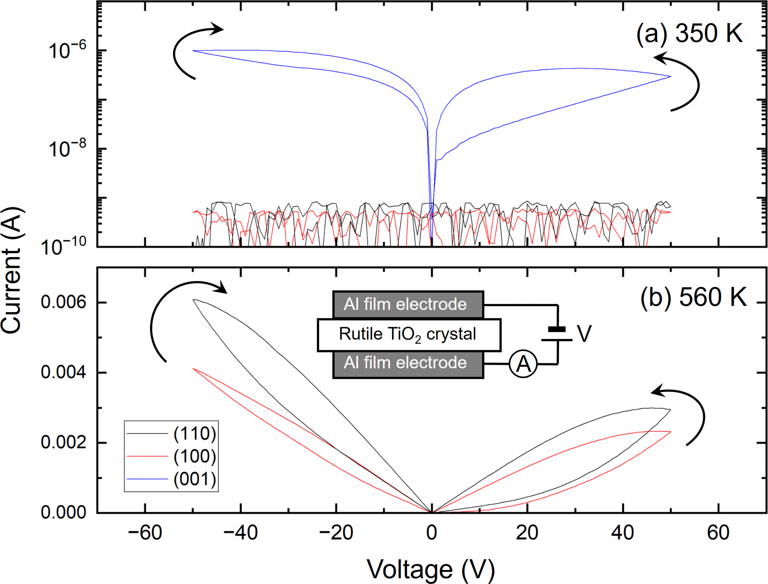

Fig. 1. I − V measurement in the synthesized pure air at (110) (black), (100) (red), and (001) (blue) at (a) 350 K and (b) 560 K. The voltage was swept in the order of 0 V → 50 V → 0 V → -50 V → 0 V. The inset shows the geometry of the electrode arrangement.
560 K for (110) and (100) (Fig. 1(b)). The temperature for the onset of hys- teresis, i.e. the temperature at which the conductivity starts to be observed, diﬀered remarkably between the crystal orientations of the TiO₂ crystal (Fig. 2, explained later). Conductivity appeared at a low temperature close to room temperature as 350 K on (001), whereas substantial sample heating was needed for conductivity on (110) and (100). It is noted that the current in the I − V measurement ﬁnally reaches the compliance current (10 mA) on (001) at 380 K, and (110) and (100) at 590 K. This indicates the formation of the electrical conduction path during the I − V measurement.

The appearance of hysteresis is attributed to a transient change in resistance due to voltage bias on a time scale comparable to the scan time of the I − V measurement, i.e. a few hundred seconds. The resistance change is induced by the electromigration of mobile dopants and/or defects during the voltage bias (hereafter simply referred to as mobile dopants). Thus, hysteresis is consid- ered to be a competing consequence between the mobile dopant aggregation by ﬁeld-induced diﬀusion and the deconcentration by thermal diﬀusion. The rela- tionship between the I − V characteristics and the crystal orientation shown in Figs. 1 and 2 manifest the crystallographic anisotropy of the dopant electro- migration responsible for electrical conductivity; it moves substantially faster

parallel to the [001] direction than the perpendicular direction.

The bias voltage-induced electrical conductivity of a rutile TiO₂ single crystal has been widely reported in a number of papers. [23–26] The crystallographic anisotropy of the bias voltage-induced conductivity has also been extensively studied, especially around room temperature. It has been consistently reported that the dopant migration under the electric ﬁeld that causes the conduc- tivity is fastest along the [001] direction. [23–25,27] Thus, the conductivity anisotropy observed in the present study is consistent with these previous reports. The mobile dopant responsible for the conductivity along [001] has often been attributed to hydrogen in past studies. [25] We also assign it to hydrogen in the present study, as discussed later.
In the present study, we found that the conductivity induced by voltage bias annealing at (001) diﬀers remarkably between atmospheric pressure and ultra- high vacuum (UHV) in the order of 10⁻⁸ Pa. Figure 2 shows the (a) current at 50 V and (b) hysteresis area as a function of temperature in the I − V measurement performed with a stepwise increase of the temperature. The similarity between these two relationships is consistent with the above inter- pretation that the origin of electrical conductivity and hysteresis is identical, namely electromigration of the mobile dopant.

It is clearly observed in Fig. 2 that there are two diﬀerent temperature char- acteristics, indicated as components (i) and (ii), where component (i) grows at a lower temperature than component (ii). The low-temperature component
(i) is only observed at (001) near room temperature. On the other hand, the high-temperature component (ii) is observed at (110) and (100) above 440 K.

The I − V characteristic is remarkably diﬀerent between UHV and atmo- spheric pressure at (001) in Fig. 2. Component (i) disappears in UHV and consequently the resistivity behavior on (001) changes to component (ii). This indicates that the mobile dopant responsible for the bias voltage-induced con- ductivity on (001) disappears in UHV. In contrast, the I − V characteristics

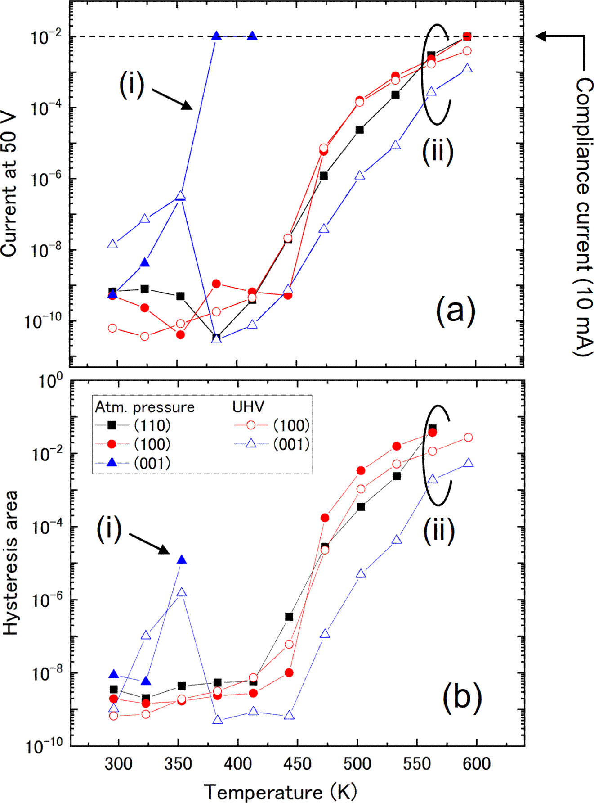

Fig. 2. Summary of (a) current at 50 V and (b) hysteresis area as a function of the sample temperature obtained from the I − V measurement which was performed in the pure air of atmospheric (atm) pressure or UHV (10⁻⁸ Pa). The hysteresis
area corresponds to the total current surrounded by the hysteresis curve at the positive bias voltage. The inset schematically shows the geometry of the electrode arrangement.
were essentially the same on (110) and (100) between UHV and atmospheric pressure.

From the fact that the mobile dopant responsible for the conductivity at (001) disappears in UHV, the dopant should be contained in the surrounding atmo- sphere. In addition, the dopant should have a signiﬁcant diﬀusion coeﬃcient along [001] at low temperatures such as room temperature. We attribute the mobile dopant responsible for component (i) is hydrogen. It is widely accepted that hydrogen has a fast diﬀusion coeﬃcient at room temperature compared to other mobile dopant candidates such as V_{O} and Ti interstitials. [25] Ad- ditionally, it has been established that the hydrogen primarily diﬀuses along

the open [001] channel. [28,29]

Since the I − V measurement was performed in the synthesized pure air, hy- drogen is considered to be supplied during the sample preparation before the I − V measurement as the form of water molecules. Both experimental and theoretical studies have shown that water molecules dissociatively adsorb onto a rutile TiO₂ crystal surface at room temperature. [30–33] The resulting hy- droxyl group binds to the surface oxygen of the TiO₂ surface, while surface hopping of the hydrogen atom, half of the dissociation reaction, has been observed. In addition, it has been shown that the atomic hydrogen is incorpo- rated into the TiO₂ crystal at room temperature. [34]

Our I − V measurements were performed in a UHV chamber, but our sample was exposed to air during sample preparation before the I − V measurements. During the air exposure, water molecules should be adsorbed on the surface.

The incorporation of hydrogen along the open [001] channel, followed by the growth of the reduction zone at the electrode interface, is thought to be accel- erated by the subsequent Joule heating. According to the diﬀusivity reported in the literature [35], the diﬀusion length of hydrogen in the [001] direction is estimated to be approximately 1 µm during the I − V measurement at 370 K, which is more than two orders of magnitude smaller than the TiO₂ crystal thickness (0.5 mm). Thus, Joule heating at the local reduction zone formed by the incorporated hydrogen is likely to play an important role. On the other hand, the conductivity mechanism at (110) and (100) should be attributed to species other than hydrogen, since the I − V characteristics are the same between UHV and atmospheric pressure. We believe that the conductivity at
(110) and (100) is due to V_{O}, as discussed below. Therefore, there are at least two diﬀerent mechanisms in the bias voltage-induced conductivity depending on both temperature and crystallographic orientation, which are hydrogen and V_{O}, as shown schematically in Fig. 3.
It is noted that the (001) orientation has the lowest conductivity in the tem- perature dependence of the electrical characteristics as shown in Fig. 2. Thus,

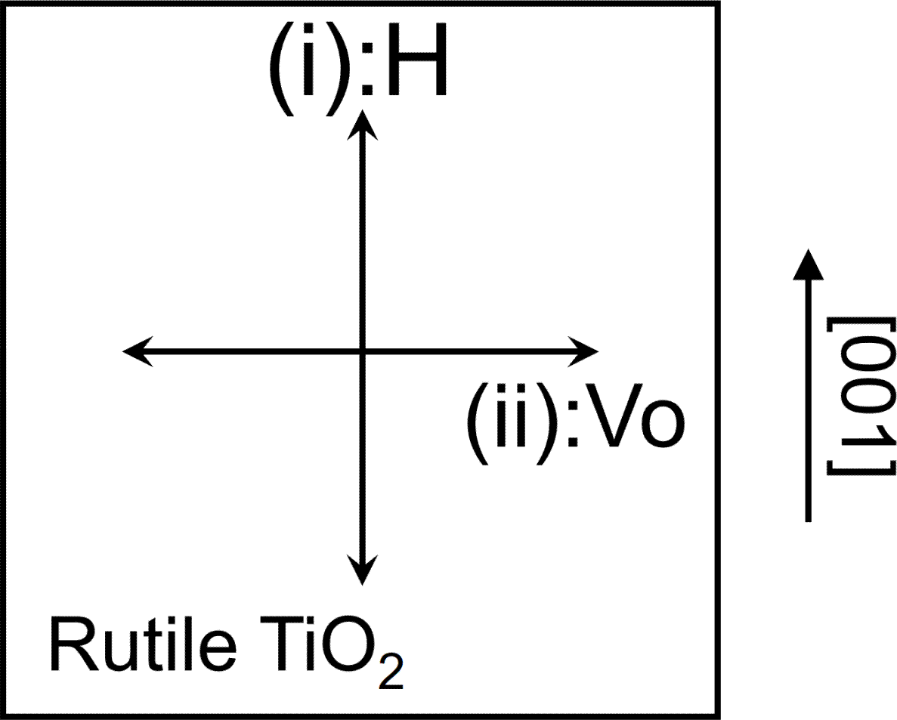

Fig. 3. The crystallographic anisotropy of hydrogen and V_{O} diﬀusion, which is responsible for the bias voltage induced conductivity near room temperature and above 450 K, respectively.
the mobile dopant responsible for component (ii), which we consider V_{O} as discussed below, has a crystallographic anisotropy in the electric ﬁled - in- duced diﬀusion: it is faster perpendicular to [001] than parallel to it.

The anisotropy of V_{O} diﬀusion derived from the result shown in Fig. 2 is con- sistent with that of the electrolytic coloration by the prolonged voltage bias annealing as shown in Fig. 4. In our previous study, it was found that the elec- trolytic coloration occurs on the sample with a ﬂat anode and a point contact cathode as shown in Fig. 4 (a). [7] In the present study, the image contrast of the electrolytic coloration is remarkably improved by using the monochro- matic light of 700 nm. The ﬂat anode was an Al thin ﬁlm while the point cathode was made by mechanically pressing a Pt wire (0.2 mm diameter) to the substrate surface in the present study (Fig. 4(a)). The distance between the point cathode and the ﬂat anode was approximately 5 mm. The voltage bias annealing was performed to obtain the electrolytic coloration with the fol- lowing conditions; voltage: 300 V, compliance current: 10 mA, temperature: 673 K, and time length: 30 min. Thus, the annealing temperature corresponds to the high-temperature component (ii) in the voltage-induced conductivity shown in Fig. 2.

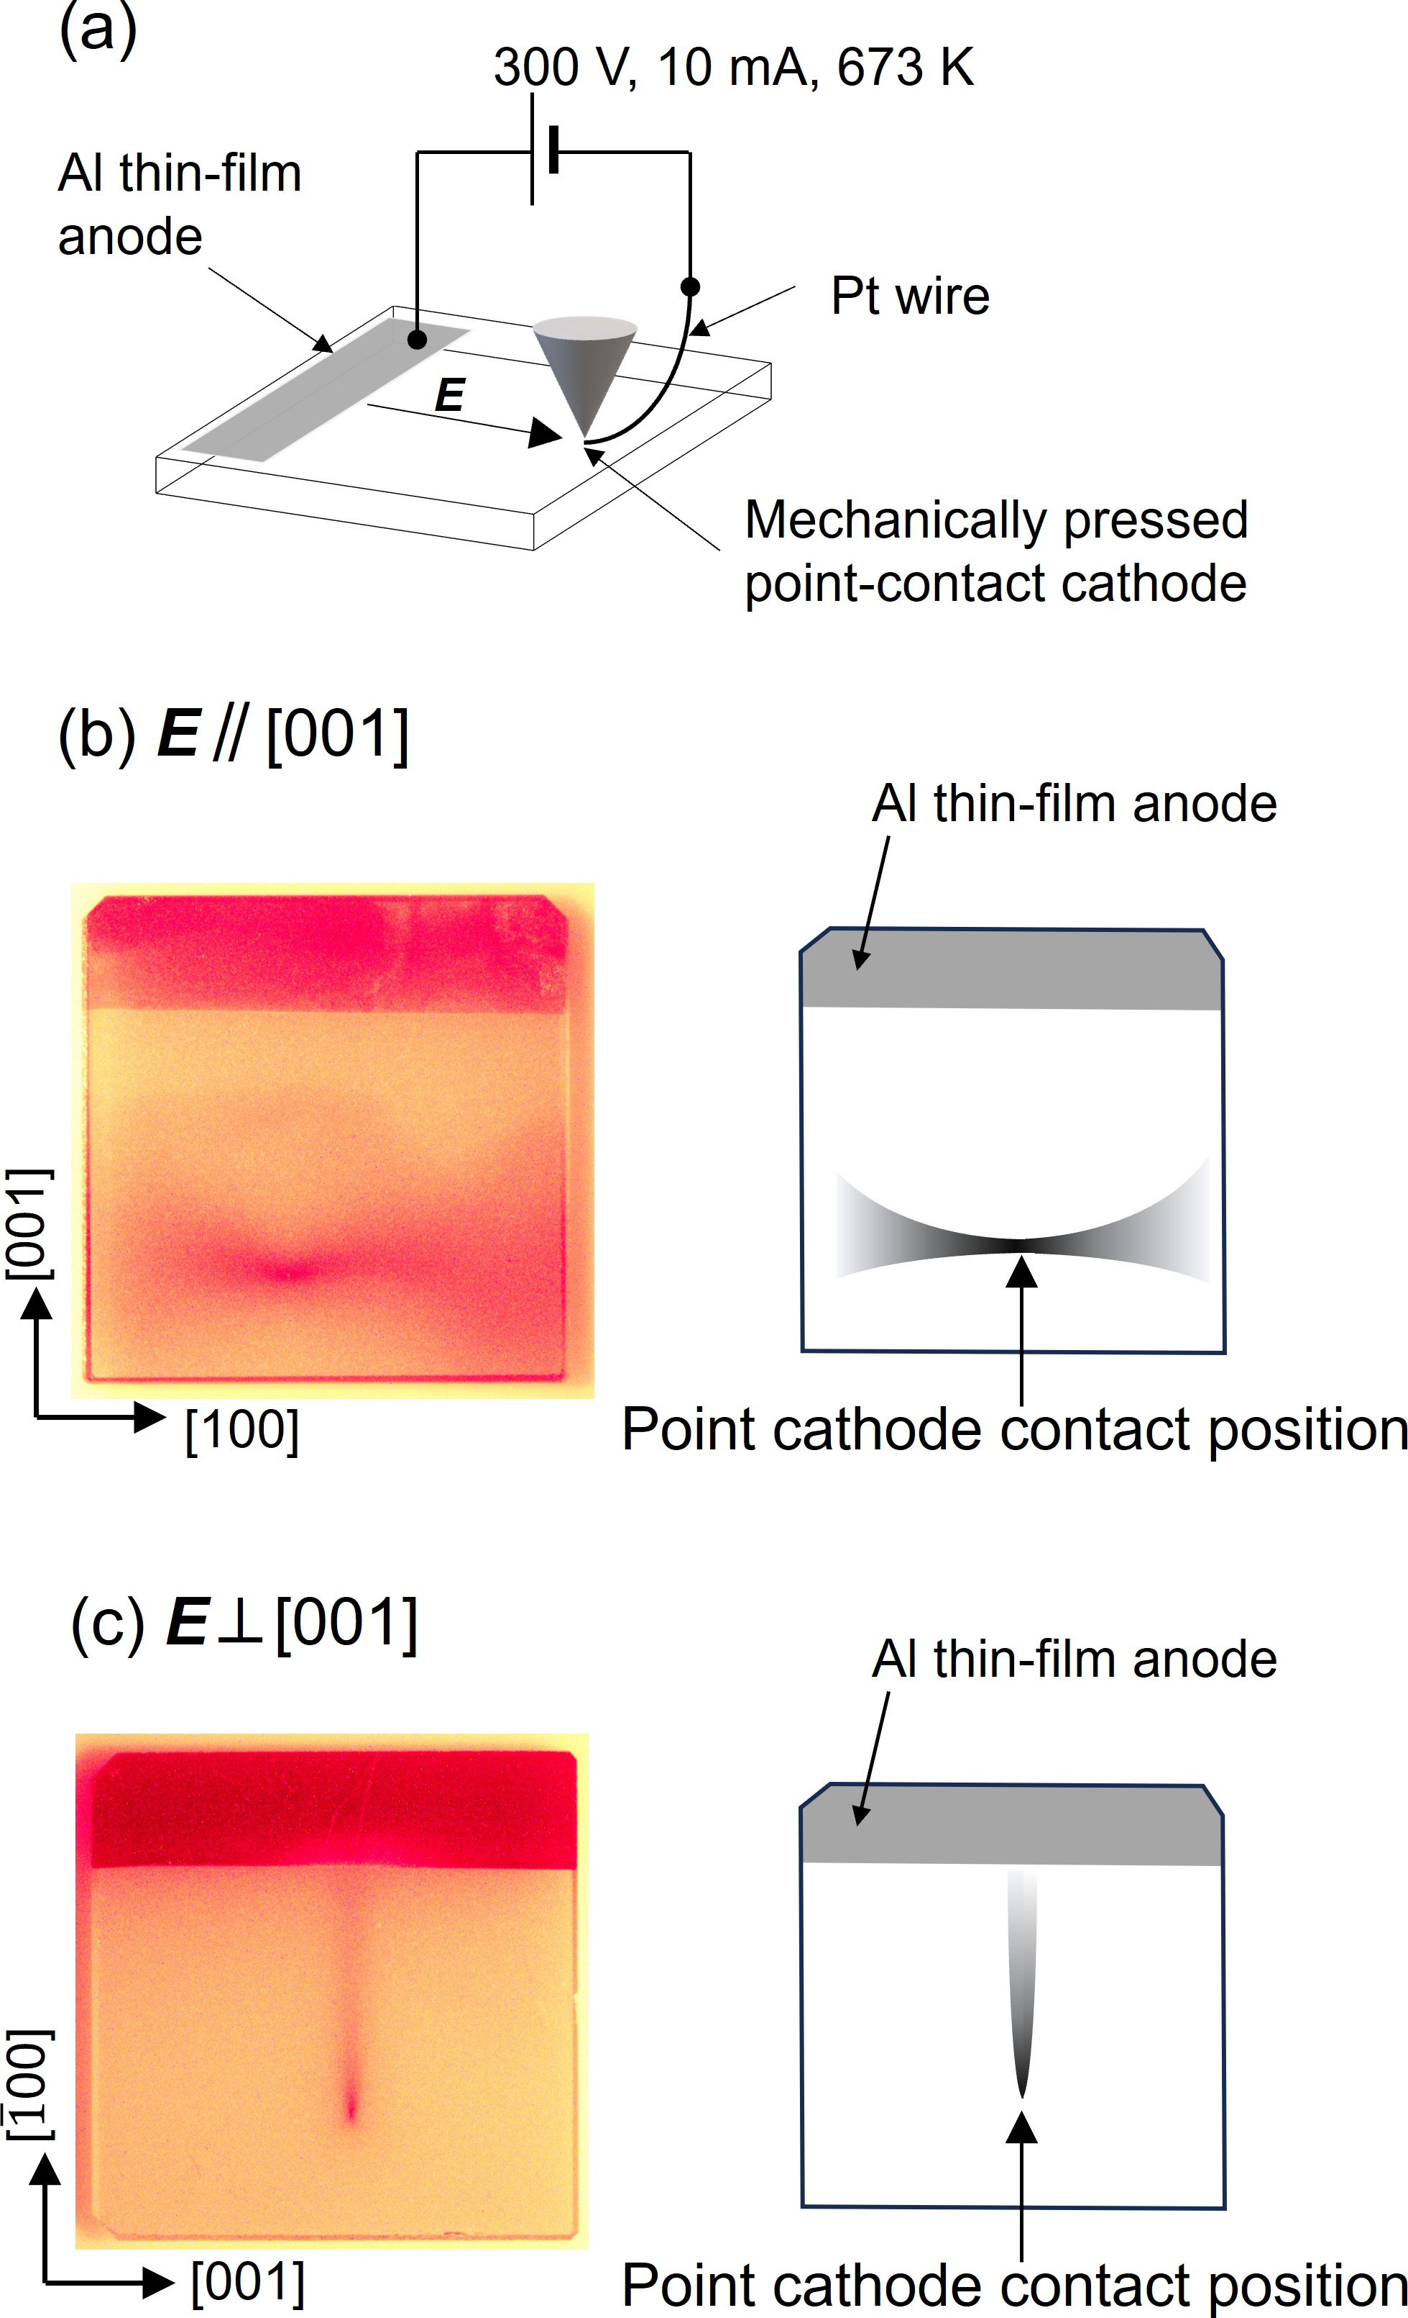
Fig. 4. (a) Schematic of the sample setup for the voltage bias annealing in dry air to observe the electrolytic coloration. The annealing was performed with a temperature of 673 K, a voltage of 300 V, a time length of 3 hours, and a compliance current of 10 mA. The negative voltage was applied to the tip electrode. TiO₂ (100) sample image taken with the monochromatic light of 700 nm wavelength after the voltage bias annealing with the electric ﬁeld direction parallel (b) and perpendicular (c) to [001].

The coloration is accompanied by the electrical conductivity and therefore corresponds to the macroscopic size of the conductive ﬁlament V_{O}. The mech- anism of the electrolytic coloration has been considered for rutile TiO₂ as follows: [36,37]

(V_{O}·Ti³⁺)
→hν
V_{O}+Ti⁴⁺+e⁻. (1)

Consistent with the mechanism of the scheme (1), the increase of the Ti³⁺ component in the electro-colored region was conﬁrmed by HAXPES as shown in Fig. 5. It is well known that the sub-component of the Ti 2p_{3/2} peak on the low binding energy side increases with the reduction reaction of TiO₂. Two components at 459.3 eV (Ti⁴⁺) and 457.6 eV (Ti³⁺) are indeed observed in Fig. 5. [38] The Voight function was applied to the peak ﬁtting. It is estimated that x of TiO_{2−x} is 0.09±0.02 for the colored point and 0.02±0.02 for the uncolored point, assuming that the valence state of Ti is only either 4+ or 3+.

The electrolytic coloration in Fig. 4 clearly shows the crystallographic anisotropy, thus demonstrating the diﬀusion anisotropy of V_{O}. In Fig. 4, the coloration is shown for two TiO₂ (100) samples with two diﬀerent relationships between the crystallographic orientation and the electric ﬁeld direction (Fig. 4 (b) and (c)). It is observed that the coloration grows perpendicular to [001] from the point cathode position in both samples. In our previous study, it was observed that the electrolytic coloration also grows perpendicular to [001] on TiO₂ (110) samples. [16] Thus, the electrolytic coloration always grows perpendicular to [001], indicating that the electromigration of V_{O} is substantially faster per- pendicular to [001] than parallel. This anisotropy of the V_{O} electromigration explains the lower growth rate of component (ii) for (001) compared with (100) and (110) observed in Fig. 2.
There are a number of publications on the thermal diﬀusion of oxygen in a rutile TiO₂ crystal. This is partly because it is related to the electron carrier behavior in the n-type TiO₂ semiconductor, which is of technological impor- tance. It should be noted that the thermal diﬀusion of oxygen in a rutile TiO₂ crystal has been reported to be slower perpendicular to [001] than parallel,
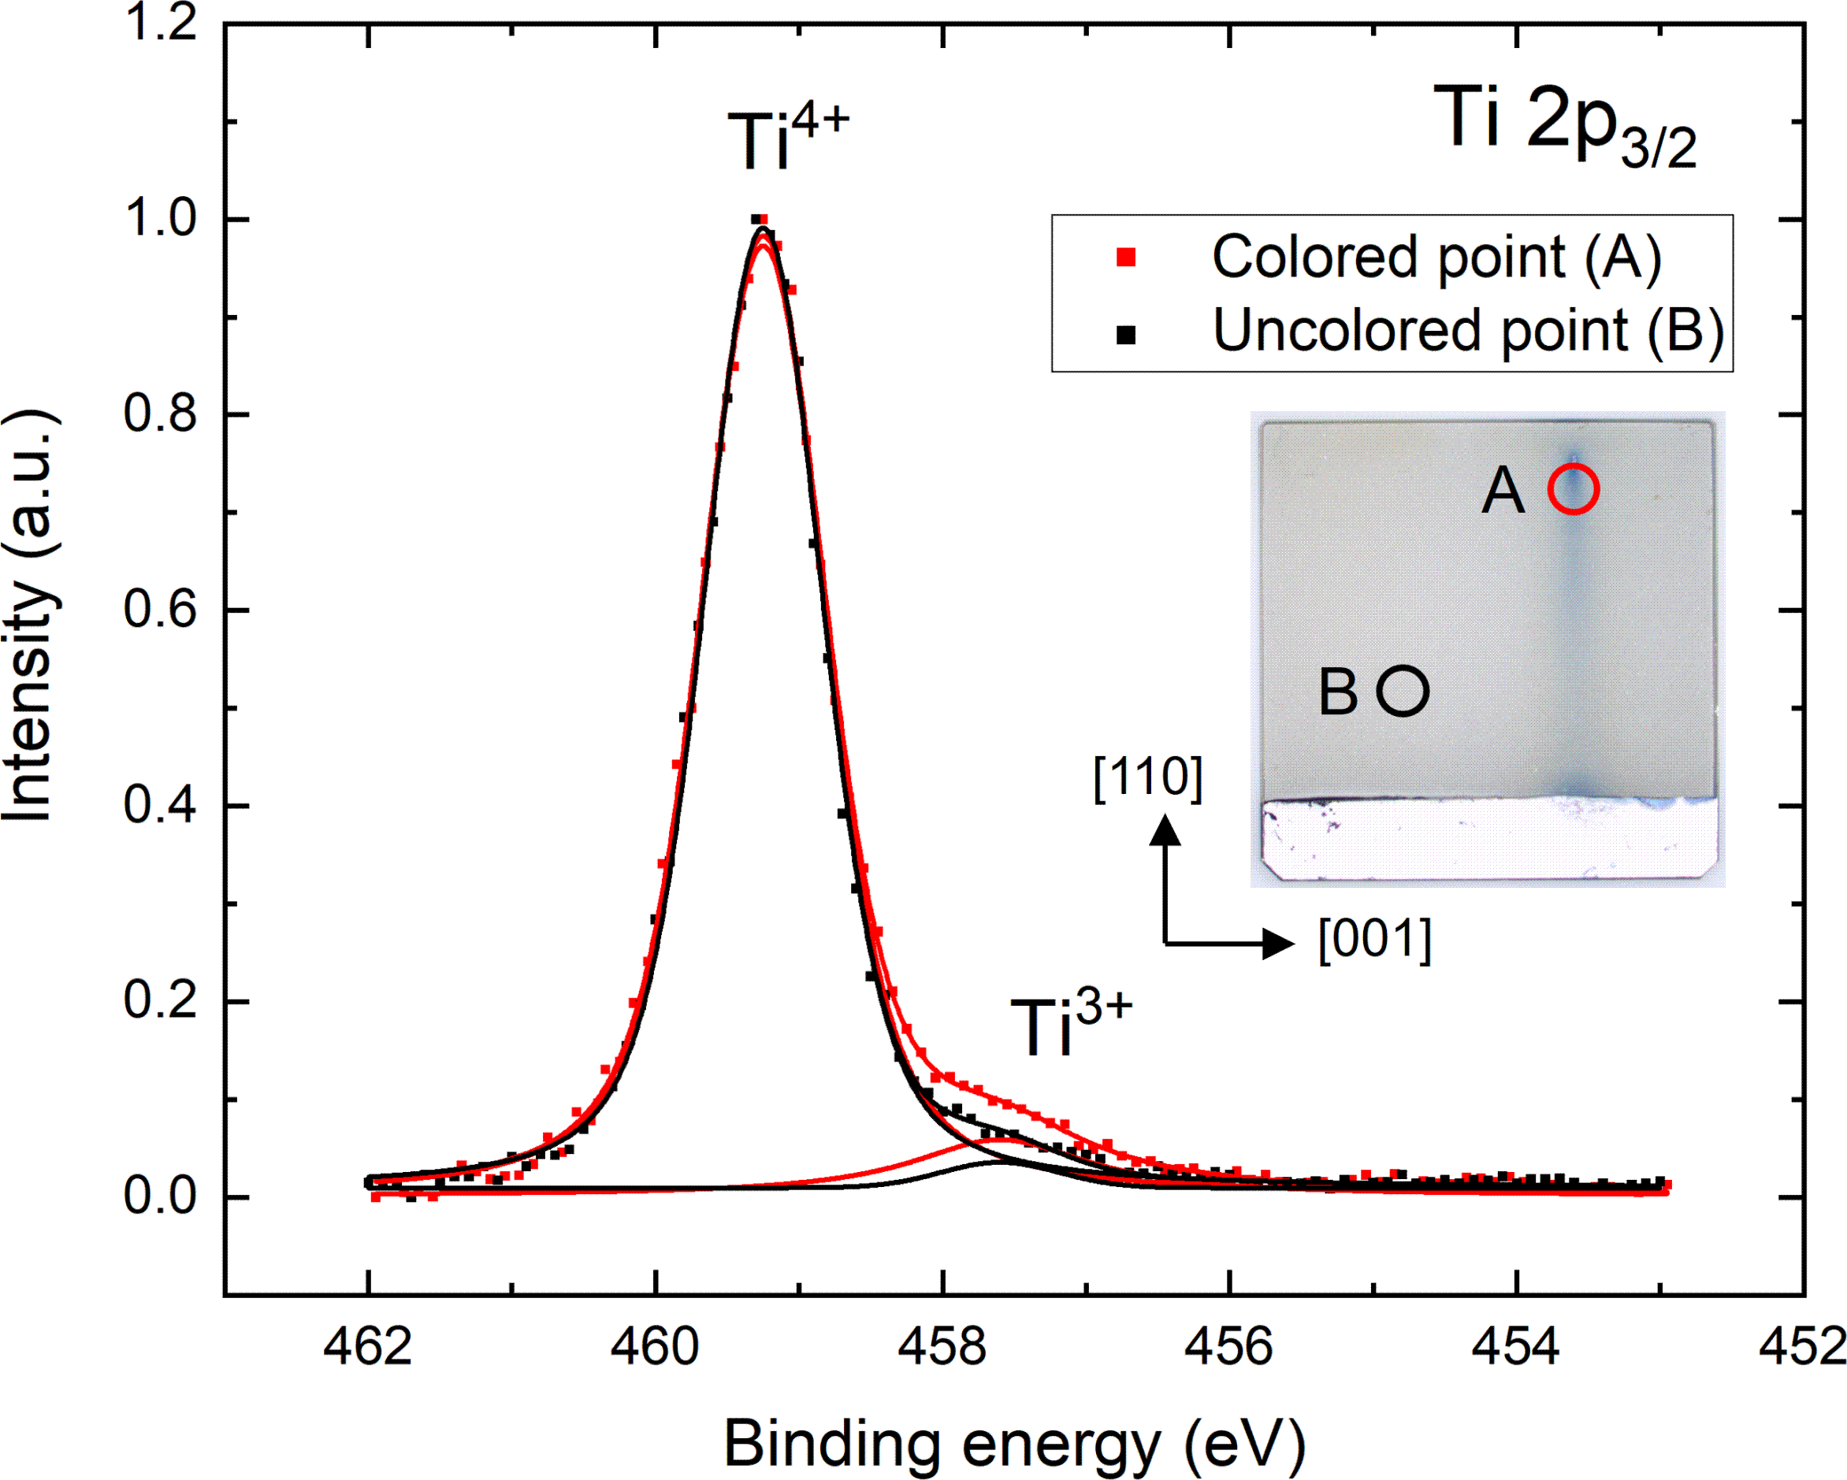
Fig. 5. HAXPES spectra of Ti 2p₃/2. The Voight function was applied for the peak ﬁtting. The spectra were measured at the electrolytically colored point A (red) and the uncolored point B (black). The inset shows the photo of the TiO₂ (110) sample used for the measurement, which was prepared by voltage bias annealing.
i.e. the opposite anisotropy to the present study. For example, Moore et al. have reported that oxygen self-diﬀusion at elevated temperature is slower per- pendicular to [001] than parallel by about half an order of magnitude. [17] The reported experimental anisotropy has been further supported by several theoretical studies. [18–21] For example, Bakulin et al. have pointed out that oxygen diﬀusion parallel to [001] is faster than perpendicular from electron density functional theory. [22] Since oxygen diﬀusion takes place via the di- rect vacancy mechanism, these previous studies indicate faster diﬀusion of V_{O} along the equivalent [001] direction. The origin of the contradiction on the V_{O} diﬀusion anisotropy between these previous reports and the present study is not clear at present. One possible explanation is the diﬀerent mi- gration mechanisms between thermal and electric ﬁeld-induced diﬀusion. In fact, the temperature required for these two diﬀusion mechanisms is signif- icantly diﬀerent. According to the previous studies, the thermal diﬀusivity of V_{O} perpendicular to [001] is described as 91exp(-2.4/kT ) cm²/s.[39] From this diﬀusivity, the diﬀusion length for voltage bias annealing in the present study is estimated to be negligibly small (1 nm at 673 K and 1 hour). This is obviously inconsistent with the mm size V_{O} ﬁlament observed in Fig. 4.
Figure 6 shows the (a) current at 50 V and (b) hysteresis area as a function of temperature in the I − V measurement with a stepwise increase of the

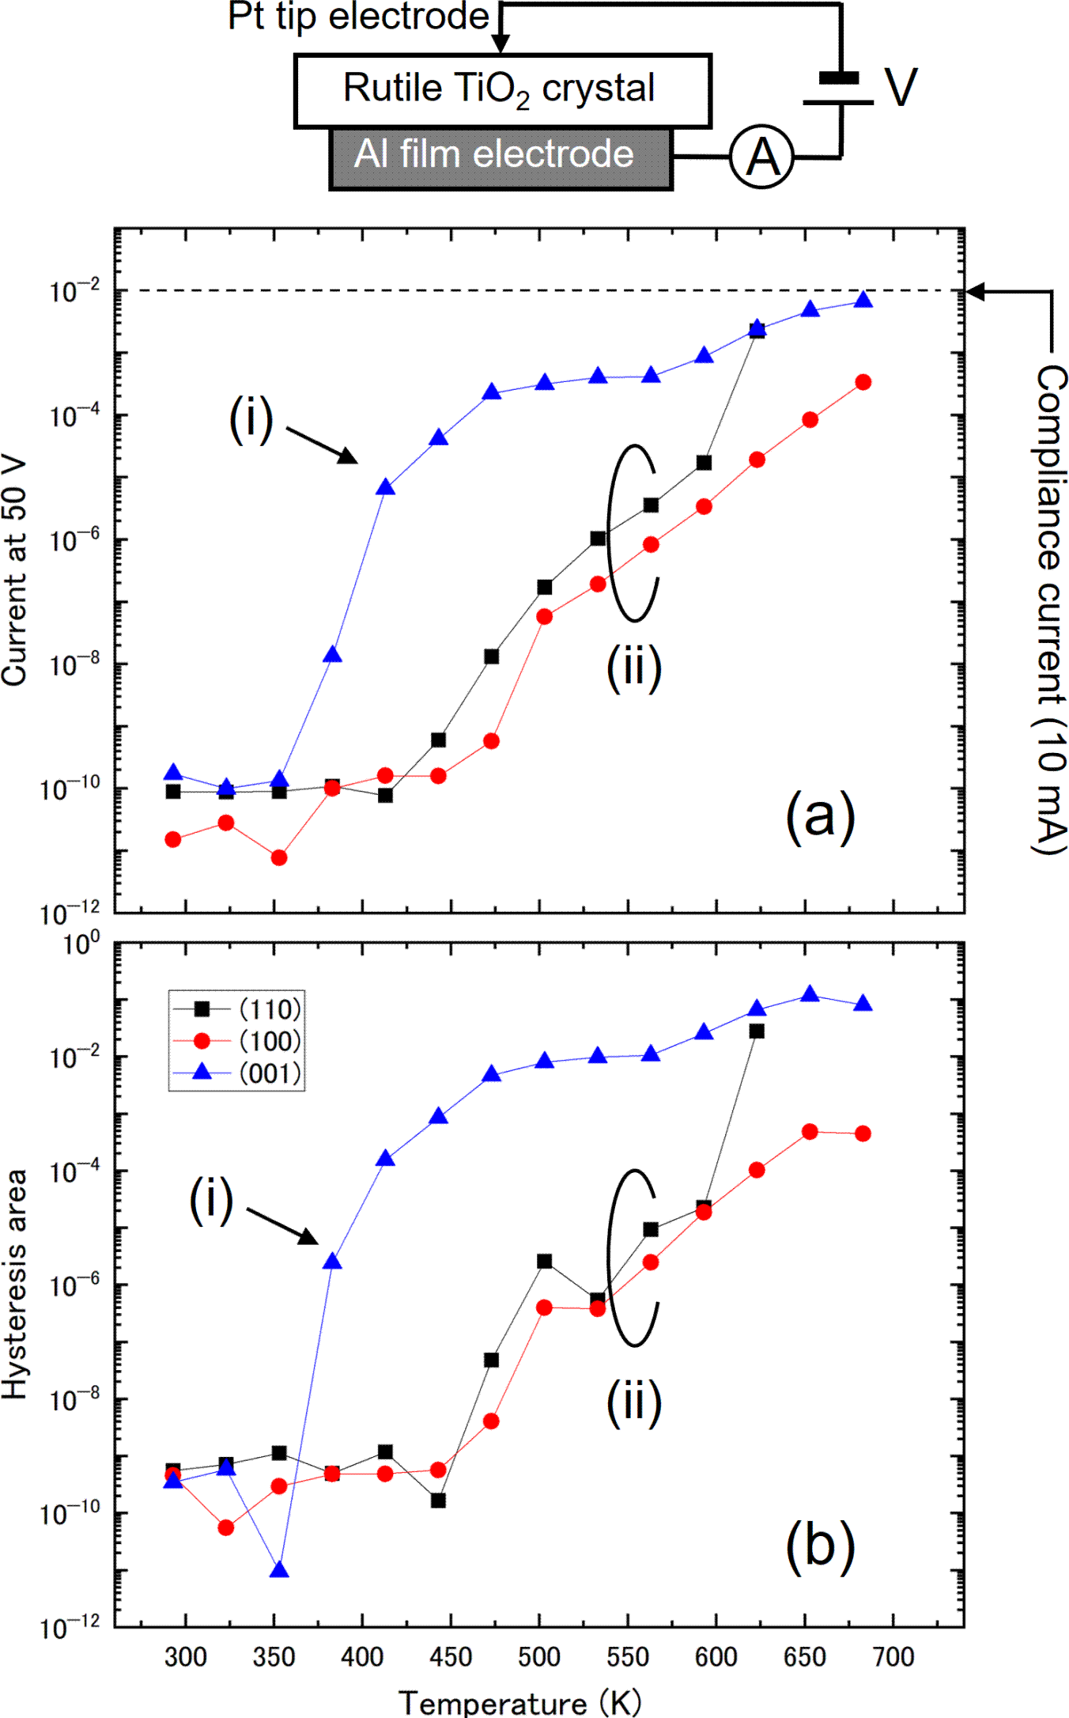
Fig. 6. Summary of (a) current at 50 V and (b) hysteresis area as a function of sam- ple temperature obtained from the I − V measurement in pure air at atmospheric pressure. The inset shows the geometry of the electrode arrangement.
temperature. Thus, the measurement method is similar to that shown in Fig. 2, but one of the ﬂat electrodes is changed to a point contact electrode as shown in the inset. It is observed that the low-temperature component (i) and the high-temperature component (ii) are reproduced even for the point―ﬂat electrode pair. However, both components (i) and (ii) are shifted to the high- temperature side. In fact, the current does not reach the compliance current (10 mA) at any orientation below 700 K, whereas the compliance current is reached at (110) and (100) below 600 K for the ﬂat electrode pair, as observed in Fig. 2. This shows that the contact area of the electrode governs the conduc- tivity. Since the conductivity is determined by the mobile dopant, the contact area of the electrode should inﬂuence the amount of the mobile dopant. The mechanism of the electrode interfacial reaction is followingly discussed for the V_{O} injection into TiO₂.

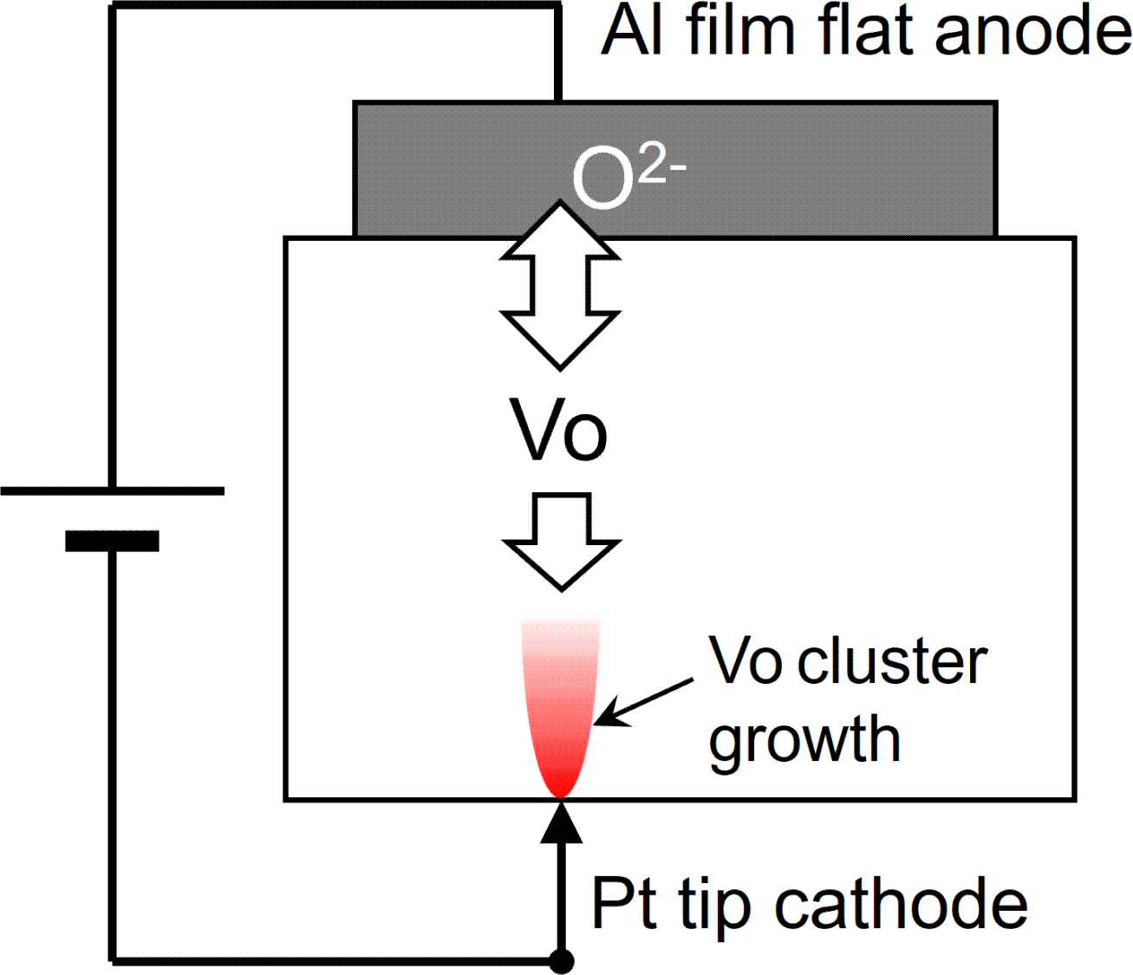
Fig. 7. The TOF-SIMS mosaic map of the ¹⁸O tracer concentration at the TiO₂
(110) sample surface after the voltage bias annealing in the ¹⁸O atmosphere. The geometry of the electrode arrangement is the same as that shown in Fig. 7.
The anodic reaction accompanied by the lattice oxygen migration under the electric ﬁeld has been observed by several groups. It has been considered that V_{O} is injected into TiO₂ by this anodic reaction (oxygen transfer reaction) as follows:
× → V•• + 1/2O₂ + 2e, (2)
O
O
O
where O× and V•• denote the lattice oxygen and the oxygen vacancy in the
O O
Kr¨oger-Vink notation, respectively. [10] The oxygen transfer reaction rate is considered to be largely inﬂuenced by the mobility of the counterpart V_{O}, hence it depends on the atomic arrangement of TiO₂ at the anode interface. Indeed, the electrolytic coloration by the voltage bias annealing is strongly dependent on the crystallographic orientation of the TiO₂ surface plane. [16] The injected V_{O} diﬀuses to the cathode by the electric ﬁeld (Fig. 7). If the cathode consists of a point contact terminal, the aggregation of the V_{O} takes place at the cathode contact position, which is visualized with the in-plane electrode conﬁguration as shown in Fig. 4. On the other hand, the electrolytic coloration is hard to visualize by the stacking geometry of the electrode pair as shown in Fig. 7 because of overlapping of the coloration and the ﬂat electrode.
The proposed mechanism drawn in Fig. 7 was examined by analyzing the distribution of a ¹⁸O tracer using TOF-SIMS. Figure 8 shows the TOF-SIMS mosaic map of the ¹⁸O tracer concentration at the surface of the TiO₂(110) sample prepared by the voltage bias annealing in the ¹⁸O₂ atmosphere. The ¹⁸O₂ gas (Isotec, 97 atom%) was introduced into the furnace during the voltage

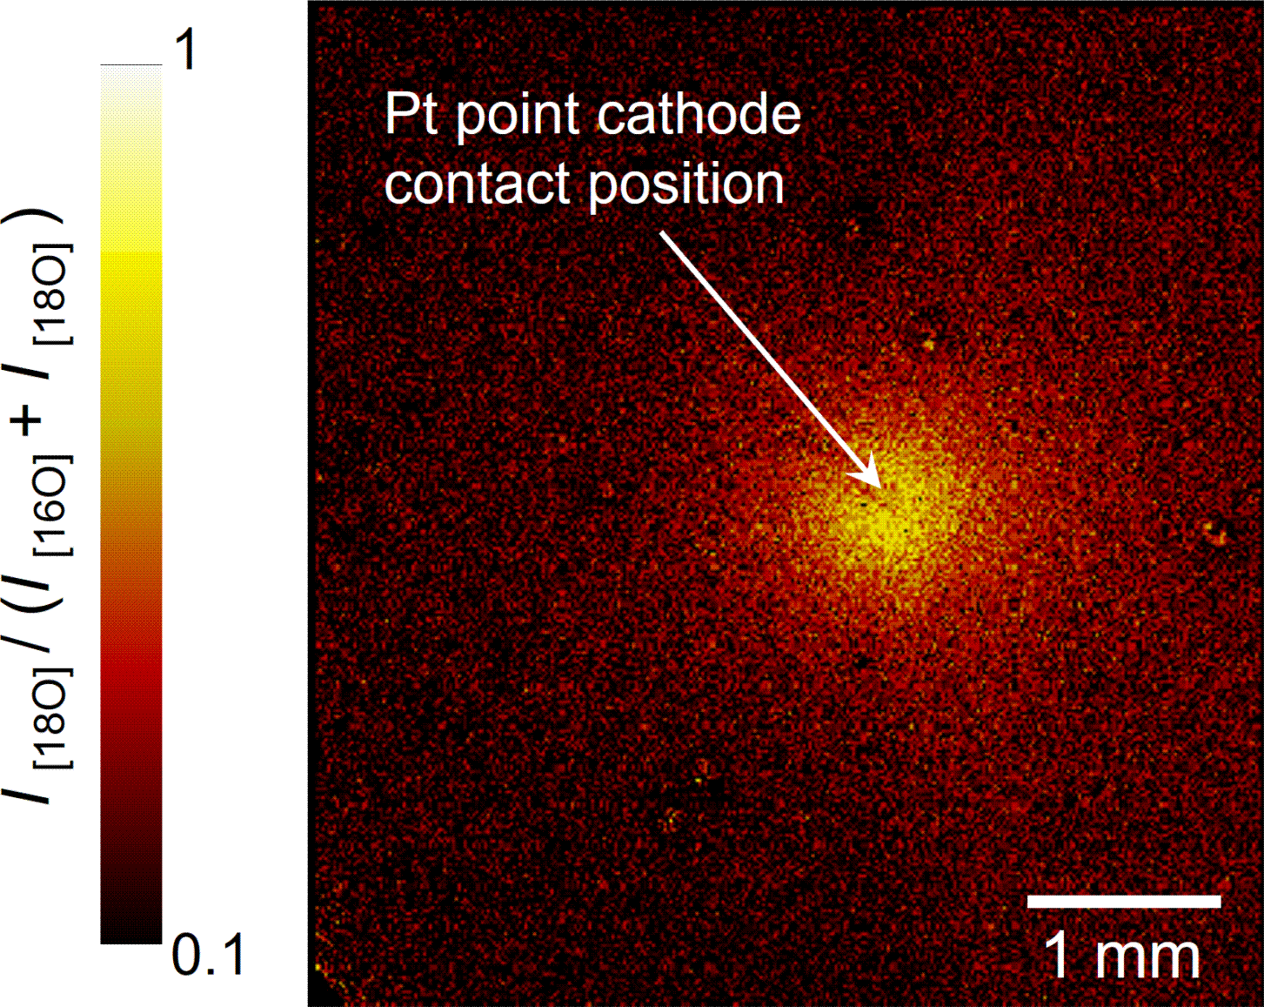

Fig. 8. Proposed mechanism of voltage bias annealing induced conductivity in TiO₂ with point cathode and ﬂat anode sandwiching the TiO₂ crystal. V_{O} is injected into TiO₂ at the anode interface, which then migrates to the cathode interface under the electric ﬁeld.
bias annealing that had been previously evacuated below 6×10⁻⁵ Pa. The
partial pressure of the ¹⁸O₂ gas in the furnace was 0.15 atmospheric pressure. The condition of the voltage bias annealing was as follows; the compliance current: 10 mA, the bias voltage: -300 V, and the temperature: 423 K. Thus, the temperature was set to the onset temperature of component (ii) in Fig. 2 that is attributed to the V_{O} aggregation at the electrode interface. Once the current reached the compliance current, the voltage bias annealing was immediately ﬁnished to minimize the eﬀect of the Joule heating.

In Fig. 8, the concentration of ¹⁸O is deﬁned to be I [¹⁸O]/(I [¹⁶O]+ I [¹⁸O]), where ¹⁶O and ¹⁸O are the TOF-SIMS intensities of ¹⁶O and ¹⁸O, respectively. It is observed that the ¹⁸O tracer concentrates at the point cathode position. This indicates faster incorporation of the ¹⁸O tracer at the point cathode position compared with other places. Because the incorporation of the ¹⁸O tracer into the TiO₂ substrate is mediated by V_{O} at the surface, this result demonstrates the concentration of V_{O} at the point cathode.
Finally, the relationship between the electrolytic coloration and the crystal structure is discussed. Figure 9 shows the θ − 2θ curve of X-ray diﬀraction (XRD) observed using Cu Kα (Rigaku MiniFlex 600) for an electrolytic col- ored TiO₂ (110) sample. The TiO₂ sample was powder, which was prepared

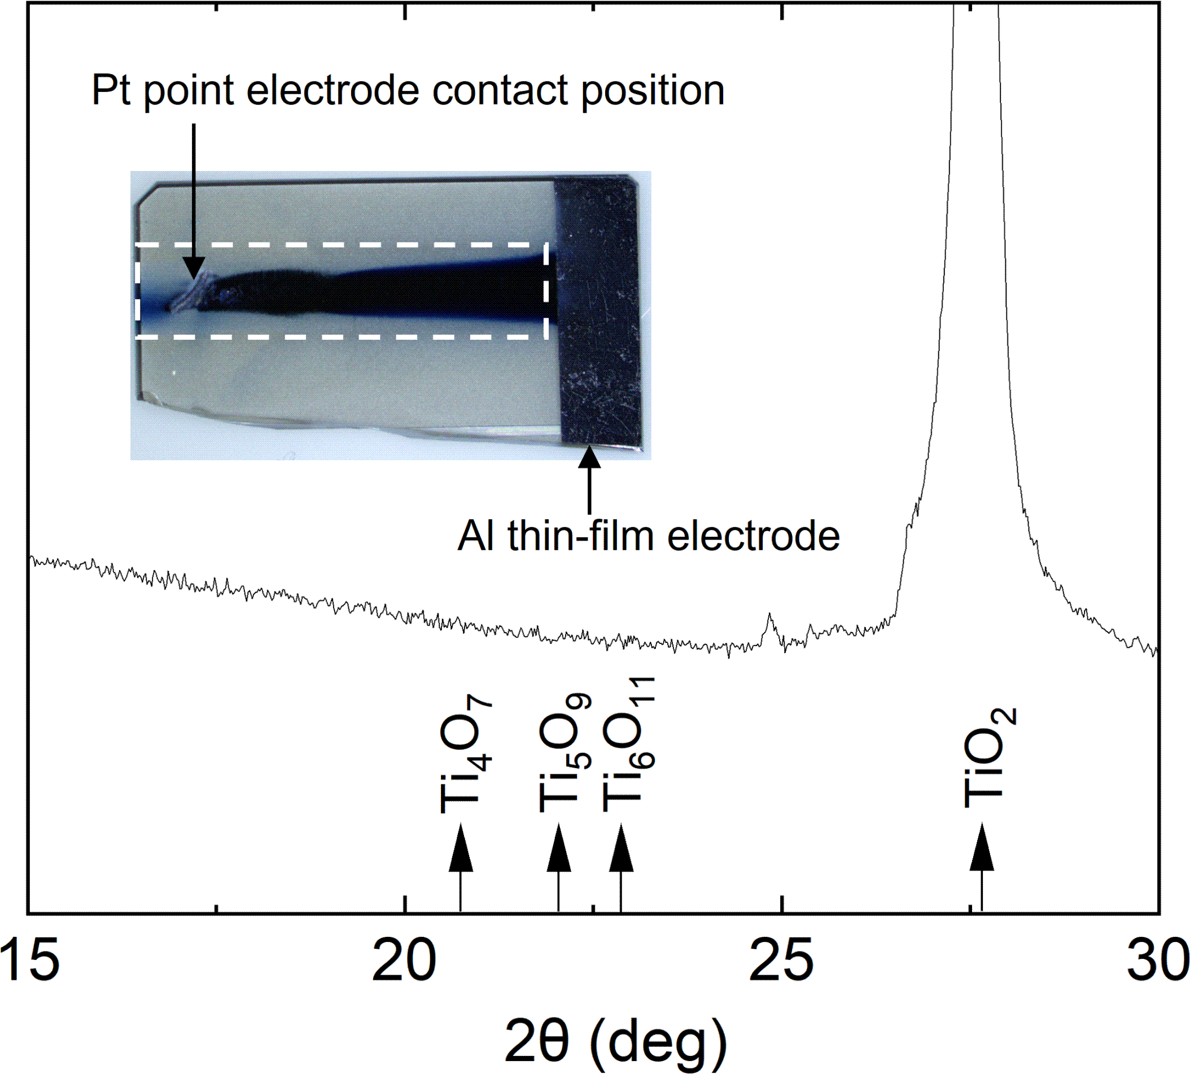
Fig. 9. A powder XRD pattern of the TiO₂ sample electrolytically colored by voltage bias annealing. The expected peak positions of the Magn`eli phase are indicated by arrows [41]. The inset shows the sample image taken before the sample was pulverized by milling. The area surrounded by the white dashed line was used for the measurement.
by milling the colored part indicated by a white dashed line box in the inset. The electrolytic coloration was performed by the voltage bias annealing at 673 K, 300 V, and the compliance current of 10 mA. The bias polarity of the Pt point electrode was initially set to negative. After reaching the compliance current that typically occurred within 30 min, the bias polarity was changed to positive, and further voltage bias annealing was performed to enhance the coloration.
Despite the clear contrast of the electrolytic coloration as shown in the in- set of Fig. 8, we observed no change in the crystal structure by XRD. Thus, the formation of the Magn`eli phase by the coloration was not recognized in the present study although several studies have claimed the formation of the oxygen-deﬁcient phases known as Magn`eli phase at the V_{O} ﬁlament.

It is proposed by Kwon et al that the formation of the nano-size V_{O} ﬁla- ment is mediated by the Magn`eli phase with the formula of Ti_{n}O_{2−n}(n > 4), which consists of oxygen-deﬁcient periodic shear planes in rutile TiO₂. [40] The Magn`eli phase has been also reported in the amorphous-to-crystalline transition in a TiO₂ ﬁlm by more recent studies. [11] On the other hand,

the contradictory result has been presented by Nagata et al that the elec- trolytic coloration is not accompanied by the Magn`eli phase. [15] Addition- ally, Skowronski group has reported Wadsley defects which are considered as a precursor to the formation of the Magn`eli phases, but the Magn`eli phase itself has not been detected. [14] Our result agrees with those previous studies that the Magn`eli phase is not formed with the V_{O} injection at the anode interface.

Conclusion

The electrical properties of a semi-insulating rutile TiO₂ single crystal in- duced by an electric ﬁeld were investigated in the temperature range between room temperature and 600 K. It was found that there are two diﬀerent mobile dopants responsible for the appearance of the conductivity by elevating the temperature, which is hydrogen and V_{O}. Because hydrogen migration is fastest along the open [001] channel, the ﬁeld-induced conductivity appears on (001) at substantially lower temperature than other crystal planes. It is likely that hydrogen is supplied from the surrounding air in the form of water molecules during the sample preparation. On the other hand, the conductivity appears at elevated temperature above 450 K on (100) and (110) by V_{O}. The conduc- tivity by V_{O} takes place at lower temperature on (100) and (110) compared with (001) because the V_{O} migration is the fastest perpendicular to [001]. It is proposed that V_{O} is injected into TiO₂ by the transfer reaction at the anode interface without forming the Magn`eli phase. Since two diﬀerent mo- bile dopants (hydrogen and V_{O}) are involved in the ﬁeld-induced conductivity, the interaction between those mobile dopants is crucial for understanding the mechanism of the recently proposed hydrogen sensing technique by using bias voltage induced-conductivity of a rutile TiO₂ crystal.

Acknowledgment

This work was partly supported by JSPS KAKENHI Grant No. 19K12633 and the Innovative Science and Technology Initiative for Security, ATLA, Japan,

Grant Number JPJ004596. The authors appreciate the XRD measurement by Dr. Y. Matsushita, and assistance of the TOF-SIMS operation by Dr. H. Yasufuku and Dr. N. Miyauchi.

References

- C. Leighton. Electrolyte-based ionic control of functional oxides, Nature Materials 18 (2019) 13.
- T. Miao, B. Cui, C. Huang, D. Wang, L. Liu, W. Liu, Y. Li, R. Chu, X. Ren, L. Liu, B. Cheng, G. Zhou, H. Qin, G. Xing, J. Hu, Gate-Tunable Anisotropic Oxygen Ion Migration in SrCoO_{x}: Toward Emerging Oxide-Based Artiﬁcial Synapses, Adv. Intell. Syst. (2023) 2200287.
- Z. Li, H. Liu, Z. Zhao, Q. Zhang, X. Fu, X. Li, F. Gu, H. Zhong, Y. Pan, G. Chen,
Q. Li, H. Li, Y. Chen, L. Gu, K. Jin, S. Yan, G. Miao, C. Ge, Q. Li, Space- Charge Control of Magnetism in Ferromagnetic Metals: Coupling Giant Magnitude and Robust Endurance, Adv. Mater. (2022) 2207353.
- Y. Cheng, S. Zhao, Z. Zhou, M. Liu, Recent development of E-ﬁeld control of interfacial magnetism in multiferroic heterostructures, Nano Research (2022) 2023-01-12.
- X. Liang, Y. Luo, Y. Pei, M. Wang, C. Liu, Multimode transistors and neural networks based on ion-dynamic capacitance, Nature Electronics 5 (2022) 859.
- H. Wang, Z. Cao, Y. Zhu, M. Liao, G. Gu, Q. Xue, D. Zhang, Tuning superconductivity of Bi₂Sr₂CaCu₂O_{8+x} by ﬂuoride ion intercalation with LaF₃ gate dielectric, J. Appl. Phys. 132 (2022) 214301.
- T.T. Suzuki, T. Ohgaki, Y. Adachi, I. Sakaguchi, Polarity reversal of resistance response to trace H₂ gas in the air between asymmetrically shaped electrodes on rutile-TiO₂ single crystal, J. Appl. Phys. 131 (2022) 034501.
- Y. Ma, D.A. Cullen, J.M. Goodwill, Q. Xu, K.L. More, Exchange of ions across the TiN/TaO interface during electroformation of TaO-based resistive switching devices, ACS Appl. Mater. Interfaces 12 (2020) 27378.
- D. Cooper, C. Baeumer, N. Bernier, A. Marchewka, C. La Torre, R.E. Dunin-Borkowski, S. Menzel, R. Waser, R. Dittmann, Anomalous resistance hysteresis in oxide ReRAM: Oxygen evolution and reincorporation revealed by in situ TEM, Adv. Mater. 29 (2017) 1700212.
- Y. Du, A. Kumar, H. Pan, K. Zeng, S. Wang, P. Yang, A.T.S. Wee, The resistive switching in TiO₂ ﬁlms studied by conductive atomic force microscopy and Kelvin probe force microscopy, AIP Adv. 3 (2013) 082107.
- X. Tian, C. Cook, W. Hong, T. Ma, G.L. Brennecka, X. Tan, In situ TEM study of the amorphous-to-crystalline transition during dielectric breakdown in TiO₂ ﬁlm, ACS Appl. Mater. Interfaces 11 (2019) 40726.

- H. Zhang, S. Yoo, S. Menzel, C. Funck, F. Cuppers, D.J. Wouters, C.S. Hwang, R. Waser, S. Hoﬀmann-Eifert, Understanding the coexistence of two bipolar resistive switching modes with opposite polarity in Pt/TiO₂/Ti/Pt nanosized ReRAM devices, ACS Appl. Mater. Interfaces 10 (2018) 29766.
- K. Tang, A.C. Meng, F. Hui, Y. Shi, T. Petach, C. Hitzman, A.L. Koh,
D. Goldhaber-Gordon, M. Lanza, P.C. McIntyre, Distinguishing oxygen vacancy electromigration and conductive ﬁlament formation in TiO₂ resistance switching using liquid electrolyte contacts, Nano Lett. 17 (2017) 4390.
- J. Kwon, A.A. Sharma, J.A. Bain, Y.N. Picard, M. Skowronski, Oxygen vacancy creation, drift, and aggregation in TiO₂ based resistive switches at low temperature and voltage, Adv. Funct. Mater. 25 (2015) 2876.
- Z. Nagata, T. Shimizu, T. Isaka, T. Tohei, N. Ikarashi, A. Sakai, Gate tuning of synaptic Functions Based on oxygen Vacancy Distribution Control in Fourterminal TiO_{2−x} Memristive Devices, Sci. Rep. 9 (2019) 10013.
- T.T. Suzuki, I. Sakaguchi, Anomalous durability of (001) plane against oxygen vacancy injection at electrode/rutile-TiO₂ interfaces, Surfaces and Interfaces 35 (2022) 102371.
- D.K. Moore, D.J. Cherniak, E.B. Watson, Oxygen diﬀusion in rutile from 750 to 1000 ◦C and 0.1 to 1000 MPa, Am. Mineral. 83 (1998) 700.
- H. Iddir, Serdar Ogut, P. Zapol, N.D. Browning, Diﬀusion mechanisms of native point defects in rutile TiO₂: Ab initio total-energy calculations, Phys. Rev. B 75 (2007) 073203.
- L. Zhu, Q.M. Hu, R. Yang, The eﬀect of electron localization on the electronic structure and migration barrier of oxygen vacancies in rutile, J. Phys.: Condens. Matter 26 (2014) 055602.
- L. Ru-Lin, F. Liang, H. Yue, C. Ya-Qing,Density functional theory calculation of diﬀusion mechanism of intrinsic defects in rutile TiO₂, Acta Phys. Sin. 67 (2018) 176101.
- T. Ichibha, A. Benali, K. Hongo, R. Maezono, Ti interstitial ﬂows giving rutile TiO₂ reoxidation process enhancement in (001) surface, Phys. Rev. Matter. 3 (2019) 125801.
- A.V. Bakulin, L.S. Chumakova, S.E. Kulkova, Study of the diﬀusion properties of oxygen in TiO₂, J. Exp. Theor. Phys. 133 (2021) 169.
- T.D. Schladt, T. Graf, N.B. Aetukuri, M. Li, A. Fantini, X. Jiang, M.G. Samant,
S.S.P. Parkin, Crystal-Facet-Dependent Metallization in Electrolyte- Gated Rutile TiO₂ Single Crystals, ACS Nano 9 (2013) 80740

- D. Long, N. Creange, A. Moballegh, E.C. Dickey, Electromigration-induced leakage current enhancement and its anisotropy in single crystal TiO₂, J. Appl. Phys. 125 (2019) 184101.
- J.R. Jameson, Y. Nishi, Role of Hydrogen Ions in TiO₂-Based Memory Devices 124 (2011) 112.
- Y. Liu, A.R. West, Voltage-dependent resistance of undoped rutile, TiO₂, ceramics, Appl. Phys. Lett. 103 (2013) 263508.
- O. Byl, J.T. Yates, Jr., Anisotropy in the Electrical Conductivity of Rutile TiO₂ in the (110) Plane, J. Phys. Chem B 110 (2006) 22966.
- A.G. Marinopoulos, R.C. Vilao, H.V. Alberto, J.M. Gil, Electronic structure and migration of interstitial hydrogen in the rutile phase of TiO₂, J. Phys.: Condens. Matter 30 (2018) 425503.
- A.J. Hupfer, E.V. Monakhov, B.G. Svensson, I. Chaplygin, E.V. Larvov,
Hydrogen motion in rutile TiO₂, Sci. Rep. 7 (2017) 17065.
- Y.B. Zhuang, R.H. Bi, J. Cheng, Resolving the odd―even oscillation of water dissociation at rutile TiO₂(110)―water interface by machine learning accelerated molecular dynamics, J. Chem. Phys. 157 (2022) 164701.
- Z.W. Wang, W.G. Chen, D. Teng, J. Zhang, A.M. Li, Z.H. Li, Y.N. Tang, The eﬀect of strain on water dissociation on reduced rutile TiO₂(110) surface, RSC Adv. 11 (2021) 8485.
- Y. Adachi, H. Sang, Y. Sugawara, Y.J. Li, Single hydrogen atom manipulation for reversible deprotonation of water on a rutile TiO₂
(110) surface, Communications Chemistry 4 (2021) 5.
- S. Tan, H. Feng, Q. Zheng, X. Cui, J. Zhao, J. Yang, B. Wang, J. G. Hou, Interfacial Hydrogen-Bonding Dynamics in Surface-Facilitated Dehydrogenation of Water on TiO₂(110), J. Am. Chem. Soc. 142 (2020) 826.
- L.B. Mo, Y. Wang, Y. Bai, Q.Y. Xiang, Q.Li, W. Q. Yao, J.O. Wang, K.
Ibrahim, H.H. Wang, C.H. Wan, J.L. Cao, Hydrogen Impurity Defects in Rutile TiO₂, Sci. Rep. 5 (2015) 17634.
- O.W. Johnson, S.-H. Paek, J.W. DeFord, Diﬀusion of H and D in TiO₂: Suppression of internal ﬁelds by isotope exchange, J. Appl. Phys. 46 (1975) 1026.
- A. Sarkar, G.G. Khan, The formation and detection techniques of oxygen vacancies in titanium oxide-based nanostructures, Nanoscale 11 (2019) 3414.
- H. Miyaoka, G. Mizutani, H. Sano, M. Omote, K. Nakatsuji, F. Komori, Anomalous electromigration of oxygen vacancies in reduced TiO₂, Solid State Commun. 123 (2002) 399.

- L.A. Bursill, M.G. Blanchin, bf Structure of cation interstitial defects in nonstoichiometric rutile, J. Physique 44 (1983) L165.
- E. Iguchi, K. Yajima, Diﬀusion of Oxygen Vacancies in Reduced Rutile (TiO₂) J. Phys. Soc. Jpn. 32 (1972) 1415.
- D.H. Kwon, K.M. Kim, J.H. Jang, J.M. Jeon, M.H. Lee, G.H. Kim, X.S.
Li, G.S. Park, B. Lee, S. Han, M. Kim, C.S. Hwang, Atomic structure of conducting nanoﬁlaments in TiO₂ resistive switching memory, Nature Nanotechnology 5 (2010) 148.
- F.C. Walsh, R.G.A. Wills, The continuing development of Magn`eli phase
titanium sub-oxides and Ebonex⃝R electrodes, Electrochimica Acta 55 (2010) 6342.

