Microstructure and thermoelectric properties of pristine and Al-doped ZnO ceramics fabricated by wet chemistry methods
ª International Center for Materials Nanoarchitectonics (WPI-MANA), National Institute for Materials Science (NIMS), 1-1 Namiki, Ibaraki, Tsukuba, 305-0044, Japan.
^{b} Graduate School of Pure and Applied Sciences, University of Tsukuba, 1-1-1 Tennodai, Ibaraki, Tsukuba, 305-8573, Japan.
^{c} National University of Science and Technology MISIS (NUST MISIS), Leninsky av. 4, Moscow, 119049, Russia.
^{d} Belgorod State University, Pobedy st. 85, Belgorod, 308015, Russia.
* E-mail: novitskii.andrei@nims.go.jp
Illia Serhiienko,^{a,b} Andrei Novitskii,^{a,*} Evgeniy Kolesnikov,^{c} Tatyana Sviridova,^{c} Kirill Kuskov,^{c} Andrei Voronin,^{c} Vladimir Khovaylo^{c,d} and Takao Mori^{a,b}
Abstract: We have shown that mainly due to the differences in microstructure and possibly the varying amount of crystalline defects in the samples, the thermoelectric performance of bulk ZnO samples obtained through wet chemistry methods is 4 times higher compared to the sample obtained from commercially available ZnO powder. By utilizing the developed chemical precipitation technique, we successfully synthesized a series of Al-doped samples with a nominal composition of Zn_{1–x}Al_{x}O (x = 0.02, 0.04, 0.06). The incorporation of Al into ZnO results in two significant effects: (1) partial substitution of Zn by Al, leading to an increase in the power factor, and (2) the formation of ZnAl₂O₄ spinel phase, which has negligible influence on electronic transport but acts as a scattering center for phonons in addition to the mass and strain fluctuations induced by the partial substitution of Zn with Al. Consequently, the thermoelectric performance was further improved by a factor of 3 through Al doping, achieving a zT value of approximately 0.12 at 1100 K for the sample with a nominal composition of Zn_{0.94}Al_{0.06}O.
Keywords: zinc oxide, thermoelectric materials, wet chemistry, spark plasma sintering
Introduction
ZnO, a wide bandgap semiconductor with non-toxic, environmentally friendly, abundant, and highly stable elements, has found applications in optoelectronic devices, solar cells, gas sensors, and other innovative technologies [1,2]. Its high electron mobility (μ), attributed to a large Seebeck coefficient (α) and low density of states effective mass (m_{d}*), has led to investigations into its potential for thermoelectric applications [3]. Besides the Seebeck coefficient, the thermoelectric figure of merit (zT) is influenced by both electrical conductivity (σ) and total thermal conductivity (κ_{tot}) as zT = α²σT/κ_{tot}, where T represents the absolute temperature, and κ_{tot} is the sum of electronic (κ_{el}) and lattice (κ_{lat}) components of thermal conductivity [4]. However, the small electronegativity difference between Zn and O limits the charge carrier concentration (n) and results in very poor electrical conductivity thus limiting the power factor (α²σ) of ZnO. Moreover, the simple wurtzite crystal structure of ZnO, strong ionic bonds, and light atomic mass of constituents lead to high lattice thermal conductivity, resulting in a total thermal conductivity of around 50 W m^{–1} K^{–1} at room temperature [5,6]. All of the abovementioned have limited the performance of ZnO as thermoelectric material. To overcome these limitations, a high power factor in ZnO can be achieved along with reduced thermal conductivity via doping, incorporation of nanostructures, point defects, interfaces, and grain boundaries [7]. Moreover, the transport properties of ZnO are strongly affected by the microstructure, which, in turn, is largely determined by the sintering technique and the type and size of the powder particles used for the bulk sample preparation [8–16]. Depending on the fabrication method, various types of defects can form in the material, including oxygen vacancies and zinc/oxygen interstitials, leading to an increase in the charge carrier concentration [1,10,17–19].
Another equally important way to push ZnO towards practical applications is the development of new energy-efficient and scalable methods for its synthesis. In this context, oxide materials, including ZnO, have a significant advantage since they can be relatively easily obtained through wet chemical methods that are usually considered to be suitable for industrial-scale production of the materials. From this point of view, we have systematically investigated of the microstructure and the thermoelectric properties of bulk ZnO sintered from ZnO powders fabricated by ultrasonic spray pyrolysis or chemical precipitation. We also prepared a series of Al-doped samples with nominal composition Zn_{1–x}Al_{x}O (x = 0.02, 0.04, 0.06) using the chemical precipitation. The introduction of Al into ZnO leads to (1) partial substitution of Zn with Al, resulting in an increase in the power factor, and (2) the formation of ZnAl₂O₄ spinel phase, which has a minimal impact on electronic transport but acts as a scattering center for phonons in addition to the mass and strain fluctuations caused by the partial substitution of Zn with Al. Consequently, for the sample with the highest nominal Al content, we were able to achieve a zT value of ~0.12 at 1100 K, which is in good agreement with previously published results for Al-doped ZnO [10,16,20].
Experimental details
Chemical precipitation. A 10% cationic solution was prepared by dissolving Zn(NO₃)₂·6H₂O (≥98%, Vekton, Russia) in deionized water (Milli-Q Water, Millipore, Germany). The precipitation process involved the dropwise addition of the prepared cationic solution and a 10% water solution of NaOH (≥98.5%, Vekton, Russia) into a reactor containing stirring deionized water [21]. The synthesis was carried out at room temperature in an air atmosphere, and the pH was kept around 13 using a pH-meter (Expert-pH 001, Econics Expert, Russia) with an uncertainty of ±0.03. The resulting gel-like precipitate was subjected to centrifugation at 4000 rpm for 30 minutes using a Rotanta 460 centrifuge (Hettich, Germany). This centrifugation step was repeated three times. The product was then separated from the mixed solution by filtering and decantation, followed by rinsing with deionized water multiple times. Finally, the powder was air-dried at room temperature for 48 hours. Subsequently, the obtained powder was calcined in an air atmosphere at 700 °C for 1 hour. This sample was labeled as CP throughout the text.
Ultrasonic spray pyrolysis. The same 10% water solution of zinc nitrate was used as the precursor solution. The solution was placed in a container with an ultrasonic generator (DK, Mist Maker). When the ultrasonic generator was activated, it generated aerosol fog at a frequency of 1.7 MHz. The aerosol passed through a silica reactor at a constant speed, which was maintained using two mini diaphragm pumps (D-7911, KNF Neuberger AB, Sweden). The silicon reactor was heated to a temperature of 700 °C using a tube furnace (20-250/13, Nabertherm, Germany). The resulting hollow microspheres of ZnO powder were collected using a mechanical stainless-steel filter in the pyrolysis collection chamber. The powder was further annealed in the air for 1 hour at 700 °C. This sample was labeled as USP throughout the text. For more details on the powder sample preparation, refer to previously published works [22,23].
Al-doped samples. As mentioned in the Introduction, one way to improve the thermoelectric performance of zinc oxide is through doping. Aluminum (Al) has been widely recognized as one of the most effective dopants for this purpose. Therefore, to prepare Al-doped samples, we carried out chemical precipitation of Al(NO₃)₃∙9H₂O (≥98%, Vekton, Russia) employing the same parameters utilized for the fabrication of pure ZnO, except for the pH value, which was maintained to be 12 for the whole precipitation process. Following the successful synthesis of both Al₂O₃ and ZnO, the powders were mixed by means of ball milling (400 rpm for 15 min in the air) in a desired ratio to obtain Al-doped samples with a nominal composition of Zn_{1–x}Al_{x}O (x = 0.02, 0.04, 0.06).
Spark plasma sintering. All the powders were densified by the spark plasma sintering (Labox 650, SinterLand, Japan) under the uniaxial pressure of 50 MPa in a vacuum at 1273 K for 8 min, resulting in a disk-shaped specimen with dimensions of Ø12.7 × 10 mm. For comparison, one more ZnO bulk sample was obtained by SPS with the same parameters from the commercially available nanopowder (99.99%, Sigma-Aldrich, USA) without any prior processing (labelled as CS).
Characterization. X-ray diffraction (XRD) patterns were collected using an X-ray diffractometer (DRON-4, IC Bourevestnik, Russia) using CoKα radiation (λ = 1.7902 Å). The Rietveld refinements were performed using the self-developed software package [24]. Raman spectra were recorded using DXR 3 Raman microscope (Thermo Scientific, USA) with a 532 nm excitation laser. The laser power was set to 2 mW. All spectra were collected using 16 exposures when every exposure length was 2 s. Scanning electron microscopy (SEM; Vega 3 SB, Tescan, Czech Republic) in conjunction with energy-dispersive X-ray spectroscopy (EDS; x-act, Oxford Instruments, UK) was employed to observe the morphology of fabricated powders, the microstructure, and the chemical composition of as-synthesized bulk specimens. The effective average particle size of all the powders was calculated in the assumption of identical size and spherical shape for all particles as D_{eff} =6d_{th}^{–1}A^{–1}, where d_{th} = 5.61 g cm^{–3} is the theoretical density of ZnO, A is the specific surface area calculated using Brunauere-Emmette-Teller (BET) method from the N₂ gas low-temperature (77 K) adsorption/desorption isotherms measurements performed by using a Nova 1200e analyzer (Quantachrome Instruments, USA) [25]. Data processing was carried out utilizing the "Rouquerol criteria" to evaluate whether isothermal adsorption data meet the assumptions of BET analysis [26,27]. The average pore size and pore volume distributions were determined using Barrett-Joyner-Halenda (BJH) method [28]. Particle size distribution analysis was conducted using photon correlation spectroscopy (also known as dynamic light scattering, DLS) with the Zetasizer Nano ZS instrument (Malvern Instruments Ltd, UK). The mean particle size was determined by fitting the particle size distribution curve with a unimodal lognormal distribution function. The SPS-processed pellets were cut into disk-shaped samples with diameter of 12.7 mm and 2 mm thickness for the thermal diffusivity measurements. Thermal diffusivity χ was obtained by a laser flash diffusivity method (LFA 457 MicroFlash, Netzsch, Germany). The specimens were coated with a ~100 nm thick layer of platinum to avoid the reaction between zinc oxide and graphite, which is also used as coating during LFA measurements in order to increase accuracy and minimize errors attributed to transparency of the ZnO to infrared radiation. The thermal diffusivity data were analyzed using a Cape-Lehman model [29] with pulse correction. The thermal conductivity κ_{tot} was estimated from LFA measurements as κ_{tot} = χ∙C_{p}∙d, where the C_{p} is the heat capacity calculated by the Debye model [30], and d is the volume density measured by the Archimedes method. For the electrical transport properties measurements, the pellets were cut along the radial direction of the disk-shaped samples into bars with dimensions of about 12 mm × 2.5 mm × 1.5 mm. The electrical conductivity σ and the Seebeck coefficient α were measured using a commercial instrument (ZEM-2, ULVAC, Inc., Japan) with a standard four-probe configuration under a He atmosphere. To verify the reproducibility of the data, the electrical transport properties were also measured by the four-probe and differential methods using a laboratory-made setup (Cryotel Ltd., Russia) in a He atmosphere with a temperature step of ~1 K.
Table 1. Code, actual composition calculated from EDS, effective average particle size D_{eff} calculated from the specific area, mean particle D_{SEM} estimated from SEM images, and weighted mean size D_{DLS} calculated from DLS measurements for ZnO powders obtained by different methods; the average grain size D_{g,SEM}, the volume density d, lattice parameters a, b, c and crystalline size D_{XRD} of obtained bulk ZnO samples.
Code | EDS composition | D_{eff} (nm) | D_{SEM} (nm) | D_{DLS} (nm) | D_{g,SEM} (µm) | d (g cm^{–3}) | a, b (Å) | c (Å) | D_{XRD} (nm)
CS | Zn_{1.05}O_{0.95} | 100± 10 | 160 ± 40 | 360 ± 50 | 4.0 – 6.4 | 5.51 | 3.2495(2) | 5.2044(3) | 76 ± 7
USP | Zn_{1.08}O_{0.92} | 290 ± 30 | 200 ± 40 | 1140 ± 150 | 1.5 – 2.3 | 5.43 | 3.2500(2) | 5.2028(3) | 67 ± 6
CP | Zn_{1.07}O_{0.93} | 550 ± 60 | 250 ± 90 | 750 ± 80 | 1.2 – 2.2 | 5.48 | 3.2500(2) | 5.2029(3) | 77 ± 7

Results and discussion
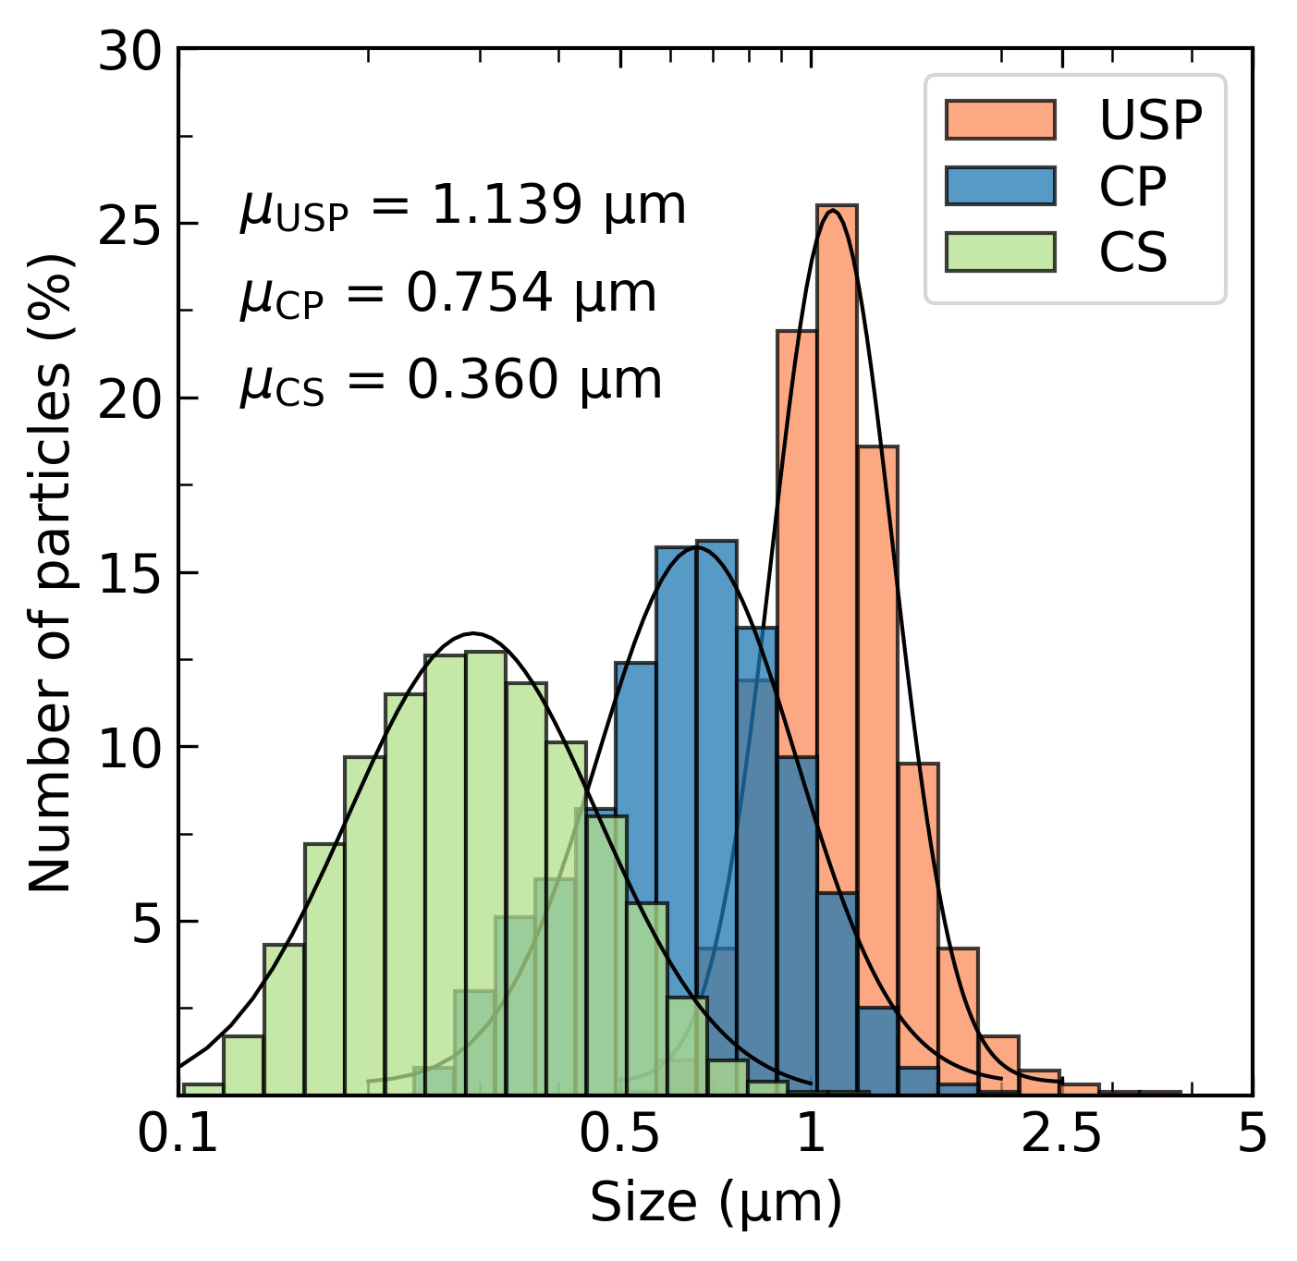
Figure 2. Particle size distribution of different ZnO powders prior to spark plasma sintering (SPS), including the commercial one (CS), and those synthesized through ultrasonic spray pyrolysis (USP) and chemical precipitation (CP) methods. The symbol µ denotes the mean particle size, which is calculated using the lognormal distribution density function.
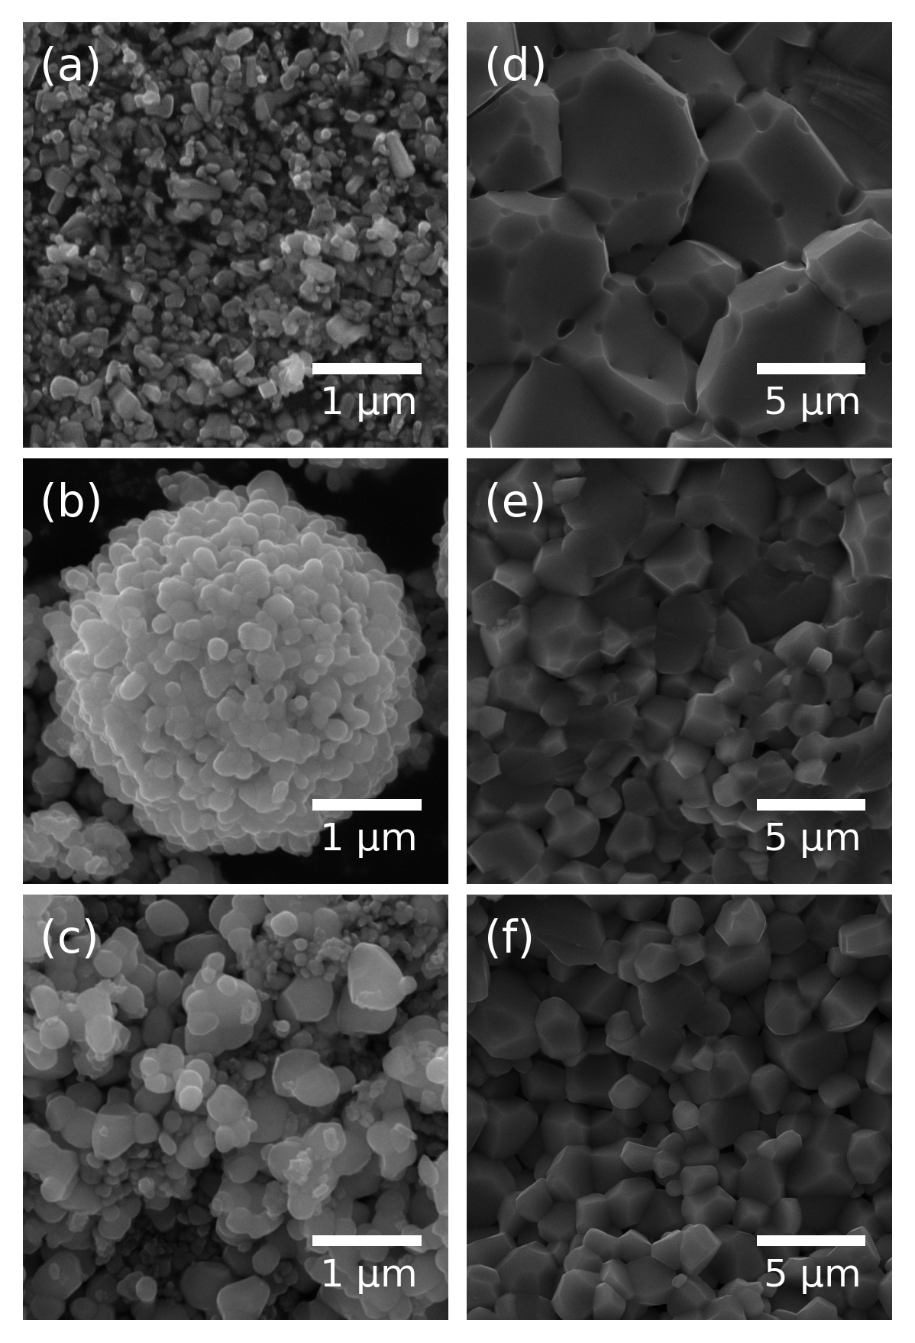
Figure 1. Scanning electron micrographs of (a – c) ZnO powders before SPS: (a) commercial one, and obtained by (b) ultrasonic spray pyrolysis, (c) chemical precipitation; (d – f) fractured surfaces of ZnO bulks sintered from these powders, respectively.
It is worth noting that the powders' size characteristics were analyzed using different methods, as mentioned in the previous section (Table 1). Each method allows one to determine a specific characteristic size; however, it is important to understand that the three obtained size characteristics (DLS, SEM, and BET, respectively) represent different average sizes in reality. Nonetheless, our main focus was to conduct a comparative analysis of the powders, and all three methods clearly demonstrated that the particle size increases from CS to CP powder. Moreover, all the powders exhibited distinct morphology. The particles of the CS powder displayed an elongated shape without a propensity for aggregation, exhibiting an average size ranging between 100 and 400 nm (Fig. 1a, Fig. 2, and Table 1). In contrast, the USP powder particles exhibited isometric shapes with sizes around 200 – 300 nm and were arranged in hollow aggregates with a spherical shape and dimensions in the micron scale (Fig. 1b, Fig. 2, and Table 1). The CP powder particles, in turn, appeared as shapeless polyhedrons with sizes ranging from 250 to 750 nm and a tendency to aggregate, resulting in aggregate sizes also reaching the micron scale (Fig. 1c, Fig. 2, and Table 1).
Despite noticeable differences in powder morphology and porosity (see Fig. S1) before sintering, all samples exhibited a dense microstructure with micron-sized isotropic grains after sintering (Fig. 1d – f). One can notice that the grain size for the samples obtained from the USP and CP powders is obviously smaller (Fig. 1, Table 1) [8,31]. Nevertheless, there are no discernible differences in the XRD patterns obtained for all samples at room temperature (Fig. 3a). The main Bragg reflections match with the wurtzite structure, confirming the presence of a pure ZnO phase with the P6₃mc space group. Moreover, the lattice parameter and the average crystalline size are found to be similar across all samples, as determined from the Rietveld refinements, estimating approximately 3.250 Å, 5.203 Å, and 73 nm, respectively (Table 1). These values are in excellent agreement with the literature [32,33]. In turn, the elemental composition of the samples corresponds to the nominal composition (Table 1) and, in fact, does not differ regardless of the method used to obtain bulk samples. The Raman spectra (Fig. 3b) further confirm the similarity of the samples in terms of crystal structure. The spectra exhibit various phonon modes at the Γ point of the Brillouin zone, which for wurtzite ZnO are represented as Γ_{opt} = A₁ + E₁ + 2E₂ + 2B₁ [34]. The A₁ and E₁ modes are Raman active polar modes, which split into TO (transverse optic) and LO (longitudinal optical) phonons. The E₂ mode represents a nonpolar Raman active mode consisting of E₂^{high} and E₂^{low} modes. The characteristic band of ZnO associated with the vibration of oxygen atoms is represented by the E₂^{high} mode at ~429 cm^{–1}. The E₂^{low} mode depicts the vibrations of the Zn sublattice. The E₂-TO mode at 332 cm^{–1} represents the difference between E₂^{high} and E₂^{low} modes. The A₁-TO and E₁-TO modes have wavenumbers of ~381 and ~409 cm^{–1}, respectively.
As mentioned before, the electrical conductivity and Seebeck coefficient of pristine ZnO are strongly influenced by the processing conditions, primarily due to variations in the charge carrier concentration originating from the presence of different types of defects (such as vacancies, interstitials, or antisites in the Zn and O sublattices) [35]. Consequently, the electrical conductivity of bulk ZnO sintered from commercially available (CS) powder was significantly lower compared to samples fabricated from CP and USP powders at room temperature (Figure 4a). Furthermore, the temperature dependencies of electrical conductivity exhibited distinct behaviour among the three samples. Although defects are speculated to play a role, determining the specific reason for this difference in σ(T) requires further extensive investigations, e.g., first-principle native defects calculations, etc. Nevertheless, as discussed above, the temperature dependence of ZnO electrical conductivity can exhibit either degenerate or non-degenerate behavior, depending on the synthesis method and the type of powder/sintering utilized [10,11].
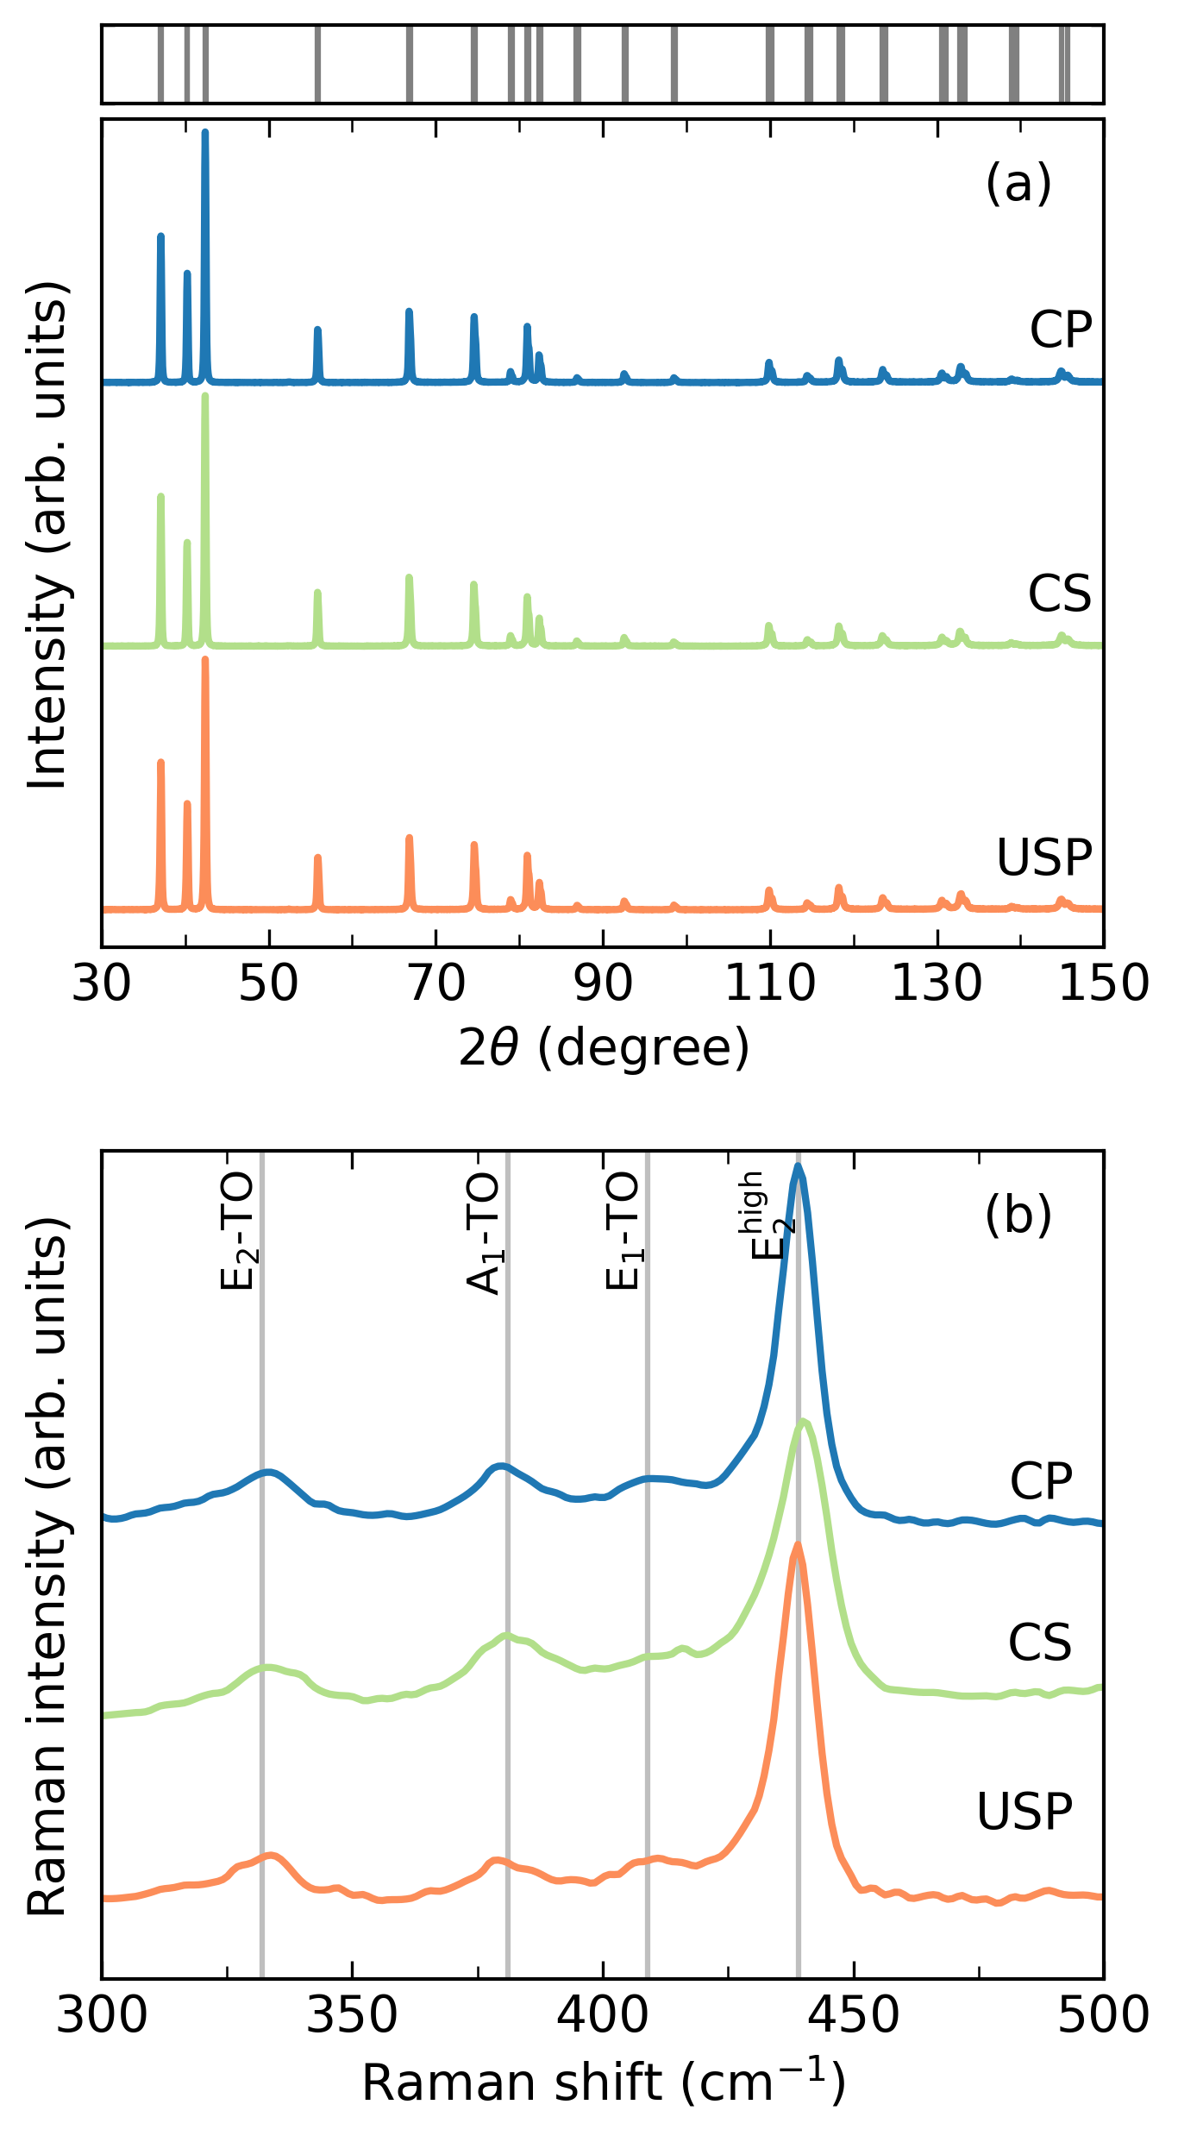
Figure 3. (a) XRD patterns and (b) Raman spectra of the CP, CS, and USP ZnO samples after SPS. Bragg’s reflections for the ZnO phase are indicated by gray ticks on the top part of the figure.
The temperature dependencies of the Seebeck coefficient for all samples appeared similar; however, the absolute values obtained for the CS sample were approximately 35% higher at room temperature and almost the same as those for the CP and USP samples at 1173 K (Fig. 4b). Clearly, the power factor (α²σ) of the CP and USP samples was significantly higher compared to the CS sample, with a value of around 1.7 µW cm^{–1} K^{–2} for both of them at 1173 K (Fig. S2). Considering the changes in the electrical conductivity, Seebeck coefficient, and the weighted mobility of charge carriers (Fig. S3) at room temperature, it can be carefully speculated that the increase in the power factor of the USP and CP samples is most likely attributed to a rise in carrier concentration, which is in line with the previous discussion.
Similarly, the thermal conductivity of the obtained samples also depends on the synthesis method, especially at low temperatures (Fig. 4с). The thermal conductivity of the CS sample at room temperature was found to be approximately 50 W m^{–1} K^{–1}, which is in good agreement with previously reported values [2,5]. In contrast, the CP and USP samples demonstrated noticeably lower thermal conductivities, exhibiting 43 and 38 W m^{–1} K^{–1}, respectively. However, at low temperatures, phonon scattering at grain boundaries and point defects predominates, while at high temperatures, the dominant scattering mechanism is the Umklapp process [36]. Consequently, at 1173 K, the thermal conductivities of the samples decreased to 5.9, 5.6, and 5.3 W m^{–1} K^{–1} for CS, CP, and USP samples, respectively (Fig. 4c).
The CP sample exhibited zT values below 0.01 across the entire temperature range, consistent with previous findings [10,11]. However, the CP and USP samples demonstrate significantly higher zT values, reaching approximately 0.04 at 1173 K. This enhancement can be attributed to the increase in the quality factor, β ∝ μ_{w}T^{5/2}/κ_{lat}, where μ_{w} represents the weighted mobility related to drift mobility as μ_{w} ≈ μ(m_{d}*/m_{e})^{3/2} (with m_{e} representing the electron mass). The quality factor determines the maximum achievable zT value for a given material at a given temperature [37]. In the case of both CP and USP samples, the μ_{w}/κ_{lat} ratio (for pure ZnO, κ_{tot} ≈ κ_{lat}) was significantly increased, leading to the observed enhancement of zT (Fig. 4d).
X-ray diffraction analysis for Al-doped samples revealed that the majority of observed XRD peaks (Fig. S4) correspond to those of the pure ZnO phase. Notably, the peaks at 2θ = 36.56° and 43.16° can be attributed to the most intense peaks of the ZnAl₂O₄ spinel phase. It is important to note that the solubility limit of Al in ZnO is exceedingly low, approximately 0.3 mol% [38]. Thus, the formation of ZnAl₂O₄ cannot be avoided during the preparation process of Al-doped ZnO [16], and even in the sample with a nominal Al concentration of x = 0.02, a discernible quantity (~0.2 vol%) of the spinel phase is already present. Furthermore, the amount of ZnAl₂O₄ increases proportionally with an increase in the nominal Al concentration (Fig. S4).
All Al-doped samples showed semiconducting behavior across the entire measured temperature range (Fig. 5a). The temperature dependence of the electrical conductivity in Al-doped samples exhibited an activation behavior. At low temperatures, characterized by activation energy E_{a} in the range of tens of meV, the conductivity values did not significantly deviate from those observed for the pure ZnO. However, a substantial increase in conductivity was observed at temperatures higher than 700 K, with E_{a} reaching the range of hundreds of meV. This finding is consistent with previously reported literature [16,20]. Moreover, it appears that the change of σ is consistent with the increase in the nominal Al content (Fig. S5a), which could be attributed to the partial substitution of Zn²⁺ ions by Al³⁺ and thus to the increase in the charge carrier concentration according to the following equation:
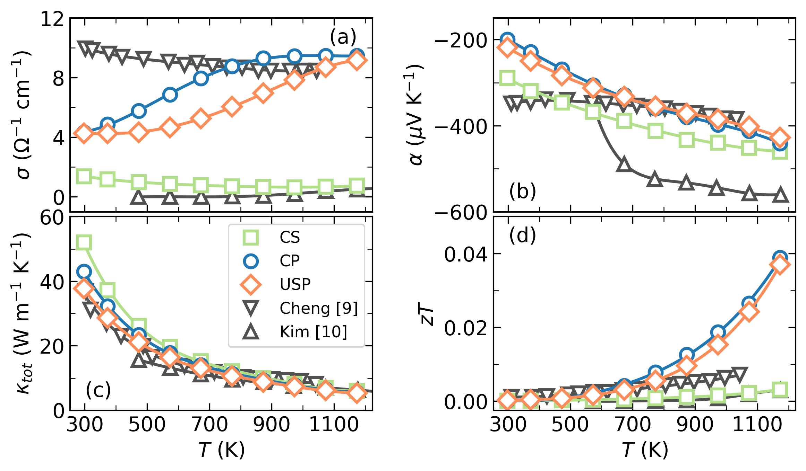
Figure 4. Temperature dependence of (a) the electrical conductivity σ, (b) the Seebeck coefficient α, (c) the total thermal conductivity κ_{tot}, and (d) the figure of merit zT for the ZnO obtained by different methods. Literature data reported for ZnO are also presented for comparison [9,10].

The Seebeck coefficient values of all the Al-doped samples exhibit negative values across the entire temperature range investigated, indicating n-type conduction behavior (Fig. 5b). The absolute values of the Seebeck coefficient slightly decrease with increasing in the nominal Al concentration (Fig. S5b) as expected from the Pisarenko relation considering the increase in charge carrier concentration discussed earlier [37].
The total thermal conductivity of the Al-doped samples follows a similar trend to that of pure ZnO, decreasing rapidly with rising temperature (Fig. 5c). The introduction of Al in ZnO affects κ_{tot} through different mechanisms. On the one hand, the partial substitution of Zn by Al introduces mass and strain fluctuations, thereby increasing the point defects scattering of phonons. On the other hand, the formation of spinel inclusions contributes to additional phonon scattering at the interface between the matrix and the inclusions. The combined effect of these two factors is most pronounced at low temperatures (Fig. 5c). However, at high temperatures where phonon-phonon scattering predominates and the contribution of the electronic thermal conductivity is more significant, the difference in total thermal conductivity values between doped samples becomes negligible, although still lower than that of the undoped sample, 6.3 W m^{–1} K^{–1} and 5.4 W m^{–1} K^{–1} at 1100 K, respectively (Fig. S5c).
Based on the obtained values of σ, α, and κ_{tot}, the temperature-dependent values of the zT were estimated and presented in Figure 5d. At 1100 K, the Al-doped sample with a nominal composition of Zn_{0.94}Al_{0.06}O achieves a zT value of ~0.12, which is 3 times higher compared to those obtained for pure ZnO. This significant enhancement in zT clearly demonstrates the substantial improvement in the electrical properties of ZnO through Al doping. The observed trend and values of zT achieved in this study are in good agreement with those reported in previous studies [10,16,20].
Conclusions
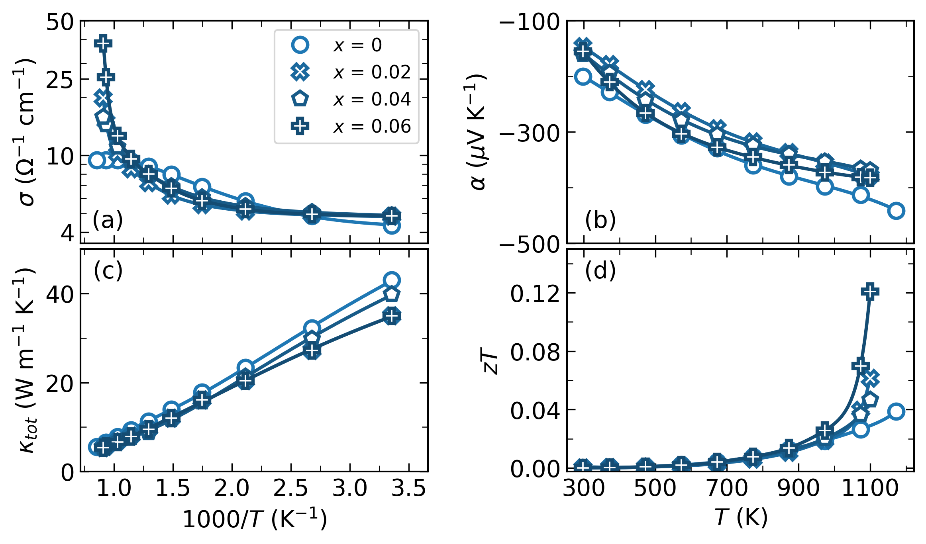
Figure 5. Temperature dependence of (a) the electrical conductivity σ, (b) the Seebeck coefficient α, (c) the total thermal conductivity κ_{tot}, and (d) the figure of merit zT for the Al-doped ZnO obtained by chemical precipitation with nominal composition Zn_{1–x}Al_{x}O (x = 0, 0.02, 0.04, 0.06).

The thermoelectric properties of the pure ZnO samples prepared by ultrasonic spray pyrolysis and chemical precipitation have been studied. Both methods proved to be sufficient for obtaining pure ZnO. Due to the peculiarities of the wet chemistry methods, the thermoelectric figure of merit of ZnO obtained through these methods is noticeably superior to that of the sample fabricated from commercially available ZnO powder. Furthermore, both methods presented in this study enable the production of ZnO nanopowder in large quantities from inexpensive starting materials, with the possibility of precisely controlling the size characteristics of the powder by manipulating processing parameters. In the context of preparation and investigation of Al-doped ZnO, we have also demonstrated that wet chemistry methods, particularly the chemical precipitation method, can be utilized to obtain Al-doped samples with comparable thermoelectric performance. Moreover, this approach offers advantages in terms of purity compared to methods such as mechanical alloying, where contamination from milling media is unavoidable. Therefore, the approaches presented in this study can be highly valuable in the field of oxide-based thermoelectrics.
CRediT authorship contribution statement
Illia Serhiienko: Conceptualization, Methodology, Investigation, Writing – original draft. Andrei Novitskii: Conceptualization, Methodology, Formal analysis, Investigation, Writing – original draft, Writing – Review & Editing, Visualization. Evgeniy Kolesnikov: Investigation, Formal analysis. Tatyana Sviridova: Investigation. Kirill Kuskov: Investigation. Andrei Voronin: Resources, Project administration, Funding acquisition. Vladimir Khovaylo: Resources, Writing – Review & Editing, Supervision. Takao Mori: Resources, Writing – Review & Editing, Funding acquisition.
Conflicts of interest
The authors declare no competing financial interest.
Acknowledgements
The study was carried out with financial support from the Russian Science Foundation, project No. 19-79-10282. T.M., A.N., and I.S. acknowledge JSPS KAKENHI JP16H06441 and JST Mirai JPMJMI19A1.
Data availability
The data that support the findings of this study are available from the corresponding author upon reasonable request.
References
[1] A. Janotti, C.G. Van de Walle, Fundamentals of zinc oxide as a semiconductor, Reports on Progress in Physics. 72 (2009) 126501. https://doi.org/10.1088/0034-4885/72/12/126501.
[2] Ü. Özgür, Y.I. Alivov, C. Liu, A. Teke, M.A. Reshchikov, S. Doǧan, V. Avrutin, S.J. Cho, H. Morko̧, A comprehensive review of ZnO materials and devices, Journal of Applied Physics. 98 (2005) 1–103. https://doi.org/10.1063/1.1992666.
[3] Y. Yin, B. Tudu, A. Tiwari, Recent advances in oxide thermoelectric materials and modules, Vacuum. 146 (2017) 356–374. https://doi.org/10.1016/j.vacuum.2017.04.015.
[4] A.F. Ioffe, Semiconductor thermoelements, and Thermoelectric cooling, Infosearch, London, 1957.
[5] T. Tsubota, M. Ohtaki, K. Eguchi, H. Arai, Thermoelectric properties of Al-doped ZnO as a promising oxide material for high-temperature thermoelectric conversion, Journal of Materials Chemistry. 7 (1997) 85–90. https://doi.org/10.1039/a602506d.
[6] H. Morkoç, Ü. Özgür, Zinc Oxide: Fundamentals, Materials and Device Technology, 1st ed., Wiley, 2009. https://doi.org/10.1002/9783527623945.
[7] T. Mori, Novel Principles and Nanostructuring Methods for Enhanced Thermoelectrics, Small. 13 (2017) 1702013. https://doi.org/10.1002/smll.201702013.
[8] P.M. Radingoana, S. Guillemet-Fritsch, P.A. Olubambi, G. Chevallier, C. Estournès, Influence of processing parameters on the densification and the microstructure of pure zinc oxide ceramics prepared by spark plasma sintering, Ceramics International. 45 (2019) 10035–10043. https://doi.org/10.1016/j.ceramint.2019.02.048.
[9] D. Bérardan, C. Byl, N. Dragoe, Influence of the Preparation Conditions on the Thermoelectric Properties of Al-Doped ZnO, Journal of the American Ceramic Society. 93 (2010) 2352–2358. https://doi.org/10.1111/j.1551-2916.2010.03751.x.
[10] H. Cheng, X.J. Xu, H.H. Hng, J. Ma, Characterization of Al-doped ZnO thermoelectric materials prepared by RF plasma powder processing and hot press sintering, Ceramics International. 35 (2009) 3067–3072. https://doi.org/10.1016/j.ceramint.2009.04.010.
[11] K.H. Kim, S.H. Shim, K.B. Shim, K. Niihara, J. Hojo, Microstructural and thermoelectric characteristics of zinc oxide-based thermoelectric materials fabricated using a spark plasma sintering process, Journal of the American Ceramic Society. 88 (2005) 628–632. https://doi.org/10.1111/j.1551-2916.2005.00131.x.
[12] J. Hoemke, A.U. Khan, H. Yoshida, T. Mori, E. Tochigi, N. Shibata, Y. Ikuhara, Y. Sakka, Microstructural analysis and thermoelectric properties of Sn-Al co-doped ZnO ceramics, in: Tokyo, Japan, 2016: p. 050004. https://doi.org/10.1063/1.4961357.
[13] J. Hoemke, A.U. Khan, H. Yoshida, T. Mori, E. Tochigi, N. Shibata, Y. Ikuhara, Y. Sakka, Sintering characteristics and thermoelectric properties of Mn–Al co-doped ZnO ceramics, Journal of the Ceramic Society of Japan. 124 (2016) 515–522. https://doi.org/10.2109/jcersj2.15282.
[14] F. Giovannelli, C. Chen, P. Díaz-Chao, E. Guilmeau, F. Delorme, Thermal conductivity and stability of Al-doped ZnO nanostructured ceramics, Journal of the European Ceramic Society. 38 (2018) 5015–5020. https://doi.org/10.1016/j.jeurceramsoc.2018.07.032.
[15] P. Díaz-Chao, F. Giovannelli, O. Lebedev, D. Chateigner, L. Lutterotti, F. Delorme, E. Guilmeau, Textured Al-doped ZnO ceramics with isotropic grains, Journal of the European Ceramic Society. 34 (2014) 4247–4256. https://doi.org/10.1016/j.jeurceramsoc.2014.07.009.
[16] L. Han, N.V. Nong, L.T. Hung, T. Holgate, N. Pryds, M. Ohtaki, S. Linderoth, The influence of α- and γ-Al2O3 phases on the thermoelectric properties of Al-doped ZnO, Journal of Alloys and Compounds. 555 (2013) 291–296. https://doi.org/10.1016/j.jallcom.2012.12.091.
[17] E. Guilmeau, P. Díaz-Chao, O.I. Lebedev, A. Rečnik, Marion.C. Schäfer, F. Delorme, F. Giovannelli, M. Košir, S. Bernik, Inversion Boundaries and Phonon Scattering in Ga:ZnO Thermoelectric Compounds, Inorganic Chemistry. 56 (2017) 480–487. https://doi.org/10.1021/acs.inorgchem.6b02354.
[18] T. Abe, Y. Nameshida, Y. Ogata, A. Miura, A. Nakagawa, T. Chiba, Y. Kashiwaba, M. Daibo, I. Niikura, Y. Kashiwaba, H. Osada, Improvement of the Photoconductive Characteristics of ZnO Single Crystals by Annealing, Journal of Electronic Materials. (2018) 1–5. https://doi.org/10.1007/s11664-018-6184-y.
[19] Y. Fujishiro, M. Miyata, M. Awano, K. Maeda, Effect of Microstructural Control on Thermoelectric Properties of Hot-Pressed Aluminum-Doped Zinc Oxide, Journal of the American Ceramic Society. 86 (2003) 2063–2066. https://doi.org/10.1111/j.1151-2916.2003.tb03610.x.
[20] C. Gayner, Improved electrical conductivity and thermoelectric performance of ZnO by doping with NaCl and CdO, Chemical Engineering Journal. 413 (2021) 128149. https://doi.org/10.1016/j.cej.2020.128149.
[21] D.V. Kuznetsov, D.V. Lysov, V.V. Levina, M.N. Kondrat’eva, D.I. Ryzhonkov, S.D. Kaloshkin, Structural special features in nanodispersed Ni-SiO2 composite materials produced by method of chemical dispersion, Inorg. Mater. Appl. Res. 1 (2010) 57–63. https://doi.org/10.1134/S2075113310010090.
[22] D.V. Lysov, D.V. Kuznetsov, A.G. Yudin, D.S. Muratov, V.V. Levina, D.I. Ryzhonkov, Preparation of nickel oxide nanostructured powders under the action of ultrasound, Nanotechnol Russia. 5 (2010) 493–497. https://doi.org/10.1134/S1995078010070098.
[23] A. Yudin, N. Shatrova, B. Khaydarov, D. Kuznetsov, E. Dzidziguri, J.-P. Issi, Synthesis of hollow nanostructured nickel oxide microspheres by ultrasonic spray atomization, Journal of Aerosol Science. 98 (2016) 30–40. https://doi.org/10.1016/j.jaerosci.2016.05.003.
[24] E.V. Shelekhov, T.A. Sviridova, Programs for X-ray analysis of polycrystals, Metal Science and Heat Treatment. 42 (2000) 309–313. https://doi.org/10.1007/BF02471306.
[25] S. Brunauer, P.H. Emmett, E. Teller, Adsorption of Gases in Multimolecular Layers, J. Am. Chem. Soc. 60 (1938) 309–319. https://doi.org/10.1021/ja01269a023.
[26] F.-X. Coudert, Tool for BET isotherm fit, (2020). https://github.com/fxcoudert/tools/tree/master/BET_isotherm_fit.
[27] J. Rouquerol, D. Avnir, C.W. Fairbridge, D.H. Everett, J.M. Haynes, N. Pernicone, J.D.F. Ramsay, K.S.W. Sing, K.K. Unger, Recommendations for the characterization of porous solids (Technical Report), Pure and Applied Chemistry. 66 (1994) 1739–1758. https://doi.org/10.1351/pac199466081739.
[28] E.P. Barrett, L.G. Joyner, P.P. Halenda, The Determination of Pore Volume and Area Distributions in Porous Substances. I. Computations from Nitrogen Isotherms, J. Am. Chem. Soc. 73 (1951) 373–380. https://doi.org/10.1021/ja01145a126.
[29] J.A. Cape, G.W. Lehman, Temperature and finite pulse-time effects in the flash method for measuring thermal diffusivity, Journal of Applied Physics. 34 (1963) 1909–1913. https://doi.org/10.1063/1.1729711.
[30] C. Kittel, ed., Introduction to Solid State Physics, John Wiley & Sons, Inc, 2005.
[31] R.V.R. Virtudazo, B. Srinivasan, Q. Guo, R. Wu, T. Takei, Y. Shimasaki, H. Wada, K. Kuroda, S. Bernik, T. Mori, Improvement in the thermoelectric properties of porous networked Al-doped ZnO nanostructured materials synthesized via an alternative interfacial reaction and low-pressure SPS processing, Inorg. Chem. Front. 7 (2020) 4118–4132. https://doi.org/10.1039/D0QI00888E.
[32] R.V.R. Virtudazo, Q. Guo, R. Wu, T. Takei, T. Mori, An alternative, faster and simpler method for the formation of hierarchically porous ZnO particles and their thermoelectric performance, RSC Advances. 7 (2017) 31960–31968. https://doi.org/10.1039/C7RA05067D.
[33] R.R. Reeber, Lattice parameters of ZnO from 4.2° to 296°K, Journal of Applied Physics. 41 (1970) 5063–5066. https://doi.org/10.1063/1.1658600.
[34] R. Cuscó, E. Alarcón-Lladó, J. Ibáñez, L. Artús, J. Jiménez, B. Wang, M.J. Callahan, Temperature dependence of Raman scattering in ZnO, Phys. Rev. B. 75 (2007) 165202. https://doi.org/10.1103/PhysRevB.75.165202.
[35] M.D. McCluskey, Defects in ZnO, in: Defects in Advanced Electronic Materials and Novel Low Dimensional Structures, Elsevier, 2018: pp. 1–25. https://doi.org/10.1016/B978-0-08-102053-1.00001-6.
[36] T.M. Tritt, ed., Thermal Conductivity: Theory, Properties, and Applications, Springer US, New York, 2004. https://doi.org/10.1007/b136496.
[37] A.F. Ioffe, Physics of Semiconductors, Infosearch, London, 1958.
[38] H. Serier, M. Gaudon, M. Ménétrier, Al-doped ZnO powdered materials: Al solubility limit and IR absorption properties, Solid State Sciences. 11 (2009) 1192–1197. https://doi.org/10.1016/j.solidstatesciences.2009.03.007.

