Isoconversional Kinetic Analysis of Thermal Decomposition of Bidirectionally Stabilized Amorphous Formulation Loading Vitamin D₃ (Cholecalciferol) and Calcium Carbonate

Dijana Jelić^{1,2*}, Miho Araki^{1,3}, and Kohsaku Kawakami^{1,4}
¹National Institute for Materials Science, Research Center for Macromolecules and Biomaterials, 1-1 Namiki, Tsukuba, Ibaraki 305-0044, Japan
²University of Banja Luka, Faculty of Natural Sciences and Mathematics, Chemistry Department, dr Mladena Stojanovića 2, 78 000 Banja Luka, Bosnia and Herzegovina
³University of Miyazaki, Faculty of Engineering, 1-1 Gakuen Kibanadai-nishi, Miyazaki 889-2192, Japan
⁴University of Tsukuba, Graduate School of Pure and Applied Sciences, 1-1-1 Tennodai, Tsukuba, Ibaraki 305-8577, Japan
*corresponding author

Abstract:
Cholecalciferol, generally known as vitamin D₃ (VD), and calcium (Ca²⁺) are very common dietary co-supplements in the pharmaceutical formulations, as they are symbiotically and pharmacologically dependent. Development of the VD/Ca²⁺ formulation is highly challenging due to stability and solubility issues, mainly for VD instability toward temperature, light, oxygen and pH. In this study, VD was loaded into carrier which consisted of amorphous calcium carbonate (ACC) and hydroxypropyl methylcellulose acetate succinate (HPMCAS), yielding amorphous VD/ACC/HPMCAS formulation with various composition ratios. The structural and thermal stability study of the formulations was conducted to find that VD was a promising molecule for the stabilization of ACC even with the trace amount (0.6%). On the other hand, ACC stabilized the amorphous state of VD; thus, they had a bidirectional stabilizing effect. The amount of VD played a significant role in thermal stabilization of the VD/ACC/HPMCAS formulations, for which kinetic analysis was performed. Using isoconversional expanded Friedman’s model (FRM) activation energies of decomposition of the organic part were determined as 190, 133, and 114 kJ mol⁻¹ for VD/ACC/HPMCAS = 0.6/64.0/35.4, 2.3/56.8/40.9, and 4.9/52.6/42.5 formulations, respectively, revealing that the formulation with the highest amount of VD (4.9%) was the least stable. The dissolution advantage for VD by amorphization was also demonstrated.
Key words: cholecalciferol, amorphous calcium carbonate, thermal stability, isoconversional kinetics

Introduction:
The cholecalciferol, commonly named vitamin D₃ (VD), is a steroid hormone as well as important nutrient. The calcium is considered to be one of the most important minerals in the human body. The deficiency of VD is related to various health problems including bone mineralization, hyperparathyroidism, cancer, cardiovascular and autoimmune diseases [,,,,] , while Ca²⁺ deficiency contributes to osteoporosis, hypocalcemia, and poor blood clotting [,]. Combined administration of calcium and VD is favored because of their complemental roles: VD sufficiency is associated with bone fractures, VD and calcium are connected with bone mineral density, VD affects parathyroid hormone, which regulates calcium level in the blood and VD insufficiency or deficiency can have an effect on alkaline phosphatase level [,]. Co-supplementation of VD and Ca²⁺ has been in focus in the last decades; however, the development of effective VD/Ca²⁺ formulation is a very challenging task, mostly due to instability and low solubility of VD. VD is highly sensitive to temperature, light, oxygen and pH [], resulting in loss of its functionality. The decomposition of VD occurs in acidic environment, while it has sufficient stability in the 5.5 < pH < 8.0 range [,]. Even though it could avoid the chemical decomposition, it offers only low bioavailability due to poor solubility [,]. To ascertain suitable conditions for storage and heat treatment of VD formulations, it is helpful to obtain thermal stability parameters including activation energy (E_{α}), pre-exponential factor (A), reaction order (n), and constant rate (k) [].
One of the most effective methods to improve the stability and bioavailability issues is the encapsulation method, in which VD is loaded in a proper carrier that improves its stability and solubility. Consequently, the bioavailability is enhanced and side effects of potential VD-hypervitaminosis and hypercalcemia are reduced, if combined with Ca²⁺, due to decrease in the administration dose []. Currently, a variety of carriers are attempted for the VD delivery: polymeric, inorganic and lipid-based carriers, etc. Luo et al. developed zein nanoparticles coated with carboxymethyl chitosan for encapsulation and controlled release of VD []. Dalek et al employed VD liposomal delivery system to show great potential in increasing the active form of VD [14]. Guttoff et al. explored stability of VD as nanoemulsion system prepared by spontaneous emulsification. It was shown that thermal stability of VD could be improved by adding sodium dodecyl sulphate as a cosurfactant []. Some commercially available nanoparticles, Arachitol NanoTM were explored as potential drug delivery system for VD []. This water-soluble nanoparticle increased the oral absorption of VD.
In addition to the efforts to improve dissolution property of VD, utilization of the synergistic roles of VD and Ca²⁺ seemed to be a logical strategy. The gelatin templated calcium carbonate nanoparticles were used for delivery of VD and amoxicillin []. Li et al designed a calcium carbonate core, crosslinked with nanoparticle of methoxy poly(ethylene glycol)-block-poly(l-glutamic acid) for the delivery of anticancer drug doxorubicin []. Gautam et al reported zein coated calcium carbonate nanoparticles for the targeted controlled release of model antibiotic and nutrient across the intestine. In all of these reports, calcium carbonate is in its crystalline form, which has low solubility in water, 0.15 mmol/L. Calcium carbonate occurs in six different forms: two hydrous (ikaite and monohydrocalcite), three anhydrous (vaterite, aragonite, calcite) and amorphous. The highest solubility should be available for the amorphous calcium carbonate (ACC). Meiron et al reported increased absorption, solubility and bioavailability of ACC comparing to crystalline calcium carbonate, where the absorption rate of ACC was higher than from crystalline calcium carbonate by 40% [].
In this study, attempts were made to include both VD and calcium carbonate in an amorphous state in one formulation. A cellulose polymer, hydroxypropyl methylcellulose acetate succinate (HPMCAS), which is known as one of the most effective excipients to prepare amorphous solid dispersion [,], was added to design the amorphous formulation. We have found that VD and calcium carbonate possess bidirectional stabilizing effect of the amorphous state. Moreover, VD and Ca²⁺ are symbiotically and pharmacologically dependent. Isoconversional kinetic analysis proved to be very valuable and convenient for the assessment of thermal stability of various drugs [,,]. Thus, thermal stability of VD was evaluated in terms of the decomposition behavior, which was subjected to comprehensive isoconversional kinetic analysis [,]. This paper provides development of mathematical models to predict kinetic behavior of various solid components and optimization of studied process for the maximum quality of VD-enriched supplements.

Experimental

Materials
VD and HPMCAS (HG grade) were obtained from Funakoshi (Tokyo, Japan) and Shin-Etsu Chemical (Tokyo, Japan), respectively. Anhydrous sodium carbonate and calcium chloride were purchased from Fuji Film Wako (Osaka, Japan) and Nacalai Tesque (Kyoto, Japan), respectively. All chemicals were used as supplied.

2.2 Preparation of Amorphous Formulations
For preparing ACC, 50 mL of calcium chloride ethanolic solution (12 mM) was rapidly mixed with 50 mL of sodium carbonate (12 mM), followed by pH adjustment to 12 using 2 M NaOH to form precipitate. The obtained suspension was centrifuged at a rotation rate of 8000 rpm for 5 min at 4°C. Then, the precipitate was washed three time by acetone using vacuum filtration. The sample was dried under vacuum at room temperature for overnight. This precipitation method had an origin in the method developed by Koga et al. []
For loading VD, 25 mL of its ethanolic solutions at concentrations of 12, 25, 50 mM were prepared. The VD/ethanol solution was poured into 50 mL of calcium chloride solution (12 mM). Then, the solution was mixed with the 12 mM sodium carbonate solution as described above and the same preparation procedure for obtaining the amorphous precipitate was applied.
For including HPMCAS, it was dissolved in an ethanol-water mixture (9:1) at a concentration of 2 mg/mL, to which calcium chloride was also dissolved at a concentration of 12 mM. The solution was mixed with the calcium chloride solution to obtain the precipitate as described above.
For loading both VD and HPMCAS, the ethanolic VD/calcium chloride solution was mixed with the HPMCAS ethanol-water solution to follow the same procedure as described above.
The formulations were passed through a sieve which has a mesh size of 0.5 mm.

2.3 Determination of VD Concentration
The loaded amount of VD was determined by high-performance liquid chromatography (HPLC, Shimadzu Prominence, Shimadzu, Kyoto, Japan) using a YMC-Pack Pro C18 column (150 mm x 2.0 mmID, YMC, Kyoto, Japan). The samples were dispersed in ethanol, followed by filtration using syringe filters with a pore size of 0.45 μm. Acetonitrile was used as a mobile phase at a flow rate of 0.2 mL/min. The injection volume and detection wavelength were 2 μL and 265 nm, respectively.

2.4 Thermal Analysis
Thermal stability of the formulations was evaluated by thermogravimetric analysis (TGA) on SDT Q600 (TA Instruments, New Castle, DE, USA) under flow of argon at a rate of 100 mL/min. The purity of the gas was 99.5 %. The samples were placed in open ceramic pans (100 μL) and heated in non-isothermal regime at rates of β = 5, 10, 15, and 20 °C/min following the ICTAC recommendations []. The samples masses were between 5.0 and 7.0 mg.
Differential scanning calorimetry (DSC) measurements were performed on Q2000 (TA Instruments, New Castle, DE, USA) calibrated by indium and sapphire. Approximately 5 mg of samples were measured using crimped aluminum pans at a heating rate of 10 °C /min. Nitrogen was used as the inert gas at a flow rate of 50 mL/min.

2.5 X-ray Powder Diffraction (XRPD)
XRPD patterns of the formulations were acquired on a Rigaku RINT Ultima X-ray Diffraction System (Rigaku Denki, Tokyo, Japan) using CuKα radiation. The voltage and the current were 40 kV and 40 mA, respectively. The samples were loaded on a glass plate and the sample surface was carefully smoothened. The diffraction data were collected at intervals of 0.02° (2 theta) with a scan speed of 2 °/min.

2.6 Solubility Measurement of VD and Dissolution Study
Approximately 20 mg of the formulations were loaded in glass vials, to which 5 mL of the phosphate buffer (50 mM, pH7) were added. The vials were rotated at approximately 50 rpm for one or two hours in a temperature-controlled oven at 37 °C, followed by filtration using syringe filters of 450-nm pore size. All the glassware and filters used for this filtration were pre-warmed in the same oven to avoid precipitation during the filtration. The filtrates were diluted with a 1:1 mixture of ethanol/water and subjected to the HPLC analysis.
The equilibrium solubility of VD was determined by the same procedure except that the equilibration was done for 24 h. Approximately 3 mg of VD was suspended in 5 mL of the phosphate buffer for the determination.

2.7 Kinetic Analysis
The mass data obtained by TGA were transformed into conversion degree (α) using the following equation:
(1)
where m_{t} represents the mass of the sample at arbitrary time t, whereas m₀ and m_{f} are the mass of the sample at the beginning and at the end of the process, respectively. Such data are easily used by proper kinetics softwares which in return provide determination of corresponding kinetic triplet: E_{α}, A and f(α), where A is the preexponential factor, E_{α} is the apparent activation energy, and f(α) is a mathematical expression of kinetics mechanism []. The exact determination of kinetic parameters is based on multiple scan methods, which requires the measurements at different heating rates, and uses the data sampled at common conversion degrees (isoconversion, model-free methods). Once the E_{α} is determined, it is possible to search for the function (kinetic model, f(α)) which enables the best fit of experimental data. Kinetics2015 (GeoIsoChem, Covina, CA, USA), used in this study, summarized linear and nonlinear regression analysis methods. All the linear regression models are variations of isoconversional models []. The Friedman model uses reaction rates, whereas the Ozawa-Flynn-Wall model uses the cumulative reacted data along various models of integrating the rate law. Kinetics2015 uses three basic analyses to derive approximate first-order kinetic parameters: an expanded Friedman model (FRM), a modified multiple heating rate Coats-Redfern integral model enhanced by Burnham and Braun (MCRIM) [], and a T_{max}-shift Kissinger model (T_{max}KSM) []. The FRM works with any thermal history, while MCRIM and T_{max}KSM require a constant heating rate. Firstly, whether the time-temperature history is close enough to a constant heating rate was evaluated before conducting the latter two analyses. To check the presumed invariance of E_{α} on conversion degree, the isoconversional "model-free“ analysis was evaluated by means of expanded FRM [], which is based on the logarithm of Eq. (2):
(2)
-E_{α}/R and ln{A_{α}(1-α)} are the slope and the intercept, respectively, for the plot of ln(β dα/dT_{α}) vs. 1/T_{α}.
The MCRIM is a multi-heating rate application of the Coast-Redfern equation, resulting in a model-free isoconversional approach, similar to that of Friedman [36]. This model is described by the following equation:
(3)
In this model, at a selected conversion degree for different heating rates, the left-hand side is plotted vs. 1/T, giving a family of straight lines of slope –E_{α}/R, while the intercept allows to calculate pre-exponential factor A. If the values of E_{α} vary with α, the results may be interpreted in terms of multi-step reaction mechanism.
The T_{max}KSM is a special case of isoconversion model, serving to determine initial values of A and E_{α}. The model is based on the plot of ln(β/T_{max}²) vs. 1/T_{max}, where T_{max} is the temperature at which, for a given heating rate, conversion rate passes its maximum. The slope and the intercept are –E_{α}/R and lnA, respectively [].
Fitting procedure includes majority of reaction models, ranging from 1st order, nth order, nucleation-growth model, as well as the activation energy distribution models, and uses a nonlinear regression methods to determine the parameters of the Eq. (2) to fit in a best way the experimental data []. The TGA results were used as the input data in order to obtain kinetic parameters: activation energy and pre-exponential factor A.
First-order (1st-order) reaction model fitting is based on the premise that the rate of disappearance is proportional to the fraction present, as expressed by dα/dt = k(1-α), where k is the rate constant and (1-α) denotes the remaining fraction. An n^{th}-order reaction is a simple extension, given by the equation: dα/dt = k(1-α)^{n}. In many cases, the n^{th}-order reaction is favorable for the decomposition of solids, as a pseudo-n^{th}-order reaction [].
Reactivity distributions (RD) for complicated materials are often characterized by distribution of activation energies models, DAEM. The characteristic of RD is that the reaction profile is broader than that of the 1st-order reaction, which can be compensate with low activation energy.
Certain polymers or minerals have a reaction rate profile for a constant heating rate that is too narrow to be fit adequately by a single 1st-order reaction. In such case, the factor A and single activation energy may be much higher in order to provide better fit and accommodate the profile's shape. The classic reaction models which deal with this type of reaction are the Prout-Tompkins[ ] and Avrami-Erofeev models []. Burnham et al. [] gave extension of the Prout-Tompkins model in the form of equation: dx/dt = - kx^{n}(1 – 0.99x)^{m}, where m represents the nucleation exponent (-0.1 < m < 1.1). This equation can also be considered as a special case of the Šesták-Berggren equation [].

Results and discussion:

Physicochemical Characterization of ACC

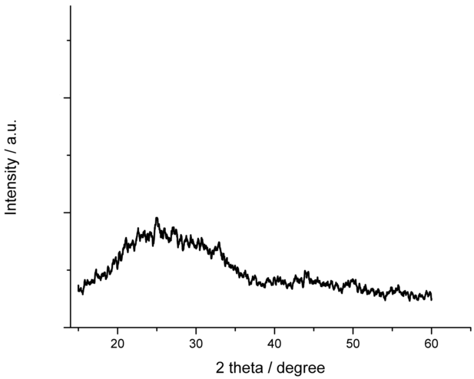
Figure 1 presents XRPD pattern of ACC, where no sharp diffraction peaks were found. The broad halo peak in the range of 20°-35° degrees indicated its amorphous structure [].

Figure 1. The XRPD pattern of ACC
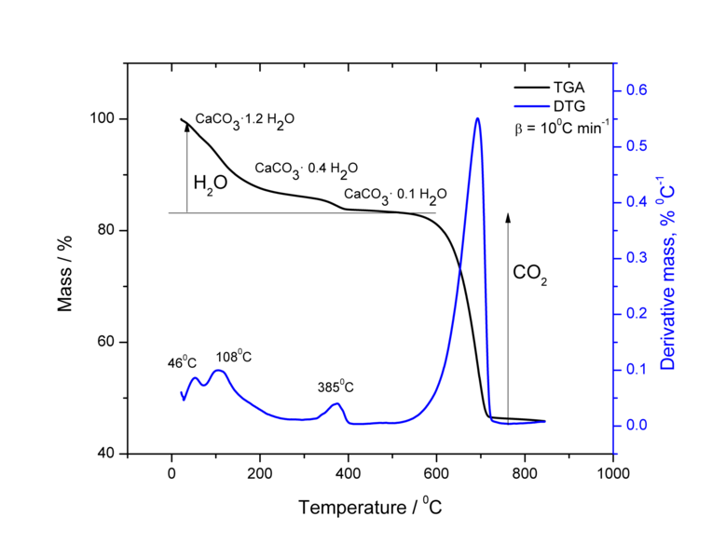
Another recognizable characteristic of the ACC is the presence of water molecules in its structure. The water can either be adsorbed on the surface or confined in the ACC structure. Biogenic ACC is a monohydrate. The amount of water for our synthesized ACC was 16.9 % as detected by TGA, which corresponds to 1.2 H₂O. The weight loss of ACC consists of three-step processes (Figure 2a). The first and second stages are related to dehydration. The first one goes in favor of adsorbed water loss (DTG peaks at 46 and 108 °C), while the second one refers to the loss of strongly bounded water (DTG peak at 385 °C). The residual mass after each step was 86.0 and 83.1 %, respectively. Thus, the weakly bonded water (the first stage) was ca. 14%, while strongly bounded one (the second stage) corresponds to 2.9%. As the second step was associated with exothermic heat flow (data not shown), crystallization of ACC can be expected. A larger amount of water is generally adsorbed onto amorphous solids compared to crystalline solids. Thus, adsorbed water molecules are released upon crystallization[].The third stage corresponds to thermal decomposition of calcium carbonate, yielding CaO after CO₂ loss (CaCO_{3(s)} = CaO_{(s)} + CO_{2(g)}↑). The final mass was 45.9 % which could be explained well with formation of CaO, for which theoretical mass is calculated as 46.6 %. The as-is ACC was stored in a desiccator with silica gel for 24 h at room temperature to obtain the XRPD pattern and TGA curves again (Figure 2b, 2c). The TGA curves showed that the remaining water was only 0.4%. Loss of the water for the first step can be understood by removal of the surface water upon drying, whereas loss of the second one should be because of crystallization of ACC during the storage. The XRPD pattern showed very well pronounced vaterite (JCPDS 33-0268) [] and calcite (JCPDS 05-0586) [] peaks of their crystalline structure.
a
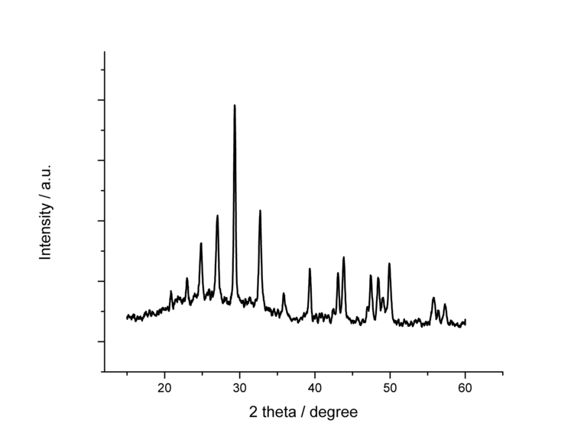
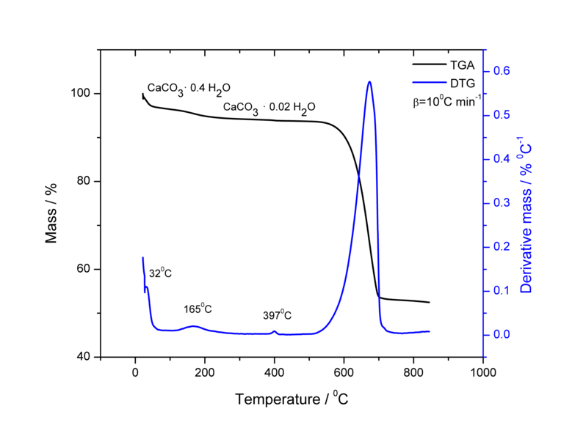
c
b
Figure 2. The TGA/DTG curve of as-is ACC (a) and that after 24-h storage in a desiccator with silica gel at room temperature (b). The XRPD pattern of ACC after 24h storage in the desiccator (c)

Physicochemical Characterization of Binary and Ternary Formulation

When the calcium carbonate formulation was prepared in the presence of HPMCAS, the obtained material consisted of 93% of calcium carbonate and 7% of HPMCAS. Figure 3 presents its XRPD pattern, which proved that the sample was partially amorphous but showed many diffraction peaks of metastable vaterite structure, for which the diffraction peaks were found at 24.70; 26.78; 32.62; 43.68; 49.82 and 55.62 degrees [47]. The similar observation was made previously by Yang et al, where HPMC was favorable for the formation of metastable aragonite phase of calcium carbonate [], while Siva et al noticed that, in the presence of polymer, metastable aragonite and vaterite phases were favored []. Even though the mechanism of transformation from ACC to vaterite is still not fully understood, Shen et al suggested that vaterite spheres are formed via homogeneous nucleation of vaterite particles, which undergo fast aggregation yielding to crystalline spheres []; others consider dehydration process of ACC responsible for vaterite particles []. Andreassen et al confirmed that vaterite was formed through combination of dissolution process of ACC and nucleation growth [].
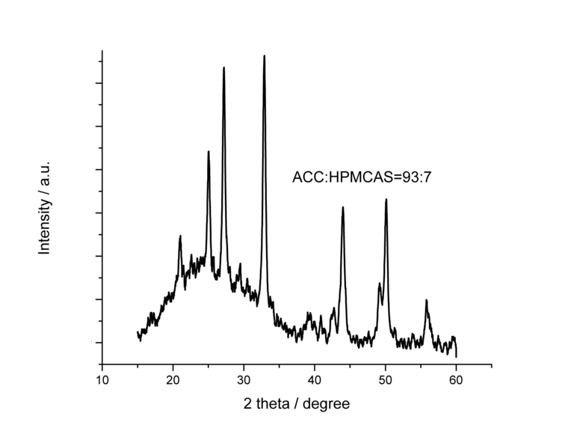
Figure 3. The XRPD pattern of calcium carbonate: HPMCAS = 93:7

However, crystallization was found to be suppressed by incorporating VD as the third component. Figure 4 shows XRPD patterns of the fresh formulation and that after 3-month storage in a desiccator with silica gel at room temperature, which indicated that the formulation was in an amorphous state at least for three months. Based on this result, VD seemed to work as a stabilizer in the VD/ACC/HPMCAS formulation. Many reports have already been available on stabilization effect of inorganic additives including PO₄³⁻ [], OH⁻ ions [] magnesium (Mg²⁺) ions [], strontium (Sr²⁺) ions [], and silicate (SiO₄⁴⁻) ions []. Although examples of stabilization by organic additives [] are limited, they include use of: poly(ethylene glycol) [], L-aspartic acid [], and phosphorylated proteins []. The detailed stabilization mechanism is still under debate; however it has been suggested that inorganic and organic additives have different mechanisms in stabilizing effect of ACC. Some inorganic additives such as PO₄³⁻ or OH⁻ contributes to higher stability of ACC if they are incorporated in the bulk. On the other hand, it was reported that much higher effect on structural stability is achieved if organic additives are adsorbed on the surface relative to incorporation in ACC structure [61]. Tobler et al reported effect of citrate ion on stabilization of ACC due to formation of clusters with calcium ions[]. Interaction between the additive and calcium ions should be one important mechanism to achieve structural stabilization of ACC. Pouget el al. reported that influence of the particle size of ACC is also significant for the ACC stability []. It was proposed that ACC consisted of stable prenucleation nanoparticles with size of approximately 2-4 nm [] or 0.6-1.1 nm [64], though Meldrum et al suggested that the presence of impurities, especially organic molecules, was influential to the ACC stability []. The ACC was (meta)stable when the particle size was smaller than 120 nm [64]. When organic solvents, such as ethanol, were used in the synthesis process, lower particle size was obtained [].
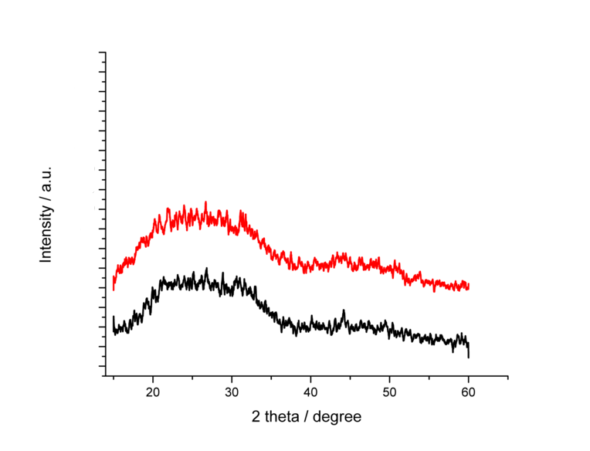
Figure 4. The XRPD pattern of fresh VD/ACC/HPMCAS (0.6:64:35.4) (red) and that after three-month storage in a desiccator at room temperature (black)
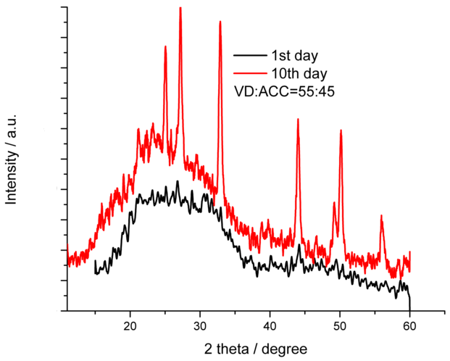
To highlight the effect of VD on structural stability of VD/ACC/HPMCAS formulation, we have synthesized two VD/ACC binary formulations with ω_{D} = 34% and 55%, where ω_{D} denotes mass percent of VD. Figure 5a and 5b present the XRPD patterns of freshly made and 10 days old VD/ACC sample of ω_{D} = 34 and 55 %, respectively. The VD/ACC sample with the higher amount of VD was still partially amorphous, with less pronounced crystalline peaks with the halo pattern, after 10 days, relative to the VD/ACC sample with smaller part of VD. This confirmation is a clear endorsement of our hypothesis.
b
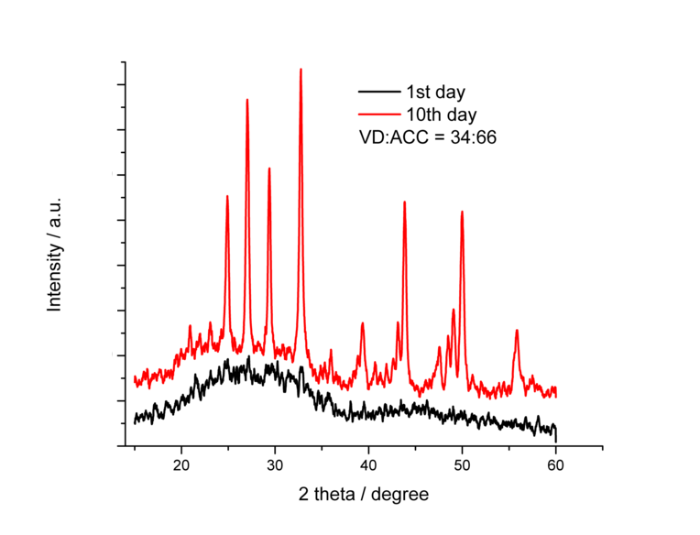
a
Figure 5. The XRPD pattern of VD/ACC formulation in mass ratio: 34:66 (a) and 55:45 (b)
The XRPD patterns of VD/ACC/HPMCAS ternary formulations with different weight percent of VD are presented in Figure 6. For determining the formulation composition, ratios of organic and inorganic components were calculated from the TGA results, which provided amount of ACC in the formulation. The VD content was determined by the HPLC analysis. The remaining part could be HPMCAS. The concentrations of the added VD solution were 12, 25, and 50 mM during the preparation process. The resultant compositions were VD/ACC/HPMCAS = 0.6/64.0/35.4, 2.3/56.8/40.9 and 4.9/52.6/42.5, respectively. Obtained concentration of VD corresponds to 960 IU mg⁻¹, 3680 IU mg⁻¹ and 78 400 IU mg⁻¹, respectively. A randomized clinical study for bone fractures recommended 50 000 IU week⁻¹ of VD [] or in combination with calcium: VD/CaCO₃ = 800 IU/1200 mg [] or 800 IU/1000 mg [].

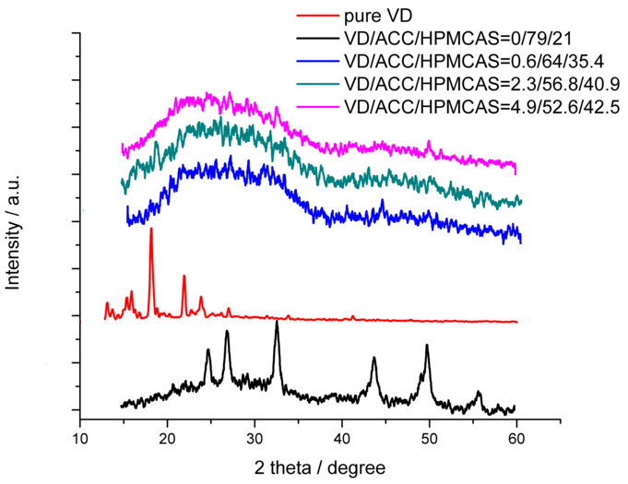
Figure 6. The XRPD pattern of VD/ACC/HPMCAS formulations with different ratios: 0/79/21 (black line); pure VD (red line); 0.6/64/35.4 (blue line); 2.3/56.8/40.9 (green line); 4.9/52.6/42.5 (pink line).
The sample that did not contain VD consisted of amorphous structure with pronounced elements of vaterite structure. Similar was observed by Sugiura et al. [60]. It was reported that ACC structure most probably occupied the core region, while ACC vaterite-like structure presented in the outer region, where transformation of ACC into vaterite is more likely to happen. Liu et al reported that morphology and structure of biogenic calcium carbonate can be also affected by the concentration of calcium ions [] originated from CaCl₂. When the amount of calcium chloride increased from 0.1% (m/v) to 0.8% (m/v), ACC was more prone to be transformed to polycrystalline vaterite. The other three VD/ACC/HPMCAS formulations showed amorphous structure. Thus, structural stability is likely to be enhanced as a result of VD uptake by ACC. It is also very important to emphasize that there was no visible crystalline peaks of VD (Figure 6) in the XRPD patterns of VD/ACC/HPMCAS, which revealed bidirectional stabilizing effect between ACC and VD. There are many reports that inorganic porous materials, such as silica, calcium carbonate, and calcium phosphate, were successfully used for stabilization of amorphous drugs due to their ability to accept drug molecules into the pores or onto their surface [,]. HPMCAS should also contribute to physical stabilization of amorphous VD, as cellulose polymers are well-known to enhance physical stability of amorphous drugs [,]. On the other hand, opposite effect of HPMCAS on physical stability of ACC (Figure 3) is a curious observation.

Kinetic Analysis of Thermal Stability

Figure 7 presents TGA curves of VD/ACC/HPMCAS ternary formulations with different amount of VD and related binary formulations. Those of pure compounds are also given. Figure 8 shows TGA derivative curves.
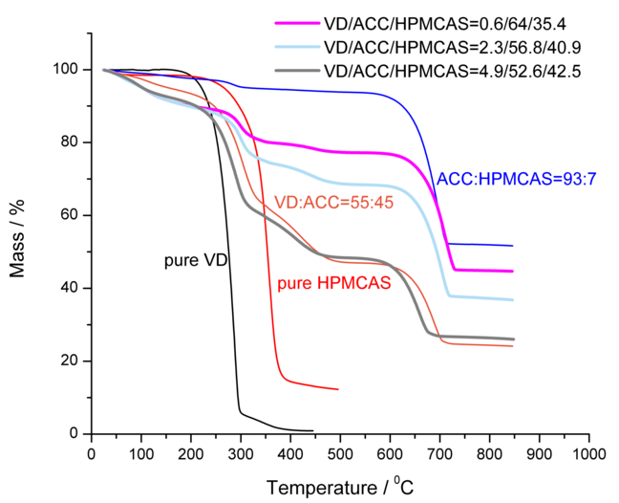
Figure 7. The TGA curves of pure VD (black line), pure HPMCAS (red line), VD/ACC formulation (brown line), ACC/HPMCAS (blue line) and VD/ACC/HPMCAS formulations (0.6/64/35.4(pink line), 2.3/56.8/40.9 (light blue line) and 4.9/52.6/42.5 (gray line))
The thermal decomposition of VD/ACC/HPMCAS formulation is a complex process that consists of three stages: dehydration, decomposition of organic part, and decomposition of inorganic part yielding calcium oxide. The temperature range of each step is as follows: dehydration (I and II stage: 25 - 200°C), decomposition of VD (III_{a} stage; 200-346°C), decomposition of HPMCAS (III_{b} stage; 236-323°C), decomposition of VD (IV stage; 346-369°C and V stage; 369-580°C) and decomposition of CaCO₃ (VI stage; 580-800°C). The thermal decomposition of VD appearing as the weight loss in the IV and V stage is probably due to adsorbed or incorporated VD into ACC structure. Also water present at high temperature (V stage) is removed upon crystallization (DTG peak at 385 °C, Figure 2a) [47].
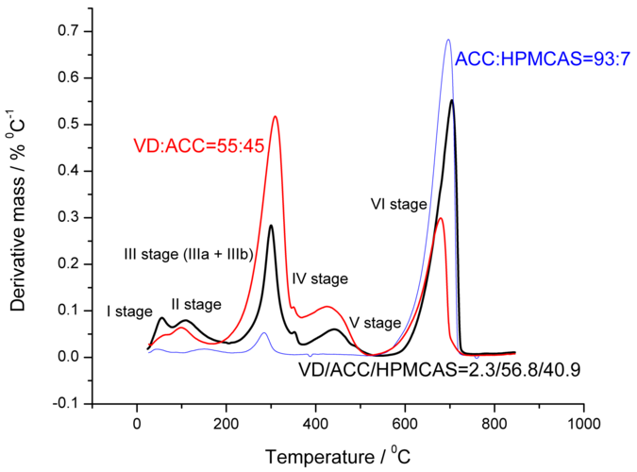

Figure 8. The DTG curves of VD/ACC (red curve), ACC/HPMCAS (blue curve) and VD/ACC/HPMCAS formulations (black curve) with designated decomposition peaks

Depending on the amount of VD, the decomposition temperatures of VD are as follows: 250 °C (ω_{D%} = 0.6%), 200 °C (ω_{D%} = 2.3%) and 185 °C (ω_{D%} = 4.9%). As the concentration of VD in the formulation increases, the thermal stability of VD/ACC/HPMCAS formulation decreased. Nevertheless, the thermal stability of VD in all the formulation was still higher than that of pure VD. The onset decomposition temperature of the VD/ACC/HPMCAS formulation moved to higher temperature by more than 30 °C compared to pure VD, which was ca. 155 °C.
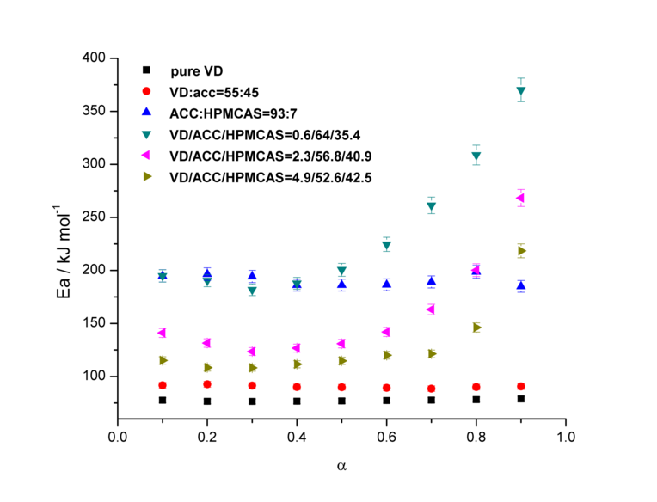
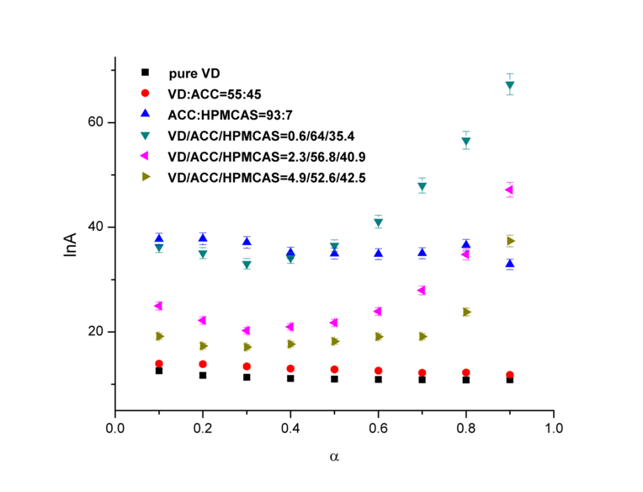
A change in thermal stability should also be reflected by a change of the kinetic parameters. Kinetic parameters for the decomposition process in the temperature range from 200 to 350 °C were calculated based on the FRM (Figure 9a and Figure 9b), MCRIM (Table 1), and T_{max}-KSM (Table 1). In this temperature region, VD and HPMCAS were decomposed.
b
a
Figure 9. Expanded FRM kinetic analysis: The Ea vs. α (a) and lnA vs. α (b) for pure VD, VD/ACC formulation, ACC/HPMCAS carrier and VD/ACC/HPMCAS formulations
The pure VD, ACC/HPMCAS and VD/ACC formulations showed that activation energy was almost constant in the entire α range (Figure 9a). The invariance of E_{α} with α suggests one-step character of the process under consideration. The activation energies for VD, ACC/HPMCAS and VD/ACC were approximately 78 kJ/mol, 190 kJ/mol and 90 kJ/mol, respectively. Not only the activation energy, but also the preexponential factor A was almost independent on α. This means that the application of FRM, which implies n=1, was justified and that reaction model f(α) = (1 − α), (F1 model) presents the true reaction. It's worth mentioning that VD/ACC formulation has a higher E_{α} by 12 kJ/mol than pure VD, which could mean that ACC contributes to better thermal stability of VD and decelerate the decomposition process of VD. Such findings in terms of thermal stability of VD and VD/ACC formulations were further confirmed by the evaluation of reaction rate. Figure 10a and 10b present the dependence of absolute reaction rate on temperature for VD and VD/ACC formulations, respectively. The symbols present measured value, while lines display calculated results. For the heating rate β = 5 °C min⁻¹ (red symbols/lines), which gave the best fit between measured and calculated data, the maximum rate for pure VD reached 0.0022 mol min⁻¹ at 285 °C, whereas that for the VD/ACC formulation was almost half, 0.0013 mol min⁻¹ at slightly higher temperature, 290 °C.
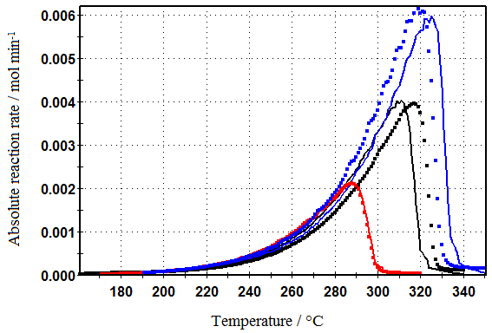
a

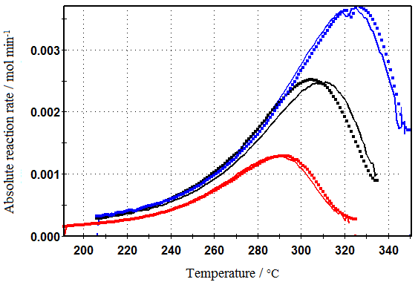
b
Figure 10. Absolute reaction rate vs. temperature obtained by FRM for VD (a) and VD/ACC (b) for β = 5 °C min⁻¹ (red symbols), 10 °C min⁻¹ (black symbols) and 15 °C min⁻¹ (blue symbols). Measured data (symbols), calculated data (lines).

In contrast to pure components and binary formulations, the E_{α} of VD/ACC/HPMCAS formulations varied with α which should be indication of the complex mechanism. It is interesting to note that E_{α} vs α dependence for all the formulations have the same trend. Up to a certain value of α, the activation energy remained constant, and then it increased. For VD/ACC/HPMCAS = 0.6/64/35.4, which had the highest thermal stability, E_{α} was stable up to a = 0.5 at 200 kJ/mol and then increased to 370 kJ/mol. For VD/ACC/HPMCAS = 2.3/56.8/40.9, E_{α} was almost constant up to α = 0.6, followed by the jump from 160 to 268 kJ/mol. VD/ACC/HPMCAS = 4.9/52.6/42.5 showed the E_{α} stability in the α < 0.7 range. Afterward activation energy changes from 146 to 218 kJ/mol. The activation energy for the VD/ACC/HPMCAS formulations increased with decreasing VD amount. The dependence of lnA on α (Figure 9b) exhibited similar behavior. To evaluate the overall effect of the E_{α} and ln A on the kinetics of the process, we have estimated the rate constant using Arrhenius plots, lnk vs. T⁻¹ (k = Ae^{-Ea/RT}) for the VD, VD/ACC and VD/ACC/HPMCAS=0.6/64/35.4 formulations (Figure 11). The rate constants for VD/ACC and VD/ACC/HPMCAS=0.6/64/35.4 were smaller compared to that for pure VD. That is, the rate constant of VD decomposition becomes slower if VD is formulated with ACC or ACC/HPMCAS, which further confirms VD thermal stability in presence of ACC or ACC/HPMCAS [27]. As amorphous solids have higher reactivity (i.e. lower chemical stability) compared to the crystalline state [] combination with ACC or ACC/HMPCAS is promising for both physical and chemical stabilization of VD.
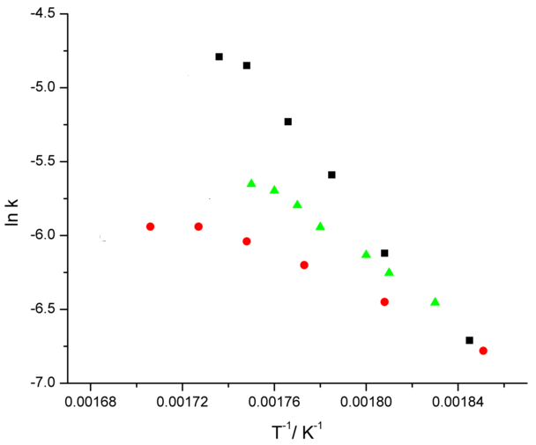
Figure 11. Arrhenius plots for thermal decomposition of VD (black squares), VD/ACC (red circles) and VD/ACC/HPMCAS=0.6/64/35.4 (green triangles)
Results of the isoconversional kinetic analysis based on FRM, MCRIM and T_{max}KSM are collected in Table 1. All three used models gave the same systematic trend of activation energy change for all VD formulations, which was in the order of VD/ACC/HPMCAS = 0.6/64/35.4, VD/ACC/HPMCAS = 2.3/56.8/40.9, VD/ACC/HPMCAS = 4.9/52.6/42.5, VD/ACC, and VD. The same trend was observed for lnA values. Increase in thermal decomposition temperature is connected to increase in activation energy or decrease in factor A [27]. It was clearly observed for thermal decomposition temperatures for VD/ACC/HPMCAS formulations of 0.6/64/35.4, 2.3/56.8/40.9, and 4.9/52.6/42.5, of which the activation energies were 250, 230, and 200 °C, respectively. The activation energy as a kinetic parameter generally has an important role in determining thermal stability of a pharmaceutical formulations []. However, there are some reports that just using the E_{α} parameter can be misleading [27]. Therefore, factor A values were estimated using the compensation effect equation lnA = a + bE, which is automatically provided by the DAEM. The results are also included in Table 1. Results from this model kept the same trend as kinetic parameters obtained from FRM and MCRIM.

Table1. Isoconversional kinetic analysis by FRM, MCRIM and T_{max}KSM
Formulation | FRM |  |  |  | MCRIM
Formulation | Ea, kJ mol⁻¹ | lnA | Σ₁ | Σ₂ | Ea, kJ mol⁻¹ | lnA
VD | 78.3 | 10.3 | 6.38 | 0.730 | 77.3 | 11.3
VD/ACC | 90.4 | 12.9 | 1.83 | 0.160 | 91.4 | 14.4
VD/ACC/HPMCAS = 0.6/64/35.4 | 190 | 35.0 | 0.260 | 2.15 x 10⁻³ | 185 | 39.7
VD/ACC/HPMCAS = 2.3/56.8/40.9 | 133 | 22.4 | 0.400 | 4.16 x 10⁻³ | 138 | 26.2
VD/ACC/HPMCAS = 4.9/52.6/42.5 | 114 | 18.3 | 0.230 | 5.30 x 10⁻³ | 118 | 20.9

Formulation | T_{max}KSM |  | DAEM
Formulation | Ea, kJ mol⁻¹ | lnA | Ea, kJ mol⁻¹ | Σ₁ | Σ₂ | A=a+bE
VD | 74.2 | 5.30 | 100% - 112 | 0.100 | 1.27 | A=3.64+5.57 x 10⁻¹E
VD/ACC | 89.4 | 8.50 | 95.9% - 97.2 | 2.56 | 0.230 | A=4.56+4.45 x 10⁻⁴E
VD/ACC/HPMCAS = 0.6/64/35.4 | 269 | 46.3 | 68.2% - 194 | 0.440 | 1.10 x 10⁻³ | A=3.11+7.19 x 10⁻⁴E
VD/ACC/HPMCAS = 2.3/56.8/40.9 | 181 | 28.9 | 80.8% - 145 | 1.67 | 8.10 x 10⁻² | A=16.7+2.54 x 10⁻⁴E
VD/ACC/HPMCAS = 4.9/52.6/42.5 | 153 | 21.9 | 90.8% - 119 | 1.22 | 4.10 x 10⁻² | A=16.4+1.22 x 10⁻⁴E
*Σ₁ and Σ₂ are sum of squares of weighted normalized rata residuals and sum of squares of weighted cumulative residuals, respectively.

The possible stabilization mechanism of VD is as follows. VD seems to have a strong ability to form complexes with different transition and alkaline earth metals. There are numerous examples in the literature regarding the VD binding with Ca²⁺, Mg²⁺, Fe³⁺, Al³⁺, Cd²⁺ etc [,]. It seems that, due to steric hindrance, only the hydroxyl oxygen atom from phenolic hydroxyl group can be coordinated with metal. Ca²⁺ ion shows strong binding affinity toward organic ligands as well as water. Therefore, its coordination number can be as high as eight []. Considering the VD structure, it is feasible to interact in a manner where Ca²⁺ crosslinks two VD molecules. Two molecules of VD can be attracted by the Ca²⁺ ion, which can coordinate with a metal ion depending on the environment. Jankovic et al demonstrated the existence of Ca²⁺/VD complexes [2D₃Ca(OH)₂(CH3COO)₂]⁺ and [2D₃Ca(CH₃-COOH)₂ 3H₂O]⁺ in the presence of polyvinyl alcohol, PVA. The MALDI TOF technique was utilized to demonstrate that the presence of PVA in the formulation resulted in the binding of two VD molecules to Ca²⁺ ion. CH₃COOH in this study was the ligand originated from the solution [81]. The positive MALDI mass spectrum was also confirmed in commercial supplementary product containing VD and CaCO₃ at m/z 536.01, 576.48 and 596.69 which were assigned to [D₃Ca(CH₃COO)₂ + H₂O]⁺, [D₃Ca(CH₃COO)₂ + 2H₂O]⁺, and [D₃Ca(CH₃COOH)₂ + 3H₂O]⁺ []. Complexation may increase solubility of drugs []. It is also very convenient approach to increase stability of drugs, including the thermal stability []. There are drugs approved by FDA based on this approach. Higuchi et al. reported increased solubility of oxytetracycline due to its complexation with Ca²⁺ in 1:2 ratio [].

For the formulation VD/ACC/HPMCAS = 0.6/64/35.4, the highest activation energy was obtained, and such increase of E_{α} is probably due to VD incorporation into the VD/ACC/HPMCAS structure. VD here has a role of impurity for structural stabilization. Thermal stability in terms of high E_{α} is due to incorporation of VD into ACC structure combined with HPMCAS, resulting in rather firm complex structure with high binding affinity between calcium and ligands (VD, CO₃², H₂O etc.). This can decrease molecular mobility, which provides kinetic stabilization. Therefore, it takes more thermal energy to decompose this VD formulation comparing to other two. For two other formulations, VD/ACC/HPMCAS = 2.3/56.8/40.9 and VD/ACC/HPMCAS = 4.9/52.6/42.5 there are more VD molecules present in the environment. In such a case, those VD molecules might have tendency to occupy the carrier surface more because of lack of Ca²⁺ ions. When VD molecules are adsorbed on the surface of ACC, the reactivity of the crystal may be greatly suppressed to block the calcite growth; however, the thermal stability might be lowered due to thermal decomposition of VD molecules, of which binding affinity differs from VD molecules incorporated in the cluster structure. Therefore, the total activation energy can be lowered. Obtained E_{α} values for VD/ACC/HPMCAS = 2.3/56.8/40.9 and VD/ACC/HPMCAS = 4.9/52.6/42.5 were more close to the enthalpy of activation of VD (98.8 kJ mol⁻¹) which is related to thermal breaking of bonds in VD structure[]. Depending on the amount of VD, the mechanism for stability of ACC structure is different: smaller amount of VD showed the same behavior as inorganic impurities used for ACC stabilization (such as OH⁻ or PO₄³⁻), while higher amount of VD reflects stabilization using organic impurities previously reported. Thus, VD inhibits the calcite growth through two different mechanism: cluster formation (VD/ACC/HPMCAS=0.6/64/35.4) or suppression of calcite growth due to adsorption of VD onto the surface (VD/ACC/HPMCAS: 2.3/56.8/40.9 and 4.9/52.6/42.5 ). Different stability mechanism was reflected through the change in activation energy.
Starting from the results obtained using the expanded FRM’s (Figure 9a and 9b), the MCRIM and the T_{max}KSM (Table 1), numerical fitting procedure which includes reaction models as phase boundary (Rn), reaction order (RO) and nucleation-growth (An (Avrami-Erofeev), B₁ (Prout-Tompkins) and SB (Šesták-Berggren)) models) were applied. Obtained isoconversional plots, α vs. T assisted in choosing the most appropriate available reaction model. For the VD formulations, under investigation, model-fitting approach showed that n-th order model gave the best fit. Note that all the VD formulations, except VD/ACC/HPMCAS=0.6/64/35.4 showed reaction order value around 1. This agrees well with isoconversional FRM results. Tsai et al reported that the same model was adequate for the thermal decomposition of both D vitamins: D₂ and D₃, where E_{α} = 131 kJ mol⁻¹ and n = 1.2 were obtained for D₃ [16]. Only thermal decomposition of ACC/HPMCAS carrier was better fitted with nucleation and growth model with following parameters: E_{a} = 195 kJ/mol, A = 1.96 ×10¹⁶ s⁻¹, n = 1.16, m = -0.1, Σ₁ = 0.687, Σ₂ = 0.0300 and belonging equation dα/dT = k(1-α)^{1.16}(α)^{-0.1}. This is probably due to high ratio of inorganic component and ability to start nucleation process earlier. It is interesting to note that the E_{a} value of ACC/HPMCAS carrier was close to value of VD/ACC/HPMCAS=0.6/64/35.4 formulation (190 kJ mol⁻¹) by FRM, unlike differences in structural stability which could be attributed to VD presence as stated above.

Table 2. n-th order model for the VD, VD/ACC and VD/ACC/HPMCAS formulations
Formulation | Ea, kJ mol⁻¹ | A, s⁻¹ | n | *Σ₁ | *Σ₂
VD | 77.6 | 4.39 x 10⁴ | 0.900 | 8.64 | 0.67
VD/ACC | 91.4 | 1.03 x 10⁶ | 1.07 | 1.83 | 0.16
VD/ACC/HPMCAS=0.6/64/35.4 | 200 | 2.28 x 10¹⁶ | 2.21 | 1.32 | 6.1x10⁻²
VD/ACC/HPMCAS=2.3/56.8/40.9 | 124 | 1.64 x10⁹ | 1.14 | 3.61 | 0.30
VD/ACC/HPMCAS=4.9/52.6/42.5 | 110 | 7.49 x10⁷ | 1.10 | 2.22 | 0.15
*Σ₁ and Σ₂ are sum of squares of weighted normalized rata residuals and sum of squares of weighted cumulative residuals, respectively.

Dissolution Advantage of the Ternary Formulation

The equilibrium solubility of VD was determined to be 4.7 μg/mL in phosphate buffer at pH 7.0. As we have succeeded in loading VD onto the ACC carrier in the amorphous state, improvement in its dissolution behavior was expected. The ternary formulation that included 8.3 % of VD was prepared and subjected to the dissolution study to find that the dissolved VD concentration in the phosphate buffer after one and two hours were 12.3 ± 2.5 and 11.4 ± 1.0 μg/mL, respectively. These values are higher than two-folds of the equilibrium solubility. Thus, the ternary formulation prepared with ACC and HPMCAS was proved to improve dissolution property of VD as well as its thermal stability.

Conclusion:
Both physical and chemical stabilization was achieved for VD and ACC in this study. We discovered that VD is a promising molecule for the physical stabilization of ACC even with the trace amount (ω_{D} = 0.6%). As ACC also contributed to physical stabilization of VD, their effects were bidirectional. Chemical stability was evaluated by isoconversional approach in which the values for activation energy and pre-exponential factor A were given in order to obtain insight in stabilization mechanism of VD/ACC/HPMCAS formulation. Amount of VD present in VD/ACC/HPMCAS formulation was found to be an important factor to determine the thermal stability. VD acts as an inhibitor of calcite precipitation either through formation of complex structure or blocking the calcite growth due to adsorption. Enhancement of the dissolution behavior of VD was also confirmed, which was the most likely because of amorphization of VD.

Acknowledgement
D.J. gratefully acknowledges the Matsumae International Foundation Fellowship 2023, Grant 23G05. D.J. is also thankful to the Ministry of Scientific and Technological Development and Higher Education of the Republic of Srpska under project No. 19.032/961-96/23.

Conflicts of interest
The authors declare no conflict of interest.

[] N. Jannasari, M. Fathi, S. J. Moshtaghian, A. Abbaspourrad. Microencapsulation of vitamin D using gelatin and cress seed mucilage: Production, characterization and in vivo study. International Journal of Biological Macromolecules. 129 (2019) 972-979.
[] J.H. Lee, J.H. O'Keefe, D. Bell, D.D. Hensrud, M.F. Holick. Vitamin D deficiency: an important, common, and easily treatable cardiovascular risk factor? J Am Coll Cardiol. 52(24) (2008) 1949-56.
[] O.C. Paucar, F.L. Tulini, M. Thomazini, J.C.C. Balieiro, E.M.J.A. Pallone, C.S. FavaroTrindade. Production by spray chilling and characterization of solid lipid microparticles loaded with vitamin D₃. Food and Bioproducts Processing. 100(A) (2016) 344-350.
[] S.J. Park, C.V. Garcia, G.H. Shin, J.T. Kim. Development of nanostructured lipid carriers for the encapsulation and controlled release of vitamin D₃. Food Chem. 225 (2017) 213-219.
[] J. Verkaik-Kloosterman, S.M. Seves, M.C. Ocké. Vitamin D concentrations in fortified foods and dietary supplements intended for infants: implications for vitamin D intake. Food Chem. 221 (2017) 629-635.
[] C.M. Weaver, R.P. Heaney, L.G. Raiisz. Calcium in Human Health Nutrition & Health. New York: Human Press, 2006.
[] D.B. Kumssa, E.J.M. Joy, E.L. Ander, M.J. Watts, S.D. Young, S. Walker S. Dietary calcium and zinc deficiency risks are decreasing but remain prevalent. Sci Rep. 5 (10974) (2015) 1-11.
[] P. Lips, E. Gielen, N.M. van Schoor. Vitamin D supplements with or without calcium to prevent fractures. Bonekey Rep. 5(3)(2014)512.
[] P. Lips. Worldwide status of vitamin D nutrition. J Steroid Biochem Mol Biol. 121(1-2) (2010) 297-300.
[] N. Rawat, N. Khan, S.K. Singh, U. K. Patil, A. Baldi. Delayed Release HPMC Capsules for Efficient Delivery of Cholecalciferol Solid Dispersion. Indian Journal of Pharmaceutical Education and Research 57(2) (2023) 408-417.
[] G. M, Lethuaut, F. Boury. New trends in encapsulation of liposoluble vitamins. J Control Release. 146(3) (2010) 276-90.
[] Y. Makino, Y. Suzuki. Solid preparation of activated Vitamin D3 having improved stability. European Patent No. EP 0413828A1; 1995.
[] R. Gupta, C. Behera, G. Paudwal, N. Rawat, A. Baldi, P.N. Gupta. Recent advances in formulation strategies for efficient delivery of Vitamin D. AAPS Pharm Sci Tech. 20(1) (2018) 1-11.
[] P. Dałek, D. Drabik, H. Wołczańska, A. Foryś, M. Jagas, N. Jędruchniewicz, M. Przybyło, W. Witkiewicz, M. Langner. Bioavailability by design - Vitamin D₃ liposomal delivery vehicles. Nanomedicine. 43 (2022) 102552.
[] V.K. Mauryaa, K. Bashirb, M. Aggarwal Vitamin D microencapsulation and fortification: trends and technologies J. Steroid Biochem. Mol. Biol., 196 (2020)105489.
[] S.Y. Tsai, H.Y. Lin, W.P. Hong et al. Evaluation of preliminary causes for vitamin D series degradation via DSC and HPLC analyses. J Therm Anal Calorim 130, (2017) 1357–1369.
[] M. Gonnet, L. Lethuaut, F. Boury. New trends in encapsulation of liposoluble vitamins. J. Controlled Release. 146 (2010) 276−290.
[] Y. Li, Z. Teng, X. Wang, Q. Wang. Development of carboxymethyl chitosan hydrogel beads in alcohol-aqueous binary solvent for nutrient delivery applications. Food Hydrocolloids. 31(2) (2013) 332-339.
[] M. Guttoff, A.H. Saberi, D.J. McClements. Formation of vitamin D nanoemulsion-based delivery systems by spontaneous emulsification: Factors affecting particle size and stability. Food Chemistry. 171 (2015)117-122.
[] C. Bothiraja, A. Pawar, G. Deshpande. Ex-vivo absorption study of a nanoparticle based novel drug delivery system of vitamin D₃ (Arachitol NanoTM) using everted intestinal sac technique. J. Pharm. Investig. 46 (2016) 425-432.
[] M. Gautam, D. Santhiya, N. Dey. Zein coated calcium carbonate nanoparticles for the targeted controlled release of model antibiotic and nutrient across the intestine. Materials Today Communications. 25 (2020) 101394.
[] K. Li, D. Zhao, L.Chang, Y. Zhang, Y. Cui, Z. Zhang. Z. Calcium-mineralized polypeptide nanoparticle for intracellular drug delivery in osteosarcoma chemotherapy. Bioactive Materials. 5(3) (2020) 721–731.
[] O.E. Meiron, A. Bar-David,D. Aflalo, A. Shechter, D. Stepensky, A. Berman, A. Sagi. Solubility and bioavailability of stabilized amorphous calcium carbonate. J. Bone Miner Res. 26 (2011) 364-72.
[] K. Kawakami, K. Sato, M. Fukushima, A. Miyazaki, Y. Yamamura, S. Sakuma. Phase Separation of Supersaturated Solution Created from Amorphous Solid Dispersions: Relevance to Oral Absorption. Eur. J. Pharm. Biopharm. 132 (2018) 146-156.
[] K. Kawakami, K. Suzuki, M. Fukiage, M. Matsuda, Y. Nishida, M. Oikawa, T. Fujita. Impact of Degree of Supersaturation on the Dissolution and Oral Absorption Behaviors of Griseofulvin Amorphous Solid Dispersions. J. Drug Delivery Sci. Technol. 56 (2020) 101172.
[] D. Jelić, T. Liavitskaya, S. Vyazovkin. Thermal stability of indomethacin increases with the amount of polyvinylpyrrolidone in solid dispersion. Thermochimia Acta. 676 (2019) 172-176.
[] M.A. Mohamed, A.K. Attia. Thermal behavior and decomposition kinetics of cinnarizine under isothermal and non-isothermal conditions. J. Therm. Anal. Calorim. 127 (2016) 1751–1756.
[] Y. Ben Osman, T. Liavitskaya, S. Vyazovkin. Polyvinylpyrrolidone affects thermal stability of drugs in solid dispersions. Int. J. Pharm. 551 (2018)111–120.
[] S. Vyazovkin. Advanced isoconversional method. J. Therm. Anal. 49 (1997) 1493-1499.
[] S. Vyazovkin. Modification of the integral isoconversional method to account for variation in the activation energy. J. Computational Chem. 22 (2001) 178-183.
[] N. Koga, Y. Nakagoe, H. Tanaka. Crystallization of amorphous calcium carbonate. Thermochim. Acta. 318 (1–2) (1998) 239-244.
[] S. Vyazovkin, A.K. Burnham, J.M. Criado, L.A. Pérez-Maqueda, C. Popescu, N. Sbirrazzuoli. ICTAC Kinetics Committee recommendations for performing kinetic computations on thermal analysis data. Thermochim. Acta. 520 (2011) 1–19.
[] S. Vyazovkin, A. K. Burnham, L. Favergeon, N. Koga, E. Moukhina, L. A. Pérez-Maqueda, N. Sbirrazzuoli, ICTAC Kinetics Committee recommendations for analysis of multi-step kinetics. Thermochimica Acta. 689 (2020) 178597.
[]Kinetics software KINETICS2015.www.geoisochem.com/software/kinetics2015/index.html.
[] A.K. Burnham, R.L. Braun. Global kinetic analysis of complex reactions. Energy and Fuels. 13 (1999)1-2.
[] H.E. Kissinger. Variation of peak temperature with heating rate in differential thermal analysis. J. Nat. Bur. Stand. 57(1956)217-22.
[] A.K. Burnham, L.N. Dinh. A comparison of isoconversional and model-fitting approaches to kinetic parameter estimation and application predictions. J. Therm. Anal. Calorim. 89 (2007) 479–490.
[] H.E. Kissinger. Reaction kinetics in differential thermal analysis. Anal. Chem. 29(1957)1702-1706.
[] S. Vyazovkin, C.A. Wight. Model-free and model-fitting approaches to kinetic analysis of isothermal and nonisothermal data. Thermochimia Acta. 340-341 (1999) 53-68.
[] R.L. Braun, A.K. Burnham. Analysis of chemical reaction kinetics using a distribution of activation energies and simpler model. Energy and Fuels. 1(1987)153-161.
[] E.G. Prout, F.C. Tompkins. The thermal decomposition of potassium permanganate. Trans. Faraday.Soc. 40 (1944)488-496.
[] M. Avrami. Kinetics of Phase Change. I General Theory. J. Chem. Phys. 7 (1939)1103-1112.
[] A.K. Burnham, R.L. Braun, T.T. Coburn, E.I. Sandvik, D.J. Schmidt, R.A. Noble. An appropriate kinetic model for well-preserved algal kerogens. Energy and Fuels. 10 (1996) 49-59.
[] A.K. Burnham. Application of the Sestak-Berggren equation to organic and inorganic materials of practical interest. J. Therm. Anal. 60 (2000) 895-908.
[] Y. Sugiura, K. Onuma, Y. Kimura, K. Tsukamoto, A. Yamazaki. Acceleration and inhibition effects of phosphate on phase transformation of amorphous calcium carbonate into vaterite, American Mineralogist. 98 (2013) 262–270.
[] K. Kawakami, K. Miyoshi, N. Tamura, T. Yamaguchi, Y. Ida Crystallization of Sucrose Glass under Ambient Conditions: Evaluation of Crystallization Rate and Unusual Melting Behavior of Resultant Crystals. J. Pharm. Sci. 95 (2006)1354-1363.
[] JCPDS vaterite No. 13-192
[] JCPDS calcite No. 5-586
[] T. Yang, R. He, U. Omeoga, L. Wang, R. Sun, NingZhang, W. Wang, D. Xu, D. Zeng. Biomimetic mineralization of the carbonates regulated by using hydroxypropyl methylcellulose macromolecules as organic templates. Journal of Crystal Growth. 508(2019)72-81.
[] T. Siva, S. Muralidharan1, S. Sathiyanarayanan, E. Manikandan, M. Jayachandran. Enhanced Polymer Induced Precipitation of Polymorphous in Calcium Carbonate: Calcite Aragonite Vaterite Phases. J Inorg Organomet Polym. 27 (2017) 770–778.
[] Q. Shen, H. Wei, Y. Zhou, Y. Huang, H. Yang, D. Wang, D. Xu. Properties of Amorphous Calcium Carbonate and the Template Action of Vaterite Spheres. J. Phys. Chem. B. 110 (7) (2006) 2994−3000.
[] J.D. Rodriguez-Blanco, S. Shaw, L.G. Benning. The Kinetics and Mechanisms of Amorphous Calcium Carbonate (ACC) Crystallization to Calcite, via Vaterite. Nanoscale 3(1) (2011) 265−271.
[] J.P. Andreassen. Formation Mechanism and Morphology in Precipitation of Vaterite-Nano-Aggregation or Crystal growth? J. Cryst.Growth 274(1−2) (2005) 256−264.
[] Y. Sugiura, O. Kazuo, Y. Atsushi. Growth dynamics of vaterite in relation to the physico-chemical properties of its precursor, amorphous calcium carbonate, in the Ca-CO₃-PO₄ system. American Mineralogist. 101 (2016) 289-296.
[] Z. Zou, X. Yang, M. Albéric, T. Heil, Q. Wang, B. Pokroy, Y. Politi, L. Bertinetti. Additives Control the Stability of Amorphous Calcium Carbonate via Two Different Mechanisms: Surface Adsorption versus Bulk Incorporation. Adv. Function.Mat. 30(23) 2020 2000003.
[] E. Loste, R. M. Wilson, R. Seshadri, F. C. Meldrum. The role of magnesium in stabilising amorphous calcium carbonate and controlling calcite morphologies. J. Cryst. Growth. 254 (2003) 206-218.
[] I. Schmidt, E. Zolotoyabko, K. Lee, A. Gjardy, A. Berner, E. Lakin, P. Fratzl, W. Wagermaier. Effect of Strontium Ions on Crystallization of Amorphous Calcium Carbonate. Cryst. Res. Technol. 54 (2019) 1900002.
[] A. Gal, S. Weiner, L. Addadi, The Stabilizing Effect of Silicate on Biogenic and Synthetic Amorphous Calcium Carbonate. J. Am. Chem. Soc. 132 (2010) 13208-13211.
[] L.B. Gower. Biomimetic Model Systems for Investigating the Amorphous Precursor Pathway and Its Role in Biomineralization. Chem. Rev. 108 (2008) 4551-4627.
[] Y. Sugiura, O. Kazuo, Y. Atsushi. Growth dynamics of vaterite in relation to the physico-chemical properties of its precursor, amorphous calcium carbonate, in the Ca-CO₃-PO₄ system. American Mineralogist. 101 (2016) 289-296.
[] M. M. Longuinho, V. Ramnarain, N. O. Peña D. Ihiawakrim, R. Soria-Martínez, M. Farina, O. Ersenc, A. L. Rossi. The influence of l-aspartic acid on calcium carbonate nucleation and growth revealed by in situ liquid phase TEM. CrystEngComm. 24 (2022)2602-2614.
[] S. Bentov, S. Weil, L. Glazer, A. Sagi, A. Berman. Stabilization of amorphous calcium carbonate by phosphate rich organic matrix proteins and by single phosphoamino acids. J Struct Biol. 171(2010)207-15.
[] D.J. Tobler, J.D. Rodriguez-Blanco, K. Dideriksen, N. Bovet, K. K. Sand, S. L. S. Stipp. Citrate Effects on Amorphous Calcium Carbonate (ACC) Structure, Stability, and Crystallization. Advanced Functional Materials. 25(2015)3018-3090.
[] E.M. Pouget, P.H.H. Bomans, J.A.C.M. Goos, P.M. Frederik, G. de With, N.A.J.M. Sommerdijk. The initial stages of template-controlled CaCO₃ formation revealed by cryo-TEM. Science. 323(2009)1455-1458.
[] D. Gebauer, A. Volkel, H. Colfen. Stable prenucleation calcium carbonate clusters. Science. 322 (2008)1819-1822.
[] F.C. Meldrum, R.P. Sear. Materials science. Now you see them. Science. 322(2008)1802-1803.
[] J. Li, Z. Chen, R.J. Wang, D.M. Proserpio. Low temperature route towards new materials: solvothermal synthesis of metal chalcogenides in ethylenediamine. Coordination Chemistry Reviews. 190–192 (1999) 707–735.
[] G. Voulgaridou, S.K. Papadopoulou, P. Detopoulou, D. Tsoumana, C. Giaginis, F.S. Kondyli, E. Lymperaki, A. Pritsa. Vitamin D and Calcium in Osteoporosis, and the Role of Bone Turnover Markers: A Narrative Review of Recent Data from RCTs. Diseases. 11(29) (2023)1-26.
[] M.C. Chapuy R. Pamphile, E. Paris, et al. Combined calcium and vitamin D₃ supplementation in elderly women: confirmation of reversal of secondary hyperparathyroidism and hip fracture risk: the Decalyos II study. Osteoporos Int. 13 (2002)257–264.
[] J. Porthouse, S. Cockayne, C. King, et al. Randomised controlled trial of calcium and supplementation with cholecalciferol (vitamin D₃) for prevention of fractures in primary care. BMJ. 330 (2005)1003.
[] R. Liu, S. Huang, X. Zhang, Y. Song, G. He, Z. Wangb, B. Lian. Bio-mineralisation, characterization, and stability of calcium carbonate containing organic matter. RSC Adv. 11 (2021) 14415-14425.
[] E. Sayed E, R. Haj-Ahmad R, K. Ruparelia, M.S. Arshad, M.W. Chang, Z. Ahmad. Porous Inorganic Drug Delivery Systems-a Review. AAPS PharmSciTech. 18(5) (2017)1507-1525.
[] J. Knapik-Kowalczuk, D. Kramarczyk, K. Chmiel, J. Romanova, K. Kawakami, M. Paluch, Importance of mesoporous silica particle size in the stabilization of amorphous pharmaceuticals – the case of simvastatin. Pharmaceutics. 12 (2020) 384.
[] K. Kawakami, Y. Bi, Y. Yoshihashi, K. Sugano, K. Terada, Time-dependent Phase Separation of Amorphous Solid Dispersions: Implications for Accelerated Stability Studies. J. Drug Delivery Sci. Technol. 46 (2018) 197-206.
[] Y. Ishizuka, K. Ueda, H. Okada, J. Takeda, M. Karashima, K. Yazawa, K. Higashi, K. Kawakami, Y. Ikeda, K. Moribe. Effect of drug–polymer interactions through HPMC-AS substituents on the physical stability of solid dispersions studied by FTIR and solid-state NMR. Mol. Pharmaceutics. 16 (2019) 2785-2794.
[] K. Kawakami. Modification of Physicochemical Characteristics of Active Pharmaceutical Ingredients and Application of Supersaturatable Dosage Forms for Improving Bioavailability of Poorly Absorbed Drugs. Adv. Drug Delivery Rev. 64 (2012) 480-495.
[] D. Jelić. Thermal Stability of Amorphous Solid Dispersions. Molecules. 26(1) (2021) 238.
[] L.R. Merc, B. Szpoganicz, M.A. Khan, X. Do Thanh, G. Bouet. Potentiometric study of vitamin D₃ complexes with manganese(II), iron(II), iron(Ill) and zinc(II) in water-ethanol medium. Journal of Inorganic Biochemistry. 73 (1999) 167-172.
[] A.L.R. Mercê, L. S. Yano, M.A. Khan, X. D. Thanh, G. Bouet. Complexing Power of Vitamin D₃ Toward Various Metals. Potentiometric Studies of Vitamin D₃ Complexes with Al³⁺ ,Cd²⁺ , Gd³⁺ and Pb²⁺ ions in Water-Ethanol Solution. Journal of Solution Chemistry. 32 (12) (2003) 1075-1085.
[] B. Janković, S. Papović, M. Vraneš, T. Knežević, S. Pržulj, S. Zeljković, S. Veličković, F. Veljković, D. Jelić. Biomineral nanocomposite scaffold (CaCO₃/PVA based) carrier for improved stability of vitamin D₃: characterization analysis and material properties. 15 (2023) 6580-6601.
[] D. Jelić, M. Đermanović, A. Marković, N. Manić, S. Veličković, F. Veljković, B. Janković. Novel insight in thermo-oxidative kinetics of vitamin D-based supplement formulation using TG–DTG–DTA, ATR-FTIR and MALDI-MS techniques. J Therm Anal Calorim 148 (2023) 4281–4305.
[] S. R. Munnangi, A.A.A. Youssef, N. Narala, P. Lakkala, S. Narala, S.K. Vemula, M. Repka. Drug complexes: Perspective from Academic Research and Pharmaceutical Market Pharmaceutical Research. 40 (2023) 1519-1540.
[] H. Arima, T. Higashi, K. Motoyama. Improvement of the bitter taste of drugs by complexation with cyclodextrins: applications, evaluations and mechanisms. Therapeutic Delivery. 3(5) (2012) 633–644.
[] T. Higuchi, S. Bolton. The Solubility and Complexing Properties of Oxytetracycline and Tetracycline III: Interactions in Aqueous Solution With Model Compounds, Biochemicals, Metals, Chelates, and Hexametaphosphate. J Am Pharm Assoc Sci Ed. 48 (1959) 557–64.
[] J. Igarashi, M. Ikeda, M. Sunagawa. Kinetics of thermal [1,7a]-sigmatropic shift of hexafuoro vitamin D3 and vitamin D3 derivatives. Evaluation of conformations of the A ring afected by 1-OH and 3-OH groups. Bioorg Med Chem Lett. 6(13) (1996) 1431–6.

