Microstructure and thermoelectric properties of pristine and Al-doped ZnO ceramics fabricated by wet chemistry methods
Illia Serhiienko,^{a,b} Andrei Novitskii,^{a,*} Evgeniy Kolesnikov,^{c} Tatyana Sviridova,^{c} Kirill Kuskov,^{c} Andrei Voronin,^{c} Vladimir Khovaylo^{c,d} and Takao Mori^{a,b}
ª International Center for Materials Nanoarchitectonics (WPI-MANA), National Institute for Materials Science (NIMS), 1-1 Namiki, Ibaraki, Tsukuba, 305-0044, Japan.
^{b} Graduate School of Pure and Applied Sciences, University of Tsukuba, 1-1-1 Tennodai, Ibaraki, Tsukuba, 305-8573, Japan.
^{c} National University of Science and Technology MISIS (NUST MISIS), Leninsky av. 4, Moscow, 119049, Russia.
^{d} Belgorod State University, Pobedy st. 85, Belgorod, 308015, Russia.
* E-mail: novitskii.andrei@nims.go.jp

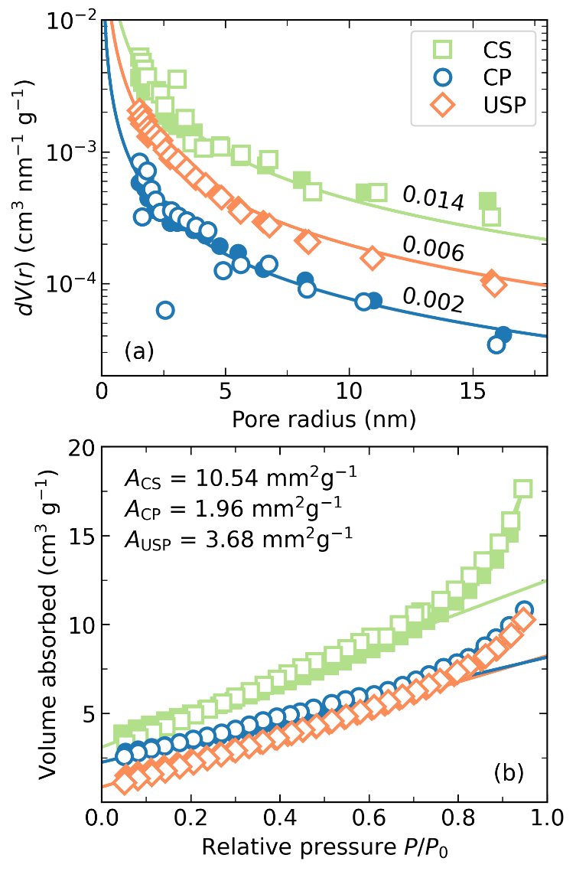
Figure S1. (a) BJH pore size distribution with a maximum pore volume indicated above each curve and (b) nitrogen adsorption (filled symbols) and desorption (empty symbols) isotherms of the CP, CS, and USP ZnO powders.

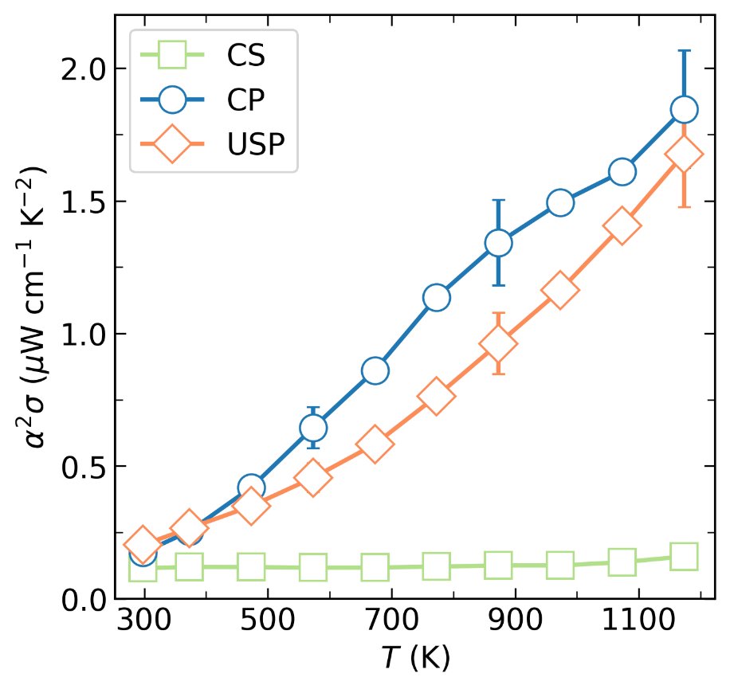
Figure S2. Temperature dependence of the power factor for the ZnO obtained by different methods.

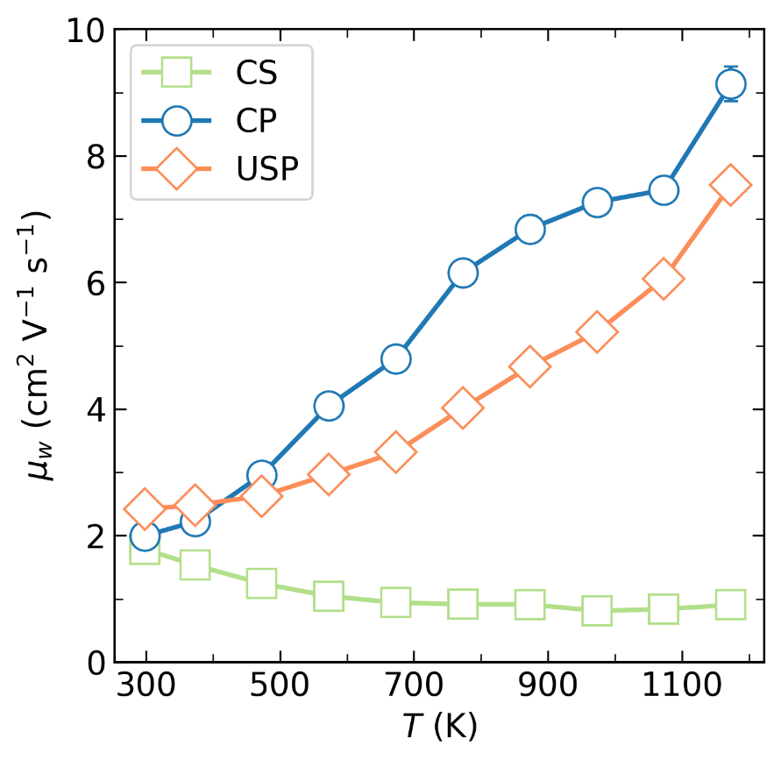
Figure S3. Temperature dependence of the weighted mobility for the ZnO obtained by different methods. The weighted mobility was calculated in the framework of the effective mass model [1].

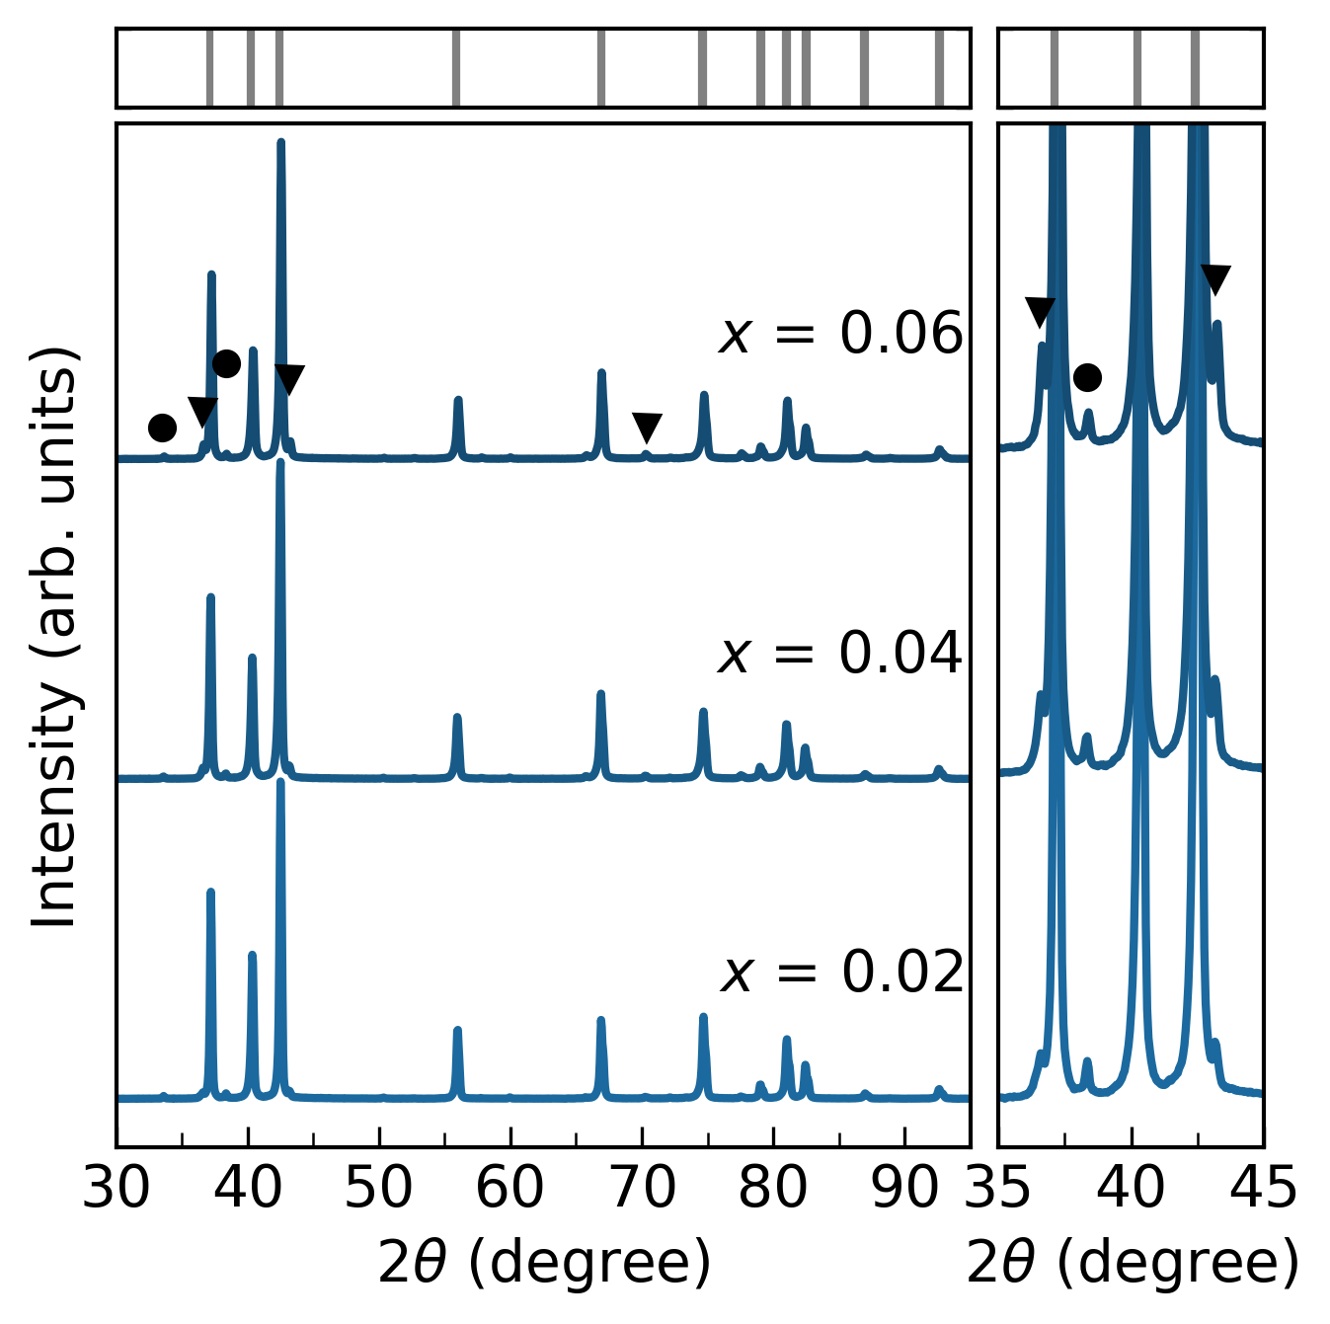
Figure S4. XRD patterns of the Al-doped ZnO samples with nominal composition Zn_{1–x}Al_{x}O (x = 0.02, 0.04, 0.06). On the right: An enlarged section in a 2θ range from 35° to 45° where ZnAl₂O₄ spinel phase, indicated by a solid black triangle (▼), has the most intensive reflections. Due to the experimental conditions, reflections caused by K_{β} radiation were also observed in the presented diffractograms, with two of the most intense reflections indicated with black circles (●). Positions of Bragg’s reflections for the main ZnO phase are indicated by ticks on the top part of the figure.

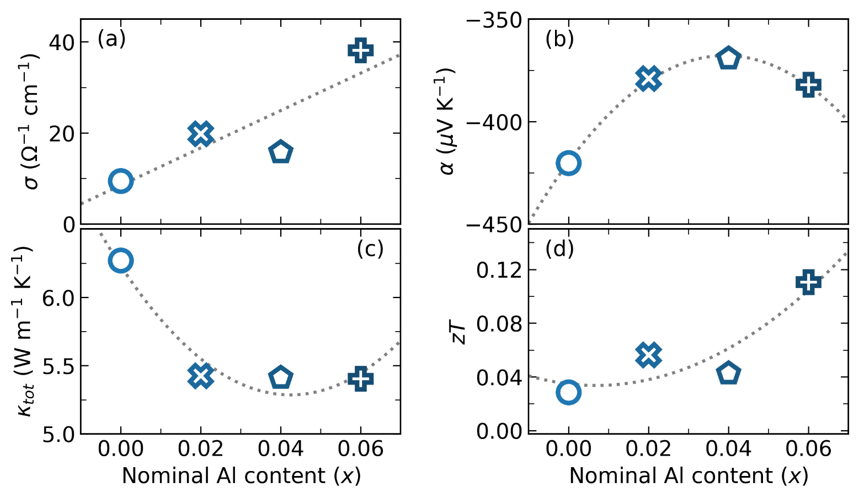
Figure S5. (a) Electrical conductivity σ, (b) Seebeck coefficient α, (c) total thermal conductivity κ_{tot}, and (d) figure of merit zT as a function of nominal Al content for the Al-doped ZnO samples at 1100 K.

References
[1] G.J. Snyder, A.H. Snyder, M. Wood, R. Gurunathan, B.H. Snyder, C. Niu, Weighted Mobility, Advanced Materials. 32 (2020) 2001537. https://doi.org/10.1002/adma.202001537.

