Investigation of silver and copper doping on antimony sulfide thin films obtained by electrophoretic deposition.
Clement Lebastard^{1,2}*, Christopher L. Hassam^{1,2,3}, Tohru Suzuki^{1,2}, Tetsuo Uchikoshi^{1,2}, Yohann Thimont⁴, David Berthebaud^{1,3}*
¹CNRS-Saint-Gobain-NIMS, IRL 3629, Laboratory for Innovative Key Materials and Structures (LINK), National Institute for Materials Science (NIMS), Tsukuba, 305-0044, Japan.
²National Institute for Materials Science (NIMS), 1-2-1 Sengen, Tsukuba, Ibaraki 305-0047, Japan.
³Nantes Université, CNRS, Institut des Matériaux de Nantes Jean Rouxel, IMN, F-44000 Nantes, France.
⁴CIRIMAT, Université de Toulouse, CNRS, Université Toulouse 3 – Paul Sabatier, 118 Route de Narbonne, 31062 Toulouse Cedex 9, France.
*Corresponding authors: David.BERTHEBAUD@cnrs.fr, LEBASTARD.ClementHugo@nims.go.jp

ABSTRUCT
In this work, we demonstrate the production of pure and doped Sb₂S₃ thin films by electrophoretic deposition (EPD). The consequences of silver and copper doping were evaluated by measuring the films’ structural and optoelectrical properties. Sb₂S₃ nanoparticles (NPs) were first synthesized in ethylene glycol and stabilized by polyethylenimine (PEI). Doped NPs were obtained thanks to silver or copper precursors, added during the synthesis process. The orthorhombic Sb₂S₃ and extra AgSbS₂ and CuSbS₂ phases were identified by XRD after thermal treatment at 300°C under vacuum. Metallic Sb impurities were also found for thermal treatment under 275°C. UV-Vis-NIR spectroscopy highlighted the optical properties of amorphous and crystalline thin films as well as the variation of optical band gaps by doping. The photocurrent measurement showed an increase of conductivity for doped thin films (by 3 in the dark & by 2 under AM 1.5 illumination). Adding silver or copper also brought a slower recombination of electron-hole pairs after switching the light off.
KEYWORDS. Electrophoretic deposition, thin films, chalcogenides, coating materials

INTRODUCTION
Generally based on chalcogenide compounds, phase-change materials (PCMs) show pronounced differences in their optoelectronic properties between at least two stable phases. The switch of properties is associated with a modification of the structural state (amorphous to crystalline, for example).^{1,2} As a binary chalcogenide, antimony trisulfide [metastibnite (amorphous) or stibnite (crystalline)] is a great example meeting those conditions. Compared to Se-or Te-based materials, sulfur-based materials present advantages in terms of abundance and low toxicity while being attractive for a wide range of applications.
Antimony trisulfide’s direct bandgap(between1.5and2.2 eV for the crystalline phase)³ makes it suitable for optoelectronic applications. Furthermore, it exhibits a high absorptioncoefficient⁴ and has been reported as a potential thermoelectricmaterial.⁵ It has been integrated into multiple types of devices for different applications: inbatteries,⁶ in solar cells (dye-sensitized, mesoporous, and planar),⁷⁻⁹ and as a photoanode material for photocatalytic water splitting.¹⁰ The choice of materials involved is crucial to consider during the device engineering to tune or increase the desired properties. More generally, several methods have been investigated in order to tune the optoelectronic properties or to increase the power conversion efficiency (PCE), including affecting the structural properties by playing on the orientation of the crystal (anisotropy) by applying a stronger pressure,^{5,11} by doping the phase with another element,¹² or, in the case of stacked devices, to work on the grain boundaries or the interfaces between Sb₂S₃ and other layers.^{8,13} In our study, we decided to focus on the doping aspect. Various metals and alkali metals have been studied as potential dopants, but this article focuses only on the case of silver and copper. The first one can lead to a decrease of the crystallization temperature and the optical bandgap value,¹⁴ while the second one allows us to reach a higher value of the optical band gap and PCE value.¹⁵ Furthermore, both AgSbS₂ and CuSbS₂ phases have already been studied for potential active layers in photovoltaic applications.^{16,17}
Thin films of Sb₂S₃ are often obtained by chemical bath deposition (CBD).¹⁸ The technique is easy to setup, cheap, and doping-friendly by adding the dopants in the bath and can be used with porous substrates. One of the major drawbacks can be the presence of antimony oxide impurities (Sb₂O₃). For photo voltaic applications, the oxide impurities form traps that limit the VOC values and reduce the power conversion efficiency.¹⁹⁻²³ Additional surface treatments have been designed to reduce those impurities (H₂S or thioacetamide sulfurization).²⁴ It is important to mention that a controlled addition of O₂ can lead to better performance in somecases.²⁵ Sputtering techniques are also widespread in the thin film community, enabling dense, high-quality films with controlled thicknesses.^{14,26} However, its scalability and cost/income balance can be limiting factors in its application.
In this paper, Sb₂S₃ films were obtained by electrophoretic deposition (EPD), a versatile and efficient coating technique based on the migration of charged particles in a colloidal suspension under an applied electric field.²⁷ Complex shapes and porous materials can be coated rapidly as long as the surface is conductive. This simple, low-energy, and cost effective process is easily scalable and can be applied to industry. Recent advancements have also shown the potential of EPD in the production of multilayered membranes,²⁸ lithium-ionbatteries,²⁹ robust structurally colored coatings,³⁰ photoelectrodes,³¹ pathogenic bacterial films,³² or UV−NIR blocking coatings for windows,³³ among others.
Sb₂S₃ nanoparticles are prepared by wet-chemical synthesis based on previous work using polyethylenimine (PEI) as a charged polymeric agent.³⁴ Various dopants have been employed to modify the optoelectronic properties of Sb₂S₃ thin films or solar cells.¹² Here, silver and copper doping is evaluated, from a structural and optical point of view but also through photocurrent measurements, showing a slower recombination. This work confirms the viability of EPD for the obtention of pure and doped-Sb₂S₃ thin films and the potential applications ensuing.

METHODS
Reagents. Antimony trichloride (SbCl₃; Merck>98%), thioacetamide (C2H5NS; Merck 98%), silver nitrate (AgNO₃; Wako 99.8%), copper chloride dihydrate (CuCl₂·2H₂O; Wako 99%), and polyethylenimine (H[CH2−CH2−NH−]_{n}H; Wako 10,000 MW) were used as starting precursors. Ethylene glycol (EG) (C₂H₆O₂; Merck 99.8%), methanol (CH₃OH; Wako 99.8%), and acetone (C₃H₆O; Wako 99.5%) were used as solvents. No extra steps of purification were performed on precursors or solvents. Indium doped tin oxide (ITO) glass (10 Ω/sq; Geomatec Co., Ltd., Japan) was used as the conductive substrate.
Synthesis Section. The Sb2S3 nanoparticles were synthesized following the procedure reported in a previous study.³⁴ In brief, 1.5 g of PEI was dissolved in 22.5 mL of ethylene glycol (EG) and stirred for 24h. In a container, 0.235 g of SbCl₃ was dissolved in 1 mL of the PEI solution and 9 mL of EG. In a separate container, 0.160 g of TAA was dissolved in 1 mL of the PEI solution and 9 mL of EG. After total dissolution, both containers were combined, stirred, and allowed to sit for 24 h. For doped syntheses, 8.5 mg of AgNO₃ or CuCl₂·2H₂O was added and dissolved concomitantly with SbCl₃ before the addition of the TAA solution. After the sitting period, the nanoparticles were cleaned by several centrifugation steps. Ten mL of methanol was first added to the solution before the initial centrifugation step (11,000 rpm, 30 min) using an AS185 centrifuge (ASONE) equipped with a 6×50 mL rotor (radius 9.5 cm). The powder was recovered and redispersed in 20 mL of methanol before centrifugation under the same conditions. This step was repeated before a last redispersion in 20 mL of methanol for deposition or, alternatively, drying to obtain powder samples for XRD. The orange powder was annealed at 300 °C for 1 h under vacuum.
Electrophoretic deposition was done with a large volume of solution to avoid a drastic diminution of the nanoparticles’ concentration during successive depositions. Fifteen mL of the Sb₂S₃ dispersion was added to a solution containing 60 mL of methanol and 75 mL of acetone. The final dispersion was then stirred before being used. The electrodes (both anode and cathode) were prepared by cutting 2.5×1 cm rectangles of ITO glass that were cleaned in three successive sonicated baths for 30 min (deionized water, ethanol, and acetone, respectively). They were connected to an electric field generator [Anatech model 3870 (Anatech, Japan)] and suspended in the Sb₂S₃/methanol/acetone solution, with a separation of 5 mm. Depositions were done from15 to 25 V and from 15 s to 1 min, regarding the number of layers and the desired thickness. When depositing several successive layers, samples were allowed to dry for 5min before the next deposition. Finally, the films were annealed under vacuum at 300°C for 1 h.
Characterization. For photocurrent measurement, a three electrode setup was used, with a Ag/AgCl reference electrode, a Pt wire as a counter electrode, and the Sb2S3 film as the working electrode. Because the borders of the films are the most prone to cracking, leading to the exposure of ITO to the electrolyte, the area was covered with epoxy resin. The working surfaces of each sample were measured using image analysis software (ImageJ). A solution of Na₂SO₄ (0.1 M, pH=7) served as a supporting electrolyte and was replaced before the new measurement. A Keithley model 2400 source meter (Keithley, USA) was used to measure the photocurrent response of the films under one sun illumination (AM 1.5 G illumination, HAL-320, Asahi Spectra USA, Inc.). Dynamic light scattering (DLS) and zeta potential measurements were taken using a diluted dispersion of nanoparticles in methanol (0.5mg·mL−1). An ELSZ-2000ZS (Otsuka Electronics Co. Ltd., Japan) and a Malvern Zetasizer Nano Z (Malvern Instruments Ltd., U.K.) were respectively used. XRD characterization was done with a θ−θ Rigaku Smart Lab 3 diffractometer (Rigaku, Japan) for the powder samples and with a Rigaku SmartLab (Rigaku, Japan) for the thin film ones. Both powder and film measurements were taken from 10 to 55°, with a 0.02° step width, a scan speed of 1°·min−1, and Cu Kα radiation. The Le Bail method was used for the full-profile fitting of XRD patterns obtained, performed using WinPlotr, within the FullProf software suite.³⁵ TG−DTA experiments were done on a TG−DTA6200 (SII Inc., Japan) with a heating rate of 10 °C·min−1, from 25 to 300 °C and under N2 flow. The initial mass of the samples was 15±2 mg. UV−vis transmittance and reflectance measurements were taken using a V-770 UV−vis−NIR spectrophotometer (JASCO Co., Japan), and absorbance spectra were obtained following those measurements. SCOUT software³⁶ was used to model the thickness of control and doped Sb2S3 thin films and to calculate their relative bandgaps. Details on the used model can be found in our previous work.³⁴ SEM pictures were obtained with a TM3000 SEM instrument (Hitachi High-Tech Co., Japan), with an accelerating voltage of 15 kV.

RESULTS AND DISCUSSION
As observed previously,³⁴ the addition of the TAA solution to the SbCl₃ solution leads to the formation of Sb₂S₃. Initially transparent, the solution becomes totally opaque after 24 h without any precipitation, suggesting the stability of the suspension, confirmed later by zetapotential measurement. In the case of Cu-doping, the dissolution of CuCl₂·2H₂O leads to a dark blue color of the solution that finally fades to colorless after a minimum of 30 min of stirring and sonication (Figure S1). Ethylene glycol acted both as a solvent and a reductant for the Cu²⁺ ions,^{37,38} following eq 1. It was noted that both doping cations have similar oxidation states (i.e., Ag⁺ and Cu⁺) at the end of the first stirring step and before the addition of TAA.
4Cu²⁺ + HO-CH₂-CH₂-OH → 4Cu⁺ + 4H⁺ + CHO-CHO (1)
After the addition of TAA and the 24 h of sitting, the doped solutions present a darker color than the control (FigureS2), but no precipitation was observed in either.
DLS and zeta potential characterization of the solutions confirm the stability observed quantitatively. The control nanoparticles’ diameter measured by DLS in methanol is 110 nm, in agreement with previous work,³⁴ while doped ones are slightly larger at 135−140 nm (Figure1, left). It seems that adding dopant does not allow obtaining nanoparticles with a narrow dispersity, increasing from 0.15 to 0.25 when silver or copper dopants are added (Figure1, left). However, the zeta potential remains constant, ranging between 60 and 65 mV (Figure1, right). PEI is added in excess during the synthesis and surrounds the Sb₂S₃ nanoparticles, leading to a positively charged surface that is constant over the synthesis (i.e., with and without dopants). Those values indicate the stability of the colloidal solution and the feasibility of EPD as a deposition method.
Initially dispersed in a methanol solution, the EPD of Sb₂S₃ nanoparticles was performed with a volume ratio of 1:1 (methanol/acetone) in order to improve the film quality by speeding up the drying, leading to smooth and crack-free thin films. Higher voltage and longer deposition time were found to increase the thickness of the film but also irremediably damage the film or substrate in return. Doing multiple short depositions, interspersed with drying steps, was a good alternative to increase the thickness without significantly affecting the film quality (i.e., cracks or delamination). No significant differences were observed between and the doped films during the deposition process.
Structural characterizations were performed on both powder samples and thin films. It is important tomentionthatSb₂S₃ crystallizes in an orthorhombic structure and belongs to the Pnma space group (62). However, it iscommon³⁹ to permute the axes and use the Pbnm space group (62) instead because the crystal tends to grow and to stack in one direction. For the rest of this study, the Pbnm system will be used in order to have the infinite (Sb₄S₆)_{n} chain along the [001] direction. Data were refined by the Le Bail refinement method, starting from the standard PDF card (JCPDS no. 42-1393), and are compiled inTable1. Figure 2 gathers the XRD powder and thin film patterns of Sb₂S₃, Sb₂S₃/Ag, and Sb₂S₃/Cu, respectively.
Diffraction peak intensities of Sb2S3 phases vary based on the sample nature (powder or thin film). In thin film samples, the intensity of the (hk0) planes is higher than that of the (hkl) ones. While for powder, the highest intensities correspond to the (211), (221), and (130) planes, attesting a stronger perpendicular interaction (van der Waals) between the (Sb₄S₆)_{n} infinite ribbons that grows along the [001] direction.
Extra peaks corresponding to the metallic Sb phase were detected when the annealing temperature was set to 275 °C. In agreement with Parize et al.,²⁰ Sb acts as an intermediate during the crystallization process. Reflection (110) at 42.0° does not overlay any reflection of the Sb₂S₃ phase; its absence confirmed the obtaining of pure stibnite or with Sb impurities at low concentrations, below the detection limit. Indium oxide peaks were detected for thin film samples due to ITO glass substrates required for EPD. When dopant was added during the synthesis, extra peaks and phases were observed, no matter the temperature of annealing (275 or 300 °C) nor the nature of the phase (powder or thin film). The identification of phases is easier on powder because the number and the peak intensity are higher; however, those phases were also found on thin film samples.
In the case of copper doping, the CuSbS₂ phase (JCPDS no. 44-1417) was identified and in agreement with other studies.^{15,40,41} In powder samples, 5 peaks were detected at 12.22, 19.18, 29.68, 29.90, and 39.09°, corresponding to the reflections (002), (102), (200), (013), and (015), respectively. For films beyond 4.0 at % of Cu-doping (up to 8.7 at %), only a broad peak was detected at 30.0° for thin film samples, as observed by Chalapathi et al. ⁴⁰ The obtaining of the CuSbS₂ phase confirms the reduction of Cu²⁺ ions (CuCl₂·2H₂O) into ones by EG. For samples doped with silver, powder and thin films contain the cubic AgSbS₂ phase (JCPDS no. 53 0842), as reported by Diliegros-Godines and Chalapathi’s studies^{42,43} and indicated by the (111), (200), and (220) peaks were detected on powder samples at 30.73 and 32.85°. Similar peaks were observed by Chalapathi et al.⁴³ and identified as the monoclinic AgSbS₂ phase (JCPDS no. 019-1137). Even if the precursors and the synthesis techniques are very different, they first obtain a mixture of Sb₂S₃ and Ag₃SbS₃ phases at 300°C, the pure cubic AgSbS₂ phase at 350 °C, and a mixture of both cubic and monoclinic AgSbS₂ phases at 400 °C. It is surprising that both cubic and monoclinic AgSbS₂ phases were obtained at 275 °C in our case. Only the cubic phase was observed in thin film samples, with a lattice parameter of 0.563 nm, in agreement with Geller et al.’s⁴⁴ reported values (0.5652nm).
No extra peaks corresponding to oxide phase Sb₂O₃ (JCPDS no. 05-0534) or metallic Cu/Ag were detected in either powder or film samples. Furthermore, for both silver and copper doping, no significant shift in diffraction patterns was noticed. Because AgSbS₂ and CuSbS₂ phases were detected, it is unlikely that Ag and Cu, respectively, entered the Sb₂S₃ crystal lattice. The fwhm values were evaluated over 10 reflections: (020), (120), (220), (310), (120), (220), (310), (320), (240), (421), (431), (351), and (061). The average crystalline size (D) was calculated from the Debye−Scherrer equation using the fwhm values determined before. Table 2 shows the values of 5 samples for each composition. The doping of Sb₂S₃ leads to an increase in the crystallite size, in agreement with nanoparticle size measured by DLS, and a diminution of the fwhm value. Overall, doping ensured the better crystallinity of thin films.
TG−DTA analysis was used to study the crystallization temperature of Sb₂S₃ (Figure 3). An exothermic peak was observed at 267 °C, with an onset around 250 °C in agreement with the literature.^{10,20} The in situ analysis of the crystallization process of Sb₂S₃ by Parizeet al.²⁰ showed that crystallization appears between 250 and 260 °C with an optimal annealing temperature of 270 °C for larger crystallites without impurities. Similar results were observed for Sb₂S₃/Cu, with an exothermic peak at 265 °C. For Sb₂S₃/Ag, the crystallization temperature was lowered to 251 °C, with an onset around 240 °C, in agreement with Dong et al.’s⁴⁵ work on silver doping of Sb₂S₃.
As mentioned previously, Sb2S3 thin films were obtained from the EPD of nanoparticles after their dispersion in a volume ratio of 1:1 (methanol/acetone). Amorphous phases are transparent, from pale yellow to deep orange, as the thickness increases, while the annealed phase varies from transparent brown to opaque black, depending on the thickness (Figure S3). Thin film microstructure was studied before and after annealing, revealing a smooth and homogeneous surface in the first case and a more or less dense layer of needles in the second case, similar to the natural mineral (i.e., stibnite). The Sb₂S₃ nanorod arrangement differs within the samples we made. We observed either free needles, without any order, or a self-assembly of the needles (Figure S4). The self-assembly can be described as “farfalle pasta” shape. Similar organized shapes were reported as twin flowers⁴⁶ or pellet drum-type⁴⁷ in the literature. Most of the time, the self-assembly of nanorods is observed, while free needles are often observed on the edge of the substrate or for very thin films (<200nm). Previousstudies47,48 attributed this morphology to the structural anisotropy of Sb₂S₃.With or without self-assembly of the nanorods, thin film XRD patterns revealed a strong intensity of (hk0) planes, confirming the presence of (Sb₄S₆)_{n} infinite ribbons that grow along the [001] direction.
The optical properties of control and doped Sb₂S₃ were evaluated by UV−vis−NIR spectroscopy (transmittance, absorption, and reflectance) and confirmed the strong disparity between amorphous and crystalline films. For a deposition at 25 V, Figure4 shows two different deposition times (15 and 30 s) of control Sb₂S₃. Amorphous spectra (solid lines) show a high transparency above 600 nm and a significant absorption below 600 nm, which becomes total in the ultraviolet range (under 400 nm). Absorption in NIR comes from the ITO substrate. The spectrum at 15 s presents a slightly different shape compared to the one at 30 s. The decrease in transmission can be correlated with the increase of thickness, whereas the modification of the shape is associated with the displacement of the interference pattern (also affected by the increase of thickness). After thermal treatment, the spectra (dashed lines) present a stronger absorption in the visible range, in agreement with the brown to opaque black aspect of crystalline films. Both amorphous and crystalline thin films’ colors are extracted from transmission spectra and displayed in Figure 4. Similar spectra were obtained with the SCOUT software³⁶ by modeling a Sb₂S₃ layer over an ITO glass system; the thickness of the ITO layer was evaluated at 153 nm, and the thickness of the Sb₂S₃ layers was evaluated through the fitting of the model (Figure S5).
Band gap values were first extracted from absorption measurement by extrapolating the linear part of the Tauc plot ((αhν)1/γ vs hν), where γ depends on the band gap transition nature (γ=2 in the case of allowed indirect and γ= 1/2 for allowed direct). As mentioned by Joschko et al.,⁴⁹ different opinions coexist in the scientific community regarding the nature of the transition for both the amorphous and crystalline Sb₂S₃ phases. In this work, we considered an allowed indirect transition and an allowed direct transition for the amorphous and crystalline phases, respectively. The values of band gap found in the literature are quite broad and reflect the material obtained (film, nanoparticle) and, more generally, its conditions of obtaining. In our study, we also observed band gap variations ±0.03 eV, but the trends that are shown below were found for every synthesis and batch of samples. Figure 5 f ilms, with extracted band gaps of 2.05 and 1.74 eV, respectively. As expected, the crystallization comes with a decrease in band gap energy. Band gap values were also estimated by using the models obtained via SCOUT and compared to the extrapolated Tauc plot ones. For indirect allowed transitions, we find similar values (around 2.0 eV), but for direct allowed transitions, Tauc plot values are higher than those obtained by modeling (Table 3). Experimental data undervalue the total secondary reflectance, roughness, and interference fringes that can lead to an overestimation of the band gap, as well as the extrapolation technique itself, which is not very quantitative. We also observed a strong disparity between the measured and modeled thicknesses of the films that can be attributed to the presence of PEI or the porosity it generates after thermal treatment.
Figures 6 and S6 depict the calculated band gap of two different batches of control and doped thin films after annealing, showing a decrease of the band gap energy in the case of Ag and an increase for Cu, which were also observed by Diliegros-Godines et al.⁴² and Lei et al.,¹⁷ respectively.
Photoconductivity of control and doped films was evaluated in the dark and under an AM 1.5 illumination. After a 10 min step of stability at 0.5 V, the light was switched on for 30 s and then switched off during another 30 s step. No significant current variation was observed over 10 cycles. Photocurrent, conductivity, and photosensitivity [S = (σ_{light} − σ_{dark}) /σ_{dark}] are shown in Table 4. It was noted that both dark and light photo currents and, by extension, dark and light conductivities increase in doped composition, in agreement with the literature (silver⁴² and copper^{17,40}). Rodrıguez-Lazcano et al.⁴¹ found that the annealed CuSbS₂ (400 °C) samples showed a photocurrent 2 orders of magnitude higher than that of the as-prepared Sb₂S₃−CuS (room temperature) and 1 order compared with the that of Sb₂S₃−CuS (350 °C). In our study, the presence of CuSbS₂ is also the reason considered for the enhancement of photoelectrical properties, more than the insertion of Cu in the lattice. It is suggested that similar behavior also happens with the presence of AgSbS₂, regarding the photoelectrical property evolution.
On another aspect, photosensitivity is higher for the control film (Table 4) than for the doped ones, as observed by Diliegros-Godinesetal.⁴² It was noted that photosensitivity is directly related to the conductivity of the film but also depends onthecrystallinity.⁵⁰ In our study, the photosensitivity values between the control film (S_{cont} =4.7) and doped one (S_{Ag}= 1.7 and S_{Cu}=2.6) are similar in terms of order of magnitude and close to the one reported by Aslan et al. S_{cont} =7.7.⁵¹ Higher values were also reported elsewhere in the literature by Diliegros-Godines et al.⁴² S_{cont}=65 and S_{Ag}=12, suggesting that the decrease in photosensitivity can be attributed to the increase in dark conductivity and the introduction of silver ions. They also observe a reduction of crystallinity (smaller crystallites and an increase of fwhm), while it is the opposite in our study. Similar values of photosensitivity among control and doped films could result from a counterbalancing effect between the increase of photocurrent (especially the dark one) and a better crystallinity.
It was observed that control and doped films do not show the same response to photocurrent measurement and, more precisely, the current evolution after switching off the light (Figure 7). Sb₂S₃ films show an instantaneous decrease of current to its dark value.^{10,42,48,52} However, for both Sb₂S₃/Ag (5%) and Sb₂S₃/Cu (5%) films, the current decreased slower and cannot reach its dark photocurrent value in 30 s. The presence of AgSbS₂ and CuSbS₂, respectively, makes the recombination slower and might act as a charge trap center.^{42,53}

CONCLUSIONS
In this work, Sb₂S₃ thin films were successfully deposited on ITO glass by EPD. The effect of Ag⁺ and Cu⁺ doping was studied from the synthesis (without extra steps) to the structural and optoelectronic properties. Annealing of the obtained amorphous films leads to crystalline structures with no significant modification in the lattice parameters of the Sb₂S₃ phase. Instead, AgSbS₂ and CuSbS₂ phases were detected, providing slightly bigger Sb₂S₃ crystallites and a better crystallinity overall. No metallic (Sb, Ag, and Cu) or oxide (Sb₂O₃) peaks were detected after a thermal treatment at 300 °C under vacuum. Annealed films showed a photocurrent response under the sun illumination and in dark conditions; conductivity increased in both cases for doped films. Bandgap values were estimated using the Tauc equation for indirect allowed and direct allowed transitions for amorphous and crystalline phases, respectively, revealing a slight tunability via doping. A decrease in the crystallization temperature was also observed for the silver-doped samples. This low-cost and simple method shows promise for the exploration of inexpensive devices by replacing the sputtering or chemical bath deposition methods.

ASSOCIATED CONTENT
Supporting Information
The Supporting Information is available free of charge at https://pubs.acs.org/doi/10.1021/acs.jpcc.4c04781.
Images of Cu²⁺ reduction, images of synthesis, images of powder and thin films, SEM images of thin film, modeling of transmittance and reflectance spectra, and Tauc plot (PDF)

ACKNOWLEDGMENTS
C. L. acknowledges the Japan Society for the Promotion of Science for postdoctoral fellowships JSPS PE21752.

REFERENCES
(1) Wuttig, M.; Yamada, N. Phase-Change Materials for Rewriteable Data Storage. Nat. Mater. 2007, 6 (11), 824−832.
(2) Phase Change Materials: Science and Applications; Raoux, S., Wuttig, M., Eds.; Springer: New York, NY, 2009.
(3) Cai, Z.; Dai, C.-M.; Chen, S. Intrinsic Defect Limit to the Electrical Conductivity and a Two-Stepp-Type Doping Strategy for Overcoming the Efficiency Bottleneck of Sb₂S₃-Based Solar Cells. Sol. RRL 2020, 4 (4), 1900503.
(4) Radzwan, A.; Ahmed, R.; Shaari, A.; Lawal, A. Ab Initio Calculations of Optoelectronic Properties of Antimony Sulfide Nano Thin Film for Solar Cell Applications. Results Phys. 2019, 15, 102762.
(5) Azadparvar, M.; Rahnamaye Aliabad, H. A.; Ozdemir, E. G. Optoelectronic and Thermoelectric Properties of Sb₂S₃ under Hydrostatic Pressure for Energy Conversion. AIP Adv. 2023, 13, 065218.
(6) Zhou, X.; Bai, L.; Yan, J.; He, S.; Lei, Z. Solvothermal Synthesis of Sb₂S₃/C Composite Nanorods with Excellent Li-Storage Performance. Electrochim. Acta 2013, 108, 17−21.
(7) Ito, S.; Tsujimoto, K.; Nguyen, D.-C.; Manabe, K.; Nishino, H. Doping Effects in Sb₂S₃ Absorber for Full-Inorganic Printed Solar Cells with 5.7% Conversion Efficiency. Int. J. Hydrogen Energy 2013, 38 (36), 16749−16754.
(8) Choi, Y. C.; Lee, D. U.; Noh, J. H.; Kim, E. K.; Seok, S. I. Highly Improved Sb₂S₃ Sensitized-Inorganic−Organic Heterojunction Solar Cells and Quantification of Traps by Deep-Level Transient Spectroscopy. Adv. Funct. Mater. 2014, 24 (23), 3587−3592.
(9) Kim, D. -H.; Lee, S. -J.; Park, M. S.; Kang, J. -K.; Heo, J. H.; Im, S. H.; Sung, S.-J. Highly Reproducible Planar Sb₂S₃-Sensitized Solar Cells Based on Atomic Layer Deposition. Nanoscale 2014, 6(23), 14549−14554.
(10) De Angelis, A. D.; Kemp, K. C.; Gaillard, N.; Kim, K. S. Antimony (III) Sulfide Thin Films as a Photoanode Material in Photocatalytic Water Splitting. ACS Appl. Mater. Interfaces 2016, 8 (13),8445−8451.
(11) Cui, Z.; Bu, K.; Zhuang, Y.; Donnelly, M.-E.; Zhang, D.; Dalladay-Simpson, P.; Howie, R. T.; Zhang, J.; Lu, X.; Hu, Q. Phase Transition Mechanism and Bandgap Engineering of Sb₂S₃ at Gigapascal Pressures. Commun. Chem. 2021, 4 (1), 125.
(12) Myagmarsereejid, P.; Ingram, M.; Batmunkh, M.; Zhong, Y. L. Doping Strategies in Sb₂S₃ Thin Films for Solar Cells. Small 2021, 17 (39), 2100241.
(13) Savadogo, O.; Mandal, K. C. Characterizations of Antimony Tri-Sulfide Chemically Deposited with Silicotungstic Acid. J. Electro chem. Soc. 1992, 139 (1), L16−L18.
(14) Dong, W.; Liu, H.; Behera, J. K.; Lu, L.; Ng, R. J. H.; Sreekanth, K. V.; Zhou, X.; Yang, J .K. W.; Simpson, R. E. Wide Bandgap Phase Change Material Tuned Visible Photonics. Adv. Funct. Mater. 2019, 29 (6),1806181.
(15) Lopez, J. Chalcostibite Copper Antimony Sulfide for Solution Processed Thin Film Solar Cells. Bachelor’s Thesis, Oregon State University,2017.
(16) Medina-Montes, M. I.; Baldenegro-Pérez, L.; Morales-Luna, M.; Sánchez, T.; Santos-Cruz, D.; Mayén-Hernández, S.; Santos-Cruz, J. Physical Properties of Photoconductive Ag-Sb-S Thin Films Prepared by Thermal Evaporation. Mater. Sci. Semicond. Process. 2022, 137, 106167.
(17) Lei, H.; Lin, T.; Wang, X.; Dai, P.; Guo, Y.; Gao, Y.; Hou, D.; Chen, J.; Tan, Z. Copper Doping of Sb₂S₃: Fabrication, Properties, and Photovoltaic Application. J. Mater. Sci.: Mater. Electron. 2019, 30 (24), 21106−21116.
(18) Chemical Solution Deposition of Functional Oxide Thin Films; Schneller, T., Ed.; Springer: Wien, 2013.
(19) Kumar, P.; You, S.; Vomiero, A. CuSCN as a Hole Transport Layer in an Inorganic Solution-Processed Planar Sb₂S₃ Solar Cell, Enabling Carbon-Based and Semitransparent Photovoltaics. J. Mater. Chem. C 2022, 10 (43), 16273−16282.
(20) Parize, R.; Cossuet, T.; Chaix-Pluchery, O.; Roussel, H.; Appert, E.; Consonni, V. In Situ Analysis of the Crystallization Process of Sb2S3 Thin Films by Raman Scattering and X-Ray Diffraction. Mater. Des. 2017, 121, 1−10.
(21) Zheng, Q.; Wang, C.; Ma, G.; Jin, M.; Cheng, S.; Lai, Y.; Yu, J. Annealing Temperature Impact on Sb₂S₃ Solar Cells Prepared by Spin-Coating Method. Mater. Lett. 2019, 243, 104−107.
(22) Deng, H.; Chen, Z.; Xie, W.; Ishaq, M.; Wu, K.; Feng, X.; Kang, Y.; Wang, W.; Cheng, S. Bulk Defect Passivation for Full-Inorganic Sb₂S₃ Solar Cells by Sulfur-Atmosphere Recrystallization Process. Sol. RRL 2023, 7 (19), 2300482.
(23) Farhana, M. A.; Manjceevan, A.; Bandara, J. Recent Advances and New Research Trends in Sb₂S₃ Thin Film Based Solar Cells. J. Sci.: Adv. Mater. Devices 2023, 8 (1), 100533.
(24) Barthwal, S.; Singh, S.; Chauhan, A. K.; Prabhu, N. S.; Prabhudessai, A. G.; Ramesh, K. A Comprehensive Insight into Deep Level Defect Engineering in Antimony Chalcogenide Solar Cells. Mater. Adv. 2023, 4 (23), 5998−6030.
(25) Liu, X.; Chen, C.; Wang, L.; Zhong, J.; Luo, M.; Chen, J.; Xue, D.; Li, D.; Zhou, Y.; Tang, J. Improving the Performance of Sb₂Se₃ Thin Film Solar Cells over 4% by Controlled Addition of Oxygen during Film Deposition. Prog. Photovoltaics 2015, 23 (12), 1828− 1836.
(26) Delaney, M.; Zeimpekis, I.; Lawson, D.; Hewak, D. W.; Muskens, O. L. A New Family of Ultralow Loss Reversible Phase Change Materials for Photonic Integrated Circuits: Sb₂S₃ and Sb₂Se₃. Adv. Funct. Mater. 2020, 30 (36), 2002447.
(27) Electrophoretic Deposition of Nanomaterials; Dickerson, J. H., Boccaccini, A. R., Eds.; Nanostructurescience and technology; Springer Science & Business Media, LLC: New York, NY, 2012.
(28) Ishii, K.; Matsunaga, C.; Kobayashi, K.; Stevenson, A. J.; Tardivat, C.; Uchikoshi, T. Fabrication of BSCF-Based Mixed Oxide Ionic-Electronic Conducting Multi-Layered Membrane by Sequential Electrophoretic Deposition Process. J. Eur. Ceram. Soc. 2021, 41 (4), 2709−2715.
(29) Kozawa, T.; Zhang, C.; Uchikoshi, T.; Fukuyama, K.; Kondo, A.; Naito, M. Solution-Based Approach for the Continuous Fabrication of Thin Lithium-Ion Battery Electrodes by Wet Mechanochemical Synthesis and Electrophoretic Deposition. Adv. Eng. Mater. 2021, 23 (12), 2100524.
(30) Katagiri, K.; Uemura, K.; Uesugi, R.; Tarutani, N.; Inumaru, K.; Uchikoshi, T.; Seki, T.; Takeoka, Y. Robust Structurally Colored Coatings Composed of Colloidal Arrays Prepared by the Cathodic Electrophoretic Deposition Method with Metal Cation Additives. ACS Appl. Mater. Interfaces 2020, 12 (36), 40768−40777.
(31) Renaud, A.; Jouan, P.-Y.; Dumait, N.; Ababou-Girard, S.; Barreau, N.; Uchikoshi, T.; Grasset, F.; Jobic, S.; Cordier, S. Evidence of the Ambipolar Behavior of Mo6 Cluster Iodides in All-Inorganic Solar Cells: A New Example of Nanoarchitectonic Concept. ACS Appl. Mater. Interfaces 2022, 14 (1), 1347−1354.
(32) Kirakci, K.; Nguyen, T. K. N.; Grasset, F.; Uchikoshi, T.; Zelenka, J.; Kubát, P.; Ruml, T.; Lang, K. Electrophoretically Deposited Layers of Octahedral Molybdenum Cluster Complexes: A Promising Coating for Mitigation of Pathogenic Bacterial Biofilms under Blue Light. ACS Appl. Mater. Interfaces 2020, 12 (47), 52492−52499.
(33) Nguyen, N. T. K.; Lebastard, C.; Wilmet, M.; Dumait, N.; Renaud, A.; Cordier, S.; Ohashi, N.; Uchikoshi, T.; Grasset, F. A Reviewon Functional Nanoarchitectonics Nanocomposites Based on Octahedral Metal Atom Clusters (Nb6, Mo6, Ta6, W6, Re6): Inorganic 0D and 2D Powders and Films. Sci. Technol. Adv. Mater. 2022, 23 (1), 547−578.
(34) Hassam, C. L.; Sciortino, F.; Nguyen, N. T. K.; Srinivasan, B.; Ariga, K.; Gascoin, F.; Grasset, F.; Mori, T.; Uchikoshi, T.; Thimont, Y.; et al. Robust, Transparent Hybrid Thin Films of Phase-Change Material Sb₂S₃ Prepared by Electrophoretic Deposition. ACS Appl. Energy Mater. 2021, 4 (9), 9891−9901.
(35) Roisnel, T.; Rodríquez-Carvajal, J. WinPLOTR: A Windows Tool for Powder Diffraction Pattern Analysis. Mater. Sci. Forum 2001, 378−381, 118−123.
(36) Theiss, W. Compute Optical Constants of Substrates from R and T Spectra, 2000.
(37) Zhang, A.; Ma, Q.; Lu, M.; Yu, G.; Zhou, Y.; Qiu, Z. Copper− Indium Sulfide Hollow Nanospheres Synthesized by a Facile Solution Chemical Method. Cryst. Growth Des. 2008, 8 (7), 2402−2405.
(38) Tang, M.; Tian, Q.; Hu, X.; Peng, Y.; Xue, Y.; Chen, Z.; Yang, J.; Xu, X.; Hu, J. In Situ Preparationof CuInS₂ Films on a Flexible Copper Foil and Their Application in Thin Film Solar Cells. CrystEngComm 2012, 14 (5), 1825.
(39) Kondrotas, R.; Chen, C.; Tang, J. Sb₂S₃ Solar Cells. Joule 2018, 2 (5), 857−878.
(40) Chalapathi, U.; Poornaprakash, B.; Park, S. H. The Effect of Cu-Doping on the Structural, Microstructural, Optical and Electrical Properties of Sb₂S₃ Thin Films. Chalcogenide Lett. 2019, 16 (9), 449− 455.
(41) Rodríguez-Lazcano, Y.; Nair, M. T. S.; Nair, P. K. CuSbS₂ Thin Film Formed through Annealing Chemically Deposited Sb₂S₃−CuS Thin Films. J. Cryst. Growth 2001, 223 (3), 399−406.
(42) Diliegros-Godines, C. J.; Santos Cruz, J.; Mathews, N. R.; Pal, M. Effect of Ag Doping on Structural, Optical and Electrical Properties of Antimony Sulfide Thin Films. J. Mater. Sci. 2018, 53 (16),11562−11573.
(43) Chalapathi, U.; Reddy, A. S.; Prasad, P. R.; Manjula, G.; Sangaraju, S.; Cheruku, R.; Al-Asbahi, B. A.; Alhammadi, S.; Reddy, C. P.; Mohanarangam, K.; et al. Two-Stage-Processed AgSbS₂ Films for Thin-Film Solar Cells. Mater. Sci. Semicond. Process. 2023, 168, 107821.
(44) Geller, S.; Wernick, J. H. Ternary Semiconducting Compounds with Sodium Chloride-like Structure: AgSbSe₂, AgSbTe₂, AgBiS₂, AgBiSe₂. Acta Crystallogr. 1959, 12 (1), 46−54.
(45) Dong, W.; Krbal, M.; Kalikka, J.; Chin, X. Y.; Gholipour, B.; Soci, C.; Fons, P. J.; Mitrofanov, K. V.; Chen, L.; Simpson, R. E. Enhanced Sb₂S₃ Crystallisation by Electric Field Induced Silver Doping. Thin Solid Films 2016, 616, 80−85.
(46) Kavinchan, J.; Thongtem, T. Cyclic Microwave Assisted Synthesis of Sb₂S₃ Twin Flowers in Solutions Containinga Template and Splitting Agent. Chalcogenide Lett. 2012, 9, 365−370.
(47) Maiti, A.; Srivastava, S. K. N, Ru Codoped Pellet Drum Bundle Like Sb₂S₃: An Efficient Hydrogen Evolution Reactionand Hydrogen Oxidation Reaction Electrocatalyst in Alkaline Medium. ACS Appl. Mater. Interfaces 2020, 12 (6), 7057−7070.
(48) Zhong, M.; Wang, X.; Liu, S.; Li, B.; Huang, L.; Cui, Y.; Li, J.; Wei, Z. High-Performance Photodetectors Based on Sb₂S₃ Nano wires: Wavelength Dependence and Wide Temperature Range Utilization. Nanoscale 2017, 9 (34), 12364−12371.
(49) Joschko, M.; Fotue Wafo, F. Y.; Malsi, C.; Kisic, D.; Validzic, I.; Graf, C. Revealing the Formation Mechanism and Band Gap Tuning of Sb₂S₃ Nanoparticles. Beilstein J. Nanotechnol.2021,12,1021−1033.
(50) Nair, M. T. S.; Nair, P. K.; Zingaro, R. A.; Meyers, E. A. Conversion of Chemically Deposited Photosensitive CdS Thin Films to n-Type by Air Annealing and Ion Exchange Reaction. J. Appl. Phys. 1994, 75 (3), 1557−1564.
(51) Aslan, E.; Zarbali, M. Preparation of High-Performance Sb₂S₃ Based Visible-Light Photodetector with Excellent Reversibility. Opt. Mater.2022,133,113028.
(52) Park, Y. S.; Lee, J.; Lee, H.; Yun, J.; Jang, G.; Lee, J.; Son, S.; Lee, C. U.; Jeong, C.; Moon, S.; et al. Surface-Passivated Vertically Oriented Sb₂S₃ Nanorods Photoanode Enabling Efficient Unbiased Solar Fuel Production. Adv. Energy Mater. 2023, 13 (29), 2301166.
(53) Peter, L. M.; Wijayantha, K. G. U.; Tahir, A. A. Kinetics of Light-Driven Oxygen Evolution at α-Fe₂O₃ Electrodes. Faraday Discuss.2012,155,309−322

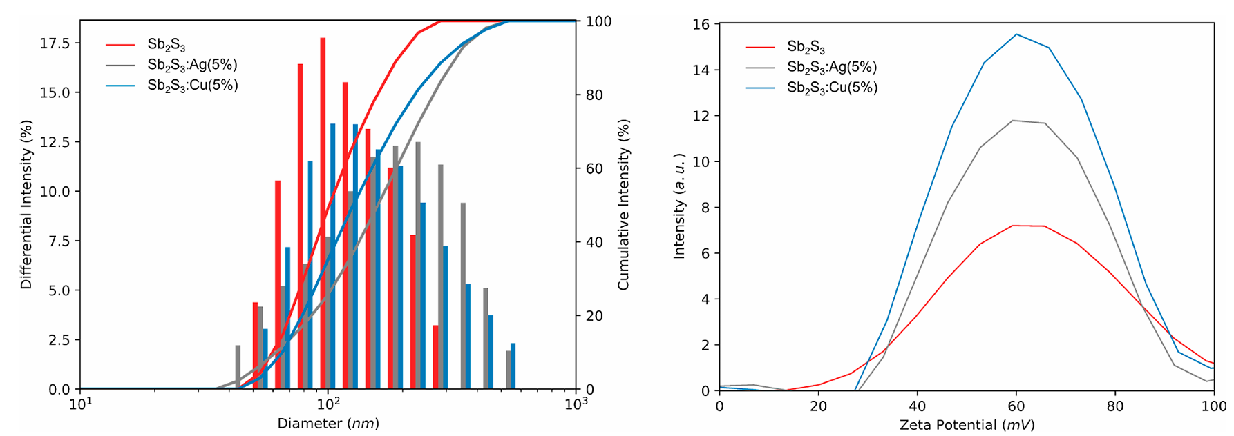
Figure 1. Left: Size distribution analysis of Sb₂S₃, Sb₂S₃/Ag, and Sb2S3/Cu nanoparticles surrounded by PEI in methanol. Right: Zetapotential of the same nanoparticles in methanol.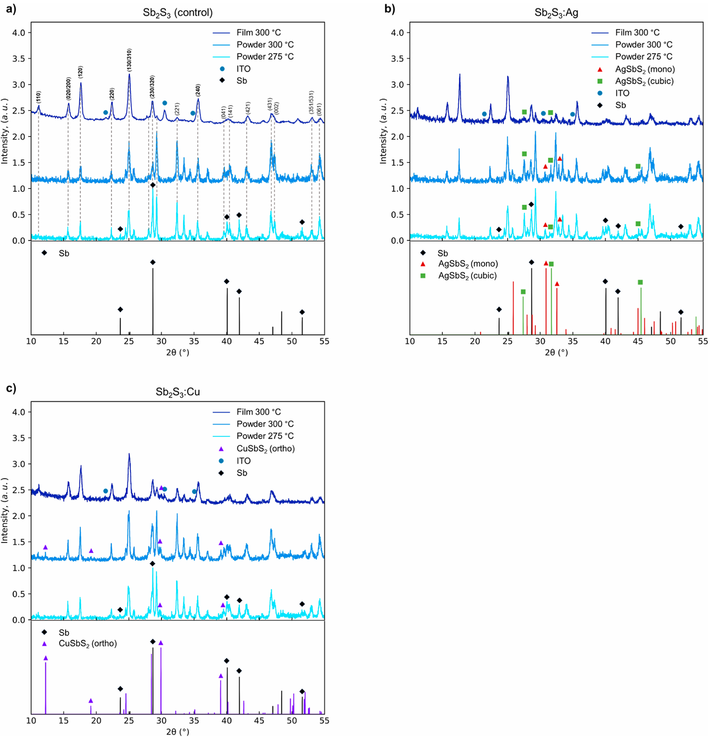
Figure 2. XRD patterns of annealed powder and thin films of Sb₂S₃ (a), Sb₂S₃ /Ag (b), and Sb₂S₃ /Cu (c).
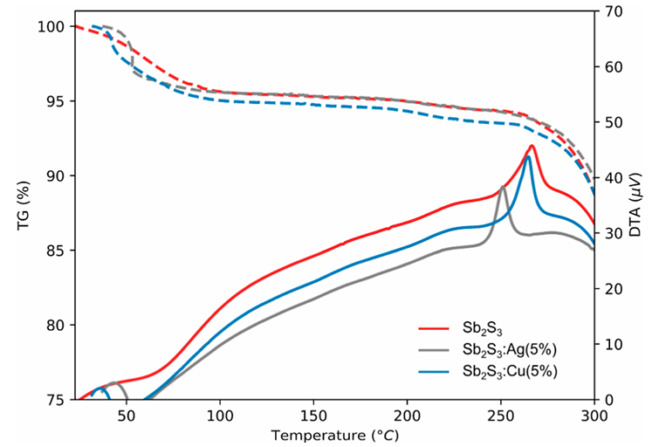
Figure 3. TG and DTA curves of free powder of Sb₂S₃, Sb₂S₃/Ag, and Sb₂S₃/Cu nanoparticles.
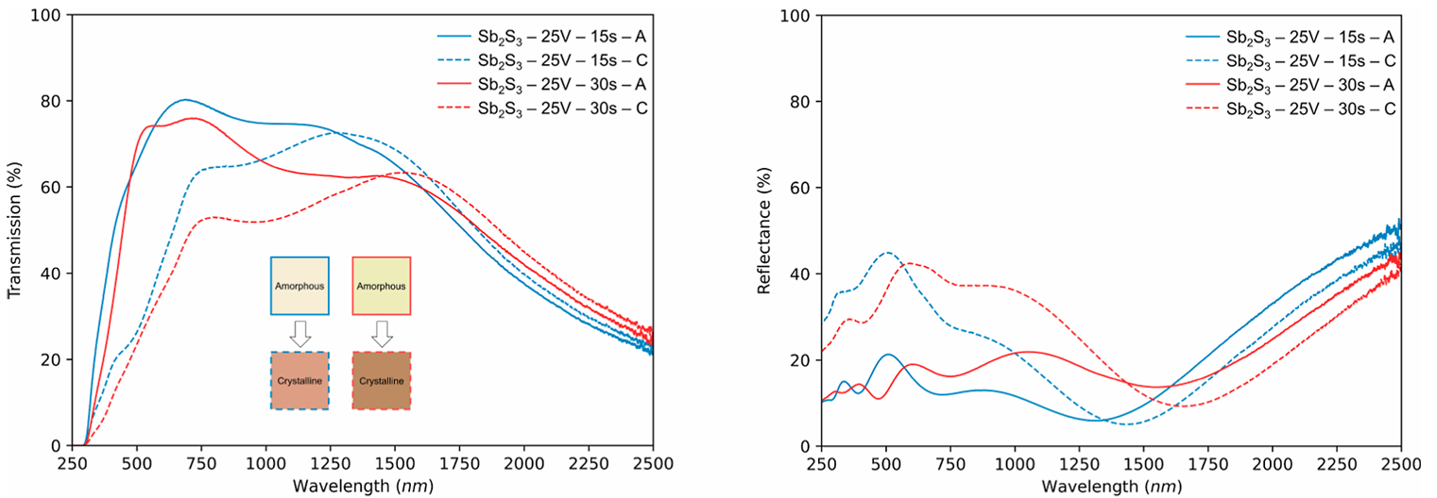
Figure 4. Transmission (left) and reflectance (right) spectra of control Sb₂S₃ before and after annealing.
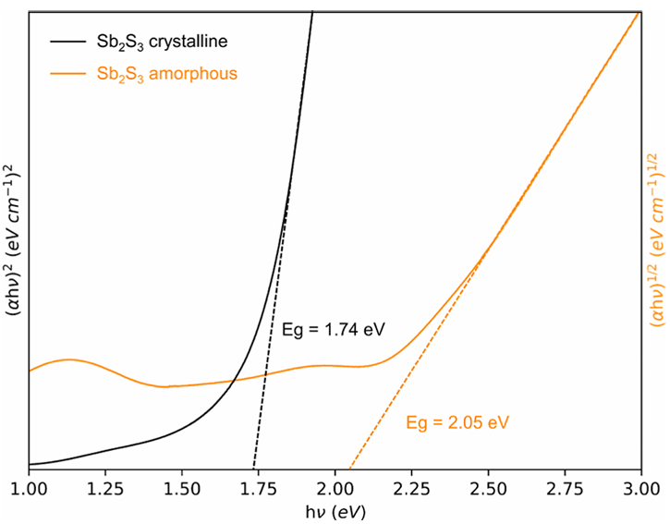
Figure 5. Tauc plot of crystalline and amorphous control Sb films.
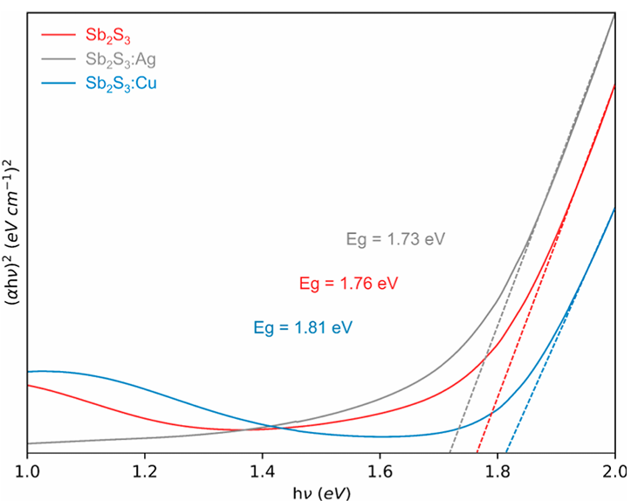
Figure 6. Tauc plots of crystalline control and doped Sb₂S₃ thin films.

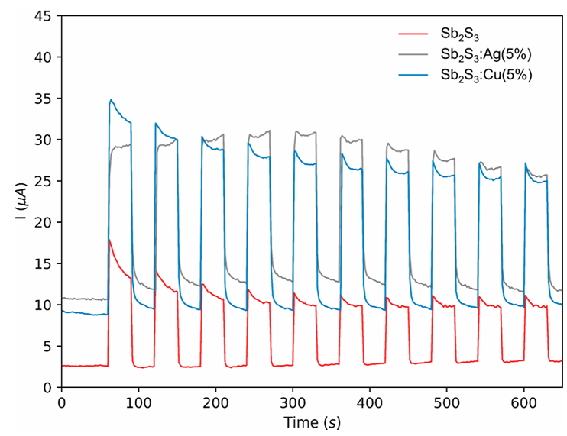
Figure7. Photocurrent responses of crystalline control and doped Sb₂S₃ thin films.

Table 1. Summary of Refined Crystallographic Unit Cell Parameters of Sb₂S₃ Thin Films and Powders Annealed at 300 °C Reported in This Work
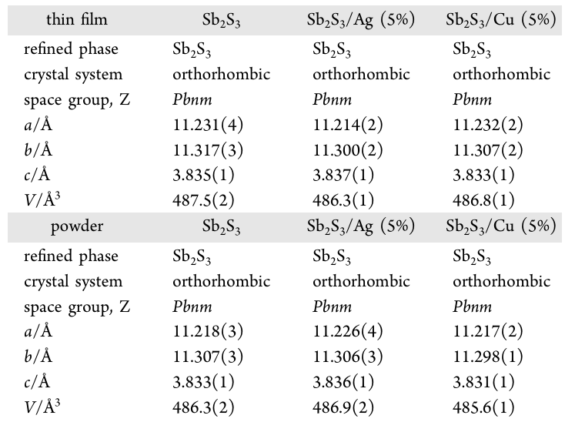

Table 2. Calculated Average FWHM and D Values for 5 Samples of Sb₂S₃, Sb₂S₃/Ag(5%), and Sb₂S₃/Cu(5%) Thin Films
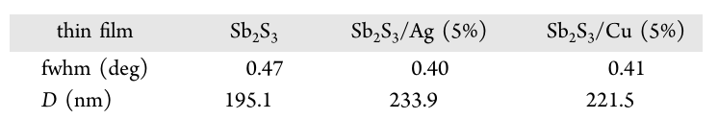

Table 3. Photoelectrical Properties of Control and Doped Annealed Thin Films
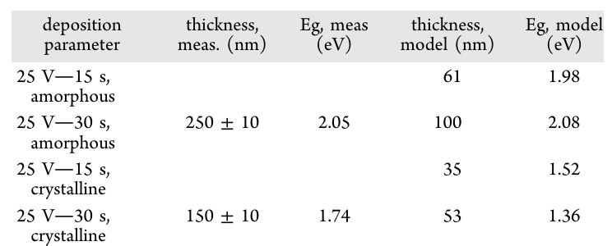

Table 4. Photoelectrical Properties of Control and Doped Annealed Thin Films
