Long-Term Physical Stability of Amorphous Solid Dispersions: Comparison of Detection Powers of Common Evaluation Methods for Spray-Dried and Hot-Melt Extruded Formulations

Kohsaku Kawakami^{1,2*} Taichi Ishitsuka³, Masafumi Fukiage³, Yohei Nishida⁴, Tetsuo Shirai⁵, Yosuke Hirai⁵, Tetsu Hideshima⁵, Fumiaki Tanabe⁶, Koji Shinoda⁶, Ryota Tamate¹, Takuya Fujita⁷

*To whom correspondence should be addressed
E-mail: kawakami.kohsaku@nims.go.jp, Tel. +81-29-860-4424

¹ Research Center for Macromolecules and Biomaterials, National Institute for Materials Science, 1-1 Namiki, Tsukuba, Ibaraki 305-0044, Japan
² Graduate School of Pure and Applied Sciences, University of Tsukuba, 1-1-1 Tennodai, Tsukuba, Ibaraki 305-8577, Japan
³ Pharmaceutical R&D, Ono Pharmaceutical Co., Ltd., 1-15-26, Kamiji, higashinari-ku, Osaka 537-0003, Japan
⁴ Sumitomo Pharma America, Inc., 84 Waterford Drive, Marlborough, MA 01752, USA
⁵ API and Pharmaceutical Development Department, Fuji Chemical Industries Co., Ltd., 1, Gohkakizawa, Kamiichi, Nakaniikawa, Toyama 930-0397, Japan
⁶ Nara Machinery Co., Ltd., 2-5-7 Jonan-Jima, Ohta-ku, Tokyo 143-0002, Japan
⁷ College of Pharmaceutical Sciences, Ritsumeikan University, 1-1-1 Noji-Higashi, Kusatsu, Shiga 525-8577, Japan

Manuscript pages: 37, Figures: 12, Tables: 3
To be submitted to J. Pharm. Sci.

Abstract
Although physical stability can be a critical issue during the development of amorphous solid dispersions (ASDs), there are no established protocols to predict/detect their physical stability. In this study, we have prepared fenofibrate ASDs using two representative manufacturing methods, hot-melt extrusion and spray-drying, to investigate their physical stability for one year. Intentionally unstable ASDs were designed to compare the detection power of each evaluation method, including X-ray powder diffraction (XRPD), differential scanning calorimetry (DSC), scanning electron microscopy (SEM), and dissolution study. Each method did not provide the same judgment results on physical stability in some cases because of their different evaluation principles and sensitivity. DSC was an effective method to detect a small amount of crystals for both types of ASDs in a quantitative manner. Although the sensitivity of XRPD was always lower compared to that of DSC, interpretation of the data was the easiest. SEM was very effective for observing the crystallization of the small amount of drug for hot-melt extruded products, as the drug crystal vividly appeared on the large grains. The dissolution performance of spray-dried products could change even without any indication of physical change including crystallization. The advantage/disadvantage and complemental roles of each evaluation method are discussed for deeper understanding on the physical stability data of ASDs.
Keywords: amorphous solid dispersion; stability; crystallization; dissolution study
1. Introduction
Amorphous solid dispersion (ASD) is among the most effective enabling formulations for enhancing the oral absorption of poorly soluble drugs¹⁻⁴. Amorphous solids can create a supersaturated state during their dissolution process due to their high energy state, which is advantageous for increasing transmembrane flux compared to other solubilization techniques such as those using surfactant micelles and organic solvents, etc, which increase equilibrium solubility. The solubilization technologies based on increase in the equilibrium solubility may face the solubility-interplay issue⁵. Thus, the probability of success in enhancing oral absorption is generally higher for ASDs compared to other enable formulation technologies.
The drawbacks of ASD technology include the requirement for specialized manufacturing facilities, difficulty in predicting oral absorption in humans, and concern about long-term storage stability. In particular, evaluation of long-term stability is time-consuming, as accelerated stability protocols as done for conventional crystalline dosage forms are not available⁶. Moreover, results may depend on the evaluation methodologies. The most familiar example is the contradiction between X-ray powder diffraction (XRPD) and differential scanning calorimetry (DSC) results. Small crystals may be overlooked in the X-ray diffraction study but may be detected by thermal analysis. The "apparent" amorphous state concluded by the XRPD analysis is referred to as X-ray amorphous^{7,8}. Meanwhile, the DSC data is sometimes difficult to interpret, because the melting is not the only endothermic event in the thermal analysis⁹, and the peak may be difficult to find after mixing with excipients due to the significant broadening of the peak¹⁰. Although crystal nuclei are not detectable using conventional experimental techniques, their presence may influence the dissolution behaviors of ASD¹¹. Thus, systematic studies to compare experimental technologies for evaluating the long-term storage stability of ASDs are needed from a practical viewpoint.
In this study, we prepared ASDs using two representative production methods, hot melt extrusion (HME) and spray-drying (SD), using fenofibrate (FEN) as a model compound for investigating long-term physical stability. FEN was selected because of its low glass transition temperature (T_{g}), which allows prompt crystallization during the stability study, and high chemical stability. To compare the detection sensitivity of different analytical methods for the physical changes of the ASDs, unstable ASDs were prepared intentionally and subjected to the stability study for one year. In addition to common physical characterization techniques, which include XRPD, DSC, and scanning electron microscopy (SEM), focus was made on changes in the dissolution properties of ASDs. This property has a direct impact on the oral absorption of the loaded drug unlike the other physical parameters, and it may be affected by undetectable small physical changes in the formulation, such as the nucleation of the amorphous drug. The advantages/disadvantages and complemental roles of each characterization method are discussed in this study.

2. Material and methods
2.1 Materials
FEN was purchased from Tokyo Kasei (Tokyo, Japan). Mannitol and Tween 80 were supplied by Nacalai Tesque (Kyoto, Japan). Vinylpyrrolidone-vinyl acetate copolymer (Kollidon VA64, PVPVA), Eudragit (Poly(methacrylic acid-co-methyl methacrylate)) RLPO (Eud RLPO), and hydroxypropyl methylcellulose acetate succinate (MG and MPP grade) (HPMCAS) were provided from BASF (Ludwigshafen am Rhein, Germany), Evonik (Essen, Germany), and Shin-Etsu Chemical (Tokyo, Japan), respectively. All reagents were used as supplied.

2.2 Rheological Measurement
Rheological measurements were made for polymers and polymer/FEN physical mixtures on Anton Paar MCR102 (Anton Paar, Graz, Austria) using a 25 mm parallel plate. The sample was loaded on the measurement stage, followed by heating at 150 °C (Eudragit samples), 180 °C (PVPVA samples), or 190 °C (HPMCAS samples). Then, the measurement was performed after equilibration at 150 °C (Eudragit samples) or 180 °C (PVPVA and HPMCAS samples) at a velocity of 0.1 rad/sec with a 1 mm gap. The samples were cooled at 2 °C/min from the equilibration temperature during the measurement, where the angular frequency of 0.1 rad/sec and 0.5% strain was applied under a constant normal force condition at 0 N. The measurement was repeated twice to confirm reproducibility.

2.3 HME
HME ASDs were prepared on NANO-16 (Leistritz, Nürnberg, Germany). Approximately 50 g of physical mixtures were used for the preparation. Compositions and optimized processing temperatures are presented in Table 1. The extrudates were grounded using an impact mill (Sample Mill, Nara Machinery, Tokyo, Japan) at a rotation rate of 16,000 min⁻¹, to which a 1-mm screen was attached.

Table 1 Compositions and processing conditions for HME.
Sample Name | Polymer | Ratio (FEN/Polymer) | Processing Temperature (°C) | Maximum Torque (Nm) | T_{g} (°C)
HME 1 | Eud RLPO | 2/8 | 130 | 13 | 33
HME 2 | PVPVA | 2/8 | 130 | 13 | 36
HME 3 | HPMCAS (MPP) | 15/85 | 120 | 14 | 36
HME 4 | HPMCAS (MPP) | 2/8 | 120 | 14 | 39
HME 5 | HPMCAS (MPP) | 25/75 | 120 | 14 | 36

2.4 SD
Spray-dried ASDs were manufactured using a B290 spray-drier (Buchi, Flawil, Switzerland). Approximately 4 g of drug/polymer powders (in total) were dissolved in 80 mL of solvent and supplied at a rate of 5 g/min. Nitrogen at a flow rate of 350 L/h was applied for atomizing the solutions using a nozzle with a 14 mm diameter. The collected powder was subjected to vacuum drying at room temperature for one day to remove residual solvent. The compositions of solutions and operation temperatures, as well as the yields determined by the weight of the ASDs collected, are presented in Table 2. Thermogravimetric analysis was performed to confirm the amount of residual solvent to find that the weight decrease upon heating was below 3% for SD1 and SD2, and below 1% for SD3 and SD4. The slightly larger value for SD1 and SD2 was likely due to the adsorption of moisture because of the hygroscopic nature of PVPVA.

Table 2 Compositions and processing conditions of the spray-dried ASDs.
Sample Name | Polymer | Ratio (FEN/Polymer) | Solvent | Temperature (Inlet/Outlet) (°C) | T_{g} (°C) | Yield (%)
SD 1 | PVPVA | 2/8 | Dichloromethane | 50/35 | 34,45 | 62
SD 2 | PVPVA | 2/8 | Acetone | 75/45 | 38 | 43
SD 3 | HPMCAS  (MG) | 15/85 | Dichloromethane/Acetone＝1/1 | 55/35 | 38 | 79
SD 4 | HPMCAS  (MG) | 2/8 | Dichloromethane/Acetone＝1/1 | 60/35 | 37 | 67

2.5 Long-Term Stability Study
The ASDs were subjected to stability studies for one year at 4, 25, 40, and 60 °C, and at 40°C75%RH. The samples were separated into small vials (10 mg as a FEN equivalent for each), which were loaded in air-tight containers with silica gel. For the study under 40°C75%RH, a saturated sodium chloride solution in an open vial was provided in place of silica gel. The sodium chloride solution was replaced frequently to avoid drying during storage. After 1, 3, 6, and 12 months, two samples were collected from the storage to be subjected to XRPD, DSC, and SEM analysis. Separately, 20 mg of formulation as a FEN equivalent was stored at 4, 25, 40 °C, and 40°C75%RH in the same manner for dissolution studies for 1, 6, and 12 months. Three samples were stored for each condition. In addition to the physical stability studies as described above, the chemical stabilities of ASDs were also assessed using high-performance liquid chromatography to find that all ASDs were chemically stable. Thus, the chemical stability did not likely to influence the physical stability results. The chemical stability data is reported in the Supplementary Information.

2.6 Instrumental Analysis for Physical Stability
DSC measurements were performed on a Q2000 (TA Instruments, New Castle, DE, USA) calibrated using indium and sapphire. Dry nitrogen was used as the inert gas at a flow rate of 50 mL/min. Measurements were performed using crimped aluminum pans at a heating rate of 10 °C/min. The onset temperature was used for the determination of the T_{g}.
XRPD patterns of all the fresh and stored ASDs were obtained on a Rigaku RINT Ultima X-ray Diffraction System (Rigaku Denki, Tokyo, Japan) using CuKα radiation. The voltage and the current were 40 kV and 40 mA, respectively. Data were collected between 3° and 40° (2 theta) at intervals of 0.02° with a scan speed of 2 °C/min.
The formulation morphology was observed by SEM (SU8000, Hitachi, Tokyo, Japan) with an accelerating voltage of 1 kV. Samples were loaded on dried carbon tapes and sputter-coated using a platinum coater (E-1030 ion sputter, Hitachi) prior to the analysis.

2.7 pH-shift Dissolution study
A non-sink pH-shift dissolution study was performed on SR8 Plus (Hanson Research, Chatsworth, CA, USA) using a paddle apparatus for fresh and stored ASDs, for which the procedure followed our previous studies^{12,13}. Formulations were dispersed at a dose of 20 mg (as a FEN equivalent) in 500 mL of hydrochloride solution (the first fluid of the Japanese Pharmacopoeia: JP1, pH 1.2) at 37 °C, followed by the addition of an aqueous solution including sodium hydroxide (3.5 w/v%) and potassium dihydrogen phosphate (0.5 w/v%) at 30 min to change the pH to 7. The paddle was rotated at a rate of 75 rpm. The volume of the solution required to change the pH was approximately 75 mL, but the precise amount was determined for each lot of media prior to their use, and the final pH was confirmed to range from 6.9 to 7.1. Fifty-five milliliters of 1w/v% Tween 80 aqueous solution were also added. Approximately 5 mL of the solution was collected at predetermined time points without replenishment with fresh media, followed by filtration using a nylon syringe filter with a pore size of 0.45 μm. FEN concentration was determined using high-performance liquid chromatography as described elsewhere¹². The dissolution profiles result significantly depends on the condition. In particular, selection of the applied dose has a significant impact for the non-sink test of supersaturable formulations¹³. The experimental conditions used in this study was proved to provide results that explain the oral absorption behavior in rats in our previous study¹².

3. Results
3.1 Determination of the Loading Limit of FEN
To determine the ASD compositions, the screening study to comprehend the loading limit of FEN was conducted using DSC. Polymers and FEN were mixed at various ratios and subjected to melt-quench and reheating using DSC. The ASDs that did not exhibit the melting peak of FEN were subjected to storage at 25 °C for one week. This procedure is based on our previous observation where the mixing state of a polymer and a drug after one week almost remained the same even after one month¹⁴. As the T_{g} of FEN is -19 °C, immediate crystallization of FEN is expected once it is isolated from the ASD as a result of the phase separation. In other words, the phase separation could be assumed as the limiting step of the crystallization. Note that the accelerated stability study at elevated temperatures is not recommended for this purpose, because storage at higher temperatures may improve mixing behavior that can lead to stabilization¹⁴.
The DSC results of the screening study are presented in Supplementary Information. Briefly, for PVPVA, although FEN was included in an amorphous state even at the 80% loading initially, the crystallization was observed after one week at a loading higher than 50%. The loading limit was determined to be 40%, which was much higher than the reported loading limit (25%) where almost the same preparation procedure was used except that the concentration of the feed solution differed¹⁵. As the concentration of our feed solution was half of the reported one, the drying process may be shorter for our system to inhibit the crystallization opportunity. Totally the same observation was made for HPMCAS to conclude that the loading limit of FEN for HPMCAS was also 40%. The miscibility of FEN with Eudragit was poor compared to the other two polymers. Although Eud L100 and L100-55 were initially tested as candidates, they could not include 30% of FEN stably. However, we found that Eud RLPO could accommodate FEN at 30%.
The manufacturing of the ASDs using HME and SD was initiated using the composition of the maximum FEN loading for each polymer, and the obtained ASDs were subjected to storage at 25 °C for one week. The ASDs that contained the loading limit of FEN were unstable in most cases. Based on this observation, the final compositions were determined as presented in Tables 1 and 2.

3.2 Rheological Evaluation of FEN/Polymer Mixtures
The appropriate viscosity of the solids for HME is generally thought as from 1,000 to 10,000 Pa・s¹⁶. Figure 1 shows the viscosities of the physical mixtures used for the preparation of HME ASDs. Pure HPMCAS and Eud RLPO are judged as inappropriate based on the viscosity criteria mentioned above, and a processing temperature higher than 180 °C is required for PVPVA. However, the viscosities decreased significantly by including FEN. We have controlled the operation temperature not to exceed the torque of 17.5 Nm to find that the extrusion was possible for mixtures that have viscosities of up to 1,000,000 Pa・s. The processing conditions were optimized as presented in Table 1.

Figure 1. The complex viscosity of polymers and the polymer/FEN physical mixtures as a function of temperature. The compositions are presented in figures. The yellow area stands for the viscosity range generally considered to be suitable for hot-melt extrusion.

3.3 Initial Characterization of the ASDs
Figure 2 shows the XRPD patterns and DSC curves of the ASDs prepared either by HME or SD. The absence of diffraction peaks in the XRPD spectra and melting peaks in the DSC curves confirmed that all ASDs were in the amorphous state. The glass transition temperatures were similar for all the ASDs, which ranged from 35 to 40 °C. The DSC curve for SD1 indicated phase separation, because a two-step decrease in the heat flow curve was observed. This was improved by changing the solvent to obtain the SD2 ASD. The solvent effect to manipulate the miscibility of the drug and the polymer will be discussed later.

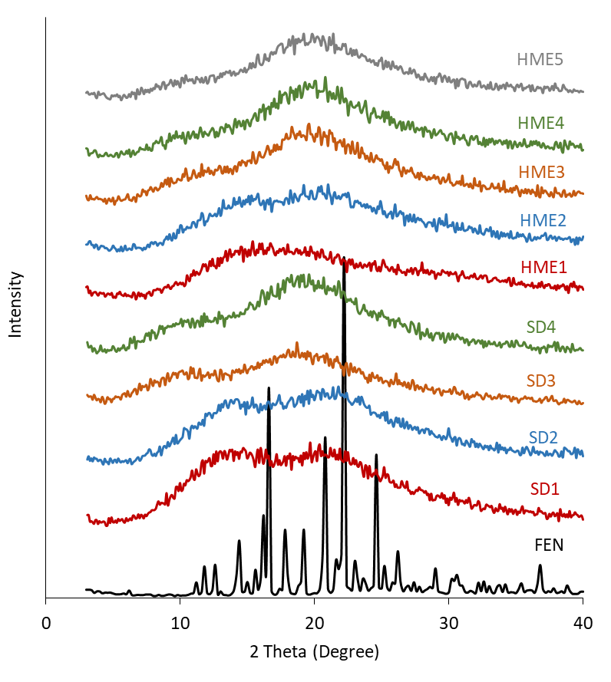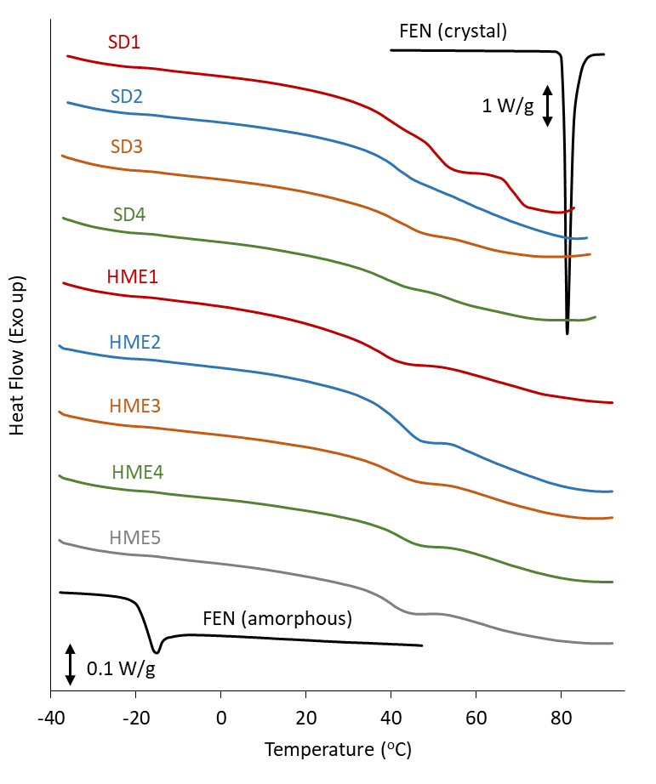
Figure 2. (Left) XRPD patterns of ASDs. The ASD types are shown in the figure. The data for intact FEN is presented for comparison. (Right) DSC curves of ASDs. The ASD types are shown in the figure. The data for intact FEN (crystal) and its glassy state, which was prepared by melt-quench, is presented for comparison. The scale of the vertical axis was the same for ASDs and the FEN glass but different for the crystal as indicated in the figure.

Figure 3 shows SEM images of the ASDs. SD ASDs that used Eudragit or PVPVA as polymers were spherical in shape with a size of micro-order with polydisperse distribution. The particles spray-dried using HPMC exhibited a shrunk structure with wrinkles, which is a typical structure of spray-dried cellulose materials¹⁷. HME particles were much larger and irregular in shape, and their sizes ranged from 20 μm to 200 μm.
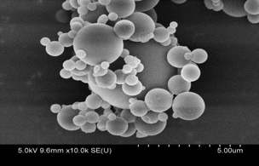
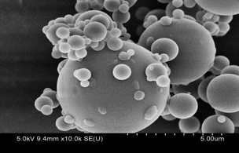
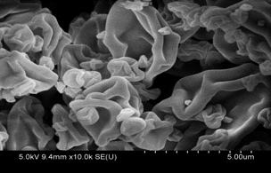
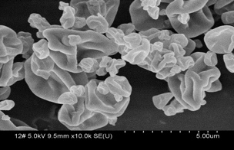
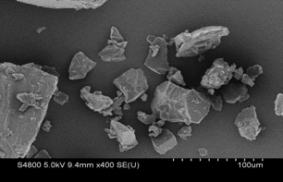
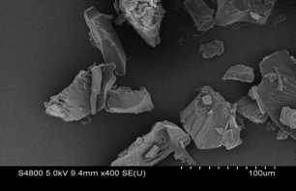
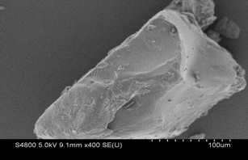
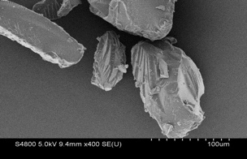
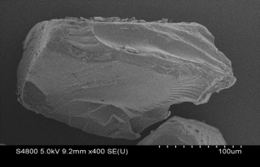
SD1
SD2
SD3
SD4
HME1
HME2
HME3
HME4
HME5

Figure 3. SEM images of ASDs. The ASD types are shown in the figure.

Figure 4 shows the pH-shift dissolution study results for the ASDs. The dissolutions from Eud RLPO and PVPVA ASDs prepared using HME (HME1 and 2) were slow, from which FEN concentration did not reach the solubility during the test period; therefore, supersaturation was not observed for these ASDs. The poor aqueous solubility of Eud RLPO was likely to be responsible for the slow dissolution from HME1. In contrast, PVPVA has a high solubility in water; nevertheless, the dissolution from HME2 was also slow. We had a similar observation for the PVPVA/FEN ASD previously¹². As only PVPVA is soluble during the initial period where Tween does not exist, FEN should be enriched in the formulation by losing PVPVA. Thus, incongruent release of the drug¹⁸⁻²⁰ was likely the reason for poor dissolution from this ASD. Meanwhile, supersaturation was achieved for HPMCAS ASDs (HME 3 to 5), where HME4 exhibited the highest degree of supersaturation.
All SD ASDs exhibited similar excellent dissolution behaviors except that a gradual decrease in concentration was observed for SD1. As the deviation was larger than that for other formulations, possible crystallization of FEN was suspected during the dissolution study. The phase separation in the formulation as found by the DSC study (Figure 2) was the likely the reason for this observation. SD1 and SD2 have the same composition but were prepared using different solvents. SD ASDs prepared using different solvents are known to have different dissolution properties due to differences in particle morphology and the accumulation of drug on the surface²¹.
A supersaturated solution may cause liquid-liquid phase separation (LLPS) for reducing the Gibbs energy of the solution²²⁻²⁴. Although the concentration to cause LLPS is basically not influenced by the presence of a small amount of polymer¹², it may be influenced by the partition of the polymer to the concentrated particles²⁵. Moreover, the polymer addition may change the apparent LLPS concentration by influencing the crystallization kinetics^{12,26}. For FEN, the apparent LLPS concentrations in the 0.1% Tween 80 solution are 35 and 60 μg/mL when formulated with PVPVA and HPMCAS, respectively¹². Thus, the LLPS concentration in the presence of PVPVA corresponds to 90% dissolution in this study as indicated in the figures, and that with HPMCAS is higher than the complete dissolution. SD1 and SD2 almost reached the LLPS concentration, whereas the maximum concentrations of other ASDs were well below that.
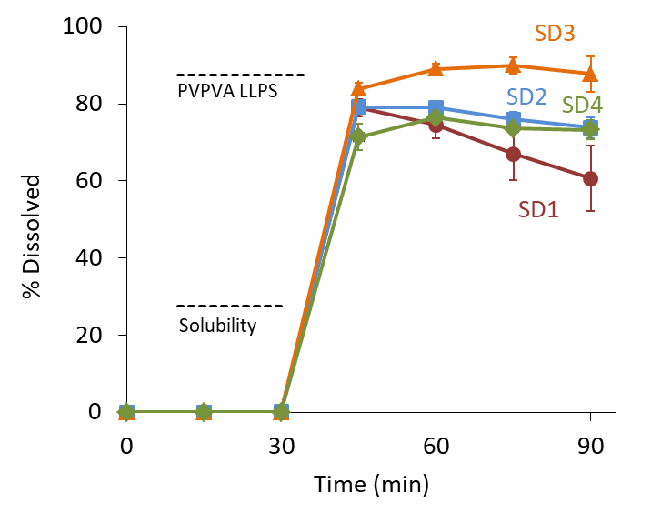
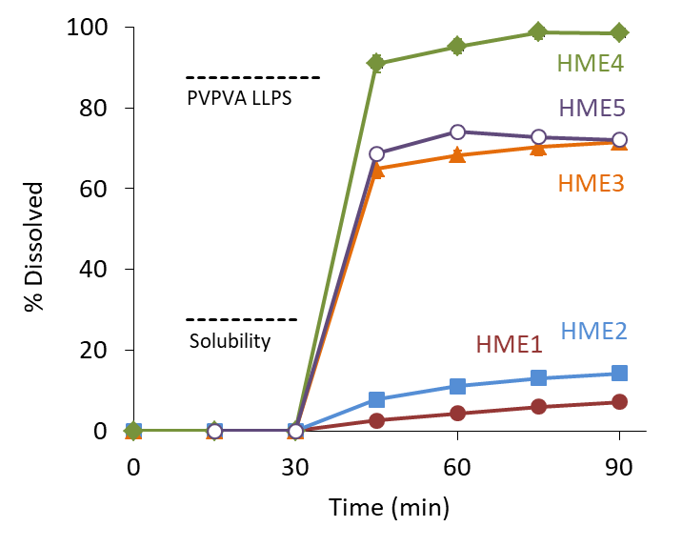
Figure 4. pH-shift dissolution profiles of ASDs. The study was initiated under pH1.2, followed by an increase in pH to 7 at 30 min. Tween 80 was also added at 30 min. The mean values for the three separated samples are presented with error bars to show standard deviations. The ASD types are shown in the figure. The crystalline solubility of FEN in the phosphate buffer (pH7) in the presence of 0.1% Tween is presented for guidance in the figure. An apparent LLPS concentration of FEN in the presence of PVPVA¹² is also presented.

3.4 Stability of HME ASDs
Figure 5 shows the summary of the stability study for HME ASDs. Although the judgement of the stability depended on the observation methods employed, the stability of HME1 was likely to be the lowest, as can be seen in its poor stability even at 25 °C for 1M; this can be explained by the lowest T_{g}. The stability of HME 5 was also poor as it could not be maintained at 25 °C for 3M; this may be explained by the largest loading of FEN. HME2 and HME4 were stable below 25 °C for one year, and HME3 was stable even at 40 °C for one year. Although the T_{g} of all ASDs were below 40 °C, rubbering was not visually confirmed for all ASDs at 40 °C.
DSC is generally more sensitive in detecting the crystallization of ASDs than XRPD. In our observation for HME ASDs, although some samples were judged to be stable by XRPD, a small melting endotherm that indicated the crystallization of FEN was observed for them (e.g., HME1 25°C1M, HME2 40°C1M, HME3 40°C75%RH1M, HME4 40°C75%RH1M, HME5 25°C3M). SEM was also a very sensitive tool to detect crystallization for HME ASDs as explained later.

Figure 5 Summary of stability results for HME ASDs. The meanings of the colors are as follows: Blue: no significant changes; Yellow: Changes suspected; Red: Changes (crystallization) observed; Gray: No evaluation because of a significant change in the ASD appearance because of rubbering and/or aggregation; White: No evaluation (not planned).

Below are some examples of the physical characterization. Figure 6 shows the characterization results for HME 1 after one month of storage. The XRPD results indicated crystallization for the ASDs stored at 40 °C and 40 °C 75%RH only. However, the presence of FEN crystals was proven in DSC curves by the melting peaks for all the ASDs except the one stored at 5 °C. The crystallization peaks were sufficiently large to detect for the ASDs at 40 °C and 40 °C 75%RH, and the peaks were small but detectable enough for those at 25 and 60 °C. SEM images clearly revealed the crystallization of FEN on ASD particles for these ASDs. Interestingly, the edge of the FEN crystals for the ASD stored at 60 °C appeared to melt after the crystallization, presumably because of the higher energy state of the FEN on the edge, which can explain the smaller melting peak in the DSC curves than those for 40 °C and 40 °C75%RH ASDs. The crystals were visible for the 25 °C ASD as well despite their low amount. As the dissolution rate of HME 1 was low even for the fresh ASD, the decrease in the dissolution rate after the storage was difficult to detect.

Figure 6. Physical characterizations of HME1 after storage for one month. The (a) XRPD, (b) DSC, (c) SEM, and (d) dissolution study results are presented. The storage conditions are indicated in the figures. The small diffraction peaks in the XRPD figure were found at the circled area for the ASDs stored at 40 °C and 40 °C 75%RH. For the DSC curve of the ASD stored at 25 °C, the small melting peak is indicated by the asterisk. The dissolution profiles of three samples are presented independently. Only the data for the initial ASD and that at 40 °C 75%RH is presented, because no significant changes were observed for all the ASDs.

Figure 7 shows the physical characterization results for HME1 and HME2 after storage at 40 °C for three months. The dissolution study results are not presented because it did not work for the evaluation of the physical stability of HME 1 and 2 due to their slow dissolution. Both the XRPD and DSC results indicated the crystallization of FEN for HME1 and a trace amount of crystallization for HME2. SEM images visualized the appearance of small FEN crystals on the ASD particles. Thus, all the investigation methods except the dissolution study presented consistent results for these ASDs.

Figure 7. Physical characterizations of HME 1 and 2 stored at 40 °C for three months. The (a) XRPD, (b) DSC, and (c) SEM results are presented. The dissolution study is omitted, because it did not change due to their slow dissolution properties.

Figure 8 shows the physical characterization results for HME 3, 4, and 5 after six or twelve months of storage at 40 °C. The diffraction peaks of the FEN crystals were found only for HME 5 in the XRPD study. The melting endothermic peak of crystalline FEN was detected for all the ASDs in the DSC analysis, and the SEM observation revealed that there were no conspicuous crystals for HME 3; however, small crystals were found on the ASD particles for HME 4 and 5. The dissolution properties for HME 3 did not change after six months of storage. However, the dissolution levels for HME 4 and 5 were slightly lower compared to those in their initial state. Although the final fractions dissolved for HME 4 and 5 were approximately 99 and 72% initially, they decreased to 86 and 56% after six months, respectively. After twelve months, the dissolution property of HME3 was still maintained, while that for HME 4 decreased to 83%, and HME 5 could not be subjected to the test because of shrinkage of the ASD. A comparison of HME 3, 4, and 5 clearly revealed that the stability was worse for the ASD with a higher drug loading.

Figure 8. Physical characterizations of HME 3, 4 and 5 stored at 40 °C for twelve months. The (a) XRPD, (b) DSC, (c) SEM images, and (d) dissolution study results are presented. Detailed information on the ASD types and storage periods is indicated in the figures.

3.5 Stability of SD ASDs
Figure 9 shows a summary of the stability study results for SD ASDs. HPMCAS ASDs (SD3 and SD4) exhibited better stability compared to PVPVA ASDs (SD1 and SD2) despite their similar T_{g}s. DSC provided the highest sensitivity for the crystallization of all ASDs. Unlike for HME ASDs, SEM was not a powerful tool to detect crystallization. Significant changes were found in the dissolution study after 6M for SD1 and SD2, and after 12M for SD3. All ASDs stored at 40 °C 75%RH exhibited a change in the dissolution properties even after one month, presumably because of the large surface area of SD ASDs that allows adsorption of much amount of moisture and aggregation of the particles.

Figure 9. A summary of the stability results for SD ASDs. The meanings of the colors are the same as those for Figure 5.

The physical characterization results for SD 2 after one month of storage are presented in Figure 10. Although the XRPD and SEM results did not provide any indication of crystallization, it was detected for the ASD stored at 40 °C as a small melting peak in the DSC curve. The crystallinity was calculated as 0.8% based on the melting enthalpy. Unlike the observation for HME ASDs, crystalline FEN cannot be observed in the SEM images. Instead, the fusion of the particles was investigated as can be seen for the image at 60 °C. In the dissolution study of the SD2 stored at 40 °C, two samples out of three exhibited significant change. Even for the samples stored at 25 °C, changes in the dissolution profiles were observed despite no difference for other evaluations. This observation means that the dissolution properties can change even without changes in the XRPD, DSC, and SEM results.

Figure 10. Physical characterization results of the SD2 stored for one month. The (a) XRPD, (b) DSC, (c) SEM, and (d) dissolution study results are presented. The dissolution profiles of three ASDs are presented independently. The storage temperatures are indicated in the figures. For the DSC curve of the ASD stored at 40 °C, the small melting peak is indicated by the asterisk.

Figure 11 shows the physical characterization results for SD ASDs stored at 25 and 40 °C for 12 months. The XRPD results indicated that all ASDs remained in the amorphous state at 25 °C but crystallization was found for SD2 and SD4 at 40 °C. SD1 could not be collected because of rubbering. The DSC results were difficult to understand because of the appearance of multiple endothermic peaks, which could be partially interpreted as the glass transition with the enthalpy recovery peak. Considering other characterization results together, the indication of the crystallization of FEN was presumably the sharp endothermic peak found at ca. 80 °C. Although SEM cannot provide information on the crystallization of FEN, the fusion of the particles was recognized for the SD4 stored at 40 °C. Some changes in appearance were suspected for SD2 at both temperatures; however, judgement was difficult. Only SD4 retained the same dissolution property when stored at 25 °C for one year. The dissolved fraction after 90 min for SD1, SD2, and SD3 were 44.3, 44.2, and 73.0%, respectively, although they were initially 60.7, 73.8, and 87.8%, respectively. As with the cases for HME ASDs, the dissolution property of ASDs can change even though no changes were found for the XRPD, DSC, and SEM analysis. It was unusual to observe that SD4 could exhibit better stability in terms of dissolution performance relative to SD3 despite its larger drug loading and lower stability of other characterization results. This was because of too excellent initial dissolution property of SD3, which could be destroyed easily by a small change in the physical state of the particles, including aggregation. In fact, in comparison of the dissolution performance of the 12M-aged ASDs, SD3 showed better dissolution property compared to SD4. As this change was not because of crystallization, it should be overcome by a further formulation process.

Figure 11. Physical characterization results of SD 1-4 stored at 25 or 40 °C for twelve months. The (a) XRPD, (b) DSC, (c) SEM, and (d) dissolution study results are presented. The dissolution profiles of three ASDs are presented independently. Detailed information on the samples is indicated in the figures.

Figure 12 shows the evolution of the crystallinity of FEN in each ASD stored at 40 °C and 40°C75%RH determined by the DSC measurements. The crystallinity was calculated from the enthalpy of the melting peak found at 80 °C. Despite the same drug loading at 20% for HME 1, 2, and 4, HME1 exhibited the fastest crystallization at 40 °C, which was likely because it had the lowest T_{g}. HME2 and HME4 showed similar crystallization profiles at 40 °C; however, HME2 was much more unstable at 40°C75%RH than HME4, most likely because of the hygroscopic nature of PVPVA. A comparison of HME 3, 4, and 5 clearly revealed that increasing drug loading made the crystallization faster. It may be interesting to note that the crystallization rate of FEN in HME1 was almost the same at 40 °C and 40°C75%RH until 3M, and the difference after that was solely the availability of the sample, although the crystallization in other ASDs was accelerated in the presence of moisture. This might be because Eudragit RLPO is not soluble in water, i.e., has extremely low affinity to water.
As SD1 was seriously aggregated at elevated temperatures, comparison of the SD ASDs was only possible for SD 2, 3, and 4. No crystallization of FEN was found for SD3 at 40 °C, whereas crystallization proceeded in SD2 and SD4. The stability order remained the same at 40°C75%RH but the difference was emphasized. All ASDs of which the crystallinity could evaluated after storage for one year include HPMCAS as an excipient. Thus, the stability test at 40°C75%RH likely worked only for HPMCAS ASDs to emphasize the stability difference.
The crystallization kinetics of amorphous drugs can be explained through the Avrami-Erofeev equation in most cases^{27,28}. However, the evolution of the crystallinity of almost all ASDs slowed down after three months of storage, for which steric hindrance by the polymers seemed to play an important role.

Figure 12. Evolution of the crystallinity of FEN as a function of the storage period determined by DSC. The storage conditions are (a) 40 °C and (b) 40°C75%RH. The data is presented as the mean values of two samples. The ASD types are shown in the figures. Some missing samples and data points are because of the rubbering of the sample, except that SD3 at 40 °C is not presented because crystallization was not confirmed in the DSC analysis.

The dissolution profiles of ASDs after storage at 5°C for two years are provided in Supplementary Information. The dissolution behaviors of all ASDs except SD1 and SD2 remained the same with those of the initial samples.

4. Discussion
4.1 Applicability of Each Characterization Method to HME and SD ASDs
The properties of ASDs depend on production methods. For example, Dong et al. prepared ASDs with the same composition using HME and co-precipitation methods to find that dissolution was faster for the co-precipitated one because of the larger surface area, whereas the physical stability was better for the HME product due to the same reason²⁹. Hou et al. found that co-precipitation could offer ASDs with better tabletability and flow properties compared to spray-dried ones³⁰. There have been many reports where mixing state of the polymer and the drug was influenced by the preparation methods^{17,31}. It is of paramount importance to understand the features of each manufacturing method and their impact on the product property during the developmental study of ASD. It is also necessary to pay attention to the compatibility between manufacturing methods and physical characterization methods.
HME and SD are the most representative manufacturing methods for ASDs. ASDs prepared by HME are initially in the form of pellets that require milling to reduce their particle size, whereas ASDs produced by SD are typically in the form of microparticles, which may have a wrinkled surface structure^{17,32}. Therefore, the ASD particles produced by HME generally have a larger particle size even after milling and a smoother surface compared to the SD particles. In our study, FEN crystallized on the surface of the HME particles during storage, which was easily investigated using SEM. In the case of the SD ASDs, presumably the crystallized FEN was buried inside the particles, which should be difficult to find using SEM. The melting of the edge of the crystallized particles at 60 °C was noteworthy and can be explained by the high vapor pressure at the highly curved part based on the Kelvin equation. DSC was a very sensitive tool to find crystallization for both types of ASDs. However, DSC data can be interpreted only with the help of other data in some cases. As presented in Figure 11(b), multiple peaks are frequently found in the DSC data for formulations with multiple components. A broad peak just below the melting temperature of FEN was found for SD4_40°C12M. The same peak was found for SD3_40°C12M. This peak may be suspected to indicate the presence of crystals at the first look, but this idea was not supported by the other characterization results. In contrast, XRPD provides very clear information. Finding of the diffraction peaks easily enables judgement on crystallization, possibly with information on crystal forms and crystallinity. However, it cannot detect small crystals. Thus, in this study, there were many cases where no diffraction peaks were detected for the samples that provided the melting peaks of crystals in the DSC study.
The presence of even a small amount of crystals^{10,33,34}or nuclei¹¹ of the drug inhibits supersaturation behavior after dissolution of ASDs, which is critical to improve the oral bioavailability of the poorly absorbable drugs. Moreover, the dissolution property of ASDs can be worsened during storage even without crystallization³⁵. In our study, the dissolution study was the more sensitive method to detect physical changes after the storage for SD 1, 2, and 3. Although the physical stability of these ASDs was acceptable at 5 and 25 °C after the one-year storage based on other characterization methods, their dissolution behaviors differed from those of the original ones. Possible reasons that influence the dissolution profile include crystallization, aggregation of the particles, and relaxation to change density. The dissolution process of ASDs is frequently described as “spring and parachute”^{1,2}. The aggregation and relaxation should influence the spring process, whereas crystallization may change both. In this study, the rapid decrease in the concentration after 90 min indicates the presence of nuclei/crystals, whereas every reason could be suspected if the concentration at 90 min was lower than that of the initial ASD. The dissolution study may work as a more sensitive characterization method rather than XRPD, DSC, and SEM, and has more practical relevance to the product performance. The complemental roles of each characterization method were clearly demonstrated in this study.

4.2 Relationship between Formulation T_{g} and Physical Stability
The ease of crystallization depends on compounds, which is summarized by the term “glass-forming ability” or “crystallization tendency”²⁸. In the field of pharmaceutical science, the most popular method for the classification method was provided by Baird et al.³⁶, where the DSC heating/cooling cycle was applied for the discrimination. If the compound has a high tendency of crystallization (class I and II), the most dominant factor to influence physical stability is T_{g}. Our previous study presented rough guidance that T_{g} must be higher than 48 °C to ensure the physical stability of the glass at 25 °C for three years²⁷. For ASDs, addition of polymers improves stability more than expected from the increase in T_{g}, because of steric hindrance for the crystallization of drug molecules. Meanwhile, every formulation process such as milling should reduce the stability because of mechanical activation, increase in surface area, and so on. Their compensation makes the above prediction still valid, although the deviation of the data is quite large²⁸.
ASDs prepared in this study have T_{g}s ranging from 33 to 39 °C, from which crystallization is supposed to be initiated within one year at 25 °C based on our previous prediction²⁷. However, FEN is a class III compound²⁸, of which the physical stability is expected to be much better than the general prediction and the predicted value can be regarded as the worst case³⁷. In fact, most of the marketed compounds in the form of ASD belong to class III in the classification system³⁸. The detailed prediction and its comparison with the observed stability are presented in Table 3. The judgement on the stability was basically made by the XRPD and DSC data. However, the dissolution property changed even without the detection of crystals by other methods. In this case, the shelf-life is presented with an asterisk in the table as it does not necessarily agree with the prediction on the crystallization. The stability was much better than the prediction for all ASDs. In particular, HME3 was stable for at least for one year even at 40 °C.

Table 3 A summary of the shelf-life of ASDs and comparison with predicted values.
ASD | T_{g} (°C) | 25 °C | 40 °C | 60 °C
HME1 | 33 | <1m (1.4m) | < 1m (1.6d) | < 1m (0.8h)
HME2 | 36 | > 1y (2.6m) | < 1m (3.0d) | 3m (1.4h)
HME3 | 36 | > 1y (2.6m) | > 1y (3.0d) | 1y (1.4h)
HME4 | 39 | > 1y (5.1m) | < 1m (5.6d) | < 1m (2.5h)
HME5 | 36 | 3m (2.6m) | < 1m (3.0d) | < 1m (1.4h)
SD1 | 34 | > 1y* (1.7m) | < 1m (1.9d) | < 1m (0.9h)
SD2 | 38 | > 1y* (4.1m) | < 1m (4.5d) | < 1m (2.1h)
SD3 | 38 | > 1y* (4.1m) | 6m (4.5d) | 6m (2.1h)
SD4 | 37 | > 1y (3.3m) | 6m (3.6d) | 3m (1.7h)
Values in parenthesis are the predicted initiation times of crystallization calculated by the master plot reported previously^{27,28}. y: years, m: months, d: days, h: hours. The prediction is based on the observation of crystallization using DSC. The asterisk means that the shelf-life is shorter if a judgement is made with the dissolution study.

4.3 Selection of the Composition and Manufacturing Method/Condition
In literature, vinyl polymers and their derivatives, such as PVPVA, are the most frequently used for preparing ASDs, followed by cellulose polymers and their derivatives, such as HPMCAS³⁹. Polymer excipients possess two important roles: stabilization of the amorphous state of the drug and maintenance of the supersaturated state of the drug after the dissolution. Although hydrogen bonding between polymer and drug has frequently been reported to influence the stabilization^{15,40} and dissolution behavior²⁰ of ASDs, it cannot be expected for FEN because of the absence of the hydrogen bond donor. Multiple polymers are sometimes used to achieve this mission⁴¹⁻⁴³. For example, in the study of Mudie et al., Eudragit L100 and HPMCAS are responsible for improving storage stability and supersaturation behavior, respectively. The drug must be released from the formulation with polymeric excipients under the mechanism of the congruent release to achieve supersaturation effectively, where polymers with high hydrophilicity including vinyl polymers have an advantage⁴⁴. On the other hand, as the LLPS concentration can be an important parameter to affect membrane permeability^{45,46}, the excipient that offers a high apparent LLPS concentration may be a better selection from this viewpoint. Cellulose polymers are generally advantageous for stabilizing the supersaturation behavior^{12,26,42}. In fact, there are many examples that LLPS concentration correlated with the oral absorption in animal studies^{12,47}. As the dissolution process can be improved by further formulation efforts⁴⁸⁻⁵⁰, focusing on the LLPS concentration should be an effective strategy for achieving high exposure to the drug after the oral administration.
As the effect of the polymer on the LLPS behavior of FEN was already comprehended in our previous study¹², polymer screening in this study was made based on miscibility with FEN and processability during manufacture using HME and SD. The requirement for the T_{g} of polymers is totally opposite for HME and SD; low T_{g} and high T_{g} are favored for HME and SD, respectively. As the T_{g} of FEN was very low at -19 °C, the T_{g} of its mixture with polymers was also low. Thus, no problems were found for HME processing, whereas SD processing was quite challenging. The yield of the ASD product decreased significantly when the high inlet temperature was employed because of the rubbering of the formulation. Another possible problem associated with operation at high temperatures is phase separation in the formulation⁵¹, which can be caused by too rapid evaporation of the solvent^{17,32}. Solvent selection is also important for designing SD ASDs. Even for the same combination of solutes, their interaction is influenced by the selection of the solvent, that is, solutes can be more attractive if their affinity with the solvent is low⁵². Thus, if an anti-solvent is added to the spraying solvent, the miscibility of the two components may be improved⁵³. The solubility of FEN in dichloromethane and acetone was visually checked to find that FEN could dissolve in dichloromethane at a concentration above 1 g/mL, whereas its solubility in acetone was lower than that. Therefore, the use of acetone as a SD solvent is expected to provide better mixing of the two components, and in fact, SD2 exhibited better mixing compared to SD1. The difference in the spraying solvent made a substantial difference in the storage stability because of the appearance of the low-T_{g} portion in the ASD. The concentration of the feed solution also likely has an impact.
High drug loading is gaining much attraction for designing patient friendly ASDs^{20,54,55}. Thus, attempts have been actively made to clarify which production method offers the high drug loading. Dedroog et al. compared the highest drug loading in SD and HME ASDs to find that PVPVA/naproxen ASD had an advantage for HME, whereas HPMCAS offered higher drug loading for SD⁵⁴. For developing challenging ASDs, which include high-drug-loading ASDs, ASDs with the class I compounds, and ASDs of low-T_{g} compounds, their physical stability must be investigated carefully. This study should help how to assess the physical stability data of ASDs after long-term storage.

5. Conclusions
FEN ASDs were prepared using two representative manufacturing methods, HME and SD, to investigate their physical stability for one year. All ASDs exhibited physical changes during storage under accelerated stability study conditions; however, the detection power of each characterization method differed. DSC was an effective method for detecting small amounts of crystals for both types of ASDs in a quantitative manner, whereas XRPD could provide clear information on crystallization despite its lower sensitivity. SEM was very effective for observing the crystallization of the small amount of drugs for HME products, as the drug crystal appeared on the large grains. SEM investigation revealed the reason why the crystallinity of the sample stored at 60 °C could be lower than that at 40 °C. It was explained by the melting of the edge of the crystals after the crystallization. Although crystallization is the most important physical change during ASD storage, the dissolution performance of spray-dried products could change even without any indication of crystallization. This study demonstrated complemental roles of each characterization method that should be helpful for understanding the physical stability data of ASDs after long-term storage.

Acknowledgement
This study was conducted as part of the Consortium for stability prediction of ASDs in Research Center for Drug Discovery and Pharmaceutical Development Science of Ritsumeikan University. Technical supports by Ms Keiko Sato, Ms Junko Tanaka, and Ms Myu Iwasaki (National Institute for Materials Science) are acknowledged. The authors would like to thank Dr. Soon-Ih Kim (Ritsumeikan University) for scientific and practical advice.

Author Contributions
K.K. designed and conducted experiments and wrote the manuscript. T.I., M.F., and Y.N. joined discussion on the results and participated in preparation of the manuscript. T.S., Y.H. and T.H. manufactured spray-dried ASDs. F.T. and H.J. manufactured HME ASDs. R.T. helped viscosity measurements. T.F. helped design of the study and reviewed the manuscript.

Data Availability
All the data used for preparing this manuscript are available upon request to the corresponding author.

Conflicts of interest
The authors declare no conflict of interest.
References
- Brouwers, J., Brewster, M. E., Augustijns, P. Supersaturating Drug Delivery Systems: The Answer to Solubility-Limited Oral Bioavailability? J. Pharm. Sci. 2009;98:2549-2572.
- Kawakami, K. Modification of Physicochemical Characteristics of Active Pharmaceutical Ingredients and Application of Supersaturatable Dosage Forms for Improving Bioavailability of Poorly Absorbed Drugs. Adv. Drug Deliv. Rev. 2012;64:480-495.
- Newman, A., Knipp, G., Zografi, G. Assessing the Performance of Amorphous Solid Dispersions. J. Pharm. Sci. 2012;101:1355-1377.
- Paudel, A., Worku, Z. A., Meeus, J., Guns, S., Van den Mooter, G. Manufacturing of Solid Dispersions of Poorly Soluble Drugs by Spray Drying: Formulation and Process Considerations. Int. J. Pharm. 2013;453:253-284.
- Porat, D., Dahan, A. Active Intestinal Drug Absorption and the Solubility-Permeability Interplay. Int. J. Pharm. 2018;537:84-93.
- Kawakami, K. Current Status of Amorphous Formulation and Other Special Dosage Forms as Formulations for Early Clinical Phases, J. Pharm. Sci. 2009;98:2875-2885.
- Crowley, K.J., Zografi, G. Cryogenic Grinding of Indomethacin Polymorphs and Solvates: Assessment of Amorphous Phase Formation and Amorphous Phase Physical Stability, J Pharm Sci. 2002;91:492-507.
- Bates, S., Zografi, G., Engers, D., Morris, K., Crowley, K., Newman, A. Analysis of amorphous and nanocrystalline solids from their X-ray diffraction patterns. Pharm. Res. 2006;32:2333-2349.
- Kawakami, K. Pharmaceutical applications of thermal analysis in "Handbook of Thermal Analysis and Calorimetry "Recent Advances in Techniques and Applications", Elsevier, 2018, 613-641.
- Liu, H., Wang, P., Zhang, X., Shen, F., Gogos, C.G. Effects of Extrusion Process Parameters on the Dissolution Behavior of Indomethacin in Eudragit® E PO Solid Dispersions, Int. J. Pharm. 2010;383:161-169.
- Song, J., Kawakami, K. 2023. Nucleation during Storage Impeded Supersaturation in the Dissolution Process of Amorphous Celecoxib, Mol. Pharmaceutics 2023;20:4050-4057.
- Kawakami, K., Sato, K., Fukushima, M., Miyazaki, A., Yamamura, Y., Sakuma, S. Phase Separation of Supersaturated Solution Created from Amorphous Solid Dispersions: Relevance to Oral Absorption. Eur. J. Pharm. Biopharm. 2018;132:146-156.
- Kawakami, K., Suzuki, K., Fukiage, M., Matsuda, M., Nishida, Y., Oikawa, M., Fujita, T. Impact of Degree of Supersaturation on the Dissolution and Oral Absorption Behaviors of Griseofulvin Amorphous Solid Dispersions. J. Drug Deliv. Sci. Technol. 2020;56:101172.
- Kawakami, K., Bi, Y., Yoshihashi, Y., Sugano, K., Terada, K. Time-dependent Phase Separation of Amorphous Solid Dispersions: Implications for Accelerated Stability Studies. J. Drug Delivery Sci. Technol. 2018;46:197-206.
- Wu, J, Van den Mooter, G. The Influence of Hydrogen Bonding between Different Crystallization Tendency Drugs and PVPVA on the Stability of Amorphous Solid Dispersions. Int. J. Pharm. 2023;646:123440.
- Gupta, S. S., Meena, A.; Parikh, T.; Serajuddin, A. T. M. Investigation of Thermal and Viscoelastic Properties of Polymers Relevant to Hot Melt Extrusion – I: Polyvinylpyrrolidone and Related Polymers. J. Excip. Food. Chem. 2014;5:32-45.
- Kawakami, K., Hasegawa, Y., Deguchi, K., Ohki, S., Shimizu, T., Yoshihashi, Y., Yonemochi, E., Terada, K. Competition of Thermodynamic and Dynamic Factors during Formation of Multi-Component Particles via Spray-Drying, J. Pharm. Sci. 2013;102:518–529.
- Saboo, S., Mugheirbi, N. A., Zemlyanov, D. Y., Kestur, U. S., Taylor L. S. Congruent Release of Drug and Polymer: A “Sweet Spot” in the Dissolution of Amorphous Solid Dispersions. J. Control. Release 2019;298:68-82.
- Indulkar, AS, Lou, X, Zhang, GGZ, Taylor, LS. Insights into the Dissolution Mechanism of Ritonavir-Copovidone Amorphous Solid Dispersions: Importance of Congruent Release for Enhanced Performance. Mol. Pharmaceutics. 2019;16:1327-1339.
- Deac, A, Qingqing, Q, Indulkar, AS, Purohit, HS, Gao, Y, Zhang, GGZ, Taylor, LS. Dissolution Mechanisms of Amorphous Solid Dispersions: Role of Drug Load and Molecular Interactions. Mol. Pharmaceutics. 2023;20:722-737.
- Bhardwaj, V., Trasi, N. S., Zemlyanov, D. Y., Taylor, L. S. Surface Area Normalized Dissolution to Study Differences in Itraconazole-Copovidone Solid Dispersions Prepared by Spray-Drying and Hot Melt Extrusion. Int. J. Pharm. 2018;540:106-119.
- Ilevbare, G. A., Taylor, L. S. Liquid-Liquid Phase Separation in Highly Supersaturated Aqueous Solutions of Poorly Water-Soluble Drugs: Implications for Solubility Enhancing Formulations. Cryst. Growth Des. 2013;13:1497-1509.
- Taylor, L., Zhang, G. G. Z. Physical Chemistry of Supersaturated Solutions and Implications for Oral Absorption. Adv. Drug. Deliv. Rev. 2016;101:122-142.
- Kawakami, K. Supersaturation and Crystallization: Non-equilibrium Dynamics of Amorphous Solid Dispersions for Oral Drug Delivery, Exp. Opin. Drug Delivery 2017;14:735-743.
- Ueda, K., Taylor, L. S. Polymer Type Impacts Amorphous Solubility and Drug-Rich Phase Colloidal Stability: A Mechanistic Study Using Nuclear Magnetic Resonance Spectroscopy. Mol. Pharmaceutics 2020;17:1352-1362.
- Ilevbare, G. A., Liu, H., Edgar, K. J., Taylor, L. S. Maintaining Supersaturation in Aqueous Drug Solution: Impact of Different Polymers on Induction Times. Cryst. Growth Des. 2013;13:740-751.
- Kawakami, K., Harada, T., Miura, K., Yoshihashi, Y., Yonemochi, E., Terada, K., Moriyama, H. Relationship between Crystallization Tendencies during Cooling from Melt and Isothermal Storage: Toward a General Understanding of Physical Stability of Pharmaceutical Glasses. Mol. Pharmaceutics 2014;11:1835-1843.
- Kawakami, K. Crystallization Tendency of Pharmaceutical Glasses: Relevance to Compound Properties, Impact of Formulation Process, and Implications for Design of Amorphous Solid Dispersions. Pharmaceutics 2019;11:202.
- Dong, Z., Chatterji, A., Sandhu, H., Choi, D. S., Chokshi, H., Shah, N. Evaluation of solid state properties of solid dispersions prepared by hot-melt extrusion and solvent co-precipitation. 2008;355:141-149.
- Hou, H. H., Rajesh, A., Pandya, K. M., Lubach, J. W., Muliadi, A., Yost, E., Jia, W., Nagapudi, K. Impact of Method of Preparation of Amorphous Solid Dispersions on Mechanical Properties: Comparison of Coprecipitation and Spray Drying, J. Pharm. Sci. 2019;108:870-879.
- Janssens, S., De Zeure, A., Paudel, A., Van Humbeeck, J., Rombaut, P., Van den Mooter, G. Influence of Preparation Methods on Solid State Supersaturation of Amorphous Solid Dispersions: A Case Study with Itraconazole and Eudragit E100. Pharm. Res. 2010;27:775-785.
- Vehring, R. Pharmaceutical particle engineering via spray drying. Pharm. Res. 2008;25:999-1022.
- Zhang, S., Kawakami, K., Yamamoto, M., Masaoka, Y., Kataoka, M., Yamashita, S., Sakuma, S. Coaxial Electrospray Formulations for Improving Oral Absorption of a Poorly Water-Soluble Drug, Mol. Pharmaceutics 2011;8:807-813.
- Moseson, D. E., Rarker, A. S., Beaudoin, S. P., Taylor, L. S. Amorphous Solid Dispersions Containing Residual Crystallinity: Influence of Seed Properties and Polymer Adsorption on Dissolution Performance. Eur. J. Pharm. Sci. 2020;146:105276.
- Sjökvist, E., Nyström, C., Alden, M., Caram-Lelham, N. Physicochemical Aspects of Drug Release. XIV. The Effects of Some Ionic and Non-Ionic Surfactants on Properties of a Sparingly Soluble Drug in Solid Dispersions. Int. J. Pharm. 1992;79:123-133.
- Baird, J. A., van Eerdenbrugh, B., Taylor, L. S. A classification system to assess the crystallization tendency of organic molecules from undercooled melts. J. Pharm. Sci. 2010;99:3787-3806.
- Kawakami, K. Surface Effects on the Crystallization of Ritonavir Glass. J. Pharm. Sci. 2015;104:276-279.
- Wyttenbach, N., Kuentz, M. Glass-Forming Ability of Compounds in Marketed Amorphous Drug Products. Eur. J. Pharm. Biopharm. 2017;112:204-208.
- Edueng, K., Mahlin, D. Bergström, C. A. S. The Need for Restructuring the Disordered Science of Amorphous Drug Formulations. Pharm. Res. 2017;34:1754-1772.
- Kothari, K, Ragoonanan, V, Suryanarayanan, R. The Role of Drug-Polymer Hydrogen Bonding Interactions on the Molecular Mobility and Physical Stability of Nifedipine Solid Dispersions. Mol. Pharmaceutics. 2015;12:162-170.
- Ueda, K., Yamazoe, C., Higashi, K., Kawakami, K., Moribe, K. Mechanism of Enhanced Nifedipine Dissolution by Polymer-blended Solid Dispersion through Molecular-level Characterization. Mol. Pharmaceutics 2018;15:4099-4109.
- Mudie, D. M., Stewart, A. M., Biswas, N., Brodeur, T. J., Shepard, K. B., Smith, A., Morgen, M. M., Baumann, J. M., Vodak, D. T. Novel High-Drug-Loaded Amorphous Dispersion Tablets of Posaconazole; In vivo and In Vitro Assessment. Mol. Pharmaceutics 2020;17:4463-4472.
- Rahman, M., Coelho, A., Tarabokija, J., Ahmad, S., Radgman, K., Bilgili, E. Synergistic and Antagonistic Effects of Various Amphiphilic Polymer Combinations in Enhancing Griseofulvin Release from Ternary Amorphous Solid Dispersions. Eur. J. Pharm. Sci. 2020;150:105354.
- Saboo, S., Moseson, D. E., Kestur, U. S., Taylor, L. S. Patterns of Drug Release as a Function of Drug Loading from Amorphous Solid Dispersions: A Comparison of Five Different Polymers. Eur. J. Pharm. Sci. 2020;155:105514.
- Raina, S. A., Zhang, G. G. Z., Alonzo, D. E., Wu, J., Zhu, D. Catron, N. D, Gao, Y., Taylor, L. S. Enhancements and Limits in Drug Membrane Transport Using Supersaturated Solutions of Poorly Water Soluble Drugs. J. Pharm. Sci. 2014;103:2736-2748.
- Narula, A., Sabra, R., Li, N. Mechanisms and Extent of Enhanced Passive permeation by Colloidal Drug Particles. Mol. Pharmaceutics 2022;19:3085-3099.
- Suzuki, K., Kawakami, K., Fukiage, M., Oikawa, M., Nishida, Y., Matsuda, M., Fujita, T. Relevance of Liquid-Liquid Phase Separation of Supersaturated Solution in Oral Absorption of Albendazole from Amorphous Solid Dispersions, Pharmaceutics 2021;13:220.
- Hughey, J. R., Keen, J. M., Miller, D. A., Kolter, K., Langley, N., McGinity, J. W. The Use of Inorganic Salts to Improve the Dissolution Characteristics of Tablets Containing Soluplus-Based Solid Dispersions. Eur. J. Pharm. Sci. 2013;48:758-766.
- Takano, R., Maurer, R., Jacob, L., Stowasser, F., Stillhart, C., Page, S. Formulating Amorphous Solid Dispersions: impact of Inorganic Salts on Drug Release from Tablets Containing Itraconazole-HPMC Extrudate. Mol. Pharmaceutics 2020;17:2768-2778.
- Hanada, M., Jermain, SV, Thompson, SA, Fukuta, H, Fukuda, M, Williams III, RO. Ternary Amorphous Solid Dispersions Containing a High-Viscosity Polymer and Mesoporous Silica Enhance Dissolution Performance. Mol. Pharmaceutics. 2021;18:198-213.
- Paudel, A., Loyson, Y., Van den Mooter, G. An Investigation into the Effect of Spray Drying Temperature and Atomizing Conditions on Miscibility, Physical Stability, and Performance of Naproxen–PVP K25 Solid Dispersions. J. Pharm. Sci. 2013;102:1249-1267.
- Bergfeldt, K., Piculell, L., Linse, P. Segregation and Association in Mixed Polymer Solutions from Flory−Huggins Model Calculations. J. Phys. Chem. B 1996;100:3680-3687.
- Paudel, A., Van den Mooter, G. Influence of Solvent Composition on the Miscibility and Physical Stability of Naproxen/PVP K 25 Solid Dispersions Prepared by Cosolvent Spray-Drying. Pharm. Res. 2012;29:251-270.
- Dedroog, S, Huygens, C, Van den Mooter, G, Chemically Identical but Physically Different: A Comparison of Spray Drying, Hot Melt Extrusion and Cryo-Milling for the Formulation of High Drug Loaded Amorphous Solid Dispersions of naproxen. Eur. J. Pharm. Biopharm. 2019;135:1-12.
- Mamidi, H, Palekar, S, Patel, H, Nukala, PK, Patel, K. Formulation Strategies for the Development of High Drug-Loaded Amorphous Solid Dispersions. Drug Discovery Today. 2023;28:1-8.

