Moiré potential independent of moiré size down to a few nanometers in sliding ferroelectrics
AUTHOR NAMES. Jian Liao¹, Xinyu Lv¹, Takashi Taniguchi², Kenji Watanabe³, Jianming Lu⁴*, and Jiamin Xue¹*
AUTHOR ADDRESS
¹School of Physical Science and Technology, ShanghaiTech University, Pudong, Shanghai 201210, China.
²Research Center for Materials Nanoarchitectonics, National Institute for Materials Science, 1-1 Namiki, Tsukuba 305-0044, Japan
³Research Center for Electronic and Optical Materials, National Institute for Materials Science, 1-1 Namiki, Tsukuba 305-0044, Japan
⁴State Key Laboratory for Mesoscopic Physics, School of Physics, Peking University, Beijing 100871, China
*Correspondence to: jmlu@pku.edu.cn; xuejm@shanghaitech.edu.cn
KEYWORDS: sliding ferroelectrics, moiré potential, moiré size, Kelvin probe force microscopy, contact-mode scanning tunneling microscopy
ABSTRACT: Sliding ferroelectricity represents a way of realizing atomically thin ferroelectric materials. Due to the moiré pattern formed in the stacking process, the alternating ferroelectric domain network provides an attractive superlattice of electrostatic potential to modulate the electronic structures of another material sitting on it. The relationship between the ferroelectric potential magnitude and the moiré size, however, has been controversial in the literature. In addition, how strong the potential remains for domain sizes down to the 10 nm range is unclear. In this study, we use contact-mode scanning tunneling microscopy with high spatial and energy resolution to show that the moiré potential is independent of the domain size ranging from hundreds to several nanometers. We also show that the electrostatic potential is solely determined by the specific materials used to fabricate the stack. This study provides important information for the sliding ferroelectrics and can foster their applications in modulating other materials.

Sliding ferroelectricity has attracted a lot of research interest thanks to its capability in producing various atomically thin ferroelectric materials by stacking atomic layers of two dimensional (2D) materials. Since its theoretical proposal¹, it has been experimentally realized in hexagonal boron nitride (hBN)^{2–4}, transitional metal dichalcogenides (TMD)^{5–9}, polymer van der Waals crystals¹⁰ and so on. Manually stacking two atomic layers with a twist angle results in moiré patterns in which the ferroelectric polarization is locked with the moiré domains. While the research on the unique ferroelectric properties of this new material system is fast growing, utilizing the alternating polarization to modulate another 2D atomic layer is also gaining strong interests. Theoretical calculations^{11,12} have examined this possibility. Meanwhile, experiments have used the moiré ferroelectric potential to modulate excitons in TMD^{13–18}, plasmon in graphene^{19,20}, band structure in graphene^{21–23} and so on. One central issue in these studies is the magnitude of potential variation introduced by the alternating polarization domains, which determines the strength of the modulation. Theoretical calculation expected that the potential variation strongly depends on the moiré size¹¹. Experimental studies, however, gave contradictory results. Electrostatic force microscopy (EFM)³ showed that the moiré electrostatic potential is independent of moiré size from micrometer down to ~30 nm (no data below this size was shown due to the lateral resolution of this technique). On the other hand, frequency-modulated Kelvin probe force microscopy (KPFM)^{13–15,24} showed that the potential depends strongly on the moiré size as expected in theory. This obvious discrepancy prompted us to examine this problem with a different experimental technique.
In this study, we use a monolayer graphene as a sensing layer and contact-mode scanning tunneling microscopy (CMSTM)^{25–27} to directly measure how the alternating potential of a twisted hBN substrate modulates the graphene layer on top. With its nanometer spatial and tens-of-millivolt energy resolution, CMSTM shows that the moiré potential of twisted hBN is independent of the moiré size, ranging from hundreds to a few nanometers. Our results provide a new perspective on this important problem in sliding ferroelectricity and could benefit future studies in utilizing this system to modulate other materials.

Twisted hBN bilayer (t-hBN) samples are fabricated and the electrostatic potential on a typical sample surface is measured with KPFM (as schematically shown in Fig. 1a) to confirm that ferroelectric domains are obtained. The process of sample fabrication and KPFM measurements are detailed in Methods. Fig. 1b shows the measured triangular moiré potential patterns similar to those in the literature^{2–4}, with sizes ranging from ~600 nm to ~40 nm, below which the domains are non-detectable due to the resolution limit of KPFM. The change in size likely originates from strain-induced twist-angle variations. The twist angles are estimated to be between 0.025° and 0.375° using the relation $b = a/δ$, where $b$ is the moiré size, $a$ is the hBN lattice constant and $δ$ is the twist angle¹⁵. From Fig. 1b, it can be seen that areas with smaller moiré patterns have less potential difference ($ΔV$) between neighbouring domains with opposite polarization, which can be quantified as shown in Fig. 1c (see the Supporting Information for data fitting details)¹⁵. $ΔV$ increases with characteristic length ($L_{c}$) of the moiré domains and reaches a maximum saturation value of ~200 mV, similar to the results of others^{2,3,15}. Previously, this trend was interpreted as the intrinsic behavior of sliding ferroelectricity^{13,15,24} and was fitted by the theoretical function of the potential variation (red curve in Fig. 1c)^{11,15}
$ΔV(z)≈\frac{P}{ε_{0}}e^{−Gz}$, (1)
where $P$ is the net polarization, $G=\frac{4π}{\sqrt{3}b}$ is the reciprocal lattice vector of the moiré pattern, $b$ is the moiré period, $z$ is the vertical distance to t-hBN interface and $ε_{0}$ is the vacuum permittivity.
However, since it is the Coulomb interaction between the tip and the sample that is detected in KPFM, the long range characteristic of this interaction could cause averaging effect and results in tens-of-nanometer spatial resolution limit. To overcome this limitation, we turn to a scanning tunneling microscopy (STM) based technique, i.e. the CMSTM^{25–27}. Fig. 1d shows the schematic of the measurement setup. A monolayer graphene as an electrostatic potential sensing layer is placed on top of the t-hBN. This powerful method has been adopted to measure the ferroelectricity in t-hBN^{4,28} and WTe₂²⁹, the delicate Wigner crystal state in 2D heterostructures³⁰, and so on. Due to its very low density of electronic states near the Dirac point, potential variation generated by the ferroelectric domains in the t-hBN effectively modulate the Fermi level in graphene (Fig. 1e), which could be detected by an STM current mapping. Since the tunneling current decay exponentially with distance as opposed to the power law decay in Coulomb interaction, STM can probe the local potential variation. Conventional STM has atomic scale resolution but limited scanning area. To detect the potential variation from hundreds of nanometer to several nanometer sized moiré patterns, it is cumbersome to use a conventional STM. Therefore, CMSTM is adopted. As schematically shown in Fig. 1d, an extra layer of hBN with a thickness of 1.1 nm used as a tunneling layer is placed on top of the graphene/t-hBN stack (sample fabrication and CMSTM measurements are detailed in Methods). By measuring the tunneling current between graphene and the conductive atomic force microscope (AFM) tip under a bias voltage $V_{b}$, the local density of states information of the graphene below the tip can be obtained. Combining the high spatial and energy resolution of STM and ease of use of AFM, the CMSTM technique is particularly suitable for studying the moiré potential in t-hBN. Fig. 1f shows a typical CMSTM tunneling current ($I_{t}$) mapping of such a device measured at $V_{b}=0.2 V$. A triangular moiré pattern in the current mapping imprinted by the ferroelectric domains in the underneath t-hBN is clearly seen. A noticeable feature is that domains of the same polarization have similar current regardless of their sizes, in contrast to the behavior shown in Figs. 1b and c.

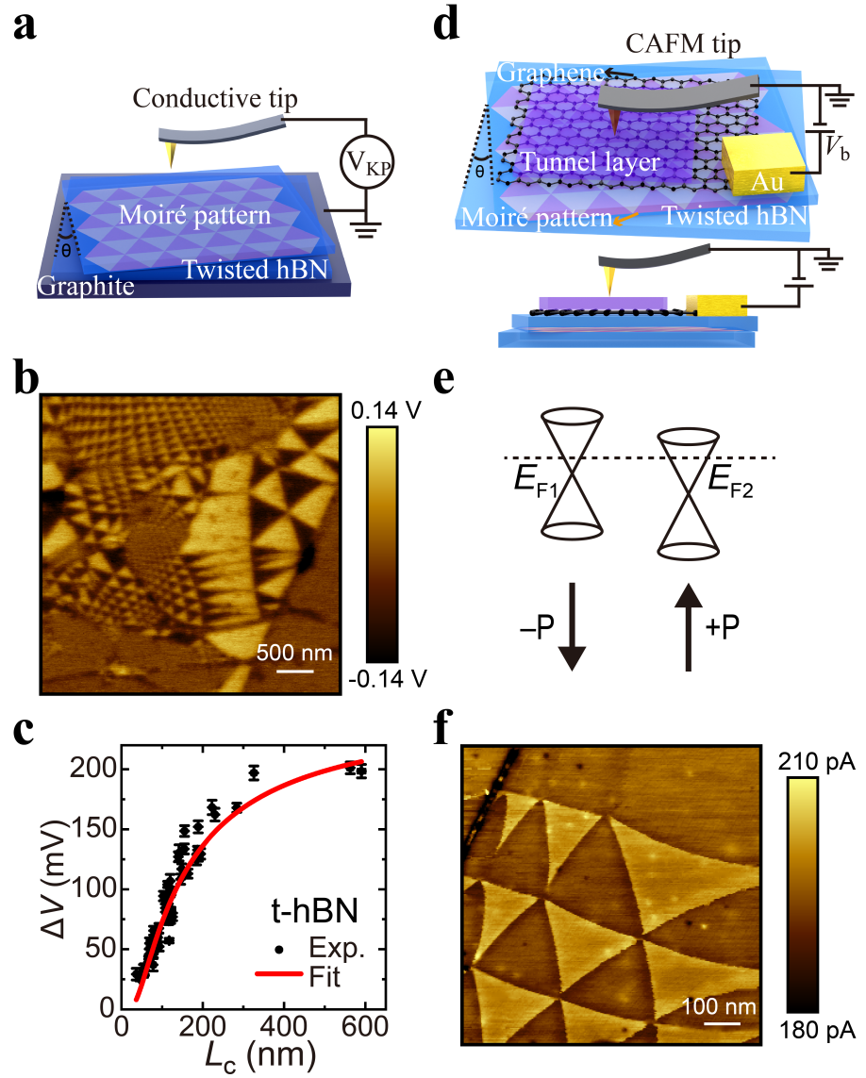
Figure 1. General KPFM and CMSTM measurements of t-hBN bilayers. a Schematic of the KFPM measurement. b A representative KPFM image of a t-hBN bilayer. c The relationship between the potential difference ($ΔV$) between neighbouring domains with opposite polarization and the domain size (characteristic length $L_{c}$). The error bars along the horizontal and vertical axes indicate the uncertainty of the moiré size and surface potential, respectively. The data points are measured from panel b and the red curve is a fitting with Eq. 1. d Schematic of the CMSTM measurement. e Fermi level modulation in the graphene sensing layer due to different polarization in t-hBN. f A typical CMSTM tunneling current $I_{t}$ mapping of a graphene layer modulated by t-hBN measured at $V_{b}=0.2 V$.
To better compare the differences of KPFM and CMSTM, we measured the same t-hBN before and after the placement of graphene and tunneling hBN layers, which are shown in Figs. 2a and c, respectively. The moiré pattern measured with the extra layers is different from that measured without, presumably due to the disturbance to the t-hBN layers introduced in the fabrication process, similar to a previous study¹³. After placing the extra layers, the moiré pattern is no longer visible in KPFM due to the screening of graphene layer, but shows up clearly in the CMSTM image of Fig. 2c. Line profiles across some elongated domains as marked by the blue and red arrows are displayed in Figs. 2b and d. In the KPFM potential profiles, narrower domains show significantly smaller $∆V$ compared with that of the wider ones. In stark contrast, the CMSTM tunneling current profile shows similar current variations independent of the domain width, strongly suggesting that the potential in t-hBN is the same for different moiré sizes and KPFM data similar to that in Fig. 1c is a result of the tip averaging effect.
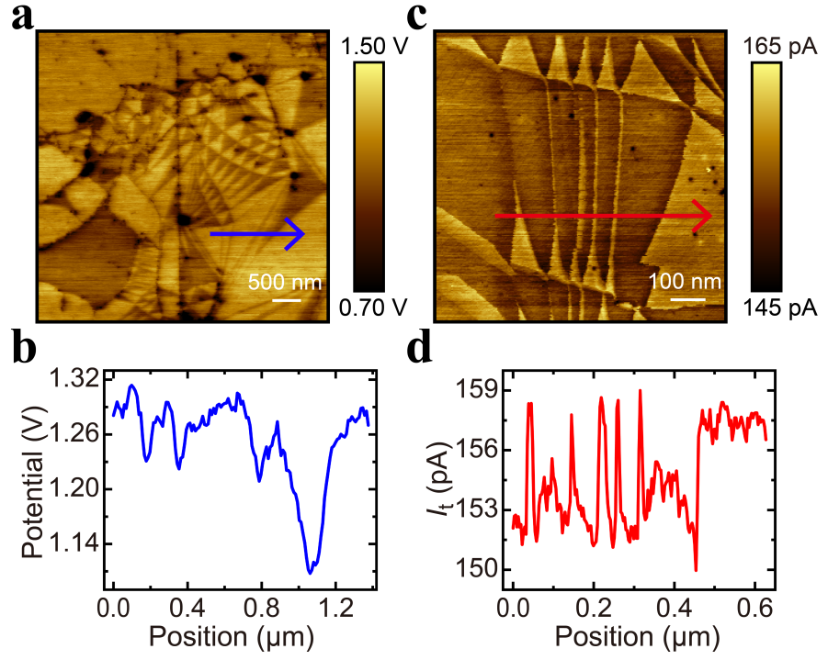
Figure 2. Comparison of KPFM and CMSTM of the same t-hBN bilayer. a KPFM image of the t-hBN substrate before covering with graphene and tunneling hBN. b Line profile along the blue arrow in panel a. c $I_{t}$ mapping measured after covering with graphene and tunneling hBN ($V_{b}=0.2 V$). d Line profile along the red arrow in panel c.
In order to quantitatively compare the results of KPFM and CMSTM, line profiles cutting through some triangular domains are extracted from the potential and tunneling current mappings (insets of Figs. 3a and b). Potential difference $ΔV$ and tunneling current difference $∆I_{t}$ between neighbouring domains with opposite polarization are plotted as a function of the central domain width (Figs. 3a and b) (the determination of width, $ΔV$ and $∆I_{t}$ can be found in the Supporting Information). It is noteworthy that even for the same domain, the measured $ΔV$ has strong dependence on the domain width (Fig. 3a), and exhibits similar behavior to that in Fig. 1c. On the other hand, $∆I_{t}$ remains stable (~ 7 pA) for width ranging from ~20 nm to 140 nm. This difference leads us to conclude that the moiré electrostatic potential in sliding ferroelectric systems should be independent of the moiré size, and the apparent different behavior in KPFM measurements is unlikely to be intrinsic.
Another benefit of CMSTM compared to the scanning potential microscopy based technique is its superior spatial resolution. Previously, EFM and KPFM studies were limited to ~30 nm and above^{3,13,15,24}. However, moiré potential with ~10 nm period is of particular interest as demonstrated in the magic angle graphene and numerous other twisted 2D systems³¹, where many intriguing physics phenomena have emerged. Therefore, it is important to measure the potential variation in t-hBN down to the 10 nm scale. Fig. 3c inset shows a high resolution CMSTM current mapping of a stretched domain. From ~7 nm to 20 nm $∆I_{t}$ stays around 7 pA, indicating that within this critical domain size range, the moiré electrostatic potential still remains the same. This finding is in apparent contradiction with the theoretical expectation¹¹, which could be due to the following two factors. First, in the theory calculation, the sample needs to be infinitely large and perfectly periodic. Both conditions were not met in this work and all previous experimental reports. Second, in the calculation the ferroelectric material is surrounded by vacuum; while in experiments it is always supported by a substrate. If the ferroelectric domains are to be utilized to modulate other materials, it is also covered from above. The screening effect by the dielectric environment could significantly alter the potential.
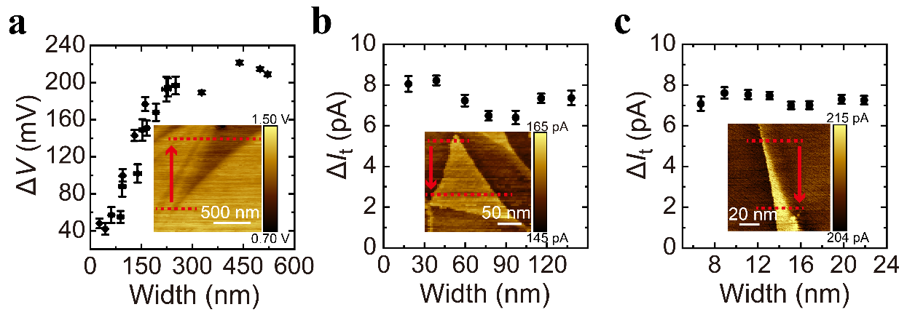
Figure 3. Quantitative comparison of KPFM and CMSTM results. a $ΔV$ at different domain width taken from a KPFM measurement shown in the inset. b, c Tunneling current difference ($∆I_{t}$) at different domain width taken from two CMSTM measurements shown in the insets. Red dashed lines mark the positions where the data in the main panels are taken.
Due to the multilayer structure, different moiré patterns can be formed which can induce super-moiré patterns and significantly alter the electrostatic potential. To rule out this possibility, the long edges of different flakes were misaligned in the device fabrication process.
To quantitatively measure the effect of the potential from the t-hBN on the electronic states in graphene, we carried out CMSTM spectroscopy on different domains of our devices. The results are shown in the Supporting Information.

Next we examine the tip averaging effect that could affect the KPFM measurements. KPFM is a scanning potential microscopic technique. It detects the force between the sample and the AFM tip caused by the electrostatic potential variation in the sample. However, due to the long range characteristic of Coulomb interaction, the tip resolution and measurement accuracy largely depend on various experimental parameters, such as the tip geometry, quantity being detected (amplitude, phase, voltage, etc.), tip excitation method (ac, dc, etc.), scanning height, and so on³. This long range interaction introduces a spatially averaging effect which could smear the intrinsic potential variation in the sample. We explore the outcome of such averaging effect with the following numerical calculation.
It has been demonstrated that^{32–34} KPFM signal can be modeled as a convolution of the intrinsic potential profile with the tip averaging function, typically in a Gaussian form, $f(x)∝exp(x^{2}/2σ^{2})$, with $σ$ determining the averaging extension. With optimization of the experimental parameters mentioned above, the best $σ$ that can be reached is in the range of tens of nanometers^{32–34}. Therefore, the convolution will result in an underestimation of the real potential variation, especially for moiré domains with sizes close to or smaller than $σ$.
This underestimation can be clearly seen in Figs. 4a and b, where two ideal potential profiles (red curves) are numerically convoluted with a Gaussian function $e^{−x^{2}/2σ^{2}}$ to simulate the KPFM measurement process. The $σ$ was chosen to be$122.5 nm$ to mach with the experimental observation in Fig. 1c. For the narrower profile (Fig. 4a), the resulted potential profile (blue) is significantly lower than the ideal curve. By changing the width $d$ of the high potential region, the relationship between $d$ and the peak potential value $ΔV$ after convolution is obtained (blue dots in Fig. 4c). $ΔV$ increases with $d$ and finally reaches an asymptotic value close to the ideal potential height of 200 mV. Interestingly, this trend can also be well fitted by Eq. 1 (orange line in Fig. 4c). Therefore, KPFM data similar to those in Figs. 1b and c could not be straightforwardly taken as a measure of the intrinsic potential of the t-hBN. To obtain a more reliable result for the small domains with the scanning potential microscopy technique, many precautions are needed (details can be found in Ref. 3).
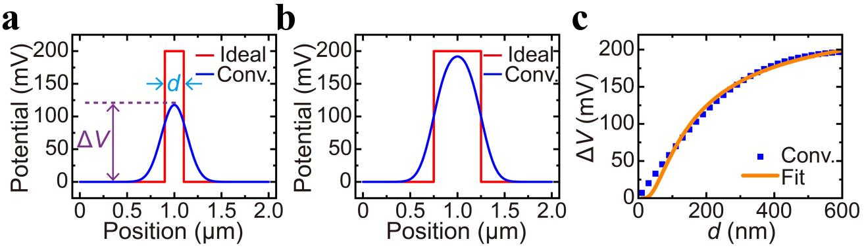
Figure 4. Numerical calculation to show the effect of convolution. a, b Ideal potential profiles (red curves) and those after convolution (blue curves). c Numerically calculated $ΔV$ as a function of the width $d$ (blue dots). The orange curve is a fitting with Eq. 1.
Through the CMSTM study, we have established that the moiré potential is independent of the moiré size in t-hBN. Presumably this behavior also holds for other 2D sliding ferroelectric materials due to the similar origin of polarization. Although KPFM may not be able to accurately measure the moiré potential for domains with sizes comparable to the tip averaging function width, when the moiré size is large enough, KPFM can be a facile and accurate method. From the data in Fig. 1c, $ΔV$ in t-hBN can be read as ~200 mV. This value corresponds to a net polarization of ~ 1.8 pC/m, in agreement with the theoretical prediction¹ (see the Supporting Information for the calculation). Since sliding ferroelectricity in TMDs is also attracting broad interests^{5–7,20,21,35}, it is worthwhile to compare them with the t-hBN. Representative KPFM measurements of twisted MoS₂ bilayer (t-MoS₂) and MoSe₂ bilayer (t-MoSe₂) are shown in Figs. 5a and b, respectively. Moiré patterns with characteristic lengths ranging from ~50 nm to 2.2 μm have been observed. A fitting method similar to the one used to get Fig. 1c (see the Supporting Information for details) yields the relationship between $ΔV$ and $L_{c}$ for t-MoS₂ and t-MoSe₂ as shown in Figs. 5c and d, respectively. From the saturation value of $ΔV$, the electrostatic potential variation of the t-MoS₂ and t-MoSe₂ can be found to be ~120 mV and ~93 mV, respectively. Theoretical calculation of the polarization strength in different sliding ferroelectric systems predicted that polarization in t-hBN is twice as strong as that in t-MoS₂,¹ which further corroborates the accuracy of the KPFM results for large domains. These KPFM data are highly reproducible (see the Supporting Information for more data), indicating that KPFM can be used as a quick way to measure the intrinsic potential in twisted sliding ferroelectric materials.
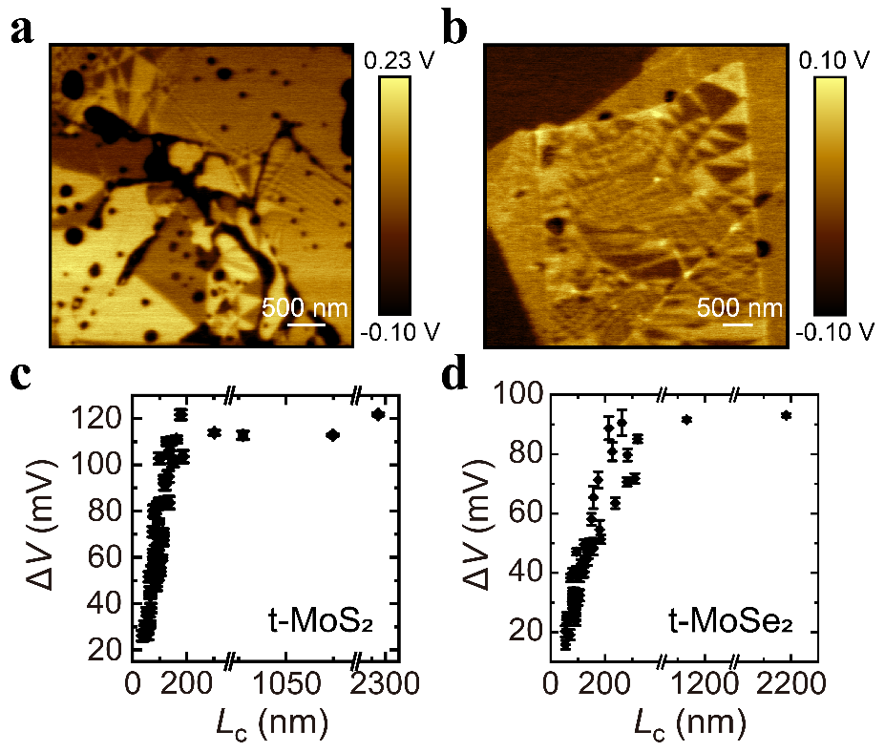
Figure 5. KPFM results of t-MoS₂ and t-MoSe₂. a, b KPFM images of t-MoS₂ and t-MoSe₂. c, d Relationship between $ΔV$ and $L_{c}$ in t-MoS₂ and t-MoSe₂.
In conclusion, we used graphene as a sensing layer and the CMSTM technique to study the moiré electrostatic potential in sliding ferroelectric t-hBN and found that the potential variation between opposite polarization domains is essentially independent of the domain size from a few to hundreds of nanometers. We also demonstrated that KPFM can be used to accurately obtain the potential for large domains. These findings provide useful information for the fast growing field of sliding ferroelectrics.
Methods
Device fabrication
All 2D materials were mechanically exfoliated onto SiO₂/Si substrates. Their thicknesses were determined using optical microscopy and AFM.
For t-X (X = hBN, MoS₂, MoSe₂) bilayer devices: a thin polycarbonate (PC) film, placed on a spherical poly(dimethylsiloxane) (PDMS) stamp, was used to pick up a thick graphite flake at 100 ℃. This graphite was then employed to tear and twist-stack an X monolayer. The desired twist angle (~0.3°) was achieved using a micro-stepping motor. However, due to the inevitable formation of bubbles and wrinkles during the transfer, the actual twist angle varied across different regions of the sample. The precise twist angle was determined by the moiré pattern period. The PC film with the sample was carefully removed from the PDMS stamp and placed onto a SiO₂/Si substrate. The sample was then heated to 150 ℃ to eliminate any bubbles between the PC film and the substrate. The transfer process for t-MoS₂ bilayer devices was performed in a glove box, while other devices were processed under ambient conditions. Metal electrodes (20 nm Ti and 20 nm Au) were deposited using a shadow mask and electron-beam evaporation (Lesker deposition system) at a rate of 0.2 Å/s under vacuum conditions (< 5 × 10⁻⁷ Torr).
For the tunnel layer/graphene/t-hBN devices: the monolayer hBN was cut into two pieces using an AFM tip. A thin PC film, placed on a spherical PDMS stamp, was used to twist-stack the monolayer hBN at 100 ℃. The t-hBN bilayer were then released onto a thick hBN substrate on SiO₂/Si at 180 ℃, and the PC film was removed using a dichloroethane solution. The sample surface was cleaned with an AFM tip, followed by measurement with KPFM. Subsequently, a thin PC film on a spherical PDMS stamp was used to pick up a 1.1 nm hBN layer as the tunnel layer at 100 ℃. This tunnel layer hBN was then used to pick up a monolayer graphene and placed onto the t-hBN. Finally, the PC film was removed using a dichloroethane solution. The electrode pattern was defined by electron beam lithography, and metal electrodes were deposited.

CAFM and KPFM measurements
CAFM measurements were conducted using an Oxford/Asylum Research Cypher S AFM. The CAFM tips, MikroMasch NSC15/Al, had a nominal resonance frequency of 325 kHz and a spring constant of 40 N/m. These tips were coated with 20 nm of Ti and 30 nm of Au to enhance conductivity. During the measurements, a bias voltage was applied to the sample, with the tip grounded.
KPFM measurements were performed using a Bruker Dimension Fastscan/Icon AFM in one-pass KPFM mode. Pt-coated conductive cantilever probes with a nominal resonance frequency of 70 kHz and a spring constant of 2 N/m (OPUS 240AC-PP, MikroMasch) were used. In the one-pass KPFM mode, both morphological and potential information were simultaneously acquired. The cantilever oscillated at its resonant frequency, f₀ (~70 kHz), under excitation from the piezoelectric ceramic. A low-frequency (~2 kHz) a.c. bias voltage was applied for phase modulation, while a d.c. bias voltage was used for contact potential difference (CPD) compensation. If the d.c. bias voltage could not fully compensate the CPD, the electrostatic force gradient with respect to the tip-to-sample distance induced a shift in f₀, which could be detected through phase changes in the cantilever oscillation. The tip-to-sample distance was determined by the amplitude of the cantilever’s mechanical oscillations.

SUPPORTING INFORMATION
Fitting procedure of KPFM and CMSTM data; Calculation of net polarization; CMSTM spectroscopy measurements; More data of KPFM

ACKNOWLEDGEMENTS
The authors thank the Soft Nano Fabrication Center at ShanghaiTech University for the equipment provided. J.X. was supported by the National Natural Science Foundation of China (NSFC, 12374189). K.W. and T.T. acknowledge support from the JSPS KAKENHI (Grant Numbers 21H05233 and 23H02052) , the CREST (JPMJCR24A5), JST and World Premier International Research Center Initiative (WPI), MEXT, Japan.

REFERENCES
(1) Li, L.; Wu, M. Binary Compound Bilayer and Multilayer with Vertical Polarizations: Two-Dimensional Ferroelectrics, Multiferroics, and Nanogenerators. ACS Nano 2017, 11 (6), 6382–6388. https://doi.org/10.1021/acsnano.7b02756.
(2) Vizner Stern, M.; Waschitz, Y.; Cao, W.; Nevo, I.; Watanabe, K.; Taniguchi, T.; Sela, E.; Urbakh, M.; Hod, O.; Ben Shalom, M. Interfacial Ferroelectricity by van Der Waals Sliding. Science 2021, 372 (6549), 1462–1466. https://doi.org/10.1126/science.abe8177.
(3) Woods, C. R.; Ares, P.; Nevison-Andrews, H.; Holwill, M. J.; Fabregas, R.; Guinea, F.; Geim, A. K.; Novoselov, K. S.; Walet, N. R.; Fumagalli, L. Charge-Polarized Interfacial Superlattices in Marginally Twisted Hexagonal Boron Nitride. Nat. Commun. 2021, 12 (1), 347. https://doi.org/10.1038/s41467-020-20667-2.
(4) Yasuda, K.; Wang, X.; Watanabe, K.; Taniguchi, T.; Jarillo-Herrero, P. Stacking-Engineered Ferroelectricity in Bilayer Boron Nitride. Science 2021, 372 (6549), 1458–1462. https://doi.org/10.1126/science.abd3230.
(5) Wang, X.; Yasuda, K.; Zhang, Y.; Liu, S.; Watanabe, K.; Taniguchi, T.; Hone, J.; Fu, L.; Jarillo-Herrero, P. Interfacial Ferroelectricity in Rhombohedral-Stacked Bilayer Transition Metal Dichalcogenides. Nat. Nanotechnol. 2022, 17 (4), 367–371. https://doi.org/10.1038/s41565-021-01059-z.
(6) Weston, A.; Castanon, E. G.; Enaldiev, V.; Ferreira, F.; Bhattacharjee, S.; Xu, S.; Corte-León, H.; Wu, Z.; Clark, N.; Summerfield, A.; Hashimoto, T.; Gao, Y.; Wang, W.; Hamer, M.; Read, H.; Fumagalli, L.; Kretinin, A. V.; Haigh, S. J.; Kazakova, O.; Geim, A. K.; Fal’ko, V. I.; Gorbachev, R. Interfacial Ferroelectricity in Marginally Twisted 2D Semiconductors. Nat. Nanotechnol. 2022, 17 (4), 390–395. https://doi.org/10.1038/s41565-022-01072-w.
(7) Ko, K.; Yuk, A.; Engelke, R.; Carr, S.; Kim, J.; Park, D.; Heo, H.; Kim, H.-M.; Kim, S.-G.; Kim, H.; Taniguchi, T.; Watanabe, K.; Park, H.; Kaxiras, E.; Yang, S. M.; Kim, P.; Yoo, H. Operando Electron Microscopy Investigation of Polar Domain Dynamics in Twisted van Der Waals Homobilayers. Nat. Mater. 2023, 22 (8), 992–998. https://doi.org/10.1038/s41563-023-01595-0.
(8) Yang, D.; Wu, J.; Zhou, B. T.; Liang, J.; Ideue, T.; Siu, T.; Awan, K. M.; Watanabe, K.; Taniguchi, T.; Iwasa, Y.; Franz, M.; Ye, Z. Spontaneous-Polarization-Induced Photovoltaic Effect in Rhombohedrally Stacked MoS₂. Nat. Photon. 2022, 16 (6), 469–474. https://doi.org/10.1038/s41566-022-01008-9.
(9) Rogée, L.; Wang, L.; Zhang, Y.; Cai, S.; Wang, P.; Chhowalla, M.; Ji, W.; Lau, S. P. Ferroelectricity in Untwisted Heterobilayers of Transition Metal Dichalcogenides. Science 2022, 376 (6596), 973–978. https://doi.org/10.1126/science.abm5734.
(10) Miao, L.-P.; Ding, N.; Wang, N.; Shi, C.; Ye, H.-Y.; Li, L.; Yao, Y.-F.; Dong, S.; Zhang, Y. Direct Observation of Geometric and Sliding Ferroelectricity in an Amphidynamic Crystal. Nat. Mater. 2022, 21 (10), 1158–1164. https://doi.org/10.1038/s41563-022-01322-1.
(11) Zhao, P.; Xiao, C.; Yao, W. Universal Superlattice Potential for 2D Materials from Twisted Interface inside H-BN Substrate. npj 2D Mater. Appl. 2021, 5 (1), 38. https://doi.org/10.1038/s41699-021-00221-4.
(12) Tan, T.; Reddy, A. P.; Fu, L.; Devakul, T. Designing Topology and Fractionalization in Narrow Gap Semiconductor Films via Electrostatic Engineering. Phys. Rev. Lett. 2024, 133 (20), 206601. https://doi.org/10.1103/PhysRevLett.133.206601.
(13) Cho, M.; Datta, B.; Han, K.; Chand, S. B.; Adak, P. C.; Yu, S.; Li, F.; Watanabe, K.; Taniguchi, T.; Hone, J.; Jung, J.; Grosso, G.; Kim, Y. D.; Menon, V. M. Moiré Exciton Polaron Engineering via Twisted hBN. Nano Lett. 2025, 25 (4), 1381. https://doi.org/10.1021/acs.nanolett.4c04996.
(14) Kim, D. S.; Xiao, C.; Dominguez, R. C.; Liu, Z.; Abudayyeh, H.; Lee, K.; Mayorga-Luna, R.; Kim, H.; Watanabe, K.; Taniguchi, T.; Shih, C.-K.; Miyahara, Y.; Yao, W.; Li, X. Harnessing Moiré Ferroelectricity to Modulate Semiconductor Monolayer Light Emission. arXiv May 17, 2024. http://arxiv.org/abs/2405.11159.
(15) Kim, D. S.; Dominguez, R. C.; Mayorga-Luna, R.; Ye, D.; Embley, J.; Tan, T.; Ni, Y.; Liu, Z.; Ford, M.; Gao, F. Y.; Arash, S.; Watanabe, K.; Taniguchi, T.; Kim, S.; Shih, C.-K.; Lai, K.; Yao, W.; Yang, L.; Li, X.; Miyahara, Y. Electrostatic Moiré Potential from Twisted Hexagonal Boron Nitride Layers. Nat. Mater. 2024, 23 (1), 65–70. https://doi.org/10.1038/s41563-023-01637-7.
(16) Roux, S.; Fraunié, J.; Watanabe, K.; Taniguchi, T.; Lassagne, B.; Robert, C. Optical Detection of Sliding Ferroelectric Switching in hBN with a WSe₂ Monolayer. Nano Lett. 2025, 25 (1), 321. https://doi.org/10.1021/acs.nanolett.4c05062.
(17) Fraunié, J.; Jamil, R.; Kantelberg, R.; Roux, S.; Petit, L.; Lepleux, E.; Pacheco, L.; Watanabe, K.; Taniguchi, T.; Jacques, V.; Lombez, L.; Glazov, M. M.; Lassagne, B.; Marie, X.; Robert, C. Electron and Hole Doping of Monolayer WSe₂ Induced by Twisted Ferroelectric Hexagonal Boron Nitride. Phys. Rev. Mater. 2023, 7 (12), L121002. https://doi.org/10.1103/PhysRevMaterials.7.L121002.
(18) Kiper, N.; Adlong, H. S.; Christianen, A.; Kroner, M.; Watanabe, K.; Taniguchi, T.; Imamoglu, A. Confined Trions and Mott-Wigner States in a Purely Electrostatic Moiré Potential. Phys. Rev. X 2025, 15, 011049. https://doi.org/10.1103/PhysRevX.15.011049.
(19) Zhang, S.; Fonseca, J.; Bennett, D.; Sun, Z.; Zhang, J.; Jing, R.; Xu, S.; He, L.; Moore, S. L.; Rossi, S. E.; Ovchinnikov, D.; Cobden, D.; Jarillo-Herrero, P.; Fogler, M. M.; Kim, P.; Kaxiras, E.; Xu, X.; Basov, D. N. Plasmonic Polarization Sensing of Electrostatic Superlattice Potentials. Plasmonic Polarization Sensing of Electrostatic Superlattice Potentials. Phys. Rev. X 2025, 15, 011019. https://doi.org/10.1103/PhysRevX.15.011019.
(20) Zhang, S.; Liu, Y.; Sun, Z.; Chen, X.; Li, B.; Moore, S. L.; Liu, S.; Wang, Z.; Rossi, S. E.; Jing, R.; Fonseca, J.; Yang, B.; Shao, Y.; Huang, C.-Y.; Handa, T.; Xiong, L.; Fu, M.; Pan, T.-C.; Halbertal, D.; Xu, X.; Zheng, W.; Schuck, P. J.; Pasupathy, A. N.; Dean, C. R.; Zhu, X.; Cobden, D. H.; Xu, X.; Liu, M.; Fogler, M. M.; Hone, J. C.; Basov, D. N. Visualizing Moiré Ferroelectricity via Plasmons and Nano-Photocurrent in Graphene/Twisted-WSe₂ Structures. Nat. Commun. 2023, 14 (1), 6200. https://doi.org/10.1038/s41467-023-41773-x.
(21) Ding, J.; Xiang, H.; Zhou, W.; Liu, N.; Chen, Q.; Fang, X.; Wang, K.; Wu, L.; Watanabe, K.; Taniguchi, T.; Xin, N.; Xu, S. Engineering Band Structures of Two-Dimensional Materials with Remote Moiré Ferroelectricity. Nat. Commun. 2024, 15 (1), 9087. https://doi.org/10.1038/s41467-024-53440-w.
(22) Wang, X.; Xu, C.; Aronson, S.; Bennett, D.; Paul, N.; Crowley, P. J. D.; Collignon, C.; Watanabe, K.; Taniguchi, T.; Ashoori, R.; Kaxiras, E.; Zhang, Y.; Jarillo-Herrero, P.; Yasuda, K. Moiré Band Structure Engineering Using a Twisted Boron Nitride Substrate. Nat. Commun. 2025, 16 (1), 178. https://doi.org/10.1038/s41467-024-55432-2.
(23) Cao, S.; Chen, M.; Zeng, J.; Ma, N.; Zheng, R.; Feng, Y.; Yan, S.; Liu, J.; Watanabe, K.; Taniguchi, T.; Xie, X. C.; Chen, J.-H. Transport Evidence of Superlattice Dirac Cones in Graphene Monolayer on Twisted Boron Nitride Substrate. 2D Mater. 2023, 10 (2), 025016. https://doi.org/10.1088/2053-1583/acbdaa.
(24) Han, K.; Cho, M.; Kim, T.; Kim, S. T.; Kim, S. H.; Park, S. H.; Yang, S. M.; Watanabe, K.; Taniguchi, T.; Menon, V.; Kim, Y. D. Highly Tunable Moiré Superlattice Potentials in Twisted Hexagonal Boron Nitrides. Advanced Science 2024, 2408034. https://doi.org/10.1002/advs.202408034.
(25) Li, R.; Taniguchi, T.; Watanabe, K.; Xue, J. Detecting Band Profiles of Devices with Conductive Atomic Force Microscopy. Review of Scientific Instruments 2020, 91 (7), 073702. https://doi.org/10.1063/5.0008412.
(26) Sun, X.; Chen, Y.; Li, Z.; Han, Y.; Zhou, Q.; Wang, B.; Taniguchi, T.; Watanabe, K.; Zhao, A.; Wang, J.; Liu, Y.; Xue, J. Visualizing Band Profiles of Gate-Tunable Junctions in MoS₂/WSe₂ Heterostructure Transistors. ACS Nano 2021, 15 (10), 16314–16321. https://doi.org/10.1021/acsnano.1c05491.
(27) Wang, K.; Taniguchi, T.; Watanabe, K.; Xue, J. Natural p–n Junctions at the MoS₂ Flake Edges. ACS Appl. Mater. Interfaces 2022, 14 (34), 39039–39045. https://doi.org/10.1021/acsami.2c09457.
(28) Yasuda, K.; Zalys-Geller, E.; Wang, X.; Bennett, D.; Cheema, S. S.; Watanabe, K.; Taniguchi, T.; Kaxiras, E.; Jarillo-Herrero, P.; Ashoori, R. Ultrafast High-Endurance Memory Based on Sliding Ferroelectrics. Science 2024, 385 (6704), 53–56. https://doi.org/10.1126/science.adp3575.
(29) Fei, Z.; Zhao, W.; Palomaki, T. A.; Sun, B.; Miller, M. K.; Zhao, Z.; Yan, J.; Xu, X.; Cobden, D. H. Ferroelectric Switching of a Two-Dimensional Metal. Nature 2018, 560 (7718), 336–339. https://doi.org/10.1038/s41586-018-0336-3.
(30) Li, H.; Li, S.; Regan, E. C.; Wang, D.; Zhao, W.; Kahn, S.; Yumigeta, K.; Blei, M.; Taniguchi, T.; Watanabe, K.; Tongay, S.; Zettl, A.; Crommie, M. F.; Wang, F. Imaging Two-Dimensional Generalized Wigner Crystals. Nature 2021, 597 (7878), 650–654. https://doi.org/10.1038/s41586-021-03874-9.
(31) Nuckolls, K. P.; Yazdani, A. A Microscopic Perspective on Moiré Materials. Nat. Rev. Mater. 2024, 9 (7), 460–480. https://doi.org/10.1038/s41578-024-00682-1.
(32) Zerweck, U.; Loppacher, C.; Otto, T.; Grafström, S.; Eng, L. M. Accuracy and Resolution Limits of Kelvin Probe Force Microscopy. Phys. Rev. B 2005, 71 (12), 125424. https://doi.org/10.1103/PhysRevB.71.125424.
(33) Liscio, A.; Palermo, V.; Samorì, P. Nanoscale Quantitative Measurement of the Potential of Charged Nanostructures by Electrostatic and Kelvin Probe Force Microscopy: Unraveling Electronic Processes in Complex Materials. Acc. Chem. Res. 2010, 43 (4), 541–550. https://doi.org/10.1021/ar900247p.
(34) Chen, Q.; Ye, F.; Lai, J.; Dai, P.; Lu, S.; Ma, C.; Zhao, Y.; Xie, Y.; Chen, L. Energy Band Alignment in Operando Inverted Structure P3HT:PCBM Organic Solar Cells. Nano Energy 2017, 40, 454–461. https://doi.org/10.1016/j.nanoen.2017.08.050.
(35) Liu, Y.; Liu, S.; Li, B.; Yoo, W. J.; Hone, J. Identifying the Transition Order in an Artificial Ferroelectric van Der Waals Heterostructure. Nano Lett. 2022, 22 (3), 1265–1269. https://doi.org/10.1021/acs.nanolett.1c04467.

