Supporting Information
Scalable liposomes functionalization via membrane lipid exchange mechanisms
Xizi Long^{a,b}, Chiho Kataoka-Hamai^{c,d}, Chialun Ho^{b,d,e}, Wei-Lun Huang^{f,g}, Yi-Ho Kuo^{h}, Li-Ting Yang^{h}, Wei-Peng Li ^{b,f,h,i,‡,}*, and Akihiro Okamoto ^{b,d,e,j,}*
ªThe Key Laboratory of Typical Environmental Pollution and Health Hazards of Hunan Province, School of Public Health, Hengyang Medical School, University of South China, Hengyang 421001, China
^{b}International Center for Materials Nanoarchitectonics, National Institute for Materials Science, Tsukuba, Ibaraki 305-0044, Japan
^{c}Research Center for Functional Materials, National Institute for Materials Science, Tsukuba, Ibaraki 305-0044, Japan
^{d}Research Center for Macromolecules and Biomaterials, National Institute for Materials Science, Tsukuba, Ibaraki 305-0044, Japan
^{e}Graduate School of Chemical Sciences and Engineering, Hokkaido University, Hokkaido 060-8628, Japan
^{f}Center of Applied Nanomedicine, National Cheng Kung University, Tainan 701, Taiwan
^{g}Department of Medical Laboratory Science and Biotechnology, College of Medicine, National Cheng Kung University, Tainan 701, Taiwan.
^{h}Department of Medicinal and Applied Chemistry, Kaohsiung Medical University, Kaohsiung 807, Taiwan
^{i}Drug Development and Value Creation Research Center, Kaohsiung Medical University, Kaohsiung 807, Taiwan
^{j}Tsukuba, Graduate School of Science and Technology Degree Programs in Life and Earth Sciences Institute for Innovation for Future Earth (IRFE) and Laboratory for Integrated Science and Materials (LiSM), Tokyo Institute of Technology.

X.-Z. Long and W.-P. Li contributed equally to this work.

Table R1. Summary of functionalized liposome preparation approaches.
Methods | Principal | Pros | Cons | Refs
DNA anchoring | Cholesterol-membrane interaction and DNA hybridization | (1) Easy to use  (2) Highly specific and efficient conjugation | (1) High cost of DNA synthesis  (2) Gene remnants  (3) Stability concern | 1
Surface modifications | Covent bonding between lipid and ligand | (1) Highly specific conjugation  (2) Diverse ligands | (1) Chemical remnants  (2) non-native protein architectures  (3) Complicated synthesis processes | 2
Azide-functionalization | Bioorthogonal chemistry | (1) Highly specific and efficient conjugation  (2) High stability in bio environment | (1) Requiring specific ligand  (2) Chemical linkers on product | 3
Gene engineering | Cell regulation for enhanced vesicle production | (1) Native protein architectures  (2) No exogenous remnants | (1) Difficult operation  (2) High cost  (3) Low applicability | 4
Precipitating membrane fragment method | Detergent-mediated membrane shedding | (1) Native protein architectures  (2) Easy to mass production | (1) Detergent remnants  (2) Difficult operation | 5
Cell membrane extraction and extrusion | Lipid membrane reassemble | (1) Low cost  (2) Easy to mass production  (3) Native protein architectures | (1) Bioactive and chemical remnants  (2) Requiring additional purification | 6-8
LIME | Membrane exchange | (1) Native protein architectures  (2) Easy to mass production  (3) Low cost  (4) High applicability | (1) Exogenous lipid remnants | The present work

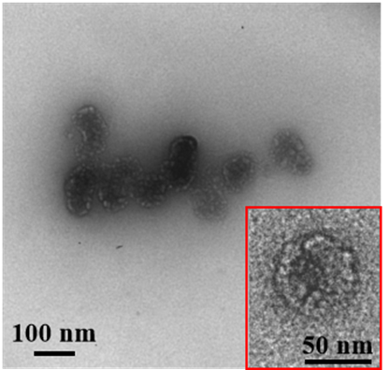
Fig. S1. The HR-TEM image of raw liposome. The inset shows the high magnification of single particle image.

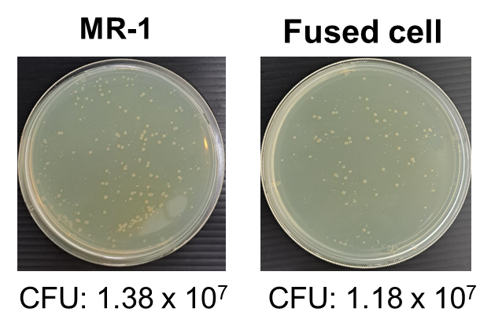
Fig. S2. The colony formation assay of MR-1 and fused cells. The bacteria with and without LIME treatment were collected by centrifugation (6000 rpm, 5 min). The diluted cell solutions were homogeneously distributed on the agar plate. After incubation at 30 ℃ for 20 h for visible colony growth, the colony number was counted to get each colony formation unit (CFU) (n=3).

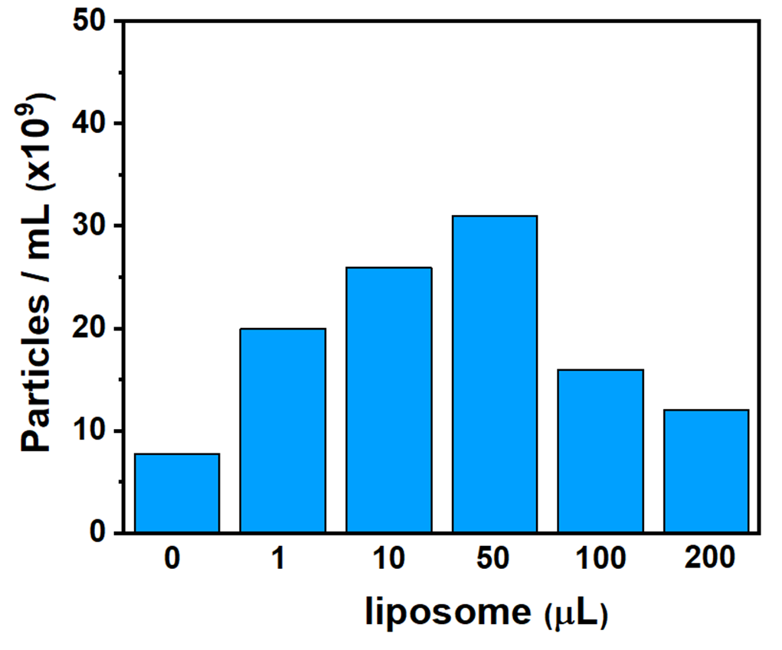
Fig. S3. The nanoparticle-tracking analysis (NTA) analysis was applied to quantify MIL production under LIME incubation for twenty hours with different amounts of liposome supply (0, 1, 10, 50, 100, and 200 μL of stock liposome solution).

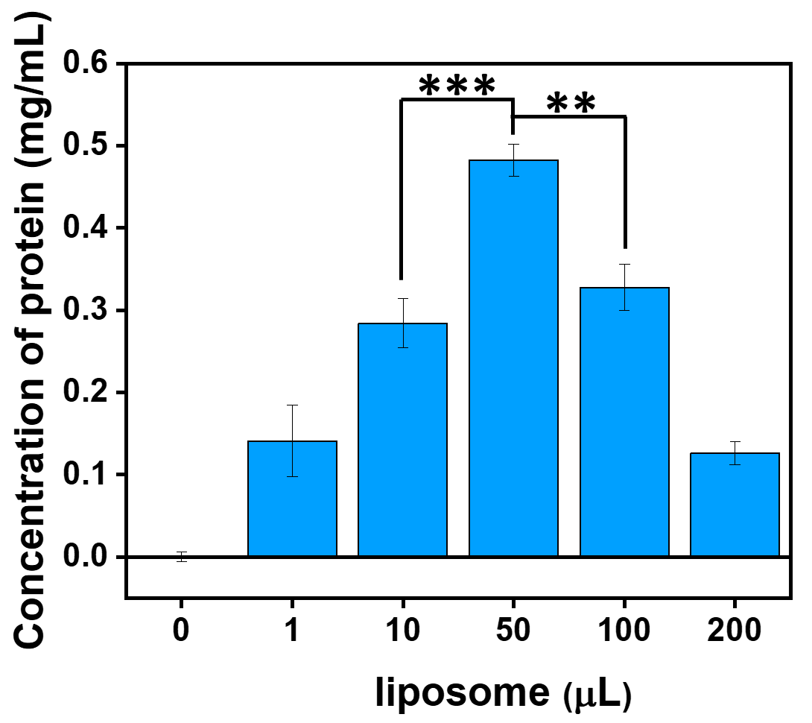
Fig. S4. The indirect evaluation of MIL production under LIME incubation for twenty hours with different amounts of liposome supply (0, 1, 10, 50, 100, and 200 μL of stock liposome solution). Protein assays were used to indirectly quantify the MIL amount in the supernatant at different reaction conditions. (**P < 0.005; ***P < 0.001)

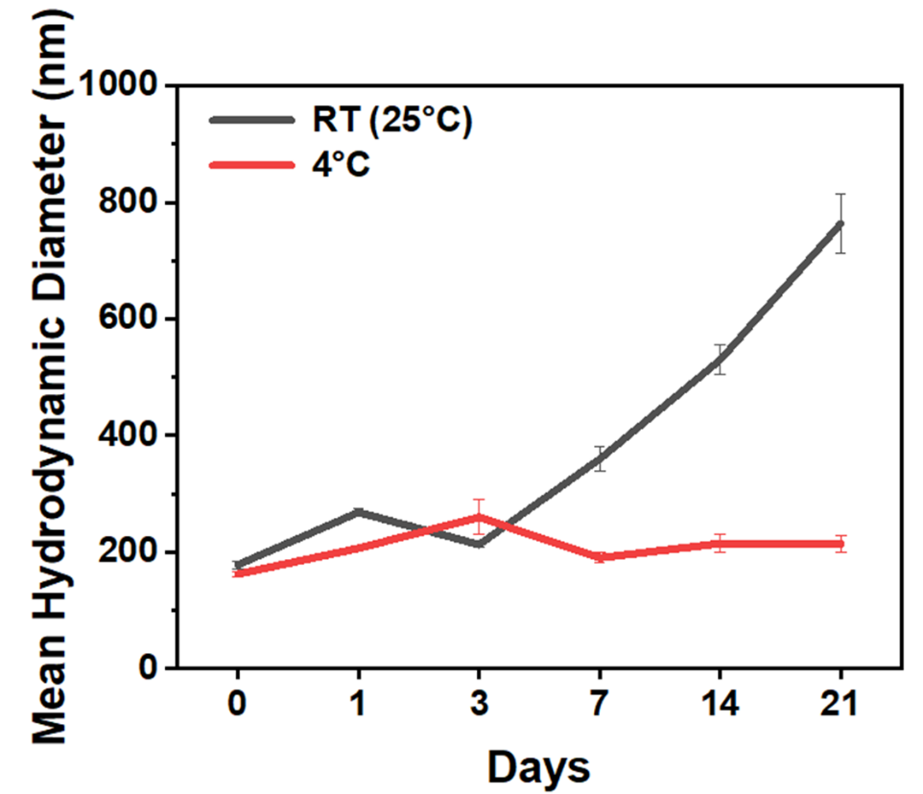
Fig. S5. The DLS analysis of MIL in PBS at 4℃ and 25℃ for different days. The hydrodynamic diameters were recorded at 0th, 1st, 3rd, 7th, 14th, and 21st day.

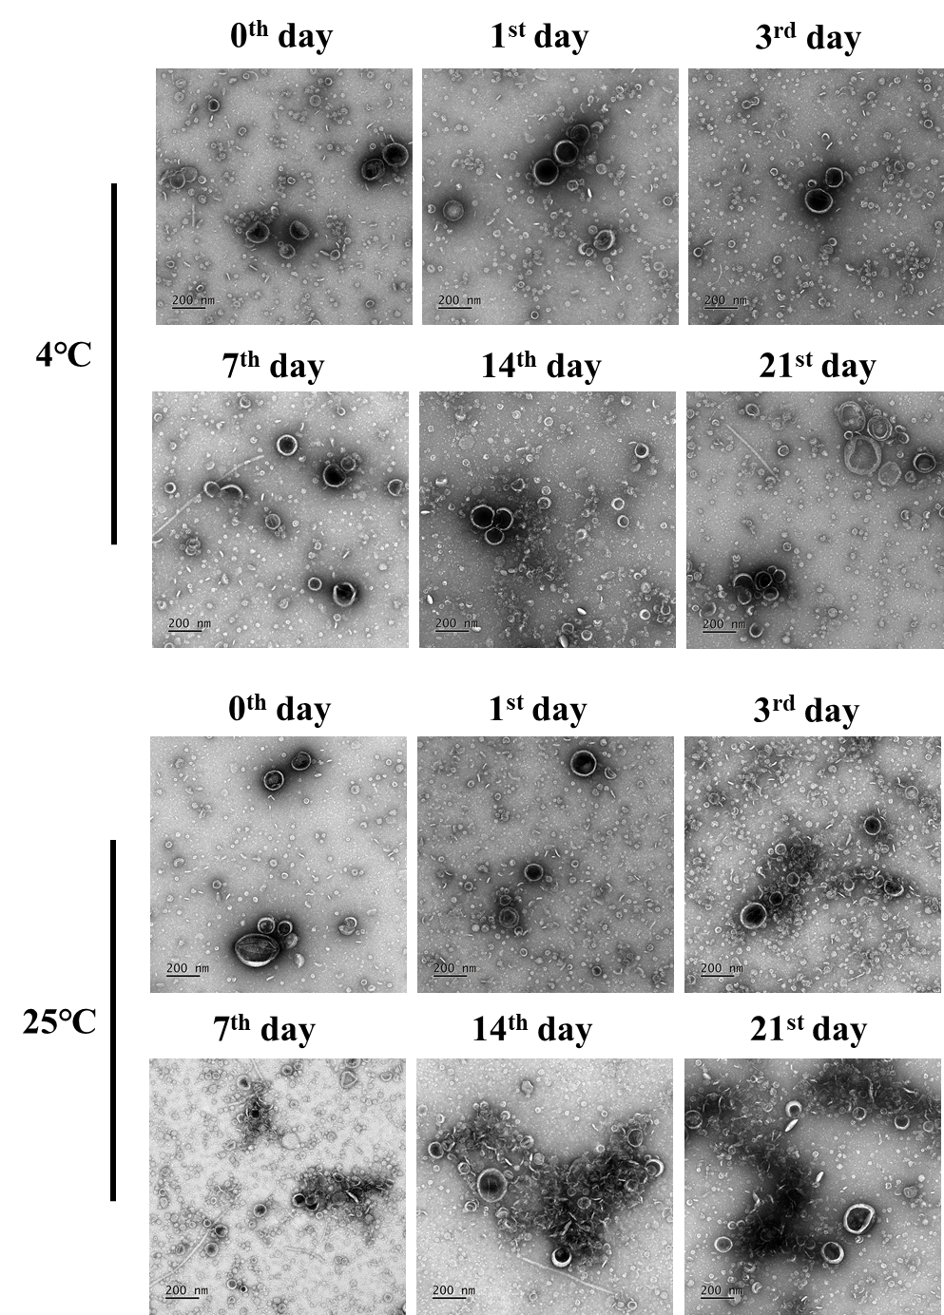
Fig. S6. Time course of MIL morphology in PBS at 4℃ and 25℃. The TEM images of MIL was captured on the 0th, 1st, 3rd, 7th, 14th, and 21st days.

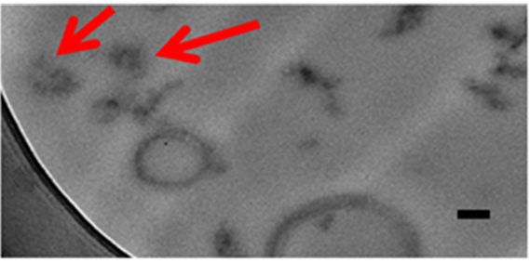
Fig. S7. The HR-TEM image of MIL dots with DAB staining. The scale bar is 100 nm.

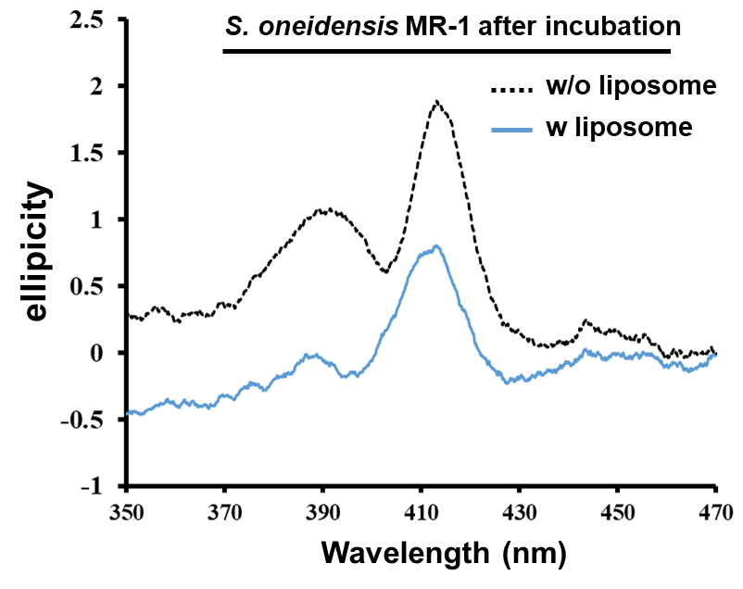
Fig. S8. The CD spectra of S. oneidensis MR-1 after the incubation for 20 hours with and without liposome.

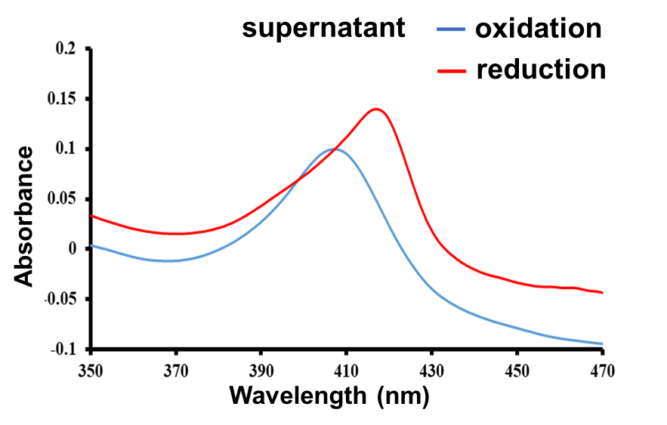
Fig. S9. The UV-vis spectra of the supernatant with liposome-contained incubation under the oxidative or reductive condition.

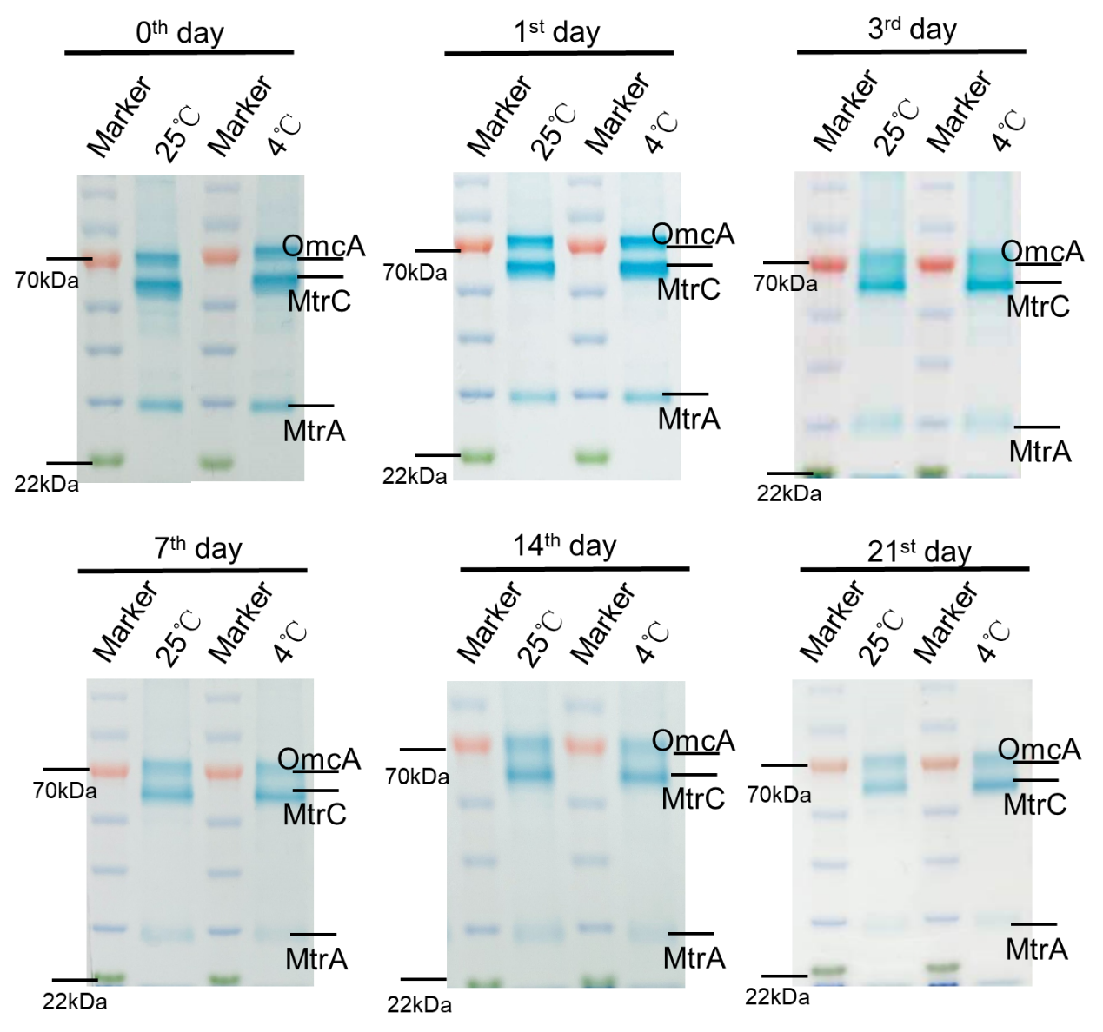
Fig. S10. Time courses of the protein profiles of MILs stored at 4 and 25 ℃. The SDS-PAGE gels were stained with heme-reactive 3,3ʹ,5,5ʹ-tetramethylbenzidine-H₂O₂ (heme staining).

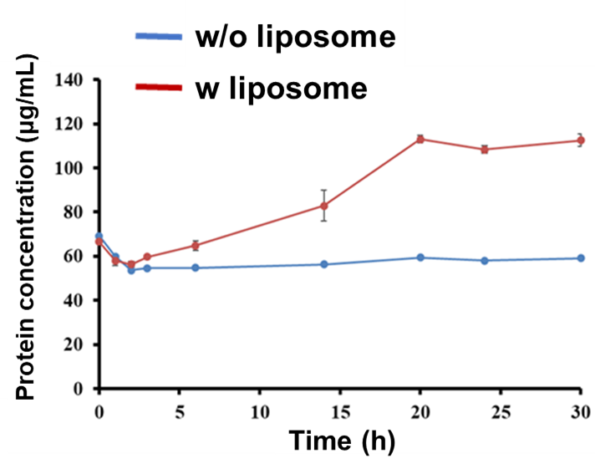
Fig. S11. The dynamic of MIL producing under the w/o and w/ liposome incubation. Protein assays were used to quantify the protein concentration in the supernatant at different incubation times.

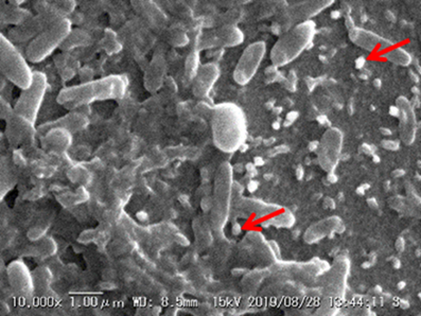
Fig. S12. The SEM image of S. oneidensis MR-1 dried on the glass after 20 hours incubation with liposome. The red arrows indicate the spherical vesicles evidencing the MIL production.

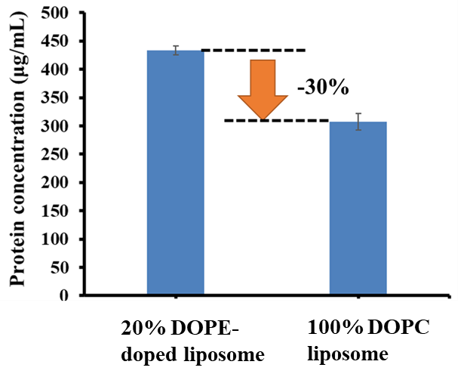
Fig. S13. The comparison of MIL yield after LIME treatment with 20% DOPE-doped liposome and 100% DOPC liposome to S. oneidensis MR-1. Protein assays were used to quantify the MIL amount in the supernatant at different reaction conditions.

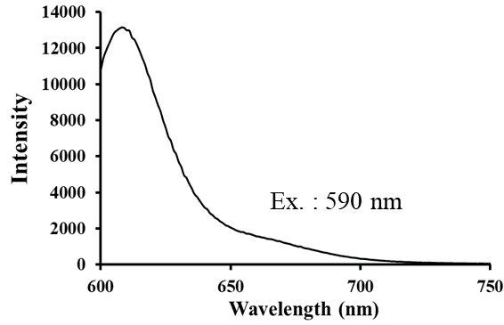

Fig. S14. The fluorescence spectrum showed the emission feature of TR-liposome under the excitation at 590 nm.

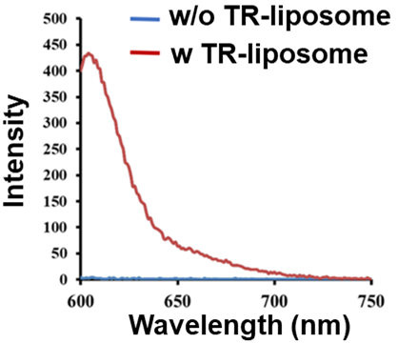
Fig. S15. The fluorescence spectra of MR-1 and TR-inserted MR-1.

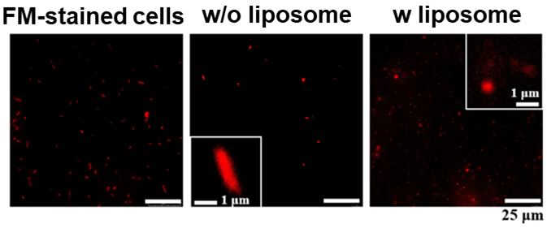
Fig. S16. The fluorescence images of FM-stained MR-1 cells before and after incubating with or without liposome. The inserts for w/o liposome and w/ liposome showed their high magnification images.

References
[1] Z. Zhang, Z. Feng, X. Zhao, D. Jean, Z. Yu, E. R. Chapman, Functionalization and Higher-order Organization of Liposomes with DNA Nanostructures. Nat. Commun. 2023, 14, 5256.
[2] V. Makwana, J. Karanjia, T. Haselhorst, S. Anoopkumar-Dukie, S. Rudrawar, Liposomal Doxorubicin as Targeted Delivery Platform: Current Trends in Surface Functionalization. International Journal of Pharmaceutics 2021, 593, 120117.
[3] Y. Xiao, Q. Liu, A. J. Clulow, T Li, M. Manohar, E. P. Gilbert, L. Campo, A. Hawley, B. J. Boyd, PEGylation and Surface Functionalization of Liposomes Containing Drug Nanocrystals for Cell-targeted Delivery. Colloids and Surfaces B: Biointerfaces 2019, 182, 110362.
[4] V. Premjani, D. Tilley, S. Gruenheid, H. L. Moual, J. A. Samis, Enterohemorrhagic Escherichia coli OmpT Regulates Outer Membrane Vesicle Biogenesis. FEMS Microbiol. Lett. 2014, 355, 185-192.
[5] T. Shinoda, N. Shinya, K. Ito, Y. Ishizuka-Katsura, N. Ohsawa, T. Terada, K. Hirata, Y. Kawano, M. Yamamoto, T. Tomita, Y. Ishibashi, Y. Hirabayashi, T. Kimura-Someya,
M Shirouzu, S. Yokoyama, Cell-free Methods to Produce Structurally Intact Mammalian Membrane Proteins. Scientific Reports 2016, 6, 30442.
[6] L. Liu, X. Bai, M. V. Martikainen, A. Kårlund, M. Roponen, W. Xu, G. Hu, E. Tasciotti, V. P. Lehto, Cell Membrane Coating Integrity Affects the Internalization Mechanism of Biomimetic Nanoparticles. Nat. Commun. 2021, 12, 5726.
[7] W. Lei, C. Yang, Y. Wu, G. Ru, X. He, X. Tong, S. Wang, Nanocarriers Surface Engineered with Cell Membranes for Cancer Targeted Chemotherapy. Journal of Nanobiotechnology 2022, 20, 45.
[8] X. Luo, C. Li, Z. Guo, H. Wang, P. He, Y Zhao, Y. Lin, C. He, Y. Hou, Y. Zhang, G. Du, Bacterial and Cancerous Cell Membrane Fused Liposome Coordinates with PD-L1 Inhibitor for Cancer Immunotherapy. Nano Res. 2024, 17, 8389-8401.

