Solution-Processed SnO_{X} as a Hole Transporting Material for Stable Sn-based Perovskite Solar Cell
Jannatul Ferdous^{a,b,c}, Md. Emrul Kayesh^{b}, Wipakorn Jevasuwanª, Naoki Fukata^{a*}, Ashraful Islam^{b*}
ªInternational Center for Materials Nanoarchitectonics, National Institute for Materials Science (NIMS), 1-1 Namiki, Tsukuba, Ibaraki 305-0044, Japan
^{b}Photovoltaic Materials Group, Centre for Green Research on Energy and Environmental Materials, National Institute for Materials Science (NIMS), 1-2-1 Sengen, Tsukuba 305-0047, Japan
^{c}Graduate School of Pure and Applied Sciences, University of Tsukuba, Tsukuba, Ibaraki 305-8573, Japan

Abstract:
Sn-based perovskites are considered a suitable alternative to toxic Pb-based perovskites due to their low toxicity and optimum optoelectronic properties. However, high-efficiency Sn-based perovskite solar cells (PSCs) typically use poly (3,4-ethylenedioxythiophene): polystyrene sulfonic acid (PEDOT:PSS) as a hole transport material (HTM), which limits their stability due to its acidic nature. This study introduces SnO_{X} nanocrystals, synthesized through a synproportionation reaction of Sn⁴⁺ with Sn⁰ under mild conditions, as a replacement for PEDOT:PSS. X-ray photoelectron and ultraviolet photoelectron spectroscopy analyses revealed that the Sn⁰ reduces Sn⁴⁺ by 38% and elevates the highest occupied molecular orbital (HOMO) to –5.70 eV, close to PEDOT:PSS, enabling HTM behavior. The perovskite films on SnO_{X} exhibit improved grain size and crystallinity compared to PEDOT:PSS. The resulting SnO_{X}-based Sn-PSCs achieved a power conversion efficiency of 11.11%. They retained 90% of their efficiency after 1000 h of maximum power point tracking, indicating superior stability over PEDOT:PSS-based devices.
Keywords: acidic nature, nanocrystal, stability, crystallinity.

- Introduction
Perovskite solar cells (PSCs) have gained a lot of attention lately because of their remarkable increase in power conversion efficiency (PCE), which has been observed in just 15 years, from 3.8% to 26.7%. ^{[1,2]} However, all reported high-performing PSCs consist of lead (Pb) in their perovskite absorber. Unfortunately, the toxicity of Pb prevents them from being used widely, which has compelled researchers to find a substitute for Pb-free PSC in the past few years.^{[3,4]} To resolve this problem, numerous research teams are currently struggling to discover alternatives to Pb, such as tin (Sn)^{[4]}, bismuth (Bi)^{[5]}, antimony (Sb)^{[6]}, copper (Cu)^{[7]}, and germanium (Ge)^{[8]} which are non-toxic metals. The objective is to find substitutes that will not compromise the optoelectronic properties of the perovskite absorber.
Among them, Sn-based perovskites are found to be the most possible substitute materials for Pb-free perovskite out of all the other options because of their reduced exciton binding energy, increased mobility of charge carriers, and optimum bandgap (1.2-1.4 eV), which is closer to the ideal value denoted by the Shockley–Queisser Limit (1.3 eV).^{[9,10]} However, the maximum reported PCE for Sn-PSCs is below 16%, which is far away from the Pb-PSCs.^{[2]} One factor contributing to the limited performance is their high defect density due to facial tendency to oxidize from Sn²⁺ to Sn⁴⁺ and fast perovskite crystallization rate.^{[11,12]} To resolve this problem, Mathews et al. utilized SnF₂ as an additive to retard Sn²⁺ oxidation.^{[13]} Subsequently, other additives such as trimethylthiourea, NH₄SCN, and 4-amino-3-hydroxybenzoic acid were employed in conjunction with SnF₂ to improve the morphology and optoelectronic properties of perovskite films.^{[12,14,15]} Recently, Q. Mi et al. reported record PCE for Sn-based PSCs of 15.7% by doing a surface treatment of perovskite with 4-fluorophenethylamine hydrobromide to passivate surface defects and minimize energy mismatch of Sn-perovskite films with charge transport materials.^{[16]} However, all the reported high-efficiency devices failed to demonstrate maximum power point tracking (MPPT) stability, which is essential for the industry standard degradation test for all solar cells. The factor related to the lower device stability is the acidic nature of poly (3,4- ethylenedioxythiophene): poly (styrene sulfonate) (PEDOT:PSS), the most frequently employed hole transporting material (HTM) in high-efficiency PSCs. PEDOT:PSS is extensively employed as HTM in the inverted PSCs due to its energy level matching with Sn-perovskite, good conductivity, high transparency, and easy solution processing methods at low temperatures (<150 °C).^{[17,18]} The acidic properties of PEDOT:PSS accelerate the oxidation of iodide to iodine in perovskites, which makes Sn-PSCs unstable under MPPT conditions.^{[19,20]} Although NiO_{x} and CuSCN have been identified as robust inorganic HTMs for the Sn-based PSC, their PCE is still not satisfactory.^{[21,22]} Actually, most of the HTMs were designed originally for Pb-perovskites. So, the energy level of the present HTM doesn’t match well with Sn-based PSC.
To make Sn-based PSCs more stable, it is necessary to substitute the organic HTMs with newly developed inorganic HTMs. Recent research has revealed that a mixed valence tin oxide (SnO_{1−X}), produced by simultaneously sputtering a SnO target and a metallic Sn target, may be a good HTM. By adjusting the sputter power of the Sn target, the amounts of excess Sn (X) in the SnO_{1−X} films can be controlled. To obtain a p-type pure phase of SnO film, the value of X should be 0.03, and it needs to be annealed at 300ºC in N₂.^{[23]} J. Huang et al. fabricated mixed valence SnO_{2−X} by using atomic layer deposition (ALD) and used as HTM for Sn-Pb-based PSCs. These PSCs exhibit comparable performance to those made with PEDOT:PSS.^{[24]} The primary benefit of employing SnO_{2−X} as the HTM for Sn–Pb PSCs is the device stability. To reduce the cost and complexity of the ALD process, recently they reported a ternary Sn (II) alloy of SnOCl, synthesized by a low-temperature solution method, as a replacement of PEDOT:PSS for Pb-Sn-based PSCs.^{[25]} S. Hayase et al. unexpectedly discovered that when nanoparticles of SnO₂ came into contact with the Sn-perovskite layer, its surface was reduced to SnO_{X} (X < 2), which then functioned as the HTM of the Sn-based PSCs.^{[26]} Therefore, the functionality of SnO_{X} as n-type or p-type depends on the value of X in the fabricated SnO_{X} films. A. Xu et. al. developed an innovative and straightforward method to produce stable Sn²⁺ self-doped SnO_{2-X} nanocrystals with a significant surface area through a synproportionation reaction of Sn⁴⁺ with metallic tin (Sn⁰) under mild conditions.^{[27]} They reported that the synproportionation reaction of Sn⁴⁺ and Sn⁰ pushed the valence band edges from 3.21 eV for SnO₂ to 2.4 eV for SnO_{2-X} and systematically investigated the photocatalytic performance of Sn²⁺ self-doped SnO_{2-X} nanocrystals. From this report, we were inspired to search for novel tin oxides that can be produced using solution-based methods.
In this study, we present SnO_{X} as a replacement for PEDOT:PSS as the HTM in Sn-based PSCs. The SnO_{X} was readily produced by reacting SnCl₄.5H₂O with Sn⁰ in water at room temperature. Here Sn⁰ partially reduced SnCl₄·5H₂O to form SnO_{X} where the value of X remains in the range of 1.7 to 1.8 as observed from the X-ray photoelectron spectroscopy (XPS) measurement. In addition, this partial Sn⁴⁺ reduction in SnO_{X} pulled the valence band energy from −7.86 eV (SnO₂) to −5.70 eV (SnO_{X}) as evidenced by the Ultraviolet Photoelectron Spectroscopy (UPS) close to the value of Sn-based perovskite. The Sn-based PSCs utilizing SnO_{X} as HTM exhibit a superior device performance comparable to the PEDOT:PSS-based devices. More importantly, the SnO_{X} HTM significantly improves the long-term stability of the Sn-based PSCs. The top-performing SnO_{X}-based Sn-PSC maintained about 90% of its initial PCE under maximum power point tracking (MPPT) conditions for 1000 h.

- Results and discussion
The synthesis of SnO or SnO₂ through a solution process is frequently accomplished using tin (II) chloride (SnCl₂) or tin (IV) chloride as a precursor solution. The conditions of the solution process, such as temperature, presence of oxidation or reducing agents, O₂, pH value, and H₂O, determine whether SnO or SnO₂ will form.^{[28]} To work SnO_{X} as the HTM for Sn-based PSCs, the value of X should be in the range of 1.7-1.8.^{[26]} To synthesize SnOCl as HTM, Huang et. al. dissolved anhydrous SnCl₂ in an ethyl alcohol/water solution and controlled the pH value using NaOH.^{[25]} However, in this work, SnO_{X} was prepared only by dissolving 1 mmol of SnCl₄·5H₂O in 30 ml of distilled water. Afterward, the mixture was vigorously stirred, and Sn⁰ powder was added at different ratios of Sn⁰: SnCl₄·5H₂O such as 1:2, 1:4, 1:8, and 1:16. The solution was stirred in a closed environment for the next 10 days. Finally, a clear light yellow SnO_{X} solution was obtained. According to the findings displayed in Figure S1, the best performance of Sn-based PSCs was obtained using SnO_{X} as HTM, fabricated from a 1:4 ratio of Sn⁰: SnCl₄·5H₂O solution. The SnO_{X} films were fabricated through spin coating using commercially available 15 wt% colloidal SnO₂ solution, along with a 1:4 ratio mixture of Sn⁰: SnCl₄·5H₂O solution, which will be abbreviated as SnO₂ and SnO_{X} hereafter.
Measurements using high-resolution transmission electron microscopy (HRTEM) were used to confirm that SnO_{X} nanocrystals were formed. HRTEM and Fast Fourier Transform (FFT) images of SnO_{X} are shown in Figure 1 a. The SnO_{X} nanoparticles were evenly distributed throughout the substrate surface, as seen by the HRTEM image. The micrographs demonstrate that SnO_{X} nanoparticles had an average diameter of between 5 and 10 nm. The crystalline structure of individual nanoparticles exhibits interplanar spacing (d₁₁₀) values of 0.33, which correspond to the tin oxide (110) atomic plane with a tetragonal cassiterite phase.^{[27]} To observe the reducing effects of Sn⁰ powder in SnCl₄·5H₂O solution, the composition of SnO₂ and SnO_{X} was measured using XPS. The XPS spectra of Sn 3d_{5/2} orbitals of SnO₂ and SnO_{X} films are displayed in Figures 1b and 1c. The Sn 3d_{5/2} spectra, which overlap with the Sn⁰, Sn²⁺, and Sn⁴⁺ components, can be deconvoluted to get a quantitative analysis of the chemical compositions and oxidation states of Sn (Sn⁰, Sn²⁺, and Sn⁴⁺) in the SnO₂ and SnO_{X} films. The content of Sn²⁺ and Sn⁴⁺ determines the peak positions of these elements in SnO₂ or SnO_{X}. An increase in Sn²⁺ content in the SnO_{X} films results in a shift of both Sn²⁺ and Sn⁴⁺ peak positions to lower binding energy.^{[26]} This occurs because metallic tin (Sn⁰) in the SnCl₄.5H₂O solution reduces Sn⁴⁺ by undergoing oxidation to Sn²⁺.The peak at around 486 eV is attributed to Sn⁴⁺ (83.21%), and a small amount of Sn²⁺ (15.89%) was found from the Sn 3d_{5/2} peak for the SnO₂. However, a comparatively considerable decrease in Sn⁴⁺ (50.20%) and an increase in Sn²⁺ (47.33%) were observed with the addition of Sn⁰ powder in SnCl₄.5H₂O. This indicates that the Sn⁰ acted as a reducing agent and partially reduced the percentage of Sn⁴⁺ from SnO₂ which is necessary to act as HTM for Sn-based PSCs.
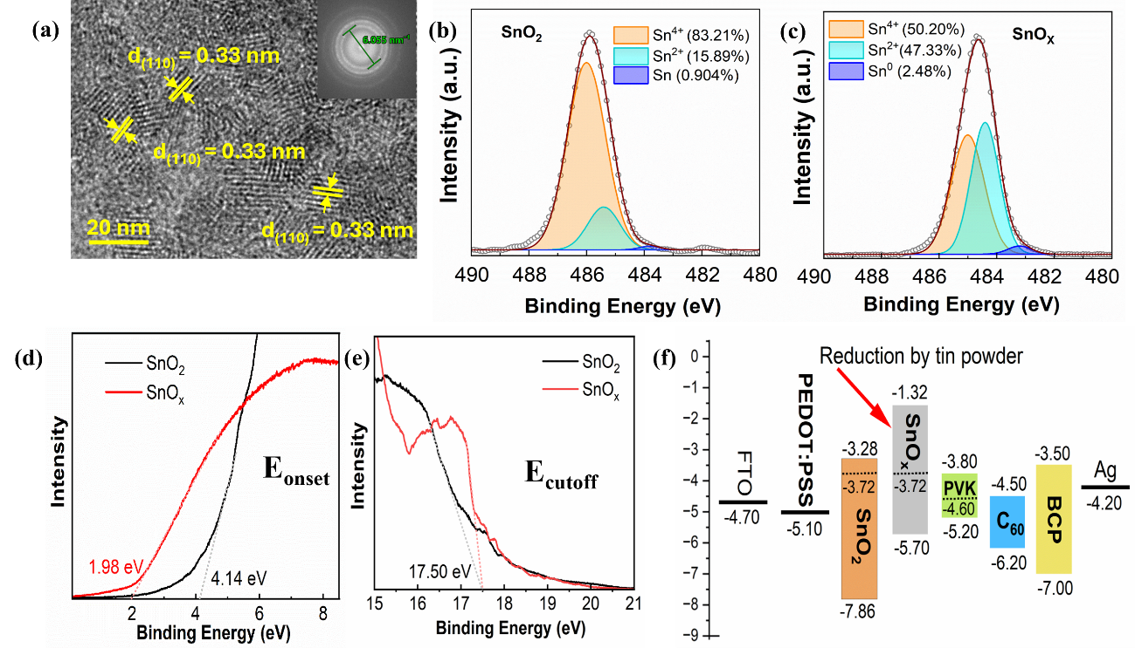
Figure 1. (a) HRTEM image of the SnO_{X} sample and the corresponding FFT pattern are inset in. XPS deconvolution spectrum of Sn 3d_{5/2} spectra of (b) SnO₂ and (c) SnO_{X} thin films. UPS spectrum of SnO₂ and SnO_{X} in the (d) energy onset (E_{onset}) region, (e) energy cutoff (E_{cutoff}) region. (f) Schematic representation of SnO_{X} and SnO₂ energy levels in relation to the perovskite layer.
As Sn⁰ partially reduces Sn⁴⁺ content in SnO_{X} film, it should also affect the energy level. To learn about the reducing effect of Sn⁰ on the energy levels of SnO_{X} film, the energy levels of SnO₂ and SnO_{X} films were determined using UPS analysis (Figure 1d and1e). The SnO₂ and SnO_{X} films were found to have the same cutoff binding energy (E_{cutoff}) of 17.50 eV. The Fermi levels (E_{f}) for the SnO₂ and SnO_{X} films were calculated to be −3.72 eV, employing the equation E_{f} = −21.22 eV + E_{cutoff}. ^{[29,30]} SnO₂ and SnO_{X} have values of valence band (E_{v}) of −7.86, and −5.70 eV, respectively, determined by the formula E_{v} = E_{f} − E_{onset}. Lastly, the conduction band (E_{c}) was determined by E_{c} = E_{v} + E_{b}, where E_{b} is the band gap, and the band gap of SnO₂ and SnO_{X} was determined from the Tauc plot (Figure S2). The E_{c} of SnO₂ and SnO_{X} were determined to be −3.28 and −1.32 eV, respectively. Figure 1f schematically illustrates the energy diagram of SnO₂ and SnO_{X} according to the UPS measurement and the others such as PEDOT:PSS, FASnI₃, C₆₀, BCP, and Ag from the literature.^{[26]} From UPS measurement, it is evident that SnO_{X} becomes an HTM for Sn-PSCs like that of PEDOT: PSS because its valence band is closer to the perovskite (−5.20 eV) in comparison to SnO₂ (−7.86 eV), which is advantageous for lowering the interface energy barrier and hence inhibiting interface recombination.^{[31]}

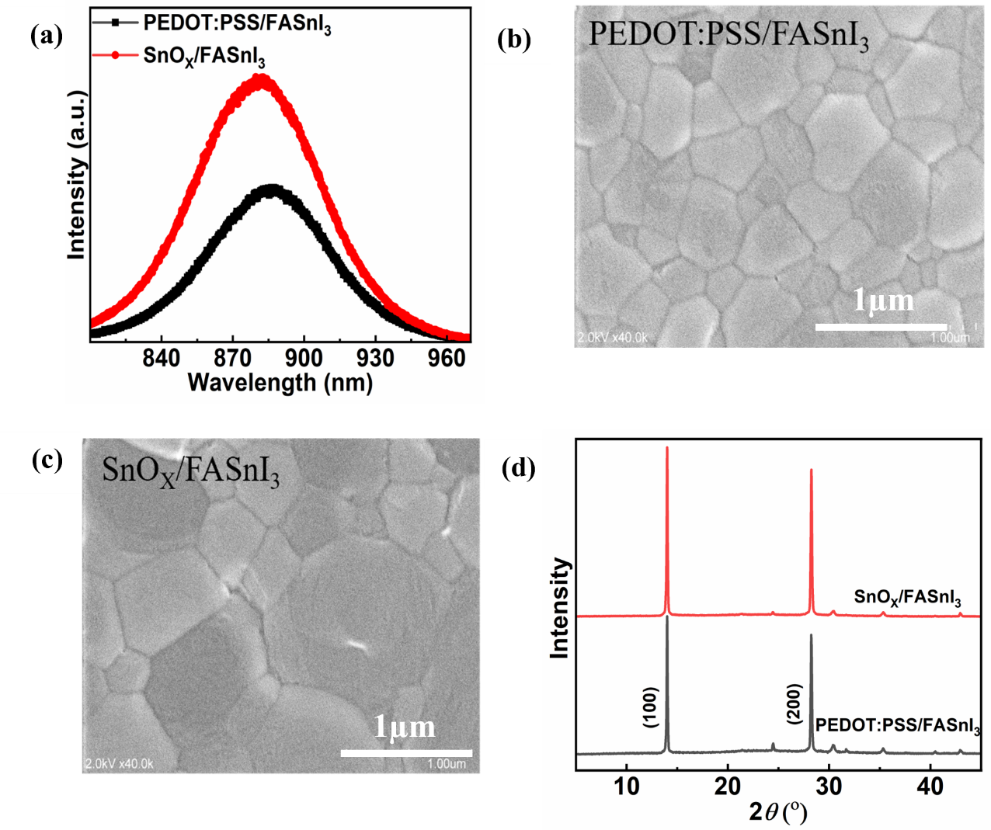Figure 2. (a) steady-state photoluminescence (SSPL)of FASnI₃ films on PEDOT:PSS and SnO_{X}. SEM images of FASnI₃ films on (b) PEDOT:PSS and (c) SnO_{X}. (d) XRD pattern of FASnI₃ films on PEDOT:PSS and SnO_{X}.
The influence of the bottom layer on the optoelectronic characteristics of FASnI₃ films was assessed by performing UV-vis absorbance and steady-state photoluminescence (SSPL) on both FASnI₃ films deposited on PEDOT:PSS and SnO_{X}. The absorption band edge was slightly blue-shifted for the FASnI₃ film deposited on SnO_{X} as observed by the UV-vis absorbance (Figure S3) and SSPL (Figure 2a). This might be because SnO_{X} contains chloride ions (Cl⁻) ions, which diffuse to the perovskite precursor solution. The presence of Cl⁻ ions on the SnO_{X} surface was confirmed by the XPS measurement (Figure S4). From the SSPL, we also observed a higher PL intensity for the FASnI₃ film deposited on SnO_{X} as compared with the FASnI₃ film on PEDOT:PSS. A PL quenching occurs when the absorber layer (like FASnI₃) is placed on top of the charge transport layer (CTL) (either electron transport layer (ETL) or hole transport layer (HTL)) because the charge carrier is involved in the transportation process. The higher PL quenching means the more efficient charge extraction from the absorber layer to the CTL with a more favorable energy level matching between FASnI₃ and HTL.^{[32]} As the energy level of PEDOT:PSS is more aligned with FASnI₃, it experienced a higher PL quenching effect. The effects of bottom layers such as PEDOT:PSS and SnO_{X} on the growth of FASnI₃ film were investigated. The scanning electron microscopy (SEM) results reveal that the FASnI₃ deposited on SnO_{X} has larger grain sizes than PEDOT:PSS. The average grain size of FASnI₃ films on PEDOT:PSS was about 300 nm (Figure 2b), whereas the FASnI₃ films on SnO_{X} was about 900 nm (Figure 2c). This may be due to the presence of Cl⁻ ions in the SnO_{X} films (Figure S4) that form an intermediate perovskite phase. The Cl⁻ ions are also well-known for kinetic control over perovskite formation. This phase later acts as a seed and guides the growth of a larger FASnI₃ grain structure.^{[33]} During spin coating of the perovskite film on PEDOT:PSS, we observed that the perovskite film became dark brown just after anti-solvent dripping. On the other hand, the perovskite film on SnO_{X} remained orange in color after anti-solvent dripping (Figure S5), indicating the formation of the intermediate phase. These results suggest that the perovskite forms immediately after anti-solvent dripping on PEDOT:PSS substrate, whereas an intermediate perovskite phase forms on SnO_{X} substrate. The formation of larger grain structures is needed for the reduction of grain boundary defects by reducing grain boundaries.^{[34]}
The X-ray diffraction (XRD) patterns of FASnI₃ films deposited on PEDOT:PSS and SnO_{X} are shown in Figure 2d. The analogous XRD peaks were predominantly identified at 14.0°, 24.4°, 28.1°, 31.6°, 40.4°, and 42.9°, corresponding to the (100), (102), (200), (122), (222), and (213) crystal planes of the orthorhombic FASnI₃ perovskite phase, respectively.^{[35]} Specifically, the FASnI₃ film deposited on SnO_{X} exhibits a noticeable enhancement in the intensity for the (100) and (200) planes compared to the FASnI₃ film on PEDOT:PSS. This result suggests that the FASnI₃ film on SnO_{X} experiences a preferred orientation along the (h00) crystallographic plane direction. This may be due to the presence of Cl⁻ ions in SnO_{X,} which diffuses to the perovskite precursor solution and forms an intermediate template phase that dictates the growth of crystalline FASnI₃ film.^{[33]}
According to the report, the SnO_{X} with mixed valence states of Sn²⁺ and Sn⁴⁺ functions as HTM, where the hole from perovskite is collected by mid-gap state.^{[26,29]} To investigate how SnO_{X} as HTM affects the photovoltaic performance, inverted planar PSCs with a structure of ITO/PEDOT:PSS/FASnI₃/C₆₀/BCP/Ag were fabricated (Figure S6). The current density vs. voltage (J-V) curves of the highest-achieving PSC based on PEDOT:PSS and SnO_{X} under 1 sun in a forward bias scan are shown in Figure 3a, and the relevant photovoltaic performance parameters are summarized in Table 1. In both forward and reverse scans, the J-V curves and accompanying parameters of PEDOT:PSS and SnO_{X}-based Sn-PSCs are displayed in Figure S7 and Table S1, respectively. The optimum Sn-PSC based on PEDOT:PSS has a PCE of 12.01% with short circuit current (J_{SC}) = 22.25 mAcm⁻², open circuit voltage (V_{OC}) = 0.71 V, and fill factor (FF) = 76 %. However, a comparable PCE of 11.11% was obtained for SnO_{X}-based Sn-PSC with J_{SC} = 21.46 mAcm⁻², V_{OC} = 0.69 V, and FF = 75 %. This result indicates the suitability of SnO_{X} as HTM for Sn-based PSCs. For every batch, a total of nineteen cells were recorded. When compared to devices based on PEDOT:PSS, those based on SnO_{X} demonstrated significantly higher reproducibility (Figure 3b).However, as compared with PEDOT:PSS-based PSCs, SnO_{X}-based PSCs experienced a lower V_{OC}. This may be due to an energy level mismatch between SnO_{X} and FASnI₃ (Figure 1f). From the SSPL measurement (Figure 2a), we also observed a lower PL quenching for SnO_{X}/FASnI₃ film, indicating lower charge extraction from the FASnI₃ to SnO_{X}. Consequently, the SnO_{X}/FASnI₃ interface underwent increased charge recombination, resulting in diminished photovoltaic performance. The incident photon-to-electron conversion efficiency (IPCE) spectra of SnO_{X} and PEDOT:PSS-based Sn-PSCs and the corresponding integrated photocurrent density curves are displayed in Figure 3c. The integrated J_{SC} values of 20.98 mAcm⁻² for the SnO_{X} device and 21.54 mAcm⁻² for the PEDOT:PSS device computed from IPCE data are in good agreement with those from J-V curves. The IPCE spectra of SnO_{X}-based Sn-PSC experienced a blue shift as compared with the PEDOT:PSS-based Sn-PSC at a higher wavelength (near 900 nm). This is due to the inclusion of Cl⁻ ions from SnO_{X} into the perovskite precursor solution. This result is consistent with the UV-vis (Figure S3) and SSPL measurements (Figure 2a) of FASnI₃ films deposited on SnO_{X} and PEDOT:PSS. Here we also observed a blue shift in bandgap for FASnI₃ film on SnO_{X} as compared with FASnI₃ film on PEDOT:PSS. To observe the bottom layer’s (such as PEDOT:PSS and SnO_{X}) effects at the HTL/Sn-perovskite interface, the cross-sectional images of PEDOT:PSS and SnO_{X}-based Sn-PSCs were captured (Figure 3d). In both devices, Sn-perovskite formed a single-grain structure across the cross-section. In the case of PEDOT:PSS-based PSCs, the Sn-perovskite film experienced some interfacial damage (marked by the red rectangle). This may be due to the reaction between acidic PEDOT:PSS and Sn-perovskite during the annealing time of the perovskite film deposition process.^{[20]} On the other hand, no interfacial damage could be observed for the Sn-perovskite in the SnO_{X}-based Sn-PSC. This is needed for stable Sn-PSCs.

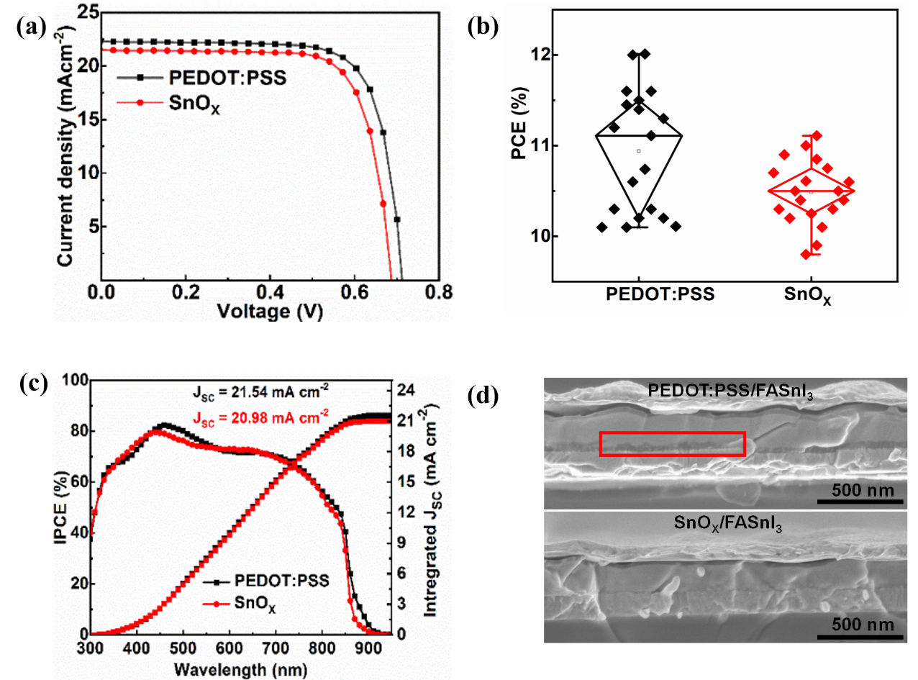
Figure 3. (a) J-V curves, (b) Statistical distribution of PCE of the PSCs using the PEDOT:PSS and SnO_{X} HTM and (c) IPCE spectra of PEDOT:PSS and SnO_{X}-based Sn-PSCs, and (d) Cross-sectional SEM images of PEDOT:PSS and SnO_{X}-based Sn-PSCs.
Table 1. Photovoltaic parameters obtained from PEDOT:PSS and SnO_{X} HTM based PSCs.
HTM | V_{OC} (V) | J_{SC} (mAcm⁻²) | FF (%) | PCE (%)
PEDOT:PSS | 0.71 | 22.25 | 0.76 | 12.01
SnO_{X} | 0.69 | 21.46 | 0.75 | 11.11
The primary motivation for finding an appropriate inorganic HTM is to address the long-term instability, which is the most significant challenge for Sn-based PSCs. Figure 4a demonstrates the stability of PEDOT:PSS and SnO_{X}-based Sn-PSCs under MPPT conditions. The PEDOT:PSS-based Sn-PSC experienced a fast degradation and became below 80% of its initial PCE. However, the SnO_{X}-based Sn-PSC maintained about 90% of its initial PCE even after 1000 h of identical conditions. The factor supposed to be responsible for this performance degradation for PEDOT:PSS-based Sn-PSC was due to the acidic nature of PEDOT:PSS that causes oxidation of iodide in perovskites, resulting in the formation of iodine (I₂). This process creates free Sn²⁺ ions, and the free Sn²⁺ ions are susceptible to Sn⁴⁺ oxidation. Figures 4b and 4c show the absorbance spectra of FASnI₃ films deposited on PEDOT:PSS and SnO_{X} before and after annealing the film at 85 °C for 72 h inside the N₂-filled glovebox. The Sn-perovskite film deposited on PEDOT:PSS exhibited absorbance spectra corresponding to I₂ and SnI₄ before and after thermal stress (Figure 4b).^{[20]} This indicates the presence of I₂ and SnI₄ in the FASnI₃ film. However, from the SEM cross-sectional view, we already observed some morphological damage (marked by the red rectangle) at the PEDOT:PSS/Sn-perovskite interface (Figure 3d). On the other hand, the absorbance spectra for the FASnI₃ film deposited on SnO_{X} remain unchanged even after 72 h of heating at 85 °C inside the glovebox (Figure 4c). This result indicates the robustness of Sn-perovskite on SnO_{X} film. That’s why the SnO_{X}-based Sn-PSCs showed much more stable device performance under MPPT conditions.

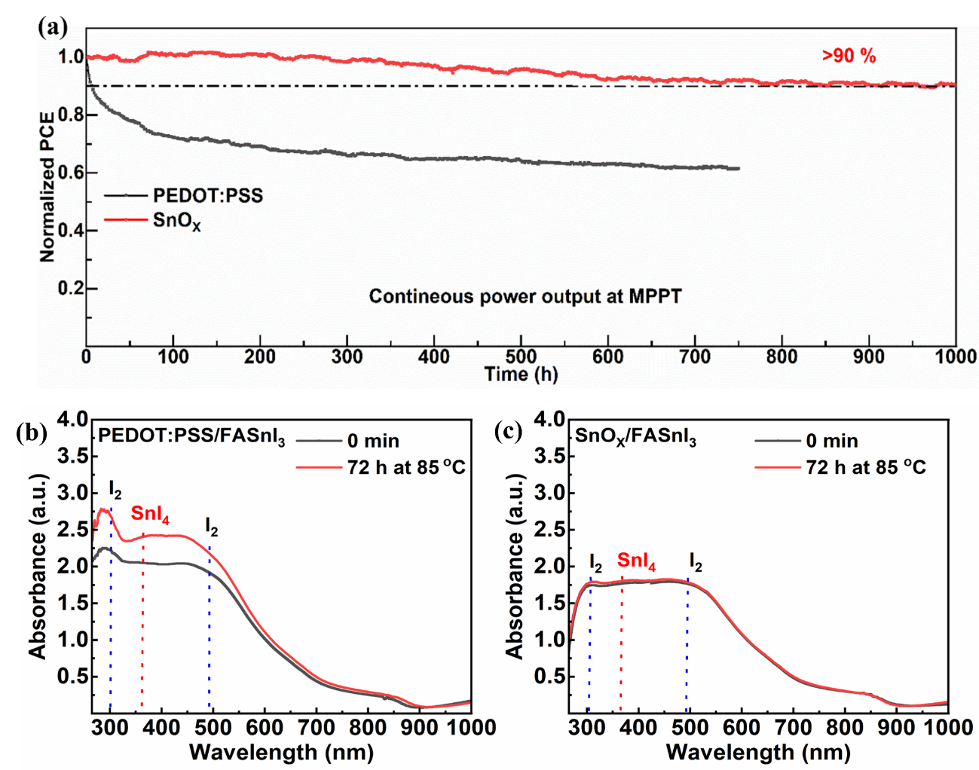
Figure 4. (a) Normalized operational stability of PEDOT:PSS and SnO_{X}-based encapsulated devices under MPPT condition. UV-vis spectra of FASnI₃ films deposited on (b) PEDOT:PSS and (c) SnO_{X} films, measured fresh and after 72 h at 85 °C conditions, respectively.

- Conclusion
In this work, we synthesized SnO_{X} nanocrystals by reducing SnCl₄.5H₂O solution through Sn⁰ powder to replace acidic PEDOT:PSS for Sn-PSCs. The synproportionation reaction between Sn⁴⁺ and Sn⁰ reduced the Sn⁴⁺ content up to 38% and elevated the HOMO level to −5.70 eV, close to the HOMO level of PEDOT:PSS. Sn-perovskite on SnO_{X} shows a larger grain structure and high crystallinity. Moreover, the utilization of SnO_{X} as a replacement for acidic PEDOT:PSS offers a solution for the degradation problem at the HTM/perovskite interface. As a result, the SnO_{X}-based PSCs retained 90% of their initial efficiency under MPPT conditions for 1000 h. This finding provides a pathway for the use of robust inorganic SnO_{X} as HTM for stable Sn-PSCs.

Experimental Section
4.1. Materials: All chemicals were utilized in their original state without supplementary purification procedures. The experimental materials comprised formamidinium iodide (FAI, >98%), phenethylammonium iodide (PEAI, >97%), tin(IV) chloride (SnCl₄·5H₂O), bathocuproine (BCP), bithiophene (>98%), and anhydrous solvents including 2-propanol, chlorobenzene (CB), and dimethyl sulfoxide (DMSO), sourced from Tokyo Chemical Industry Co., Japan. Furthermore, tin (II) fluoride (SnF₂, >99%), tin (II) iodide (SnI₂, 99.99%), metallic tin (Sn⁰) and fullerene-C₆₀ from Sigma–Aldrich were employed. The PEDOT:PSS (Clevious PVP Al 4083) was sourced from Germany and Taiwan, while ethylenediammonium diiodide (EDAI₂) was procured from Merck. For SnO₂, 15 wt% SnO₂ in water was brought from Alfa-Aesar.
4.2. SnO_{X} synthesis: The SnO_{X} nanocrystals were synthesized by dissolving 1 mmol of SnCl₄·5H₂O in distilled water and adding Sn⁰ at different molar ratios of Sn⁰: SnCl₄.5H₂O such as 1:16, 1:8, 1:4, and 1:2. In this sequence, first SnCl₄·5H₂O was completely dissolved in distilled water. Then Sn⁰ was added under vigorous stirring and the bottle cap was closed. After that, the required transparent light-yellow colored SnO_{X} nanocrystal solution was formed.
4.3. Fabrication of SnO_{X} and PEDOT:PSS film: An indium-doped tin oxide (ITO) conductive glass substrate was utilized as the front electrode in PSCs. ITO substrates were subjected to a 30 min cleaning process in a sonication system utilizing a detergent solution, deionized water, acetone, and a mixed solution of ethanol and isopropanol. Before the deposition of HTL, the ITO substrates underwent a 30 min treatment with UV-O₃. SnO_{X} was spin-coated on ITO at 3000 rpm for 20 s for HTM. After spin coating, the substrates were quickly transferred to the N₂-filled glovebox and were subjected to annealing at 100 °C for 20 min to avoid oxidation. For PEDOT:PSS films, PEDOT:PSS was dropped on the substrate and spin-coated at 4000 rpm for 30 s. The PEDOT:PSS films were annealed at 150 °C for 20 min. After that, they were transferred to the glovebox for device fabrication.
4.4. Fabrication of FASnI₃ film: The FASnI₃ precursor solution was prepared by mixing EDAI₂, PEAI, SnF₂, SnI₂, and FAI in the following ratio: 0.01:0.05:0.1:1:0.94. After that, DMSO was added and stirred for 1 h at room temperature to make a 0.9 M precursor solution. The precursor solution was dropped and spin-coated for 12 and 48 s at 1000 and 5000 rpm, respectively. At the 39th s, 160 μL of CB was added as an antisolvent. First, the substrate was heated to 65 °C for a few seconds. Then, it was heated to 100 °C for an additional 12 min.
4.5. PSCs fabrication: After depositing the HTL, the perovskite and other subsequent layers were fabricated inside the glovebox. The perovskite layer was deposited as mentioned in the ‘Fabrication of FASnI₃ film’ part. The C₆₀ was thermally evaporated at 1 Å/s for 30 nm, and BCP was 1 Å/s for 7 nm. Finally, 100 nm of Ag was thermally evaporated using a rate of 0.5 Å/s for 5 nm, 1 Å/s for 10 nm, and 1.5 Å/s for the rest of the thickness.
4.6. Characterization: The X-ray diffraction (XRD) analysis was done with a Rigaku RINT-2500 powder X-ray diffractometer that used Cu Kα radiation. We used a Hitachi SU-8000 SEM with a 2 kV acceleration voltage for film morphology and device cross-section. The absorbance and transmittance were measured with a Shimadzu UV-visible 3600 spectrophotometer. An ultrahigh vacuum of 5×10⁻¹¹ mbar, a Mg Kα source (hν = 1486.7 eV) was used to do X-ray photoelectron spectroscopy (XPS) in a PHI Quantera SXM (ULVAC-PHI). ULVAC-PHI (PHI VersaProbe 4) and an Al Kα radiation source were utilized to measure ultraviolet photoemission spectroscopy (UPS). PL measurement was conducted in the Hamamatsu C12132 fluorescence lifetime spectrometer. A solar simulator that produces standard 1 sun (100 mWcm⁻², WXS-155S-10: Wacom Denso Co., Japan) was used to test the relationship between current and voltage. The CEP-2000BX device from Bunkoukeiki Co., LTD. was used to measure the IPCE. The dark J-V characteristics of PSCs were carried out in PAIOS.

Acknowledgements:
A.I. would like to thank JSPS KAKENHI grant number 22H02190 for the financial support. A.I also conveys gratitude for the funding provided by JST-Mirai Program Grant Number JPMJMI21E6 and JST-ALCA-Next Program Grant Number JPMJAN23B2 in Japan. This research was also supported by the World Premier International Center (WPI) for Materials Nanoarchitectonics (MANA), NIMS, and Advanced Research Infrastructure for Materials and Nanotechnology (ARIM) of the Ministry of Education, Culture, Sports, Science and Technology (MEXT), Japan.

References:
1. A. Kojima, K. Teshima, Y. Shirai, T. Miyasaka, J. Am. Chem. Soc., 2009, 131, 6050-6051.
2. Photovoltaic Research, NREL, https://www.nrel.gov/pv/cell-efficiency.html (accessed: September, 2024).
3. X. Li, X. Gao, X. Zhang, X. Shen, M. Lu, J. Wu, Z. Shi, V. L. Colvin, J. Hu, X. Bai, W. W. Yu, Y. Zhang, Adv. Sci., 2021, 8, 2003334.
4. W. Gao, C. Chen, C. Ran, H. Zheng, H. Dong, Y. Xia, Y. Chen, W. Huang, Adv. Funct. Mater. 2020, 30, 2000794.
5. A. H. Slavney, T. Hu, A. M. Lindenberg, H. I. Karunadasa, J. Am. Chem. Soc. 2016, 138, 2138–2141.
6. B. Saparov, F. Hong, J. Sun, H. Duan, W. Meng, S. Cameron, I. G. Hill, Y. Yan, D. B. Mitzi, Chem. Mater. 2015, 27, 5622–5632.
7. D. Cortecchia, H. A. Dewi, J. Yin, A. Bruno, S. Chen, T. Baikie, P. P. Boix, M. Grätzel, S. Mhaisalkar, C. Soci, N. Mathews, Inorg. Chem. 2016, 55, 1044–1052.
8. T. Krishnamoorthy, H. Ding, C. Yan, W. L. Leong, T. Baikie, Z. Zhang, M. Sherburne, S. Li, M. Asta, N. Mathews, S. G. Mhaisalkar, J. Mater. Chem. A., 2015, 3, 23829–23832.
9. D. Cui, X. Liu, T. Wu, X. Lin, X. Luo, Y. Wu, H. Segawa, X. Yang, Y. Zhang, Y. Wang, Han, L, Adv. Funct. Mater. 2021, 31, 2100931.
10. F. Li, C. Zhang, J.H. Huang, H. Fan, H. Wang, P. Wang, C. Zhan, C. M. Liu, X. Li, L. M. Yang, Y. Song, K. J. Jiang, Angew. Chem. Int. Ed. 2019, 58, 6688 –6692.
11. C. Redondo-Obispo, T.S. Ripolles, S. Cortijo-Campos, A.L. Álvarez, E. Climent-Pascual, A. Andrés de, C. Coya, Materials and Design, 2020, 191, 108587.
12. Z. Zhu, X. Jiang, D. Yu, N. Yu, Z. Ning, Q. Mi, ACS Energy Letters, 2022, 7, 2079-2083.
13. T. M. Koh, T. Krishnamoorthy, N. Yantara, C. Shi, W. L. Leong, P. P. Boix, A. C. Grimsdale, S. G. Mhaisalkar, N. Mathews, J. Mater. Chem. A, 2015, 3, 14996−15000.
14. X. Jiang, F. Wang, Q. Wei, H. Li, Y. Shang, W. Zhou, C Wang, P Cheng, Q Chen, L Chen, Z. Ning, Nature communications, 2020, 11, 1245.
15. S. Wang, L. Yan, W. Zhu, Z. Cao, L. Zhou, L. Ding, F. Hao, Nano Energy, 2022, 99, 107416.
16. Y. Shi, Z. Zhu, D. Miao, Y. Ding, Q. Mi, ACS Energy Letters, 2024, 9, 1895-1897.
17. S. Ye, W. Sun, Y. Li, W. Yan, H. Peng, Z. Bian, Z. Liu, C. Huang, Nano Lett. 2015, 15, 3723−3728.
18. H. Wenbin, R. Guanhua, L. Jiuming, Li. Zhiqi, B. Hongchang, L. Chunyu, G. Wenbin, ACS Applied Materials & Interfaces, 2020, 12, 49297-49322.
19. Q. Wang, Z. Lin, J. Su, Z. Hu, J. Chang, Y. Hao, Nano Select, 2021, 2, 1055–1080.
20. B. Chen, Z. Yu, A. Onno, Z. Yu, S. Chen, J. Wang, Z. C. Holman, J. Huang, Sci. Adv. 2022, 8, eadd0377.
21. F. Li, X. Hou, Z. Wang, X. Cui, G. Xie, F. Yan, X. Z. Zhao, Q. Tai, ACS Appl. Mater. Interfaces, 2021, 13, 40656−40663.
22. J. Cao, Q. Tai, P. You, G. Tang, T. Wang, N. Wang, F. Yan, J. Mater. Chem. A, 2019, 7, 26580−26585.
23. C. K. G. Kwok, Y. Wang, K. Egbo, M. K. Hossain, S. K. Shil, K. M. Yu, Surfaces and Interfaces, 2022, 35, 102473.
24. Z. Yu, Z. Yang, Z. Ni, Y. Shao, B. Chen, Y. Lin, H. Wei, Z. J. Yu, Z. Holman, J. Huang, Nat. Energy, 2020, 5, 657.
25. Z. Yu, J. Wang, B. Chen, M. A. Uddin, Z. Ni, G. Yang, J. Huang, Adv. Mater. 2022, 34, 2205769.
26. T. Kitamura, L. Wang, Z. Zhang, A. K. Baranwal, G. Kapil, S. R. Sahamir, Y. Sanehira, H. Bi, T. Ma, Q. Shen, S. Hayase, ACS Energy Lett. 2023, 8, 3565−3568.
27. C. Fan, Y. Peng, Q. Zhu, L. Lin, R. Wang, A. Xu, J. Phys. Chem. C, 2013, 117, 24157−24166.
28. J. J. Yoo, G. Seo, M. R. Chua, T. G. Park, Y. Lu, F. Rotermund, Y.-K. Kim, C. S. Moon, N. J. Jeon, J.-P. Correa-Baena, V. Bulović, S. S. Shin, M. G. Bawendi, J. Seo, Nature, 2021, 590, 587-593.
29. X. Ren, X. Ning, H. Guo, J. Wei, J. Guo, H. Yang, T Li, F. Hou, J. Phys. Chem. C, 2024, 128, 6813−6820.
30. H. Wang, X. Wan, F. Li, X. He, G. Xu, C. Xu, Z. Jiang, Z. Dai, S. Zhang, Q. Song, ACS Nano, 2024, 18, 16867−16877.
31. J. Chen, X. Zhao, S. Kim, N. Park, Adv. Mater. 2019, 31, 1902902.
32. J. Chen, C. Zhang, X. Liu, L. Peng, J. Lin, and X. Chen, Photonics Research, 2021, 9, 151-170.
33. S. T. Williams, F. Zuo, C.-C. Chueh, C.-Y. Liao, P.-W. Liang, A. K.-Y. Jen, ACS Nano, 2014, 8, 10640−10654.
34. M. E. Kayesh, T. H. Chowdhury, K. Matsuishi, R. Kaneko, S. Kazaoui, J.-J. Lee, T. Noda, A. Islam, ACS Energy Lett. 2018, 3, 1584−1589.
35. X. Meng, J. Lin, X. Liu, X. He, Y. Wang, T. Noda, T. Wu, X. Yang, L. Han, Advanced Materials, 2019, 31, p.1903721.

