Chapter 10
Pulsed field gradient nuclear magnetic resonance measurement of lithium diffusion in solid electrolytes
Naoaki Kuwata and Gen Hasegawa

Research Center for Energy and Environmental Materials, National Institute for Materials Science (NIMS), Namiki, Tsukuba, Ibaraki 305-0044, Japan
E-mail: KUWATA.Naoaki@nims.go.jp

Abstract

Nuclear magnetic resonance (NMR) is a powerful technique for measuring atomic diffusion in lithium-ion conductors such as solid electrolytes and active materials. Since ion and electron fluxes inside the battery are governed by ion diffusion, the determination of the diffusion coefficient is essential. This section describes a method for determining the diffusion coefficient of a solid electrolyte using mainly pulsed field gradient (PFG) NMR. The diffusion coefficient of a perovskite solid electrolyte (Li_{0.29}La_{0.57}TiO₃; LLTO) was determined. Tracer diffusion coefficient measured by isotope exchange and secondary ion mass spectrometry (SIMS), and conductivity diffusion coefficient measured by impedance spectroscopy were also applied for LLTO. PFG-NMR studies have revealed anisotropic diffusion of LLTO due to the two-dimensional crystal structure. SIMS studies show that grain boundary diffusion of LLTO is 10,000 times slower than bulk diffusion. The Haven ratio was shown to be 0.24 at the grain boundary compared to 1 in the bulk.

Keywords Diffusivity, solid electrolyte, anisotropy, grain boundary, Haven ratio, non-Arrhenius behavior

1.1 Introduction

This section describes the diffusion measurements of solid materials using the nuclear magnetic resonance (NMR) method. There are two main methods for observing atomic diffusion in solids by NMR. The first method is to determine the correlation time of atomic motion by measuring the relaxation times (T₁ and T₂); the second method is pulsed field gradient NMR (PFG-NMR). The first method is based on the of Bloembergen-Purcel-Pound (BPP) theory for relaxation of nuclear magnetization ¹. Basically, the temperature dependence of T₁ is measured, the minimum value of T₁ is found, and the correlation time τ is obtained from the relation $ω_{0}τ \sim 1$ , where ω₀ is Larmor frequency, and converted to the diffusion coefficient via Einstein–Smoluchowski equation ^{2, 3}. The timescale of the τ is in the order of τ ~ 10⁻⁸ s, which corresponds to the ion hopping between sites. The second method is the PFG-NMR ⁴⁻⁷. In this method, magnetic field gradient pulses are used to label the Larmor frequencies of nuclear spins. These nuclei are diffused for a fixed time (Δ) and then refocused using the spin-echo sequence. In other words, it is a tracer diffusion measurement that tracks nuclear spins as labels. ⁸ The diffusion time Δ is on the order of 10 ms to 1 s. PFG-NMR observes macroscopic diffusion for longer times than relaxation time analysis. Tracer diffusion coefficients can also be measured using isotope exchange and secondary ion mass spectrometry (SIMS). ⁹⁻¹² The relationship between ionic conductivity, PFG-NMR, and SIMS results will allow analysis of diffusion phenomena at various scales.

1.2 Diffusion and flux in solids

A solid-state battery converts the chemical potential difference of electrodes (anode/cathode) into electrical energy. The charge/discharge current for battery operation is usually limited by the ion flux. As is well known, the diffusive flux in the presence of a concentration gradient is expressed by Fick's first law. ¹³

$$\begin{aligned}J = -\tilde{D}\frac{dc}{dx} \#\left(1\right)\end{aligned}$$

where J is the flux, $\tilde{D}$ is the chemical diffusion coefficient, c is the concentration, and x is the distance. In chemical systems other than ideal solutions, the driving force for diffusion of each species is the gradient of chemical potential of this species. Then generalized Fick's law ¹³ can be written

$$\begin{aligned}J_{i} = -D_{i}\frac{c_{i}}{k_{B}T}\frac{dμ_{i}}{dx}\#\left(2\right)\end{aligned}$$

where the index i denotes the species, k_{B} is the Boltzmann constant, T is the absolute temperature, μ is the chemical potential. D_{i} is the center-of-mass diffusion coefficient of chemical species i. The correction factor for $\tilde{D}$ and D_{i} is referred to as a thermodynamic factor ¹⁴. In addition, the flux of charged particles (ions) is also driven by the electric potential gradient (dϕ/dx). Using the Nernst-Einstein relationship ² between ionic conductivity (σ) and conductivity diffusion coefficient (D_{σ}), the flux of ions in the electric field is written as follows.

$$\begin{aligned}J_{i} = D_{σ}\frac{c_{i}z_{i}e}{k_{B}T}\frac{dϕ}{dx}\#\left(3\right)\end{aligned}$$

where z is the valence and e is the elementary charge. The electrochemical potential may be used to summarize the Eq. (2) and (3). The above equation relates diffusion and flux. Thus, the way to increase the charge/discharge current is to increase the diffusion coefficient, concentration of chemical species, or electrode area.

1.3 Diffusion coefficient of solid electrolyte evaluated by NMR

Here we show results of diffusion measurements for polycrystalline Li_{0.29}La_{0.57}□_{0.14}TiO₃ (LLTO). LLTO is a material that exhibits high Li⁺ ionic conductivity (9×10⁻⁴ Scm⁻¹, 300 K). ^{15, 16} The crystal structure is a perovskite structure (ABO₃), which contains Li, La, and vacancies (□) at the A site and Ti at B site. Li⁺ ions in the vicinity of the A site by hopping into the vacant A site. Precisely, LLTO has a double perovskite structure with La-rich and La-poor layers, with La occupy 95.6% in the La-rich layer, whereas La occupy only 23.8% in the La-poor layer. ¹⁷ This crystal structure predicts a two-dimensional diffusion pathway ¹⁸ as shows in Fig. 1.1(a).
In real LLTO sample, however, the anisotropy of ionic conductivity is quite small even in transparent single crystals ¹⁶. Ionic conductivity in the ab direction is about 1.2 times greater than in the c direction ^{16, 19}. The reason for this small anisotropy is probably due to the presence of 90° domains in which La-rich layer rotates at the domain boundary. ²⁰ Even transparent bulk single crystals have been found to have 90° domains of a few micrometers in size, which would average out the macroscopic diffusion anisotropy.
Therefore, we first show the microstructure. Fig. 1.1 (b) shows a laser microscopy of polycrystalline LLTO. The surface is polished and thermally treated. Crystal grains and grain boundaries, as well as voids and a second phase (TiO₂) can be observed. Fig. 1.1 (c) shows the Euler map obtained by scanning electron microscopy (SEM) with electron backscattering diffraction (EBSD). Although the structure of LLTO is double perovskite, the EBSD analysis was simplified with cubic perovskite. Grain orientation and grain boundaries can be clearly distinguished from EBSD. Most grains are randomly oriented. Fig. 1.1 (d) shows the crystal phases attributed by EBSD. The green areas are perovskite LLTO and the pink areas are rutile TiO₂. Fig. 1.1 (e) is a TEM image of a magnified LLTO grain. Contrast between bright and dark areas can be observed. The magnified lattice image confirms the presence of 90° domains as in the previous literature. ²¹ The size is several hundred nanometers.

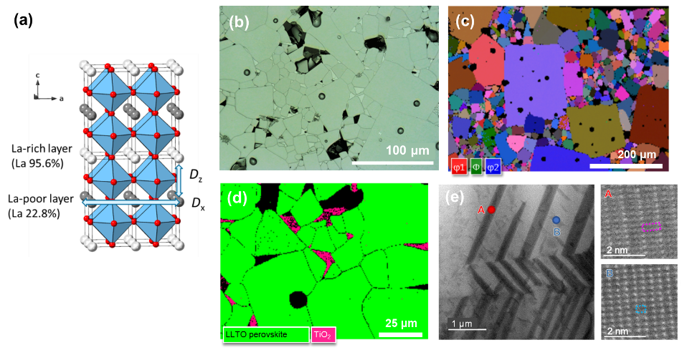
Fig. 1. 1 Microstructure of LLTO. (a) Crystal structure and expected diffusion direction of LLTO. (b) Laser microscope image after polishing and thermal etching, (c) Euler map showing crystal orientation of LLTO by SEM-EBSD, (d) identification of crystal phase by EBSD. Perovskite LLTO in green, rutile TiO₂ in pink, (e) 90° domain observed by TEM. Reprinted with permission from 22. Copyright 2023 American Chemical Society.

Fig. 1.2(a) shows the temperature dependence of the static ⁷Li NMR spectra of LLTO from 298 K to 793 K. The NMR spectra are composed of a sharp central peak (+1/2 to −1/2 transition) and a broad satellite peak (+3/2 to +1/2, −1/2 to −3/2). The central peak has narrowed by motional narrowing, while the satellite peaks remain broad. Fig. 1.2 (b) shows the temperature dependence of quadrupole coupling constant C_{Q,} simulated using a randomly oriented solid quadrupole pattern. The satellite peak width C_{Q} is determined by the interaction of the quadrupole moment of ⁷Li and the average electric field gradient at the Li site. ²³ The quadrupole coupling constant C_{Q} was investigated by first-principles calculations. The crystal configuration used in the calculations is shown in Fig. 1.2 (c). The bottleneck site is 0.4 eV more energetically stable than the A site. For the bottleneck site, the C_{Q} is calculated to be 333 kHz. On the other hand, near the A site, the symmetry is better and the C_{Q} is smaller, 26.4 kHz. As will be shown later, the local C_{Q} differences are averaged out because the jump frequency is on the order of 100 MHz. Thus, the C_{Q} is due to the average electric field gradient in the crystal experienced by the Li⁺ ions at several sites. The gradual decrease in C_{Q} with increasing temperature may be due to changes in the occupancy of the bottleneck and A sites and the symmetry of the averaged Li⁺ ion environment; in the case of LLTO, as temperature increases, the TiO₆ tilt angle decreases and a phase transition to the cubic phase occurs. ²⁴ These changes would increase the average symmetry of the Li sites and consequently decrease C_{Q}.

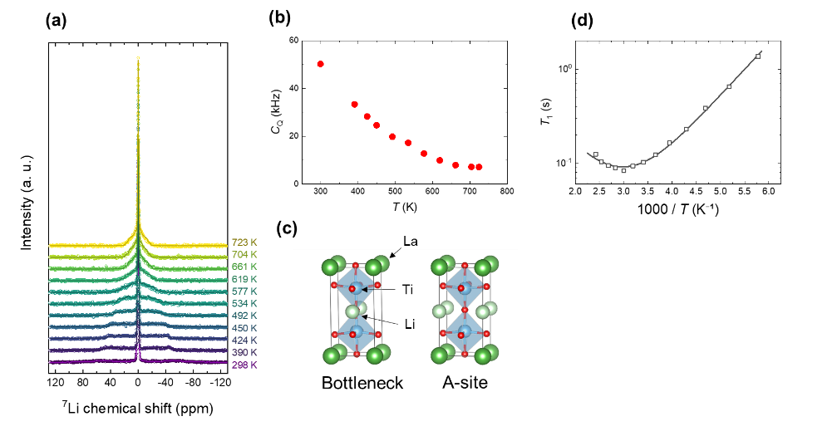
Fig. 1. 2 Temperature dependence of ⁷Li NMR spectra of LLTO. (a) Static ⁷Li NMR spectra and simulation using the quadrupole patterns, (b) Temperature dependence of the quadrupole coupling constant C_{Q} of the satellite peaks, (c) Crystal arrangement used to calculate C_{Q}, (d) Arrhenius plot of relaxation time T₁. Solid lines are fitting curves. Reprinted with permission from 22. Copyright 2023 American Chemical Society.

Fig. 1.2 (d) shows the temperature dependence of the relaxation time T₁. The resonance frequency of ⁷Li is 155.4 MHz. When the T₁ minimum is observed, the BPP model can be used to analyze the correlation time. The equation for the BPP relaxation is written as follows:

$$\begin{aligned}\left(\frac{1}{T_{1}}\right)=C\left[\frac{τ_{c}}{1+ω_{0}^{2}τ_{C}^{2}}+\frac{4τ_{c}}{1+{4ω}_{0}^{2}τ_{C}^{2}}\right]\#\left(4\right)\end{aligned}$$

where τ_{c} is the correlation time, ω₀ is the Larmor frequency, and C is a constant that depends on the mechanism of relaxation. Thermally activated temperature dependence of τ_{c}, $τ_{c}=τ_{0}\exp{⁡(E_{a}/k_{B}T)}$, is assumed. Least-squares fitting resulted in the τ₀ of 1.4 × 10⁻¹¹ s and E_{a} of 0.11 eV. The relaxation mechanism is discussed and attributed mainly to dipole interactions (⁷Li−⁷Li and ⁷Li−¹³⁹La nuclei). ²⁵ Empirically, the τ_{c} obtained at the T₁ minimum corresponds well to the long-range diffusion of Li⁺ ions. Diffusion coefficients (D_{local}) were estimated from correlation times using the following Einstein-Smoluchowski equation

$$\begin{aligned}D_{local}=\frac{l^{2}}{2dτ_{c}}\#\left(5\right)\end{aligned}$$

where, l is the jump distance, d is the dimension of diffusion. For l and d, the distance between A sites (3.87 × 10⁻¹⁰ m) and three dimensional diffusion for polycrystalline are assumed, respectively. Then, D_{local} is calculated to be 1. 28×10⁻⁷ cm²s⁻¹ at 333 K. This value is close to the value D_{NMR} = 9.2 × 10⁻⁸ cm²s⁻¹ (333 K) measured by PFG-NMR. This result indicates that short-range (site-to-site hopping) and long-range (μm order) diffusion of Li⁺ ions occur by the same mechanism. In other words, the effect of the 90° domain boundary on long-range diffusion is small.
Next, we show the results of PFG-NMR. A stimulated echo pulse sequence is schematically shown in Fig. 1.3(a). For a homogeneous diffusing species, the echo signal intensity decays according to Stejskal-Tanner equation, ⁴

$$\begin{aligned}\frac{S}{S_{0}}=\exp\left[-{bD}_{NMR}\right]\#\left(6\right)\end{aligned}$$

where S/S₀ is the intensity ratio of the echo signal, D_{NMR} is the PFG-NMR diffusion coefficient. Value b is defined as $b=γ^{2}g^{2}δ^{2}(Δ-δ/3)$, where γ is the gyromagnetic ratio, g is the magnitude of the magnetic field gradient, δ is the duration of the magnetic field gradient pulse, and Δ is the diffusion time.
Fig. 1.3 (b) shows a plot of the b vs. log of the echo intensity. Notably, the decay plot is curvilinear, rather than linear as predicted from Eq. (6). Here, a two-dimensional diffusion model expected from the crystal structure of LLTO is used to interpret the curvature. When the two-dimensional diffusing crystals, comprising two diffusion components, D_{x} (=D_{y}) and D_{z}, are randomly oriented, the PFG echo signal is obtained by averaging the element over all the solid angles. As a result, the following equation can be derived ²⁶

$$\begin{aligned}\frac{S}{S_{0}}=\exp\left(-bD_{x}\right){\int_{0}^{1}{\exp\left[-b\left(D_{z}-D_{x}\right)u^{2}\right]du}}\#\left(7\right)\end{aligned}$$

The fitting result using Eq. (7) is shown by the solid lines in Fig. 1.3(b), in which the D_{x} of LLTO is determined to be 6.1×10^{－7} cm² s⁻¹ at 393 K. On the other hand, the D_{z} is 3.3×10^{－8} cm² s⁻¹ at 393 K. Fitting results showed that D_{z} is 18 times larger than D_{x}.

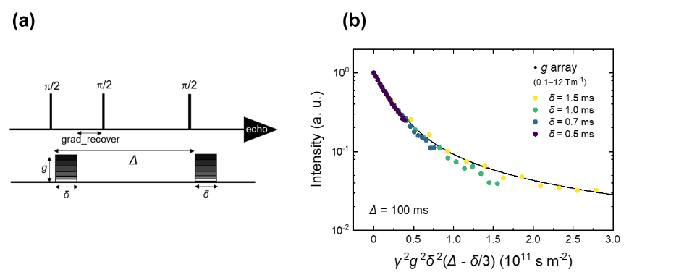
Fig. 1. 3 PFG-NMR measurements of LLTO. (a) Schematic of the stimulated echo pulse sequence. (b) Echo decay plot measured with g as a variable. Temperature is 393 K and Δ is 100 ms. Reprinted with permission from 22. Copyright 2023 American Chemical Society.

Figures 1.4 (a) and (b) show PFG echo decay plots measured in the temperature ranges 298-393 K and 493-693 K, respectively. Anisotropic diffusion is evident in all temperature ranges. Neutron diffraction experiment showed that the La occupancy in the La-rich layer of Li_{0.2}La_{0.6}TiO₃ remains above 96 % between 5 K and 773 K. ²⁴ Therefore, the anisotropic long-range diffusion of LLTO does not change at high temperatures is reasonable. Figure 1.4 (c) shows an Arrhenius plot of D_{NMR}, together with the D_{σ} calculated from the bulk ionic conductivity of LLTO. Despite the complex microstructure of LLTO, D_{NMR} and D_{σ} agree well with each other. The Haven ratio (H_{R} ≡ D_{NMR}/D_{σ}) of LLTO is close to 1, in contrast to the value of 0.4 observed for garnet-type solid electrolytes. ⁶ This can be attributed to the small concerted motion effect of the Li⁺ ions. The AIMD simulation ²⁷ of LLTO suggests that the activation energies between a Li⁺-ion single jump and concerted jump are near-identical. Above 450 K, the activation energy changes, and both D_{NMR} and D_{σ} show non-Arrhenius behavior. The experimental results show that the non-Arrhenius conductivity in LLTO is due to changes in mobility and not the number of carriers.
A relationship between the tilt angle in the perovskite structure and the activation barrier has been proposed. Varez et al. emphasized the relationship between the tilt angle of TiO₆ octahedra and the change in activation energy. ²⁸ The rotational motion of TiO₆ promotes hopping of the Li⁺ ions and thus, the smaller is the tilt angle, the lower is the activation energy. ²⁹ Both the activation energy obtained by PFG-NMR and the C_{Q} observed in the static NMR support the local environmental change associated with the variation in the tilt angle.

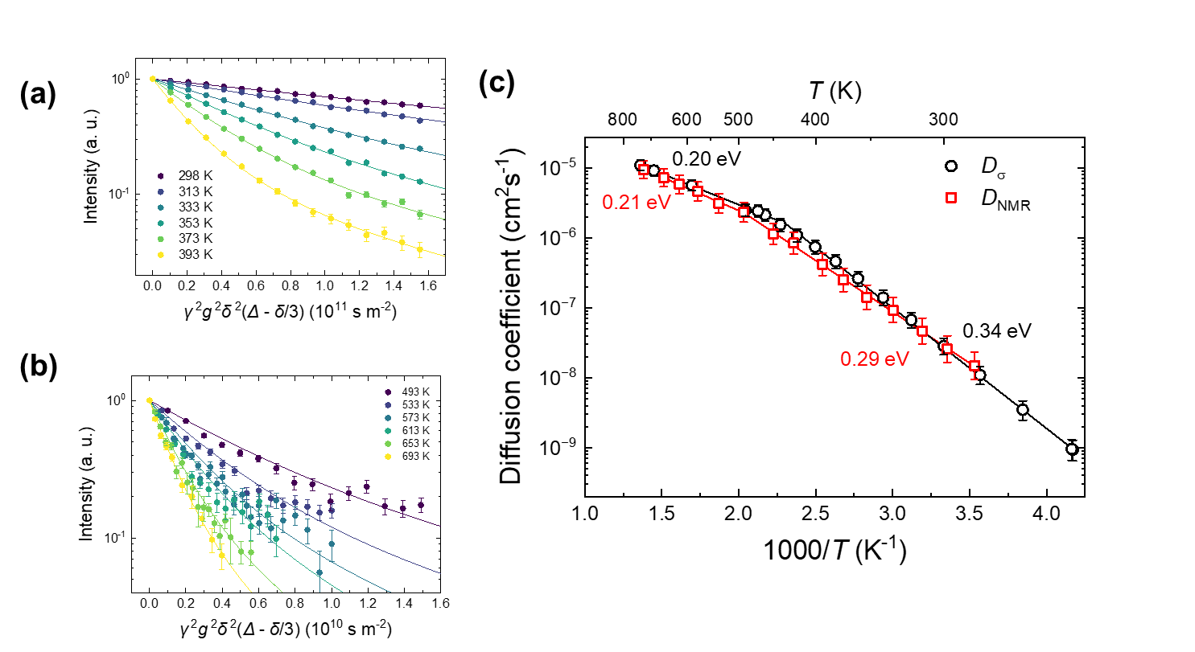
Fig. 1. 4 Temperature dependence of the diffusion coefficient of LLTO. PFG echo decay plots for temperature ranges of (a) 298–393 K and (b) 493–693 K. Solid lines indicate the fitting using Eq. (6). (c) Arrhenius plots of $D_{NMR}$ and $D_{σ}$. Reprinted with permission from 22. Copyright 2023 American Chemical Society.

1.4 Diffusion measurement using isotope exchange and SIMS
Here we show diffusion coefficients obtained by methods other than NMR, the tracer diffusion method using isotope exchange and SIMS analysis. The advantage of isotope exchange experiments is that isotope migration can be directly observed. Experiments using radioactive tracers have a long history but are difficult to handle. Therefore, stable isotopes are used recently. The natural abundance of the stable lithium isotopes ⁶Li and ⁷Li are 0.076 and 0.924, respectively. Most lithium ionic conductors show high diffusivity even at room temperature, requiring special experimental conditions. Currently, neutron radiography ³⁰, SIMS imaging ^{9, 12}, and NMR imaging ^{31, 32} are known as imaging methods to distinguish between ⁶Li and ⁷Li.
Figure 1.4 shows a LLTO solid electrolyte immersed in a ⁶LiNO₃ solution for isotope exchange, followed by SIMS imaging to visualize the ⁶Li isotope distribution. Isotope exchange is carried out at 295 K for 59 h, then quenched and maintained at 163 K to freeze Li diffusion. The fraction of ⁶Li (= ⁶Li/(⁶Li+⁷Li)) changes from the bottom to the top of the LLTO. SIMS images show that the ⁶Li concentration changes rapidly at the grain boundaries rather than in the bulk. Experimental results show that the grain boundary diffusion is slower than the bulk diffusion in solid electrolytes with fast diffusion pathways such as LLTO. Note that the SIMS resolution is 1 μm and the bulk diffusion is an average that includes multiple 90° domains. Fig. 1.4 (b) presents a SIMS image after another 16 days of diffusion at 295K. The distribution of ⁶Li is homogenized by diffusion, but the ⁶Li concentration still varies stepwise at the grain boundaries. Assuming that the flux across the grain boundary is equal and that the grain boundary thickness is 0.5 nm, the grain boundary diffusion coefficient (D*_{gb}) is calculated to be five orders of magnitude smaller than the bulk diffusion coefficient (D*_{bulk}). ¹² Figure 1. 4 (c) shows the long-range SIMS line profiles. The profiles are analyzed by the diffusion equation to quantitatively determine the effective diffusion coefficient (D*_{eff}), which includes the grain boundary and the bulk diffusion coefficients. ¹²

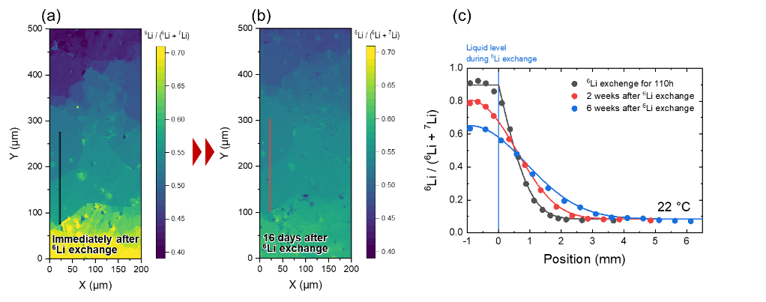
Fig. 1. 4 SIMS imaging of polycrystalline LLTO with ⁶Li exchanged from the bottom of the sample by liquid ⁶LiNO₃ solution. (a) immediately after the isotope exchange for 59 hours and (b) after 16 days storage at 22°C. The contour color map is shown as ⁶Li/(⁶Li+⁷Li) ratio. (c) SIMS line analysis of the LLTO. Reproduced from Reference 12 with permission from the Royal Society of Chemistry.

Fig. 1.5 (a) shows a complex impedance plot of LLTO at 300 K, where the vertical and horizontal axes represent the real and imaginary parts of the impedance. As blocking electrodes, thin Au films are sputtered onto the LLTO. The impedance can be separated into bulk and grain boundary components at 50 kHz. ³³ Furthermore, a blocking effect is observed below 500 Hz. As can be seen from SEM-EBSD, the volume fraction of the bulk is much larger than that of the grain boundaries. However, because of the very low grain boundary diffusivity (D*_{gb}), the effective resistance of LLTO is greater at the grain boundaries than in the bulk. The bulk resistance includes the effects of randomly oriented anisotropic crystals and 90° domains, which are difficult to separate by the impedance method. To understand the ionic conduction mechanism, complementary techniques such as NMR and SIMS should be used effectively.
Fig. 1. 5 (b) compares conductivity diffusion coefficients for bulk (D_{σ, bulk}) and total (D_{σ, total}) with PFG-NMR (D_{NMR, bulk}) and tracer diffusion coefficient (D*_{total}) in an Arrhenius plot. In the bulk, D_{σ, bulk} and D_{NMR, bulk} results are in very good agreement. In contrast, for the total values including grain boundaries, D_{σ, total} and D*_{total}, shows different values. When the bulk part is subtracted from total, the Haven ratio is found to be 0.24 for the grain boundary diffusion coefficient. The concerted motion between Li⁺ ions may have a significant effect at the grain boundary. These measurements are useful for discussing the details of the diffusion mechanism in comparison with molecular dynamics simulations. Techniques such as neutron quasi-elastic scattering ¹⁹ and muon spin relaxation ³⁴ are also powerful techniques to reveal diffusion mechanisms at various time scales. Local structure analysis by solid-state high-resolution NMR is also a powerful tool, although it could not be described in detail, several results ³⁵⁻³⁸ have been achieved in the “Interface IONICS”.

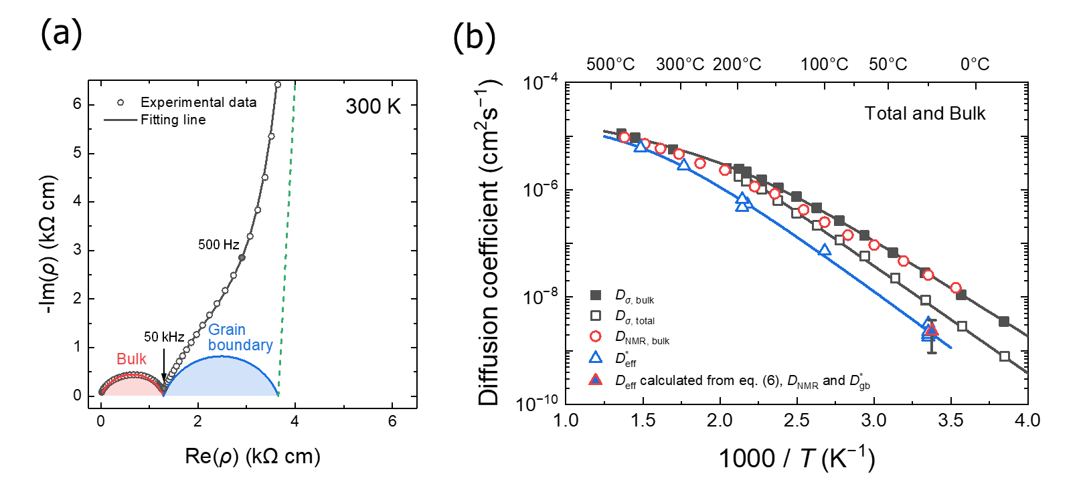
Fig. 1. 5 (a) Complex impedance plot of LLTO (300 K): bulk and grain boundary resistances can be distinguished. (b) Arrhenius plots of diffusion coefficients, where D_{σ} is conductivity diffusion coefficient determined from impedance spectroscopy, D_{NMR} is determined by PFG-NMR, D*_{eff} is the effective tracer diffusion coefficient determined from SIMS line analysis, D*_{gb} is the grain boundary diffusion coefficient obtained from SIMS imaging. Reproduced from Reference 12 with permission from the Royal Society of Chemistry.

Conclusions

The diffusion coefficient measured by PFG-NMR and its application to solid electrolytes is described. PFG-NMR has revealed an anisotropic diffusion due to the two-dimensional crystal structure of perovskite solid electrolytes. D_{NMR} is in very good agreement with the D_{σ, bulk} and show a non-Arrhenius temperature dependence. Local motion (D_{local}) estimated from correlation times obtained from T₁ measurements correspond well with macroscopic D_{NMR}. SIMS and conductivity measurements indicate the importance of grain boundary as well as bulk diffusion coefficients. Since the diffusion of Li⁺ ions in LLTO are strongly related to the microstructure, it is important to analyze ion dynamics on various time and spatial scales.

Acknowledgements

This study was supported by JSPS KAKENHI, grant number JP19H05814 (Grant-in-Aid for Scientific Research on Innovative Areas “Interface IONICS”) and JP21H02033 (Grant-in-Aid for Scientific Research (B)). We would like to thank Prof. Yoshiyuki Inaguma for the informative discussion.

References

(1) Bloembergen, N.; Purcell, E. M.; Pound, R. V. Relaxation Effects in Nuclear Magnetic Resonance Absorption. Phys. Rev. 1948, 73 (7), 679-712.
(2) Heitjans, P.; Indris, S. Diffusion and ionic conduction in nanocrystalline ceramics. J. Phys. Condens. Matter. 2003, 15 (30), R1257-R1289.
(3) Wilkening, M.; Heitjans, P. From Micro to Macro: Access to Long-Range Li⁺ Diffusion Parameters in Solids via Microscopic ^{6, 7}Li Spin-Alignment Echo NMR Spectroscopy. ChemPhysChem 2012, 13 (1), 53-65.
(4) Stejskal, E. O.; Tanner, J. E. Spin Diffusion Measurements: Spin Echoes in the Presence of a Time-Dependent Field Gradient. J. Chem. Phys. 1965, 42 (1), 288-292.
(5) Tanner, J. E. Use of the Stimulated Echo in NMR Diffusion Studies. J. Chem. Phys. 1970, 52 (5), 2523-2526.
(6) Dorai, A.; Kuwata, N.; Takekawa, R.; Kawamura, J.; Kataoka, K.; Akimoto, J. Diffusion coefficient of lithium ions in garnet-type Li_{6.5}La₃Zr_{1.5}Ta_{0.5}O₁₂ single crystal probed by ⁷Li pulsed field gradient-NMR spectroscopy. Solid State Ionics 2018, 327, 18-26.
(7) Hayamizu, K.; Seki, S.; Haishi, T. ⁷Li NMR diffusion studies in micrometre-space for perovskite-type Li_{0.33}La_{0.55}TiO₃ (LLTO) influenced by grain boundaries. Solid State Ionics 2018, 326, 37-47.
(8) Price, W. S. NMR studies of translational motion: principles and applications; Cambridge University Press, 2009.
(9) Kuwata, N.; Lu, X.; Miyazaki, T.; Iwai, Y.; Tanabe, T.; Kawamura, J. Lithium diffusion coefficient in amorphous lithium phosphate thin films measured by secondary ion mass spectroscopy with isotope exchange methods. Solid State Ionics 2016, 294, 59-66.
(10) Kuwata, N.; Hasegawa, G.; Maeda, D.; Ishigaki, N.; Miyazaki, T.; Kawamura, J. Tracer diffusion coefficients of Li ions in Li_{x}Mn₂O₄ thin films observed by isotope exchange secondary ion mass spectrometry. J. Phys. Chem. C 2020, 124 (42), 22981–22992.
(11) Hasegawa, G.; Kuwata, N.; Tanaka, Y.; Miyazaki, T.; Ishigaki, N.; Takada, K.; Kawamura, J. Tracer diffusion coefficients of Li⁺ ions in c-axis oriented Li_{x}CoO₂ thin films measured by secondary ion mass spectrometry. Phys. Chem. Chem. Phys. 2021, 23 (3), 2438–2448.
(12) Hasegawa, G.; Kuwata, N.; Ohnishi, T.; Takada, K. Visualization and evaluation of lithium diffusion at grain boundaries in Li_{0.29}La_{0.57}TiO₃ solid electrolytes using secondary ion mass spectrometry. J. Mater. Chem. A 2024, 12 (2), 731-738.
(13) Mehrer, H. Diffusion in solids: fundamentals, methods, materials, diffusion-controlled processes; Springer-Verlag, Berlin, Heidelberg, 2007.
(14) Weppner, W.; Huggins, R. A. Determination of the kinetic parameters of mixed‐conducting electrodes and application to the system Li₃Sb. J. Electrochem. Soc. 1977, 124 (10), 1569-1578.
(15) Inaguma, Y.; Liquan, C.; Itoh, M.; Nakamura, T.; Uchida, T.; Ikuta, H.; Wakihara, M. High ionic conductivity in lithium lanthanum titanate. Solid State Commun. 1993, 86 (10), 689-693.
(16) Inaguma, Y.; Yu, J.; Katsumata, T.; Itoh, M. Lithium Ion Conductivity in a Perovskite Lanthanum Lithium Titanate Single Crystal. J. Ceram. Soc. Jpaan 1997, 105 (1222), 548-550.
(17) Zinkevich, T.; Schwarz, B.; Braun, P.; Weber, A.; Ehrenberg, H.; Indris, S. Effect of sintering temperature on Li diffusivity in Li_{0.29}La_{0.57}TiO₃: Local hopping and long-range transport. Solid State Ionics 2020, 357, 115486.
(18) Qi, J.; Banerjee, S.; Zuo, Y.; Chen, C.; Zhu, Z.; Holekevi Chandrappa, M. L.; Li, X.; Ong, S. P. Bridging the gap between simulated and experimental ionic conductivities in lithium superionic conductors. Mater. Today Phys. 2021, 21, 100463.
(19) Matsuura, M.; Fujiwara, Y.; Moriwake, H.; Ohara, K.; Kawakita, Y. Microscopic dynamics of lithium diffusion in single crystal of the solid-state electrolyte La_{2/3−x}Li_{3x}TiO₃ (x = 0.13) studied by quasielastic neutron scattering. Phys. Rev. B 2021, 104 (9), 094305.
(20) Kobayashi, S.; Yokoe, D.; Fujiwara, Y.; Kawahara, K.; Ikuhara, Y.; Kuwabara, A. Lithium Lanthanum Titanate Single Crystals: Dependence of Lithium-Ion Conductivity on Crystal Domain Orientation. Nano Lett. 2022, 22 (13), 5516-5522.
(21) Gao, X.; Fisher, C. A. J.; Kimura, T.; Ikuhara, Y. H.; Moriwake, H.; Kuwabara, A.; Oki, H.; Tojigamori, T.; Huang, R.; Ikuhara, Y. Lithium Atom and A-Site Vacancy Distributions in Lanthanum Lithium Titanate. Chem. Mater. 2013, 25 (9), 1607-1614.
(22) Hasegawa, G.; Kuwata, N.; Hashi, K.; Tanaka, Y.; Takada, K. Lithium-Ion Diffusion in Perovskite-Type Solid Electrolyte Lithium Lanthanum Titanate Revealed by Pulsed-Field Gradient Nuclear Magnetic Resonance. Chem. Mater. 2023, 35 (10), 3815-3824.
(23) Diez‐Gómez, V.; Andres, P. L.; Sanz, J. Effects of Li Confined Motion on NMR Quadrupolar Interactions: A Combined ⁷Li NMR and DFT‐MD Study of LiR₂(PO₄)₃ (R=Ti or Zr) Phases. ChemSusChem 2020, 13 (5), 1027-1036.
(24) Varez, A.; Fernández-Díaz, M. T.; Alonso, J. A.; Sanz, J. Structure of Fast Ion Conductors Li_{3x}La_{2/3-x}TiO₃ Deduced from Powder Neutron Diffraction Experiments. Chem. Mater. 2005, 17 (9), 2404-2412.
(25) Bohnke, O.; Emery, J.; Fourquet, J.-L. Anomalies in Li+ ion dynamics observed by impedance spectroscopy and 7Li NMR in the perovskite fast ion conductor (Li_{3x}La_{2/3-x}□_{1/3-2x})TiO₃. Solid State Ionics 2003, 158 (1), 119-132.
(26) Callaghan, P. T.; Jolley, K. W.; Lelievre, J. Diffusion of water in the endosperm tissue of wheat grains as studied by pulsed field gradient nuclear magnetic resonance. Biophys. J. 1979, 28 (1), 133-141.
(27) He, X.; Zhu, Y.; Mo, Y. Origin of fast ion diffusion in super-ionic conductors. Nat. Commun. 2017, 8 (1), 15893.
(28) Varez, A.; Rivera, A.; Bucheli, W.; Jimenez, R.; Sanz, J. Li motion mechanisms in (Li,Na)_{3x}La_{2/3-x}TiO₃ (x = 0.067 and 0.167) series followed by ND, NMR and Impedance spectroscopy. MRS Proceedings 2011, 1313.
(29) Wu, J.; Chen, L.; Song, T.; Zou, Z.; Gao, J.; Zhang, W.; Shi, S. A review on structural characteristics, lithium ion diffusion behavior and temperature dependence of conductivity in perovskite-type solid electrolyte Li_{3x}La_{2∕3−x}TiO₃. Funct. Mater. Lett. 2017, 10 (03), 1730002.
(30) Takai, S.; Mandai, T.; Kawabata, Y.; Esaka, T. Diffusion coefficient measurements of La_{2/3−x}Li_{3x}TiO₃ using neutron radiography. Solid State Ionics 2005, 176 (29–30), 2227-2233.
(31) Marbella, L. E.; Zekoll, S.; Kasemchainan, J.; Emge, S. P.; Bruce, P. G.; Grey, C. P. ⁷Li NMR Chemical Shift Imaging To Detect Microstructural Growth of Lithium in All-Solid-State Batteries. Chem. Mater. 2019, 31 (8), 2762-2769.
(32) Dorai, A.; Kawamura, J.; Omata, T. Visualization of polysulfide dissolution in lithium-sulfur batteries using in-situ NMR microimaging. Electrochem. Commun. 2022, 141, 107360.
(33) Braun, P.; Uhlmann, C.; Weber, A.; Störmer, H.; Gerthsen, D.; Ivers-Tiffée, E. Separation of the bulk and grain boundary contributions to the total conductivity of solid lithium-ion conducting electrolytes. J. Electroceram. 2017, 38 (2-4), 157-167.
(34) Sugiyama, J.; Mukai, K.; Ikedo, Y.; Nozaki, H.; Månsson, M.; Watanabe, I. Li Diffusion in Li_{x}CoO₂ Probed by Muon-Spin Spectroscopy. Phys. Rev. Lett. 2009, 103 (14), 147601.
(35) Hatakeyama-Sato, K.; Umeki, M.; Adachi, H.; Kuwata, N.; Hasegawa, G.; Oyaizu, K. Exploration of organic superionic glassy conductors by process and materials informatics with lossless graph database. npj Computational Materials 2022, 8 (1).
(36) Ugata, Y.; Hasegawa, G.; Kuwata, N.; Ueno, K.; Watanabe, M.; Dokko, K. Temperature Dependency of Ion Transport in Highly Concentrated Li Salt/Sulfolane Electrolyte Solutions. J. Phys. Chem. C 2022.
(37) Fujita, Y.; Kimura, T.; Deguchi, M.; Motohashi, K.; Sakuda, A.; Tatsumisago, M.; Tsukasaki, H.; Mori, S.; Ikeda, K.; Ohara, K.; et al. Structural Investigation of Li₂O–LiI Amorphous Solid Electrolytes. J. Phys. Chem. C 2023, 127 (30), 14687-14693.
(38) Ikeda, M.; Jalem, R.; Hasegawa, G.; Kuwata, N.; Liu, Q.; Yamamoto, T.; Shigematsu, K.; Tateyama, Y.; Azuma, M. Theoretical Prediction and High-Pressure Synthesis of New LISICON-Type Solid-State Electrolyte Li_{2.75}[B_{0.625}P_{0.125}S_{0.25}]O_{3.375}. J. Phys. Chem. C 2023, 127 (29), 14117-14124.

