Supplemental Material

Comparative experimental and theoretical study on anomalous Nernst effect of Heusler alloy Co₂FeSi thin film: Estimation of on-site Coulomb interaction at Co

site

Weinan Zhouª, Keisuke Masudaª, Kazuki Sumida^{b}, Yuichi Fujita^{a*}, Akio Kimura^{c,d,e}, and Yuya Sakurabaª

ªResearch Center for Magnetic and Spintronic Materials (CMSM), National Institute for Materials Science (NIMS), Tsukuba, Ibaraki, Japan;
^{b}Research Institute for Synchrotron Radiation Science, Hiroshima University, Higashi-Hiroshima, Hiroshima, Japan;
^{c}Graduate School of Advanced Science and Engineering, Hiroshima University, HigashiHiroshima, Hiroshima, Japan;
^{d}International Institute for Sustainability with Knotted Chiral Meta Matter (WPI-SKCM²), Higashi-Hiroshima, Hiroshima, Japan;
^{e}Synchrotron Radiation Research Center, National Institutes for Quantum Science and Technology (QST), Sayo, Hyogo, Japan;

Contact:
Weinan Zhou ZHOU.Weinan@nims.go.jp; Yuya Sakuraba SAKURABA.Yuya@nims.go.jp
Research Center for Magnetic and Spintronic Materials (CMSM), National Institute for Materials Science (NIMS), Tsukuba, Ibaraki 305-0047, Japan

*Present address: Global Research and Development Center for Business by Quantum-AI technology (G-QuAT), National Institute of Advanced Industrial Science and Technology (AIST),
Tsukuba, Ibaraki 305-8568, Japan

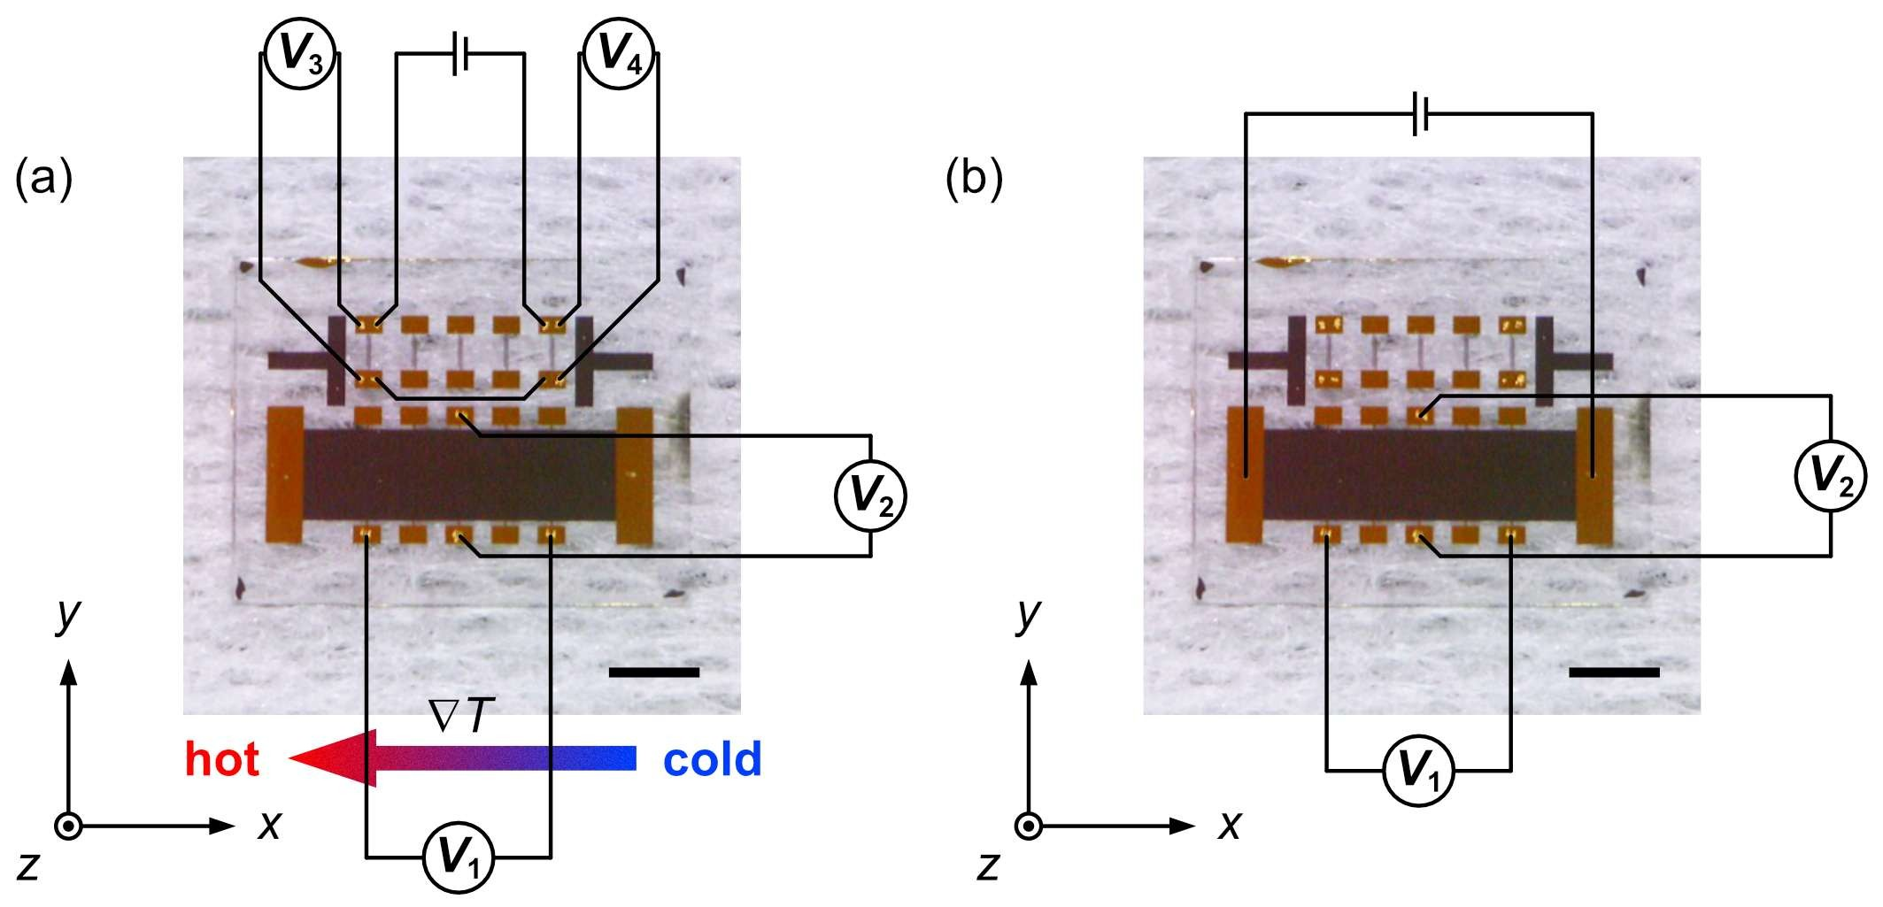

Figure S1. (a) Photograph of the patterned sample, together with the schematic representation of the experimental configuration for the ANE and (b) AHE measurements. The corresponding Cartesian coordinate system is also shown. In (a), V₁, V₂, V₃, and V₄ represent four nanovoltmeters measuring the longitudinal thermoelectric signal due to SE, the transverse thermoelectric signal due to ANE, the resistance of on-chip thermometers at the hot side and cold side of the sample, respectively. In (b), V₁ and V₂ represent 2 nanovoltmeters for measuring the longitudinal and transverse resistance, respectively. The scale bars in (a) and (b) indicate the length of 2 mm.

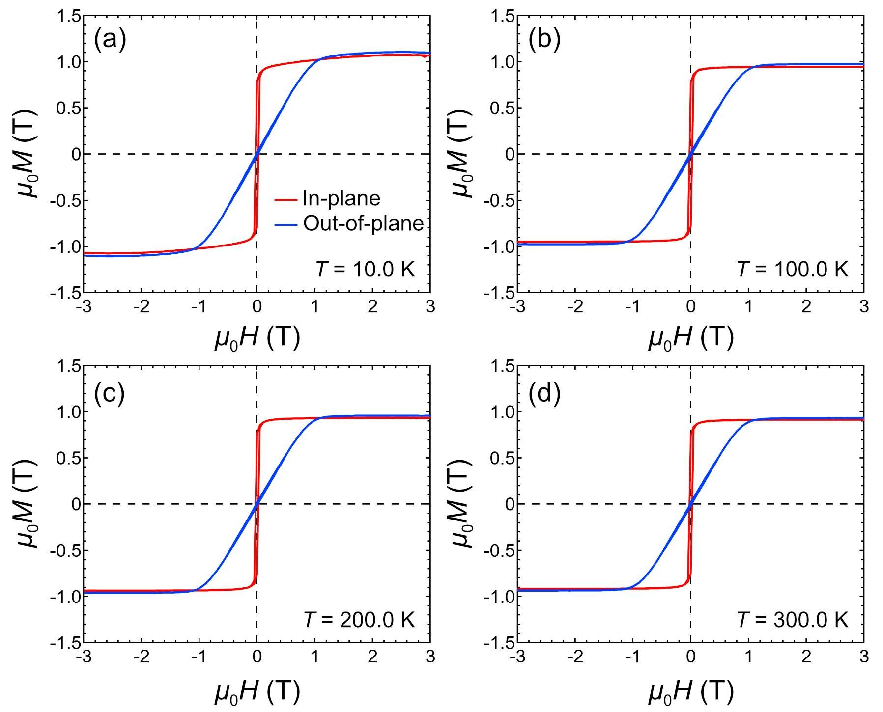

Figure R2. (a) In-plane and out-of-plane M-H curves of the Co₂FeSi thin film measured at T = 10.0, (b) 100.0, (c) 200.0, and (d) 300.0 K. The shape of the out-of-plane M-H curves was consistent with the ANE and AHE results shown in Figure 2(a–d). The saturation magnetization (M_{s}) of Co₂FeSi slightly increased with decreasing T. At 10 K, μ₀M_{s} = 1.1 T, which corresponded to a magnetic moment of ~4.2 μ_{B}/f.u.

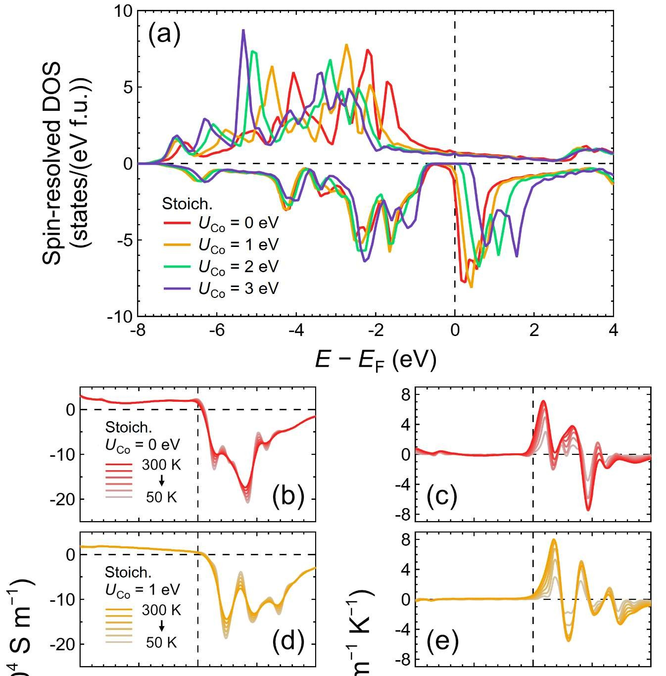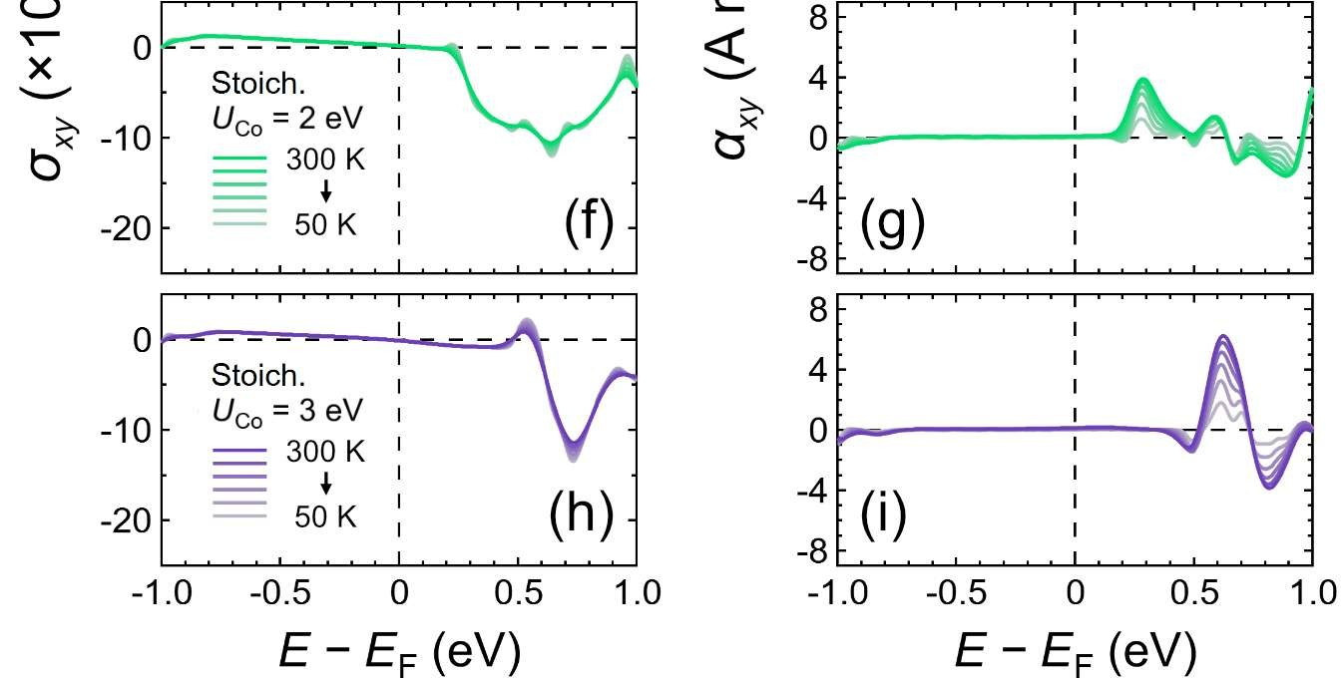

Figure S3. (a) Spin-resolved DOS values for Co₂FeSi with stoichiometric (Stoich.) composition around the Fermi level (E_{F}), with various values for the on-site Coulomb interaction at the Co site (U_{Co}). (b) Calculated σ_{xy} values in the energy window of ±1 eV relative to E_{F} with U_{Co} = 0 eV, (d) U_{Co} = 1 eV, (f) U_{Co} = 2 eV, and (h) U_{Co} = 3 eV. (c) Corresponding α_{xy} values with U_{Co} = 0 eV, (e) U_{Co} = 1 eV, (g) U_{Co} = 2 eV, and (i) U_{Co} = 3 eV. The saturation of colors of the lines indicates the T values of the results, which ranged from 50 to 300 K in 50 K steps. The values of α_{xy} and σ_{xy} at E_{F} in (b)–(i) as functions of T are shown in Figure S4(a, b), respectively.

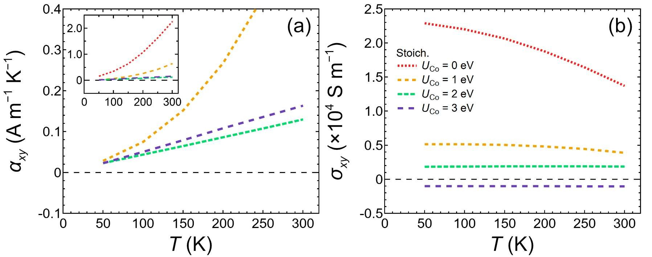

Figure S4. (a) α_{xy} and (b) σ_{xy} values at E_{F} of stoichiometric (Stoich.) Co₂FeSi with various values for U_{Co}. The inset of (a) shows the calculated results over a wider range for the y-axis. The legends in (b) also apply to (a).

