Coercivity Engineering in Nd-Fe-B Hot-deformed Magnets
by Grain Boundary Infiltration: Micromagnetic Viewpoint
A. Bolyachkin^{1,2,}*, E. Dengina^{1,3}, H. Sepehri-Amin^{1,3}, T. Ohkubo¹, and K. Hono^{1,3}
¹ Research Center for Magnetic and Spintronic Materials, NIMS, Tsukuba 305-0047, Japan
² International Center for Young Scientists, NIMS, Tsukuba 305-0047, Japan
³ Graduate School of Science and Technology, University of Tsukuba, Tsukuba, 305-8573, Japan
*bolyachkin.anton@nims.go.jp

The grain boundary diffusion process (GBDP) is one of the most efficient treatments for increasing the coercivity (H_{c}) of Nd-Fe-B magnets [1,2]. However, this enhancement typically occurs at the expense of remanence (M_{r}). In this study, micromagnetic simulations were performed to quantify this tradeoff in hot-deformed Nd-Fe-B magnets subjected to the GBDP using a Nd-based eutectic alloy [3]. The GBDP was imitated in a series of models with a gradually increasing volume fraction of the infiltrated Nd-rich nonmagnetic phase. One of these models is demonstrated in Fig. 1a. The imitated infiltration reduced the remanence and grain connectivity via the remaining thin magnetic intergranular phase (IGP), which in turn increased the coercivity. We distinguished between the roles of exchange and magnetostatic interactions in this coercivity enhancement. Furthermore, the simulated M_{r} vs. H_{c} curves (Fig. 1b) defined realistic limits for coercivity that depended on the IGP magnetization, which was estimated to be 0.9 ± 0.1 T by reproducing experimental M_{r} vs. H_{c} data from the literature.
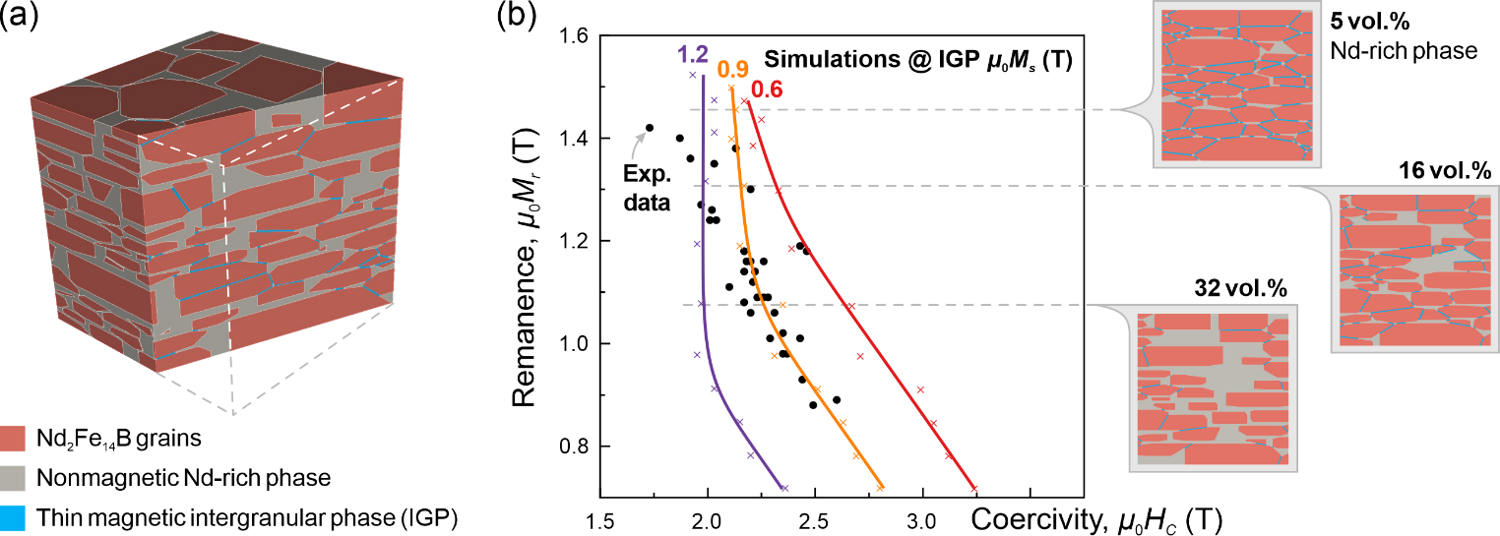
Figure 1. (a) Micromagnetic model of the hot-deformed Nd-Fe-B magnets subjected to the grain boundary diffusion by a Nd-based eutectic alloy. (b) Simulated remanence vs. coercivity of the Nd-Fe-B magnets as the content of the Nd-rich nonmagnetic phase increased. Simulations were performed for different magnetizations of the thin intergranular phase (IGP). Solid lines are guides for the eye.
The support by the MEXT (JPMXP1122715503) and JSPS (JP23H01674) is acknowledged.
References
- K. Hioki, “High performance hot-deformed Nd-Fe-B magnets”, Sci. Technol. Adv. Mater. 22 (2021) 72.
- H. Sepehri-Amin et al., “High-coercivity ultrafine-grained anisotropic Nd-Fe-B magnets processed by hot deformation and the Nd-Cu grain boundary diffusion process”, Acta Mater. 61 (2013) 6622.
- A. Bolyachkin et al., “Micromagnetic simulations of Nd-Fe-B hot-deformed magnets subjected to eutectic grain boundary diffusion process”, Scripta Mater. 247 (2024) 116095.

