Supplemental Material for
Exciton dynamics in marginally twisted WSe₂ homobilayer: role of interlayer coupling, phonons, and intervalley scattering

Hansol Kim^{1,2}, Gyusu Lee¹, Jinjae Kim^{1,3}, Jiwon Park^{1,3}, Andrew S. Kim^{1,2,3}, Jongyun Choi^{4,5}, Kenji Watanabe⁶, Takashi Taniguchi⁶, Moon-Ho Jo^{4,5} and Hyunyong Choi^{1,3,*}
¹Department of Physics, Seoul National University, Seoul 08826, Korea
²Research Institute of Basic Sciences, Seoul National University, Seoul 08826, Korea
³Institute of Applied Physics, Seoul National University, Seoul 08826, Korea
⁴Department of Materials Science and Engineering, Pohang University of Science and Technology, Pohang 37673, Korea
⁵Center for Van der Waals Quantum Solids, Institute for Basic Science (IBS), Pohang 37673, Korea
⁶Advanced Materials Laboratory, National Institute for Materials Science, 1-1 Namiki, Tsukuba, 305-0044, Japan

*Corresponding author: hy.choi@snu.ac.kr

Supplemental Notes
S1. Lindblad master equation
To study the valley coherence and polarization of excitons, we present a modified Jaynes-Cummings model [Eq. (1)] designated to each $K$and $K^{'}$ valley. We use a Lindblad master equation [Eq. (2)] to solve for the steady-state solution of the density matrix. The evolution of the density matrix is in the form as below,
$$\begin{aligned}\frac{d}{dt}ρ_{K}=-\left(γ_{K}+γ_{v}\right)ρ_{K}+r_{K}ρ_{g}+γ_{v}ρ_{K^{'}}-\frac{1}{2}r_{KK^{'}}\left(ρ_{KK^{'}}+ρ_{K^{'}K}\right)+ig\left(ρ_{Kg}-ρ_{gK}\right)\#\left(S1A\right)\end{aligned}$$
$$\begin{aligned}\frac{d}{dt}ρ_{K^{'}}=γ_{v}ρ_{K}+r_{K^{'}}ρ_{g}-\left(γ_{K^{'}}+γ_{v}\right)ρ_{K^{'}}-\frac{1}{2}r_{KK^{'}}\left(ρ_{KK^{'}}+ρ_{K^{'}K}\right)+ig\left(ρ_{K^{'}g}-ρ_{gK^{'}}\right)\#\left(S1B\right)\end{aligned}$$
$$\begin{aligned}\frac{d}{dt}ρ_{g}=γ_{K}ρ_{K}+γ_{K^{'}}ρ_{K^{'}}+r_{KK^{'}}\left(ρ_{KK^{'}}+ρ_{K^{'}K}\right)-\left(r_{K}+r_{K^{'}}\right)ρ_{g} \\ +ig\left(-ρ_{Kg}-ρ_{K^{'}g}+ρ_{gK}+ρ_{gK^{'}}\right) \#\left(S1C\right)\end{aligned}$$
$$\begin{aligned}\frac{d}{dt}ρ_{KK^{'}}=-\frac{1}{2}\left(γ_{K}+γ_{K^{'}}+2γ_{v}+2γ_{d}+r_{K}+r_{K^{'}}\right)ρ_{KK^{'}}+\frac{1}{2}r_{KK^{'}}\left(2ρ_{g}-ρ_{K}-ρ_{K^{'}}\right) \\ +ig\left(ρ_{Kg}-ρ_{gK^{'}}\right)\#\left(S1D\right)\end{aligned}$$
$$\begin{aligned}\frac{d}{dt}ρ_{K^{'}K}=-\frac{1}{2}\left(γ_{K}+γ_{K^{'}}+2γ_{v}+2γ_{d}+r_{K}+r_{K^{'}}\right)ρ_{K^{'}K}+\frac{1}{2}r_{KK^{'}}\left(2ρ_{g}-ρ_{K}-ρ_{K^{'}}\right) \\ +ig\left(ρ_{K^{'}g}-ρ_{gK}\right)\#\left(S1E\right)\end{aligned}$$
$$\begin{aligned}\frac{d}{dt}ρ_{Kg}=i\left(-Δ_{K}+i\left(\frac{γ_{K}}{2}+γ_{d}+\frac{r_{K}+r_{K^{'}}}{2}\right)\right)ρ_{Kg}-\frac{1}{2}r_{KK^{'}}ρ_{K^{'}g}+ig\left(ρ_{K}-ρ_{g}\right)+igρ_{KK^{'}} \#\left(S1F\right)\end{aligned}$$
$$\begin{aligned}\frac{d}{dt}ρ_{K^{'}g}=i\left(-Δ_{K^{'}}+i\left(\frac{γ_{K^{'}}}{2}+γ_{d}+\frac{r_{K^{'}}+r_{K}}{2}\right)\right)ρ_{K^{'}g}-\frac{1}{2}r_{KK^{'}}ρ_{Kg}+ig\left(ρ_{K^{'}}-ρ_{g}\right)+igρ_{K^{'}K} \#\left(S1G\right)\end{aligned}$$
$$\begin{aligned}\frac{d}{dt}ρ_{gK}=i\left(Δ_{K}-i\left(\frac{γ_{K}}{2}+γ_{d}+\frac{r_{K}+r_{K^{'}}}{2}\right)\right)ρ_{gK}-\frac{1}{2}r_{KK^{'}}ρ_{gK^{'}}-ig\left(ρ_{K}-ρ_{g}\right)-igρ_{KK^{'}} \#\left(S1H\right)\end{aligned}$$
$$\begin{aligned}\frac{d}{dt}ρ_{gK^{'}}=i\left(Δ_{K^{'}}-i\left(\frac{γ_{K^{'}}}{2}+γ_{d}+\frac{r_{K^{'}}+r_{K}}{2}\right)\right)ρ_{gK^{'}}-\frac{1}{2}r_{KK^{'}}ρ_{gK}-ig\left(ρ_{K^{'}}-ρ_{g}\right)-igρ_{K^{'}K}. \#\left(S1I\right)\end{aligned}$$
Here, we assume that $Δ_{K}=Δ_{K^{'}}=Δ$, $r_{K}=r_{K^{'}}$, $γ_{K}=γ_{K^{'}}$, $r_{KK^{'}}=\sqrt{r_{K}r_{K^{'}}}=r_{K}$ and Rabi frequency for each transition is equivalent. Solving under the steady-state condition, we yield in the leading order of $ρ_{g}≈1$. The steady-state degree of linear polarization (DOLP) $ρ_{l}$ can be expressed as [1]
$$\begin{aligned}ρ_{l}=\frac{ρ_{KK^{'}}+ρ_{K^{'}K}}{ρ_{K}+ρ_{K^{'}}} .\#\left(S2\right)\end{aligned}$$
Then, we proceed the derivation of $ρ_{K}$, $ρ_{K^{'}}$, $ρ_{KK^{'}}$, $ρ_{K^{'}K}$, and $ρ_{g}$ using the steady-state form of the density matrix. The DOLP is then solved as,
$$ρ_{l}≈\frac{\left[\frac{2g^{2}Γ_{D}}{Δ^{2}+Γ_{D}^{2}}\left(ρ_{K}+ρ_{K^{'}}-2ρ_{g}+ρ_{KK^{'}}+ρ_{K^{'}K}\right)+2r_{K}ρ_{g}-r_{K}\left(ρ_{K}+ρ_{K^{'}}\right)\right]γ_{K}}{\left[\frac{2g^{2}Γ_{D}}{Δ^{2}+Γ_{D}^{2}}\left(ρ_{K}+ρ_{K^{'}}-2ρ_{g}+ρ_{KK^{'}}+ρ_{K^{'}K}\right)\left(1-\frac{r_{K}}{Γ_{K}}\right)+2r_{K}\left(1-\frac{r_{K}}{Γ_{K}}\right)ρ_{g}+\frac{r_{K}^{2}}{Γ_{K}}\left(ρ_{K}+ρ_{K^{'}}\right)\right]Γ_{K}}$$
$$\begin{aligned}≈{\left(1-\frac{r_{K}}{Γ_{K}}\right)}^{-1}\frac{γ_{K}}{Γ_{K}}=\frac{γ_{K}}{Γ_{K}-r_{K}} .\#\left(S3\right)\end{aligned}$$
where $Γ_{K}=γ_{K}+γ_{d}+γ_{v}$ and $Γ_{D}=\frac{γ_{K}}{2}+γ_{d}+r_{K}$. This equation will reduce to Eq. (5) in the main text, once we assume the weak pump limit, $r_{K}, r_{K^{'}}→0$
$$\begin{aligned}ρ_{l}=\frac{1}{1+\frac{γ_{v}+γ_{d}}{γ_{K}}} .\#\left(S4\right)\end{aligned}$$
To study the steady-state helicity $ρ_{c}$, because we selectively inject to a single valley, e.g. $K$ valley, one of the pump channel $r_{K^{'}}=0$ is set to zero.
$$\begin{aligned}ρ_{c}=\frac{ρ_{K}-ρ_{K^{'}}}{ρ_{K}+ρ_{K^{'}}} ,\#\left(S5\right)\end{aligned}$$
where we assume $r_{K}≪γ_{K}$ and weak light-matter coupling $g$, $η=\frac{2g^{2}Γ_{D}}{Δ^{2}+Γ_{D}^{2}}, ζ=\frac{2g^{2}Δ}{Δ^{2}+Γ_{D}^{2}}$. We subtract Eq. (S1A) and (S1B) in the steady-state,
$$\begin{aligned}\left(γ_{K}+2γ_{v}+η\right)\left(ρ_{K}-ρ_{K^{'}}\right)≈r_{K}-2ζIm\left[ρ_{{KK}^{'}}\right] .\#\left(S6\right)\end{aligned}$$
We add Eq. (S1A) and (S1B) in the steady-state,
$$\begin{aligned}\left(γ_{K}+η\right)\left(ρ_{K}+ρ_{K^{'}}\right)≈r_{K}+2η\left(1-Re\left[ρ_{{KK}^{'}}\right]\right). \#\left(S7\right)\end{aligned}$$
Thus, neglecting $η≪1$, Eq. (S5) reduces to Eq. (6) in the main text.
$$\begin{aligned}ρ_{c}≈\frac{\left(γ_{K}+η\right)}{\left(γ_{K}+2γ_{v}+η\right)}\frac{1}{1+\frac{2η}{r_{K}}\left(1-Re\left[ρ_{{KK}^{'}}\right]\right)}≈\frac{1}{1+\frac{2γ_{v}}{γ_{K}}} . \#\left(S8\right)\end{aligned}$$

S2. Transfer matrix
The Green’s function can be derived through transfer matrix method [2,3], which for the case of normal incidence, the electric field is decomposed to reflected $(E_{r})$ and transmitted $(E_{t})$ components. Using a transfer matrix $M(z_{1}, z_{0})$, the fields at a position $z_{1}$ in terms of the fields at an initial position $z_{0}$ are expressed as,
$$\begin{aligned}\left(\begin{aligned}E_{r}\left(z_{1}\right) \\ E_{t}\left(z_{1}\right)\end{aligned}\right)=M\left(z_{1},z_{0}\right)\left(\begin{aligned}E_{r}\left(z_{0}\right) \\ E_{t}\left(z_{0}\right)\end{aligned}\right). \#\left(S9\right)\end{aligned}$$
Transfer matrix typically factors into two parts: one for the propagation within the material, with refractive index $n$,
$$\begin{aligned}M\left(z_{1},z_{0}\right)=\left(\begin{matrix}e^{ink_{0}\left(z_{1}-z_{0}\right)} & 0 \\ 0 & e^{-ink_{0}\left(z_{1}-z_{0}\right)}\end{matrix}\right) ,\#\left(S10\right)\end{aligned}$$
and the other for the interface between two media of the refractive indices $ϵ_{1}$ and $ϵ_{2}$:
$$\begin{aligned}M\left(ϵ_{2},ϵ_{1}\right)=\frac{1}{2\sqrt{ϵ_{2}}}\left(\begin{matrix}\sqrt{ϵ_{2}}+\sqrt{ϵ_{1}} & \sqrt{ϵ_{2}}-\sqrt{ϵ_{1}} \\ \sqrt{ϵ_{2}}-\sqrt{ϵ_{1}} & \sqrt{ϵ_{2}}+\sqrt{ϵ_{1}}\end{matrix}\right) .\#\left(S11\right)\end{aligned}$$
The reflection of the background thus, can be derived from the relation
$$\begin{aligned}\left(\begin{aligned}0 \\ t_{0}\end{aligned}\right)=M\left(z_{1},z_{0}\right)\left(\begin{aligned}r_{0} \\ 1\end{aligned}\right), \#\left(S12\right)\end{aligned}$$
where $t_{0}$ is the transmission coefficient and $z_{1}$ is the point at the last interface.
To calculate the Green’s function at $z=z_{1}$ from the electric field at $z=z_{0}$, we use the relation
$$\begin{aligned}G\left(z_{1}\right)=\frac{i}{2k_{0}}{\left(\begin{aligned}1 \\ 1\end{aligned}\right)}^{T}M\left(z_{1},z_{0}\right)\left(\begin{aligned}r_{0} \\ 1\end{aligned}\right) .\#\left(S13\right)\end{aligned}$$
This Green’s function encapsulates how the excitation at $z_{0}$​ propagates and reflects/transmits to the position $z_{1}$​ in the presence of the sample.

S3. Extraction of $γ_{d}$
In our analysis, $γ_{d}$ was extracted using a modified transfer matrix method (TMM) that accounts for the multilayer optical structure of the heterostructure. The fitting procedure involves several steps. First, we initially determined the resonance energy of the excitons by fitting the experimental RC spectrum with a multiple Voigt profile, which is a convolution of a Gaussian and a Lorentzian curve. The Gaussian width provides an estimate of the inhomogeneous broadening, while the Lorentzian width reflects the homogeneous linewidth, encompassing both radiative and non-radiative decay rate, as well as $γ_{d}$.
After the initial Voigt fitting, we fine-tuned the fit by considering various material parameters, including the thickness of hBN and WSe₂, the refractive index of hBN, and the gold layer. Specifically, we used top, bottom layer hBN thickness of 10 nm and 15 nm, respectively. We used WSe₂ thickness of 0.618 nm. The refractive index we used for hBN $n_{hBN}=\sqrt{4.97}$ and for gold $n_{Au}=\sqrt{-11.2+1.2i}$, respectively. Before fitting with the modified TMM, we considered the upper bounds for radiative decay $γ_{r}$, non-radiative decay $γ_{nr}$, and pure-dephasing rate $γ_{d}$. The upper bounds were derived from the first initial fitted Lorentzian width, which incorporates the effects of all the decay processes. The upper bound of inhomogeneous broadening was achieved through the Gaussian width of the initial Voigt profile fitting.
Next, the transfer matrix is constructed as follows:
$$\begin{aligned}M_{tot}=M_{hBN→Au}M_{hBN}^{'}M_{hBN→air}M_{air}'M_{hBN→air}M_{hBN}M_{air→hBN} \#\left(S14\right)\end{aligned}$$
We then used the part of this matrix ($M_{hBN→air}M_{hBN}M_{air→hBN}$) to calculate the Green’s function, and the reflection from the substrate. The reflection from the substrate $r_{0}$ is used for fitting RC [Eq. (15)]. Notably, the TMD excitonic response is not embedded in the TMM matrix itself but is handled separately via the Green’s function approach. Fitted RC spectra examples are shown in Fig. S6.

S4. Device fabrication
The twisted homobilayer was encapsulated with 10 nm and 15 nm top and bottom hexagonal boron nitride (hBN) dielectric layers, confirmed by atomic force microscopy [Fig. S7]. For the fabrication process, we first used a polycarbonate (PC)/poludimethylsiloxane (PDMS) stamp to pick up a thin (10 nm) hBN flake, followed by transferring the first half of the monolayer WSe₂, which was torn by the hBN flake. The remaining half of the monolayer was then rotated by $0.5°$ using rotation stage. All transfer steps, including the hBN flake, WSe₂ monolayer, and graphite, were carried out at $70℃$ to minimize the additional rotation induced by thermal drift and atomic relaxation.
Next, we transferred the bottom hBN flake on the bottom gate electrodes, which were patterned by electron beam lithography (EBL) with a PDMS dry transfer stamp, also at $70℃$. The residual polymer on the surface of the bottom hBN flake was cleaned by thermal annealing to $300℃$ for over 12 hours. A gold bottom gate was patterned via standard electron-beam lithography comprising 5 nm Ti layer followed by a 45 nm thick Au layer.
The tear-and-picked up twisted WSe₂ was released onto the bottom hBN flake at $170℃$, and cleaned with methanol for an hour at $50℃$. To minimize bubbles within the stack, we additionally performed thermal annealing at $200℃$ more than 12 hours. Thus, the twist angle of the stacked bilayer is known to relax mainly during thermal annealing process fabrication, so we additionally performed polarization-resolved second harmonic generation to ensure our twist angle, which ensured our twist-angle control within $0.5°$.

S5. Experimental details
A halogen lamp (Thorlabs OSL2) was used as a white-light source for the RC measurements. The lamp's output was coupled into a single-mode fiber and collimated using a triplet collimator. A 50× objective lens (Mitutoyo Plan Apo SL, $NA=0.42$) was used to focus the beam onto the sample, achieving a beam diameter of less than 1 µm with an average power of less than 5 nW. The reflected beam was collected through the same objective lens and then dispersed using a diffraction grating of 300 grooves per millimeter. A charge-coupled device (CCD) camera (Oxford Newton 970 EMCCD) recorded the signal.
For the PL measurement, we used 632.8 nm diode laser, whose beam path was designed to share the same optical path as the RC spectroscopy. A 633 nm notch filter was used to filter out the laser line. We used an excitation photon intensity of 30 μW in all of our PL measurement. All measurements of the data in this work were acquired in a closed-cycle Montana cryostat (Cryostation s50) with a base temperature ranging from 4 K to 125 K.
Ultrafast pump-probe measurements were performed using a 250 kHz Ti:Sapphire regenerative amplifier (Coherent RegA 9040), delivering 50 fs pulses at a central wavelength of 800 nm (1.55 eV). Tunable pump pulses were generated by an optical parametric amplifier (Coherent OPA 9450). Both pump and probe beam were linearly polarized and spatially overlapped on the sample. The pump induced changes in reflectivity $(ΔR/R_{0})$ were recorded as a function of delay time by moving the pump delay stage. Group velocity dispersion of the white-light probe pulse was controlled by prism pairs (Thorlabs SF10) in both paths to compensate the dispersion introduced by the optical elements. A dual-slotted chopper of 1.7 kHz was used to measure the reflectance without the pump $(R_{0})$ and pump induced differential reflectance $(ΔR)$, and the transient reflectivity signals $(ΔR/R_{0})$ were extracted using a phase-sensitive lock-in amplifier (Stanford Research Systems SR 540) to improve signal-to-noise ratio. The reflected probe beam was spectrally filtered using a monochromator (Dongwoo Optron MonoRa 512i) and detected by an avalanche photodiode.

S6. Convolution fitting
Aside from our modeling in the quantum master equation, we assume that the observed dynamics are effectively modeled by a biexponential decay fitting denoted as $τ_{1}$ and $τ_{2}$, with a finite rise time $τ_{r}$. [4] Then, the transient signal is written as below,
$$\begin{aligned}y=Θ\left(t-t_{0}\right)\left(1-e^{-\frac{t}{τ_{r}}}\right)\left(A_{1}e^{-\frac{t}{τ_{1}}}+A_{2}e^{-\frac{t}{τ_{2}}}\right) ,\#\left(S15\right)\end{aligned}$$
where $A{}_{1}$and $A{}_{2}$ are amplitudes of the exponential decay terms, respectively. For simplification, we set $t_{0}=0$ for setting the time-zero where pump pulse and probe pulse are temporally overlapped. In principle, the temporal profile of a mode-locked laser can be written as a Gaussian function,
$$\begin{aligned}f_{pump}\left(t\right)=A_{pump}e^{\frac{-t^{2}}{σ_{pump}^{2}}}\sin\left(ω_{pump}t\right), \#\left(S16\right)\end{aligned}$$
where $A_{pump}$ is the amplitude, $σ_{pump}$ is the pump width, and $ω_{pump}$ is the angular central frequency of the pump pulse. The probe pulse is expressed in a similar manner. For the pump-probe experiments, the pump-induced reflection difference is the experimentally observable, thus, we need to convolute the pump-induced signal (the convolution of sample signal and pump pulse) and the probe pulse.
$$\begin{aligned}g\left(t\right)=\int_{-∞}^{∞}{dα\int_{∞}^{∞}{dβ y\left(β\right)f_{pump}\left(β-α\right)}f_{probe}\left(α-t\right)} \#\left(S17\right)\end{aligned}$$
Simplifying the integral above with the assumption that $σ_{pump}≈σ_{probe}=σ$, we have the following expression,
$$g\left(t\right)=B_{1}\exp\left(-\frac{t}{τ_{1}}\right)\left\{1-\operatorname{erf}\left(\frac{σ}{\sqrt{2}τ_{1}}-\frac{t}{\sqrt{2}σ}\right)\right\}+B_{2}\exp\left(-\frac{t}{τ_{2}}\right)\left\{1-\operatorname{erf}\left(\frac{σ}{\sqrt{2}τ_{2}}-\frac{t}{\sqrt{2}σ}\right)\right\}$$
$$-B_{1}\exp\left\{-t\left(\frac{1}{τ_{1}}+\frac{1}{τ_{r}}\right)\right\}\left\{1-\operatorname{erf}\left(\frac{σ}{\sqrt{2}}\left(\frac{1}{τ_{1}}+\frac{1}{τ_{r}}\right)-\frac{t}{\sqrt{2}σ}\right)\right\}$$
$$\begin{aligned}-B_{2}\exp\left\{-t\left(\frac{1}{τ_{2}}+\frac{1}{τ_{r}}\right)\right\}\left\{1-\operatorname{erf}\left(\frac{σ}{\sqrt{2}}\left(\frac{1}{τ_{2}}+\frac{1}{τ_{r}}\right)-\frac{t}{\sqrt{2}σ}\right)\right\}. \#\left(S18\right)\end{aligned}$$

S7. Localization energy of AP
To investigate the possibility of thermally induced carrier delocalization, we performed temperature-dependent reflection contrast (RC) spectroscopy under various gate voltages. In particular, we examined the behavior of the attractive polaron associated with $X_{1}$ under negative gate voltage of -4 V (hole-doped regime) disappears its spectra at 150 K ($k_{B}T≈12.95 meV$) suggesting a binding energy of comparable magnitude [Fig. S8 (a)]. This suggests an exciton-polaron binding energy on the order of $\sim 13 meV$.
This estimate is consistent with previous studies indicating that the polaron binding energy an order of magnitude smaller than the binding energy of the neutral exciton in monolayer TMDs. [5,6] We further estimate the exciton-polaron binding energy by analyzing the energy splitting between the attractive polaron and the neutral exciton $X_{1}$ at $E_{F} = 0$. [6] From our data, this splitting is measured to be $14.8±0.5 meV$. These observations indicate that thermal delocalization of the polaron occurs when $k_{B}T$ is comparable to the exciton-polaron binding energy, providing experimental evidence for temperature sensitive nature of domain confinement.
In addition, we provide crude estimates of the exciton binding energies for $X_{1}$ and $X_{2}$ using a 2D hydrogenic model, where the 1s-2s transition energy difference is known to account for approximately 8/9 of the total binding energy. [7,8] It is well known that the simple 2D hydrogenic model tends to underestimate the binding energy due to the differences of dielectric environment between 1s and 2s transition, it remains a useful starting point for estimating the binding energy. Based on this model, previous work has estimated the monolayer WSe₂ exciton binding energy to be approximately $187 meV$. [9] Based on the experimentally measured 1s and 2s resonance positions of twisted WSe₂, we extract binding energies of approximately $95.1 meV$, for $X_{1}$ and $96.6 meV$ for $X_{2}$. These values are smaller than the binding energy of the monolayer exciton monolayer exciton and are significantly larger than the thermal energy up at 125 K ($k_{B}T≈10.79 meV$), supporting the conclusion that these excitons remain robustly localized within domain-specific environments across our entire experimental temperature range (4-125 K).
S8. Optical characterization of an additional t-WSe₂ sample
To confirm the presence of two excitonic resonances and their gate dependence, we fabricated an additional twisted WSe₂ homobilayer sample [Fig. S13 (a)] with a twist angle of $0.4° ± 0.5°$. We performed $V_{G}$-dependent reflection contrast (RC) spectroscopy on this sample at a temperature of 4 K, which revealed consistent excitonic features and electrostatic doping responses [Fig. S13 (b)], further supporting the observations presented in the main text.
In the charge-neutral regime, $X_{1}$ and $X_{2}$ exciton exhibited an energy separation of ~ 15 meV, which is consistent with the device in the main text (~ 17 meV). Under hole doping, the lower energy exciton $X_{1}$ followed the expected attractive polaron behavior, while $X_{2}$ remained largely doping-independent, which is consistent with our main result. Under electron doping, both $X_{1}$and $X_{2}$ excitons displayed similar behavior, influenced by the Fermi sea of electrons residing in $Q$ valley. This resulted in the emergence of both both repulsive polaron and attractive polaron branches for each exciton.

S9. PFM measurement
Single frequency vertical-PFM measurements were conducted at room temperature under ambient conditions using Oxford Asylum Cypher ES. A Pt/Ir-coated conductive tip (Nanosensors PPP-EFM-20), was used. A bias voltage of 2 V was applied between the tip and the sample to generate an electric field along the out-of-plane direction. The contact resonance frequency during measurement was approximately 320 kHz with a spring constant of 2.8 N m⁻¹.

Figures
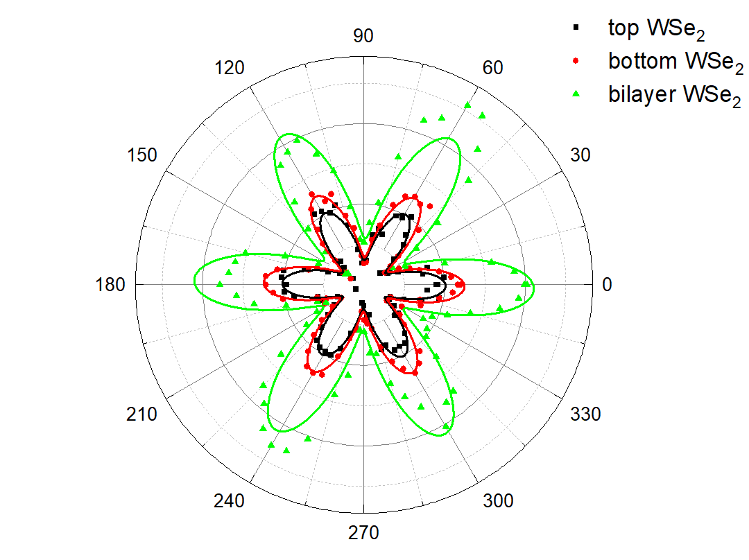
Figure S1. The twist angle is determined using polarization-resolved second harmonic generation (SHG) spectroscopy. The signal is fitted using $y=y_{0}+A\sin^{2}\left(\frac{π}{w}\left(x-x_{c}\right)\right)$, where $x$ is the polarization angle and $x_{c}$ is the crystal orientation. In the fitting procedure, $w$ is fixed to ${60}^{∘}$, which leave $y_{0}$ and $A$ as free fitting parameters. Each of the layer is fitted: black for top layer, red for bottom layer WSe₂ and green for the twisted bilayer WSe₂. The increase in the signal as shown green for bilayer manifests that it is rhombohedral stacked WSe₂. The twist angle between two layers is $0.22°±0.5°$.

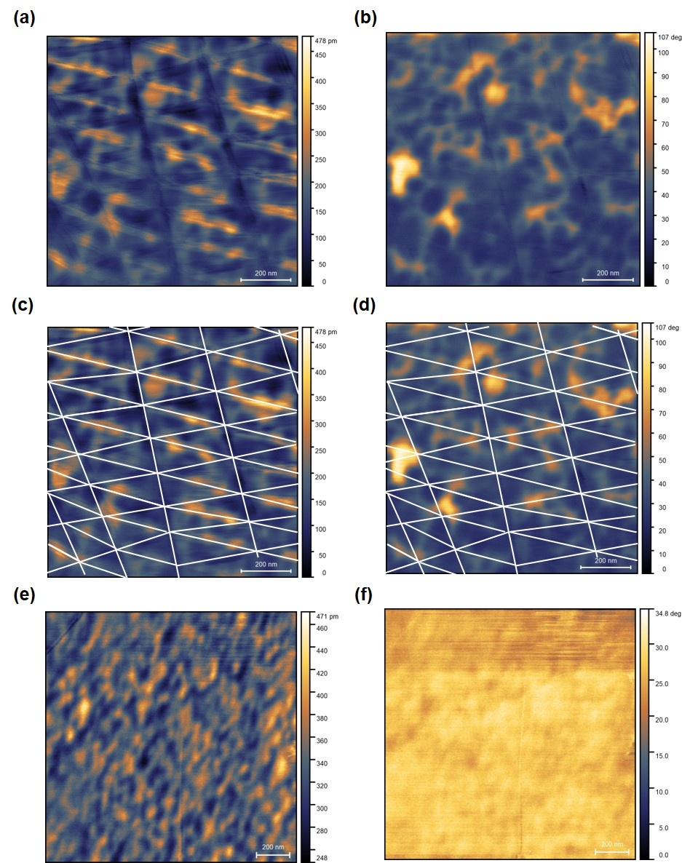
Figure S2. Single frequency vertical-PFM image of t-WSe₂ and monolayer WSe₂. (a) PFM amplitude and (b) phase map of t-WSe₂ region. Corresponding domain-resolved (c) amplitude and (d) phase maps are shown, with white lines indicating the domain boundaries between the AB and BA stacking order. (e) PFM amplitude and (b) phase map monolayer WSe₂ region.

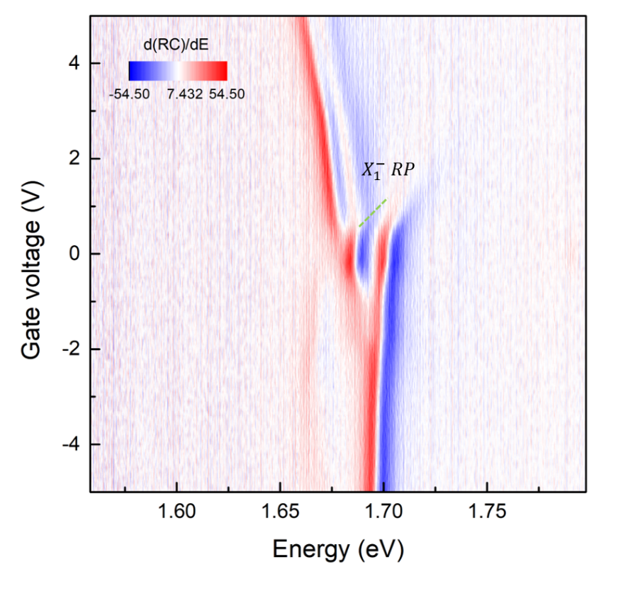
Figure S3. Gate voltage-dependent plot of the first energy derivative of the reflectance contrast $d(RC)/dE$ in t-WSe₂. Green dashed line indicates the emergence of $X_{1}$ repulsive polaron in the electron-doped regime ($X_{1}^{-} RP$).

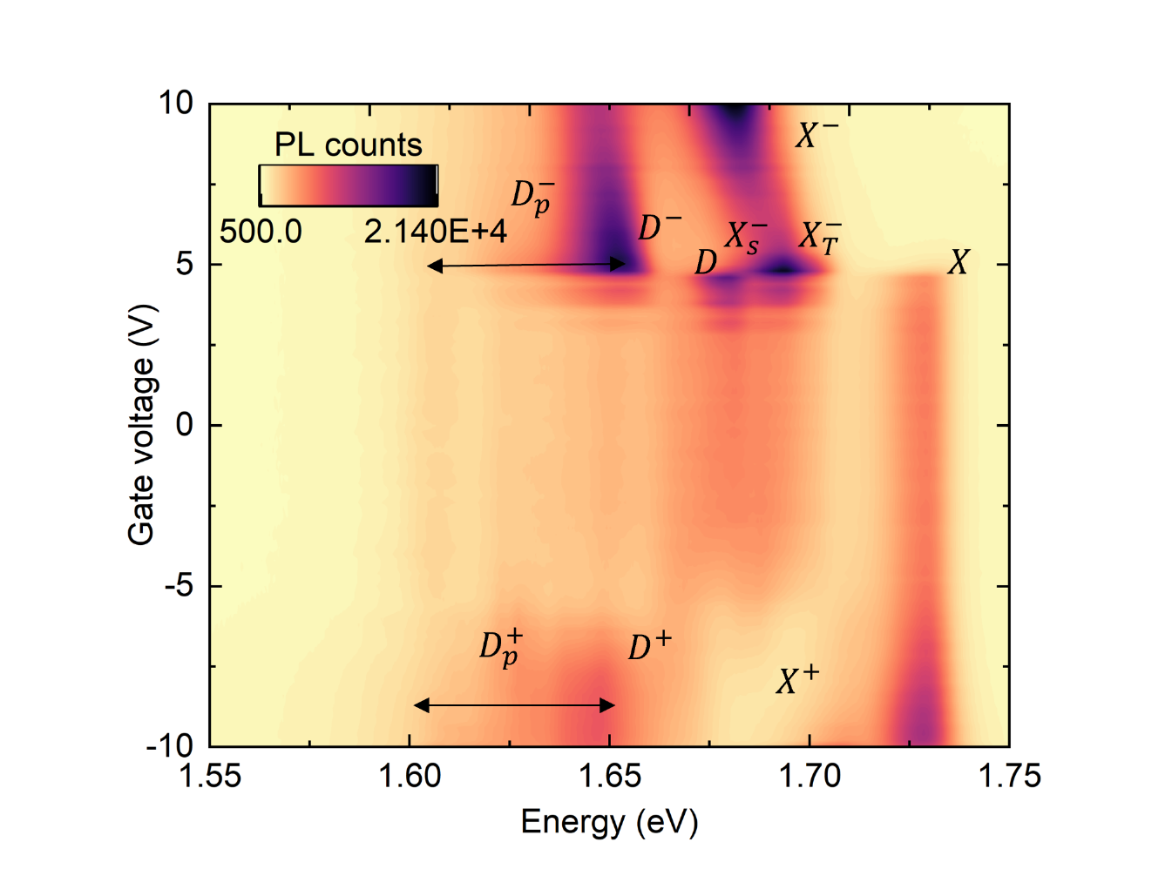
Figure S4. Excitonic complexes observed in $V_{G}$-dependent PL in monolayer WSe₂. Following many prior results [6,10–15], we identify the bright A exciton $(X)$, trions $(X^{-}, X^{+})$, dark exciton and its trions $(DX, DX^{+}, DX^{-})$, and the phonon replicas $(D_{p}, D_{p}^{+}, D_{p}^{-})$. PL measurements were conducted at 4 K using a 632.8 nm diode laser.

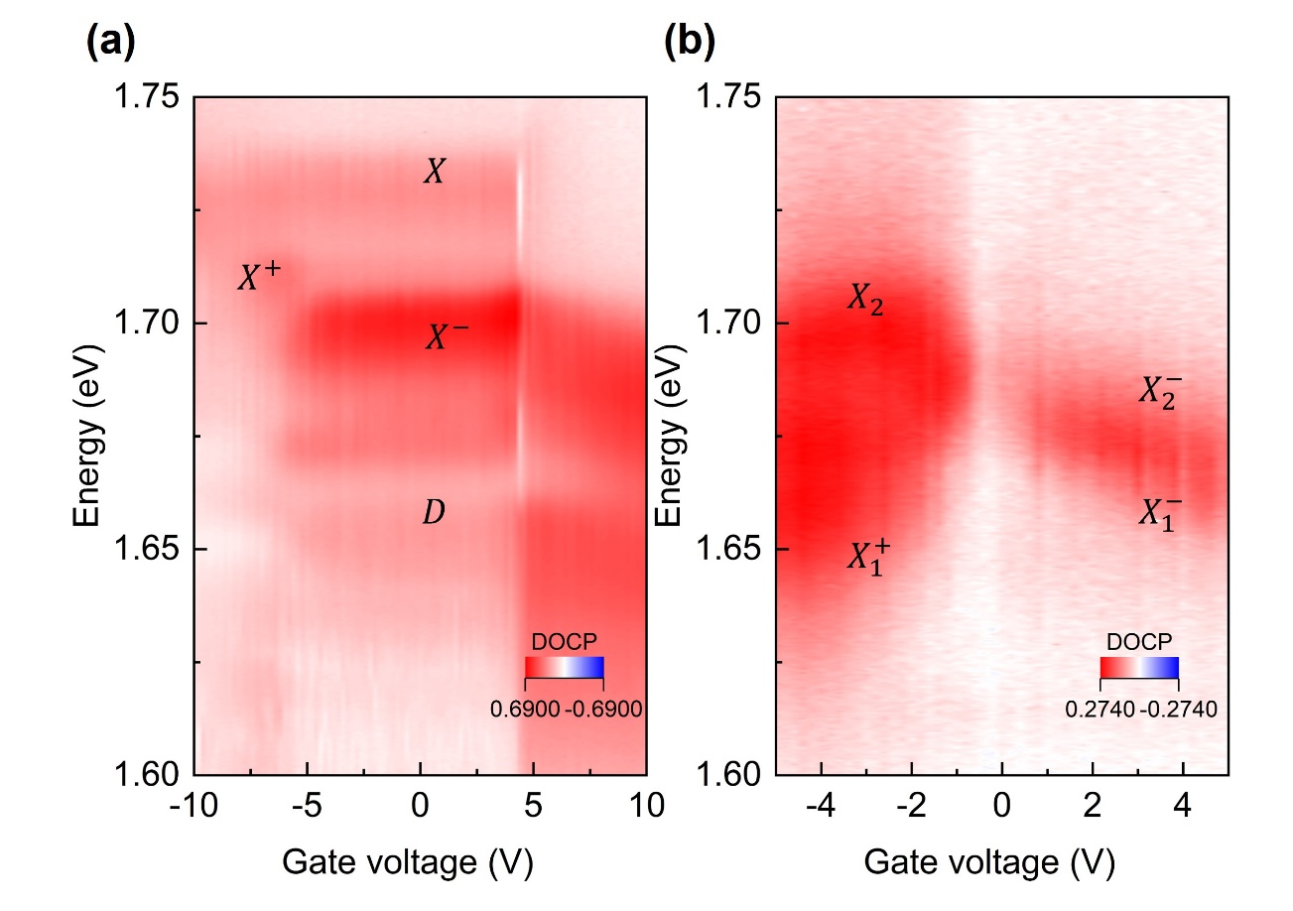
Figure S5. $V_{G}$-dependent degree of circular polarization (DOCP) measurements. (a) Monolayer WSe₂ and (b) twisted WSe₂ homobilayer (t-WSe₂). Across all doping regimes, the observed excitonic species exhibit a non-zero DOCP, indicating finite valley polarization under circularly polarized excitation.
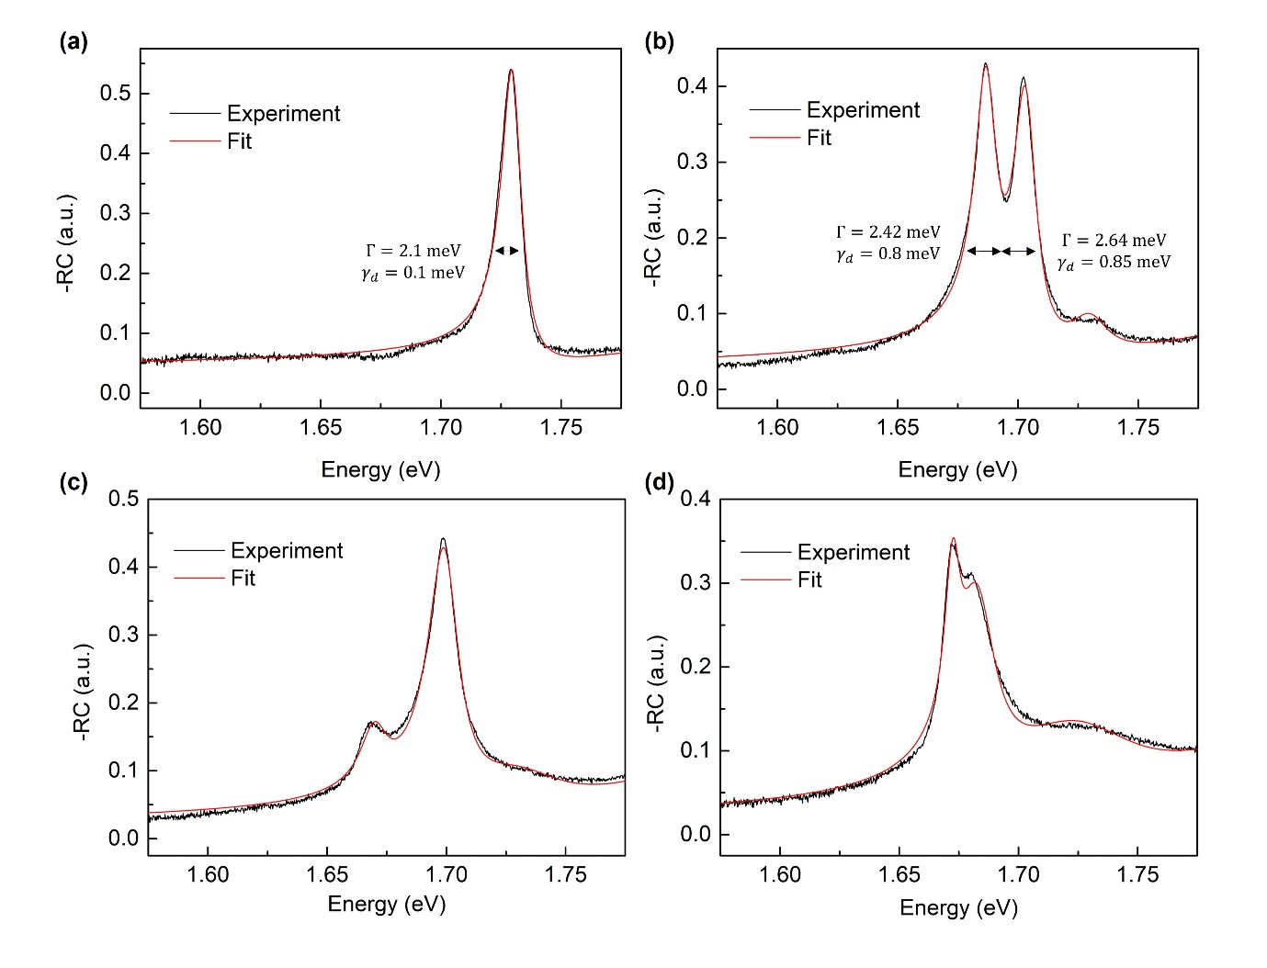
Figure S6. Fitted RC spectrum of monolayer WSe₂ and twisted bilayer WSe₂. (a) Fitted RC spectrum of monolayer WSe₂ in the neutral regime. (b) Fitted RC spectrum of t-WSe₂ in the neutral regime. The homogeneous linewidth is denoted by $Γ$, and the pure-dephasing rate by $γ_{d}$. (c) Fitted RC spectrum of t-WSe₂ at -2 V. (d) Fitted RC spectrum of t-WSe₂ at 3 V. The green line indicates experimental RC spectrum, while the red dashed line shows the corresponding fitted spectrum.
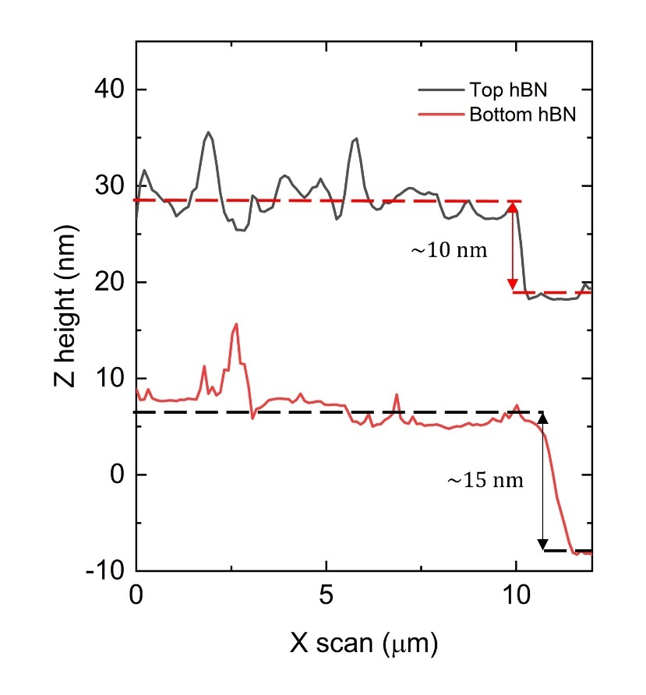
Figure S7. Atomic force microscopy measurement for top (black) and bottom (red) hexagonal boron nitride (hBN). Line-profile along the interface between hBN and the substrate. The arrows indicate the estimated thicknesses for both layers, 10 nm (top) and 15 nm (bottom), respectively.

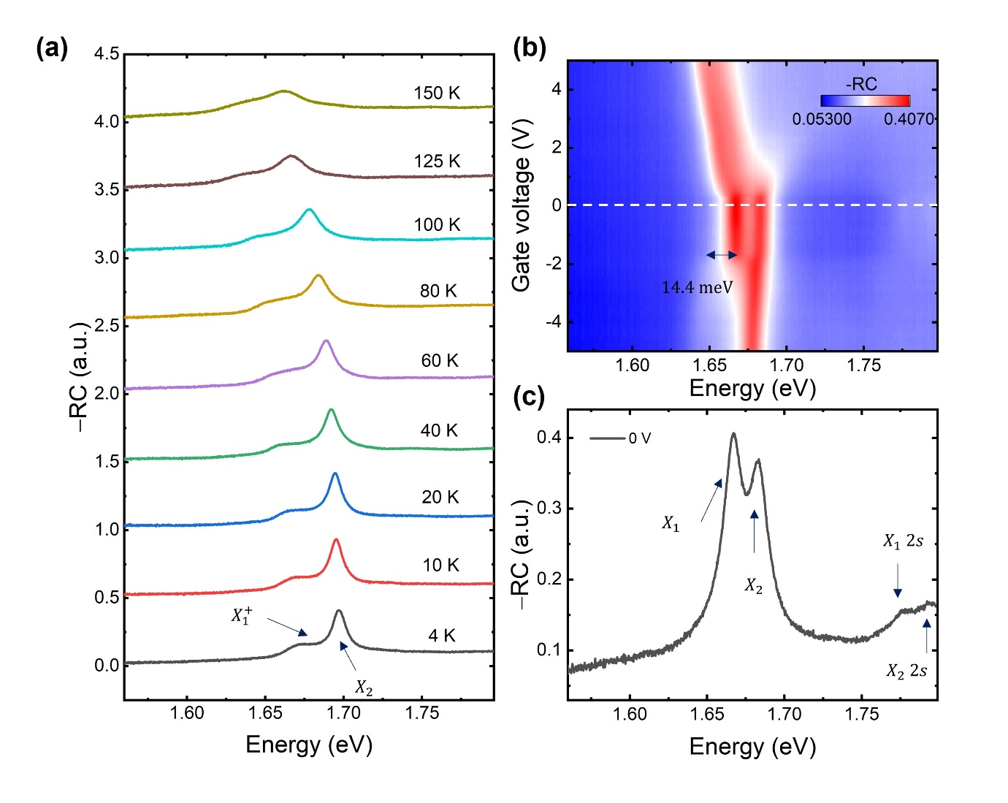
Figure S8. Temperature-dependent reflection contrast (RC) spectra. (a) Temperature-dependent RC spectra from at gate voltage – 4 V, ranging from 4 K to 150 K. Attractive polaron associated to $X_{1}$ ($X_{1}^{+}$) diminishes when the temperature increases above 150 K. The exciton-polaron binding energy measured from exciton-attractive polaron splitting is approximately $14.8±0.5 meV$ which is comparable to the thermal energy of $k_{B}T≈12.95 meV$. (b) $V_{G}$-dependent RC spectra at 100 K from gate voltage -5 V to 5 V. White dashed line indicates the line-profile at 0 V. The exciton-polaron splitting, marked by a double-headed arrow, is measured to be $14.4 meV$. (c) RC spectra at 0 V. $X_{1},X_{2}, X_{1}$ 2s transition, $X_{2}$ 2s transition are shown in the spectrum.

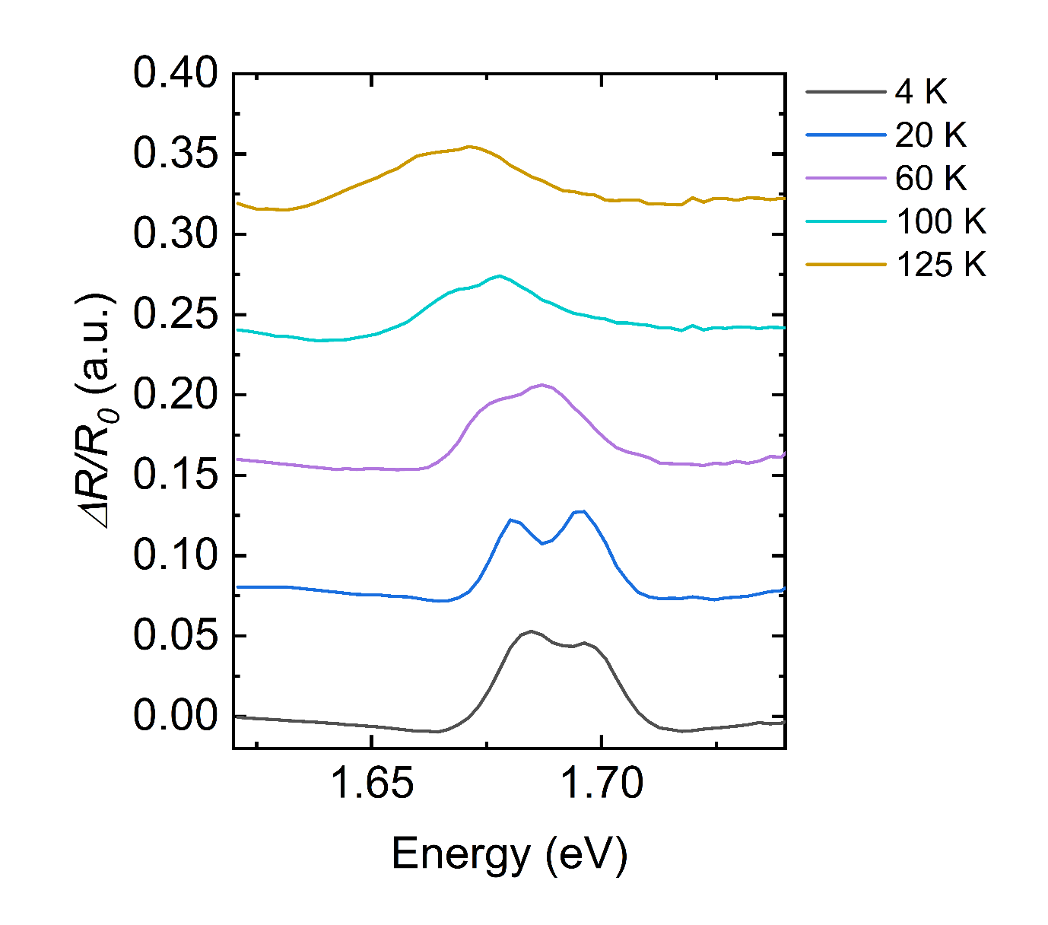
Figure S9. Temperature dependent spectra of differential reflectance $ΔR/R_{0}$ of t-WSe₂, using a photoexcitation energy of 1.79 eV from 4 K to 125 K. Similar linewidths broadening and energy redshift is observed for both excitons $X_{1}$ and $X_{2}$ in steady-state reflection contrast measurement [Fig. 4 (a)].

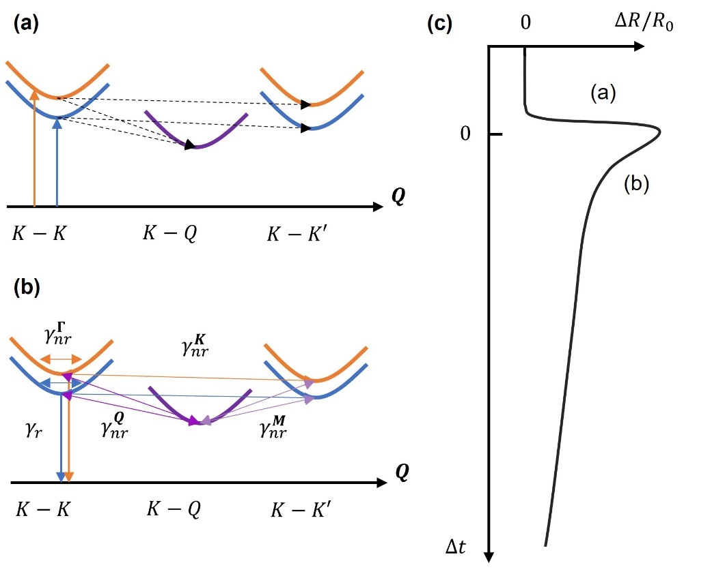
Figure S10. Schematic representation of exciton formation, thermalization, and decay in excitonic center-of-mass motion $(Q)$. (a) Upon photoexcitation, coherent $K-K$ coherent excitons corresponding to $X_{1}$ (blue) and $X_{2}$ (orange) states are initially generated. Within sub-picosecond timescales, incoherent excitons are formed via phonon-assisted processes with the holes remaining in the $K$ valley. (b) Intra- and intervalley exciton-phonon scattering, as well as exchange interactions, drive exciton thermalization by redistributing the population among available excitonic states. Excitons within the light cone $(K-K)$ undergoes radiative recombination ($γ_{r}$). After thermalization, most excitons are located in energetically favorable $K-Q$ states, which lie outside of light cone. Nonradiative decay process, denoted by $γ_{nr}^{i}$ arise from phonon-mediated coupling $(i=Γ, K, M, Q)$. (c) Representative $ΔR/R_{0}$ schematic diagram of an exciton, illustrating the sequential processes of the exciton generation (a), thermalization, and subsequent radiative or nonradiative decay (b).

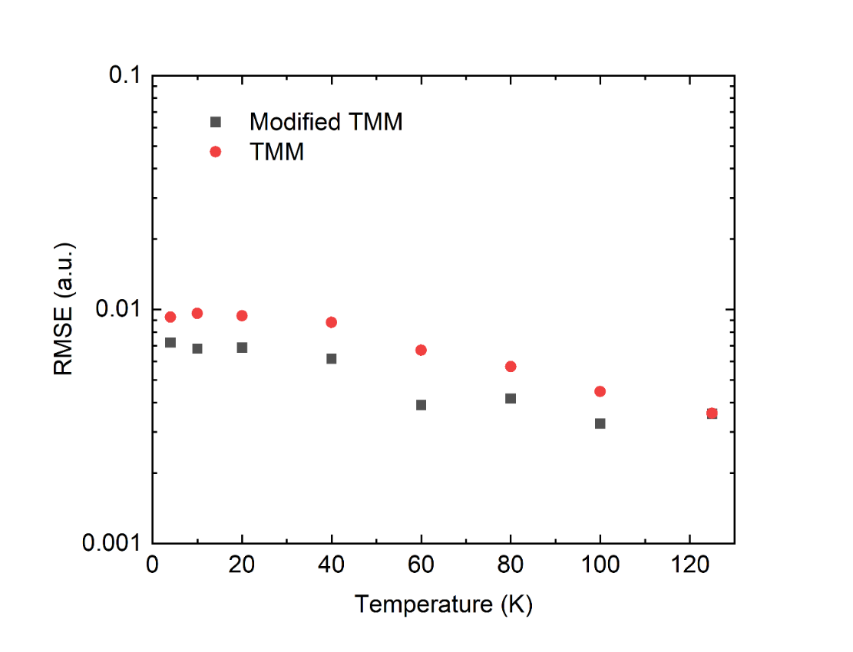
Figure S11. The comparison model we take is the conventional TMM which uses a Lorentzian complex susceptibility $χ=χ_{bg}+\frac{f}{E_{0}^{2}-E^{2}-iEΓ}$. [16,17] The best fit of all temperature range is obtained for the modified TMM, which accounts for dephasing rate as well as the inhomogeneous linewidth. Root-mean-square error (RMSE) is used as figure-of-merit for temperature-dependent t-WSe₂ reflection contrast.

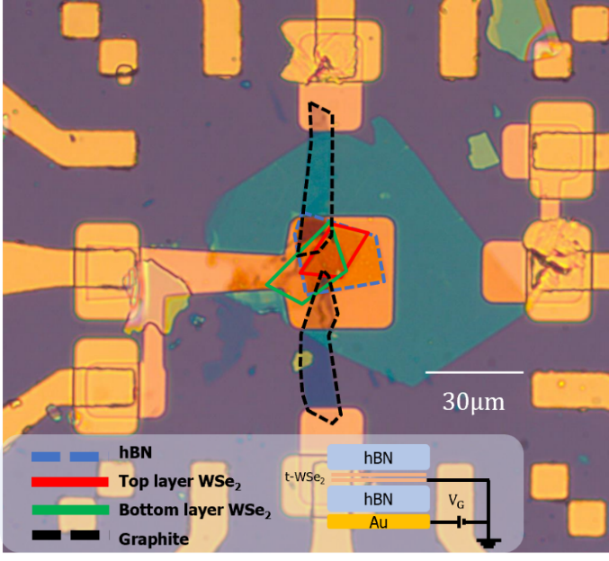
Figure S12. Optical microscopic image of the twisted WSe₂ homobilayer sample in the main text. The twist angle is $0.22°±0.5°$, aforementioned in Fig. S1. The sample is encapsulated by hBN layers, and has few-layer graphene (graphite) for electric contact. The blue dashed line indicates top hBN layer, red solid line is top WSe₂ layer, green solid line is bottom WSe₂ layer, and black dashed line is the few-layer graphene.

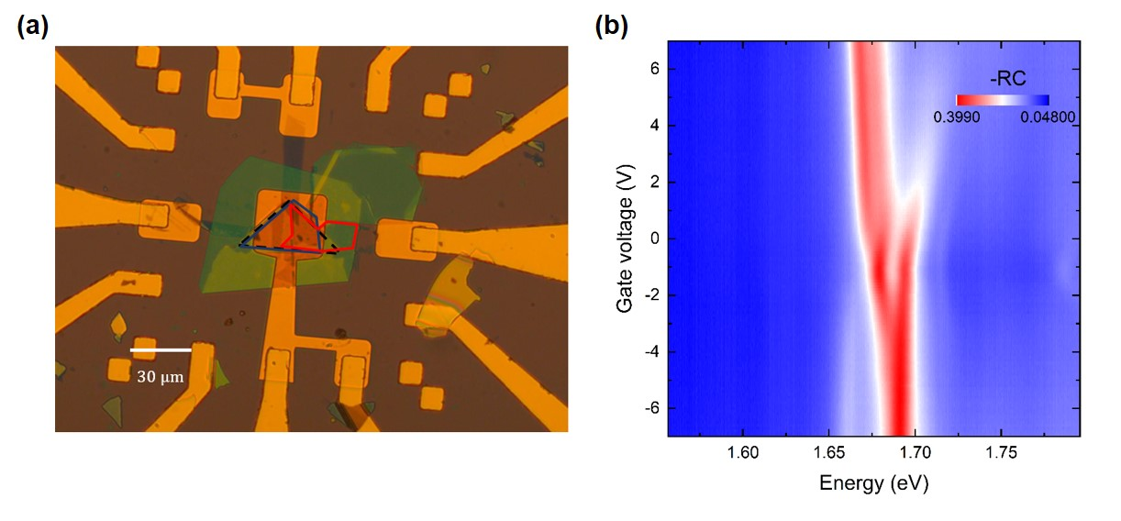
Figure S13. (a) Optical microscopic image of the fabricated t-WSe₂ with a twist angle of $0.4°±0.5°$. The red and blue lines indicate the top and bottom WSe₂ layers, respectively, while the black dashed line marks the top hBN flake. (b) $V_{G}$-dependent reflection contrast of the $0.4°±0.5°$ t-WSe₂. Two intralayer excitons, $X_{1}$ and $X_{2}$, are observed in the charge-neutral regime (marked as a white dashed line), showing a response in both hole- and electron-doped regimes that is qualitatively similar to the device with a $0.22°±0.5°$ twist angle.

References

[1] L. Qiu, C. Chakraborty, S. Dhara, and A. N. Vamivakas, Room-temperature valley coherence in a polaritonic system, Nat. Commun. 10, 1513 (2019).
[2] H. A. MacLeod, Thin-Film Optical Filters, 3rd ed. (CRC Press, Boca Raton, 2001).
[3] E. L. Ivchenko and G. E. Pikus, Superlattices and Other Heterostructures: Symmetry and Optical Phenomena, Vol. 110 (Springer, Berlin, Heidelberg, 1997).
[4] J. Kim et al., Correlation-driven nonequilibrium exciton site transition in a WSe2/WS2 moiré supercell, Nat. Commun. 15, 3312 (2024).
[5] D. K. Efimkin, E. K. Laird, J. Levinsen, M. M. Parish, and A. H. MacDonald, Electron-exciton interactions in the exciton-polaron problem, Phys. Rev. B 103, 075417 (2021).
[6] E. Liu, J. van Baren, Z. Lu, T. Taniguchi, K. Watanabe, D. Smirnov, Y.-C. Chang, and C. H. Lui, Exciton-polaron Rydberg states in monolayer MoSe2 and WSe2, Nat. Commun. 12, 6131 (2021).
[7] A. Chernikov, T. C. Berkelbach, H. M. Hill, A. Rigosi, Y. Li, B. Aslan, D. R. Reichman, M. S. Hybertsen, and T. F. Heinz, Exciton Binding Energy and Nonhydrogenic Rydberg Series in Monolayer ${\mathrm{WS}}_{2}$, Phys. Rev. Lett. 113, 076802 (2014).
[8] G. Zhang, A. Chaves, S. Huang, F. Wang, Q. Xing, T. Low, and H. Yan, Determination of layer-dependent exciton binding energies in few-layer black phosphorus, Sci. Adv. 4, eaap9977 (2018).
[9] K. He, N. Kumar, L. Zhao, Z. Wang, K. F. Mak, H. Zhao, and J. Shan, Tightly Bound Excitons in Monolayer ${\mathrm{WSe}}_{2}$, Phys. Rev. Lett. 113, 026803 (2014).
[10] A. M. Jones et al., Optical generation of excitonic valley coherence in monolayer WSe2, Nat. Nanotechnol. 8, 634 (2013).
[11] A. Steinhoff et al., Biexciton fine structure in monolayer transition metal dichalcogenides, Nat. Phys. 14, 1199 (2018).
[12] Z. Li et al., Emerging photoluminescence from the dark-exciton phonon replica in monolayer WSe2, Nat. Commun. 10, 2469 (2019).
[13] A. Ben Mhenni et al., Breakdown of the Static Dielectric Screening Approximation of Coulomb Interactions in Atomically Thin Semiconductors, ACS Nano 19, 4269 (2025).
[14] E. Liu, J. van Baren, Z. Lu, M. M. Altaiary, T. Taniguchi, K. Watanabe, D. Smirnov, and C. H. Lui, Gate Tunable Dark Trions in Monolayer ${\mathrm{WSe}}_{2}$, Phys. Rev. Lett. 123, 027401 (2019).
[15] M. He et al., Valley phonons and exciton complexes in a monolayer semiconductor, Nat. Commun. 11, 618 (2020).
[16] M. Li, S. Biswas, C. U. Hail, and H. A. Atwater, Refractive Index Modulation in Monolayer Molybdenum Diselenide, Nano Lett. 21, 7602 (2021).
[17] V. Smejkal, C. Trovatello, Q. Li, S. D. Conte, A. Marini, X. Zhu, G. Cerullo, and F. Libisch, Photonic effects in the non-equilibrium optical response of two-dimensional semiconductors, Opt. Express 31, 107 (2023).

