Sprayable Tissue Adhesive Microparticle–Magnetic Nanoparticle Composites for Local Cancer Hyperthermia
Shima Ito^{1,2}, Kazuhiro Nagasaka^{1,2}, Hiyori Komatsu^{1,2}, Hiroaki Mamiya³, Masaki Takeguchi⁴, Akihiro Nishiguchi¹, Tetsushi Taguchi^{1,2}*
¹Biomaterials Field, Research Center for Macromolecules and Biomaterials, National Institute for Materials Science, 1-1 Namiki, Tsukuba, Ibaraki 305-0044, Japan
²Graduate School of Science and Technology, Degree Programs in Pure and Applied Sciences, University of Tsukuba, 1-1-1 Tennodai, Tsukuba, Ibaraki 305-8577, Japan
³Research Center for Magnetic and Spintronic Materials, National Institute for Materials Science, 1-2-1 Sengen, Tsukuba, Ibaraki 305-0047, Japan
⁴Research Center for Basic Research on Materials, National Institute for Materials Science, 1-2-1 Sengen, Tsukuba, Ibaraki 305-0047, Japan
Correspondence and requests for materials should be addressed to T. T. (email: TAGUCHI.Tetsushi@nims.go.jp)

Abstract
Incomplete removal of early-stage gastrointestinal cancers by endoscopic treatments often leads to recurrence induced by residual cancer cells. To completely remove or kill cancer tissues and cells and prevent recurrence, chemotherapy, radiotherapy, and hyperthermia using biomaterials with drugs or nanomaterials are usually administered following endoscopic treatments. However, there are few biomaterials that can be applied using endoscopic devices to locally kill cancer tissues and cells. We previously reported that decyl group-modified Alaska pollock gelatin-based microparticles (denoted C10MPs) can adhere to gastrointestinal tissues under wet conditions through the formation of a colloidal gel driven by hydrophobic interactions. In this study, we combined C10MPs with superparamagnetic iron oxide nanoparticles (SPIONs) to develop a sprayable heat-generating nanomaterial (denoted SP/C10MP) for local hyperthermia of gastrointestinal cancers. The rheological property, tissue adhesion strength, burst strength, and underwater stability of SP/C10MP were improved through decyl group modification and SPION addition. Moreover, SP/C10MP that adhered to gastrointestinal tissues formed a colloidal gel, which locally generated heat in response to an alternating magnetic field. SP/C10MP successfully killed cancer tissues and cells in colon cancer-bearing mouse models in vitro and in vivo. Therefore, SP/C10MP has the potential to locally kill residual cancer tissues and cells after endoscopic treatments.
Keywords: endoscope surgery, local hyperthermia, tissue adhesion, underwater stability, hydrophobic interaction
- Introduction
Endoscopic submucosal dissection (ESD) and endoscopic mucosal resection (EMR) are used as minimally invasive treatments to remove gastrointestinal cancers in Asian, European, and Latin American countries [1-4]. However, of the patients who undergo ESD or EMR to remove gastrointestinal cancers, 1.3%–4.2% experience recurrence induced by residual cancer tissues and cells [5-7] and require reoperation.
Chemotherapy and/or radiotherapy are usually administrated after ESD or EMR to prevent recurrence [8]. However, these therapies induce serious adverse events [9] because they affect not only cancer cells but also normal cells. To mitigate these adverse events, researchers have designed biomaterials to treat cancer cells and tissues using chemical and thermal methods that locally kill cancer tissue and cells [10-12]. Photodynamic therapy (PDT) using photosensitizer and local laser irradiation by endoscopic technique is known as a minimally invasive and local treatment method [13, 14]. However, patients need to avoid sunlight exposure for several weeks to prevent skin phototoxicity which decreases the quality of life of patients [15]. Hyperthermia is a thermal cancer treatment that exploits the greater sensitivity of cancer tissues, compared with normal tissues, to heat in the temperature range of 42 to 45 °C [16-20]. Hyperthermia treatments use heat-generating agents, such as gold nanoparticles [21, 22], black phosphorus [23, 24], and quantum dots [25, 26], to increase the temperature at the cancer site. To date, there are two methods to accumulate heat-generating agents at cancer sites. One method is to coat the nanoscale heat-generating agent with poly(ethylene glycol), which prolongs blood circulation for enhanced permeability and retention, thus increasing the local concentration of the agent at the target site following intravenous injection [27]. However, achieving high delivery efficiency of the agent is still a challenge. The other method is to combine the heat-generating agent with biomaterials, such as hydrogels, fiber sheets, and microparticles (MPs), which deliver the agent directly to the target site in high concentrations. Iron oxide nanoparticles respond to an alternating magnetic field (AMF) and have been used as heat-generating agents owing to their biocompatibility [28]. Researchers have combined iron oxide nanoparticles with hydrogels [29], fiber sheets [30], and MPs [31] to increase the concentration of the nanoparticles at the target site for hyperthermia treatments. Although these composite materials can be used for hyperthermia treatments of cancer, they do not readily adhere to soft tissues under wet conditions for stable retention of heat-generating agents on the cancer cite. Meanwhile, the sprayable property of materials is also important when applying materials in the spatially limited gastrointestinal tract. Therefore, biomaterials are required that can not only locally kill residual cancer tissues and cells after endoscopic surgery but also have a sprayable property and adhere to soft tissues under wet conditions.
We previously developed a wound dressing based on MPs (denoted C10MPs) prepared from decyl group-modified Alaska pollock gelatin (C10-ApGltn) [32]. C10MPs readily adhere to gastrointestinal tissues (e.g., esophagus, stomach, duodenum, and large intestine) under wet conditions through the formation of a colloidal gel as C10MPs hydrate [33-35]. Furthermore, we demonstrated that the C10MPs colloidal gel can close ex vivo duodenal perforations models [35] and cover ulcers of in vivo porcine ESD models [34]. In addition, C10MPs are sprayable using an endoscopic device, which facilitates local delivery of C10MPs to the part of the gastrointestinal tract where the cancer had been removed [36].
In this study, we combined superparamagnetic iron oxide nanoparticles (SPIONs) with C10MPs to obtain SPION-mixed C10MP composites (SP/C10MP powder) for local cancer hyperthermia treatment and stable tissue adhesion (Fig. 1(a)). We confirmed that SP/C10MP powder was sprayable for easy delivery using an endoscopic device and that colloidal gels formed on gastrointestinal tissues (Fig. 1 (b)). Then, we performed rheological measurements, tissue adhesion tests, and underwater stability tests on SP/C10MP colloidal gel, obtained after hydration of SP/C10MP powder, to clarify the interactions within the SP/C10MP colloidal gel and at the interface between the colloidal gel and tissue for stable tissue adhesion. (Fig. 1(c)). Furthermore, we evaluated the ablation effect of heat generated by the SP/C10MP colloidal gel upon AMF exposure on cancer cells. Finally, in vivo hyperthermia treatment of a colon cancer-bearing mouse model using SP/C10MP colloidal gel and AMF was evaluated (Fig. 1(d)).
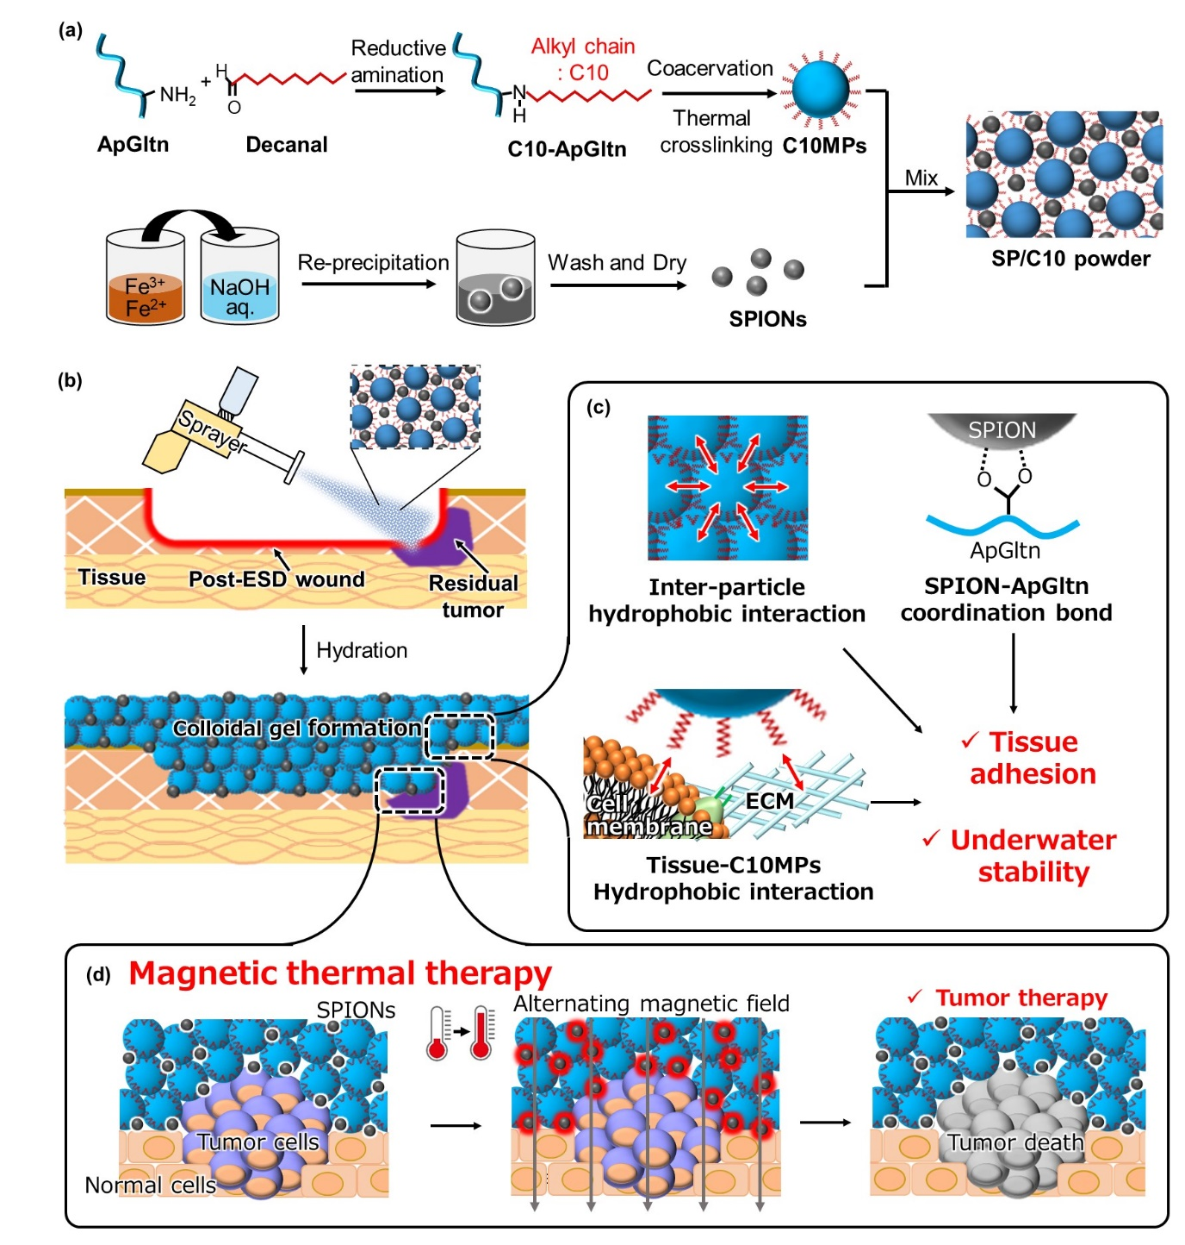
Fig. 1. Local hyperthermia of cancers using SPION/C10MP. (a) C10-ApGltn was synthesized by reductive amination using ApGltn and decanal. C10MPs were prepared by coacervate formation, freeze-drying, and thermal crosslinking. SPIONs were synthesized by co-precipitation of Fe²⁺ and Fe³⁺ at high pH. Obtained C10MPs and SPIONs were physically mixed to produce SPION-mixed C10MPs (SP/C10MP powder). (b) Application of SP/C10MP powder. SP/C10MP powder can be delivered using a spray device to the wound where the residual cancer remains after endoscopic treatment. SP/C10MP powder forms a colloidal gel on the tissue by hydration. (c) Mechanism of tissue adhesion and underwater stability of colloidal gel. C10MPs assemble with neighboring C10MPs through hydrophobic interactions after hydration, and SPIONs form coordination bonds with the carboxyl groups of C10-ApGltn, which improves the rheological property of the colloidal gel. Decyl groups of C10MPs also interact with the tissue through hydrophobic interactions. These interactions contribute to the improved tissue adhesion strength and underwater stability. (d) Magnetic thermal cancer therapy using SP/C10MP colloidal gel. In response to a magnetic field, SPIONs in the colloidal gel locally generate heat, which kills residual cancer cells and tissues.

2. Materials and Methods
2-1. Materials
Alaska pollock gelatin (Mw = 34,323 Da, amino group content = 355 µmol/g) was purchased from Nitta Gelatin (Osaka, Japan). Ethanol and 2-picoline borane were purchased from Junsei Chemical Co. (Tokyo, Japan). Iron (Ⅱ) chloride anhydrous, iron (Ⅲ) chloride anhydrous, sodium azide, formalin buffer solution (10%), and 4% paraformaldehyde were purchased from Wako Pure Chemical Industry Co. (Osaka, Japan). Fresh porcine stomach was purchased from Tokyo Shibaura Zouki (Tokyo, Japan). Saline was purchased from Otsuka Pharmaceutical Co. (Tokyo, Japan). Water-soluble tetrazolium (WST)-8 reagent (Cell Count Regent SF) was purchased from Nacalai Tesque (Kyoto, Japan). Dimethyl sulfoxide, trimethylamine, decanal, and 2, 4, 6-trinitrobenzensulfonic acid (TNBS) were purchased from Tokyo Chemical Industry Co. (Tokyo, Japan). Dulbecco's modified Eagle medium (DMEM), phalloidin with rhodamine, and fetal bovine serum (FBS) were purchased from Sigma Aldrich (St. Louis, MO, USA). Penicillin/streptomycin (P/S) was purchased from Thermo Fischer Scientific (Waltham, MA, USA). Human mesenchymal stem cells (hMSCs) were purchased from PromoCell (Heidelberg, Germany). Luciferase stably expressing cell line (KM12; human colon cancer) was purchased from the National Institutes of Biomedical Innovation, Health and Nutrition (Osaka, Japan). Triton X-100 was purchased from Cayman Chemical (Ann Arbor, MI, USA. 4′,6-Diamidino-2-phenylindole dihydrochloride (DAPI) was purchased from DOJINDO (Kumamoto, Japan). Nude mice (BALB/c-nu, male, 6 weeks old) were purchased from The Jackson Laboratory Japan (Kanagawa, Japan). D-luciferin potassium was purchased from PerkinElmer (Waltham, MA, USA).

2.2. Synthesis of C10-ApGltn
Decyl group-modified Alaska pollock gelatin (C10-ApGltn) was synthesized by reacting the amino groups of ApGltn with decanal as previously reported [32, 35, 37]. In brief, 100 g of ApGltn was dissolved in 350 mL of ultrapure water at 50 °C with stirring at 400 rpm. Decanal (0.0710 mol; 2 molar equivalents of amino groups in ApGltn) in 50 mL of ethanol was added to the ApGltn solution, followed by stirring for 1 h. Next, 2-picoline borane (0.0355 mol; 1 molar equivalent of amino groups in ApGltn) in 100 mL of ethanol was added to the solution with stirring at 400 rpm. The concentration of the resulting solution was 20 w/v% ApGltn (water/ethanol = 350/150 (mL/mL)). The reaction was continued for 17 h at 50 °C, and the resulting solution was carefully dropped into ethanol (5000 mL) for precipitation at 25 °C. The precipitate was washed three times with 2500 mL of ethanol at 25 °C to remove the remaining decanal and 2-picoline borane, and then it was vacuum-dried under 3 mbar overnight to give C10-ApGltn. The degree of substitution (DS) was measured as previously reported [32]. Residual amino groups in ApGltn and C10-ApGltn were quantified using TNBS. Introduction of decyl groups into ApGltn was also confirmed using Fourier transform infrared spectroscopy (FT-IR; ALPHA Ⅱ; Brucker, Billerica, MA, USA) and ¹H nuclear magnetic resonance (¹H NMR; JNM-AL300, JEOL, Tokyo, Japan).

2.3. Preparation of C10MPs
C10MPs were prepared as previously reported [33, 35, 37]. C10-ApGltn was first dissolved in ultrapure water with stirring at 50 °C to give 5 w/v% ApGltn solution. The same volume of ethanol, a poor solvent for ApGltn, was carefully dropped into the C10-ApGltn solution to form a coacervate in the mixture. The coacervate in the water/ethanol mixture was then frozen at –30 °C for 24 h and freeze-dried for 2 days. Finally, the coacervate was thermally treated at 150 °C for 3 h to crosslink C10-ApGltn molecules and obtained C10MPs. The same procedure was repeated with ApGltn (without decyl group modification) to obtain ApGltn MPs (denoted OrgMPs). Obtained C10MPs were characterized using scanning electron microscopy (SEM; JCM7000, JEOL), and particle diameter analysis was performed using ImageJ (NIH, Bethesda, MD, USA).

2.4 Synthesis of SPIONs
SPIONs were synthesized through co-precipitation of Fe²⁺ and Fe³⁺ ions using a NaOH solution as previously reported [38-41]. Briefly, 2 g of FeCl₂ anhydrous (2 g) and 5.4 g of FeCl₃ anhydrous were dissolved in 5 mL of ultrapure water to obtain a Fe²⁺ and Fe³⁺ solution (1:2 molar ratio). The solution obtained was carefully dropped into 1.8 M NaOH solution (80 mL, pH 13.26, 50 °C) in a flask under nitrogen flow with stirring at 1200 rpm to produce black SPION precipitates. After stirring for 1 h, the SPION precipitates were collected by centrifugation and a magnet, and the supernatant was replaced with ultrapure water, followed by ultrasonication for 30 min (pH of the suspension = 12.44). The pH of the SPION precipitate suspension was adjusted to 7.4 using 1 M HCl solution. This washing procedure was repeated until the pH of the suspension was 7.4 after ultrasonication. Finally, the SPION precipitates were washed three times with ultrapure water and vacuum-dried under 3 mbar for 24 h to obtain SPION black powder. The obtained SPIONs were characterized using high-resolution transmission electron microscopy (HRTEM; JEM2100F, JEOL), transmission electron microscopy (TEM; JEM-ARM200F, JEOL), energy dispersive X-ray spectroscopy (EDX; JEM2100F, JEOL), X‐ray diffraction (XRD; RINT-Ultima Ⅲ, Rigaku Co., Tokyo, Japan), selected area electron diffraction (SAED; JEM2100F, JEOL), and Vibrating Sample Magnetometry (VSM; MPMS3, Quantum Design, San Diego, CA, USA). The diameter of the SPION particles was determined by analyzing TEM images using ImageJ (NIH).

2.5. Preparation of SP/C10MP powder
SPIONs and Org-/C10-MPs were physically mixed in a 2 mL tube at different weight ratios (SP/MP = 0/50, 20/50, 40/50, 60/50 mg/mg) to obtain SPION-mixed C10MP powder (SP/C10MP) and SPION-mixed OrgMP powder (SP/OrgMP) for the following experiments.

2.6. Water contact angle measurement
The water contact angle (WCA) was measured to evaluate the wettability of SP/C10MP and SP/OrgMP powders according to previous methods [33, 35]. The powder was fixed on a glass plate with a double adhesive tape, and the surface of the powder was smoothed with a spatula. Ultrapure water (10 µL) was dropped on the powder using a contact angle meter (DM700, Kyowa Interface Science Co., Saitama, Japan), and the WCA was measured and correlated with the decyl group modification and SPION content.

2.7. Preparation and characterization of SP/C10MP colloidal gel
SP/OrgMP and SP/C10MP colloidal gels were prepared by hydrating the powder using phosphate-buffered saline (PBS). Briefly, SP/OrgMP or SP/C10MP powder was placed on a silicone mold with a diameter of 10 mm and thickness of 1.5 mm, and the surface of the powder was smoothed with a spatula. The powder was then hydrated with 300 µL of PBS for 30 min. Excess water on the resulting colloidal gel was removed, and the weight of the colloidal gel (W_{w}) was measured, followed by freeze-drying. The weight of the freeze-dried gel (W_{d}) was measured, and the water contents of SP/OrgMP and SP/C10MP colloidal gels were calculated using the following formula. The mass of phosphoric acid in PBS was not included in the calculation.

$$Water content \left(\%\right)= \frac{W_{w}-W_{d}}{W_{w}} × 100$$

2.8. Observation of C10MP aggregation in PBS
SP/OrgMP and SP/C10MP powders were hydrated with PBS in a 2 mL tube to give a 5 w/v% suspension. The suspension was incubated for up to 30 min, and the aggregation of SP/C10MP powder was observed using bright-field microscopy (BZ-X710, Keyence, Osaka, Japan).

2.9. Measurement of rheological property of SP/C10MP colloidal gel
The rheological properties of SP/OrgMP and SP/C10MP colloidal gels were measured as previously reported [35]. SP/OrgMP and SP/C10MP powders with different weight ratios were placed on a silicone mold (diameter = 10 mm, thickness = 1.5 mm). After smoothing the surface of the powder with a spatula, the powder was hydrated with 300 µL of PBS at 37 °C for 30 min. The resulting colloidal gel was placed on the plate of a rheometer (MCR 301 Rheometer, Anton Paar, Graz, Austria) heated to 37 °C and fixed with a probe (diameter = 10 mm). The storage and loss moduli were measured as a function of the shear strain (0.1%–1000%) and angular frequency (0.1–100 rad/s).

2.10. FT-IR spectra
To determine the interactions between SPIONs and ApGltns, SP/OrgMP or SP/C10MP powders with SP/MP ratios of 0/50 and 40/50 (mg/mg) were hydrated with 300 µL of PBS in a silicone mold (diameter = 10 mm, thickness = 1.5 mm). The resulting colloidal gels were freeze-dried, and the FT-IR spectra of dried colloidal gels were acquired.

2.11. Tissue adhesion strength of SP/C10MP colloidal gel
The tissue adhesion strengths of SP/OrgMP and SP/C10MP colloidal gels were measured according to ASTM F2258-05. Briefly, fresh porcine stomachs were washed with ultrapure water, and the mucosa of the porcine stomach was removed with surgical scissors to expose the submucosal tissue. The resulting stomach tissue was cut into squares (2.5 × 2.5 cm). The serosa side of one square was fixed to a flat plate (37 °C), while the serosa side of another square was fixed to the probe of a texture analyzer (TA-XT2i, Stable Microsystems, Surrey, UK). To remove excess water on and in the tissue, 16-fold KimwipeTM was sandwiched between the two squares on the submucosal side at 80 kPa for 3 min. Then, SP/OrgMP or SP/C10MP powder with different SPION contents (SP/MP = 0/50, 20/50, 40/50, 60/50 mg/mg) was placed on the submucosal side and again sandwiched between the two squares at 80 kPa for 3 min. Finally, the tissue adhesion strength of SP/OrgMP and SP/C10MP was measured by lifting the probe at a speed of 10 mm/min (Fig. 4(a)). After measuring the tissue adhesion strength, the submucosal side of both squares were fixed with 10% formalin buffer solution and stained with hematoxylin-eosin (HE) to observe the interface between the colloidal gel and stomach submucosal tissue.

2.12. Burst strength with SP/C10MP colloidal gel
The burst strength with SP/OrgMP and SP/C10MP colloidal gels was also measured according to ASTM-F2392-04R with minor modifications as previously reported [37]. Fresh porcine duodenum was washed with water and cut into circles with a diameter of 35 mm. To prepare the ex vivo post-ESD perforation model on the duodenum, the mucosal layer (diameter = 10 mm) was removed with surgical scissors to expose the submucosal tissue, and a 1 mm pinhole was created in the center of the exposed submucosal tissue. Then, SP/OrgMP or SP/C10MP powders with SP/MP ratios of 0/50 and 40/50 (mg/mg) were placed on the prepared perforation model using a silicone mold (diameter = 10 mm, thickness = 1.5 mm). The powders were hydrated with 300 µL of PBS for 30 min to form colloidal gels. The burst strengths with SP/OrgMP and SP/C10MP colloidal gels were measured by applying air pressure to the colloidal gel at a rate of 2 mL/min (Fig. 4(f)).

2.13. Underwater stability of SP/C10MP colloidal gel
The underwater stability of SP/OrgMP and SP/C10MP colloidal gels applied on stomach tissues was evaluated by immersing the sample in saline as previously reported [33, 35, 37]. Briefly, fresh porcine stomachs were washed with ultrapure water, and the mucosal layer of the stomach was removed using surgical scissors. The exposed submucosal tissue was then cut into a circle with a diameter of 35 mm. SP/OrgMP and SP/C10MP powders with SP/MP ratios of 0/50 and 40/50 (mg/mg) were then placed on the stomach submucosal tissue using a silicone mold (diameter = 10 mm, thickness = 1.5 mm), and then they were hydrated with 300 µL of PBS for 30 min to form colloidal gels. Stomach submucosal tissues with deposited colloidal gels were immersed in saline containing 0.02 w/v% NaN₃ for 2 days. Then, stomach tissues with colloidal gels before and after immersion were fixed with 10% formalin buffer solution to observe the underwater adhesion stability of the colloidal gels. The remaining colloidal gel areas of SP/OrgMP and SP/C10MP colloidal gels were calculated using ImageJ and the following formula.

$$Remaining colloidal gel rate \left(\%\right)= \frac{Remaining colloidal gel area at day 2}{Remaining colloidal gel area at day 0} ×100$$

2.14. Heat-generating property of SP/C10MP colloidal gel in AMF
The heat-generating property of SP/C10MP colloidal gel in response to an AMF was measured using magnetic field applicators (G2 D5, Nanoscale Biomagnetics, Zaragoza, Spain). Briefly, SP/C10MP powders with SP/MP ratios of 0/50, 20/50, 40/50, and 60/50 (mg/mg) were placed in a silicone mold (diameter = 10 mm, thickness = 1.5 mm) and hydrated with 300 µL of PBS to obtain colloidal gels. Then, the obtained colloidal gel was placed on the stage of a magnetic field applicator and AMF (130 G, 373.35 kHz) was applied to the colloidal gel for up to 600 s. The temperature of the colloidal gel was measured using a thermal camera (Xi 400, Optris, Berlin, Germany).

2.15. Cell viability assessment with colloidal gel extract
Human mesenchymal stem cells (hMSCs) and a human colon cancer cell line (KM12-Luc) were cultured in DMEM medium containing 10% FBS and 1% P/S. Cells were seeded in a 96-well plate at a concentration of 5.0×10⁴ cells/well and incubated for 24 h at 37 °C under 5% CO₂ atmosphere. To prepare the medium with colloidal gel extract, SP/OrgMP and SP/C10MP colloidal gels with SP/MP ratios of 0/50 and 40/50 (mg/mg) were hydrated with PBS in a silicone mold (diameter = 10 mm, thickness = 1.5 mm). The resulting colloidal gels were immersed in 2 mL of DMEM medium for 24 h at 37 °C. After centrifugation of the medium containing the colloidal gel at 3400 rpm, the supernatant was used as the extractant. Medium containing the SPION extract was prepared by incubating 20 mg/mL SPION suspension for 24 h at 37 °C and centrifuging at 3400 rpm. The obtained extracts (100 µL) were added to the seeded hMSC and KM12-Luc cells and incubated for 24 h at 37 °C under 5% CO₂ atmosphere. Cell viability was measured with the mitochondrial activity test using WST-8 according to the manufacturer’s procedure.

2.16. Immunofluorescence staining
hMSCs and KM12-Luc cells, treated with the colloidal gel or SPION extract medium for 24 h, were fixed with 4% paraformaldehyde for 15 min and washed with PBS. Each sample was then treated with 0.2% Triton X for 15 min to permeabilize and washed with PBS. Then, 1% BSA/PBS was added, and the cells were incubated for 60 min at room temperature for blocking. Phalloidin with rhodamine was added, and the cells were incubated for 60 min and washed with PBS. Cell nuclei were stained with 0.001 mg/mL DAPI/PBS. The obtained samples were observed using confocal laser scanning microscopy (BZ-X700, Keyence).

2.17. In vitro thermal treatment using SP/C10MP colloidal gel
hMSCs and KM12-Luc cells were cultured in DMEM supplemented with 10% FBS and 1% P/S. hMSCs and KM12-Luc cells were seeded into 8-well glass plates at a concentration of 3.0×10⁵ cells/well and incubated for 24 h at 37 °C under 5% CO₂ atmosphere. The SP/C10MP colloidal gel was prepared by hydrating SP/C10MP powder (20/25 mg/mg) with 300 µL of PBS in a square silicone mold (length = 8 mm, thickness = 1 mm). The obtained SP/C10MP colloidal gel was added to the incubated hMSCs and KM12-Luc cells, and AMF (130 G, 373.35 kHz) was applied to the colloidal gel for 10 min to increase the surface temperature of the colloidal gel to 44 °C. After removing the SP/C10MP colloidal gel from the medium, the medium was replaced with 10% WST-8/DMEM, and the cells were incubated for 2 h. Finally, the cell number was estimated from the absorbance at 450 nm and the calibration curve. For control groups, hMSCs and KM12-Luc cells were cultured with or without SP/C10 colloidal gel and AMF.

2.18. LIVE/DEAD staining of KM12-Luc cells
LIVE/DEAD staining of KM12-Luc cells was performed according to the manufacturer’s protocol. Briefly, the obtained KM12-Luc cell samples were treated with PBS containing 2 µM calcein-AM and 4 µM EthD-Ⅲ and incubated for 15 min at room temperature. The resulting samples were washed with PBS and observed using confocal laser scanning microscopy (BZ-X700, Keyence).

2.19. In vivo biodegradability of SP/C10MP colloidal gel
All animal experiments were approved by the Animal Care and Use Committee of the National Institute for Materials Science. To prepare colloidal gels for implantation, SP/OrgMP and SP/C10MP powders with SP/MP ratios of 0/50 and 40/50 (mg/mg) were hydrated with 300 µL of PBS in a mold (diameter = 10 mm, thickness = 1.5 mm) for 30 min. The resulting colloidal gel was then implanted into the subcutaneous tissue of nude mice (BALB/c-nu, male, 6 weeks old, The Jackson Laboratory Japan) using a spatula, and the incision was closed with a surgical stapler. At 6, 12, and 18 days of post-implantation, the mice were sacrificed and the gels with surrounding tissues were fixed in 10% formalin buffer solution for HE staining.

2.20. In vivo magnet thermal ablation effect of SP/C10MP colloidal gel
The in vivo magnetic thermal ablation effect of SP/C10MP colloidal gel was evaluated using a human colon-derived cancer-bearing mouse model. The cancer-bearing mouse model was prepared according to a previous method [42]. Briefly, cultured KM12-Luc cells in PBS at 2.5×10⁶ cells/0.1 mL were injected into the subcutaneous tissue on the back of nude mice. After the cells were injected, the cancer size was measured until the cancer size exceeded 100 mm³. The cancer size was calculated according to the following formula:

$$Tumor volume \left({mm}^{3}\right)= \frac{ab^{2}}{2}$$

where a is the cancer length and b is the cancer width. After the cancer volume reached approximately 100 mm³, the mice were divided into 2 groups: control (untreated) group and SP/C10MP colloidal gel implantation with AMF group. For both groups, a subcutaneous space between the cancer and abdominal tissue was prepared for implantation after anesthesia. For the colloidal gel implantation group, the SP/C10MP colloidal gel (SP/MP = of 40/50 (mg/mg), diameter = 10 mm, thickness = 1.5 mm) was implanted into the subcutaneous space. The mice were then exposed to AMF at 130 G and 373.35 kHz daily for the first three days and once every two days from the fourth day [20], and the temperature on a skin surface was monitored with a thermal camera. Luciferin (30 mg/mL, 100 µL) was abdominally injected and allowed to distribute for 10 min, and cancer luminescence was observed using an IVIS imaging system (Lumina Ⅱ, PerkinElmer) once every six days. AMF loading and IVIS observation were repeated for 12 days. When the cancer length reached 20 mm, the mouse was sacrificed as a humanitarian endpoint, and the survival rate was calculated. At 18 days post-implantation, all mice were sacrificed, and cancers were fixed with 10% formalin buffered solution for HE staining and TdT-mediated dUTP nick-end labeling (TUNEL).

2.21. Statistical analysis
All data are shown as mean ± standard deviation calculated from 3 or 5 independent experiments. Statistical analysis was performed using GraphPad Prism v.8.0 (GraphPad Software, La Jolla, CA, USA). The following statistical significance levels were used: *p < 0.05, **p < 0.01, ***p < 0.001, and ****p < 0.0001.

3. Results and Discussion
3.1. Synthesis and characterization of C10-ApGltn
C10-ApGltn was synthesized by reacting the amino groups in ApGltn with decanal through Schiff base formation and reductive amination. The DS of obtained C10-ApGltn was 47 mol% (Table S1), indicating that almost half of the amino groups in ApGltn reacted with decanal. The number of amino groups in ApGltn was 355 µmol/g, and the molecular weight of ApGltn was 34,352 g/mol. Therefore, 12.2 amino groups were derived from lysine and hydroxylysine in one ApGltn molecule. After the reaction, 5.7 decyl groups were introduced into one ApGltn molecule. Introduction of the decyl groups was also confirmed by analyzing the FT-IR and ¹H-NMR spectra (Fig. S1). The FT-IR spectra showed an increase in the secondary amine stretching peak as well as the decyl group sp³ CH symmetric- and asymmetric-stretching peaks at 3,295 cm⁻¹, 3,927 cm⁻¹, and 3,871 cm⁻¹, respectively. The ¹H-NMR spectra showed an increase in the CH₂ peak at 1.24 ppm. These results further supported the presence of alkyl chains and the introduction of decyl groups.

3.2. Preparation and characterization of C10MPs
OrgMPs and C10MPs were prepared by coacervate formation, freeze-drying, and thermal crosslinking. According to the SEM images, both OrgMPs and C10MPs were spherical particles (Fig. 2(a, b)) with mean diameters of 3.5 ± 1.8 and 2.3 ± 1.0 µm, respectively (Fig. 2(c)). The smaller particle size of C10MPs indicated that aggregation of C10-ApGltn in water/ethanol mixed solvent was greater than that of Org-ApGltn.

3.3. Synthesis and characterization of SPIONs
SPIONs were synthesized by co-precipitating Fe²⁺ and Fe³⁺ ions from an alkaline solution. The obtained SPIONs were characterized using HRTEM, EDX, XRD, SAED, and magnetization measurements. The HRTEM image showed round- or square-shaped particles (Fig. 2(d)) and a highly aligned lattice with a distance of 2.14 Å, corresponding to the (400) lattice plane (Fig. 2(e)). Analysis of the size distribution revealed the formation of nanoparticles with diameters of 11.4 ± 2.4 nm (Fig. 2(f)). EDX measurements confirmed that the nanoparticles consisted of oxygen and iron atoms (Fig. S2), indicating the formation of pure iron oxide nanoparticles. The XRD and SAED patterns contained the specific diffraction peaks of Fe₃O₄, and the measured lattice distance was close to the reported data (JCPDS 00-019-0629), indicating that Fe₃O₄ nanoparticles were successfully synthesized (Fig. S3, S4 and Table S2). To determine the superparamagnetic property of the particles, we measured the magnetization of the obtained Fe₃O₄ nanoparticles as a function of magnetic field using VSM. As a result, the obtained Fe₃O₄ nanoparticles showed superparamagnetic behavior with negligible coercivity at high temperatures (Fig. S5). These results indicated that the obtained Fe₃O₄ nanoparticles were SPIONs with a saturation magnetization of 60.8 emu/g, which was comparable with that of previously reported SPIONs [38, 41, 43].

3.4. Wettability and spray application of SP/C10MP powder
Prepared OrgMPs or C10MPs and SPIONs were physically mixed in a 2 mL tube to obtain SP/OrgMP and SP/C10MP powders. To evaluate the effect of SPIONs on the WCA, the SP/MP ratio was varied as follows: 0/50, 20/50, 40/50, and 60/50 (mg/mg). As the SPION content increased, the WCA of both SP/OrgMP and SP/C10MP powders decreased (Fig. 2(h)). Specifically, when the SPION to C10MP ratios were 0/50 and 40/50, the WCAs were 90 ± 5° and 61 ± 7° (Fig. 2(i)), respectively. Some researchers reported that adding SPIONs leads to a hydrophilic surface, which lowers the WCA [44, 45]. This tendency toward hydrophilicity occurs because negatively charged SPIONs (Fig. S6) interact with the cations in PBS (e.g., Na⁺) and orient the surrounding water molecules [46]. Therefore, the hydrophilic properties of the mixed SP/C10MP powder were likely controlled by the SPION content. Owing to the rapid absorption of water by SP/C10MP powder to form a colloidal gel, SP/C10MP powder would efficiently absorb water on wound after cancer removal and would be useful for clinical applications. In addition, SP/C10MP powder was easily sprayed using an endoscopic device for delivery onto gastrointestinal tissues, where it formed an SPION-containing colloidal gel layer on the wet tissue after hydration (Fig. S7). Because it is difficult to detect the site where residual cancer tissue and cells remain after ESD or EMR, SP/C10MP powder is sprayed and covers the whole exposed submucosal tissue for better thermal treatment effect.

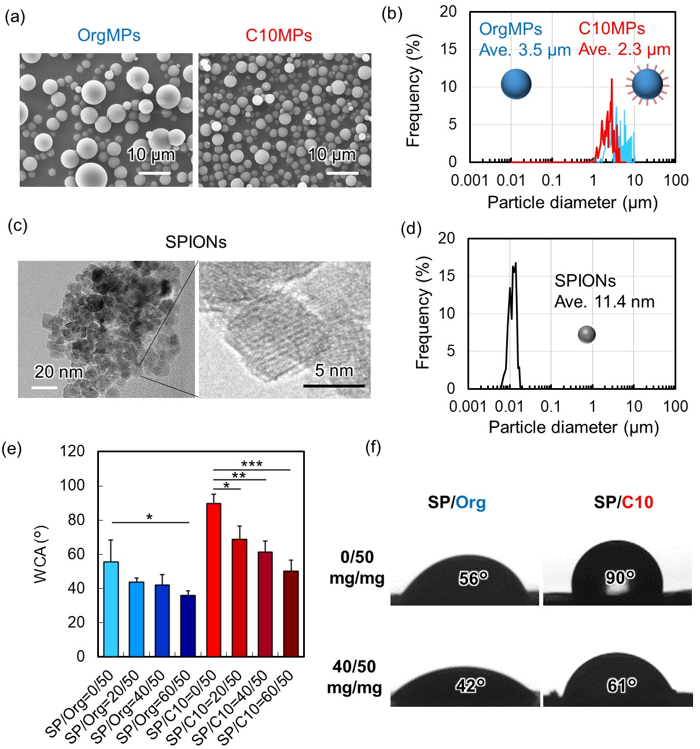
Fig. 2. Characterization of OrgMPs, C10MPs, SPIONs, and mixed powders. (a) SEM images of OrgMPs and C10MPs. Scale bars represent 10 µm. (b) Particle diameter distribution of OrgMPs and C10MPs showing mean diameters of 3.5 µm and 2.3 µm, respectively. (c) HRTEM images of SPIONs. Scale bars represent 20 nm (left) and 5 nm (right). (d) Particle diameter distribution of SPIONs showing an average diameter of 11.4 nm. (e) WCA of SP/OrgMP and SP/C10MP powders with SP/MP weight ratios of 0/50, 20/50, 40/50, and 60/50 (mg/mg). WCA was measured 2 s after the water droplet contacted the MPs. Statistical significance tested by Tukey’s multiple comparison test (n = 3): *p < 0.05, **p < 0.01, and ***p < 0.001. (f) Images of water droplets at 2 s after water droplets contacted SP/OrgMP or SP/C10MP powders with SP/MP ratios of 0/50 and 40/50 (mg/mg) and average WCA at 2 s after water droplets contacted the powder.
3.5. Characterization of SP/C10MP colloidal gel
SP/OrgMP and SP/C10MP colloidal gels were prepared by hydrating SP/OrgMP and SP/C10MP powders in a mold (Fig. 3(a)). To characterize the resulting colloidal gels, the water content was measured (Fig. 3(b)). As the weight of SPIONs in the colloidal gel increased, the water content decreased. The water content of the SP/C10MPs colloidal gel was lower than that of the SP/OrgMP colloidal gel because the former was more hydrophobic than the latter. We also observed the aggregation of C10MPs in the presence of SPIONs using bright-field microscopy. C10MPs started to aggregate immediately after the addition of water and formed a dense colloidal gel after 60 min of hydration (Fig. 3(d)). In contrast, OrgMPs did not aggregate and did not form a colloidal gel. This difference likely originated in the assembly of C10MPs, which was driven by hydrophobic interactions in the aqueous environment [33, 35, 37]. Aggregated SPIONs (yellow arrows) were also distributed and encapsulated in the colloidal gel, indicating that the resulting C10MP colloidal gel acted as a matrix for the retention of SPIONs. Next, the effect of adding SPIONs on the rheological property of the colloidal gel was investigated. The storage (G’) and loss (G”) moduli of the C10MP colloidal gel were measured as a function of shear strain and angular frequency. The storage modulus of the C10MP colloidal gel increased as the concentration of SPIONs increased (Fig. 3(d), (e)). The storage modulus of OrgMP also increased as the concentration of SPIONs increased. The storage moduli at the shear strain of 1% and angular frequency of 10 rad/s were compared, as shown in Fig. 3(f). The storage modulus of the SP/C10MP colloidal gel (15,290 Pa at SP/MP=0/50) was 44.4 times higher than that of the SP/OrgMP colloidal gel (344.74 Pa at SP/MP=0/50), indicating that by modifying the decyl group, C10MP was able to stabilize the colloidal gel structure through hydrophobic interactions between each C10MP to provide stiffness (Fig. 3(i)). Furthermore, the storage modulus also increased as the SPION content increased in both SP/OrgMP and SP/C10MP colloidal gels. Specifically, the storage modulus of the SP/C10MP colloidal gel with the highest SPION content (SP/MP=60/50) was 92,000 Pa, which was 6 times higher than the C10MP colloidal gel without SPIONs (SP/MP=0/50). To investigate this phenomenon, we obtained FT-IR spectra of freeze-dried SP/OrgMP and SP/C10MP colloidal gels (Fig. 3(g)). The peak arising from the stretching of carbonyl (C=O) groups (1,638 cm⁻¹) in OrgMPs and C10MPs shifted to a lower wavenumber (1,629 cm⁻¹) when SPIONs were added. Iron oxide nanoparticles can form coordination bonds with the carboxyl groups of organic molecules [43, 47]. These results suggested that SPIONs interacted with the carboxyl groups of the ApGltn molecule (Fig. 3(h)). The results also indicated that SP/C10MPs became a nanocomposite material after hydration (Fig. 3(j)).
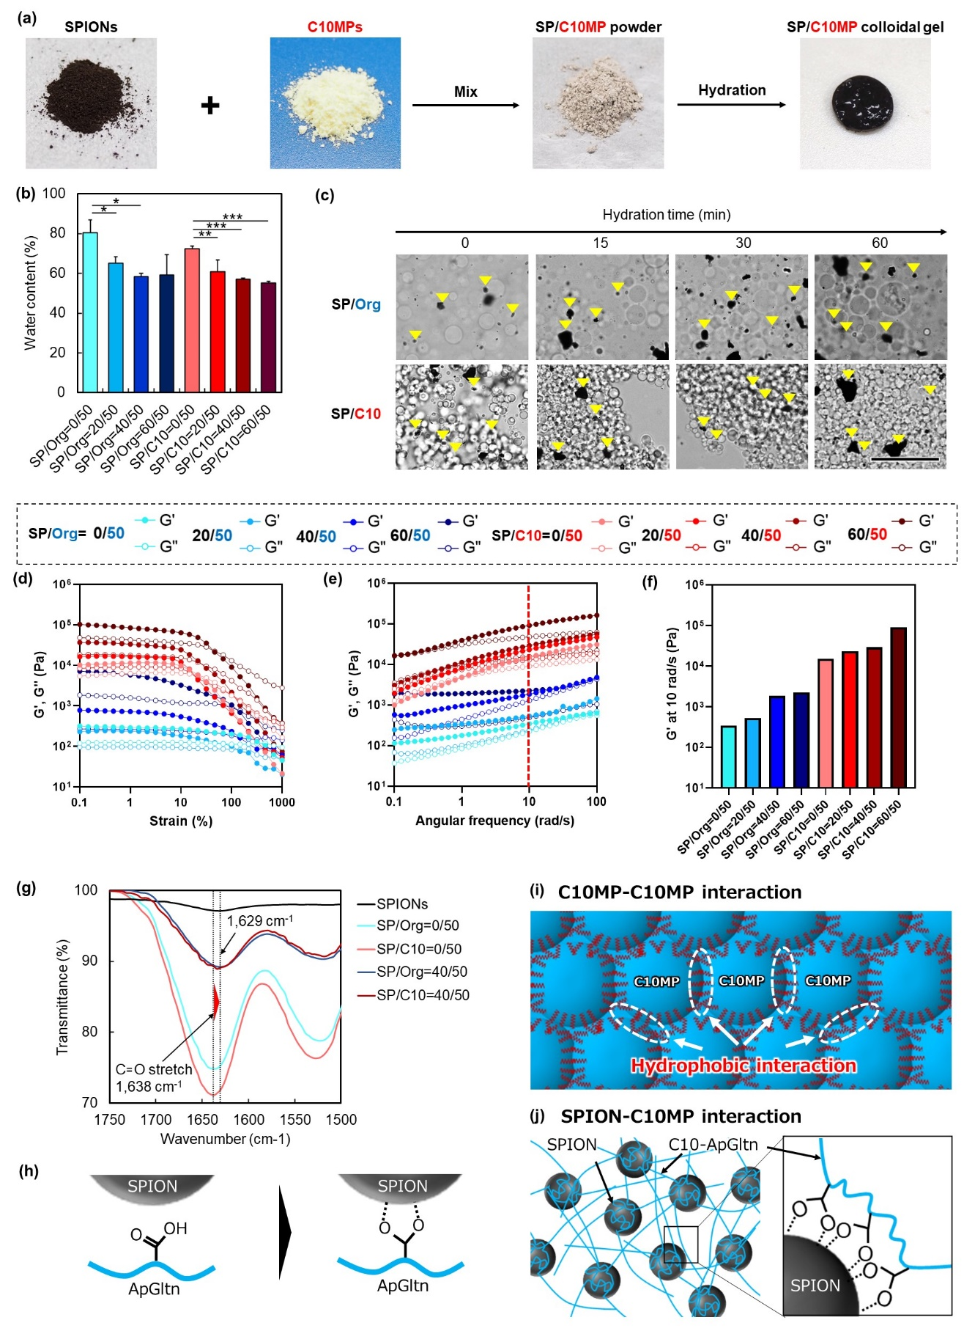
Fig. 3. Characterization of SP/OrgMP and SP/C10MP colloidal gels. (a) Preparation of the SP/C10MP colloidal gel. (b) Water content of SP/OrgMP and SP/C10MP colloidal gels. Statistical significance tested by Tukey’s multiple comparison test (n = 3): *p < 0.05, **p < 0.01, and ***p < 0.001. (c) Particle aggregation as a function of the hydration time (0, 15, 30, and 60 min). Yellow arrows indicate SPION aggregation. Scale bar represents 50 µm. C10MPs aggregated with particle hydration, indicating the existence of hydrophobic interactions. (d–f) Rheological properties of SP/OrgMP and SP/C10MP colloidal gel. Storage (G’) and loss (G”) moduli were measured at the (d) angular frequency of 10 rad/s and (e) shear strain of 1%. (f) Storage moduli of SP/OrgMP and SP/C10MP colloidal gels at the shear strain of 1% and angular frequency of 10 rad/s (n = 1). (g) FT-IR spectra of freeze-dried SP/OrgMP and SP/C10MP colloidal gels. (h) Schematic representation of the interactions between SPION and ApGltn molecule. Enhancement of storage modulus through (i) hydrophobic interactions among C10MPs and (j) the formation of coordination bonds between SPIONs and C10-ApGltn. The improved storage modulus of the C10MP colloidal gel was attributed to these two interactions.

3.6. Measurement of adhesion strength and perforation-closing ability of SP/C10MP colloidal gel
The tissue adhesion strength of the colloidal gels was measured by applying SP/OrgMP or SP/C10MP powder between porcine stomach submucosal tissues and peeling off (Fig. 4(a)). A sticky adhesion layer formed between the tissues with C10MPs and the SP/C10MP colloidal gel, whereas an adhesion layer did not form with OrgMPs and the SP/OrgMP colloidal gel (Fig. 4(b)). As shown in Fig. 4(c), the tissue adhesion strength of the SP/C10MP colloidal gel was higher than that of the SP/OrgMP colloidal gel. The maximum tissue adhesion strengths of SP/C10MP colloidal gels with SP/MP ratios of 0/50, 20/50, 40/50, and 60/50 (mg/mg) were 14.2 ± 3.6, 17.0 ± 3.8, 20.2 ± 4.3, and 14.5 ± 1.6 kPa, respectively. In contrast, those of SP/OrgMP colloidal gels with SP/MP ratios of 0/50, 20/50, 40/50, and 60/50 (mg/mg) were 3.7 ± 1.6, 5.6 ± 0.5, 6.4 ± 0.5, and 6.40 ± 0.4 kPa, respectively (Fig. 4(d)). The improved adhesion strength of SP/C10MP was attributed to the formation of hydrophobic interactions among C10MPs and between the stomach submucosal tissue and C10MPs [33]. Furthermore, the tissue adhesion strength also increased as the concentration of SPIONs increased, except for the SP/C10PM colloidal gel with SP/MP=60/50. These results suggested that SPIONs acted as nanofillers to allow additional interactions, such as coordinate bonding with ApGltn/C10-ApGltn molecules, which improved the bulk strength of the resulting colloidal gel. Moreover, the decreased tissue adhesion strength of the SP/C10MP colloidal gel with SP/MP=60/50 suggested decreased hydrophobic interactions due to high content of SPIONs, resulting in less interpenetration of the hydrophobic groups of C10MPs into the stomach submucosal tissues. We also obtained cross-sectional images of the stomach and colloidal gel layer after the adhesion strength measurement (Fig. 4(e)). For SP/C10MP groups with SP/MP=0/50, 20/50, and 40/50, a large amount of colloidal gel still adhered to the upper surface, and the stomach submucosal tissues were partially deformed and peeled off. These results indicated that the mechanical property was improved by decyl group modification and SPION addition. From these results, SP/C10MP with SP/MP=40/50 was used for further experiments.
During endoscopic treatment of the thin duodenum and large intestine tissue, accidental perforation (one of the complications after endoscopic surgery) of the duodenum occurs at a high rate of 29%–35.7% [48, 49]. The SP/C10MP colloidal gel was developed to close perforations arising from endoscopic procedures. To evaluate the perforation-closing ability of the SP/C10MP colloidal gel, the burst strength was measured after a 1-mm pinhole was closed using the SP/OrgMP or SP/C10MP colloidal gel (Fig. 4(f)). The results showed that the burst strength was greater with the SP/C10MP colloidal gel than with the SP/OrgMP colloidal gel, which was attributed to the decyl group modification. After closing the pinhole with C10MPs and the SP/C10MP colloidal gel, the burst strength was 82 ± 15 and 104 ± 33 mmHg, respectively. The pressure in the duodenum is 3.5 to 4.5 mmHg [50]. The SP/C10MP colloidal gel was developed to withstand the pressure in the intestine and close post-ESD perforations. Our previous studies showed that C10MPs can adhere to the submucosal tissue of the duodenum and prevent complications (e.g., bleeding and contraction [33, 34]), and thus SP/C10MPs should also work as a sealing material for accidental perforation during ESD.

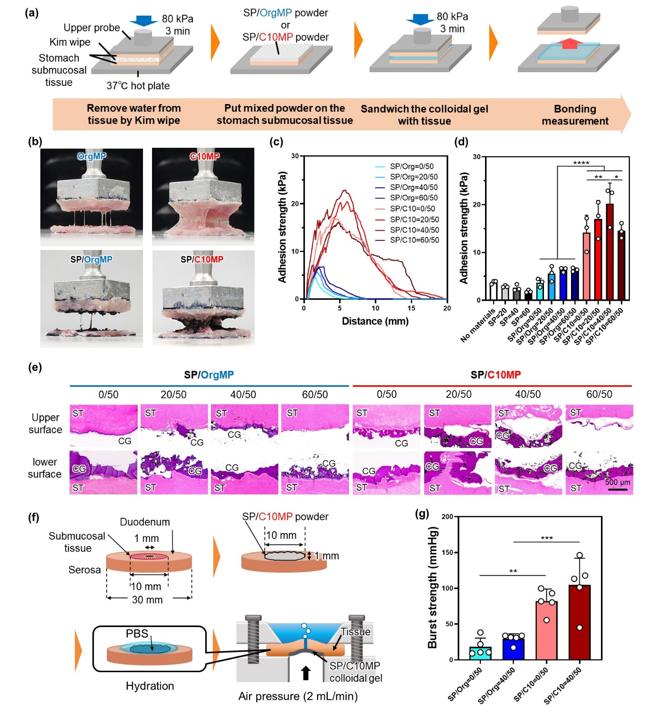
Fig. 4. Tissue adhesion strength and perforation-sealing ability of SP/OrgMP and SP/C10MP colloidal gels. (a) Procedure for measuring the tissue adhesion strength. Porcine stomach submucosal tissue was attached to both the upper probe and stage. SP/C10MP powder was then sandwiched between two duodenum submucosal tissues for 3 min, and the adhesion strength was measured. (b) Images of the colloidal gel layer and porcine stomach tissue during the adhesion strength measurement. (c) Tissue adhesion strengths of SP/OrgMP and SP/C10MP colloidal gels as a function of the distance between two stomach tissues. (d) Comparison of the maximum adhesion strengths of SP/OrgMP and SP/C10MP colloidal gels. Statistical significance tested by Tukey’s multiple comparison test (n =3): *p < 0.05, **p < 0.01, ****p <0.0001. No material means adhesion strength without gel. (e) Cross-sectional images of colloidal gels and stomach submucosal tissues following HE staining. ST: stomach tissue, CG: colloidal gel. Scale bar represents 500 µm. (f) Procedure for measuring the burst strength. A 1 mm pinhole was prepared on the porcine duodenal submucosal tissue and closed using the SP/C10MP colloidal gel through hydration of SP/C10MP powder. Then, the burst strength was measured. (g) Burst strengths with SP/OrgMP and SP/C10MP colloidal gels. Statistical significance tested by Tukey’s multiple comparison test (n = 5): **p < 0.01, ***p <0.001.

3.7. Underwater stability of SP/C10MP colloidal gel
Colloidal gels were attached to stomach submucosal tissues and then immersed in saline for 2 days to evaluate their underwater stabilities. C10MP and SP/C10MP colloidal gels remained intact and adhered to the submucosal tissue, whereas OrgMP and SP/OrgMP colloidal gels dispersed and dissolved in the saline on day 2 (Fig. 5(a)). The remaining rates of C10MP and SP/C10MP colloidal gels were 55 ± 4% and 50 ± 6%, respectively, which were significantly greater than those of OrgMP and SP/C10MP colloidal gels (Fig. 5(b)). Hydrophobic groups interact with extracellular matrix (ECM) proteins, such as fibronectin and the lipid membrane of cells [51]. Therefore, interactions of decyl groups on ApGltn molecules with ECM proteins and cells likely contributed to the formation of a stable adhesion layer in the wet environment. Interestingly, there were no significant differences between the underwater stabilities of C10MPs with SPIONs and C10MPs without SPIONs, although the addition of SPIONs increased the hydrophilicity of the powder (Fig. 2(f)). A previous study showed that silica nanoparticles adhere strongly to soft tissues by adsorbing ECM proteins on the surface of the nanoparticles [52]. Similarly, SPIONs likely interacted with the soft tissue as well as the ApGltn of the colloidal gel, which contributed to the underwater stability even in the presence of hydrophilic SPIONs.
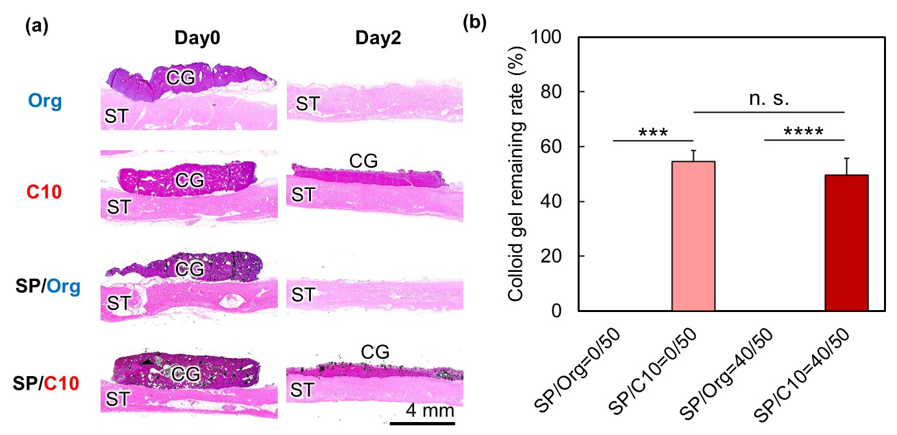
Fig. 5. Underwater stability of SP/C10MP colloidal gel. (a) HE images of SP/OrgMP and SP/C10MP colloidal gels adhered to stomach submucosal tissues. The colloidal gel was formed on the stomach submucosal tissue by hydrating SP/OrgMP or SP/C10MP powder with PBS. The resulting samples were immersed in saline at 37 °C for 2 days. (b) The remaining rate of SP/OrgMP and SP/C10MP colloidal gels was calculated by dividing the colloidal gel area after 2 days of immersion by the initial gel area. Statistical significance tested by Tukey’s multiple comparison test (n = 3): ***p < 0.001, ****p < 0.0001. n. s. indicates no significance between data. The underwater stability was increased by decyl group modification but unaffected by SPION addition.

3.8. Observation of heat generation by applying AMF to SP/C10MP colloidal gel
The heat generated by the SP/C10MP colloidal gel upon AMF exposure was evaluated. AMF (130 G, 373.35 kHz) was applied to SP/C10MP colloidal gels with SP/MP ratios from 0/50 to 60/50 (mg/mg) for 600 s, and the temperature change on the colloidal gel surface was measured using a thermal camera (Fig. 6(a)). The temperature of the SP/C10MP colloidal gel increased significantly as the SPION content and AMF exposure time increased. Specifically, after AMF exposure for 600 s, the temperatures on the surfaces of SP/C10MP colloidal gels with SP/MP ratios of 20/50, 40/50, and 60/50 (mg/mg) increased up to 33, 48, and 56 °C, respectively. No temperature increase was observed on the surface of the colloidal gel without SPIONs. The surface temperatures of all SP/C10MP colloidal gels reached a plateau after 180 s of AMF exposure (Fig. 6(b)). Considering that the temperature range suitable for hyperthermia treatment and inducing cancer cell death is 42–45 °C [16], we used the colloidal gel with the SP/C10 ratio of 40/50 (mg/mg) for in vitro and in vivo experiments.

3.9. Cell viability of SP/C10MP colloidal gel
Human mesenchymal stem cells (hMSCs) as normal cells and human colon cancer-derived cells (KM12-Luc) as diseased cells were treated with various extracts to evaluate cell viability. After the addition of SPION, C10MP, and SP/C10MP colloidal gel extracts to hMSCs, the cell viabilities were respectively 86 ± 4%, 86 ± 3%, and 71 ± 1%, indicating that the toxicity of these extracts was low (Fig. 6(c)). Following actin staining of hMSCs, actin filament structures and extensions were observed in the cells exposed to different extracts (Fig. 6(d)). In contrast, the viability of KM12 cells treated with the C10MP colloidal gel drastically decreased to 38 ± 4% (Fig. 6(e)), and immature actin clusters formed in the cells (Fig. 6(f)), indicating that extracted C10-ApGltn fragments suppressed the proliferation of cancer cells. Some researchers reported that cancer cells show a tendency toward greater membrane fluidity than normal cell membranes owing to disruption of the molecular balance of the plasma membrane [53, 54]. Additionally, interactions between cell membranes and the hydrophobic groups of molecules enhances the cellular uptake of hydrophobic molecules [55]. Therefore, the fluidity of the KM12 cell membrane likely promoted the uptake of C10-ApGltn fragments, thus decreasing cell viability.

3.10. In vitro cancer ablation effect of SP/C10MP colloidal gel
The ability of the SP/C10MP colloidal gel to treat cancer cells was evaluated in vitro by applying AMF to the SP/C10MP colloidal gel loaded in hMSCs or KM-12 cells. Without AMF exposure, the SP/C10MP colloidal gel was not cytotoxic to hMSCs. However, after thermal treatment, the viability of hMSCs decreased to 56 ± 7% (Fig. 6(g)). In contrast, the viability of KM-12 cells slightly decreased to 70 ± 5% after the addition of the SP/C10MP colloidal gel and significantly decreased to 10 ± 3% after AMF exposure (Fig. 6(h)). Analysis of LIVE/DEAD staining revealed that only KM12 cells treated with the SP/C10MP colloidal gel and AMF underwent cell death (Fig. 6(i)). These results indicated that the SP/C10MP colloidal gel was an effective agent for the hyperthermia treatment of cancer cells in vitro.
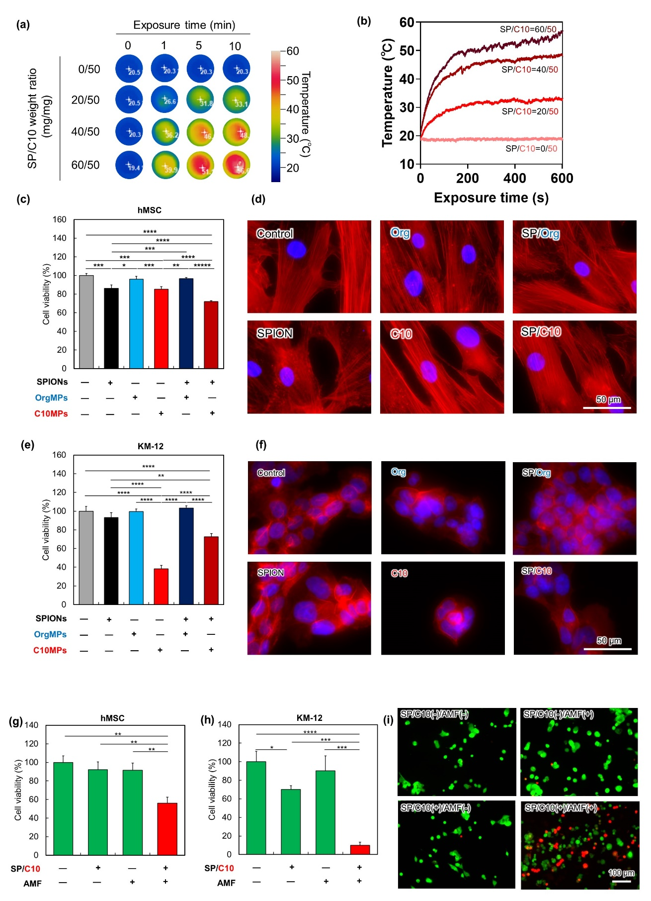
Fig. 6. Heat generation, in vitro cell viability, and cancer cell ablation effect of the SP/C10MP colloidal gel. (a) Effect of SP/MP weight ratio and exposure time on temperature change. (b) Continuous temperature change with different SPION contents as a function of time. Viability of (c) hMSCs and (e) KM-12 cells treated with medium containing SPION, OrgMP, and C10MP extracts. 100% represents the viability of cells treated with the medium containing no extracts. Statistical significance tested by Tukey’s multiple comparison test (n = 5): *p < 0.05, **p < 0.01, ***p < 0.001, ****p < 0.0001, *****p < 0.00001. Immunofluorescence staining images of (d) hMSCs and (f) KM-12 cells treated with medium containing SPION, OrgMP, and C10MP extracts. Red represents actin filament and blue represents nucleus. Scale bar represents 50 µm. Cell viability of (g) hMSCs and (h) KM-12 cells treated with the SP/C10MP colloidal gel and AMF. Statistical significance tested by Tukey’s multiple comparison test (n = 3): *p < 0.05, **p < 0.01, ***p < 0.001, ****p < 0.0001. (i) LIVE/DEAD staining images of KM-12 cells treated with the SP/C10MP colloidal gel and AMF. Scale bar represents 100 µm.

3.11. Biocompatibility of SP/C10MP colloidal gel
To evaluate the biocompatibility of the colloidal gels, SP/OrgMP and SP/C10MP colloidal gels were implanted into the subcutaneous tissues of nude mice. Photographs of the subcutaneous tissues showed that black-colored SPIONs remained in both SP/OrgMP and SP/C10MP colloidal gel groups at 18 days after implantation (Fig. 7(a)). Images of HE-stained subcutaneous tissues and colloidal gels showed that C10MP colloidal gel fragments remained at 6 and 12 days after implantation. However, at 18 days after implantation, a small amount of the C10MP colloidal gel remained, some cells infiltrated between SPION aggregates, and blood vessels formed (Fig. 7(b) and S8). This result was consistent with the results of our previous study, namely hydrophobically modified gelatin induced angiogenesis in vivo [56]. Furthermore, severe inflammation and capsule formation were not observed. These results indicated that C10MPs degraded within 12 days after implantation and were replaced by infiltrated cells. SPIONs were stable for 18 days, indicating that heat could be generated at 18 days after implantation. It is known that iron oxide-related materials cause multiple mechanisms such as ROS production and apoptosis depending on dose and concentration. Therefore, further investigation into the long-term toxicity and biodegradability of SPIONs over 18 days is required for clinical application.

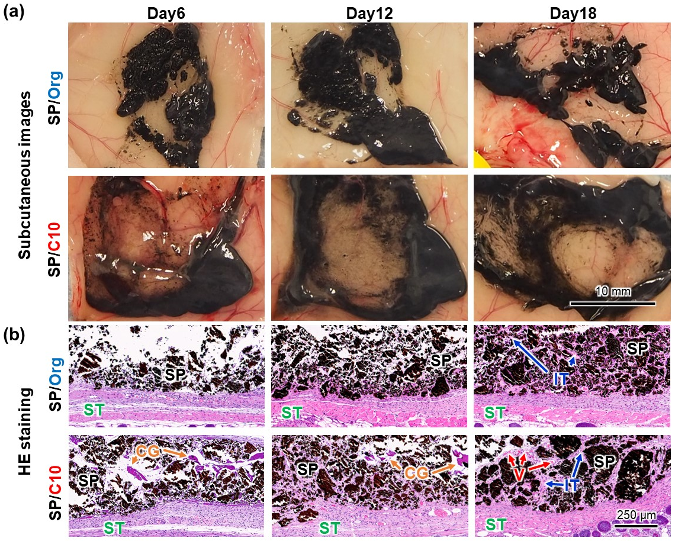
Fig. 7. Biocompatibility of the SP/C10MP colloidal gel. (a) Photographs and (b) HE staining images of SP/OrgMP and SP/C10MP colloidal gels implanted into the subcutaneous tissues of nude mice for 6, 12, and 18 days. ST: subcutaneous tissue, SP: SPIONs, IT: infiltrated tissue, CG: colloidal gel, V: blood vessel. Scale bar represents 250 µm.

3.12. In vivo cancer ablation effect SP/C10MP colloidal gel
The in vivo ablation effect of the SP/C10MP colloidal gel on colon cancer cells was evaluated by implanting the colloidal gel into the subcutaneous tissues of colon cancer-bearing nude mice (Fig. 8(a)). After AMF exposure, the color of the area enclosing the implanted SP/C10MP colloidal gel changed from green to red in the thermal camera images, indicating that SPIONs generated heat locally at the applied area (Fig. 8(b)). After AMF exposure, the surface temperature of the mouse skin increased from 31 to 43 °C within 300 s and then remained at 43.5 °C for the rest of the treatment, up to 600 s (Fig. 8(c)). The ablation of KM12-Luc cancer cells treated with the SP/C10MP colloidal gel and AMF was monitored by measuring the luminescence of the cancer cells (Fig. 8(d), (e)). Immediately after implanting the SP/C10MP colloidal gel, the luminescence intensities measured for the control group and the SP/C10MP colloidal gel with AMF group did not differ. On days 6 and 12, the luminescence intensities measured for the SP/C10MP colloidal gel with AMF group did not increase, whereas the intensities for the control group increased dramatically. Changes in the cancer volume were similar. Specifically, the average cancer volume measured for the SP/C10MP colloidal gel with AMF group was 267 ± 199 mm³ on day 12, while that measured for the control group reached 1656 ± 462 mm³ on day 12 (Fig. 8(f)). Notably, for three out of five mice in the SP/C10 colloidal gel with AMF group, the cancer volume was low throughout the experiment (Fig. 8(h)), indicating that thermal treatment using the SP/C10 colloidal gel and AMF effectively inhibited the proliferation of cancer cells. The slight increase in cancer volume for the other two mice was considered to originate in the movement or degradation of the colloidal gel implanted in the subcutaneous tissue of the mouse. The body weights of the mice in both groups did not drastically decrease during the experiment, indicating that the SP/C10MP colloidal gel was not severely toxic to the tissue (Fig. 8(i)). The probability of survival on day 16 was significantly different between the control group and the SP/C10MP colloidal gel with AMF group (Fig. 8(j)). All mice in the control group died, whereas 80% of mice in the SP/C10MP colloidal gel with AMF group were alive. These results indicated that thermal treatment using the SP/C10MP colloidal gel and AMF effectively killed cancer tissues in vivo.
Pathological and immunohistochemical analyses, including HE and TUNEL staining, of the cancer tissues after the in vivo experiment showed that the size of the cancer tissue was smaller in the SP/C10MP colloidal gel with AMF group than in the control group (Fig. 9(a)). Images of TUNEL stained tissues revealed that there were numerous necrotic cells on the surface of the tissue treated with the SP/C10MP colloidal gel and AMF, whereas there were few necrotic cells on the surface of the control tissue (Fig. 9(b)). These results suggested that the heat generated by the SP/C10MP colloidal gel upon AMF exposure induced necrosis of KM12-Luc cells, which significantly reduced the growth of cancer tissues. Histological observation of organs revealed that no necrosis occurred in the tissues of mice with or without SP/C10MP colloidal gel treatment (Fig. 9(c)), indicating that this colloidal gel was not systemically toxic. Here, we suggested that SP/C10MP colloidal gel could thermally treat cancer tissue using the tumor-bearing mice on their back. However, further investigations of this composite material using cancer models on intestines and function as MRI contrast agents are required to prove the feasibility of this SP/C10MP colloidal gel system for clinical application.
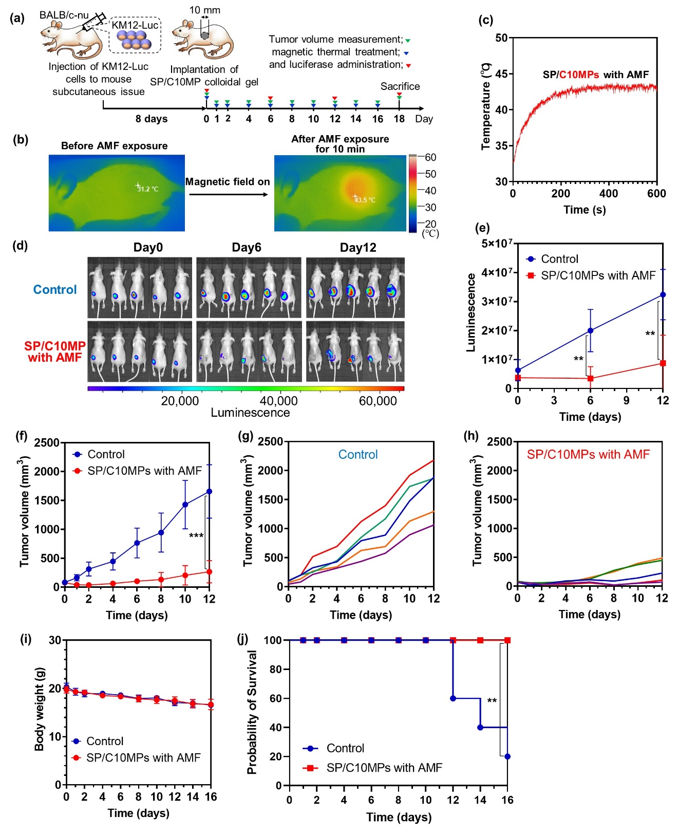
Fig. 8. In vivo cancer hyperthermia treatment using the SP/C10MP colloidal gel and AMF. (a) Schematic illustration of the treatment schedule of KM12-Luc cancer-bearing mice. (b) Thermal camera images of the mouse back before and after AMF exposure for 600 s. (c) Skin surface temperature of the mouse back as a function of AMF exposure time. The skin surface temperature of the mouse back increased up to 43.5 °C through heat generated by the SP/C10MP colloidal gel upon AMF exposure. (d) IVIS luminescence images of KM12-Luc cancer-bearing mice treated with the SP/C10MP colloidal gel and AMF at 0, 6, and 12 days after the start of magnetic thermal treatment. The control group consists of KM12-Luc cancer-bearing mice without the SP/C10MP colloidal gel and AMF treatment. (e) IVIS luminescence intensity at 0, 6, and 12 days after the start of magnetic thermal treatment (n = 5). Statistical significance tested by a two-tailed Student’s t-test: **p < 0.01. (f) Average cancer size of KM12-Luc cancer-bearing mice treated with the SP/C10MP colloidal gel and AMF (n = 5). Statistical significance tested by a two-tailed Student’s t-test: ***p < 0.001. (g, h) Cancer size of each KM12-Luc cancer-bearing mouse (g) without treatment (control) and (h) treated with the SP/C10MP colloidal gel and AMF. (i) Body weight of mice as a function of time. (j) Probability of survival of KM12-Luc cancer-bearing mice treated with or without SP/C10MP colloidal gel and AMF. Probability of survival was observed up to 16 days after the start of magnetic thermal treatment (n = 5). Statistical significance tested by the log-rank (Mantel–Cox) test: **p < 0.01.

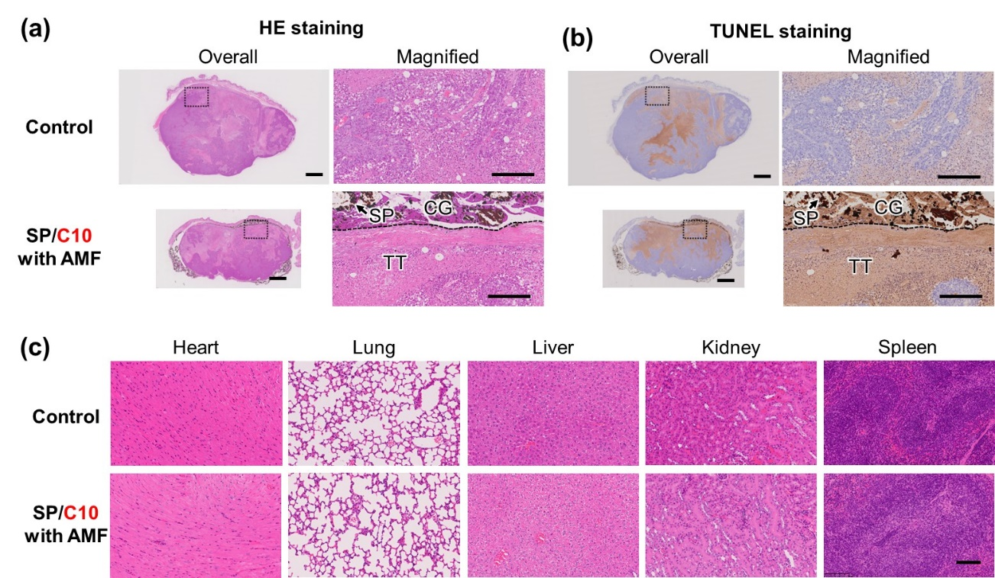
Fig. 9. (a, b) Images of cancer tissues treated with or without the SP/C10MP colloidal gel and AMF on day 18. Images taken after (a) HE and (b) TUNEL staining of tissues. CG: colloidal gel, TT: cancer tissue, SP: SPIONs. Scale bars represent 2 mm for overall images and 250 µm for magnified images. (c) Images of heart, lung, liver, kidney, and spleen taken after HE staining. Scale bar represents 100 µm.

- Conclusion
We combined tissue adhesive MPs of decyl group-modified Alaska pollock gelatin (C10-ApGltn) with superparamagnetic iron oxide nanoparticle (SPIONs) to develop nanocomposites for cancer hyperthermia treatment. The nanocomposite of C10MP and SPIONs formed a colloidal gel (SP/C10MP colloidal gel) after hydration. Compared with the C10MP colloidal gel, the SP/C10MP colloidal gel showed improved tissue adhesion, burst strength, and underwater stability owing to the addition of SPIONs. In addition, upon AMF exposure, the SP/C10MP colloidal gel generated heat, which locally ablated the cancer cells of colon cancer-bearing mice. Therefore, SP/C10MP mixed powder is not only an innovative heat-generating biomaterial for local cancer hyperthermia but also a tissue adhesive and sealant for preventing perforation after endoscopic cancer treatment.

Data availability
The authors declare that all data supporting the findings of this study are available within the paper and its Supporting Information.

Conflicts of interest
The authors have no competing interests to declare.

Acknowledgments
This work was financially supported in part by the JSPS KAKENHI Grant-in-Aid for JSPS Fellows (grant no. 22J20039), the JSPS KAKENHI (grant nos. 23H01718, 22H03962, and 22K19947), and the Uehara Memorial Foundation.

Appendix A. Supplementary data
Supplementary data related to this article can be found at

Reference
[1] T. Gotoda, Endoscopic resection of early gastric cancer, Gastric Cancer 10(1) (2007) 1-11.
[2] H. Isomoto, S. Shikuwa, N. Yamaguchi, E. Fukuda, K. Ikeda, H. Nishiyama, K. Ohnita, Y. Mizuta, J. Shiozawa, S. Kohno, Endoscopic submucosal dissection for early gastric cancer: A large-scale feasibility study, Gut 58(3) (2009) 331-336.
[3] P. Pimentel-Nunes, M. Dinis-Ribeiro, T. Ponchon, A. Repici, M. Vieth, A. De Ceglie, A. Amato, F. Berr, P. Bhandari, A. Bialek, M. Conio, J. Haringsma, C. Langner, S. Meisner, H. Messmann, M. Morino, H. Neuhaus, H. Piessevaux, M. Rugge, B.P. Saunders, M. Robaszkiewicz, S. Seewald, S. Kashin, J.M. Dumonceau, C. Hassan, P.H. Deprez, Endoscopic submucosal dissection: European Society of Gastrointestinal Endoscopy (ESGE) Guideline, Endoscopy 47(9) (2015) 829-854.
[4] N. González, A. Parra-Blanco, V. Arantes, K. Mönkemüller, W. Albuquerque, A.D. Durante, W. Bejarano, D.J. Castro, R. Castaño, A. Calvo, S. Con, R. Fiszerowicz, J. Landaeta, F.M. Filho, D.M. Milhomem Cardoso, J.O. Nieto, A. Peñaloza-Ramírez, R. Pinilla, L.A.R. de Oliveira, M.R. Ferro, C.A.R. Medranda, M.C. Rodríguez Rubiano, P. Sakai, G.V. Cárdenas, G. Villa-Gómez, N. Zambrano H, Current Status of Endoscopic Submucosal Dissection in Latin America, Acta Gastroenterol. Latinoam. 46(3) (2016) 213-219.
[5] M. Tao, X. Zhou, M. Hu, J. Pan, Endoscopic submucosal dissection versus endoscopic mucosal resection for patients with early gastric cancer: a meta-analysis, BMJ Open 9(12) (2019) e025803.
[6] M.K. Back, H.S. Moon, I.S. Kwon, J.H. Park, J.S. Kim, S.H. Kang, J.K. Sung, E.S. Lee, S.H. Kim, B.S. Lee, H.Y. Jeong, Analysis of factors associated with local recurrence after endoscopic resection of gastric epithelial dysplasia: a retrospective study, BMC Gastroenterology 20(1) (2020) 148.
[7] M. Sekiguchi, H. Suzuki, I. Oda, S. Abe, S. Nonaka, S. Yoshinaga, H. Taniguchi, S. Sekine, R. Kushima, Y. Saito, Favorable long-term outcomes of endoscopic submucosal dissection for locally recurrent early gastric cancer after endoscopic resection, Endoscopy 45(09) (2013) 708-713.
[8] A. Japanese Gastric Cancer, Japanese gastric cancer treatment guidelines 2018 (5th edition), Gastric Cancer 24(1) (2021) 1-21.
[9] K. Hamada, R. Ishihara, Y. Yamasaki, N. Hanaoka, S. Yamamoto, M. Arao, S. Suzuki, T. Iwatsubo, M. Kato, Y. Tonai, S. Shichijo, N. Matsuura, H. Nakahira, T. Kanesaka, T. Akasaka, Y. Takeuchi, K. Higashino, N. Uedo, H. Iishi, N. Kanayama, T. Hirata, Y. Kawaguchi, K. Konishi, T. Teshima, Efficacy and Safety of Endoscopic Resection Followed by Chemoradiotherapy for Superficial Esophageal Squamous Cell Carcinoma: A Retrospective Study, Clinical and Translational Gastroenterology 8(8) (2017) e110.
[10] X. Ma, C. Yang, R. Zhang, J. Yang, Y. Zu, X. Shou, Y. Zhao, Doxorubicin loaded hydrogel microparticles from microfluidics for local injection therapy of tumors, Colloids Surf. B. Biointerfaces 220 (2022) 112894.
[11] H.-R. Lin, Y.-T. Chen, Y.-C. Wu, Y.-J. Lin, Glycol chitin/PAA hydrogel composite incorporated bio-functionalized PLGA microspheres intended for sustained release of anticancer drug through intratumoral injection, Journal of Biomaterials Science, Polymer Edition 29(15) (2018) 1839-1858.
[12] J. Wang, D. Wang, H. Yan, L. Tao, Y. Wei, Y. Li, X. Wang, W. Zhao, Y. Zhang, L. Zhao, X. Sun, An injectable ionic hydrogel inducing high temperature hyperthermia for microwave tumor ablation, Journal of Materials Chemistry B 5(22) (2017) 4110-4120.
[13] A. Nanashima, T. Abo, T. Nonaka, Y. Nonaka, T. Morisaki, R. Uehara, K. Ohnita, D. Fukuda, G. Murakami, K. Tou, M. Kunizaki, S. Hidaka, T. Tsuchiya, H. Takeshita, K. Nakao, T. Nagayasu, Photodynamic therapy using talaporfin sodium (laserphyrin®) for bile duct carcinoma: A preliminary clinical trial, Anticancer Res. 32(11) (2012) 4931-4938.
[14] J. Lindenmann, N. Fink-Neuboeck, Photodynamic Therapy for Esophageal Cancer: Functional, Clinical, and Immunological Aspects, in: J. Haybaeck (Ed.), Mechanisms of Molecular Carcinogenesis – Volume 1, Springer International Publishing, Cham, 2017, pp. 225-250.
[15] A.B. Ormond, H.S. Freeman, Dye Sensitizers for Photodynamic Therapy, Materials (Basel) 6(3) (2013) 817-840.
[16] S.F. Medeiros, A.M. Santos, H. Fessi, A. Elaissari, Stimuli-responsive magnetic particles for biomedical applications, Int. J. Pharm. 403(1) (2011) 139-161.
[17] M. Shinkai, Functional magnetic particles for medical application, J. Biosci. Bioeng. 94(6) (2002) 606-613.
[18] W. Zhang, Z. Guo, D. Huang, Z. Liu, X. Guo, H. Zhong, Synergistic effect of chemo-photothermal therapy using PEGylated graphene oxide, Biomater. 32(33) (2011) 8555-8561.
[19] Z. Meng, F. Wei, R. Wang, M. Xia, Z. Chen, H. Wang, M. Zhu, NIR-Laser-Switched In Vivo Smart Nanocapsules for Synergic Photothermal and Chemotherapy of Tumors, Advanced Materials 28(2) (2016) 245-253.
[20] C.-H. Hou, S.-M. Hou, Y.-S. Hsueh, J. Lin, H.-C. Wu, F.-H. Lin, The in vivo performance of biomagnetic hydroxyapatite nanoparticles in cancer hyperthermia therapy, Biomater. 30(23) (2009) 3956-3960.
[21] J.B. Vines, J.-H. Yoon, N.-E. Ryu, D.-J. Lim, H. Park, Gold Nanoparticles for Photothermal Cancer Therapy, Frontiers in Chemistry 7 (2019).
[22] G. Terentyuk, G. Maslyakova, L. Suleymanova, N. Khlebtsov, B. Khlebtsov, G. Akchurin, I. Maksimova, V. Tuchin, Laser-induced tissue hyperthermia mediated by gold nanoparticles: toward cancer phototherapy, Journal of Biomedical Optics 14(2) (2009) 021016.
[23] D. Jana, S. Jia, A.K. Bindra, P. Xing, D. Ding, Y. Zhao, Clearable Black Phosphorus Nanoconjugate for Targeted Cancer Phototheranostics, ACS Appl. Mater. Interfaces 12(16) (2020) 18342-18351.
[24] L. Sutrisno, H. Chen, Y. Chen, T. Yoshitomi, N. Kawazoe, Y. Yang, G. Chen, Composite scaffolds of black phosphorus nanosheets and gelatin with controlled pore structures for photothermal cancer therapy and adipose tissue engineering, Biomater. 275 (2021) 120923.
[25] M. Chu, X. Pan, D. Zhang, Q. Wu, J. Peng, W. Hai, The therapeutic efficacy of CdTe and CdSe quantum dots for photothermal cancer therapy, Biomater. 33(29) (2012) 7071-7083.
[26] H. Xie, M. Liu, B. You, G. Luo, Y. Chen, B. Liu, Z. Jiang, P.K. Chu, J. Shao, X.-F. Yu, Biodegradable Bi2O2Se Quantum Dots for Photoacoustic Imaging-Guided Cancer Photothermal Therapy, Small 16(1) (2020) 1905208.
[27] J. Xie, Y. Zhang, C. Yan, L. Song, S. Wen, F. Zang, G. Chen, Q. Ding, C. Yan, N. Gu, High-performance PEGylated Mn–Zn ferrite nanocrystals as a passive-targeted agent for magnetically induced cancer theranostics, Biomater. 35(33) (2014) 9126-9136.
[28] X. Liu, Y. Zhang, Y. Wang, W. Zhu, G. Li, X. Ma, Y. Zhang, S. Chen, S. Tiwari, K. Shi, S. Zhang, H.M. Fan, Y.X. Zhao, X.J. Liang, Comprehensive understanding of magnetic hyperthermia for improving antitumor therapeutic efficacy, Theranostics 10(8) (2020) 3793-3815.
[29] L. Zhang, X. Guan, X. Xiao, Z. Chen, G. Zhou, Y. Fan, Dual-phase injectable thermosensitive hydrogel incorporating Fe3O4@PDA with pH and NIR triggered drug release for synergistic tumor therapy, European Polymer Journal 176 (2022) 111424.
[30] T. Marín, P. Montoya, O. Arnache, R. Pinal, J. Calderón, Development of magnetite nanoparticles/gelatin composite films for triggering drug release by an external magnetic field, Materials & Design 152 (2018) 78-87.
[31] Q. Du, T. Ma, C. Fu, T. Liu, Z. Huang, J. Ren, H. Shao, K. Xu, F. Tang, X. Meng, Encapsulating Ionic Liquid and Fe3O4 Nanoparticles in Gelatin Microcapsules as Microwave Susceptible Agent for MR Imaging-guided Tumor Thermotherapy, ACS Appl. Mater. Interfaces 7(24) (2015) 13612-13619.
[32] Y. Mizuno, R. Mizuta, M. Hashizume, T. Taguchi, Enhanced Sealing Strength of a Hydrophobically-Modified Alaska Pollock Gelatin-Based Sealant, Biomater. Sci. 5(5) (2017) 982–989.
[33] A. Nishiguchi, Y. Kurihara, T. Taguchi, Underwater-Adhesive Microparticle Dressing Composed of Hydrophobically-Modified Alaska Pollock Gelatin for Gastrointestinal Tract Wound Healing, Acta Biomater. 99 (2019) 387–396.
[34] A. Nishiguchi, F. Sasaki, H. Maeda, M. Kabayama, A. Ido, T. Taguchi, Multifunctional Hydrophobized Microparticles for Accelerated Wound Healing after Endoscopic Submucosal Dissection, Small 15(35) (2019) 1901566.
[35] S. Ito, A. Nishiguchi, F. Sasaki, H. Maeda, M. Kabayama, A. Ido, T. Taguchi, Robust Closure of Post-Endoscopic Submucosal Dissection Perforation by Microparticle-Based Wound Dressing, Mater. Sci. Eng. C 123 (2021) 111993.
[36] S. Ito, A. Nishiguchi, T. Taguchi, Effect of particle size on the tissue adhesion and particle floatation of a colloidal wound dressing for endoscopic treatments, Acta Biomater. 159 (2023) 83-94.
[37] S. Ito, A. Nishiguchi, H. Ichimaru, K. Nagasaka, H. Hirade, T. Taguchi, Prevention of postoperative adhesion with a colloidal gel based on decyl group-modified Alaska pollock gelatin microparticles, Acta Biomater. 149 (2022) 139-149.
[38] M.A. Dheyab, A.A. Aziz, M.S. Jameel, O.A. Noqta, P.M. Khaniabadi, B. Mehrdel, Simple rapid stabilization method through citric acid modification for magnetite nanoparticles, Sci. Rep. 10(1) (2020) 10793.
[39] H.-C. Roth, S. Schwaminger, P. Fraga García, J. Ritscher, S. Berensmeier, Oleate coating of iron oxide nanoparticles in aqueous systems: the role of temperature and surfactant concentration, Journal of Nanoparticle Research 18(4) (2016) 99.
[40] Y. Wei, B. Han, X. Hu, Y. Lin, X. Wang, X. Deng, Synthesis of Fe3O4 Nanoparticles and their Magnetic Properties, Procedia Engineering 27 (2012) 632-637.
[41] L. Li, K.Y. Mak, C.W. Leung, K.Y. Chan, W.K. Chan, W. Zhong, P.W.T. Pong, Effect of synthesis conditions on the properties of citric-acid coated iron oxide nanoparticles, Microelectronic Engineering 110 (2013) 329-334.
[42] H. Cho, N. Kim, T. Murakami, T. Sim, Anti-Tumor Activity of AZD4547 Against NTRK1 Fusion Positive Cancer Cells Through Inhibition of NTRKs, Frontiers in Oncology 11 (2021).
[43] S. Nigam, K.C. Barick, D. Bahadur, Development of citrate-stabilized Fe3O4 nanoparticles: Conjugation and release of doxorubicin for therapeutic applications, Journal of Magnetism and Magnetic Materials 323(2) (2011) 237-243.
[44] N. Ghaemi, S.S. Madaeni, P. Daraei, H. Rajabi, S. Zinadini, A. Alizadeh, R. Heydari, M. Beygzadeh, S. Ghouzivand, Polyethersulfone membrane enhanced with iron oxide nanoparticles for copper removal from water: Application of new functionalized Fe3O4 nanoparticles, Chem. Eng. J. 263 (2015) 101-112.
[45] N. Abdullah, R.J. Gohari, N. Yusof, A.F. Ismail, J. Juhana, W.J. Lau, T. Matsuura, Polysulfone/hydrous ferric oxide ultrafiltration mixed matrix membrane: Preparation, characterization and its adsorptive removal of lead (II) from aqueous solution, Chem. Eng. J. 289 (2016) 28-37.
[46] B.S. Lalia, V. Kochkodan, R. Hashaikeh, N. Hilal, A review on membrane fabrication: Structure, properties and performance relationship, Desalination 326 (2013) 77-95.
[47] C. Bae, H. Kim, Y.-M. Kook, C. Lee, C. Kim, C. Yang, M.H. Park, Y. Piao, W.-G. Koh, K. Lee, Induction of ferroptosis using functionalized iron-based nanoparticles for anti-cancer therapy, Materials Today Bio 17 (2022) 100457.
[48] J.H. Jung, K.D. Choi, J.Y. Ahn, J.H. Lee, H.Y. Jung, K.S. Choi, G.H. Lee, H.J. Song, D.H. Kim, M.Y. Kim, S.E. Bae, J.H. Kim, Endoscopic Submucosal Dissection for Sessile, Nonampullary Duodenal Adenomas, Endoscopy 45(2) (2013) 133-135.
[49] Y. Miura, S. Shinozaki, Y. Hayashi, H. Sakamoto, A.K. Lefor, H. Yamamoto, Duodenal Endoscopic Submucosal Dissection is Feasible Using the Pocket-Creation Method, Endoscopy 49(1) (2017) 8-14.
[50] N. Filipovic, A. Cvetkovic, V. Isailovic, Z. Matovic, M. Rosic, M. Kojic, Computer Simulation of Flow and Mixing at the Duodenal Stump after Gastric Resection, World J. Gastroenterol. 15(16) (2009) 1990-1998.
[51] R. Mizuta, T. Taguchi, Enhanced Sealing by Hydrophobic Modification of Alaska Pollock-Derived Gelatin-Based Surgical Sealants for the Treatment of Pulmonary Air Leaks, Macromol. Biosci. 17(4) (2017) 1600349.
[52] S. Rose, A. Prevoteau, P. Elzière, D. Hourdet, A. Marcellan, L. Leibler, Nanoparticle solutions as adhesives for gels and biological tissues, Nature 505(7483) (2014) 382-385.
[53] W. Szlasa, I. Zendran, A. Zalesińska, M. Tarek, J. Kulbacka, Lipid composition of the cancer cell membrane, J. Bioenerg. Biomembr. 52(5) (2020) 321-342.
[54] H.L. Nguyen, V.H. Man, M.S. Li, P. Derreumaux, J. Wang, P.H. Nguyen, Elastic moduli of normal and cancer cell membranes revealed by molecular dynamics simulations, Physical Chemistry Chemical Physics 24(10) (2022) 6225-6237.
[55] T. Abou Matar, P. Karam, The Role of Hydrophobicity in the Cellular Uptake of Negatively Charged Macromolecules, Macromol. Biosci. 18(2) (2018) 1700309.
[56] Y. Mizuno, T. Taguchi, Self-assembled Dodecyl Group-Modified Gelatin Microparticle-Based Hydrogels with Angiogenic Properties, NPG Asia Mater. 12(1) (2020) 48.

