Strain visualization using large-angle convergent-beam electron diffraction

Fumihiko Uesugiª*, Chiaki Tanii^{b}, Naoyuki Sugiyama^{b}, Masaki Takeguchiª
ªNational Institute for Materials Science, 1-2-1 Sengen, Tsukuba, Ibaraki 305-0047, Japan
^{b}Toray Research Center, Inc., 3-2-11 Sonoyama, Ohtsu, Shiga 520-8567, Japan
*Corresponding author: Fumihiko Uesugi
National Institute for Materials Science, 1-2-1 Sengen, Tsukuba, Ibaraki 305-0044, Japan
Tel: +81-29-859-2685; Email: UESUGI.Fumihiko@nims.go.jp

Abstract
In this study, we report a strain visualization method using large-angle convergent-beam electron diffraction (LACBED). We compare the proposed method with the strain maps acquired via STEM-NBD, a combination of scanning transmission electron microscopy (STEM) and nanobeam electron diffraction (NBD). Although STEM-NBD can precisely measure the lattice parameters, it requires a large amount of data and personal computer (PC) resources to obtain a two-dimensional strain map. Deficiency lines in the transmitted disk of LACBED reflect the crystalline structure information and move, curve, or disappear in the deformed area. Properly setting the optical conditions makes it possible to acquire real-space images over a broad area in conjunction with deficiency lines on the transmitted disk. The proposed method acquires images by changing the relative position between the specimen and the deficiency line and can grasp the strain information with a small number of images. In addition, the proposed method does not require high-resolution images. It can reduce the required PC memory or storage consumption in comparison with that of STEM-NBD, which requires a high-resolution diffraction pattern (DP) from each point of the region of interest. Compared with the two-dimensional maps of LACBED and NBD, NBD could detect large distortions in the area where the deficiency line curved, moved, or disappeared. The curving or moving direction of the deficiency line is qualitatively consistent with the NBD results. If quantitative strain values are not essential, strain visualization using LACBED can be considered an effective technique. We believe that the strain information of a sample can be obtained effectively using both methods.
Keywords: LACBED, NBD, Strain analysis

1. Introduction
Efficient measurements of the location and strength of strain is important in semiconductor device development. Depending on the location and the strength, because strain affects the occurrence of crystal defects [1] and improves the electrical properties [2], the demand for obtaining the strain distribution in semiconductor devices is high. Following the progress in the miniaturization of semiconducting devices, the available opportunities to use transmission electron microscopy (TEM) are increasing for analyzing them from the viewpoint of spatial resolution.
Strain measurements using nanobeam electron diffraction (NBD) [3–7] or convergent beam electron diffraction (CBED) [7–14] can provide quantitative strain information; however, the information is limited to the beam irradiation area. Therefore, obtaining strain information from a broader area combining with scan system, such as scanning TEM (STEM) or stage scan system, is effective [15,16]. The data acquired using above method is four-dimensional (4D). Although several free libraries such as py4DSTEM [17] have been recently released to analyze 4D data, programming is required to use these libraries. Therefore, this process is not ideal for analysts unfamiliar with programming. Furthermore, acquired data using STEM-NBD, a combination of STEM and NBD, is a substantial amount of data, reaching several hundred gigabytes (GB), and consumes a significant part of PC resources. If the area where the strain exists before the measurement is known, measuring only the strain area may be more efficient.
Large-angle convergent-beam electron diffraction (LACBED) [18,19] can simultaneously obtain information from real and reciprocal spaces. LACBED is extensively used to study crystal defects [20–22]. Deficiency lines in the transmitted disk, called Bragg lines, reflect the crystal structure in which they appear. The Bragg lines bend, move, and blur in the strain area. Therefore, strain information can be obtained by scanning the Bragg line in the region of interest (ROI). Several strain measurement methods using LACBED have been proposed, and strain information has been obtained by comparing experimental data with dynamical simulation results [23–26]. Although quantitative strain information cannot be obtained, we considered using LACBED to obtain strain conditions without complicated calculations. We compared the information obtained through LACBED and STEM-NBD to study the effectiveness of LACBED. In this study, LACBED data were acquired using the script function of the Gatan Microscopy Suite (GMS) software [27]. Using this script, transmitted disks that include a real-space image and a Bragg line in reciprocal space can be acquired while relatively moving the Bragg line on the ROI. Extra scattered electrons were cut out to clearly observe the Bragg lines using the selected area (SA) aperture in LACBED observations, as explained in Section 2. When using a probe scan, the extra electrons cannot be appropriately cut out using the SA aperture as the diffracted disk moves on the image plane. Therefore, a stage-scanning system operated by the script was adopted. We considered the Bragg line and direction suitable for measuring the strain in the vertical and horizontal directions of the device. We report that we can approximately determine the presence of strain and whether it is tensile or compressive by comparing the regions where the strain is adjacent to the movement and curvature of the Bragg line.

2. Strain visualization using LACBED
A detailed concept of the proposed strain visualization method using LACBED is discussed in this section.
The differences between the well-known CBED and the LACBED are shown in Fig. 1. In the CBED method case, only the Bragg lines in the reciprocal space can be observed because the incident electron beam converges on the sample. By contrast, in the LACBED method case, the specimen is moved away from the object plane, while the incident electron beam converges on the object plane; therefore, both reciprocal-space Bragg lines and real-space images can be observed. The images obtained via the LACBED method are blurred because they are out of focus. The position of the Bragg line depends on the lattice parameters and electron-beam direction. Bragg lines are observed as straight lines in stress-free areas or areas with a constant lattice parameter. The Bragg lines move similarly to the diffraction spots depending on the change in the lattice parameter. If the lattice parameter decreases, the Bragg line, for example, the (hkl) line, moves in a direction far away from the (-h-k-l) line. If the lattice parameter increases, it moves closer to the (-h-k-l) line. The Bragg line bends if it approaches a stressed area or if the sample bends. Therefore, it may be possible to obtain and visualize the stress information of a sample by scanning the Bragg line over the ROI.

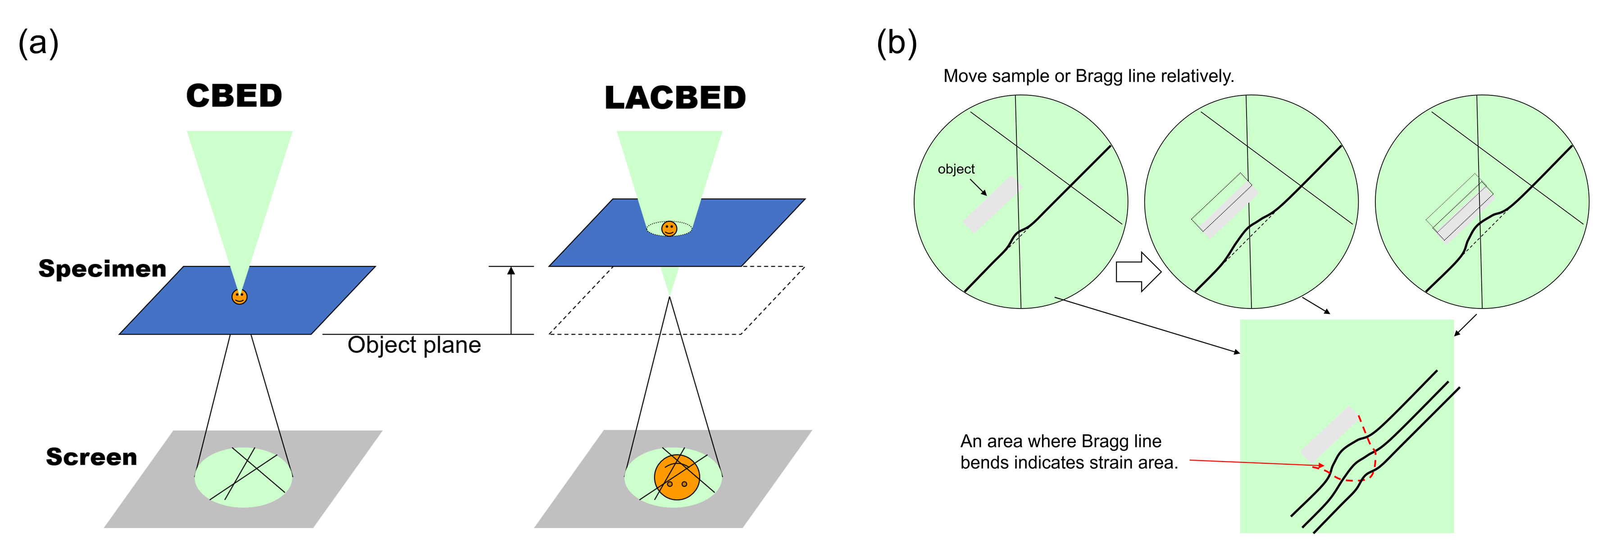
Fig. 1. (a) Comparison between CBED and LACBED. (b) Concept of strain acquisition using Bragg lines.

Fig. 2(a) shows the optical system of the LACBED. After the incident electron beam is focused on the object plane, the sample is moved by an appropriate amount above or below the object plane. The relative field of view in real and reciprocal spaces depends on the displacement of the sample. The Bragg lines in the transmitted disk can be clearly observed as deficiency lines by inserting an SA aperture into the image plane and obstructing the reflection of electrons in the diffracted disks (Fig. 2(b)).
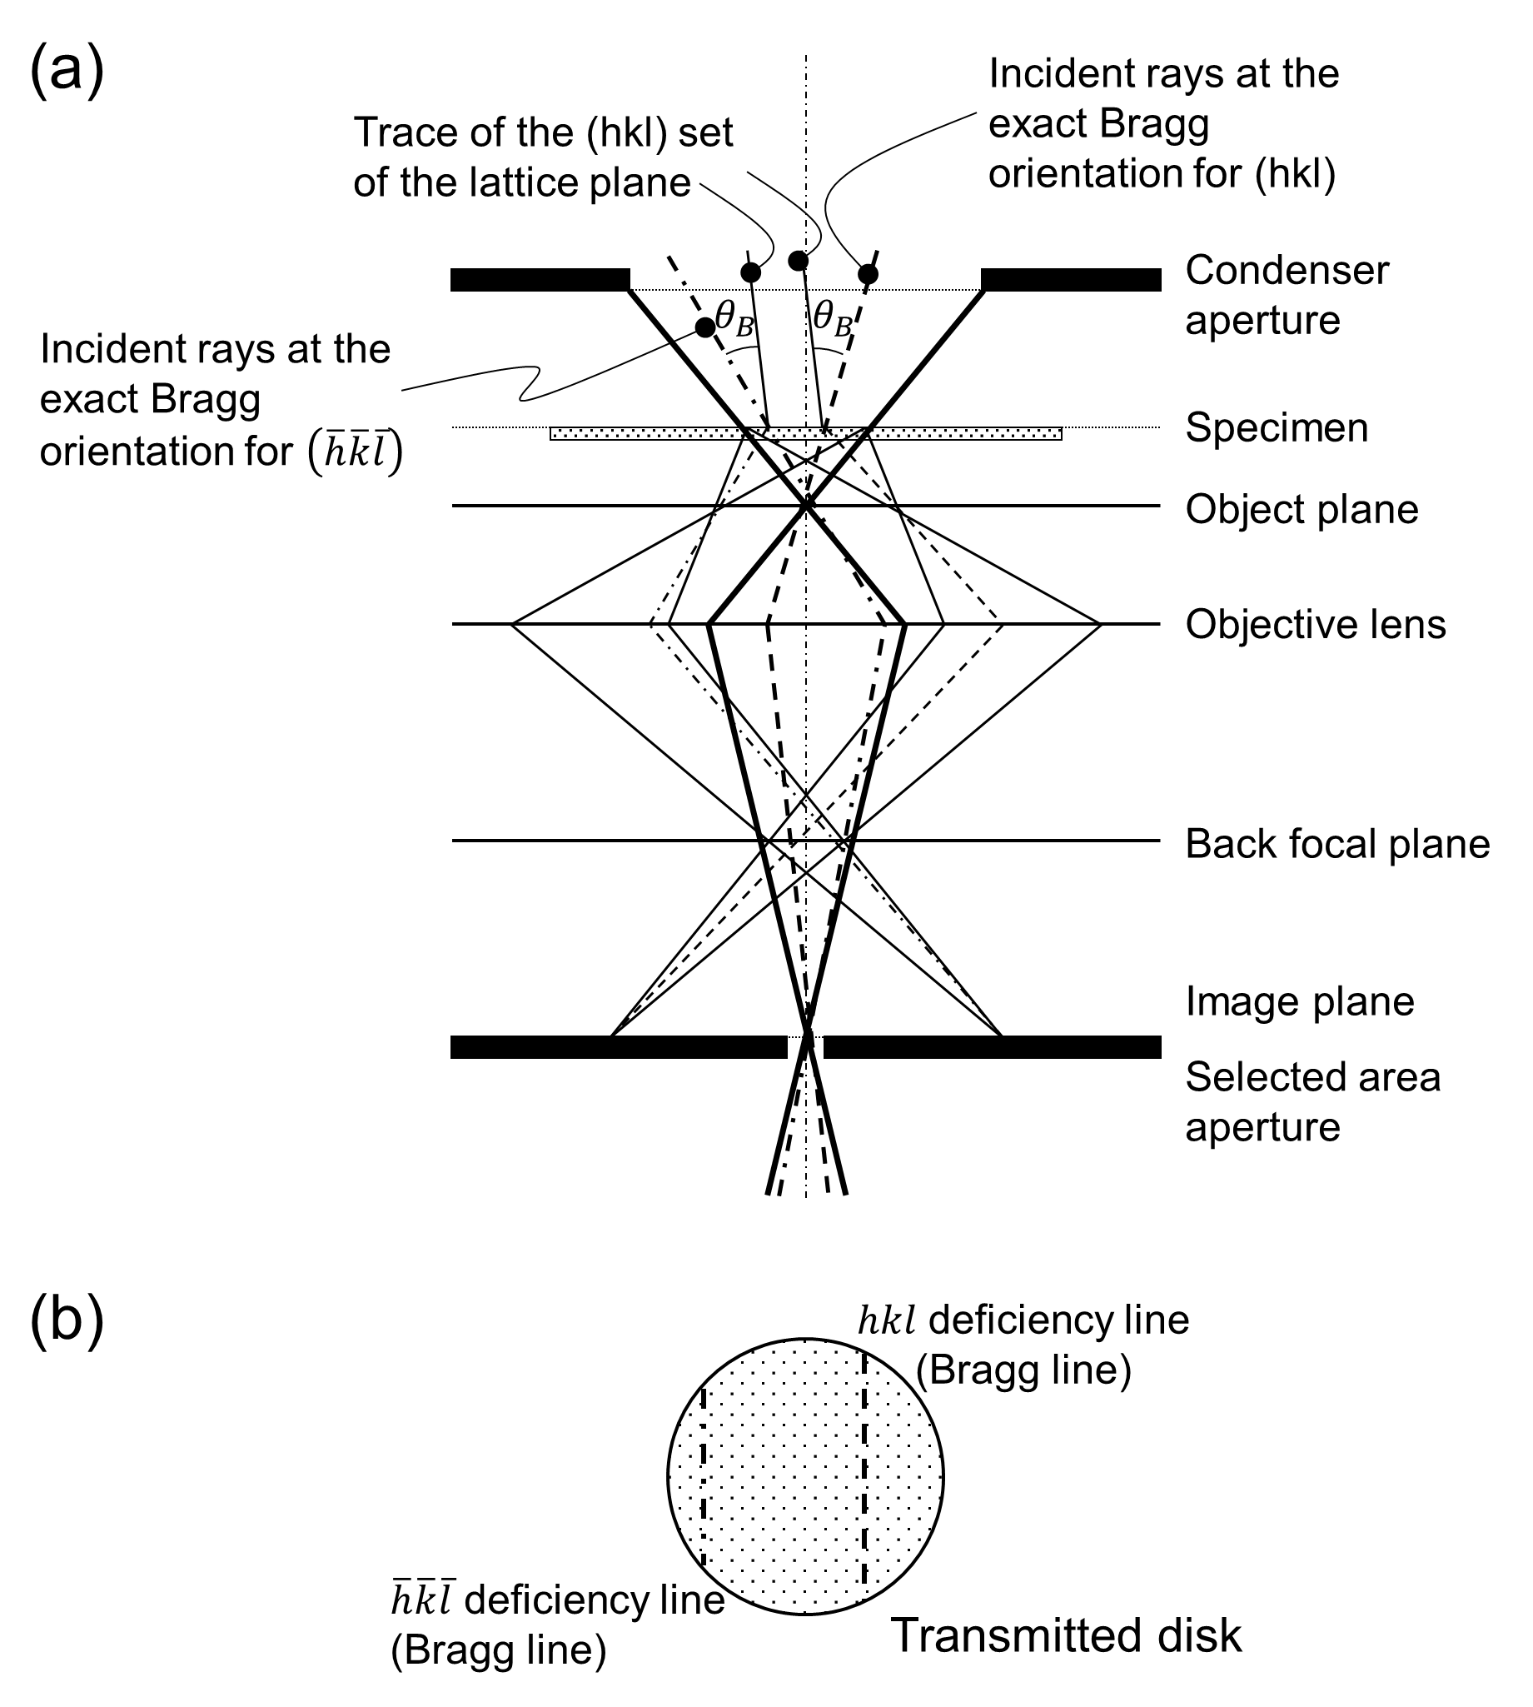
Fig. 2. LACBED conceptual optical system. (a) Electron path and optical system. (b) Transmitted disk and deficiency lines (Bragg lines) at the back focal plane. The convergence angle of the electron beam is emphasized for clarity.

3. Sample preparation and methods
A p-channel metal-oxide-semiconductor transistor with a commercial 45-nm node CPU was used in the present study. The transistors have an embedded SiGe (eSiGe) part in the source and drain areas to induce strain in the channel area, taking advantage of the lattice constant of Ge, which is larger than that of Si. A part with the transistors was thinned to 200 nm using a focused ion beam (FIB, Hitachi NB 5000) and was used as a TEM sample. The sample was set to be relatively thick to avoid stress relief and bending.
TEM (JEOL JEM-F200) was performed at 200 kV. The μμDiff mode of the JEM-F200 was used in the STEM-NBD measurements. By dividing the 1250 nm × 450 nm area into 136 × 50 points, diffraction patterns (DPs) from each point were acquired using a highly sensitive complementary metal-oxide semiconductor (CMOS) camera (Gatan OneView®). The size of each DP was 2048 × 2048 pixels, and the total amount of data retrieved exceeded 111 GB. Hereinafter, the direction vertical to the surface of the Si substrate is referred to as the vertical direction, and the direction parallel to the surface is referred to as the horizontal direction. Because the TEM sample was observed along the <110> Si direction, in the STEM-NBD measurements, the horizontal and vertical strains were measured using the 220 and 002 spots, respectively. The surface direction of the Si substrate was set to [001]. Strain calculation was followed the method of Uesugi.et.al [15].
In the LACBED measurements, the incident direction of the electron beam was set such that its deviation from the transistor-fabrication direction was small, and the density of the Bragg lines associated with the incident direction was low to prevent the obstruction of the real-space images. The 660 and 008 Si lines were used to observe the strain in the horizontal and vertical directions, respectively. The areas used for data acquisition are shown as green and blue squares in Fig. 3(a), and the deviation from [$1\overline{1}0$]Si is less than 2.5° in both cases. The TEM probe mode was used for measurements. The convergence semi-angle of the incident beam was approximately 120 mrad. A program was written using a GMS script to acquire the LACBED data while scanning the Bragg line on the sample relatively. The program repeatedly moved the sample by controlling the goniometer and acquired the LACBED transmission disk using a CMOS camera. The captured image size was 1024 × 1024 pixels, and the pixel sizes in the vertical and horizontal data were 1.13 and 0.99 nm, respectively. The step widths of the stage movement were 6.37 and 18.9 nm in the vertical and horizontal directions, respectively. Although the width of the Bragg line depended on the specimen thickness, the full width at half maximum (FWHM) of the Bragg line was approximately 13 nm in real space in the present experiment. This experiment obtained 100 images in each direction.
修正
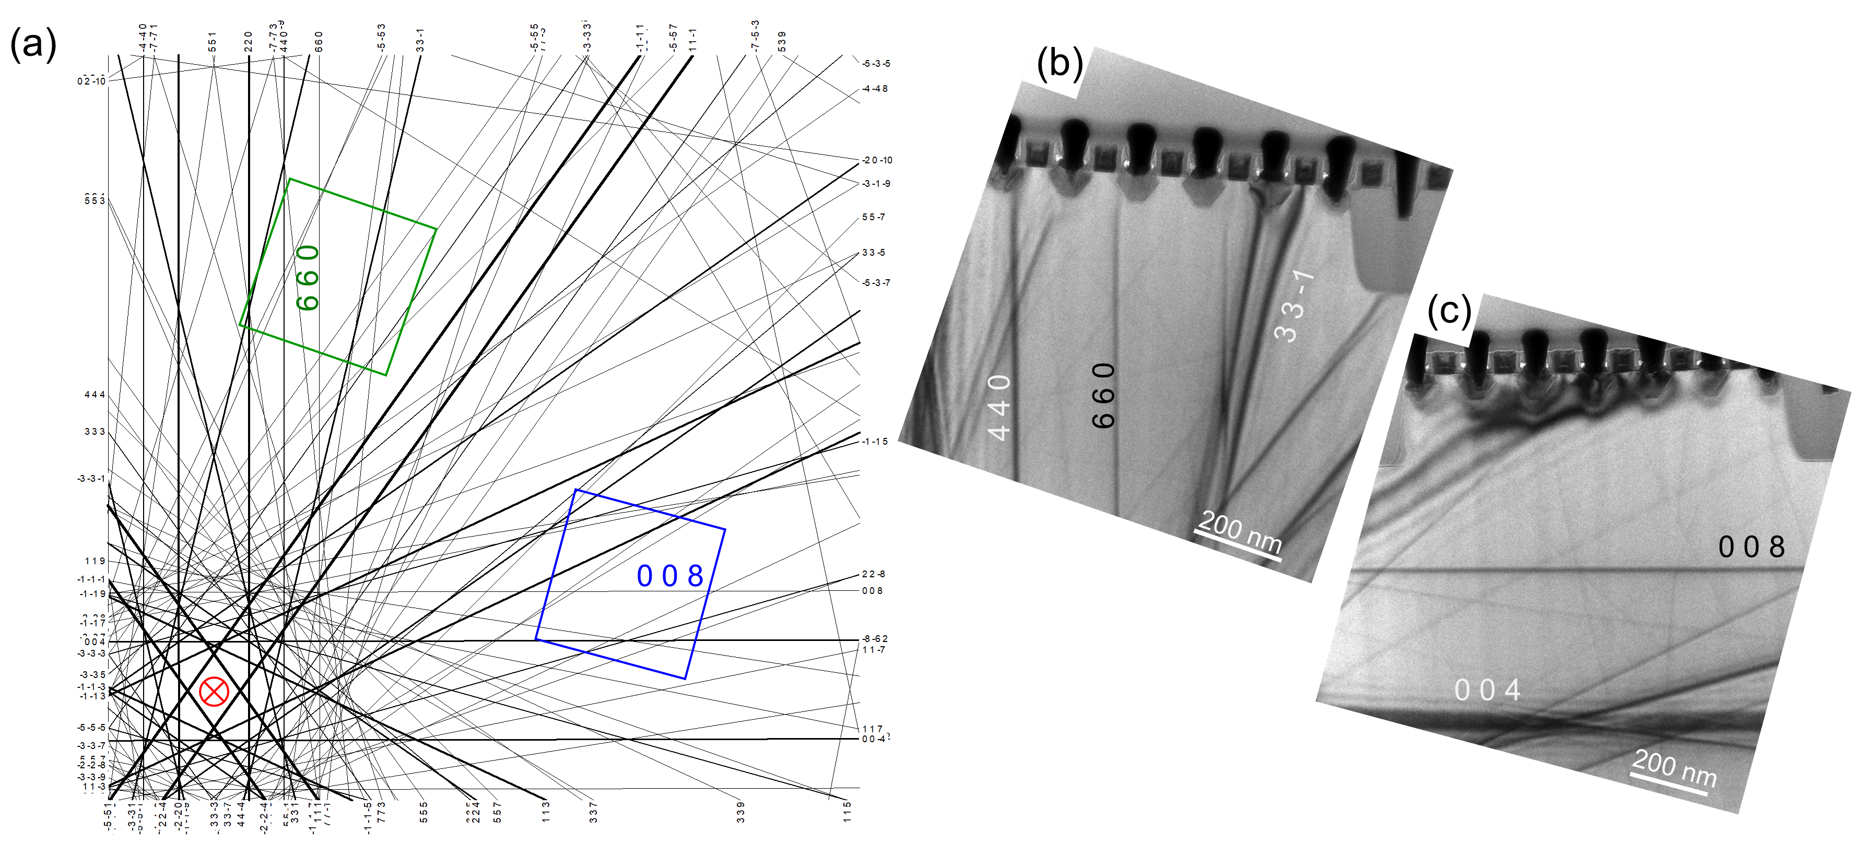
Fig. 3. Map of the Bragg lines and the incident directions (a). The green square is used to observe the 660 line (horizontal strain), and the blue square is used to observe the 008 line (vertical strain). The [$1\overline{1}0$] pole is indicated using $⨂$. Examples of the field of view to measure the (b) horizontal and (c) vertical strains.

To easily understand the strain state, the acquired image series were reconstructed into a single image using a GMS script. Fig. 4 shows a conceptual diagram for the image reconstruction process, where “*” denotes the cross-correlation (CC) function. First, an image wherein the Bragg line indicates stress-free areas is selected from the image series. This image is referred to as the “standard” image. Second, an extracted area that includes the Bragg line in the standard image is selected. This area is referred to as the “evaluation area.” The first and second steps are executed by the user. Subsequently, the CC between the standard and target, that is, the other remaining images in the image series, is calculated. The displacement δ is then obtained from the CC result, where δ denotes the difference between the center position and the position with the maximum value. A composite image is constructed by repeating the CC measurement, extracting the evaluation area image, aligning the images using δ, and connecting the images in the obtained image series.
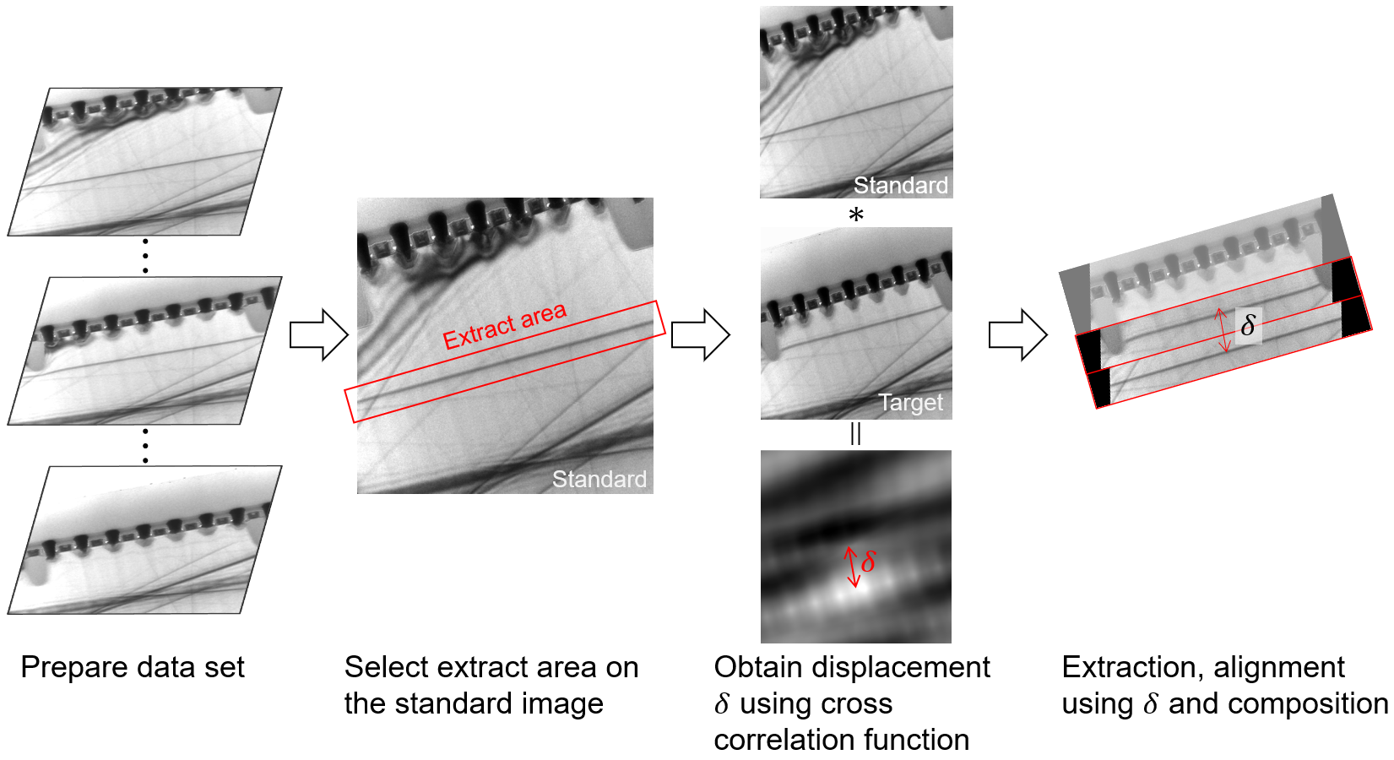
Fig. 4. Conceptual flow diagram of reconstructing images for easily understanding the strain conditions. Image reconstruction was performed using a cross-correlation function.

4. Results and discussion
Part of the LACBED series data is shown in Fig. 5. The red arrows indicate the lines used for strain observations. The lines are straight on the area far from the eSiGe parts. However, as they approach the eSiGe part, they cannot remain straight and bend or blur. The 660 line used for observing the horizontal strain bends or fades among the eSiGe parts but remains in comparison with the 008 line in the vertical direction. The 008 line fades approximately 150 nm from the bottom part of the eSiGe area and disappears at 100 nm. The presence and approximate amount of distortion can be obtained by scanning the Bragg lines.

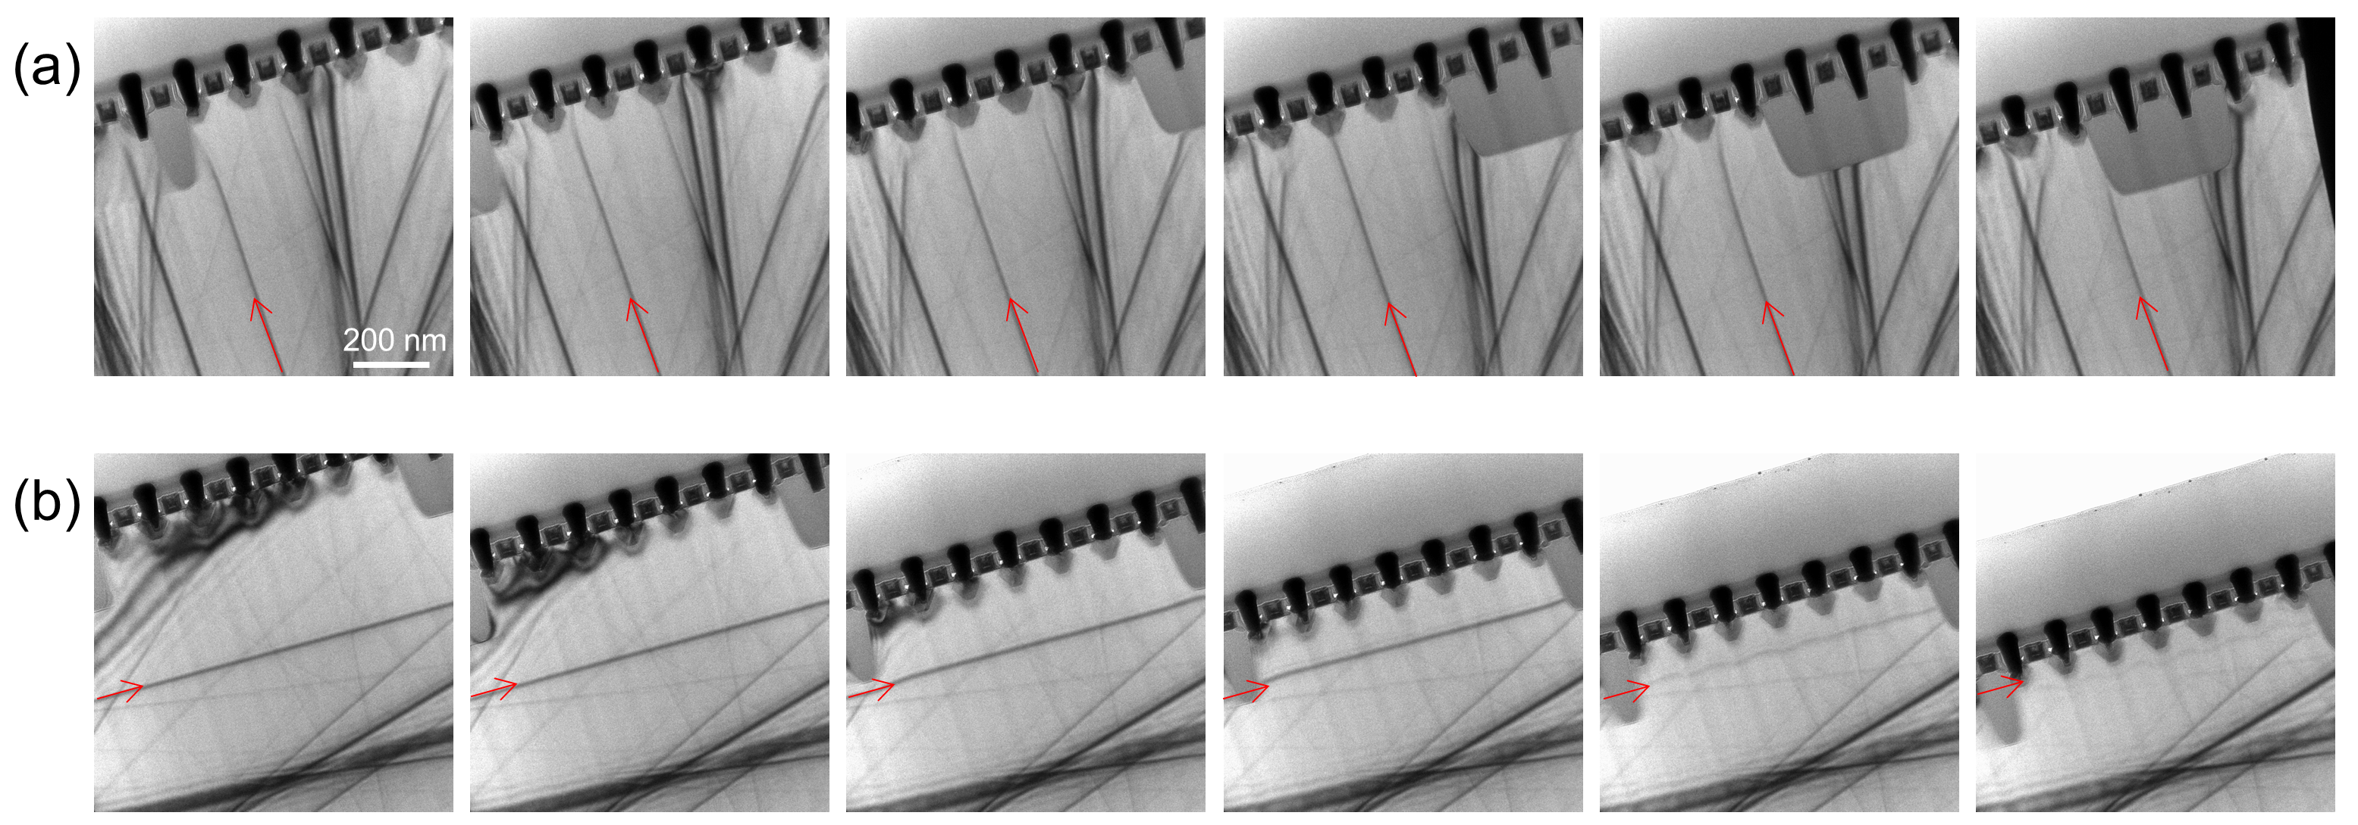
Fig. 5. Bragg line scans over the specimen. The strain is displayed in the (a) horizontal direction using the 660 line and (b) in the vertical direction using the 008 line.

The LACBED and NBD results were compared. A composite image of the LACBED and NBD strain maps is shown in Fig. 6. The sample contained seven eSiGe parts between shallow trench isolations (STIs) of SiO₂. The area, where is about 400nm far from the surface of the Si Substrate, was assumed to be stress-free. In NBD method, the strain was calculated by comparing the DP obtained in the ROI with the DP obtained from the stress-free areas. Since the lattice constant of eSiGe was more than 1% larger than that of Si, both the horizontal and vertical lattice parameters of the eSiGe parts are displayed in red (Fig.6 (a) and (b)). The horizontal strains in the channel regions under the gates among eSiGe parts were compressive because the eSiGe parts expanded. In the deeper area of the eSiGe part, approximately 75–150 nm from the surface of the Si substrate, the lattice parameter of the Si region also expanded in the horizontal direction. In addition, there was a weak horizontal expansion distortion in the region at the same depth, with no eSiGe because the upper region expanded in the vertical direction. The Si areas among the eSiGe parts exhibited tensile strain in the vertical direction because these areas were elongated by the eSiGe parts. As the lattice constant of the eSiGe part was larger than that of Si, vertical compressive strain occurred in the region approximately 75–150 nm from the Si substrate surface; the strain's magnitude was higher when the eSiGe part was on top and lower without it.

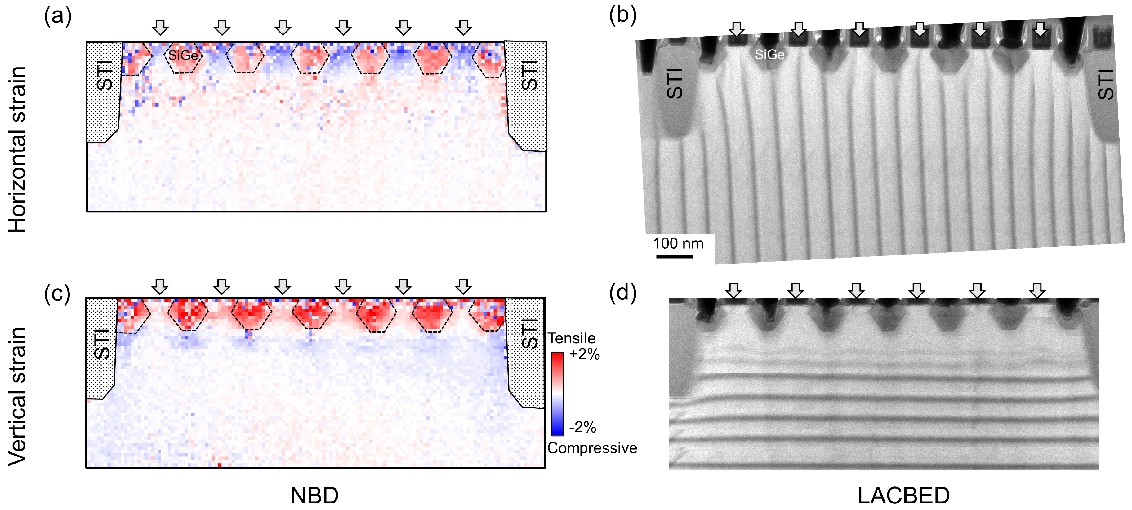
Fig. 6. NBD (left column) and LACBED (right column) results. The upper row indicates the horizontal strain and the lower row indicates the vertical strain. The downward arrows indicate the gate position.

The LACBED results in Fig. 6 were constructed using the method introduced in Section 3. The constructed images (Figs. 6(b) and 6(d)) did not use all the acquired images. During the analysis of the horizontal distortion results shown in Fig. 6(b), it became clear that the 660 lines did not align directionally but they were gently curved. By contrast, for the vertical distortion, although the 008 lines were straight under the bottom of the STI, they began to wave below the area indicated with blue in the STEM-NBD result at approximately 200 nm from the substrate surface. The Si substrate in the blue area was compressed by the eSiGe parts. They became invisible in the area closer to the eSiGe parts. The strain trends above and below the 008 line differ, and the strain varies in a complex manner with the period of the eSiGe interval. Because of the influences of these systems, it was thought that the 008 lines became invisible. Regarding the horizontal strain, the Bragg lines used for the measurement extended in the vertical direction. The STEM-NBD results show that only tensile or compressive strain in the horizontal direction exists at each depth. Therefore, the strain tendency does not differ substantially between the left and right sides of the 660 line, and the 660 line is less blurred than the 008 line until it reaches the surface.
In the LACBED results, the bending or disappearance of the Bragg lines was observed from the Si substrate surface to the depth of the STI bottom in both the vertical and horizontal directions. Significant changes in the lattice constant were also observed in this area using STEM-NBD. Since LACBED senses the curvature change of the sample itself too, the same information of NBD is not obtained. However, although it is qualitative, it provides information on changes in the lattice constant like NBD.

5. Conclusions
In this study, we compared the strain measured using STEM-NBD with the bending and disappearance of the Bragg lines observed using LACBED. The Bragg lines in the LACBED observation appeared curved, split, or disappearing in an area where STEM-NBD detected substantial strain. Because the Bragg line in LACBED measurements also senses the curvature of the sample itself, it cannot be used to estimate a quantitative strain value but can reveal the presence of strain. STEM-NBD requires functions such as the JEOL μμDiff mode (which is included as a standard system in FEI), and these functions are often optional. Therefore, some users cannot use STEM-NBD. In contrast, LACBED does not require the use of such a specialized function. We used a GMS script to acquire LACBED data while moving the sample stage to make the Bragg line to scan relative to the specimen, but similar data can be obtained by repeatedly “moving the stage and obtaining an image” manually without using a script. Because LACBED patterns cannot be easily quantified, LACBED cannot be used as a substitute for STEM-NBD; however, it can be easily used to evaluate the presence or absence of stress. Moreover, even if STEM-NBD can be executed, it is possible to reduce the consumption of PC resources by narrowing the area to be measured via STEM-NBD and conducting an approximate situation survey using LACBED. As we did not optimize the stage-movement step in the present experiment, the amount of obtained LACBED data was 400 MB in each direction. We consider that the strain condition of the investigated system can be obtained using a Bragg line scan on an ROI without any leftover information, and the amount of data can be suppressed if the stage movement step is set such that it is approximately equal to the FWHM of the Bragg line. We believe it is better to use both systems depending on the situation, such as observing with LACBED when strict information is not required, and measuring with STEM-NBD when detailed information is desired.

Author information

Contributions
F.U. designed the analytical concept of this study, conducted the study, and wrote the original draft. C.T. and N.S. prepared the samples using FIB. M.T. reviewed the manuscript and supervised the analytical aspects of the analyses. All authors participated in the discussions.

Acknowledgements
We thank editage (https://www.editage.jp/) for editing a draft of this manuscript.

Competing interests
The author declares no competing financial and nonfinancial interests.

Corresponding authors
Correspondence should be addressed to Fumihiko Uesugi.

Funding
This research did not receive any specific grants from funding agencies in the public, commercial, or not-for-profit sectors.

References
[1] S.M. Hu, Stress-related problems in silicon technology, J. Appl. Phys. 70 (1991)R53-R80. https://doi.org/10.1063/1.349282.
[2] V. Chan, K. Rim, M. Ieong, S. Yang, R. Malik, Y. Way Teh, M. Yang, Q. Ouyang, Strain for CMOS performance improvement, Proceedings of the IEEE 2005 Custom Integrated Circuits Conference, 2005., San Jose, CA, USA (2005) 667–674.
[3] K. Usuda, T. Numata, T. Irisawa, N. Hirashita, S. Takagi, Strain characterization in SOI and strained-Si on SGOI MOSFET channel using nano-beam electron diffraction (NBD), Mater. Sci. Eng. B (2005) 143–147. https://doi.org/10.1016/j.mseb.2005.08.062.
[4] K. Usuda, T. Mizuno, T. Tezuka, N. Sugiyama, Y. Moriyama, S. Nakaharai, S. Takagi, Strain relaxation of strained-Si layers on SiGe-on-insulator (SGOI) structures after mesa isolation, Appl. Surf. Sci. 224 (2004) 113–116. https://doi.org/10.1016/j.apsusc.2003.11.058.
[5] P. Favia, M.B. Gonzales, E. Simoen, P. Verheyen, D. Klenov, H. Bender, Nanobeam diffraction: technique evaluation and strain measurement on complementary metal oxide semiconductor devices, J. Electrochem. Soc. 158 (2011) H438. https://doi.org/10.1149/1.3546851.
[6] J.P. Liu, K. Li, S.M. Pandey, F.L. Benistant, A. See, M.S. Zhou, L.C. Hsia, R. Schampers, D.O. Klenov, Strain relaxation in transistor channels with embedded epitaxial silicon germanium source/drain, Appl. Phys. Lett. 93 (2008). https://doi.org/10.1063/1.3040323.
[7] A. Armigliato, S. Frabboni, G.C. Gazzadi, Electron diffraction with ten nanometer beam size for strain analysis of nanodevices, Appl. Phys. Lett. 93 (2008). https://doi.org/10.1063/1.3003581.
[8] A. Benedetti, H. Bender, C. Torregiani, M. Van Dal, K. Maex, Nanometer scale characterisation of CoSi2 and NiSi induced strain in Si by convergent beam electron diffraction, Mater. Sci. Eng. B 114–115 (2004) 61–66. https://doi.org/10.1016/j.mseb.2004.07.035.
[9] J.M. Zuo, Automated lattice parameter measurement from HOLZ lines and their use for the measurement of oxygen content in YBa2Cu3O7-δ from nanometer-sized region, Ultramicroscopy 41 (1992) 211–223. https://doi.org/https://doi.org/10.1016/0304-3991(92)90110-6.
[10] Y. Tomokiyo, S. Matsumura, T. Okuyama B, T. Yasunaga, N. Kuwano, K. Oki, Dynamical diffraction effect on HOLZ-pattern geometry in Si-Ge alloys and determination of local lattice parameter, Ultramicroscopy 54 (1994) 276–285.
[11] S. Krak, J. Mayer, C. Witt, A. Weickenmeier, M. Ruk, Analysis of local strain in aluminium interconnects by energy filtered CBED , Ultramicroscopy 81(3–4) (2000) 245–62.
[12] R. Wittmann, C. Parzinger, D. Gerthsen, Quantitative determination of lattice parameters from CBED patterns: accuracy and performance, Ultramicroscopy 70 (1998) 145–159. https://doi.org/https://doi.org/10.1016/S0304-3991(97)00107-1.
[13] S.J. Rozeveld, J.M. Howe, Determination of multiple lattice parameters from convergent-beam electron diffraction patterns, Ultramicroscopy 50 (1993) 41–56. https://doi.org/https://doi.org/10.1016/0304-3991(93)90089-G.
[14] F. Uesugi, T. Yamazaki, K. Kuramochi, I. Hashimoto, K. Kojima, S. Takeno, Distortion measurement of multi-finger transistor using split higher-order laue zone lines analysis, Jpn. J. Appl. Phys. 47 (2008) 3709. https://doi.org/10.1143/JJAP.47.3709.
[15] F. Uesugi, A. Hokazono, S. Takeno, Ultramicroscopy evaluation of two-dimensional strain distribution by STEM/NBD, Ultramicroscopy 111 (2011) 995–998. https://doi.org/10.1016/j.ultramic.2011.01.035.
[16] F. Uesugi, Strain mapping in selected area electron diffraction method combining a Cs-corrected TEM with a stage scanning system, Ultramicroscopy 135 (2013) 80–83. https://doi.org/10.1016/j.ultramic.2013.07.003.
[17] B.H. Savitzky, S.E. Zeltmann, L.A. Hughes, H.G. Brown, S. Zhao, P.M. Pelz, T.C. Pekin, E.S. Barnard, J. Donohue, L. Rangel Dacosta, E. Kennedy, Y. Xie, M.T. Janish, M.M. Schneider, P. Herring, C. Gopal, A. Anapolsky, R. Dhall, K.C. Bustillo, P. Ercius, M.C. Scott, J. Ciston, A.M. Minor, C. Ophus, Py4DSTEM: A Software package for four-dimensional scanning transmission electron microscopy data analysis, Microscop. Microanal. 27 (2021) 712–743. https://doi.org/10.1017/S1431927621000477.
[18] M. Tanaka, R. Saito, K. Ueno, Y. Harada, Large-Angle Convergent-Beam Electron Diffraction, Journal of Electron Microscopy, 29, Issue 4, 1980, Pages 408–412, https://doi.org/10.1093/oxfordjournals.jmicro.a050262
[19] Jean- Paul Morniroli, Large-angle Convergent-beam Electron Diffraction applications to Crystal Defects, CRC Press, 2018.
[20] M. Texier, G. Regula, M. Lancin, B. Pichaud, LACBED study of extended defects in 4H-SiC, Philosoph. Magazine Lett. 0839 (2006) 137. https://doi.org/10.1080/09500830600873752.
[21] J.P. Morniroli, and P. Vermaut, Characterization of dislocations in anisotropic materials using LACBED patterns, J. Phys. IV France 03 (1993) C7-2165-C7-2168.
https://doi.org/10.1051/jp4:19937344
[22] J.P. MORNIROLI, CBED and LACBED characterization of crystal defects, J Microsc 223 (2006) 240–245. https://doi.org/https://doi.org/10.1111/j.1365-2818.2006.01630.x.
[23] C.T. Chou, S.C. Anderson, D.J.H. Cockayne, A.Z. Sikorski, M.R. Vaughan, Surface relaxation of strained heterostructures revealed by Bragg line splitting in LACBED patterns, Ultramicroscopy 55 (1994) 334–347. https://doi.org/https://doi.org/10.1016/0304-3991(94)90070-1.
[24] F. Wu, A. Armigliato, R. Balboni, S. Frabboni, Dynamical simulation of LACBED patterns in cross-sectioned heterostructures, Micron 31 (2000) 211–216. https://doi.org/https://doi.org/10.1016/S0968-4328(99)00085-2.
[25] A. Kenda, H. Cerva, P. Pongratz, M. Hierlemann, R. Liebmann, Strain measurements of ULSI devices using LACBED with TSUPREM modeled displacements, in: J.L. Cullis A. G. and Hutchison (Ed.), Microscopy of Semiconducting Materials, Springer Berlin Heidelberg, Berlin, Heidelberg, 2005, pp. 437–440.
[26] A. Spessot, S. Frabboni, R. Balboni, A. Armigliato, Strain field reconstruction in shallow trench isolation structures by CBED and LACBED, Nucl. Instrum. Methods Phys. Res. B 253 (2006) 149–153. https://doi.org/https://doi.org/10.1016/j.nimb.2006.10.052.
[27] Gatan Microscopy Suite Software, (n.d.). https://www.gatan.com/products/tem-analysis/gatan-microscopy-suite-software (accessed November 9, 2022).

large-angle convergent-beam electron diffraction (LACBED); scanning transmission electron microscopy (STEM); nanobeam electron diffraction (NBD); personal computer (PC); diffraction pattern (DP); transmission electron microscopy (TEM); convergent beam electron diffraction (CBED); four-dimensional (4D); gigabytes (GB); region of interest (ROI); Gatan Microscopy Suite (GMS); selected area (SA); focused ion beam (FIB); embedded SiGe (eSiGe); complementary metal-oxide semiconductor (CMOS); full width at half maximum (FWHM); cross-correlation (CC); shallow trench isolations (STIs).

