Oxidation Properties of Additively Manufactured High Entropy Alloys -A Short Review
Jhuo-Lun Lee ^{a, b, c, d}, An-Chou Yeh ^{a, b, c*}, Hideyuki Murakami ^{d*}
ª High Entropy Materials Center, National Tsing Hua University (NTHU), Hsinchu 30013, Taiwan ROC
^{b} Ph.D. Program in Prospective Functional Materials Industry, NTHU, Hsinchu 30013, Taiwan ROC
^{c} Department of Materials Science and Engineering, NTHU, Hsinchu, 30013, Taiwan ROC
^{d} Research Center for Structural Materials, National Institute for Materials Science, Tsukuba, 305-0047, Japan
*Corresponding authors

Email address: a0920989910@gmail.com; yehac@mx.nthu.edu.tw; murakami.hideyuki@nims.go.jp
Abstract: High entropy alloys (HEAs) challenge conventional alloy design by incorporating five or more principal elements in near-equal atomic proportions, forming random solid solutions with simple phases. HEAs exhibit exceptional properties such as high phase stability, mechanical strength, corrosion, oxidation, wear, fatigue resistance, and notable thermal stability. While traditional methods like arc melting and casting are often used for HEA preparation, they pose limitations due to cost and processing challenges. Additive Manufacturing(AM) has emerged as a transformative technique, enabling the cost-effective fabrication of complex structures with customized properties. Here, we summarized the following “state-of-the-art” additively manufactured alloy systems: AlCrCoNiX (X=Fe, Si, Ti, etc.) HEAs, CoCrFeMnNi HEAs, and refractory HEAs. This review focused on elucidating their oxidation properties, emphasizing key findings, challenges, and opportunities. It also discussed the potential strategies for enhancing oxidation resistance. Additionally, it highlighted research gaps and underscored the urgent need for further exploration to meet the demands for high-temperature applications.
Keywords: Oxidation properties, Additive manufacturing, High entropy alloys
1. Introduction
High entropy alloys (HEAs) redefine traditional alloy design by incorporating five or more principal elements in near-equal atomic proportions[1,2]. HEAs, originating from pioneering research at the University of Taiwan, form random solid solutions during solidification and exhibit simple solid solution phases such as BCC, FCC, or HCP structures[3]. HEAs demonstrate exceptional properties, including high phase stability, remarkable mechanical strength, excellent resistance to corrosion, oxidation, wear, and fatigue, and notable thermal stability[4-12]. Most studies prepare HEAs using traditional processing routes like arc melting and casting. However, these methods are often expensive and time-consuming, hindering their practical applications due to the challenges in achieving desired shapes and chemical homogeneity.
In recent years, additive manufacturing (AM) has revolutionized material fabrication by enabling the cost-effective creation of complex structures with excellent forming quality and customized properties[13,14]. Typically, AM can be seen as a layer-by-layer deposition process using a high-energy source with computer-aided design (CAD). Various types of AM methods have been applied to HEAs[15], including selective laser melting (SLM)[16,17], electron-beam-melting (EBM)[18,19], directed energy deposition (DED)[20,21], and other methods. Recently, AM-HEAs have gained increasing interest in the research community due to their exceptional high-temperature properties, making them promising structural materials for high-temperature environments [12,22-24].
In high-temperature applications, superior oxidation resistance is crucial to prevent surface degradation that could compromise mechanical performance. AM-HEAs possess distinctive features, such as refined dendritic structures and metallurgical imperfections, which may induce different oxidation kinetics than traditional processes[25]. Also, prior studies have indicated that HEAs exhibit a favorable combination of specific strength and oxidation resistance compared to conventional alloys[26]. Furthermore, it has been reported that AM-HEAs exhibit slower oxidation kinetics than those produced using traditional methods. The parabolic rate constant of AlCrCoNiFe series alloys in AM specimens (ground) exposed to 1100°C for 200 hours was lower than that of arc-melted specimens (ground) exposed to 1050°C for 100 hours[27,28]. However, previous research has primarily focused on the microstructures and high-temperature mechanical properties of AM-HEAs. Therefore, it is crucial to comprehend the oxidation resistance of AM-HEAs fully. Hence, there is a compelling need for a comprehensive review explicitly focusing on the oxidation properties of AM-HEAs.
This review critically surveys the existing literature and highlights key findings, challenges, and opportunities in the oxidation properties of AM-HEAs. We will discuss crucial aspects such as types of thermally grown oxide, phase evolution, oxidation kinetics, and mechanisms under oxidative conditions. Additionally, we will explore potential strategies for enhancing the oxidation resistance of AM-HEAs, encompassing alloy design, process optimization, and surface modification. By consolidating the current state-of-the-art knowledge, this review seeks to provide valuable insights for materials science and engineering researchers, fostering the development of robust, oxidation-resistant HEA-based materials for advanced engineering applications and contributing to innovation and sustainability across various industrial sectors. In the following text, alloys composed of element A in x at% and element B in y at% will be denoted as A_{x}B_{y}. ​If no numerical values are specified, the alloys are assumed to be in an equimolar ratio.
2. AlCrCoNiX (X=Fe, Si, Ti, etc.) HEAs
According to traditional oxidation theory, the ability of an alloy to resist oxidation largely relies on the ability of protective oxides like Al₂O₃ and Cr₂O₃ to form[29]. As a result, many studies have focused on incorporating Al and Cr into the AM-HEAs systems to investigate whether this enhances their resistance to oxidation at high temperatures.
The first attempts were made by Mohanty et al.[27]. Two AlCoCrFeNi HEAs with varying Al content, which are Al₈Co₂₃Cr₂₃Fe₂₃Ni₂₃ and Al₁₄Co_{21.5}Cr_{21.5}Fe_{21.5}Ni_{21.5}, prepared by direct laser deposition(DLD), were investigated. Specimens were ground till 2000 grade emery paper. Cyclic oxidation tests were conducted at 1100 °C for 200 hours. After an early transition stage, quasi-parabolic oxide growth was observed in Al₈Co₂₃Cr₂₃Fe₂₃Ni₂₃ and Al₁₄Co_{21.5}Cr_{21.5}Fe_{21.5}Ni_{21.5} HEAs. A more significant mass gain was observed for Al₈Co₂₃Cr₂₃Fe₂₃Ni₂₃ compared to Al₁₄Co_{21.5}Cr_{21.5}Fe_{21.5}Ni_{21.5} throughout the testing duration. The oxide scale comprises an external Cr₂O₃ scale and an internal Al₂O₃ subscale for all oxidized samples. Al content significantly influenced the thickness and uniformity of the oxide scale(Fig. 1[27]). The higher aluminum content in Al₁₄Co_{21.5}Cr_{21.5}Fe_{21.5}Ni_{21.5} promoted a continuous Al₂O₃ oxide layer, offering better protection against oxidation than the Al₈Co₂₃Cr₂₃Fe₂₃Ni₂₃ alloy.
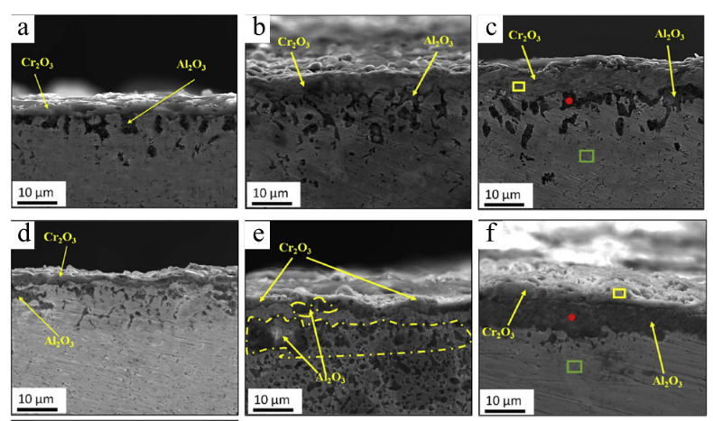
Fig. 1. Cross-sectional SEM micrographs of the oxide scale morphology developed on (a-c) Al₈Co₂₃Cr₂₃Fe₂₃Ni₂₃ and (d-e) Al₁₄Co_{21.5}Cr_{21.5}Fe_{21.5}Ni_{21.5} at 1100 ºC after (a, d) 20 h, (b, c) 100 h, and (c, f) 200 h. Modified after ref.[27].

Kuzminova et al.[30] studied the effect of Al content in the (CrFeCoNi)_{100-x}Al_{x} system on the oxidation resistance. Three alloys, namely CoCrFeNi, Al_{2.4}Co_{24.4}Cr_{24.4}Fe_{24.4}Ni_{24.4}, and Al₁₀Co_{22.5}Cr_{22.5}Fe_{22.5}Ni_{22.5}, were prepared by powder bed fusion(PBF) from Al and CrFeCoNi powder blends. Isothermal oxidation tests were conducted at 800 and 1000 ℃ for up to 500 hours. The resulting oxide scale mainly comprises MnO, Cr₂O₃, and Al₂O₃. In addition, AlN was found beneath the Al₂O₃ layer in Al₁₀Co_{22.5}Cr_{22.5}Fe_{22.5}Ni_{22.5} at 1000 ℃. It was found that without Al addition, the oxide scale delamination is severe. The addition of Al in the CrFeCoNi system could promote the formation of the Al₂O₃ layer predominantly along the columnar grain boundaries and improve the oxidation properties. The issue of powder impurity is also reported herein. On the one hand, the original CrFeCoNi powder contains ~1 wt.% of Mn, leading to unprotective Mn-rich oxides. On the other hand, the formation of nitrides was attributed to the retained nitrogen in the as-built sample conveyed from the powder.
Lee et al.[31] investigated the oxidation kinetics of novel Al₂O₃-forming L1₂-strengthened high entropy alloys, comparing them with the traditional 3D-printable Ni-based superalloy IN718. Pre-alloyed gas-atomized powders with nominal compositions of Al₈Co₃₅Cr₁₈Ni₃₄Ti₃Nb₂ (HEA4) and Al₉Co₂₅Cr₁₅Ni_{43.7}Ti₃Nb₂Mo_{1.5}W_{0.8} (HEAX) are prepared. Alloys were fabricated by SLM from pre-alloyed powders. Specimens were ground till #1200 SiC abrasive paper. Isothermal oxidation tests were conducted at 900 °C to 1100 °C for 24 hours, and a cyclic test at 1100 °C. The resulting isothermal weight gain behavior and parabolic constant highlighted the superior oxidation resistance of HEAs compared to IN718, attributed to the formation of a protective α-Al₂O₃ layer in HEAs (as shown in Fig. 2[31]). Also, it was suggested that the superior isothermal weight gain behavior of HEAX could be related to higher Al content. Higher Al content increases Al activity, facilitating alumina formation to inhibit oxygen ingress. Regarding the cyclic oxidation test, the stability of protective oxide is critical. IN718 shows significant weight loss, suggesting oxide spallation. By contrast, HEAX shows limited weight change. Previous studies have found that AM IN718 demonstrated severe spallation attributed to the segregation of impurity elements, such as sulfur[32,33]. Despite the detailed quantification of the powder composition not being reported in this research, future works are encouraged to investigate the effects of impurity elements on the cyclic oxidation behavior of AM-HEAs.
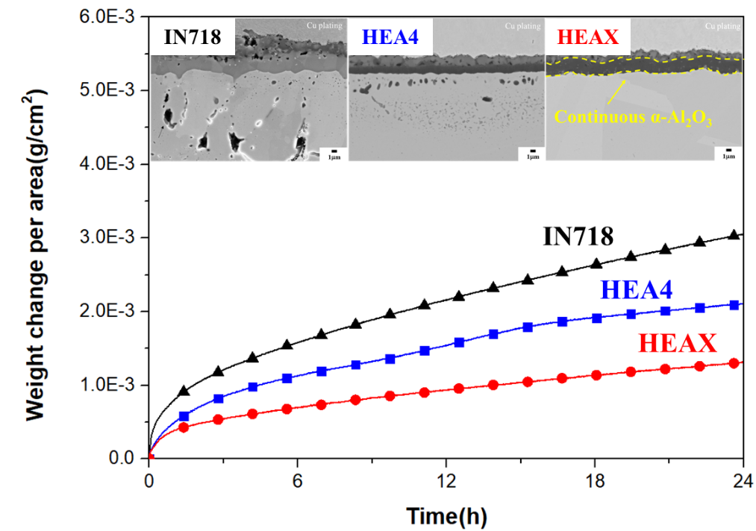

Fig. 2. Isothermal oxidation kinetics of HEAs and IN718 at 1100 ℃ and corresponding cross-sectional SEM micrographs of the oxide scale morphology after testing[31].

The above studies show that increasing Al content can improve oxidation resistance. However, Yan et al.[34] investigated two types of AlCrCoNiSi-based HEAs, namely Al₁₀Cr₁₇Co₃₄Ni₃₄Si₅ (Al10) and Al₁₅Cr₁₆Co₃₂Ni₃₂Si₅ (Al15), prepared by laser powder-based directed energy deposition. The deposited microstructures of both alloys consist of Al-depleted FCC and Al-rich BCC phases. The surface oxidation behaviors of these two alloys were studied at 1100 ℃ for 100h. Specimens were ground and polished. The results show that the oxidation kinetics of Al10 and Al15 alloys follow linear rate law at early-stage oxidation and parabolic rate law at prolonged oxidation times. The linear and parabolic oxidation rate constants of Al10 alloy are lower than that of Al15, which indicates a better oxidation resistance in alloy with lower Al content. The oxide scales for Al10 and Al15 alloys comprise mainly α-Al₂O₃, with a small fraction of (Ni, Co)Al₂O₄ spinel and θ-Al₂O₃. Moreover, a newly formed FCC layer was found beneath the oxide scale in the Al-depletion zone. The author attributed the formation of this FCC layer to the phase transformation of BCC, which occurs due to the preferential oxidation of Al, leading to a reduction in Al content in the BCC phases. The newly formed FCC layer is almost twice as thick in Al10 as in Al15 after 100h of exposure. It is concluded that the thicker newly-formed FCC layer in the Al10 alloy effectively hinders the outward diffusion of Al, resulting in lower oxidation kinetics, as shown in Fig. 3[34].
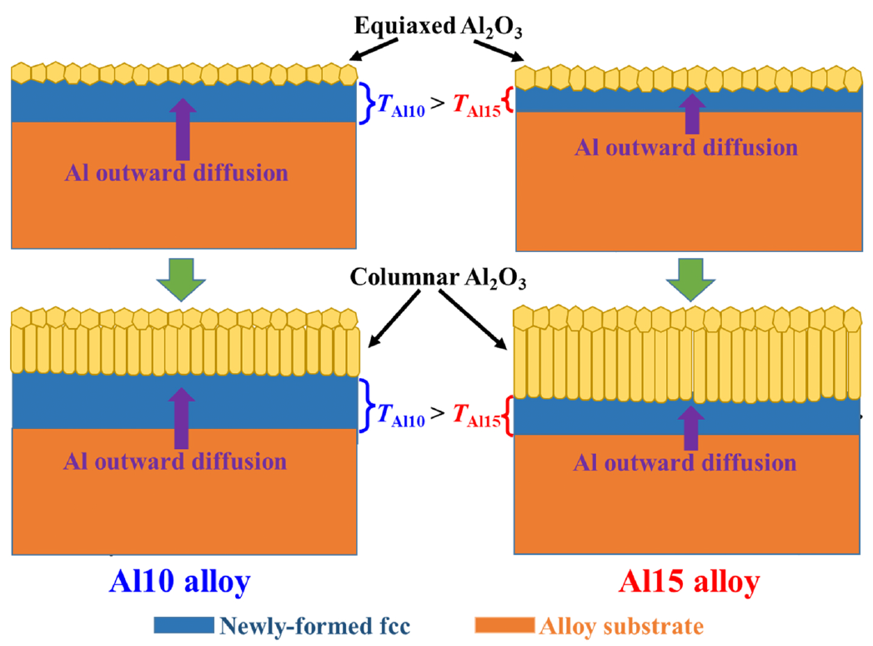
Fig. 3. Schematic diagram showing the formation of oxide scales on Al10 and Al15 alloys[34].

Surface modification by surface plastic deformation treatments, such as laser shock peening (LSP), can significantly improve the oxidation resistance of conventional alloys prepared by AM (for example, Ti6Al4V alloy[35] and IN625 composites[36]). Considering this, Tong et al.[37] studied the high-temperature oxidation behaviors of SLM-fabricated AlCoCrCuFeNi HEA with and without LSP. Isothermal oxidation tests were conducted at 700, 900, and 1100 ℃ for 100 hours. Specimens were ground and polished to a 3 μm diamond suspension. The weight gain curves indicate that all samples initially exhibited linear growth, transitioning to parabolic growth as the testing time increased. This linear phase corresponds to the transient oxidation stage of the reaction control process. Additionally, samples treated with LSP consistently showed lower weight gain and a constant reduced oxidation rate across all tests and temperatures. In contrast, untreated specimens displayed rough spinel oxide scales, which detached from the matrix and experienced significant spallation after prolonged exposure. It was concluded that the combined effects of grain refinement and compressive residual stress contributed to the enhanced oxidation resistance observed in the LSP-treated samples. The detailed oxidation mechanism is illustrated in Fig. 4[37].

Fig. 4. Schematic diagrams of the high-temperature oxidation process: (a) without LSP and (b) with LSP. Modified after ref.[37].

3. CoCrFeMnNi HEAs
Another alloy system, CoCrFeMnNi HEAs, has garnered significant attention since its discovery in 2004[38]. Various AM methods have been employed for processing CoCrFeMnNi HEAs[18,39,40], although the emphasis has not been on oxidation properties. Previous studies have been published investigating the oxidation mechanism of CoCrFeMnNi HEAs through traditional processes [41,42]. However, variations in oxidation mechanisms have been observed across different fabrication processes[25].
Tong et al.[25] studied CoCrFeMnNi HEAs utilizing laser additive manufacturing (LAM) and conducted high-temperature isothermal oxidation tests at 800 to 1000 °C for 100 hours. Pre-alloyed powders with chemical compositions such as Co_{20.5}Cr_{19.8}Fe_{19.4}Mn_{20.1}Ni_{20.1}O_{0.1} are used to fabricate the bulk material. Specimens were ground and polished to a 0.25 μm diamond suspension. The oxidation kinetics of the LAM-fabricated specimens adhered to the parabolic rate law. Different testing temperatures induce notable changes in oxide scales. At 800 °C, the oxide scale comprises Mn₂O₃ and Cr₂O₃, whereas Mn₃O₄ and (Mn, Cr)₃O₄ at 900 and 1000 °C. It was found that the Mn-rich and Cr-rich oxides formed due to the rapid outward diffusion of Mn and Cr along the dendrite grain boundaries reacting with inward diffusing oxygen. With the experiment results, the author further elaborates on the oxidation kinetics of LAM-fabricated CoCrFeMnNi HEAs. Also, the metallurgical defects and thermal stress within LAM-fabricated specimens were found to be detrimental factors affecting high-temperature oxidation properties. The defects could act as rapid diffusion channels and stress concentration points to promote the spallation of oxides. These observations demonstrate the influence of sample specificity of the AM route could indeed affect the oxidation properties of materials.
Similarly, Jia et al.[43] studied the oxidation behavior of the CoCrFeMnNi HEAs prepared by SLM with and without annealing. Annealing was set as 900 °C heat treatment for 4 hours. Isothermal oxidation tests were conducted for 8 hours at 800, 900, and 1000 °C. Specimens were ground and polished to a 0.5 μm diamond suspension. The parabolic law could describe the oxidation kinetics for samples with and without annealing throughout the testing temperature. The oxide products were in accordance with previous studies, i.e., Cr-oxides and Mn-oxides. A notable finding was that the annealing process significantly enhanced oxidation resistance by impeding preferential oxidation and reducing oxide spallation risk. This was attributed to removing melt pool boundaries and residual stress caused by the AM process after annealing.
4. Refractory HEAs
Refractory HEAs(RHEAs), introduced by Senkov in 2010, are metallic materials crafted for extreme heat environments.[44] Composed of Cr, Mo, Ta, Hf, Nb, V, W, and additional elements in equimolar or near-equimolar ratios, RHEAs exhibit exceptional strength at high temperatures[45-48]. However, the high melting points of different elements also pose challenges to preparing RHEAs using traditional methods, especially complex shaping. Therefore, many efforts have been made to fabricate RHEAs by AM[49-53]. On the other hand, despite their promise for advanced structural applications in gas turbines, RHEAs suffer from poor oxidation resistance, mainly due to their inability to form a protective oxide layer at high temperatures[54,55].
With a particular focus on the formability of a protective oxide layer at high temperatures, Zhou et al.[56] investigated the oxidation resistance of a series of AlCrMoTaTi RHEAs manufactured by laser melting deposition(LMD). Three alloys, namely Al_{5.6}Cr_{30.4}Mo_{18.2}Ta_{19.7}Ti_{26.1} (Al5), Al₁₀Cr_{31.3}Mo_{22.5}Ta_{19.5}Ti_{16.7} (Al10), and Al_{15.4}Cr_{27.5}Mo_{19.2}Ta_{20.7}Ti_{17.2} (Al15) were studied. The as-prepared RHEA primarily comprises two BCC phases, namely BCC1 and BCC2. The highest (Cr+Al) concentrations were found in the phase boundary, followed by the BCC2 phase and BCC1 phase. The BCC2 phase volume fraction and the phase boundary area are increased with increasing Al content. Oxidation kinetics were evaluated by isothermal oxidation at 1300 °C for 20 hours. Al15 shows superior oxidation performance with the lowest weight gain after testing. Further investigation reveals that the oxide scale of Al5 and Al10 comprises a mixture of TiO₂, Ta₂O₅, Cr₂O_{3,} and α-Al₂O₃. Interestingly, Al15 can form a pure external α-Al₂O₃ scale. The above results show that Al content plays a significant role in the oxidation process of the AlCrMoTaTi RHEA. This work also highlights that AM-RHEAs can be a potential candidate for achieving excellent high-temperature oxidation resistance.

Table 1. High-temperature oxidation properties of additively manufactured HEAs
Alloy | Processing | Temperature (ºC) | Weight gain(mg/cm²) |  |  | K_{p}(g² /cm⁴s) | Ref.
Alloy | Processing | Temperature (ºC) | 8h | 20h | 100h | K_{p}(g² /cm⁴s) | Ref.
Al₈Co₂₃Cr₂₃Fe₂₃Ni₂₃ | DLD | 1100 | - | 0.17 | 0.82 | 1.7×10⁻¹² | [27]
Al₁₄Co_{21.5}Cr_{21.5}Fe_{21.5}Ni_{21.5} | DLD | 1100 | - | 0.03 | 0.44 | 3.8×10⁻¹³ | [27]
CoCrFeNi | PBF | 800 | - | 0.09 | 0.13 | - | [30]
CoCrFeNi | PBF | 1000 | - | 0.38 | -0.17 | - | [30]
Al_{2.4}Co_{24.4}Cr_{24.4}Fe_{24.4}Ni_{24.4} | PBF | 800 | - | 0.15 | 0.18 | 1.5×10⁻¹³ | [30]
Al_{2.4}Co_{24.4}Cr_{24.4}Fe_{24.4}Ni_{24.4} | PBF | 1000 | - | 1.00 | 1.76 | 6.8×10⁻¹² | [30]
Al₁₀Co_{22.5}Cr_{22.5}Fe_{22.5}Ni_{22.5} | PBF | 800 | - | 0.04 | 0.15 | 1.4×10⁻¹³ | [30]
Al₁₀Co_{22.5}Cr_{22.5}Fe_{22.5}Ni_{22.5} | PBF | 1000 | - | 1.46 | 2.77 | 2.6×10⁻¹¹ | [30]
Al₈Co₃₅Cr₁₈Ni₃₄Ti₃Nb₂ | SLM | 900 | 0.11 | 0.19 | - | 5.7×10⁻¹³ | [31]
Al₈Co₃₅Cr₁₈Ni₃₄Ti₃Nb₂ | SLM | 1000 | 0.42 | 0.60 | - | 4.4×10⁻¹² | [31]
Al₈Co₃₅Cr₁₈Ni₃₄Ti₃Nb₂ | SLM | 1100 | 1.25 | 1.98 | - | 5.3×10⁻¹¹ | [31]
Al₉Co₂₅Cr₁₅Ni_{43.7}Ti₃Nb₂Mo_{1.5}W_{0.8} | SLM | 900 | 0.09 | 0.13 | - | 2.7×10⁻¹³ | [31]
Al₉Co₂₅Cr₁₅Ni_{43.7}Ti₃Nb₂Mo_{1.5}W_{0.8} | SLM | 1000 | 0.35 | 0.50 | - | 2.9×10⁻¹² | [31]
Al₉Co₂₅Cr₁₅Ni_{43.7}Ti₃Nb₂Mo_{1.5}W_{0.8} | SLM | 1100 | 0.78 | 1.19 | - | 1.8×10⁻¹¹ | [31]
AlCoCrCuFeNi | SLM | 700 | - | 0.13 | 0.29 | 2.5×10⁻¹³ | [37]
AlCoCrCuFeNi | SLM | 900 | - | 0.21 | 0.38 | 3.8×10⁻¹³ | [37]
AlCoCrCuFeNi | SLM | 1100 | - | 0.27 | 0.50 | 6.1×10⁻¹³ | [37]
AlCoCrCuFeNi | SLM  +LSP | 700 | - | 0.08 | 0.22 | 1.3×10⁻¹³ | [37]
AlCoCrCuFeNi | SLM  +LSP | 900 | - | 0.11 | 0.25 | 1.5×10⁻¹³ | [37]
AlCoCrCuFeNi | SLM  +LSP | 1100 | - | 0.14 | 0.31 | 2.7×10⁻¹³ | [37]
CoCrFeMnNi | LAM | 800 | - | 1.2 | 3.2 | 2.9×10⁻¹¹ | [25]
CoCrFeMnNi | LAM | 900 | - | 1.9 | 4.9 | 7.0×10⁻¹¹ | [25]
CoCrFeMnNi | LAM | 1000 | - | 4.0 | 8.7 | 2.1×10⁻¹⁰ | [25]
CoCrFeMnNi | SLM | 800 | 0.67 | - | - | 1.6×10⁻¹¹ | [43]
CoCrFeMnNi | SLM | 900 | 1.02 | - | - | 3.7×10⁻¹¹ | [43]
CoCrFeMnNi | SLM | 1000 | 4.01 | - | - | 5.7×10⁻¹⁰ | [43]
CoCrFeMnNi | SLM  +annealing | 800 | 0.62 | - | - | 1.3×10⁻¹¹ | [43]
CoCrFeMnNi | SLM  +annealing | 900 | 0.91 | - | - | 2.9×10⁻¹¹ | [43]
CoCrFeMnNi | SLM  +annealing | 1000 | 3.02 | - | - | 3.2×10⁻¹⁰ | [43]
Al_{5.6}Cr_{30.4}Mo_{18.2}Ta_{19.7}Ti_{26.1} |  |  | 3.72 | 9.22 | - | 3.0×10⁻⁹ | [56]
Al₁₀Cr_{31.3}Mo_{22.5}Ta_{19.5}Ti_{16.7} | LMD | 1300 | 3.04 | 5.12 | - | 4.1×10⁻¹⁰ | [56]
Al_{15.4}Cr_{27.5}Mo_{19.2}Ta_{20.7}Ti_{17.2} |  |  | 0.91 | 1.12 | - | 1.3×10⁻¹¹ | [56]

5. Conclusions and future works
Table 1 presents a comprehensive overview of the high-temperature oxidation characteristics of AM-HEAs, detailing weight gain and parabolic constants sourced from various authors. Analysis of Table 1 reveals several key insights. Firstly, AlCrCoNiX (X=Fe, Si, Ti, etc.) HEAs exhibit superior oxidation resistance compared to CoCrFeMnNi HEAs, with the most notable weight gain performance observed in AlCoCrCuFeNi HEAs post-treated with the LSP process. This underscores the beneficial impact of aluminum additions on oxidation resistance, mirroring trends seen in traditional alloys. Furthermore, the potential efficacy of stress alleviation on sample surfaces in further enhancing AM-HEAs oxidation resistance is expected, as emphasized by multiple studies[25,37,43]. Secondly, an evident research gap exists regarding the oxidation properties of AM-RHEAs, with only a single publication addressing this aspect thus far. Numerous possible future works are discussed as follows. Firstly, it is pertinent to note that current oxidation investigations of AM-HEAs primarily rely on traditional theoretical frameworks applied to empirical data. Given the multi-element composition of HEAs and the complex microstructures induced by AM, an urgent need arises for a comprehensive model capable of accurately predicting oxide formation and oxidation kinetics. Secondly, the effect of impurity elements in the alloy powders should be carefully investigated since they could be detrimental to oxidation performance[30,32]. Thirdly, all studies reviewed herein used ground or polished specimens for oxidation tests (not specified in ref. [30,56]). However, previous studies suggest that the surface conditions of AM specimens also affect oxidation properties[32,57,58]. Therefore, it is crucial to understand how the unique microstructural characteristics, such as surface roughness, grain texture, and residual stress induced by AM, impact the oxidation properties of HEAs. The above-mentioned issues are worth concerted efforts from researchers to delve deeper into this area in forthcoming studies. The oxidation behavior of AM-HEAs stands as a crucial research domain poised to address application requirements. A pressing demand exists for materials exhibiting high-temperature stability, particularly in terms of oxidation resistance. Consequently, further research and development efforts are warranted to comprehensively explore the oxidation behavior of AM-HEAs, with the ultimate aim of meeting these critical application demands.
Acknowledgments
This work was financially supported by the “High Entropy Materials Center” from The Featured Areas Research Center Program within the framework of the Higher Education Sprout Project by the Ministry of Education (MOE) in Taiwan. This work was also supported by the National Science and Technology Council (NSTC) in Taiwan under Grant NSTC 112-2927-I-007-504, NSTC 110-2221-E-007-020-MY3, NSTC 112-2224-E-007-003. The authors would like to thank Drs. Takanobu Hiroto and Akira Ishida, both NIMS, for their academic support, and Jhuo-Lun Lee would like to thank NIMS for the provision of the international collaborative graduate program (ICGP) scholarship.

Declaration of Conflict of Interest
The authors declare that they have no known competing financial interests or personal relationships that could have appeared to influence the work reported in this paper.

References
1. Yen H, Yeh A-C, Yeh J-W. High-entropy alloys: An overview on the fundamentals, development, and future perspective. 2023.
2. Yeh A-C, Gorsse S, Keppens V, et al. Design and development of high entropy materials. APL Materials. 2023;11(3).
3. Yeh JW, Chen SK, Lin SJ, et al. Nanostructured high‐entropy alloys with multiple principal elements: novel alloy design concepts and outcomes. Advanced engineering materials. 2004;6(5):299-303.
4. Gorsse S, Chen Y-T, Hsu W-C, et al. Modeling the precipitation processes and the formation of hierarchical microstructures in a single crystal high entropy superalloy. Scripta Materialia. 2021;193:147-152.
5. Lin C-L, Lee J-L, Kuo S-M, et al. Investigation on the thermal expansion behavior of FeCoNi and Fe30Co30Ni30Cr10-xMnx high entropy alloys. Materials Chemistry and Physics. 2021;271:124907.
6. Chen Y-T, Chang Y-J, Murakami H, et al. Hierarchical microstructure strengthening in a single crystal high entropy superalloy. Scientific reports. 2020;10(1):12163.
7. Hsu W-L, Murakami H, Araki H, et al. A study of NiCo0. 6Fe0. 2CrxSiAlTiy high-entropy alloys for applications as a high-temperature protective coating and a bond coat in thermal barrier coating systems. Journal of the Electrochemical Society. 2018;165(9):C524.
8. Tsao T-K, Yeh A-C, Murakami H. The microstructure stability of precipitation strengthened medium to high entropy superalloys. Metallurgical and Materials Transactions A. 2017;48:2435-2442.
9. Hsu W-L, Murakami H, Yeh J-W, et al. A heat-resistant NiCo0. 6Fe0. 2Cr1. 5SiAlTi0. 2 overlay coating for high-temperature applications. Journal of the Electrochemical Society. 2016;163(13):C752.
10. Tsao T-K, Yeh A-C, Kuo C-M, et al. High temperature oxidation and corrosion properties of high entropy superalloys. Entropy. 2016;18(2):62.
11. Yeh A, Tsao T, Chang Y, et al. Developing new type of high temperature alloys–high entropy superalloys. Int J Metall Mater Eng. 2015;1(107):1-4.
12. Lee J-L, Wang P-T, Lo K-C, et al. Effect of serrated grain boundary on tensile and creep properties of a precipitation strengthened high entropy alloy. Science and Technology of Advanced Materials. 2023;24(1):2158043.
13. Gibson I, Rosen DW, Stucker B, et al. Additive manufacturing technologies. Vol. 17. Springer; 2021.
14. Blakey-Milner B, Gradl P, Snedden G, et al. Metal additive manufacturing in aerospace: A review. Materials & Design. 2021;209:110008.
15. Zhang W, Chabok A, Kooi BJ, et al. Additive manufactured high entropy alloys: A review of the microstructure and properties. Materials & Design. 2022;220:110875.
16. Piglione A, Dovgyy B, Liu C, et al. Printability and microstructure of the CoCrFeMnNi high-entropy alloy fabricated by laser powder bed fusion. Materials Letters. 2018;224:22-25.
17. Sun K, Peng W, Yang L, et al. Effect of SLM processing parameters on microstructures and mechanical properties of Al0. 5CoCrFeNi high entropy alloys. Metals. 2020;10(2):292.
18. Wang P, Huang P, Ng FL, et al. Additively manufactured CoCrFeNiMn high-entropy alloy via pre-alloyed powder. Materials & Design. 2019;168:107576.
19. Yamanaka K, Shiratori H, Mori M, et al. Corrosion mechanism of an equimolar AlCoCrFeNi high-entropy alloy additively manufactured by electron beam melting. npj Materials Degradation. 2020;4(1):24.
20. Gu GH, Kim RE, Kim ES, et al. Fabrication of structural and compositional heterostructured CoCrNi–CoCrFeMnNi multi-material using direct energy deposition additive manufacturing. Intermetallics. 2022;151:107726.
21. Savinov R, Wang Y, Wang J, et al. Comparison of microstructure and properties of CoCrFeMnNi high-entropy alloy from selective laser melting and directed energy deposition processes. Procedia Manufacturing. 2021;53:435-442.
22. Lin W-C, Chang Y-J, Hsu T-H, et al. Microstructure and tensile property of a precipitation strengthened high entropy alloy processed by selective laser melting and post heat treatment. Additive Manufacturing. 2020;36:101601.
23. Kim Y-K, Yang S, Lee K-A. Superior temperature-dependent mechanical properties and deformation behavior of equiatomic CoCrFeMnNi high-entropy alloy additively manufactured by selective laser melting. Scientific reports. 2020;10(1):8045.
24. Li J, Xiang S, Luan H, et al. Additive manufacturing of high-strength CrMnFeCoNi high-entropy alloys-based composites with WC addition. Journal of Materials Science & Technology. 2019;35(11):2430-2434.
25. Tong Z, Liu H, Jiao J, et al. Laser additive manufacturing of CrMnFeCoNi high entropy alloy: Microstructural evolution, high-temperature oxidation behavior and mechanism. Optics & Laser Technology. 2020;130:106326.
26. Kumar P, Lam T-N, Tripathi PK, et al. Recent progress in oxidation behavior of high-entropy alloys: A review. APL Materials. 2022;10(12).
27. Mohanty A, Sampreeth J, Bembalge O, et al. High temperature oxidation study of direct laser deposited AlXCoCrFeNi (X= 0.3, 0.7) high entropy alloys. Surface and coatings technology. 2019;380:125028.
28. Butler TM, Weaver ML. Oxidation behavior of arc melted AlCoCrFeNi multi-component high-entropy alloys. Journal of Alloys and Compounds. 2016;674:229-244.
29. Bar-Cohen Y. High temperature materials and mechanisms. Vol. 44. CRC Press Boca Raton, FL, USA:; 2014.
30. Kuzminova YO, Firsov DG, Shibalova AA, et al. The oxidation behavior of the CrFeCoNiAlx (x= 0, 1.0, and 5.0 wt%) high-entropy alloy synthesized with Al elemental powder via powder bed fusion technique at high temperatures. Micron. 2023;166:103399.
31. Lee J-L, Chou P-H, Tsai C-C, et al. Oxidation kinetics of novel L1₂-strengthened high entropy alloys prepared by selective laser melting.to be submitted to J. Alloys. Comp. 2024.
32. Sanviemvongsak T, Monceau D, Madelain M, et al. Cyclic oxidation of alloy 718 produced by additive manufacturing compared to a wrought-718 alloy. Corrosion Science. 2021;192:109804.
33. Malacarne R, Mathieu S, Aranda L, et al. Type II hot corrosion of A718 and AD 730™ polycrystalline Ni-based alloys: Influence of the SO₃ partial pressure. Corrosion Science. 2023;224:111550.
34. Yan G, Zheng M, Gu J, et al. High-temperature oxidation behavior of laser additively manufactured AlCrCoNiSi-based high-entropy alloys at 1100℃. Journal of Alloys and Compounds. 2024;976:173120.
35. Guo W, Wang H, Peng P, et al. Effect of laser shock processing on oxidation resistance of laser additive manufactured Ti6Al4V titanium alloy. Corrosion Science. 2020;170:108655.
36. Chen L, Sun Y, Li L, et al. Improvement of high temperature oxidation resistance of additively manufactured TiC/Inconel 625 nanocomposites by laser shock peening treatment. Additive Manufacturing. 2020;34:101276.
37. Tong Z, Zhang Y, Liu H, et al. Laser shock peening of AlCoCrCuFeNi high-entropy alloy fabricated by laser powder bed fusion: An enhanced oxidation-resistance mechanism at high-temperature. Corrosion Science. 2024;226:111667.
38. Cantor B, Chang I, Knight P, et al. Microstructural development in equiatomic multicomponent alloys. Materials Science and Engineering: A. 2004;375:213-218.
39. Guo J, Goh M, Zhu Z, et al. On the machining of selective laser melting CoCrFeMnNi high-entropy alloy. Materials & Design. 2018;153:211-220.
40. Chew Y, Bi G, Zhu Z, et al. Microstructure and enhanced strength of laser aided additive manufactured CoCrFeNiMn high entropy alloy. Materials Science and Engineering: A. 2019;744:137-144.
41. Laplanche G, Volkert U, Eggeler G, et al. Oxidation behavior of the CrMnFeCoNi high-entropy alloy. Oxidation of metals. 2016;85:629-645.
42. Holcomb GR, Tylczak J, Carney C. Oxidation of CoCrFeMnNi high entropy alloys. Jom. 2015;67:2326-2339.
43. Jia X, Xu Z, He Y, et al. Oxidation Behavior of CoCrFeMnNi High-Entropy Alloy Fabricated by Selective Laser Melting. Metals and Materials International. 2023:1-14.
44. Senkov O, Wilks G, Miracle D, et al. Refractory high-entropy alloys. Intermetallics. 2010;18(9):1758-1765.
45. Senkov ON, Wilks GB, Scott JM, et al. Mechanical properties of Nb25Mo25Ta25W25 and V20Nb20Mo20Ta20W20 refractory high entropy alloys. Intermetallics. 2011;19(5):698-706.
46. Yao H, Qiao J, Hawk J, et al. Mechanical properties of refractory high-entropy alloys: Experiments and modeling. Journal of Alloys and Compounds. 2017;696:1139-1150.
47. Senkov O, Woodward C. Microstructure and properties of a refractory NbCrMo0. 5Ta0. 5TiZr alloy. Materials Science and Engineering: A. 2011;529:311-320.
48. Senkov O, Senkova S, Woodward C. Effect of aluminum on the microstructure and properties of two refractory high-entropy alloys. Acta Materialia. 2014;68:214-228.
49. Dobbelstein H, George EP, Gurevich EL, et al. Laser metal deposition of refractory high-entropy alloys for high-throughput synthesis and structure-property characterization. International Journal of Extreme Manufacturing. 2020;3(1):015201.
50. Zadorozhnyy V, Tomilin I, Berdonosova E, et al. Composition design, synthesis and hydrogen storage ability of multi-principal-component alloy TiVZrNbTa. Journal of alloys and compounds. 2022;901:163638.
51. Katz-Demyanetz A, Gorbachev I, Eshed E, et al. High entropy Al0. 5CrMoNbTa0. 5 alloy: Additive manufacturing vs. casting vs. CALPHAD approval calculations. Materials Characterization. 2020;167:110505.
52. Zhang H, Xu W, Xu Y, et al. The thermal-mechanical behavior of WTaMoNb high-entropy alloy via selective laser melting (SLM): experiment and simulation. The International Journal of Advanced Manufacturing Technology. 2018;96:461-474.
53. Liu C, Zhu K, Ding W, et al. Additive manufacturing of WMoTaTi refractory high-entropy alloy by employing fluidised powders. Powder Metallurgy. 2022;65(5):413-425.
54. Lo K-C, Murakami H, Glatzel U, et al. Elemental effects on the oxidation of refractory compositionally complex alloys. International Journal of Refractory Metals and Hard Materials. 2022;108:105918.
55. Gorr B, Schellert S, Müller F, et al. Current status of research on the oxidation behavior of refractory high entropy alloys. Advanced Engineering Materials. 2021;23(5):2001047.
56. Zhou Z, Peng X, Lü W, et al. Ultra-high temperature oxidation resistant refractory high entropy alloys fabricated by laser melting deposition: Al concentration regulation and oxidation mechanism. Corrosion Science. 2023;224:111537.
57. Mrozowski N, Prillieux A, Epifano E, et al. Surface reactivity during a hot isostatic pressing treatment of Ni-based superalloy René 77 specimens manufactured by laser powder bed fusion and metal inject molding. Corrosion Science. 2024;234:112119.
58. Sanviemvongsak T, Monceau D, Desgranges C, et al. Intergranular oxidation of Ni-base alloy 718 with a focus on additive manufacturing. Corrosion Science. 2020;170:108684.

