High coercivity permanent magnets without reliance on scarce elements

H. Sepehri-Amin*, A. Bolyachkin, Xin Tang
National Institute for Materials Science, Tsukuba 305-0047, Japan

*h.sepehriamin@nims.go.jp

Abstract
Permanent magnets are known as one of the enablers for achieving carbon neutrality due to their applications in green energy conversion. With the growing demand for permanent magnets, concerns arise regarding element criticality while maintaining the magnets’ functionality. Coercivity (resistance to magnetization reversal) is one of the most important extrinsic magnetic properties of permanent magnets, affecting their functionality. To date, coercivity enhancement has mostly been achieved by the addition of scarce elements, e.g. Dy is often used in Nd₂Fe₁₄B type permanent magnets, exacerbating the materials’ criticality. This review shows how fundamental research has provided alternative strategies for coercivity enhancement without reliance on scarce elements. Specifically, we showcase microstructural engineering, in particular fine-tuning the composition of grain boundary phase and its coverage of the matrix grains in the Nd₂Fe₁₄B type permanent magnets, has led to the development of high coercivity without reliance on Dy. Furthermore, based on micromagnetic simulations, we also discuss further microstructural modifications in the Nd₂Fe₁₄B type magnets required to push coercivity towards its physical limit. Lastly, we will demonstrate how the principles of microstructure engineering can be extended to improve the coercivity of other permanent magnets such as SmCo₅-type and recently-developed SmFe₁₂-based sintered magnets.

Keywords: Permanent magnet, Coercivity, Microstructure, Intergranular phase, Micromagnetic simulation

- Introduction
Permanent magnets are widely used in green energy conversion and transportation applications, contributing towards net-zero CO₂ emissions [1,2]. For sustainable production of permanent magnets, their reliance on critical elements such as Dy should be eliminated while the use of other rare earths (RE) should be diversified. This must be accomplished without sacrificing the extrinsic magnetic properties, particularly remanent magnetization (M_{r}) and coercivity (H_{c}). Among these two, controlling the coercivity and its enhancement is the most challenging, that can be illustrated with Nd-Fe-B permanent magnets.
Nd-Fe-B permanent magnets are based on the Nd₂Fe₁₄B phase, which has a large magnetic anisotropy constant (K₁ = 4.9 MJ/m³) and saturation magnetization (µ₀M_{s} = 1.61 T), resulting in a record maximum energy product at room temperature [3]. However, the coercivity of Nd-Fe-B magnets remains low (µ₀H_{c} < 1.8 T) comparing to its theoretical limit – the magnetic anisotropy field of the Nd₂Fe₁₄B main phase (µ₀H_{A} =7.6 T) [4,5]. The ratio H_{c}/H_{A} can quantify this discrepancy (Fig. 1). Coercivity drops further at elevated temperatures of operating motors and generators (150-180 ºC) down to the point when a magnet cannot withstand the opposing demagnetization field [4,5]. A common approach to prevent this is to increase H_{A} of the main phase by doping heavy RE like Dy and Tb [3-6]. Such (Nd,Dy)-Fe-B sintered magnets with high H_{c}/H_{A} = 0.35 are widely used in traction motors and generators. However, this approach is not sustainable in the long term due to the element criticality issue. It is important to clarify the coercivity mechanism and the role of extrinsic factors such as microstructural defects to find an alternative way of coercivity enhancing. As an example, following by inputs on the intergranular phase (IGP) from the multiscale microstructure characterization, Dy-free hot-deformed Nd-Fe-B magnets were developed via grain boundary engineering with H_{c}/H_{A} as sufficient as in (Nd,Dy)-Fe-B sintered magnets. Moreover, their coercivity mechanism similarly changed from the Kondorsky type to Stoner-Wohlfarth one according to the angular dependence of coercivity (color codes in Fig. 1). Thus, the microstructure engineering is a feasible alternative.

The issue of suppressed H_{c}/H_{A} is common for all types of permanent magnets (Fig. 1) – that is the matter of Brown’s paradox [7]. In this paper, we review the current progress with Nd-Fe-B magnets, which have the most advanced H_{c}/H_{A} to date, in order to generalize the concept of coercivity increase by microstructure engineering and to implement it to other types of magnets.
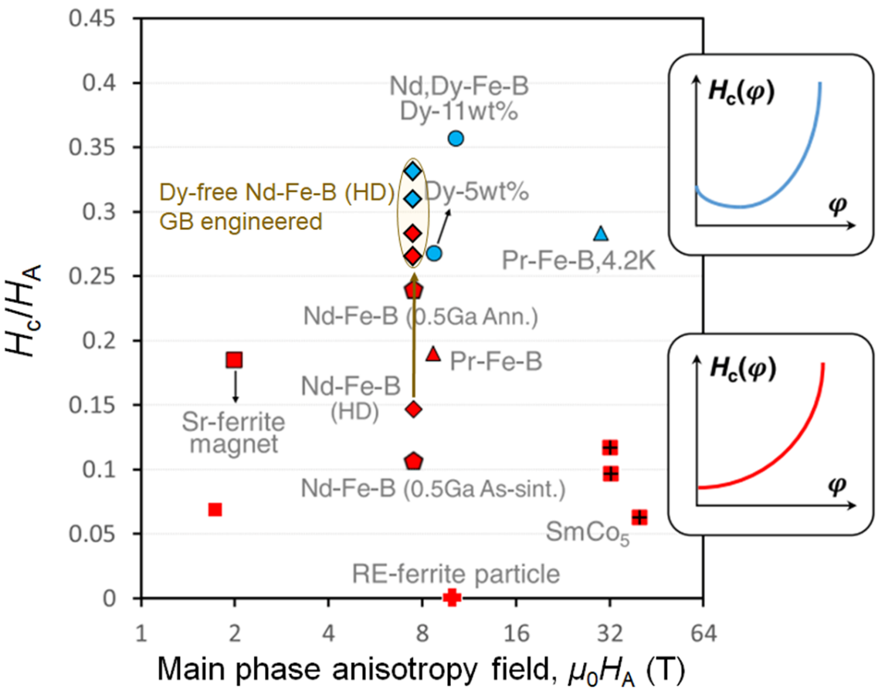
Figure 1: Coercivity to magnetic anisotropy field ratio of different industrial permanent magnets. The red and blue colors represent the Kondorsky and Stoner-Wohlfarth type coercivity mechanisms, respectively, according to the coercivity angular dependencies (insets). Reproduced from Li et al. [8] with copyright permission.

- (Nd,Dy)-Fe-B sintered magnets
To develop Dy-free high-performance Nd-Fe-B magnets, the reasons for high H_{c}/H_{A} of (Nd,Dy)-Fe-B sintered magnets should be elucidated first. Nd-Fe-B sintered magnets are usually produced by the conventional powder processing route followed by magnetic field alignment, liquid phase sintering (1000-1150 ºC), and post-annealing (520-650 ºC) [3]. After all these, the coercivity of Dy-free Nd-Fe-B sintered magnets remains as low as ~1.2 T (0.15·H_{A}) [2]. The reason for such low coercivity was attributed to the thin IGP, containing more than 65 at% of Fe and Co [9]. The ferromagnetic nature of IGP was proposed and confirmed by soft X-ray magnetic circular dichroism (XMCD) [10], spin-polarized scanning electron microscopy [11], electron holography [12], and a model amorphous thin film with the same composition as IGP, showed a moderate µ₀M_{s} of 0.5 T [9].
When Nd-Fe-B sintered magnets are doped with Dy, the coercivity substantially increases, e.g., up to 3.4 T (0.4·H_{A}) in a magnet with the composition of Nd_{10.8}Dy_{3.7}Fe_{78.1}Co_{1.0}Cu_{0.2}B_{6.2} at% [13]. Such a coercivity increase cannot be explained by enhancing H_{A} of the (Nd_{0.8}Dy_{0.2})₂Fe₁₄B matrix phase solely since its increment is not sufficient (2.2 vs. 1.7 T, respectively). There should be an extrinsic contribution also. Tang et al. systematically compared the microstructure of Dy-free and Dy-containing sintered magnets (Fig. 2) [13]. Grain morphology and phase composition were similar in these magnets, as well as the content of Fe + Co in their IGP. The main difference was that the IGP was enriched with 4 at.% Dy in the Dy-containing magnet. This resulted in reduced IGP magnetization due to the antiferromagnetic coupling between Dy and Fe ions, as was confirmed by XMCD and first-principles calculations. Less magnetic IGP means less promoted nucleation of magnetization reversal with subsequent pinning, which is also manifested in the angular dependence of coercivity, changing toward the Stoner-Wohlfarth type. Thus, high coercivity and extraordinary H_{c}/H_{A} in (Nd,Dy)-Fe-B sintered magnets is not only due to intrinsic factors (high H_{A} of the matrix phase), but due to the microstructure-related extrinsic factors (IGP) as well.
Figure 2: General microstructure and chemical composition of the IGP in (a,c,e) Dy-free Nd-Fe-B and (b,d,f) (Nd,Dy)-Fe-B sintered magnets (total 9 wt%). (g) Saturation magnetizations of the IGP in these magnets calculated by first principles considering the evaluated compositions. Reproduced from Tang et al. [13].

- Dy-free Nd-Fe-B magnets
One way to increase the coercivity of Nd-Fe-B magnets while avoiding Dy is to reduce the grain size [14-19]. However, this method becomes impractical below ~3 µm grain size in sintered magnets due to severe oxidation [17,18]. Anisotropic Nd-Fe-B magnets obtained by hot deformation of rapidly solidified powders do not prone to this issue [20,21]. Typical hot-deformed (HD) magnets have platelet-shaped Nd₂Fe₁₄B grains of ~300 nm size in lateral direction and ~100 nm in height, approaching to the single domain size of the Nd₂Fe₁₄B phase. Nevertheless, the coercivity is limited to 1.8 T for a similar reason as in sintered magnet – formation of the thin magnetic IGP [22,23]. Sepehri-Amin et al. overcome this limitation by diffusion of the low melting point Nd-Cu alloy into the grain boundaries [23]. Many of the Nd₂Fe₁₄B grains become separated by diffused Nd-rich nonmagnetic phase free of Fe and Co, that resulted in a significant increase in coercivity. After the followed up studies with different diffusion sources, the H_{c}/H_{A} ratio of hot-deformed Nd-Fe-B magnets approached 0.34 as shown in Fig. 1 [8]. However, such an increase in coercivity comes at the expense of magnetization due to the decrease in volume fraction of the Nd₂Fe₁₄B phase. In addition, a more detailed evaluation of the grain boundaries revealed their heterogeneity (Fig. 3a) [24]. There are thick Nd-rich nonmagnetic phase (Fig. 3b) and the IGP of a ~3 nm thickness (Fig. 3c), which still contains a large amount of Fe and should therefore be magnetic. This thin IGP is inherited from the as-deformed state and its composition does not change during the diffusion process. Considering these microstructural features, it is still an open question what is the ultimate feasible coercivity of the diffusion processed Dy-free hot-deformed Nd-Fe-B magnets upon a reasonable remanence.
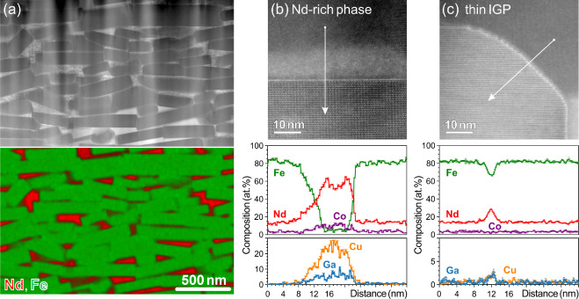
Figure 3: (a) Typical inhomogeneity of the grain boundaries in the diffusion processed hot-deformed Nd-Fe-B magnets: (b) thick Nd-rich phase and (c) thin magnetic IGP with high Fe content. Reproduced from Bolyachkin et al. [24] with copyright permission.

Recent progress in building finite element models of permanent magnets helps to address the above question in micromagnetic simulations [24,25]. Realistic models can be constructed based on tomographic series of SEM images, while retrieved microstructural statistics can be further used to develop representative synthetic models (Fig. 4a) – those are more tunable and can imitate different microstructural transformations including the grain boundary diffusion. Using such synthetic models, Bolyachkin et al. performed micromagnetic simulations for HD magnets varying the magnetization of thin IGP and the volume fraction of the nonmagnetic Nd-rich phase preserving the Nd₂Fe₁₄B grain size [24]. The remanence vs. coercivity tradeoff was obtained (Fig. 4b). When the thin IGP has a magnetization of 0.9 T or more, the remanence decreases rapidly with increasing volume fraction of the Nd-rich phase, while the coercivity is almost unaltered. The coercivity starts to increase only when the percolation threshold for grain interconnectivity is reached. To gain the coercivity prior to the threshold, the IGP magnetization should be suppressed. Thus, a large coercivity of 2.8 T and a remanence of 1.3 T are expected in Dy-free hot-deformed Nd-Fe-B magnets with 16 vol.% Nd-rich phase (Fig. 4b) if the IGP magnetization can be reduced to 0.3 T [24]. This requires further optimization of the diffusion process and microstructure in the initial HD magnets.
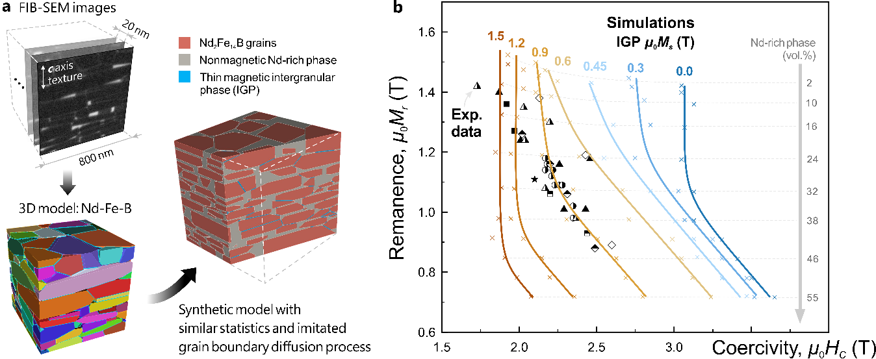
Figure 4: (a) Realistic model constructed on tomographic FIB-SEM data and representative synthetic model based on that. (b) Simulated remanence vs. coercivity of hot-deformed Nd-Fe-B magnets with different saturation magnetization of the thin IGP and volume fraction of the thick Nd-rich nonmagnetic phase. The reported experimental data are shown with different symbols. Reproduced from Bolyachkin et al. [24,25] with copyright permission.

- Other industrial permanent magnets
Other industrial permanent magnets also exhibit low H_{c}/H_{A} (Fig. 1), for example SmCo₅-type sintered magnets, which are used for high-temperature applications due to their high Curie temperature (T_{c}) of 1020 K. Figure 5a shows the typical hysteresis loop of such a magnet. Although it has a large coercivity of 3.9 T, the corresponding H_{c}/H_{A} is only 0.12 considering µ₀H_{A} ≈ 32 T of the SmCo₅ phase [26]. Examining the general microstructure in Fig. 5b, there are some isolated grains of the Sm-rich secondary phase as well as a minor fluctuation of the Sm content in the matrix grains (a gray contrast). The latter is due to the Sm₅Co₁₉ phase (Fig. 5c), which differs from SmCo₅ in the periodicity of stacking faults (Fig. 5d). However, both SmCo₅ and Sm₅Co₁₉ phases show a large H_{A} of ~32 and ~25 T, respectively [27]. An actual reason for the low H_{c}/H_{A} is supposed to be the absent IGP – the grains are in direct contact, so a strong exchange coupling is expected (Fig. 5c). Further research is needed to address whether the coercivity of SmCo₅-type sintered magnets can be increased closer to the theoretical limit by realizing the IGP.
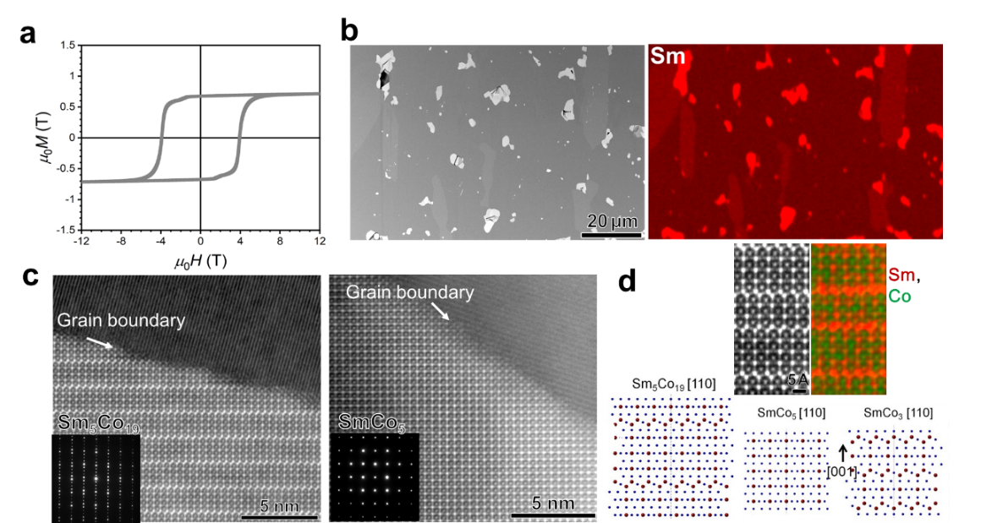
Figure 5: (a) Hysteresis loop of a commercial SmCo₅-based sintered magnet, (b) its general microstructure, and (c) the grain boundary region with selected area electron diffraction patterns of the main grains (insets). (d) Observed arrangement of Sm and Co atoms and its simulations along the [110] direction, indicating the formation of different phases depending on the periodicity of stacking faults [26,27]. Reproduced from Miura et al. [26] with copyright permission.

- Potential of SmFe₁₂-based compounds
The SmFe₁₂-based compound with a 7.7 at.% of RE discovered in late 1987 exhibits attractive intrinsic magnetic properties, i.e., μ₀M_{s} = 1.64 T, μ₀H_{A} = 12 T, and T_{c} = 555 K, surpassing those of Nd₂Fe₁₄B [3,28]. The conversion of these properties into sufficient extrinsic magnetic properties has remained a challenge. Sepehri-Amin et al achieved high coercivity (1.2 T) and remanence (1.5 T) on the anisotropic Sm(Fe,Co)₁₂B_{x} thin film [29], demonstrating the prospects of the SmFe₁₂-based compounds as the next generation permanent magnets capable of diversifying the use of RE elements. However, the development of bulk magnets has been hindered by the metastability of the SmFe₁₂ phase. To overcome that, the phase is often stabilized as SmFe_{12-x}M_{x} by substituting with a nonmagnetic element M such as V, Ti, Mo, etc. Among the stabilizing elements, V has been found to be the most beneficial for realizing the coercivity as it promotes the formation of the Sm-rich IGP [30,31]. Fig. 6a and b show the hysteresis loops and typical microstructure of the SmFe₁₂-based sintered magnet [32,33] with indicated secondary phases of SmO_{x} and Fe₂Ti. It is noteworthy that the matrix phase is surrounded by the Sm-rich IGP containing of about 50 at.% Fe (Fig. 6c). Microalloying with Cu helps to reduce Fe further, resulting in the coercivity of 1.4 T [34]. Thus, similarly to Nd-Fe-B magnets, the IGP engineering is one of the key factors to achieve a high coercivity in SmFe₁₂-based anisotropic bulk magnets that is a matter of further investigations.
Fig. 6d summarizes the remanence vs. coercivity of SmFe₁₂-based sintered magnets compared to other permanent magnets. While the coercivity of SmFe₁₂-based magnets has started approaching that of Nd₂Fe₁₄B magnets, there is a significant gap in the remanence, which outlines the main bottleneck for the commercialization of SmFe₁₂-based sintered magnets. To overcome this, further accurate optimization of the magnet’s composition (e.g., substitution of Co for Fe) and minimization of the secondary phases are required.
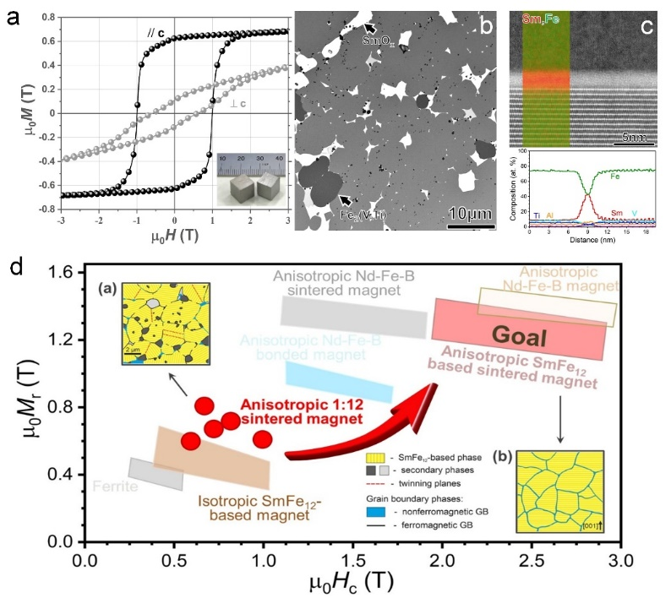
Figure 6: (a) Hysteresis loops, (b) general microstructure, and (c) grain boundary region in the SmFe₁₂-based sintered magnet. (d) Remanence vs. coercivity of industrial magnets with the current status of SmFe₁₂-based magnets as well as their schematic typical and ideal microstructures (insets). Reproduced from Zhang et al. [32,33] with copyright permission.

- Conclusion
Advanced multiscale microstructural characterization in combination with micromagnetic simulations on realistic models is a powerful tool to reveal the extrinsic origins of coercivity and to guide modification of these origins towards the ultimate coercivity approaching its theoretical limit (H_{A}). It was demonstrated for Nd-Fe-B magnets, that the Fe-rich intergranular phase is one of the most critical defects defining the coercivity. The IGP engineering allowed to achieve a high coercivity as close as 0.35·H_{A} in Dy-free hot-deformed Nd-Fe-B magnets with the prospect of further improvement. This experience can be extended to other industrial and prospective permanent magnets, such as SmCo₅-type, and SmFe₁₂-based sintered magnets, addressing the imperfections in their up-to-date typical microstructures. All of this will contribute to the sustainable industry of high coercivity permanent magnets without reliance on scarce elements and diverse use of rare earth elements.

Acknowledgments
This work was supported in part by JSPS KAKENHI Grant Number JP23H01674.

References
- O. Gutfleisch, M. A. Willard, E. Brück, C. H. Chen, S. G. Sankar, and J. P. Liu: Adv. Mater. 23, 821 (2011).
- J. Li, H. Sepehri-Amin, T. Sasaki, T. Ohkubo, and K. Hono: Sci. Technol. Adv. Mater. 22, 386 (2021).
- M. Sagawa, S. Fujimura, N. Togawa, H. Yamamoto, Y. Matsuura: J. Appl. Phys. 55, 2083–2087 (1984).
- K. Hono, H. Sepehri-Amin: Scr. Mater. 67, 530–535 (2012).
- K. Hono, H. Sepehri-Amin: Scr. Mater. 151, 6–13 (2018).
- S. Hirosawa, Y. Matsuura, H. Yamamoto, S. Fujimura, M. Sagawa, and H. Yamauchi: J. Appl. Phys. 59, 873–879 (1986).
- H. Kronmüller, K. D. Durst, M. Sagawa: J. Magn. Magn. Mater. 74, 291 (1988).
- J. Li, H. Sepehri-Amin, T. Ohkubo, and K. Hono: Phys. Rev. B 105, 174432 (2022).
- H. Sepehri-Amin, T. Ohkubo, T. Shima, and K. Hono: Acta Mater. 60, 819–830 (2012).
- T. Nakamura, A. Yasui, Y. Kotani, T. Fukagawa, T. Nishiuchi, H. Iwai, T. Akiya, T. Ohkubo, Y. Gohda, K. Hono, S. Hirosawa: Appl. Phys. Lett. 105, 202404 (2014).
- T. Kohashi, K. Motai, T. Nishiuchi, S. Hirosawa: Appl. Phys. Lett. 104, 232408 (2014).
- Y. Murakami, T. Tanigaki, T.T. Sasaki, Y. Takeno, H.S. Park, T. Matsuda, T. Ohkubo, K. Hono, D. Shindo: Acta Mater. 71, 370–379 (2014).
- X. Tang, J. Li, H. Sepehri-Amin, A. Bolyachkin, A. Martin-Cid, S. Kobayashi, Y. Kotani, M. Suzuki, A. Terasawa, Y. Gohda, T. Ohkubo, T. Nakamura, K. Hono: NPG Asia Mater. 15, 50 (2023).
- R. Ramesh, K. Srikrishna: J. Appl. Phys. 64, 6406–6415 (1988).
- P. Nothnagel, K.H. Müller, D. Eckert, A. Handstein: J. Magn. Magn. Mater. 101, 379–381 (1991).
- K. Uestuener, M. Katter, W. Rodewald: IEEE Trans. Magn. 42, 2897–2899 (2006).
- W.F. Li, T. Ohkubo, K. Hono, M. Sagawa: J. Magn. Magn. Mater. 321, 1100–1105 (2009).
- H. Sepehri-Amin, Y. Une, T. Ohkubo, K. Hono, M. Sagawa: Scr. Mater. 65, 396–399 (2011).
- T.T. Sasaki, T. Ohkubo, Y. Takada, T. Sato, A. Kato, Y. Kaneko, K. Hono: Scr. Mater. 113, 218–221 (2016).
- R.W. Lee, Appl. Phys. Lett. 46, 790 (1985).
- J.J. Croat, J.F. Herbst, R.W. Lee, F.E. Pinkerton, Appl. Phys. Lett. 44, 148 (1984).
- J. Liu, H. Sepehri-Amin, T. Ohkubo, K. Hioki, A. Hattori, T. Schrefl, K. Hono, Acta Mater. 61, 5387 (2013).
- H. Sepehri-Amin, T. Ohkubo, S. Nagashima, M. Yano, T. Shoji, A. Kato, T. Schrefl, K. Hono, Acta Mater. 61, 66 (2013).
- A. Bolyachkin, E. Dengina, H. Sepehri-Amin, T. Ohkubo, and K. Hono: Scr. Mater. 247 (2024) 116095.
- A. Bolyachkin, E. Dengina, N. Kulesh, X. Tang, H. Sepehri-Amin, T. Ohkubo, and K. Hono: npj Comp. Mater. 10, (2024) 34.
- A. Miura, H. Sepehri-Amin, K. Masuda, H. Tsuchiura, Y. Miura, R. Iguchi, Y. Sakuraba, J. Shiomi, K. Hono, K. Uchida: Appl. Phys. Lett. 115, 222403 (2019).
- O. Akdogan, H. Sepehri-Amin, N.M. Dempsey, T. Ohkubo, K. Hono, O. Gutfleisch, T. Schrefl, and D. Givord: Adv. Electron. Mater. 1, 1500009 (2015).
- Y. Hirayama, Y.K. Takahashi, S. Hirosawa, and K. Hono: Scr. Mater. 138, 62-65 (2017).
- H. Sepehri-Amin, Y. Tamazawa, M. Kambayashi, G. Saito, Y.K. Takahashi, D. Ogawa, T. Ohkubo, S. Hirosawa, M. Doi, T. Shima, and K. Hono: Acta Mater. 194, 337-342 (2020).
- X. Tang, J. Li, A. K. Srinithi, H. Sepehri-Amin, T. Ohkubo, and K. Hono: Scr. Mater. 200, 113925 (2021).
- K. Otsuka, M. Kamata, T. Nomura, H. Iida, and H. Nakamura: Mater. Trans. 62, 887-891 (2021).
- J. S. Zhang, X. Tang, H. Sepehri-Amin, A. K. Srinithi, T. Ohkubo, and K. Hono: Acta Mater. 217, 117161 (2021)
- J. S. Zhang, X. Tang, A. Bolyachkin, A. K. Srinithi, T. Ohkubo, H. Sepehri-Amin, and K. Hono: Acta Mater. 238, 118228 (2022)
- A.K. Srinithi, Xin Tang, H. Sepehri-Amin, J. Zhang, T. Ohkubo, and K. Hono: Acta Mater. 256, 119111 (2023).
 | Dr. H. Sepehri-Amin is leading Green Magnetic Materials Group in NIMS, Tsukuba. He received his doctoral degree of engineering from University of Tsukuba in 2011. His research interests are design and development of high-performance magnetic materials for green energy conversions.
 | Dr. A. Bolyachkin is an ICYS Research Fellow at NIMS, Tsukuba. He received his Ph.D. from Ural Federal University, Russia, in 2020. His research interest is devoted to micromagnetic simulations and data driven development of magnetic materials.
 | Dr. Xin Tang is a senior researcher at Green Magnetic Materials Group, NIMS, Tsukuba. He received his Ph.D. from University of Tsukuba in 2018. His research interest is on high-performance permanent magnets and magnetic refrigeration materials.

