Micropore-forming Photocurable Tissue Adhesive Promotes Cell Infiltration for Wound Healing

Akihiro Nishiguchi^{1,2*}, Miho Ohta¹, Debabrata Palai¹, Hana Yasue^{1,2}, Pritha Sarkar^{1,3}, Hiyori Komatsu^{1,4}, Tetsushi Taguchi^{1,4*}

¹ Biomaterials Field, Research Center for Macromolecules and Biomaterials, National Institute for Materials Science, 1-1 Namiki, Tsukuba, Ibaraki 305-0044, Japan
² Department of Materials Science and Technology, Graduate School of Advanced Engineering, Tokyo University of Science, 6-3-1 Niijuku, Katsushika-ku, Tokyo 125-8585, Japan
³ Department of Materials Science and Engineering, University of Central Florida, 4266 Spoleto Circle, Apt 206, Oviedo, Florida, USA
⁴ Graduate School of Science and Technology, Degree Programs in Pure and Applied Sciences, University of Tsukuba, 1-1-1 Tennodai, Tsukuba, Ibaraki 305-8577, Japan

E-mail: NISHIGUCHI.Akihiro@nims.go.jp, TAGUCHI.Tetsushi@nims.go.jp

Abstract
Tissue adhesives suffer from a trade-off relationship between tissue adhesion strength for long-term wound closure and degradation rate for tissue regeneration, which results in the suppression of postoperative wound healing. Here, we report the development of micropore-forming tissue adhesives with an enhanced cell infiltration capacity for tissue regeneration. By leveraging the phase-separation behavior of gelatin modified with hydrogen-bonding moieties, bicontinuous and micropore-forming photocrosslinked hydrogels were developed. The photocrosslinked hydrogels are injectable and enzymatically degradable, showing high tissue adhesive strength against tissues of the collagen membrane, heart, stomach, and large intestine. Moreover, the microporous structure of the hydrogels could enhance fibroblast infiltration through the micropores. These hydrogels could also induce hair follicle regeneration and wound healing in skin incision wound models. This novel tissue adhesive has enormous potential for promoting wound healing and preventing postoperative complications.

Keywords: injectable gel, liquid–liquid phase separation, porous material, tissue adhesion, wound healing

1. Introduction
Postoperative complications, including bleeding from vascular anastomoses,[1] air leakage after lung surgery,[2] perforation or stenosis of the digestive tract,[3] and adhesion,[4] remain major clinical issues. Postoperative complications often prolong hospital stay and require reoperation, impairing quality of life.[5] Instead of conventional standard treatments, such as sutures and staplers, tissue adhesives have been utilized to prevent postoperative complications, especially for achieving minimally invasive surgery.[6] Tissue adhesives enable the covering and closing of rough tissue surfaces through the simple spraying of pre-gel solutions and rapid gelation under a laparoscope, which shortens the operative time and reduces tissue damage and the risk of infection.[7] To further promote postoperative wound healing, tissue adhesives must be biodegradable and integrated into host tissues. Several synthetic adhesives, such as cyanoacrylate-based adhesives,[8] are not degradable and even generate toxic byproducts, and cells merely infiltrate the adhesive, although their tissue adhesive strength is high.
To overcome these problems, biodegradable and biopolymer-based tissue adhesives, including polyester,[9] polysaccharides,[10, 11] gelatin,[12-16] and tropoelastin,[17] have been widely studied for biomedical applications.[18] The challenge in designing biodegradable tissue adhesives is the trade-off relationship between tissue adhesive strength and degradability. Tissue adhesion is required to immediately close a wound without interfering with the wound healing process. However, highly crosslinked tissue adhesives possess a strong bulk mechanical strength and tend to degrade slowly, inhibiting cell infiltration and integration with host tissues. The rapid degradation behavior of tissue adhesives leads to fast cell infiltration; however, the adhesive strength to tissues decreases, which leads to failure in long-term wound closure. Although fibrin glue is the most clinically used tissue adhesive, it possesses a relatively low tissue adhesive property and uncontrolled biodegradation rate. Therefore, developing tissue adhesives that can promote tissue regeneration while maintaining a high adhesive strength is needed.
Here, we report the design of micropore-forming tissue adhesives to overcome the trade-off relationship for promoting wound healing (Figure 1). Photocurable tissue adhesives (photoglues) with tunable micropores were engineered using the liquid–liquid phase separation (LLPS) phenomenon of photocrosslinkable methacryloyl group (MA)-modified gelatin (GelMA) and ureidopyrimidinone unit (UPy)-modified gelatin (GelUPy). Previously, we reported a bioinspired approach for creating LLPS hydrogels with micropores for cell delivery applications.[19, 20] Here, micropore-forming photoglues were obtained through photocrosslinking gelatin in one phase (GelMA matrix) and the elution of gelatin in another phase (GelUPy porogen). We developed two types of micropore-forming photoglues with microcapillary network structures (μCN) and microfiber network structures (μFN). Micropore-forming photoglues exhibit strong tissue adhesive properties against diverse tissue surfaces. Moreover, the microporous structures promote cell infiltration while maintaining mechanical strength of the hydrogels. This process is based on micropore-guided cell infiltration and not on matrix degradation-dependent infiltration, thus contributing to the rapid integration of tissue adhesives into host tissues and the promotion of wound healing.

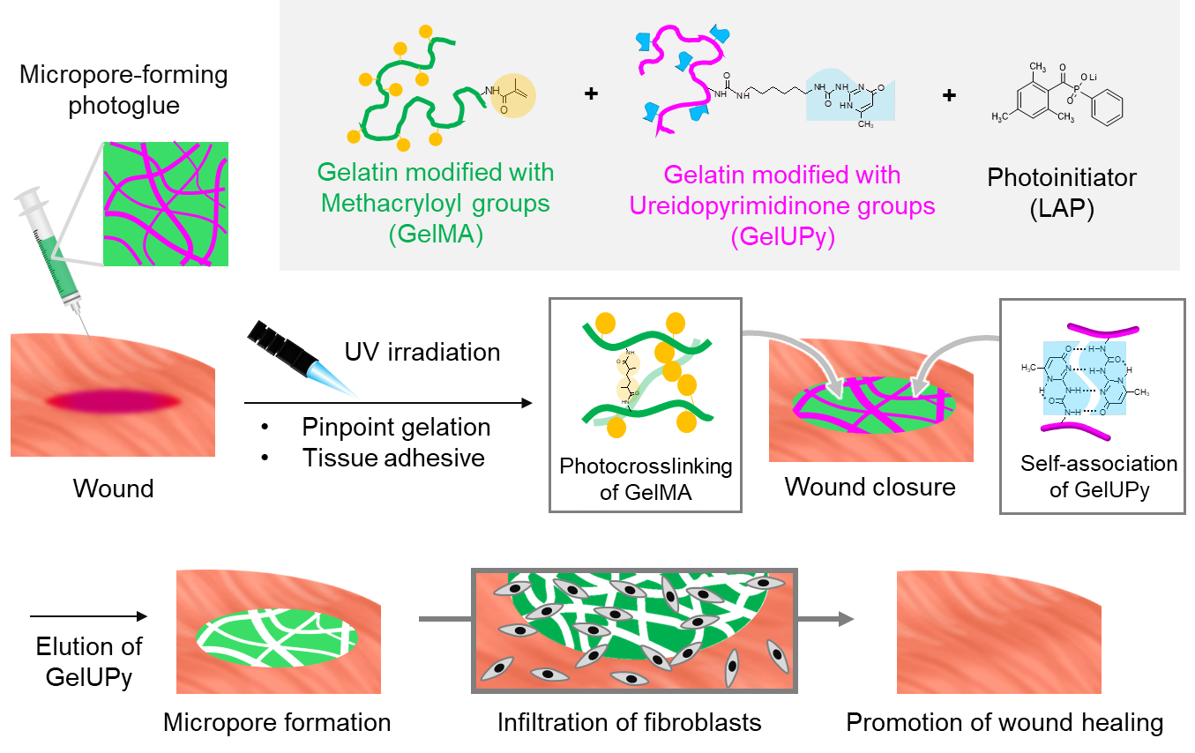
Figure 1. Schematic illustration of micropore-forming photocurable tissue adhesive hydrogels composed of gelatin modified with methacryloyl (GelMA) and ureidopyrimidinone (GelUPy) groups. Micropore-forming photoglues demonstrated pinpoint gelation and adhesive properties upon UV irradiation and wound closure. LLPS structures can function as porogens during wound healing and promote the infiltration of fibroblasts and wound healing.
2. Materials and Methods
Synthesis of GelMA, GelUPy, and GelUPyMA: GelMA was synthesized, as previously described.[21] Porcine skin-derived gelatin (10 g, 10 wt%, amino group: 290 μmol/g; Sigma-Aldrich, St. Louis, MO, USA) was dissolved in 0.25 M carbonate-bicarbonate buffer (100 mL, pH 9) at 50°C. Methacrylic anhydride (MAA, 3.25 mmol, 492.3 L) was added to the gelatin solution under magnetic stirring. The reaction proceeded for 1 h at 50°C, whereafter the pH was readjusted to 7.4 to terminate the reaction. The products were dialyzed in pure water for three days and freeze-dried to obtain GelMA. The degree of substitution of MA with gelatin was determined using 2,4,6-trinitrobenzenesulfonic acid sodium salt dihydrate (Tokyo Chemical Industry Co., Ltd., Tokyo, Japan).
GelUPy was synthesized according to a previously reported method. Briefly, the UPy unit was synthesized via the reaction of 2-amino-4-hydroxy-6-methylpyrimidine (33.0 mmol, 4.1 g; Sigma-Aldrich) with 1,6-diisocyanatohexane (148.6 mmol, 25.0 g; Tokyo Chemical Industry Co., Ltd.) at 100°C for 16 h under stirring. Thereafter, the product was obtained by precipitating and washing with hexane and collecting with filtration. UPy units (38.6 mg, 0.132 mmol, 50 mol% equivalent to the amino groups in gelatin) were dispersed in dimethylsulfoxide (DMSO) (5 mL) and added to gelatin solution (1 g) in DMSO (20 mL) at 50°C under stirring. The reaction proceeded for 24 h at 25°C under stirring. The product was obtained through precipitation in cold ethanol and ethyl acetate (v/v = 1/1) under stirring. The precipitates were collected using a glass filter and washed with cold chloroform and ethanol. The products were then dried at room temperature under reduced pressure. GelUPyMA was synthesized via the reaction of GelUPy57 (feeding ratio of UPy: 56 mol% equivalent to the amino groups in gelatin) with MAA in the same manner as that for GelMA. The synthesized GelMA, GelUPy, and GelUPyMA were characterized using ¹H-nuclear magnetic resonance (¹H-NMR, DMSO-d6, ECZ 400S, 400 MHz; JEOL, Tokyo, Japan) and Fourier-transform infrared (FT-IR, ALPHA Ⅱ; Bruker Corp., Billerica, MA, USA). The amount of UPy in the obtained sample was quantified using UV spectroscopy.

Synthesis of Fluorescently Labeled Gelatin Derivatives: For the modification of Gel, GelUPy, and GelMA with FITC (Sigma-Aldrich), the gelatin derivatives were dissolved in DMSO, and FITC (1 mol% equivalent to the amino groups in sG) added to the solution. After precipitation, washing, and drying in the same manner as that for the synthesis of GelUPy, the products were further dialyzed using a dialysis membrane (molecular weight cutoff: 10 kDa) for three days. After freeze-drying for three days, Gel (FITC), GelUPy (FITC), and GelUPyMA (FITC) were obtained.
For the modification of Gel, GelUPy, and GelUPyMA with N-hydroxysuccinimide (NHS)-tethered Cy5.5 (Lumiprobe, Hunt Valley, MD, USA), gelatin derivatives (3 g) were dissolved in DMSO (60 mL) at 50°C for 2 h and cooled to room temperature. NHS-tethered Cy5.5 (6.3 mg, 8.8 µmol) was added and stirred for 24 h at room temperature. After precipitation and washing in the same manner as that for GelUPy synthesis, the products were dialyzed using a dialysis membrane (molecular weight cutoff: 10 kDa) for three days. After freeze-drying for three days, Gel (Cy5.5), GelUPy (Cy5.5), and GelUPyMA (Cy5.5) were obtained.

Hydrogel Preparation: Gel, GelMA, GelUPy, and GelUPyMA were dissolved in phosphate-buffered saline (PBS, 15 wt%) at 50°C under stirring. Lithium phenyl-2,4,6-trimethylbenzoylphosphinate (LAP, 0.1%) was added to the gelatin solution. The pre-gel solutions were prepared through vigorously mixing these gelatin solutions at equal volumes using a pipetter (GelMA+Gel, GelMA+GelUPy, GelUPyMA+GelUPy, and GelUPyMA+Gel). The mixed pre-gel solutions were maintained at 37°C until further use. The pre-gel solutions were individually poured into a silicone mold with a 1-mm thickness and sandwiched with another silicon sheet. The solutions were then incubated at 4°C for 1 h to form the hydrogels (not chemically crosslinked). After removing the silicon sheet from the hydrogel surface, the hydrogel was UV-irradiated (100 mJ/cm²) using an irradiation device (CL-1000 UV crosslinker, analytikjena, Germany) to prepare the photocrosslinked hydrogel.

CLSM Observation: To visualize the hydrogel structures, fluorescently labeled GelMA (FITC; green), Gel (Cy5.5; violet), GelUPy (Cy5.5), GelUPyMA (Cy5.5), GelUPy (FITC), and Gel (FITC) were used. Fluorescently labeled gelatin was dissolved in PBS and mixed with other gelatin derivatives and LAP to prepare the pre-gel solution. The pre-gel solution was then UV-irradiated and observed via CLSM (CLSM 900 with Airyscan2; Zeiss, Oberkochen, Germany).

Rheological Measurements: Rheological measurements of the pre-gel solutions were performed using a rheometer (MCR301; Anton Paar GmbH, Graz, Austria). The pre-gel solutions were placed on the stage of the rheometer (pre-warmed to 37°C). A jig with a diameter of 10 mm was set with a gap of 1 mm. Viscosity as a function of shear rate (0.01–1000 1/s) was measured at 37°C.

Injectability Test: The pre-gel solutions were loaded into a 1 mL lock-type syringe. The syringes and 27-gauge needles were used for measurements in a compression-testing machine (EZ-LX; Shimadzu, Kyoto, Japan). Each syringe was subjected to an increasing stress up to 50 N at an approaching speed of 100 mm/min. The ejected gel was weighed, and injectability calculated as follows:

Injectability (%) = W_{e}/W_{o} × 100 (1)

where W_{o} is the original weight of the adhesive before ejection, and W_{e} the weight of the ejected gel.

Swelling Ratio: The pre-gel solutions were UV-irradiated to form a hydrogel sheet and cut into discs with an 8 mm punch. The discs were placed into tubes with 1 mL PBS and incubated for 24 h at 37°C. After incubation, the gels were collected and weighed (W_{s}). The swollen gels were desalted via incubation in water for 24 h, freeze-dried, and weighed (W_{d}). The swelling ratio was calculated as follows:

Swelling ratio = (W_{s} − W_{d})/W_{d} (2)

where W_{s} and W_{d} represent the weight of swelled and dried gels, respectively.

Enzymatic Degradation Test: The pre-gel solutions were treated with UV irradiation to form a hydrogel sheet and cut into discs using an 8 mm punch. The discs were placed in 1 mL PBS with or without 1 mg/mL collagenase (120 U/mL; Nacalai Tesque, Inc., Kyoto, Japan) and incubated at 37°C for 1, 4, and 8 h. After incubation, the supernatants were discarded, and the resulting gel freeze-dried and weighed.

Tensile Test: Tensile strengths of the gels were measured using a tensile tester (EZ-S 500N; Shimadzu). The pre-gel solutions were poured into a dumbbell-shaped silicone mold (total length: 35 mm; width: 2 mm; thickness: 1 mm; ISO 37-2) and sandwiched with another silicon sheet. The solution was then incubated at 4°C for 1 h to form the hydrogels. After removing the silicon sheet from the hydrogel surface, the hydrogel was UV-irradiated, released from the mold, and fixed with a 1 N clamp. The initial distance between clamps was 18 mm. Tensile tests were performed at a speed of 100 mm/min, according to a previous report.[22]

Tissue Adhesion Test: Burst strengths of the hydrogels were measured according to the the American Society of Testing and Materials (ASTM) procedure (ASTM-F2392-04R, Standard Test Method for Burst Strength of Surgical Sealants). The 30 mm collagen casings (Nippi, Yokohama, Japan) were cut into discs and prepared with 3-mm pinholes. A silicone ring mold (outer and inner diameters: 20 and 15 mm, respectively; thickness: 1 mm) was used to fix the gel thickness. The pre-gel solutions (300 µL) were added to the center of the silicon mold on collagen casings and exposed to UV irradiation. The samples were placed in a chamber, and the burst strength (maximum pressure) measured by running a saline solution using a syringe pump at a flow rate of 2 mL/min at 37°C.

Cell Viability Assay: The mouse fibroblast cell line, L929 (RIKEN, Saitama, Japan), was cultured in Dulbecco’s modified Eagle’s medium (DMEM; Fujifilm Wako Pure Chemical Corporation, Osaka, Japan) supplemented with 10% fetal bovine serum (FBS; Sigma-Aldrich) and 1% penicillin-streptomycin (P/S; Thermo Fisher Scientific, Waltham, MA, USA). Each pre-gel solution was sterilized via filtration with a 0.22 μm filter. The pre-gel solution was poured into a silicone mold and subjected to UV irradiation. The hydrogels were cut with an 8 mm punch, immersed in DMEM, and incubated for 24 h at 37°C. The supernatants were then collected and frozen before use. L929 cells were seeded at 1 × 10⁴ cells/well in a 96-well plate and cultured for 24 h at 37°C in a 5% CO₂ incubator. The cells were then exposed to each supernatant and cultured for 24 h. Cell morphology was observed using an optical microscope (EVOS XL Cell Imaging System; Thermo Fisher Scientific). The cells were counted using a cell counting kit (WST-8 assay; DOJINDO, Kumamoto, Japan). Briefly, 10 µL WST-8 reagent was added to 100 µL culture medium and incubated for 2 h. The absorbance of the medium was monitored at 450 nm using a microplate reader. Cell numbers were calculated using a standard curve. The absorbance of cells cultured without gelatin was set at 100%.

Infiltration Assays: Normal human dermal fibroblasts (NHDFs, Lonza, Switzerland) were cultured in DMEM supplemented with 10% FBS and 1% P/S. The pre-gel solutions were added to a cell culture insert (pore size: 8 μm) and UV-irradiated to form the hydrogels. The hydrogels were then incubated in PBS for 24 h at 37°C. NHDFs were seeded at 1 × 10⁴ cells/well in the cell culture inserts (medium volume in the insert: 100 μL, plate: 1 mL) and cultured for three days at 37°C in a 5% CO₂ incubator. The cells were fixed with 4% paraformaldehyde for 30 min. After washing with PBS, the cells were permeabilized with 0.2% Triton-X for 30 min. The cells were then blocked with 1% bovine serum albumin/PBS for 1 h. For actin staining, the cells were stained with rhodamine-labeled phalloidin (1:200; Thermo Fisher Scientific) overnight at 4°C. After washing with PBS, the cells were stained with 4′,6-diamidino-2-phenylindole (Thermo Fisher Scientific) for 1 h at 25°C. Cellular morphology was observed using CLSM, and infiltration depth of the cells quantified from the CLSM images using ImageJ software.

Subcutaneous Implantation: All animal experiments were approved by the Animal Care and Use Committee of the National Institute for Materials Science (Ibaraki, Japan). Each pre-gel solution was sterilized via filtration with a 0.22 μm filter and kept at 37°C until use. The pre-gel solution was poured into a silicone mold (1 mm thickness) and sandwiched with another silicon sheet. After incubation at 4°C for 1 h to induce instant gelation, the hydrogel was UV-irradiated (100 mJ/cm²) using an irradiation device (CL-1000 UV crosslinker) and cut into discs using an 8 mm punch. Female Wistar rats (7 weeks old, n = 3–4) were anesthetized via inhalation of 2.5% isoflurane. Hair on the back skin of rats was shaved with a razor, and the area disinfected with 70% ethanol. Hydrogels were then subcutaneously implanted into the rats by cutting 2 cm of skin, and the incision sites sutured. At 1, 2, 4, and 8 weeks after treatment, the rats were euthanized through blood removal, and the tissues collected. The samples were fixed in a 10% formalin neutral buffer solution and stained with HE for histological observation. Images of the hematoxylin and eosin (HE)-stained gel sections were scanned using a digital slide scanner (NanoZoomer S210; Hamamatsu Photonics, Hamamatsu, Japan).

Skin Incision Wound Models: Each pre-gel solution was sterilized via filtration with a 0.22 μm filter and kept at 37°C until use. Female Wistar rats (7 weeks old, n = 3–4) were anesthetized via inhalation of 2.5% isoflurane. Hair on the back skin of rats was shaved with a razor, and the area disinfected with 70% ethanol. Skin incisions were made on the backs by cutting away 1 cm of skin using a scalpel. After hemostasis, the pre-gel solutions were applied to the wounds and UV-irradiated using a spot-type LED device (HLV2-24VL3-405, peak emission wavelength: 405 nm; CCS Inc., Kyoto, Japan). Carprofen (RIMADYL; Zoetis, Parsippany-Troy Hills, NJ, USA) and amikacin solution (Meiji Seika Pharma, Tokyo, Japan) were intraperitoneally administered to reduce pain and prevent infection. Two weeks after treatment, the rats were euthanized through blood removal, and tissues then collected. The samples were fixed in a 10% formalin neutral buffer solution and stained with HE for histological observation. Images of the HE- and Masson’s trichrome (MT)-stained gel sections were scanned using a digital slide scanner.

Statistical Analysis: The results are expressed as mean ± s.d. One-way analysis of variance (ANOVA), followed by Tukey’s multiple comparison post hoc test, was used to test for differences among the groups. Experiments were repeated multiple times as independent experiments. Data shown in each figure are complete datasets obtained from independent representative experiments. None of the samples were excluded from the analysis. Statistical significance is indicated by *P <0.05, **P <0.01, ***P <0.001, and ****P <0.0001. Statistical analyses were performed using GraphPad Prism v.8.0 (GraphPad Software, La Jolla, CA, USA).

3. Results and Discussion
3.1. Formation of LLPS Structures and Micropores in Hydrogels
We previously reported on thiol-ene reaction-based LLPS hydrogels using the self-association of UPy units.[19, 20] Instead of using click chemistry for gelation, GelMA was used as a component of the tissue adhesive. GelMA allows pinpoint adhesion only at the targeted site upon UV irradiation and can be used as a single-syringe adhesive,[23] which improves operability compared with that of conventional double-syringe adhesives. To fabricate photoglues, GelMA71, GelUPy48, and GelUPy57MA43 were synthesized (Table S1). The ¹H-NMR results showed the successful introduction of UPy and MA into gelatin (Figure S1). In the FT-IR measurements, no signals were observed at 2280 cm⁻¹ that could be ascribed to the isocyanate groups in GelUPy nor at 1774 and 1722 cm⁻¹ that could be ascribed to the stretching vibration of the carbonyl groups of MAA in GelMA and GelUPyMA (Figure S2). This result indicated that unreacted free UPy derivatives and MAA did not remain in the synthesized gelatin derivatives.
Four types of hydrogels were prepared as photocurable tissue adhesives: nonporous-1 (GelMA+Gel), μCN (GelMA+GelUPy), nonporous-2 (GelUPyMA+GelUPy), and μFN (GelUPyMA+Gel). Nonporous-1 and -2 were composed of photocrosslinked GelMA or GelUPyMA as control groups of μCN and μFN, respectively. Confocal laser scanning microscopy (CLSM) observation showed that mixing GelMA and GelUPy or GelUPyMA and Gel formed LLPS microfibrous structures in hydrogels (μCN and μFN), respectively (Figure 2). The μCN and μFN hydrogels had a higher turbidity, indicating successful LLPS formation (Figure S3). After immersion in PBS for 24 h, GelUPy and Gel were eluted from the hydrogels, and microporous structures created. In μCN, microfibers of GelUPy were removed and capillary networks structures formed in the hydrogels, whereas the Gel matrix was eluted to form microfiber network-based hydrogels in μFN. This micropore formation process can occur after wound closure in vivo and may support cell infiltration. Several methods, including the use of particle porogens,[24-26] microgels,[27, 28] and air bubbles,[29] have been reported to provide porous structures in injectable hydrogels. However, creating interconnected pores and sufficient void spaces for cell infiltration remains challenging. The LLPS-based technique show in this study would be useful for creating interconnected microporous structures in tissue-adhesive hydrogels.
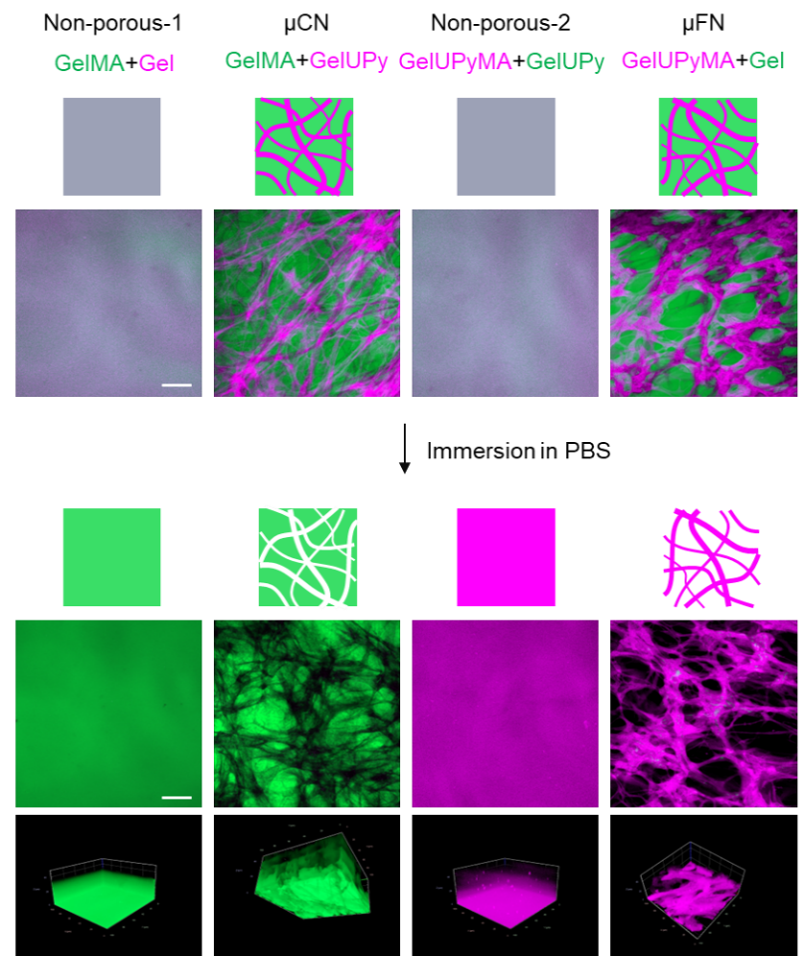
Figure 2. CLSM and 3D-reconstructed images of photoglues before and after immersion in PBS. Nonporous-1, μCN, nonporous-2, and μFN hydrogels were prepared via UV irradiation (100 mJ/cm²) in the presence of 0.1% LAP. For visualization, fluorescently labeled GelMA (FITC; green), Gel (Cy5.5; violet), GelUPy (Cy5.5), GelUPyMA (Cy5.5), GelUPy (FITC), and Gel (FITC) were used. Scale bars = 50 µm.

3.2. Mechanical Properties of Photocrosslinked Hydrogels
To design tissue adhesives for clinical translation, their biocompatibility, tissue adhesive strength, and operability need to be addressed. Photoglue can be administered via single-syringe injection under UV irradiation. Compared to the double-syringe type, single-syringe tissue adhesives can easily be used by surgeons without incomplete mixing of the two components. To assess the ability of the photoglue to act as a single-syringe adhesive, its viscosity and injectability were evaluated. Rheological measurements revealed that the viscosity of all pre-gel solutions decreased depending on the shear rate, indicating a shear-thinning-like property (Figure 3a). Nonporous-1, μCN, and μFN possessed a low viscosity, with shear rates measuring over 1 1/s, whereas nonporous-2 showed a relatively high viscosity due to its high concentration of GelUPy. The injectability of these pre-gel solutions using 27-gauge needles was >90%, and the force required for injection <40 N, which is the injectable range of the operator (Figure 3b).[30] Gelation occurred within a few seconds after UV irradiation. The swelling ratio of each hydrogel was relatively low, with no considerable differences observed between samples (Figure 3c). Rheological measurements of the hydrogels showed that the suitable composition and fabrication conditions for photocrosslinking were 0.1% LAP and 100 mJ/cm² (Figure S4). These GelMA-based hydrogels were enzymatically degraded during incubation with collagenase, indicating that they may be absorbable by the body (Figure 3d).

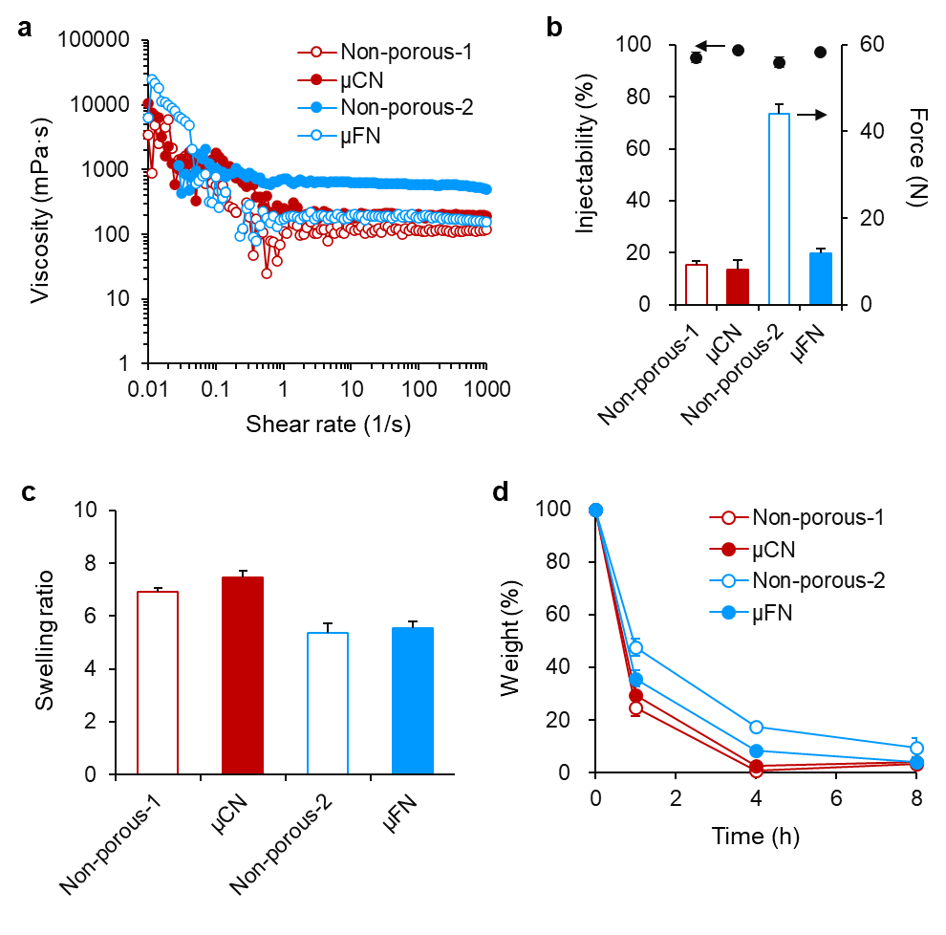
Figure 3. (a) Viscosity of the pre-gel solutions as a function of shear rate. (b) Injectability of the pre-gel solutions using 27-gauge needles. (c) Swelling ratio of the hydrogels. (d) Degradation behavior of the hydrogels during incubation with collagenase. Data are presented as the mean ± s.d. Error bars represent the s.d. (n = 3).

3.3. Tissue Adhesive Property of Photoglues
The burst strength of the engineered photoglues was evaluated using collagen casings, according to the ASTM procedure (ASTM-F2392-04R) (Figure 4a). Nonporous-1 and μCN showed a burst strength >10 kPa, whereas nonporous-2 and μFN did not adhere strongly (Figure 4b). Burst strength depends on the bulk strength of hydrogels and interfacial adhesion to the tissues. Nonporous-1 and μCN possessed similar burst strengths, indicating that the LLPS structures did not impair their tissue adhesive properties. Although nonporous-2 possessed the same level of tensile strength as that of nonporous-1, its adhesion strength was poor due to the high viscosity of its pre-gel solution, which did not glue into the small gaps on tissue surfaces. The μCN photoglue adhered strongly onto various tissue surfaces. A defect prepared on heart tissue surfaces could be sealed using μCN, and μCN remained adhesive after water flushing (Figure 4c). PBS leakage in the stomach and large intestine was impeded after applying μCN, and no leakage could be observed even after applying pressure (Figure 4d,e). Although these tissue adhesive experiments were performed before pore formation in photoglues, pore formation occurred after 2 weeks of implantation into the tissues (shown in Figure 6). Thus, at early stage after application of photoglues, micropores were not formed yet and no leakage of fluids through pores may not occur.

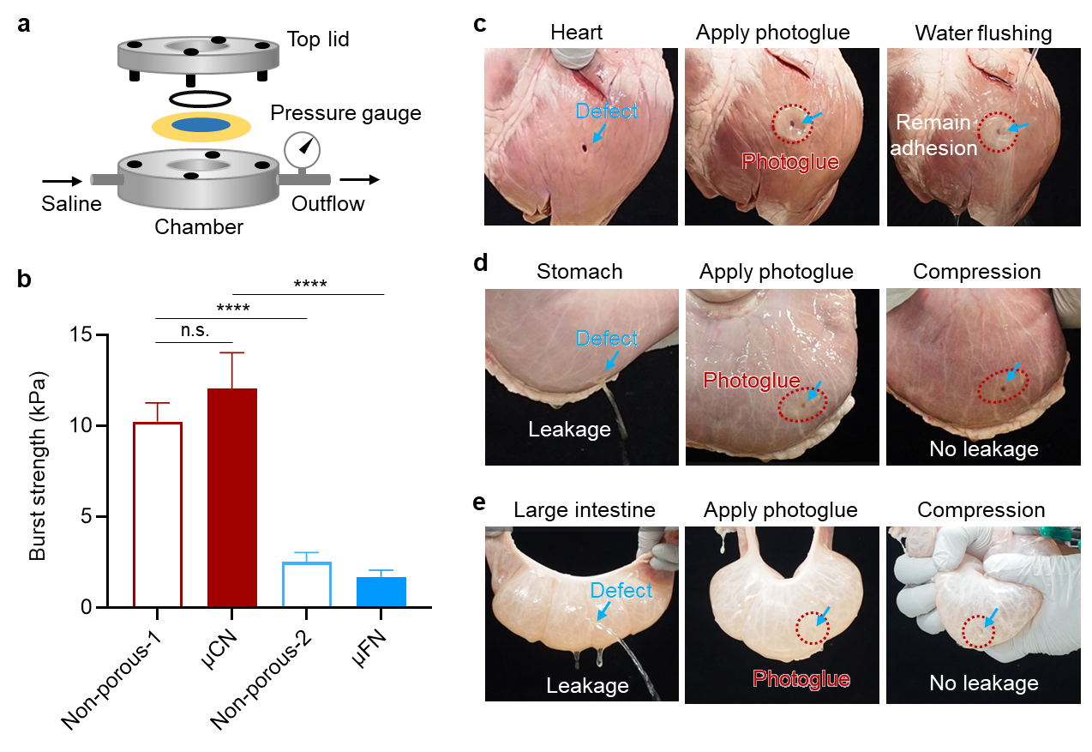
Figure 4. (a) Schematic illustration of the burst strength measurements. (b) Burst strength of the hydrogels against collagen casings (n = 5; error bars represent the s.d.). Tissue adhesion of μCN hydrogels to the porcine heart (c), stomach (d), and large intestine (e). Data are presented as the mean ± s.d. ****P <0.0001, as analyzed via one-way ANOVA with Tukey’s multiple comparison post hoc test. n.s. = not significant.

3.4. Cell Infiltration into Photoglues
To overcome a trade-off relationship between tissue adhesion strength for long-term wound closure and degradation rate for tissue regeneration, we designed microporous tissue adhesives that possess sufficient tissue adhesive strength and cell-infiltrative properties through microporous structures, which may promote wound healing without compromising the mechanical strength of adhesives. To address the ability of LLPS hydrogels to infiltrate cells, NHDFs were used as dermal tissue-derived cells. Prior to the cell infiltration experiments, the cytocompatibility of hydrogels were evaluated using an extraction method. Results showed that each hydrogel had a high cytocompatibility (Figure S5). Next, NHDFs were seeded onto the hydrogels to evaluate their infiltrating depth into the hydrogels after three days of culture. Although nonporous-1 hydrogels showed few infiltrating cells, NHDFs highly infiltrated into μCN (Figure 5a). The infiltration depth of μCN showed 3.5- and 2.6-fold increases compared with that of nonporous-1 and μFN, respectively, whereas μFN also enhanced infiltration compared with that of nonporous-2 (Figure 5b). In contrast, fibrin glue showed reduced cell infiltration into the glue (Figure S6). Fibrin glue is composed of high concentrations of fibrinogen and thrombin, and fibrin fibers accumulate at a high density in the glue, which suppresses cell infiltration. These results suggest that the introduction of microporous structures into tissue adhesives using LLPS enhances cell infiltration and promotes wound healing.

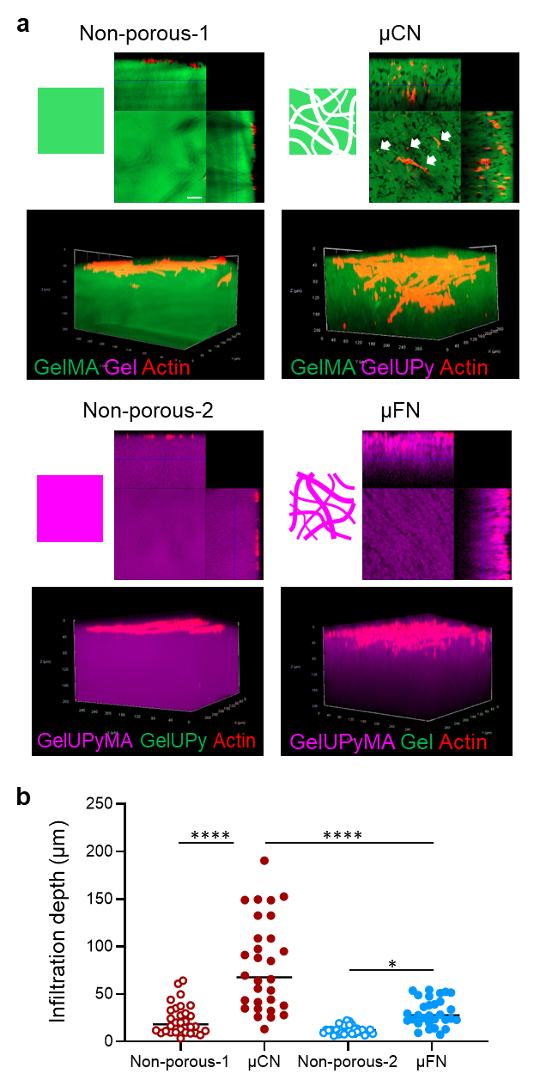
Figure 5. (a) 3D-reconstructed CLSM images of NHDFs seeded onto hydrogels. Fluorescently labeled gelatin derivatives were used to visualize the hydrogels. Actin was stained with phalloidin (red). Cross-sectional images (top) displayed the section at a 200-μm depth from the hydrogel surfaces. White arrows show the infiltrated cells at a 100-μm depth. (b) The depth of infiltrated cells from hydrogel surfaces were quantified from the CLSM images. Data are presented as the mean ± s.d. *P <0.05 and ****P <0.0001, as analyzed via one-way ANOVA with Tukey’s multiple comparison post hoc test. Scale bar = 50 µm.

3.5. Biodegradability and Wound Healing Property of Photoglues
To evaluate the biodegradability of the micropore-forming photoglues, they were subcutaneously implanted in rats. No irritation or swelling at the site of implantation was confirmed. Histological observations showed that severe inflammation around the hydrogels did not occur, and hydrogel thickness decreased in all samples (Figure 6a,b). This result indicates that the gelatin-based photocrosslinked hydrogels are biodegradable, which agrees with the in vitro enzymatic degradation results. Regarding inner structures of the hydrogels, LLPS structures were confirmed at 1 week after implantation, and micropores gradually formed at 4 weeks in μCN, whereas nonporous-1 possessed a densely crosslinked matrix without micropores. The pore formation rate of μCN was relatively slower compared with that measured during the in vitro study because some GelMA was distributed in GelUPy phases in the hydrogels and partially crosslinked in GelUPy phases. On the other hand, slow formation of pores would be favorable for maintaining tissue adhesion without leakage of fluids at early stage after application of photoglues.
To determine whether microporous tissue adhesives enhance wound healing, skin incision wound models of rats were used. Incision wounds were closed by applying the hydrogels, and tissue structures observed during wound healing to compare with wounds treated through suturing or a clinically used adhesive for skin (Dermabond) (Figure 6c). HE-stained images confirmed that host cells (e.g., immune cells and fibroblasts) infiltrated the wound area, and the wounds closed at 2 weeks in all samples (Figure 6d). MT staining revealed that newly formed collagens were observed in the wounds of all samples, and μCN showed a comparable regeneration of hair follicles and macrophage accumulation with those of control and suture samples (Figure 6e-g). Although Dermabond quickly closed wounds during the procedure, it caused inflammatory responses and did not induce hair follicle regeneration due to the presence of toxic components (e.g., 2-octyl cyanoacrylate monomer) or formaldehyde as a degradation product of polymerized 2-octyl cyanoacrylate. Taken together, microporous tissue adhesives may promote tissue regeneration as a cell-infiltrative scaffold while maintaining tissue adhesive strength during wound healing.

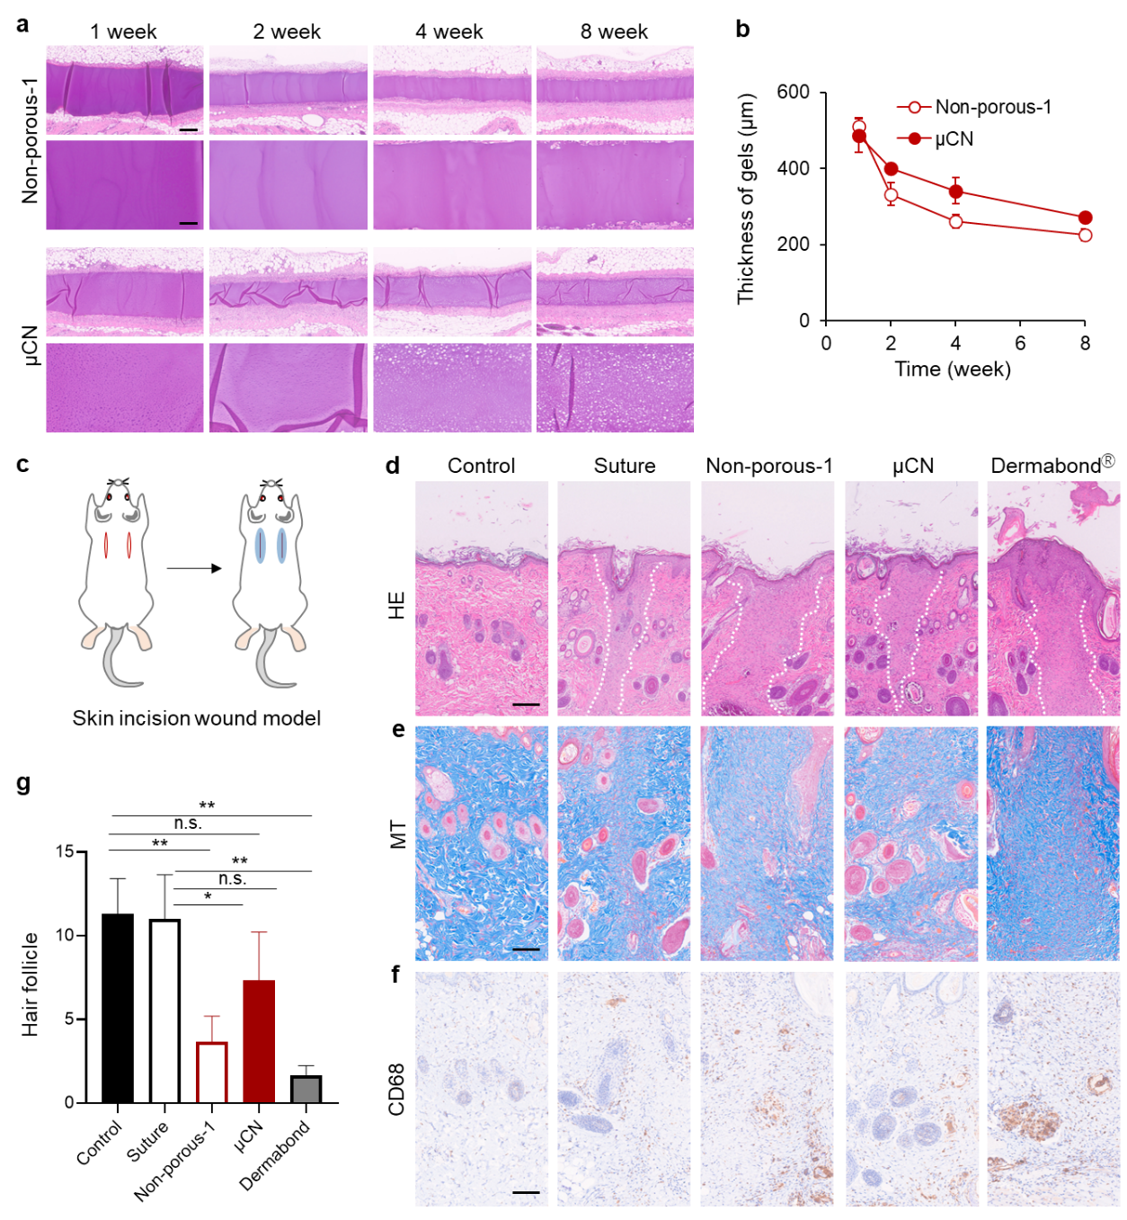
Figure 6. (a) HE-stained images of subcutaneously implanted hydrogels in rats. (b) Thickness of hydrogels quantified from the HE images. (c) Schematic illustration of the skin incision wound models generated in rats. HE- (d), MT- (e), and CD68 antibody-stained (f) images of wounded tissues at 2 weeks after the treatments. (g) Number of hair follicles in the wounded area. Data are presented as the mean ± s.d (error bars represent the s.d.; n = 3). **P <0.001, as analyzed via one-way ANOVA with Tukey’s multiple comparison post hoc test. n.s. = not significant. Scale bars = 200 µm (top) and 50 µm (bottom) for (a); 200 µm for (d); and 100 µm for (e,f).

4. Conclusion
In conclusion, we presented a microporous tissue adhesive with an enhanced cell infiltration capacity for tissue regeneration. Based on LLPS technology, the micropore-forming photoglues, μCN and μFN hydrogels, were engineered. The pre-gel solution of the photoglue possessed high injectability, and the photocrosslinked hydrogels were enzymatically degraded. The μCN hydrogels showed a high tissue adhesive strength against the collagen membrane, heart, stomach, and large intestinal tissues. Moreover, the microporous hydrogels served as highly cell-infiltrative scaffolds, and fibroblasts could infiltrate through their pores. These hydrogels formed micropores after implantation in rats and exhibited biodegradability. Finally, μCN hydrogels promoted hair follicle regeneration and wound healing in skin incision wound models. This novel tissue adhesive holds promise for overcoming the trade-off between tissue adhesion strength for long-term wound closure and degradation rate for tissue regeneration and contributes to promoting wound healing and preventing postoperative complications.

Acknowledgments
This study received financial support from the Japan Society for the Promotion of Science (JSPS) KAKENHI (grant no. 22H03962), the Project for Translational Research program, the Strategic Promotion for Practical Application of Innovative Medical Technology from the Japan Agency of Medical Research and Development, the Inamori Foundation, the Toshiaki Ogasawara Memorial Foundation, and the Uehara Memorial Foundation.

Competing Interests: The authors declare no competing financial interests.

References
[1] M.B. Detweiler, J.G. Detweiler, J. Fenton, Sutureless and reduced suture anastomosis of hollow vessels with fibrin glue: A review, Journal of Investigative Surgery 12(5) (1999) 245-262.
[2] W.H. Anger Jr, Surgical Sealant for Preventing Air Leaks After Pulmonary Resections in Patients With Lung Cancer, AORN Journal 92(3) (2010) 351-352.
[3] M. Barret, B. Beye, S. Leblanc, F. Beuvon, S. Chaussade, F. Batteux, F. Prat, Systematic review: the prevention of oesophageal stricture after endoscopic resection, Aliment Pharmacol Ther 42(1) (2015) 20-39.
[4] D. Menzies, H. Ellis, Intestinal obstruction from adhesions how big is the problem?, Ann. R. Coll. Surg. Engl. 72 (1990) 60-63.
[5] H. Ellis, B.J. Moran, J.N. Thompson, M.C. Parker, M.S. Wilson, D. Menzies, A. McGuire, A.M. Lower, R.J. Hawthorn, F. O'Brien, S. Buchan, A.M. Crowe, Adhesion-related hospital readmissions after abdominal and pelvic surgery: a retrospective cohort study, Lancet 353(9163) (1999) 1476-1480.
[6] G.M. Taboada, K. Yang, M.J.N. Pereira, S.S. Liu, Y. Hu, J.M. Karp, N. Artzi, Y. Lee, Overcoming the translational barriers of tissue adhesives, Nat. Rev. Mater. 5(4) (2020) 310-329.
[7] L. Yu, J. Ding, Injectable hydrogels as unique biomedical materials, Chem. Soc. Rev. 37(8) (2008) 1473-1481.
[8] F. Leonard, R. K. Kulkarni, J. Nelson, G. Brandes, Tissue adhesives and hemostasis-inducing compounds: The alkyl cyanoacrylates, J. Biomed. Mater. Res. 1 (1967) 3-9.
[9] Q. Xu, L. Guo, S. A, Y. Gao, D. Zhou, U. Greiser, J. Creagh-Flynn, H. Zhang, Y. Dong, L. Cutlar, F. Wang, W. Liu, W. Wang, W. Wang, Injectable hyperbranched poly(beta-amino ester) hydrogels with on-demand degradation profiles to match wound healing processes, Chem Sci 9(8) (2018) 2179-2187.
[10] N. Nakajima, H. Sugai, S. Tsutsumi, S.H. Hyon, Self-Degradable Bioadhesive, Key Engineering Materials 342-343 (2007) 713-716.
[11] T. Ito, Y. Yeo, C.B. Highley, E. Bellas, C.A. Benitez, D.S. Kohane, The prevention of peritoneal adhesions by in situ cross-linking hydrogels of hyaluronic acid and cellulose derivatives, Biomaterials 28(6) (2007) 975-983.
[12] Y. Yang, G. He, Z. Pan, K. Zhang, Y. Xian, Z. Zhu, Y. Hong, C. Zhang, D. Wu, An Injectable Hydrogel with Ultrahigh Burst Pressure and Innate Antibacterial Activity for Emergency Hemostasis and Wound Repair, Adv Mater (2024) e2404811.
[13] Ehsan Shirzaei Sani, Ahmad Kheirkhah, Devyesh Rana, Zhongmou Sun, William Foulsham, Amir Sheikhi, Ali Khademhosseini, Reza Dana, N. Annabi, Sutureless repair of corneal injuries using naturally derived bioadhesive hydrogels, Sci. Adv. 5 (2019) eaav1281.
[14] Y. Mizuno, R. Mizuta, M. Hashizume, T. Taguchi, Enhanced sealing strength of a hydrophobically-modified Alaska pollock gelatin-based sealant, Biomater. Sci. 5(5) (2017) 982-989.
[15] A. Nishiguchi, T. Taguchi, A pH-driven genipin gelator to engineer decellularized extracellular matrix-based tissue adhesives, Acta Biomater. 131 (2021) 211-221.
[16] D. Palai, M. Ohta, I. Cetnar, T. Taguchi, A. Nishiguchi, Enhanced ROS scavenging and tissue adhesive abilities in injectable hydrogels by protein modification with oligoethyleneimine, Biomater Sci 12(9) (2024) 2312-2320.
[17] Nasim Annabi, Yi-Nan Zhang, Alexander Assmann, Ehsan Shirzaei Sani, George Cheng, Antonio D. Lassaletta, Andrea Vegh, Bijan Dehghani, Guillermo U. Ruiz-Esparza, Xichi Wang, Sidhu Gangadharan, Anthony S. Weiss, A. Khademhosseini, Engineering a highly elastic human protein–based sealant for surgical applications, Sci. Transl. Med. 9 (2017) eaai7466.
[18] J. Sun, J. Su, C. Ma, R. Gostl, A. Herrmann, K. Liu, H. Zhang, Fabrication and Mechanical Properties of Engineered Protein-Based Adhesives and Fibers, Adv Mater 32(6) (2020) e1906360.
[19] A. Nishiguchi, S. Ito, K. Nagasaka, H. Komatsu, K. Uto, T. Taguchi, Injectable microcapillary network hydrogels engineered by liquid-liquid phase separation for stem cell transplantation, Biomaterials 305 (2024) 122451.
[20] A. Nishiguchi, E. Araki, D. Palai, S. Ito, T. Taguchi, Development of Phase-Separating Microfiber Network Hydrogels to Promote In Vitro Vascularization, Biomacromolecules 25(9) (2024) 6146-6154.
[21] H. Shirahama, B.H. Lee, L.P. Tan, N.J. Cho, Precise Tuning of Facile One-Pot Gelatin Methacryloyl (GelMA) Synthesis, Sci Rep 6 (2016) 31036.
[22] X. Yan, Q. Chen, L. Zhu, H. Chen, D. Wei, F. Chen, Z. Tang, J. Yang, J. Zheng, High strength and self-healable gelatin/polyacrylamide double network hydrogels, J. Mater. Chem. B 5(37) (2017) 7683-7691.
[23] K. Yue, G. Trujillo-de Santiago, M.M. Alvarez, A. Tamayol, N. Annabi, A. Khademhosseini, Synthesis, properties, and biomedical applications of gelatin methacryloyl (GelMA) hydrogels, Biomaterials 73 (2015) 254-71.
[24] N. Huebsch, E. Lippens, K. Lee, M. Mehta, S.T. Koshy, M.C. Darnell, R.M. Desai, C.M. Madl, M. Xu, X. Zhao, O. Chaudhuri, C. Verbeke, W.S. Kim, K. Alim, A. Mammoto, D.E. Ingber, G.N. Duda, D.J. Mooney, Matrix elasticity of void-forming hydrogels controls transplanted-stem-cell-mediated bone formation, Nat Mater 14(12) (2015) 1269-77.
[25] S. Sokic, M. Christenson, J. Larson, G. Papavasiliou, In situ generation of cell-laden porous MMP-sensitive PEGDA hydrogels by gelatin leaching, Macromol. Biosci. 14(5) (2014) 731-739.
[26] X. Yang, B. Yang, Y. Deng, X. Xie, Y. Qi, G. Yan, X. Peng, P. Zhao, L. Bian, Coacervation-mediated cytocompatible formation of supramolecular hydrogels with self-evolving macropores for 3D multicellular spheroid culture, Adv Mater 35 (2023) e2300636.
[27] J. Koh, D.R. Griffin, M.M. Archang, A.C. Feng, T. Horn, M. Margolis, D. Zalazar, T. Segura, P.O. Scumpia, D. Di Carlo, Enhanced In Vivo Delivery of Stem Cells using Microporous Annealed Particle Scaffolds, Small 15(39) (2019) e1903147.
[28] D. Rommel, M. Mork, S. Vedaraman, C. Bastard, L.P.B. Guerzoni, Y. Kittel, R. Vinokur, N. Born, T. Haraszti, L. De Laporte, Functionalized Microgel Rods Interlinked into Soft Macroporous Structures for 3D Cell Culture, Ad. Sci 9(10) (2022) 2103554.
[29] F. Saeedinejad, F. Alipanah, S. Toro, N. Pereira, D. Ghanbariamin, I. Jozic, T. Schmidt, E. Arab-Tehrany, Y.S. Zhang, A. Tamayol, M. Samandari, In Situ-Formed Tissue-Adhesive Macroporous Scaffolds Enhance Cell Infiltration and Tissue Regeneration, Acta Biomater (2025).
[30] T.E. Robinson, E.A.B. Hughes, A. Bose, E.A. Cornish, J.Y. Teo, N.M. Eisenstein, L.M. Grover, S.C. Cox, Filling the Gap: A Correlation between Objective and Subjective Measures of Injectability, Adv Healthc Mater 9(5) (2020) e1901521.

Table of Contents
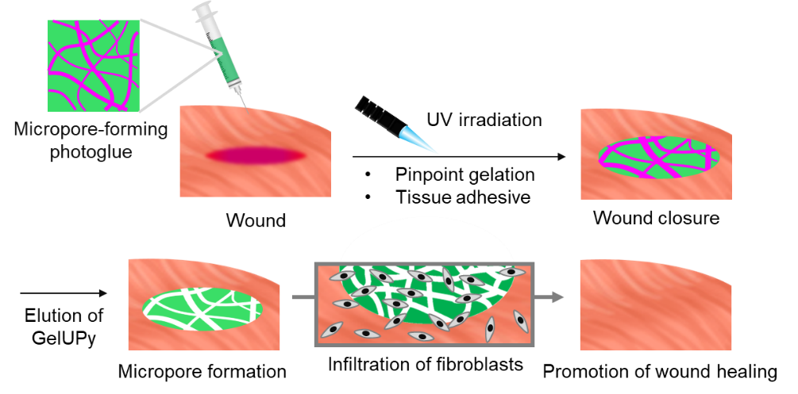

Micropore-forming photocurable tissue adhesive promotes cell infiltration for wound healing

