Reduced Thermal Conductivity and Enhanced TE performance in CrSb₂ via Fe-Bi co-substitution
Sahiba Bano¹, Shamim Sk¹, Takashi Aizawa¹, and Takao Mori^{*1, 2}
¹Research Center for Materials Nanoarchitectonics (MANA), National Institute for Materials Science (NIMS), Namiki 1-1, Tsukuba 305-0044, Japan
²Graduate School of Pure and Applied Sciences, University of Tsukuba, Tsukuba, Japan
*Corresponding author's E-mail: MORI.Takao@nims.go.jp
Abstract:
The efficiency of thermoelectric (TE) technology relies on the performance of TE materials. Substitution with heavy elements is an effective strategy in TE for enhancing phonon scattering without much affecting electrical transport properties. However, selecting suitable dopants to achieve a high thermoelectric figure-of-merit (ZT) poses a significant challenge. Thus, in this study, the efficacy of combined (Fe and Bi) co-substitution in CrSb₂ is investigated as a promising strategy to enhance ZT by lowering thermal conductivity. A series of co-doped Cr_{1-x}Fe_{x}Bi_{y}Sb_{2-y} (x = 0, 0.25, 0.50, 0.75, 1 and y = 0.10, 0.15, 0.20,0.25) samples were synthesized via furnace reaction followed by spark plasma sintering technique. Phase analysis and temperature dependence TE transport properties were systematically studied on synthesized samples. Furthermore, to analyze the impact of disorder induced by Bi/Fe substitution, electronic structure calculation was performed using the projector augmented-wave method. Notably, Cr_{0.75}Fe_{0.25}Bi_{0.15}Sb_{1.85} exhibited a low thermal conductivity of ~ 2.5 W m⁻¹ K⁻¹ at 300 K, which reduced to half compared to that of pristine CrSb₂ (~ 5 W m⁻¹ K⁻¹). This reduction is attributed to the introduction of significant mass fluctuations and point defects along with the presence of Bi at grain boundaries by co-substitution. Consequently, a remarkable 90% enhancement in ZT (~0.021) at 350 K was achieved for Cr_{0.75}Fe_{0.25}Bi_{0.15}Sb_{1.85} compared to that of pristine CrSb₂ (ZT~0.012). This study can provide valuable insights into the rational design of effective dopants in other TE materials also.
Keywords: Thermoelectric, thermal conductivity, electronic structure, transport properties, microstructure, and alloying.

- Introduction
The development of eco-friendly technologies is vital to reach the global goal of achieving net-zero emissions [1–5]. Additionally, as the use of Internet of Things (IoT) devices grows, there's a rising need for power sources that can independently capture energy from their surroundings. Solid-state thermoelectric devices have the potential to manage heat effectively by converting it directly into electricity and vice versa [6–9]. In recent years, there's been a significant focus on improving high-performance thermoelectric (TE) materials to enhance conversion efficiency and make this technology more widely applicable. The efficiency of TE materials is measured using a dimensionless figure of merit (ZT), defined as ZT = $\frac{α^{2}σ}{κ_{Tot}}T$, where α is the Seebeck coefficient, σ is electrical conductivity, κ_{Tot} is total thermal conductivity i.e., (κ_{ele}+κ_{Latt}), and T is absolute temperature [3].
Recently, a series of high-performing TE materials have been investigated i.e., Bi₂Te₃ -based-materials [10–13], PbTe-based compounds [14–18], skutterudites [19–23], half-Heusler alloys [24–29], Zintl compounds [30–38] and so on. Furthermore, semiconductors with a narrow band gap and 3d electronic states near the conduction and valence band edges have garnered significant interest [39–41]. Among them, CrSb₂ (antiferromagnetic compound) is one such material that has an orthorhombic marcasite structure with narrow band gap of ~ 0.07 eV and would be a promising candidate for thermoelectric applications [40,42,43]. The magnetic properties of doped CrSb₂ i.e., Cr_{1-x}Fe_{x}Sb₂ and Cr_{1-x}Ru_{x}Sb₂ have been reported by Kjekshus et al. [44] and Takahashi et al. [45] respectively. Later, H. J. Li et al. [46–50] studied temperature-dependent TE properties of different doped CrSb₂ samples. They showed that doping in CrSb₂ leads to a synergistic reduction in thermal conductivity while simultaneously optimizing carrier concentration. For instance, the strategic doping of Mn at Cr [50] and Te at Sb [49] in CrSb₂ resulted in a simultaneous reduction of electrical resistivity and thermal conductivity. Among them, the Te doping at Sb-site demonstrated a significant enhancement in the thermoelectric performance of CrSb₂ [49]. However, thermal conductivity was not decreased up to the mark which is still high ~ 10 W m⁻¹K⁻¹ at ~313 K and limited their ZT value to low value. Thus, enhancing the thermoelectric ZT in CrSb₂ involves a balance between optimizing electrical transport properties with suppressing thermal conductivity. In this content, substitution or co-substitution with heavy elements has been a conventional strategy to enhance phonon scattering without compromising electrical transport properties [51–54]. However, the selection of dopants that can achieve a substantial improvement in ZT remains a difficult challenge.
The present study investigates the promising way of combined (Fe and Bi) doping in CrSb₂, aiming to synergistically enhance ZT by effectively reducing thermal conductivity. A comprehensive exploration of the electrical and thermal transport properties of a series of (Fe, Bi) co-doped CrSb₂ compounds forms the basis of this investigation. Notably, Cr_{0.75}Fe_{0.25}Bi_{0.15}Sb_{1.85} exhibits a remarkable 50% reduction in thermal conductivity compared to pristine CrSb₂. The involved interplay between (Fe, Bi) co-substitution and the induced disorder, elucidated through electronic structure calculations, contributes to the understanding of the observed enhancements in ZT. These findings can provide valuable insights into the rational design of dopants in other thermoelectric materials also.
- Experimental and computational details
Synthesis details: Doped samples with the specified composition of Cr_{1-x}Fe_{x}Bi_{y}Sb_{2-y} (x = 0, 0.25, 0.50, 0.75, 1 and y = 0, 0.10, 0.15, 0.20, 0.25) were precisely prepared by weighing high-purity Cr, Fe, Sb, and Bi ingots in a stoichiometric ratio within an argon-filled glove box. Subsequently, the accurately weighed samples were completely sealed in a quartz tube under a vacuum of 10⁻³ mbar and subjected to heat treatment within a furnace, as illustrated in Figure S1. Following the furnace reaction, the resulting samples were finely crushed into powders using a mortar and pestle, and then loaded into a graphite die with an approximate diameter of 10 mm. After that using spark plasma sintering (SPS), circular dense pellets were successfully formed, where, the pellet density was determined through the Archimedes principle, with the corresponding data presented in Table S1. It is noteworthy that the sintering conditions underwent optimization through experimentation at different temperatures, as detailed in the Results and Discussion section.
Characterizations: X-ray diffraction (XRD) patterns were acquired using a SmartLab3 X-ray diffractometer (Rigaku) with Cu Kα radiation, employing a scanning speed of 4°/min. The XRD Rietveld refinement was done for present samples by FullProf Suite Rietveld software. Surface microstructure and compositional analysis were studied by FESEM (Hitachi SU8000) with energy dispersive spectroscopy (EDS, XFlash FlatQUAD 5060F). Moreover, the temperature-dependent transport properties, specifically electrical conductivity and Seebeck coefficient of bulk samples, were measured from room temperature to 513 K using a ZEM-3 instrument under a partial helium atmosphere. Thermal diffusivity was also characterized by a LFA 467 apparatus from NETZSCH, with an uncertainty of ± 3%. Additionally, total thermal conductivity was determined using the equation κ_{Tot} = λc_{P}D, where λ represents the thermal diffusivity measured by the LFA 467 equipment, c_{P} denotes the specific heat, and D stands for the density of the samples.
Computational details: The spin-polarized electronic structure calculations are carried out using the projector augmented-wave method as implemented in Quantum Espresso code [55] within density functional theory [56]. The exchange-correlation functional of Perdew, Burke, and Ernzerhof (PBE) [57] is used under the generalized gradient approximation + U (GGA + U) [58] method. Here, U is the one-site Coulomb interaction, which is used to address the correlation effects. The U for both Cr 3d and Fe 3d is chosen as 3 eV in the calculations [59]. The unit cell of CrSb₂ contains two formula units, which means Cr₂Sb₄. Hence, we made 2 × 1 × 1 and 2 × 2 × 1 supercells to get a stoichiometry of Cr_{0.75}Fe_{0.25}Sb₂ (Cr₃FeSb₈) and Cr_{0.75}Fe_{0.25}Sb_{1.875}Bi_{0.125} (Cr₆Fe₂Sb₁₅Bi), respectively. Here, it is important to note that the calculation of Cr_{0.75}Fe_{0.25}Sb_{1.875}Bi_{0.125} is used to address the experimentally synthesized Cr_{0.75}Fe_{0.25}Sb_{1.85}Bi_{0.15} compound. The k-mesh sizes of 8 × 8 × 16, 4 × 8 × 16 and 4 × 4 × 16 for the CrSb₂, Cr_{0.75}Fe_{0.25}Sb₂ and Cr_{0.75}Fe_{0.25}Sb_{1.875}Bi_{0.125} compounds, respectively, are used in the calculations. While the energy convergence criteria for the self-consistent field calculation were set to be 10⁻⁸ Ry. The calculations are done in the Pnnm (58) space group with the optimized lattice parameters (Table1).
- Result and Discussion:
  - Optimization of sintering temperature
The synthesis of CrSb₂ is usually done by solid-state reaction route followed by hot-pressing as mentioned in previous reports [47–49]. In this work, we have employed the spark plasma sintering (SPS) technique to fabricate these bulk samples. The SPS technique surpasses traditional hot-pressing methods because of its uniform heating that ensures homogeneity, while the pulsed current helps in fine microstructure control and minimizes impurities along with enhanced densification. Moreover, due to the limited literature on the fabrication of CrSb₂ bulk pellets through SPS, we initiated a systematic investigation to enhance density of samples. The optimization process involved sintering within the temperature range of 350 °C to 600 °C utilizing the SPS technique. This systematic approach was undertaken to address the existing gaps and to establish an optimal temperature regime for the effective synthesis of CrSb₂ bulk pellets through SPS. The density versus sintering temperature for CrSb₂ (with sample picture) is shown in Figure 1.
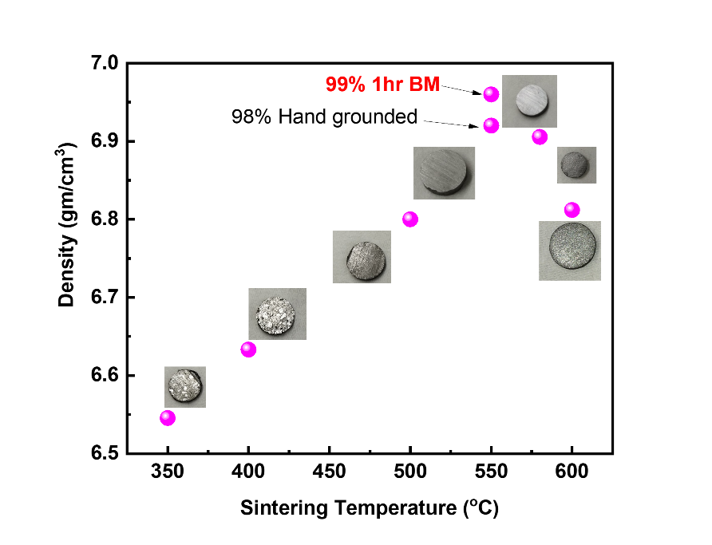
Figure 1: Density obtained at different sintering temperatures for CrSb₂.
Notably, sintering at temperatures below 500 °C results in the formation of low-density samples, while sintering at 550 °C yields high density of 98%. Further increase in the sintering temperature (exceeding 550 °C), leads to a decline in density, which may be due to excessive heating that can lead to abnormal grain growth and volatilization of elements [60]. This can result in increased porosity as the material may not pack as efficiently which can be seen in Figure 1. Thus, 580 °C emerges as the optimal sintering temperature for achieving high-density sintering. Subsequently, to enhance density further, the reacted powder was subjected to one hour of milling after the furnace reaction followed by SPS. Interestingly, the relative density was found to be increased from 98% to 99% by sintering this ball-milled powder at an optimized temperature (@ 550 °C). This outcome highlights the effectiveness of the milling and SPS process in further improving the material density. Apart from the density optimization, both non-milled and ball milled CrSb₂ samples are also characterized through the X-ray diffraction (XRD) pattern and FESEM. The XRD pattern for bulk and 1 hr. ball milled sample matches well with the orthorhombic CrSb₂ phase (space group Pnnm), as shown in Figure S2. However, it is important to note that the peaks in the milled sample appear broader compared to the non-milled sample which is indicative of a reduction in grain size as evident in SEM Figure S3. This reduction in grain size is helpful in mitigating thermal conductivity by effectively scattering phonons, contributing to the enhanced thermoelectric properties of the material [61].
  - Effect of Fe-substitution in Cr_{1-x}Fe_{x}Sb₂
After optimizing sintering conditions, alloying with Fe (at concentrations of 25%, 50%, 75% and complete replacement of Cr) was carried out at the Cr-site in CrSb₂. This strategic alloying aims to achieve a reduction in thermal conductivity through mass mismatch effects. Moreover, by substituting Fe (1.26Å) at the Cr site (1.30 Å), we anticipate influencing the lattice dynamics and phonon scattering mechanisms, leading to enhanced control over the thermal transport properties [62]. Employing the optimized ball milling and sintering conditions as detailed in the above section, the synthesis of Fe-alloyed CrSb₂ samples was successfully accomplished. Subsequently, these Fe-alloyed samples underwent an extensive characterization for their structural and transport properties using XRD, SEM, EDAX and the ZEM-3 instrument, as elaborated in the forthcoming section.
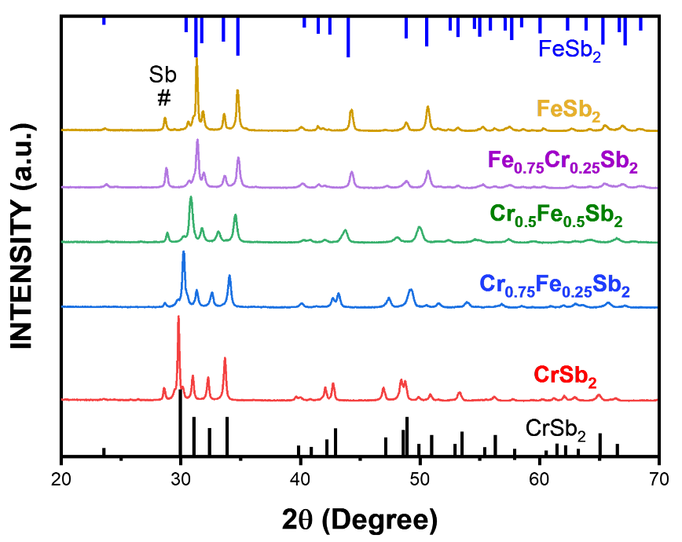
Figure 2: XRD pattern with varying Fe concentration of Cr_{1-x}Fe_{x}Sb₂(x = 0, 0.25, 0.50, 0.75 and 1).
3.2.1 Structural Investigation
The XRD pattern for Cr_{1-x}Fe_{x}Sb₂ is depicted in Figure 2. The primary XRD peaks are attributed to the orthorhombic CrSb₂ phase (space group Pnnm), with an additional peak at ~28° corresponding to the presence of the Sb element (indicated by #). This additional Sb peak is attributed to the quenching process performed at 650 °C, which is in proximity to the melting temperature of Sb (630 °C). Moreover, the observed shift of diffraction peaks towards higher angles with an increase in Fe concentration in Cr_{1-x}Fe_{x}Sb₂ indicates the successful incorporation of Fe (1.26Å) at the Cr site (1.30 Å). This shift is ascribed to the relatively smaller size of Fe compared to Cr. This significant observation serves as a compelling indicator of the effectiveness of Fe substitution within the lattice of CrSb₂. The deliberate introduction of Fe atoms induces a structural adjustment in the crystalline lattice, thus influencing their thermoelectric properties, as further discussed.
3.2.2. Thermoelectric Properties
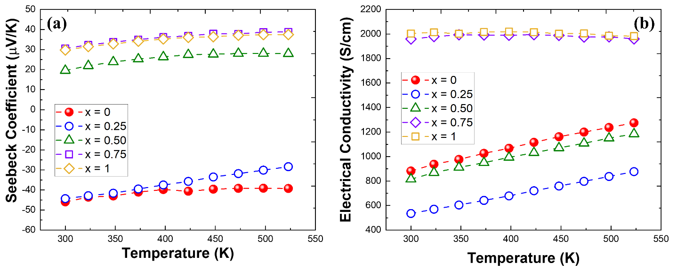
Figure 3: Temperature dependence of (a) Seebeck coefficient and (b) electrical conductivity for Cr_{1-x}Fe_{x}Sb₂ (x = 0, 0.25, 0.50, 0.75 and 1).
The temperature-dependent Seebeck coefficient (α) and electrical conductivity (σ) of Cr_{1-x}Fe_{x}Sb₂ are illustrated in Figure 3. Figure 3(a) reveals n-type conduction for CrSb₂ and Fe_{0.25}Cr_{0.75}Sb₂, where electrons serve as the majority charge carriers. Further increases in Fe concentration, specifically at x > 0.25, result in a change in thermopower from negative to positive, suggesting holes as the majority charge carriers. This observation suggests that Fe acts as an electron acceptor dopant in Cr_{1-x}Fe_{x}Sb₂, introducing holes into the system. Moreover, for x = 1 i.e., FeSb₂ identified as a p-type semiconductor at room temperature, which is consistent with previous reports [63,64]. The temperature-dependent σ plot (Figure 3b) reveals semiconductor behavior of all samples, wherein the σ notably increases with rising temperature. However, a significant reduction in conductivity is observed upon Fe doping (x = 0.25) in Cr_{1-x}Fe_{x}Sb₂. This decline in conductivity implies that Fe [Ar] 3d⁶ 4s² serves as an electron acceptor upon substitution at the Cr-site, exhibiting an oxidation state of +3. This, in turn, leads to a decrease in electron concentration and a subsequent reduction in conductivity can be observed. However, for samples with x > 0.25, there is an observed enhancement in σ, potentially may be attributed to increased hole concentrations with increasing Fe concentrations.
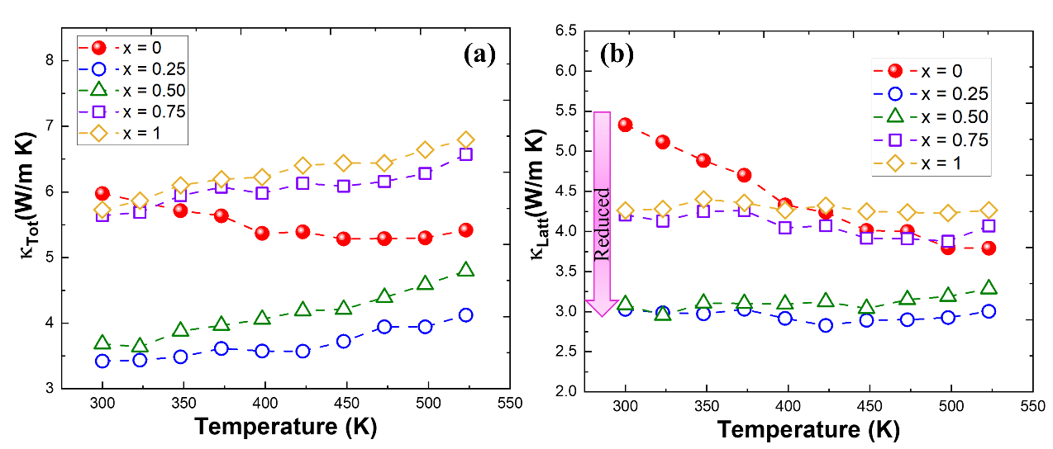
Figure 4: (a) Total thermal conductivity (κ_{Tot}) and (b) lattice thermal conductivity (κ_{Latt}) with increasing temperature of Cr_{1-x}Fe_{x}Sb₂ (x = 0, 0.25, 0.50, 0.75 and 1).
The subsequent analysis depicts the temperature-dependent variations in total thermal conductivity (κ_{Tot}) and lattice thermal conductivity (κ_{Latt}) for Cr_{1-x}Fe_{x}Sb₂, as illustrated in Figure 4. While electronic thermal conductivity (κ_{elec}) is obtained using Weidemann Franz law i.e., κ_{e} = LσT and presented in supporting information (Figure S4) where in L = Lorenz number and taken as 2.44×10⁻⁸ W S⁻¹K⁻², T= absolute temperature. As can be seen from Figure 4, that lattice thermal conductivity contributed majorly to total thermal conductivity for CrSb₂. Following the introduction of Fe dopants, a distinct decrease in total thermal conductivity is noted for Cr_{0.75}Fe_{0.25}Sb₂ and Cr_{0.5}Fe_{0.5}Sb₂. Specifically, Cr_{0.75}Fe_{0.25}Sb₂ exhibits the lowest thermal conductivity, observed approximately 3.5 Wm⁻¹K⁻¹ at room temperature. A 50% reduction compared to the pristine CrSb₂ (thermal conductivity ~ 6 Wm⁻¹K⁻¹) is observed. This reduction is attributed to decrease in lattice thermal conductivity due to enhanced phonon scattering from mass fluctuation. The difference in atomic mass of iron relative to chromium, introducing mass fluctuation and augmenting phonon scattering, thereby impeding efficient thermal energy transfer. However, beyond x > 0.5, the thermal conductivity begins to rise due to an increased contribution from electronic thermal conductivity which can be seen in Figure S4.
The temperature-dependent electrical conductivity and Seebeck coefficient indeed evidence that Fe doping induces competition between holes and electrons. This ultimately results in a decrease in both electrical conductivity and the Seebeck coefficient. Nevertheless, thermal conductivity analysis shows an almost 50% reduction, aligning with our objective of minimizing thermal conductivity in CrSb₂. The result highlights that Cr_{0.75}Fe_{0.25}Sb₂ exhibits the lowest thermal conductivity among all other doped samples. Therefore, in line with further minimizing thermal conductivity, Cr_{0.75}Fe_{0.25}Sb₂ is chosen for further investigation, and additional iso-electronic doping of heavy atom Bi at the Sb-site is undertaken to achieve a supplementary reduction in thermal conductivity along with balancing the electrical transport properties for achieving the high figure of merit. The subsequent sections will investigate into the thermoelectric properties of co-doped Cr_{0.75}Fe_{0.25}Bi_{y}Sb_{2-y}.
  - Effect of Bi doping in Cr_{0.75}Fe_{0.25}Bi_{2-y}Sb₂
To further reducing thermal conductivity of CrSb₂, doping with the heavier element Bi at the Sb-site is considered, incorporating varying concentrations of 5%, 7.5%, 10%, and 12.5%. The determination of the optimal Bi content aimed at achieving a reduction in thermal conductivity and an enhancement in the ZT value. The larger atomic mass of Bi compared to Sb may create lattice distortions and increase phonon scattering within the crystal lattice. This interference with the regular lattice structure hinders the efficient transfer of thermal energy, leading to a reduction in thermal conductivity. Additionally, the topological behavior of bismuth doping can influence the electronic structure of the material, impacting its electrical conductivity and Seebeck coefficient [65]. These combined effects contribute to achieving the desired balance for optimizing the material's thermoelectric performance, with the goal of enhancing the figure of merit for efficient TE applications. The findings from these analyses are explained in the subsequent section.
3.3.1 Structural investigation
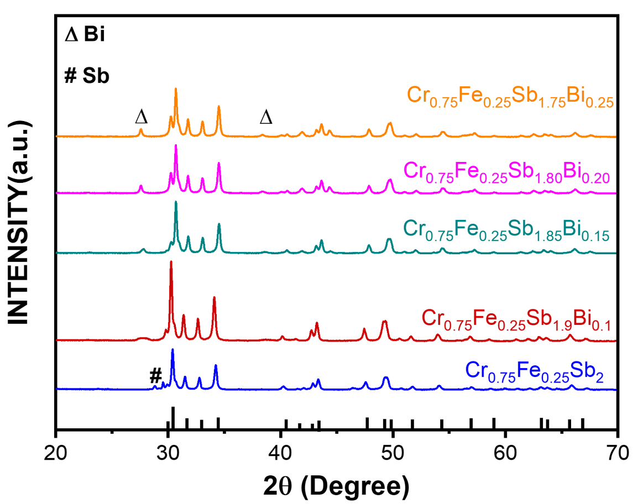
Figure 5: XRD patterns with varying Bi concentration in Cr_{0.75}Fe_{0.25}Sb_{2-y}Bi_{y} (y = 0, 0.1, 0.15, 0.20, 0.25).
The X-ray diffraction pattern was systematically acquired to assess the phase composition of the synthesized bulk polycrystalline Cr_{0.75}Fe_{0.25}Sb_{2-y}Bi_{y} samples, as illustrated in Figure 5. The distinct diffraction peaks identified corresponded to the orthorhombic CrSb₂ phase, emerging as the predominant crystalline structure. Simultaneously, additional peaks associated with the presence of Bi were detected at ~27° and ~38°, indicating a progressive increase with higher concentrations of Bi. Furthermore, a noticeable shift of peaks towards higher diffraction angles was noted, corresponding with an apparent decrease in lattice spacing. The observed reduction in lattice spacing, contrary to expectations based on Bi replacing Sb atoms, prompted further investigation. The theoretical calculations using density functional theory (DFT) were conducted in order to scrutinize this ambiguity, as reflected in Table 1.
The DFT calculations on lattice parameters supported and aligned with the XRD results and demonstrated a decrease in lattice spacing. This outcome elucidates that, despite the predicted increase in lattice spacing due to the larger size of Bi compared to Sb, lattice parameters are found to shrink. Moreover, during the sintering process, the occurrence of Bi spilling was observed. This phenomenon indirectly aligns with solubility limits, as detailed in a recent scientific report [54]. The excessive presence of bismuth in the lattice structure, as evidenced by Bi peaks in XRD and the shift in diffraction peaks altering lattice parameters, highlights the complex interplay between alloying elements and their profound influence on the structural characteristics of Cr_{0.75}Fe_{0.25}Sb_{2-y}Bi_{y}.
Table 1: Optimized lattice parameters values from DFT calculation and experimental lattice values (mentioned in parentheses) for CrSb₂, Cr_{0.75}Fe_{0.25}Sb₂ and Cr_{0.75}Fe_{0.25}Sb_{1.875}Sbi_{0.125}.
Geometry parameters | CrSb₂ | Cr_{0.75}Fe_{0.25}Sb₂ | Cr_{0.75}Fe_{0.25}Sb_{1.875}Bi_{0.125}
a (Å) | 6.05119 (6.03358) | 5.84502 (6.00456) | 5.48153 (5.98765)
b (Å) | 6.71857 (6.86552) | 6.52908 (6.79230) | 6.19322 (6.77573)
c (Å) | 3.20064 (3.26627) | 3.13878 (3.24361) | 2.94223 (3.23796)
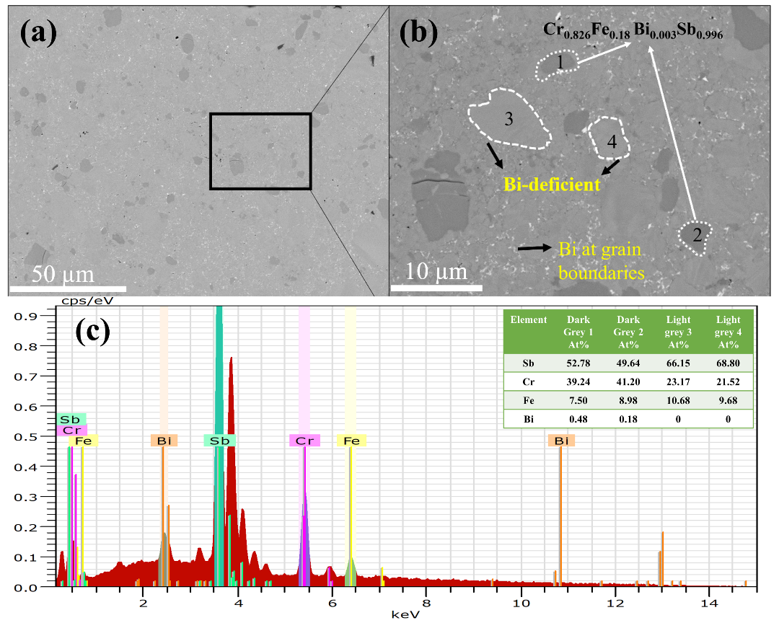
Figure 6: SEM micrograph at (a) low magnification (b) high magnification and (c) EDX spectra of sample Cr_{0.75}Fe_{0.25}Sb_{1.85}Bi_{0.15.}
SEM investigation was performed to understand the effect of microstructure on TE properties. Figure 6 shows the micrograph of the optimized sample, Cr_{0.75}Fe_{0.25}Sb_{1.85}Bi_{0.15}, of the present study. Figure 6(a) shows the overall view, while Figure 6(b) provides a magnified image of a rectangular area from Figure 6(a). In the magnified image, the well-distributed presence of Bi at grain boundaries is evident, as white in color. Additionally, two contrasting regions are observed: darker grey regions alongside lighter grey regions represented by white dotted circle. The corresponding elemental concentrations in these regions are detailed in the inset Table of Figure 6(c). Moreover, the elemental analysis from Energy Dispersive X-ray Spectroscopy (EDS) spectra indicates that the light grey region lacks Bi content, whereas the dark grey regions contain some Bi content, attributed to the limited solubility of Bi in those regions. This finding aligns with the observed decrease in calculated lattice parameters upon Bi alloying. Furthermore, the co-existence of two phases, along with the presence of Bi at grain boundaries may also facilitate phonon scattering and contribute to the reduction in thermal conductivity in the Bi-doped samples [54]. This aspect will be further elucidated in the subsequent section.
3.3.2 Thermoelectric Properties
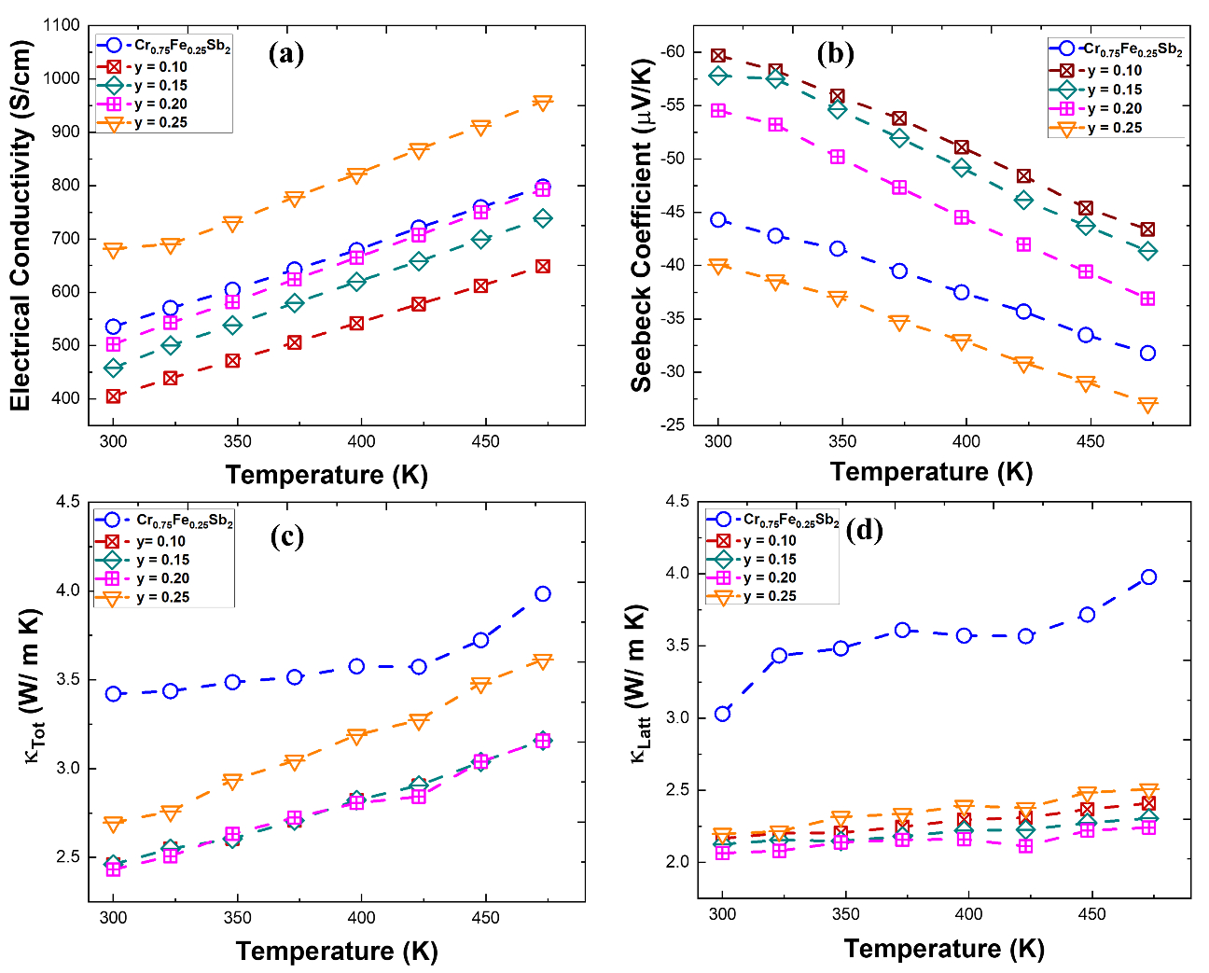
Figure 7: (a) Electrical conductivity (b) Seebeck coefficient (c) Total thermal conductivity (κ_{Tot}) and (d) lattice thermal conductivity (κ_{Latt}) of Cr_{0.75}Fe_{0.25}Bi_{y}Sb_{2-y} with increasing temperature.
The transport properties, measured across a temperature range of 300 K to 480 K, are illustrated in Figure 7. The temperature-dependent electrical conductivity is depicted in Figure 7(a), showcasing an increase in electrical conductivity with rising temperature for all specimens, which indicates their semiconductor behavior. Notably, the electrical conductivity found decrease for low Bi concentration (y = 0.10) doping from its Fe-optimized CrSb₂ matrix. However, σ starts increasing for higher Bi doping (y > 0.10) and even for y = 0.25 i.e., Cr_{0.75}Fe_{0.25} Bi_{0.25}Sb_{1.75} showed higher σ than that of matrix Cr_{0.75}Fe_{0.25}Sb_{2.} The optimized Bi content in Cr_{0.75}Fe_{0.25}Bi_{y}Sb_{2-y}, as indicated in Figure 7(a), leads to a substantial improvement in electrical conductivity, likely or might attributed to an enhanced carrier concentration. Moreover, from Figure 7(b), it is evident that all samples exhibit a negative Seebeck coefficient throughout the entire temperature range, signifying electrons as the majority charge carriers in the Cr_{0.75}Fe_{0.25}Bi_{y}Sb_{2-y} system. In contrast to electrical conductivity, the Seebeck coefficient increases for y = 0.10 but decreases for y > 0.10. In summary, the observed trends in electrical conductivity and Seebeck coefficient in the Cr_{0.75}Fe_{0.25}Bi_{y}Sb_{2-y} system likely stem from the intricate interplay between carrier concentration, and electronic band structure modification induced by Bi doping. Further detailed theoretical calculation is conducted in order to provide deeper insights into the specific mechanisms governing these trends, as mentioned in the later sections.
The temperature-dependent thermal transport properties of Cr_{0.75}Fe_{0.25}Bi_{y}Sb_{2-y} are displayed in Figure 7(c-d). The plot reveals a systematic reduction in overall thermal conductivity with an increment in the Bi doping content, for entire temperature range from 300 K to 480 K. Notably, at room temperature, the thermal conductivity reaches its lowest value for y = 0.20, exhibiting approximately 2.5 Wm⁻¹K⁻¹. A nearly 50% reduction in thermal conductivity compared to pristine CrSb₂ is observed. This pronounced reduction underscores the considerable efficacy of co-doping with Bi and Fe in reducing thermal conductivity. To explore into the specific contributions, lattice thermal conductivity (κ_{Latt}) is determined by subtracting the electronic contribution from the total thermal conductivity. The electronic thermal conductivity (κ_{elec}) is derived using the Weidemann Franz law, as previously employed and is presented in supporting information (Figure S5) while temperature-dependent lattice thermal conductivity is depicted in Figure 7(d). It is apparent from Figure S5 that κ_{elec} increases with rising temperature, corresponding the behavior observed in the electrical conductivity data. Figure 7(d) clarifies that the primary contribution to the total thermal conductivity in CrSb₂ originates from κ_{Latt}. Consequently, the notable reduction in κ_{Latt} upon doping with Fe and Bi serves to effectively suppress the overall thermal conductivity. This substantial decrease in lattice thermal conductivity is attributed to phonon scattering resulting from Bi-induced point defects. Hence, the reduction in thermal conductivity in Cr_{0.75}Fe_{0.25}BiySb_{2-y} primarily stems from two key factors, which include the introduction of point defects by Bi and the presence of Bi at grain boundaries, resulting in the generation of strain. Further, the DFT is again employed to know the contribution of co-doping of Fe and Bi in CrSb₂ in order to confirm the above-proposed mechanisms.
  - Role of Fe and Bi as dopants
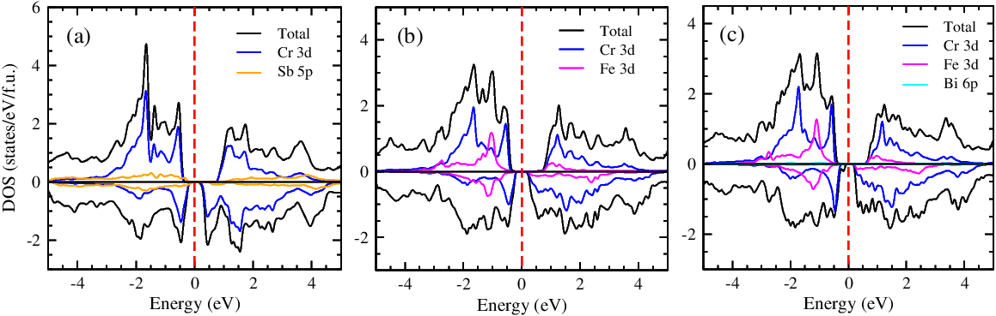
Figure 8: Total and partial density of states (DOS) of (a) CrSb₂, (b) Cr_{0.75}Fe_{0.25}Sb₂ and (c) Cr_{0.75}Fe_{0.25}Sb_{1.875}Bi_{0.125}. The vertical dashed line (red) indicates the Fermi level of the system, which is set to be zero in the middle of the band gap.
To know the contribution of density of states (DOS) in transport properties, we have calculated the total DOS and partial DOS of CrSb₂, Cr_{0.75}Fe_{0.25}Sb₂ and Cr_{0.75}Fe_{0.25}Sb_{1.875}Bi_{0.125} as shown in Figure 8. The dashed line at 0 eV represents the Fermi level of the compounds. The band gap calculated for CrSb₂ is ~0.16 eV, which gives quite good agreement with the experimentally reported band gap of 0.07 eV [66]. While, in the DOS of CrSb₂ (Figure 8(a)), the main contribution comes from the Cr 3d orbitals, with a negligibly small contribution from the Sb 5p orbitals for both the spin-up and spin-down channels that signifies the dominating behaviour of Cr 3d orbitals in the transport properties of CrSb₂. Similarly, the DOS of Cr_{0.75}Fe_{0.25}Sb₂ is calculated as shown in Figure 8(b). The DOS of Cr_{0.75}Fe_{0.25}Sb₂ showed that there are almost equal contributions from Cr 3d and Fe 3d orbitals in the valence band (VB) region, while in the conduction band (CB) region, the DOS consists of a dominant contribution from Cr 3d orbitals with a small contribution from Fe 3d orbitals. Precisely, in the low-lying energy range of -1.5 eV to 0 eV in the VB, the contributions in the DOS from Cr 3d and Fe 3d orbitals are calculated as ~60% and ~40%, respectively. However, these contributions are found to be ~80% and ~20%, respectively, in the energy range of 0 eV to 1.5 eV in the CB.
Moreover, the DOS of Cr_{0.75}Fe_{0.25}Sb_{1.875}Bi_{0.125} is calculated as shown in Figure 8(c). It displays that the dominant contribution in the DOS of Cr_{0.75}Fe_{0.25}Sb_{1.875}Bi_{0.125} comes from the Cr 3d and Fe 3d orbitals, with the negligibly small contribution from Bi 6p orbitals around the Fermi level. Therefore, it is demonstrated here that Bi doping does not significantly impact electrical transport due to its restricted solubility. Hence, the reduction in thermal conductivity in Cr_{0.75}Fe_{0.25}Bi_{y}Sb_{2-y} primarily comes from the introduction of point defects by Bi and the presence of Bi at grain boundaries, resulting in the generation of strain.
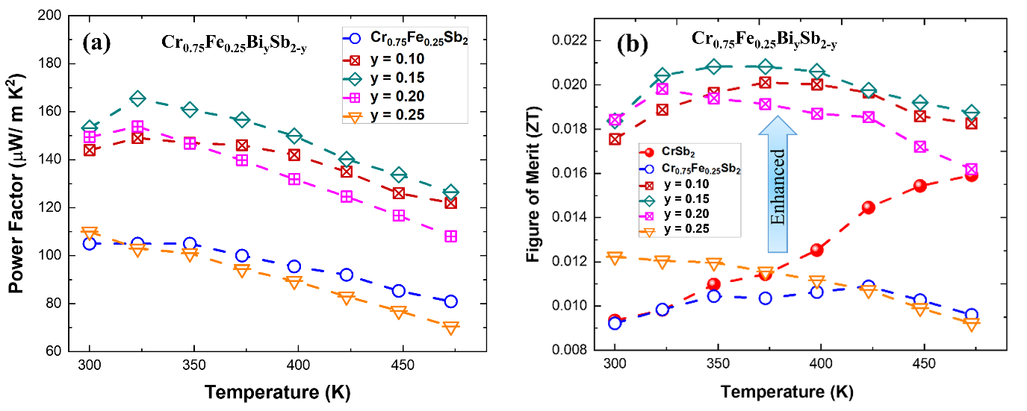Figure 9: Temperature dependence (a) power factor and (d) figure of merit (ZT) for Cr_{0.75}Fe_{0.25}Bi_{y}Sb_{2-y.}
Lastly, the power factor and Figure of merit (ZT) of the optimized composition have been evaluated. Figure 9 shows the temperature-dependent power factor and ZT for Cr_{0.75}Fe_{0.25}Bi_{y}Sb_{2-y.} It is worth mentioning here that the power factor was found to be increased from ~100 to ~170 µW m⁻¹K⁻² on Bi alloying for y = 0.15 due to the enhanced Seebeck coefficient. Synergistically improved power factor and low thermal conductivity leading to maximum ZT ~0.021 at 350 K showing 90% enhancement compared to ZT of pristine CrSb₂. The co-doping strategy involving both Bi and Fe emerges as a potent means of modulating thermal transport properties, signifying a promising avenue for optimizing the thermoelectric performance of CrSb₂-based materials. The observed temperature-dependent trends provide valuable insights into the intricate interplay of dopants and their influence on thermal conductivity, which example could be useful for the tailored design and enhancement of other thermoelectric materials also.

- Conclusion:
In conclusion, our investigation into the thermoelectric properties of CrSb₂, along with Fe and Bi-doped variants, revealed significant insights into the interplay of dopants and their influence on thermal transport. Optimized synthesis through spark plasma sintering and thorough sintering conditions yielded high-density samples, confirming the orthorhombic CrSb₂ phase. Fe substitution at the Cr site in Cr_{1-x}Fe_{x}Sb₂ induced p-type conduction, resulting in a remarkable 40% reduction in thermal conductivity for Cr_{0.75}Fe_{0.25}Sb₂. The subsequent introduction of Bi, despite limited solubility, played a crucial role in reducing thermal conductivity through the introduction of point defects and strain at grain boundaries. The co-doping strategy with Fe and Bi showcased a nearly 50% decline in thermal conductivity at room temperature, reaching its lowest value for Cr_{0.75}Fe_{0.25}Bi_{0.25}Sb_{1.75}. This, coupled with an improved electrical conductivity and power factor, synergistically contributed to achieving a maximum ZT of ~0.021 at 350 K for Cr_{0.75}Fe_{0.25}Bi_{0.15}Sb_{1.85}, marking a substantial 90% enhancement compared to pristine CrSb₂. Density of states calculations highlighted the specific orbital contributions, emphasizing the role of Bi in influencing the electronic band structure. In summary, co-doping with Fe and Bi emerged as a potential strategy for optimizing thermal transport properties in CrSb₂-based materials, offering promise for enhanced thermoelectric materials.

Acknowledgements
This research was supported by JST Mirai Program, Japan (grant number JPMJMI19A1).

References:
[1] J. He, T.M. Tritt, Advances in thermoelectric materials research: Looking back and moving forward, Science (1979) 357 (2017). https://doi.org/10.1126/science.aak9997.
[2] X.-L. Shi, J. Zou, Z.-G. Chen, Advanced Thermoelectric Design: From Materials and Structures to Devices, Chem Rev 120 (2020) 7399–7515. https://doi.org/10.1021/acs.chemrev.0c00026.
[3] G.J. Snyder, E.S. Toberer, Complex thermoelectric materials, Nat Mater 7 (2008) 105–114. https://doi.org/10.1038/nmat2090.
[4] T. Mori, S. Priya, Materials for energy harvesting: At the forefront of a new wave, MRS Bull 43 (2018) 176–180. https://doi.org/10.1557/mrs.2018.32.
[5] L.E. Bell, Cooling, Heating, Generating Power, and Recovering Waste Heat with Thermoelectric Systems, Science (1979) 321 (2008) 1457–1461. https://doi.org/10.1126/science.1158899.
[6] I. Petsagkourakis, K. Tybrandt, X. Crispin, I. Ohkubo, N. Satoh, T. Mori, Thermoelectric materials and applications for energy harvesting power generation, Sci Technol Adv Mater 19 (2018) 836–862. https://doi.org/10.1080/14686996.2018.1530938.
[7] Q.H. Zhang, X.Y. Huang, S.Q. Bai, X. Shi, C. Uher, L.D. Chen, Thermoelectric devices for power generation: recent progress and future challenges, Adv Eng Mater 18 (2016) 194–213.
[8] S.B. Riffat, X. Ma, Thermoelectrics: a review of present and potential applications, Appl Therm Eng 23 (2003) 913–935. https://doi.org/10.1016/S1359-4311(03)00012-7.
[9] T. Hendricks, T. Caillat, T. Mori, Keynote Review of Latest Advances in Thermoelectric Generation Materials, Devices, and Technologies 2022, Energies (Basel) 15 (2022) 7307. https://doi.org/10.3390/en15197307.
[10] S. Bano, A. Kumar, B. Govind, A.H. Khan, A. Ashok, D.K. Misra, Room temperature Bi2Te3-based thermoelectric materials with high performance, Journal of Materials Science: Materials in Electronics 31 (2020) 8607–8617.
[11] Q. Zhang, T. Fang, F. Liu, A. Li, Y. Wu, T. Zhu, X. Zhao, Tuning Optimum Temperature Range of Bi2Te3‐Based Thermoelectric Materials by Defect Engineering, Chemistry–An Asian Journal 15 (2020) 2775–2792.
[12] S. Bano, A. Kumar, B. Govind, A. Bhardwaj, A. Kapoor, A. Ashok, T. Vijayaraghavan, P. Kushwaha, S.P. Singh, Enhanced Thermoelectric Performance of Ni x Bi0. 5Sb1. 5Te3 via In Situ Formation of NiTe2 Channels, ACS Appl Energy Mater 5 (2022) 14127–14135.
[13] Z. Zhang, M. Sun, J. Liu, L. Cao, M. Su, Q. Liao, Y. Deng, L. Qin, Ultra-fast fabrication of Bi2Te3 based thermoelectric materials by flash-sintering at room temperature combining with spark plasma sintering, Sci Rep 12 (2022) 10045.
[14] Z.-Z. Luo, S. Cai, S. Hao, T.P. Bailey, Y. Luo, W. Luo, Y. Yu, C. Uher, C. Wolverton, V.P. Dravid, Extraordinary role of Zn in enhancing thermoelectric performance of Ga-doped n-type PbTe, Energy Environ Sci 15 (2022) 368–375.
[15] B. Jia, Y. Huang, Y. Wang, Y. Zhou, X. Zhao, S. Ning, X. Xu, P. Lin, Z. Chen, B. Jiang, Realizing high thermoelectric performance in non-nanostructured n-type PbTe, Energy Environ Sci 15 (2022) 1920–1929.
[16] H.-T. Liu, Q. Sun, Y. Zhong, Q. Deng, L. Gan, F.-L. Lv, X.-L. Shi, Z.-G. Chen, R. Ang, High-performance in n-type PbTe-based thermoelectric materials achieved by synergistically dynamic doping and energy filtering, Nano Energy 91 (2022) 106706.
[17] S. Wang, C. Chang, S. Bai, B. Qin, Y. Zhu, S. Zhan, J. Zheng, S. Tang, L.-D. Zhao, Fine Tuning of Defects Enables High Carrier Mobility and Enhanced Thermoelectric Performance of n-Type PbTe, Chemistry of Materials 35 (2023) 755–763.
[18] M. Wu, H. Cui, S. Cai, S. Hao, Y. Liu, T.P. Bailey, Y. Zhang, Z. Chen, Y. Luo, C. Uher, Weak Electron–Phonon Coupling and Enhanced Thermoelectric Performance in n‐type PbTe–Cu2Se via Dynamic Phase Conversion, Adv Energy Mater 13 (2023) 2203325.
[19] J. Gainza, F. Serrano‐Sánchez, J.E. Rodrigues, J. Prado‐Gonjal, N.M. Nemes, N. Biskup, O.J. Dura, J.L. Martínez, F. Fauth, J.A. Alonso, Unveiling the Correlation between the Crystalline Structure of M‐Filled CoSb3 (M= Y, K, Sr) Skutterudites and Their Thermoelectric Transport Properties, Adv Funct Mater 30 (2020) 2001651.
[20] J. Zhang, L. Zhang, W. Ren, W. Gou, J. Zhang, H. Geng, Multiple-filling-induced full-spectrum phonon scattering and band convergence leading to high-performance n-type skutterudites, ACS Appl Mater Interfaces 13 (2021) 29809–29819.
[21] D. Qin, W. Shi, Y. Lu, W. Cai, J. Sui, Efficient Si Doping Promoting Thermoelectric Performance of Yb-Filled CoSb3-Based Skutterudites, ACS Appl Mater Interfaces 14 (2022) 30901–30906.
[22] D. Li, X. Shi, Z. Feng, M. Li, J. Zhu, X. Ma, L. Zhang, H. Zhong, W. Liu, S. Li, Fast fabrication of high‐performance CoSb3‐based thermoelectric skutterudites via one‐step Yb‐promoted peritectic solidification, Adv Funct Mater 33 (2023) 2305269.
[23] C. Bourgès, W. Zhang, K.K. Raut, Y. Owada, N. Kawamoto, M. Mitome, K. Kobayashi, J.-F. Halet, D. Berthebaud, T. Mori, Investigation of Mn Single and Co-Doping in Thermoelectric CoSb3-Skutterudite: A Way Toward a Beneficial Composite Effect, ACS Appl Energy Mater 6 (2023) 9646–9656.
[24] F. Garmroudi, M. Parzer, A. Riss, N. Reumann, B. Hinterleitner, K. Tobita, Y. Katsura, K. Kimura, T. Mori, E. Bauer, Solubility limit and annealing effects on the microstructure & thermoelectric properties of Fe2V1− xTaxAl1− ySiy Heusler compounds, Acta Mater 212 (2021) 116867.
[25] F. Garmroudi, A. Riss, M. Parzer, N. Reumann, H. Müller, E. Bauer, S. Khmelevskyi, R. Podloucky, T. Mori, K. Tobita, Boosting the thermoelectric performance of Fe 2 VAl− type Heusler compounds by band engineering, Phys Rev B 103 (2021) 085202.
[26] F. Garmroudi, M. Parzer, A. Riss, S. Beyer, S. Khmelevskyi, T. Mori, M. Reticcioli, E. Bauer, Large thermoelectric power factors by opening the band gap in semimetallic Heusler alloys, Materials Today Physics 27 (2022) 100742.
[27] Y. Rached, M. Caid, H. Rached, M. Merabet, S. Benalia, S. Al-Qaisi, L. Djoudi, D. Rached, Theoretical insight into the stability, magneto-electronic and thermoelectric properties of XCrSb (X: Fe, Ni) Half-Heusler alloys and their superlattices, J Supercond Nov Magn 35 (2022) 875–887.
[28] A. El-Khouly, A.M. Adam, Y. Altowairqi, I. Serhiienko, E. Chernyshova, A. Ivanova, V.L. Kurichenko, A. Sedegov, D. Karpenkov, A. Novitskii, Transport and thermoelectric properties of Nb-doped FeV0. 64Hf0. 16Ti0. 2Sb half-Heusler alloys synthesized by two ball milling regimes, J Alloys Compd 890 (2022) 161838.
[29] X. Ai, B. Lei, M.O. Cichocka, L. Giebeler, R.B. Villoro, S. Zhang, C. Scheu, N. Pérez, Q. Zhang, A. Sotnikov, Enhancing the Thermoelectric Properties via Modulation of Defects in P‐Type MNiSn‐Based (M= Hf, Zr, Ti) Half‐Heusler Materials, Adv Funct Mater 33 (2023) 2305582.
[30] J. Liang, H. Yang, C. Liu, L. Miao, J. Chen, S. Zhu, Z. Xie, W. Xu, X. Wang, J. Wang, Realizing a high ZT of 1.6 in n-type Mg3Sb2-based Zintl compounds through Mn and Se codoping, ACS Appl Mater Interfaces 12 (2020) 21799–21807.
[31] Z. Liu, N. Sato, W. Gao, K. Yubuta, N. Kawamoto, M. Mitome, K. Kurashima, Y. Owada, K. Nagase, C.-H. Lee, Demonstration of ultrahigh thermoelectric efficiency of∼ 7.3% in Mg3Sb2/MgAgSb module for low-temperature energy harvesting, Joule 5 (2021) 1196–1208.
[32] Z. Liu, W. Gao, H. Oshima, K. Nagase, C.-H. Lee, T. Mori, Maximizing the performance of n-type Mg3Bi2 based materials for room-temperature power generation and thermoelectric cooling, Nat Commun 13 (2022) 1120.
[33] L. Huang, T. Liu, X. Mo, G. Yuan, R. Wang, H. Liu, X. Lei, Q. Zhang, Z. Ren, Thermoelectric performance improvement of p-type Mg3Sb2-based materials by Zn and Ag co-doping, Materials Today Physics 21 (2021) 100564.
[34] L. Yu, S. Wei, L. Wang, Z. Zhang, Z. Ji, S. Luo, J. Liang, W. Song, S.-Q. Zheng, Band Engineering and Phonon Engineering Effectively Improve n-Type Mg3Sb2 Thermoelectric Material Properties, ACS Appl Mater Interfaces 15 (2023) 53594–53603.
[35] L. Hu, Q. Zhang, Z. Shan, L. Wang, Y. Zheng, J. Fan, Synergy of grain size and texture effect for high-performance Mg3Sb2-based thermoelectric materials, Scr Mater 235 (2023) 115629.
[36] Z. Liang, C. Xu, S. Song, X. Shi, W. Ren, Z. Ren, Enhanced Thermoelectric Performance of p‐Type Mg3Sb2 for Reliable and Low‐Cost all‐Mg3Sb2‐Based Thermoelectric Low‐Grade Heat Recovery, Adv Funct Mater 33 (2023) 2210016.
[37] L. Wang, N. Sato, Y. Peng, R. Chetty, N. Kawamoto, D.H. Nguyen, T. Mori, Realizing high thermoelectric performance in N‐Type Mg3 (Sb, Bi) 2‐based materials via synergetic Mo addition and Sb–Bi ratio refining, Adv Energy Mater 13 (2023) 2301667.
[38] W. Zhang, J.-F. Halet, T. Mori, Understanding the complex electronic structure of Mg 3 Sb 2 and the effect of alloying through first-principles tight-binding models, J Mater Chem A Mater 11 (2023) 24228–24238.
[39] V. V Glushkov, I.I. Lobanova, V.Y. Ivanov, V. V Voronov, V.A. Dyadkin, N.M. Chubova, S. V Grigoriev, S. V Demishev, Scrutinizing Hall effect in Mn 1− x Fe x Si: Fermi surface evolution and hidden quantum criticality, Phys Rev Lett 115 (2015) 256601.
[40] Q. Du, D. Guzman, S. Choi, C. Petrovic, Crystal size effects on giant thermopower in CrSb 2, Phys Rev B 101 (2020) 035125.
[41] Q. Du, L. Wu, H. Cao, C.-J. Kang, C. Nelson, G.L. Pascut, T. Besara, T. Siegrist, K. Haule, G. Kotliar, Vacancy defect control of colossal thermopower in FeSb2, NPJ Quantum Mater 6 (2021) 13.
[42] T. Harada, T. Kanomata, Y. Takahashi, O. Nashima, H. Yoshida, T. Kaneko, Structural and electrical properties of Cr1− xRuxSb2, J Alloys Compd 383 (2004) 200–204.
[43] K. Adachi, K. Sato, M. Matsuura, Magnetic properties of CrSb2, J Physical Soc Japan 26 (1969) 906–910.
[44] A. KJEKSHUS, P. PETERZÉNS, T. RAKKE, A.F. ANDRESEN, Compounds with the Marcasite Type Crystal Structure. XIII. Structural and Magnetic Properties of C^ Fe^ fAsj, CrtFe1_ (Sb2, Fej-tN^ Asj and Fe^ NijSbj, Acta Chemica Scandinavi «! A 33 (1979) 469–480.
[45] Y. Takahashi, T. Harada, T. Kanomata, K. Koyama, H. Yoshida, T. Kaneko, M. Motokawa, M. Kataoka, Magnetoresistance effect of pseudobinary compounds Cr1− xRuxSb2, J Alloys Compd 459 (2008) 78–82.
[46] H.J. Li, X.Y. Qin, Y. Liu, D. Li, J.L. Hu, Resistivity, thermopower, and thermal conductivity of nickel doped compounds Cr1− xNixSb2 at low temperatures, J Alloys Compd 509 (2011) 3677–3681.
[47] H. Li, X. Qin, Y. Liu, D. Li, The effect of Ti substitution for Cr on transport and thermoelectric properties of CrSb2 at low temperatures, J Alloys Compd 506 (2010) 917–922.
[48] H.J. Li, X.Y. Qin, D. Li, H.X. Xin, The effect of Sn substitution for Sb on transport and thermoelectric properties of CrSb2 at low temperatures, J Alloys Compd 472 (2009) 400–405.
[49] H.J. Li, X.Y. Qin, D. Li, Transport and thermoelectric properties of CrSb2− xTex at low temperatures, Materials Science and Engineering: B 149 (2008) 53–57.
[50] H.J. Li, X.Y. Qin, D. Li, Transport and thermoelectric properties of Cr1− xMnxSb2 at low temperatures, J Alloys Compd 467 (2009) 299–304.
[51] T. Xing, C. Zhu, Q. Song, H. Huang, J. Xiao, D. Ren, M. Shi, P. Qiu, X. Shi, F. Xu, L. Chen, Ultralow Lattice Thermal Conductivity and Superhigh Thermoelectric Figure-of-Merit in (Mg, Bi) Co-Doped GeTe, Advanced Materials 33 (2021). https://doi.org/10.1002/adma.202008773.
[52] C. Fu, Y. Liu, H. Xie, X. Liu, X. Zhao, G. Jeffrey Snyder, J. Xie, T. Zhu, Electron and phonon transport in Co-doped FeV0. 6Nb0. 4Sb half-Heusler thermoelectric materials, J Appl Phys 114 (2013).
[53] Y. Huang, K. Hayashi, Y. Miyazaki, Outstanding thermoelectric performance of n-type half-Heusler V (Fe1− xCox) Sb compounds at room-temperature, Acta Mater 215 (2021) 117022.
[54] N.S. Chauhan, Y. Miyazaki, Contrasting role of bismuth doping on the thermoelectric performance of VFeSb half-Heusler, J Alloys Compd 908 (2022) 164623.
[55] P. Giannozzi, S. Baroni, N. Bonini, M. Calandra, R. Car, C. Cavazzoni, D. Ceresoli, G.L. Chiarotti, M. Cococcioni, I. Dabo, QUANTUM ESPRESSO: a modular and open-source software project for quantum simulations of materials, Journal of Physics: Condensed Matter 21 (2009) 395502.
[56] W. Kohn, L.J. Sham, Density functional theory, in: CONFERENCE PROCEEDINGS-ITALIAN PHYSICAL SOCIETY, EDITRICE COMPOSITORI, 1996: pp. 561–572.
[57] J.P. Perdew, K. Burke, M. Ernzerhof, Generalized gradient approximation made simple, Phys Rev Lett 77 (1996) 3865.
[58] V.I. Anisimov, J. Zaanen, O.K. Andersen, Band theory and Mott insulators: Hubbard U instead of Stoner I, Phys Rev B 44 (1991) 943.
[59] G. Kuhn, S. Mankovsky, H. Ebert, M. Regus, W. Bensch, Electronic structure and magnetic properties of CrSb 2 and FeSb 2 investigated via ab initio calculations, Phys Rev B 87 (2013) 085113.
[60] Y. Zhen, J. Li, Normal sintering of (K, Na) NbO3‐based ceramics: influence of sintering temperature on densification, microstructure, and electrical properties, Journal of the American Ceramic Society 89 (2006) 3669–3675.
[61] P. Das, S. Bathula, S. Gollapudi, Evaluating the effect of grain size distribution on thermal conductivity of thermoelectric materials, Nano Express 1 (2020) 020036.
[62] K. Zhao, E. Eikeland, D. He, W. Qiu, Z. Jin, Q. Song, T. Wei, P. Qiu, J. Liu, J. He, Thermoelectric materials with crystal-amorphicity duality induced by large atomic size mismatch, Joule 5 (2021) 1183–1195.
[63] D. Gujjar, S. Gujjar, V.K. Malik, H.C. Kandpal, Transport and electrical properties of cryogenic thermoelectric FeSb2: the effect of isoelectronic and hole doping, Journal of Physics: Condensed Matter 36 (2023) 115703.
[64] K. Wang, R. Hu, J. Warren, C. Petrovic, Enhancement of the thermoelectric properties in doped FeSb2 bulk crystals, J Appl Phys 112 (2012).
[65] Y. Kumar, P. Sharma, N.K. Karn, V.P.S. Awana, Shubnikov-de Haas (SdH) Oscillation in Self-Flux Grown Rhombohedral Single-Crystalline Bismuth, J Supercond Nov Magn 36 (2023) 389–395. https://doi.org/10.1007/s10948-023-06494-8.
[66] R. Hu, V.F. Mitrović, C. Petrovic, Anisotropy in the magnetic and electrical transport properties of Fe 1− x Cr x Sb 2, Phys Rev B 76 (2007) 115105.

Supplementary Information
Reduced Thermal Conductivity and Enhanced TE performance in CrSb₂ via Fe-Bi co-substitution
Sahiba Bano¹, Shamim Sk¹, Takashi Aizawa¹, and Takao Mori^{*1, 2}
¹Research Center for Materials Nanoarchitectonics (MANA), National Institute for Materials Science (NIMS), Namiki 1-1, Tsukuba 305-0044, Japan
²Graduate School of Pure and Applied Sciences, University of Tsukuba, Tsukuba, Japan
*Corresponding author's E-mail: MORI.Takao@nims.go.jp

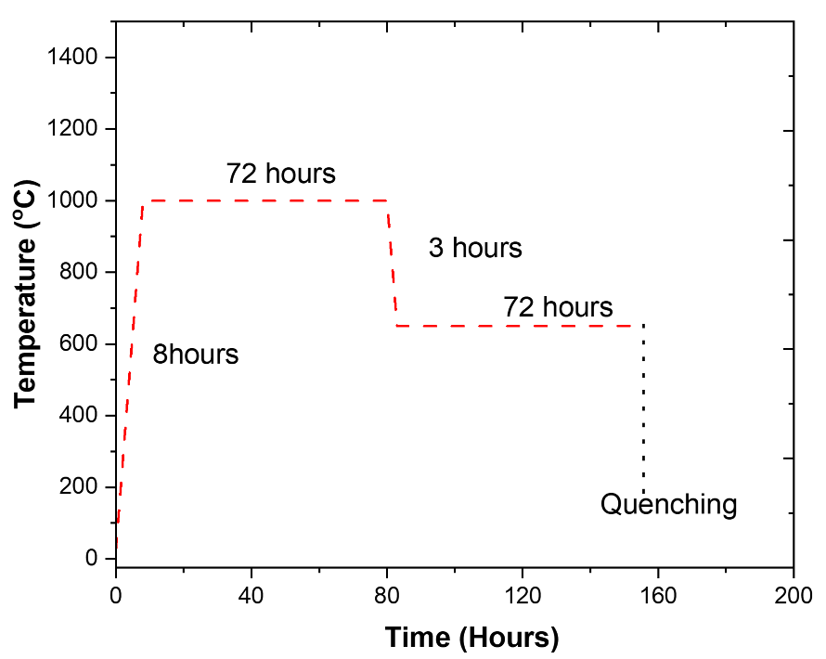

Figure S1: Heating profile for furnace reaction.

Sample | Density g/ cm³
CrSb₂ | 6.953
Cr_{0.75}Fe_{0.25}Sb₂ | 7.196
Cr_{0.50}Fe_{0.50}Sb₂ | 7.376
Cr_{0.25}Fe_{0.75}Sb₂ | 7.327
FeSb₂ | 7.714
Cr_{0.75}Fe_{0.25}Bi_{0.10}Sb_{0.90} | 7.904
Cr_{0.75}Fe_{0.25}Bi_{0.15}Sb_{0.85} | 7.907
Cr_{0.75}Fe_{0.25}Bi_{0.20}Sb_{0.80} | 7.886
Cr_{0.75}Fe_{0.25}Bi_{0.25}Sb_{0.75} | 7.880

Table S1: Density obtained for Fe and Bi co-doped CrSb₂ samples using Archimede’s principle.
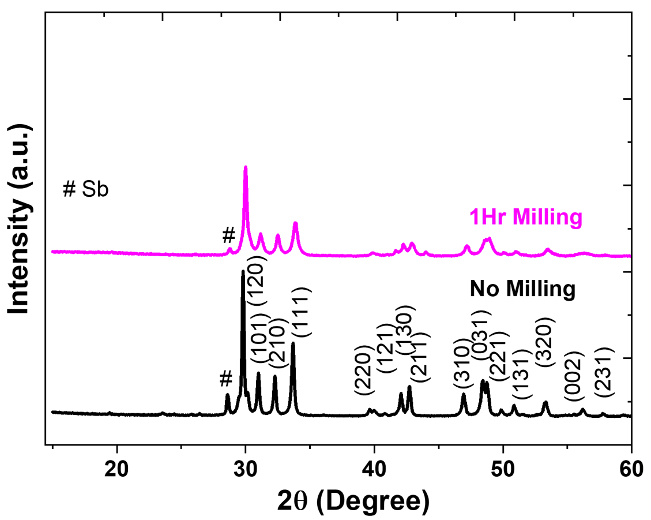
Figure S2: XRD patterns for non-milled and milled CrSb₂.

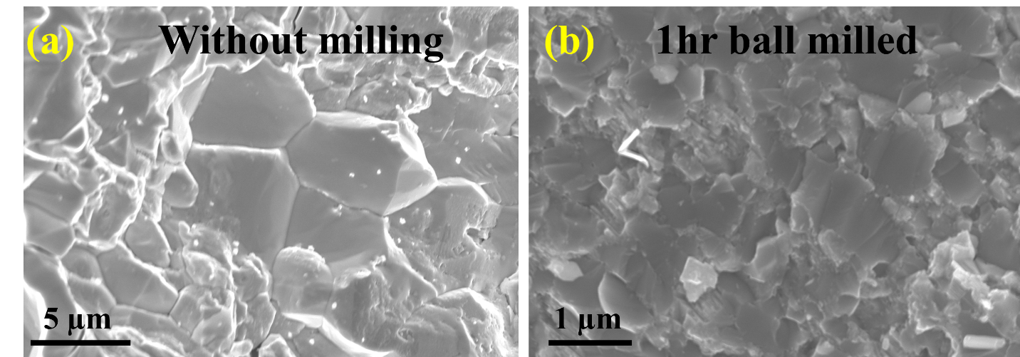
Figure S3: SEM image of bulk CrSb₂ (a) without milling and (b) 1hr milling.
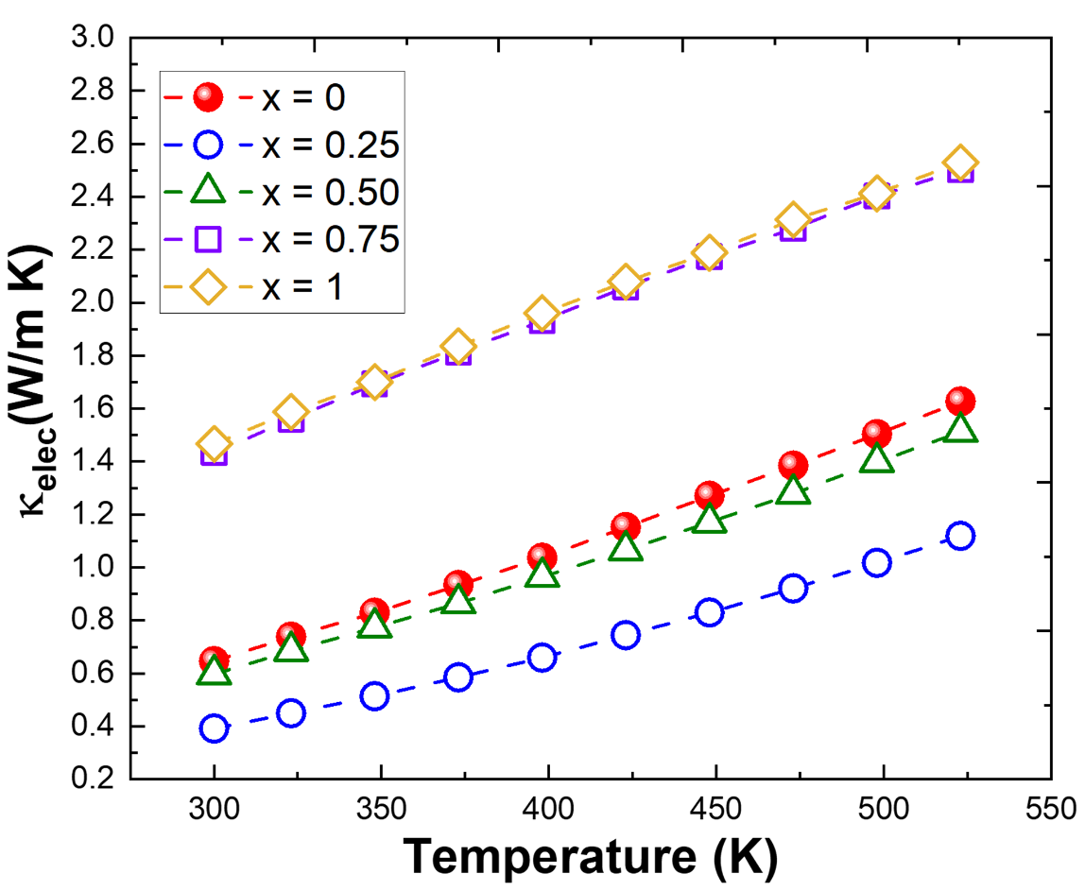
Figure S4: Temperature dependent κ_{elec} for Cr_{1-x}Fe_{x}Sb₂.

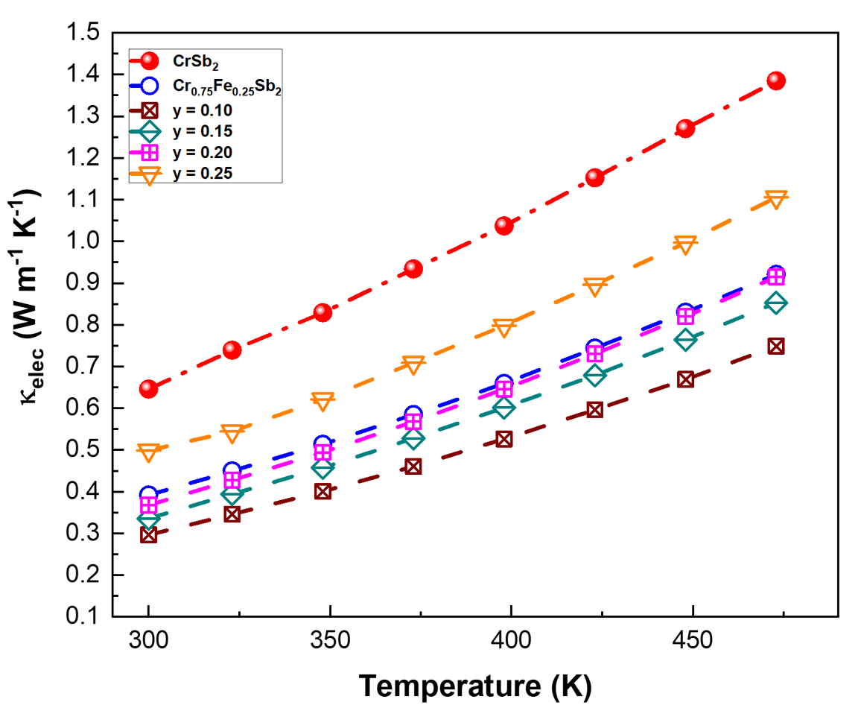
Figure S5: Temperature-dependent κ_{elec} for Cr_{0.75}Fe_{0.25}Bi_{y}Sb_{2-y}.

