Segregation-induced microstructural refinement in a FeMnAlC-TiB metal matrix composite by laser powder bed fusion
Abstract
Microstructural control is crucial in laser powder bed fusion (LPBF) technique. The columnar-to-equiaxed transition is an effective approach to reduce anisotropy and improve mechanical properties of additively manufactured materials. Recent studies have shown that grain refinement can be induced through heterogeneous nucleation ahead of the epitaxially growing solid-liquid (S/L) interface. This paper investigated the solidification process of a metal matrix composite (FeMnAlC-TiB) produced by LPBF, which resulted in a texture-free nanoequiaxed δ-Fe matrix, reinforced by nanoprecipitates and an M₂B-type network structure. The analysis of Electron Backscatter Diffraction (EBSD), Transmission Electron Microscopy- Automatic Crystal Orientation and Phase Mapping (TEM-ASTAR), and Three-dimensional Atom Probe (3DAP) indicated that boron (B) segregation plays a major role in terms of microstructure refinement by generating a thermal undercooling zone ahead of the S/L interface. As a result of the microstructural refinement and the presence of reinforced particles, the LPBF-processed material exhibited hardness 150% higher than the base steel and achieved remarkable levels of strength as compared with the as-cast counterparts.

Keywords: LPBF; metal matrix composite; solidification; segregation

Graphical abstract
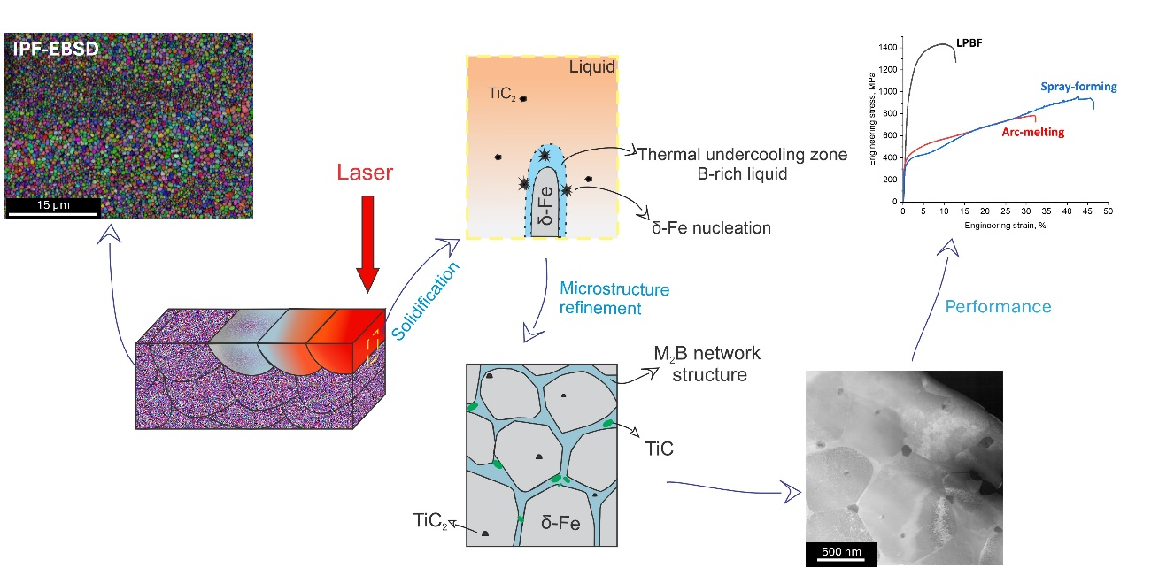
- Introduction
Introducing titanium (Ti) and boron (B) into ferrous systems, resulting in a metal matrix composite (MMC), has emerged as a strategy for enhancing mechanical performance [1,2]. In the specific case of the Fe-Mn-Al-C system (lightweight steels), the incorporation of these elements increases stiffness and further reduces density, thereby enhancing its potential for structural applications [3,4]. Since the reinforced particles are formed in-situ, the solidification process must be carefully controlled. Slow solidification kinetics associated with conventional casting techniques results in sizes and morphologies of particles that potentially affect negatively the mechanical properties [1,2].
Additive manufacturing, particularly the laser powder bed fusion (LPBF) technique, offers new avenues for composite design by enabling refined microstructure through rapid solidification [2]. This technique consists of building components layer by layer, enabling the fabrication of complex geometries with tailored properties. Due to its versatility, it has been widely applied in the aerospace, automotive, and biomedical industries. LPBF is characterized by large thermal gradients and high cooling rates, and due to the complex thermal conditions, the microstructure achieves unique characteristics, which are affected by the experimental conditions and chemical composition [5]. Typical solidification begins at the melt pool boundaries, by heterogeneous nucleation, and is directed towards the center of the pool [6]. Due to the thermal conditions involved in the LPBF process, there is a strong tendency for epitaxial growth from the partially remelted grains of the previously solidified layer, forming columnar grains structures and pronounced anisotropy in FeMnAlC alloys [7].
Grain refinement is an effective approach to reducing anisotropy, improving the mechanical properties of LPBF manufactured alloy [8,9]. The optimization of processing parameters can reduce the epitaxial growth, leading to the columnar-to-equiaxial transition and, as a consequence, grain refinement [10,11]. However, the exploration of other approaches to ease the transition from columnar-to-equiaxial, such as solute segregation-driven heterogenous nucleation, would further open the possibility of increasing the degree of freedom in the design of high-quality, i.e. highly dense components with finer microstructure. Recent studies [8,12] have highlighted the significant role of alloying elements and their segregation behavior in controlling the solidification process during LPBF processing. However, a deeper understanding of how solute effects influence grain refinement in LPBF-processed composites remains essential for advancing this field.
Despite recent advances in additive manufacturing of steels and composites, the role of solute in grain refinement during LBPF solidification remains not well established. Understanding this phenomenon is essential for tailoring microstructure and mechanical properties. Therefore, the present paper processed a FeMnAlC-TiB composite by LPBF and investigated the segregation phenomenon and solidification process through transmission electron microscopy (TEM) and Three-Dimensional Atom Probe (3DAP). Furthermore, the microstructure and mechanical properties of the LBPF-processed composite were compared with those obtained by arc-melting and spray-forming.
- Materials and methods
Based on previous studies [3,4], in which FeMnAlC-TiB composites were processed by arc-melting and spray-forming, the Fe-15Mn-3Al-0.1C-1.67Ti-0.75B (wt.%) composite was selected for the present work. According to the thermodynamic calculation [4], the metal matrix would be reinforced by 5 vol% of TiB₂ at equilibrium condition. The powder was produced using a close-coupled atomizer and a fraction size between 20 and 63 μm was used for the LPBF process. The particle size distribution was measured by laser diffraction technique using the Malvern Mastersizer 2000® equipment. The morphology of the particles was evaluated using a Malvern G3 optical measurement system. The powder characterization is presented in the supplementary material section.
The LPBF was carried out on an Aconity MINI machine (Aconity GmbH, Germany) equipped with an ytterbium fiber laser beam spot diameter of 80 μm. It was used a bi-directional scanning strategy with a 67° rotation between layers, layer thickness of 30 μm and the combination of laser power, scanning speed and hatching space of 158 W, 600 mm/s, 90 μm, respectively, resulted in a bulk material with no cracks and density of 99.7% (Archimedes’ principle). The LPBF process was conducted with oxygen levels below 50 ppm. Cylindrical compression specimens with a diameter of 3 mm and a length of 7 mm were printed.
Electron Backscattered Diffraction (EBSD) technique was used to investigate the texture and grain morphology. A Scanning Electron Microscope (SEM) MIRA – TESCAN coupled with a Bruker XFlash 6/30 detector was used. The EBSD analysis was conducted on the plane parallel to the building direction. Samples preparation involved conventional grinding, followed by final polishing with a vibratory system utilizing a 40 nm colloidal silica suspension. Transmission Electron Microscopy (TEM) analyses were performed to investigate the LPBF-microstructure on a nanometric scale. For these investigations, a thin foil (lamella) specimen was prepared by focused-ion beam (FIB) lift-out method, using a dual-beam FIB-SEM (FEI Helios G4 UX). TEM and Energy Dispersive X-ray Spectroscopy (EDX) analysis of the thin lamella was performed using FEI Titan G2 80-200, coupled with a Thermo-Fisher Super-X detector, operating at 200 kV. A NanoMEGAS ASTAR system was used to obtain the phase mapping on the TEM.
To understand the local atomic distribution of elements and the solidification mechanism during LPBF process, Three-Dimensional Atom Probe (3DAP) analysis was performed. Needle-shaped specimens were prepared using standard FIB-based lift out procedure from mechanically polished specimen using Helios 5 UX. 3DAP analysis was performed using a local electrode atom probe (LEAP 5000XS, CAMECA Inc. U.S.A.) in laser mode with a pulse energy of 30 pJ at 50 K and a detection rate of 0.5%.
The effects of the LPBF processing on the mechanical properties were evaluated by Vickers microhardness and compression tests. Cylindrical compression specimens with a diameter of 3 mm and a length of 7 mm were carried out with a strain rate of 10⁻³ s⁻¹, using an Instron 5900R machine equipped with an Instron Advanced Video Extensometer. The tests were performed in the direction parallel to the building direction.

- Results and discussion
As shown in Fig. 1a-b, L-PBF processing produced a nanostructured material formed by equiaxed grains of δ-ferritic (δ-Fe) with no preferential texture (Fig 1c), contrary to that usually reported [7,13]. The convection zones created by the laser movement led to different refinement levels. The marked area in yellow (Fig. 1a) has an average grain size of 578 ± 12 nm, while the red square indicates a reduced average grain size of 341 ± 8 nm. The substantial microstructural refinement achieved through LPBF processing becomes more evident when compared to the same composite produced by arc-melting (Fig. 1d) and spray-forming (Fig. 1e). In both cases, the microstructure consists of a coarse duplex matrix (α-ferrite + austenite) reinforced by predominantly micrometric-sized TiB₂ particles, with a minor amount of TiC.
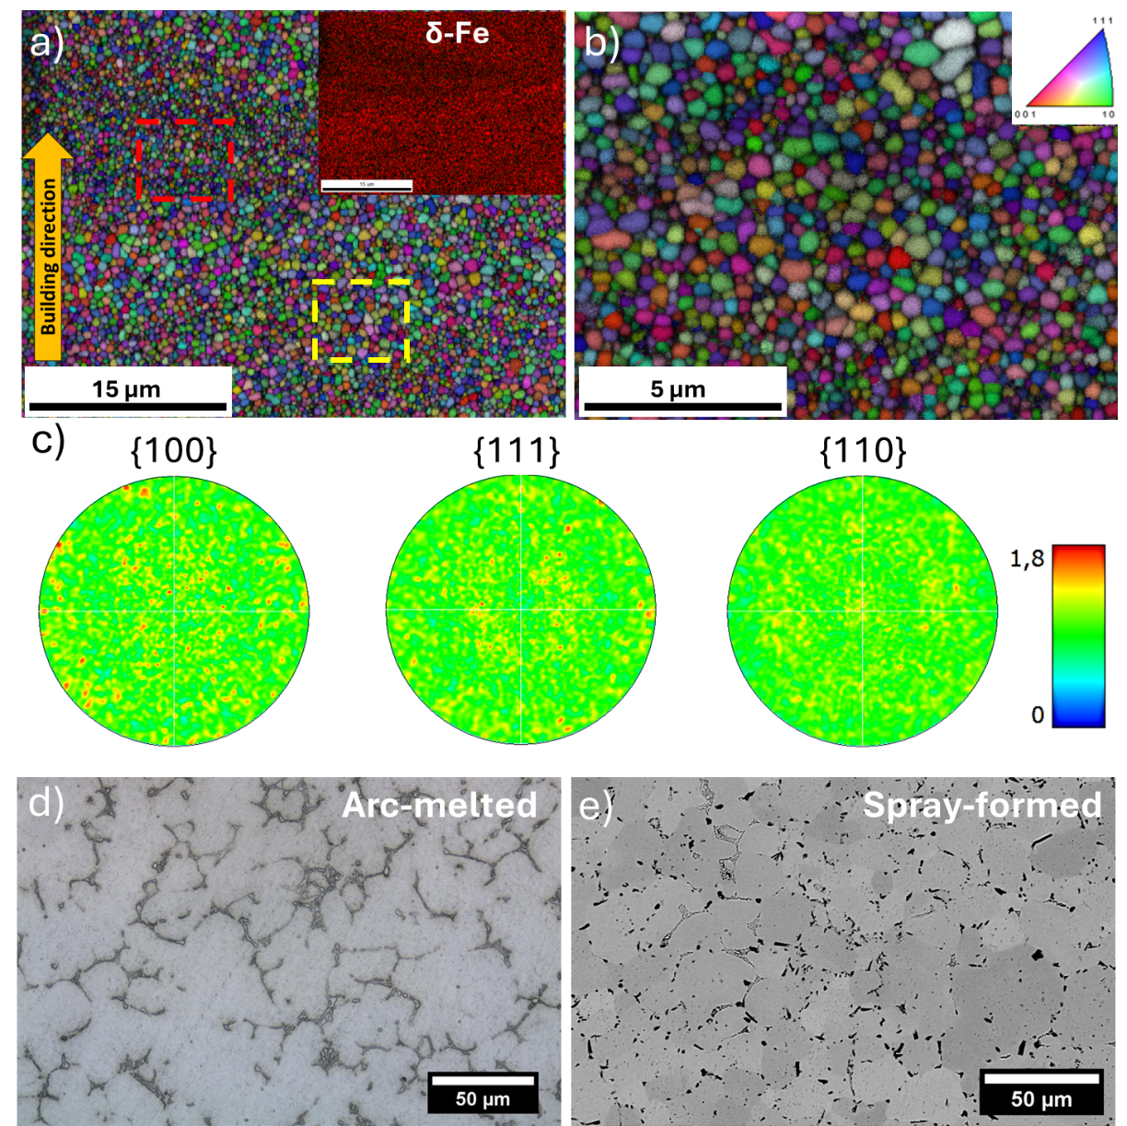
Figure 1 – a) EBSD inverse pole figure maps of the section parallel to the building direction of the LPBF processed composite, shown at magnification of (a) 5Kx and (b) 15 Kx; (c) corresponding pole figures for the region analyzed in (a); and microstructures of the same composite processed via d) arc-melting and e) spray-forming routes.

High-Angle Annular Dark-Field (HAADF) image, Fig 2a, reveals that, beyond the nanometric equiaxed grains, the LPBF-processed material also features nanoprecipitates (orange arrows) and a continuous phase (red arrows) along the grain boundaries (GB). Fig 2b and Fig2c highlight that the precipitates are located both within the δ-Fe grains and at GB. The Nanobeam Electron Diffraction (NBED) from the intergranular continuous phase region (Fig. 2d), marked by the white arrow in Fig. 2b, indicates that this phase corresponds to a M₂B-type boride. The ASTAR map phase, Fig.2g, points out the M₂B-boride forming a network structure between the δ-Fe grains. Unexpectedly, the microbeam electron diffraction (MBED) pattern acquired from the cuboidal intragranular nanoprecipitates (black arrow in Fig. 2b), shown in Fig 2e, indicates that this nanoprecipitate corresponds to the TiC₂ (β) carbide with an orientation relationship (OR) with δ-Fe described as ${\left(\text{1}\overline{\text{1}}\text{0}\right)}_{δ}\text{//}{\left(\overline{\text{2}}\text{0}\overline{\text{1}}\right)}_{β}$ and ${\left[110\right]}_{δ}\text{//}{\left[10\overline{2}\right]}_{β}$. This carbide, with a space group of Pm-3m and a = 4.327 Å, is metastable in the FeMnAlC-TiB system, as its formation is not thermodynamically predicted [4].The intergranular precipitate at GB triple junctions, shown in Fig. 2c, is identified as TiC (γ) in Fig. 2f. Apparently, there is no specific OR between intergranular TiC precipitates and the δ-ferrite. EDX elemental maps shown in Fig. 2h (acquired from the region in Fig 2b) reveal that Fe and Al are relatively depleted in the intergranular continuous phase compared to the matrix, while Mn and Ti are enriched, indicating the last two elements were segregated during solidification process. Additionally, no oxides were identified in the analyses, suggesting that atmospheric control during both the atomization process and the part fabrication was effective.
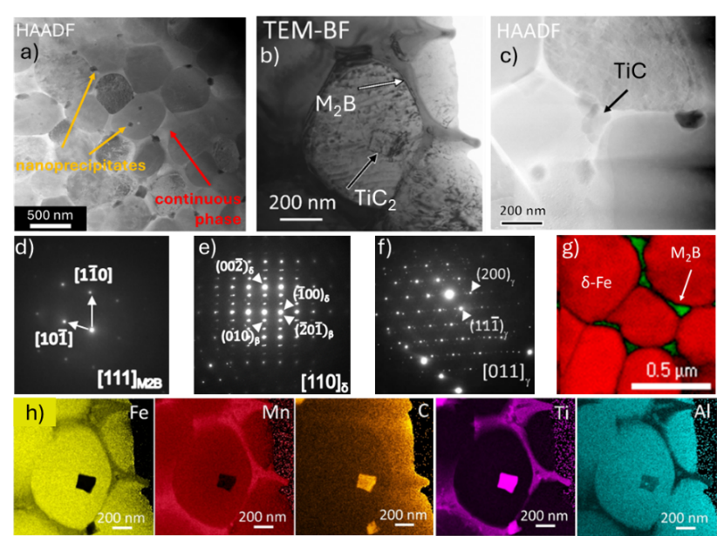
Fig. 2 – (a) STEM-HAADF from LPBF-processed alloy; (b) TEM-BF of cuboidal intragranular precipitate present within a δ-Fe grain and intergranular phase; (c) HAADF of precipitates present at GB; NBED patterns obtained from d) intergranular phase; e) intragranular precipitate and f) triple-junction precipitate; (g) TEM-ASTAR phase mapping; (h)STEM-EDX maps acquired from the region shown in (b).

Fig. 3a shows the 3DAP maps corresponding to Fe, Mn, Al, Ti, C and B, including δ-Fe matrix and intergranular phase. The interface between δ-Fe and intergranular phase is indicated by red arrow in Al map in Fig. 3a. In addition to the enrichment of Mn e Ti previously identified by the STEM-EDS analysis, the 3DAP maps and the 1D concentration profile indicated by #1 area (Fig. 3b) indicate that the intergranular continuous phase is also enriched in C and B. It can be noted that the 1D concentration profile was analyzed along the longitudinal direction of a cuboidal region of interest (ROI) with dimensions: $17×9 ×40$nm³. The chemical composition of the intergranular phase is estimated as Fe-16.46Mn-0.10Al-5.55Ti-0.28C-16.76B (at.%) from the volume enclosed within the aforementioned cuboidal ROI, based on the methodology highlighted in [14]. This results suggested that the M₂B-type corresponds to the (Fe,Mn)₂B with Ti possibly in solid solution.
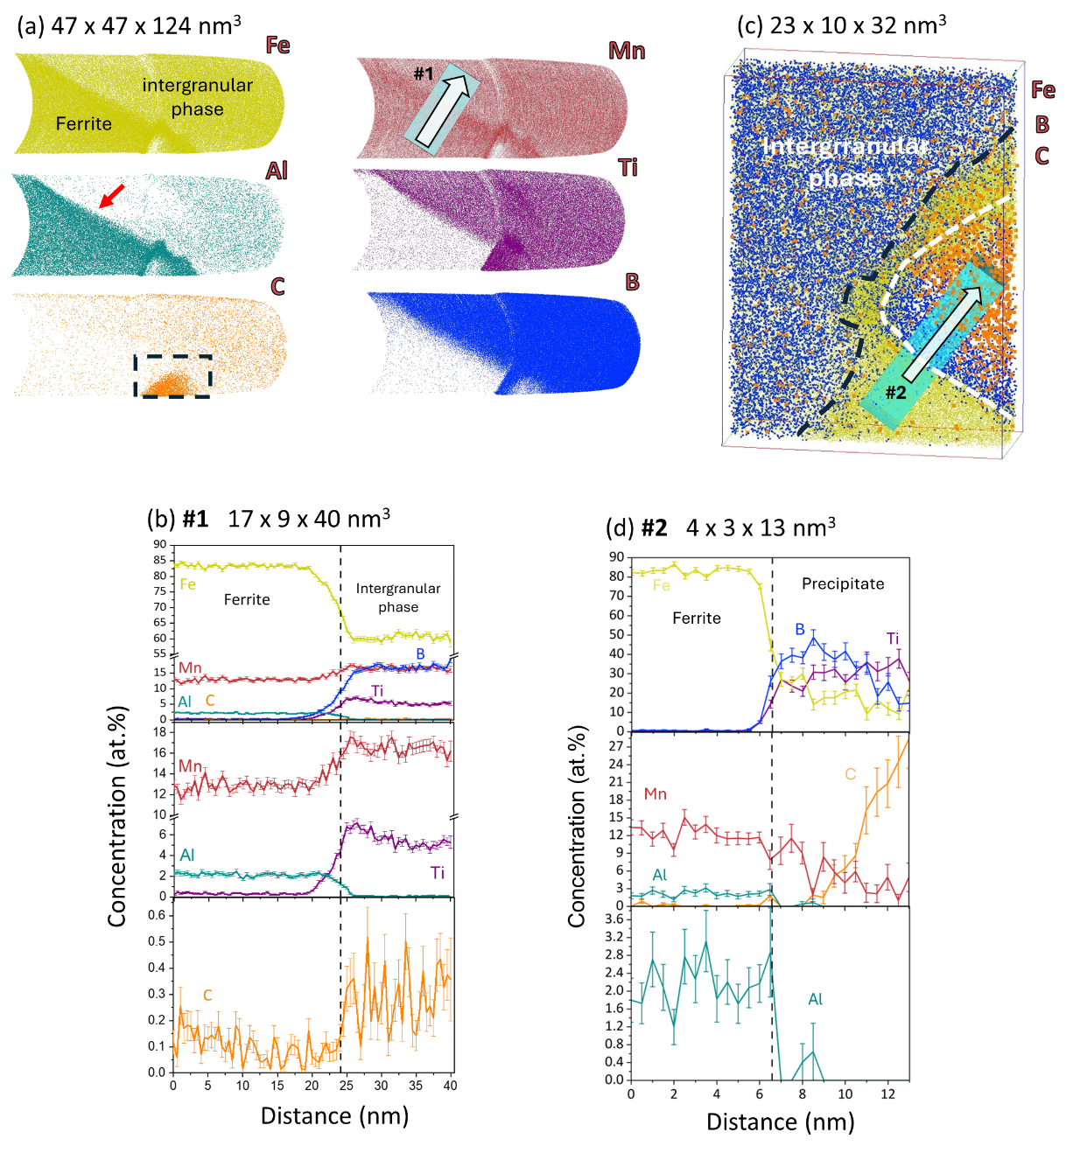
Fig. 3 – a-c) Three-dimensional atom maps showing the interface between ferrite and intergranular phase and (b-d) 1D concentration profiles across the interface marked as #1 and #2.

In addition to the intergranular phase, 3DAP maps in Fig. 3a also includes an intragranular nano-sized precipitate (highlighted by the dashed rectangle in C map) formed within δ-ferrite but close to the interface at the intergranular region. As shown in the enlarged 3DAP map (Fig. 3c) obtained from the selected volume enclosed within dashed rectangle, the precipitate (demarcated using a white-dotted curve) has an inhomogeneous composition profile. The concentration profile, Fig. 3d, across the above interface (marked as #2 in Fig. 3c) clearly elucidates the aforementioned distribution of B and C in the precipitate. It can be noted that only the side of the precipitate facing the δ-Fe matrix shows B enrichment, as is evident from the enlarged 3DAP map (Fig. 3c). Nevertheless, composition at the core of this precipitate is estimated as Fe-4.10Mn-0.38Al-32.54Ti-23.56B-24.91C (at.%). Combining STEM-based EDS and NBED results with 3DAP observations, nano-sized precipitate may be expected to have a stoichiometry corresponding to Ti(B,C)₂. Considering the similarity of the atomic radii of B and C, it seems reasonable to assume that B occupies some of the C sites in the TiC₂ unit cell.
The microstructural refinement and the absence of columnar grains, as shown in Fig. 1, indicated that a intensively nucleation occurred ahead of the epitaxially growing S/L interface, as also reported in [8,15]. It is recently reported that the addition of inoculant agents allowed the development of fine and equiaxed grain structure by LPBF [5,16]. In special, Ti is commonly applied as an inoculant agent for steels to promote equiaxed grains [17]. Through in-situ and ex-situ reactions, nano-sized particles of TiN, TiO and TiC can act as nucleation sites for δ-Fe, reducing or preventing the columnar grain growth [5]. In the present work, the presence of the metastable TiC₂ within the δ-Fe suggests that they may act as an inoculant particle. TiC carbide does not appear to act as an inoculant agent, as (i) it is not a primary phase [4], and (ii) the majority of it was found at grain boundaries (Fig. 3), a distribution that does not align with the characteristics of effective inoculant particles, as discussed in [5].
The microstructural refinement can also be ascribed to the presence of solutes [8,9,18]. Besides Mn, Ti and C, the 3DAP showed that B was also segregated during the solidification process. Previous studies indicated that the Mn and C segregation has no significant influence on grain refinement [7,19]. In contrast, B exhibits a high growth restriction factor (Q) in iron systems. The low solubility of B in Fe results in its segregation in the liquid ahead of the S/L interface, inducing the formation of a constitutional undercooling (∆T_{CS}) zone in conventional casting processes, thereby promoting grain refinement. [9]. However, unlike conventional casting, ∆T_{CS} zone is significantly restrict in the LPBF process due to the intrinsic ultra-high thermal gradients (~10⁵ K/m), which severely suppress the partitioning of solute elements [8].
On the other hand, B segregation can lead to the formation of thermal undercooling (∆T_{t}) zone. The liquid enriched by B is responsible for reducing the interfacial velocity of S/L interface, generating a restriction of the primary δ-Fe growth, as shown in [8]. Consequently, a thermal ∆T_{t} ahead of the S/L interface is generated and it achieves values over the critical nucleation undercooling, as shown in Fig. 4. Hence, the formation of the columnar grains was suppressed by the high nucleation rate of δ-Fe.
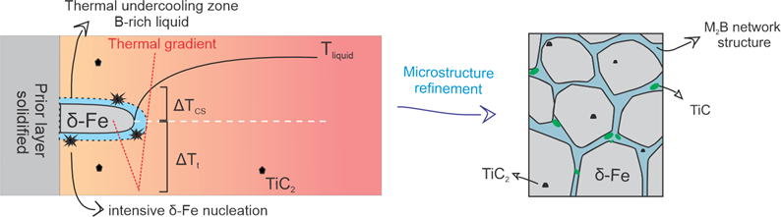
Fig 4. – Schematic representation of the solidification process.

Soon after the massive δ-Fe nucleation, the remaining B-rich liquid thermally undercooled may have reached the M₂B-boride stability temperature (below 1100 °C [4]), forming the network structure at grain boundaries, and suppressing the TiB₂ formation. In addition, the high cooling rate did not allow enough time for the boron to be completely rejected from δ-Fe matrix during solidification. The reheating process associated with the melting of subsequent powder layers facilitates the diffusion of saturated boron from the matrix to the grain boundary regions and/or the surface of the carbides contained within the grain. This effect explains the compositional gradient observed in carbide shown in Fig 3c-d.
The microstructural refinement combined with the reinforced particles resulted in outstanding strengthening of the material, as shown in Table 1. The achieved hardness of 426 ± 10 HV represents a substantial increase of approximately 150% compared to the base steel (without Ti and B additions) [4]. Furthermore, the hardness was enhanced by 103% and 30% compared to the composites with the same composition but processed by arc-melting [4] and spray-forming [3], respectively (microstructures showed in Fig. 1b-c).

Table 1 – Mechanical properties of the studied composite produced by LPBF, arc-melting and spray-forming.
Route | YS  (MPa) | UCS/UTS  (MPa) | Elongation  (%) | Microhardness  (HV)
LPBF | 915 ± 15 | 1385 ± 64 | 13 ± 1 | 426 ± 10
Arc-melting [4] | 314 | 733 | 30 | 210
Spray-forming [3] | 277 | 960 | 45 | 330

The LBPF-composite showed a yield strength (YS), ultimate compressive stress (UCS) and final elongation of 915 MPa, 1.4 GPa and 13%, respectively. This substantial strengthening compared to composites produced by other routes, shown in Fig. 5, can be attributed to the carbide nanoprecipitates and the boride network structure. On the other hand, ductility was significantly reduced, which can be explained by the brittle nature of the M₂B network structure, as previously reported [4,20,21].
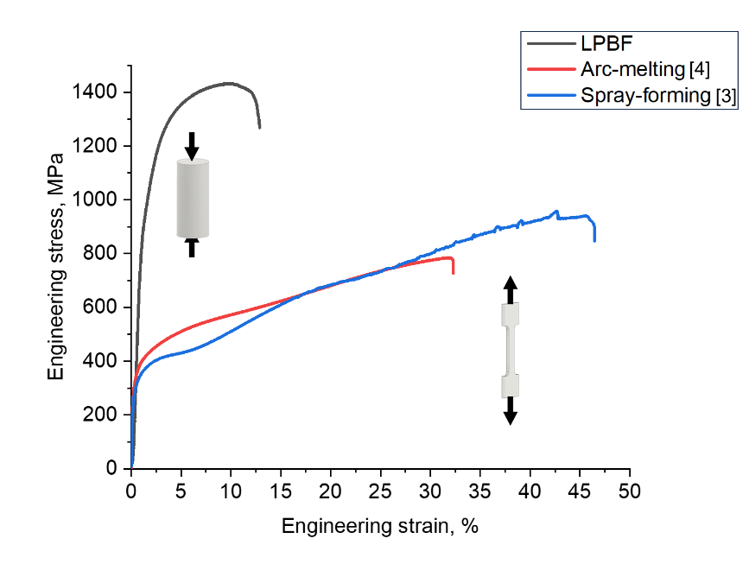
Fig. 5 – Engineering stress-strain curve of the LBPF-processed composite obtained from the compression tests. The tensile curves and hardness of the same composite but processed by arc-melting and spray-forming are also included.

- Conclusions
In summary, this study produced a metal matrix composite via LPBF, featuring a δ-Fe matrix with a texture-free nanometric equiaxed grains, and reinforced from carbides nanoprecipitates and a boride-structured network. 3DAP based near-atomic scale analysis clearly showed B segregation during solidification. B rejection from matrix resulted in a sluggish growth of S/L interface, generating a thermal undercooling ahead to the S/L interface that activated the heterogeneous nucleation of new δ-Fe grains. Thus, the high heterogeneous nucleation rate caused by thermal undercooling, combined with the presence of potential nucleating agent, was responsible for the columnar-to-equiaxed transition and, consequently, microstructural refinement. The combined effects of grain refinement and nanoparticle reinforcement resulted in significant enhancement of mechanical strength compared to conventionally processed counterparts. However, the presence of a boride network at grain boundaries contributed to a reduction in ductility. These findings highlight the potential of LPBF for tailoring microstructures and optimizing the mechanical performance of advanced metal matrix composites.

Acknowledgements
This study was financed in part by the Coordenação de Aperfeiçoamento de Pessoal de Nível Superior - Brasil (CAPES) - Finance Code 001. The authors thank the Fundação de Amparo à Pesquisa do Estado de São Paulo (FAPESP) and the Laboratory of Structural Characterization (LCE/DEMa/UFSCar) for the general facilities.

Funding
This work was supported by the Fundacão de Amparo à Pesquisa do Estado de São Paulo – FAPESP (Process Numbers: 2016/11309-0, 2020/05049-1, and 2021/11537-1); the Coordenacão de Aperfeiçoamento de Pessoal de Nível Superior - Brasil (CAPES) - Finance Code 001; the Conselho Nacional de Desenvolvimento Científico e Tecnológico – Brasil - CNPq (Grant Number 141250/2020-8, and Process No. 403955/2021-1).

Competing interests
The authors declare that they have no conflict of interest

References
[1] H. Springer, C. Baron, A. Szczepaniak, V. Uhlenwinkel, D. Raabe, Stiff, light, strong and ductile: nano-structured High Modulus Steel, Sci. Rep. 7 (2017) 2757. https://doi.org/10.1038/s41598-017-02861-3.
[2] H. Springer, C. Baron, F. Mostaghimi, J. Poveleit, L. Mädler, V. Uhlenwinkel, Additive manufacturing of high modulus steels: New possibilities for lightweight design, Addit. Manuf. 32 (2020) 101033. https://doi.org/10.1016/j.addma.2019.101033.
[3] A.L. Vidilli, L.B. Otani, G.Y. Koga, V. Amigó, C. Bolfarini, In-situ synthesis and characterization of lightweight steel matrix composites reinforced by TiB2, J. Alloy. Metall. Syst. (2024) 100093. https://doi.org/10.1016/j.jalmes.2024.100093.
[4] A.L. Vidilli, F.G. Coury, G. Gonzalez, L.B. Otani, V. Amigó, C. Bolfarini, Tailoring the Microstructure and Properties of Reinforced FeMnAlC Composites by In-Situ TiB2–TiC–M2B Formation, Metall. Mater. Trans. A (2023) 11–15. https://doi.org/10.1007/s11661-023-07230-6.
[5] H. Ikehata, D. Mayweg, E. Jägle, Grain refinement of Fe–Ti alloys fabricated by laser powder bed fusion, Mater. Des. 204 (2021). https://doi.org/10.1016/j.matdes.2021.109665.
[6] J. Guan, Q. Wang, Laser Powder Bed Fusion of Dissimilar Metal Materials: A Review, Materials (Basel). 16 (2023). https://doi.org/10.3390/ma16072757.
[7] R. Seede, A. Whitt, J. Ye, S. Gibbons, P. Flater, B. Gaskey, A. Elwany, R. Arroyave, I. Karaman, A lightweight Fe–Mn–Al–C austenitic steel with ultra-high strength and ductility fabricated via laser powder bed fusion, Mater. Sci. Eng. A 874 (2023) 145007. https://doi.org/10.1016/j.msea.2023.145007.
[8] Q. Tan, Y. Yin, A. Prasad, G. Li, Q. Zhu, D.H. StJohn, M.X. Zhang, Demonstrating the roles of solute and nucleant in grain refinement of additively manufactured aluminium alloys, Addit. Manuf. 49 (2022) 102516. https://doi.org/10.1016/j.addma.2021.102516.
[9] Q. Zheng, H. sheng Chen, J. Zhou, W. Wang, S. xiao Xi, Y. Yuan, Effect of boron element on microstructure and mechanical properties of 316L stainless steel manufactured by selective laser melting, J. Mater. Res. Technol. 26 (2023) 3744–3755. https://doi.org/10.1016/j.jmrt.2023.08.148.
[10] P.F. Jiang, C.H. Zhang, S. Zhang, J.B. Zhang, J. Chen, H.T. Chen, Additive manufacturing of novel ferritic stainless steel by selective laser melting: Role of laser scanning speed on the formability, microstructure and properties, Opt. Laser Technol. 140 (2021) 107055. https://doi.org/10.1016/j.optlastec.2021.107055.
[11] W. Zhao, H. Xiang, R. Yu, G. Mou, Effects of laser scanning speed on the microstructure and mechanical properties of 2205 duplex stainless steel fabricated by selective laser melting, J. Manuf. Process. 94 (2023) 1–9. https://doi.org/10.1016/j.jmapro.2023.03.068.
[12] J. Braun, L. Kaserer, J. Stajkovic, H. Kestler, G. Leichtfried, Grain refinement mechanisms of alloying molybdenum with carbon manufactured by laser powder bed fusion, Mater. Des. 215 (2022) 110507. https://doi.org/10.1016/j.matdes.2022.110507.
[13] X. Yan, S. Gao, C. Chang, H. Liao, M. Liu, Microstructure and tribological property of selective laser melted Fe-Mn-Al-C alloy, Mater. Lett. 270 (2020) 127699. https://doi.org/10.1016/j.matlet.2020.127699.
[14] K. Hono, S.S. Babu, Atom-Probe Field Ion Microscopy, in: Phys. Metall., Elsevier, 2014: pp. 1453–1589. https://doi.org/10.1016/B978-0-444-53770-6.00015-0.
[15] V.P. Narayana Samy, M. Schäfle, F. Brasche, U. Krupp, C. Haase, Understanding the mechanism of columnar–to-equiaxed transition and grain refinement in additively manufactured steel during laser powder bed fusion, Addit. Manuf. 73 (2023). https://doi.org/10.1016/j.addma.2023.103702.
[16] A. Durga, N.H. Pettersson, S.B.A. Malladi, Z. Chen, S. Guo, L. Nyborg, G. Lindwall, Grain refinement in additively manufactured ferritic stainless steel by in situ inoculation using pre-alloyed powder, Scr. Mater. 194 (2021) 113690. https://doi.org/10.1016/j.scriptamat.2020.113690.
[17] J.H. Park, Youngjo Kang, Inclusions in Stainless Steels - A Review, 87 (2017) 1–26. https://doi.org/10.1002/srin.201700130.
[18] D.H. Stjohn, M. Qian, M.A. Easton, P. Cao, The Interdependence Theory: The relationship between grain formation and nucleant selection, Acta Mater. 59 (2011) 4907–4921. https://doi.org/10.1016/j.actamat.2011.04.035.
[19] K. Kim, Y. Kim, S. Yang, B. Koo, K. Lee, Microstructure and mechanical properties of carbon-bearing ultrahigh-strength high Co-Ni Steel ( AerMet 340 ) fabricated via laser powder bed fusion, Materialia 20 (2021) 101244. https://doi.org/10.1016/j.mtla.2021.101244.
[20] H. Springer, R. Aparicio Fernandez, M.J. Duarte, A. Kostka, D. Raabe, Microstructure refinement for high modulus in-situ metal matrix composite steels via controlled solidification of the system Fe–TiB 2, Acta Mater. 96 (2015) 47–56. https://doi.org/10.1016/j.actamat.2015.06.017.
[21] C. Baron, H. Springer, D. Raabe, Efficient liquid metallurgy synthesis of Fe-TiB2 high modulus steels via in-situ reduction of titanium oxides, Mater. Des. 97 (2016) 357–363. https://doi.org/10.1016/j.matdes.2016.02.076.

