Received 00th January 20xx,
- Research Center for Materials Nanoarchitechtonics (MANA), National Institute for Materials Science, 1-1 Namiki, Tsukuba, Ibaraki 305-0044, Japan.
- Graduate School of Chemical Sciences and Engineering, Hokkaido University, North 13 West 8, Kita-ku, Sapporo 060-0808, Japan.
- Department of Applied Chemistry, Faculty of Engineering, Osaka University, 2-1 Yamadaoka, Suita, Osaka 565-0871, Japan.
- Nanostructures Research Laboratory, Japan Fine Ceramics Center, 2-4-1 Mutsuno, Nagoya, Aichi 456-8587, Japan.
- Surface and Bulk Analysis Unit, National Institute for Materials Science, 1-2-1 Sengen, Tsukuba, 305-0047, Japan.
† Electric Supplementary Information available: [details of any supplementary information available should be included here]. See DOI: 10.1039/x0xx00000x
Accepted 00th January 20xx
DOI: 10.1039/x0xx00000x

Rational Design of Chloride Ion Transport Channels in Open Borate Framework
Yu Meng,^{a,b} Naoyoshi Nunotani,^{c} Kazuki Shitara,*^{d} Yoshitaka Matsushita,^{e} Nobuhito Imanaka,^{c} Kazunari Yamaura^{a,b} and Yoshihiro Tsujimoto *^{a,b}
Chloride-ion solid electrolytes have been widely investigated as core components of membranes, gas sensors, and all-solid-state batteries with high energy densities. Several fast chloride-ion solid electrolytes operating at ambient-to-intermediate temperatures have been reported, ranging from inorganic metal chlorides and metal-organic compounds to complexes. However, these chlorides have the major drawbacks of being thermally and chemically unstable, and design strategies for chloride-ion conductors have not yet been developed compared with those for cation conducting solids, which restricts their practical applications. Here, we report that water-insoluble and thermally stable borate chloride (Ca_{1–x}La_{x})₂B₅O₉Cl_{1+2x} exhibits one-dimensional chloride-ion transport defined by the dimensionality of open borate framework. Experimental and first-principles molecular dynamics simulations indicate that the predominant chloride-ion conduction is attributed to cooperative diffusion through interstitial chloride sites. This conduction is also strongly influenced by the association with La species. These results show that the rational design of chloride-ion channels and conduction paths based on the dimensionality of the borate framework would provide a new direction for the development of the variety and conducting properties of chemically and thermally stable chloride-ion solid electrolytes.
Introduction
Solid electrolytes, in which specific ions can migrate as a charge carrier, have been extensively investigated because of a wide range of attractive applications including sensors, separators, thermoelectric convertors, and all-solid-state batteries.^{1–4} The types of solid electrolytes range from inorganic salts, polymers, and complexes to metal-organic frameworks, among which inorganic solid electrolytes have the advantages of low-to-high temperature operation owing to their high thermal and chemical stability, as exemplified by yttria-stabilized zirconia for solid oxide fuel cells⁵, Na-β alumina for sodium-sulfur batteries⁶, and Li₆PS₅Cl for Li-ion batteries⁷. Recently, increasing attention has been paid to anion-conducting solid electrolytes, particularly for new types of rechargeable batteries that transfer anion charges, such as H–, F–, and Cl–.⁸ These anions are not only abundant elemental resources available worldwide but also offer the potential to create a new range of applications that considerably differ from conventional ones.
At present, the variety of chloride-ion conducting solid electrolytes is poor in comparison with a rich variety of cation-conducting solid electrolytes^{9–11}. However, inorganic metal chlorides, typically simple binary and ternary chlorides, have been continuously investigated over the last century. In particular, PbCl₂ (cotunnite-type structure) and Cs(Sn/Pb)Cl₃ (perovskite-type structure) achieve high ionic conductivities via cation substitution even near room temperature, for example, 2.3×10^{–4} S cm^{–1} at 160°C for Pb_{0.98}K_{0.02}Cl_{1.98}¹² and 1.3–3.45×10^{–4} S cm^{–1} at 25°C for CsSn_{0.9}Bi_{0.1}Cl_{3.1},¹³ CsSn_{0.9}In_{0.067}Cl₃,¹⁴ and CsSn_{0.95}Mn_{0.05}Cl₃¹⁵. These chlorides have also been reported to exhibit promising electrochemical properties for all-solid-state chloride-ion batteries (CIBs). However, the major drawback of these chlorides, as well as other metal chlorides, is their low thermal and chemical stability, including low melting points (e.g. 501°C for PbCl₂¹⁶, 368°C for CsSnCl₃¹⁷) and high water solubility¹⁸. For perovskite-type chlorides, a cubic-to-monoclinic phase transition occurs under humid conditions, resulting in a significant reduction in chloride ion conductivity. In contrast, a layered mixed-anion compound La_{1–x}Ca_{x}OCl_{1–x} (0 ≤ x ≤ 0.2) with the tetragonal matlockite-type structure possesses great structural stability against humidity and high temperature.¹⁹ Moreover, La_{0.8}Ca_{0.2}OCl_{0.8} (x = 0.2) prepared via ball milling exhibited chloride-ion conductivity as high as 7×10^{–4} and 1×10^{–2} S cm^{–1} at 400 and 700°C, respectively, which are comparable to those of PbCl₂ and CsPbCl₃. Although the lowest operating temperature is higher than those of doped PbCl₂ and CsSnCl₃, anion lattice engineering using both oxide and chloride ions is an attractive approach to design new chloride-ion solid electrolytes with high
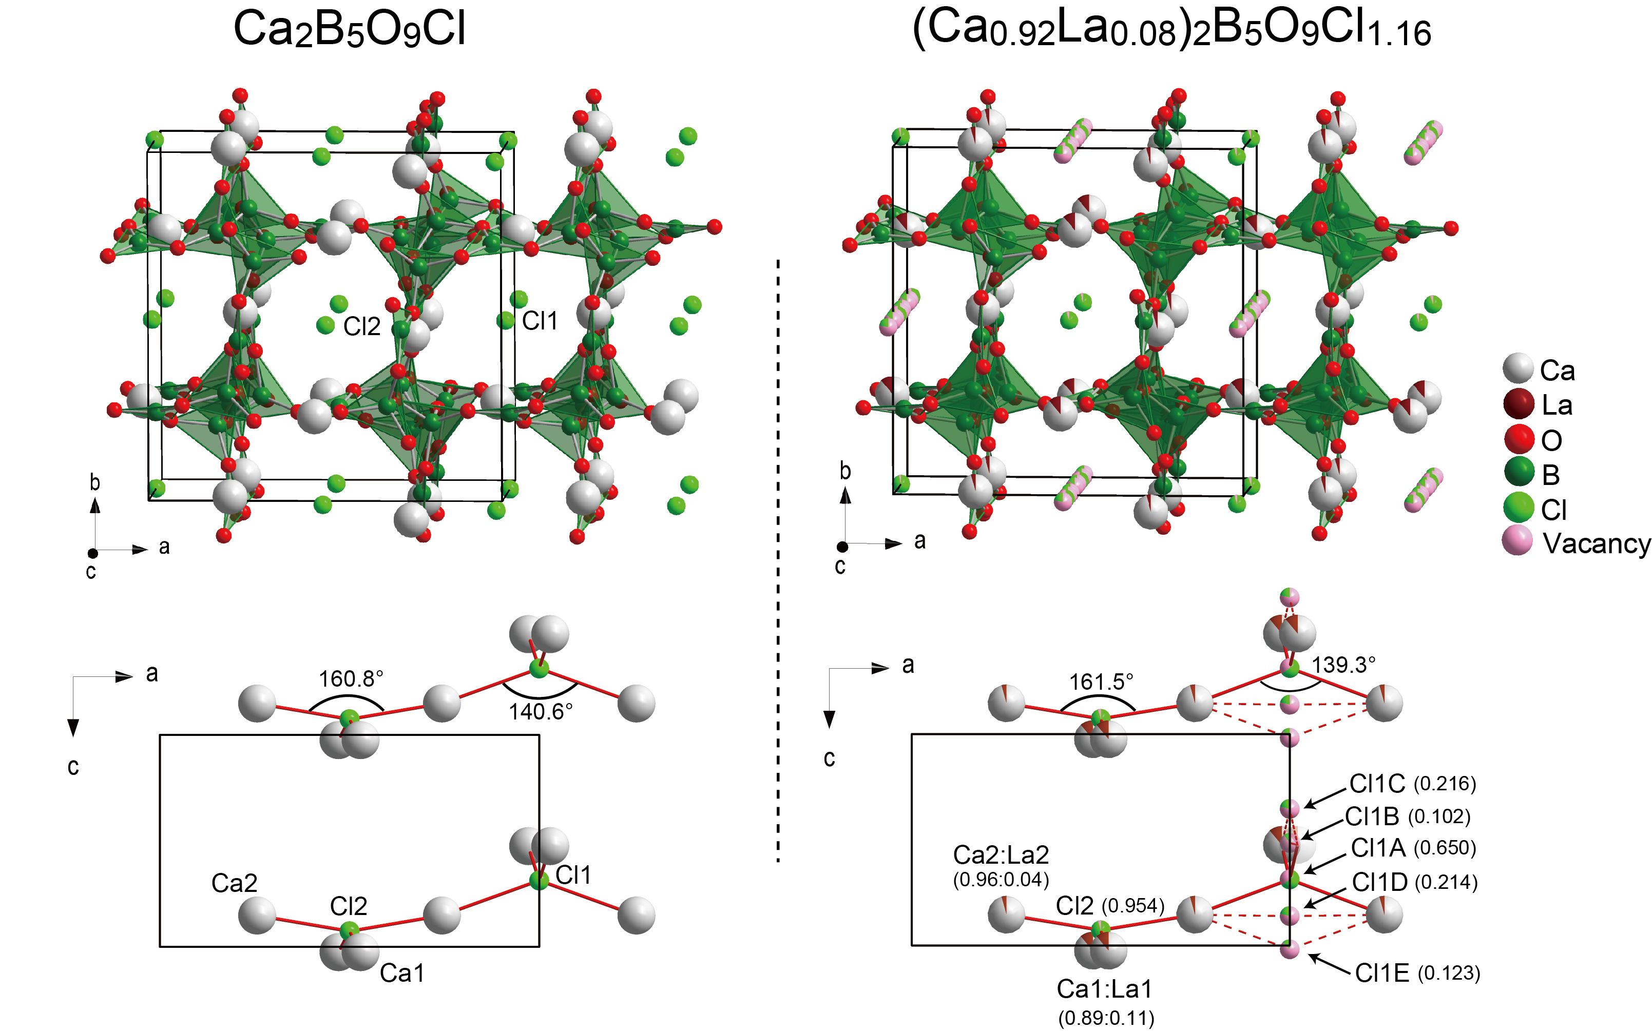
Figure 1. Crystal structures of Ca₂B₅O₉Cl (left panels) and (Ca_{0.92}La_{0.08})₂B₅O₉Cl_{1.16} (right panels) and the local coordination environment around Ca²⁺ ions, highlighting the Cl– ion distribution. Site occupancy factors for the Ca/La and Cl atoms are presented in parentheses.

structural stability and high ionic conductivity even at moderate temperatures. On the other hand, making Cl– transport dominant in the mixed-anion sublattices, where the migration barrier for Cl– ions tends to be higher than that for O^{2–} ion, remains a major challenge.^{20,21} Indeed, even layered oxychlorides such as Ba₃M₂O₅Cl₂ (M = Y, Sc)²², Sr₂ScO₃Cl²², Bi_{4-x}Sr_{x}NbO_{8–d}Cl²³, and MBi_{2-x}Te_{x}O_{4+x/2}Cl (M = La, Lu)^{24,25}, which adopt two-dimensional (2D) chloride layers similar to those in LaOCl, favor oxide-ion conduction.
Crystalline borates are well known to exhibit a rich variety of open frameworks with 0D–3D dimensionality, which are mainly composed of triangular BO₃ and/or tetrahedral BO₄ units.²⁶ The negatively charged borate framework typically form open channels at the molecular scale which serve as conducting pathways for the mobile cations including Li⁺, and Na⁺.^{27–30} Importantly, the borate frameworks rarely produce oxygen deficiencies due to the strong covalent interactions between B and O atoms,³¹ and therefore no oxide-ion conduction can be expected. To examine possible chloride ion conduction in open framework borates, we chose a hilgardite-type oxychloride, Ca₂B₅O₉Cl,³² which is water-insoluble and thermally stable even at 700°C (Supporting Information, Figure S1). The borate chloride has been studied for applications of deep UV non-linear optics and photoluminescence,^{33–35} but not as ionic conductors. Each Cl– ion forms a flattened tetrahedron with Ca²⁺ ions in the ab plane, confining the chloride ions to one-dimensional channels. In this paper, we report that La-doped Ca₂B₅O₉Cl exhibits one-dimensional chloride-ion conduction within the (B₅O₉)^{3–} borate framework, which reaches 1.32×10^{–4} S cm^{–1} at 700°C with 5% La doping. Single-crystal structure analysis revealed an increased concentration of Cl– ions by La³⁺ doping in chloride-ion transport channels, involving significant chlorine deficiencies at the original site and site disorder along the channel directions. First-principles molecular dynamic simulation indicated one-dimensional diffusion of chloride ions by the interstitialcy mechanism influenced by the association between La and Cl defects. The open borate framework would provide a useful tool for rational design of chloride-ion channels and conduction paths, further developing chloride-ion conductors.
Results and discussion
Colorless transparent single crystals of Ca₂B₅O₉Cl were grown by the self-flux method using a CaCl₂ molten salt and extracted by washing the products with water (Figure S2). The crystal structure of Ca₂B₅O₉Cl, determined by single-crystal structure analysis at room temperature, is shown in Figure 1. The borate chloride crystallizes in an orthorhombic cell (space group Pnn2) with cell parameters a = 11.3572(5) Å, b = 11.2309(4) Å, c = 6.3500(3) Å, and V = 809.95(6) Å³. The crystallographic data including the atomic coordinates (Tables S1, S2, and S3) are consistent with previous reports.³² We notice that the Cl1 atom placed at 2b Wyckoff positions are significantly underbonded against the surrounding Ca atoms compared with the Cl2 atom at 2a positions: the bond-valence-sum (BVS) value for the Cl1 atom is 0.69, considerably smaller than 0.98 for the Cl2 atom, reflecting the difference in the ClCa₄ tetrahedral volume. The underbonding state of the Cl1 atom would be favorable for Cl– ion migration. However, the nearest neighbor (NN) distance between Cl ions in each 1D open channel is 6.3500(3) Å, much longer than those of fast chloride ion conductors (for example, 3.413(6) Å for PbCl₂ and 3.416(3) Å for LaOCl).^{36,37} Therefore, the introduction of interstitial chloride ions or site disorder into chloride ion channels is essential for facilitating Cl– ion migration in Ca₂B₅O₉Cl. To examine the possibility of additional chloride ion insertion via the aliovalent substitution of Ca²⁺ by La³⁺, a flux method using a CaCl₂ molten salt was employed again under conditions similar to those of undoped Ca₂B₅O₉Cl, but La₂O₃ was used as a La source with an atomic ratio of Ca/La = 31/1. La-doped Ca₂B₅O₉Cl single crystals with similar morphologies and dimensions were obtained (Figure S2). SEM-EDX elemental analysis estimated the atomic ratio of Ca:La to be 1.80:0.21, that is, approximately 10% substitution of La for Ca (Figure S3). The cell volume was also found to increase by 1.2% (a = 11.3807(5) Å, b = 11.3109(6) Å, c = 6.3692(3) Å, and V = 819.88(7) Å³), thereby maintaining structural symmetry. The cell expansion can be explained by considering the introduction of La³⁺, which has a larger ionic radius (1.30 Å) than Ca²⁺ (1.26 Å),³⁸ and the insertion of additional chloride ions, as discussed below. Single-crystal structure analysis at the initial stages could readily identified the borate framework composed of (B₅O₉)^{3–} units, and the
random occupations of two nonequivalent 4c sites by Ca and La atoms in ratios of 0.89/0.11 (Ca1/La1) and 0.96/0.04 (Ca2/La2), respectively. The total atomic ratio of Ca to La determined by SCXRD was consistent with the results of the EDX measurements. Further structure analysis revealed not only a substantial reduction in the occupancy (g = 0.65) of the Cl1A atom corresponding to the Cl1 in the undoped phase but also the presence of interstitial chloride ions within the Cl1 channels at Cl1B : 1.10(4) Å, Cl1C : 2.12(2) Å, Cl1D : 1.10(2) Å, and Cl1E : 2.10(4) Å from the Cl1A site, which are even shorter than the NN distances between the chloride ions in the undoped phase. The site occupancies of Cl1B–1E were refined to 0.102, 0.216, 0.214, and 0.123, respectively, based on the overall charge valence. The chloride site disorder in the Cl1 channels contrasts with the absence of interstitial chloride ions and almost no Cl2 site vacancies (g = 0.954) within the Cl2 channels. The final refined chemical composition was (Ca_{0.92}La_{0.08})₂B₅O₉Cl_{1.16}. The final
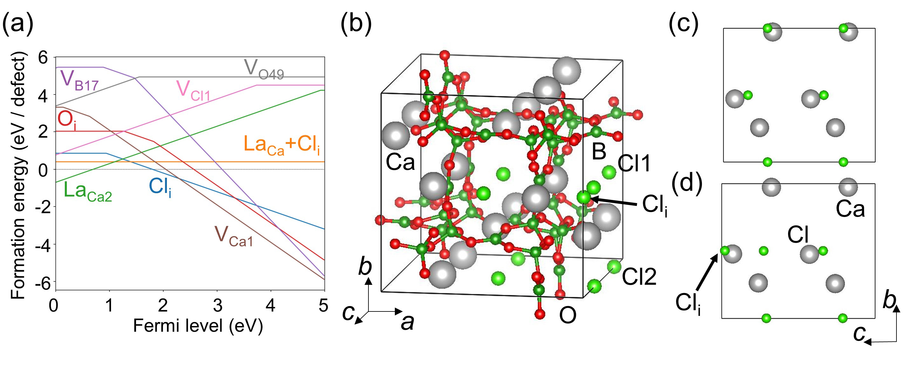
Figure 2. a) Formation energies of point defects as a function of Fermi level on oxidation and chloridation limits. For each defect type, only the most stable sites are depicted. b) Obtained structure with most stable Cli’. c, d) Obtained structure seen from a-axis of perfect crystal and point defect model with Cl_{i}’. Only Cl and Ca are drawn in the range of the internal coordinates of the a-axis from 0.6 to 1.0. The structure models were drawn using the VESTA program³⁹.

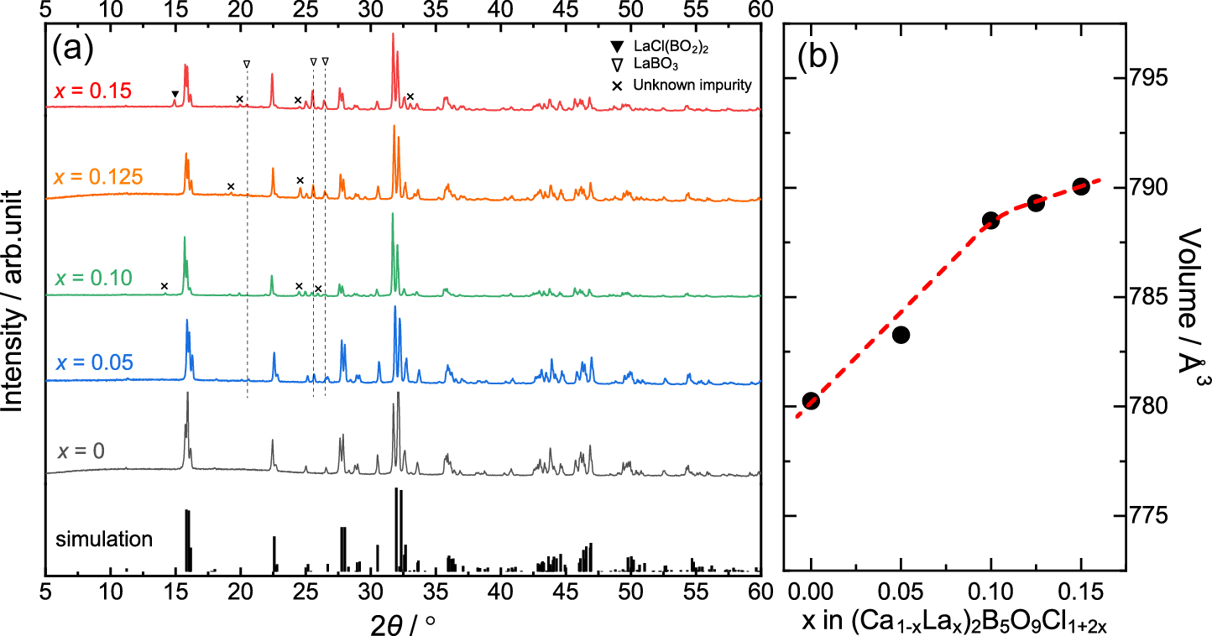
Figure 3. (a) Powder X-ray diffraction patterns of (Ca_{1–x}La_{x})₂B₅O₉Cl_{1+2x} (x = 0−0.15) solid solutions measured at room temperature. (b) The cell volume as a function of x in (Ca_{1–x}La_{x})₂B₅O₉Cl_{1+2x}. The dashed line is a guide to the eyes.

refined crystal structure and crystallographic data are shown in Figure 1 and Tables S1, S4, and S5.
To understand the defect chemistry of Ca₂B₅O₉Cl, the formation energies of point defects were investigated using first-principles calculations. Figure 2a shows the plots of the calculated formation energies against the variation of Fermi level under the assumed equilibrium condition of oxidation and chloridation limit. For each defect type, the most stable sites are depicted. The gradient of the lines in the plot indicates the charge states of defects. A positive (negative) slope of the lines of defect formation energy indicates a donor (acceptor)-type defect. The Fermi level position in the band gap balances the concentrations of positive and negative point defects and electronic carriers (holes and electrons) to meet the condition of charge neutrality. In the Ca₂B₅O₉Cl system, the concentrations of positive and negative point defects determine the Fermi level because of its high insulation (Figure S4). As seen in Figure 2a, La_{Ca}• and Cl_{i}’ have the lowest formation energies for positive and negative point defects, respectively, and thus, these defects should be dominant over the other defects. La_{Ca}• and Cl_{i}’ stand for a La atom on a Ca site with single positive charge and a Cl atom on an interstitial site with single negative charge, respectively, in Kröger-Vink notation.

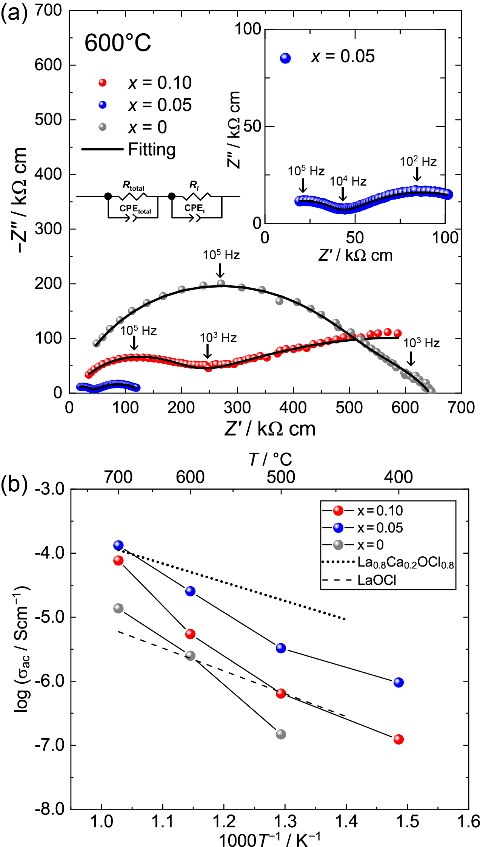
Figure 4. (a) Nyquist plots of (Ca_{1–x}La_{x})₂B₅O₉Cl_{1+2x} (x = 0−0.10) solid solutions recorded under an Ar gas atmosphere at 600°C with the inset showing the equivalent circuit model used to fit the data. R_{total} and CPE_{total} stand for a total resistance and its constant phase element, respectively, which are attributed to bulk and grain-boundary components, and R_{i} and CPE_{i} for an electrode-electrolyte interface resistance and its constant phase element, respectively. The inset plot shows the magnified image of the data for x = 0.05. Fitting curves are indicated by black lines. (b) Arrhenius plots of the ac conductivity (σ_{ac}) of (Ca_{1–x}La_{x})₂B₅O₉Cl_{1+2x} (x = 0−0.10) as a function of temperature. The data for LaOCl (dash line) and non-ball-milled La_{0.8}Ca_{0.2}OCl_{0.8} (dotted line) are also shown together.⁴⁰

The association energy between La_{Ca}• and Cl_{i}’ was also estimated to be 0.70 eV from all possible configurations of La_{Ca}• in the cell containing the most stable Cl_{i}’. The formation energies of the complex defects of La_{Ca}• and Cl_{i}’ are lower than those of isolated La_{Ca}• and Cl_{i}’ under the condition of charge neutrality, suggesting the presence of these associated defects in La-doped Ca₂B₅O₉Cl. Figure 2b shows the calculated structure containing the most stable Cl_{i}’, which is located in the Cl1 channel. Figures 2c and d show the structures of the perfect crystal and Cl_{i}’ defect model, respectively, viewed along the a-axis. For clarity, only Ca and Cl atoms are drawn in the range of internal coordinates of the a-axis from 0.6 to 1.0. It should be noted that the Cl atom at the original Cl1 site closest to the
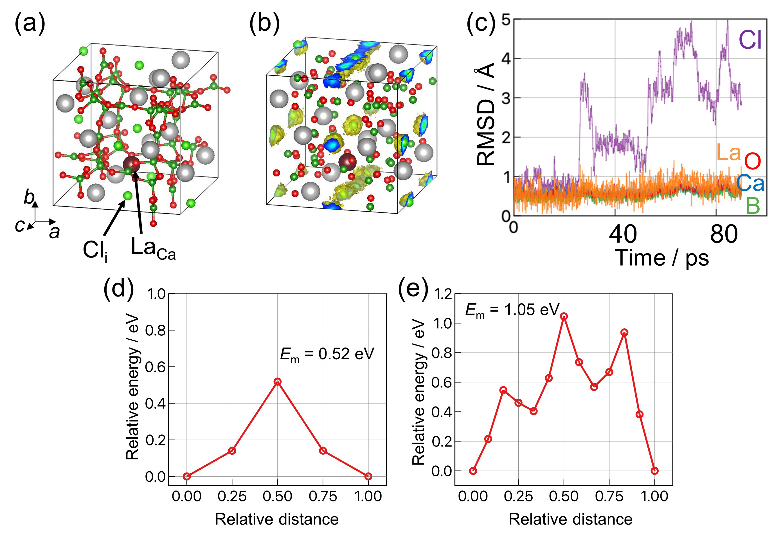
Figure 5. a, b) The most stable structure containing a complex defect of La_{Ca} and Cl_{i}’. and the corresponding atomic distribution of Cl during MD simulation. c) Root mean squared displacements during MD simulations of the model containing a complex defect of La_{Ca}• and Cl_{i}’. Migration energy of Cl_{i}’ in models with (d) point defect Cl_{i}’ and (e) complex defect of La_{Ca}• and Cl_{i}’.

interstitial Cl atom is significantly displaced along the c-axis. This result is consistent with the single-crystal structure analysis, revealing complex Cl-site disorder in the Cl1 channel.
From the chloride site disorder observed by the single-crystal structure analysis and first-principles calculations, we can expect Cl– ion conduction, especially along the Cl1 channels. To investigate the possible chloride ion conductivity and carrier concentration dependence, polycrystalline samples of (Ca_{1–x}La_{x})₂B₅O₉Cl_{1+2x} (x = 0−0.15) solid solutions were synthesized using a conventional solid-state reaction. Figure 3 shows the room-temperature powder X-ray diffraction (PXRD) patterns of the La-doped Ca₂B₅O₉Cl along with the data for the undoped phase. All solid solutions could be obtained as the main phase, but several tiny peaks assigned to LaBO₃ and/or La(BO₂)₂Cl were detected, suggesting deviation from the nominal chemical compositions. The cell volume increased monotonically with an increase in x ≤ 0.10; however, it remained almost unchanged at 0.125 ≤ x. It is likely that the solid solubility limit was between 0.10 and 0.125.
Figure 4a shows the typical Nyquist plots of (Ca_{1–x}La_{x})₂B₅O₉Cl_{1+2x} (x = 0, 0.05, 0.10) at 600°C, measured by impedance methods in an Ar gas atmosphere. The data obtained at 400, 500, and 700°C are presented in Figure S5. For each sample, the plot was fitted using a total resistance (R_{total}), its constant phase element (CPE_{total}), an electrode-electrolyte interface resistance (R_{i}), and its constant phase element (CPE_{i}), where the total components include the contributions from bulk and grain-boundary components. Figure 4b shows the temperature dependence of the ac conductivity (σ_{ac}) of (Ca_{1–x}La_{x})₂B₅O₉Cl_{1+2x} (x = 0−0.10) solid solutions, estimated from the total resistance. The σ_{ac} of the undoped phase is comparable to the ionic conductivity of LaOCl at 600–700°C, and on the order of 10⁻⁵ S cm^{–1} at 700°C. Interestingly, 5 % La doping into Ca₂B₅O₉Cl improved the conductivity of x = 0 by more than one order of magnitude. x = 0.05 exhibits the highest conductivity of 1.32×10⁻⁴ S cm^{–1} at 700 °C. The conductivities of (Ca_{1–x}La_{x})₂B₅O₉Cl_{1+2x} are lower than those of the ball-milled La_{0.8}Ca_{0.2}OCl_{0.8} but become comparable to those of the non-ball-milled La_{0.8}Ca_{0.2}OCl_{0.8} with increasing temperature (Figure 4b and Figure S6). The enhanced conductivity of (Ca_{1–x}La_{x})₂B₅O₉Cl_{1+2x} can be attributed to the increased carrier (or chloride ion) concentration and the presence of interstitial chloride ions. However, a further increase in the amount of La doping tends to reduce the conductivity, which is probably because of the overdoping effects associated with clustering among the dopants (i.e., La³⁺ ions) and interstitial chloride ions. In fact, no sign of sample degradation for x = 0.10 was not observed in the PXRD and thermogravimetric measurements (Figure S7). The activation energy (E_{a}) of (Ca_{1–x}La_{x})₂B₅O₉Cl_{1+2x} estimated using the Arrhenius equation is 1.67, 1.1, and 1.21 eV for x = 0, 0.05, and 0.10, respectively. 5-10% La doping into Ca₂B₅O₉Cl reduces the activation energy in comparison with that of the undoped phase. To gain insight into the conducting species in (Ca_{1–x}La_{x})₂B₅O₉Cl_{1+2x}, polarization measurements for x = 0.05 were carried out at 700°C in an Ar gas atmosphere (Figure S8). The time evolution of σ_{dc}/σ_{acl}, where σ_{dc} stands for the dc conductivity, exhibited a considerably high degree of polarization (σ_{dc}/σ_{ac} < 0.1 over 30 min), suggesting that ions are the dominant migrating species, not electrons, as expected from its high insulating nature.
Based on the results of the single-crystal structure analysis and point defect calculations, Cl_{i}’ should be a dominant conduction species. To identify chloride ion diffusion and its conduction mechanism, first-principles molecular dynamics calculations were performed for the association model involving La_{Ca}• and Cl_{i}’ (Figure 5a). The O_{i} model, which has a higher formation energy than Cl_{i}’, was also used to determine whether oxide ion conduction occurred. The Cl-ion distribution density revealed 1D Cl–-ion diffusion along the c-axis in the Cl1 channel during the simulation of the Cl_{i}’ model, while the Cl ions in other channels remained stationary (Figure 5b). The root mean squared displacement (RMSD) result clearly showed only Cl jumps associated with the diffusion of Cl atoms, in contrast to the absence of jumps of the other elements, including O atoms (Figure 5c). Furthermore, the root squared displacement (RSD) calculations for Cl atoms revealed that three Cl atoms in the Cl1 channel cooperatively jump (Figure S9), suggesting Cl-ion diffusion via the interstitialcy mechanism. In contrast, no jumps of the O atoms were observed in the O_{i} model (Figure S10). Therefore, we can conclude that Cl_{i}’ is the dominant point defect for ionic conduction.
Chloride ion migration in Ca₂B₅O₉Cl was also investigated by nudged elastic band (NEB) calculations^{41,42} for two models of the Cl_{i}’ point defect and associated defects with La_{Ca}• and Cl_{i}’ via the interstitialcy mechanism. The estimated energy barrier for the Cl ion migration in the former model was 0.52 eV (Figure 5d). This value is much lower than the experimental activation energies of (Ca_{1–x}La_{x})₂B₅O₉Cl_{1+2x}. The discrepancy between the experimental and calculated values can be attributed to the formation of Cl_{i}’ and the association between La_{Ca}• and Cl_{i}’ in the undoped and La-doped phases, respectively. Assuming that conducting Cl_{i}’ is perfectly released from the association with La in the dilute state of the La-doped system, the activation energy can be expressed as the sum of the migration energy of Cl_{i}’ and the association energy of La_{Ca}•–Cl_{i}’. This value was 1.22 eV, which is higher than that of x = 0.05, implying the possibility that conducting Cl is not fully released from the association with the dopant like other ionic conductors⁴³. Thus, the migration energy of Cl_{i}’ in the association model of a 1×1×3 supercell with Ca₂₃La₁Cl₁₃B₆₀O₁₀₈ (x = 0.0417) was calculated (Figure 5e), yielding 1.05 eV. This value agrees well with the experimental E_{a} value for x = 0.05, which suggests that the association with La_{Ca}• significantly affects the activation energy of Cl_{i}’ conduction in La-doped Ca₂B₅O₉Cl. Since the migration energy of free Cl_{i}’ from association with La in Ca₂B₅O₉Cl is comparable to those of related metal (oxy)chlorides (e.g. 0.54 eV for La_{0.8}Ca_{0.2}OCl_{0.8} and 0.15–0.69 eV for CsSnCl₃), optimizing dopant species and compositions could improve the ionic conductivity of Ca₂B₅O₉Cl.
Conclusions
In summary, we demonstrated a unique strategy to design chloride-ion conducting channels using an open borate framework compound, (Ca_{1–x}La_{x})₂B₅O₉Cl_{1+2x}, which is the first to exhibit one-dimensional chloride-ion transport defined by the dimensionality of the borate framework. The aliovalent substitution of La³⁺ for Ca²⁺ causes an increase in the concentration of chloride ions in one of the two non-equivalent chloride-ion channels surrounded by covalent (B₅O₉)^{3–} units, involving significant chlorine deficiencies at the original site and site disorder along the channels. No oxygen deficiencies or disorder occurred, in contrast to oxide-ion conducting oxyhalides. First-principles molecular dynamics simulations show one-dimensional cooperative diffusion of interstitial chloride ions along the chloride-ion channels. The calculations of the formation energies of point defects suggest the presence of non-negligible association between La_{Ca}• and Cl_{i}’, which enhances the energy barrier for the chloride ion migration, compared with that without the defect association. As presented in this study, open borate framework built up with rigid covalent B–O bonds can be a useful tool for rationally designing 0D–3D chloride-ion conduction paths based on its structural dimensionality, which will contribute not only to understanding of the chloride-ion transport phenomena but also to improving the poor variety of chloride-ion conductions. In addition, it has significant advantages in terms of low environmental impact and abundant resources. The chloride-ion conductivity of the present compound is lower than those of previously reported perovskite chlorides and doped PbCl₂, however, further exploration using a rich variety of open borate frameworks^{26,44} could contribute to the realization of safe, low-temperature-driven fast chloride-ion conducting solid electrolytes with thermal and chemical stability for all-solid-state chloride ion batteries.
Author contributions
Y. T. conceived and designed the experiments. Y.T., Y.M., N.N., Y.M., N.I., and K.Y. performed all experimental work. K.S. performed all first-principles calculations. Y.T., Y.M., N.N., and K.S. wrote the draft paper. All authors discussed the results and commented on the manuscript.
Conflicts of interest
There are no conflicts to declare.
Data availability
Data supporting this article have been included as part of the Supplementary Information. Crystallographic data for Ca₂B₅O₉Cl and (Ca_{0.92}La_{0.08})₂B₅O₉Cl_{1.16} have been deposited at the CCDC with the deposition numbers 2353931 and 2353932, respectively. These Data Are Available Free of Charge by the Joint Cambridge Crystallographic Data Centre and Fachinformationszentrum Karlsruhe Access Structures Service (www.ccdc.cam.ac.uk/structures).
Acknowledgements
This work was partly supported by the JSPS KAKENHI (22K14465, 22H05146, 23K23046), Core-to-Core Program (JPJSCCA20200004), JSPS Bilateral Program (No. JPJSBP120237714), something else. MANA is supported by World Premier International Research Center Initiative (WPI), MEXT, Japan. Y.T. acknowledges the grant from the Sumitomo Foundation.
Notes and references
1. B. Lei, S. Bai, S. Ju, C. Yin, C. Chen and J. Zhang, Mater Res Express, 2021, 8, 062001.
2. N. Yamazoe and N. Miura, MRS Bull, 1999, 24, 37–43.
3. T. Famprikis, P. Canepa, J. A. Dawson, M. S. Islam and C. Masquelier, Nat Mater, 2019, 18, 1278–1291.
4. T. Nestler, E. Roedern, N. F. Uvarov, J. Hanzig, G. Antonio Elia and M. de Vivanco, Physical Sciences Reviews, 2019, 4, 20170115.
5. S. Singhal, Solid State Ion, 2000, 135, 305–313.
6. M. P. Fertig, K. Skadell, M. Schulz, C. Dirksen, P. Adelhelm and M. Stelter, Batter Supercaps, 2022, 5, e20210013.
7. H. J. Deiseroth, S. T. Kong, H. Eckert, J. Vannahme, C. Reiner, T. Zaiß and M. Schlosser, Angewandte Chemie - International Edition, 2008, 47, 755–758.
8. Q. Liu, Y. Wang, X. Yang, D. Zhou, X. Wang, P. Jaumaux, F. Kang, B. Li, X. Ji and G. Wang, Chem, 2021, 7, 1993–2021.
9. I. V. Murin, O. V. Glumov and N. A. Mel’Nikova, in Russian Journal of Electrochemistry, 2009, vol. 45, pp. 411–416.
10. B. Wu, J. Luxa, J. Šturala, S. Wei, L. Děkanovský, A. K. Parameswaran, M. Li and Z. Sofer, ENERGY & ENVIRONMENTAL MATERIALS, 2024, 7, e12530.
11. D. NEWMAN, D. HAZLETT and K. MUCKER, Solid State Ion, 1981, 3–4, 389–392.
12. R. Sakamoto, N. Shirai, A. Inoishi and S. Okada, ChemElectroChem, 2021, 8, 4441–4444.
13. T. Xia, Q. Li, X. Zhao and X. Shen, Advanced Materials, 2024, 36, 2310565.
14. G. Karkera, M. Soans, A. Akbaş, R. Witter, H. Euchner, T. Diemant, M. A. Cambaz, Z. Meng, B. Dasari, S. G. Chandrappa, P. W. Menezes and M. Fichtner, Adv Energy Mater, 2023, 13, 2300982.
15. R. SAKAMOTO, N. SHIRAI, L. ZHAO, A. INOISHI, H. SAKAEBE and S. OKADA, Electrochemistry, 2023, 91, 23–00041.
16. J. G. Speight, LANGE’S HANDBOOK OF CHEMISTRY, 16th Ed., McGraw-Hill, New York, 2005.
17. L. Peedikakkandy and P. Bhargava, RSC Adv, 2016, 6, 19857–19860.
18. IUPAC-NIST Solubility Database, Version 1.1 NIST Standard Reference Database 106.
19. N. Imanaka, K. Okamoto and G. Y. Adachi, Angewandte Chemie - International Edition, 2002, 41, 3890–3892.
20. H. Matsumoto, T. Miyake and H. Iwahara, Mater Res Bull, 2001, 36, 1177–1184.
21. K. Shitara, A. Kuwabara, K. Hibino, K. Fujii, M. Yashima, J. R. Hester, M. Umeda, N. Nunotani and N. Imanaka, Dalton Transactions, 2021, 50, 151–156.
22. H. Yaguchi, K. Fujii, Y. Tsuchiya, H. Ogino, Y. Tsujimoto and M. Yashima, ACS Appl Energy Mater, 2022, 5, 295–304.
23. M. Kluczny, J. T. Song, T. Akbay, E. Niwa, A. Takagaki and T. Ishihara, J Mater Chem A Mater, 2022, 10, 2550–2558.
24. N. Ueno, H. Yaguchi, K. Fujii and M. Yashima, J Am Chem Soc, 2024, 11235–11244.
25. H. Yaguchi, D. Morikawa, T. Saito, K. Tsuda and M. Yashima, Adv Funct Mater, 2023, 33, 2214082.
26. F. C. Hawthorne, Mineral Mag, 2014, 78, 957–1027.
27. Z. Zhang, Y. Wang, B. Zhang, Z. Yang and S. Pan, Angewandte Chemie International Edition, 2018, 57, 6577–6581.
28. F. Strauss, G. Rousse, D. Alves Dalla Corte, C. Giacobbe, R. Dominko and J. M. Tarascon, Inorg Chem, 2018, 57, 11646–11654.
29. B. Calès, A. Levasseur, C. Fouassier, J. M. Réau and P. Hagenmuller, Solid State Commun, 1977, 24, 323–325.
30. L. Duchêne, S. Lunghammer, T. Burankova, W. C. Liao, J. P. Embs, C. Copéret, H. M. R. Wilkening, A. Remhof, H. Hagemann and C. Battaglia, Chemistry of Materials, 2019, 31, 3449–3460.
31. X. Li, L. Yang, Z. Zhu, X. Wang, P. Chen, S. Huang, X. Wei, G. Cai, P. Manuel, S. Yang, J. Lin, X. Kuang and J. Sun, Sci China Mater, 2022, 65, 2737–2745.
32. Z. Žak and F. Hanic, Acta Crystallogr B, 1976, 32, 1784–1787.
33. Z. Wang, J. He, B. Hu, P. Shan, Z. Xiong, R. Su, C. He, X. Yang and X. Long, ACS Appl Mater Interfaces, 2020, 12, 4632–4637.
34. V. P. Dotsenko, I. V. Berezovskaya, N. P. Efryushina, E. V. Shabanov and A. S. Voloshinovskii, Physica Status Solidi (A) Applications and Materials Science, 2006, 203, 892–897.
35. J. Liang, X. Yang and S. Xiao, Opt Mater (Amst), 2023, 135, 113269.
36. M. Lumbreras, J. Protas, S. Jebbari, G. J. Dirksen and J. Schoonman, Solid State Ion, 1986, 20, 295–304.
37. L. H. Brixner and E. P. Moore, Acta Crystallogr C, 1983, 39, 1316–1316.
38. R. D. Shannon, Acta Crystallographica Section A, 1976, 32, 751–767.
39. K. Momma and F. Izumi, J Appl Crystallogr, 2011, 44, 1272–1276.
40. N. Nunotani, M. R. I. Bin Misran, M. Inada, T. Uchiyama, Y. Uchimoto and N. Imanaka, Journal of the American Ceramic Society, 2020, 103, 297–303.
41. G. Henkelman, B. P. Uberuaga and H. Jónsson, J Chem Phys, 2000, 113, 9901–9904.
42. G. Henkelman and H. Jónsson, J Chem Phys, 2000, 113, 9978–9985.
43. J. Koettgen, S. Grieshammer, P. Hein, B. O. H. Grope, M. Nakayama and M. Martin, Physical Chemistry Chemical Physics, 2018, 20, 14291–14321.
44. M. Mutailipu, K. R. Poeppelmeier and S. Pan, Chem Rev, 2021, 121, 1130–1202.

