Half-Calcium Substitution of the CaB₆ Surface with Hydrogen: Synthesis, Structural Characterization, and Electronic Structure
Hikari Yoshioka,^{[a]} Mitsuhiro Saito,^{[b,c]} Satoshi Tominaka,^{[d]} Susumu Okada,^{[a,e]} Mina Maruyama,^{[a,e]} Yanlin Gao,^{[a,e]} Ben Slater,^{[f]} Shin-ichi Ito,^{[a]} Miwa Hikichi,^{[a]} Ryuki Tsuji,^{[a,e]} Osamu Oki,^{[a,e]} Yuichi Ikuhara,^{[b,c]} Shin-ichi Orimo,^{[c,g]} Hideo Hosono,^{[h,i]} Takahiro Kondo*^{[a,c,e]}
[a] Ms. Hikari Yoshioka, Prof. Susumu Okada, Dr. Mina Maruyama, Dr. Yanlin Gao, Dr. Shin-ichi Ito, Miwa Hikichi, Dr. Ryuki Tsuji, Dr. Osamu Oki, Prof. Takahiro Kondo*
Institute of Pure and Applied Sciences
University of Tsukuba
1-1-1, Tennodai, Tsukuba, Ibaraki 305-8573 Japan
E-mail: takahiro@ims.tsukuba.ac.jp
[b] Dr. Mitsuhiro Saito, Prof. Yuichi Ikuhara
Institute of Engineering Innovation, School of Engineering
The University of Tokyo
Bunkyo, Tokyo 113-8656, Japan
[c] Dr. Mitsuhiro Saito, Prof. Yuichi Ikuhara, Prof. Shin-ichi Orimo, Prof. Takahiro Kondo
Advanced Institute for Materials Research (AIMR)
Tohoku University
Sendai, Miyagi 980-8577 Japan
[d] Dr. Satoshi Tominaka
Center for Basic Research on Materials,
National Institute for Materials Science
1-1 Namiki, Tsukuba, Ibaraki 305-0044 Japan
[e] Prof. Susumu Okada, Dr. Mina Maruyama, Dr. Yanlin Gao, Dr. Ryuki Tsuji, Dr. Osamu Oki, Prof. Takahiro Kondo
Hydrogen Boride Research Center, Tsukuba Institute for Advanced Research (TIAR)
University of Tsukuba
1-1-1 Tennodai, Tsukuba, Ibaraki, 305-8577 Japan
[f] Prof. Ben Slater
Dept of Chemistry
University College London
WC1E 6BT, United Kingdom
[g] Prof. Shin-ichi Orimo
Institute for Materials Research
Tohoku University
2-1-1 Katahira, Aoba-ku, Sendai, Miyagi 980-8577, Japan
[h] Prof. Hideo Hosono
Research Center for Materials Nanoarchitectonics
National Institute for Materials Science
1-1 Namiki, Tsukuba, Ibaraki 305-0044 Japan
[i] Prof. Hideo Hosono
MDX Research Center for Element Strategy
Institute of Science Tokyo
4259 Nagatsuta, Midori-ku, Yokohama, Kanagawa 226-8503, Japan

Abstract: Modifying the surface structure of borides to form boron-hydrogen bonds, as observed in hydrogenated borophene, may enhance their catalytic activity, as well as their hydrogen storage and release capabilities. In this study, we demonstrate the formation of boron-hydrogen bonds at the surface of calcium hexaboride (CaB₆). Through an ion-exchange reaction, approximately half of the calcium ions in CaB₆ are replaced by protons, forming three-center two-electron (B–H–B) bonds according to the reaction: CaB₆ + H⁺ → HCa_{0.5}B₆ + 0.5Ca²⁺. Scanning transmission electron microscopy reveals that the resulting HCa_{0.5}B₆ consists of alternating Ca-rich and Ca-deficient planes, attributed to the propagation of the ion-exchange reaction from the (2×1) reconstructed surface. Owing to the strong sensitivity of catalytic properties to surface states, the surface modification strategy proposed in this study may provide new opportunities for the design of highly efficient functional materials such as boride-based catalysts.
Introduction
Two-dimensional materials composed of boron and hydrogen, known as hydrogenated borophene or borophane, have attracted considerable attention for their potential applications in various fields, particularly as catalysts in hydrogen-related systems.^{[1-11]} Freestanding hydrogenated borophene, specifically hydrogen boride nanosheets composed of a negatively charged hexagonal boron network bonded with positively charged hydrogen atoms, can be synthesized via a simple ion-exchange reaction, in which Mg²⁺ cations in MgB₂ are replaced by protons.^{[12]}
Hydrogen boride nanosheets can release hydrogen under several conditions, such as heating at temperatures above 423 K; ultraviolet (UV) irradiation;^{[13]} visible-light irradiation when modified with copper nanoparticles,^{[14]} phenanthroline molecules,^{[15]} or dye molecules;^{[16]} and applying a low electrochemical cathodic bias.^{[17]} In addition to their hydrogen-releasing capability, these nanosheets also exhibit remarkable multifunctionality, serving as efficient solid acid catalysts^{[18,19]} and reducing agents ^{[20-24]} with chemical stability in aqueous environments.^{[25,26]} Furthermore, they can deactivate various pathogens, including the Omicron variant of SARS-CoV-2, influenza virus, feline calicivirus, and bacteriophages.^{[27]}
Moreover, hydrogen boride nanosheets with an alternative two-dimensional network motif, consisting of 5–7-membered boron rings, has been synthesized using YCrB₆ instead of MgB₂ as the starting material.^{[28,29]} As predicted by theoretical studies, controlling the structural motif, including the formation of nanotubes and/or doping with other elements like alkali or alkaline earth metals, is expected to modify the properties of hydrogen boride, potentially enhancing its hydrogen storage capacity.^{[30-32]} In contrast, to the best of our knowledge, there have been no reports addressing the modification of the surface of three-dimensional materials to form hydrogen boride. The hydrogen boride surface component may enhance hydrogen storage capacity by offering adsorption sites and structural stability, while also enabling tunable electronic properties and efficient ion transport for advanced energy applications. In this study, we report the formation of a hydrogen boride component at the CaB₆ surface, in which approximately half the calcium ions are replaced by protons, forming three-center two-electron bonds. The resulting compound (HCa_{0.5}B₆) preserves the characteristic octahedral boron framework and exhibits hydrogen generation capacity.
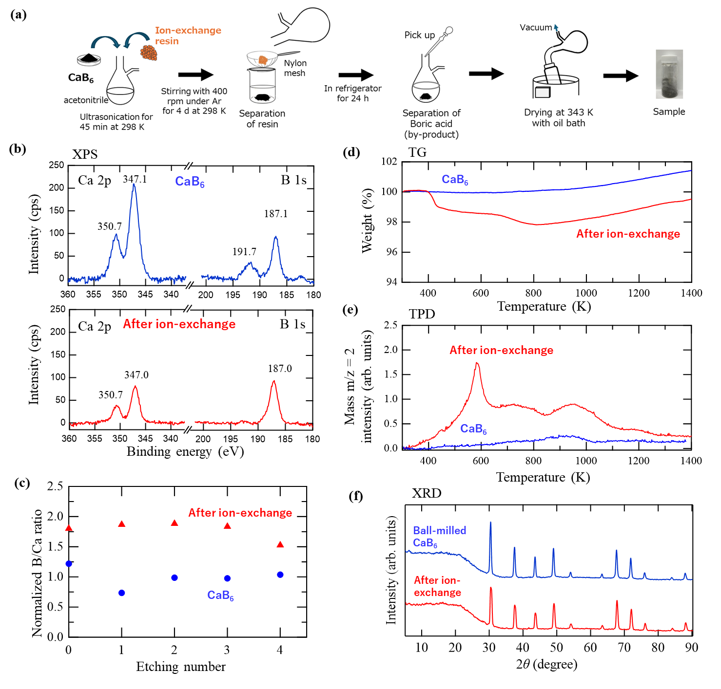

Figure 1. a) Schematic of the synthesis process. b) X-ray photoelectron spectroscopy (XPS) results for ball-milled CaB₆ before and after ion exchange. c) Normalized B/Ca ratio estimated by XPS analysis as a function of etching number, where the average value of the 2nd–4th cycles was set to be 1.0. d) Thermogravimetry (TG) results in an Ar flow for CaB₆ before and after ion exchange. e) Temperature programmed desorption (TPD) of m/z = 2 (H₂) for CaB₆ before and after ion-exchange. f) X-ray diffraction (XRD) patterns for ball-milled CaB₆ before and after ion exchange.

Results and Discussion
The typical synthesis process of HCa_{0.5}B₆ on the surface of CaB₆ is schematically shown in Fig. 1a. To facilitate the substitution of Ca²⁺ cations by protons, a strong acid cation-exchange resin was mixed with CaB₆ in acetonitrile, followed by ultrasonication for 45 min. The mixture was then magnetically stirred at 298 K for four days under Ar atmosphere. After removing the by-product boric acid, the resulting powder was separated from the resin and dried, according to the procedure reported for the synthesis of hydrogen boride nanosheets.^{[12]} In this study, 16 different treatments, such as HCl treatment, ethylenediaminetetraacetic acid (EDTA) treatment, and ball milling pretreatment, were applied to CaB₆ (Fig. S1). In each case, the product was analyzed by X-ray photoelectron spectroscopy (XPS) to determine the calcium-to-boron ratio. The typical synthesis process of HCa_{0.5}B₆ on the surface of CaB₆ is schematically shown in Fig. 1a.
Fig. 1b shows the XPS spectra of ball-milled CaB₆ before and after the ion-exchange process described in Fig. 1a. For pristine ball-milled CaB₆, two distinct B 1s peaks are observed at 187.1 eV and 191.7 eV, corresponding to CaB₆ and boron oxide, respectively.^{[33]} The Ca 2p spectrum displays two peaks at 350.7 eV and 347.1 eV, attributed to Ca 2p_{1/2} and Ca 2p_{3/2}, respectively, where the contributions from CaB₆ and calcium oxide likely overlap. In contrast, after the ion-exchange process, the B 1s spectrum displays only a single peak at 187.0 eV, indicating the absence of any detectable boron oxide. The calcium-to-boron ratio calculated by the ratio of the XPS peak areas of Ca 2p_{3/2} and B 1s with sensitivity factors of Ca (21.1321) and B (2.1017) are 15:85 and 8:92, for the sample before and after the ion-exchange, respectively. That is, the ratio of Ca/B for ion-exchanged sample is approximately half (0.49) of that in pristine CaB₆.
Similarly, all 16 treatment methods lead to a decrease in calcium content. As shown in Fig. S1b, the calcium content in these samples is approximately 60% of that in pristine CaB₆, indicating that calcium ions in CaB₆ are partially removed, with approximately half consistently eliminated across all treatments.
As XPS is a surface-sensitive technique, additional XPS measurements were conducted after several cycles of Ar⁺ ion etching to investigate the stoichiometric ratio in the bulk region. Irradiation at 600 V for 150 s was selected for one cycle, which corresponded to an etching depth of 100 nm in the case of SiO₂. As shown in Fig. 1c and Fig. S2, the B/Ca ratio in the ion-exchanged sample is approximately twice that in pristine CaB₆ up to the third cycle. This indicates that the ion-exchange reaction occurred not only on the topmost surface but also inside the subsurface region. A similar trend is observed for the ball-milled CaB₆, as shown in Fig. S3, where the Ca-deficient state persists even after seven etching cycles. Here we note that Ar⁺ ion etching with relatively high-energy of 600 eV may lead to boron signal loss or redistribution, potentially compromising the accuracy of the analysis. Nevertherless, these results indicate that the reduction in Ca content occurs not only at the topmost surface but also extends to the subsurface region of CaB₆.
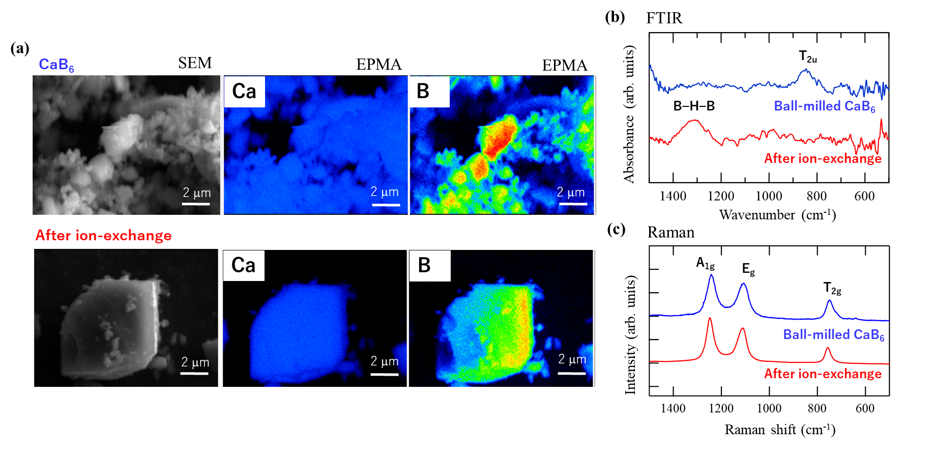

Figure 2. a) Scanning electron microscope (SEM) images and electron probe microanalysis (EPMA) mapping for CaB₆ before and after ion-exchange. The boron detector is located at an oriented angle so that the boron distribution does not reflect the real distribution. b) Fourier-transform infrared (FTIR) spectra and c) Raman scattering spectra for ball-milled CaB₆ before and after ion-exchange.
To examine the hydrogen content in the sample, thermogravimetric (TG) analysis in Ar flow and temperature-programmed desorption (TPD) measurements of H₂ were conducted simultaneously, and their results are shown in Figs. 1d and 1e, respectively. H₂ was clearly detected in the ion-exchanged sample over a wide temperature range from 400 to 1200 K, accompanied by a distinct weight loss. In contrast, no weight loss was observed for pristine CaB₆. Around 400 K, the total weight loss of the ion-exchanged sample (Fig. 1d) exceeds the amount of released H₂ (Fig. 1e), suggesting that the additional weight loss may be attributed to water desorption. Based on the ion-exchange reaction: CaB₆ + H⁺ → HCa_{0.5}B₆ + 0.5Ca²⁺, the theoretical H₂ desorption from HCa_{0.5}B₆ is calculated to be 1.16%, which aligns with the weight loss observed between 400 and 800 K in Fig. 1d by considering the additional weight loss by water. The apparent weight gain above 800 K in the TG curve is likely due to the background effects of the instrument.
Different from the XPS, TG, and TPD results, the X-ray diffraction (XRD) patterns in Fig. 1f show no evidence of new phases or structural changes in CaB₆ after ion exchange, even when ball-milled CaB₆ was used as pretreatment. The results and XPS analysis (Fig. S1) thus suggest that the ion-exchange reaction is confined to the near-surface region, without forming any additional ordered structures detectable by XRD, regardless of the ball milling pretreatment process.
Scanning electron microscopy (SEM) and electron probe microanalysis (EPMA) mapping reveal a uniform Ca distribution after ion exchange, as shown in Fig. 2a. According to quantitative EPMA analysis (Fig. S4), the B/Ca ratios are estimated to be 7.24 and 3.93 before and after ion exchange, respectively, marking a 54.3% reduction in Ca content. This result is consistent with the XPS, TG, and TPD data shown in Fig. 1, indicating that approximately half of the Ca ions remain after ion exchange.
The FTIR spectrum of ball-milled CaB₆ (Fig. 2b) shows a peak at 845 cm⁻¹, which can be attributed to the T_{2u} mode arising from the bending vibration of the octahedral boron framework coordinated with Ca.^{[34,35]} After ion exchange, the peak disappears, while a peak related to the B−H−B bending vibrational mode emerges at 1320 cm⁻¹.^{[36,37]} This new peak is broadened due to the presence of various B−B distances in the B−H−B bond,^{[36]} indicating that the hydrogen in the sample formed three-center two-electron B−H−B bonds after ion exchange. In the Raman spectra (Fig. 2c), the sample after ion exchange exhibits peaks corresponding to the vibrational modes of boron octahedra, specifically A_{1g}, E_{g}, and T_{2g}, implying that the boron octahedral framework of CaB₆ is preserved after ion exchange. However, the B–H–B peaks observed in the FTIR spectrum did not appear in the Raman spectrum, implying that hydrogen forms ionic B–H–B bonds with boron. Furthermore, the peak positions of the A_{1g}, E_{g}, and T_{2g} modes shift to lower wavenumbers in ball-milled CaB₆ compared to pristine CaB₆ and shift back to slightly higher wavenumbers after ion exchange, as shown in Fig. S5. This indicates that the bonding strength of the octahedral framework is modified by both ball milling and ion-exchange reaction.
To gain further insight into the atomic structure of the sample after ion exchange, high-angle annular dark-field (HAADF) images were captured using a scanning transmission electron microscope (STEM) equipped with a spherical aberration (Cs) corrector. As shown in Fig. 3 and Figs. S6–S11, square-shaped bright spots corresponding to the (001) plane of CaB₆ are observed in the HAADF images of pristine and ball-milled CaB₆ (Figs. 3a, S6, and S7), originating from the Ca atoms surrounded by the octahedral boron framework, as schematically illustrated in Fig. 3c. Although the boron atoms are not visible in the HAADF images, annular bright-field (ABF) imaging detects the boron features, as shown in Fig. S7, consistently supporting the schematic structure shown in Fig. 3c. In contrast, in the ion-exchanged sample, the intensity contrast due to Ca appears in alterative planes along the [100] direction in the HAADF images (Figs. 3b, S6, S8, and S9), indicating the formation of a layered structure comprising Ca-rich planes interspersed with planes where Ca has been replaced by protons. However, the contrast in the corresponding ABF and enhanced ABF (eABF) images is less pronounced than that in the HAADF images, and Ca features can be identified in both planes, along with boron features (Fig. S8). Line profiles along the [100] direction in the HAADF and ABF images (Fig. S9) reveal a periodic variation in spot intensity, confirming the alternating presence of Ca-rich and Ca-deficient (Ca_{1-x}, x<1) planes. Compared to CaB₆ in Fig. 3a, the peak spots of the ion-exchanged sample are less sharp, and the Ca–Ca distance is shorter in the Ca-rich plane, as shown in Fig. 3b. This is likely due to the replacement of Ca ions by protons not only on the surface but also in the subsurface regions of CaB₆. These results are consistent with the XPS, XRD, TG, TPD, EPMA (quantitative analysis), FTIR, and Raman results (Figs. 1 and 2), all supporting the presence of a half ion-exchanged state (HCa_{0.5}B₆) on the surface of CaB₆. Quantitatively, as shown by the XPS etching results shown in Fig. 1c, up to the subsurface (~a few hundread nm), the ion-exchange reaction may occur to form HCa_{0.5}B₆ for the CaB₆ particle with ~10 μm (as shown in Fig. 2a), which is consistent with observations of HAADF, ABF, BF and eABF including their cross sectional mapping (Fig. 3, S6, S8, and S9) in terms of subsurface ion exchange. This is consistent with the absence of the bulk state change shown by XRD (Fig. 1f).
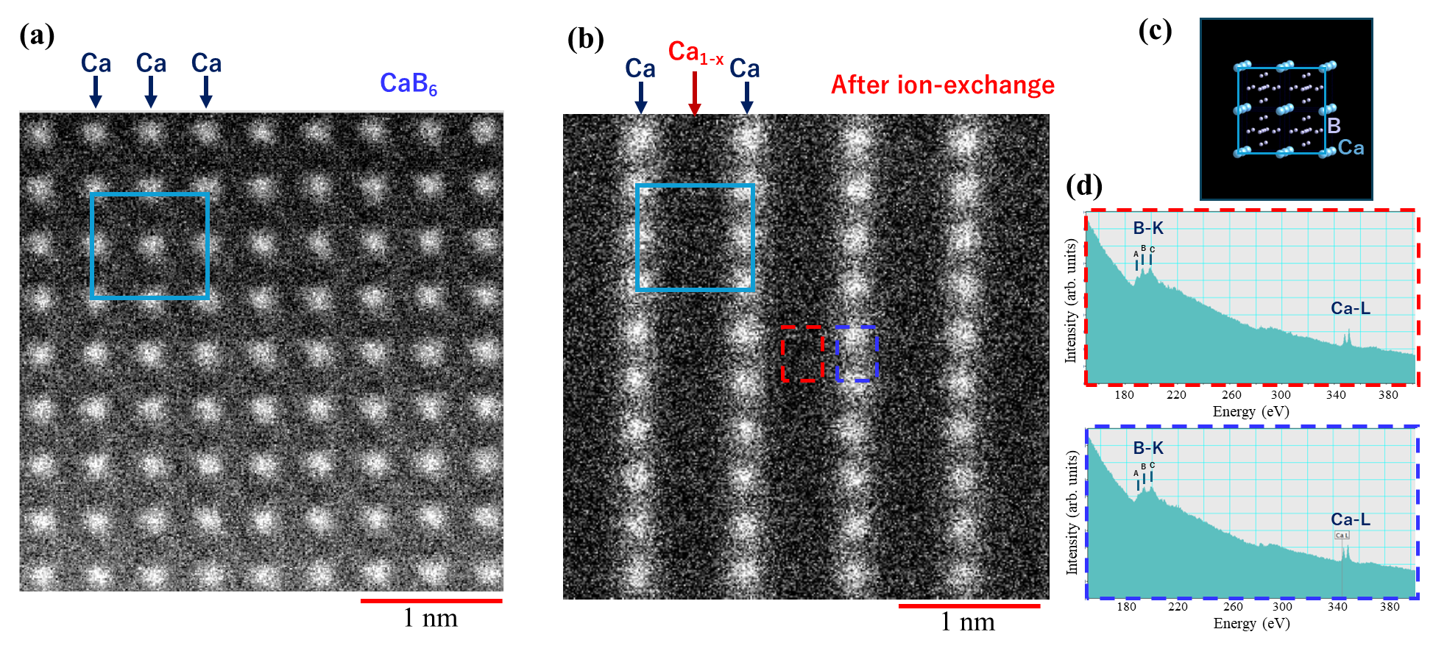

Figure 3. Atomic-resolution high-angle annular dark-field images in scanning transmission electron microscopy (HAADF-STEM) images for a) pristine CaB₆ and b) CaB₆ after ion-exchange (with ball-milling pre-treatment). c) Schematic image of the CaB₆ (001) surface. Electron energy loss spectroscopy (EELS) spectra at d) Ca-poor (Ca_{1-x}) line and e) Ca-rich line (measured in the red and blue dashed boxes in panel b, respectively).
Both B and Ca signals are observed in the Ca-rich and Ca-deficient regions in the electron energy loss spectroscopy (EELS) spectra (Figs. 3c and 3d). This is consistent with the ABF images, confirming the presence of Ca in both planes (presumably at the bulk for the Ca-deficient plane). Three peaks in the B-K edge of the electron energy losses near edge structure (ELNES) are observed in the EELS spectra. Notably, the intensity of peak A at ~188 eV is greater in the Ca-deficient plane than in the Ca-rich plane for both ion-exchanged CaB₆ (Fig. 3d) and ball-milled CaB₆ (Figs. S9 and S10). These results indicate that the boron bonding environment in the Ca-deficient plane is altered by ion exchange reactions, possibly due to the formation of a B−H−B bond, as indicated by FTIR spectra (Fig. 2b).
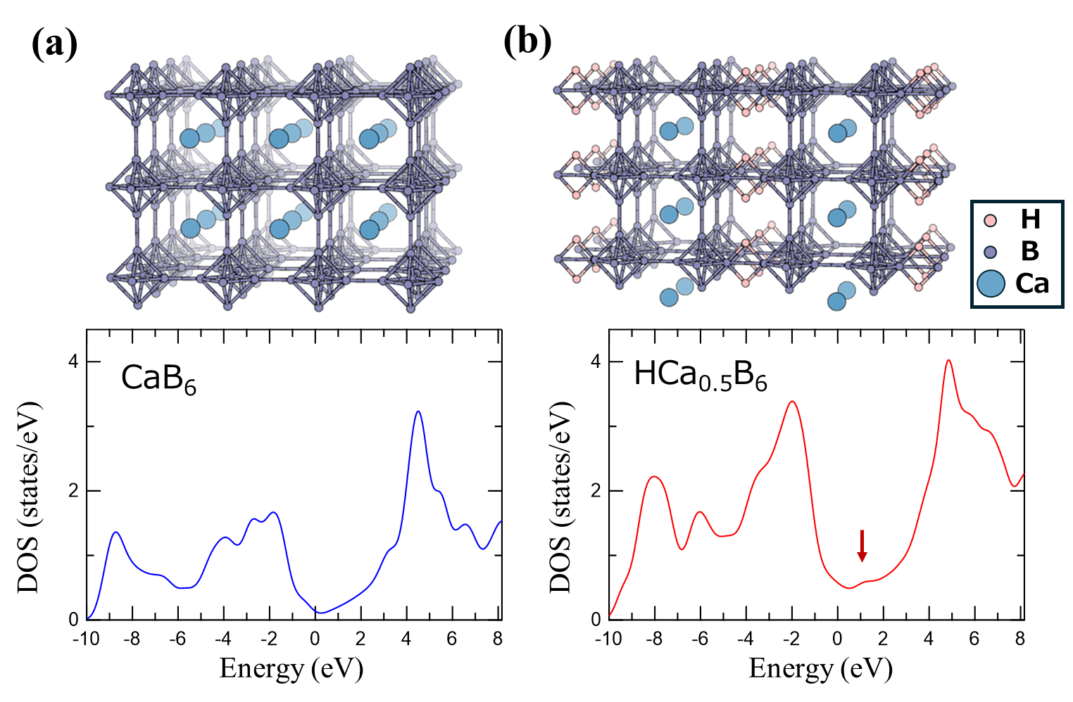

Figure 4. Structure model and electronic density of states (DOS) calculated by density functionl theory (DFT) for a) CaB₆ and b) HCa_{0.5}B₆. The energy is measured from that of the Fermi level.
The proposed structure of HCa_{0.5}B₆ is illustrated in Fig. 4, based on the following experimental observations: the B/Ca ratio is set at 12 according to XPS, quantitative EPMA analysis, and SEM results; B–H–B bonds are formed, preserving the octahedral boron network, as supported by IR, Raman, TG, TPD, and EELS data; and the structure is composed of alternating Ca-rich and Ca-deficient planes, as observed by STEM. Density functional theory (DFT) calculations were then performed to examine the electronic band structure and density of states (DOS). As shown in Fig. S12 and Fig. 4, HCa_{0.5}B₆ is in a metal electronic state, with a higher DOS near the Fermi level compared to CaB₆, suggesting that it may have intriguing functionality such as enhanced catalytic activity. Moreover, a small DOS peak is observed at approximately 1 eV for HCa_{0.5}B₆ as indicated by an arrow in Fig. 4b, which can explain the higher peak A in the B-K edge in the ELNES observed for the ion-exchanged sample (Fig. 3d).
It is noteworthy that a (2×1) reconstructed surface has been reported for LaB₆ on the topmost layer with the alternating presence of metal atoms along the octahedral boron framework. ^{[38]} Beneath the reconstructed surface, subsurface La atoms occupy positions similar to those in the bulk but form a distorted structure due to charge modulation,^{[38]} representing a significant deviation from the pristine metal hexaboride structure on the surface.^{[39]} Regarding hydrogen bonding, theoretical studies have reported similar B–H–B configurations at the ridges of boron octahedra on metal hexaboride surfaces.^{[40]} Based on these findings, one possible mechanism for the formation of “half-plane ion-exchange” observed in this study is that Ca cations on the (2×1) reconstructed surface undergo ion exchange with two protons. This ion-exchange reaction then propagates from the surface into the bulk in a site-specific manner, preferentially occurring beneath the initially exchanged surface sites.
To investigate the applicability of this concept to other metal hexaborides, the same ion-exchange process was applied to YB₆. As shown in Fig. S13, the Y/B ratio was reduced to approximately half after the ion-exchange reaction, as confirmed by XPS, and a hydrogen desorption signal was detected by TPD. These results demonstrate that our surface modification strategy is applicable to a range of metal hexaboride systems, including LaB₆, BaB₆, YbB₆, EuB₆, and NaB₆. As catalytic properties are highly sensitive to surface states, the surface modification strategy demonstrated in this study may stimulate further innovation in the design of more effective boride-based catalysts.

Summary
A hydrogen boride component has been formed on the surface of calcium hexaboride (CaB₆) through an ion-exchange reaction. Approximately half of the calcium ions in CaB₆ are replaced by protons, forming three-center two-electron (B–H–B) bonds according to the reaction: CaB₆ + H⁺ → HCa_{0.5}B₆ + 0.5Ca²⁺. Scanning transmission electron microscopy reveals that the resulting HCa_{0.5}B₆ consists of alternating Ca-rich and Ca-deficient planes, attributed to the propagation of the ion-exchange reaction from the (2×1) reconstructed surface.
Acknowledgement
This study was supported by JSPS KAKENHI (Grant Nos. JP19H02551, JP19H05046:A01, JP21H00015:B01, JP21H05012, JP21H05232, JP21H05233, JP21K14484, JP22H00283, JP22K18964, JP23H05469, JP23H01843, JP23K26536, JP24H02204, JP25H00417, and JP25K08414), MEXT Element Strategy Initiative to Form Core Research Center (JPMXP0112101001), and JST CREST Program Japan (Grant No. JPMJCR21O4, JPMJCR24A2, JPMJCR24A4, and JPMJCR23A4).
Keywords: Calcium hexaboride (CaB₆) • boron • hydrogen boride • boride surface • ion exchange

[1] C. Tan, X. Cao, X.-J. J. Wu, Q. He, J. Yang, X. Zhang, J. Chen, W. Zhao, S. Han, G.-H. H. Nam, M. Sindoro, H. Zhang, Chem. Rev. 2017, 117, 6225–6331. DOI 10.1021/acs.chemrev.6b00558
[2] Q. Li, E. B. Aklile, A. Tsui, M. C. Hersam, Nat. Chem. 2025, DOI 10.1038/s41557-025-01773-4.
[3] N. Azhar, W. S. Ng, N. R. A. Mohd Shah, A. F. Zainul Abidin, K. Arifin, K. S. Loh, W. Y. Wong, R. Mohamad Yunus, Mater. Today Chem. 2025, 46, 102716. DOI 10.1016/j.mtchem.2025.102716
[4] C. Han, R. Han, X. Zhang, Z. Xu, W. Li, Y. Yamauchi, Z. Huang, J. Mater. Chem. A 2022, 10, 2736–2750. DOI 10.1039/D1TA09562E
[5] D. Zhang, C. Zhang, S. Wang, W. Sun, J. Zhejiang Univ. Sci. A 2024, 25, 877–888. DOI /10.1631/jzus.A2400003
[6] T. A. Abtew, B. C. Shih, P. Dev, V. H. Crespi, P. Zhang, Phys. Rev. B 2011, 83, 094108. DOI 10.1103/PhysRevB.83.094108
[7] T. A. Abtew, P. Zhang, Phys. Rev. B 2011, 84, 094303. DOI 10.1103/PhysRevB.84.094303
[8] Y. Jiao, F. Ma, J. Bell, A. Bilic, A. Du, Angew. Chem., Int. Ed. 2016, 55, 10292. DOI 10.1002/anie.201604369
[9] T. Kondo, Sci. Technol. Adv. Mater. 2017, 18, 780. DOI 10.1080/14686996.2017.1379856
[10] X. Zeng, Y. Jing, S. Gao, W. Zhang, Y. Zhang, H. Liu, C. Liang, C. Ji, Y. Rao, J. Wu, B. Wang, Y. Yao, S. Yang, Nat. Commun. 2023, 14, DOI 10.1038/s41467-023-43294-z.
[11] T. Kondo, Chem. Lett. 2023, 52, 611–621. DOI 10.1246/cl.230210
[12] H. Nishino, T. Fujita, N. T. Cuong, S. Tominaka, M. Miyauchi, S. Iimura, A. Hirata, N. Umezawa, S. Okada, E. Nishibori, A. Fujino, T. Fujimori, S. Ito, J. Nakamura, H. Hosono, T. Kondo, J. Am. Chem. Soc. 2017, 139, 13761–13769. DOI 10.1021/jacs.7b06153
[13] R. Kawamura, N. T. Cuong, T. Fujita, R. Ishibiki, T. Hirabayashi, A. Yamaguchi, I. Matsuda, S. Okada, T. Kondo, M. Miyauchi, Nat. Commun. 2019, 10, 4880. DOI 10.1038/s41467-019-12903-1
[14] A. Mauliana, A. Yamaguchi, T. Kondo, M. Miyauchi, Small 2024, 20, 2404986. DOI 10.1002/smll.202404986
[15] J. Takeshita, H. Tsurugi, A. Mauliana, A. Yamaguchi, T. Kondo, M. Miyauchi, Adv. Sci. 2024, 2405981. DOI 10.1002/advs.202405981
[16] C. Shimada, A. Yamaguchi, A. Mauliana, Y. Yang, H. Tsurugi, T. Kondo, M. Miyauchi, ACS Appl. Mater. Interfaces 2024, 16, 35225–35231. DOI 10.1021/acsami.4c07768
[17] S. Kawamura, A. Yamaguchi, K. Miyazaki, S. Ito, N. Watanabe, I. Hamada, T. Kondo, M. Miyauchi, Small 2024, 20. DOI 10.1002/smll.202310239
[18] A. Fujino, S. Ito, T. Goto, R. Ishibiki, R. Osuga, J. N. Kondo, T. Fujitani, J. Nakamura, H. Hosono, T. Kondo, Phys. Chem. Chem. Phys. 2021, 23, 7724–7734. DOI 10.1039/D0CP03079A
[19] A. Fujino, S. Ito, T. Goto, R. Ishibiki, J. N. Kondo, T. Fujitani, J. Nakamura, H. Hosono, T. Kondo, ACS Omega 2019, 4, 14100−14104. DOI 10.1021/acsomega.9b02020
[20] S. Ito, T. Hirabayashi, R. Ishibiki, R. Kawamura, T. Goto, T. Fujita, A. Yamaguchi, H. Hosono, M. Miyauchi, T. Kondo, Chem. Lett. 2020, 49, 789–793. DOI 10.1246/cl.200206
[21] S. Gao, Y. Zhang, J. Bi, B. Wang, C. Li, J. Liu, C. Kong, S. Yang, S. Yang, J. Mater. Chem. A, 2020, 8, 18856. DOI 10.1039/D0TA06542K
[22] A. Saad, D. Liu, Y. Wu, Z. Song, Y. Li, T. Najam, K. Zong, P. Tsiakaras, X. Cai, Appl. Catal. B, 2021, 298, 120529. DOI 10.1016/j.apcatb.2021.120529
[23] N. Noguchi, S. Ito, M. Hikichi, Y. Cho, K. Goto, A. Kubo, I. Matsuda, T. Fujita, M. Miyauchi, T. Kondo, Molecules 2022, 27, 8261, DOI 10.3390/molecules27238261.
[24] S. Gao, H. Zhao, P. Gao, J. Bi, D. Liu, D. Zhu, B. Wang, S. Yang, ACS Appl. Mater. Interfaces, 2022, 14, 34750. DOI 10.1021/acsami.2c08510
[25] K. I. M. Rojas, N. T. Cuong, H. Nishino, R. Ishibiki, S. Ito, M. Miyauchi, Y. Fujimoto, S. Tominaka, S. Okada, H. Hosono, N. B. Arboleda, T. Kondo, Y. Morikawa, I. Hamada, Commun. Mater. 2021, 2, 81. DOI 10.1038/s43246-021-00184-5
[26] S. Ito, M. Hikichi, N. Noguchi, M. Yuan, Z. Kang, K. Fukuda, M. Miyauchi, I. Matsuda, T. Kondo, Phys. Chem. Chem. Phys. 2023, 25, 15531–15538. DOI 10.1039/D3CP01256E
[27] T. Nagai, A. Mauliana, K. Kobayashi, A. Yamaguchi, K. Miyazaki, Y. Yang, J. Takeshita, T. Fujita, K. Sunada, H. Ishiguro, T. Kondo, M. Miyauchi, J. Mater. Chem. B 2025, 13, 38–40. DOI 10.1039/D4TB02854F
[28] M. Niibe, M. Cameau, N. T. Cuong, O. I. Sunday, X. Zhang, Y. Tsujikawa, S. Okada, K. Yubuta, T. Kondo, I. Matsuda, Phys. Rev. Mater. 2021, 5, 084007. DOI 10.1103/PhysRevMaterials.5.084007
[29] X. Zhang, Y. Tsujikawa, I. Tateishi, M. Niibe, T. Wada, M. Horio, M. Hikichi, Y. Ando, K. Yubuta, T. Kondo, I. Matsuda, J. Phys. Chem. C 2022, 126, 12802–12808. DOI 10.1021/acs.jpcc.2c02431
[30] L. Chen, X. Chen, C. Duan, Y. Huang, Q. Zhang, B. Xiao, Phys. Chem. Chem. Phys. 2018, 20, 30304–30311. DOI 10.1039/C8CP05846F
[31] N. Ploysongsri, V. Vchirawongkwin, V. Ruangpornvisuti, Int. J. Hydrogen Energy 2021, 46, 39273–39283. DOI 10.1016/j.ijhydene.2021.09.175
[32] P. Habibi, T. H. G. Saji, T. J. H. Vlugt, O. A. Moultos, P. Dey, Appl. Surf. Sci. 2022, 603, 154323. DOI 10.1016/j.apsusc.2022.154323
[33] M. Aono, S. Kawai, S. Kono, M. Okusawa, T. Sagawa, Y. Takehana, J. Phys. Chem. Solids 1976, 37, 215–219. DOI 10.1016/0022-3697(76)90164-5
[34] S. Turrell, Z. Yahia, J.P. Huvenne, B. Lacroix, G. Turrell, J. Mol. Struct. 1988, 174, 455–460. DOI 10.1016/0022-2860(88)80200-X
[35] T. M. Mattox, S. Chockkalingam, I. Roh, J. J. Urban, J. Phys. Chem. C 2016, 120, 5188–5195. DOI 10.1021/acs.jpcc.5b12680
[36] S. Tominaka, R. Ishibiki, A. Fujino, K. Kawakami, K. Ohara, T. Masuda, I. Matsuda, H. Hosono, T. Kondo, Chem 2020, 6, 406–418. DOI 10.1016/j.chempr.2019.11.006
[37] S. Ito, K. I. M. Rojas, Y. Yasuda, N. Noguchi, K. Fukuda, M. Hikichi, Z. Kang, M. Yuan, R. Tsuji, O. Oki, S. Roy, Y. Hikita, I. Matsuda, M. Miyauchi, I. Hamada, T. Kondo, J. Phys. Chem. Lett. 2024, 15, 10965–10976. DOI 10.1021/acs.jpclett.4c01975
[38] P. Buchsteiner, F. Sohn, J. G. Horstmann, J. Voigt, M. Ciomaga Hatnean, G. Balakrishnan, C. Ropers, P. E. Blöchl, M. Wenderoth, Phys. Rev. B 2019, 100, 205407. DOI 10.1103/PhysRevB.100.205407
[39] A. D. Liu, X. H. Zhang, Y. J. Qiao, Ceram. Int. 2014, 40, 15997–16002. DOI 10.1016/j.ceramint.2014.07.131
[40] K. M. Schmidt, S. T. Misture, O. A. Graeve, V. R. Vasquez, ACS Omega 2019, 4, 65–72. DOI 10.1021/acsomega.8b02652

Entry for the Table of Contents

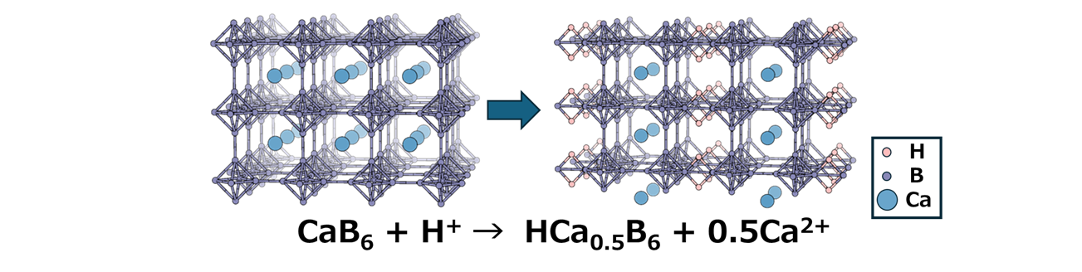

A hydrogen boride component was formed on the surface of calcium hexaboride (CaB₆) via an ion-exchange reaction. Approximately half of the calcium in CaB₆ is replaced by protons, forming three-center two-electron B–H–B bonds. The resulting HCa_{0.5}B₆ consists of alternating Ca-rich and Ca-deficient planes. The substantially modified surface states of CaB₆ may open new avenues for the design of efficient functional materials such as boride-based catalysts.
Institute and/or researcher Twitter usernames: (@UNIV_TSUKUBA_EN) (@takahirokondo)

