Supplemental information

Quasi-linear Kane conduction band model in nitrogen-doped indium tin oxide

Martin Markwitz,^{1, 2, 3, ∗} Song Yi Back,⁴ Edward X. M. Trewick,^{1, 3} Peter P. Murmu,² Takao Mori,^{4, 5} Ben J. Ruck,^{1, 3} and John V. Kennedy^{2, 3}
¹School of Chemical and Physical Sciences, Victoria University of Wellington, PO Box 600, Wellington 6140, New Zealand
²National Isotope Centre, GNS Science, PO Box 30368, Lower Hutt 5010, New Zealand
³The MacDiarmid Institute for Advanced Materials and Nanotechnology, Victoria University of Wellington, PO Box 600, Wellington 6140, New Zealand
⁴International Center for Materials Nanoarchitectonics (WPI-MANA), National Institute for Materials Science (NIMS), 1-1 Namiki, Tsukuba, Ibaraki 305-0044, Japan
⁵Graduate School of Pure and Applied Science, University of Tsukuba, 1-1-1 Tennodai, Tsukuba, Ibaraki 305–8671, Japan

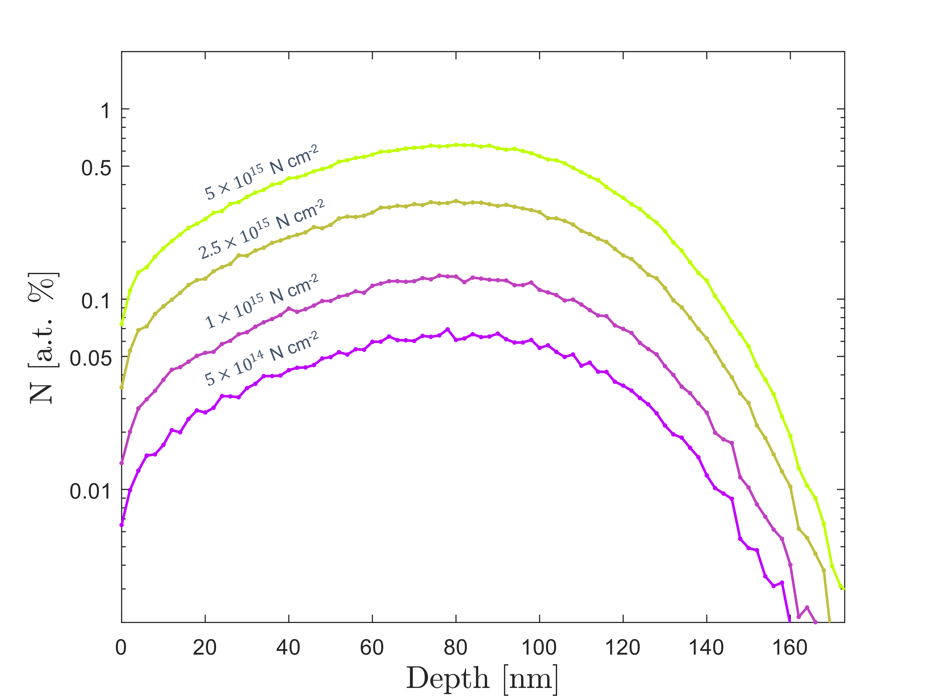
FIG. S1. (Color online) Monte-Carlo TRIM-Dynamic simulation of nitrogen implantation in ITO for the experimental conditions used in this work.
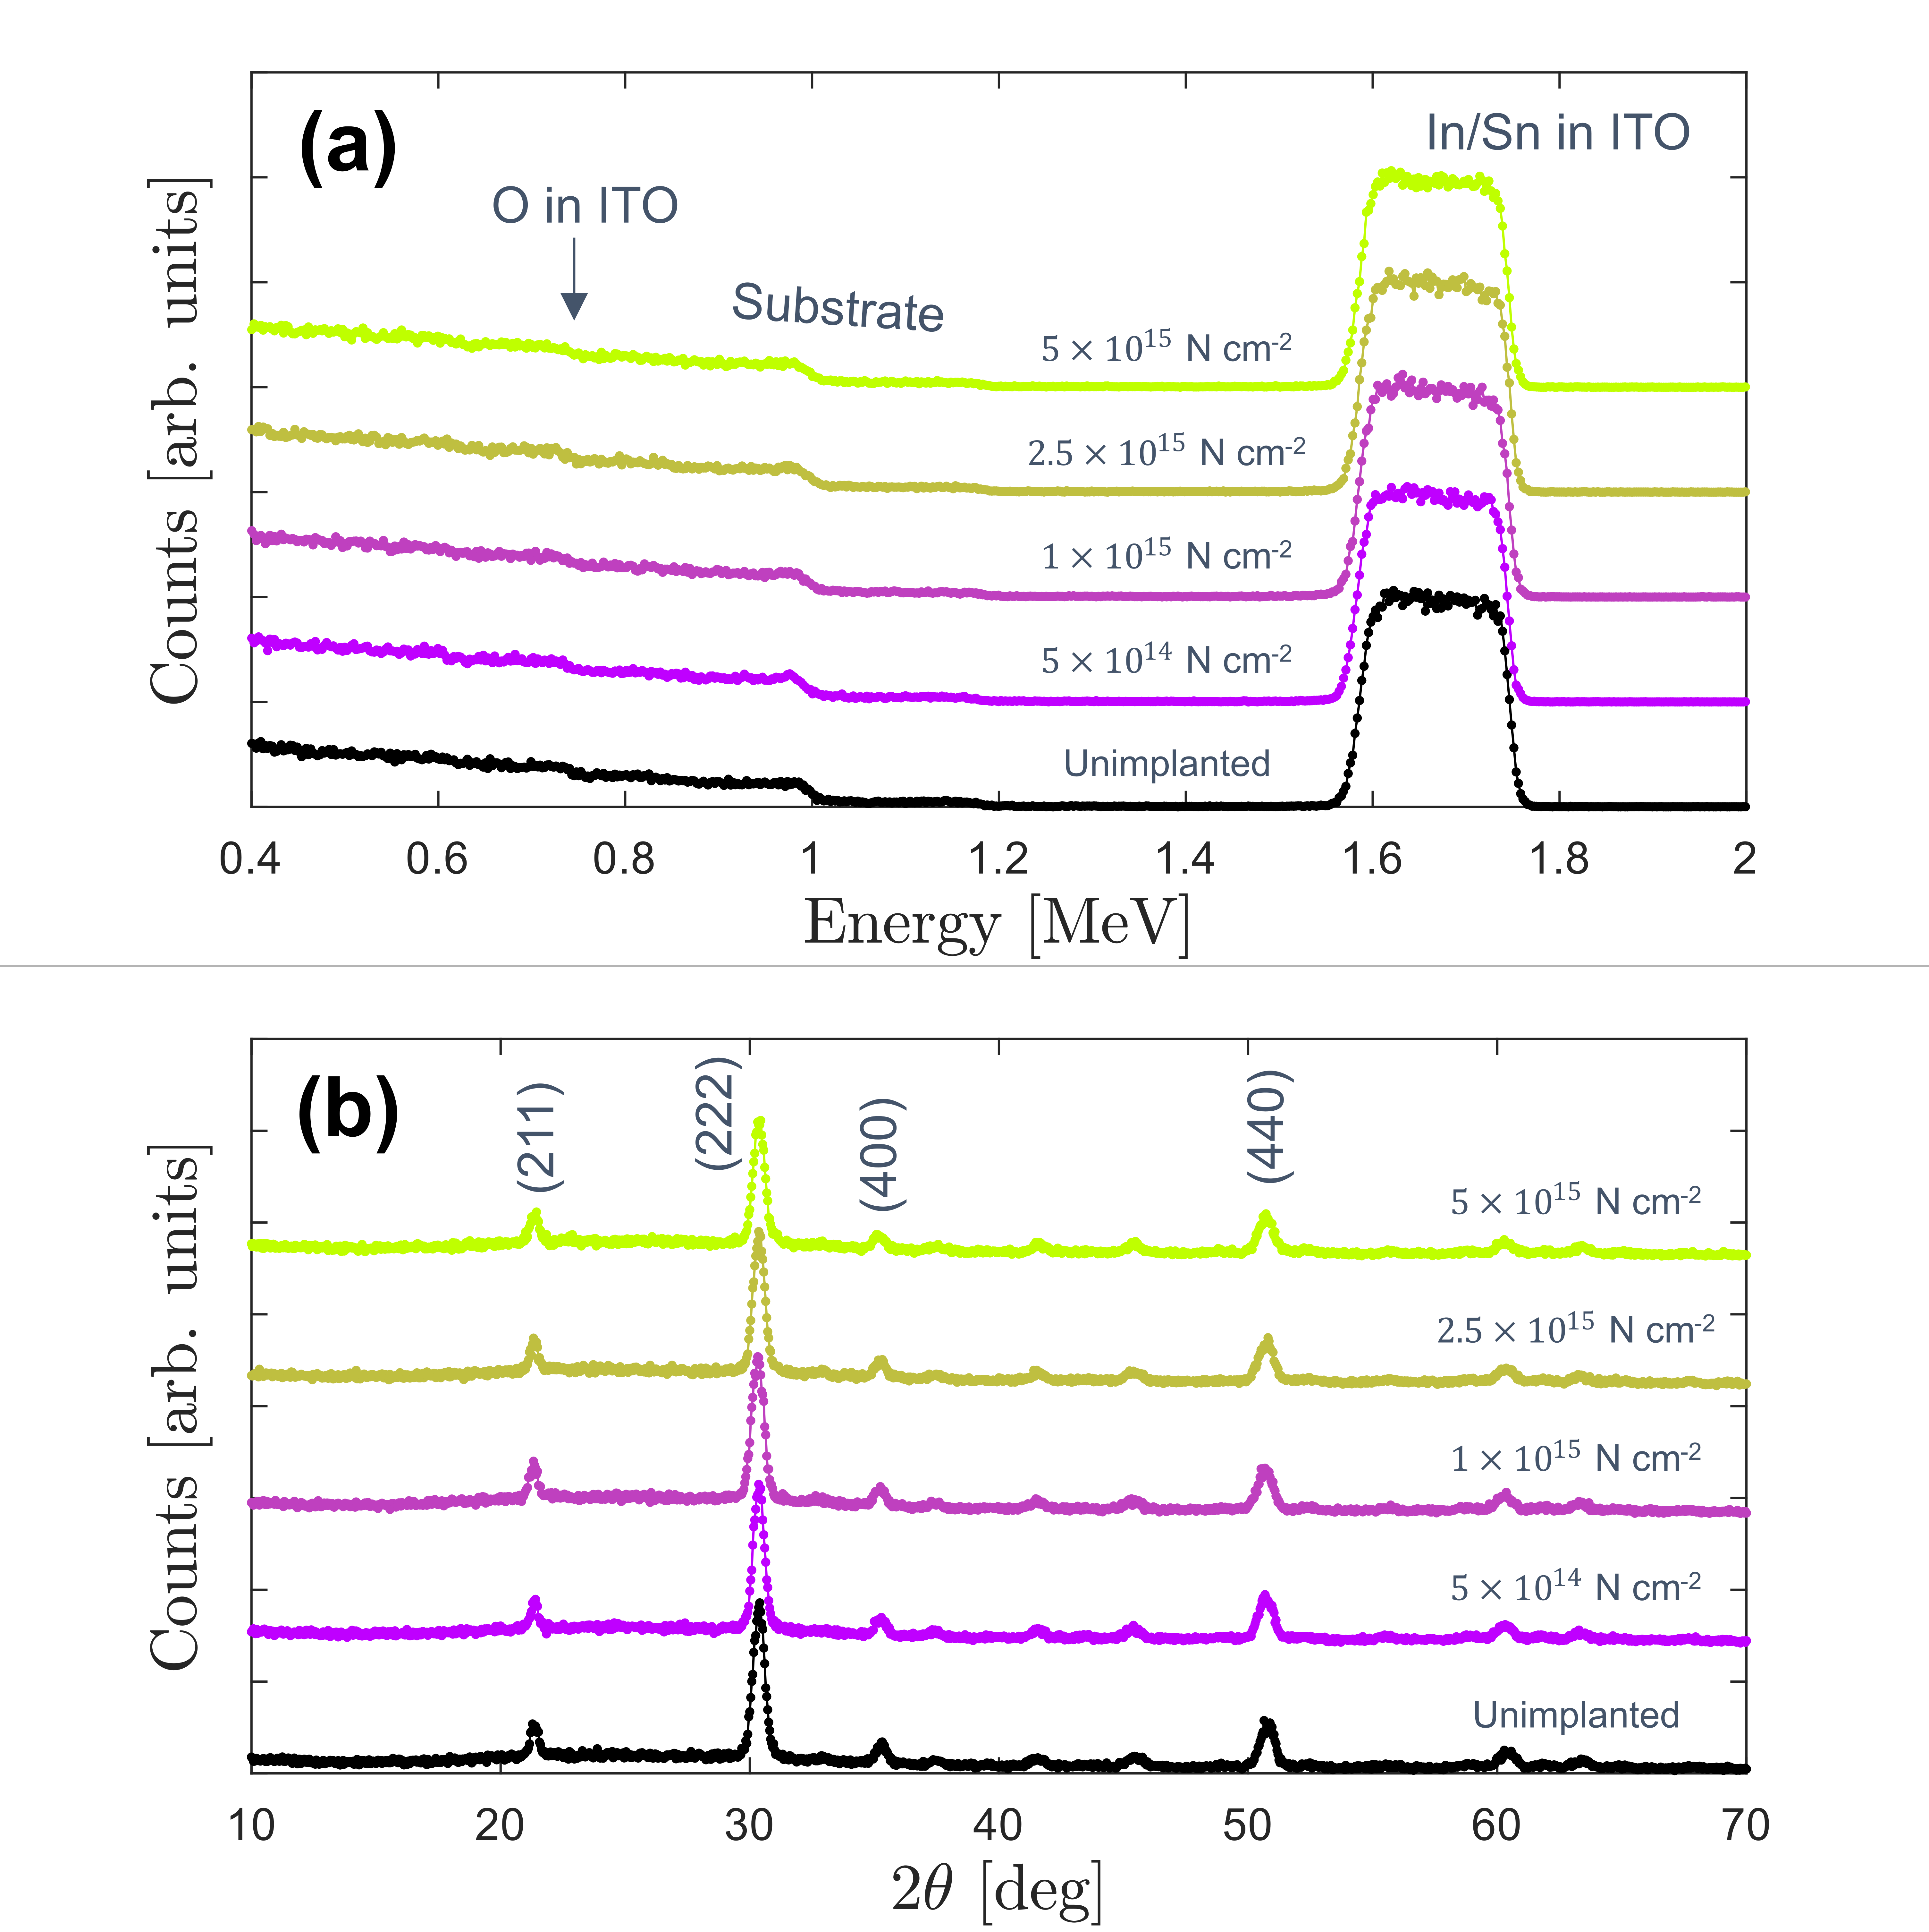
FIG. S2. (Color online) (a) $2.0$ MeV ⁴He⁺ Rutherford backscattering spectra. (b) Cu K α_{1/2} grazing incidence (ω=2°) X-ray diffractograms. Data is vertically offset for visual clarity.
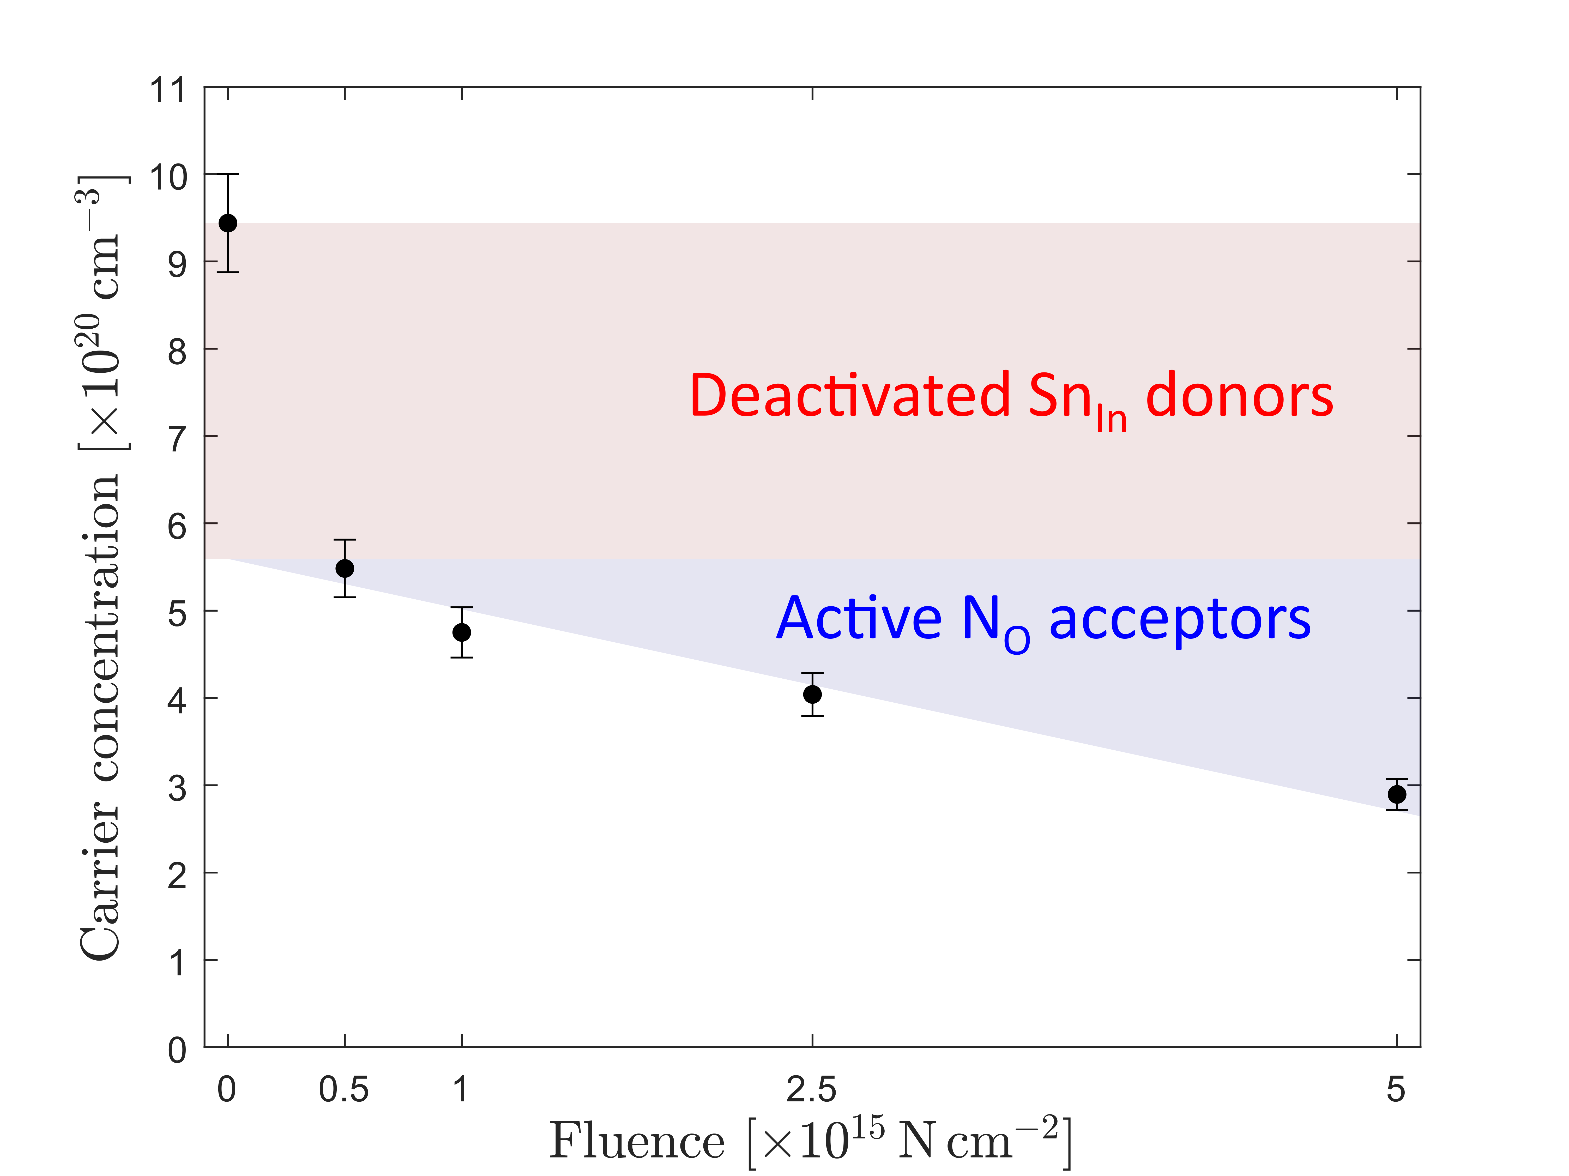
FIG. S3. (Color online) Carrier concentration in un-annealed implanted ITO films showing proportionality between implantation fluence increase and carrier concentration reduction. The estimated concentration of tin donors is 3.9×10²⁰±0.2×10²⁰ cm⁻³.

