Defect and dopant complex mediated high power factor in transparent selenium-doped copper iodide thin films

Peter P. Murmu^{a,*}, Martin Markwitz^{a,b,c}, Shen V. Chong^{c,d}, Niall Maloneª, Takao Mori^{e,f}, Himanshu Vyas^{g}, L. John Kennedy^{g}, Sergey Rubanov^{h}, C.I. Sathish^{i}, Jiabao Yi^{i}, and John Kennedy^{a,c,*}

ªNational Isotope Centre, GNS Science, PO Box 30368, Lower Hutt 5010, New Zealand
^{b}School of Chemical and Physical Sciences, Victoria University of Wellington, PO Box 600, Wellington 6140, New Zealand
^{c}The MacDiarmid Institute for Advanced Materials and Nanotechnology, PO Box 600, Wellington 6140, New Zealand
^{d}Robinson Research Institute, Victoria University of Wellington, PO Box 33436, Lower Hutt 5046, New Zealand
^{e}International Center for Materials Nanoarchitectonics (WPI-MANA), National Institute for Materials Science (NIMS), 1-1 Namiki, Tsukuba, Ibaraki 305-0044, Japan
^{f}Graduate School of Pure and Applied Science, University of Tsukuba, 1-1-1 Tennodai, Tsukuba, Ibaraki 305–8671, Japan
^{g}Department of Physics, School of Advanced Sciences, Vellore Institute of Technology (VIT), Chennai Campus, Chennai 600 127, Tamil Nadu, India
^{h}IHIC, Bio21 Institute, The University of Melbourne, Parkville, Victoria 3010, Australia
^{i}Global Innovative Center of Advanced Nanomaterials, School of Engineering, College of Engineering, Science, and Environment, University of Newcastle, Callaghan, NSW, 2308 Australia

Corresponding Authors: j.kennedy@gns.cri.nz (John Kennedy); p.murmu@gns.cri.nz (Peter Murmu)

Abstract
Wide bandgap materials have attracted considerable attention as energy materials due to their versatile technological device applications. Among them, optically transparent semiconductors offer viable renewable energy harvesting as transparent thermoelectric generator devices. A high-performance thermoelectric generator requires a high electrical conductivity, large Seebeck coefficient and low thermal conductivity, which remain major challenges. In this paper, we report a high power factor for selenium (Se)-doped transparent $p$-type copper iodide (CuI) films. Ion beam-sputtered CuI films were doped using 30 keV ⁸⁰Se⁺ implantation with Se at.% varying between 0.50% and 6.50%. UV‒visible spectroscopy results showed a wide bandgap, E_{g} ≈2.99 eV, with a moderate decrease in the bandgap upon Se implantation. X-ray diffraction and transmission electron microscopy revealed the formation of highly textured γ-CuI films, with slight lattice relaxation upon Se implantation. Hall effect measurements showed a ~ 34% increase in electrical conductivity (σ ≈ 26.6 Ω⁻¹cm⁻¹) due to a ~54% increase in carrier density (p_{H} ≈ 5.4 × 10¹⁹ cm⁻³) in the $p$-type γ-CuI film implanted with 5.0 × 10¹⁴ Se⋅cm⁻². A high Seebeck coefficient, α ≈ 388.9 µVK⁻¹, and moderate electrical conductivity, σ ≈ 29.1 Ω⁻¹ cm⁻¹, yield a nearly 85% increase in the power factor, α²σ ≈ 439.7 µWm⁻¹K⁻², for a 1.0 × 10¹⁵ Se⋅cm⁻² implanted film compared to the unimplanted film (α²σ ≈ 236.4 µWm⁻¹K⁻²). Displacement per atom (DPA) calculations using Transport of Ions in Matter (TRIM) simulation and ab initio density functional theory calculations revealed that the increased DPA values and the {Se_{I}-V_{Cu}} defect complex act as a shallow acceptor, which could be attributed to the observed increase in hole density. Our results show that native defects and defect complexes are beneficial for enhancing the power factor in transparent CuI for thermoelectric applications.

KEYWORDS: Thermoelectric; chalcogens; selenium; implantation; power factor; defect complex

1. Introduction
Sustainable energy generation is highly desirable for addressing the ever-growing global energy demand. Thermoelectric technology provides an attractive energy harvesting method for emission-free energy generation. Its key attractive features include no moving parts enabling quiet functioning, low maintenance and reliable operation without any hazardous chemical discharge. A variety of heat sources, such as ambient heat, body heat, natural heat (solar and geothermal) and industrial waste heat, from a wide range of temperatures, from ambient to high temperatures (> 1000 K) can be captured [1, 2, 3]. At the core of this technology lies the thermoelectric materials that directly convert heat into electricity via the Seebeck effect. They are categorized based on their operating temperature regime, such as low temperature (< 500 K), intermediate temperature (500 K – 900 K), and high temperature (>900 K) [4]. The energy conversion efficiency is given by the dimensionless performance parameter figure-of-merit (ZT), which is dependent on the inherent properties of thermoelectric materials – the Seebeck coefficient (α), electrical conductivity (σ), and thermal conductivity (κ) – and is written as ZT = α²σT/κ, where T is the absolute temperature [5]. Adversely interlinked α, σ and κ require maximizing the power factor, α²σ, while lowering the thermal conductivity for maximum energy conversion efficiency. Research on thermoelectric materials is driven by optimizing α, σ and κ for targeted temperature applications [6, 7, 8, 9].
Copper iodide (CuI) is a promising thermoelectric material for ambient- to low-temperature thermoelectric applications [10]. It is a $p$-type wide bandgap semiconductor (E_{g} ~ 3.1 eV) that combines high optical transparency and effective hole transport [11, 12]. It has emerged as a key material for transparent electronics [13, 14] and energy harvesting for transparent thermoelectric generators [15, 16]. CuI is found in three allotropes, zincblende γ-CuI (< 350 °C), wurtzite β-CuI (350 °C - 380 °C), and rocksalt α-CuI (>380 °C) [11], which possess a valence band mainly formed by Cu $3d$ and I $5p$ orbitals, whereas the conduction band mainly consists of Cu $4s$ states. Copper vacancies (V_{Cu}) are considered the major source of holes in intrinsic $p$-type CuI and are easily formed due to their low formation energy, while other defects, such as iodine vacancies (V_{I}), antisite copper (Cu_{I}) and copper interstitial (Cu_{i}), act as donors [17]. Currently, CuI possesses an inferior electrical conductivity (σ) compared to that of its n-type counterpart, such as indium tin oxide [18, 19]. Intrinsic and extrinsic doping strategies have been employed to increase carrier concentration and mobility, improving electrical conductivity, which can lead to commercial utilization in transparent electronic devices [10]. Intrinsic doping includes stoichiometric variation by varying growth conditions [14] or post-fabrication thermal treatment [20, 21]. This is believed to primarily vary the copper vacancy to improve the hole conductivity in the material. Recently, extrinsic doping of CuI has been actively explored to improve its conductivity. A wide range of dopant elements, such as the alkali element Cs [22]; the transition metal ions Zn [12] and Fe [23]; the metal ions Al, Ga, Sn, and Ag [24, 25]; rare-earth elements [26]; and the chalcogen elements S [27, 28, 29, 30], Se [31, 32], and Te [33], have been investigated.
Among them, chalcogen elements have been reported to be suitable dopants due to their low formation energy. Sulfur doping into CuI has been reported by several groups [27, 28, 29, 30], with electrical conductivities as high as ~10³ Ω⁻¹cm⁻¹ reported by Geng et al. [30]. Recently, our group [33] reported the incorporation of Te into CuI, which modified the scattering mechanism and had a limited effect on the electrical conductivity of the films. Doping medium-sized Se into CuI has been studied experimentally [5] and theoretically [32]. Storm et al. [31] reported Se doping into CuI films grown by pulsed-laser deposition (PLD) and reported that Se doping increased the hole density by nearly 2 orders of magnitude to $p$_{H} = 8 × 10¹⁷ cm⁻³. Graužinytė et al. [34] predicted a shallow acceptor for Se (265 meV) under Cu-rich conditions in CuI. Recently, Willis et al. [32] performed electronic band structure and defect calculations for Se in CuI and reported a slightly deeper transition level (~300 meV) for substitutional Se into I (Se_{I}) defects. The addition of dopants to the CuI matrix not only alters the defect chemistry but can also form defect complexes from impurities and native defects [22]. Matsuzaki et al. [22] reported Cs doping in CuI films fabricated by spin-coating and solvent evaporation methods and reported the formation of a stable Cs-V_{Cu} complex that acts as a shallow acceptor, enhancing the hole concentration.
In this paper, we report the microstructural, optical, and electrical transport of Se-doped CuI films. Se implantation was carried out via ion implantation into ion beam-sputtered CuI films. We observed that Se implantation shifts the carrier scattering mechanism from polar phonon to ionized impurity scattering. Ab initio density functional theory calculations revealed that the Se_{I}-V_{Cu} defect complex acts as a shallow acceptor, which could be beneficial for enhancing the hole density.

2. Materials and methods
Copper iodide thin films were fabricated via ion beam sputtering [35] using a commercially available copper iodide sputtering target (99.99% purity) obtained from the American Elements. CuI thin films were deposited on 10 × 10 mm² (001) silicon (Si) and 500 nm thermally oxidized silicon surfaces on (001) silicon, SiO₂/Si, and soda-lime microscope glass substrates. The sputtering was carried out using 16.0 keV Ar⁺ at ambient temperature under vacuum (P_{op}~ 6 × 10⁻⁶ mbar) with a target current density of ~ 0.2 mA⋅cm⁻². The CuI sputtering target was placed at an incident angle of 45°, while the substrate holders were placed at 60° to grow 70 ± 10 nm CuI films. Selenium (Se) ion implantation was carried out using a GNS low-energy ion implanter at normal incidence and at ambient temperature [36]. Then, 30 keV ⁸⁰Se⁺ ions were implanted into CuI to achieve fluences (ions⋅cm⁻²) between 5.0 × 10¹⁴ Se⋅cm⁻² and 8.0 × 10¹⁵ Se⋅cm⁻². Transport of Ions in Matter in dynamic mode (Dynamic-TRIM) calculations using Monte Carlo simulations [37] showed that the implantation projected range was R_{P} ~ 17.8 nm and that the longitudinal straggling of ΔR_{P} was ~11.2 nm. Maximum elemental concentrations of 0.50 at% and 6.50 at% were observed for 5.0 × 10¹⁴ Se⋅cm⁻² and 8.0 × 10¹⁵ Se⋅cm⁻², respectively, as shown in Fig. 1. Displacement per atom (DPA) calculations were also conducted using the TRIM simulation tool in the “detailed calculation with full damage cascade” mode [38].
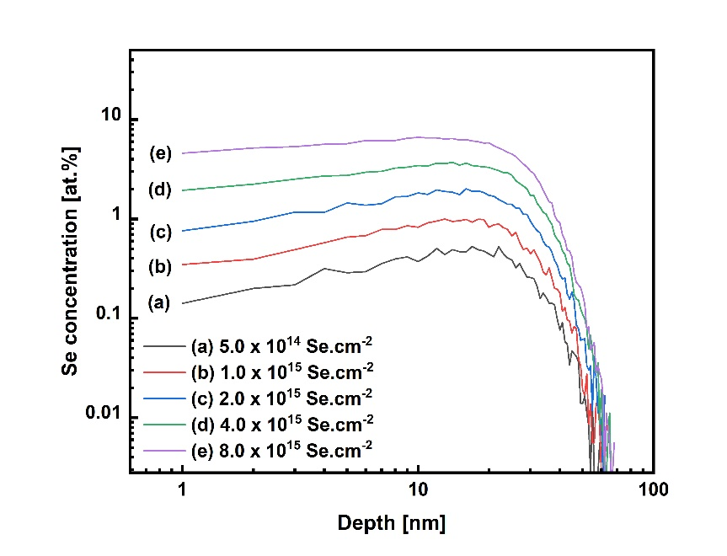
Figure 1: Dynamic TRIM calculations for 30 keV ⁸⁰Se⁺ into CuI.
X-ray diffraction (XRD) patterns were obtained using a Rigaku SmartLabs diffractometer employing a nonmonochromated Cu X-ray source with two principal wavelengths (1.54059 Å and 1.54432 Å). Cross-sectional transmission electron microscopy (X-TEM) and high-resolution transmission electron microscopy (HRTEM) were used for characterization using an FEI TECNAI TF20 field emission gun transmission electron microscope (TEM) operated at 200 kV. Room-temperature electrical and galvanoelectric properties were measured in the van der Pauw configuration using an Ecopia HMS-3000 Hall Measurement System at an applied magnetic field of 0.55 T. Au electrodes (~ 30 nm) were sputtered for ohmic contact for 4-probe van der Pauw and Hall effect measurements. The Seebeck coefficient (α) was measured at room temperature on a ZEM-3 system [39]. Temperature-dependent two-probe resistivity measurements were carried out using a physical property measurement system from Quantum Design. UV‒visible transmission measurements were carried out by a Perkin Elmer Lambda 365 spectrophotometer at The Measurement Standards Laboratory of New Zealand (MSL).

2. Theoretical calculation
Ab initio density functional theory (DFT) [40, 41] calculations were conducted with QUANTUM Espresso [42, 43, 44] using the Kresse-Joubert projector augmented wave method [45] with the PBE exchange-correlation functional [46] using ultrasoft pseudopotentials of Dal Corso [47]. The valences of copper, iodine, and selenium used in this work are 3d¹⁰4s¹, 5 s²5p5, and 3d¹⁰4s²4p⁴, respectively. The reciprocal space of the 64-atom supercells of CuI was sampled with a 3×3×3 Monkhorst-Pack grid [48], and to produce the band structure diagrams, banduppy was used to unfold the bands to the Brillouin zone [49, 50, 51]. The calculations are converged to within 1 meV/atom using a wavefunction cutoff energy of 60 Ry with the aforementioned Monkhorst-Pack grid density. Symmetry-unrestricted structure optimization was conducted with the conjugate gradient algorithm with Hellman–Feynman forces. For the calculation of the projected density of states, a 9×9×9 Monkhorst-Pack grid was used.
A rotationally symmetric ortho-atomic Hubbard parameter $U_{eff}=U-J$ with $J=0$ introduced by Dudarev et al. [52] was used to better model the underbound (and overdelocalized) Cu 3d valence manifold. The $U_{Cu}=U_{eff}$ Hubbard parameter was varied between $0$ and $6$ eV to better model the electron-electron interaction, with the best resulting parameter of $U_{Cu}=3.9$ eV matching the upper valence band profile of CuI from available valence band X-ray photoelectron spectroscopy data of undoped CuI. To model the role of doping both intrinsic and extrinsic defects, the formation energies for various defects and charge states were calculated. The intrinsic copper (V_{Cu}) and iodine (V_{I}) vacancies, and the extrinsic substitutional Se_{Cu} and Se_{I} defects were considered. Furthermore, a defect complex involving one Se_{I} and V_{Cu} defect was considered to study the interplay between the acceptor status of those respective defects in the vicinity of one another. Corrections involving valence band referencing, potential alignment, and image charge corrections were conducted following the Lany and Zunger procedure [53, 54, 55]. The total formation energy of a defect is given as:
$$ΔE_{D}^{q}=\left[E_{D}^{q}-E_{H}\right]-\sum_{i}{n_{i}\left(μ_{i}+Δμ_{i}\right)}+q\left(ΔE_{F}+ΔE_{D}^{q,PA}\right)+E_{D}^{q,IC}$$
in which $ΔE_{D}^{q}$ is the formation energy of a defect $D$ with charge state $q$, $E_{D}^{q}$ is the total energy of the defect-inclusive supercell, $E_{H}$ is the energy of the host supercell, $n_{i}=+1/-1$ is the number of added or removed atoms of each type, and $μ_{i}$ is the chemical potential of the element in its ambient phase. The term $Δμ_{i}$ is the relative chemical potential, limited by the host stability condition $Δμ_{CuI}=Δμ_{Cu}+Δμ_{I}$, where $Δμ_{CuI}=-0.65$ eV/f.u., and the chemical potential of the constituents is allowed to vary between $0$ and $Δμ_{CuI}$. The term $ΔE_{F}$ is the Fermi energy relative to the valence band maximum of the host supercell, and $ΔE_{D}^{q,PA}$ is a potential alignment to the I 5s core farthest from the point defect site. Finally, the scaled first-order image charge correction $E_{D}^{q,IC}$ is performed using an experimental dielectric constant of $ε_{r}=6.5$ [56].

3. Results and discussion
XRD was used to identify the crystal structure and estimate the lattice constant (a) and average crystallite size (D). Figure 2a shows the XRD diffractograms obtained from θ/2θ scans for unimplanted and Se-implanted CuI films on SiO₂/Si. The unimplanted CuI film showed a Bragg peak (or reflection) at 2θ = 25.29° attributed to γ-CuI (111) along with Si (004) from the substrate observed at 2θ = 69.25°. The reflection near 2θ = 34.05° is substrate derived. All the Se-implanted CuI films showed γ-CuI (111) at a slightly higher reflection angle with 2θ = 25.41° for the film implanted with 8.0 × 10¹⁵ Se⋅cm⁻². An increase in the 2θ values of the films suggested lattice relaxation with increasing Se implantation fluence. However, all the films displayed only one major CuI reflection, which indicates a highly textured γ-CuI film growth along the <111> direction. This is consistent with our previously reported CuI films and other reports from the literature that revealed (111)-dominated growth of the CuI films [57].
The lattice parameters and crystallite size were calculated to gain more insight into the Se implantation-induced modification of the CuI crystal structure. Bragg’s law, λ=2d_{(hkl)}sinθ, was used to calculate the lattice plane d₍₁₁₁₎ and lattice constant, a, associated with the CuI (111) reflection. The Debye–Scherrer equation, D = Kλ/βcosθ, was used to calculate the crystallite sizes for γ-CuI (111), where K is a constant taken as K = 0.94 and β is the FWHM in radians, which is related to the total peak broadening (β_{T}) and instrumental broadening ($β_{I}$) and is given as $β={\left(β_{T}^{2}- β_{I}^{2}\right)}^{1/2}$. Figure 2b shows the lattice parameters and crystallite sizes of the unimplanted and Se-implanted CuI films. The lattice spacing for the unimplanted CuI film was estimated to be d₍₁₁₁₎ = 3.520 ± 0.008 Å, which showed slight relaxation upon Se implantation, with d₍₁₁₁₎ = 3.502 ± 0.005 Å for the film implanted with 8.0 × 10¹⁵ Se⋅cm⁻². The lattice parameter for the unimplanted film is calculated to be a = 6.085 ± 0.002 Å, which is consistent with the reported value in literature [58, 59]. Se implantation caused a nominal decrease in the lattice parameter, with the lowest value of a = 6.062 ± 0.001 Å calculated for the 8.0 × 10¹⁵ Se⋅cm⁻² implanted film. We observed a similar decreasing trend in the lattice parameters with increasing doping concentration in Te-incorporated CuI films [33]. The crystallite size for the unimplanted film was estimated to be D = 29.0 ± 1.1 nm, which decreased up to ~13% for films implanted with a fluence ≤ 4.0 × 10¹⁵ Se⋅cm⁻². However, the largest crystallite size, D = 34.1 ± 0.01 nm, was estimated for the 8.0 × 10¹⁵ Se⋅cm⁻² implanted film.
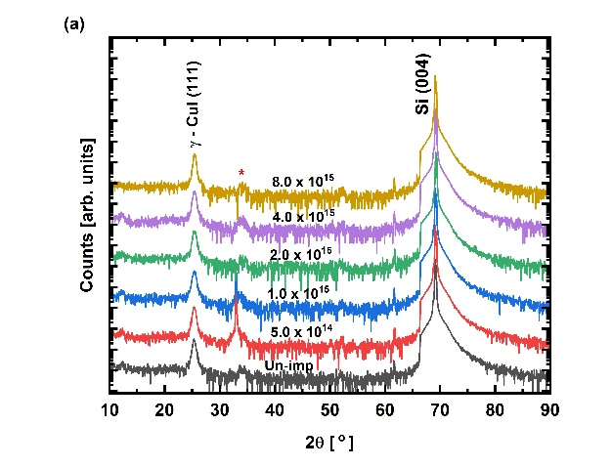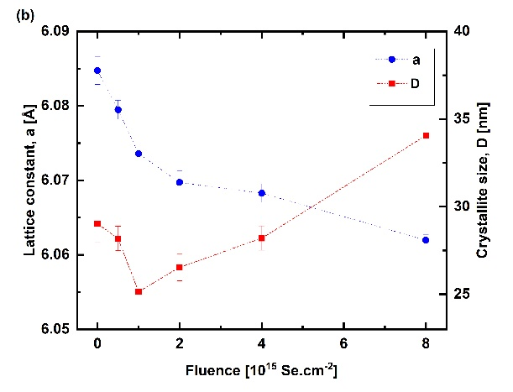
Figure 2: (a) XRD diffractograms of unimplanted and Se-implanted CuI films deposited on SiO₂/Si substrates; (b) lattice parameters and crystallite sizes associated with the CuI(111) reflection.
XTEM and HRTEM images were obtained to further elucidate the crystal structure and any changes in the microstructures upon Se implantation into the CuI film. Figure 3 shows representative XTEM, HRTEM and associated SAED patterns for unimplanted and 8.0 × 10¹⁵ Se⋅cm⁻² implanted films. The XTEM and HRTEM images show polycrystalline film growth. The SAED pattern from the selected HRTEM image for the unimplanted CuI film shows diffraction from $γ-CuI\left(111\right)$, $γ-CuI\left(20\overline{2}\right)$, and $γ-CuI\left(31\overline{1}\right)$, which further supports the fabrication of the γ-CuI phase. The lattice spacings for the $\left(111\right)$, $\left(20\overline{2}\right)$, and $\left(31\overline{1}\right)$ planes were estimated to be approximately 3.50 Å, 2.10 Å, and 1.80 Å, respectively. The SAED pattern for the 8.0 × 10¹⁵ Se⋅cm⁻² implanted film (Fig. 3f) showed similar diffraction planes, and no distinct changes in the lattice spacings were observed.

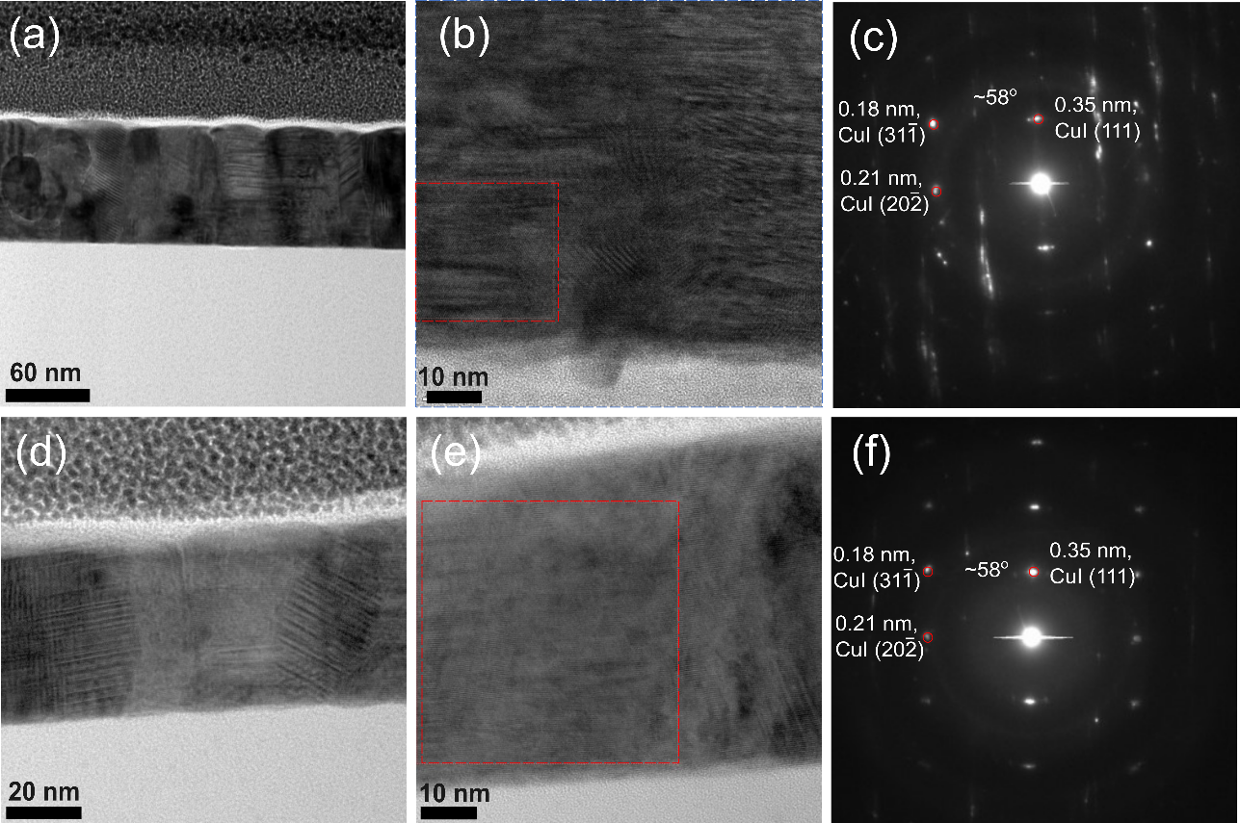
Figure 3: X-TEM, HRTEM and SAED patterns for (a)-(c) unimplanted CuI and (d-f) 8.0 × 10¹⁵ Se⋅cm⁻²-implanted CuI films.

Hall effect measurements and Seebeck effect measurements were performed to investigate the charge carrier transport properties of unimplanted and Se-implanted CuI films. All the films showed positive Hall coefficients, confirming a $p$-type conductivity. Figure 4a shows the Hall carrier density and Hall carrier mobility of unimplanted and Se-implanted CuI films. The Hall carrier density for the unimplanted film was found to be p_{H} ≈ 3.5 × 10¹⁹ cm⁻³. Se implantation led to a slight increase in the Hall carrier density for films implanted with ≤ 4.0 × 10¹⁵ Se⋅cm⁻² with a ~85% increase (p_{H} ≈ 6.5 × 10¹⁹ cm⁻³) in the 2.0 × 10¹⁵ Se⋅cm⁻² implanted film. For the highest fluence, 8.0 × 10¹⁵ Se⋅cm⁻², implantation led to nearly one order of magnitude increase in the Hall carrier density (p_{H} ≈ 1.4 × 10²⁰ cm⁻³). The carrier mobility for the unimplanted film was found to be µ_{H} ≈ 4.7 cm²V⁻¹s⁻¹, which is consistent with our previous studies [20, 39]. A progressive decrease in carrier mobility was observed in the Se-implanted films. It decreased by one order of magnitude to µ_{H} ≈ 0.6 cm²V⁻¹s⁻¹ in the film implanted with 8.0 × 10¹⁵ Se⋅cm⁻². A similar trend was observed in our previously reported S- and Te-doped CuI films, with a decrease in carrier mobility with increasing dopant concentration [33].
A varying carrier density and carrier mobility had a significant impact on the electrical conductivity and Seebeck coefficient, as shown in Fig. 4b. The electrical conductivity of the unimplanted film was found to be σ ≈ 26.8 Ω⁻¹cm⁻¹, which increased by ~34% to σ ≈ 36.1 Ω⁻¹cm⁻¹ in the film implanted with 5.0 × 10¹⁴ Se⋅cm⁻². However, for the films implanted with ≥ 1.0 × 10¹⁵ Se⋅cm⁻², there was a trade-off between carrier density and carrier mobility. The electrical conductivity decreased by ~46% to σ ≈ 14.4 Ω⁻¹cm⁻¹ in the 8.0 × 10¹⁵ Se⋅cm⁻² implanted film. Positive Seebeck coefficients were obtained for all the samples, corroborating the $p$-type conductivity observed in the Hall effect measurements. The Seebeck coefficient was found to be α ≈ 296.7 µVK⁻¹ for the unimplanted film. With a fluence ≤ 1.0 × 10¹⁵ Se⋅cm⁻², the Seebeck coefficient of the 2.0 × 10¹⁵ Se.cm⁻² implanted film progressively increased by ~36%, α ≈ 405.4 µVK-1. The highest Se implantation, 8.0 × 10¹⁵ Se.cm⁻², yielded the lowest Seebeck coefficient, α ≈ 244.7 µVK⁻¹. It is evident that Se implantation has a significant impact on the carrier transport properties, affecting their scattering mechanism and power factor (α²σ), which is discussed in the following section.
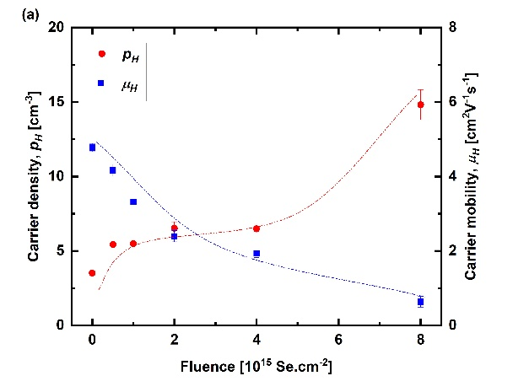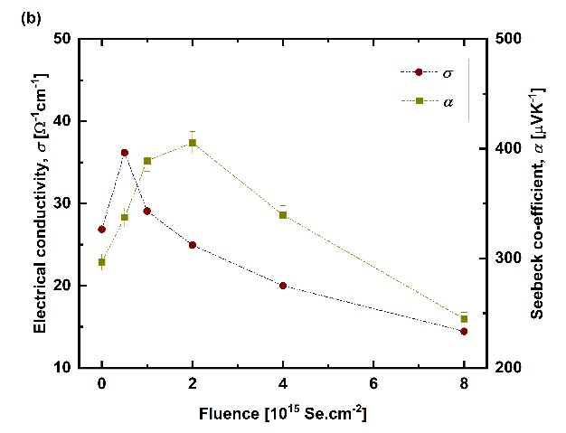
Figure 4: (a) Carrier density and carrier mobility, (c) electrical conductivity, and (d) Seebeck coefficient for Se-implanted CuI films deposited onto SiO₂/Si. Dotted lines are visual guides.

Temperature-dependent resistivity, ρ(T), measurements were carried out to estimate the activation energy (E_{A}) in the unimplanted and Se-implanted films. Figure 5a shows the temperature-dependent conductivity curves obtained for temperatures between 300 K and 220 K. The measurements were conducted using the 2-probe method, which may have contributed to the significant contact resistance observed during the PPMS measurements. It is evident that the films become more resistive at lower temperatures, which is a characteristic of semiconducting materials. In the high-temperature regime, near neighbor hopping (NNH) is considered the most likely mechanism for conduction in a disordered system [60, 61]. The electrical resistivity (ρ) can be written as
$$ρ(T)={ρ_{0}e}^{\left(\frac{E_{A}}{T}\right)}$$
where ρ₀ is the preexponential factor, and
E_{A} is activation energy associated with the characteristic temperature.
The inset in Fig. 5a shows a representative ρ(T) fit for an unimplanted CuI film in the temperature range 300–260 K, where NNH is the dominant conduction mechanism. The activation energy is estimated to be E_{A} ≈ 236.5 meV, as shown in Fig. 5b. This is similar to what has been reported for CuI PLD-grown CuI films, which showed an acceptor binding energy of 240 meV [31]. The E_{A} increased by ~11% (E_{A} ≈ 264.4 meV) and 8% (E_{A} ≈ 236.5 meV) for the 5.0 × 10¹⁴ Se.cm⁻² and 2.0 × 10¹⁵ Se.cm⁻² implanted films, respectively. However, the 8.0 × 10¹⁵ Se.cm⁻² implanted film showed a nearly 56% decrease in the activation energy (E_{A} ≈ 102.4 meV), likely due to shallower acceptor levels in the electronic band. This corroborated the Hall effect measurement, which showed almost one order of magnitude greater carrier density in the 8.0 × 10¹⁵ Se.cm⁻² implanted film.

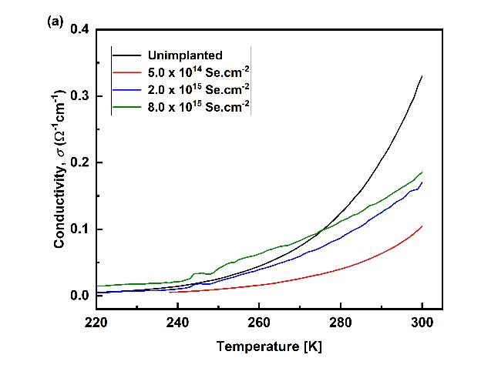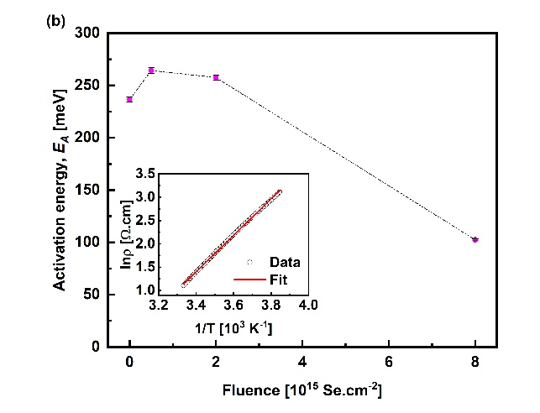
Figure 5: (a) Temperature-dependent conductivity (300–220 K) for unimplanted and Se-implanted CuI films. (b) Activation energy estimated from temperature-dependent resistivity curves fit between 300 K and 260 K. Inset: a representative ρ(T) fit for an unimplanted CuI film.

The Seebeck coefficient with respect to carrier concentration, also referred to as the Pisarenko relationship, was modeled by considering various scattering mechanisms. A dual parabolic band model was considered for this analysis with an effective mass of m_{hh} = 2.4m₀ and a light hole with a mass of m_{lh} = 0.3m₀. In the power law relaxation time approximation, the relaxation time is $τ=τ_{0}{\tilde{E}}^{r}$, where $\tilde{E}=E/k_{B}T$ is the reduced energy, k_{B} is Boltzmann’s constant, $τ_{0}$ is the relaxation time constant, and $r$ is determined by the dominant carrier scattering mechanism. Figure 9 shows plots for common carrier scattering mechanisms at room temperature, namely, ionized impurity scattering, II (r = 1.5); polar optical phonon scattering, POP (r = 0.5); and acoustic phonon scattering, AP (r = -0.5). The carrier density $p_{H}$ with an average contribution from both the light and heavy holes is given as
$$p_{H}=\frac{1}{2π^{2}}{\left(\frac{2m^{*}k_{B}T}{ℏ^{2}}\right)}^{3/2}F_{1/2}$$
where $ℏ$ ($ℏ=h/2π$) is the reduced Planck constant and $m^{*}$ is the effective mass. The Fermi integral $F_{s}$, in which ${\tilde{E}}_{F}=E_{F}/k_{B}T$ is the reduced Fermi energy and $E_{F}$ is the Fermi energy, is written as
$$F_{s}=\int_{\tilde{E}=0}^{\tilde{E}→+∞}{\frac{{\tilde{E}}^{s}}{e^{\tilde{E}-{\tilde{E}}_{F}}+1}}d\tilde{E}$$
The transport function α in terms of Fermi integrals is expressed as
$$α=\frac{k_{B}}{q}\left[\frac{\left(r+\frac{5}{2}\right)F_{r+\frac{3}{2}}}{\left(r+\frac{3}{2}\right)F_{r+\frac{1}{2}}}-{\tilde{E}}_{F}\right]$$
Figure 6 shows the Pisarenko relationship along with the calculated plots for various scattering mechanisms. It is evident that in the unimplanted CuI film, the dominant scattering mechanism is from the polar optical phonon method. However, upon Se implantation, the ionized impurity scattering mechanism dominates. This is consistent with previously reported various element-doped CuI where the scattering mechanism shifts toward ionized scattering upon doping [33].

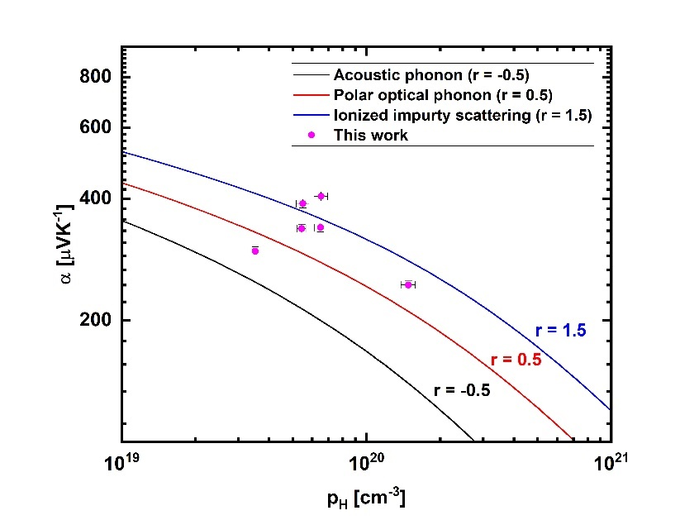
Figure 6: Seebeck coefficient-carrier density plot derived from Boltzmann transport theory for acoustic phonon scattering (r=-0.5), optical phonon scattering (r=0.5), ionized impurity scattering (r=1.5), and the Seebeck coefficient compared to experimental data.

The DPA was calculated to estimate changes in implantation-induced damage by taking into account multiple implantation parameters, such as the ion species, ion energy, fluence, and material density [62, 63]. DPA denotes the average number of times an atom from the CuI lattice is displaced during Se ion implantation. The DPA was calculated using the TRIM simulation tool considering the “detailed calculation with full damage cascade” mode. The DPA was calculated from the average number of collision events in the projected range in the CuI layer using the following equation:
$$DPA=\frac{F ×N_{D}}{N_{A}}$$
where F: fluence (ions.cm⁻²)
N_{D}: number of defects/Å.ion (#)
N_{A}: atomic density (atoms.cm⁻³)

Figure 7a shows the collision event plots for 30 keV ⁸⁰Se⁺ into the CuI layer. The DPA values were estimated using collision event values for the 70 nm projected range. The atomic density for CuI was calculated at N_{A} = 3.58 × 10²² atoms.cm⁻³ by assuming a material density of ρ = 5.67 g.cm⁻³. The DPA values ranged between 1.2 and 19.4 for fluences of 5.0 × 10¹⁴ Se.cm⁻² and 8.0 × 10¹⁵ Se.cm⁻². The power factor was plotted against DPA to determine the effect of Se implantation in the CuI films, as shown in Fig. 7b. The power factor for the unimplanted film (DPA = 0) was found to be α²σ ≈ 236.4 µW m⁻¹K⁻², which increased by ~85% to α²σ ≈ 439.7 µWm⁻¹K⁻² for the film with DPA = 2.4 (fluence = 1.0 × 10¹⁵ Se.cm⁻²). A further increase in the DPA value (DPA ≥ 4.9) led to a decrease in the power factor due to the trade-off between the electrical conductivity and Seebeck coefficient, as shown in Fig. 4. For the film showing the highest DPA = 19.4 (fluence = 8.0 × 10¹⁵ Se·cm⁻²), the power factor decreased by ~63% to α²σ ≈ 86.5 µWm⁻¹K⁻² due to the simultaneous decrease in electrical conductivity and Seebeck coefficient.

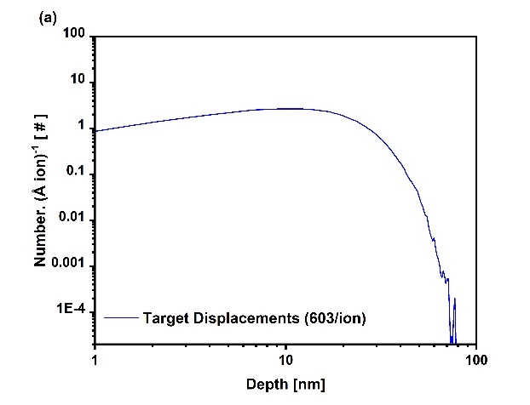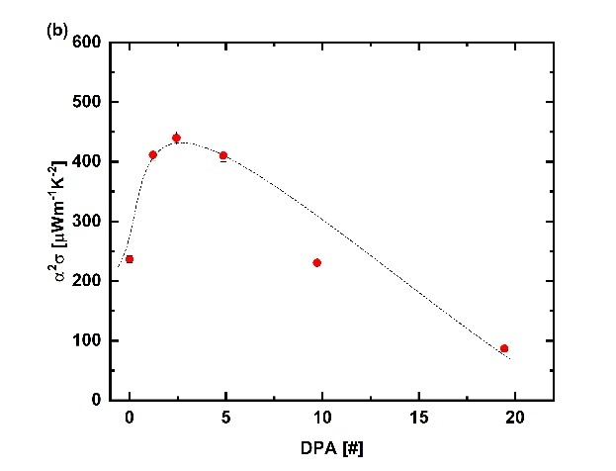
Figure 7: (a) TRIM calculation for collision events for 30 keV ⁸⁰Se⁺ into CuI and (b) power factor vs. displacement per atom (dotted line is a visual guide).

UV‒visible transmission measurements were employed to study the effect of Se implantation into CuI films. Figure 8a shows the transmission spectra for unimplanted and Se-implanted CuI films. All the films showed an average optical transparency above 60% in the visible range. Excitonic absorption (Z₁/Z₂) and related spin-orbit coupled transitions (Z₃) were observed at Z₁/Z₂ ≈ 3.08 eV and at Z₃ ≈ 3.69 eV, respectively. This observation is similar to that of Se-doped CuI films grown by PLD [31]. There is no distinct excitonic absorption feature in the 8.0 × 10¹⁵ Se.cm⁻² implanted film, unlike the rest of the films.
The optical bandgap (E_{g}) was estimated from the transmission spectra via Tauc’s plot and absorption coefficient fits. The Tauc plot was fitted using ${\left(α_{T}E\right)}^{n}=α_{0,T}\left(E-E_{g}\right)$, where α_{T} is the absorption coefficient written as $α_{T}=\frac{1}{z}\ln\left(1/T\right)$, E is the photon energy, z is the film thickness, T is the transmittance, and n is the exponent [64]. Figure 8b shows the estimated E_{g} values for unimplanted and Se-implanted CuI films. The optical bandgap for the unimplanted film was estimated to be E_{g} = 2.99 ± 0.01 eV. The Se implantation up to 4.0 × 10¹⁵ Se.cm⁻² slightly decreased to E_{g} = 2.95 ± 0.01 eV. However, the 8.0 × 10¹⁵ Se.cm⁻² implantation decreased the optical bandgap by ~10% to E_{g} = 2.68 ± 0.01 eV.

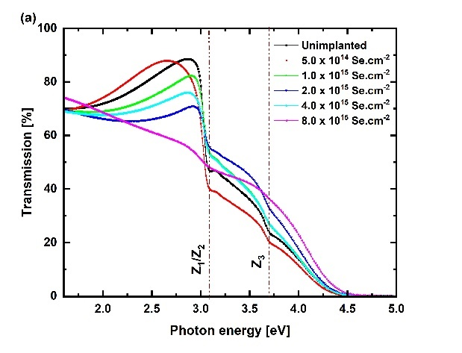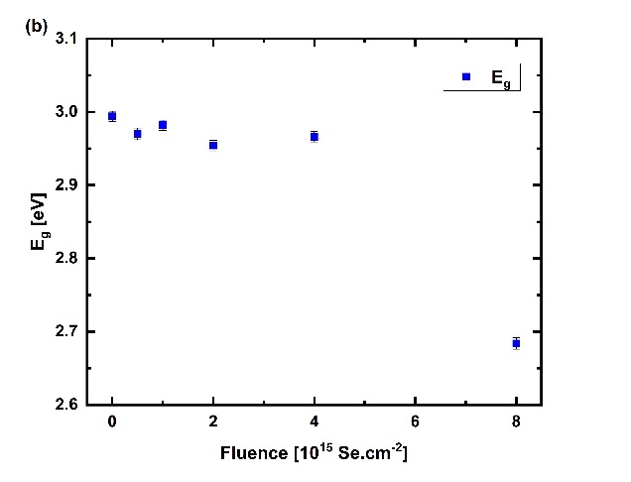
Figure 8: (a) UV‒visible transmission spectra and (b) optical bandgap energy (E_{g}) of unimplanted and Se-implanted CuI films deposited onto glass.

Ab initio density functional theory (DFT) calculations were performed to examine the effects of Se doping and defect formation. The formation energies of the V_{Cu}⁰ and Se_{I}⁰ defects are $0.5$ eV and $0.58$ eV under Cu-rich conditions, respectively, and the thermodynamic transitions to V_{Cu}⁻ and Se_{I}⁻ occur at $0.21$ eV and $0.37$ eV above the valence band edge, respectively; the results are summarized in Table I. This result is close to that of the PBE+$U$ Cu-rich condition of Huang et al. [65]. The PBE0 calculations of Graužinytė et al. [34] show thermodynamic transitions for the V_{Cu} defect at $0.28$ eV and the Se_{I} defect at $0.27$ eV. Their calculated Se_{I} defect (along with all other chalcogenides) directly transitions from a donor to an acceptor rather than through a neutral charge, implying that the chalcogenides are not ideal for $p$-type doping of CuI and could instead be used for Fermi energy pinning within the gap. They used PBE exchange-correlation functionals for geometric optimization and PBE0 to calculate the formation energies of those defects. Storm et al. [31] investigated the Se doping of CuI through pulsed laser deposition and reported an uncompensated activation energy of $0.24$ eV using a single parabolic band model with a low effective mass ($m_{eff}=0.3m_{0}$). Willis et al. [32] studied defects using the ShakeNBreak method with full hybrid functional geometric optimization and reported a V_{Cu} thermodynamic transition from neutral to negative at $0.24$ eV, which is in good agreement with previous investigations. These Se_{I} defects undergo two thermodynamic transitions rather than the direct positive-to-negative transition of Graužinytė et al. [34], the former occurring deep within the valence band and the latter occurring at $0.38$ eV above the valence band edge, close to our predicted energy of $0.37$ eV.
Since V_{Cu} defects are known to be abundant, we considered the possibility of forming a defect complex {V_{Cu}:Se_{I}}. We observed a thermodynamic transition from neutral to negative at $0.16$ eV above the valence edge, which is shallower than both the V_{Cu} and Se_{I} defects. This provides evidence that rather than Se_{I} providing a significant concentration of free carriers at room temperature, SeI enhances the doping efficiency of intrinsic defects, comparable to the doping calculations of CuI:Cs and Cu₂O:Na by Matsuzaki et al. [22]. The total energy of this defect complex is lower than the summed formation energy of the individual defects, suggesting that such defects are mutually stabilized. However, the second transition from negative to twice-negative is greatly lifted to $0.79$ eV above the valence band edge, indicating instability due to coulombic repulsion between the two ionized point defects. The formation energy diagram of the Cu-rich conditions in Fig. 9a and the Cu-poor conditions in Fig. 9b are shown for the individual defects and the defect complex. The in-gap region from the PBE+$U$ calculation was considered the range of possible Fermi energies for this work.

Table I: Defect formation energy and thermodynamic transition energy under Cu-rich ($Δμ_{Cu}=0$, $Δμ_{I}=ΔH_{CuI}$, $Δμ_{Se}=\frac{1}{2}ΔH_{{Cu}_{3}{Se}_{2}}$) and (b) Cu-poor ($Δμ_{Cu}=\frac{1}{3}ΔH_{{Cu}_{3}{Se}_{2}}$, $Δμ_{I}=ΔH_{CuI}-\frac{1}{3}ΔH_{{Cu}_{3}{Se}_{2}}$, $Δμ_{Se}=0$) conditions for the relevant defect charge states. The charge transitions are stated relative to the valence band edge $E_{V}$, where $ΔE_{F}=0$.
Defect | Cu-rich $ΔH_{D}^{q}$ [eV] | Cu-poor $ΔH_{D}^{q}$ [eV]
V_{Cu}⁰ | $$0.50$$ | $$0.25$$
V_{Cu}⁻ | $$0.71$$ | $$0.46$$
 | $$ε:\left(-,0\right)=E_{V}+0.21$$
Se_{I}⁰ | $$0.58$$ | $$0.42$$
Se_{I}⁻ | $$0.92$$ | $$0.76$$
 | $$ε:\left(-,0\right)=E_{V}+0.37$$
{V_{Cu}:Se_{I}}⁰ | $$1.00$$ | $$0.62$$
{V_{Cu}:Se_{I}}⁻ | $$1.16$$ | $$0.78$$
{V_{Cu}:Se_{I}}²⁻² | $$2.11$$ | $$1.73$$
 | $$ε:\left(-,0\right)=E_{V}+0.16$$
 | $$ε:\left(-2,1\right)=E_{V}+0.79$$

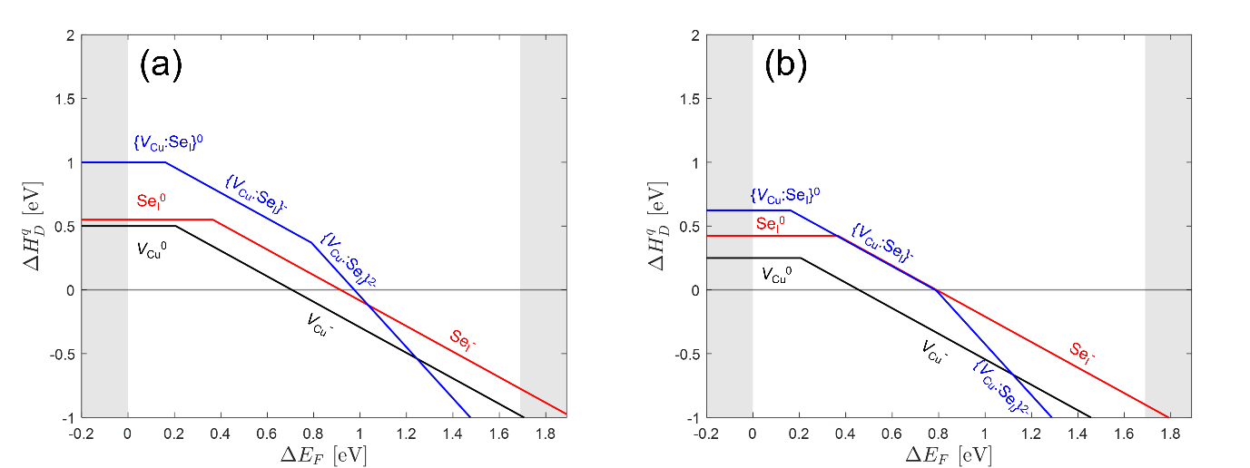
Figure 9: Defect formation energy diagram of CuI defects under (a) Cu-rich ($Δμ_{Cu}=0$, $Δμ_{I}=ΔH_{CuI}$, $Δμ_{Se}=\frac{1}{2}ΔH_{{Cu}_{3}{Se}_{2}}$) and (b) Cu-poor ($Δμ_{Cu}=\frac{1}{3}ΔH_{{Cu}_{3}{Se}_{2}}$, $Δμ_{I}=ΔH_{CuI}-\frac{1}{3}ΔH_{{Cu}_{3}{Se}_{2}}$, $Δμ_{Se}=0$) conditions.

To investigate the effects of Se_{I} and {V_{Cu}:Se_{I}} defects on the band structure, unfolded band structure diagrams and projected density of states diagrams are shown in Fig. 10a-b and Fig. 10c-d, respectively. It is important to note that the energy diagrams are aligned to the valence band maximum of the pristine system. The Se_{I} defect in Figure 10a appears to lift the valence band and provide localized states to CuI, as expected for a deep acceptor dopant. This disorder is hypothesized to manifest as reduced carrier mobility, as observed in our work and the work of Storm et al. [31]. The Fermi energy is within the Se_{I}-associated defect energy band. Considering the {V_{Cu}:Se_{I}} defect, the valence band is more obviously lifted than that of the Se_{I} defect, and the band structure disorder itself near these defects is quenched. This is a result of the shallower defect transition from neutral to negative with a more delocalized acceptor state than the isolated Se_{I} defect.

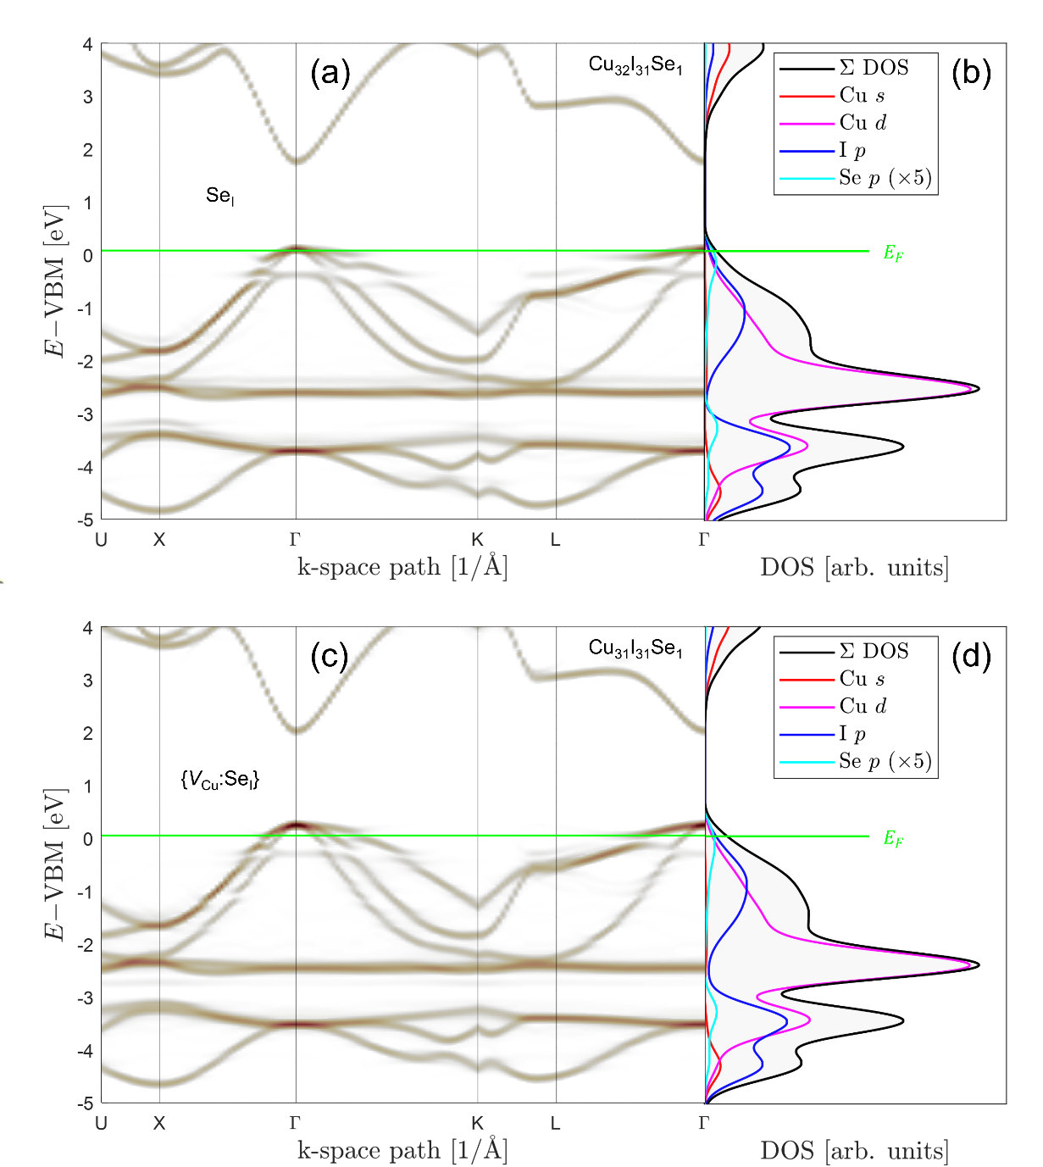
Figure 10: CuI with a Se_{I}⁰ supercell with a Cu₃₂I₃₁Se₁ stoichiometry: (a) unfolded band structure and (b) orbital-projected density of states. CuI with a {V_{Cu}:Se_{I}}⁰ supercell with a Cu₃₁I₃₁Se₁ stoichiometry; (c) unfolded band structure and (d) orbital-projected density of states. The Fermi energy is the green line for that isolated defect.
The doping of chalcogen elements (O, S, Se and Te) was predicted by Graužinytė et al. [34] to donate holes when they substitute for iodine in CuI. The substitution of S and Se with I was found to improve the carrier concentration via acceptor doping. Sulfur is the most investigated dopant element in CuI reported by various groups [27, 30, 29]. Only a limited number of studies on the Se doping of CuI have been reported [31, 32]. It was reported that Se has a low solubility (~ 1%) and introduces an acceptor state ~240 meV from the valence band [31]. Storm et al. [31] reported that an increase in the acceptor density upon Se doping decreased the activation energy. In our study, the 8.0 × 10¹⁵ Se.cm⁻² implanted film showed a one order of magnitude increase in the hole density (p_{H} ≈ 1.4 × 10²⁰ cm⁻³) and a 56% decrease in the activation energy (E_{A} ≈ 102.4 meV), likely due to shallower acceptor levels in the electronic band. Willis et al. [32] performed theoretical calculations on Se doped into CuI and reported that Se is a rather electronically inactive dopant. However, they predicted that Se doping enhances native defects such as V_{Cu,} which increases the hole density. Recently, Matsuzaki et al. [22] reported that Cs (an alkali element) dopant formed dopant-native defect complexes, which improved the hole density. The abovementioned studies support our observation of an increase in hole density upon Se doping in our CuI films. However, Se doping also modified the scattering mechanism from acoustic phonon scattering to ionized impurity scattering, which is commonly observed in moderate-to-heavily doped CuI [15, 10]. Electronic band structure calculations revealed that the {Se_{I}:V_{Cu}} defect complex acted as a shallow acceptor, which could be attributed to the enhanced hole density in the Se-doped CuI films. The displacements per atom calculated using the Transport of Ions in Matter simulation showed that a moderate level of DPA is beneficial for a high power factor owing to its moderate electrical conductivity and high Seebeck coefficient.

4. Conclusions
In summary, we report the microstructural, optical and electrical transport properties of Se-implanted CuI films. XRD, TEM, Hall and UV‒visible spectroscopy results showed the fabrication of highly textured and optically transparent $p$-type γ-CuI films. Se doping was performed by 30 keV ⁸⁰Se⁺ implantation with Se at% varying between 0.50% and 6.50% at ~17.8 nm below the surface layer. The XRD and TEM results showed a slight lattice relaxation upon Se implantation, with the lattice constant settling at a≈ 6.062 Å for CuI. Resistivity and Hall effect measurements showed an ~ 34% increase in electrical conductivity (σ ≈ 26.6 Ω⁻¹ cm⁻¹) due to an ~54% increase in carrier density (p_{H} ≈ 5.4 × 10¹⁹ cm⁻³) in the $p$-type γ-CuI film implanted with 5.0 × 10¹⁴ Se.cm⁻². A high Seebeck coefficient, α ≈ 388.9 µVK⁻¹, and moderate electrical conductivity, σ ≈ 29.1 Ω⁻¹ cm⁻¹, yield a nearly 85% increase in the power factor, α²σ ≈ 439.7 µWm⁻¹K⁻², for the 1.0 × 10¹⁵ Se.cm⁻² implanted film compared to the unimplanted film (α²σ ≈ 236.4 µWm⁻¹K⁻²). UV‒visible spectroscopy results showed a wide bandgap, E_{g} ≈2.99 eV, for the unimplanted film, which decreased to E_{g} ≈2.68 eV for the highest-Se fluence-implanted film. DPA calculated using TRIM showed that the highest power factor was observed for DPA ≈ 2.4. Electronic band structure and implantation-induced damage calculations revealed increased DPA values and that the Se_{I}-V_{Cu} defect complex acted as a shallow acceptor, which could be attributed to the enhanced hole density. Our study shows that controlled doping can be performed via ion implantation to manipulate native defects and defect complexes to achieve a high power factor in transparent CuI for thermoelectric applications.

CONFLICT OF INTEREST
The authors declare that there are no conflicts of interest.

Acknowledgments
This research was funded by the Royal Society of New Zealand through the Marsden Fund (grant number MFP-GNS2301). This project is supported by the Ministry of Business, Innovation and Employment New Zealand through the Materials for Low Carbon Future program (Strategic Science Investment Fund; grant number C05X1702) and the JST Mirai Program, Japan (grant number JPMJMI19A1). We thank Dr. Annette Koo at The Measurement Standards Laboratory of New Zealand for assistance with the UV‒visible spectrometer measurements.

CRediT authorship contribution statement
Peter P. Murmu: conceptualization, funding acquisition, data curation, investigation, methodology, formal analysis, writing – original draft and editing. Martin Markwitz: investigation, methodology, data curation, formal analysis, writing – editing and reviewing. Shen V. Chong: data curation, writing – review. Niall Malone: data analysis, writing – review. Himanshu Vyas: data curation, writing – review. L. John Kennedy: supervision, writing – review. Sergey Rubanov: data curation, writing – review. CI Sathish: data curation, writing – review. Jiabao Yi: supervision, writing – review. Takao Mori: funding acquisition, supervision, writing – review. John Kennedy: funding acquisition, supervision, writing – review.

References

[1] | D. Champier, "Thermoelectric generators: A review of applications," Energy conversion and management, vol. 140, pp. 167-181, 2017.
[2] | M. Hyland, H. Hunter, J. Liu, E. Veety and D. Vashaee, "Wearable thermoelectric generators for human body heat harvesting," Applied Energy, vol. 182, pp. 518-524, 2016.
[3] | K. Yu, Y. Zhou and Y. Liu, "Near-Room-Temperature Thermoelectric Materials and Their Application Prospects in Geothermal Power Generation," Geomechanics and Geophysics for Geo-Energy and Geo-Resources, vol. 6, p. 12, 2020.
[4] | X. Shi, J. Zou and Z. Chen, " Advanced thermoelectric design: from materials and structures to devices," Chemical reviews, vol. 120, no. 15, pp. 7399 - 7515, 2020.
[5] | G. Snyder and E. Toberer, "Complex thermoelectric materials," Nature materials, vol. 7, no. 2, pp. 105-114., 2008.
[6] | H. T. Liu, Q. Sun, Y. Zhong, Q. Deng, L. Gan, F. L. Lv, X. L. Shi, Z. G. Chen and R. Ang, "High-performance in n-type PbTe-based thermoelectric materials achieved by synergistically dynamic doping and energy filtering," Nano Energy, vol. 91, p. 106706, 2022.
[7] | L. Zhang, X. L. Shi, Y. L. Yang and Z. G. Chen, "Flexible thermoelectric materials and devices: From materials to applications," Materials today, vol. 46, pp. 62-108, 2021.
[8] | I. Petsagkourakis, K. Tybrandt, X. Crispin, I. Ohkubo, N. Satoh and T. Mori, "Thermoelectric materials and applications for energy harvesting power generation," Science and technology of advanced materials, vol. 19, no. 1, pp. .836-862, 2018.
[9] | W. Liu, J. Hu, S. Zhang, M. Deng, C. G. Han and Y. Liu, "New trends, strategies and opportunities in thermoelectric materials: A perspective," Materials Today Physics, vol. 1, pp. 50-60., 2017.
[10] | A. Liu, H. Zhu, M. Kim, J. Kim and Y. Noh, "Engineering copper iodide (CuI) for multifunctional p‐type transparent semiconductors and conductor," Advanced Science, vol. 8, no. 14, p. 2100546, 2021.
[11] | M. Grundmann, F. Schein, M. Lorenz, T. Böntgen, J. Lenzner and H. von Wenckstern, "Cuprous iodide - a p-type transparent semiconductor: History and novel applications," physica status solidi (a), vol. 210, no. 9, pp. 1671-1703, 2013.
[12] | A. Liu, H. Zhu, W. Park, S. Kim, H. Kim, M. Kim and Y. Noh, "High-performance p-channel transistors with transparent Zn doped-CuI," Nature Communications, vol. 11, no. 1, p. 4309, 2020.
[13] | N. Yamada, R. Ino, H. Tomura, Y. Kondo and Y. Ninomiya, "High-Mobility Transparent p-Type CuI Semiconducting Layers Fabricated on Flexible Plastic Sheets: Toward Flexible Transparent Electronics," Advanced Electronic Materials, vol. 3, no. 12, p. 1700298, 2017.
[14] | C. Yang, M. Kneiß, M. Lorenz and M. Grundmann, "Room-temperature synthesized copper iodide thin film as degenerate p-type transparent conductor with a boosted figure of merit," Proceedings of the National Academy of Sciences, vol. 133, no. 46, pp. 12929-12933, 2016.
[15] | C. Yang, D. Souchay, M. Kneiß, M. Bogner, H. Wei, M. Lorenz, O. Oeckler, G. Benstetter, Y. Fu and M. Grundmann, "Transparent flexible thermoelectric material based on non-toxic earth-abundant p-type copper iodide thin film," Nature communications, vol. 8, no. 1, p. 16076, 2017.
[16] | B. Morais Faustino, D. Gomes, J. Faria, T. Juntunen, G. Gaspar, C. Bianchi, A. Almeida, A. Marques, I. Tittonen and I. and Ferreira, "CuI p-type thin films for highly transparent thermoelectric pn modules," Scientific reports, vol. 8, no. 1, p. 6867, 2018.
[17] | J. Wang, J. Li and S. Li, "Native p-type transparent conductive CuI via intrinsic defects," Journal of Applied Physics, vol. 110, no. 5, p. 054907, 2011.
[18] | G. Dalapati, H. Sharma, A. Guchhait, N. Chakrabarty, P. Bamola, Q. Liu, G. Saianand, A. Krishna, S. Mukhopadhyay, A. Dey and T. Wong, "Tin oxide for optoelectronic, photovoltaic and energy storage devices: a review," Journal of materials chemistry A, vol. 9, no. 31, pp. 16621-16684, 2021.
[19] | M. Markwitz, S. Y. Back, E. X. M. Trewick, P. P. Murmu, T. Mori, B. J. Ruck and J. V. Kennedy, "Quasilinear Kane conduction band model in nitrogen-doped indium tin oxide," Physical Review B, vol. 109, p. 115201, 2024.
[20] | P. P. Murmu, V. Karthik, Z. Liu, V. Jovic, T. Mori, W. Yang, K. Smith and J. Kennedy, "Influence of carrier density and energy barrier scattering on a high Seebeck coefficient and power factor in transparent thermoelectric copper iodide," ACS Applied Energy Materials, vol. 3, no. 10, pp. 10037-10044, 2020.
[21] | M. Almasoudi, A. Saeed, N. Salah, A. Alshahrie, P. Hasan, A. Melaibari and K. Koumoto, "CuI: a promising halide for thermoelectric applications below 373 K," ACS Applied Energy Materials, vol. 5, no. 8, pp. 10177-10186, 2022.
[22] | K. Matsuzaki, N. Tsunoda, Y. Kumagai, Y. Tang, K. Nomura, F. Oba and H. Hosono, "Hole-Doping to a Cu (I)-Based Semiconductor with an Isovalent Cation: Utilizing a Complex Defect as a Shallow Acceptor," Journal of the American Chemical Society, vol. 144, no. 36, pp. 16572-16578, 2022.
[23] | M. Taunk, S. Kumar, A. Aherwar and Y. Seo, "Doping-induced structural and optical modifications in γ-CuI nanocrystals," Journal of Physics and Chemistry of Solids, vol. 184, p. 111703, 2024.
[24] | J. Zhu, M. Gu and R. Pandey, "Structural and electronic properties of CuI doped with Zn, Ga and Al," Journal of Physics and Chemistry of Solids, vol. 74, no. 8, pp. 1122-1126, 2013.
[25] | S. Kumar, M. Battabyal, K. Sethupathi and D. Satapathy, " Thermoelectric properties of Ag-doped CuI: a temperature dependent optical phonon study," Physical Chemistry Chemical Physics, vol. 24, no. 39, pp. 24228-24237, 2022.
[26] | N. Salah, A. Abusorrah, Y. Salah, M. Almasoudi, N. Baghdadi, A. Alshahri and K. Koumoto, "Effective dopants for CuI single nanocrystals as a promising room temperature thermoelectric material," Ceramics International, vol. 46, no. 17, pp. 27244-27253, 2020.
[27] | K. Ahn, G. Kim, S. Kim, J. Kim, G. Ryu, P. Lee, B. Ryu, J. Cho, Y. Kim, J. Kang, Y. Noh and M. Kim, "Highly Conductive p-Type Transparent Conducting Electrode with Sulfur-Doped Copper Iodide," Chemistry of Materials, vol. 34, no. 23, pp. 10517--10527, 2022.
[28] | A. S. Mirza, M. Pols, W. Soltanpoor, S. Tao, G. Brocks and M. Morales-Masis, "The role of sulfur in sulfur-doped copper (I) iodide p-type transparent conductors," Matter, vol. 6, no. 12, pp. 4306-4320, 2023.
[29] | P. P. Murmu, J. Kennedy, Z. Liu and T. Mori, "The role of sulfur valency on thermoelectric properties of sulfur ion implanted copper iodide," Journal of Alloys and Compounds, vol. 921, no. 1, p. 166103, 2022.
[30] | F. Geng, Y. Wu, D. Splith, L. Wang, X. Kang, X. Chen, P. Guo, S. Liang, L. Yang, M. Lorenz and M. Grundmann, "Amorphous Transparent Cu(S,I) Thin Films with Very High Hole Conductivity," The Journal of Physical Chemistry Letters, vol. 14, no. 26, pp. 6163-6169, 2023.
[31] | P. Storm, M. S. Bar, S. Selle, H. von Wenckstern, M. Grundmann and M. Lorenz, "p-Type Doping and Alloying of CuI Thin Films with Selenium," Physica Status Solidi (RRL), vol. 15, no. 8, p. 2100214, 2021.
[32] | J. Willis, R. Claes, Q. Zhou, M. Giantomassi, G. M. Rignanese, G. Hautier and D. O. Scanlon, "Limits to Hole Mobility and Doping in Copper Iodide," Chemistry of Materials, vol. 35, no. 21, pp. 8995-9006, 2023.
[33] | M. Markwitz, P. P. Murmu, S. Back, T. Mori, B. Ruck and J. Kennedy, "Effect of grain boundary scattering on carrier mobility and thermoelectric properties of tellurium incorporated copper iodide thin films," Journal of Surfaces and Interfaces, 2023.
[34] | M. Graužinytė, S. Botti, M. A. Marques, S. Goedecker and J. A. Flores-Livas, "Computational acceleration of prospective dopant discovery in cuprous iodide," Physical Chemistry Chemical Physics, vol. 21, no. 35, pp. 18839-18849, 2019.
[35] | P. P. Murmu, S. V. Chong, J. Storey, S. Rubanov and J. Kennedy, "Secondary phase induced electrical conductivity and improvement in thermoelectric power factor of zinc antimonide films," Materials Today Energy, vol. 13, pp. 249-255, 2019.
[36] | J. Leveneur, J. Kennedy, G. V. M. Williams, J. Metson and A. Markwitz, "Large room temperature magnetoresistance in ion beam synthesized surface Fe nanoclusters on SiO2," Applied Physics Letters, vol. 98, no. 5, p. 053111, 2011.
[37] | J. Biersack, "Computer simulations of sputtering," Nuclear Instruments and Methods in Physics Research Section B: Beam Interactions with Materials and Atoms, vol. 27, no. 1, pp. 21-36, 1987.
[38] | J. Ziegler, M. Ziegler and J. Biersack, "SRIM–The stopping and range of ions in matter (2010)," Nuclear Instruments and Methods in Physics Research Section B: Beam Interactions with Materials and Atoms, vol. 268, no. 11-12, pp. 1818-1823, 2010.
[39] | P. Murmu, V. Karthik, S. Chong, S. Rubanov, Z. Liu, T. Mori, J. Yi and J. Kennedy, "Effect of native defects on thermoelectric properties of copper iodide films," Emergent Materials, vol. 4, no. 1, pp. 761-768, 2021.
[40] | P. Hohenberg and W. Kohn, "Inhomogeneous electron gas," Physical Review, vol. 136, no. 38, p. B864, 1964.
[41] | W. Kohn and L. J. Sham, "Self-consistent equations including exchange and correlation effects," Physical Review, vol. 140, p. A1133, 1965.
[42] | P. Giannozzi, S. Baroni, N. Bonini, M. Calandra, R. Car, C. Cavazzoni, D. Ceresoli, G. L. Chiarotti, M. Cococcioni, I. Dabo and others, "QUANTUM ESPRESSO: a modular and open-source software project for quantum simulations of materials," Journal of Physics: Condensed Matter, vol. 21, no. 39, p. 395502, 2009.
[43] | P. Giannozzi, O. Andreussi, T. Brumme, O. Bunau, M. B. Nardelli, M. Calandra, R. Car, C. Cavazzoni, D. Ceresoli, M. Cococcioni and others, "Advanced capabilities for materials modelling with Quantum ESPRESSO," Journal of Physics: Condensed Matter, vol. 29, no. 46, p. 465901, 2017.
[44] | P. Giannozzi, O. Baseggio, P. Bonfà, D. Brunato, R. Car, I. Carnimeo, C. Cavazzoni, S. De Gironcoli, P. a. F. R. F. Delugas and others, "Quantum ESPRESSO toward the exascale," The Journal of Chemical Physics, vol. 152, no. 15, p. 154105, 2020.
[45] | G. Kresse and D. Joubert, "From ultrasoft pseudopotentials to the projector augmented-wave method," Physical Review B, vol. 59, no. 3, p. 1758, 1999.
[46] | J. P. Perdew, K. Burke and M. Ernzerhof, "Generalized gradient approximation made simple," Physical Review Letters, vol. 77, no. 18, p. 3865, 1996.
[47] | A. Dal Corso, "Pseudopotentials periodic table: From H to Pu," Computational Materials Science, vol. 95, pp. 337-350, 2014.
[48] | H. J. Monkhorst and J. D. Pack, "Special points for Brillouin-zone integrations," Physical Review B, vol. 13, no. 12, p. 5188, 1976.
[49] | P. V. C. Medeiros, S. Stafström and J. Björk, "Effects of extrinsic and intrinsic perturbations on the electronic structure of graphene: Retaining an effective primitive cell band structure by band unfolding," Physical Review B, vol. 89, p. 041407(R), 2014.
[50] | P. V. C. Medeiros, S. S. Tsirkin, S. Stafström and J. Björk, "Unfolding spinor wave functions and expectation values of general operators: Introducing the unfolding-density operator," Physical Review B, vol. 91, p. 041116(R), 2015.
[51] | M. Iraola, J. L. Mañes, K. H. Bradlyn, T. Neupert, M. G. Vergniory and S. S. Tsirkin, "IrRep: Symmetry eigenvalues and irreducible representations of ab initio band structures," Computer Physics Communications, vol. 272, p. 108226, 2022.
[52] | S. Dudarev, G. Botton, S. Savrasov, C. Humphreys and A. Sutton, "Electron-energy-loss spectra and the structural stability of nickel oxide: An LSDA+U study," Physical review B, vol. 57, no. 3, p. 1505, 1998.
[53] | S. Lany and A. Zunger, "Anion vacancies as a source of persistent photoconductivity in II-VI and chalcopyrite semiconductors," Physical Review B, vol. 72, no. 3, p. 035215, 2005.
[54] | S. Lany and A. Zunger, "Dopability, intrinsic conductivity, and nonstoichiometry of transparent conducting oxides," Physical Review Letters, vol. 98, no. 4, p. 045501, 2007.
[55] | S. Lany and A. Zunger, "Assessment of correction methods for the band-gap problem and for finite-size effects in supercell defect calculations: Case studies for ZnO and GaAs," Physical Review B, vol. 78, no. 23, p. 235104, 2008.
[56] | R. Hanson, J. Hallberg and C. Schwab, "Elastic and piezoelectric constants of the cuprous halides," Applied Physics Letters, vol. 28, pp. 964-966, 1972.
[57] | D. Ahn, J. D. Song, S. S. Kang, J. Lim, S. H. Yang, S. Ko, S. H. Park, S. J. Park, D. S. Kim, H. J. Chang and J. Chang, "Intrinsically p-type cuprous iodide semiconductor for hybrid light-emitting diodes," Scientific Reports, vol. 10, no. 1, p. 3995, 2020.
[58] | P. Storm, M. S. Bar, G. Benndorf, S. Selle, C. Yang, H. Von Wenckstern, M. Grundmann and M. Lorenz, " High mobility, highly transparent, smooth, p-type CuI thin films grown by pulsed laser deposition," APL Materials, vol. 8, no. 9, p. 091115, 2020.
[59] | P. Darnige, Y. Thimont, L. Presmanes and A. Barnab{\'e}, "Insights into stability, transport, and thermoelectric properties of transparent p-type copper iodide thin films," Journal of Materials Chemistry C, vol. 11, no. 2, pp. 630-644, 2023.
[60] | D. K. Kaushik, M. Selvaraj, S. Ramu and A. Subrahmanyam, "Thermal evaporated Copper Iodide (CuI) thin films: A note on the disorder evaluated through the temperature dependent electrical properties," Solar Energy Materials and Solar Cells, vol. 165, pp. 52-58, 2017.
[61] | A. Bhogra, A. Masarrat, R. Meena, D. Hasina, M. Bala, C. L. Dong, C. L. Chen, T. Som, A. Kumar and A. Kandasami, "Tuning the electrical and thermoelectric properties of N ion implanted SrTiO3 thin films and their conduction mechanisms," Scientific reports, vol. 9, no. 1, p. 14486, 2019.
[62] | A. Mahendra, P. P. Murmu, S. Acharya, A. Islam, H. Fiedler, P. Gupta, S. Granville and J. Kennedy, "Role of interface intermixing on perpendicular magnetic anisotropy of cobalt-iron-boron alloy," Applied Physics A, vol. 129, no. 7, p. 500, 2023.
[63] | R. Burcea, J. F. Barbot, P. O. Renault, D. Eyidi, T. Girardeau, M. Marteau, F. Giovannelli, A. R. J. M. Zenji, S. Dilhaire and P. Eklund, "Influence of generated defects by Ar implantation on the thermoelectric properties of ScN," ACS Applied Energy Materials, vol. 5, no. 9, pp. 11025-11033, 2022.
[64] | O. V. Rambadey, A. Kumar, A. Sati and P. R. Sagdeo, "Exploring the interrelation between Urbach energy and dielectric constant in Hf-substituted BaTiO3," ACS omega, vol. 6, no. 47, pp. 32231-32238, 2021.
[65] | D. Huang and Y. Zhao, "First-principles study of γ-CuI for p-type transparent conducting materials," Journal of Physics D: Applied Physics, vol. 45, no. 14, p. 145102+07, 2012.

Highlights
- Selenium doping into CuI via ion implantation
- Increased hole density in the Se-implanted CuI films
- DFT calculations showed that the Se-native defect complexes were shallow acceptors
- The highest power factor was observed for the film with DPA = 2.4

