Fermi energy modulation by tellurium doping of thermoelectric copper(I) iodide
Martin Markwitz^{1,2,3}, Peter P. Murmu², Song Yi Back⁴, Takao Mori^{4,5}, John V. Kennedy^{2,3}, Ben Ruck^{1,3}
¹School of Chemical and Physical Sciences, Victoria University of Wellington, PO Box 600, Wellington 6140, New Zealand
²National Isotope Centre, GNS Science, PO Box 30368, Lower Hutt 5010, New Zealand
³The MacDiarmid Institute for Advanced Materials and Nanotechnology, Victoria University of Wellington, PO Box 600, Wellington 6140, New Zealand
⁴International Center for Materials Nanoarchitectonics (WPI-MANA), National Institute for Materials Science (NIMS), 1-1 Namiki, Tsukuba, Ibaraki 305-0044, Japan
⁵Graduate School of Pure and Applied Science, University of Tsukuba, 1-1-1 Tennodai, Tsukuba, Ibaraki 305–8671, Japan
Corresponding author: m.markwitz@gns.cri.nz

Abstract
There is a current lack of commercial $p$-type counterpart to state of the art $n$-type transparent conductors. Copper (I) iodide (CuI) is the leading $p$-type candidate, attracting major attention for promising electrical conductivities, partially by chalcogenide doping (O, S, Se, Te). Such improvements lead to promising future integration of CuI in transparent electronic devices such as thermoelectric generators, thin film transistors, and a hole transport layer in perovskite solar cells. The role of chalcogenide doping in CuI is to improve the carrier concentration in CuI, however, the effect of tellurium is yet to be explored in heavily $p$-type doped CuI. In this work we investigate the role of tellurium in heavily intrinsically doped $p$-type CuI. We report the effects of tellurium doping (up to $2.4$ % Te) in CuI thin films and study the variation in electrical properties of the material. The point defects introduced by ion implantation; the method used to introduce the tellurium led to a progressive reduction in the films’ work functions from $4.9$ eV to $4.5$ eV. This effect has major repercussions on the other measured electrical properties, such as the electrical conductivity, which is decreased by 3 orders of magnitude, while the Seebeck coefficient is increased by $80$ %. We conduct density functional theory calculations to help explicate the effect of tellurium doping on the valence band structure of CuI. Consequently, this work shows that the Fermi energy in heavily $p$-type doped CuI can be readily tuned by Te doping.
Keywords: Transparent conductor, copper iodide, Fermi energy, point defects, chalcogenide, tellurium, implantation

1 Introduction
Transparent conductors are technological important materials for electronics and energy applications. Designing and fabricating materials which are both transparent and conductive is becoming increasingly important for the development of fully transparent electrodes, heterojunction diodes, thin film transistors, transparent thermoelectric generators, amongst other applications with high potential uptake. All these applications require both p- and n-type semiconductors for electronic device designing which remains an active pursuit in transparent electronics. The conductivity of $p$-type transparent conducting materials are lacking compared to their $n$-type counterparts, In₂O₃:Sn, SnO₂:F, and ZnO:Al/Ga, and possessing electrical conductivities of up to ${10}^{4}$ Scm⁻¹. The $p$-type transparent conductors which are garnering the most interest to fill this market gap are based delafossites (i.e., CuAlO₂), layered oxychalcogenides (i.e., LaCuOS:Sr), and the lone-standing cuprous iodide (CuI) [1]. To achieve high mobility in $p$-type Cu-based transparent semiconductors, a highly disperse valence band with a low carrier effective mass is essential.
CuI is a wide band gap semiconductor $E_{G}>3$ eV with the zincblende lattice structure for which conducting thin films can be grown without the need for high temperature treatment [2]. Although discovered in 1907 by Bädeker, only recently it has re-kindled attention as a promising $p$-type semiconductor for transparent electronic applications [2]. Yang et al. [3] showed that CuI possesses simultaneously a high optical transparency ($>70$ %) and electrical conductivity ($>{10}^{2}$ Scm⁻¹) which places it in a league of its own compared to other materials of its class. The high electrical conductivity of CuI stems from a high concentration of copper vacancies (V_{Cu}) which provide defect states near the valence band edge and minimally distort the host matrix [4]. The electrical carrier mobility of polycrystalline CuI thin films presented in much published research is limited to $∼10$ cm²V⁻¹s⁻¹, and carrier concentrations are limited to $∼1.5×{10}^{20}$ cm⁻³ [5]. This limits the laboratory-electrical conductivity of CuI thin films to $∼250$ Scm⁻¹. Single crystal growth has shown the capability for a high mobility of $43.9$ cm²V⁻¹s⁻¹ to be achieved in CuI [6]. Heavy doping of CuI eventually leads to carrier mobilities limited by carrier scattering. There is promising potential for mobilities up to $32.6$ cm²V⁻¹s⁻¹ to be reachable with a carrier concentration of $1×{10}^{20}$ cm⁻³, revealing the ultimate intrinsic conductivities of $522$ Scm⁻¹. Achieving electrical conductivities beyond the ${10}^{3}$ Scm⁻¹ scale requires Fermi level tuning by extrinsic doping with optimized crystal growth, advancing carrier concentration and carrier mobility, respectively. Theoretically, the copper vacancy has been identified as the dominating acceptor defect, firstly, due to its shallow neutral-to-ionized thermodynamic transition $ϵ\left(-/0\right)$, and secondly, due to the absence of competing donor defects, the dominant of which are Cu_{i}, and V_{I}, the copper interstitial and iodine vacancy, respectively [2, 7, 8, 9]. This places the Fermi energy at the precipice of the valence band. Advancing of the Fermi energy (E_{F}) into the valence band can provide improvements in electrical conductivity, along with resulting in metallic-like temperature-dependent electrical conductivity in CuI. The converse can also be useful: retarding E_{F} from the valence band can suppress the thermal activation of carriers and provide electrically insulating behaviour. The Fermi energy is an important degree of freedom which can be accessed by tuning growth conditions and doping, having significant implications on the electrical properties of the semiconductor host [10]. Such Fermi level tuning has been used to successfully control the properties of transparent conducting Cu_{1-x}Cr_{1+x}O₂ [11], In₂O₃:Sn/N [12], and thermoelectric ScN:Mg [13]. To use CuI as an energy material, methods for readily tuning its Fermi energy to suit device application must be discovered. The efficacy of dopants in CuI is, however, limited by their solubility limit in the host, and the tendency to provide compensating defects. Excessive doping commonly leads to worsening carrier mobility and carrier concentration due to some combination of these effects [14, 15].
To achieve doping without significantly affecting the crystal grain structure, ion implantation is the preferred method as it can deposit a precise concentration of an extrinsic dopant into a host matrix. The choice of dopants is therefore of utmost importance, and through theoretical investigations, CuI has been found to be $p$-type dopable with chalcogens (O, S, Se, Te) when they are substituted onto the iodine site [16]. Among these, S is currently the most-explored $p$-type dopant for CuI, showing significant improvements in electrical conductivity compared to undoped CuI which leads to an increasing electrical conductivity of up to $∼500$ Scm⁻¹ [17, 18, 19]. O is also a known $p$-type dopant for CuI, and exposure to atmosphere is known to provide a significant effect on the measurable electrical properties [20, 21]. Alloying Se with CuI resulted in $p$-type doping therein while incorporating either Se or Te at elevated concentrations ($>5$ at %) affected the crystallization of the CuI films [22, 14]. Such an effect was ascribed to the solubility limit of those dopants in CuI, which greatly affected the mobility of those films. This work uses ion implantation to introduce Te into CuI thin films, remaining in the chemical doping regime rather than the alloying regime. We unravel the chemical effect of Te in CuI and how it can be used to tune the position of the Fermi energy for $p$-type CuI.
This paper presents the variation in electronic properties of sputtered CuI thin films implanted with tellurium at a range of fluences within the doping regime ($<2.4$ % Te). Electrical, chemical, and optical measurements indicate the introduction of compensating donors and the disordering of the valence band, leading to a simultaneous reduction in Hall carrier concentration and mobility. Density functional theory calculations showed significant disordering of the CuI valence band maximum, and a tellurium-on-iodine (Te_{I}) thermodynamic defect transition energy $0.58$ eV above the valence band edge which corroborated the decrease in carrier concentration and mobility due to Fermi-level shift deeper into the band gap and disordered the valence band.

2 Material and methods

2.1 Synthesis
Copper iodide thin films were deposited onto 10 × 10 mm² soda-lime microscope glass, sapphire, and 500 nm thermally oxidized silicon substrates (SiO₂/Si) using ion beam sputtering at room temperature. Prior to sputter deposition the substrates were ultrasonically cleaned in acetone, followed by ethanol, then deionized water, for 15 minutes each. The sputtering was conducted in a high-vacuum system at a base pressure of ~2×10⁻⁷ mbar using a 16 keV Ar⁺ ion beam with a beam current of 0.15 mA impinging on a commercial CuI sputter target. The CuI sputter target was angled at 45° and the catchers at 60° as described in reference to maximize their sputter yield [14]. Tellurium acceleration energies of 65 keV (R_{P}=26 nm) were used for in the GNS Science low-energy ion implanter [23]. The implantation energy was identified by TRIM-Dynamic (T-DYN), a Monte-Carlo ion implantation code based on binary collision approximation to provide the best distribution of Te within the films by a single implantation, displayed in Figure S1(a) [24]. The implantation fluences used in this work were 5×10¹⁴ Te cm⁻², 1×10¹⁵ Te cm⁻², 2×10¹⁵ Te cm⁻², and 3×10¹⁵ Te cm⁻², leading to peak tellurium concentrations at R_{p} of $0.6$ %, $1.2$ %, $1.8$ %, and $2.4$ %, respectively. A schematic of the main defect (Te_{I}) within the unit cell of CuI generated by implantation is drawn in Figure S1(b). The samples were implanted with beam current densities less than 1 μAcm⁻² to avoid sample heating and self-annealing.

2.2 Structural characterization
Rutherford backscattering spectrometry (RBS) with the detector placed at 165° relative to the incident 2 MeV ⁴He⁺ beam was used to identify the stoichiometry and extract the thicknesses of the CuI thin films implanted with Te [25]. The resultant RBS data is included in Figure S1(c) and the stoichiometry of ([I]+[Te])/[Cu] is included as Figure S1(d). Optical film properties (visible transmittance, band gap, and Urbach energy) were measured with a Perkin Elmer Lambda 365 spectrophotometer from 300 to 1100 nm. X-ray diffraction (XRD) was performed for structure identification of the deposited and implanted films. The out-of-plane lattice constants and crystallite sizes were measured with θ/2θ diffraction geometry using a Rigaku SmartLabs diffractometer with a non-monochromated Cu X-ray source (main wavelengths 1.54059 Å and 1.54432 Å). Ultraviolet photoelectron spectroscopy (UPS) was employed to measure the sample work functions (Φ) and was conducted with a He UV source (21.2 eV) with an ESCALAB250Xi. The electron take-off angle was 90° from the film surface, and a 5 V measurement bias applied to the stage during measurement. X-ray photoelectron spectroscopy (XPS) was conducted with an ESCALAB250Xi using an Al K α₁ X-ray source (1486.68 eV) [12]. For all samples the C 1s core level was aligned to 289.5-Φ [26]. The XPS data was analysed with CasaXPS following the copper-associated curve fitting processes as by Biesinger [27]. Topographical measurements were conducted with NanoSurf FlexAFM atomic force microscope (AFM) in the tapping mode, the resultant data analysed by Gwyddion software for each film shown in Figure S2 [28].

2.3 Carrier transport characterization
Gold contacts were ion beam sputtered onto the corners of the CuI films for Hall effect measurements to acquire the samples’ electrical conductivity, carrier concentration, and carrier mobility [14]. The measurements were conducted with a Ecopia HMS-3000 Hall probe system using van der Pauw contact geometry with a magnetic field of 0.55 T. The Seebeck coefficient of the films was measured using a ZEM-3 series ULVAC measurement system at room temperature as in references [29, 30, 18]. The error in the HMS-3000 derived values is 5 % while the ZEM-3 derived measurement errors is 6 %.

2.4 Theoretical calculations
Plane augmented wave (PAW) DFT calculations were conducted with Quantum ESPRESSO [31, 32, 33]. The PBE functional was used as the exchange-correlation functional at the GGA level [34]. Band unfolding was performed with banduppy [35, 36, 37]. Ultrasoft pseudopotentials by Dal Corso used in this work [38]. A 6×6×6 Γ-centred Monkhorst-Pack mesh [39] with a wave-function kinetic energy cutoff of 60 Ry (816 eV) was used to converge the electronic structure calculations to within 1 meV atom⁻¹ of the 8-atom cubic unit cell of CuI. The pressures were relaxed to below 0.5 Pa and forces to within 5 meVÅ⁻¹. A 64-atom cubic supercell with the suitable image charge correction techniques (potential alignment via the deep I 5s orbitals and Makov-Payne point charge correction) has been known to lead to defect level convergence closely to the dilute defect limit, and is the correction method used in this work [40, 41, 42]. In accordance with the convergence of the unit cell, a 3×3×3 Γ-centred Monkhorst-Pack grid was used for all supercell calculations.
A rotationally invariant ortho-atomic Hubbard parameter $U_{eff}=U-J=3.9$ eV was applied to the Cu 3d orbital manifold as introduced by Dudarev et al. [43] to match the profile of the upper valence band density of states to the valence band spectrum measured with XPS. Tellurium was substituted onto the copper and iodine sites (Te_{I}, Te_{Cu}) to study the relative formation energies of each defect. Incorporating one tellurium substitution in the 64-atom supercell leads to a stoichiometry of Cu₁I_{0.97}Te_{0.03} or Cu_{0.97}I₁Te_{0.03}, which corresponds to a tellurium atomic concentration of 1.5 %, within the range of dopant concentrations as by ion implantation.

3 Results and discussion
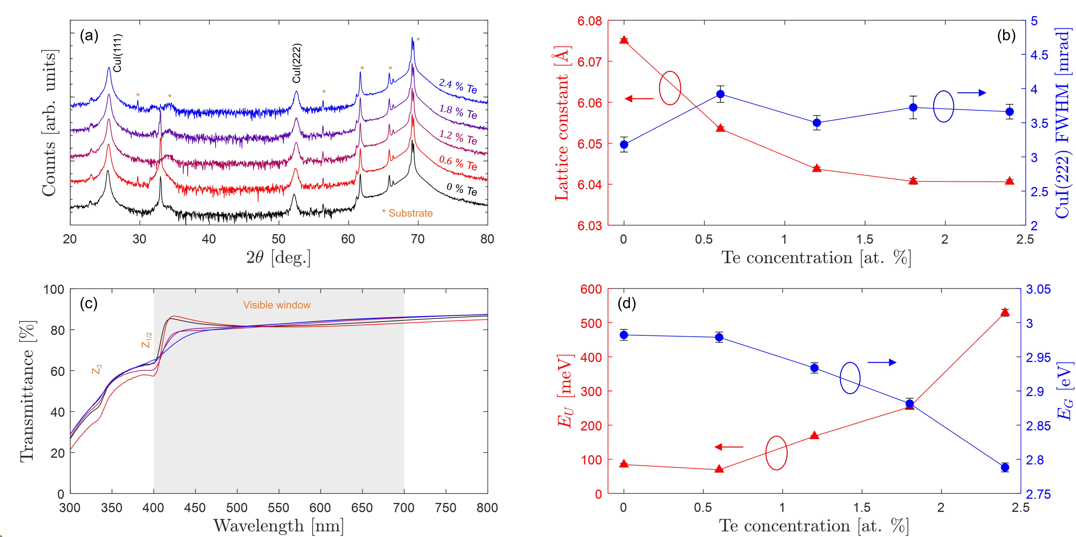
FIG. 1: (Color online) (a) θ-2θ XRD patterns of Te implanted CuI films on Si substrates. Data are vertically offset for visual clarity. (b) Variation of calculated out-of-plane film properties: lattice constant (red, left) and FWHM (blue, right). (c) UV-Visible transmittance spectra with highlighted visible region and Z_{1/2} and Z₃ optical transitions. (d) Variation of calculated Urbach (red, left) and band gap (blue, right) energies.

XRD measurements in Figure 1a showed that the deposited and implanted films are comprised highly textured CuI by the exclusive presence of the CuI(111) and CuI(222) peaks present in the measured data. Additionally, many substrate peaks associated with the Si(004) substrate are also visible. The out-of-plane lattice constant and peak FWHM were extracted from the CuI(222) peaks, the data shown in Figure 1b. The samples showed a steady reduction in lattice constant from 6.075±0.001 Å to 6.041±0.001 Å, as calculated with Bragg’s law after conducting curve-fitting of split pseudo-Voigt functions to each CuI-attributed peak within MATLAB. The reduction in lattice constant is attributed to strain relaxation through the collision cascade and excludes the possibility for high concentrations of interstitial formation in CuI. The lack of FWHM variation (which stays in the range of 3-4 mrad) implies that the crystallite sizes were minimally varied by the implantation. We interpret that tellurium is incorporated in the CuI lattice structure (not interstitially) by these observations forming point defect sites. AFM measurements were performed to observe variations in surface roughness by implantation. The data is shown in Figure S2(a-e) for the respective fluences explored in this work. Figure S2(f) is the variation in surface roughness which shows an increase from $1.5±0.1$ nm to $7.4±0.1$ nm.
Figure 1c shows the UV-Visible transmittance spectra, showing that all films possess high visible transmittance. The average visible transmittance of the samples ranges is $81±1$ % and does not vary by the fluences used in this work. Variation of the band gap energy was observed, investigated further by calculating the Urbach and direct band gap energy. The Urbach energy determines the absorption onset slope and is related to energetic disorder of the band edges in structurally disordered semiconductors. The unimplanted film shows excitonic absorption features Z_{1/2} at 3.05 eV and Z₃ at 3.68 eV, while absorption is suppressed due to the disordering of the valence band maximum [22]. Below the fundamental gap energy, the absorption coefficient varies exponentially through the expression $α_{T}=α_{0,U}e^{\left(E-E_{1}\right)/E_{U}}$ wherein $E$ is the photon energy, $α_{0,U}$ and $E_{1}$ are fitting parameters, $E_{U}$ is the Urbach energy, and $α_{T}=\frac{1}{z}\ln\left({\left(1-R\right)}^{2}/T\right)$ is the energy-dependent absorption coefficient with the approximation $R≪1$, where $z$ is the film thickness, $T$ is the transmittance, and $R$ is the reflectance. Figure 1e shows the Tauc plot, evaluating the abscissa of the linear fit to the absorption coefficient above the fundamental gap energy. The fitted expression is ${\left(α_{T}E\right)}^{n}=α_{0,T}\left(E-E_{G}\right)$ in which $n$ is the type of optical gap ($n=2$ for direct band gap semiconductors such as CuI), and $α_{0,T}$ is a fitting coefficient, and $E_{G}$ is the band gap [14]. The Urbach and Tauc plot fits are shown in Figure S3a and Figure S3b, respectively. The Urbach energy varies from $79±2$ meV to $529±10$ meV suggesting a significant increase in band disorder by tellurium implantation [44]. Interestingly, the Urbach energy of the undoped sample is close to the exciton binding energy in CuI ($58$ meV) [15]. The band gap evaluated through the Tauc plot method varies greatly between $2.99±0.01$ eV and $2.79±0.01$ eV, indicating the introduction of states above the valence band maximum. The undoped sample possessed a band gap close to reported literature values ($3.0$ eV) [29]. The reduction in the Tauc direct band gap and increase in Urbach energy is interpreted as electronic disorder provided by point defect substitution in tellurium undoped CuI thin films.
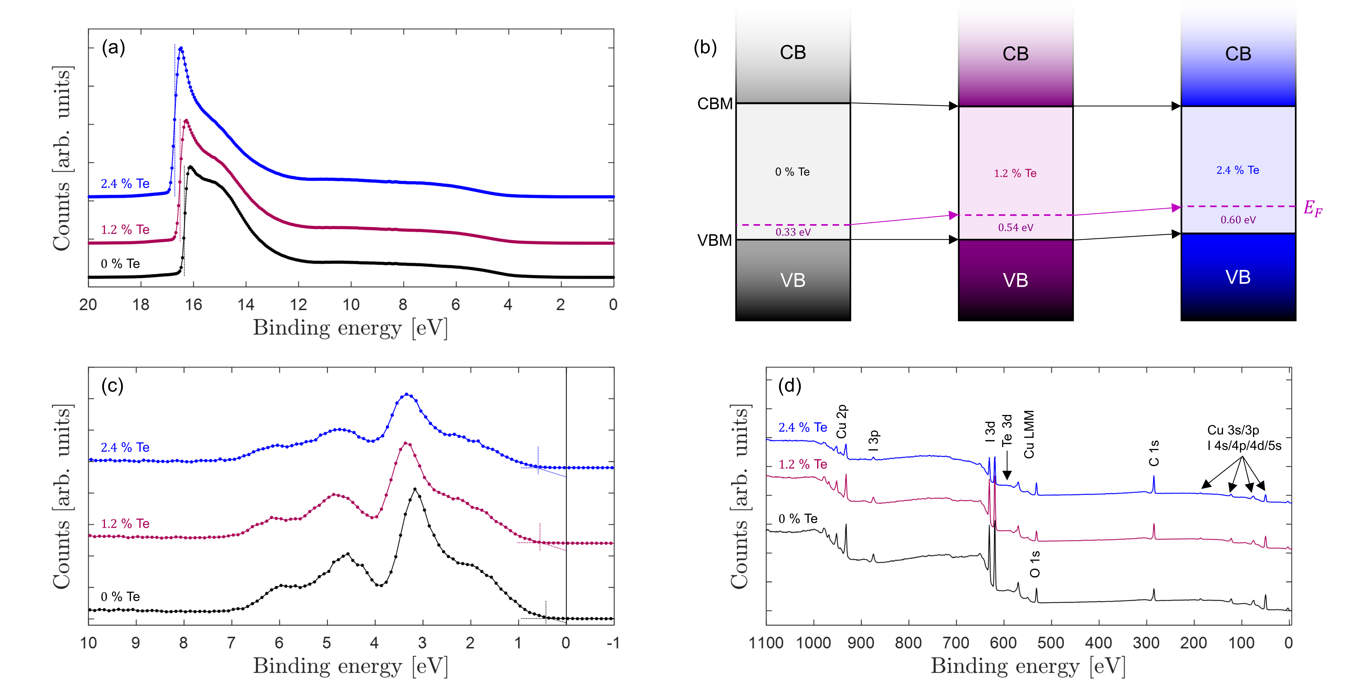
FIG. 2: (Color online) (a) UPS survey spectra. (b) Band alignment diagrams showing that the Fermi energy becomes increasingly spaced from the valence band in the samples. (c) High resolution XPS valence band spectra. (d) XPS survey spectra. Data are vertically offset for visual clarity.
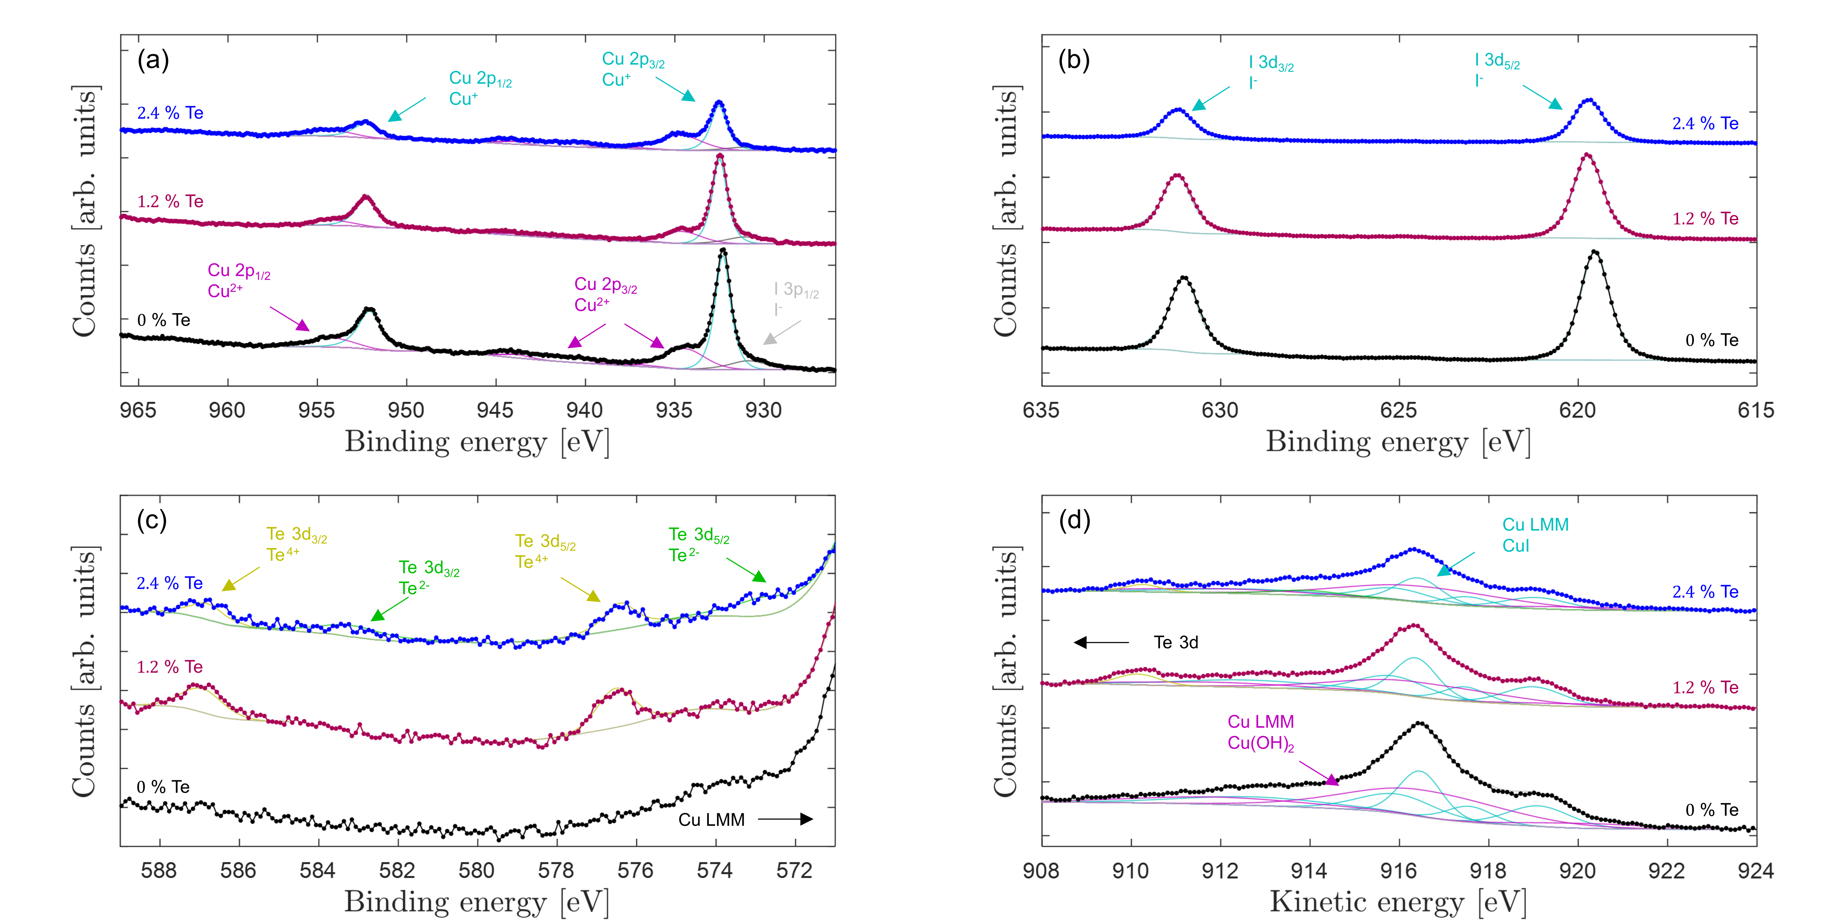
FIG. 3: (Color online) High resolution XPS (a) Cu 2p core level, (b) I 3d core level, (c) Te 3d core level, and (d) Cu LMM auger electron peak. Data are vertically offset for visual clarity.
Continuing, we carried out UPS measurements to measure the work function study the variation in band alignment in CuI by Te implantation. Figure 2(a) shows the UPS survey spectra, from which the work function was evaluated by finding the binding energy of the secondary electron cutoff. The work function varied from $4.9±0.1$ eV for the undoped sample, to $4.7±0.1$ eV for the $1.2$ % Te sample, to $4.5±0.1$ eV for the $2.4$ % Te sample. Using XPS, the valence bands were studied of each sample, the binding energy scale aligned as previously mentioned. Figure 3(b) shows the band alignment diagram of the films. The spacing between the valence band edge and Fermi energy increased continuously from $0.33$ eV for the undoped sample to $0.54$ eV for the $1.2$ % Te sample to $0.60$ eV for the $2.4$ % Te sample. The ionization energy was measured to be $5.23$ eV for the undoped sample, $5.24$ eV for the $1.2$ % Te sample, and $5.10$ eV for the $2.4$ % Te sample. The electron affinities of the samples were then calculated by subtracting the band gaps from the ionization energies, finding $2.25$ eV for the undoped sample, $2.31$ eV for the $1.2$ % Te sample, and $2.31$ eV for the $2.4$ % Te sample. The ionization energy reduces while the electron affinity remains almost unchanged. This indicates that the implantation mainly causes disorder to the valence band while leaving the conduction band unaffected. XPS survey spectra are reported in Figure 2(d) which show dominating presence of Cu and I with some contribution from adventitious C and O. Tellurium cannot be observed in the survey spectrum due to overlap with the Cu LMM Auger electron peak.
To observe the presence of tellurium and to investigate its chemical environment (along with the environments of the other chemical species), high resolution core level XPS measurements were conducted on the Cu 2p, I 3d, Te 3d, and Cu LMM core levels, shown in Figure 3(a), Figure 3(b), Figure 3(c), and Figure 3(d), respectively. The C 1s and O 1s spectra showing features associated with the adventitious hydrocarbon species are depicted in Figure S4. Figure 3(a) shows Cu 2p_{3/2} and Cu 2p_{1/2} features associated with Cu⁺ and Cu²⁺ (due to the presence of satellite peaks), along with the I 3p_{1/2} core associated with the I⁻ state. The spacing of the Cu 2p_{3/2} and Cu 2p_{1/2} peaks is $19.75$ eV by spin orbit coupling. The Cu 2p_{3/2} peak positions are $932.3±0.1$ eV for the undoped film and $932.5±0.1$ eV for the tellurium doped samples which we attribute to Cu⁺ in the CuI chemical environment in agreement with other literature reports [27]. Cu²⁺ states associated with the Cu(OH)₂ chemical environment, the main peak situated at $934.5±0.1$ eV for the undoped sample and $934.7±0.1$ eV for both Te doped samples are also observed [27]. Considering the I 3d core level, the I 3d_{5/2} and I 3d_{3/2} states separated by $10.5$ eV are shown in Figure 3(b). The position of the I 3d_{5/2} state is $619.5±0.1$ eV for the undoped film and $619.7±0.1$ eV for both Te doped films. This peak is attributed to iodine in CuI [27]. The undoped sample does not show the presence of tellurium, whilst the other samples report features associated with the Te 3d_{5/2} and Te 3d_{3/2} core levels, shown in Figure 3(c). Due to the convolution of these spectra with the Cu LMM auger electron peaks displayed in Figure 3(d) the spectral regions were processed simultaneously. CuI and Cu(OH)₂ chemical states were assumed for the Cu LMM curve fitting with peak spacings, FWHM, and relative heights. Overall, the peak area ratio between the CuI and Cu(OH)₂ and fits resulted in a percentage ratios of CuI:Cu(OH)₂ of $60$:$40$ as per the Cu 2p core level fits. The Te 3d_{5/2} and Te 3d_{3/2} core levels were spaced by $10.4$ eV, realizing a Te⁴⁺ chemical state at$576.5±0.1$ eV in the $1.2$ % Te sample. A Te⁴⁺ chemical state was observed in the $2.4$ % Te sample at $576.4±0.1$ eV along with a Te²⁻ feature at $572.8±0.1$ eV. The Te⁴⁺ chemical state within the surface layer of the film can be attributed to the formation of TeO₂, and the Te²⁻ chemical state can be attributed to the presence of Cu₂Te [45]. The Cu LMM spectra peak fits showed peak positions at electron kinetic energies of $916.4±0.1$ eV for CuI and $916.6±0.1$ eV for Cu(OH)₂ in the undoped sample leading to a modified Auger energy of $1848.7±0.2$ eV for CuI and $1851.1±0.2$ eV for Cu(OH)₂ [27]. The doped samples showed Cu LMM Auger electron kinetic energies for CuI at $916.3±0.1$ eV for both samples, and Cu LMM Auger electron kinetic energies for Cu(OH)₂ at $916.4±0.1$ eV, and $916.5±0.1$ eV, respectively. The modified Auger energies of the implanted samples are within error of the unimplanted sample.
Considering the electrical and thermoelectric measurements, the unimplanted film showed an electrical conductivity and Seebeck coefficients of $61±3$ Scm⁻¹ and $196±12$ μVK⁻¹, respectively. The Seebeck coefficient remained positive for all implanted samples. Such results are in line with our previous reports of as-deposited CuI films. Conducting Hall effect measurements provide a single-band approximated Hall carrier concentration of $4.5×{10}^{19}±0.3×{10}^{19}$ cm⁻³ and a carrier mobility of $8.4±0.5$ cm²V⁻¹s⁻¹. The Hall coefficients for all films was always positive, in agreement with the $p$-type carrier conduction as found by the films’ Seebeck coefficients. Implanting tellurium led to a significant reduction in electrical conductivity of up to three orders of magnitude to $0.042±0.002$ Scm⁻¹ mainly due to a major reduction in Hall carrier concentration by two orders of magnitude to $0.024×{10}^{19}±0.005×{10}^{19}$ cm⁻³ and reduction Hall mobility of close to one order of magnitude to $1.5±0.3$ cm²V⁻¹s⁻¹. It is possible that the sample roughness influences the electrical conductivity of the films [46]. The Seebeck coefficient increased nearly by a factor of two to $354±21$ μVK⁻¹. Annealing Cu_{1-x}Cr_{1+x}O₂ at varying temperatures also provided a significant tunability in carrier concentration, and carrier mobility, similar to the presented data [11]. The $2.4$ % Te doped sample had electrical properties which were out of the range of measurement for our equipment. The data of the measurable samples is summarized in Table 1. The reduction in Hall carrier concentration is indicative of distancing of the Fermi energy relative to the valence band maximum, in good agreement with the observed trend in Figure 2b. Figure 4 the plots the resultant Seebeck coefficient against the Hall carrier concentration, showing a significant departure from the expected relationship by Boltzmann transport theory. This is indicative of a major departure of the Fermi energy from the valence band of CuI, corroborated also by the significant reduction in carrier mobility.
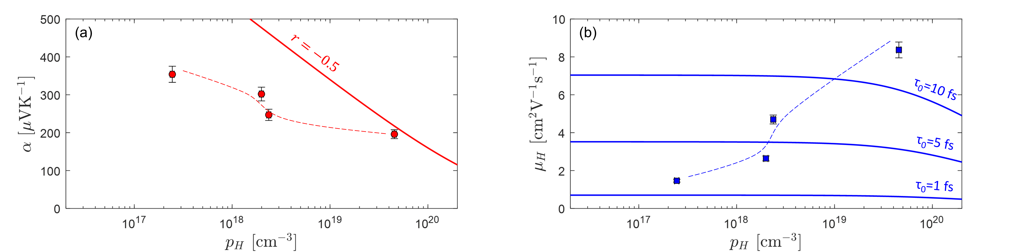
FIG. 4: (Color online) (a) Plots of Seebeck coefficient and (b) Hall carrier mobility against Hall carrier concentration. Boltzmann transport theory for acoustic phonon scattering ($r=-1/2$) shows significant deviation of experimental data from theoretical curve. Varying scattering time constants ($τ_{0}$) show the significant variation in carrier mobility. Dashed lines are used to guide the eye.
Table 1: Summary of room temperature electrical measurement data on tellurium doped CuI thin films over a range of concentrations.
F [×10¹⁵ Te cm⁻²] | Te % at R_{p} | p_{H} [×10¹⁹ cm⁻³] | μ_{H} [cm²V⁻¹s⁻¹] | σ [Scm⁻¹] | α [μVK⁻¹]
$$0$$ | 0 | $$4.5±0.3$$ | $$8.4±0.5$$ | $$61±3$$ | $$196±12$$
$$0.5$$ | 0.6 | $$0.24±0.02$$ | $$4.7±0.3$$ | $$1.8±0.1$$ | $$247±15$$
$$1$$ | 1.2 | $$0.20±0.02$$ | $$2.6±0.3$$ | $$0.79±0.04$$ | $$302±18$$
$$2$$ | 2.4 | $$0.024±0.005$$ | $$1.5±0.3$$ | $$0.042±0.002$$ | $$354±21$$

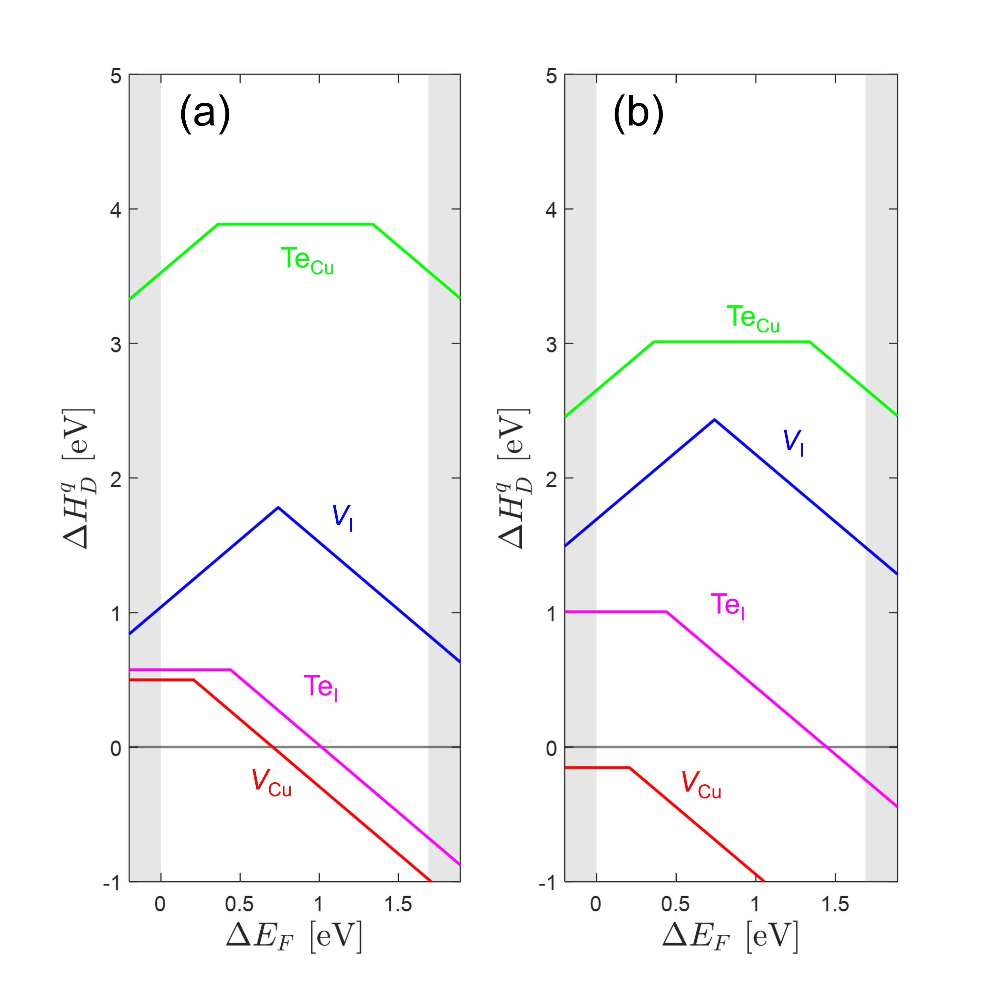
FIG. 5: (Color online) Defect formation energy diagram of tellurium substitutional and intrinsic vacancy defects of CuI in (a) Cu-rich ($Δμ_{Cu}=0$, $Δμ_{I}=ΔH_{CuI}$, $Δμ_{Te}=ΔH_{CuTe}$) and (b) Cu-poor ($Δμ_{Cu}=ΔH_{CuI}$, $Δμ_{I}=0$, $Δμ_{Te}=0$) growth conditions.

To study the effect of Te doping in electronic structure of CuI in more detail, DFT calculations were conducted. We consider tellurium substitutional defects (Te_{Cu} and Te_{I}) along with the intrinsic vacancy defects (V_{Cu} and V_{I}), each over a range of charge states (-, 0, +). The lattice constant of the pristine supercell is $6.1355$ Å, greater than the powder value of $6.054$ Å by $1.35$ %, and the calculated band gap is $1.69$ eV, that gap being adopted for the defect formation energy diagram. We calculate defect formation energy diagrams as discussed in the computational methods section, the results shown in Figure 5a and Figure 5b which depict Cu-rich and Cu-poor growth conditions, respectively. The preferred defect charge states at the valence band edge are V_{Cu}⁰, V_{I}⁺, Te_{Cu}⁺, Te_{I}⁰, data summarized in Table 2. The lattice constant variation of the V_{Cu}⁰ and V_{I}⁺ defects provide lattice constant shifts of $-0.18$ % and $-0.53$ %, respectively, and the Te_{Cu}⁻ and Te_{I}⁰ defects provide lattice constant variation of $-0.23$ % and $-0.05$ %, respectively. The overall reduction in lattice constant by production of point defects is in good agreement with XRD measurement. Interstitial chalcogenides are known to possess even greater defect formation energies [16], and are thus not further considered in this work. The copper vacancy (V_{Cu}) provides a deep acceptor thermodynamic transition at $0.21$ eV above the band edge, in good agreement with other calculations [7, 16]. The iodine vacancy (V_{I}) is a donor defect near the valence band, with $ε\left(-/+\right)$ at $0.74$ eV above the valence band edge. The tellurium substitutional defects strongly prefer the iodine site when the Fermi energy is at the valence band edge regardless of chemical potential. This is due to the relative defect formation energy $0.58$ eV (Te_{I}) and $3.53$ eV (Te_{Cu}) in Cu-rich conditions, and $1.00$ eV (Te_{I}) and $2.65$ eV (Te_{Cu}) in Cu-poor conditions, in good agreement with Ref. [16]. The Te_{Cu} defect is a donor when the Fermi energy is close to the valence band and neutralizes $0.44$ eV above the band edge, which would provide n-type doping in CuI. The Te_{I} defect provides a deep acceptor level which transitions from neutral to negative at $0.36$ eV above the valence band edge [7]. It is unlikely, therefore, that tellurium can be useful as a $p$-type dopant in already heavily doped $p$-type CuI. To study the effects of the dominant point defects (V_{Cu}⁰ and Te_{I}⁰) on the carrier bands, the unfolded band structure and orbital-projected density of states of those defects are calculated.
Table 2: Percentage variation of the lattice parameter relative to the undoped supercell and defect formation energy in Cu-rich and Cu-poor conditions for the relevant defect charge states. The charge transitions are stated relative to the valence band edge $E_{V}$ where $ΔE_{F}=0$.
Defect | $Δa$ [%] | Cu-rich $ΔH_{D}^{q}$ [eV] | Cu-poor $ΔH_{D}^{q}$ [eV]
V_{Cu}⁰ | $$-0.18$$ | $$0.50$$ | $$-0.15$$
V_{Cu}⁻ | $$-1.18$$ | $$0.71$$ | $$0.06$$
 |  | $$ε:\left(-/0\right)=E_{V}+0.21$$
V_{I}⁺ | $$-0.04$$ | $$1.04$$ | $$1.69$$
V_{I}⁻ | $$-0.53$$ | $$2.52$$ | $$3.17$$
 |  | $$ε:\left(-/+\right)=E_{V}+0.74$$
Te_{Cu}⁺ | $$0.76$$ | $$3.53$$ | $$2.65$$
Te_{Cu}⁰ | $$-0.23$$ | $$3.89$$ | $$3.01$$
 |  | $$ε:\left(0/+\right)=E_{V}+0.36$$
Te_{I}⁰ | $$-0.06$$ | $$0.58$$ | $$1.00$$
Te_{I}⁻ | $$-0.99$$ | $$1.02$$ | $$1.44$$
 |  | $$ε:\left(-/0\right)=E_{V}+0.44$$

The V_{Cu}⁰ unfolded band structure and orbital-projected density of states are shown in Figure 6a and Figure 6b, respectively. The Fermi energy is moved into the valence band, and minimal band disordering is introduced, identified by the lack of band blurring within the unfolded band structure diagram. Figure 6c and 6d shows the unfolded band structure and orbital-projected density of states of the supercell including the Te_{I}⁰ defect. Significant band disorder is introduced by the Te_{I} defect, and the Fermi energy is placed within the separated section of the valence band from the rest of the structure [47]. The orbital-projected density of states diagram shows that the contribution to the band edge of the valence band is now dominated by Te 5p states. These states are flat within $k$-space which implies orbital localization in real space. As such, the Te 5p states are interpreted to poorly hybridise with the valence band. Localized disturbances in the band structure act as scattering centres, which can reduce the carrier lifetime, and by extension, the carrier mobility.
Point defects provide important effects on the location of the Fermi energy relative to the band edges, the resulting transport properties, and these effects are interwoven with the structural properties as compared to the unimplanted samples [13, 48]. The controlled annealing of $p$-type Cu_{1-x}Cr_{1+x}O₂ led to the suppression of free carriers by the distancing of the Femi energy from the valence band, along with an increase in Seebeck coefficient, similarly to our results [11]. For the band-degenerated $n$-type ITO compensated with nitrogen doping, the Fermi energy was tuned towards the valence band, again reducing the carrier concentration and increasing the Seebeck cofficient [12]. Mg-doping ScN provided a shift of the Fermi energy towards the valence band [13].
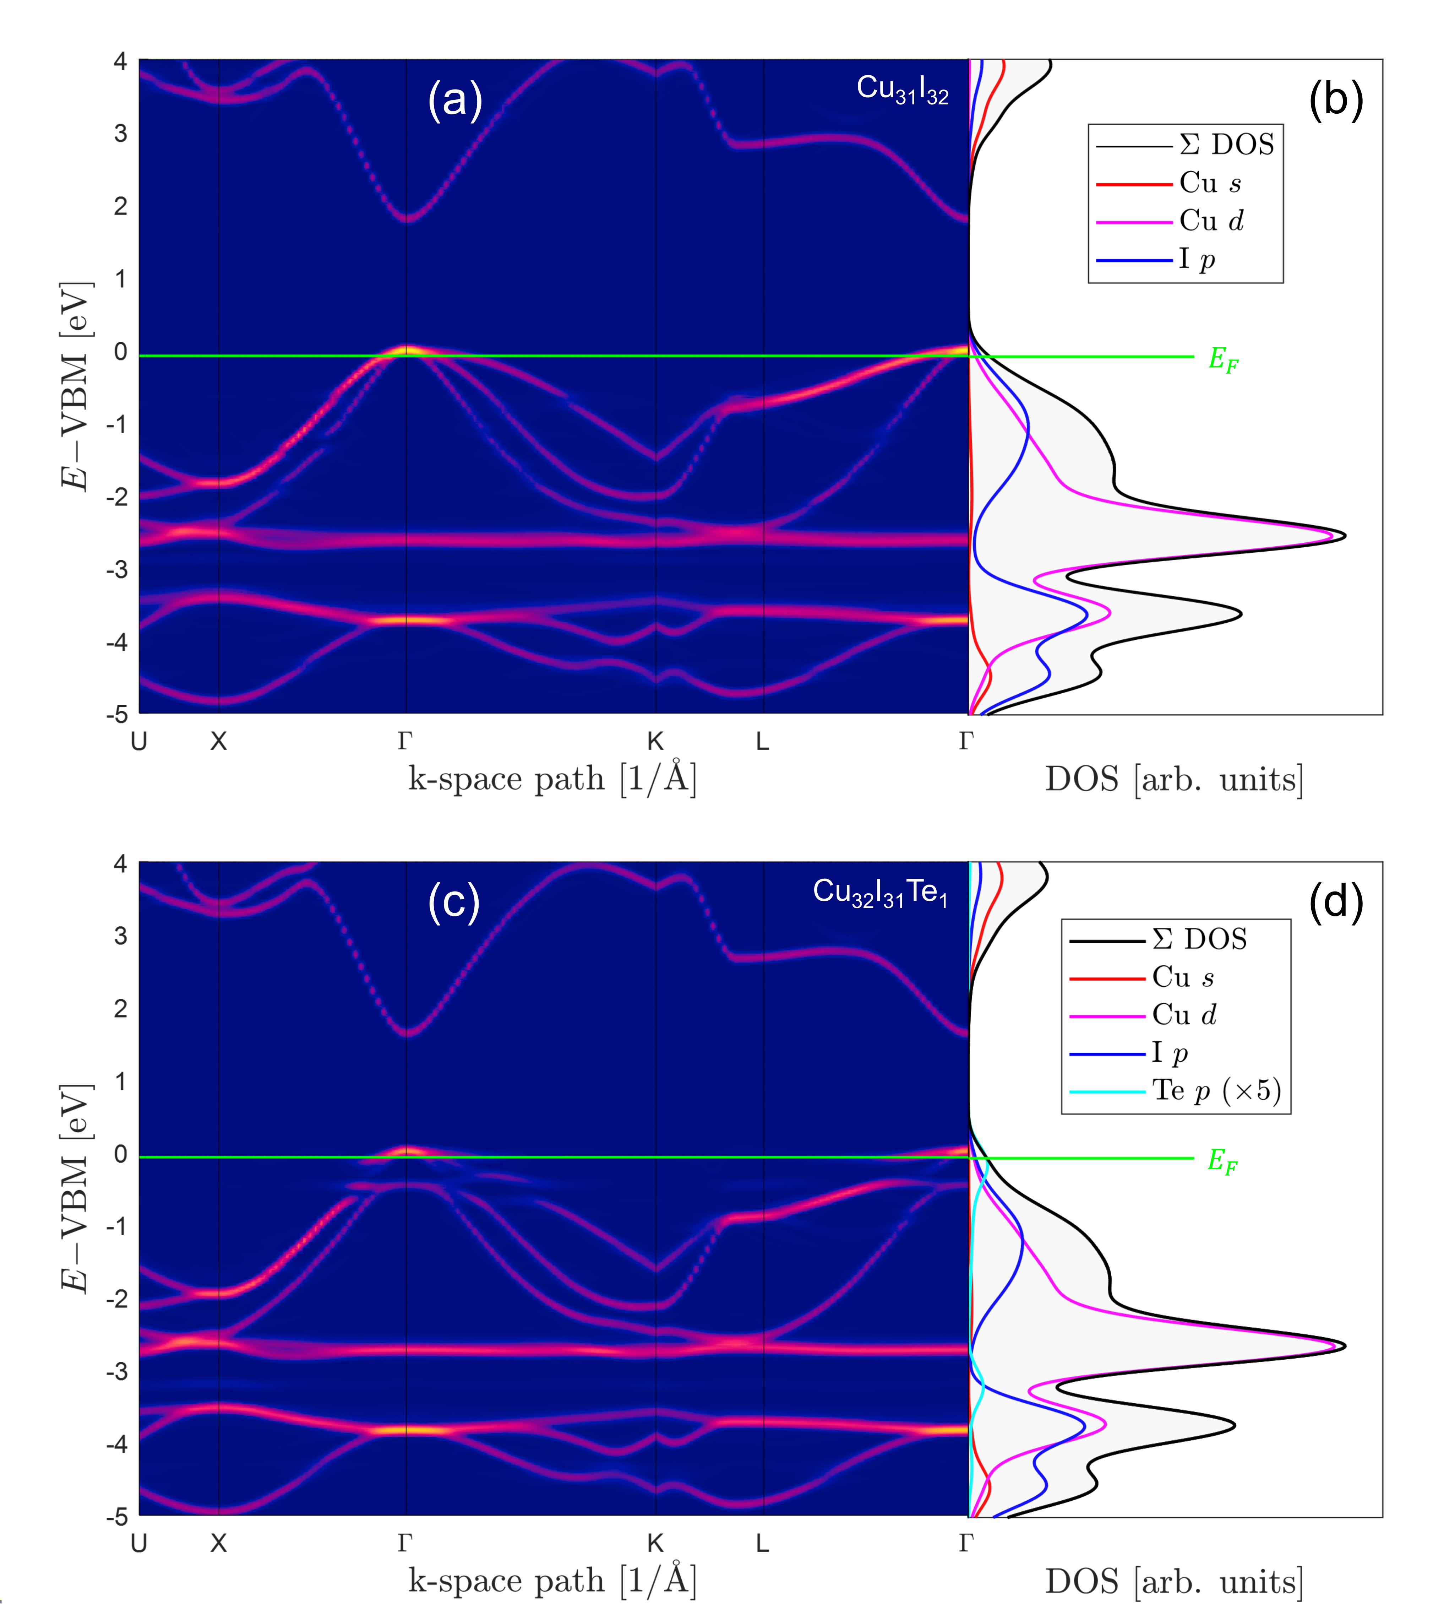
FIG. 6: (Color online) CuI with V_{Cu}⁰ supercell with stoichiometry Cu₃₁I₃₂ (a) unfolded band structure and (b) orbital-projected density of states of Cu₃₁I₃₂. CuI with Te_{I}⁰ supercell with stoichiometry Cu₃₂I₃₁Te₁ (c) unfolded band structure and (d) orbital-projected density of states of Cu₃₂I₃₁Te₁. The Fermi energy is the green line for that isolated defect.

The results of this work are placed in context of one another. Tellurium implantation results in an increase in point defects to form, for example, tellurium substitution and vacancy defects. The implanted tellurium substitutes onto copper or iodine sites in the lattice, leading to an overall reduction in lattice constant. The implantation also provides disorder to the valence band maximum by Te_{Cu} and Te_{I} doping, the latter providing tellurium 5p states near the top of the valence band. This has the effect of reducing the band gap and the excitonic absorption intensity. Consequently, the increased band disorder leads to an increased Urbach energy. The valence band disorder greatly reduces carrier mobility within the film, implying that Te is a source of strong carrier scattering. Finally, implantation reduces the work function of heavily $p$-type doped CuI, and acts to reduce the carrier concentration, directly caused by the Te_{I} defects which provide in-gap states to the CuI films. Dopants must be carefully considered to improve the thermoelectric properties of materials, something which is often guided by DFT calculations. Testing the results of DFT are important to include or rule out potential dopants such as the until-now disputed Te_{I} $p$-type doping of heavily doped CuI. Further, calculating unfolded band structures is important to find where the band disorder is introduced when extrinsic doping is conducted.

Conclusions
We report structural, optical, electrical, and thermoelectric properties of Te doped CuI thin films, alongside DFT calculations to provide a cohesive understanding of the experimental findings to elucidate if tellurium is, or is not, an effective $p$-type acceptor in already heavily doped CuI. After implantation of up to $2×{10}^{15}$ Te cm⁻² ($1.8$ % Te), the films observe a reduction in electrical conductivity by three orders of magnitude $61±3$ Scm⁻¹ to $0.042±0.002$ Scm⁻¹ and increase in Seebeck coefficient from $196±12$ μVK⁻¹ to $354±21$ μVK⁻¹. This effect is consistent with the UPS and XPS observation of the reduction in work function compared to the as-deposited film. This manifests as an increased spacing between the Fermi energy and valence band maximum and inhibits thermal activation of carriers. We conduct DFT calculations to study the defect formation energy of tellurium-based defect sites in a CuI matrix and investigate the effects on band structure and density of states. This work shows that already heavily $p$-type doped CuI cannot be further doped with tellurium at room temperature. Tellurium doping for introducing deep acceptor states for Fermi energy pinning may be beneficial for insulating or moderately doped CuI.

Associated content

Acknowledgements
This research is funded the Ministry of Business, Innovation and Employment (MBIE) New Zealand (grant number C05X1802). This project is supported by the MBIE through the Materials for Low Carbon Future programme (Strategic Science Investment Fund; grant number C05X1702) and JST Mirai Program, Japan (grant number JPMJMI19A1). We acknowledge Mr. John Futter, Mr. Chris Purcell, and Mr. Niall Malone (National Isotope Centre, GNS Science, New Zealand) for their contributions by implanter sputter target preparation, performing the RBS measurements, and helpful discussion regarding the XPS measurement interpretation.

CRediT authorship contribution statement
Martin Markwitz: conceptualization, data curation, formal analysis, investigation, methodology, writing – original draft and editing. Peter P. Murmu: conceptualization, funding acquisition, validation, writing – review. Song Yi Back: investigation, writing – review. Takao Mori: funding acquisition, supervision, writing – review. John V. Kennedy: funding acquisition, supervision, writing – review. Ben J. Ruck: funding acquisition, supervision, validation, writing – review.

Declaration
The authors declare that they have no competing interests.

References

[1] | J. Willis and D. O. Scanlon, “Latest directions in p-type transparent conductor design,” Journal of Materials Chemistry C, vol. 9, no. 36, pp. 11995-12009, 2021.
[2] | M. Grundmann, F. Schein, M. Lorenz, T. Böntgen, J. Lenzner and H. von Wenckstern, “Cuprous iodide - a p-type transparent semiconductor: History and novel applications,” physica status solidi (a), vol. 210, no. 9, pp. 1671-1703, 2013.
[3] | C. Yang, M. Kneiß, M. Lorenz and M. Grundmann, “Room-temperature synthesized copper iodide thin film as degenerate p-type transparent conductor with a boosted figure of merit,” Proceedings of the National Academy of Sciences, vol. 113, no. 46, pp. 12929-12933, 2016.
[4] | C. Yang, D. Souchay, M. Kneiß, M. Bogner, H. Wei, M. Lorenz, O. Oeckler, G. Benstetter, Y. Fu and M. Grundmann, “Transparent flexible thermoelectric material based on non-toxic earth-abundant p-type copper iodide thin film,” Nature communications, vol. 8, no. 1, p. 16076, 2017.
[5] | J. Willis, R. Claes, Q. Zhou, M. Giantomassi, G. M. Rignanese, G. Hautier and D. O. Scanlon, “Limits to Hole Mobility and Doping in Copper Iodide,” Chemistry of Materials, vol. 35, no. 21, pp. 8995-9006, 2023.
[6] | D. Chen, Y. Wang, Z. Lin, J. Huang, X. Z. Chen, D. Pan and F. Huang, “Growth strategy and physical properties of the high mobility p-type CuI crystal,” Crystal Growth & Design, vol. 10, no. 5, pp. 2057-2060, 2010.
[7] | D. Huang and Y. Zhao, “First-principles study of γ-CuI for p-type transparent conducting materials,” Journal of Physics D: Applied Physics, vol. 45, no. 14, p. 145102, 2012.
[8] | M. Almasoudi, A. Saeed, N. Salah, A. Alshahrie, P. Hasan, A. Melaibari and K. Koumoto, “CuI: a promising halide for thermoelectric applications below 373 K,” ACS Applied Energy Materials, vol. 5, no. 8, pp. 10177--10186, 2022.
[9] | R. Mulla and M. Rabinal, “Defect-Controlled Copper Iodide: A Promising and Ecofriendly Thermoelectric Material,” Energy Technology, vol. 6, no. 6, pp. 1178-1185, 2018.
[10] | A. Klein, K. Albe, N. Bein, O. Clemens, K. A. Creutz, P. Erhart, M. Frericks, E. Ghorbani, J. P. Hofmann, B. Huang, B. Kaiser, U. Kolb, J. Koruza, C. Kübel, K. N. S. Lohaus, J. Rödel, R. Rohrer, W. Rheinheimer, R. A. De Souza, V. Streibel, A. Weidenkaff, M. Widenmeyer, B. X. Xu and H. Zhang, “The Fermi energy as common parameter to describe charge compensation mechanisms: A path to Fermi level engineering of oxide electroceramics,” Journal of Electroceramics, vol. 51, no. 3, pp. 147-177, 2023.
[11] | P. Lunca-Popa, J. Afonso, P. Grysan, J. Crêpellière, R. Leturcq and D. Lenoble, “Tuning the electrical properties of the p-type transparent conducting oxide Cu1- xCr1+ xO2 by controlled annealing,” Scientific Reports, vol. 8, no. 1, p. 7216, 2018.
[12] | M. Markwitz, S. Y. Back, E. X. M. Trewick, P. P. Murmu, T. Mori, B. J. Ruck and J. V. Kennedy, “Quasilinear Kane conduction band model in nitrogen-doped indium tin oxide,” Physical review B, 2024.
[13] | N. Tureson, M. Marteau, T. Cabioch, N. Van Nong, J. Jensen, J. Lu, G. Greczynski, D. Fournier, N. Singh, A. Soni, L. Belliard, P. Eklund and A. le Febvrier, “Effect of ion-implantation-induced defects and Mg dopants on the thermoelectric properties of ScN,” Physical Review B, vol. 98, no. 20, p. 205307, 2018.
[14] | M. Markwitz, P. Murmu, S. Back, T. Mori, B. Ruck and J. Kennedy, “Effect of grain boundary scattering on carrier mobility and thermoelectric properties of tellurium incorporated copper iodide thin films,” Journal of Surfaces and Interfaces, 2023.
[15] | P. Storm, M. S. Bar, G. Benndorf, S. Selle, H. von Wenckstern, M. Grundmann and M. Lorenz, “High mobility, highly transparent, smooth, p-type CuI thin films grown by pulsed laser deposition,” Applied Physics Letters Materials, vol. 8, p. 091115, 2020.
[16] | M. Graužinyte, S. Botti, M. Marques, S. Goedecker and J. Flores-Livas, “Computational acceleration of prospective dopant discovery in cuprous iodide,” Physical Chemistry Chemical Physics, vol. 21, no. 35, pp. 18839-18849, 2019.
[17] | K. Ahn, G. Kim, S. Kim, J. Kim, G. Ryu, P. Lee, B. Ryu, J. Cho, Y. Kim, J. Kang, Y. Noh and M. Kim, “Highly Conductive p-Type Transparent Conducting Electrode with Sulfur-Doped Copper Iodide,” Chemistry of Materials, vol. 34, no. 23, pp. 10517--10527, 2022.
[18] | P. Murmu, J. Kennedy, Z. Liu and T. Mori, “The role of sulfur valency on thermoelectric properties of sulfur ion implanted copper iodide,” Journal of Alloys and Compounds, vol. 921, no. 1, p. 166103, 2022.
[19] | M. Son, G. H. Kim, O. Song, C. .. H. Park, S. Kwon, J. Kang, K. Ahn and M. G. Kim, “Dopant Control of Solution-Processed CuI: S for Highly Conductive p-Type Transparent Electrode,” Advanced Science, p. 2308188, 2024.
[20] | P. Storm, S. Gierth, S. Selle, M. Bar, H. von Wenckstern, M. Grundmann and M. Lorenz, “Evidence for oxygen being a dominant shallow acceptor in p-type CuI,” APL Materials, vol. 9, no. 5, p. 051101, 2021.
[21] | P. Darnige, Y. Thimont, L. Presmanes and A. Barnab{\'e}, “Insights into stability, transport, and thermoelectric properties of transparent p-type copper iodide thin films,” Journal of Materials Chemistry C, vol. 11, no. 2, pp. 630-644, 2023.
[22] | P. Storm, M. Bar, S. Selle, H. von Wenckstern, M. Grundmann and M. Lorenz, “p-Type Doping and Alloying of CuI Thin Films with Selenium,” Physica Status Solidi (RRL) - Rapid Research Letters, vol. 15, no. 8, p. 2100214, 2021.
[23] | H. Fiedler, P. Gupta, J. Kennedy and A. Markwitz, “28Si+ ion beams from Penning ion source based implanter systems for near-surface isotopic purification of silicon,” Review of Scientific Instruments, vol. 89, no. 12, p. 123305, 2018.
[24] | J. Biersack, S. Berg and C. Nender, “T-DYN Monte Carlo simulations applied to ion assisted thin film processes,” Nuclear Instruments and Methods in Physics Research Section B: Beam Interactions with Materials and Atoms, vol. 59, pp. 21-27, 1991.
[25] | J. Kennedy, W. Trompetter, P. Murmu, L. Leveneur, P. Gupta, H. Fiedler, F. Fang, J. Futter and C. Purcell, “Evolution of Rutherford’s ion beam science to applied research activities at GNS Science,” Journal of the Royal Society of New Zealand, vol. 51, no. 1, pp. 1-18, 2021.
[26] | G. Greczynski and L. Hultman, “C 1s peak of adventitious carbon aligns to the vacuum level: dire consequences for material's bonding assignment by photoelectron spectroscopy,” ChemPhysChem, vol. 18, no. 12, pp. 1507-1512, 2017.
[27] | M. C. Biesinger, “Advanced analysis of copper X-ray photoelectron spectra,” Surface and Interface Analysis, vol. 49, no. 13, pp. 1325-1334, 2017.
[28] | D. Nečas and P. Klapetek, “Gwyddion: an open-source software for SPM data analysis,” Open Physics, vol. 10, no. 1, pp. 181-188, 2012.
[29] | P. Murmu, V. Karthik, S. Chong, S. Rubanov, Z. Liu, T. Mori, J. Yi and J. Kennedy, “Effect of native defects on thermoelectric properties of copper iodide films,” Emergent Materials, vol. 4, no. 1, pp. 761-768, 2021.
[30] | P. Murmu, V. Karthik, Z. Liu, V. Jovic, T. Mori, W. Yang, K. Smith and J. Kennedy, “Influence of Carrier Density and Energy Barrier Scattering on a High Seebeck Coefficient and Power Factor in Transparent Thermoelectric Copper Iodide,” Applied Energy Materials, vol. 3, no. 1, pp. 10037-10044, 2020.
[31] | P. Giannozzi, S. Baroni, N. Bonini, M. Calandra, R. Car, C. Cavazzoni, D. Ceresoli, G. Chiarotti, M. Cococcioni, I. Dabo and e. al., “QUANTUM ESPRESSO: a modular and open-source software project for quantum simulations of materials,” Journal of physics: Condensed matter, vol. 211, no. 39, p. 395502, 2009.
[32] | P. Giannozzi, O. Andreussi, T. Brumme, O. Bunau, M. Nardelli, M. Calandra, R. Car, C. Cavazzoni, D. Ceresoli, M. Cococcioni and e. al., “Advanced capabilities for materials modelling with Quantum ESPRESSO,” Journal of physics: Condensed matter, vol. 29, no. 46, p. 4655901, 2017.
[33] | P. Giannozzi, O. Baseggio, P. Bonfà, D. Brunato, R. Car, I. Carnimeo, C. Cavazzoni, S. De Gironcoli, P. Delugas, F. .. Ferrari Ruffino and e. al., “Quantum ESPRESSO toward the exascale,” The Journal of chemical physics, vol. 152, p. 154105, 2020.
[34] | J. Perdew, K. Burke and M. Ernzerhof, “Generalized gradient approximation made simple,” Physical review letters, vol. 77, no. 18, p. 3865, 1996.
[35] | P. Medeiros, S. Stafström and J. Björk, “Effects of extrinsic and intrinsic perturbations on the electronic structure of graphene: Retaining an effective primitive cell band structure by band unfolding,” Physical Review B, vol. 89, no. 4, p. 041407, 2014.
[36] | P. Medeiros, S. Tsirkin, S. Stafström and J. Björk, “Unfolding spinor wave functions and expectation values of general operators: Introducing the unfolding-density operator,” Physical Review B, vol. 91, no. 4, p. 041116, 2015.
[37] | M. Iraola, J. Mañes, B. Bradlyn, M. Horton, T. Neupert, M. Vergniory and S. Tsirkin, “IrRep: symmetry eigenvalues and irreducible representations of ab initio band structures,” Computer Physics Communications, vol. 272, p. 108226, 2022.
[38] | A. Dal Corso, “Pseudopotentials periodic table: From H to Pu,” Computational Materials Science, vol. 95, pp. 337-350, 2014.
[39] | H. Monkhorst and J. Pack, “Special points for Brillouin-zone integrations,” Physical review B, vol. 13, no. 12, p. 5188, 1976.
[40] | G. Makov and M. Payne, “Periodic boundary conditions in ab initio calculations,” Physical review B, vol. 51, no. 7, p. 40114, 1995.
[41] | S. Lany and A. Zunger, “Assessment of correction methods for the band-gap problem and for finite-size effects in supercell defect calculations: Case studies for ZnO and GaAs,” Physical review B, vol. 78, no. 23, p. 235104, 2008.
[42] | Y. Kumagai and F. Oba, “Electrostatics-based finite-size corrections for first-principles point defect calculations,” Physical review B, vol. 89, no. 19, p. 195205, 20114.
[43] | S. Dudarev, G. Botton, S. Savrasov, C. Humphreys and A. Sutton, “Electron-energy-loss spectra and the structural stability of nickel oxide: An LSDA+U study,” Physical review B, vol. 57, no. 3, p. 1505, 1998.
[44] | C. Kaiser, O. J. Sandberg, N. Zarrabi, W. Li, P. Meredith and A. Armin, “A universal Urbach rule for disordered organic semiconductors,” Nature Communications, vol. 12, no. 1, p. 3988, 2021.
[45] | J. Park, J. Seo, J. Lim and B. Yoo, “Synthesis of Copper Telluride Thin Films by Electrodeposition and Their Electrical and Thermoelectric Properties,” Frontiers in Chemistry, vol. 10, p. 799305, 2022.
[46] | W. Tang, Y. Chao, X. Weng, L. Deng and K. Xu, “Optical property and the relationship between resistivity and surface roughness of indium tin oxide thin films,” Physics Procedia, vol. 32, pp. 680-686, 2012.
[47] | O. Rubel, A. Bokhanchuk, S. J. Ahmed and E. Assmann, “Unfolding the band structure of disordered solids: From bound states to high-mobility Kane fermions,” Physical Review B, vol. 90, no. 11, p. 115202, 2014.
[48] | Y. Zheng, T. J. Slade, L. Hu, X. Y. Tan, Y. Luo, Z. Z. Luo, J. Xu, Q. Yan and M. G. Kanatzidis, “Defect engineering in thermoelectric materials: what have we learned?,” Chemical Society Reviews, vol. 50, no. 16, pp. 9022-9054, 2021.

