Rational design of nitride phosphor-in-glass with robust stability and photoluminescence performance
Yuting Zhangª, Yuting Yeª, Guoying Zhao^{*a}, Yufeng Liuª, Lili Liuª, Xin Qiao^{b}, Zhongzhi Wang^{b}, Bo Li^{b}, Hong-Tao Sun^{d}, Ji-Guang Li^{e}, Jingshan Hou^{*a}, Feng Wang^{*c}, Yongzheng Fang^{*a}
ª School of Materials Science and Engineering, Shanghai Institute of Technology, Shanghai 201418, PR China
^{b} Baotou Research Institute of Rare Earths, Baotou, 014030, China
^{c}Department of Materials Science and Engineering, City University of Hong Kong, 83 Tat Chee Avenue, Hong Kong SAR, China
^{d}Research Center for Materials Nanoarchitectonics (MANA), National Institute for Materials Science (NIMS), 1-2-1 Sengen, Tsukuba 305-0047, Japan
^{e}Research Center for Functional Materials, National Institute for Materials Science, Tsukuba, Ibaraki 305-0044, Japan
*Corresponding author
E-mail: zhaogy135@126.com (GY Zhao)
E-mail: fyz1003@sina.com (YZ Fang)
Abstract: Phosphor-in-Glass (PiG) has been recognized as a promising approach for harnessing the luminous efficiency of high-quality phosphors while benefiting from the thermal stability inherent to the glass matrix. It has been reported that PiG based on yellow-emitting YAG:Ce oxide phosphors and oxide glasses shows high-efficiency photoluminescence with enhanced thermal stability. However, it remains a grand challenge to embed highly luminescent red-emitting nitride phosphors, one of the most important materials for white light illumination, into traditional oxide glasses because of their mismatch in the refractive indices and strong erosion of nitride phosphors by high-temperature glass melts. in Here we report a rational approach to fabricate nitride phosphor-embedded PiGs. Using (Sr,Ca)AlSiN₃:Eu²⁺ (SCASN:Eu) as a model nitride phosphor, we show that the soft telluride glass with a high refractive index and a low glass transition temperature can be as an excellent matrix for incorporating nitride phosphors.. The matching in the refractive indices of telluride glass (~2.15) and nitride phosphor (~2.19) ensures enhanced efficiency in the extraction of both excitation and emission photons. More importantly, the low glass transition temperature of telluride glass, with respect to those of traditional oxide glasses, makes nitride phosphors survive from the exposure to glass melts. Benefiting from these advantages, the SCASN:Eu PiG demonstrates an impressive 93% of the quantum efficiency that are similar to pure SCASN:Eu. The activation energy of PiG, 0.47 eV notably surpasses that of phosphor-in-silicone (0.17 eV), underscoring its superior thermal stability. Furthermore, PiG shows boosted photoluminescence performance under harsh environments with respect to phosphors.We show that the assembled white light-emitting diode module have precise color tuning capabilities, achieving an optimal color rendering index of 93.7, a luminous efficacy of 80.4 lm/W, and a correlated color temperature of 5850 K.This finding offers a viable route to combine outstanding luminescent properties of nitride phosphors with the exceptional thermal stabilityof soft glasses. and hold immense potential for advancing the realm of full-spectrum, high-quality white light illumination.
Keywords: (Sr,Ca)AlSiN₃:Eu²⁺ phosphor; Telluride glass; High quantum efficiency; Robust stability

Introduction
In the realm of solid-state lighting, White Light-Emitting Diodes (WLEDs) hold immense promise for advancement owing to their energy efficiency and environmentally-friendly attributes, remarkable luminous efficacy, as well as their uncomplicated and easily fabricable structures [1-8]. These light sources find applications in diverse fields such as plant growth illumination, signaling and indicator lamps, flat-panel displays, among others [9-14]. Nevertheless, the conventional organic phosphor resin converters suffer from notable drawbacks, including inadequate thermal stability, low thermal conductivity, and susceptibility to aging-induced degradation and phosphor corrosion. These issues collectively lead to a reduction in the efficiency of white light emission from the WLEDs and a shorter operational lifespan of the devices [15-20].
To address the issue of aging-induced discoloration in organic resin PiS encapsulation, three distinct solutions have been proposed, namely single crystals (SCs), transparent ceramics (TCs), and phosphor-in-glass (PiG) [21-25]. Nevertheless, both SCs and TCs are encumbered by complexities and elevated costs in their preparation. Conversely, PiG has garnered substantial attention for its cost-effectiveness, straightforward synthesis, and capacity for color adjustment. Notably, PiG boasts commendable chemical attributes and thermal stability, combining the desirable qualities of high quantum efficiency in phosphors with the enduring stability of a glass matrix. This amalgamation is achieved through the uniform dispersion of phosphors within the glass matrix, resulting in sheet composites formed via low-temperature sintering. Furthermore, in recent years, rare earth red nitride phosphors have gained increasing significance in the domain of WLEDs owing to their expansive red-light emission spectrum, superior luminous efficiency, and remarkable conversion efficiency [26-28].
Y₃Al₅O₁₂:Ce³⁺ (YAG:Ce) PiG samples as prepared by Bao et al. employed a borosilicate glass matrix with varying particle sizes and underwent a primary sintering at 900 °C [29]. In the study conducted by Huang et al., Lu₃Al₅O₁₂:Ce³⁺ PiG fluorescent thin slices were developed, also utilizing a borosilicate glass matrix, and subjected to a secondary sintering within the range of 680-800 °C [30]. Wang et al. prepared Y_{1.31}Ce_{0.09}Gd_{1.6}Al₅O₁₂ (Ce: GdYAG)-PiG slices with a borosilicate glass matrix, undergoing primary sintering at 1350°C and secondary sintering at 850 °C [31]. Notably, while all of the aforementioned studies utilized borosilicate glass as the matrix, it's essential to acknowledge that achieving complete densification in a more thermally stable matrix necessitates higher sintering temperatures. However, such elevated temperatures can induce strong interfacial reactions leading to the corrosion of phosphorus powder particles. To mitigate this concern, a preference for telluride glass with a lower softening temperature can be considered, as it effectively prevents the corrosion of phosphor particles at high temperatures. The elevation of sintering temperature correlates with an increased susceptibility of the fluorescent crystal phase to erosion, thereby compromising the preservation of high luminescence efficiency. Consequently, extensive research efforts have been dedicated to the quest for glass matrix materials and preparation procedures that can uphold the structural integrity and stability of the fluorescent crystal phase. While YAG:Ce phosphors have been the subject of previous investigations, nitride red phosphors have assumed a pivotal role in the modulation of light source luminescence quality. Nevertheless, these nitride red phosphors exhibit inherent fragility and sensitivity, which pose substantial challenges in achieving optimal photon extraction efficiency. Huang et al. addressed this challenge by selecting a borosilicate glass matrix in conjunction with nitride red phosphors, with a secondary sintering temperature range of 750-850 °C [32]. Similarly, Li et al. explored the use of La₃Si₆N₁₁:Ce³⁺ nitride phosphors combined with borosilicate glass, employing a co-sintering temperature range of 1000-1090 °C [19]. Moreover, Zhao et al. conducted experiments involving the combination of three commercial phosphors with borosilicate glass, with a secondary sintering temperature of 800 °C [33]. While these previous research endeavors primarily centered around borosilicate glass and nitride phosphors, the excessively high co-sintering temperatures employed posed challenges to the stabilization of the nitride fluorescent crystal phase.
In this study, we designed a glass system comprised of TeO₂-WO₃-PbO, which exhibits a remarkably low softening temperature. Notably, the co-sintering temperature when coupled with nitride materials remains within the range of 465-485 ℃. This innovation effectively preserves the crystalline phase of the phosphor, thereby upholding luminescence performance. Additionally, the inclusion of W and Pb components in the glass system ensures that the high refractive index of telluride glass, measured at approximately 2.15, aligns effectively with that of (Sr,Ca)AlSiN₃:Eu²⁺ phosphor(~2.19) [34-36]. This alignment significantly reduces light scattering and minimizes interfacial reactions resulting from refractive index mismatch. Microstructural analysis of the samples reveals the uniform dispersion of phosphors within the glass matrix, with notable suppression of interfacial reactions. The samples consistently maintained a phosphor quantum efficiency of 93%, demonstrating exceptional thermal stability. SCASN:Eu PiG slice can be used as an inorganic converter to replace the traditional organic converter, and it has a wide range of application prospects.

2. Experimental

2.1. The precursor glass matrix and PiG slices were prepared
Precursor glass matrix consisting of 60TeO₂-30WO₃-10PbO was prepared by melt-quenching method. Molar ratio of TeO_{2,} PbO, and WO₃ were well mixed before loaded into a crucible. The reaction mixture was melted in an alumina crucible at 800 °C for 30 min and then poured into a preheated steel plate and finally cooled to room temperature. The obtained glass block was ground into glass powder using a ball mill. The PiG converter was prepared by the tablet pressing method and sintering process. As shown in Fig. 1, the glass powder and phosphor particles were thoroughly mixed with a mortar to obtain a slurry, which was then pressed into discs by a tablet press. For SCASN:Eu PiG, the content of SCASN:Eu phosphor was designed to be 10wt%. To investigate the glass transition temperature (T_{g}), the glass powder was also pressed into glass discs and sintered in a muffle furnace from 460 °C to 520 °C. The effect of the sintering temperature on the SCASN:Eu PiG luminescence was evaluated for the discs, which were sintered in the range of 465 °C to 485 °C. The sintering time of the samples in the muffle furnace was 30 min for all samples.
As a control group, we prepared phosphor-in-silicone (PiS) sample. The ab glue (a:b=1:1) mixed with 10 wt % red phosphor was mixed evenly in a rotating speed machine, and then preheated in an oven at 120 °C for 30 min and held at 160 °C for 4 h to prepare PiS discs.
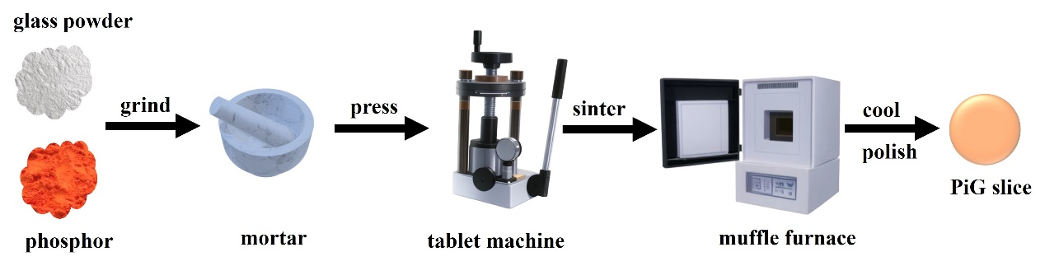
Fig.1. Experimental flow of PiG slice preparation by tablet press

2.2. Characterization
The photoluminescence (PL), Photoluminescence excitation (PLE) and temperature-dependent emission spectra were measured on Hitachi F-7000 Xenon discharge lamp spectrometer (F-7000, Hitachi, Japan). The transmittance spectra were measured with an ultraviolet visible near-infrared spectrophotometer (UH4150, Hitachi, Japan). The X-ray powder diffractometer (XRD) patterns were obtained on a XRD spectrometer ((TD-3500, Dandong). The scanning electron microscopy (SEM) was used to take SEM images, and a layer of gold is sputtered on the surface of the sample to enhance its electrical conductivity. The energy-dispersive spectrometer (EDX) and SEM were used to analyze its elemental composition (Gemini Sigma 360, Zeiss, Germany). The decay time and the internal quantum efficiency (IQE) were measured with a spectrofluorometer quantum yield spectrometer ((FLS920, Edinburgh Instruments, UK). Fluorescence microscopy images were taken in dark-field mode on a fluorescence microscope (Axioscope 5, Zeiss, Germany). The thermal conductivity is measured with a thermal conductivity meter (Hotdisk Tps 2500, Hotdisk, Sweden). The PiG slice was mounted on a 450 nm blue LED chip in an integrating sphere to measure the luminescence performance, including electroluminescence (EL) emission spectra, chromaticity color coordinates (CIE), correlated color temperature (CCT), and color rendering index (Ra), were measured in an integrating sphere (HAAS-2000, EVERFINE, China).

3. Result and discussion

3.1. Microstructure and luminescence of PiG and PiS
Due to its low melting point and high refractive index, telluride glass serves as an ideal matrix for incorporating (Sr,Ca)AlSiN₃:Eu²⁺ phosphor. We investigated the glass transition temperature (T_{g}) of telluride glass by subjecting the glass powder to secondary sintering, and we observed that glass sintered at approximately 470 °C exhibited a molten state with remarkable transparency. We prepared a series of PiG slices (thickness: 0.5 mm) at various temperatures by uniformly dispersing 10 wt% SCASN:Eu phosphor within the glass matrix, utilizing sintering temperatures ranging from 465 °C to 485 °C. Refer to Fig. 2a for photographs of these slices captured under both daylight and UV illumination, revealing the highest transparency of SCASN PiG was attained at 470 °C. Kim et al. demonstrated a linear relationship between luminescence efficiency and the transmittance of the phosphor color converter in technologies like white light-emitting diodes (WLEDs) and laser diodes (LDs) [16, 37]. However, it's worth noting that incident light is often absorbed by the phosphor particles rather than being directly transmitted. Consequently, the presence of apertures in the color converter that serve as scattering centers can enhance luminescence efficiency [38, 39]. The scattering model is depicted in Fig. 2b As a result, achieving the maximum luminescence efficiency for the lighting device does not necessitate a completely transparent color converter; instead, the converter should possess an appropriate level of transmittance. Importantly, moderate light scattering contributes to enhanced color uniformity and efficient light extraction in high-power WLEDs converters [40]. In the TeO₂-WO₃-PbO glass system, TeO₂ serves as the primary agent for glass network formation, organizing [TeO₄] groups with tetrahedral coordination. WO₃ complements this role as another network-forming agent, interspersed with TeO₂, thereby establishing mixed bonds encompassing Te-O-W and W-O-W configurations. Concurrently, WO₃ contributes to the enhancement of the glass's refractive index and augments its chemical stability. In contrast, PbO functions as a glass-modifying oxide [41]. A comprehensive review of the existing literature yielded a network structure diagram for PiG samples (Fig. 2c).
Fig. 2d presents a dark-field microscopic image of the PiS sample surface, revealing the presence of numerous sizable air holes rather than phosphor particles. This observation is corroborated in Fig. 2e, which presents a fluorescence microscopic image under the 455 nm fluorescence channel. This image depicts a red background, and the air holes' locations do not exhibit a distinct red coloration. The emergence of these significant air holes is attributed to the phosphor deposition process stemming from the glue dispensing method. The vivid crimson dots are uniformly dispersed within the telluride glass, as prominently depicted in the surface and 3D reconstructed images of the 470 °C-10 wt%-SCASN:Eu PiG slice (Fig. 2f, g, i). The surface topography of the 470°C-PiG slice is presented in Fig. 2i (scale bar, 50 μm), illustrating the uniform distribution of red phosphor. Similarly, there are some air holes scattered on the sample's surface, albeit of smaller size due to the pressing process, effectively addressing the issue of phosphor settling. This uniform phosphor distribution, accompanied by a moderate number of air holes, confers benefits to the color uniformity of the PiG slice [42]. Furthermore, we conducted thermal conductivity measurements to assess the heat dissipation performance of the samples. A higher thermal conductivity signifies enhanced heat dissipation performance, whereas lower thermal conductivity implies better thermal insulation and diminished heat dissipation. Following testing, PiG displayed a thermal conductivity of 0.40 W/(m•K), in contrast to PiS, which exhibited a thermal conductivity of 0.15 W/(m•K). As a result, PiG's thermal conductivity surpassed that of PiS by approximately 2.6-fold. This augmented thermal conductivity confers a notable advantage in bolstering the thermal stability of the fluorescent conversion material.
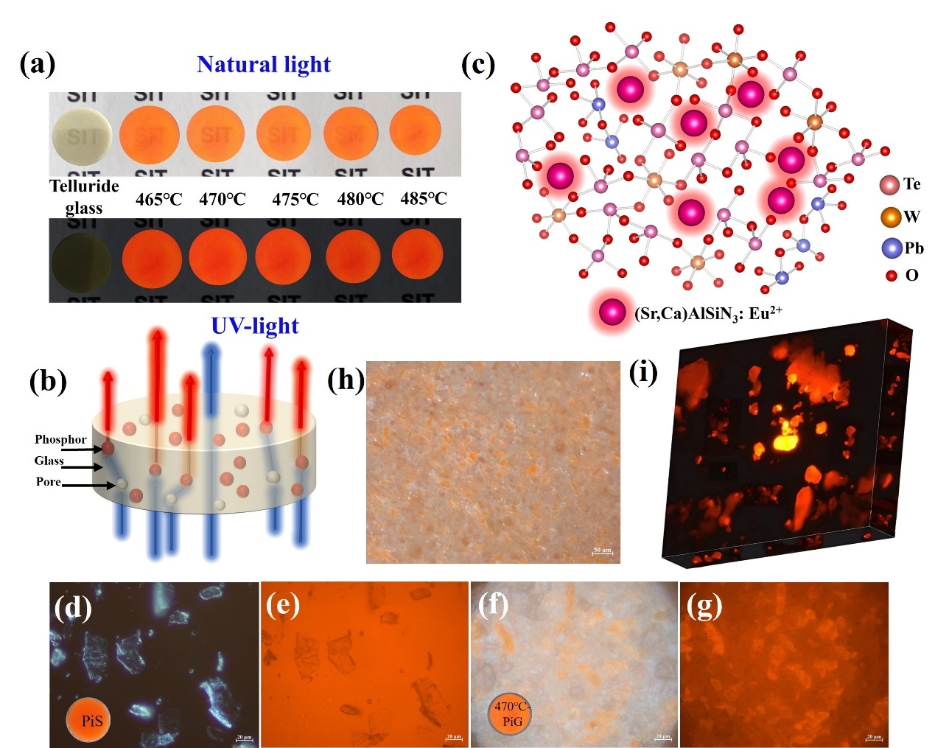
Fig. 2. (a) Telluride glass wafer and flat discs of 10wt%-SCASN:Eu PiG slices with various temperature (thickness: 0.5 mm). (b) Light scattering model diagram. (c) Schematic diagram of PiG sample glass network. (d)-(e) Microscopic image and fluorescence microscopic image of the 10wt%-SCASN:Eu PiS. (f)-(g) Microscopic image and fluorescence microscopic image of the 470 ℃-PiG slice. (h) PiG morphology at 50 μm scale. (i) 3D reconstruction of 10wt%-SCASN:Eu PiG (scale bar, 20 μm).

The photoluminescence spectrum of the 470°C-PiG slice, illustrated in Fig. 3a, reveals a broad emission peak centered at 615 nm. This emission corresponds to the 4f⁶5d to 4f⁷ transition within the Eu²⁺ level when excited at 445 nm. It is worth noting that the SCASN:Eu phosphor exhibits a wide excitation peak within the 200-500 nm range. However, in the case of the 470°C-PiG slice, there is a notable reduction in excitation intensity in the shorter wavelength span of 200-350 nm. This attenuation may be attributed to the absorption characteristics of the telluride glass substrate at shorter wavelengths [43]. Turning to Fig. 3b, the diffraction peaks of (Sr,Ca)AlSiN₃:Eu²⁺ phosphor align perfectly with the standard card ICSD-163203, while the telluride glass phase exhibits no impurity peaks beyond its characteristic peaks. The diffraction peaks of PiS and 470°C-PiG coincide with SCASN:Eu. In Fig. 3c, the XRD diffraction pattern of the 10wt%-SCASN:Eu PiG sheet at various temperatures displays a bump in the 25°-30° range attributed to the telluride glass phase, corroborated by the telluride glass diffraction spectrum in Fig. 3b. Notably, the diffraction peak intensity diminishes with rising temperature.
To delve into the intrinsic characteristics of the samples, we conducted measurements of the internal quantum efficiency (IQE). The 470 °C-PiG slice exhibited an IQE of 91.14%, while the 475 °C-PiG slice recorded an IQE of 82.91%, with the phosphor itself demonstrating an IQE of 98.13% (refer to Fig. 3d, e). Notably, the IQE of the samples preserved a remarkable 93% of the phosphor's efficiency, marking a noteworthy achievement in maintaining nitride properties. Compared to borosilicate glass requiring co-sintering at temperatures within the 800-1000℃ range, telluride glass offers a distinct advantage with its lower sintering temperature (465-485℃), providing enhanced assurance for the preservation of structural stability within the nitride crystal phase and reducing erosion during co-sintering. Furthermore, the refractive index alignment between telluride glass (~2.15) and red nitride phosphor (~2.19) significantly amplifies photon extraction efficiency at the interface between crystalline and amorphous phases. It's worth noting that higher temperatures corresponded to increased concentration quenching of the phosphor, reinforcing the idea that 470 °C represents the optimal sintering temperature, striking a balance between phosphor luminous intensity and glass transition temperature [29]. Fig. 3f presents fluorescence lifetime decay curves for both the 470°C-PiG sample and the nitride phosphor, which underwent fitting using a biexponential curve fitting approach. The fluorescence decay lifetime of the nitride phosphor is measured at 0.708 μs, whereas the fluoresceence decay lifetime of the 470°C-PiG sample shows a reduction to 0.644 μs. This diminishment can be attributed to a partial disruption of the crystalline phase structure within SCASN:Eu induced by the elevated temperature. [44].
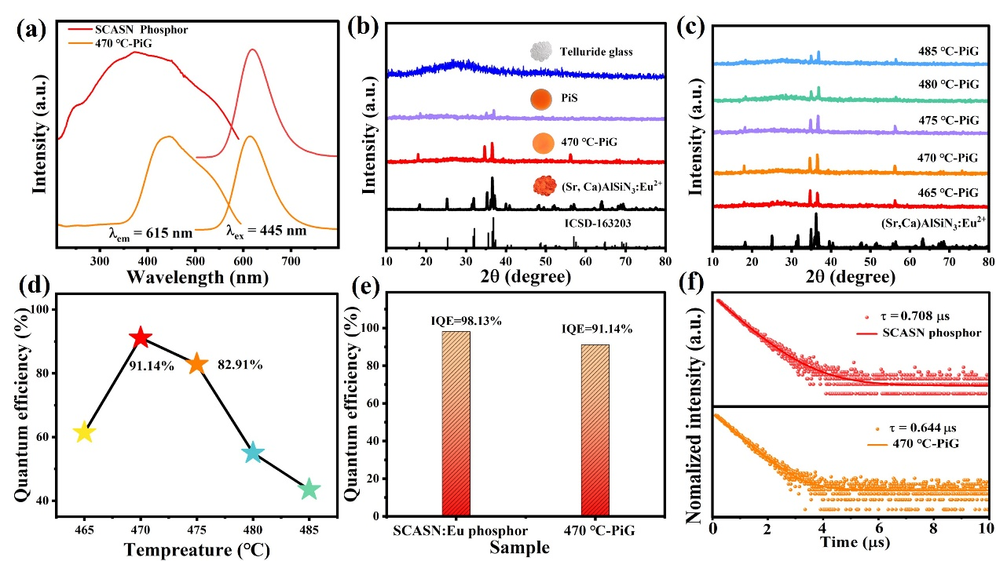
Fig. 3. (a) Photoluminescence spectra of (Sr,Ca)AlSiN₃:Eu²⁺ phosphor and 470 ℃-PiG. (b) XRD patterns of PiG slices at different sintering temperatures. (c) XRD patterns of different samples. (d) Internal quantum efficiency (IQE) at different temperatures. (e) Comparison of IQE between nitride phosphor and 470℃-PiG. (f) decay curves.

Fig. 4a shows the SEM of the 470 °C-PiG slice. It can be seen on the surface of the sample that the particles in the main glass are uniformly distributed. The distribution and content of elements can be seen in the total elemental distribution mapping (Fig. 4b). The energy dispersive X-ray spectroscopy (EDX) mapping (Fig. 4c) shows the distribution position of the elements in the sample. Certain particles are distinctly dispersed within the host glass matrix. Elemental mapping reveals that Te, W, Pb, and O signals originate exclusively from the glass matrix, whereas signals of Sr, Ca, Al, Si, N, and Eu emanate from the phosphor particles. Additionally, electron microscopy reveals the presence of porous phases, and it is noteworthy that there is minimal interfacial interaction between the phosphor and the glass matrix. The interfaces are sharply defined, and the crystalline phases remain largely unaltered.
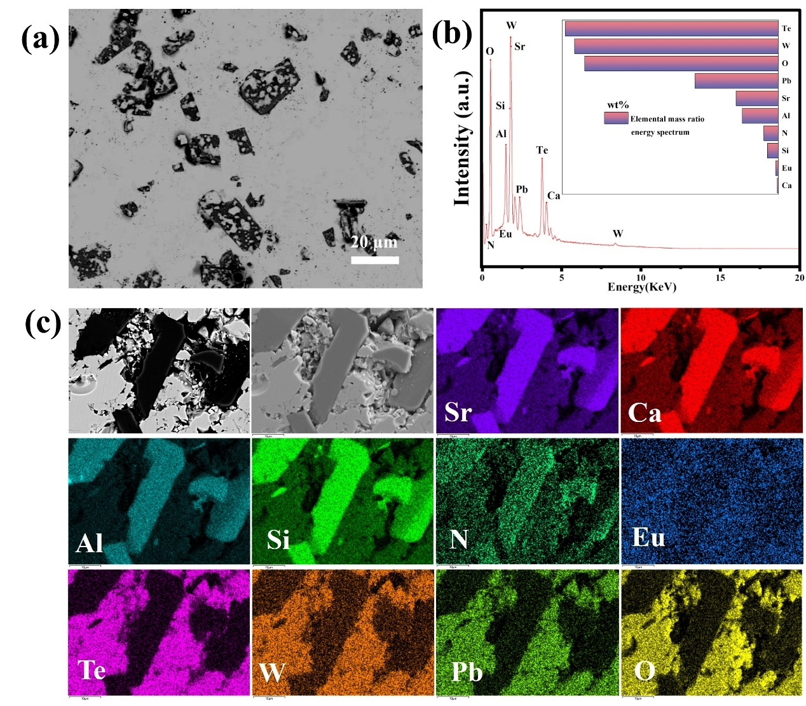
Fig. 4. Backscattered scanning electron micro-graph (BSEM) and energy dispersive X-ray spectroscopy (EDX) mapping:(a) Top-view SEM image of the PiG slice (scale bar, 20 nm). (b)The corresponding EDX. (c) EDX elemental mappings of the surface of a particle selected from 470℃-PiG slice (scale bar, 10 nm).

3.2. Thermal stability and device performance of PiG-based WLEDs
We assessed the sample's thermal stability through a temperature range of 25-275 ℃, involving heating and cooling cycles. In both PiG and PiS (as illustrated in Fig. 5a), the luminescence intensity exhibited a decline as the temperature increased (solid line), with no significant alteration in the half-peak width. The PiG normalization plot in the upper right corner revealed a slight blue shift in the peak wavelength, a phenomenon explained by the configuration coordinate diagram (refer to Fig. 6). Notably, the peak wavelength of photoluminescence (PL) intensity and offset demonstrated reversible recovery during sample cooling (dashed line). Furthermore, at equivalent temperatures, the spectral PL intensity in PiG surpassed that of PiS. Temperature-dependent contour spectra of 470 ℃-PiG and PiS are depicted in Fig. 5 b and c. It is evident that PiG exhibits superior thermal stability compared to PiS. We quantified the peak emission intensity of the samples over a temperature range spanning from room temperature to 573 K (Fig. 5d). Remarkably, the PiG sample maintained 93.5% and 78.6% of its initial value at 373 K and 473 K, respectively, thereby preserving the fluorescence intensity of SCASN:Eu phosphor more effectively. In contrast, within the control group, PiS retained only 71.8% of the initial value at 373 K and exhibited a pronounced decrease, down to 40.2%, at 473 K. Employing the Arrhenius equation I_{T}/I₀ = [1 + D_{exp} (-E_{a}/kT)]⁻¹ [35] we calculated the thermal activation energy E_{a} (Fig. 5e), with PiG's thermal activation energy (0.47eV) surpassing that of PiS (0.17 eV). Organic resins are susceptible to external thermal decomposition, while inorganic glass matrix, encapsulation protects the phosphor and effectively improves thermal burst performance [45, 46]. These results underscore the compatibility between the outstanding luminescent properties of SCASN:Eu phosphor and the remarkable thermal stability of telluride glass. The selection of an appropriate temperature for secondary sintering ensures minimal interfacial reactions between phosphor and glass, resulting in exceptional luminescent properties and highlighting the advantages of PiG, based on telluride glass, as a color converter for WLED devices.
The energy level diagram and configuration coordinate diagram of Eu²⁺ are drawn (Fig. 6). The main factors affecting Eu²⁺ luminescence is crystal field splitting (D_{q}) caused by charge migration and Stokes shift. The excitation and emission spectra of Eu²⁺ are derived from the electric dipole transition of 5d-4f. The electrons transition from 4f⁶5d to the ground state of 4f⁷ (⁸S_{7/2}) and produce a wide band spectrum. (Sr,Ca)AlSiN₃:Eu²⁺ space group is Cmc2₁. Eu²⁺ (CN = 6, R_{Eu} ²⁺ = 1.17 Å) ion radius is 1.17Å and Sr ²⁺(CN = 6, R_{Sr} ²⁺ = 1.18Å), Ca²⁺ (CN = 6, R_{Ca} ²⁺ = 1 Å) ion radius is close, Eu²⁺ therefore occupies two distinct cation sites (Eu(Ⅰ)²⁺ and Eu(Ⅱ)²⁺). Fig. 5a shows the temperature-dependent emission spectra of 470℃-PiG sample and
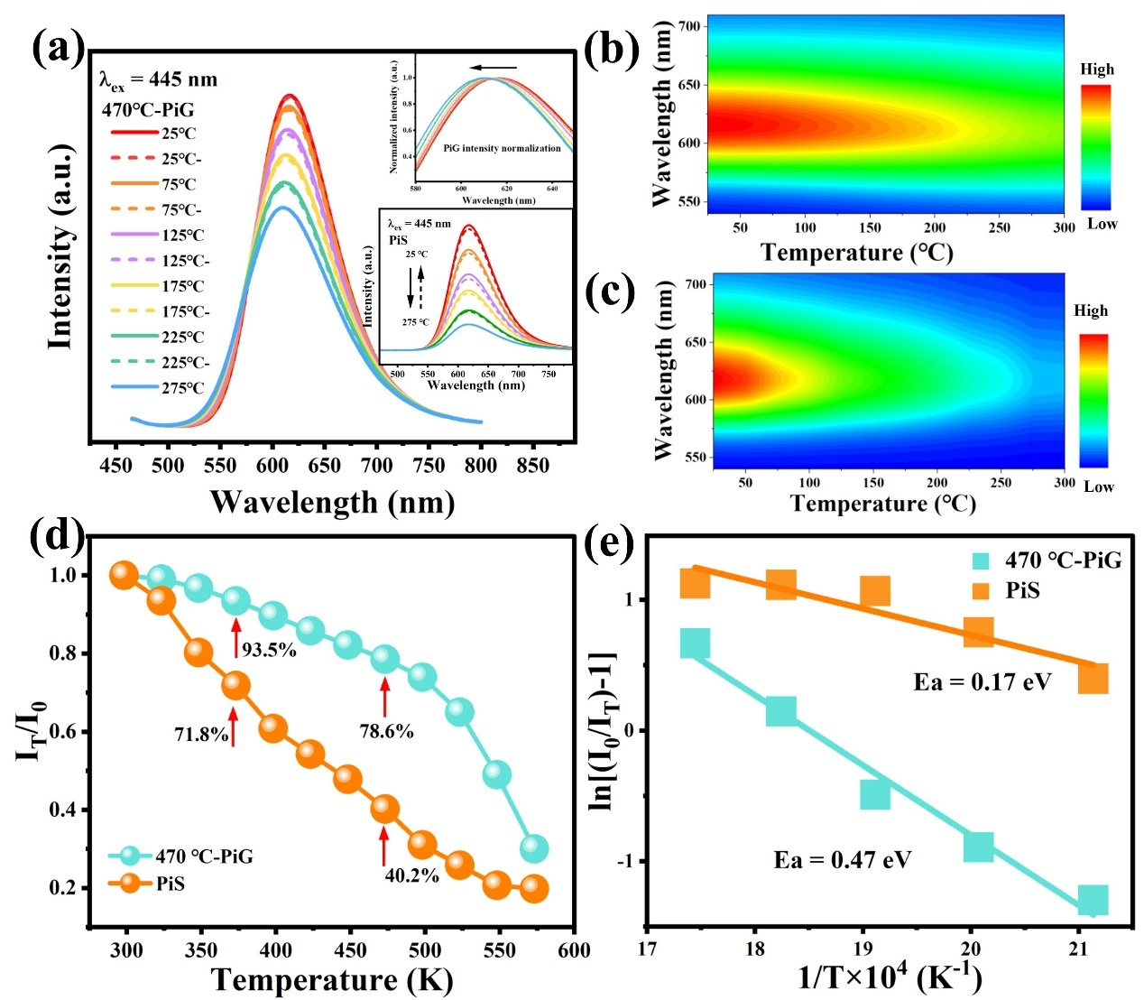
Fig. 5. (a) Temperature dependent PL spectra of 470 ℃-PiG and PiS. 3D-contour plot oftemperature-dependent PL spectra of (b) PiG and (c) PiS. (d) Temperature dependence of integrated luminescence intensity of two samples. (e) The thermal quenching activation energy E_{a} is calculated according to the data in (c).

PiS sample. As the temperature increases, the emission intensity decreases and temperature quenching occurs. In the upper right corner is the normalized PL spectrum of the PiG sample, which is observed to blue shift with increasing temperature. Temperature-dependent luminescence thermal quenching and blue shift can be explained in terms of thermal migration in the configuration coordinate diagram in Fig. 6. The electrons are activated from the ground state to the excited state, and decline through luminous modes ① and ②. With the increase of temperature, the electrons absorb more thermal activation energy and transition to the ground state through mode ③, resulting in thermal quenching. The thermally activated phonons tunnel through the configuration diagram from the low-energy excited state Eu(Ⅱ)²⁺ to the high-energy excited state Eu(Ⅰ)²⁺ (Mode ④), resulting in a blue shift in the spectrum[47, 48].
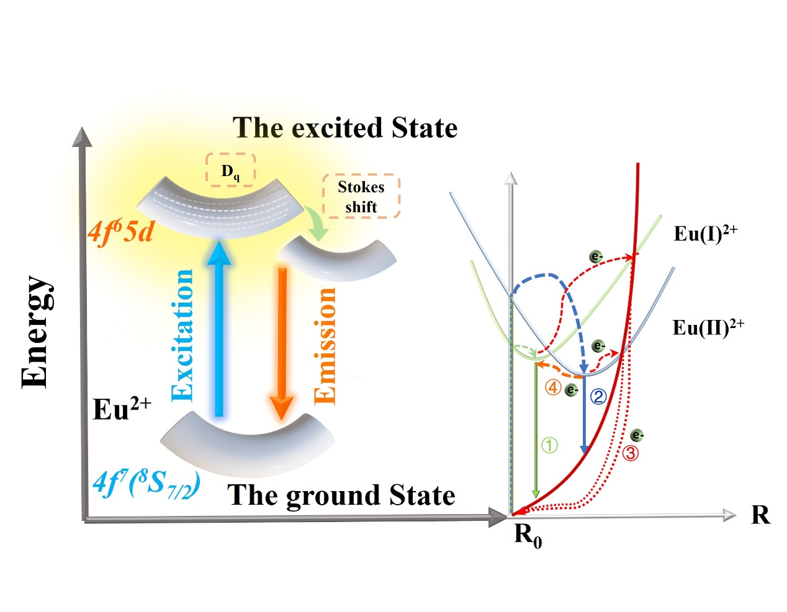Fig. 6. Energy level diagram and configuration coordinate diagram of Eu²⁺.

The moisture resistance of both PiG and PiS samples was evaluated by immersing them in deionized water for varying durations, ranging from day 0 to day 30. Fig. 7a illustrates that the relative emission intensity of PiG remained relatively stable throughout this period, while Fig. 7b reveals a significant decrease in the relative emission intensity of PiS. After undergoing a 30-day immersion aging experiment, PiS exhibited a notable decline in emission intensity, retaining only 70.5% of its initial emission intensity. In contrast, PiG showed only a slight decrease, maintaining a substantial 93.4% of its original emission intensity, as demonstrated in Fig. 7c. These findings highlight the effectiveness of telluride glass in minimizing the corrosion of SCASN:Eu phosphor and preserving its luminescent performance. This offers a viable solution to address the challenges associated with the aging and corrosion of epoxy resin-encapsulated phosphors.
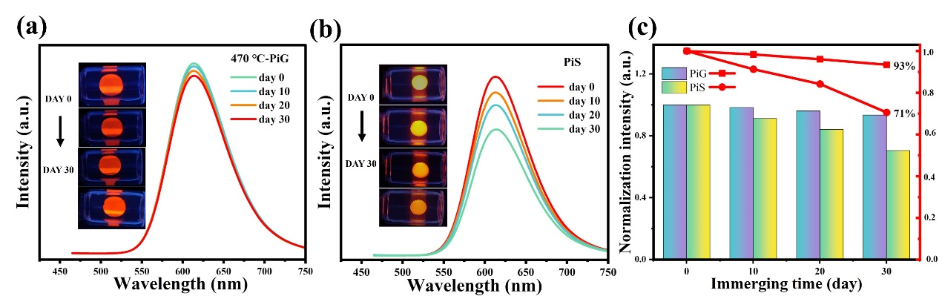Fig. 7. (a)-(b) 470℃-PiG and PiS 30-day moisture resistance test. (c) Comparison of relative luminescence intensity between 470℃-PiG and PiS moisture resistance test.

In order to assess the practical applicability of SCASN:Eu PiG and SCASN:Eu PiS, we designed and constructed WLED devices (as depicted in Fig. 8a-f). When subjected to a 20 mA, 450 nm blue chip excitation, the electroluminescence profiles of these devices, showcased in Fig. 8a-f, exhibited distinct blue and red bands, producing a vivid red light without the incorporation of additional phosphors. Fig. 8g presents a 3D waterfall comparison of the electroluminescence spectra, revealing a slightly higher luminous intensity for PiG compared to PiS. The CIE color coordinate plot in Fig. 8h demonstrates that the red color purity of PiG increases with rising temperature, while PiS exhibits the highest color purity. In Fig. 8i, we recorded the EL+PL spectra of 470 °C-PiG after 48 hours of operation at an LED current of 20 mA. Over this duration, photoluminescence surface decomposition of phosphor particles occurred under the light, resulting in a decline in luminescence intensity. While the photoluminescence intensity of PiG decreased, the peak wavelength and half-width remained relatively stable. After 48 hours, PiG retained 78% of its initial intensity, which, while well-maintained, was slightly lower than the 83% achieved by Yooh et al [49]. This discrepancy may be attributed to the inherent instability of red nitride phosphors, leading to a reduction in the maintenance of photostable intensity due to pronounced diversification. Table 1 provides a comparative analysis of the properties of nitride PiG in various glass systems. It is noteworthy that the optimum co-sintering temperature of the telluride glass system developed in this study is only 470 °C, which is significantly lower than that of the borosilicates and bismuthates listed in the table. Remarkably, it efficiently upholds both quantum efficiency (93%) and thermal stability (93.5%) of the nitride phosphors, thereby demonstrating outstanding performance in terms of quantum efficiency and thermal stability.

Table 1. Comparison of properties of nitride PiG in different glass systems
System of glass | phosphor | Optimum co-sintering temperature | Quantum efficiency retention rate | Thermal stability retention rate | References
B₂O₃-Na₂O-SiO₂-CaO | CaAlSiN₃:0.2%Eu²⁺ | 800 ℃ | 82% | ~90% | Ref.[32]
58Bi₂O₃-20B₂O₃-10SiO₂-4ZnO­  3Al₂O₃-4Na₂O-1Li₂O | (Sr,Ca)AlSiN₃:Eu²⁺ | 530 ℃ | - | 86.6% | Ref.[44]
Na₂O-K₂O-SrO-MgO-CaO-Al₂O₃-B₂O₃-SiO₂ | La₃Si₆N₁₁:Ce³⁺ | 1060 ℃ | - | 98% | Ref.[19]
40SiO₂−30B₂O₃−1BN−15BaO−7K₂O−7Na₂O | YAG:Ce -LuAG:Ce -CASN:Eu | 800 ℃ | 92 % | 80%  (at 573 K) | Ref.[33]
SiO₂-Al₂O₃-Na₂O-CaO-TiO₂ | La₃Si₆N₁₁:Ce³⁺ | 650 ℃ | 72% | 96% | Ref.[50]
60TeO₂-30WO₃-10PbO | (Sr,Ca)AlSiN₃:Eu²⁺ | 470 ℃ | 93% | 93.5% | This work

To explore the luminescence properties of SCASN:Eu-PiG, we fabricated PiG slices at different temperatures and combined them with InGaN blue chips for remote excitation at 450 nm. As depicted in Fig. 9a, a scratch-coating method was employed for the application of LuAG:Ce³⁺ green phosphor onto the surface of the PiG slice. This phosphor serves as the green light source crucial for white light modulation. Fig. 9b displays the three-dimensional electroluminescence spectra of different white light-emitting diodes (WLEDs), accompanied by a comprehensive set of optical parameters available for reference in Table 2. Notably, the modulated device showcased an impressive color rendering index of 93.7, along with a luminous efficacy of 80.4 lm/W and chromaticity coordinates at (0.3458, 0.3426). These coordinates, as displayed in Fig. 9c, offer adjustability in the proximity of white light. Fig. 9(d)-(f) offer visual representations under different lighting conditions, including natural light, red light (Ra=65.4), and white light (Ra=93.7). Collectively, these results underscore that a thoughtfully designed color converter can indeed yield high-quality white light across the full spectrum.

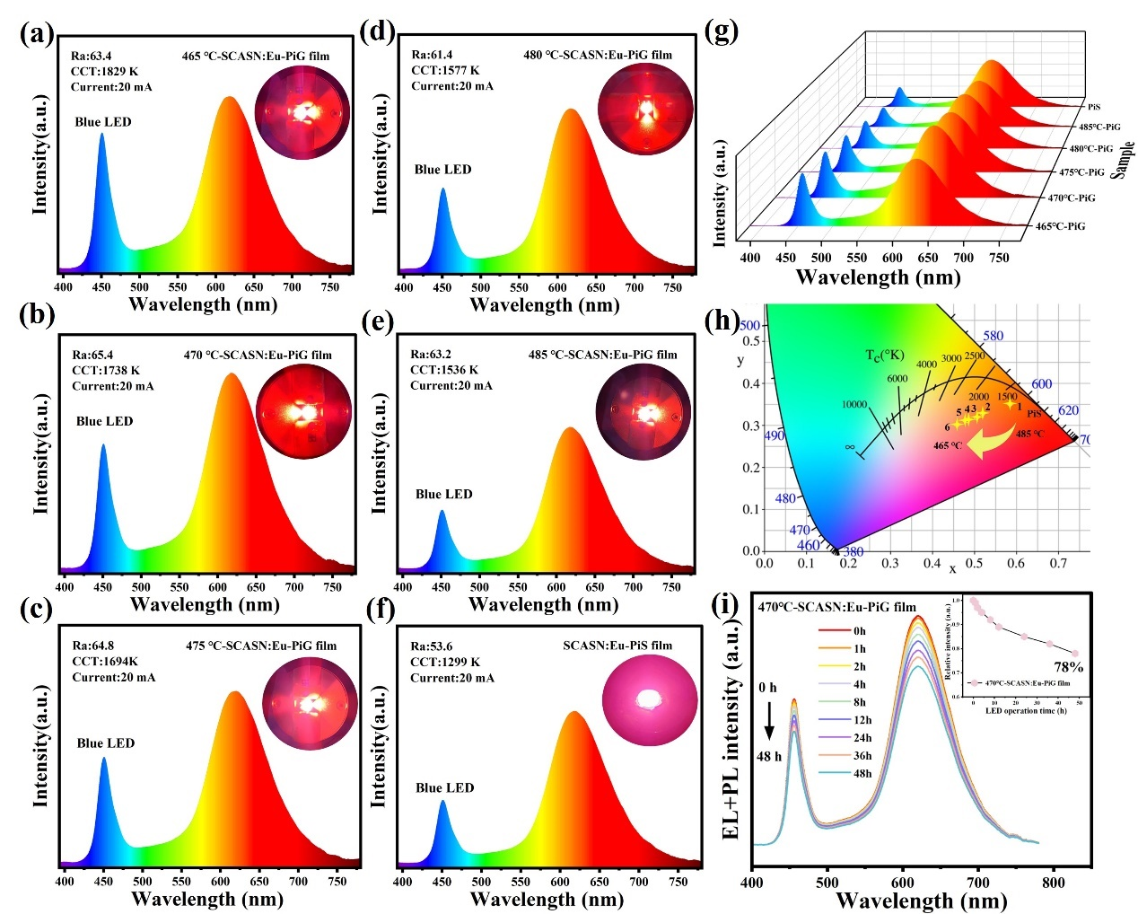
Fig. 8. (a)-(f) electroluminescence spectra of WLEDs assembled with different samples. (e) electroluminescence spectra 3D waterfall diagram. (f) CIE color coordinates for different WLEDs. (i) At a working current of 20 mA, the EL+PL spectrum of 470 ℃-PiG changes with the relative intensity of LED illumination time.

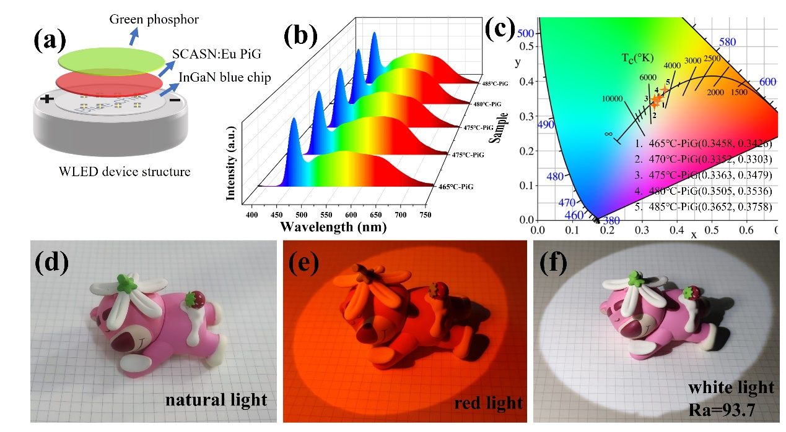

Fig. 9. (a) The WLED structural schematic. (b) 3D EL spectra of blue light chips with SCASN:Eu PiG and LuAG:Ce phosphor coupled to WLEDs. (c) CIE coordinates. (d)- (f) Picture effects in natural light, red light, warm white light.

Table 2. CIE coordinates, CCT,CRI of WLED devices prepared from different samples at 20 mA current.
Samples | CIE (x, y) | CCT(K) | Ra | LE(lm/w)
465℃-PiG | (0.3458, 0.3426) | 4940 | 93.8 | 73.5
470℃-PiG | (0.3352, 0.3303) | 5850 | 93.7 | 80.4
475℃-PiG | (0.3363, 0.3479) | 5342 | 92.0 | 81.4
480℃-PiG | (0.3505, 0.3536) | 4804 | 91.0 | 77.1
485℃-PiG | (0.3652, 0.3758) | 4432 | 88.2 | 81.8

4. Conclusions
In this work, a series of 10 wt%-SCASN:Eu PiG samples were prepared by combining SCASN:Eu with low-melting-point, high-refractive-index telluride glass using a compactor and low-temperature co-sintering method. The 470 °C-PiG samples (91.14%) retained the phosphor (98.13%) and had an internal quantum efficiency of 93%. The activation energy of PiG (0.47 eV) is higher than that of PiS (0.17 eV), showing excellent thermal stability. The emission intensity of the PiG slice at 373 K is 93.5% of the initial value. This study demonstrates the superiority of telluride glass-based PiG as color converters, offering a straightforward strategy for color synthesis. The prepared WLEDs have high color rendering index, high luminous efficacy (Ra=93.7, LE=80.4 lm/W), and high potential for development in the field of full-spectrum high-quality luminescence. The careful selection of an appropriate glass matrix is pivotal in enhancing photon utilization in PiG slices and ensuring the stability of the phosphor crystal phase structure. This aspect holds significant importance in advancing the development of glass matrix composites characterized by exceptional stability and superior luminous quality.
References
[1] X. Liu, X.L. Qian, Z.W. Hu, X.P. Chen, Y. Shi, J. Zou, J. Li, Al₂O₃-Ce:GdYAG composite ceramic phosphors for high-power white light-emitting-diode applications, J. Eur. Ceram. Soc. 39(6) (2019) 2149-2154. https://doi.org/10.1016/j.jeurceramsoc.2019.01.054.
[2] L. Han, J. Song, W.Z. Liu, Z.L. Xiao, L.L. Zhang, A.X. Lu, Z.H. Xiao, W.X. You, Q. Zhang, Preparation and luminescent properties of Tm³⁺-Dy³⁺ co-doped phosphate glass for white light-emitting-diode applications, J. Lumines. 227 (2020) 8. https://doi.org/10.1016/j.jlumin.2020.117559.
[3] F. Schutt, M. Zapf, S. Signetti, J. Strobel, H. Kruger, R. Roder, J. Carstensen, N. Wolff, J. Marx, T. Carey, M. Schweichel, M.I. Terasa, L. Siebert, H.K. Hong, S. Kaps, B. Fiedler, Y.K. Mishra, Z. Lee, N.M. Pugno, L. Kienle, A.C. Ferrari, F. Torrisi, C. Ronning, R. Adelung, Conversionless efficient and broadband laser light diffusers for high brightness illumination applications, Nat. Commun. 11(1) (2020) 10. https://doi.org/10.1038/s41467-020-14875-z.
[4] Z.H. Liu, P. Hu, H.J. Jiang, P. Sun, Y.F. Liu, Z.H. Luo, J.T. Xu, Z.R. Huang, J. Jiang, CaAlSiN₃:Eu²⁺/Lu₃Al₅O₁₂:Ce³⁺ phosphor-in-glass film with high luminous efficiency and CRI for laser diode lighting, J. Mater. Chem. C 9(10) (2021) 3522-3530. https://doi.org/10.1039/d1tc00136a.
[5] H.S. Yang, Y.J. Zhang, Y.Q. Zhang, Y. Zhao, X.J. Liang, G.X. Chen, Y.F. Liu, W.D. Xiang, Designed glass frames full color in white light-emitting diodes and laser diodes lighting, Chem. Eng. J. 414 (2021) 7. https://doi.org/10.1016/j.cej.2021.128754.
[6] T. Zhou, C. Hou, L. Zhang, Y. Ma, J. Kang, T. Li, R. Wang, J. Huang, J. Li, H. Ren, Z. Fu, F.A. Selim, M. Li, H. Chen, Efficient spectral regulation in Ce:Lu₃(Al,Cr)₅O₁₂ and Ce:Lu₃(Al,Cr)₅O₁₂/Ce:Y₃Al₅O₁₂ transparent ceramics with high color rendering index for high-power white LEDs/LDs, J. Adv. Ceram. 10(5) (2021) 1107-1118. https://doi.org/10.1007/s40145-021-0496-8.
[7] S.S. Lin, H. Lin, Q.M. Huang, H.Y. Yang, B. Wang, P.F. Wang, P. Sui, J. Xu, Y. Cheng, Y.S. Wang, Highly Crystalline Y₃Al₅O₁₂:Ce³⁺ Phosphor-in-Glass Film: A New Composite Color Converter for Next-Generation High-Brightness Laser-Driven Lightings, Laser Photon. Rev. 16(12) (2022) 10. https://doi.org/10.1002/lpor.202200523.
[8] H. Zhou, H.Z. Zhang, X.F. Ye, X.B. Tong, J. Han, X.M. Zhang, Near-UV excited green-emission enhancement by efficient energy transfer in Na1.8Mg0.9Si1.1O4:Ce3+,Tb3+ phosphor for solid-state lighting applications, Opt. Laser Technol. 150 (2022) 7. https://doi.org/10.1016/j.optlastec.2022.107950.
[9] Y.A. Berkovich, I.O. Konovalova, A.N. Erokhin, S.O. Smolyanina, V.G. Smolyanin, O.S. Yakovleva, I.G. Tarakanov, T.M. Ivanov, LED lighting optimization as applied to a vitamin space plant growth facility, Life Sci. Space Res. 20 (2019) 93-100. https://doi.org/10.1016/j.lssr.2018.09.004.
[10] S.P. Ying, H.K. Fu, H.H. Hsieh, J.H. Wu, Optical film design of low-glare LED panel light, Opt. Laser Technol. 111 (2019) 45-50. https://doi.org/10.1016/j.optlastec.2018.09.031.
[11] H. Zhang, H. Yang, G.G. Li, S.Q. Liu, H.R. Li, Y.M. Gong, Y.J. Liang, Y.J. Chen, Enhancing thermometric performance via improving indicator signal in Bi³⁺-doped CaNb₂O₆:Ln⁽³⁺) (Ln = Eu/Sm/Dy/Tb) phosphors, Chem. Eng. J. 396 (2020) 12. https://doi.org/10.1016/j.cej.2020.125251.
[12] P. Xue, L.H. Tian, A far-red phosphor LaSrZnNbO₆:Mn⁴⁺ for plant growth lighting, Opt. Mater. 115 (2021) 7. https://doi.org/10.1016/j.optmat.2021.111063.
[13] M. Lupo, M.A. Bashir, C. Silvestri, E. Brunori, A.L. Pica, V. Cristofori, LED Lighting Effects on Plant Growth and Quality of Pyrus communis L. Propagated In Vitro, Agronomy-Basel 12(10) (2022) 13. https://doi.org/10.3390/agronomy12102531.
[14] Y.Y. Liang, Q.T. Cao, Y.Q. Zhou, W.L. Zhou, J.L. Zhang, L.P. Yu, S.X. Lian, Z.X. Qiu, Towards control facilities for mimicking plant growth optimum action spectrum: Efficient near-ultraviolet to far-red light-conversion in Cr³⁺-doped rare-earth aluminate phosphors, Chem. Eng. J. 454 (2023) 9. https://doi.org/10.1016/j.cej.2022.140235.
[15] I.E.O. Hinostroza, H. Desirena, J. Hernandez, J. Molina, I. Moreno, E. De la Rosa, Eu³⁺-doped glass as a color rendering index enhancer in phosphor-in-glass, J. Am. Ceram. Soc. 101(7) (2018) 2914-2920. https://doi.org/10.1111/jace.15464.
[16] H. Lin, T. Hu, Y. Cheng, M.X. Chen, Y.S. Wang, Glass Ceramic Phosphors: Towards Long-Lifetime High-Power White Light-Emitting-Diode Applications-A Review, Laser Photon. Rev. 12(6) (2018) 31. https://doi.org/10.1002/lpor.201700344.
[17] H. Lee, S.H. Lee, Y.G. Choi, W.B. Im, W.J. Chung, Eu²⁺ and Mn²⁺ co-doped oxyfluoride glass ceramic for white color conversion of 400 nm UV-LED, J. Lumines. 222 (2020) 5. https://doi.org/10.1016/j.jlumin.2020.117156.
[18] T. Hu, L.X. Ning, Y. Gao, J.W. Qiao, E.H. Song, Z.T. Chen, Y.Y. Zhou, J. Wang, M.S. Molokeev, X.X. Ke, Z.G. Xia, Q.Y. Zhang, Glass crystallization making red phosphor for high-power warm white lighting, Light-Sci. Appl. 10(1) (2021) 12. https://doi.org/10.1038/s41377-021-00498-6.
[19] L. Xu, X.D. Wang, L.H. Wang, S.Y. Bao, Y. Wang, X.J. Liang, W.D. Xiang, Design of a Novel La₃Si₆N₁₁:Ce³⁺ Phosphor-in-Glass Film for High Power Laser Lighting: Luminous Efficiency toward 200 lmW⁻¹, ACS Sustain. Chem. Eng. 10(38) (2022) 12817-12825. https://doi.org/10.1021/acssuschemeng.2c03897.
[20] Q.X. Wen, Y. Wang, C. Zhao, L. Xu, X.D. Wang, Y.S. Xu, S. Lin, X.J. Liang, J.P. Liu, W.D. Xiang, Ultrahigh Power Density LuAG:Ce Green Converters For High-Luminance Laser-Driven Solid State Lighting, Laser Photon. Rev. 17(6) (2023) 10. https://doi.org/10.1002/lpor.202200909.
[21] K.W. Park, S.G. Lim, G. Deressa, J.S. Kim, T.W. Kang, H.L. Choi, Y.M. Yu, Y.S. Kim, J.G. Ryu, S.H. Lee, T.H. Kim, High power and temperature luminescence of Y₃Al₅O₁₂:Ce³⁺ bulky and pulverized single crystal phosphors by a floating-zone method, J. Lumines. 168 (2015) 334-338. https://doi.org/10.1016/j.jlumin.2015.08.045.
[22] Q. Yao, P. Hu, P. Sun, M. Liu, R. Dong, K.F. Chao, Y.F. Liu, J. Jiang, H.C. Jiang, YAG:Ce³⁺ Transparent Ceramic Phosphors Brighten the Next-Generation Laser-Driven Lighting, Adv. Mater. 32(19) (2020) 7. https://doi.org/10.1002/adma.201907888.
[23] Y.B. Li, C.Y. Ma, C.D. Zuo, W.G. Ye, X.F. Shen, Y.Z. Wang, Y.K. Li, C. Zhao, Z.C. Wen, X.Y. Yuan, Y.G. Cao, High thermal stability AlN-YAG: Ce composite phosphor ceramics for high-power laser-driven lighting, Appl. Phys. Lett. 119(25) (2021) 7. https://doi.org/10.1063/5.0077184.
[24] Y. Peng, Z.K. Yu, J.Z. Zhao, Q. Wang, J.X. Liu, B. Sun, Y. Mou, M.X. Chen, Unique sandwich design of high-efficiency heat-conducting phosphor-in-glass film for high-quality laser-driven white lighting, J. Adv. Ceram. 11(12) (2022) 1889-1900. https://doi.org/10.1007/s40145-022-0654-7.
[25] J.X. Yang, M. Feng, K. Zhang, Z.Y. Chen, R. Xu, A. Khan, Y. Li, J.Y. Xie, L.S. Liu, F. Song, W. Huang, All-Inorganic Functional Phosphor-Glass Composites by Light Curing Induced 3D Printing for Next-Generation Modular Lighting Devices, Adv. Opt. Mater. 10(21) (2022) 10. https://doi.org/10.1002/adom.202201110.
[26] L. Chen, M. Fei, Z. Zhang, Y. Jiang, S.F. Chen, Y.Q. Dong, Z.H. Sun, Z. Zhao, Y.B. Fu, J.H. He, C. Li, Z. Jiang, Understanding the Local and Electronic Structures toward Enhanced Thermal Stable Luminescence of CaAlSiN₃:Eu²⁺, Chem. Mat. 28(15) (2016) 5505-5515. https://doi.org/10.1021/acs.chemmater.6b02121.
[27] W.T. Ding, Z.L. Zhang, X. Hou, Y. Mei, D. Long, L.Y. Ying, M. Lu, B.P. Zhang, Dual-emitting phosphor-glass composites by the melt-quenching method for high-quality laser lighting, Ceram. Int. 48(23) (2022) 34602-34609. https://doi.org/10.1016/j.ceramint.2022.08.047.
[28] Q.G. Huang, H. Lin, B. Wang, S.S. Lin, P.F. Wang, P. Sui, J. Xu, Y. Cheng, Y.S. Wang, Patterned glass ceramic design for high-brightness high-color-quality laser-driven lightings, J. Adv. Ceram. 11(6) (2022) 862-873. https://doi.org/10.1007/s40145-022-0578-2.
[29] S.Y. Bao, Y.Y. Liang, L.S. Wang, L.H. Wang, L. Xu, Y. Wang, X.J. Liang, W.D. Xiang, Superhigh-Luminance Ce:YAG Phosphor in Glass and Phosphor-in-Glass Film for Laser Lighting, ACS Sustain. Chem. Eng. 10(24) (2022) 8105-8114. https://doi.org/10.1021/acssuschemeng.2c02657.
[30] Q.G. Huang, P. Sui, F. Huang, H. Lin, B. Wang, S.S. Lin, P.F. Wang, J. Xu, Y. Cheng, Y.S. Wang, Toward High-Quality Laser-Driven Lightings: Chromaticity-Tunable Phosphor-in-Glass Film with "Phosphor Pattern" Design, Laser Photon. Rev. 16(7) (2022) 10. https://doi.org/10.1002/lpor.202200040.
[31] L.H. Wang, J.W. Liu, L. Xu, S.Y. Bao, Y. Wang, J.D. Zhang, X.J. Liang, W.D. Xiang, Realizing High-Power Laser Lighting: Artfully Importing Micrometer BN into Ce: GdYAG Phosphor-in-Glass Film, Laser Photon. Rev. 17(2) (2023) 9. https://doi.org/10.1002/lpor.202200585.
[32] Y.J. Zhang, Z.L. Zhang, X.D. Liu, G.Z. Shao, L.L. Shen, J.M. Liu, W.D. Xiang, X.J. Liang, A high quantum efficiency CaAlSiN₃:Eu²⁺ phosphor-in-glass with excellent optical performance for white light-emitting diodes and blue laser diodes, Chem. Eng. J. 401 (2020) 10. https://doi.org/10.1016/j.cej.2020.125983.
[33] C. Zhao, Q.X. Wen, S.Y. Bao, S. Pan, W.D. Xiang, X.J. Liang, Tricolor Pattern Design: Ultrahigh Thermal Conductivity Phosphor-in-Glass Film for Laser Illumination, ACS Sustain. Chem. Eng. (2023) 10. https://doi.org/10.1021/acssuschemeng.3c02765.
[34] Z. Wang, B. Shen, F. Dong, S. Wang, W.-S. Su, A first-principles study of the electronic structure and mechanical and optical properties of CaAlSiN 3, Physical Chemistry Chemical Physics 17(22) (2015) 15065-15070.
[35] S.X. Li, L. Wang, Q.Q. Zhu, D.M. Tang, X.J. Liu, G.F. Cheng, L. Lu, T. Takeda, N. Hirosaki, Z.R. Huang, R.J. Xie, Crystal structure, tunable emission and applications of Ca_{1-x}Al_{1-x}Si_{1+x}N_{3-x}O_{x} :RE (x=0-0.22, RE = Ce³⁺, Eu²⁺) solid solution phosphors for white light-emitting diodes, J. Mater. Chem. C 4(47) (2016) 11219-11230. https://doi.org/10.1039/c6tc04057h.
[36] M.R. Oermann, H. Ebendorff-Heidepriem, Y. Li, T.-C. Foo, T.M. Monro, Index matching between passive and active tellurite glasses for use in microstructured fiber lasers: erbium doped lanthanum-tellurite glass, Opt. Express 17(18) (2009) 15578-84. https://doi.org/10.1364/oe.17.015578.
[37] Y. Kim, S. Kim, F. Iqbal, H. Yie, H. Kim, Effect of transmittance on luminescence properties of phosphor-in-glass for LED packaging, Opt. Express 23(3) (2015) A43-A50. https://doi.org/10.1364/oe.23.000a43.
[38] S. Kim, H. Yie, S. Choi, A. Sung, H. Kim, Pore characteristics for improving luminous efficacy of phosphor-in-glass, Opt. Express 23(24) (2015) A1499-A1511. https://doi.org/10.1364/oe.23.0a1499.
[39] Y.R. Tang, S.M. Zhou, C. Chen, X.Z. Yi, Y. Feng, H. Lin, S. Zhang, Composite phase ceramic phosphor of Al<sub>2</sub>O<sub>3</sub>-Ce:YAG for high efficiency light emitting, Opt. Express 23(14) (2015) 17923-17928. https://doi.org/10.1364/oe.23.017923.
[40] H.C. Yoon, K. Yoshihiro, H. Yoo, S.W. Lee, J.H. Oh, Y.R. Do, Low-Yellowing Phosphor-in-Glass for High-Power Chip-on-board White LEDs by Optimizing a Low-Melting Sn-P-F-O Glass Matrix, Sci Rep 8 (2018) 11. https://doi.org/10.1038/s41598-018-25680-6.
[41] D. Munoz-Martín, M.A. Villegas, J. Gonzalo, J.M. Fernández-Navarro, Characterisation of glasses in the TeO2–WO3–PbO system, J. Eur. Ceram. Soc. 29(14) (2009) 2903-2913. https://doi.org/10.1016/j.jeurceramsoc.2009.04.018.
[42] G. Liu, Z.F. Tian, Z.H. Chen, H.Z. Wang, Q.H. Zhang, Y.G. Li, CaAlSiN₃:Eu²⁺ phosphors bonding with bismuth borate glass for high power light excitation, Opt. Mater. 40 (2015) 63-67. https://doi.org/10.1016/j.optmat.2014.11.047.
[43] R. Xiang, X.J. Liang, P.Z. Li, X.X. Di, W.D. Xiang, A thermally stable warm WLED obtained by screen-printing a red phosphor layer on the LuAG:Ce³⁺ PiG substrate, Chem. Eng. J. 306 (2016) 858-865. https://doi.org/10.1016/j.cej.2016.08.008.
[44] H.T. Zhang, Y.A. Li, J.R. Ling, J. Yang, M. Jin, W.T. Xu, Y.F. Zhou, M.C. Hong, (Sr,Ca)AlSiN₃:Eu²⁺phosphor-in-glass and YAG ceramic composites for high CRI and high-power white LEDs, Ceram. Int. 49(14) (2023) 23871-23877. https://doi.org/10.1016/j.ceramint.2023.04.230.
[45] H. Wang, Y. Mou, Y. Peng, Y. Zhang, A.G. Wang, L.L. Xu, H.L. Long, M.X. Chen, J.N. Dai, C.Q. Chen, Fabrication of phosphor glass film on aluminum plate by using lead-free tellurite glass for laser-driven white lighting, J. Alloy. Compd. 814 (2020) 6. https://doi.org/10.1016/j.jallcom.2019.152321.
[46] Y. Wang, L.H. Wang, S.Y. Bao, L. Xu, J.D. Zhang, Y.Y. Liang, L.S. Wang, X.J. Liang, W.D. Xiang, High-performance and heat-resistant Ce:YAG phosphor in glass for laser lighting, J. Alloy. Compd. 921 (2022) 8. https://doi.org/10.1016/j.jallcom.2022.166083.
[47] J. Li, J.Y. Ding, Y.X. Cao, X.F. Zhou, B. Ma, Z.Y. Zhao, Y.H. Wang, Color-Tunable Phosphor Mg_{1.25}Si_{1.25}Al_{2.5}O₃N₃:Eu²⁺-A New Modified Polymorph of AlON with Double Sites Related Luminescence and Low Thermal Quenching, ACS Appl. Mater. Interfaces 10(43) (2018) 37307-37315. https://doi.org/10.1021/acsami.8b15249.
[48] M. Que, Z. Ci, Y. Wang, G. Zhu, S. Xin, Y. Shi, Q. Wang, Crystal structure and luminescence properties of a cyan emitting Ca₁₀(SiO₄)₃(SO₄)₃F₂:Eu²⁺ phosphor, CrystEngComm 15(32) (2013) 6389. https://doi.org/10.1039/c3ce40482j.
[49] Y.H. Nam, K. Han, W.J. Chung, W.B. Im, Double Encapsulation of CsPbBr₃ Perovskite Nanocrystals with Inorganic Glasses for Robust Color Converters with Wide Color Gamut, ACS Appl. Nano Mater. 4(7) (2021) 7072-7078. https://doi.org/10.1021/acsanm.1c01079.
[50] S.H. You, S.X. Li, P. Zheng, T.L. Zhou, L. Wang, L.H. Liu, N. Horisaki, F.F. Xu, R.J. Xie, A Thermally Robust La₃Si₆N₁₁:Ce-in-Glass Film for High-Brightness Blue-Laser-Driven Solid State Lighting, Laser Photon. Rev. 13(2) (2019) 10. https://doi.org/10.1002/lpor.201800216.

