Cumulative effect of spectral downshifting, anti-reflection and space-charge region formation in enhancing the spectral response of self-powered silicon photodetectors on sensitisation with CdZnS/ZnS core-shell quantum dots
Kumaar Swamy Reddy Bapathi ^{abc}, Mostafa F. Abdelbar ^{cd}, Wipakorn Jevasuwan ^{c}, Pramod H Borse ^{b}, Sushmee Badhulika ª* and Naoki Fukata ^{c}*
ª Department of Electrical Engineering, Indian Institute of Technology Hyderabad, Kandi, Sangareddy, Hyderabad
^{b} Centre for Solar Energy Materials, International Advanced Research Centre for Powder
Metallurgy & New Materials, Balapur, Hyderabad
^{c} Research Centre for Materials Nanoarchitectonics, National Institute for Materials Science, Tsukuba, Japan
^{d} Institute of Nanoscience & Nanotechnology, Kafrelsheikh University, 33516 Kafrelsheikh, Egypt

Graphical Abstract
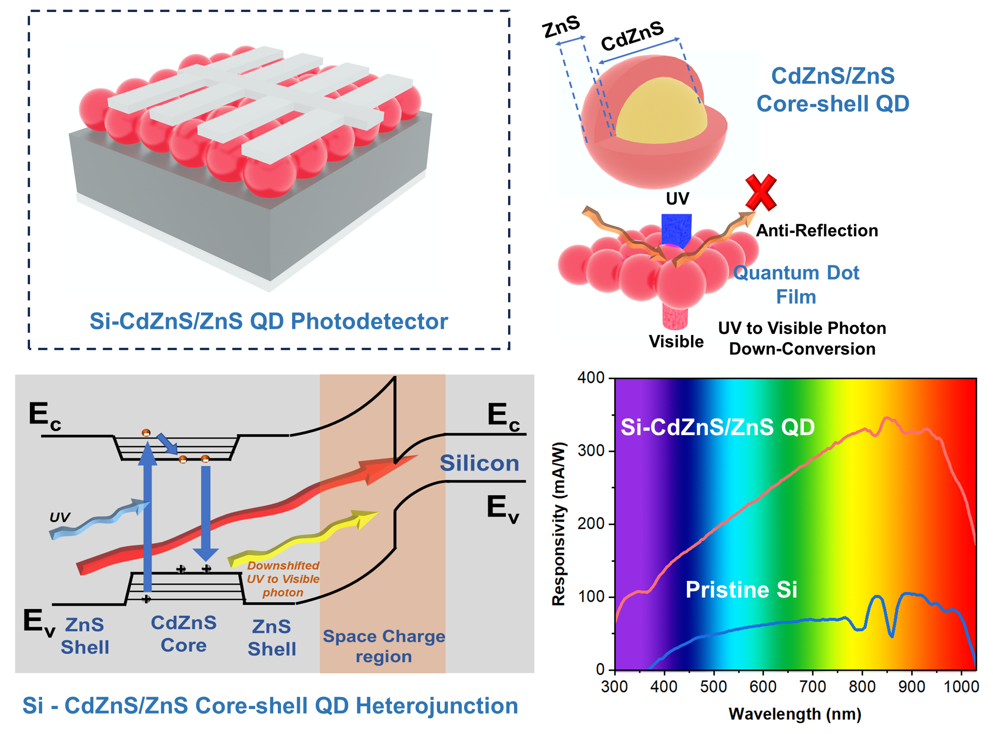
Abstract

Despite their ubiquity, Silicon (Si)-based photodetectors face intrinsic limitations that inhibit their performance, especially in the critical ultraviolet (UV) range. Downshifting of high energy photons by employing luminescent quantum dots (QDs) has up to now been the commonest photon harvesting technique in Si photodetectors. This research article describes the monolithic integration of CdZnS/ZnS core-shell QDs with Si photodetectors to make use of the spectral downshifting effect. Silicon detectors sensitised with these QDs have shown remarkably enhanced responsivity and external quantum efficiency over a broad spectral range of 300 - 1100 nm. Apart from the spectral down-shifting process, the anti-reflection effect of the QD film and the formation of a space charge region at the Si-CdZnS/ZnS interface have also contributed to enhanced device performance. The additive effect of spectral downshifting, anti-reflection effects and heterojunction formation has given these QD-sensitized devices enhanced responsivity and EQE values of 345 mA/W and 0.5, markedly higher than the values of 110 mA/W and 0.15 seen in pristine devices. Given the notable enhancement demonstrated without the need for the application of epitaxial techniques, this study may assist in mitigating the inherent limitations of Si photodetectors.

Keywords: Si photodetector, core-shell quantum dots, luminescent quantum dots, spectral downshifting, self-powered, broadband

- Introduction
Broadband photodetectors are widely employed in applications such as spectroscopy, optical coherence tomography, flame detection, and surveillance.^{1–7} Broadband photodetectors are also increasingly employed in emerging niche applications such as machine vision, atmospheric monitoring, and autonomous vehicles and are also being integrated with energy harvesting devices.^{8–10} These emerging applications require detectors with greater functionality. Silicon technology dominates the electronic and opto-electronic device field due to its exceptional opto-electronic properties and compatibility with existing microelectronic technologies. To date, Si is the most commonly-used material employed in the fabrication of broadband photodetectors. However, Si photodetectors inherently face the drawback of low spectral responsivity and are far from meeting the requirements of emerging applications.
The key issues that contribute to the poor responsivity of Si photodetectors and which need to be addressed are: i) Thermalization losses due to high-energy photons (UV spectra) and ii) reflection losses of incident photons due to the high refractive index of Si.^{11,12} Si photodetectors are sensitive to visible and NIR spectra but have poor responsivity in the UV range, making them less suitable for applications that require high UV sensitivity. UV photons which have energies that exceed the bandgap of Si (1.1 eV), generate hot electrons when absorbed at the surface, which are typically lost as phonon emissions by non-radiative recombination process, resulting in heating of the crystal lattice.
Solar irradiance measurement, luminescence spectroscopy, UV curing systems, space and atmospheric research exploration demand detectors with broadband spectral response and high responsivity in the UV region.^{13–15} This has prompted exhaustive research to curtail thermalisation and reflection losses using several strategies, such as the use of tandem device architectures, hot carrier extraction, integration with III–V compound semiconductors, spectral splitting, etc.^{16–20} However, these approaches escalate the device structure's cost and complexity, and are often incompatible with well-established complementary metal oxide semiconductor (CMOS) technology.
Colloidal quantum dots are highly versatile semiconductor nanocrystals that display size-tuneable optical properties with cost-effective solution processing techniques.^{21–24} The absorption and emission characteristics of QDs offer pathway to address the thermalisation and reflection losses in Si photodetectors. QDs can be tuned to convert high-energy photons to lower-energy photons via spectral downshifting. After electronic and vibrational relaxation, the excited photocarriers re-emit down-shifted photons that have lower energies. ^{21,25,26} The high-energy UV photons are converted to low-energy visible and IR photons. Sensitization of Si with QDs can thus enable Si to capture photons across a broader range of energies, especially in the UV range, ultimately leading to improved detector responsivity. So far, materials such as Silicon QDs and rare-earth doped QDs are used as spectral downshifters.^{25,27–32} However, these QDs suffer from small stokes shift and high photo-oxidation. Recently, CdZnS based core-shell QDs have emerged as promising for downshifting applications due to their large Stokes shift and high stability.
In this study, we investigate the monolithically-integrated Si-CdZnS/ZnS core-shell QD heterojunction and its potential use in photodetectors. Colloidal core-shell CdZnS/ZnS QDs are synthesised using the hot-injection technique. Integration of the synthesised CdZnS/ZnS QDs with Si photodetectors leads to significant enhancement of the device responsivity and of quantum efficiency. Detailed optical and optoelectronic device testing revealed that CdZnS/ZnS QDs act as a spectral down-shifting and anti-reflection layer. A space charge region is formed at the Si and CdZnS/ZnS QDs interface due to favourable relative band energetics that assists with better separation and transportation of photocarriers. This cumulative effect of spectral down-shifting, anti-reflection, and space charge region formation at the Si-CdZnS/ZnS QD interface appears to contribute to the overall enhancement of the photodetector responsivity quantum efficiency.
- Materials
N-type Si wafers with a resistance of 1 - 10 Ω and thickness of 280 µm were procured from Aki Corporation. Cadmium chloride (CdCl₂, 99.9%), zinc acetate (ZnAc), octadecene (95%), oleic acid (90%) and oleyamine (90%) were procured from Sigma Aldrich.
  - Instrumentation
High-resolution transmission electron microscopic images of QDs were captured by transmission electron microscopy (TEM, JEOL-JEM-2100). The morphology of the QD films was captured using a field emission scanning electron microscope (FE-SEM, Hitachi SU-8000). The topography of the QD films was obtained using an atomic force microscope (WI-Tec). The reflectance was measured using a UV-VIS-NIR spectrophotometer (JASCO V-670). PL Measurements were carried out using Quantaurus-Tau C11367. The responsivity and external quantum efficiency (EQE) of the devices were measured using a spectral response measurement system (Bunkoukeiki BQE-100 F). The temporal response of devices at individual wavelengths was measured using a monochromator device (Bunkoukeiki BSD-60Z). The intensity of the light sources was calibrated using a Si photodiode (Hamamatsu Photonics S1337–1010BQ). A Keithley 2400 semiconductor analyser was used for electrical measurements. Dark current and capacitance–voltage characteristics were analysed using a room temperature prober (Hisol HMP-400).

  - Synthesis of CdZnS/ZnS core-shell quantum dots
CdZnS/ZnS QDs were synthesised using the procedure laid out in our group’s previously published work.²⁵ Initially, two stock sulphur solutions were prepared. Stock Solution 1 consists of 1.6-mM sulphur in 2.4 ml of octadecene. Stock Solution 2 consists of 4-mM sulphur in 5 ml oleylamine. In a 3-neck flask, 1 mM cadmium chloride and 10 mM ZnAc were added to 10 ml oleic acid. The mixed solution was heated to 150 ˚C in an argon flow; 20 ml octadecene was then added to the solution. The temperature of the mixture was raised to 310 ˚C. To form CdZnS core QDs, Stock Solution 1 was rapidly injected into the mixture and the reaction was maintained at 310 ˚C for 12 minutes. Stock Solution 2 was then slowly injected drop-wise and the reaction was continued at 310 ˚C for three hours to form the ZnS shells. After the reaction was complete, the synthesized QDs were allowed to precipitate by addition of excess ethanol. The precipitated QDs were centrifuged for 20 minutes and subsequently dispersed in toluene and re-precipitated in ethanol.

  - Fabrication of the Si- CdZnS/ZnS QD photodetector
N-type Si wafers (1 - 10 Ω and 280 µm thick) were used to fabricate the photodetector. The Si wafer was diced into 10 mm x 10 mm pieces. The diced Si substrates were initially cleaned using acetone, DI water, isopropanol and DI water under sonication for 15 minutes each. The cleaned Si substrates were then dried in a nitrogen stream. The back electrode of Ti/Ag was sputtered onto the rear side of the wafer. The synthesized QDs powder was dispersed in toluene solution and sonicated for 30 minutes. The dispersed CdZnS/ZnS QDs were drop-cast onto the Si substrates and allowed to dry naturally. The number of drop-casting cycles was varied from one to five. A finger-patterned Ag front electrode was deposited on the QD-dropcast Si substrates using sputtering. The full process of device fabrication is pictorially represented in Figure 1.
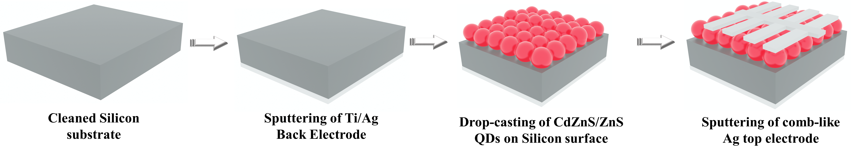
Figure 1. Illustration of CdZnS/ZnS QDs sensitization on Si and photodetector device fabrication process.

- Results & discussion
  - Material characterisation of CdZnS/ZnS core-shell QDs
TEM and STEM imaging were performed to study size and shape of QDs. The TEM image of synthesized QDs (Figure 2a) shows the QDs to be smaller than 11 nm, with 8.6 nm being the average size. The quantum dots size distribution is shown in the Figure S1. To study the elemental composition of the synthesized quantum dots, Energy dispersive spectroscopy (EDS) has been performed as shown in Ref [25] and Figure S2. EDS revealed the presence of Cd, Zn and S elements in the QDs. The atomic percentage (at%) of Cd, Zn and S are quantified to be 8.50%, 43.49% and 48.01%, respectively. To observe the core-shell structure of the QDs in greater detail, imaging was performed using scanning transmission electron microscopy. Figure 2b shows a STEM image of the QDs that reveals the core-shell structure of CdZnS/ZnS QDs. The lighter region in the centre is the CdZnS core, whereas the slightly darker outer region is the ZnS shell. The inset to Figure 2b shows the marked regions of CdZnS core and ZnS shell, for the sake of clarity.
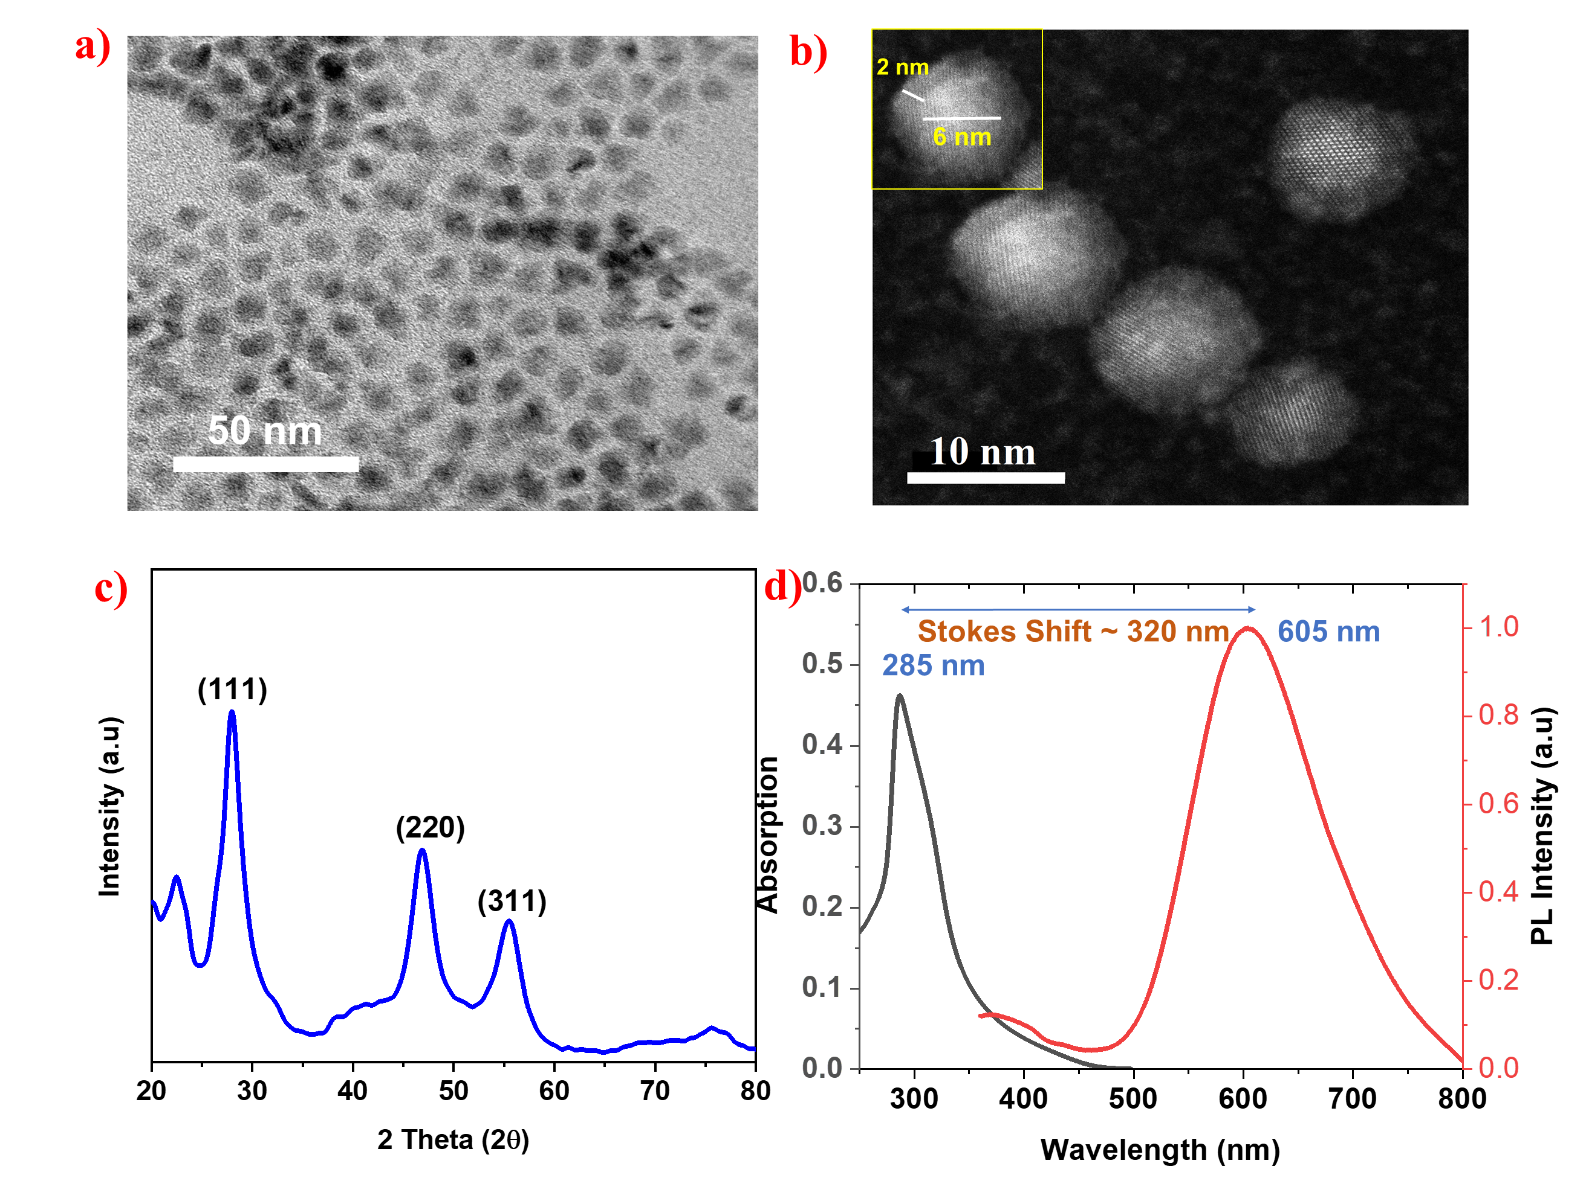Figure 2. a) TEM image, b) STEM image, c) X-ray diffraction spectrum and d) absorption/emission spectrum of CdZnS/ZnS QD.
X-ray diffraction analysis was carried out to confirm the structural phase of the synthesized QDs. Figure 2c depicts the XRD spectrum of QDs, which shows three significant peaks that correspond to the zinc blende ZnS crystal structure. The prevalence of only ZnS peaks in the XRD spectrum indicates that the core CdZnS is coated by the ZnS, forming a core-shell structure instead of an alloy compound. The observed result is in agreement with the observations made in similar core-shell QD systems.^{33,34} The peaks at 27.93˚, 46.77˚ and 55.64˚ respectively correspond to the (111), (220) and (311) planes of ZnS. It is interesting to note that in XRD spectra, no peak related to CdS is observed, however EDS shows the presence of Cd. This infers that the Cd is present as a dopant into the ZnS lattice.

In CdZnS/ZnS QDs, the core CdZnS has the primary role of absorbing the incoming photons and generating charge carriers. The ZnS shell acts as a passivation layer to the core, thus enhancing the photostability of the material and acting as protective barrier between the external factors. The shell's passivating effect reduces surface defects and non-radiative recombination centres, increasing the efficiency of light emission. The absorbance spectrum reveals that QDs exhibit significant absorption in the range of 250 - 350 nm (Figure 2d). UV absorption of QDs is primarily attributed to the intrinsically wide bandgap of ZnS and CdZnS systems and also to the quantum confinement effect. The emission spectrum of CdZnS/ZnS QDs shows a peak ranging from 500 nm to 750 nm, centred at 605 nm. The emission peak of 605 nm corresponds to orange light. Figure S3 shows the pictures of CdZnS/ZnS QDs under ambient light and UV light. As seen in Figure S3b, the orange color emitted by the QDs under UV light, well corroborates the PL study. This suggests that the absorbed UV photons are down-shifted to visible photons and then re-emitted.^{35–37} These studies reveal that synthesized CdZnS/ZnS QDs can be employed as a spectral downshifting layer in Si devices to more efficiently capture UV photons.
3.2 Morphological studies of CdZnS/ZnS quantum dot films
The number of drop-casting cycles was varied from one to five and the effect on detector performance was examined. Figure S4a shows the pristine Si substrate without any QD film, which appears to be smooth. Dust particles are focussed on while imaging the pristine Si substrate for the sake of clarity in assessing the surface morphology. Figure S4b shows the 1-cycle QD film on the Si substrate, which appears to have uniform coverage, with very few pinholes. Figure S4c shows the 2-cycle QD film, and reveals that pinholes in the QD film have increased with the additional QD layer. Figure S4d and Figure S4e show the 3- and 4-cycle QD films on Si, respectively. It is interesting to see that with the further increase in QD drop-cast cycles, the number and size of pinholes increases drastically. It appears that the greater thickness of QD films results in an island-like film rather than a uniform film. Figure S4f shows the 5-cycle QD film: it can be seen that pinhole formation has further increased and that the film roughness appears to have increased. The inset to Figure S4 shows corresponding photographs of QD-sensitized Si substrates under illumination with UV light.

3.3 Optimization of quantum dot film deposition
I-V characteristics, spectral responsivity, and EQE of detectors were studied to elucidate the influence of number of QD drop-casting cycles on the device’s performance. I-V characteristics of detectors were measured under monochromatic light at 900 nm (2 mW/cm²), as seen in Figure 3a. The pristine device shows a very low short circuit current density of 147.2 µA/cm². Interestingly, with the sensitization of device with QDs, short circuit current density shows a marked increase. Initially, with the addition of 1 cycle and 2 cycles of QDs, the short circuit current density increased to 228.7 µA/cm² and 396.9 µA/cm², respectively. The device with the 3 cycles-QD film shows the highest short circuit density of 571.4 µA/cm². With the further increase in QD drop-casting cycles, the short circuit density began to fall. That for the 4- and 5- cycle QD films is 550.4 µA/cm² and 359.2 µA/cm². Thus, the I-V characteristics confirm the enhanced Si photodetector response after sensitization with CdZnS/ZnS core-shell QDs. To examine wavelength-dependent enhancement in response, we measured the spectral responsivity and EQE of the detectors from 300 - 1000 nm. The pristine device shows low spectral responsivity in the range of 100 mA/W, but the QD-sensitized devices show greatly increased spectral responsivity (Figure 3b). Peak spectral responsivities of 110 mAW^{–1}, 178 mAW^{–1}, 345 mAW^{–1}, 268 mAW^{–1}, and 126 mAW^{–1} were respectively obtained for 1-, 2-, 3-, 4- and 5-cycle QD devices. Similar to the device performance seen with I-V characteristics, the 3-cycles device shows the highest spectral responsivity. Figure 3c shows the EQE of pristine and QD-sensitised devices. It is seen that the external quantum efficiency also increased after QD sensitisation, with the 3 cycles-QD device showing the greatest enhancement.
It is interesting to note that the detector response increased over a wide spectral range, from 300 nm to 1100 nm, with the sensitization of the bare Si photodetector with CdZnS/ZnS core-shell QDs. Typically, core-shell QDs exhibit down-shifting of high energy photons to low-energy photons, but in a narrow band. In our experiments, as observed from the absorption and emission characteristics, the CdZnS/ZnS QDs downshifted the high-energy UV photons (250 - 350 nm) to low-energy visible light photons (500 - 650 nm). It therefore appears that the device performance can be enhanced in the UV range by adding CdZnS/ZnS core-shell QDs. However, interestingly, the enhancement in performance is seen over a broad spectral range, which indicates that other than the spectral-down shifting effect, several other optical and opto-electronic processes are also contributing to the enhancement in device performance. Hence, to unravel the exact process behind this enhancement in performance, reflectance, and photoluminescence 3D mapping, dark current measurements and C-V characteristics were studied. These are discussed below.
  - Opto-electronic testing of the optimized Si-CdZnS/ZnS QD device
Temporal response involves measuring the photocurrent of the device using periodic illumination with light over several cycles.³⁸ Temporal response indicates the magnitude of photocurrent generated in the device and how fast the device responds to the incident light dose. Rise and fall times can be estimated from the temporal response curve. The rise time is defined as the time taken for the device to reach 90 % of the saturated photocurrent from the 10 % of the initial dark current state on illumination. Similarly, the fall time is defined as the time taken by the device to reach 10 % of the initial dark current from 90% of the saturated photocurrent level under dark conditions.^{39,40} The temporal response of the 3-cycles QD device was measured under UV (320 nm), visible (600 nm) and NIR (900 nm) light. Figure 4a shows the temporal response of the device to UV light (320 nm). It is seen that under illumination with UV light, the photocurrent of the device rises instantaneously, indicating the fast response of the device. The device displays a photocurrent of 33 µA and rise/fall time of 72/93 ms, as shown in Figure 4d. Figure 4b shows the temporal response of the device under illumination with visible light at 600 nm. The device displays a photocurrent of 70 µA and rise/fall time of 78/83 ms, as seen in Figure 4e. Similarly, the device shows a faster response to NIR light (900 nm) illumination, as seen in the Figure 4c. A photocurrent of 105 µA and rise/fall time of 82/78 ms is obtained under NIR illumination, as shown in Figure 4f. Temporal studies of the device also reveal that the detector shows a response ranging from UV-Visible to NIR, with a faster response speed in the range of few milliseconds.
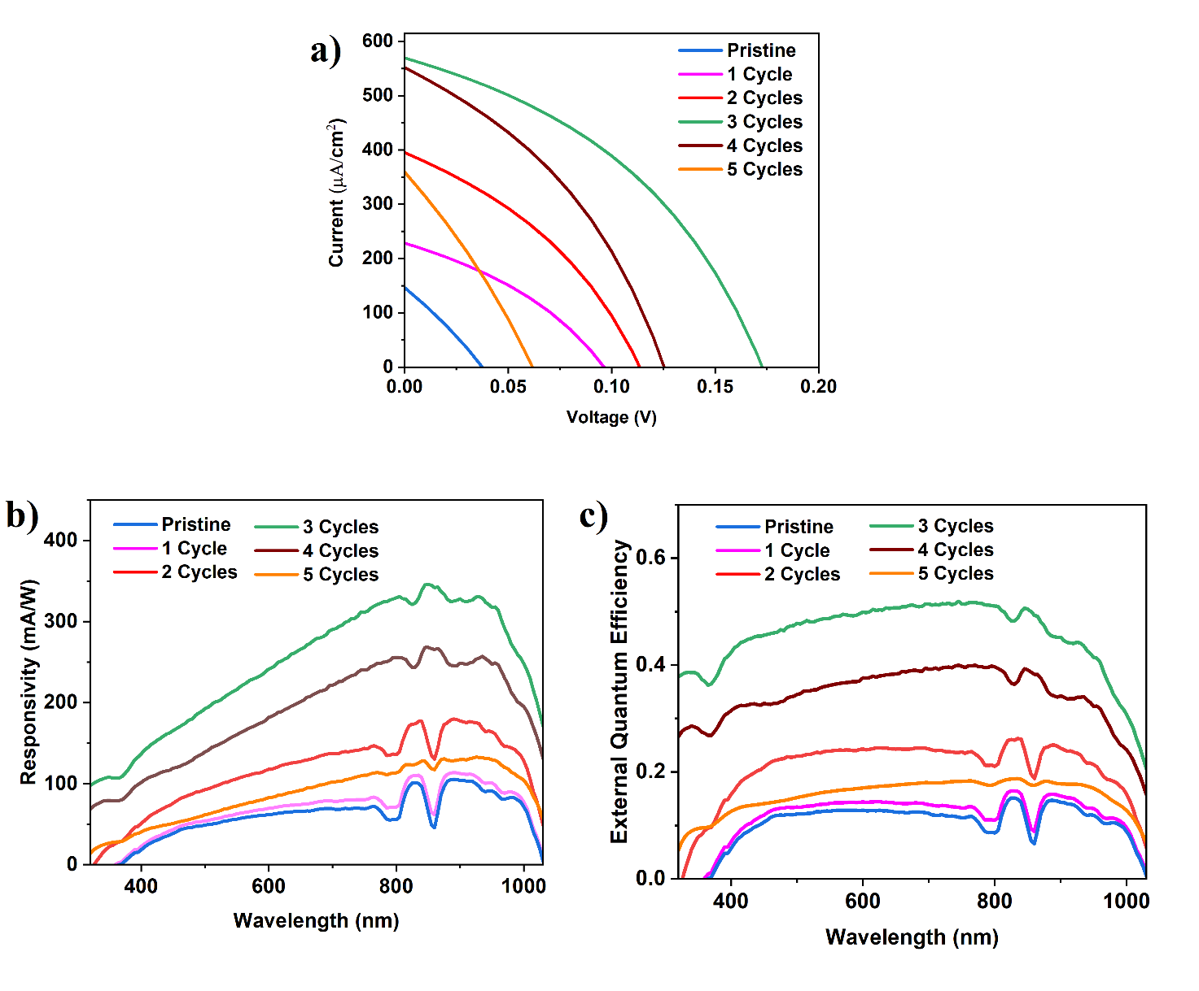
Figure 3. a) I–V characteristics under monochromatic light (900 nm, 2 mW/cm²), b) Responsivity and c) EQE of Si-CdZnS/ZnS devices.
Given the high responsivity in the range of ~345 mA/W and rise/fall times shorter than 100 ms, our fabricated photodetector is potentially useful for applications such as solar light intensity meters, spectroscopes and ambient light detectors. Capability of the detector to respond proportionally to a range of light intensities without any saturation or non-linearity in the photocurrent is desirable for various applications.⁴¹ In order to assess the photocurrent linearity of our detector, the temporal response at varied intensities was measured at different wavelengths, as shown in Figure S5. The photocurrent is plotted against the light intensities (Figure 4g), which shows that photocurrent varies almost linearly with light intensity at various wavelengths. Owing to the linear photocurrent response, our device might be useful in applications such as imaging, spectroscopy, and microscopy, in which varying light conditions are encountered.⁴² Typically, in solution-processed photodetectors, the relation between the photocurrent and the light intensity is non-linear, owing to the presence of defects states in the photoactive material.⁴³ In our case, the linear photocurrent response demonstrates that there is no significant influence of defect states on the response of our photodetector.^{44,45} Detectivity is calculated at various intensities (0.1 – 2 mW/cm²) at multiple wavelengths. The device exhibited superior detectivity in the order of 10¹² jones towards visible (600 nm) and NIR (900 nm) spectra and 10¹¹ jones towards UV (320 nm) spectrum. Detectivity is the reciprocal of noise equivalent power, which characterizes the ability of a photodetector to detect weak light signals. The superior detectivity exhibited by our device shows that it can be employed for applications involving weak light intensities such as stray light detection and imaging.
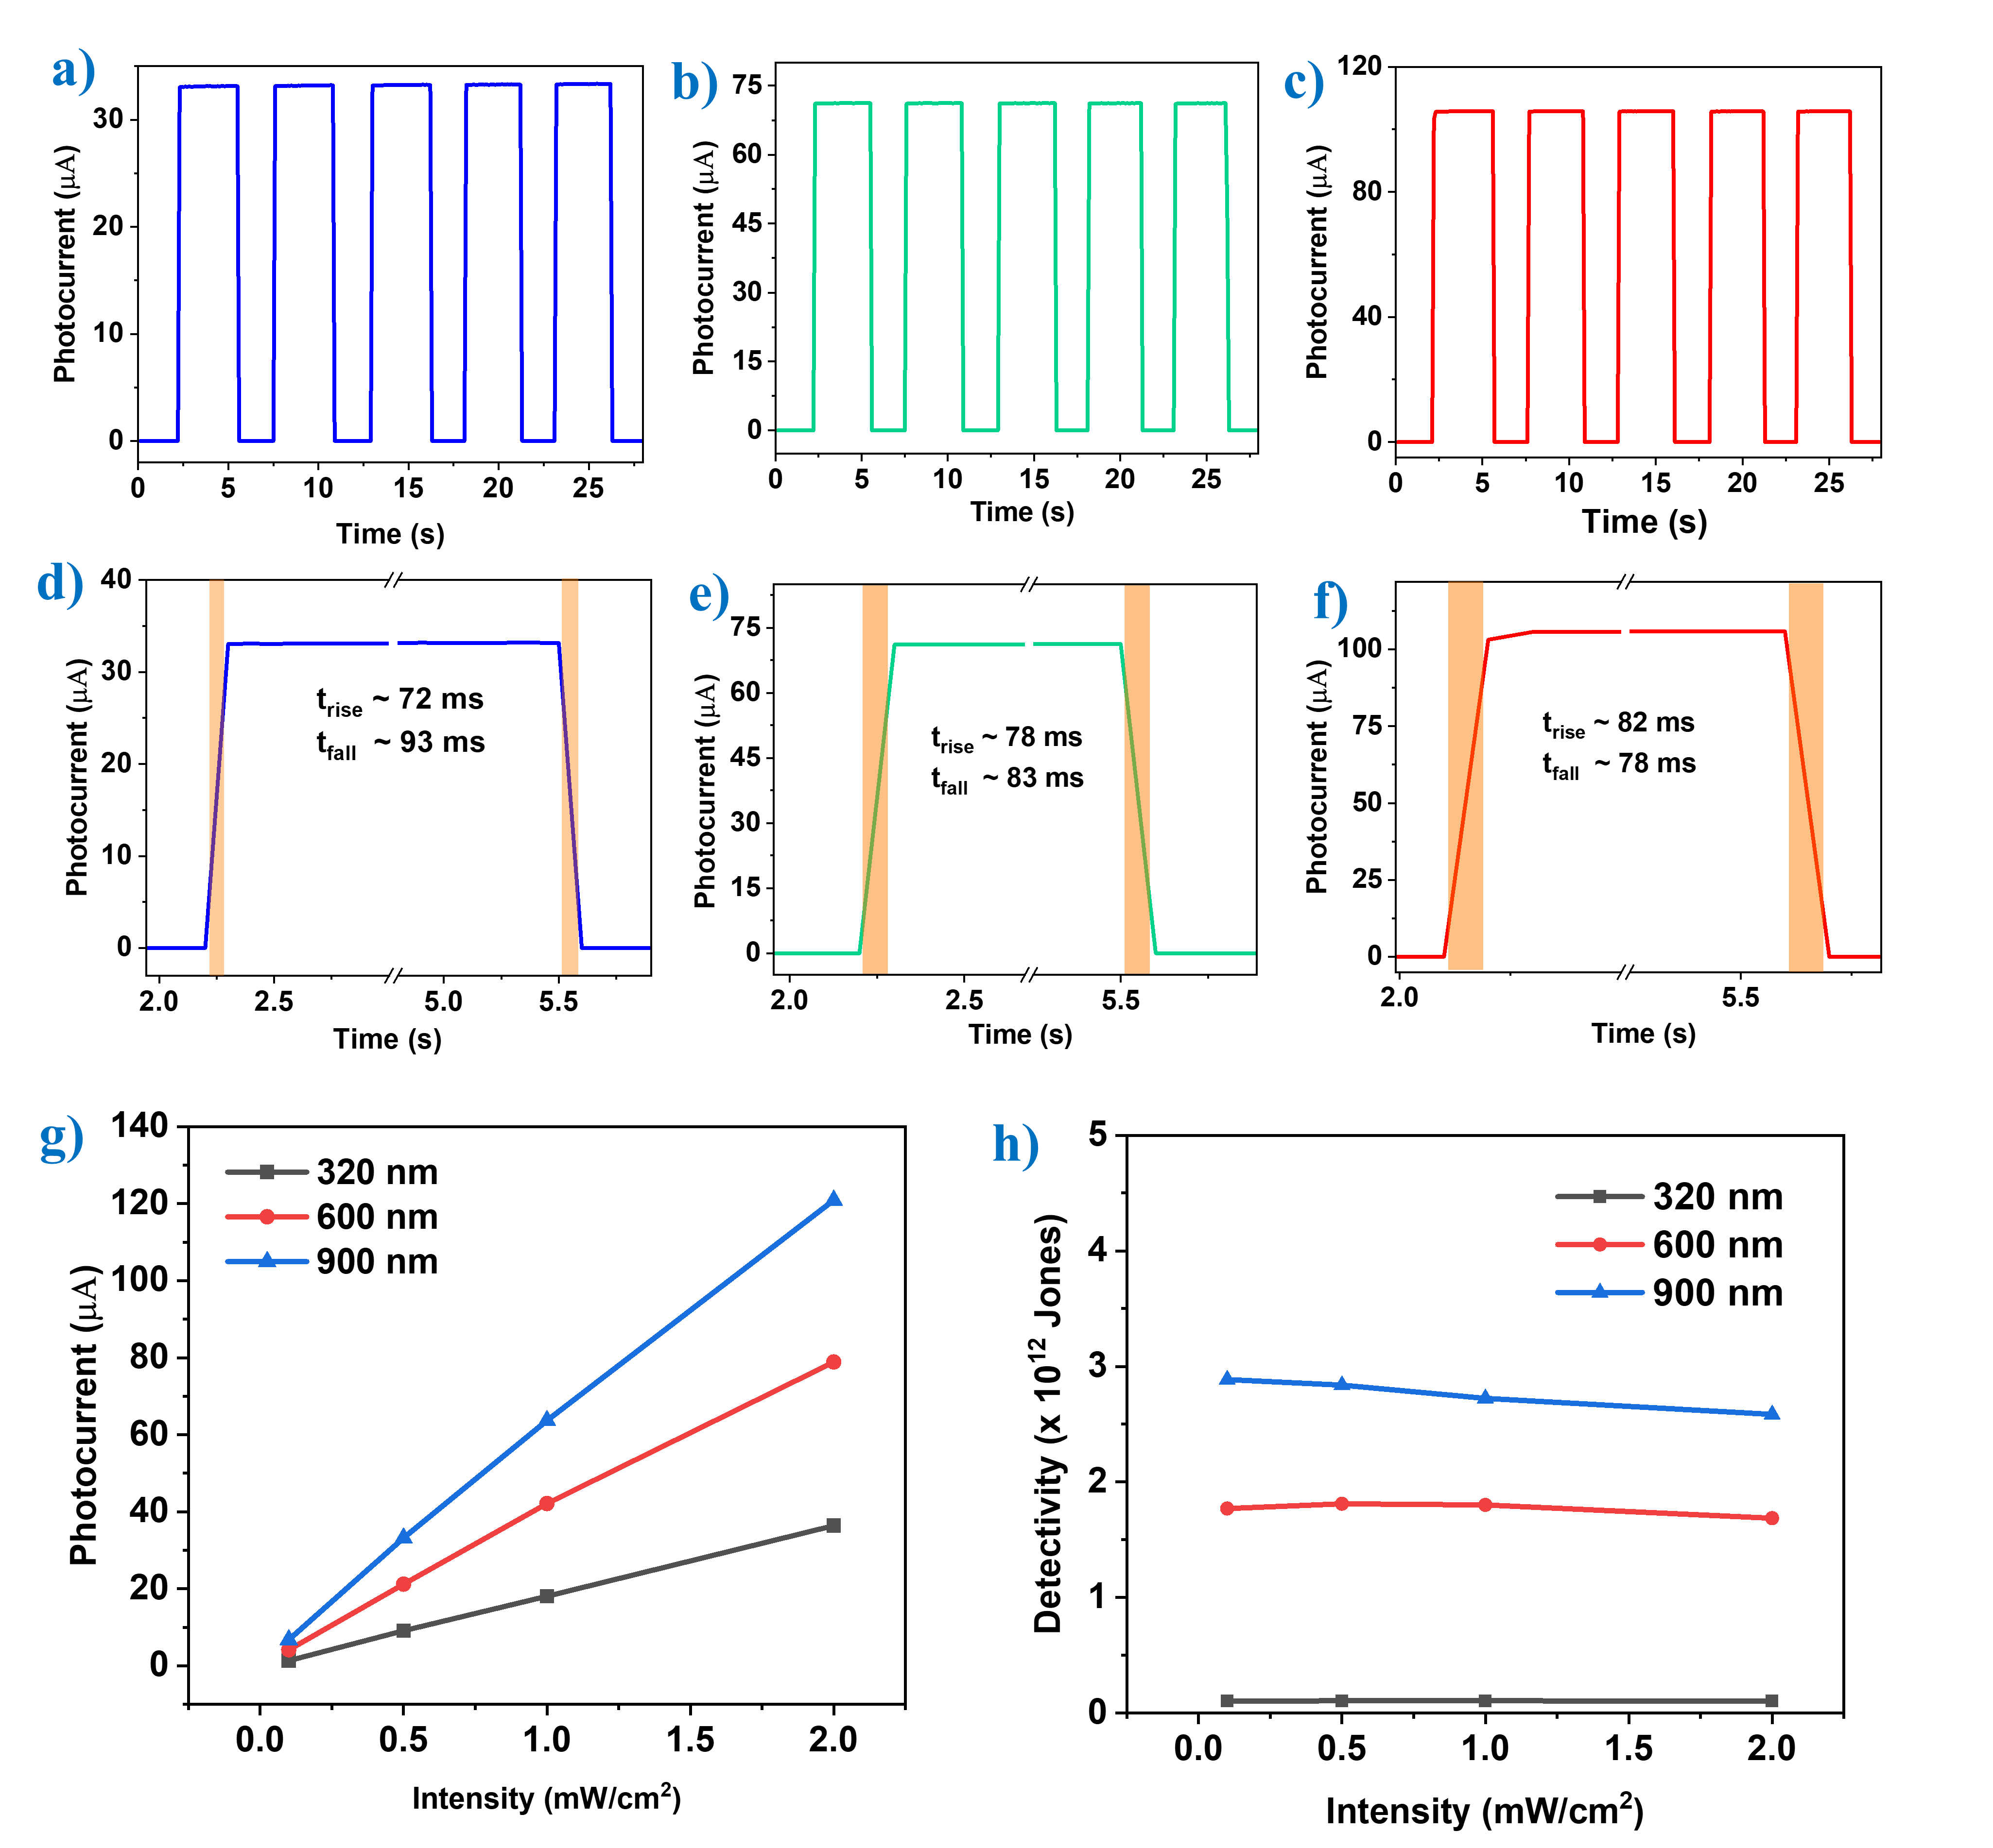
Figure 4. Temporal response of the Si-CdZnS/ZnS device under a) UV, 320 nm, b) Visible, 600 nm and c) NIR, 900 nm. Rise/Fall time estimation of device under d) UV, e) Visible and f) NIR illumination. g) Device photocurrent and h) Detectivity plotted versus intensity for multiple wavelengths.

  - Mechanism of response enhancement in the device
As discussed in the previous sections, the detector response has been improved over a wide spectral range (300 - 1100 nm) by adding CdZnS/ZnS QDs. The absorbance and emission characteristics show that the CdZnS/ZnS QDs act as a spectral downshifting layer that converts UV photons to visible photons. Hence, upon sensitization with CdZnS/ZnS, the QD device response is expected to improve in the UV region owing to the spectral downshifting effect. However, the device shows a marked increase in responsivity and external quantum efficiency over the entire spectral range from 300 nm to 1100 nm. To probe the exact phenomenon behind the enhancement in device performance, further extensive material and device characterization was therefore carried out. As we have seen in the SEM images, the Si substrates exhibit a rougher surface after deposition of QDs, which is likely to decrease the reflectance and thus leading to an improved device response. Hence, to confirm the role of the anti-reflection effect of the QD films, the reflectance of the pristine and the QDs-sensitised samples were measured, as shown in Figure 5a. The results show the reflectance of the samples to be sharply reduced by the deposition of QDs. Figure 5b shows AFM images of the pristine Si and the 3-cycle QD-Si film which reveal that the surface roughness is increased by the deposition of QDs. The surface roughness of the pristine Si and Si-QD samples is calculated to be 0.86 nm and 10.94 nm, respectively. In any opto-electronic device such as a photodetector or solar cell, the device response is dependent on number of photons absorbed by the photoactive material. The deposition of QDs markedly increases the roughness and decreases the reflectance of Si, confirming that the QDs act as an anti-reflection layer.^{46–48} It is also noted that reflectance has decreased over the entire spectra range from 300 - 1000 nm. It is interesting to note that, the reflectance has decreased more in shorter wavelengths than in longer wavelengths. However, the enhancement in the detector performance is more pronounced in longer wavelengths than in shorter wavelengths as shown in Figure 4b. In general, the Si-based devices possess higher quantum efficiency in the longer wavelengths, owing to its narrow bandgap, which leads to this higher magnitude of performance enhancement at longer wavelengths.
Further, to confirm whether the downshifted visible light photons are successfully absorbed by the underlying Si substrate, we studied 3D PL mapping and steady-state PL emission of the QD film deposited on glass and Si substrates. Figure 5c shows 3D mapping of the dependence of the emitted photon wavelength on the excitation wavelength. It is seen that down-shifting of photons occurs significantly from 320 nm to 450 nm (UV range); they are converted to photons in the visible range of 525 - 700 nm. This confirms the applicability of the CdZnS/ZnS core-shell QDs to down-shifting applications.
To confirm the successful absorption of the downshifted photons by Si, the steady-state PL of QDs deposited on Si was measured and compared with PL spectra of QDs on glass, as seen in Figure 5d. The steady-state PL spectra were measured by exciting the QDs with an excitation pulse of 380 nm. The results reveal that the emitted PL intensity from the QDs deposited on the Si substrate is lower than the PL intensity from QDs deposited on the glass substrate, suggesting that the photons down-shifted by the QDs are absorbed by the Si, resulting in quenching of the PL intensity.⁴⁹ In contrast, the high PL intensity from the QDs deposited on the glass substrate indicates the emission of down-shifted photons with no pathway for absorption. These results suggest that both the anti-reflection effect from the QD films and the down-shifting characteristic of the core-shell QDs contribute to the enhancement of the device performance over the entire spectral range of 300 - 1100 nm.
There are recent reports in the literature that Si and QDs can form heterojunctions when the QDs are deposited as a film of sufficient thickness.^{50–52} Thanks to the favourable band energetics between the Si and CdZnS/ZnS QDs, when these QDs are deposited as a film, the Si-CdZnS/ZnS interface can form a space charge region, which results in built-in potential. The presence of built-in potential can assist with charge separation and carrier transportation, ultimately resulting in the enhancement of detector performance. To probe the interface between Si and CdZnS/ZnS QDs and confirm the presence of the built-in potential, dark current measurements and capacitance–voltage characteristics were studied. Figure 5e shows the I-V characteristics of the device measured under dark conditions. The dark current density is plotted on a natural logarithmic scale against applied voltage. Both the pristine Si and Si-CdZnS/ZnS samples display an asymmetric ln(I)–V relationship, which denotes the rectifying nature of the junction in the device. The rectifying junction in the pristine-Si device arises from the Schottky barrier between the n-type Si and the Ag electrode. The pristine Si device is therefore, in essence, a Schottky junction diode.⁵³ It is of interest to note that, after deposition of the CdZnS/ZnS QD layer on the Si, the dark current decreases markedly, as seen in the I-V plot. The decrease in the dark current of the device indicates the formation of a depletion region in the device due to the formation of heterojunctions between the Si and CdZnS/ZnS QDs.
To further confirm the formation of a heterojunction between the Si and CdZnS/ZnS QDs, the capacitance–voltage (C–V) relation was studied, and built-in potential in the device was estimated via Mott-Schottky plots. Figure 5f shows the Mott-Schottky plot of the pristine Si device, measured at 100 kHz. The built-in potential in the pristine Si device is estimated to be 0.41 V. The Mott-Schottky plot of the Si-CdZnS/ZnS device reveals the built-in potential in the device to be 0.63 V. These results suggest that the deposition of the CdZnS/ZnS QDs over the Si as film, which results in the formation of a space charge region in the device, adds to the built-in potential.^{50,54}
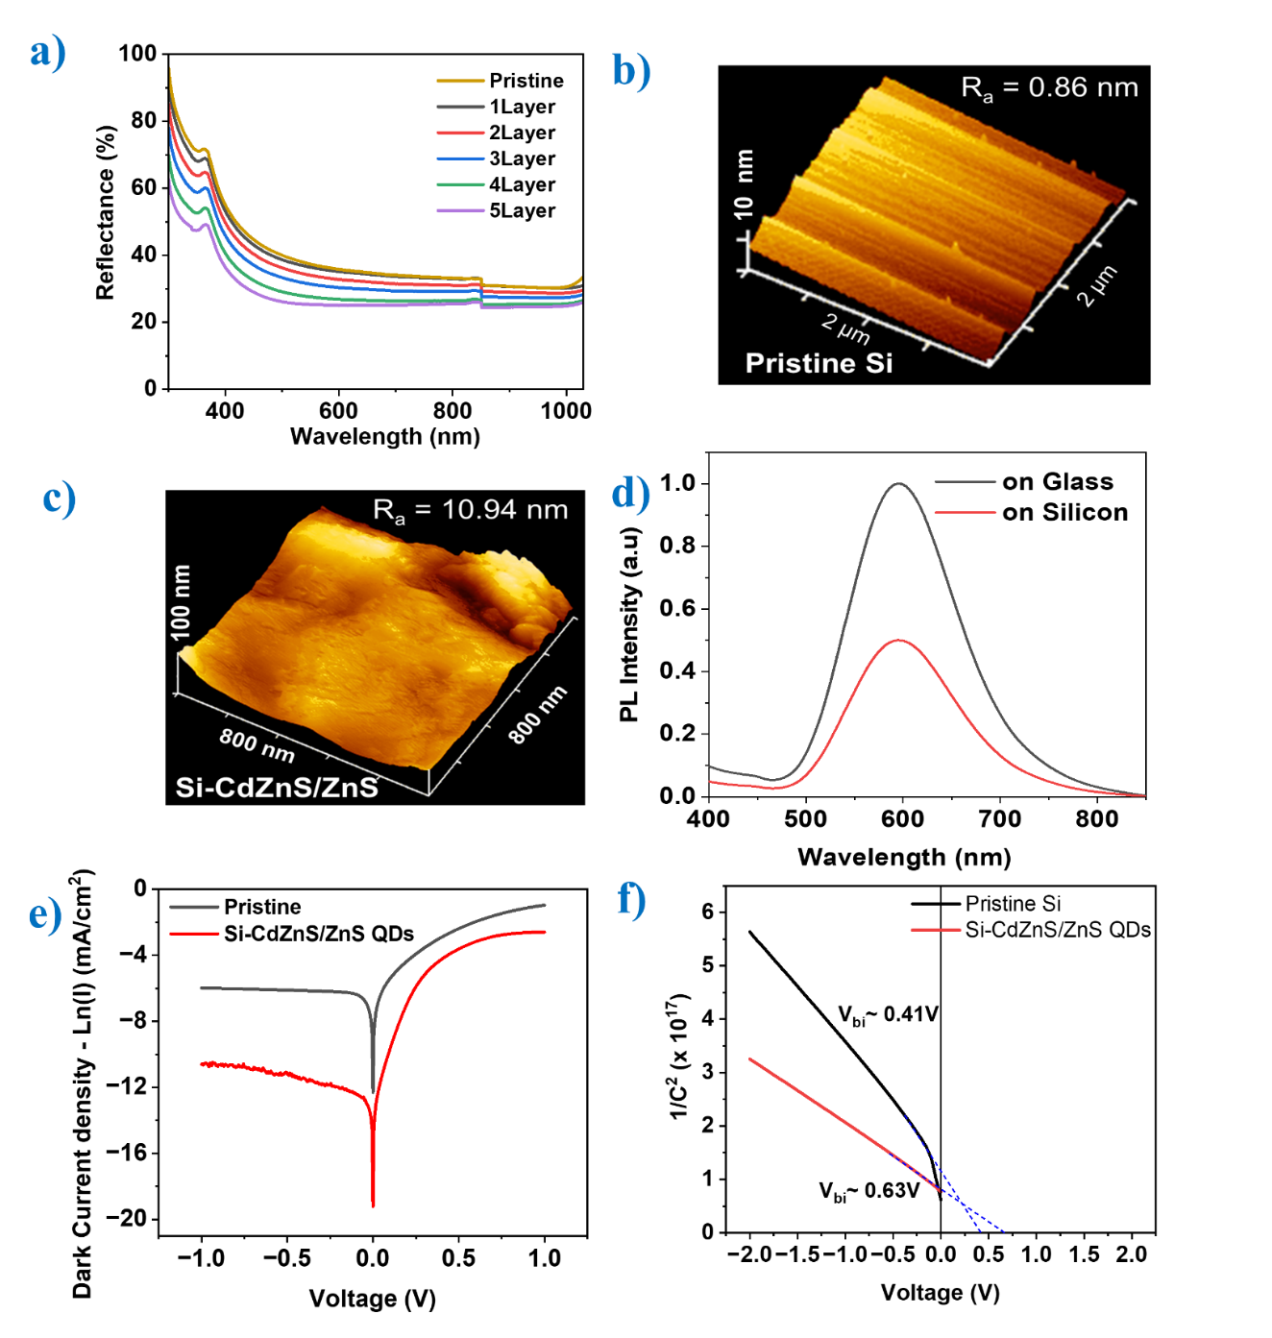
It can be concluded that, based on the reflection spectra, photoluminescence spectra, dark current measurements, and C-V characteristics, the enhancement in the performance of the Si Schottky junction detector upon sensitization with the CdZnS/ZnS core-shell QDs can be attributed to the cumulative effect of spectral downshifting of UV to visible photons, the anti-reflective effect of QDs and the formation of heterojunctions at the Si-CdZnS/ZnS QDs interface.

Figure 5. a) Reflectance of the pristine and CdZnS/ZnS QD-sensitized Si devices. b) AFM images of pristine and CdZnS/ZnS QD-sensitized Si. c) 3D Mapping of photoluminescence intensity of emission wavelength versus excitation wavelength of CdZnS/ZnS core-shell QDs. d) PL Spectra of CdZnS/ZnS QD film on glass and Si substrates. e) Dark current measurements of pristine and QD-sensitized Si device. 1/C² vs V Mott-Schottky plot of f) Pristine and QD-sensitized device.

  - Band diagram explaining the photoresponse of the Si-CdZnS/ZnS device
The origin of the photoresponse and the functioning of the Si-CdZnS/ZnS device is explained using a band diagram, constructed based on Anderson’s rule. The response from a photodetector involves optoelectronic processes such as photon absorption, exciton generation, charge separation, and carrier transportation. Before investigating the photoresponse in the Si-CdZnS/ZnS device, it is necessary to gain insight into the photoresponse from the pristine Si device. The pristine Si detector comprises of titanium-silver (Ti-Ag) as the rear electrode and Ag as the top electrode. Rear electrode is deposited as thin-film, completely masking the rear side of Si. The top electrode is deposited as a comb-like pattern, to facilitate the pathway for the photons to incident on the Si and also to efficiently collect the photogenerated carriers. Thus, the pristine Si device assumes a vertical metal-semiconductor-metal (MSM) architecture. Figure 6a depicts the energy band levels of Si and metal contacts before and after contact and also illustrates the photoresponse mechanism. Si possess V_{B} and C_{B} energy levels at 4.08 eV and 5.2 eV, with a band gap of 1.12 eV. Because an n-type Si wafer with a doping density of 10¹⁵ cm^{–3} is used, the Fermi level lies at 4.3 eV. The Ti rear contact and Ag front contact possess work functions of 4.3 eV and 4.7 eV, respectively. Owing to the relative energy levels between the Si and the metal electrodes, a Schottky junction is formed at the both M-S interfaces. Interestingly, as the Fermi level of Si and titanium rear electrode both lie at 4.3 eV, there will be no Schottky barrier formation at the Si-Titanium interface.⁵⁵ Figure S6a shows the I-V characteristics of the Si control device with Ti-Ag electrodes. The linear I-V relation confirms the absence of a Schottky barrier at the Ti-Ag and Si interface. However, in contrast, due to the significant Fermi level difference between Si and Ag, a barrier is formed at the interface.⁵³ The non-linear I-V curve of the Ag-Si-Ag control device, as seen in Figure S6b, confirms the presence of a barrier at the Si-Ag contact.
Electron-hole pairs are generated on illumination with photons of energy greater than the Si bandgap. The generated photoelectrons in the conduction band move away from the Si-Ag interface due to the presence of the Schottky barrier. They tend to move towards the Si-Ti interface and will reach the Ti contact due to the favourable lower energy level. Meanwhile, the holes tend to move toward the Si-Ag interface and reach the Ag contact. Thus, under illumination, the generated photoelectrons and holes migrate towards their Ti and Ag contacts, causing the photoresponse of the device.
Figure 6b shows the relative band energy levels of core-shell CdZnS/ZnS QDs and Si before making contact. Based on the band levels, the junction between ZnS and CdZnS is a type-I heterojunction. Due to the relatively narrower energy gap and band positions of Si, a type-I heterojunction is also expected to be formed between Si and the QDs. When the QDs and the Si make contact with each other, the conduction electrons equilibrate, resulting in the creation of band bending at the interface, as shown in the Figure 6c. When the high-energy UV photons are incident over the Si-CdZnS/ZnS device, the CdZnS core absorbs them. The absorbed UV photons generate electron hole pairs in the CdZnS, with electrons having higher kinetic energy due to the incoming UV photons. The higher energy of the hot electrons is lost due to non-radiative transitions or vibrational relaxations and the hot electrons de-excite to the E_{C} of CdZnS. Owing to the bound type-I heterojunction alignment between CdZnS shell and ZnS core-shell, there is no escape pathway for a de-excited electron, which ultimately recombines to re-emit a photon. This emitted photon has much lower energy than the absorbed UV photon, thus resulting in the observed down-shifting of energy. This downshifted visible photon is absorbed by the underlying Si substrate, which again generates an e-h pair in the Si. The generated e-h pairs are separated by the Schottky junction at the Si-Ag interface and are transported to their respective electrodes, generating a photocurrent. Visible and NIR spectrum photons are transparent to the CdZnS QDs and hence directly reach the Si, where they are absorbed and add to the photoresponse.
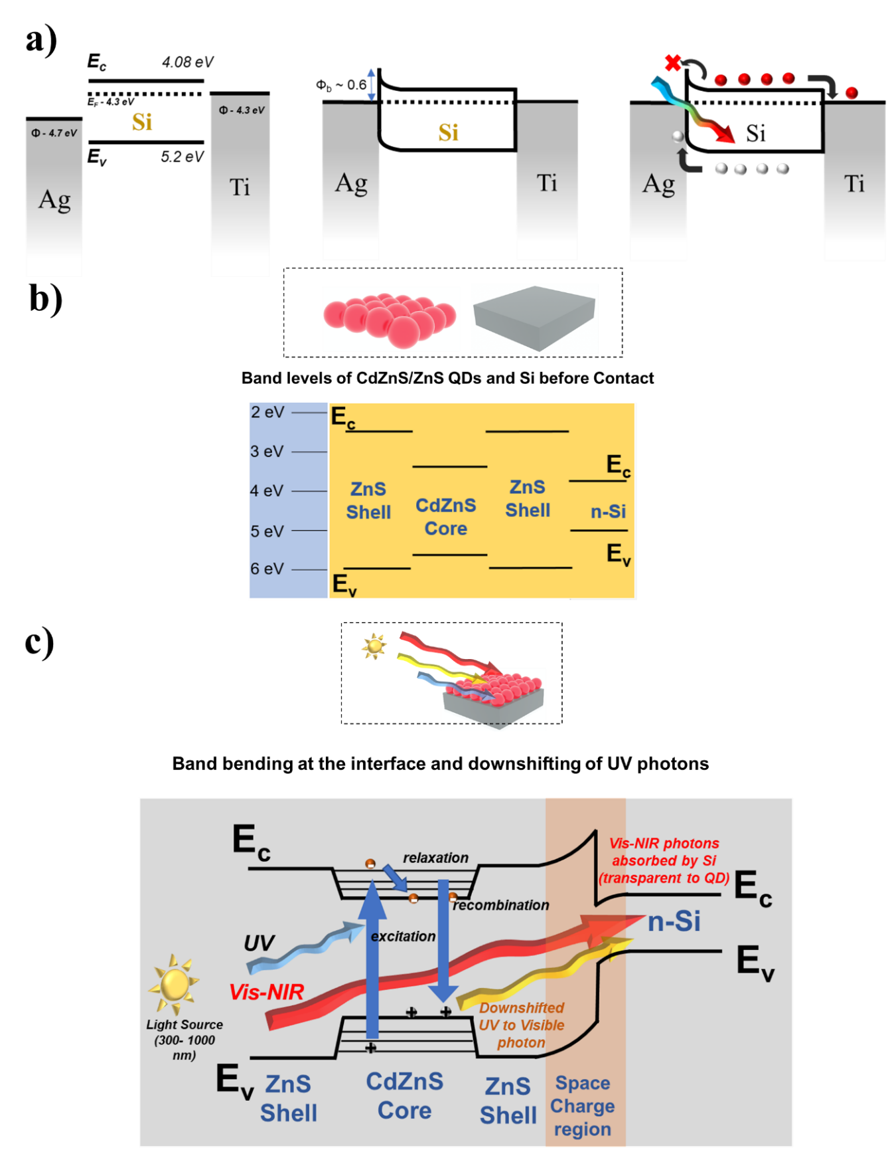
Figure 6. Band diagram of the a) Pristine Si device and Si-CdZnS/ZnS QDs device b) prior to contact and c) after contact and photo-illumination.
3.7 Photo-cyclic stability
For a photodetector to be deployed for practical applications, it should possess high photo-cyclic stability without any saturation or significant decrease in the photocurrent over many irradiation cycles. To assess the photo-cyclic stability of our fabricated device, the transient response of the detector is measured over 500 illumination cycles at different wavelengths. Figure S7 reveals the detector transient response over 500 cycles (320 nm, 600 nm and 900 nm –2 mW/cm²). It is seen that the device has retained more than 95% of the photocurrent even after 500 cycles, without any significant hysteresis. This reveals that our fabricated devices are suitable for practical applications in which long-term operation over multiple illumination cycles is required.
3.8 Comparison of the CdZnS/ZnS-Si detector with other QD-based devices
Responsivity, rise time and detectivity for our fabricated device were compared those with similar QDs based devices (Figure 7a and 7b).^{54,56–63}. Peng et al. employed PbSe QDs for detection in a photoconductor architecture.⁵⁶ The authors describe the deposition of PbSe QDs as ink on ZnO NPs, which shows a decent response and rise-time of 100 mAW^{–1} and 340 ms, respectively. However, the device operates at a high bias of 1 V. Another report, by Hsiao et al., demonstrates the sensitization of the Si with carbon QDs to improve light absorption and supress dark current.⁵⁴ Although the device shows good rise time of 10 µs, the responsivity is very minimal in the range of 9.4 mA/W. Qin et al. demonstrated a synergistic approach to enhancing the response of a 2D MoS₂ detector with sensitization of CuInS₂ QDs and plasmonic Au NPs. Despite showing slightly raised responsivity of 16.65 mA/W, the rise time is significantly lower, at 5s.⁵⁸ Subramaniam et al., reported enhanced photoluminescence quantum yield and carrier lifetime in CsPbBr₃ QDs by post-treatment with antimony tri-bromide. The post-treated QDs were used in a photodetector that demonstrated very minimal responsivity of 48.1 μA/W but a decent rise time of 98 ms.⁶² In the abovementioned reports, QDs are employed as the photoactive layer which absorbs the incoming photons and generates excitons that are later collected, generating a photocurrent. However, in our case, CdZnS/ZnS QDs are used as a down-shifting layer that converts the incoming UV photons to visible photons. These re-emitted photons are further absorbed by Si and lead to the generation of photocurrent. One clear advantage with down-shifting QDs is that photon down-conversion and subsequent photon transfer to the underlying layer are a far more efficient process than an exciton generation and separation process in conventional QDs. Generally, QDs show poor conductivity and high density of surface trap states. The generated excited charge carriers in the QDs have a greater probability of recombining and hence it is difficult to extract them as photocurrent.⁵⁴ However, the downshifted photons can be easily collected without any significant losses. Apart from the down-shifting, it is also demonstrated that CdZnS/ZnS QDs are acting as an anti-reflecting layer and creating space charge region which further underscores the effectiveness of the device architecture. The device shows a high responsivity of 345 mAW^{–1}, detectivity of 10¹² jones and rise time of 82 ms, without any applied bias (0 V). The other relevant performance metrics of the compared photodetectors are included in the supplementary information (Table S1).
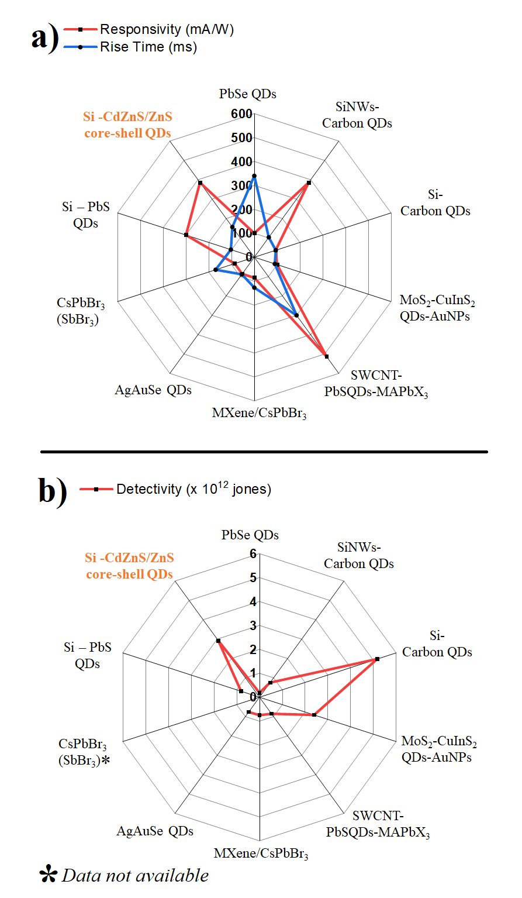

Figure 7. Comparison of a) Responsivity, Rise time and b) Detectivity of Si-CdZnS/ZnS device with other relevant QD based photodetectors in literature.

4. Conclusions
In conclusion, we demonstrate here an efficient and simple hybrid Si -quantum dot architecture to boost the response of a Si photodetector. CdZnS/ZnS core-shell QDs are synthesized using the hot injection-method, which absorbs the UV photons and downshifts to visible light photons. This downshifting ability of the CdZnS/ZnS QDs is exploited to enhance the performance of this Si Schottky junction photodetector. CdZnS/ZnS QDs are monolithically integrated with the Si by using simple drop-casting. When the device is optimized with QD film, it shows a dramatic enhancement of its performance owing to the downshifting effect of the CdZnS/ZnS QDs. Interestingly, the device response is enhanced over the entire spectral range (300 – 1100 nm) denoting the involvement of an as yet unknown underlying mechanism that is distinct from spectral downshifting. Further extensive studies such as 3D PL mapping, reflectance spectra, dark current measurements and capacitance-voltage characteristics were performed. The results suggest the anti-reflection effect of the QDs film and the formation of space region between Si-CdZnS/ZnS interface to also contribute to the enhancement of the device’s performance. The sensitization of the Si with the CdZnS/ZnS core-shell QDs has enhanced the device performance, creating a cumulative effect of spectral downshifting, anti-reflection effect and heterojunction formation. The demonstrated device architecture and observed underlying mechanisms have potential for assisting with the fabrication of more efficient multi-functional photodetectors.
Supporting information
Quantum dots particle size distribution; EDS spectrum of CdZnS/ZnS core-shell quantum dots; CdZnS/ZnS quantum dots under ambient light and UV illumination; SEM images of Pristine Si and CdZnS/ZnS QD films deposited films deposited on Si; Temporal response of the 3-cycles QD detector under varied light intensities; I–V characteristics of control Si devices with Ti-Ag and Ag electrodes; Photocyclic stability; Comparison of our fabricated CdZnS/ZnS QD-Si device with other QD-based detectors.
CRediT authorship contribution statement
Kumaar Swamy Reddy B: Methodology, Investigation, Writing - original draft. Mostafa F. Abdelbar: Validation, Investigation, Writing – review & editing. Wipakorn Jevasuwan: Validation, Discussion, Writing - review & editing. Pramod H Borse: Investigation, Writing – review & editing. Sushmee Badhulika: Supervision, Investigation, Writing – review & editing. Naoki Fukata: Conceptualization, Resources, Writing - original draft, Supervision, Project administration, Funding acquisition.
Declaration of competing interests
The authors declare that they have no known competing financial interests or personal relationships that could have appeared to influence the work reported in this paper.
Acknowledgements
KSRB would like to thank National Institute for Material Science (NIMS) for extending experimental and financial support for the carrying out this research work through International Cooperative Graduate Programme (ICGP). KSRB would also like to acknowledge Director, ARCI (DST, India lab) for support.
Data availability
The data supporting the findings of this study are available within this article and its supplementary information.

REFERENCES
(1) Grotevent, M. J.; Yakunin, S.; Bachmann, D.; Romero, C.; Vázquez de Aldana, J. R.; Madi, M.; Calame, M.; Kovalenko, M. V.; Shorubalko, I. Integrated Photodetectors for Compact Fourier-Transform Waveguide Spectrometers. Nat. Photonics 2023, 17 (1), 59–64. https://doi.org/10.1038/s41566-022-01088-7.
(2) Lee, S.; Park, T.; Hur, J.; Yoo, H. Calcium Titanate Orthorhombic Perovskite-Nickel Oxide Solar-Blind UVC Photodetectors with Unprecedented Long-Term Stability Exceeding 500 Days and Their Applications to Real-Time Flame Detection. ACS Photonics 2022, 9 (12), 4005–4016. https://doi.org/10.1021/acsphotonics.2c01471.
(3) Polat, E. O.; Mercier, G.; Nikitskiy, I.; Puma, E.; Galan, T.; Gupta, S.; Montagut, M.; Piqueras, J. J.; Bouwens, M.; Durduran, T.; Konstantatos, G.; Goossens, S.; Koppens, F. Flexible Graphene Photodetectors for Wearable Fitness Monitoring. Sci. Adv. 5 (9), eaaw7846. https://doi.org/10.1126/sciadv.aaw7846.
(4) Ollearo, R.; Ma, X.; Akkerman, H. B.; Fattori, M.; Dyson, M. J.; van Breemen, A. J. J. M.; Meskers, S. C. J.; Dijkstra, W.; Janssen, R. A. J.; Gelinck, G. H. Vitality Surveillance at Distance Using Thin-Film Tandem-like Narrowband near-Infrared Photodiodes with Light-Enhanced Responsivity. Sci. Adv. 9 (7), eadf9861. https://doi.org/10.1126/sciadv.adf9861.
(5) Fathipour, V.; Schmoll, T.; Bonakdar, A.; Wheaton, S.; Mohseni, H. Demonstration of Shot-Noise-Limited Swept Source OCT Without Balanced Detection. Sci. Rep. 2017, 7 (1), 1183. https://doi.org/10.1038/s41598-017-01339-6.
(6) Sahare, S.; Ghoderao, P.; Sharma, M. K.; Solovan, M.; Aepuru, R.; Kumar, M.; Chan, Y.; Ziółek, M.; Lee, S.-L.; Lin, Z.-H. Pyro-Phototronic Effect: An Effective Route toward Self-Powered Photodetection. Nano Energy 2023, 107, 108172. https://doi.org/10.1016/j.nanoen.2023.108172.
(7) Shen, J.; Li, B.; Yang, Y.; Yang, Z.; Liu, X.; Lim, K.-C.; Chen, J.; Ji, L.; Lin, Z.-H.; Cheng, J. Application, Challenge and Perspective of Triboelectric Nanogenerator as Micro-Nano Energy and Self-Powered Biosystem. Biosens. Bioelectron. 2022, 216, 114595. https://doi.org/10.1016/j.bios.2022.114595.
(8) Zhang, G.-X.; Zhang, Z.-C.; Chen, X.-D.; Kang, L.; Li, Y.; Wang, F.-D.; Shi, L.; Shi, K.; Liu, Z.-B.; Tian, J.-G.; Lu, T.-B.; Zhang, J. Broadband Sensory Networks with Locally Stored Responsivities for Neuromorphic Machine Vision. Sci. Adv. 9 (37), eadi5104. https://doi.org/10.1126/sciadv.adi5104.
(9) Choi, D.; Lee, Y.; Lin, Z.-H.; Cho, S.; Kim, M.; Ao, C. K.; Soh, S.; Sohn, C.; Jeong, C. K.; Lee, J.; Lee, M.; Lee, S.; Ryu, J.; Parashar, P.; Cho, Y.; Ahn, J.; Kim, I.-D.; Jiang, F.; Lee, P. S.; Khandelwal, G.; Kim, S.-J.; Kim, H. S.; Song, H.-C.; Kim, M.; Nah, J.; Kim, W.; Menge, H. G.; Park, Y. T.; Xu, W.; Hao, J.; Park, H.; Lee, J.-H.; Lee, D.-M.; Kim, S.-W.; Park, J. Y.; Zhang, H.; Zi, Y.; Guo, R.; Cheng, J.; Yang, Z.; Xie, Y.; Lee, S.; Chung, J.; Oh, I.-K.; Kim, J.-S.; Cheng, T.; Gao, Q.; Cheng, G.; Gu, G.; Shim, M.; Jung, J.; Yun, C.; Zhang, C.; Liu, G.; Chen, Y.; Kim, S.; Chen, X.; Hu, J.; Pu, X.; Guo, Z. H.; Wang, X.; Chen, J.; Xiao, X.; Xie, X.; Jarin, M.; Zhang, H.; Lai, Y.-C.; He, T.; Kim, H.; Park, I.; Ahn, J.; Huynh, N. D.; Yang, Y.; Wang, Z. L.; Baik, J. M.; Choi, D. Recent Advances in Triboelectric Nanogenerators: From Technological Progress to Commercial Applications. ACS Nano 2023, 17 (12), 11087–11219. https://doi.org/10.1021/acsnano.2c12458.
(10) Lone, S. A.; Lim, K. C.; Kaswan, K.; Chatterjee, S.; Fan, K.-P.; Choi, D.; Lee, S.; Zhang, H.; Cheng, J.; Lin, Z.-H. Recent Advancements for Improving the Performance of Triboelectric Nanogenerator Devices. Nano Energy 2022, 99, 107318. https://doi.org/10.1016/j.nanoen.2022.107318.
(11) Callies, A.; Hanser, M.; Goldschmidt, J. C.; Bläsi, B.; Höhn, O. Structuring of Perovskite-Silicon Tandem Solar Cells for Reduced Reflectance and Thermalization Losses. Opt. Express 2023, 31 (12), 19428–19442. https://doi.org/10.1364/OE.491371.
(12) Esmaielpour, H.; Durant, B. K.; Dorman, K. R.; Whiteside, V. R.; Garg, J.; Mishima, T. D.; Santos, M. B.; Sellers, I. R.; Guillemoles, J.-F.; Suchet, D. Hot Carrier Relaxation and Inhibited Thermalization in Superlattice Heterostructures: The Potential for Phonon Management. Appl. Phys. Lett. 2021, 118 (21), 213902. https://doi.org/10.1063/5.0052600.
(13) Lin, Y.-H.; Huang, M.-W.; Liu, C.-K.; Chen, J.-R.; Wu, J.-M.; Shih, H. C. The Preparation and High Photon-Sensing Properties of Fluorinated Tin Dioxide Nanowires. J. Electrochem. Soc. 2009, 156 (11), K196. https://doi.org/10.1149/1.3223984.
(14) Wu, J. M.; Chang, W. E. Ultrahigh Responsivity and External Quantum Efficiency of an Ultraviolet-Light Photodetector Based on a Single VO2 Microwire. ACS Appl. Mater. Interfaces 2014, 6 (16), 14286–14292. https://doi.org/10.1021/am503598g.
(15) Wu, J. M.; Fang, C.-W.; Lee, L.-T.; Yeh, H.-H.; Lin, Y.-H.; Yeh, P.-H.; Tsai, L.-N.; Lin, L.-J. Photoresponsive and Ultraviolet to Visible-Light Range Photocatalytic Properties of ZnO:Sb Nanowires. J. Electrochem. Soc. 2010, 158 (1), K6. https://doi.org/10.1149/1.3514618.
(16) Kuang, Y.; Ma, Y.; Zhang, D.; Wei, Q.; Wang, S.; Yang, X.; Hong, X.; Liu, Y. Enhanced Optical Absorption in Perovskite/Si Tandem Solar Cells with Nanoholes Array. Nanoscale Res. Lett. 2020, 15 (1), 213. https://doi.org/10.1186/s11671-020-03445-3.
(17) Liu, J.; Qu, J.; Kirchartz, T.; Song, J. Optoelectronic Devices Based on the Integration of Halide Perovskites with Silicon-Based Materials. J. Mater. Chem. A 2021, 9 (37), 20919–20940. https://doi.org/10.1039/D1TA04527J.
(18) Liu, Y.; Ji, Z.; Li, Y.; Fan, H. J.; Mai, W. Spectrum-Shaped Si-Perovskite Hybrid Photodetectors for Hyperspectral Bioimaging. Photonics Res. 2021, 9 (9), 1734–1744. https://doi.org/10.1364/PRJ.411415.
(19) Wen, P.; Tiwari, P.; Mauthe, S.; Schmid, H.; Sousa, M.; Scherrer, M.; Baumann, M.; Bitachon, B. I.; Leuthold, J.; Gotsmann, B.; Moselund, K. E. Waveguide Coupled III-V Photodiodes Monolithically Integrated on Si. Nat. Commun. 2022, 13 (1), 909. https://doi.org/10.1038/s41467-022-28502-6.
(20) Xue, Y.; Han, Y.; Wang, Y.; Li, J.; Wang, J.; Zhang, Z.; Cai, X.; Tsang, H. K.; Lau, K. M. High-Speed and Low Dark Current Silicon-Waveguide-Coupled III-V Photodetectors Selectively Grown on SOI. Optica 2022, 9 (11), 1219–1226. https://doi.org/10.1364/OPTICA.468129.
(21) Geyer, S. M.; Scherer, J. M.; Moloto, N.; Jaworski, F. B.; Bawendi, M. G. Efficient Luminescent Down-Shifting Detectors Based on Colloidal Quantum Dots for Dual-Band Detection Applications. ACS Nano 2011, 5 (7), 5566–5571. https://doi.org/10.1021/nn2010238.
(22) Kortan, A. R.; Hull, R.; Opila, R. L.; Bawendi, M. G.; Steigerwald, M. L.; Carroll, P. J.; Brus, L. E. Nucleation and Growth of CdSe on ZnS Quantum Crystallite Seeds, and Vice Versa, in Inverse Micelle Media. J. Am. Chem. Soc. 1990, 112 (4), 1327–1332. https://doi.org/10.1021/ja00160a005.
(23) Murray, C. B.; Norris, D. J.; Bawendi, M. G. Synthesis and Characterization of Nearly Monodisperse CdE (E = Sulfur, Selenium, Tellurium) Semiconductor Nanocrystallites. J. Am. Chem. Soc. 1993, 115 (19), 8706–8715. https://doi.org/10.1021/ja00072a025.
(24) Kulkarni, S. K.; Winkler, U.; Deshmukh, N.; Borse, P. H.; Fink, R.; Umbach, E. Investigations on Chemically Capped CdS, ZnS and ZnCdS Nanoparticles. Appl. Surf. Sci. 2001, 169–170, 438–446. https://doi.org/10.1016/S0169-4332(00)00700-5.
(25) Abdelbar, M. F.; Abdelhameed, M.; Esmat, M.; El-Kemary, M.; Fukata, N. Energy Management in Hybrid Organic-Silicon Nanostructured Solar Cells by Downshifting Using CdZnS/ZnS and CdZnSe/ZnS Quantum Dots. Nano Energy 2021, 89, 106470. https://doi.org/10.1016/j.nanoen.2021.106470.
(26) Liu, T.; Liu, X.; Chen, D.; Liu, Q.; Zuo, Y.; Guo, X.; Zheng, J.; liu, Z.; Xue, C.; Cheng, B. Drop-Casting CsPbBr3 Perovskite Quantum Dots as down-Shifting Layer Enhancing the Ultraviolet Response of Silicon Avalanche Photodiode. Appl. Phys. Lett. 2021, 119 (15), 153501. https://doi.org/10.1063/5.0067710.
(27) Boosting the down-shifting luminescence of rare-earth nanocrystals for biological imaging beyond 1500 nm | Nature Communications. https://www.nature.com/articles/s41467-017-00917-6 (accessed 2023-12-28).
(28) Subramani, T.; Chen, J.; Sun, Y.-L.; Jevasuwan, W.; Fukata, N. High-Efficiency Silicon Hybrid Solar Cells Employing Nanocrystalline Si Quantum Dots and Si Nanotips for Energy Management. Nano Energy 2017, 35, 154–160. https://doi.org/10.1016/j.nanoen.2017.03.037.
(29) Abdelhameed, M.; Jevasuwan, W.; Subramani, T.; Chen, J.; Fukata, N. Efficiency Enhancement of Si Nanostructure Hybrid Solar Cells by Optimizing Non-Radiative Energy Transfer from Si Quantum Dots. Nano Energy 2021, 82, 105728. https://doi.org/10.1016/j.nanoen.2020.105728.
(30) Fukata, N.; Subramani, T.; Jevasuwan, W.; Dutta, M.; Bando, Y. Functionalization of Silicon Nanostructures for Energy-Related Applications. Small 2017, 13 (45), 1701713. https://doi.org/10.1002/smll.201701713.
(31) Dutta, M.; Thirugnanam, L.; Trinh, P. V.; Fukata, N. High Efficiency Hybrid Solar Cells Using Nanocrystalline Si Quantum Dots and Si Nanowires. ACS Nano 2015, 9 (7), 6891–6899. https://doi.org/10.1021/acsnano.5b03268.
(32) Abdelbar, M. F.; El-Kemary, M.; Fukata, N. Downshifting of Highly Energetic Photons and Energy Transfer by Mn-Doped Perovskite CsPbCl3 Nanocrystals in Hybrid Organic/Silicon Nanostructured Solar Cells. Nano Energy 2020, 77, 105163. https://doi.org/10.1016/j.nanoen.2020.105163.
(33) One pot synthesis of thick shell blue emitting CdZnS/ZnS quantum dots with narrow emission line width. https://opg.optica.org/ome/fulltext.cfm?uri=ome-10-5-1232&id=430162 (accessed 2023-10-12).
(34) Lee, K.-H.; Lee, J.-H.; Kang, H.-D.; Han, C.-Y.; Bae, S. M.; Lee, Y.; Hwang, J. Y.; Yang, H. Highly Fluorescence-Stable Blue CdZnS/ZnS Quantum Dots against Degradable Environmental Conditions. J. Alloys Compd. 2014, 610, 511–516. https://doi.org/10.1016/j.jallcom.2014.05.052.
(35) Jing, P.; Zheng, J.; Ikezawa, M.; Liu, X.; Lv, S.; Kong, X.; Zhao, J.; Masumoto, Y. Temperature-Dependent Photoluminescence of CdSe-Core CdS/CdZnS/ZnS-Multishell Quantum Dots. J. Phys. Chem. C 2009, 113 (31), 13545–13550. https://doi.org/10.1021/jp902080p.
(36) Ran, L.; Li, H.; Wu, W.; Gao, Y.; Chai, Z.; Xiao, J.; Li, Q.; Kong, D. Ultrafast Optical Properties of Type-II CdZnS/ZnSe Core-Shell Quantum Dots. Opt. Express 2018, 26 (14), 18480–18491. https://doi.org/10.1364/OE.26.018480.
(37) Li, F.; You, L.; Li, H.; Gu, X.; Wei, J.; Jin, X.; Nie, C.; Zhang, Q.; Li, Q. Emission Tunable CdZnS/ZnSe Core/Shell Quantum Dots for White Light Emitting Diodes. J. Lumin. 2017, 192, 867–874. https://doi.org/10.1016/j.jlumin.2017.08.021.
(38) Reddy, K. S. B.; Panda, S.; Ramasamy, E.; Veerappan, G.; Badhulika, S.; Borse, P. H. Fabrication of Self-Powered Broadband Photodetector by 50% Replacement of Pb by Mg in CH3NH3Pb0.5Mg0.5Cl2I Perovskite Lattice. Mater. Adv. 2023. https://doi.org/10.1039/D3MA00411B.
(39) Reddy B, K. S.; Veeralingam, S.; Borse, P. H.; Badhulika, S. Synchronous Enhancement of Responsivity, Response Time and, Spectral Range in Solution Processed CdS Photodetector upon Modification with PEDOT:PSS. J. Alloys Compd. 2022, 919, 165775. https://doi.org/10.1016/j.jallcom.2022.165775.
(40) Kumaar Swamy Reddy, B.; Panda, S.; Ramasamy, E.; Veerappan, G.; Borse, P. H.; Badhulika, S. Exploring the Impact of Electron Transport Layer Thickness and Morphology on Perovskite Infiltration and Photoresponse in HTM-Free Self-Powered Photodetector. Sol. Energy 2023, 265, 112106. https://doi.org/10.1016/j.solener.2023.112106.
(41) Bao, C.; Chen, Z.; Fang, Y.; Wei, H.; Deng, Y.; Xiao, X.; Li, L.; Huang, J. Low-Noise and Large-Linear-Dynamic-Range Photodetectors Based on Hybrid-Perovskite Thin-Single-Crystals. Adv. Mater. 2017, 29 (39), 1703209. https://doi.org/10.1002/adma.201703209.
(42) Ji, Z.; Cen, G.; Su, C.; Liu, Y.; Zhao, Z.; Zhao, C.; Mai, W. All-Inorganic Perovskite Photodetectors with Ultrabroad Linear Dynamic Range for Weak-Light Imaging Applications. Adv. Opt. Mater. 2020, 8 (23), 2001436. https://doi.org/10.1002/adom.202001436.
(43) Stranak, V.; Herrendorf, A.-P.; Wulff, H.; Drache, S.; Čada, M.; Hubička, Z.; Tichy, M.; Hippler, R. Deposition of Rutile (TiO2) with Preferred Orientation by Assisted High Power Impulse Magnetron Sputtering. Surf. Coat. Technol. 2013, 222, 112–117. https://doi.org/10.1016/j.surfcoat.2013.02.012.
(44) Swamy Reddy Bapathi, K.; Abdelbar, M. F.; Jevasuwan, W.; Borse, P. H.; Badhulika, S.; Fukata, N. Passivation-Free High Performance Self-Powered Photodetector Based on Si Nanostructure-PEDOT:PSS Hybrid Heterojunction. Appl. Surf. Sci. 2024, 648, 158992. https://doi.org/10.1016/j.apsusc.2023.158992.
(45) Nguyen, T. M. H.; Kim, S.; Bark, C. W. Solution-Processed and Self-Powered Photodetector in Vertical Architecture Using Mixed-Halide Perovskite for Highly Sensitive UVC Detection. J. Mater. Chem. A 2021, 9 (2), 1269–1276. https://doi.org/10.1039/D0TA08738F.
(46) Down-Shifting and Anti-Reflection Effect of CsPbBr3 Quantum Dots/Multicrystalline Silicon Hybrid Structures for Enhanced Photovoltaic Properties - PMC. https://www.ncbi.nlm.nih.gov/pmc/articles/PMC7221981/ (accessed 2023-10-12).
(47) Dual-functional antireflection and down-shifting coating for Si solar cells - ScienceDirect. https://www.sciencedirect.com/science/article/pii/S0927775722016624?ref=pdf_download&fr=RR-2&rr=814582d10f1680d7 (accessed 2023-10-12).
(48) Krishnan, C.; Mercier, T.; Rahman, T.; Piana, G.; Brossard, M.; Yagafarov, T.; To, A.; E. Pollard, M.; Shaw, P.; M. Bagnall, D.; Hoex, B.; A. Boden, S.; G. Lagoudakis, P.; B. Charlton, M. D. Efficient Light Harvesting in Hybrid Quantum Dot–Interdigitated Back Contact Solar Cells via Resonant Energy Transfer and Luminescent Downshifting. Nanoscale 2019, 11 (40), 18837–18844. https://doi.org/10.1039/C9NR04003J.
(49) Mawlong, L. P. L.; Bora, A.; Giri, P. K. Coupled Charge Transfer Dynamics and Photoluminescence Quenching in Monolayer MoS2 Decorated with WS2 Quantum Dots. Sci. Rep. 2019, 9 (1), 19414. https://doi.org/10.1038/s41598-019-55776-6.
(50) Masala, S.; Adinolfi, V.; Sun, J.-P.; Gobbo, S. D.; Voznyy, O.; Kramer, I. J.; Hill, I. G.; Sargent, E. H. The Silicon:Colloidal Quantum Dot Heterojunction. Adv. Mater. 2015, 27 (45), 7445–7450. https://doi.org/10.1002/adma.201503212.
(51) Xiao, X.; Xu, K.; Yin, M.; Qiu, Y.; Zhou, W.; Zheng, L.; Cheng, X.; Yu, Y.; Ning, Z. High Quality Silicon: Colloidal Quantum Dot Heterojunction Based Infrared Photodetector. Appl. Phys. Lett. 2020, 116 (10), 101102. https://doi.org/10.1063/1.5140255.
(52) Xu, Q.; Cheong, I. T.; Song, H.; Van, V.; Veinot, J. G. C.; Wang, X. Heterogeneous Integration of Colloidal Quantum Dot Inks on Silicon Enables Highly Efficient and Stable Infrared Photodetectors. ACS Photonics 2022, 9 (8), 2792–2801. https://doi.org/10.1021/acsphotonics.2c00587.
(53) Kumar, M.; Patel, M.; Kim, H.-S.; Kim, J.; Yi, J. High-Speed, Self-Biased Broadband Photodetector-Based on a Solution-Processed Ag Nanowire/Si Schottky Junction. ACS Appl. Mater. Interfaces 2017, 9 (44), 38824–38831. https://doi.org/10.1021/acsami.7b14250.
(54) Hsiao, P.-H.; Kuo, K.-Y.; Chen, Y.; Wu, T.-Y.; Chen, C.-Y. Balance of Photon Management and Charge Collection from Carbon-Quantum-Dot Layers as Self-Powered Broadband Photodetectors. Nanoscale Adv. 2023, 5 (4), 1086–1094. https://doi.org/10.1039/D2NA00852A.
(55) Thiyagu, S.; Hsueh, C.-C.; Liu, C.-T.; Syu, H.-J.; Lin, T.-C.; Lin, C.-F. Hybrid Organic–Inorganic Heterojunction Solar Cells with 12% Efficiency by Utilizing Flexible Film-Silicon with a Hierarchical Surface. Nanoscale 2014, 6 (6), 3361–3366. https://doi.org/10.1039/C3NR06323B.
(56) Peng, M.; Liu, Y.; Li, F.; Hong, X.; Liu, Y.; Wen, Z.; Liu, Z.; Ma, W.; Sun, X. Room-Temperature Direct Synthesis of PbSe Quantum Dot Inks for High-Detectivity Near-Infrared Photodetectors. ACS Appl. Mater. Interfaces 2021, 13 (43), 51198–51204. https://doi.org/10.1021/acsami.1c13723.
(57) Xie, C.; Nie, B.; Zeng, L.; Liang, F.-X.; Wang, M.-Z.; Luo, L.; Feng, M.; Yu, Y.; Wu, C.-Y.; Wu, Y.; Yu, S.-H. Core–Shell Heterojunction of Silicon Nanowire Arrays and Carbon Quantum Dots for Photovoltaic Devices and Self-Driven Photodetectors. ACS Nano 2014, 8 (4), 4015–4022. https://doi.org/10.1021/nn501001j.
(58) Qin, S.; Li, K.; Zhu, J.; Xu, H.; Ali, N.; Rahimi-Iman, A.; Wu, H. A New Strategy to Improve the Performance of MoS2-Based 2D Photodetector by Synergism of Colloidal CuInS2 Quantum Dots and Surface Plasma Resonance of Noble Metal Nanoparticles. J. Alloys Compd. 2021, 856, 158179. https://doi.org/10.1016/j.jallcom.2020.158179.
(59) Ka, I.; Gerlein, L. F.; Asuo, I. M.; Nechache, R.; Cloutier, S. G. An Ultra-Broadband Perovskite-PbS Quantum Dot Sensitized Carbon Nanotube Photodetector. Nanoscale 2018, 10 (19), 9044–9052. https://doi.org/10.1039/C7NR08608C.
(60) Li, H.; Li, Z.; Liu, S.; Li, M.; Wen, X.; Lee, J.; Lin, S.; Li, M.-Y.; Lu, H. High Performance Hybrid MXene Nanosheet/CsPbBr3 Quantum Dot Photodetectors with an Excellent Stability. J. Alloys Compd. 2022, 895, 162570. https://doi.org/10.1016/j.jallcom.2021.162570.
(61) Wang, Z.; Liu, F.; Gu, Y.; Hu, Y.; Wu, W. Solution-Processed Self-Powered near-Infrared Photodetectors of Toxic Heavy Metal-Free AgAuSe Colloidal Quantum Dots. J. Mater. Chem. C 2022, 10 (3), 1097–1104. https://doi.org/10.1039/D1TC03837K.
(62) Subramaniam, M. R.; Pramod, A. K.; Hevia, S. A.; Batabyal, S. K. Enhanced Photoluminescence Quantum Yield, Lifetime, and Photodetector Responsivity of CsPbBr3 Quantum Dots via Antimony Tribromide Post-Treatment. J. Phys. Chem. C 2022, 126 (3), 1462–1470. https://doi.org/10.1021/acs.jpcc.1c07493.
(63) Wang, J.; Chen, J. High-Sensitivity Silicon: PbS Quantum Dot Heterojunction near-Infrared Photodetector. Surf. Interfaces 2022, 30, 101945. https://doi.org/10.1016/j.surfin.2022.101945.


Mr. B Kumaar Swamy Reddy obtained his B.Tech (Nano Science & Technology) from Anna University, Chennai in 2018 and is currently pursuing his Ph.D. from the Indian Institute of Technology, Hyderabad and International Advanced Research Center for Powder Metallurgy and New Materials, Hyderabad. His PhD research is focussed on fabricating photodetectors employing solution-processed semiconducting nanostructures. He has hands-on experience in synthesis of chalcogenides, perovskites, quantum dots, Si nanostructures and metal oxides.

Dr. Mostafa Abdelbar is a visiting researcher at National Institute for Material Science (NIMS), Tsukuba, Japan. He got his Ph.D in materials science and engineering from the University of Tsukuba, Japan. He works as a lecturer at Institute of Nanoscience & Nanotechnology, Kafrelsheikh University, Egypt. His research focus on fabrication of high efficiency and low-cost Si nanowire solar cells.


Dr. Wipakorn Jevasuwan, Ph.D. in Electrical Engineering; now she is a researcher in Research Center for Materials Nanoachitectronics (MANA) at National Institute for Materials Science (NIMS) in Japan. Her past research experiences related to VLSI circuit design, amorphous and multicrystalline silicon-based solar cells, InP quantum dot, III-V MISFET and high-k gate stacked development. Currently, her research focus on Si and Ge NWs and core-shell NW structures for FET and solar cell applications. Basic research on functional semiconducting nanomaterials together with material development, device fabrication and characterization are her main research activities.


Dr Pramod H. Borse has a Ph.D. in Physics from Pune University. Presently, he is working as a Scientist-G in DST, India lab. i.e. International Advanced Research Center for Powder Metallurgy and New Materials (ARCI), Hyderabad, India. He has undertaken research activities in the frontier areas such as Nanomaterial synthesis of semiconductor and oxide systems, Solar energy materials, Solar Hydrogen production materials, X-ray based nano-film processing, Photocatalysis, Thermoelectric material, Condensed Matter Physics etc. He has also developed opto- electronic and gas sensors for commercial applications.

Dr. Sushmee Badhulika obtained her B.Tech (Electrical Engineering) from National Institute of Technology, Rourkela, India in 2007 and her M.S and Ph.D from the Department of Electrical Engineering, University of California, Riverside, USA in 2009 and 2011 respectively. She is currently a Professor in the Dept. of Electrical Engineering at IIT, Hyderabad. Her research interests include Flexible nanoelectronics, Wearable electronics, sensors, supercapacitors and Applied electrochemistry.


Dr. Naoki Fukata is a Field Director, a Principal Investigator (PI) and Group Leader of Nanostructured Semiconducting Materials Group, Research Center for Materials Nanoarchitectonics (MANA), National Institute for Materials Science (NIMS), Japan. He is also a Professor of University of Tsukuba. He received his Ph.D. in engineering from University of Tsukuba. He worked at Tohoku University as an Associate Professor and then a Lecturer at University of Tsukuba. He is working at NIMS from 2005. His research group is focused on the functionalization of semiconducting nanomaterials such as nanowire for the applications of next-generation high speed transistors and high efficiency solar cells.

