Charge-to-spin conversion in fully epitaxial Ru/Cu hybrid nanolayers with interface control
Jieyuan Song^{1,2*}, Cong He^{1*}, Thomas Scheike¹, Zhenchao Wen^{1§}, Hiroaki Sukegawa¹, Tadakatsu Ohkubo¹, Yukio Nozaki³, and Seiji Mitani^{1,2}
¹ National Institute for Materials Science (NIMS), Tsukuba 305-0047, Japan
² Graduate School of Science and Technology, University of Tsukuba, Tsukuba 305-8577, Japan
³ Department of Physics, Keio University, Yokohama, Kanagawa 223-8522, Japan

*These authors contributed equally to this work.
§wen.zhenchao@nims.go.jp

Abstract
The demonstration of the charge-to-spin conversion, especially with enhanced spin Hall conductivity, is crucial for the development of energy-efficient spintronic devices such as spin-orbital torque (SOT) based magnetoresistive random access memories. In this work, fully epitaxial Ru/Cu heterostructures were fabricated with interface engineering and nanolayer insertions consisting of Cu (1nm)/Ru (1nm) structures with different numbers of periods. The atomically controlled interface was confirmed by the high-resolution high-angle annular dark-field scanning transmission electron microscopy, and the epitaxial relationship persists even in the hybrid nanolayer insertion structures. The spin current generation was detected by the measurement of unidirectional spin Hall magnetoresistance, and the effective damping-like spin Hall efficiency (ξ_{DL}) was further quantitatively evaluated by the spin-torque ferromagnetic resonance with thickness dependence of the ferromagnetic layer. It is found that the sharp interface Ru/Cu film has a sizeable ξ_{DL} of −2.2% and the insertion of Cu/Ru nanolayers at the interface can increase the ξ_{DL} value to −3.7%. The former could be attributed to the interface spin-orbit filtering effect and the latter may be further understood by the intrinsic contribution from the local electronic structure tuning due to the lattice distortion near the interface. A large effective spin Hall conductivity is achieved to be (3~5)×10⁵ $\frac{ℏ}{2e}$Ω⁻¹m⁻¹ in the epitaxial Ru/Cu hybrid nanolayers, which is in the same range as that of platinum. This work indicates that the interfacial control with hybrid nanolayer structures can extend the SOT-based materials to highly conductive metals, even with weak spin-orbit interactions, toward high stability, low cost, and low energy consumption for spintronic applications.
Keywords: charge-to-spin conversion, epitaxial Ru/Cu heterostructures, interface control

1. Introduction
Spin-charge conversion refers to the process by which a flow of spin angular momentum, i.e., spin current, is converted into a flow of electric charge, or vice versa. This process is mediated by the spin-orbit interactions (SOIs), which couple the spin and orbital degrees of freedom in a material. [1–5] Manipulation of the spin-charge conversion by engineering materials and nanostructures is essential for the development of energy-efficient spintronic devices such as magnetoresistive random access memories (MRAMs) [6,7], spin-orbit oscillators [8,9], and spin-orbital magnetoresistance sensors. [10] The generation/detection of spin current is one of the most important technologies in spin-charge conversion. In nonmagnetic material (NM)/ferromagnetic material (FM) heterostructures, a spin current can be generated via spin-orbit effects, e.g., the spin Hall effect (SHE), of the NM layer in the direction perpendicular to an applied charge current. When the spin current is injected into the FM layer, it can exert a torque on the magnetization of the FM layer, so-called spin-orbital torque (SOT), resulting in efficient magnetization switching with low energy consumption. [11–14] In addition, the spin accumulation at the interface of NM/FM induced by the injected spin current can alter the longitudinal resistance of the device, providing a spin-orbit-driven magnetoresistance. [15,16] The demonstration of these effects relies on an important parameter called the spin Hall efficiency (ξ_{SH}), which quantifies the process of spin-charge conversion. Typically, 5d heavy metals such as Ta [7,17–19], Pt [20–22], W [23,24], or some topological insulators such as Bi₂Se₃ [25,26] with strong spin-orbital couplings are constructed with relatively large ξ_{SH}. However, there are drawbacks such as unstable phases, high cost, or low conductivity, which hinder practical applications, and drive the exploration of other novel materials and nanostructure systems.
Recently, light metals with high stability and large conductivity are drawing attention for the spin current generation, [27,28] which can be considered promising candidates for spin-orbit devices. In general, most of them have negligible SHE effects in their bulk states, as confirmed for Cu [29,30] and Ru [31], which have negligible spin Hall efficiencies. Nevertheless, it has been found that the atomic-scale oxidation of Cu can generate a large spin current with comparable ξ_{SH} to Pt, which can be explained by the spin vorticity coupling of the electron mobility gradient [28], or the enhanced interfacial SOIs, such as Rashba effect. [27,32,33] Moreover, interfacial and layered structure engineering in light-metal-based heterostructures also generates significant spin currents. [34–37] Jamali et al. reported the enhanced efficiencies of SOTs in multilayer-stacked Co/Pd, owing to a probable bulk contribution of the multilayers. [34] Theoretically, Amin et al. derived two mechanisms for the generation of spin current at the interface of two NMs (i.e., NM1/NM2) and the NM/FM interface, namely the spin filtering effect and the spin precession effect. [35] Experimentally, Baek et al. demonstrated the interface-generated spin currents in the CoFeB/Ti and NiFe/Ti bilayer structures. [36] It was also shown that the sign and magnitude of the spin currents could be modulated by adjusting the electrical conductivity of the two materials forming the interface. [37] These results suggest the great potential of well-controlled nanostructures and interfaces for improving spin-charge conversion efficiency. To date, most of the above studies have been based on polycrystalline systems, which show less controllable properties due to the grain boundaries and structural imperfections. It is of scientific interest to study epitaxial materials with atomic-scale microstructure analysis for the effective control of the nanolayer structures and interfaces for spin-charge conversion.
In this work, we prepared highly conductive Ru/Cu epitaxial thin films with nanolayer [Cu (1 nm)/Ru (1 nm)]_{n} (n = 0, 1, 2) insertions for spin current generation, i.e., charge-to-spin conversion. The atomic-scale crystal structures were characterized in detail. A sizable effective damping-like spin Hall efficiency (ξ_{DL}) with a significant effective spin Hall conductivity was demonstrated by the measurements of unidirectional spin Hall magnetoresistance (USMR) and spin-torque ferromagnetic resonance (ST-FMR). The sharp interface between Ru and Cu, as well as the nanolayer-insertion structures showed the substantial ability to convert charge current to spin current in the fully epitaxial Ru/Cu system.
2. Experimental section
The Ru/Cu thin films were deposited on single-crystal sapphire Al₂O₃(0001) substrates using a magnetron sputtering apparatus (ULVAC, Inc.) at a base pressure of 4 × 10⁻⁷ Pa. The substrates were baked ex-situ at 1000 ℃ for 1 h in a conventional muffle furnace (AS ONE HPN-ON) for thermal cleaning, which removed the surface contamination of the substrates and improved the flatness. In the vacuum chamber, the substrates were degassed at 300 ℃ for 1 h, then the deposition was performed with Ar ambience of 0.1 Pa. The sputtering power for each target is Ru: direct current (DC) 38 W, Cu: radio frequency (RF) 30 W, and Ni₈₁Fe₁₉ (NiFe): DC 18 W. The deposition rates are 0.41 Å/s for Ru, 0.25 Å/s for Cu, and 0.21 Å/s for NiFe. To improve the surface morphology and crystallinity, each deposition step was carefully controlled with different temperature treatments, as shown in Fig. 1(a). The Ru bottom layer was deposited at 300 ℃. The [Cu/Ru]_{n} layer, Cu, and NiFe layers were deposited at room temperature (RT), where n is the number of periods. In-situ post-annealing was carried out at 550 ℃ for the Ru bottom layer, 300 ℃ for the thick Cu layer, and 200 ℃ for the NiFe layer. All samples were characterized by in-situ reflection high energy electron diffraction (RHEED) observation and ex-situ atomic force microscopy (AFM). The microstructure analysis was performed by the high-resolution high-angle annular dark-field scanning transmission electron microscopy (HAADF-STEM), nano-beam electron diffraction (NBED), and the energy dispersive X-ray spectroscopy (EDS) (FEI Titan G2 80–200 ChemiSTEM).
By the microfabrication with photolithography and Ar-ion milling, the films were patterned into Hall bar structures (width: 10 μm, length: 25 μm) for USMR measurements and rectangular structures (width: 10 μm, length: 40 μm) for ST-FMR measurements. For the USMR measurements, we applied an alternating current at a frequency of f = 227 Hz and an external in-plane magnetic field varying between –3000 and 3000 Oe. Then longitudinal resistance $R_{xx}^{2ω}$ and the transverse resistance $R_{xy}^{2ω}$ were then measured using a lock-in amplifier (nf LI5660). For the ST-FMR measurements, a 15 dBm RF power of f = 7–15 GHz was applied from a signal generator (Keysight E8257D) and an external in-plane magnetic field swept from 0 to 3000 Oe. In-plane angular dependence was also performed with φ = 0–360°. All transport measurements were performed at RT.
3. Results and discussions
3.1 Crystallinity and microstructure characterization
We prepared three samples with [Cu (1 nm)/Ru (1 nm)]_{n} nanolayer insertion between a typical bilayer consisting of Ru and Cu of equal thickness, where n is 0, 1, and 2. The total thickness of the bottom Ru-Cu NM layer was fixed at 20 nm. A layer of 5 nm NiFe was deposited as the FM layer for spin current detection. The schematic stack structure is shown in Fig. 1(a). Figure 1(b) indicates the epitaxial relationship of Al₂O₃(0001)/Ru(0001)/Cu(111)/NiFe(111). From bottom to top, small bulk lattice mismatches were shown between these atomic planes, with values of –1.66%, –5.47%, and +2.62%, respectively. With the optimized fabrication conditions, a flat surface was achieved for the Al₂O₃ substrate//Ru (10 nm)/Cu (10 nm)/NiFe (5 nm)/MgO cap (2 nm) heterostructure, as shown in Fig. 1(c). The average roughness (R_{a}) is ~0.23 nm and the peak-to-valley (P-V) is ~2.53 nm obtained from an AFM image for a 1×1 μm² area. The other two stacks also have the same quality flatness with R_{a} < 0.3 nm and P-V < 2.6 nm. Figures 1(d-f) show the RHEED patterns with the incident electron beam parallel to the Al₂O₃[$10\overline{1}0$] direction. The Ru, Cu, and NiFe layers showed sharp streaks with clear Kikuchi lines, indicating a single crystal structure of the film stacks. The RHEED patterns along the Al₂O₃[$11\overline{2}0$] direction are shown in Figs. 1(g-i), where the positions of the streaks confirm the sixfold epitaxial growth of hcp Ru(0002)/fcc Cu(111)/fcc NiFe(111), consistent with the designed structure (Fig. 1(b)). The well-defined surface flatness and crystallinity are imperative for the steadiness and reliability of the spin-transport measurements.
To reveal the microstructure of the films, HAADF-STEM observations were performed for the Ru/Cu samples with a [Cu (1 nm)/Ru (1 nm)]_{n} (n = 0, 1) nanolayer structure along the Al₂O₃[$10\overline{1}0$] direction. The cross-sectional HAADF-STEM image in Fig. 2(a) shows the microstructure of Al₂O₃ substrate//Ru (10 nm)/Cu (10 nm)/NiFe (5 nm)/MgO (2 nm) stack, displaying the atomic-resolution structure at Ru/Cu/NiFe interfaces. An atomically sharp interface was revealed between Ru and Cu layers where typical stacking sequences of hcp-structured ABAB and fcc-structured ABCABC were clearly observed for Ru and Cu layers, respectively, and a perfect lattice matching (no misfit dislocation) was achieved between Cu and NiFe layers. The EDS elemental maps and element depth profiles shown in Figs. 2(b) and 2(c) confirmed the good quality of the film growth, i.e., sharp interfaces were formed between different layers and no element interdiffusion occurred. Figures 2(d-g) present the NBED patterns of each layer, collected along the orientation of Al₂O₃[$10\overline{1}0$], Ru[$11\overline{2}0$], Cu[110], and NiFe[110]. This identified epitaxial relationship is also consistent with the RHEED observations.
Microstructure characterization of Al₂O₃//Ru (9 nm)/[Cu (1 nm)/Ru (1 nm)]₁/Cu (9 nm)/NiFe (5 nm)/MgO (2 nm) sample was shown in Fig. 3. A relative flat interface of the [Cu (1 nm)/Ru (1 nm)]₁ nanolayer can be observed in Fig. 3(a). The alternate structure of the [Cu (1 nm)/Ru (1 nm)]₁ nanolayer can also be found in the EDS elemental maps in Fig. 3(b) without interdiffusion. The corresponding NBED patterns of each layer were illustrated in Figs. 3(d-g) where the epitaxial relationship and crystallinity kept nearly the same as Ru (10 nm)/Cu (10 nm) stack in Fig. 2. To reveal the atomic-scale structure at the multilayered Ru/Cu interfaces, a magnified HAADF-STEM is shown in Fig. 3(c). Although the bulk lattice mismatch between Ru and Cu is 5.47%, the interface between Ru and Cu was relatively sharp and distinguishable with a detectable stacking sequence of ABCABC for Cu and ABAB for Ru. The bottom Ru was well-grown which laid a foundation for the flatness and epitaxial orientation of the film. After the nanolayer structure was inserted, the top Cu layer continuously kept a single crystal growth mode, same as the Ru (10 nm)/Cu (10 nm) stack. With this well-controlled series, we may discuss the contribution from the [Cu (1 nm)/Ru (1 nm)]_{n} insertion nanolayers in the following spin-transport measurements.
3.2 USMR measurement
We performed the second harmonic measurements to evaluate the USMR in the Ru/Cu samples with patterned Hall bar structures. The experimental configuration is shown in Fig. 4(a). The USMR is an effect arising from the spin accumulation at the NM/FM interface with parallel or antiparallel alignment between the spin polarization of spin current and the magnetization of the FM layer. [15,16] The USMR signal can identify the generation of spin current in the NM layer. The second harmonic components of the longitudinal resistance ($R_{xx}^{2ω}$) measured at a constant current density j = 1.4 × 10⁷ A cm⁻² are shown in Figs. 4(b-d) for the three samples of Ru/[Cu(1 nm)/Ru (1 nm)]_{n} (n = 0, 1, 2)/Cu, respectively. The $R_{xx}^{2ω}$ signal was saturated when the field exceeds 1000 Oe and the peaks that jumped near zero fields were attributed to the multidomain structures. [15] It is clearly observed that the interface-engineered samples (n = 1, 2) in Figs. 4(c) and 4(d) have a much larger difference in $R_{xx}^{2ω}$ between positive and negative saturation magnetic fields, compared to the Ru (10 nm)/Cu (10 nm) sample without an insertion layer in Fig. 4(b). By measuring the transverse second harmonic resistance component ($R_{xy}^{2ω})$, the anomalous Nernst effect (ANE) which has the same angular dependence as the USMR signal, was subtracted from the $R_{xx}^{2ω}$(see Supplementary), and we obtained the extracted USMR signal $R_{xx\left(USMR\right)}^{2ω}$. The relative resistance difference $∆R_{xx(USMR)}^{2ω}$ is defined as follows,
$∆R_{xx(USMR)}^{2ω}=R_{xx\left(USMR\right)}^{2ω}\left(±M,±j\right)-R_{xx\left(USMR\right)}^{2ω}\left(±M,∓j\right).$ (1)
The current density dependence of a USMR ratio, i.e., $∆R_{xx(USMR)}^{2ω}/R$, is shown in Fig. 4(e). The experimental data for the three stacks are well fitted to a linear response, indicating that the USMR arises from a spin-dependent accumulation at the vicinity of the interface. This result indicates that despite the weak SOIs of both Ru and Cu, it is clear that the spin current is generated in the Ru/Cu samples.
Corresponding to the three samples of Ru/[Cu (1 nm)/Ru (1 nm)]_{n} (n = 0, 1, 2)/Cu, the slopes of the three fitting lines are –0.11, –0.17, and –0.16 (×10^{–12}A cm^{–2}), respectively. In comparison with the value of –1.9×10^{–12}A cm^{–2} in the Pt/NiFe sample [28], the USMR signal of the RuCu samples is small. Nevertheless, the stacks with an inserted Cu (1 nm)/Ru (1 nm) nanolayer have relatively larger slope values than the sample without insertion, indicating that the Cu/Ru nanolayers improve the spin-charge conversion efficiency.
3.3 ST-FMR measurement
We further measured the ST-FMR signal to quantitively identify the efficiency of spin current generation in the samples. Figure 5(a) shows the experimental setup of a rectangular Ru/Cu device integrated with a Ta/Au coplanar waveguide. A RF current is applied into the device, resulting in an oscillating transverse spin current. The spin current exerts spin-orbital torques on the magnetization of the FM layer, which causes the FMR. A DC voltage can be induced by the ST-FMR due to the anisotropic magnetoresistance effect of the FM layer. The produced DC voltage has two mixed contributions, including a symmetric Lorentzian line shape (V_{S}) and an antisymmetric Lorentzian line shape (V_{A}) derived by, [8]
$V=V_{s}\frac{∆^{2}}{{(H-H_{res})}^{2}+∆^{2}}+V_{A}\frac{∆(H-H_{res})}{{(H-H_{res})}^{2}+∆^{2}}+C$, (2)
where, V_{S} is related to the damping-like SOT from the oscillating spin current and V_{A} is related to the Oersted field and the field-like spin torque. $∆$ is the resonance linewidth, H_{res} is the resonance field, and C is a constant representing the voltage offset. In Fig. 5(b), clear resonance spectra are observed in the magnetic field dependence of voltage with the frequency f varied from 7−15 GHz at φ = 45° for the Ru (8 nm)/[Cu (1 nm)/Ru (1 nm)]₂/Cu (8 nm) sample. The resonance field increases with the increase of frequency. Detailed fitting results based on Eq. (2) are plotted in Figs. 5(c-e) with frequency f = 11 GHz for the three samples, respectively. A negative V_{S} signal was observed for each sample which is in agreement with the USMR results. In Figs. 5(f-h), the Kittel formula:
$f=\left(γ/2π\right){[(H_{res}+H_{ani})\left(H_{res}+4πM_{eff}\right)]}^{1/2}$ (3)
was used to fit the results of the frequency f to the resonance field H_{res} extracted from the V-H curves at each frequency. Here, γ is the gyromagnetic ratio, H_{ani} is the in-plane anisotropy field, and 4πM_{eff} is the effective demagnetization field. In Figs. 5(i-k), the in-plane angular dependence measurements with fixed f = 11 GHz were also performed for the three stacks, and the V_{S} (V_{A}) signal was fitted with the relationship of $sin2φcosφ$. With the ratio of V_{S}/V_{A}, the effective spin Hall efficiency can be given by [38]
$ξ_{STFMR}=\frac{V_{s}}{V_{A}}\frac{eμ_{0}M_{s}t_{NiFe}t_{RuCu}}{ℏ}\sqrt{\frac{H_{res}+4πM_{eff}}{H_{res}+H_{ani}}}$ , (4)
where the μ₀ is the vacuum permeability. This equation was often used in some bilayer systems. The multilayer structure of the NM layer with interface engineering can be treated as a single layer so the utilization of this equation will not lose the certainty within the comparative range among the three samples.
Further evaluation of the damping-like (DL) and field-like (FL) distinguishment is necessary to determine the appropriate value of the spin Hall efficiency. The FM thickness dependence of ST-FMR signals can separate the DL component (ξ_{DL}) and FL component (ξ_{FL}) by this equation:
$\frac{1}{ξ_{STFMR}}=\frac{1}{ξ_{DL}}\left(1+\frac{ℏ}{e}\frac{ξ_{FL}}{μ_{0}M_{s}{t_{RuCu}t}_{NiFe}}\right),$ (5)
The results with linear fitting are shown in Fig. 6. The ξ_{DL} can be obtained from the intercept of the y-axis and the ξ_{FL} can be evaluated from the slope of the fitted curves. [38,39]
Thus, we obtained the ξ_{DL} and ξ_{FL} of each stack and summarized the values with the longitudinal conductivity (σ_{xx}) and the effective spin Hall conductivity (σ_{SH}) in Table 1. The values for Pt are also shown for comparison. We note that the spin memory loss often occurs at the spin Hall layer/FM interface with different insertion layers and FM materials, [40–42] so the values obtained for the whole multilayer systems may slightly differ from the actual values for the Ru/Cu layers. Here, we focus on the effect of interface control on the charge-to-spin conversion in the samples and we compare the trends and relative changes in the effective spin Hall efficiency of the systems associated with different interfaces. The effective damping-like spin Hall efficiency of the Ru (10 nm)/Cu (10 nm) sample is determined to be −2.2%, which is much larger than the value of +0.6% of a single Ru layer [31] and the negligible value (~0%) of a single Cu layer [28]. Since it is a bilayer structure with a sharp interface, the sizeable ξ_{DL} could originate from the interfacial spin-orbit effects. Because of the weak SOIs of Ru and Cu, no significant Rashba effect at the Ru/Cu interface has been reported. Another interface effect, so-called the spin-orbit filtering effect, [35,36] may play an important role for the spin current generation at the Ru/Cu interface. Due to the spin-orbit filtering, the incoming unpolarized carriers can become spin-polarized by spin-dependent reflection and transmission at the interface. Moreover, it was recently reported that the sign of the spin current from the spin-orbit filtering effect is related to the magnitude of the charge current in the two materials that constitute the interface. [37] The resistivities of Ru (10 nm) and Cu (10 nm) in our study are about 9.4 and 3.8 μΩ∙cm, respectively. This leads to the charge current in the top Cu layer that is more than two times higher than that in the lower Ru layer, resulting in a spin current with negative sign in the spin filtering process at the Ru/Cu interface.In the [Cu (1 nm)/Ru (1 nm)]_{n} nanolayer-inserted stacks, the ξ_{DL} values are −3.6% and −3.7% for n = 1 and 2, respectively. The nanolayer insertion increases the ξ_{DL} in the Ru/Cu structure by almost 1.7 times while the increase in the number of repetitions does not show a distinct effect on further enhancement. Because such interfacial effect in symmetrically successive Ru/Cu and Cu/Ru structures can cancel each other out, the repetition numbers of interfaces would not significantly change the efficiency of spin-charge conversion. Nevertheless, the emergence of lattice distortions in the nano-inserted layers due to the lattice mismatch between Ru and Cu (~5.5%) may affect the local band electronic structures near the interface. The increase in ξ_{DL} owing to the nanolayer insertion may result from the contributions of the intrinsic spin Hall effect due to the change in local electronic structures. [34]
Another important phenomenon is the orbital Hall effect (OHE), which can also generate SOTs, as in the polycrystalline FM/Ru/Al₂O₃ and FM/Cu/Al₂O₃ [43,44]. Nevertheless, a relatively small signal of OHE was reported in the polycrystalline NiFe/Ru/Al₂O₃ sample and the torque efficiency increases with increasing the thickness of the Ru layer from ~3 nm to ~9 nm. Here, in the series of epitaxial Al₂O₃/Ru/[Cu/Ru]_{n}/Cu/NiFe samples, the effective torque efficiency increases with decreasing Ru thickness from 10 nm to 8 nm, which has an opposite tendency compared to the OHE in the polycrystalline NiFe/Ru/Al₂O₃ case. Consequently, there could be some differences in the interfacial crystal structure and combination between the epitaxial and the polycrystalline samples. A full understanding of the charge-spin conversion in such a multilayer system may require the first-principles calculations, which are beyond the scope of the current study. The field-like spin Hall efficiency also increases from 0.5% to 5.9% with the interface engineering, which may be due to the change in spin-dependent disorder scattering in the samples.[45] The effective damping-like spin Hall conductivity of each stack is further deduced to be −3.9×10⁵, −4.8×10⁵, and −4.7×10⁵ $\frac{ℏ}{2e}$Ω⁻¹m⁻¹ for n = 0, 1, and 2, as listed in Table 1. The large effective spin Hall conductivities, comparable to that in Pt, [8] may have significant implications for spintronic devices.
4. Conclusions
We fabricated fully epitaxial Ru/Cu multilayers with interface-controlled structures by nanolayer insertion and investigated the spin-charge conversion in the system. The atomically resolved microstructures of the Ru/Cu layers and their interfaces were confirmed by STEM observation, and the epitaxial growth was maintained even with the insertion of the Cu/Ru nanolayers. The spin current generation was detected by USMR measurements, where a linear response of the USMR ratio to the current density was achieved. The quantitative evaluation was performed by the ST-FMR method and the damping-like and field-like components were evaluated by thickness dependence of NiFe layer. The effective damping-like efficiencies of spin-charge conversion were achieved to be −2.2% to −3.7% for [Cu (1 nm)/Ru (1 nm)]_{n} nanolayer insertion stacks with n varying from 0 to 2. The interfacial spin-orbit filtering effect could explain the spin current generated at the sharp Ru/Cu interface, and the local band structure tuning involved in the lattice distortion of the Cu/Ru nanolayer insertions further improved the spin Hall efficiencies. The effective spin Hall conductivities of these films are 3~5 ×10⁵ $\frac{ℏ}{2e}$Ω⁻¹m⁻¹, which is as large as that of Pt.
Acknowledgements
This work was partially supported by JST CREST (Grant No. JPMJCR19J4) and the JSPS KAKENHI Grant Nos. 20K04569, 21H01750, and 22H04966. J.S. acknowledges the National Institute for Materials Science for the provision of a NIMS Junior Research Assistantship.
References
[1] Kato Y K, Myers R C, Gossard A C and Awschalom D D 2004 Observation of the Spin Hall Effect in Semiconductors Science 306 1910–3
[2] Valenzuela S O and Tinkham M 2006 Direct electronic measurement of the spin Hall effect Nature 442 176–9
[3] Cheng L, Li Z, Zhao D and Chia E E M 2021 Studying spin–charge conversion using terahertz pulses APL Materials 9 070902
[4] Shao Q, Li P, Liu L, Yang H, Fukami S, Razavi A, Wu H, Wang K, Freimuth F, Mokrousov Y, Stiles M D, Emori S, Hoffmann A, Åkerman J, Roy K, Wang J-P, Yang S-H, Garello K and Zhang W 2021 Roadmap of Spin–Orbit Torques IEEE Transactions on Magnetics 57 1–39
[5] Han X, Wang X, Wan C, Yu G and Lv X 2021 Spin-orbit torques: Materials, physics, and devices Appl. Phys. Lett. 118 120502
[6] Bhatti S, Sbiaa R, Hirohata A, Ohno H, Fukami S and Piramanayagam S N 2017 Spintronics based random access memory: a review Materials Today 20 530–48
[7] Liu L, Pai C-F, Li Y, Tseng H W, Ralph D C and Buhrman R A 2012 Spin-Torque Switching with the Giant Spin Hall Effect of Tantalum Science 336 555–8
[8] Liu L, Moriyama T, Ralph D C and Buhrman R A 2011 Spin-Torque Ferromagnetic Resonance Induced by the Spin Hall Effect Phys. Rev. Lett. 106 036601
[9] Liu L, Pai C-F, Ralph D C and Buhrman R A 2012 Magnetic Oscillations Driven by the Spin Hall Effect in 3-Terminal Magnetic Tunnel Junction Devices Phys. Rev. Lett. 109 186602
[10] Li R, Zhang S, Luo S, Guo Z, Xu Y, Ouyang J, Song M, Zou Q, Xi L, Yang X, Hong J and You L 2021 A spin–orbit torque device for sensing three-dimensional magnetic fields Nat Electron 4 179–84
[11] Wen Z, Qiu Z, Tölle S, Gorini C, Seki T, Hou D, Kubota T, Eckern U, Saitoh E and Takanashi K 2019 Spin-charge conversion in NiMnSb Heusler alloy films Science Advances 5 eaaw9337
[12] Garello K, Avci C O, Miron I M, Baumgartner M, Ghosh A, Auffret S, Boulle O, Gaudin G and Gambardella P 2014 Ultrafast magnetization switching by spin-orbit torques Appl. Phys. Lett. 105 212402
[13] Tang K, Lau Y-C, Nawa K, Wen Z, Xiang Q, Sukegawa H, Seki T, Miura Y, Takanashi K and Mitani S 2021 Spin Hall effect in a spin-1 chiral semimetal Phys. Rev. Res. 3 033101
[14] Tang K, Wen Z, Seki T, Sukegawa H and Mitani S 2022 Elemental Doping and Interface Effects on Spin–Orbit Torques in CoSi‐Based Topological Semimetal Thin Films Adv Materials Inter 2201332
[15] Avci C O, Garello K, Ghosh A, Gabureac M, Alvarado S F and Gambardella P 2015 Unidirectional spin Hall magnetoresistance in ferromagnet/normal metal bilayers Nature Phys 11 570–5
[16] Zhang S S-L and Vignale G 2016 Theory of unidirectional spin Hall magnetoresistance in heavy-metal/ferromagnetic-metal bilayers Phys. Rev. B 94 140411
[17] Kim J, Sinha J, Hayashi M, Yamanouchi M, Fukami S, Suzuki T, Mitani S and Ohno H 2013 Layer thickness dependence of the current-induced effective field vector in Ta|CoFeB|MgO Nature Mater 12 240–5
[18] Suzuki T, Fukami S, Ishiwata N, Yamanouchi M, Ikeda S, Kasai N and Ohno H 2011 Current-induced effective field in perpendicularly magnetized Ta/CoFeB/MgO wire Appl. Phys. Lett. 98 142505
[19] Kim J, Sinha J, Mitani S, Hayashi M, Takahashi S, Maekawa S, Yamanouchi M and Ohno H 2014 Anomalous temperature dependence of current-induced torques in CoFeB|MgO heterostructures with Ta-based underlayers Phys. Rev. B 89 174424
[20] Emori S, Bauer U, Ahn S-M, Martinez E and Beach G S D 2013 Current-driven dynamics of chiral ferromagnetic domain walls Nature Mater 12 611–6
[21] Miron I M, Garello K, Gaudin G, Zermatten P-J, Costache M V, Auffret S, Bandiera S, Rodmacq B, Schuhl A and Gambardella P 2011 Perpendicular switching of a single ferromagnetic layer induced by in-plane current injection Nature 476 189–93
[22] Pi U H, Won Kim K, Bae J Y, Lee S C, Cho Y J, Kim K S and Seo S 2010 Tilting of the spin orientation induced by Rashba effect in ferromagnetic metal layer Appl. Phys. Lett. 97 162507
[23] Pai C-F, Liu L, Li Y, Tseng H W, Ralph D C and Buhrman R A 2012 Spin transfer torque devices utilizing the giant spin Hall effect of tungsten Appl. Phys. Lett. 101 122404
[24] Pai C-F, Nguyen M-H, Belvin C, Vilela-Leão L H, Ralph D C and Buhrman R A 2014 Enhancement of perpendicular magnetic anisotropy and transmission of spin-Hall-effect-induced spin currents by a Hf spacer layer in W/Hf/CoFeB/MgO layer structures Appl. Phys. Lett. 104 082407
[25] Mellnik A R, Lee J S, Richardella A, Grab J L, Mintun P J, Fischer M H, Vaezi A, Manchon A, Kim E-A, Samarth N and Ralph D C 2014 Spin-transfer torque generated by a topological insulator Nature 511 449–51
[26] Wang Y, Deorani P, Banerjee K, Koirala N, Brahlek M, Oh S and Yang H 2015 Topological Surface States Originated Spin-Orbit Torques in Bi2Se3 Phys. Rev. Lett. 114 257202
[27] An H, Kageyama Y, Kanno Y, Enishi N and Ando K 2016 Spin–torque generator engineered by natural oxidation of Cu Nat Commun 7 13069
[28] Okano G, Matsuo M, Ohnuma Y, Maekawa S and Nozaki Y 2019 Nonreciprocal Spin Current Generation in Surface-Oxidized Copper Films Phys. Rev. Lett. 122 217701
[29] Wang H L, Du C H, Pu Y, Adur R, Hammel P C and Yang F Y 2014 Scaling of Spin Hall Angle in 3d, 4d, and 5d Metals from Y3Fe5O12/Metal Spin Pumping Phys. Rev. Lett. 112 197201
[30] Sinova J, Valenzuela S O, Wunderlich J, Back C H and Jungwirth T 2015 Spin Hall effects Rev. Mod. Phys. 87 1213–60
[31] Wen Z, Kim J, Sukegawa H, Hayashi M and Mitani S 2016 Spin-orbit torque in Cr/CoFeAl/MgO and Ru/CoFeAl/MgO epitaxial magnetic heterostructures AIP Advances 6 056307
[32] Gao T, Qaiumzadeh A, An H, Musha A, Kageyama Y, Shi J and Ando K 2018 Intrinsic Spin-Orbit Torque Arising from the Berry Curvature in a Metallic-Magnet/Cu-Oxide Interface Phys. Rev. Lett. 121 017202
[33] Kageyama Y, Tazaki Y, An H, Harumoto T, Gao T, Shi J and Ando K 2019 Spin-orbit torque manipulated by fine-tuning of oxygen-induced orbital hybridization Science Advances 5 eaax4278
[34] Jamali M, Narayanapillai K, Qiu X, Loong L M, Manchon A and Yang H 2013 Spin-Orbit Torques in Co/Pd Multilayer Nanowires Phys. Rev. Lett. 111 246602
[35] Amin V P, Zemen J and Stiles M D 2018 Interface-Generated Spin Currents Phys. Rev. Lett. 121 136805
[36] Baek S C, Amin V P, Oh Y-W, Go G, Lee S-J, Lee G-H, Kim K-J, Stiles M D, Park B-G and Lee K-J 2018 Spin currents and spin–orbit torques in ferromagnetic trilayers Nature Materials 17 509–13
[37] Choi G, Ryu J, Lee S, Kang J, Noh N, Yuk J M and Park B-G 2022 Thickness Dependence of Interface-Generated Spin Currents in Ferromagnet/Ti/CoFeB Trilayers Advanced Materials Interfaces 9 2201317
[38] Pai C-F, Ou Y, Vilela-Leão L H, Ralph D C and Buhrman R A 2015 Dependence of the efficiency of spin Hall torque on the transparency of Pt/ferromagnetic layer interfaces Phys. Rev. B 92 064426
[39] Chen T-Y, Peng C-W, Liao W-B and Pai C-F 2021 Characterization of Spin-Orbit Torque Efficiency in the RF Regime for MRAM Applications 2021 IEEE International Symposium on Radio-Frequency Integration Technology (RFIT) 2021 IEEE International Symposium on Radio-Frequency Integration Technology (RFIT) (Hualien, Taiwan: IEEE) pp 1–6
[40] Rojas-Sánchez J-C, Reyren N, Laczkowski P, Savero W, Attané J-P, Deranlot C, Jamet M, George J-M, Vila L and Jaffrès H 2014 Spin Pumping and Inverse Spin Hall Effect in Platinum: The Essential Role of Spin-Memory Loss at Metallic Interfaces Phys. Rev. Lett. 112 106602
[41] Zhang W, Han W, Jiang X, Yang S-H and S. P. Parkin S 2015 Role of transparency of platinum–ferromagnet interfaces in determining the intrinsic magnitude of the spin Hall effect Nature Phys 11 496–502
[42] Tao X, Liu Q, Miao B, Yu R, Feng Z, Sun L, You B, Du J, Chen K, Zhang S, Zhang L, Yuan Z, Wu D and Ding H 2018 Self-consistent determination of spin Hall angle and spin diffusion length in Pt and Pd: The role of the interface spin loss Science Advances 4 eaat1670
[43] Liao L, Xue F, Han L, Kim J, Zhang R, Li L, Liu J, Kou X, Song C, Pan F and Otani Y 2022 Efficient orbital torque in polycrystalline ferromagnetic-metal/Ru/Al2O3 stacks: Theory and experiment Phys. Rev. B 105 104434
[44] Kim J, Go D, Tsai H, Jo D, Kondou K, Lee H-W and Otani Y 2021 Nontrivial torque generation by orbital angular momentum injection in ferromagnetic-metal/Cu/Al2O3 trilayers Phys. Rev. B 103 L020407
[45] Ando K 2021 Generation and manipulation of current-induced spin-orbit torques Proceedings of the Japan Academy, Series B 97 499–519

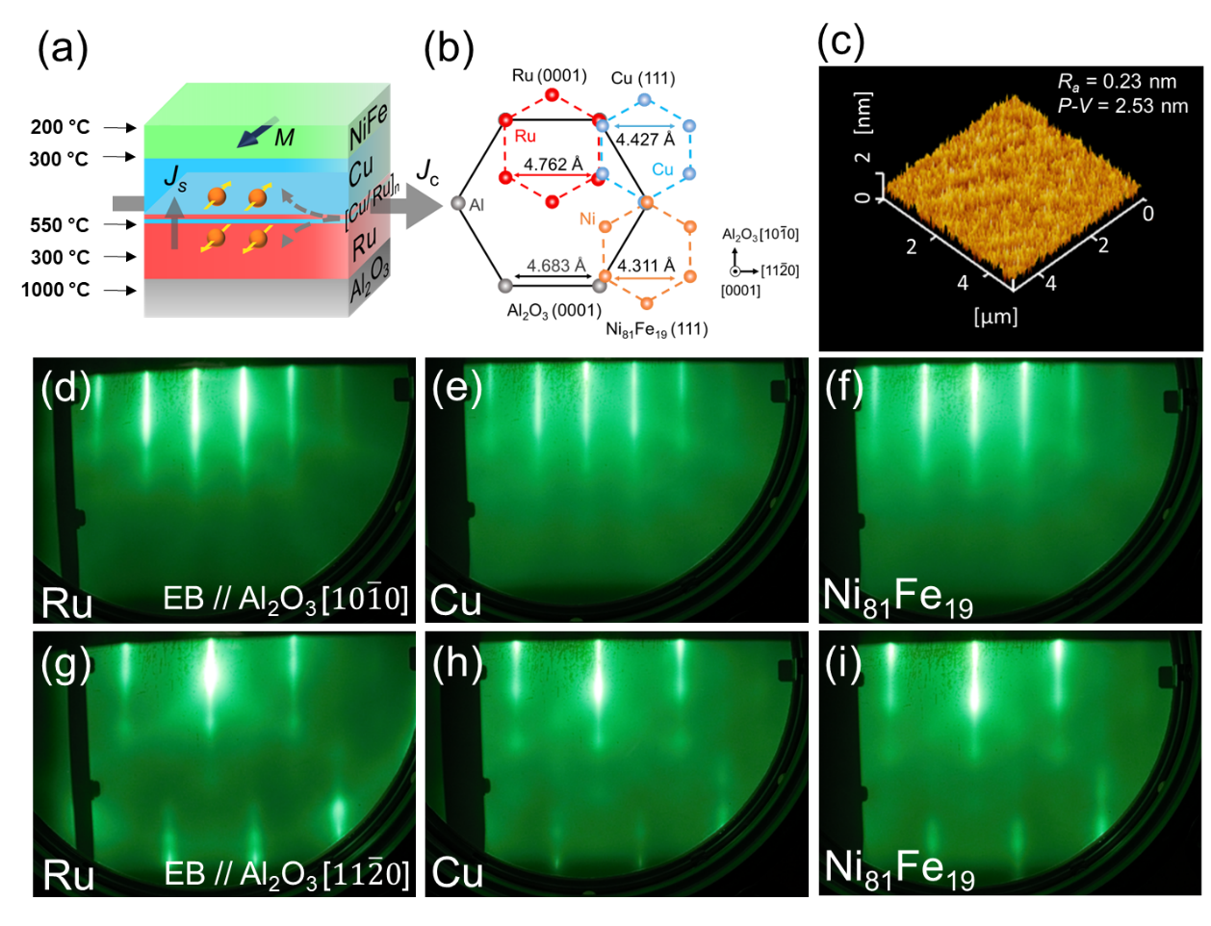

Figure 1. (a) Schematic illustration of the sample stack. (b) Epitaxial relationships of Al₂O₃(0001)//Ru(0001)/Cu(111)/Ni₈₁Fe₁₉(111). (c) AFM image for the Al₂O₃ substrate//Ru (10 nm)/Cu (10 nm)/Ni₈₁Fe₁₉ (5 nm)/MgO (2 nm) surface. (d) RHEED patterns of Ru layer, (e) Cu layer, and (f) Ni₈₁Fe₁₉ layer with incident electron beam along Al₂O₃[$10\overline{1}0$] azimuth. (g) RHEED patterns of Ru layer, (h) Cu layer, and (i) Ni₈₁Fe₁₉ layer with incident electron beam along Al₂O₃[$11\overline{2}0$] azimuth. All RHEED observations were performed after post-annealing.

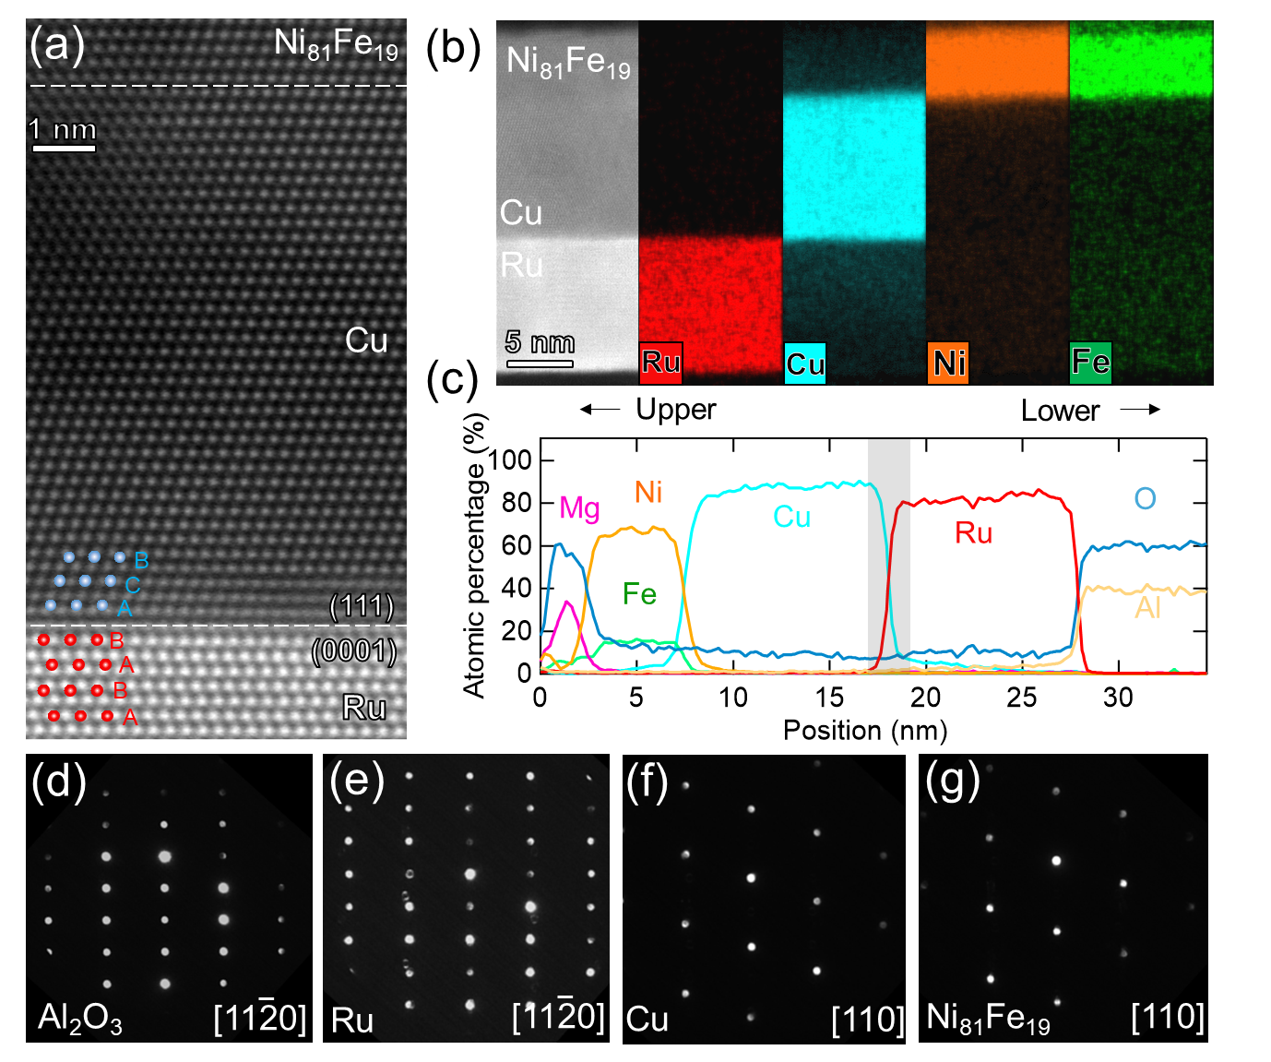

Figure 2. (a) Cross-sectional HAADF-STEM images with atomic model. (b) EDS elemental maps and (c) elemental depth profiles for Al₂O₃ substrate//Ru (10 nm)/Cu (10 nm)/Ni₈₁Fe₁₉ (5 nm)/MgO (2 nm). (d) NBED patterns for Al₂O₃ substrate, (e) Ru layer, (f) Cu layer, and (g) Ni₈₁Fe₁₉ layer.

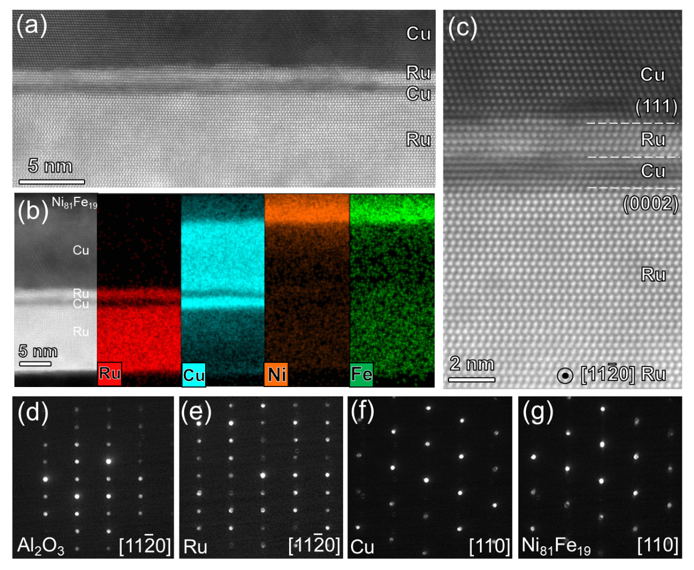
Figure 3. (a) Cross-sectional HAADF-STEM images for Al₂O₃ substrate//Ru (9 nm)/Cu (1 nm)/Ru (1 nm)/Cu (9 nm)/Ni₈₁Fe₁₉ (5 nm)/MgO (2 nm). (b) EDS elemental maps. (c) Magnified HAADF-STEM image near Cu (1 nm)/Ru (1 nm) interface. (d) NBED patterns for Al₂O₃ substrate, (e) Ru layer, (f) Cu layer, and (g) Ni₈₁Fe₁₉ layer.

Figure 4. (a) Measurement setup of USMR with the microscope image of a Hall bar device. (b-d) $R_{xx}^{2ω}$ as a function of magnetic field for (b) Ru (10 nm)/Cu (10 nm), (c) Ru (9 nm)/[Cu (1 nm)/Ru (1 nm)]₁/Cu (9 nm), and (d) Ru (8 nm)/[Cu (1 nm)/Ru (1 nm)]₂/Cu (8 nm). The magnetic field sweeps along y direction, and the current density is j = 1.4 × 10⁷ A cm⁻². (e) Charge current density dependence of normalized resistance ${ΔR}_{xx(USMR)}^{2ω}/R$.

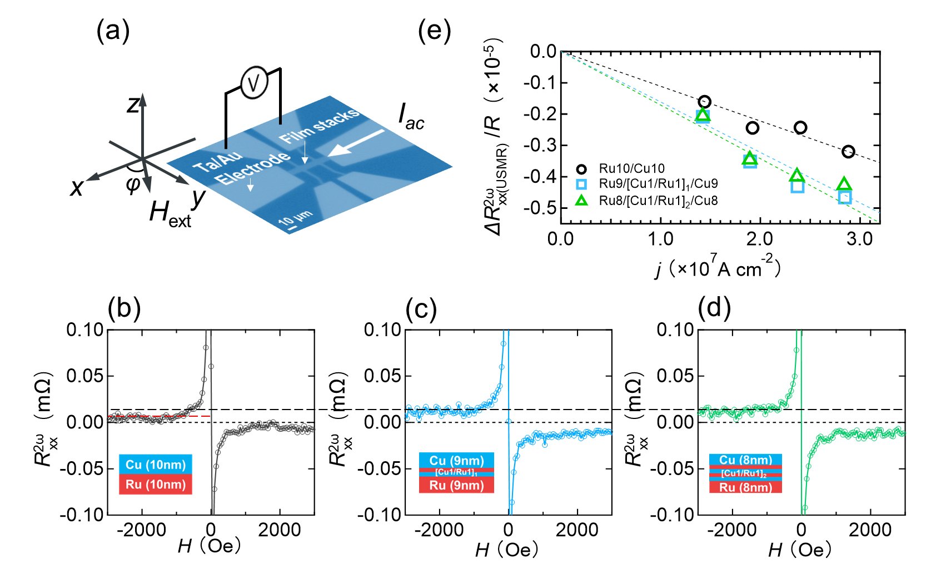

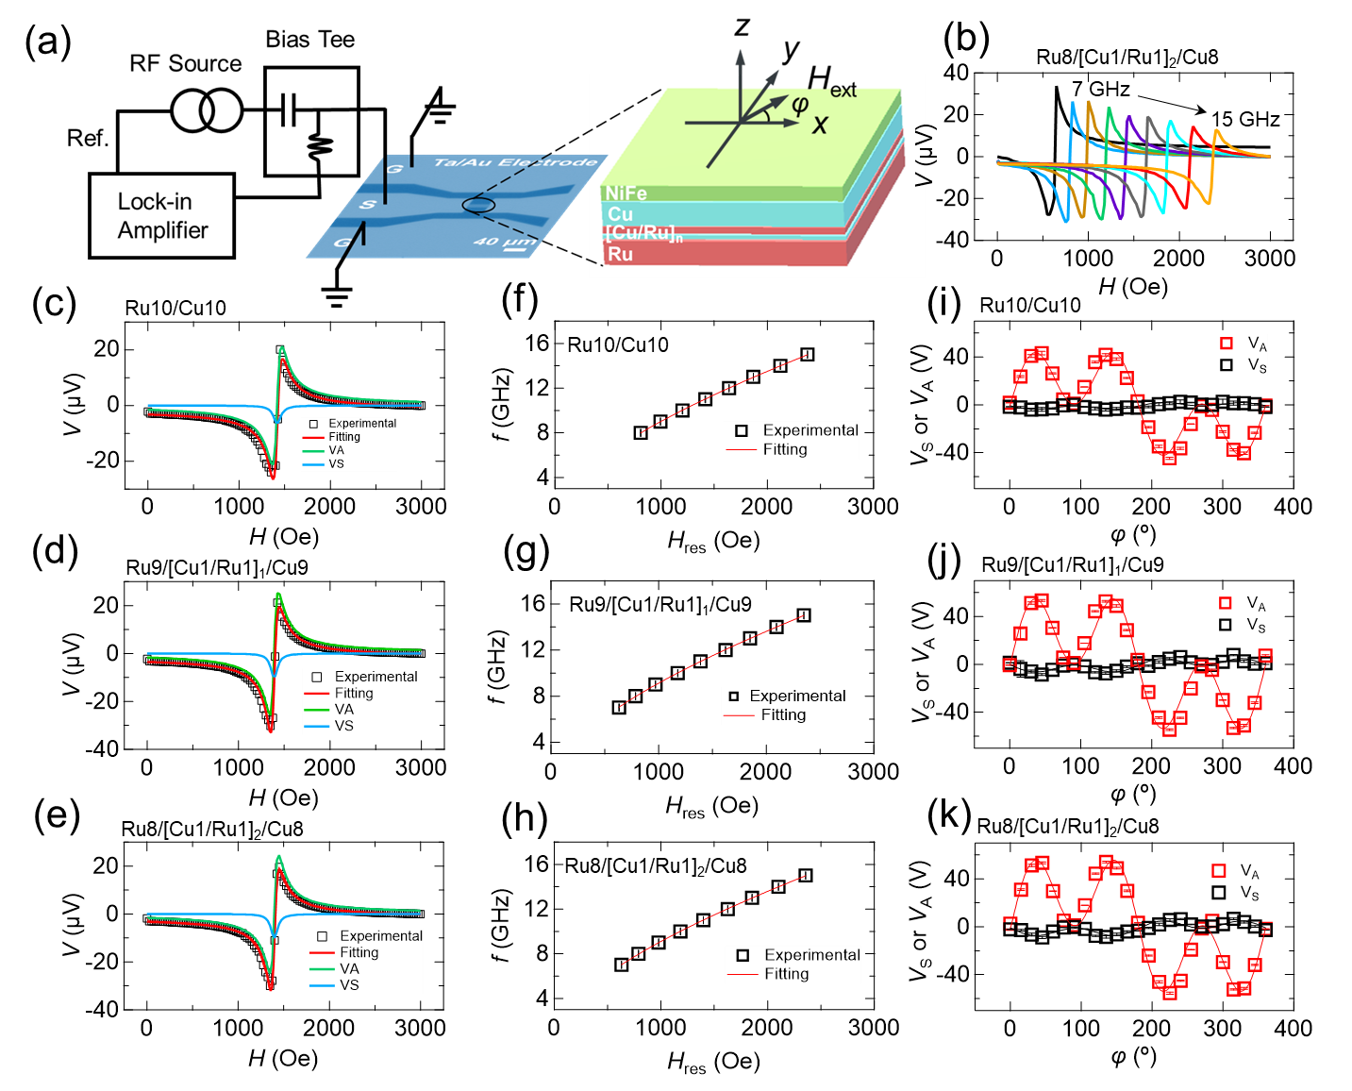
Figure 5. (a) Measurement setup of ST-FMR. (b) ST-FMR spectra with f varying from 7–15 GHz at φ = 45° for the sample of Ru (8 nm)/[Cu (1 nm)/Ru (1 nm)]₂/Cu (8 nm)/Ni₈₁Fe₁₉. (c-e) Representative ST-FMR spectra (φ = 45° and f = 11 GHz), (f-h) extracted H_{res} for 8–15 GHz with Kittel fitting, (i-k) φ dependence of V_{S} and V_{A}. The sample names of Ru (10 nm)/Cu (10 nm), Ru (9 nm)/[Cu (1 nm)/Ru (1 nm)]₁/Cu (9 nm), and Ru (8 nm)/[Cu (1 nm)/Ru (1 nm)]₂/Cu (8 nm) are shown on the panels, respectively.

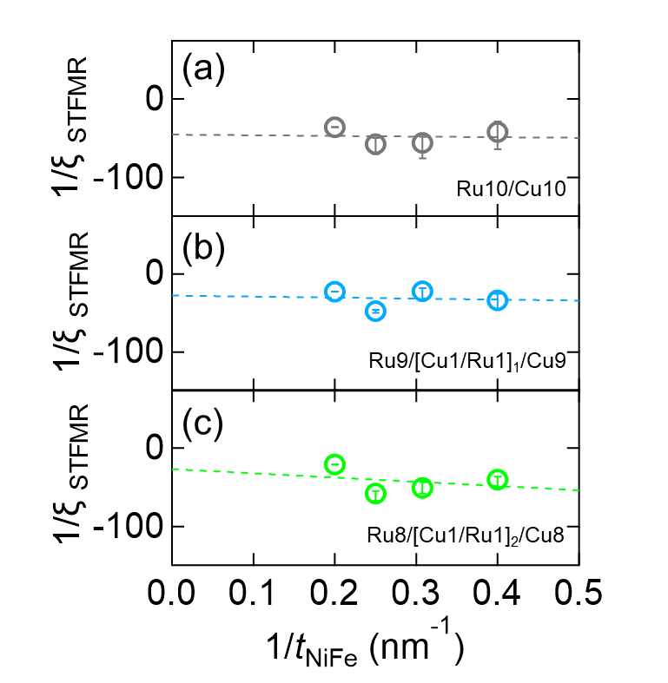

Figure 6. Inverse ξ_{STFMR} as a function of inverse NiFe thickness for (a) Ru (10nm)/Cu (10nm), (b) Ru (9nm)/[Cu (1nm)/Ru (1nm)]₁/Cu (9nm) and (c) Ru (8nm)/[Cu (1nm)/Ru (1nm)]₂/Cu (8nm) samples.

Table 1. Summary of the effective damping-like (ξ_{DL}) and field-like (ξ_{FL}) spin Hall efficiencies, longitudinal conductivity (σ_{xx}), and the effective spin Hall conductivity (σ_{SH}) in this work and Pt.

Structure (nm) | ξ_{DL} (%) | ξ_{FL} (%) | σ_{xx} (Ω⁻¹m⁻¹) | σ_{SH} ($\frac{ℏ}{2e}$Ω⁻¹m⁻¹)
Ru(10)/Cu(10) | −2.2 | 0.5 | 176.5×10⁵ | −3.9×10⁵
Ru(9)/[Cu(1)/Ru(1)]₁/Cu(9) | −3.6 | 1.4 | 133.1×10⁵ | −4.8×10⁵
Ru(8)/[Cu(1)/Ru(1)]₂/Cu(8) | −3.7 | 5.9 | 127.4×10⁵ | −4.7×10⁵
Pt (ref. 8) | 8 | - | 42×10⁵ | 3.4×10⁵

