Improved Hydration Property of Tissue Adhesive/Hemostatic Microparticle based on Hydrophobically-modified Alaska Pollock Gelatin

Shima Ito^{a,b}, Kazuhiro Nagasaka^{a,b}, Hiyori Komatsu^{a,b}, Debabrata Palaiª, Akihiro Nishiguchiª, Tetsushi Taguchi^{a,b}*
ªBiomaterials field, Research Center for Macromolecules and Biomaterials, National Institute for Materials Science, 1-1 Namiki, Tsukuba, Ibaraki 305-0044, Japan
^{b}Graduate School of Science and Technology, Degree Programs in Pure and Applied Sciences, University of Tsukuba, 1-1-1 Tennodai, Tsukuba, Ibaraki 305-8577, Japan

Correspondence and requests for materials should be addressed to T.T. (email: TAGUCHI.Tetsushi@nims.go.jp)

Abstract
The management of bleeding is an important aspect of endoscopic surgery to avoid excessive blood loss and minimize pain. In clinical settings, sprayable hemostatic particles are used for their easy delivery, adaptability to irregular shapes, and rapid hydration. However, conventional hemostatic particles present challenges associated with tissue adhesion. In a previous study, we reported tissue adhesive microparticles (C10-sa-MPs) derived from Alaska pollock gelatin modified with decyl groups (C10-sa-ApGltn) using secondary amines as linkages. The C10-sa-MPs adhere to soft tissues through a hydration mechanism. However, their application as a hemostatic agent was limited by their long hydration times, attributed to their high hydrophobicity. In this study, we present a new type microparticle, C10-am-MPs, synthesized by incorporating decanoyl group modifications into ApGltn (C10-am-ApGltn), using amide bonds as linkages. C10-am-MPs exhibited enhanced hydration characteristics compared to C10-sa-MPs, attributed to superior water absorption facilitated by amide bonds rather than secondary amines. Furthermore, C10-am-MPs demonstrated comparable tissue adhesion properties and underwater adhesion stability to C10-sa-MPs. Notably, C10-am-MPs exhibited accelerated blood coagulation in vitro compared to C10-sa-MPs. The application of C10-am-MPs in an in vivo rat liver hemorrhage model resulted in a hemostatic effect comparable to a commercially available hemostatic particle. These findings highlight the potential utility of C10-am-MPs as an effective hemostatic agent for endoscopic procedures and surgical interventions.
Keywords: Endoscope submucosal dissection; bleeding; hemostatic agent; microparticles; tissue adhesion; underwater stability; hydrophobic interaction

- Introduction
Endoscopic submucosal dissection (ESD) is a minimally invasive treatment for early-stage gastrointestinal cancer. ESD selectively removes mucosal and submucosal tissues surrounding the cancerous area [1]. In contrast to conventional endoscopic methods, ESD can remove a large volume of cancerous tissue in a single procedure; therefore, there has been a growing trend in the adoption of ESD procedures [2]. However, ESD treatment is associated with a high bleeding rate of 22.6% [3]. Bleeding during or after ESD may result in symptoms such as hematemesis or bloody stools, often necessitating a second surgical intervention [4]. In clinical settings, the main approach to treating bleeding involves electrocoagulation of the blood vessels using electric forceps or a knife, which cauterizes and solidifies the blood vessels, effectively stopping bleeding [5]. However, there is concern regarding potential tissue damage and the risk of perforation. Therefore, endo-clips have been used as an alternative option to stop bleeding [6], although they may also result in additional tissue damage and increase the risk of perforation. Additionally, the application of endo-clips requires a secondary operation to remove the applied clips, imposing an additional invasive procedure on patients. These challenges have motivated the development of adhesive biomaterials with robust hemostatic properties. There are various biomaterials that have been developed for the treatment of bleeding, including biodegradable hydrogels [7] and particles [8, 9]. Among the range of hemostatic materials available, hemostatic particles have demonstrated desirable features for endoscopic surgery. For example, commercially available hemostatic materials, such as the inorganic material-based Hemospray® [10] and starch-based Arista™ [9], can be sprayed from a device over a damaged area, enabling convenient application within the spatially confined gastrointestinal cavity. Moreover, this approach enables the concentration of coagulation factors to promote blood clotting. However, these materials often exhibit weak tissue adhesion and limited underwater stability, compromising their hemostatic ability at severe hemorrhage sites as they tend to detach from damaged tissue [11].
Recently, certain types of hemostatic particles have been reported that can generate a tissue-adhesive hydrogel on damaged tissue by absorbing blood and leveraging inter-particle interactions [11-13]. For example, carboxymethyl chitosan/catechol and aldehyde-modified hyaluronic acid [14], okura-derived powder [15], snail-derived powder [16], and polyacrylic acid/polyethyleneimine/quaternized chitosan [13] can absorb blood to form a hydrogel that adheres to tissue through a combination of hydration and physical and/or chemical interactions such as catechol chemistry, imine formation, and hydrogen bond [17]. However, these materials lacked sufficient hemostatic properties, adhesion strength, and underwater adhesion stability when applied to tissues in aqueous conditions, highlighting the need to design particles with enhanced performance in these aspects.
In a previous study, we developed tissue adhesive microparticles based on decyl group- modified Alaska pollock gelatin (C10-sa-ApGltn), where C10 groups were linked through a secondary amine [18-21]. We demonstrated the capability of the microparticles (C10-sa-MPs) to be sprayed from an endoscopic device. Additionally, C10-sa-MPs formed a colloidal gel through hydration, exhibiting both tissue adhesive properties and underwater adhesion stability [18]. Moreover, we confirmed that C10-sa-MPs were both biocompatible and biodegradable in vivo [19, 20]. Although C10-sa-MPs demonstrated valuable functional properties, their application as a hemostatic agent faced limitations attributed to a slow hydration rate.
In this study, we designed decanoyl group-modified Alaska pollock gelatin (C10-am-ApGltn) that was modified with C10 groups linked via an amide bond, to prepare microparticles (C10-am-MPs) aimed at enhancing hydration speed (Fig. 1). Sylvie, et al., previously reported a simulation where the amide bond can interact with more water molecules than secondary amine due to the presence of oxygen in the amide bond [22]. Given the superior water absorption characteristics of the amide bond compared to the secondary amine, we hypothesized that C10-am-MPs could deliver accelerated hydration and provide sufficient hemostatic properties. In this study, we compared hydration properties, tissue adhesion, underwater adhesion stability, and blood coagulation efficacy between C10-sa-MPs and C10-am-MPs. We also assessed the hemostatic properties of C10-am-MPs in comparison to a commercially available hemostatic particle using a rat liver hemorrhage model.
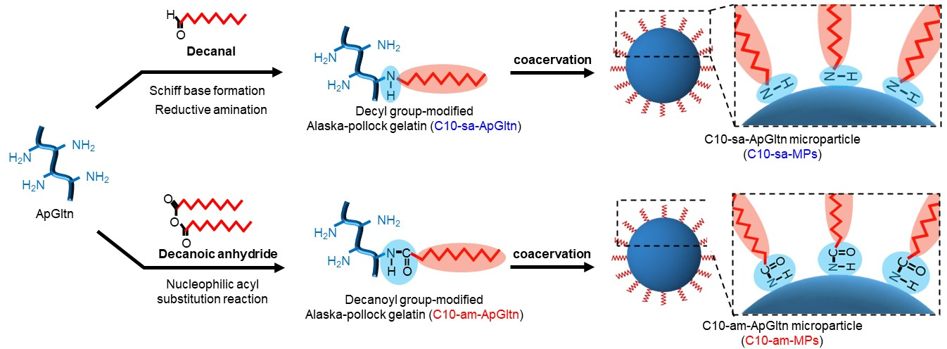
Fig. 1. Synthesis process for decyl group-modified Alaska pollock gelatin (C10-sa-ApGltn) and decanoyl group-modified Alaska pollock gelatin (C10-am-ApGltn) to prepare C10-sa-MPs and C10-am-MPs.

2. Materials and Methods
2-1. Materials
Alaska pollock gelatin (ApGtln, molecular weight (MW) = 34,352 Da, amine group content: 364 µmol/g and MW = 34,323 Da, amine group content: 355 µmol/g) was purchased from Nitta Gelatin Inc. (Osaka, Japan). Decanal, decanoic anhydrate, dimethyl sulfoxide (DMSO), trimethylamine (TEA), and 2, 4, 6-trinitrobenzene sulfonic acid (TNBS) were obtained from Tokyo Chemical Industry Co., Ltd. (Osaka, Japan). Ethanol and 2-picoline borane were purchased from Junsei Chemical Co., Ltd. (Tokyo, Japan). Fresh porcine stomach was purchased from Tokyo Shibaura Zouki (Tokyo, Japan). Sodium azide, 10% formalin buffer solution, and 4% paraformaldehyde were purchased from Wako Pure Chemical Industry Co., Ltd (Osaka, Japan). Water-soluble tetrazolium (WST)-8 reagent (Cell Count Reagent SF) was purchased from Nacalai Tesque (Kyoto, Japan). Saline was purchased from Otsuka Pharmaceutical Co., Ltd (Tokyo, Japan). RPMI-1640 media, fetal bovine serum (FBS), and phalloidin-tetramethylrhodamine B isothiocyanate were purchased from Sigma Aldrich (St. Louis, MO, USA). Penicillin-streptomycin (P/S) was purchased from Thermo Fischer Scientific (Waltham, MA, USA). Human colon epithelial (Caco-2) cells were purchased from RIKEN (Saitama, Japan). Triton X-100 was purchased from Cayman Chemical (Ann Arbor, MI, USA). 4′,6-Diamidino-2-phenylindole dihydrochloride (DAPI) was purchased from DOJINDO (Kumamoto, Japan). Rats (Sprague-Dawley (SD), male, 6 weeks old) were purchased from The Jackson Laboratory Japan (Kanagawa, Japan).

2.2. Synthesis of C10-sa-ApGltn
C10-sa-ApGltn was synthesized following a previously established method [19, 23]. In brief, ApGltn (50 g) was dissolved into 175 mL of ultrapure water at 50 °C under continuous stirring at 400 rpm. Subsequently, 35 mL of ethanol and 35.5 mmol of decanal (two equivalent molar ratio of amine groups in ApGltn) dissolved into ethanol were added into the ApGltn solution, followed by 1 hour of stirring at 50 °C. Then, 53.3 mmol of 2-picoline borane (1.5 equivalent molar ratio of decanal), used as a reductant, was added to the ethanol solution under continuous stirring at 400 rpm. The resulting solution had a 20 w/v% ApGtln concentration (water: ethanol = 175:75 (mL)). After stirring the reaction for 17 hours, the solution was dropped into 2,500 mL of chilled ethanol (maintained at −7 to 4 °C) to induce precipitation. The precipitate was washed three times with 1,250 mL of ethanol to remove residual decanal and 2-picoline borane, then vacuum dried overnight (< 3 mbar) to obtain C10-sa-ApGltn powder.

2.3. Synthesis of C10-am-ApGltn
C10-am-ApGltn was synthesized through a reaction with primary amine and decanoic anhydrate. Briefly, ApGltn (10 g) was dissolved in 35 mL of 0.1 M phosphoric acid buffer solution (pH 8.0) at 50 °C with continuous stirring at 400 rpm. Subsequently, 7.06 mmol of decanoic anhydrate (2-equivalent molar ratio of amine groups in ApGltn) was dissolved in 15 mL of ethanol and added into the ApGltn solution. The resulting solution had a 20 w/v% ApGtln concentration (water: ethanol = 35:15 (mL)). After stirring for 1 hour, the obtained solution was dropped into 500 mL of iced ethanol (maintained at −7 to 4 °C) to reprecipitate. The precipitate was washed three times with 250 mL of ethanol to remove residual decanoic acid. The washed precipitate was dissolved in a water/ethanol mixture (35/15 mL) and then dialyzed against 2 L of a water/ethanol mixture at a ratio of 7/3 (v/v) for 2 days at room temperature. The dialyzed solution was freeze dried to obtain C10-am-ApGltn powder.

2.4. Characterization of C10-sa-ApGltn and C10-am-ApGltn
The degree of substitution (DS) for the obtained C10-sa- and C10-am-ApGltn was quantified using the TNBS method, as previously reported [23]. This method measures the number of residual amine groups in ApGtln. The introduction of the decyl or decanoyl group was confirmed through Fourier transform infrared spectroscopy (FT-IR, ALPHA Ⅱ; Brucker Corp., USA) and ¹H-nuclear magnetic resonance (¹H-NMR, JNM-AL300; JEOL, Japan). Inorganic substances in the synthesized C10-am-ApGltn, such as phosphorus and sodium ions, were detected using energy dispersive X-ray spectroscopy (EDX; JCM- 7000, JEOL, Japan) by quantifying phosphorus and sodium elements.

2.5. Preparation and characterization of C10-sa-MPs and C10-am-MPs
C10-sa- and C10-am-MPs were prepared using the coacervation method, following a previous method [18-20, 24]. In this process, a poor solvent for C10-sa- and C10-am-ApGltn was used to induce coacervation. C10-sa- or C10-am-ApGltn was dissolved in ultrapure water at a concentration of 5 w/v%. An equal volume of ethanol, serving as a poor solvent, was added dropwise to the ApGltn solution, inducing the formation of a coacervate. The resulting coacervate solutions were freeze dried to remove water and ethanol. Subsequently, thermal treatment at 150 °C for 3 hours under vacuum conditions (< 3 mbar) was applied to facilitate the formation of chemical bonds between C10-sa- or C10-am-ApGltn molecules. Org-MPs derived from Org-ApGltn, non-modified Alaska pollock gelatin, were prepared using the same procedure. The obtained MPs were examined using scanning electron microscopy (SEM; JCM- 7000, JEOL, Japan) and the particle diameter was determined using Image J software.

2.6. Water contact angle analysis of C10-sa-MPs and C10-am-MPs
The water contact angle (WCA) was measured according to a previous method [19, 25, 26] using a contact angle meter (DM700, Kyowa Interface Science, Japan). C10-sa- or C10-am-MPs (20 mg) were fixed to a glass plate using dual tape and smoothed with a spatula to form a MPs layer. A water droplet (10 µL) was dropped onto the surface of MPs layer and the WCA was measured every second for up to 5 seconds.

2.7. X-ray photoelectron spectroscopy (XPS) analysis of C10-sa-MPs and C10-am-MPs
XPS analysis was performed using a dual scanning X-ray photoelectron microprobe equipped with hard X-ray photoelectron spectroscopy (HAX-PES/XPS; ULVAC-PHI, Inc., Japan) using Al Kα radiation (100 µmφ, 25 W, 15 kV) at an operating pressure below 6.5 × 10⁻⁵ Pa. The MPs were placed onto a sample holder, and spectra were obtained with a pass energy of 20 eV. The obtained spectra were analyzed using Multipak software (ULVAC-PHI, Inc., Japan), with a reference charge correction of 284.5 eV applied for C 1s.

2.8. Preparation and colloidal gel formation of C10-sa-MPs and C10-am-MPs
C10-sa- and C10-am-MPs (50 mg) were deposited onto a silicone mold (diameter (D) = 10 mm) and leveled using a spatula. The MPs were then hydrated with 500 µL of PBS for 30 minutes at 37 °C, resulting in the formation of stable colloidal gels. The colloidal gels were weighed (W_{wet}), then freeze dried to remove water and the dry weight was measured (W_{dry}). The water content of the colloidal gels was calculated using both W_{wet} and W_{dry}, according to the formula below. The weight of the salt from the PBS was excluded from the calculation.

$$Water content \left(\%\right)=\frac{W_{wet}-W_{dry}}{W_{wet}}×100$$

2.9. Observation of aggregation behavior of C10-sa-MPs and C10-am-MPs
The aggregation behaviors of C10-sa- and C10-am-MPs were observed using a previously established method [20, 24]. MPs (10 mg) were dispersed in 200 µL of PBS (5 w/v%) and hydrated in an incubator for 0, 5, 15, 30, and 60 minutes. Subsequently, a 10 µL suspension of MPs was deposited onto a glass slide, and the aggregation of MPs in PBS was observed using a bright-field microscope (BZ-X710, Keyence, Osaka, Japan).

2.10. Rheological analysis of colloidal gels formed by C10-saMPs- and C10-am-MPs
The rheological properties of colloidal gels formed with C10-sa- and C10-am-MPs were evaluated using a rheometer (MCR 301 Rheometer, Anton Paar GmbH, Graz, Austria), measuring both the storage modulus (G’) and the loss modulus (G”). Stable colloidal gels, prepared as previously described, were positioned on the stage of the rheometer, which was heated to 37 °C, and fixed by a probe (D: 10 mm). Measurements of G’ and G” were performed across a range of shear strains (0.01 to 1,000%) and angular frequencies (0.1 to 100 rad/s).

2.11. Measurement of the stability of C10-sa-MP and C10-am-MP colloidal gels in PBS
The stability of colloidal gels formed with C10-sa- and C10-am-MPs was assessed by immersing the gel into PBS. The weight of the colloidal gels, prepared as previously described, was initially measured as W₀. Subsequently, the colloidal gel was immersed in 50 mL of PBS and incubated for 72 hours. After 1, 3, 6, 12, 24, 48, and 72 hours of incubation, the weight of the colloidal gel was measured as W_{t}. The remaining colloidal gel ratio was calculated using the formula below. The weight of the salt in the PBS was excluded from the calculation.

$$Remaining colloidal gel ratio \left(\%\right)=\frac{W_{t}}{W_{0}}×100$$

2.12. Assessment of the tissue adhesion strength of C10-sa-MPs and C10-am-MPs
The adhesion strength of C10-sa- and C10-am-MPs to the surface of stomach submucosal tissue was evaluated following ASTM F2258-05 guidelines and a previously reported methodology [18, 24]. In brief, a fresh porcine stomach was washed and cut into squares measuring 2.5 cm × 2.5 cm. To simulate the ESD procedure, the mucosal layer was removed by injecting saline into the submucosal layer to expose the underlying submucosa. The stomach sections were fixed to a probe and stage set at 37 °C on a texture analyzer (TA-XT2i, Stable Microsystems, UK) using a cyanoacrylate adhesive (Henkel Japan Ltd., Tokyo, Japan). After removing water from the stomach tissue by sandwiching a Kimwipe between two submucosal sections under 80 kPa for 3 minutes, 100 mg of C10-sa- or C10-am-MPs was applied and evenly distributed across the submucosal tissue. The MPs were compressed again (80 kPa, 3 minutes), and the tissue adhesion strength was measured by raising the probe at a speed of 10 mm/min (Fig. 4(a)). Org-MPs and the commercially available hemostatic material Arista™ were used as control groups.

2.13. Effect of hydration time on the tissue adhesion strength of C10-sa-MPs and C10-am-MPs
To determine the hydration time of C10-sa- and C10-am-MPs on stomach tissue, the adhesion strength was assessed over various hydration times. Fresh stomach sections were fixed to a probe and stage set at 37 °C of a texture analyzer. Water was removed from the submucosal tissue using a Kimwipe, then 100 mg of C10-sa- or C10-am-MPs was applied to the tissue. PBS was placed surrounding the stomach tissue, and the MPs and tissue were covered to maintain humidity. Following the hydration of MPs for 1, 5, 10, and 30 minutes, adhesion strength was measured (Fig. 5(a)). Subsequently, the stomach submucosal tissues were fixed with a 10% formalin buffer solution, and the interface between the MPs and stomach submucosal tissue was observed using hematoxylin-eosin (HE) staining.

2.14. Assessment of the underwater adhesion stability of C10-sa-MP and C10-am-MP colloidal gels
The underwater adhesion stability of colloidal gels formed with Org-, C10-sa-, and C10-am-MPs, along with Arista™, was evaluated by immersing MPs applied to the stomach tissue in saline. MPs (50 mg) were applied to the exposed submucosal layer of a fresh stomach tissue section, to cover a circular area (D = 10 mm), followed by hydration with 500 mL of PBS at 37 °C for 30 minutes to form a colloidal gel. The obtained colloidal gel, adhering to the submucosal tissue, was immersed in 50 ml of saline containing 0.02 w/v% sodium azide. Following a 2-day incubation at 37 °C, the remaining colloidal gel on the submucosal tissue was fixed with a 10% formalin buffer solution for HE staining. The amount of colloidal gel remaining on the submucosal tissue was quantified using Image J analysis.

2.15. In vitro blood coagulation test
An in vitro blood coagulation test was performed following a previously established method [27]. Briefly, 1 mL of citrated whole porcine blood was activated by the addition of 27.2 µmol of calcium chloride (CaCl₂). Subsequently, 0.1 g of Org-, C10-sa-, C10-am-MPs, or Arista™ was added to the activated blood, and the mixture was vortexed for 10 seconds. The resulting mixture was incubated for 3 minutes, then the vial was inverted to analyze blood fluidity. To assess time-dependent clot formation in various samples, clot formation was observed on a well plate following a previously reported method with minor modifications [13-15, 28]. Initially, 200 µL of citrated whole blood was activated by adding 5.44 µmol of CaCl₂, then 20 mg of a sample was added and the mixture was vortexed for 10 seconds. The mixture (100 µL) was transferred to a 48-well plate and incubated for 0.5, 1.0, 1.5, 2.0, 2.5, 3.0, 4.0, and 5.0 minutes. At each time point, 500 µL of PBS was added to the well for washing, and blood clot formation was determined by assessing coverage of more than 80% of the well area.

2.16. Cell viability assessment of C10-sa-MPs and C10-MPs
The viability of Caco-2 cells, a human colorectal adenocarcinoma-derived cell line, exposed to Org-, C10-sa-, and C10-am-MPs was assessed. The cells were cultured in RPMI medium supplemented with 10% FBS and 1% P/S. Caco-2 cells were seeded in 96-well plates at a concentration of 5.0 × 10⁴ cells/well and incubated at 37 °C with 5 % CO₂ for 24 hours. Colloidal gels, prepared as previously described, were immersed in 2 mL of RPMI for 24 hours to prepare an RPMI medium conditioned with extracts from the MPs. This conditioned RPMI medium was added to Caco-2 cells and incubated at 37 °C for 24 hours. The cell number was determined with a mitochondrial activity test using WST-8 according to the manufacturer’s instructions. Following a 2-hour incubation of cells with 10% WST-8, the absorbance at 450 nm was measured using a microplate reader (Spark10M, TECAN, Männedorf, Switzerland).

2.17. Immunofluorescence staining
Caco-2 cells, exposed to the conditioned medium from the colloidal gels for 24 hours, were fixed with 4% paraformaldehyde for 15 minutes then washed with PBS. Each sample was then permeabilized with 0.2% Triton X for 15 minutes then washed with PBS. For blocking, 1% bovine serum albumin (BSA) in PBS was added, and the cells were incubated for 60 minutes at room temperature. Subsequently, phalloidin-isothiocyanate in PBS was added, and the cells were incubated for 60 minutes then washed with PBS. Cell nuclei were stained with 1 µg/mL DAPI in PBS and the samples were observed using confocal laser scanning microscopy (BZ-X700, Keyence).

2.18. The in vivo hemostatic effect of C10-sa-MPs and C10-am-MPs using a rat liver hemorrhage model
Animal experiments were conducted with the approval of the Institutional Animal Care and Use Committee (IACUC) of the National Institute for Material Science (Approval number: 76-2023-4). The hemostatic effect of C10-sa- and C10-am-MPs was assessed using a liver bleeding model, following established protocols [29, 30]. Male SD rats (6 weeks old, n = 7 to 10) were anesthetized through the inhalation of isoflurane. Following ethanol disinfection, the abdominal wall was opened to expose the liver. A liver injury was introduced by creating a defect 2 mm in depth and 4 mm in diameter using a circular punch. After 5 seconds of free bleeding, 30 mg of Org-MPs, C10-sa-MPs, C10-am-MPs, or Arista™ was applied to the bleeding area using a spatula. Blood was collected over a 5-minute period using parafilm and a pre-weighed filter paper to measure blood loss. Following this experiment, the damaged tissues were collected and fixed with a 10% formalin buffer solution for HE staining.

2.19. Statistical analysis
All data are presented as mean ± standard deviation (SD), calculated from 3, 5, or 10 independent experiments. Statistical analysis was conducted using GraphPad Prism v.8.0 (GraphPad Software). One-way ANOVA, followed by Tukey’s multiple comparison post hoc test, was used to test differences among groups. Significance levels are denoted as follows: *P < 0.05, **P < 0.01, ***P < 0.001, and ****P < 0.0001.

3. Results and Discussion
3.1. Synthesis and characterization of C10-sa-ApGltn and C10-am-ApGltn
C10-sa-ApGltn was synthesized through the modification of decyl groups with amine groups of ApGltn, involving the formation of a Schiff base and subsequent reductive amination, as outlined in previous reports [19, 23]. C10-am-ApGltn was synthesized through the nucleophilic acyl substitution reaction of the amino groups of ApGltn with decanoic anhydrate under high pH conditions.
The DS was determined using the TNBS method, which quantifies the residual amine groups in the synthesized C10-sa- and C10-am-ApGtln molecules. The DS values for C10-sa- and C10-am-ApGltn were 47 and 44 mol%, respectively (Table S1). Taking into account the total amine groups of ApGltn (355 and 364 mmol/g), the molecular weight of ApGltn (34,323 and 34,352 Da), and the DS data, it was determined that the number of decyl or decanoyl groups in one C10-sa- and C10-am-ApGltn molecule was 5.73 and 5.50, respectively. The introduction of decyl or decanoyl groups into ApGltn was confirmed through FT-IR and ¹H-NMR (Fig. S1, (a), (b)). In the FT-IR spectra of C10-sa-ApGltn, the specific peaks corresponding to secondary amines at 3,288 cm⁻¹ increased compared to Org-ApGltn. The specific peaks corresponding to the C–H vibration of the decyl or decanoyl groups at 2,927 cm⁻¹ increased in both spectra. These results indicate that decyl and decanoyl groups were introduced to ApGltn to obtain C10-sa- and C10-am-ApGltn, respectively. The increased intensity of the specific proton peak derived from the C–H bond of the decyl or decanoyl groups in the ¹H-NMR spectra for C10-sa- and C10-am-ApGltn further confirms the successful introduction of decyl or decanoyl groups to ApGltn. The presence of residual inorganic compounds, such as phosphoric acid and sodium ions, could potentially impact hydration characteristics; therefore, we confirmed the removal of inorganic compounds from C10-am-ApGltn after dialysis through EDX analysis (Fig. S3(a), (b)). The dialysis process effectively removed almost all traces of phosphorus and sodium atoms, suggesting that inorganic compounds introduced during the synthesis process did not affect the hydration properties of C10-sa- and C10-am-ApGltns/MPs.

3.2. Preparation and characterization of C10-sa-MPs and C10-am-MPs
C10-sa- and C10-am-MPs were prepared through coacervate formation by the addition of a poor solvent followed by freeze-drying. SEM observation revealed that both MP types had a spherical shape with a smooth surface (Fig. 2(a)). The average particle diameters of Org-MPs, C10-sa-MPs, and C10-am-MPs were 2.78 ± 1.68, 2.16 ± 0.68, and 3.19 ± 0.83 µm, respectively. Org-MPs exhibited a broader size distribution compared to C10-sa- and C10-am-MPs, likely due to the induction of aggregation by decyl/decanoyl groups during coacervate formation. [18]. XPS analysis was performed to confirm the presence of amide bonds on the surface of the C10-sa- and C10-am-MPs (Fig. S4(a), (b)). A higher intensity peak at 287.5 eV, attributed to C=O and N–C=O, was observed for C10-am-MPs compared to C10-sa-MPs. This indicates that C10-am-MPs have a higher content of amide bonds, which are used to link C10 groups with ApGltn molecules.
WCA analysis was performed to assess the surface wettability of the MPs. The modification of ApGltn with decyl or decanoyl groups resulted in an increased WCA for C10-sa- and C10-am-MPs (96.9 ± 0.9 ° and 75.8 ± 0.1 °, respectively), compared to Org-MPs (44.8 ± 2.5 °), as determined 1 second after water droplet application (Fig. 2(c), (d)). However, the WCA of C10-am-MPs decreased more rapidly compared to that of C10-sa-MPs, reaching 43.9 ± 0.6 ° within 5 seconds, which was similar to the WCA for Org-MPs at 5 seconds (40.6 ± 3.0 °). In contrast, C10-sa-MPs maintained a high WCA (78.8 ± 2.7 °) after a 5-second water droplet application. These results indicated that C10-am-MPs had higher wettability compared to C10-sa-MPs despite having the same DS. This difference is attributed to the distinct linkage of C10 groups in C10-sa- and C10-am-MPs. Because of the higher hydrophilicity from the amide bond linkage in C10-am-MPs, water molecules are readily absorbed onto their surface [22]. These findings demonstrate the successful enhancement of the water-absorption characteristics of C10 group-modified ApGltn MPs by changing from a secondary amine to an amide bond linkage.
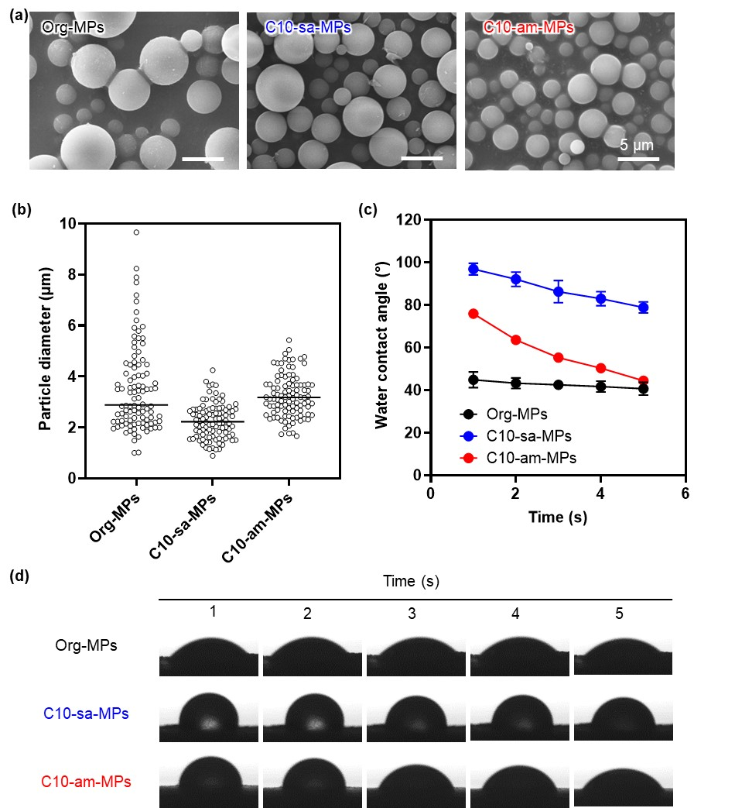
Fig. 2. Characterization of Org-MPs, C10-sa-MPs, and C10-am-MPs. (a) SEM images of the different MPs. Scale bars represent 5 µm. (b) Particle diameter distribution of the different MPs with black lines indicating the average diameter. (c) Time-dependent changes in water contact angle after water droplet application on the surface of the different MPs. (d) Sequential images illustrating the time-dependent behavior of a water droplet on the surface of the different MPs.
3.3. Characterization of C10-sa-MP and C10-am-MP colloidal gels
Colloidal gels derived from Org-, C10-sa-, and C10-am-MPs were prepared through hydration of the MPs by PBS. The time-dependent water content of the colloidal gels was initially measured after hydration with PBS (Fig. 3(a)). The water content of C10-am-MPs reached 55.7 ± 19.7% within 10 minutes, whereas it took 25 minutes to reach 59.8 ± 4.1% with C10-sa-MPs. Despite the hydrophobic modification in C10-am-MPs, their hydration behavior closely resembled that of Org-MPs. This result indicates that C10-am-MPs have a superior water absorption capacity compared to C10-sa-MPs, attributed to the higher amide content in C10-am-ApGltn. To elucidate the difference in hydration speed among MPs, we compared the aggregation behavior between C10-sa-MPs and C10-am-MPs (Fig. 3(b)). Both C10-sa- and C10-am-MPs aggregated to form a colloidal gel, while Org-MPs did not. This indicates that colloidal gel formation was driven by the hydrophobic interactions among C10-sa- or C10-am-MPs. C10-am-MPs initiated aggregation after 15 minutes of hydration, while it took 30 minutes for C10-sa-MPs. This suggests that C10-am-MPs had a faster water absorption capability and initiated hydrophobic interactions earlier than C10-sa-MPs, resulting in rapid colloidal gel formation.
Rheological analysis was performed to determine the difference in the modulus of the colloidal gels (Fig. 3(c), (d)). All the colloidal gels exhibited a higher storage modulus (G’) than loss modulus (G”) in the low shear strain area, indicating that all MPs reached gel state. The G’ of C10-sa- and C10-am-MPs at 1% strain and 10 rad/s in frequency (23.6 and 2.3 kPa, respectively) was higher than that of Org-MPs (0.26 kPa). This increase in G’ was attributed to the modification of decyl or decanoyl groups, which induces hydrophobic interactions among MPs, a trend consistent with previous studies [19, 24]. The lower storage modulus of C10-am-MPs, compared to C10-sa-MPs, was likely due to the enhanced water absorption characteristics of C10-am-MPs, resulting in increased water retention within the bulk of the colloidal gel. We also confirmed the frequency-dependent increase of G’ and G”, indicative of the typical rheological behavior observed in physically-crosslinked gels [31, 32]. An increase in the G’ of the colloidal gel in the presence of decyl or decanoyl groups was observed, indicating the induction of physical crosslinking among MPs. To determine the stability of the colloidal gels in an aqueous environment, they were immersed in PBS and the weight change was monitored (Fig. 3(e)). The superior water-absorption characteristics of C10-am-MPs led to a rapid increase in colloidal gel weight within the first 6 and 12 hours compared to C10-sa-MPs, indicating greater water absorption. The colloidal gel weight of C10-am- and C10-sa-MPs remained unchanged after immersion for 24 hours, whereas the weight of Org-MPs continued to decrease. This suggests that Org-MPs swelled and dispersed in PBS without forming a colloidal gel. These results indicate that the underwater stability of the colloidal gel is improved by the modification of decyl or decanoyl groups, inducing subsequent inter-particle interactions following hydration in a water environment. Note that in the physiological condition, there is variety of enzymes on the gastrointestinal surface, therefore, it is expected that the colloidal gel weight would decline earlier than this result on the actual gastrointestinal condition.
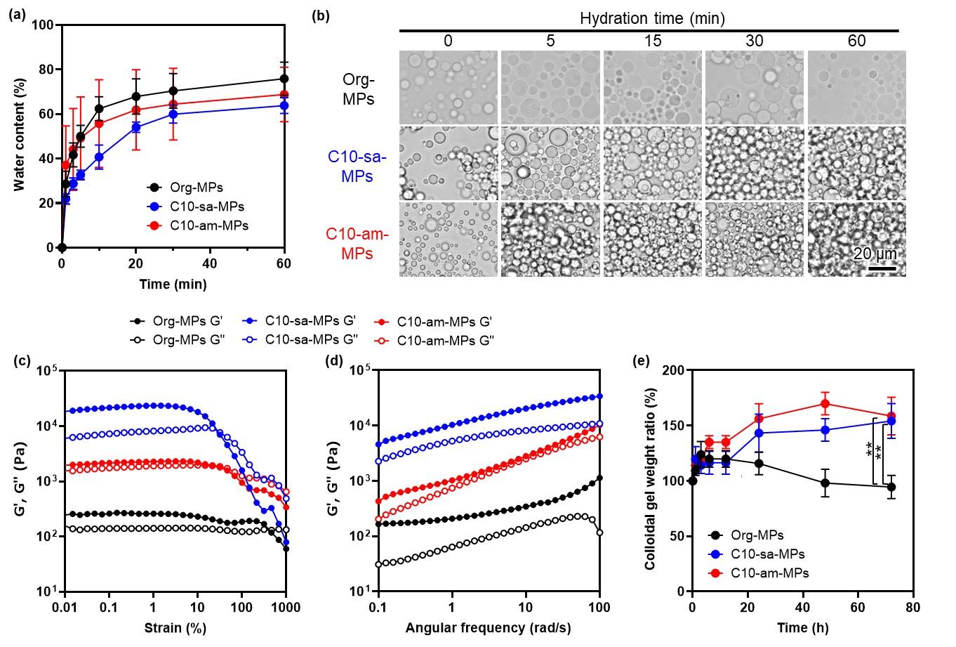
Fig. 3. Characterization of colloidal gels formed with C10-sa- and C10-am-MPs. (a) Time-dependent water content of the different colloidal gels. (b) Colloidal gels formed with MPs in PBS after incubation for various periods. Scale bar represents 20 µm. (c, d) Storage (G’) and loss modulus (G”) of the colloidal gels as a function of (c) strain and (d) angular frequency. (e) Weight ratio of the colloidal gels after immersion in PBS for various periods. **p < 0.01; statistical significance was determined using Tukey's multiple comparison test.

3.4. Adhesion strength of C10-sa-MPs and C10-am-MPs
The tissue adhesion strength of C10-sa- and C10-am-MPs was assessed by sandwiching MPs between two porcine stomach submucosal tissues according to the ASTM F2258-05 method (Fig. 4(a)). Following the application of C10-sa- and C10-am-MPs between the stomach submucosal tissues, the formation of a colloidal gel adhesion layer was observed, indicating that high adhesion strength had been achieved (Fig. 4(b)). In contrast, Org-MPs and Arista™ exhibited lower adhesion strength. Consequently, the adhesion strength of both C10-sa- and C10-am-MPs groups was high compared to that of the Org-MPs and Arista™ groups (18.7 ± 2.6, 16.4 ± 2.9, 5.3 ± 1.1, and 5.4 ± 1.0 kPa for C10-sa-, C10-am-, Org-MPs, and Arista™, respectively) (Fig. 4(c), (d)). The increased adhesion strength can be attributed to the enhanced interaction at the colloidal gel-tissue interface, facilitated by the formation of hydrophobic interactions between the decyl or decanoyl groups and hydrophobic molecules in the tissue, including the phospholipid bilayer membrane, fibronectin, and elastin, which are present in extracellular matrix [33]. Furthermore, the intrinsic strength of the colloidal gel was also an important factor for adhesion strength. Both C10-sa- and C10-am-MPs formed stable and stiff colloidal gel layers following hydration (Fig. 3(c) and (d)). Therefore, the increase of tissue adhesion strength was attributed to two kinds of interactions: MP-tissue interactions and inter-particle interactions. Zhao, et al., reported barnacle-glue-inspired paste for hemostasis, which incorporates NHS ester to polymer to form chemical bonds to tissue. In the paper, they reported adhesion strength for porcine tissue as approximately 13 kPa, which was comparable with the adhesion strength of C10-am-MPs (16.4 ± 2.9 kPa). From this result and the literature, C10-am-MPs achieved sufficient tissue adhesion compared with the clinically available and other lab-based hemostatic materials.
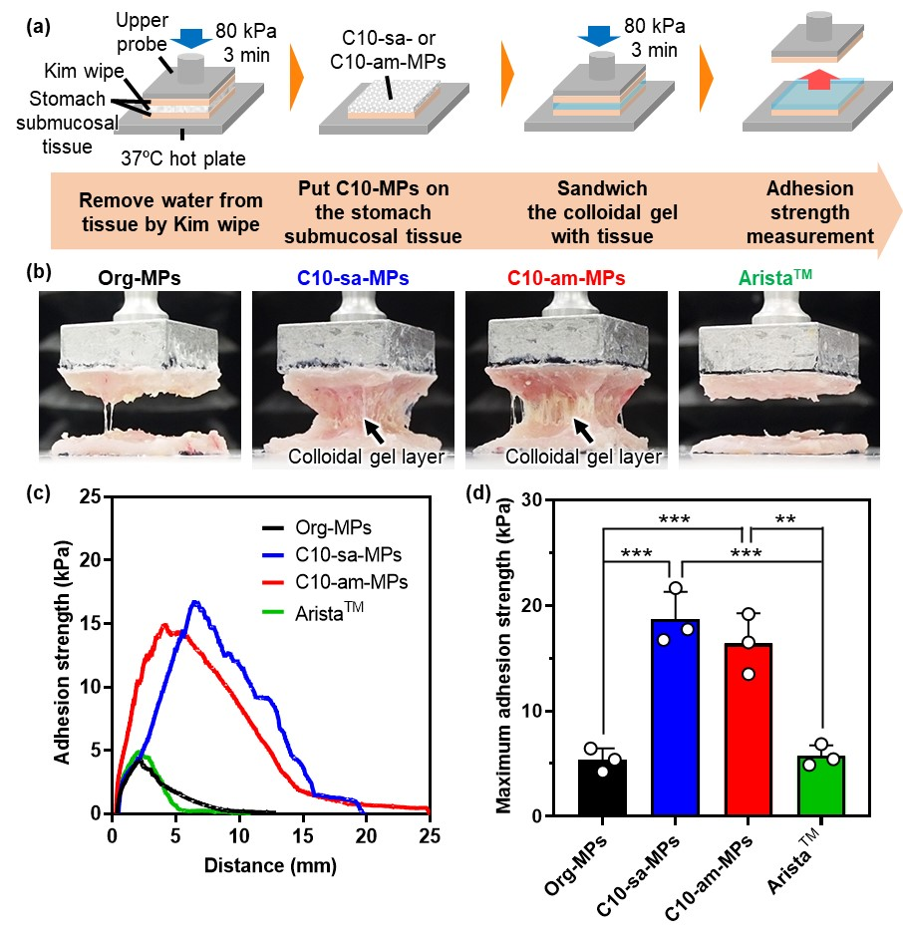
Fig. 4. Tissue adhesion strength of Org-, C10-sa-, C10-am-MPs, and Arista™. (a) Experimental procedure for tissue adhesion strength measurement. MPs were sandwiched between two stomach tissues and compressed, then adhesion strength was measured by lifting the upper stomach tissue. (b) Images of the stomach tissue and colloidal gel layer during the lifting of the upper probe. Arista™, a commercially available hemostatic particle, was used as a control. Black arrows indicate the colloidal gel layer. (c) Adhesion strength change with stomach tissue separation distance. (d) Maximum adhesion strength comparison. **p < 0.01, ***p < 0.001; statistical significance was analyzed using the Tukey's multiple comparison test.

3.5. Effect of hydration time on the adhesion strength of C10-sa-MPs and C10-am-MPs
To compare the hydration dynamics and resulting colloidal gel formation of C10-sa- and C10-am-MPs, the adhesion strength of the MPs after hydration was assessed over various periods (Fig. 5(a)). In a previous study, we established that the hydration of MPs led to a reduction in adhesion strength [20]. Therefore, we hypothesized that C10-am-MPs, with their superior hydration characteristics, would exhibit anti-adhesion properties rapidly in comparison to C10-sa-MPs. Upon hydration of MPs on the stomach tissue, C10-am-MPs rapidly hydrated, becoming transparent and forming a colloidal gel within 10 minutes. In contrast, it took 30 minutes for C10-sa-MPs to form a transparent layer on the stomach tissue under the same conditions (Fig. 5(b)). The adhesion strength of C10-am-MPs rapidly decreased after 1, 5, and 10 minutes of hydration, which was significantly different to C10-sa-MPs (Fig. 5(c)). Based on HE staining, it was observed that C10-am-MPs adhered onto the upper tissue before and after 1 minute of hydration; however, no adhesion layer of colloidal gel from C10-am-MPs was observed on the upper tissue following hydration for 5, 10, and 30 minutes (Fig. 5(d)). In contrast, C10-sa-MPs adhered to both sides of the tissues even after hydration for 10 minutes, suggesting incomplete hydration of C10-sa-MPs. It is likely that the introduction of amide linkage between the alkyl groups and ApGltn effectively promoted the hydration of C10-am-MPs. Therefore, C10-am-MPs have promising potential as a hemostatic material for hemorrhage sites due to their improved water absorption properties.
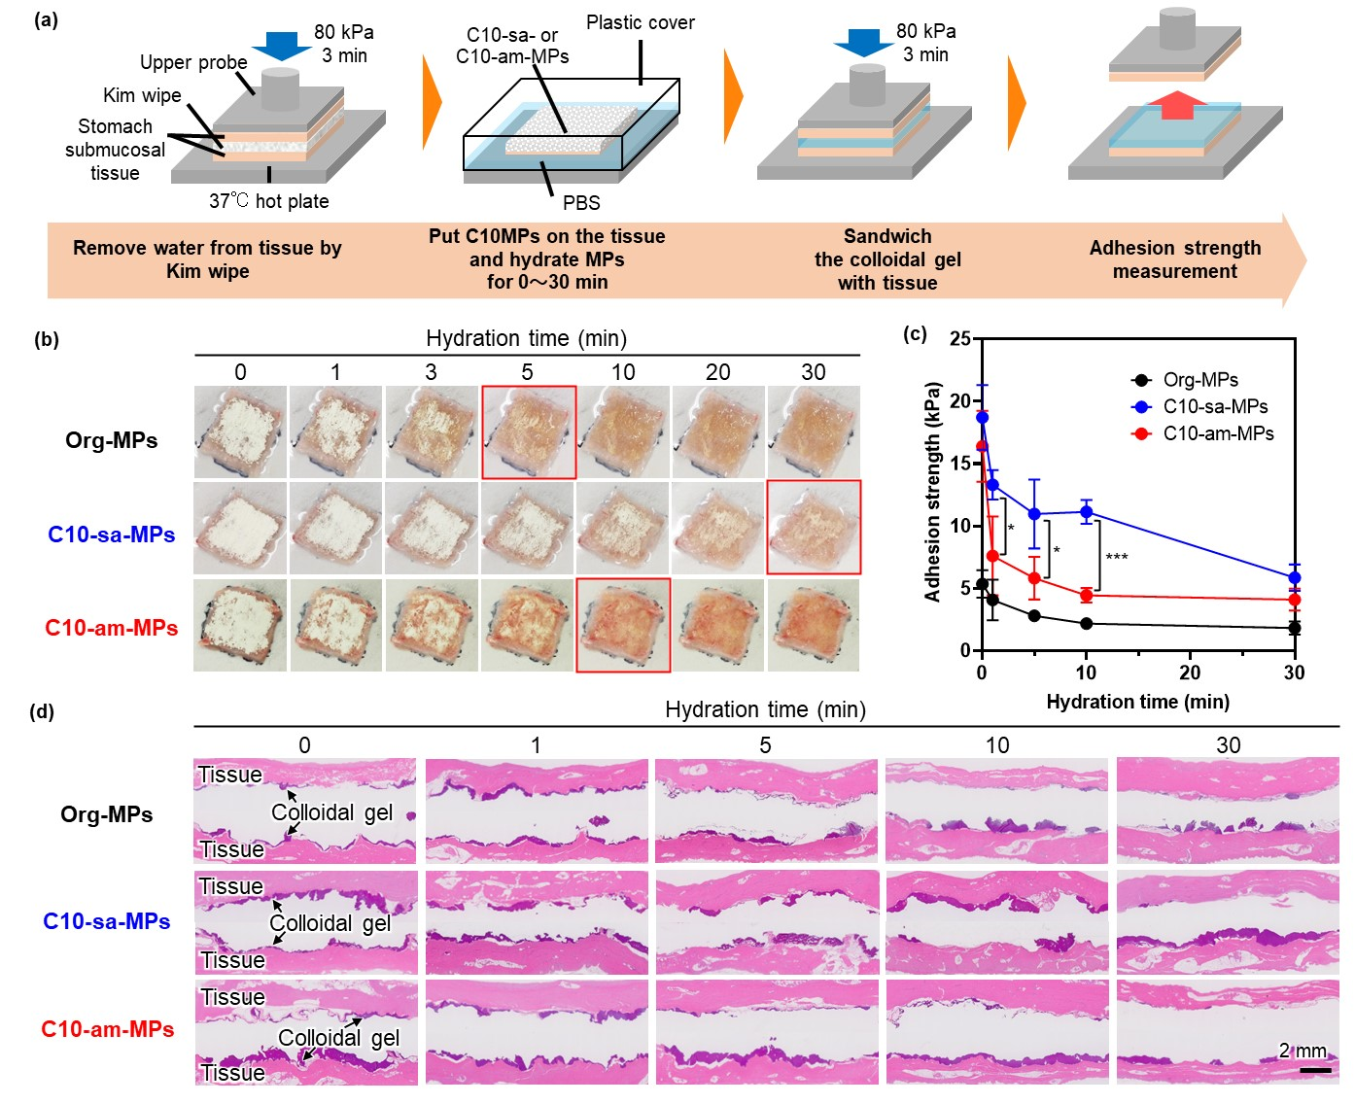
Fig. 5. Effect of hydration time on the tissue adhesion strength of C10-sa- and C10-am-MPs. (a) Experimental procedure for the tissue adhesion strength test following hydration for various periods. MPs were hydrated on the stomach submucosal tissue for 1 to 30 minutes, then the adhesion strength was measured. (b) Hydration behavior of Org-, C10-sa-, and C10-am-MPs on the stomach submucosal tissue for up to 30 minutes. The red frames indicate the time points when MPs achieved complete hydration. (c) Changes in maximum adhesion strength relative to hydration time. *p < 0.05, ***p < 0.001; statistical significance analyzed using a student’s t-test. (d) HE staining images of the stomach submucosal tissue and colloidal gel. The deep purple layer represents the colloidal gel while the pink layer represents the stomach submucosal tissue. Scale bar represents 2 mm.

3.6. Underwater adhesion stability of C10-sa-MP and C10-am-MP colloidal gels
The underwater adhesion stability of C10-sa- and C10-am-MPs was assessed by immersing the MPs applied to the stomach submucosal tissue into saline for 2 days. The colloidal gels formed with C10-sa- and C10-am-MPs remained attached to the stomach submucosal tissue for the 2-day period. In contrast, Org-MPs and Arista™ did not exhibit similar stability, suggesting that C10-sa- and C10-am-MPs possess robust underwater adhesion stability (Fig. 6(a), (b)). This can be attributed to the hydrophobic interactions between the decyl or decanoyl groups present on the MPs and hydrophobic molecules in the tissue, which have the same adhesion mechanism. However, while both C10-sa- and C10-am-MPs formed colloidal gels, their internal structures exhibited notable differences. C10-sa-MPs aggregated densely with minimal spacing between MPs, whereas C10-am-MPs had larger inter-MP spaces. These differences are likely due to the superior hydration ability and water retention properties of C10-am-MPs.
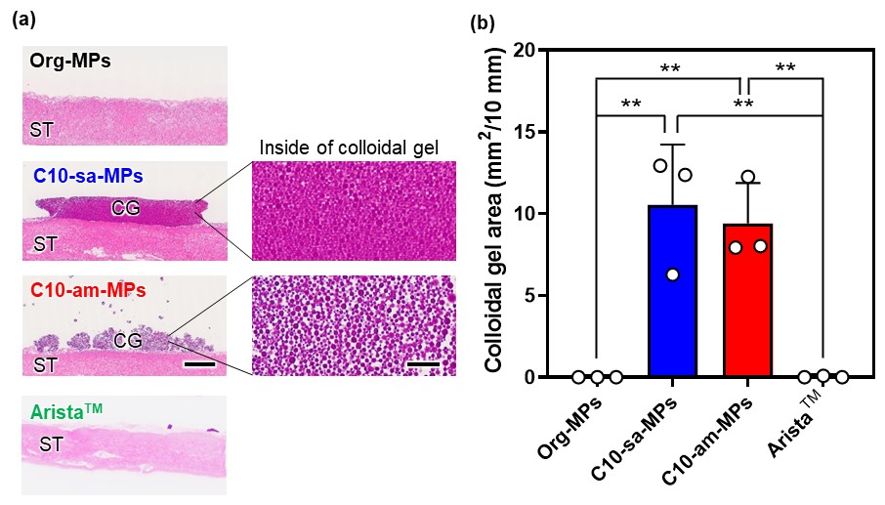
Fig. 6. Underwater adhesion stability of MPs applied to the stomach submucosal tissues after immersion in saline for 2 days. (a) Cross-sectional images of the stomach submucosal tissue, Org-, C10-sa-, and C10-am-MP colloidal gels, and Arista™ after immersion in saline for 2 days. Scale bars on the left and right represent 2 mm and 40 µm, respectively. ST and CG indicate stomach tissue and colloidal gel, respectively. (b) Remaining colloidal gel area of each particle after immersion in saline for 2 days. **p < 0.01; statistical significance was analyzed using the Tukey's multiple comparison test.

3.7. Effect of MPs on blood coagulation
To investigate the effect of the MPs on blood coagulation, MPs were mixed with calcium-activated porcine whole blood and the resulting blood coagulation behavior was observed after a 3-minute incubation at 37 °C (Fig. 7(a)). In the control, Org-MP, and C10-sa-MP groups, blood coagulation was not completed. In contrast, blood treated with C10-am-MPs and Arista™ exhibited a lack of fluidity, indicating that blood coagulation occurred within the 3-minute timeframe. To determine the blood coagulation time, we monitored the stability of the blood-MP mixture at different time points (Fig. 7(b), (c)). The untreated blood coagulated within 3.3 ± 0.6 minutes upon the addition of calcium ions in citrate acid supplemented blood. The blood coagulation time was shortened by 1 minute (to 2.3 ± 0.6 minutes) by the addition of Org-MPs. This acceleration can be attributed to the ability of the Org-MPs to absorb plasma, leading to the concentration of red blood cells (RBCs) and platelets, thus inducing the coagulation cascade [11, 13, 14, 34]. Conversely, the introduction of C10-sa-MPs delayed blood coagulation by 1 minute (to 4.3 ± 1.2 minutes). This is likely due to the extended hydration and colloidal gel formation time required by C10-sa-MPs as a result of their high hydrophobicity. Conversely, C10-am-MPs and Arista™ promoted blood coagulation (1.6 ± 0.3 and 2.0 ± 0.5 minutes, respectively), which can be attributed to their superior water-absorption properties, promoting blood concentration and subsequent fibrin formation. It has been reported that the hydrophobic groups in chitosan can interact with the lipid membrane of RBCs to promote blood coagulation [35]. Taken together, C10-am-MPs have potential for use as a hemostatic material, based on their rapid hydration characteristics that promote blood concentration and effective colloidal gel formation through inter-particle and MP-RBC interactions (Fig. 7(d)).
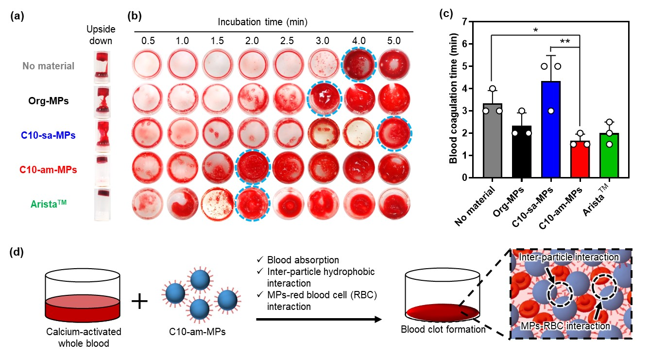
Fig. 7. The effect of MPs on blood coagulation. (a) Blood fluidity following the addition of Org-, C10-sa-, C10-am-MPs, and Arista™ to calcium-activated porcine whole blood. Each vial was inverted after incubation of the mixture. (b) Images of calcium-activated porcine whole blood mixed with samples after washing with PBS at different time points. The blue dashed circles indicate the time of blood coagulation. (c) Comparative analysis of blood coagulation time. *p < 0.05, **p < 0.01; statistical significance was analyzed using a Dunnett's multiple comparisons test. (d) Mechanism underlying the early blood clot formation induced by C10-am-MPs. C10-am-MP clot formation is attributed to rapid blood absorption and colloidal gel formation through inter-particle interactions and MP-red blood cell (RBC) interactions.

3.8. Cytocompatibility of MPs
Caco-2 cells were exposed to extracts from Org-, C10-sa-, and C10-am-MPs for 24 hours to assess cell viability (Fig. 8(a)). In all groups, cell viability exceeded 90% and there was no significant difference compared to the control group. In each group, the cells attached to the plate and extended with normal actin structures (Fig. 8(b)). These results indicate the excellent cytocompatibility of both C10-sa- and C10-am-MPs.
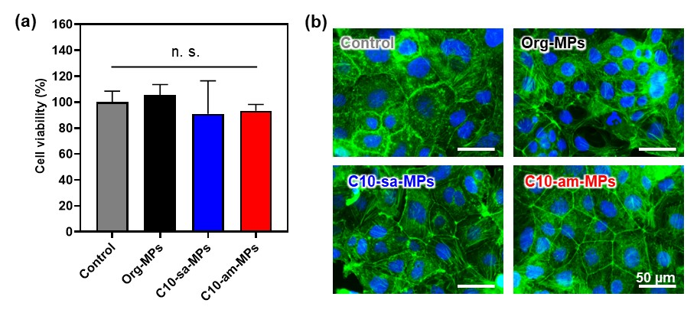
Fig. 8. Cytocompatibility of Org-, C10-sa-, and C10-sa-MPs using Caco-2 cells. (a) Cell viability of Caco-2 cells exposed to sample extracts. n. s. indicates no significant difference in the data. (b) Images of Caco-2 cells treated with medium containing sample extracts. Green represents actin filaments and blue represents the nuclei. Scale bars represent 50 µm.

3. 9. Hemostatic properties of the MPs using a rat liver hemorrhage model
Finally, we investigated the hemostatic properties of MPs using a rat liver hemorrhage model, in which a 4 mm circular defect in width was created on the liver (Fig. 9(a)). When the defect was not covered with any material, continuous blood leakage was observed (Fig. 9(a4)). However, blood leakage effectively stopped with the addition of C10-sa- or C10-am-MPs (Fig. 9(b)). Interestingly, even though both C10-sa- and C10-am-MPs effectively stopped the bleeding, their hydration behaviors differed. Specifically, C10-am-MPs on the liver transitioned from white to red within 5 minutes, forming a blood clot. In contrast, C10-sa-MPs remained white and did not exhibit efficient blood absorption. This suggests that C10-am-MPs have superior blood absorbing properties at a hemorrhage site compared to C10-sa-MPs. We further assessed blood loss from the liver among the control, C10-sa-, C10-am-MPs, and Arista™ groups (Fig. 9(c)). The blood loss in the control, C10-sa-, C10-am-MPs, and Arista™ groups was 1.16 ± 0.44, 0.61 ± 0.48, 0.59 ± 0.29, and 0.66 ± 0.36 g, respectively. These findings indicate that the use of MPs effectively prevented blood loss. In particular, C10-am-MPs exhibited superior hemostatic properties compared to the control group and effectively prevented bleeding, similar to the commercially available Arista™. This efficacy can be attributed to the presence of C10 groups in C10-am-MPs, linked via amide bonds to ApGltn, which facilitate hydration upon contact with blood. Therefore, C10-am-MPs were able to absorb plasma within 5 minutes, concentrating RBCs and platelets, thereby inducing blood coagulation. It is interesting to note that C10-sa-MPs also decreased blood loss, comparable to that of C10-am-MPs, despite a lower hydration speed. Histological analysis revealed the presence of spaces between the C10-sa-MP colloidal gel layer and liver tissue (Fig. 9(d)), suggesting a potential risk of re-bleeding with C10-sa-MPs. In contrast, C10-am-MPs absorbed plasma and water upon contact with blood to form a complete colloidal gel layer that covered the entire defect area. These findings lead us to hypothesize that the mechanisms underlying the hemostatic properties of C10-sa- and C10-am-MPs were different (Fig. 9(e)). C10-sa-MPs have greater adhesion characteristics compared to C10-am-MPs (Fig. 5(c)); therefore, C10-sa-MPs could adhere to the liver tissue, acting as a sealant to effectively stop bleeding. Conversely, C10-am-MPs absorbed blood and formed a colloidal gel through hydrophobic interactions between C10-am-MPs and MP-RBCs when applied to the hemorrhage site. C10-am-MPs could also adhere to the liver tissue through hydrophobic interactions to stop bleeding. Previously, we reported in vivo biodegradation of C10-sa-MPs in rat and mouse back, where C10-sa-MPs colloidal gel degraded within 2 weeks without severe inflammation [18] and there were no pathological findings in other organs such as the heart, lung, liver, kidney and spleen [36]. Even though C10-am-MPs contain a higher number of amide bonds than C10-sa-MPs for the linkage of C10 groups, products after hydrolysis of amide bonds such as carboxyl groups and amine groups are safe for the body. Therefore, we expect that the in vivo biodegradation and systemic impact of C10-am-MPs colloidal gel are the same as C10-sa-MPs colloidal gel.
In this study, we demonstrated that C10-am-MPs exhibit superior hydration and hemostatic properties compared to C10-sa-MPs, achieved through changing linkage of C10 groups from secondary amines to amide bonds. Previous reports have highlighted the sprayable nature [21, 37] of hydrophobically modified ApGltn microparticles. This feature is crucial in the context of hemostatic materials, particularly in endoscopic surgery. Therefore, future work will explore the capacity of C10-am-MPs to be delivered via endoscopic spray to the bleeding site in gastrointestinal tissue to function as a hemostatic material, followed by their gradual degradation during the wound-healing process.
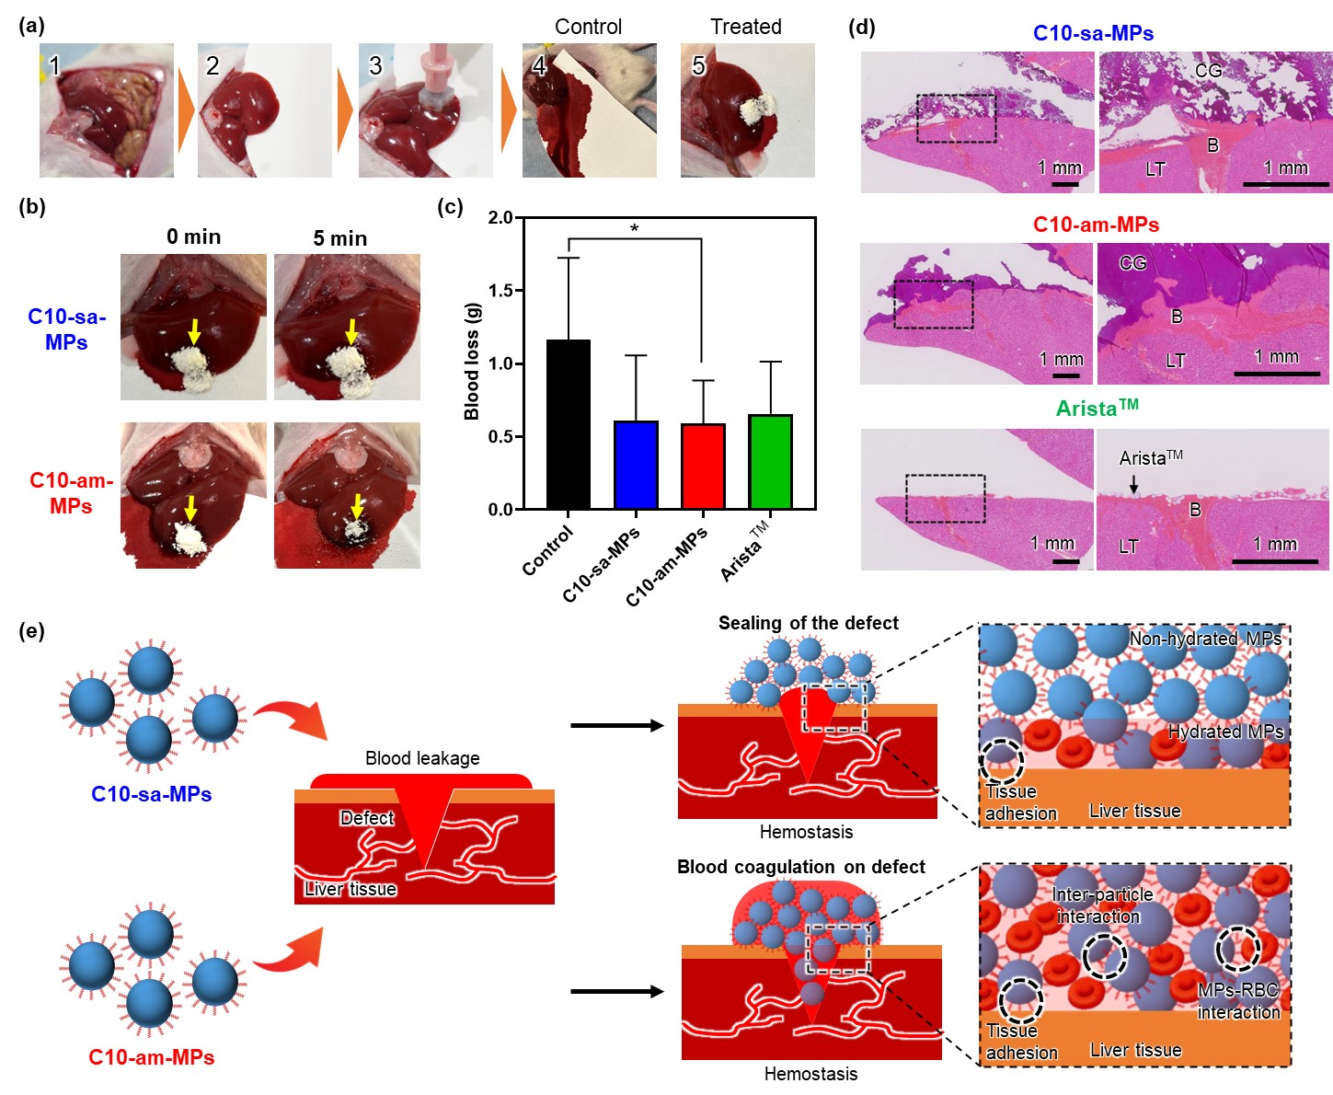
Fig. 9. Hemostatic efficacy of C10-sa-, C10-am-MPs, and Arista™ using a rat liver hemorrhage model. (a) Experimental procedure for the rat liver hemorrhage model. A circular defect was created on the liver, then C10-sa-MPs, C10-am-MPs, and Arista™ were applied to the defect. (b) Images of the liver hemorrhage model treated with C10-sa-MPs and C10-am-MPs immediately following application and after 5 minutes. (c) Blood loss during the 5-minute treatment. *p < 0.05; statistical significance analyzed using the Tukey's multiple comparison test. (d) Cross-sectional images of C10-sa-MPs, C10-am-MPs, and Arista™ after the 5-minute treatment. In each group, the left and right images represent the entire liver injury and a magnified view of the interface between the colloidal gel and tissue, respectively. Scale bars represent 1 mm. (e) Mechanisms underlying the hemostatic properties of C10-sa-MPs and C10-am-MPs.

- Conclusion
In this study, we prepared decyl and decanoyl group-modified ApGltn microparticles (C10-sa-MPs and C10-am-MPs, respectively), with the aim of developing an improved hemostatic material with enhanced hydration characteristics, tissue adhesion properties, underwater adhesion stability, and coagulation efficacy. C10-am-MPs exhibited superior hydration and promoted blood coagulation, attributed to the amide linkage of C10 groups, which induced rapid hydration. C10-am-MPs demonstrated robust tissue adhesion strength and underwater adhesion stability when applied to the stomach submucosal tissue. In the rat liver hemorrhage model, C10-am-MPs exhibited hemostatic properties comparable to those of commercially available hemostatic particles. Taken together, these results highlighted the promising potential of C10-am-MPs as a tissue-adhesive hemostatic material.

Data availability
The authors declare that all data supporting the findings of this study are available within the paper and the associated Supporting Information.

Conflicts of interest
The authors have no competing interests to declare.

Acknowledgments
This work was financially supported in part by the JSPS KAKENHI Grant-in-Aid for JSPS Fellows (grant no. 22J20039), the JSPS KAKENHI (grant nos. 23H01718, 22H03962, and 22K19947), and the Uehara Memorial Foundation.

Appendix A. Supplementary data
Supplementary data related to this article can be found at

Reference
[1] T. Gotoda, Endoscopic resection of early gastric cancer, Gastric Cancer 10(1) (2007) 1-11.
[2] Y. Tamegai, Y. Saito, N. Masaki, C. Hinohara, T. Oshima, E. Kogure, Y. Liu, N. Uemura, K. Saito, Endoscopic submucosal dissection: a safe technique for colorectal tumors, Endoscopy 39(05) (2007) 418-422.
[3] S. Oka, S. Tanaka, I. Kaneko, R. Mouri, M. Hirata, T. Kawamura, M. Yoshihara, K. Chayama, Advantage of Endoscopic Submucosal Dissection Compared with EMR for Early Gastric Cancer, Gastrointest. Endosc. 64(6) (2006) 877-883.
[4] K. Takizawa, I. Oda, T. Gotoda, C. Yokoi, T. Matsuda, Y. Saito, D. Saito, H. Ono, Routine coagulation of visible vessels may prevent delayed bleeding after endoscopic submucosal dissection - An analysis of risk factors, Endoscopy 40(03) (2008) 179-183.
[5] H.S. Choi, H.J. Chun, Accessory Devices Frequently Used for Endoscopic Submucosal Dissection, Clin Endosc 50(3) (2017) 224-233.
[6] H. Isomoto, N. Yamaguchi, H. Minami, K. Nakao, Management of complications associated with endoscopic submucosal dissection/ endoscopic mucosal resection for esophageal cancer, Digestive Endoscopy 25(S1) (2013) 29-38.
[7] Y. Guo, M. Wang, Q. Liu, G. Liu, S. Wang, J. Li, Recent advances in the medical applications of hemostatic materials, Theranostics 13(1) (2023) 161-196.
[8] Y.-I. Chen, J. Wyse, Y. Lu, M. Martel, A.N. Barkun, TC-325 hemostatic powder versus current standard of care in managing malignant GI bleeding: a pilot randomized clinical trial, Gastrointestinal Endoscopy 91(2) (2020) 321-328.e1.
[9] A. Haseeb, M.L. Freeman, S.K. Amateau, Alternative approach to hemostatic particle spraying for treatment of GI bleeding by the use of cross-platform devices, VideoGIE 4(8) (2019) 386-388.
[10] S.-j. Tang, P. Hosseini-Carroll, T.S. Vesa, Hemospray hemostasis in bleeding diffusely ulcerated esophagus, VideoGIE 4(3) (2019) 142-144.
[11] K. Zhang, Y. Xian, M. Li, Z. Pan, Z. Zhu, Y. Yang, H. Wang, L. Zhang, C. Zhang, D. Wu, Gelable and Adhesive Powder for Lethal Non‐Compressible Hemorrhage Control, Advanced Functional Materials (2023).
[12] X. Peng, X. Xia, X. Xu, X. Yang, B. Yang, P. Zhao, W. Yuan, P.W.Y. Chiu, L. Bian, Ultrafast self-gelling powder mediates robust wet adhesion to promote healing of gastrointestinal perforations, Science Advances 7(23) (2021) eabe8739.
[13] X. Peng, X. Xu, Y. Deng, X. Xie, L. Xu, X. Xu, W. Yuan, B. Yang, X. Yang, X. Xia, L. Duan, L. Bian, Ultrafast Self-Gelling and Wet Adhesive Powder for Acute Hemostasis and Wound Healing, Advanced Functional Materials 31(33) (2021) 2102583.
[14] Y. Fang, L. Zhang, Y. Chen, S. Wu, Y. Weng, H. Liu, Polysaccharides based rapid self-crosslinking and wet tissue adhesive hemostatic powders for effective hemostasis, Carbohydrate Polymers 312 (2023) 120819.
[15] Y. Huang, C. Fan, Y. Liu, L. Yang, W. Hu, S. Liu, T. Wang, Z. Shu, B. Li, M. Xing, S. Yang, Nature-Derived Okra Gel as Strong Hemostatic Bioadhesive in Human Blood, Liver, and Heart Trauma of Rabbits and Dogs, Adv Healthc Mater (2022) e2200939.
[16] T. Deng, D. Gao, X. Song, Z. Zhou, L. Zhou, M. Tao, Z. Jiang, L. Yang, L. Luo, A. Zhou, L. Hu, H. Qin, M. Wu, A natural biological adhesive from snail mucus for wound repair, Nature commun. 14(1) (2023) 396.
[17] Y. Ouyang, X. Su, X. Zheng, L. Zhang, Z. Chen, Q. Yan, Q. Qian, J. Zhao, P. Li, S. Wang, Mussel-inspired “all-in-one” sodium alginate/carboxymethyl chitosan hydrogel patch promotes healing of infected wound, International Journal of Biological Macromolecules 261 (2024) 129828.
[18] A. Nishiguchi, Y. Kurihara, T. Taguchi, Underwater-Adhesive Microparticle Dressing Composed of Hydrophobically-Modified Alaska Pollock Gelatin for Gastrointestinal Tract Wound Healing, Acta Biomater. 99 (2019) 387–396.
[19] S. Ito, A. Nishiguchi, F. Sasaki, H. Maeda, M. Kabayama, A. Ido, T. Taguchi, Robust Closure of Post-Endoscopic Submucosal Dissection Perforation by Microparticle-Based Wound Dressing, Mater. Sci. Eng. C 123 (2021) 111993.
[20] S. Ito, A. Nishiguchi, H. Ichimaru, K. Nagasaka, H. Hirade, T. Taguchi, Prevention of postoperative adhesion with a colloidal gel based on decyl group-modified Alaska pollock gelatin microparticles, Acta Biomater. 149 (2022) 139-149.
[21] S. Ito, A. Nishiguchi, T. Taguchi, Effect of particle size on the tissue adhesion and particle floatation of a colloidal wound dressing for endoscopic treatments, Acta Biomater. (2023).
[22] S. Neyertz, D. Brown, M. Pilz, N. Rival, B. Arstad, F. Männle, C. Simon, The Stability of Amino-Functionalized Polyhedral Oligomeric Silsesquioxanes in Water, The Journal of Physical Chemistry B 119(21) (2015) 6433-6447.
[23] Y. Mizuno, R. Mizuta, M. Hashizume, T. Taguchi, Enhanced Sealing Strength of a Hydrophobically-Modified Alaska Pollock Gelatin-Based Sealant, Biomater. Sci. 5(5) (2017) 982–989.
[24] S. Ito, A. Nishiguchi, T. Taguchi, Effect of particle size on the tissue adhesion and particle floatation of a colloidal wound dressing for endoscopic treatments, Acta Biomater. 159 (2023) 83-94.
[25] Y. Mizuno, T. Taguchi, Self-assembled Dodecyl Group-Modified Gelatin Microparticle-Based Hydrogels with Angiogenic Properties, NPG Asia Mater. 12(1) (2020) 48.
[26] A. Nishiguchi, Y. Kurihara, T. Taguchi, Hemostatic, Tissue-Adhesive Colloidal Wound Dressing Functionalized by UV Irradiation, ACS Appl. Bio Mater. 3(3) (2020) 1705-1711.
[27] S. Liu, Z. Zheng, S. Wang, S. Chen, J. Ma, G. Liu, B. Wang, J. Li, Polydopamine-coated chitosan/calcium pyrophosphate hybrid microflowers as an effective hemostatic agent, Carbohydrate Polymers 224 (2019) 115175.
[28] C. Kong, S. Chen, X. Wang, C. Hu, B. Li, R. Fu, J. Zhang, Hemoadhican, a Tissue Adhesion Hemostatic Material Independent of Blood Coagulation, Advanced Healthcare Materials 12(24) (2023).
[29] G.M. Seon, M.H. Lee, B.-J. Kwon, M.S. Kim, M.-A. Koo, D. Kim, Y. Seomun, J.-T. Kim, J.-C. Park, Functional improvement of hemostatic dressing by addition of recombinant batroxobin, Acta Biomater. 48 (2017) 175-185.
[30] Y. Murakami, M. Yokoyama, H. Nishida, Y. Tomizawa, H. Kurosawa, In vivo and in vitro evaluation of gelation and hemostatic properties of a novel tissue-adhesive hydrogel containing a cross-linkable polymeric micelle, Journal of Biomedical Materials Research Part B: Applied Biomaterials 91B(1) (2009) 102-108.
[31] T. Fischer, J. Köhler, M. Möller, S. Singh, Physical gels of poly(vinylamine) by thermal curing, RSC Advances 10(37) (2020) 21933-21939.
[32] T. Venerová, M. Pekař, Rheological properties of gels formed by physical interactions between hyaluronan and cationic surfactants, Carbohydrate Polymers 170 (2017) 176-181.
[33] R. Mizuta, T. Taguchi, Enhanced Sealing by Hydrophobic Modification of Alaska Pollock-Derived Gelatin-Based Surgical Sealants for the Treatment of Pulmonary Air Leaks, Macromol. Biosci. 17(4) (2017) 1600349.
[34] Q. Li, F. Lu, S. Shang, H. Ye, K. Yu, B. Lu, Y. Xiao, F. Dai, G. Lan, Biodegradable Microporous Starch with Assembled Thrombin for Rapid Induction of Hemostasis, ACS Sustainable Chemistry & Engineering 7(10) (2019) 9121-9132.
[35] M.B. Dowling, R. Kumar, M.A. Keibler, J.R. Hess, G.V. Bochicchio, S.R. Raghavan, A self-assembling hydrophobically modified chitosan capable of reversible hemostatic action, Biomater. 32(13) (2011) 3351-3357.
[36] S. Ito, K. Nagasaka, H. Komatsu, H. Mamiya, M. Takeguchi, A. Nishiguchi, T. Taguchi, Sprayable tissue adhesive microparticle–magnetic nanoparticle composites for local cancer hyperthermia, Biomaterials Advances 156 (2024) 213707.
[37] A. Nishiguchi, F. Sasaki, H. Maeda, M. Kabayama, A. Ido, T. Taguchi, Multifunctional Hydrophobized Microparticles for Accelerated Wound Healing after Endoscopic Submucosal Dissection, Small 15(35) (2019) 1901566.

