Supporting Information
Process Optimization on Kesterite-based Ceramics for Enhancing their Thermoelectric Performances Assisted by Active Machine Learning Approach: A tool for metal-sulfide ceramics development
Cédric Bourgès^{1*}, Guillaume Lambard^{2*}, Naoki Sato³, Makoto Tachibana³, Satoshi Ishii^{3,4}, and Takao Mori^{3,4}
¹ International Center for Young Scientists (ICYS), National Institute for Materials Science (NIMS), 1-1 Namiki, Tsukuba, 305-0044, Japan
²Center for Basic Research on Materials (CBRM), National Institute for Materials Science (NIMS), 305-0044, Namiki 1-1, Tsukuba, Ibaraki, Japan
³Research Center for Materials Nanoarchitectonics (MANA), National Institute for Materials Science (NIMS), 1-1 Namiki, Tsukuba, Ibaraki, 305–0044 Japan
⁴Graduate School of Pure and Applied Sciences, University of Tsukuba, 1-1-1 Tennoudai, Tsukuba 305-8577, Japan

Corresponding Author: BOURGES.Cedric@nims.go.jp, LAMBARD.Guillaume@nims.go.jp
Keywords: Kesterite, Machine Learning, Process, Thermoelectric, Ceramic
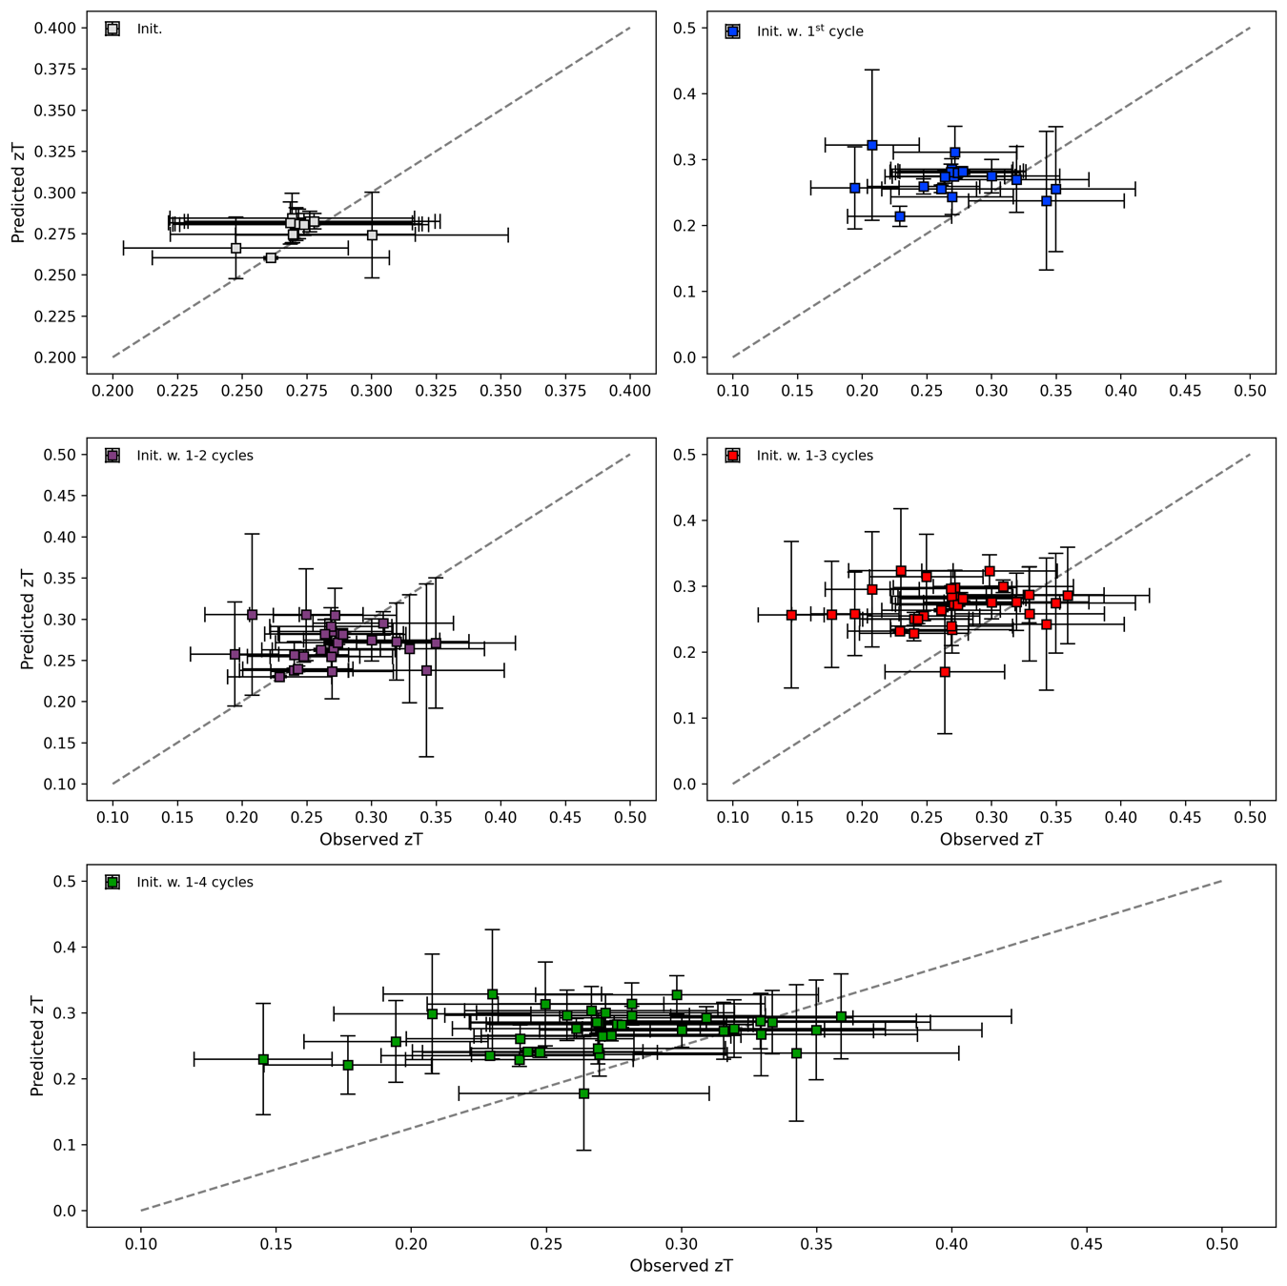
Figure S1. Comparison between predicted (Random Forests regression¹) and observed average figure-of-merit zT based the pre-ALMLBO initial data (grey squares), and the initial data extended with data from the 1st, 2nd, 3rd, and 4th ALMLBO cycles (blue, purple, red, and green squares, respectively) with vertical and horizontal error bars representing a standard deviation related to a leave-one-out² cross-validation, and computed from m=1-2 experimental measurements and the systematic uncertainty of ~17.5% ³, respectively (the dashed lines show a perfect prediction for the purpose of visual guidance only).
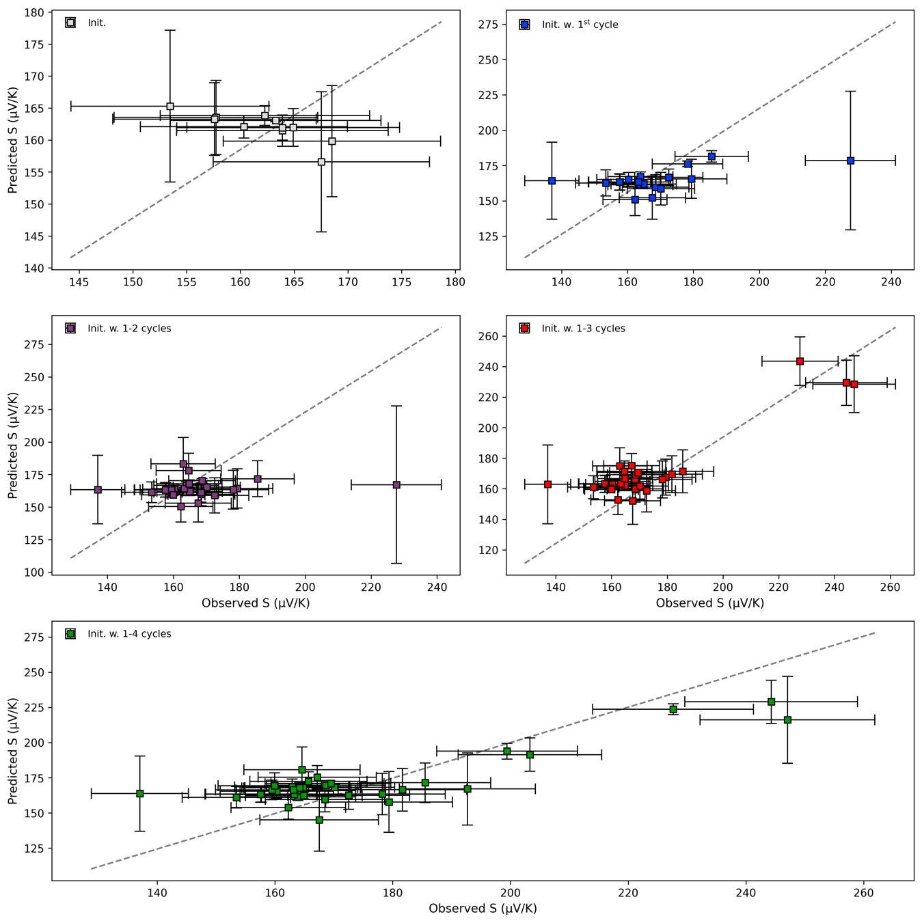
Figure S2. Comparison between predicted (Random Forests regression¹) and observed average Seebeck coefficient (𝜇V/K) based the pre-ALMLBO initial data (grey squares), and the initial data extended with data from the 1st, 2nd, 3rd, and 4th ALMLBO cycles (blue, purple, red, and green squares, respectively) with vertical and horizontal error bars representing a standard deviation related to a leave-one-out² cross-validation, and computed from m=1-2 experimental measurements and the systematic uncertainty of ~6% ³, respectively (the dashed lines show a perfect prediction for the purpose of visual guidance only).
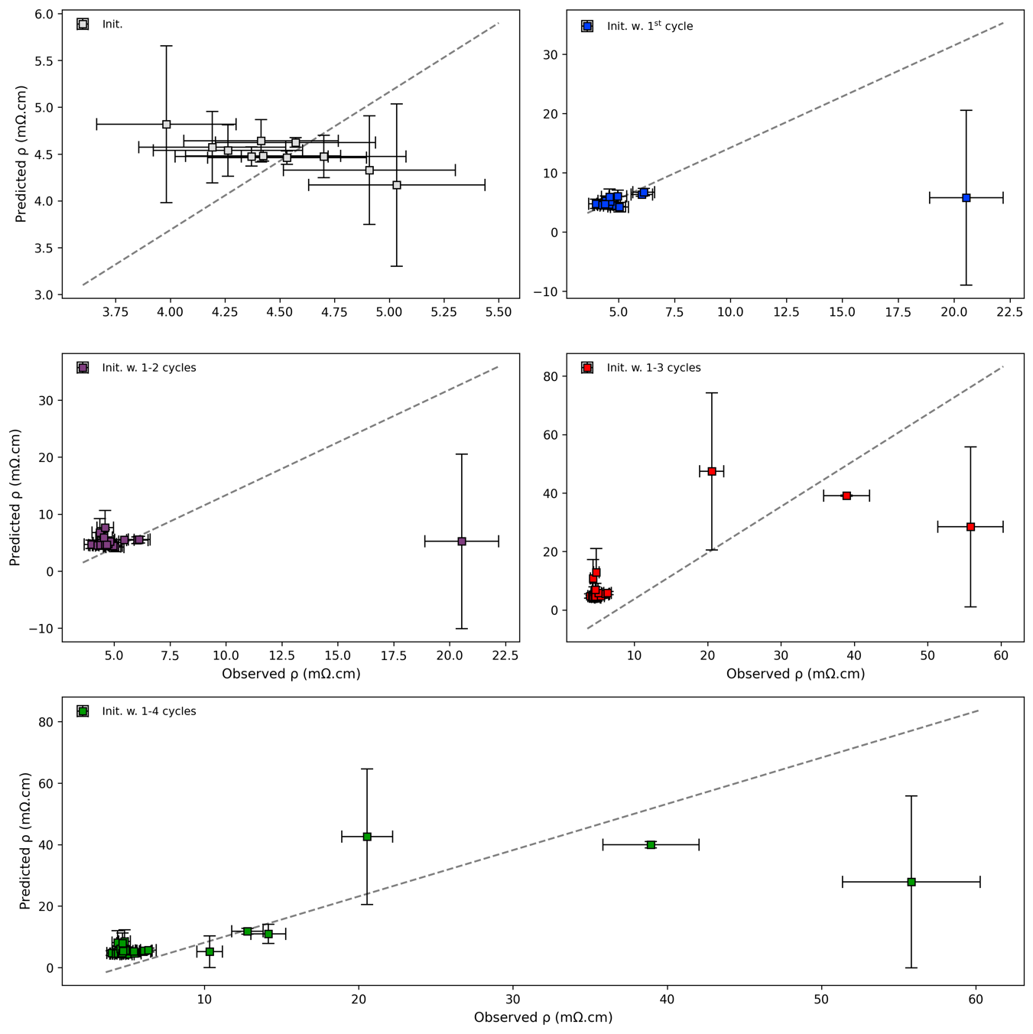
Figure S3. Comparison between predicted (Random Forests regression¹) and observed average resistivity 𝜌 (m𝛺.cm) based the pre-ALMLBO initial data (grey squares), and the initial data extended with data from the 1st, 2nd, 3rd, and 4th ALMLBO cycles (blue, purple, red, and green squares, respectively) with vertical and horizontal error bars representing a standard deviation related to a leave-one-out² cross-validation, and computed from m=1-2 experimental measurements and the systematic uncertainty of ~8% ³, respectively (the dashed lines show a perfect prediction for the purpose of visual guidance only).
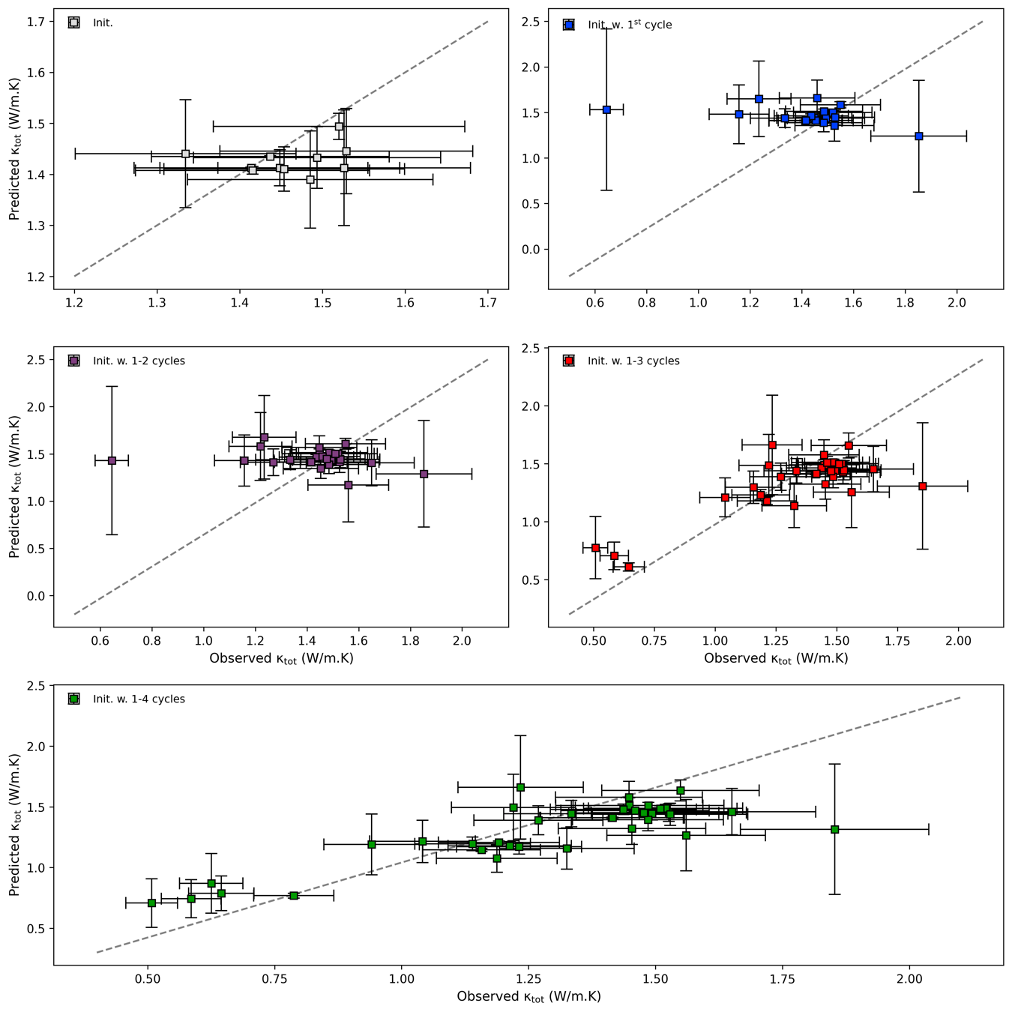
Figure S4. Comparison between predicted (Random Forests regression¹) and observed average thermal conductivity 𝜅_{tot} (W/m.K) based the pre-ALMLBO initial data (grey squares), and the initial data extended with data from the 1st, 2nd, 3rd, and 4th ALMLBO cycles (blue, purple, red, and green squares, respectively) with vertical and horizontal error bars representing a standard deviation related to a leave-one-out² cross-validation, and computed from m=1-2 experimental measurements and the systematic uncertainty of ~10% ³, respectively (the dashed lines show a perfect prediction for the purpose of visual guidance only).
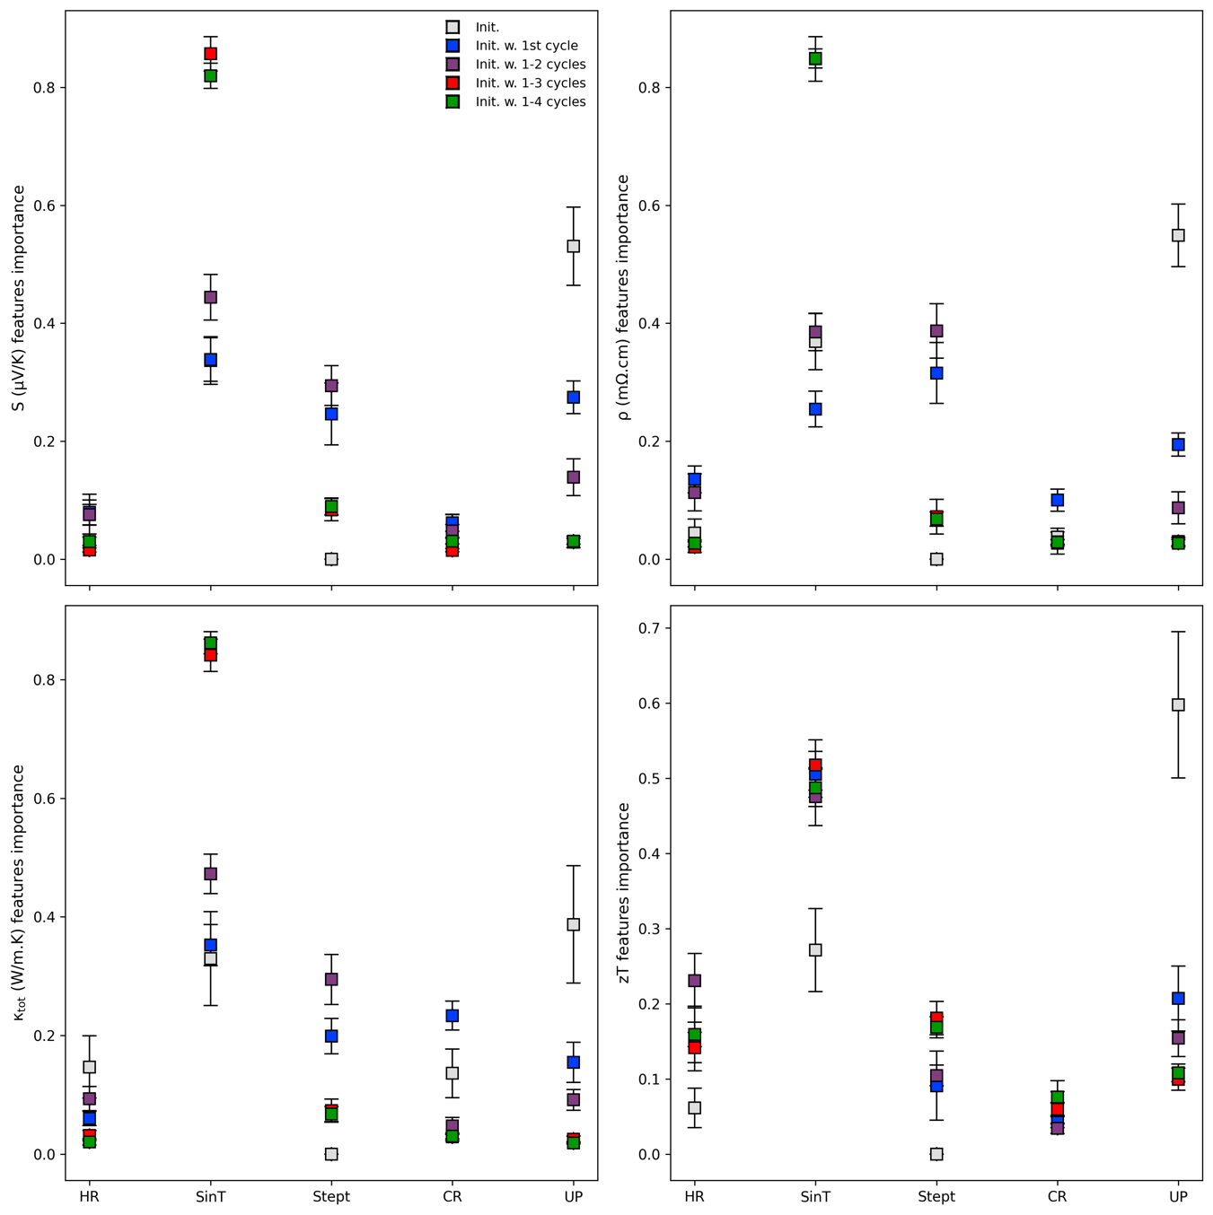
Figure S5. Distribution of average features importance ¹ for the SPS process parameters 𝜃 regarding the prediction of the Seebeck coefficient, S (𝜇V/K), resistivity, 𝜌 (m𝛺.cm), thermal conductivity, 𝜅_{tot} (W/m.K), and figure-of-merit, zT, based on the pre-ALMLBO initial data (grey squares) extended with data from the 1st, 2nd, 3rd, and 4th ALMLBO cycles (blue, purple, red, and green squares, respectively). Mean values and error bars are provided according to the leave-one-out ² cross-validation used for Random Forests ² models training. HR and CR are the heating and cooling rates (K/min), respectively; SinT and Stept are the sintering temperature (K) and step time (min), respectively; UP is the uniaxial pressure (MPa).

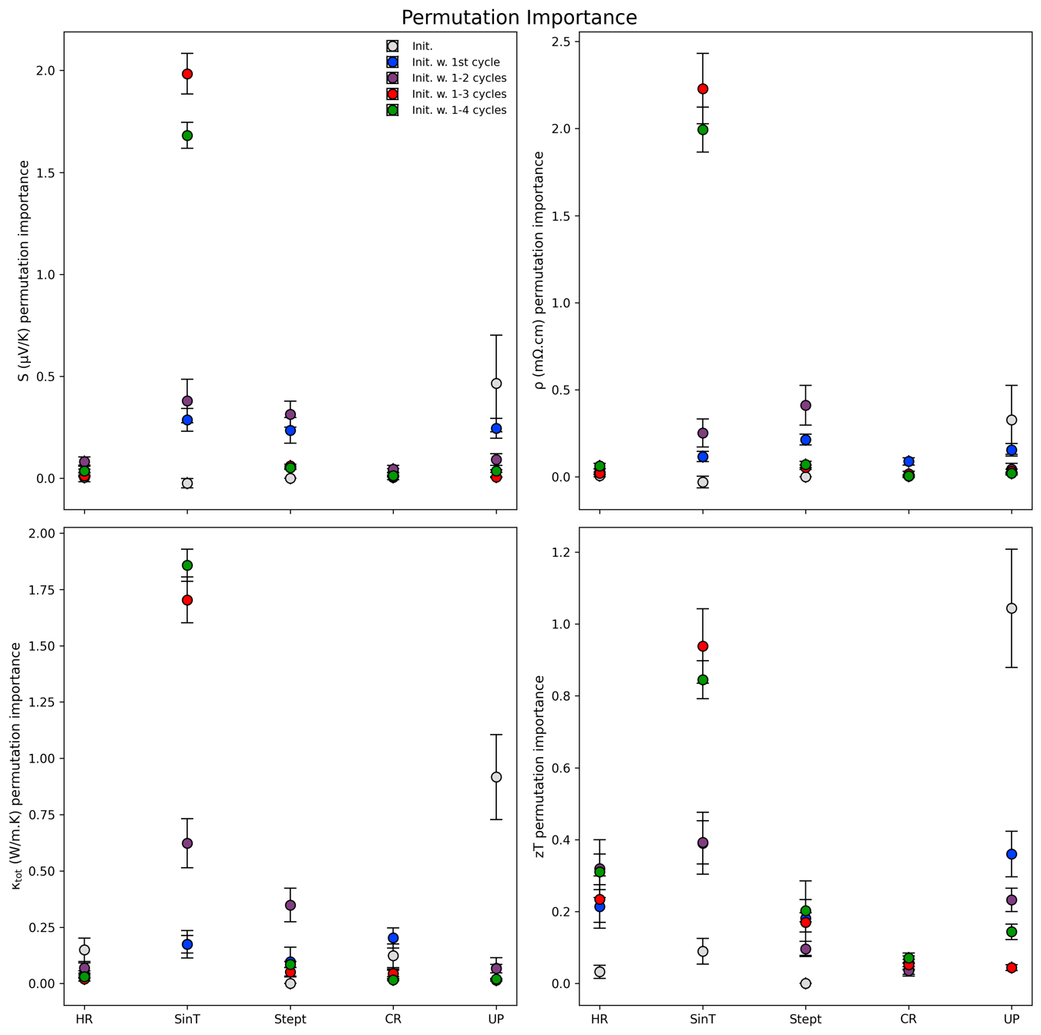
Figure S5-bis. Distribution of average features permutation importance ¹ for the SPS process parameters 𝜃 regarding the prediction of the Seebeck coefficient, S (𝜇V/K), resistivity, 𝜌 (m𝛺.cm), thermal conductivity, 𝜅_{tot} (W/m.K), and figure-of-merit, zT, based on the pre-ALMLBO initial data (grey squares) extended with data from the 1st, 2nd, 3rd, and 4th ALMLBO cycles (blue, purple, red, and green squares, respectively). Mean values and error bars are provided according to the leave-one-out ² cross-validation used for Random Forests ² models training. HR and CR are the heating and cooling rates (K/min), respectively; SinT and Stept are the sintering temperature (K) and step time (min), respectively; UP is the uniaxial pressure (MPa).
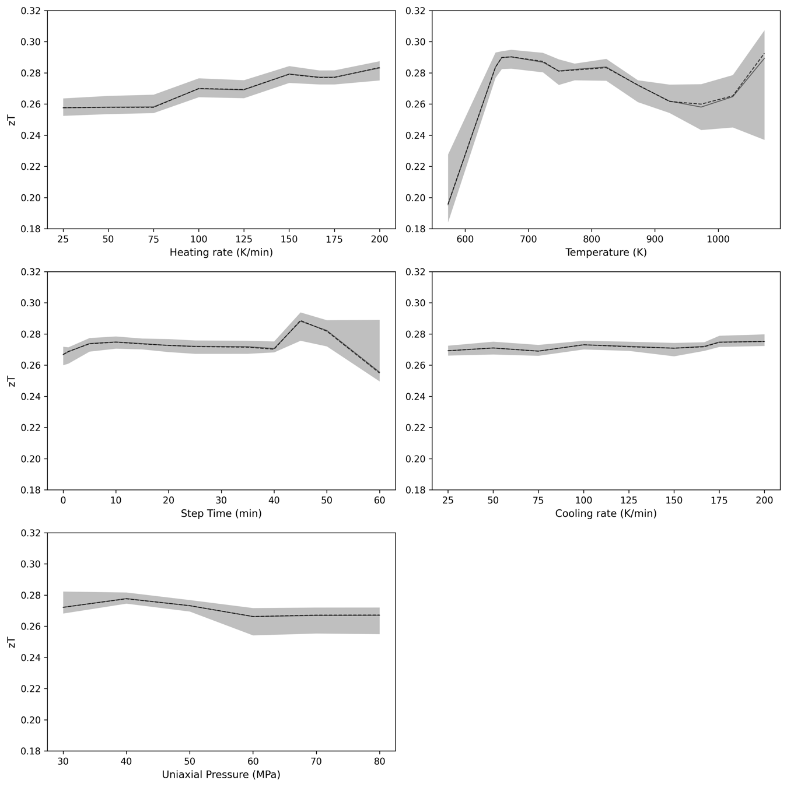
Figure S6. Partial dependence ⁴ of the figure-of-merit, zT, on the heating rate (K/min), sintering temperature (K), step time (min), cooling rate (K/min), and uniaxial pressure (MPa) (from top to bottom, left to right) evaluated from the whole dataset, i.e., from the initial data to the 4th ALMLBO cycle included.
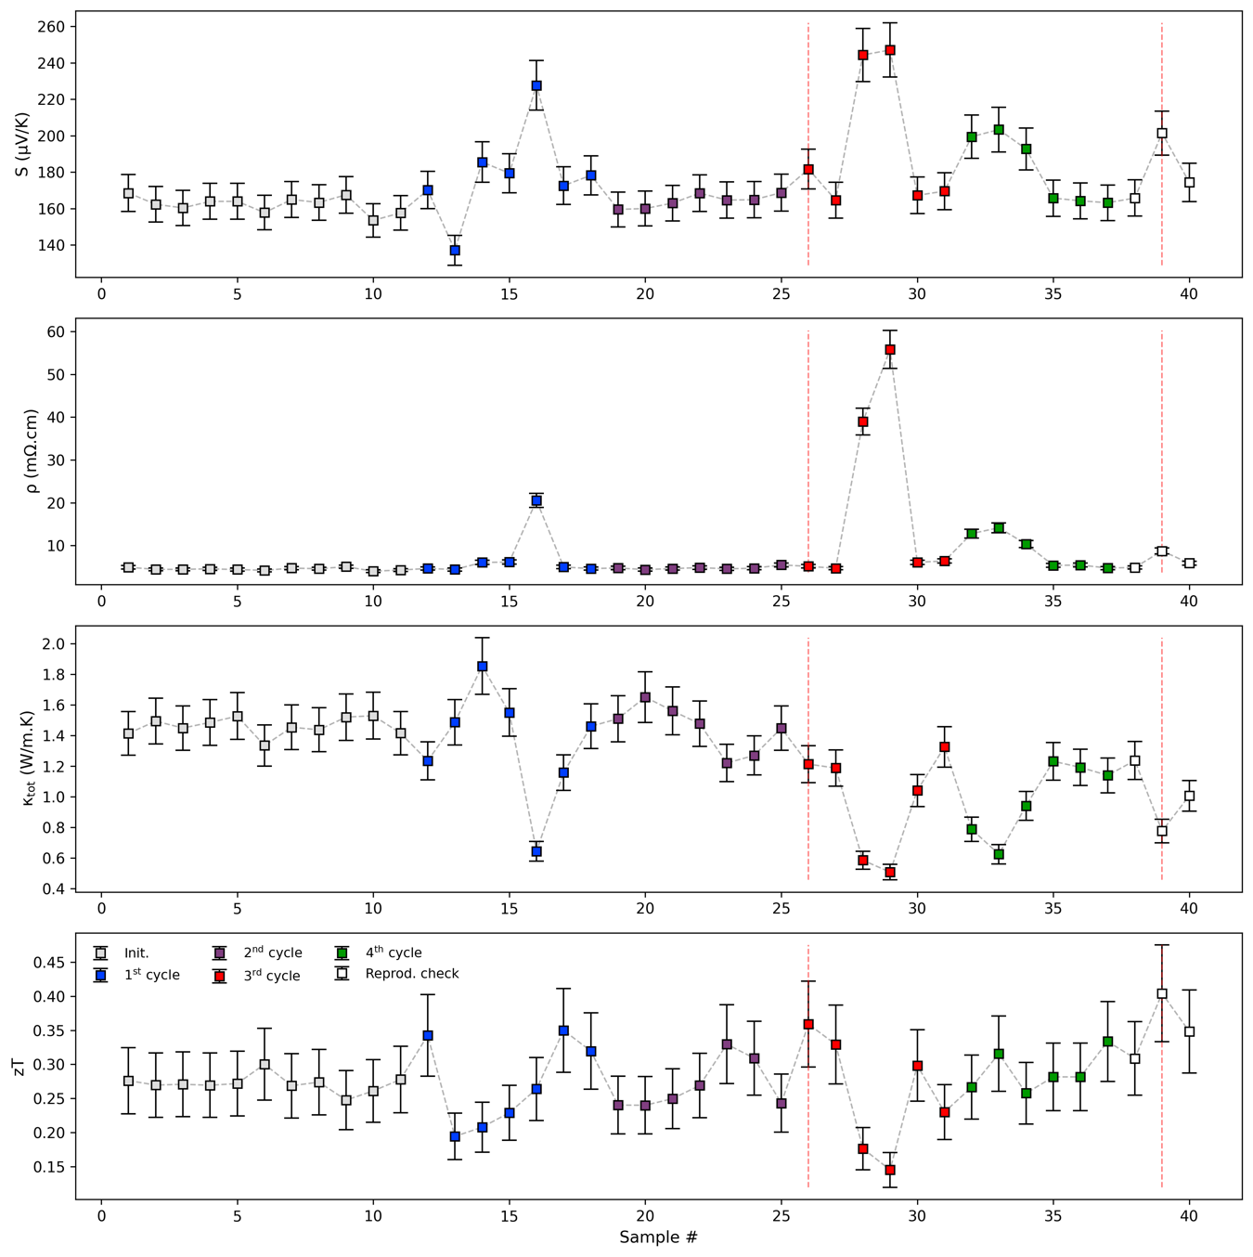
Figure S7. Evolution of the measured Seebeck coefficient, S (𝜇V/K), resistivity, 𝜌 (m𝛺.cm), thermal conductivity, 𝜅_{tot} (W/m.K), and figure-of-merit, zT, values of the kesterite Cu_{2.125}Zn_{0.875}SnS₄ along the ALMLBO pipeline development. The initial (pre-ALMLBO), 1st, 2nd, 3rd, and 4th cycle data are depicted by grey, blue, purple, red, and green squares, respectively. The three white squares denote a reproducibility study performed with high-purity chemicals a posteriori of the ALMLBO pipeline. Two dashed red lines illustrate the samples with the highest reported zT values in this study, i.e., zT = 0.36, 0.40. Error bars denote the joint statistical and systematic uncertainties on the at ~6, 8, 10, 17.5% ³ for S, 𝜌, 𝜅_{tot}, and zT, respectively.
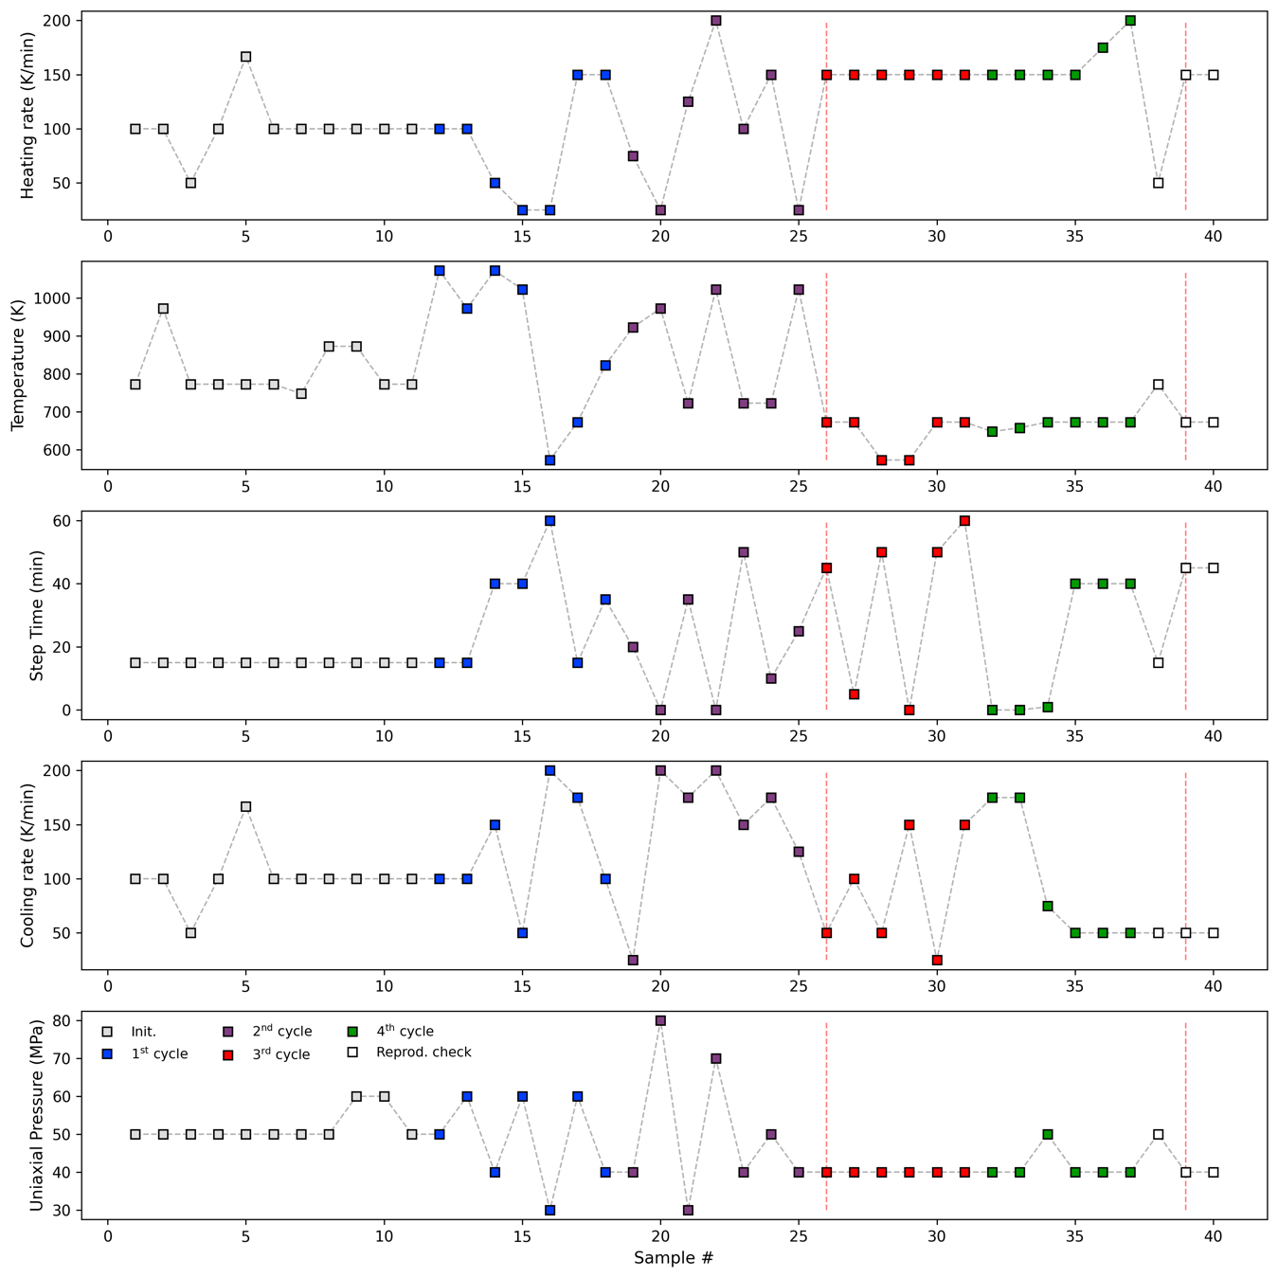
Figure S8. Evolution of the SPS process parameters 𝚹, heating rate (K/min), sintering temperature (K), step time (min), cooling rate (K/min), and uniaxial pressure (MPa) (from top to bottom) along the ALMLBO pipeline development. The initial (pre-ALMLBO), 1st, 2nd, 3rd, and 4th cycle data are depicted by grey, blue, purple, red, and green squares, respectively. The three white squares denote a reproducibility study performed with new ball milling jar, SPS device and high-purity chemicals a posteriori of the ALMLBO pipeline. Two dashed red lines illustrate the samples with the highest reported zT values in this study, i.e., zT = 0.36, 0.40.

Figure S9. Comparison of the simulated X-ray diffraction (XRD) patterns of the kesterite ordered structure ($I\overline{4}$) and disordered structure ($I\overline{4}2m)$ with corresponding structural representation

Figure S10. a) X-ray powder diffraction (XRPD) pattern b) and c) d) Scanning electron microscopy (SEM) images of the CZTS after mechanical alloying by SPEX ball milling
Figure S11. Scanning electron microscopy (SEM) images of a) sample sintered below T < 773 K and b) T > 773 K of the CZTS-SPSed samples. HR: Heating rate, SinT: Sintering temperature, Stept: Step time, CR: Cooling rate, UP: Uniaxial pressure

Figure S12. Scanning electron microscopy images with energy dispersive spectroscopy (SEM-EDS) mapping analysis of a) Reference b) MLProcess and c) DProcess of the kesterite sample after SPS
Figure S13. Cycling measurement (RT-725K) dependance in temperature of the Seebeck coefficient S, and electrical resistivity ρ of the MLP+HPC CZTS SPSed samples
Figure S14. a) Lattice (κ_{latt}) and electrical (κ_{lelec}) contribution of the temperature dependent thermal conductivity of the CZTS SPSed samples and b) Heat capacity measurement Cp of the CZTS-Cu_{2.125}Zn_{0.825}SnS₄ samples
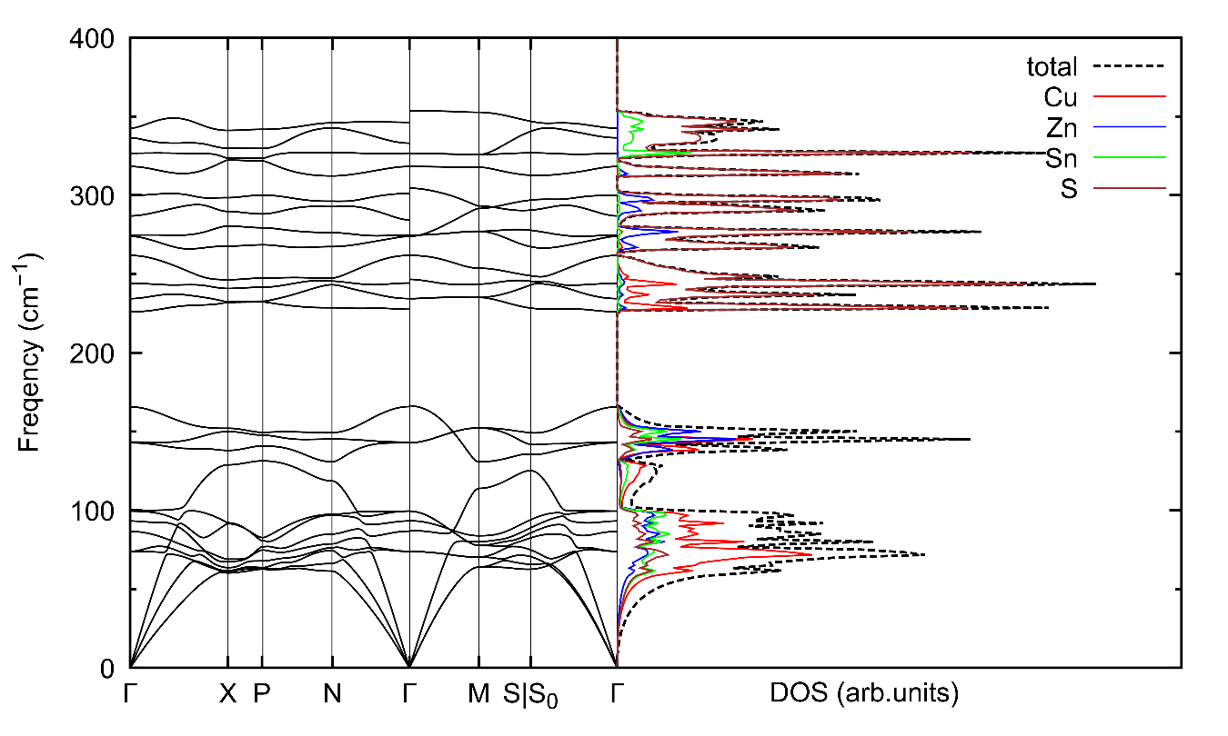
Figure S15. Phonon dispersions and atom-projected vibrational density of states (DOS) of CZTS proto structure Cu₂ZnSnS₄.

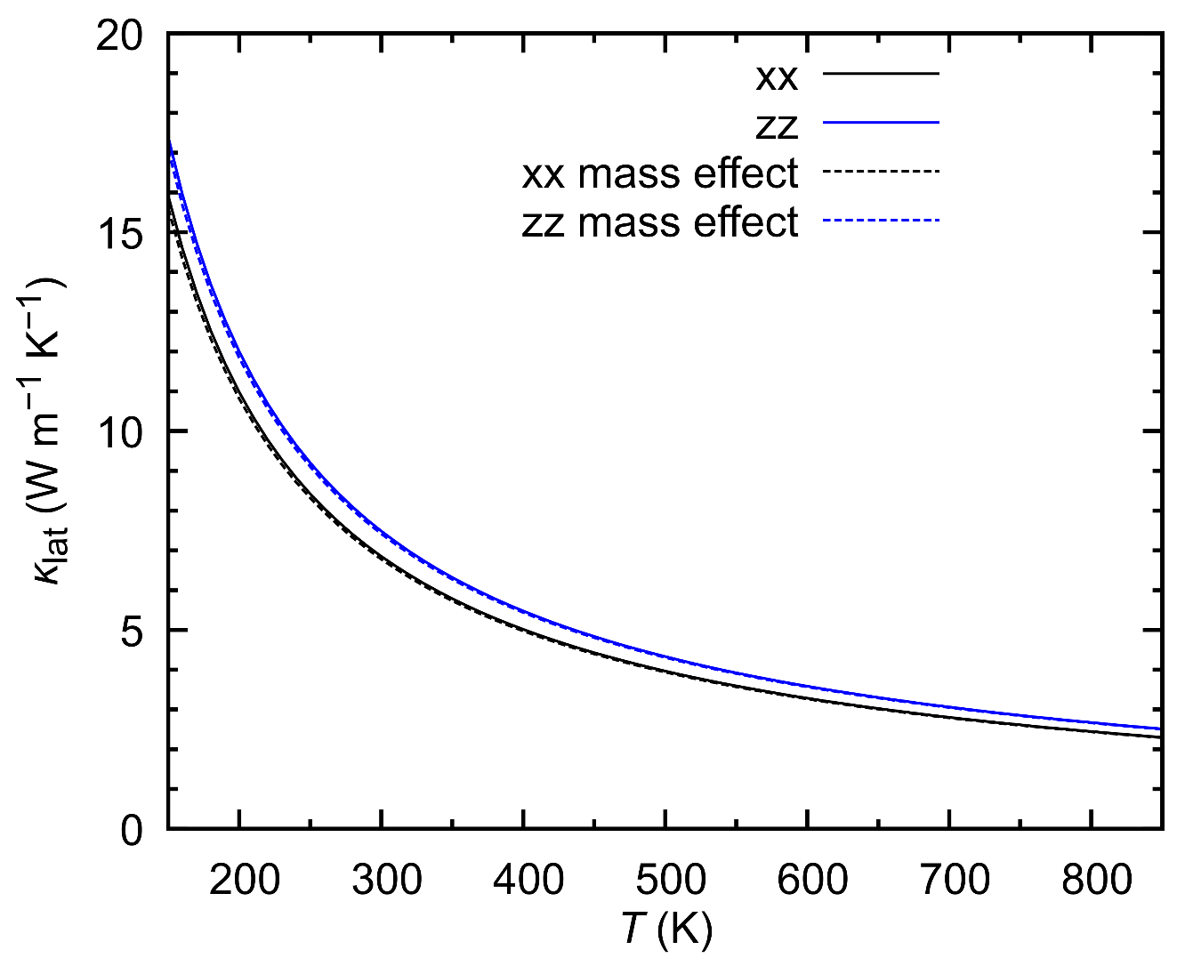
Figure S16. Calculated lattice thermal conductivity of single crystal ordered Cu₂ZnSnS₄ (solid lines) together with the one with mass difference effect by Tamura’s model ⁵ considering Cu-Zn disordering (dashed lines).

Table S1. Calculated lattice parameters of Cu₂ZnSnS₄ using various functionals together with experimental one.
Method (functional) | Lattice parameters
Method (functional) | a (Å) | c (Å)
PBE | 5.381 | 10.802
PBEsol | 5.275 | 10.699
PBE+U | 5.430 | 10.849
PBEsol+U | 5.355 | 10.791
Experimental (Ref) | 5.426 | 10.840
Table S2. Structural arrangement of the ordered kesterite ($I\overline{4})$ considered in the Rietveld analysis
Label | x | y | z | B | occ. | Mult
Cu1 | 0.5000 | 1.0000 | 0.7500 | - | 0.25 | 2
Cu2 | 0.5000 | 0.5000 | 0.5000 | - | 0.25 | 2
Zn1 | 0.0000 | 0.5000 | 0.7500 | - | 0.25 | 2
Sn1 | 0.0000 | 1.0000 | 0.5000 | - | 0.25 | 2
S1 | 0.2558 | 0.7418 | 0.6288 | - | 1.00 | 8
 |  |  |  | I
 | B11 | B22 | B33 | B12 | B13 | B23
Cu1 | 89.6 | 89.6 | 20.5 | 0 | 0 | 0
Cu2 | 119.8 | 119.8 | 29.7 | 0 | 0 | 0
Zn1 | 115.9 | 115.9 | 29.4 | 0 | 0 | 0
Sn1 | 72.2 | 72.2 | 17.3 | 0 | 0 | 0
S1 | 78.0 | 71.5 | 19.7 | 5.9 | 0.9 | 3.1

(1) Breiman, L. Random Forests. Mach. Learn. 2001, 45, 5–32. https://doi.org/https://doi.org/10.1023/A:1010933404324.
(2) Efron, B. The Jackknife, the Bootstrap and Other Resampling Plans; Society for Industrial and Applied Mathematics, 1982. https://doi.org/10.1137/1.9781611970319.
(3) Alleno, E.; Bérardan, D.; Byl, C.; Candolfi, C.; Daou, R.; Decourt, R.; Guilmeau, E.; Hébert, S.; Hejtmanek, J.; Lenoir, B.; Masschelein, P.; Ohorodnichuk, V.; Pollet, M.; Populoh, S.; Ravot, D.; Rouleau, O.; Soulier, M. Invited Article: A Round Robin Test of the Uncertainty on the Measurement of the Thermoelectric Dimensionless Figure of Merit of Co_{0.97}Ni_{0.03}Sb₃. Rev. Sci. Instrum. 2015, 86 (1), 011301. https://doi.org/10.1063/1.4905250.
(4) Hastie, T.; Tibshirani, R.; Friedman, J. The Elements of Statistical Learning Data Mining, Inference, and Prediction, Second Edition.; Springer, 2009; Vol. 10.13.2.
(5) Tamura, S.-I. Isotope Scattering of Dispersive Phonons in Ge. Phys. Rev. B 1983, 27, 858. https://doi.org/https://doi.org/10.1103/PhysRevB.27.858.

