Title
Effect of impurity elements on the creep rupture strength of Gr. 91 steel welded joints at 650 °C

Author names
Katsuhiro Sato^{1, 2)*}, Masatoshi Mitsuhara^{3)*}, Kodai Nagata²⁾, Keiji Kubushiro¹⁾, Kyohei Nomura¹⁾, Takahiro Kimura¹⁾, Yoshiki Shioda⁴⁾, Kota Sawada⁵⁾, Kazuhiro Kimura⁵⁾, Hideharu Nakashima³⁾

Affiliations
- Technology & Intelligence Integration, IHI Corporation, 1, Shin-Nakahara-cho, Isogo-ku, Yokohama-shi, Kanagawa, 235-8501, Japan
- Interdisciplinary Graduate School of Engineering Sciences, Kyushu University, 6-1 Kasuga-kouen, Kasuga-shi, Fukuoka, 816-8580, Japan
- Department of Advanced Materials Science and Engineering, Faculty of Engineering Sciences, Kyushu University, 6-1 Kasuga-kouen, Kasuga-shi, Fukuoka, 816-8580, Japan
- Project Center, Carbon Solution Business Unit, Resources, Energy & Environment Business Area, IHI Corporation, 1-1, Toyosu 3-chome, Koto-ku, Tokyo, Japan
- Research Center for Structural Materials, National Institute for Materials Science, 1-2-1 Sengen, Tsukuba, Ibaraki, 305-0047, Japan

* Corresponding authors
Katsuhiro Sato (E-mail: sato3887@ihi-g.com)
Masatoshi Mitsuhara (E-mail: mitsuhara@kyudai.jp)

Abstract
The upper limits for Sb, As, and Sn in Gr. 91 steel are set by the recent standardized Gr. 91 Type 2 specification. To clarify how the three impurities impact the microstructures and creep rupture strength of Gr. 91 welded joints, two types of steel with varying impurity concentrations were prepared. The first contained high impurity concentrations (Steel 1), while the other had low impurity concentrations (Steel 2). The results of the creep tests on the welded joints showed that Steel 1 had lower creep rupture strength compared to Steel 2, indicating premature failure caused by the impurities. Comparing the microstructures in the as-welded joints, it was observed that Steel 1 had more M₂₃C₆ particles in the fine-grained heat affected zone (FGHAZ) than Steel 2. This finding indicates that M₂₃C₆ dissolution during the welding process was hindered in Steel 1. It is believed that M₂₃C₆ dissolution was reduced due to the segregation of impurities at the grain boundaries or the interface between the matrix and M₂₃C₆ particles. Consequently, the microstructure in FGHAZ of Steel 1 showed lower creep resistance because the pinning force by M₂₃C₆ was decreased due to the reduction of re-precipitation on the grain boundaries during post weld heat treatment. The degradation in the creep rupture strength due to the impurities was attributed to the earlier progression of recovery process in FGHAZ during creep, leading to premature creep void formation.

Keywords
Creep strength enhanced ferritic steel; creep void; M₂₃C₆; re-precipitation; impurity element
1. Introduction
Material specifications and allowable stress for various alloys are stipulated by standards such as Boiler and Pressure Vessel Code established by American Society of Mechanical Engineers (ASME). Ensuring maximal and safe material properties involves ongoing discussions within standards committees and research institutes to update specifications based on the latest findings and industrial knowledge. Understanding these evolving standards is crucial for designing and maintaining high-temperature components in production plants. Gr. 91 steel finds widespread use in thermal power generation plants. Its specifications and allowable stress have undergone multiple revisions^{1,2,3,4,5} due to phenomena such as heat-to-heat variation in long term creep strength ^{6,7,8,9}. Recently, Electric Power Research Institute (EPRI) proposed a new specification, aiming to narrow the composition range to minimize creep strength variation and ensure creep rupture ductility¹⁰. Following extensive discussions within ASME standards committee, the modified specification from the proposal by EPRI was standardized as Gr. 91 Type 2 in ASME Code case 2864 (2016)¹¹, which was subsequently adopted in ASME Boiler and Pressure Vessel Code: Section II-A (2019)¹. Simultaneously, the existing steel specification was categorized as Gr. 91 Type 1 within this standard¹. Table 1 outlines the chemical requirements for product analysis according to ASME SA-387/SA-387M Gr. 91 (2019)¹. Notably, Type 2 not only narrowed the composition allowance of the major elements but also introduced regulations on maximum concentration for impurities such as tramp elements. Previous research has noted that heats with higher impurity concentrations exhibit lower creep ductility¹². The allowable stress for Type 2, as specified in ASME Code case 2864-1 (2019)¹³ and subsequently in ASME Boiler and Pressure Vessel Code: Section II-D (2021) ⁴, is marginally higher than that of Type 1.
Reports indicate that one of the newly restricted impurities in Type 2, Cu, has no significant effect on the creep rupture strength of Gr. 91 steel¹⁴. Furthermore, Cu is added as an austenite forming element¹⁵ in certain commercial alloys such as Gr. 122 steel^{1,2}. However, research exploring the impact of other impurities (Sb, As, and Sn) has been limited. Previous studies suggested that Sb or Sn might lower the creep rupture strength of Gr. 91 steel^{14,16,17}. Notably, Sb or Sn concentrations added in those studies exceeded the upper limits in Type 2 specification by more than fivefold^{14,16,17}. Hence, the usefulness of impurity regulation in Type 2 specification to eliminate heats with lower creep strength remains debatable¹⁸. To the best of our knowledge, no study has yet experimentally investigated the effects of As.
In creep strength enhanced ferritic steels like Gr. 91 steel, it is well known that the creep rupture strength of welded joints is lower than that of the base metal^{19,20}. These welded joints typically rupture at heat affected zone (HAZ), exhibiting Type-IV failure^{20,21,22,23}. The degradation of creep rupture strength in the welded joints are caused by reduced pinning force contributed by M₂₃C₆ carbide at HAZ^{21,22,23}. The reasons behind the reduced pinning force are attributed to the microstructural developments at HAZ such as dissolution and re-precipitation of M₂₃C₆ during welding and post weld heat treatment (PWHT), and grain refinement through α/γ reverse transformation. Essentially, the microstructural changes at HAZ during welding and subsequent PWHT significantly influence the creep strength of welded joints. Bridges et al. conducted creep tests on the welded joints made from long-term-serviced steels²⁴. They noted substantial creep void formation at HAZ in steel that did not satisfy Type 2 specification²⁴. In their test material, four elements, As, S, Cu, and Al, exceeded the upper limits of Type 2 specification²⁴. However, their research did not discuss the influence of chemical compositions on microstructure development at HAZ. Therefore, the effects of impurity elements (specifically Sb, As, and Sn) on the creep strength and microstructures of Gr. 91 welded joints have yet to be conclusively clarified.
Building on the aforementioned context, this study focuses on Sb, As, and Sn, recently subjected to upper limits in Gr. 91 Type 2 specification. Its aim is to elucidate how these impurity elements impact the creep rupture strength and microstructures of Gr. 91 steel welded joints. To achieve this, two test steels with varying impurity concentrations were prepared, and creep tests were conducted using welded joints of each steel. Some materials, particularly those manufactured in earlier years, might contain multiple impurities²⁵. Therefore, Sb, As, and Sn were combinedly added in the high-impurity-containing steel. While the concentrations of Sb, As, and Sn in the high-impurity-containing steel in this study were lower than in previous studies^{14,16,17}, they exceeded the upper limits of Type 2 specification by two-to-three times to magnify their effects.

2. Experimental procedure
This study utilized two steel plates: one containing high impurities (Steel 1) and the other with low impurities (Steel 2). Unless specified, “impurity” refers to three elements: Sb, As, and Sn. Table 1 displays the chemical compositions of these steels. Steel 1 and Steel 2 satisfied Gr.91 Type 1 and Type 2 specifications, respectively. Note that the impurity concentrations in Steel 1 exceeded the upper limits of Type 2 (see Table 1). The chemical compositions of both steels were almost identical except for Sb, As, and Sn. Steel plates of 20 mm in thickness were produced through vacuum induction melting, followed by hot-rolling and cold-rolling. These plates were normalized at 1050 °C for 1.5 h (fan cooling) and tempered at 760 °C for 1 h (air cooling). Tensile test for both steels was conducted at room temperature and 650 °C using the specimen with gauge length and diameter of 30 mm and 6 mm, respectively.
After machining the bevel as depicted in Fig. 1 (a), both plates were separately welded. PWHT was administered at 760 °C for 4 h. Figs. 1 (b) and 1 (c) exhibit macrostructures of Steel 1 and Steel 2 welded joints after PWHT. Welding defects such as incomplete fusion and weld crack were not confirmed from the macroscopic observations shown in Figs. 1 (b) and 1 (c). Creep test specimens were extracted from the center of the plate thickness of the welded joint after PWHT, orienting the stress loading direction across the fusion line. The specimen had gauge length and diameter of 30 mm and 6 mm, respectively. Creep rupture tests were carried out at 650 °C under stress ranging from 39.5 to 80 MPa. Additionally, creep interruption tests were conducted at 650 °C under 50 MPa, with interruption times set at 1000 and 2000 h for Steel 1, and 2000 and 3000 h for Steel 2. Although the interruption times were different in each steel, the creep life ratios (i.e., the ratio of the interruption time to the rupture time) of the two interrupted specimens were similar between both steels. Specific values of this ratio will be detailed in Section 3.2.
The specimens were mechanically and chemically polished using colloidal silica for microstructural observation. Optical microscopy (OM) was performed using specimens etched with Vilella’s reagent, a mixture of picric acid, hydrochloric acid, and alcohol. Secondary electron (SE) images were obtained via scanning electron microscopy (SEM) using Zeiss Ultra55 and SU6600 (Hitachi High-Tech) operated at 2 and 15 kV, respectively. The former condition is suitable for the observation of fine precipitate particles near the surface due to the high spatial resolution resulting from the low acceleration voltage. M₂₃C₆ particles in the steels were observed with dark contrast under this observation condition. The volume fraction of M₂₃C₆ was determined over an evaluation area of 12.4 μm × 18.4 μm. The average value derived from four observation fields served as the representative value. The latter observation condition is useful for grasping M₂₃C₆ particle and creep void distributions as surface unevenness is empathized. Under this condition, M₂₃C₆ particles were observed with bright contrast due to the edge effect. The number of creep voids was estimated using SE image within an observation area of 200 μm × 433 μm. Energy dispersive x-ray spectroscopy (EDS) with SEM was conducted to obtain elemental maps. Electron backscattered diffraction (EBSD) measurement was performed using EDAX OIM system where the accelerated voltage was operated at 15 kV. The reconstruction of prior austenite grains from the martensite structure was achieved via an analysis based on K-S relationship using ROPA software (TSL Solutions). Impurities distribution was analyzed by three-dimensional atom probe tomography (APT) using LEAP 5000XS (CAMECA) in the laser pulse mode with a wavelength of 355 nm. For APT data analysis and visualization, IVAS 6.3 software was used. Hardness of the base metals was evaluated by Vickers hardness test, applying a force of 1.0 kgf (9.8N). Additionally, micro-Vickers hardness test, applying a force of 0.05 kgf (0.49 N), was conducted to investigate the hardness change in the direction across the weld line, while avoiding areas with creep voids during indentation.

3. Results
3.1 Microstructural characterization for HAZ
Figs. 2 (a) and 2 (b) display OM images of the base metals in Steel 1 and Steel 2. The observation suggests that prior austenite grains (PAGs) in both steels before welding were approximately 20 μm and almost homogeneous. Figs. 2 (c) and 2 (d) show SE images of the base metals. The observed precipitated particles seemed to be M₂₃C₆ as they were present on the grain boundaries. From Figs. 2 (c) and 2 (d), the volume fractions of the particles in Steel 1 and Steel 2 were estimated to be 1.7 % and 1.9 %, respectively. The equilibrium volume fractions of M₂₃C₆ at the PWHT temperature (760 °C) were 1.7 % and 1.8 % in Steel 1 and Steel 2. These values were calculated using Thermo-Calc with SSOL4 database. The volume fractions of the particles observed in Figs. 2 (c) and 2 (d) closely matched the theoretical values of M₂₃C₆ in both steels. The hardness of Steel 1 and Steel 2 was measured to be 233 HV1.0 and 231 HV1.0, respectively. For the comparison of mechanical properties of the two steels, tensile test for as-tempered steel was carried out at room temperature and 650 °C. The results are offered in Table 2. Yield stress, tensile strength, and ductility were almost identical between both steels at each temperature. These results reveal the minimal differences in the microstructures and mechanical properties between the base metals in both steels.
For a comprehensive microstructural assessment of the welded joints, continuous EBSD measurement from weld metal to base metal was conducted. EBSD measurement results for Steel 1 and Steel 2 after PWHT are depicted in Fig. 3. Figs. 3 (a) and 3 (c) illustrate IPF maps of martensite structure in Steel 1 and Steel 2. Figs. 3 (b) and 3 (d) show IPF maps of reconstructed austenite. Notably, the weld metal, base metal, and refined microstructure in HAZ were confirmed in both steels. For a quantitative comparison of microstructures between Steel 1 and Steel 2 welded joints, the average PAG size per field-of-view (200 μm × 100 μm, as depicted in Fig. 3) was evaluated within 100 μm intervals based on EBSD results. Figs. 4 (a) and 4 (b) depict the changes in PAG size in the direction across the weld line in Steel 1 and Steel 2 welded joints after PWHT. While some variations were noted across different fields-of-view, PAG size in the base metal was approximately 20–30 μm for both steels. Instances where PAG size increased in specific observation fields could be attributed to the presence of relatively coarse grains and the influence of a small observation field. The region with smaller PAG size (approximately 10 μm) compared to the base metal showing limited variation among observation fields was identified as fine-grained HAZ (FGHAZ), which was heated above Ac₃ temperature during welding. Moreover, the region exhibiting PAG sizes ranging from 10–20 μm or exhibiting a duplex grain structure positioned between the base metal and FGHAZ was identified as inter-critical HAZ (ICHAZ), which was heated above Ac₁ but below Ac₃ temperature during welding. Therefore, it is feasible to distinguish the regions between FGHAZ, ICHAZ, and the base metal by examining the variations in PAG size. Figs. 4 (c) and 4 (d) show the hardness variations in Steel 1 and Steel 2 welded joints after PWHT. In both steels, FGHAZ exhibited the minimum hardness. Notably, there was no significant difference in the profiles of PAG size and hardness between the two steels, as depicted in Fig. 4. This suggests that the grain refining behavior through α/γ reverse transformation at HAZ in Steel 1 was negligibly influenced by impurities.
Typically, Ac₁ and Ac₃ temperatures in 9–12% Cr steels have been reported between 760–850 °C and 870–960 °C, respectively²⁶, while these temperatures specifically depend on heating rate. Therefore, the equilibrium transformation point, Ae₁ and Ae₃, were calculated using Thermo-Calc and compared between Steel 1 and Steel 2. From the calculation, Ae₁ and Ae₃ temperatures of Steel 1 were estimated to be 830 °C and 867 °C, and those of Steel 2 were 830 °C and 863 °C, suggesting that there was no significant difference in the equilibrium transformation temperatures between the two steels.

3.2 Creep rupture strength and Type IV failure
Fig. 5 illustrates the relationship between stress and creep rupture time at 650 °C. For comparative purposes, it presents the average creep rupture strength of Gr. 91 welded joints²⁷ alongside 99 % confidence limit²⁷. This figure highlights the premature failure of Steel 1 in comparison to Steel 2 under identical stress levels. Notably, all specimens for both steels exhibited Type-IV failure, regardless of the stress condition.
To explore why the creep rupture strength of Steel 1 degraded, two interrupted specimens under 50 MPa were prepared for each type of steel. Fig. 6 shows OM dark field (OM-DF) images of the two interrupted and ruptured specimens from each steel under 50 MPa. The numbers within parentheses in the figures denote the creep life ratio. The values of creep life ratio of the two interrupted specimens in each steel were approximately 0.3 and 0.6. In OM-DF images, bright contrast indicates the formation of creep voids in HAZ. Across both steels, the amount of creep voids increased with prolonged creep time. Notably, a significant difference in the amount of creep voids was observed between Steel 1 and Steel 2, as evidenced by comparison with 2000 h interrupted specimens. Steel 1 exhibited a higher amount of creep voids than Steel 2.
Figs. 7 (a) and 7 (b) display SE images of FGHAZ in Steel 1 interrupted at 1000 h before and after binarization. Binarization was employed to facilitate the observation of creep void distribution using image-J software. These images reveal the existence of creep voids at 1000 h in Steel 1, albeit not clearly visible in OM-DF image presented in Fig. 6 (a). Fig. 7 (c) depicts magnified SE image as delineated by the frame in Fig. 7 (a). Fig. 7 (d) shows SE image overlaying on IPF map which was obtained using the same observation field. Figs. 7 (c) and 7 (d) illustrate that creep voids were positioned at grain boundaries. Additionally, the precipitate particles observed in Fig. 7 (c). Cr elemental map obtained by SEM-EDS is depicted in Fig. 7 (e). Cr-enrichment indicates that the precipitated particles in Fig. 7 (c) were mainly M₂₃C₆. Figs.7 (f) and 7 (g) also show magnified SE image and overlayed IPF map as delineated by the frame in Fig. 7 (a). Fig. 7 (h) offers Cr map by SEM-EDS. In Figs. 7 (f) and 7 (g), a creep void was observed adjacent to M₂₃C₆ particles aligned inside grains²⁸. Although aligned M₂₃C₆ particles seemed to distribute along the grain boundaries near a triple junction, Fig. 7 (g) reveals that these particles exist inside the grains as represented by white arrows. This particular distribution of the particles aligned inside the grains was attributed to grain refinement through α/γ reverse transformation. It is suggested that aligned M₂₃C₆ particles inside the grains remained undissolved during welding process, persisting along the original grain boundaries before transformation^{21,22}.
Subsequently, the microstructures of 2000 h interrupted specimens were examined to identify the location of Type-IV failure in either FGHAZ or ICHAZ. After 2000 h of creep exposure, there was a significant difference in the amount of creep voids between the two steels (see Fig. 6). Figs. 8 (a) and 8 (b) present the changes in PAG size across the weld line in 2000 h interrupted Steel 1 and Steel 2. As discussed earlier, PAG size enabled the identification of FGHAZ, ICHAZ, and the base metal. Figs. 8 (c) and 8 (d) depict the number of creep voids per observation field (200 μm × 433 μm) within 200 μm intervals, while Figs. 8 (e) and 8 (f) illustrate hardness changes. Both steels exhibited the maximum creep voids and localized hardness minima in FGHAZ. These findings indicate that the location of Type-IV failure in both welded joints was FGHAZ. Notably, the hardness of FGHAZ in Steel 1 appeared to be marginally lower than that of Steel 2.
Fig. 9 displays the relationships between the amount of creep voids and creep time or creep life ratio. These relations utilize the maximum value of creep voids per observation field in each interrupted specimen. Fig. 9 (a) clearly indicates the earlier formation of numerous creep voids in Steel 1 compared to Steel 2. However, the difference was less pronounced in the relationship between the amount of creep voids and creep life ratio, as shown in Fig.9 (b). The plots for Steel 1 at 1000 h (creep life ratio of 0.29) and Steel 2 at 2000 h (creep life ratio of 0.36) suggest that the number of creep voids did not significantly differ between the two steels until the midpoint of their creep life.

3.3 Microstructural changes of FGHAZ
As previously discussed, it appeared that the welded joints in this study ruptured at FGHAZ. Therefore, the microstructural changes during PWHT followed by creep exposure were investigated. Fig. 10 shows SE images depicting microstructures at FGHAZ in the as-welded state, after PWHT, and in 2000 h interrupted specimens. In both steels, there seemed to be an increase in equiaxed grains with a small aspect ratio after 2000 h of creep exposure. Figs. 11 (a) and 11 (b) illustrate histograms of grain boundary rotation angles at FGHAZ after PWHT and 2000 h of creep exposure in Steel 1 and Steel 2. In both steels, peaks were evident around 52° and 60° after PWHT, but their frequencies were decreased after 2000 h of creep exposure. These boundaries correspond to block boundaries²⁶. According to previous reports, equiaxed grains form and block boundaries decrease due to recovery and recrystallization during creep in Gr. 91 steel welded joints^{26,29}. In Fig. 11 (b), boundaries at around 60° were marginally lower in Steel 1 compared to Steel 2, implying that recovery and recrystallization at FGHAZ were more pronounced in Steel 1 during 2000 h of creep exposure.
The particles observed in Fig. 10 were likely M₂₃C₆. M₂₃C₆ existing at FGHAZ in the as-welded joints was undissolved during welding process, and it remained along the original grain boundaries before transformation^{21,22}. Comparing Figs. 10 (a) and 10 (d), coarser particles seemed to be more prevalent in the as-welded joint of Steel 1 than in Steel 2. From these figures, the average diameters of the particles in Steel 1 and Steel 2 were estimated to be 0.10 μm and 0.07 μm. Fig. 12 exhibits changes in M₂₃C₆ volume fraction in the direction across the weld line. This fraction decreased in the direction away from the base metal in the as-welded joint because the heating temperature during welding was higher closer to the weld line, promoting M₂₃C₆ dissolution. Comparing the as-welded joints of both steels, M₂₃C₆ volume fraction at ICHAZ and FGHAZ was higher in Steel 1 than in Steel 2. Notably, M₂₃C₆ dissolution during the welding process in Steel 1 was suppressed compared to Steel 2. After PWHT, M₂₃C₆ volume fraction at ICHAZ and FGHAZ in each steel increased to be comparable to that of the base metal. This indicates that the re-precipitation of M₂₃C₆ occurred during PWHT. The equilibrium volume fractions calculated using Thermo-Calc at the PWHT temperature (760 °C) are shown in Fig. 12. M₂₃C₆ volume fractions at ICHAZ and FGHAZ after PWHT closely matched the theoretical values in both steels. As indicated by red arrows in Fig. 12, M₂₃C₆ re-precipitation at ICHAZ and FGHAZ was lower in Steel 1 compared to Steel 2 because higher amount of M₂₃C₆ remained undissolved in the as-welded joint of Steel 1.

4. Discussion
The creep rupture strength of the high-impurity-containing steel (Steel 1) welded joint was notably lower than that of the low-impurity-containing steel (Steel 2) welded joint. As outlined in Section 3.2, Steel 1 exhibited earlier and increased formation of creep voids at FGHAZ. However, there was no significant difference in the correlation between the amount of creep voids and the creep life ratio in the two steels. Based on these results, it is reasonable to suggest that the degradation in the creep rupture strength of Steel 1 was associated with the behavior of creep void formation at FGHAZ.
In the welded joints of the creep strength enhanced ferritic steels, the mechanism of creep void formation at HAZ (FGHAZ and ICHAZ) has been understood as follows^{19,30,31}. Comparing the weld metal and base metal, the creep resistance of HAZ is generally lower due to the microstructural evolution during the welding process and subsequent PWHT^{21,22,23}. Consequently, HAZ experiences constrained deformation as it is situated between regions with higher creep resistance, resulting in multiaxial stress development. This stress state promotes the formation of creep voids, and their accumulation and interconnection eventually lead to rupture at HAZ. Tabuchi investigated the microstructure development during creep exposure using Gr. 91 steel welded joints³². He reported that microstructure recovery and recrystallization at HAZ commenced promptly during creep exposure followed by the formation of creep voids³². This recovery process at HAZ could promote multiaxial stress development and creep void formation, especially due to the increasing disparity in creep resistance between HAZ and the weld metal and base metal. Therefore, the rapid formation of numerous creep voids at FGHAZ in Steel 1 suggests that its microstructure recovery process progressed earlier compared to Steel 2.
The pinning force exerted by precipitate particles acts as a resistance against dislocation motions and grain boundary migration, suppressing the recovery and recrystallization of the martensite structure^{33,34,35}. M₂₃C₆ on the grain boundaries plays a primary role in the pinning force due to its higher volume fraction compared to other precipitates in Gr. 91 steel³³. Typically, M₂₃C₆ dissolves during welding, followed by re-precipitation during PWHT³⁶. However, some M₂₃C₆ particles remain undissolved at FGHAZ because the heating temperature and time during welding are insufficient for complete dissolution. The higher the amount of remaining undissolved particles, the lesser the solid solution of M₂₃C₆ constituent elements in the matrix. Consequently, there is a reduction in pinning force due to the decreased re-precipitation of M₂₃C₆ particles on the grain boundaries during PWHT^{22,23,36}. In essence, fewer re-precipitated M₂₃C₆ particles on the grain boundaries facilitate an easier microstructure recovery process during creep^{22,23,36}.
The change in M₂₃C₆ volume fraction before and after PWHT reflects the process of re-precipitation. As shown in Fig. 12, the volume fraction change at FGHAZ appeared lower in Steel 1 than in Steel 2, indicating reduced M₂₃C₆ re-precipitation in Steel 1. Fig. 13 offers a schematic illustration of the differing behaviors in M₂₃C₆ dissolution and re-precipitation between the two steels. In the as-welded joint of Steel 1, which contains high impurities, a substantial amount of M₂₃C₆ remained as undissolved particles at FGHAZ. At FGHAZ, which was heated above Ac₃ temperature during welding, undissolved M₂₃C₆ particles were mainly distributed inside grains as they remained along the original grain boundaries before α/γ reverse transformation. Consequently, the reduced pinning force at FGHAZ in Steel 1 was specifically attributed to the decrease of M₂₃C₆ re-precipitation on the grain boundaries during PWHT^{22,23,36}. It should be noted that the difference in M₂₃C₆ volume fraction between the as-welded joints of both steels was pronounced at both FGHAZ and ICHAZ, as shown Figs. 12. At ICHAZ, which was heated above Ac₁ but below Ac₃ temperature during welding, fresh martensite and tempered martensite (untransformed region) coexist. It is implied that undissolved M₂₃C₆ particles remained on the grain boundaries in the untransformed region. Such microstructure development at ICHAZ suggests the possibility that the reduction of the pinning force by the increase of undissolved particles was not remarkable at ICHAZ compared to FGHAZ.
Prior research indicated the grain boundary segregation of Sb and Sn in Gr. 91 steel, resulting the degradation of the creep rupture strength^{16,17}. The grain boundary segregation of As in α-Fe has also been reported³⁷. Moreover, a previous study suggested that Sb, As, and Sn might segregate in the grain boundaries in 2.25Cr steel, leading to temper embrittlement³⁸. Therefore, it is implied that the impurities in Steel 1 might segregate in the grain boundaries or exist at the interface between the matrix and M₂₃C₆ precipitated on the grain boundaries. In a related study, one of the co-authors noted that a small addition of P decreased the grain boundary diffusivity of Cr by comparing Fe-0.11%P alloy and pure iron³⁹. They suggested that P segregation could reduce diffusivity by decreasing the free volume of the grain boundary³⁹. Additionally, Čermák et al. investigated the grain boundary diffusivity of Cr in Fe-8.03Cr-0.17C ternary alloy and an alloy with similar composition to Gr. 91 steel⁴⁰, reporting lower diffusivity in the latter alloy and discussing the possibility that the grain boundary segregation of the alloying elements might decrease diffusivity⁴⁰. As shown in Figs. 12 (a) and 12 (b), M₂₃C₆ dissolution was suppressed at ICHAZ and FGHAZ in Steel 1. This experimental result implies that the suppressed M₂₃C₆ dissolution was more pronounced before the occurrence of α/γ reverse transformation during the welding process. Based on these findings, it is reasonable to propose that the segregation of Sb, As, and Sn in Steel 1 lowered the diffusivity of M₂₃C₆ constituent elements, resulting the suppression of M₂₃C₆ dissolution during welding.
To investigate the impurity segregation in Steel 1, APT was conducted using as-tempered specimen (before the welding). APT sample was prepared using EBSD analysis followed by the lift-out technique via focused ion beam milling so that it included M₂₃C₆ on PAGB. Fig. 14 (a) shows a three-dimensional elemental map which depicts P iso-concentration surface (0.45 at.%) overlaying Fe and C map. Figs. 14 (b) and (c) show P and Cr maps by the observation from the direction as shown by the arrow in Fig. 14 (a). Two M₂₃C₆ particles represented by Cr and C enrichment were observed. As previously reported ⁴¹⁻⁴³, P segregation was observed in the interface between M₂₃C₆ and matrix, and in PAGB indicated by the arrows in Figs. 14 (a) and 14 (b). Figs.14 (d)–(f) show elemental maps of the three impurities. As the clear segregation could not be visible in the elemental maps due to the small addition of the impurities, the concentration profiles were acquired to investigate the impurities distribution. Fig. 14 (g) displays the concentration profile across PAGB along the column as shown in Fig. 14 (a). The profile across M₂₃C₆ (top one) and matrix was also offered in Fig. 14 (h). Although impurity segregation at PAGB was not clearly detected within this APT sample, Sn segregation at the interface between M₂₃C₆ and matrix was confirmed. It should be noted that these results do not necessarily indicate the occurrence of the segregation only at the interface between M₂₃C₆ and matrix. There is a possibility that segregated Sn around the grain boundary was pushed into the interface between matrix and M₂₃C₆ when it has been precipitating on the grain boundary, as in the behavior of P in 12Cr steel reported by Isik et al ⁴¹. Figs. 14 (g) and (h) imply that Sb and As segregation were not significant compared to Sn. While the segregation of P in Steel 1 was also revealed by APT, the concentrations of P in Steel 1 and Steel 2 were almost identical (see Table 1). Therefore, the difference in microstructural developments during welding at HAZ between the two steels is considered to be attributed to the segregation of Sn. Additionally, it is possible to propose that M₂₃C₆ dissolution during welding was likely suppressed due to the impurity segregation. This possibility was supported by APT which revealed the segregation of Sn at the interface between M₂₃C₆ and matrix in the as-tempered steel 1.
The grain boundary segregation energies of Sn and Sb in α-Fe at 800 K (527 °C) are reported as 4–23 and 8–27 kJ/mol in a review article⁴⁴, suggesting that segregation tendencies of the two impurities are not significantly different. Assuming that segregation tendency at the interface between precipitate and matrix can be identically represented by the grain boundary segregation energy, the reason why the segregation of Sb was not observed in Steel 1 was attributed to its lower composition compared to Sn (see Table 1). On the other hand, the grain boundary segregation energy of As was not reviewed in the article⁴⁴, implying the segregation of this impurity was less pronounced. Although the possibility of site competition⁴⁵ between impurity atoms cannot be disregarded, it is concluded that the segregation of As may be less prevalent in Steel 1.
As the volume fraction of undissolved M₂₃C₆ particles was increased in Steel 1, it was expected that PAG size at ICHAZ and FGHAZ would become smaller due to the increased pinning force against γ grains growth during the welding process. However, there was no significant difference in PAG size at ICHAZ and FGHAZ between both steels, as shown in Fig 4. This experimental result implies that the driving force of γ grains growth was much larger than the pinning force resulting from the undissolved particles. Nevertheless, further investigation is needed to clarify whether undissolved M₂₃C₆ particles or impurity elements affect grain refinement behavior through α/γ reverse transformation. In future work, it is desirable to prepare steels with the single addition of Sb, As, or Sn and to investigate the segregation effect of each element on α/γ reverse transformation behavior.
In summary, this study revealed that M₂₃C₆ dissolution during welding was inhibited, and its re-precipitation on the grain boundaries during PWHT was reduced at FGHAZ in the high-impurity-containing steel with Sb, As, and Sn. Consequently, recovery and recrystallization progressed earlier during creep, leading to premature creep void formation at FGHAZ. Additionally, it should be noted that creep voids were observed near adjacent undissolved M₂₃C₆ particles, as shown in Fig. 7 (f). When M₂₃C₆ constituent elements are consumed to grow coarse particles such as undissolved particles, the amount of fine re-precipitated particles decreases. Consequently, local creep resistance decreases, likely causing preferential creep void formation near undissolved particles²¹. Undissolved M₂₃C₆ particles seem to not only degrade the creep resistance of HAZ but also provide preferential sites for creep void formation. This study demonstrated that the creep void formation at HAZ was promoted in the steel with high impurity concentrations, leading to the degradation of creep rupture strength in Gr. 91 steel welded joint. In terms of creep rupture strength, maintaining concentrations of impurities below the Type 2 upper limit is preferable.

5. Conclusions
To clarify the impact of impurity elements (Sb, As, and Sn) on the creep rupture strength of Gr. 91 steel welded joints, creep tests were conducted using two steels: one with high impurity concentrations (Steel 1) and another with low impurity concentrations (Steel 2). The key findings of this study are as follows:
- The creep rupture strength of Steel 1 welded joint was inferior to that of Steel 2 welded joint, indicating premature failure caused by the impurities.
- The three regions (FGHAZ, ICHAZ, and base metal) were successfully identified by focusing on changes in PAG size. There was no significant disparity in PAG size at FGHAZ and ICHAZ between the two steels.
- Creep interrupted specimen observations revealed FGHAZ as the primary region for the most developed creep voids in both steels. Steel 1 exhibited earlier and increased formation of creep voids at FGHAZ. However, there was no significant difference in the relationship between the amount of creep voids and the creep life ratio in the two steels.
- Steel 1 retained a significantly higher amount of undissolved M₂₃C₆ particles at FGHAZ in its as-welded joint compared to Steel 2. As APT result revealed the enrichment of Sn at the interface between matrix and M₂₃C₆. This result supports the possibility that M₂₃C₆ dissolution during welding was likely suppressed as the diffusion of its constituent elements was retarded due to the impurity segregation.
- The degradation in the creep rupture strength of the welded joint was attributed to the accelerated progression of the recovery process and subsequent creep void formation at FGHAZ. This was primarily caused by the reduced pinning force due to the decrease of M₂₃C₆ re-precipitation on the grain boundaries during PWHT.

Acknowledgements
This work was partially supported by JSPS KAKENHI [grant numbers JP20H02466, JP22H01759].

References
1 ASME Boiler and Pressure Vessel Code, Section II-A 2019, SA387/SA387M Grade 91
2 ASME Boiler and Pressure Vessel Code, Section II-A 2021, SA387/SA387M Grade 91
3 ASME Boiler and Pressure Vessel Code, Section II-D 2019, SA387/SA387M Grade 91
4 ASME Boiler and Pressure Vessel Code, Section II-D 2021, SA387/SA387M Grade 91
5 K. Kimura, K. Sawada: History of Allowable Stresses in Japan and Perspective on Improvement in Creep Strength Property of Grade 91 Steel, Joint EPRI-123HiMAT Int. Conf. on Advances in High Temperature Materials, (2019), pp. 47-59.
6 K. Sawada, K. Sekido, K. Kimura, K. Arisue, M. Honda, N. Komai, N. Fukuzawa, T. Ueno, N. Shimohata, H. Nakatomi, K. Takagi, T. Kimura, K. Nomura, K. Kubushiro: Effect of Initial Microstructure on Creep Strength of ASME Grade T91 Steel, ISIJ Int., 60 (2020), pp. 382-391.
https://www.jstage.jst.go.jp/article/isijinternational/60/2/60_ISIJINT-2019-358/_article
7 K. Kimura, K. Sawada, H. Kushima, Y. Toda: Influence of Chemical Composition and Heat Treatment on Long-term Creep Strength of Grade 91 Steel. Procedia Eng. 55 (2013), pp. 2-9.
https://doi.org/10.1016/j.proeng.2013.03.211
8 K. Maruyama, J. Nakamura, N. Sekido, K. Yoshimi: Causes of heat-to-heat variation of creep strength in grade 91 steel, Mater. Sci. Eng. A, 696 (2017), pp. 104-112.
https://www.sciencedirect.com/science/article/pii/S0921509317305038
9 K. Sawada, H. Kushima, T. Hara, M. Tabuchi, K. Kimura: Heat-to-heat variation of creep strength and long-term stability of microstructure in Grade 91 steels, Mater. Sci. Eng. A, 597 (2014), pp. 164-170.
https://doi.org/10.1016/j.msea.2013.12.088
10 EPRI: The Benefits of Improved Control of Composition of Creep-Strength-Enhanced Ferritic Steel Grade 91, Electric Power Research Institute, Palo Alto, CA, Report No. 3002003472, (2014).
https://www.epri.com/#/pages/product/000000003002003472/
11 ASME Boiler and Pressure Vessel Code Case 2864: 2016, 9Cr-1Mo-V Material Section I.
12 J. Parker, J. Siefert: Metallurgical and stress state factors which affect the creep and fracture behavior of 9% Cr steels, Adv. Mater. Sci. Eng., 2018 (2018), pp. 1-15.
https://doi.org/10.1155/2018/6789563
13 ASME Boiler and Pressure Vessel Code Case 2864-1: 2019, 9Cr-1Mo-V Material Section I.
14 F. Masuyama, N. Nishimura, M. Ozaki: Creep Properties of Gr.91 Castings and Forgings With High Residual Elements, ASME 2004 Pressure Vessels and Piping Conf., (2004), PVP2004-2567.
https://doi.org/10.1115/PVP2004-2567
15 D. Rojas, J. Garcia, O. Prat, C. Carrasco, G. Sauthoff, A.R. Kaysser-Pyzalla: Design and characterization of microstructure evolution during creep of 12% Cr heat resistant steels, Mater. Sci. Eng. A, 527 (2010), pp. 3864-3876.
https://www.sciencedirect.com/science/article/pii/S0921509310002212
16 Y-W. Xu, S-H. Song: Impurity antimony-induced creep property deterioration and its suppression by rare earth cerium for a 9Cr-1Mo ferritic heat-resistant steel, Metals, 6 (2016), 187.
https://doi.org/10.3390/met6080187
17 S-H. Song, Y-W. Xu, H-F. Yang: Effect of Impurity Tin on the Creep Properties of a P91 Heat-Resistant Steel, Metall. Mater. Trans. A, 45 (2014), pp. 4361–4370.
https://doi.org/10.1007/s11661-014-2400-4
18 K. Maruyama, N. Sekido, K. Yoshimi: A Postassessment Test of 100,000 h Creep Rupture Strength of Grade 91 Steel at 600 °C, J. Pressure Vessel Technol., 139 (2017), pp. 051404.
https://asmedigitalcollection.asme.org/pressurevesseltech/article/139/5/051404/473271/A-Postassessment-Test-of-100-000-h-Creep-Rupture
19 T. Watanabe, M. Tabuchi, M. Yamazaki, H. Hongo, T. Tanabe: Creep damage evaluation of 9Cr–1Mo–V–Nb steel welded joints showing Type IV fracture, Int. J. Press. Vessel. Pip., 83 (2006), pp. 63-71.
https://doi.org/10.1016/j.ijpvp.2005.09.004
20 K. Kimura, M. Yaguchi: Evaluation of Stress Rupture Factors for Grade 91 Weldments, J. Pressure Vessel Technol., 142 (2020), pp. 041502.
https://doi.org/10.1115/1.4046431
21 S. K. Albert, M. Matsui, T. Watanabe, H. Hongo, K. Kubo, M. Tabuchi: Microstructural Investigations on Type IV Cracking in a High Cr Steel, ISIJ Int., 42 (2002), pp.1497-1504.
https://doi.org/10.2355/isijinternational.42.1497
22 Y. Liu, S. Tsukamoto, T. Shirane, F. Abe: Formation Mechanism of Type IV Failure in High Cr Ferritic Heat-Resistant Steel-Welded Joint, Meatll. Mater. Trans. A, 44 (2013), 4626.
https://doi.org/10.1007/s11661-013-1801-0
23 Y. Liu, S. Tsukamoto, K. Sawada, F. Abe: Role of Boundary Strengthening on Prevention of Type IV Failure in High Cr Ferritic Heat-Resistant Steels, Meatll. Mater. Trans. A, 45 (2014), 1306.
https://doi.org/10.1007/s11661-013-2072-5
24 A. Bridges, J. Siefert, J. Richardson: The Development of Nondestructive Evaluation Coupons in Full Grade 91 Cross-welds with Various Levels of Creep Damage, Joint EPRI-123HiMAT Int. Conf. on Advances in High Temperature Materials, (2019), pp.315-326.
25 H. Tezuka, H. Kato: Effect of Impurity Level and Normalizing Condition on Creep Rupture Behavior of 2.25Cr-1Mo Steel Thick Weld Joint, Joint EPRI-123HiMAT Int. Conf. on Advances in High Temperature Materials, (2019), pp.162-173.
26 S. Collom, P. Gressel, J. Ghanbaja, A. Jacques, A. Redjaïmia: Characterization of welded joint in martensitic steel Grade 91 after interrupted creep test at 600 °C, Mater. Sci. Eng. A, 855 (2022), pp. 3864-3876.
https://doi.org/10.1016/j.msea.2022.143851
27 M. Yaguchi, K. Nakamura, S. Nakahashi: ASME 2016 Pressure Vessels and Piping Conf., (2016), PVP2016-63316.
https://doi.org/10.1115/PVP2016-63316
28 Y. Tanaka, K. Kubushiro, S. Takahashi, N. Saito, H. Nakagawa: Creep-Induced Microstructural Changes in Large Welded Joints of High Cr Heat Resistant Steel , Procedia. Eng., 55 (2013), 41.
https://doi.org/10.1016/j.proeng.2013.03.216
29 Y. Wang, R. Kannan, L.Li: Insight into Type IV cracking in Grade 91 steel weldments, Mater. Des., 190 (2020), 108570.
https://doi.org/10.1016/j.matdes.2020.108570
30 Y. Li, H. Hongo, M. Tabuchi, Y. Takahashi, Y. Monma: Evaluation of creep damage in heat affected zone of thick welded joint for Mod.9Cr–1Mo steel, Int. J. Press. Vessel. Pip., 86 (2009), pp. 585-592.
https://doi.org/10.1016/j.ijpvp.2009.04.008
31 T. Honda, T. Fukahori, T. Tokiyoshi, Y. Chuman, T. Igari, A. CF. Cocks: Creep damage analysis of mod.9Cr-1Mo steel welds considering void mechanics modeling, Int. J. Press. Vessel. Pip., 189 (2021), pp. 104251.
https://doi.org/10.1016/j.ijpvp.2020.104251
32 M. Tabuchi: Evaluation of Creep Damage and Fracture in High Cr Steel Welds, Proc. 13th International Conference on Fracture, (2013).
33 H. G. Armaki, R. Chen, K. Maruyama, M. Igarashi: Creep Behavior and Degradation of Subgrain Structures Pinned by Nanoscale Precipitates in Strength-Enhanced 5 to 12 Pct Cr Ferritic Steels, Metall. Mater. Trans. A, 42 (2011), pp. 3084-3094.
https://doi.org/10.1007/s11661-011-0726-8armaki
34 K. Sato, K. Nomura, Y. Sakakibara, Y. Shioda, N. Saito: Microstructural changes in 9Cr-1Mo-V-Nb weld metal after aging at 1013K, ISIJ Int., 64 (2024), pp.295-302.
https://doi.org/10.2355/isijinternational.ISIJINT-2023-157
35 H. G. Armaki, R. Chen, K. Maruyama, M. Igarashi: Premature creep failure in strength enhanced high Cr ferritic steels caused by static recovery of tempered martensite lath structures, Mater. Sci. Eng. A, 527 (2010), pp. 6581-6588.
https://doi.org/10.1016/j.msea.2010.07.037
36 X. Yu, S. S. Babu, H. Terasaki, Y. Komizo, Y. Yamamoto, M. L. Santella: Correlation of precipitate stability to increased creep resistance of Cr–Mo steel welds, Acta Mater., 61 (2013), pp. 2194-2206.
https://doi.org/10.1016/j.actamat.2012.12.040
37 D. Costa, A. Carraretto, P. J. Godowski, P. Marcus: Evidence of arsenic segregation in iron, J. Mater. Sci. Lett., 12 (1993), pp. 135-137.
https://doi.org/10.1007/BF02818656
38 M. A. Islam, J. F. Knott, P. Bowen: Critical level of intergranular fracture to affect the toughness of embrittled 2.25Cr-1Mo steels, J. Mater. Eng. Perform., 13 (2004), pp. 600-606.
https://doi.org/10.1361/10599490420610
39 M. Mitsuhara, S. Yamasaki, H. Nakashima: Current Issues Related to Strengthening of Heat-resistant Materials, Bull. Iron Steel Inst. Japan, 27 (2022), pp.657-661. (in Japanese). https://y100.isij.or.jp/ferrum/PDF/PDFOpen_New.php?PNAME=OPN/VOL02709/2022_Vol.027_No.09_0657.pdf
40 J. Čermák, J. Růžičková, A. Pokorná: Low-temperature tracer diffusion of chromium in Fe-Cr ferritic alloys, Scripta Mater., 35 (1996), pp. 411-416.
https://doi.org/10.1016/1359-6462(96)00148-0
41 M. I. Isik, A. Kostka, V. A. Yardley, K. G. Pradeep, M. J. Duarte, P. P. Choi, D. Raabe, G. Eggeler: The nucleation of Mo-rich Laves phase particles adjacent to M₂₃C₆ micrograin boundary carbides in 12% Cr tempered martensite ferritic steels, Acta Mater., 90 (2015), pp. 94-104.
https://doi.org/10.1016/j.actamat.2015.01.027
42 X. M. Chen, S. H. Song, L. Q. Weng, S. J. Liu: Solute grain boundary segregation during high temperature plastic deformation in a Cr–Mo low alloy steel, Mater. Sci. Eng. A, 528 (2011), pp. 7663-7668.
https://doi.org/10.1016/j.msea.2011.06.084
43 H. Yin, G. Yang, J. Zhao, H. Bao: Mo-rich Laves phase in a 9.5Cr-1.5MoCoVNbNB heat-resistant steel during long-term aging at 620 °C, Mater. Character., 182 (2021), pp. 111588.
https://doi.org/10.1016/j.matchar.2021.111588
44 P. Lejček, M. Šob, V. Paidar: Interfacial segregation and grain boundary embrittlement: An overview and critical assessment of experimental data and calculated results, Progr. Mater. Sci., 87 (2017), pp. 83-139,
https://doi.org/10.1016/j.pmatsci.2016.11.001
45 H-L. Mai, X-Y. Cui, D. Scheiber, L. Romaner, S-P. Ringer: Phosphorus and transition metal co-segregation in ferritic iron grain boundaries and its effects on cohesion, Acta Mater., 250 (2023), pp. 118850.
https://doi.org/10.1016/j.actamat.2023.118850

Caption list
Table 1 Chemical requirements for product analysis by ASME SA-387/SA-387M Gr.91 steel¹ and chemical compositions of test materials (mass%).
Fig. 1 (a) Groove configuration and macrostructures of (b) Steel 1 and (c) Steel 2 welded joints after PWHT.
Fig. 2 (a), (b) OM and (c), (d) SE images of the base metals in (a), (c) Steel 1 and (b), (d) Steel 2.
Table 2 Tensile test results for the base metals of Steel 1 and Stee 2 at room temperature and 650 °C.
Fig. 3 EBSD results for (a), (b) Steel 1 and (c), (d) Steel 2 welded joints. IPF maps of (a), (c) martensite (indexed as α-Fe phase) and (b), (d) reconstructed austenite after PWHT. The white frames depict the field-of-view used for the evaluation of the average PAG size within 100 μm intervals.
Fig. 4 Changes of (a), (b) PAG size and (c), (d) hardness in the direction across the weld line before creep in (a), (c) Steel 1 and (b), (d) Steel 2. CGHAZ, FGHAZ, and ICHAZ represent coarse-grained HAZ, fine-grained HAZ, and inter-critical HAZ, respectively.
Fig. 5 Creep rupture strength of the welded joints at 650 °C
Fig. 6 OM-DF images of HAZ in interrupted and ruptured (a) Steel 1 and (b) Steel 2 welded joints at 650 °C, 50 MPa. The numbers in brackets indicate the creep life ratio at each interrupted time.
Fig. 7 SE image of FGHAZ in 1000 h interrupted Steel 1 at 650 °C, 50 MPa (a) before and (b) after binarization. (c), (f) magnified SE images as delineated by the frames in (a). (d), (g) IPF maps overlayed on SE images and (e), (h) Cr elemental maps obtained by SEM-EDS. White arrows in (f), (g) indicate M₂₃C₆ particles aligned inside the grains.
Fig. 8 Changes of (a), (b) PAG size, (c), (d) hardness and (e), (f) number of creep voids in the direction across the weld line in 2000 h interrupted (a), (c), (e) Steel 1 and (b), (d), (f) Steel 2 at 650 °C, 50 MPa.
Fig. 9 Number of creep voids in FGHAZ versus (a) time and (b) creep life ratio at 650 °C, 50MPa.
Fig. 10 SE images of the microstructures at FGHAZ in (a)-(c) Steel 1 and (d)-(f) Steel 2 welded joints. (a), (d) As-weld, (b), (e) after PWHT, and (c), (f) 2000 h interrupted at 650 °C, 50 MPa.
Fig. 11 Histograms for the misorientation angle of the high angle grain boundary (a) after PWHT and (b) 2000 h interrupted at 650 °C, 50 MPa.
Fig. 12 Changes of M₂₃C₆ volume fraction in the direction across the weld line before (as-weld) and after PWHT in (a) Steel 1 and (b) Steel 2.
Fig. 13 Schematic illustration showing the differences in microstructural evolutions during welding and PWHT between Steel 1 and Steel 2.
Fig. 14 APT results for (a) three-dimensional elemental map overlaying Fe, C, and P atoms, and two-dimensional elemental maps (b) P, (c) Cr, (d) Sn, (e) As, and (f) Sb. Concentration profiles (g) across PAGB along the column as shown in (a) and (h) across the M₂₃C₆ (top one) and matrix.

Graphical abstract
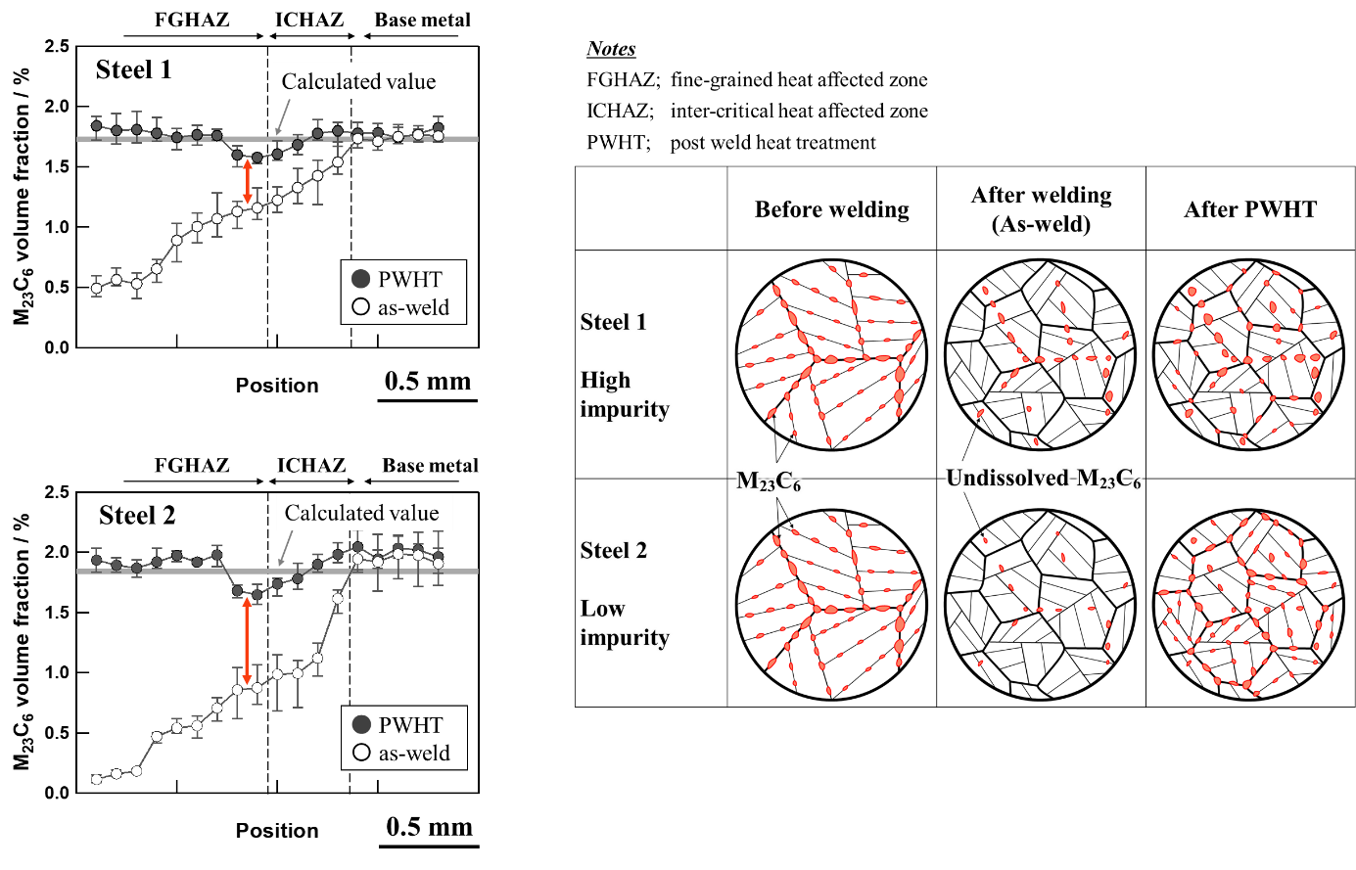

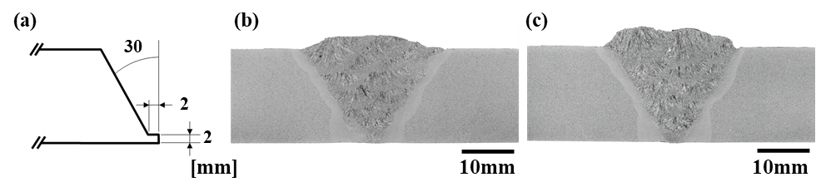
Fig. 1 (a) Groove configuration and macrostructures of (b) Steel 1 and (c) Steel 2 welded joints after PWHT.

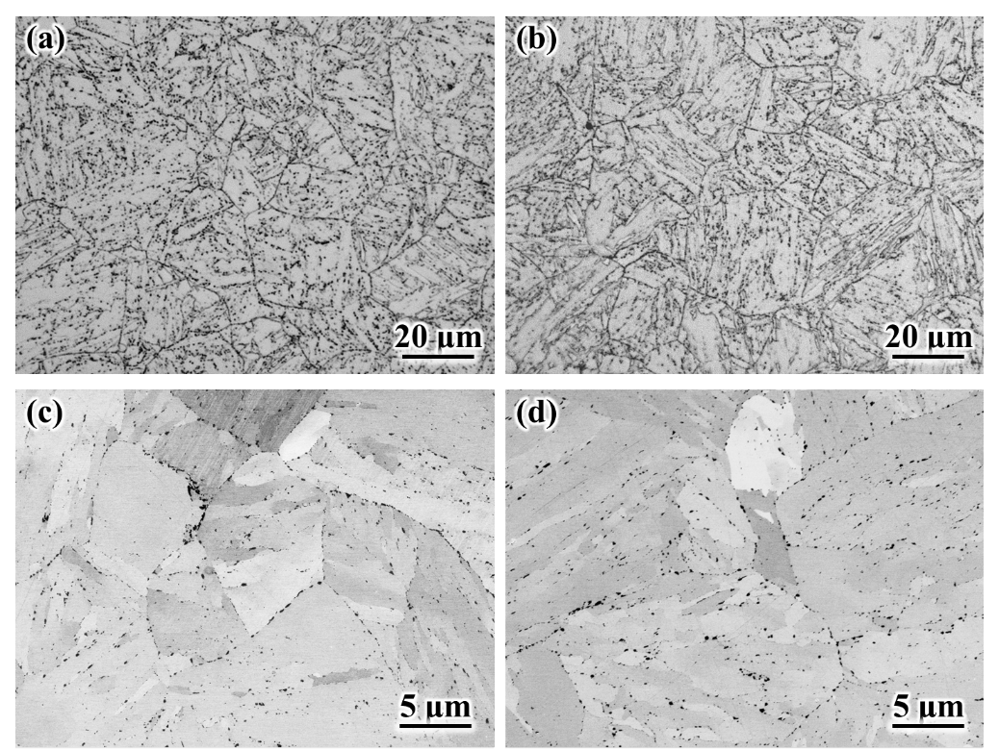
Fig. 2 (a), (b) OM and (c), (d) SE images of the base metal in (a), (c) Steel 1 and (b), (d) Steel 2.

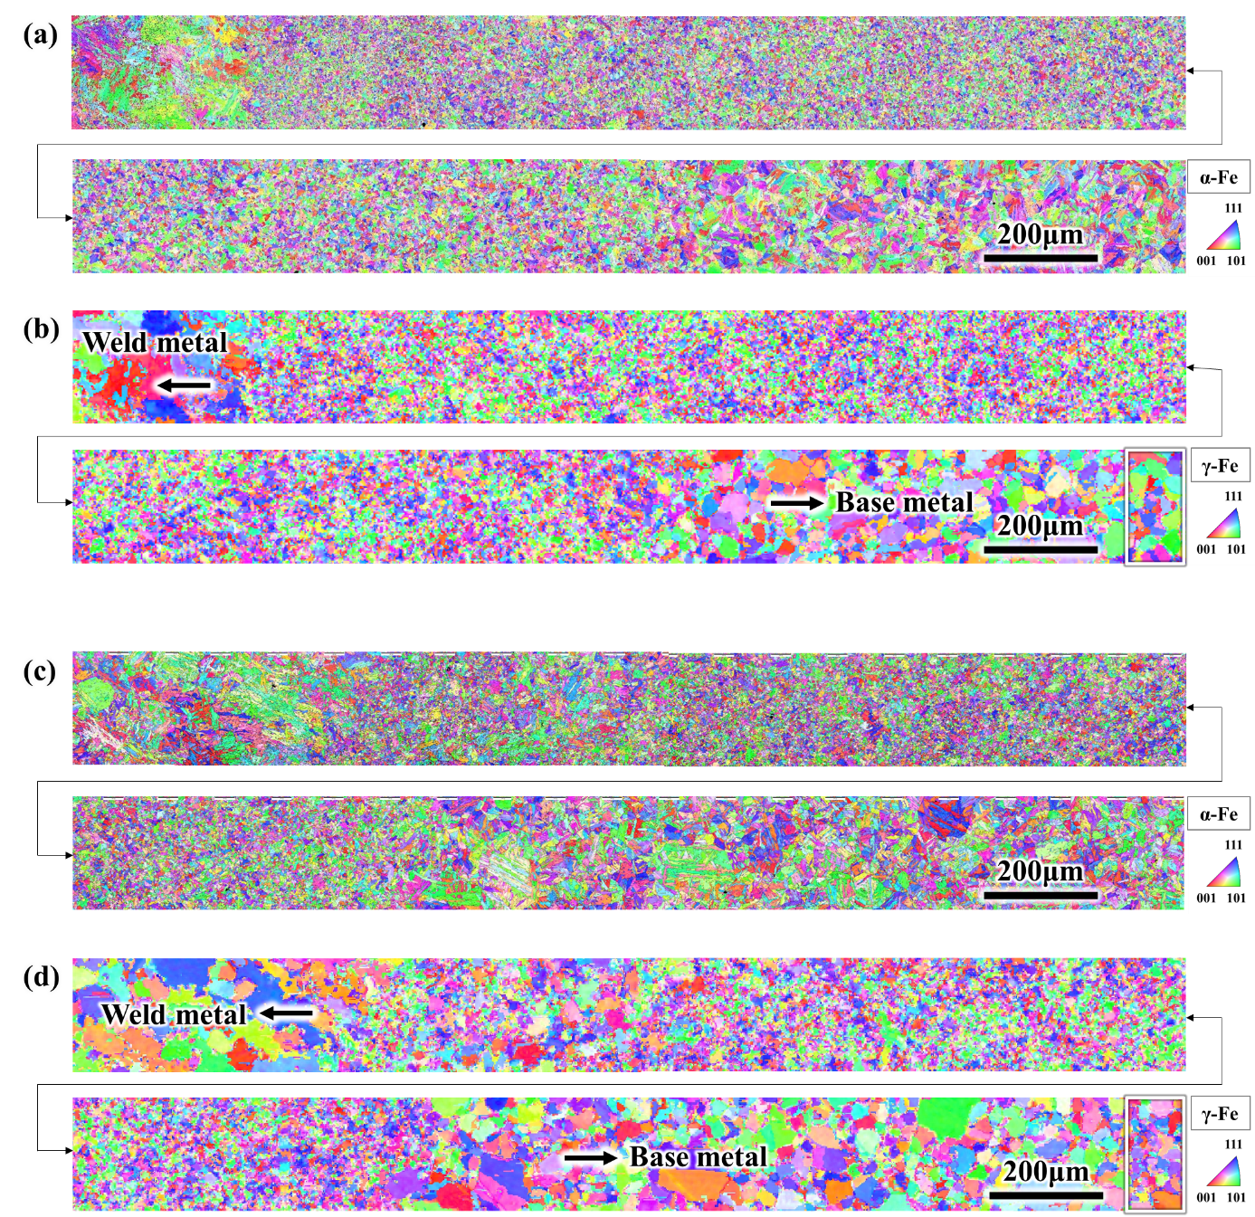
Fig. 3 EBSD results of (a), (b) Steel 1 and (c), (d) Steel 2 welded joints. IPF maps of (a), (c) martensite (indexed as α-Fe phase) and (b), (d) reconstructed austenite in Steel 2 after PWHT. The white frames depict the field-of-view used for the evaluation of the average PAG size within 100 μm intervals.

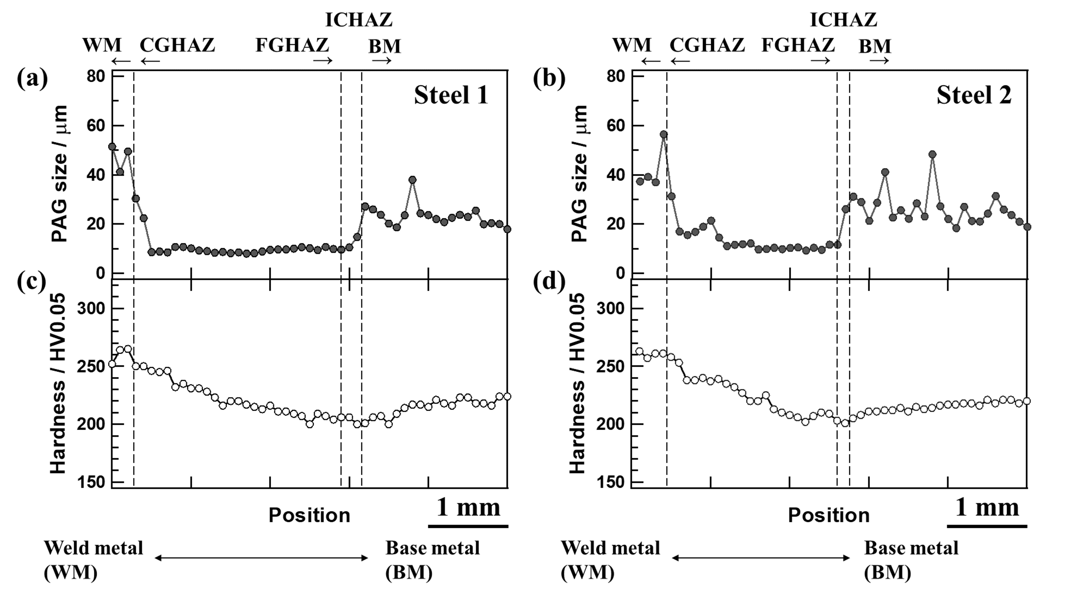
Fig. 4 Changes of (a), (b) PAG size and (c), (d) hardness in the direction across the weld line before creep in (a), (c) Steel 1 and (b), (d) Steel 2. CGHAZ, FGHAZ, and ICHAZ represent coarse-grained HAZ, fine-grained HAZ, and inter-critical HAZ, respectively.

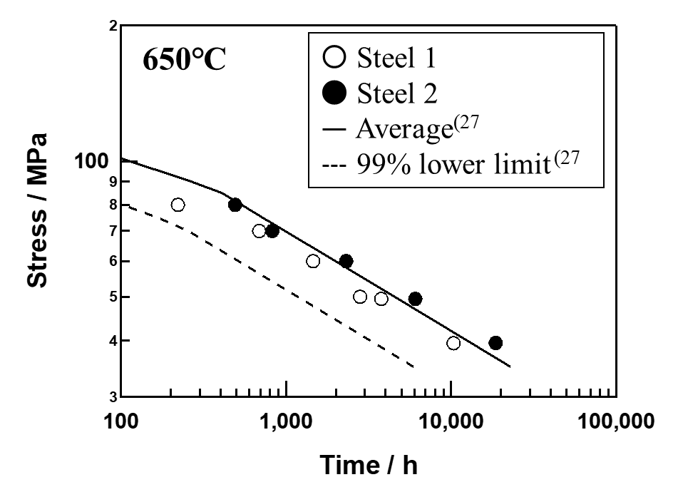
Fig. 5 Creep rupture strength of the welded joints at 650 °C

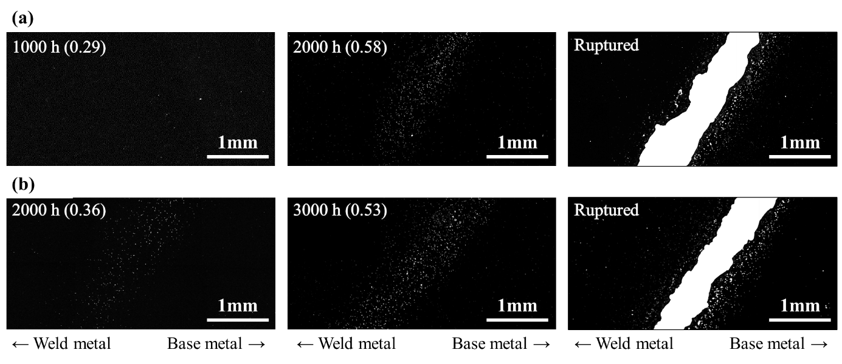
Fig. 6 OM-DF images of HAZ in interrupted and ruptured (a) Steel 1 and (b) Steel 2 welded joints at 650 °C, 50 MPa. The numbers in brackets indicate the creep life ratio at each interrupted time.

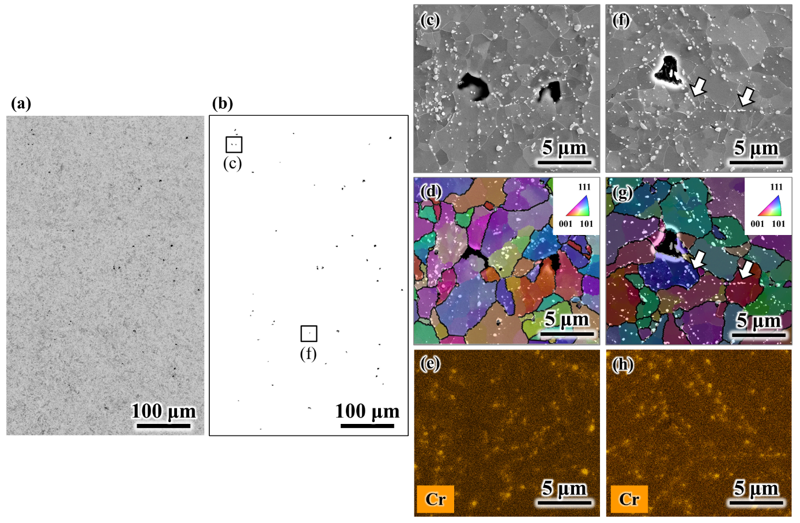
Fig. 7 SE image (a) before and (b) after binarized which show the creep void distribution of FGHAZ in 1000 h interrupted Steel 1 at 650 °C, 50 MPa. (c), (f) magnified SE images as delineated by the frames in (a). (d), (g) IPF maps overlayed on SE images and (e), (h) Cr elemental maps by SEM-EDS. White arrows in (f), (g) indicate M₂₃C₆ particles aligned inside the grains.

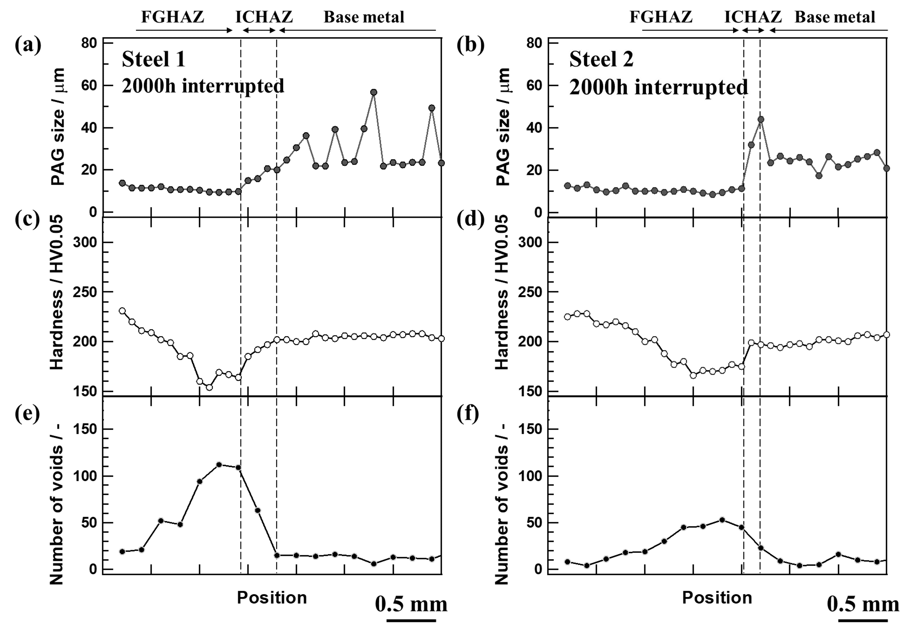
Fig. 8 Changes of (a), (b) PAG size, (c), (d) hardness and (e), (f) number of creep voids in the direction across the weld line in 2000 h interrupted (a), (c), (e) Steel 1 and (b), (d), (f) Steel 2 at 650 °C, 50 MPa.

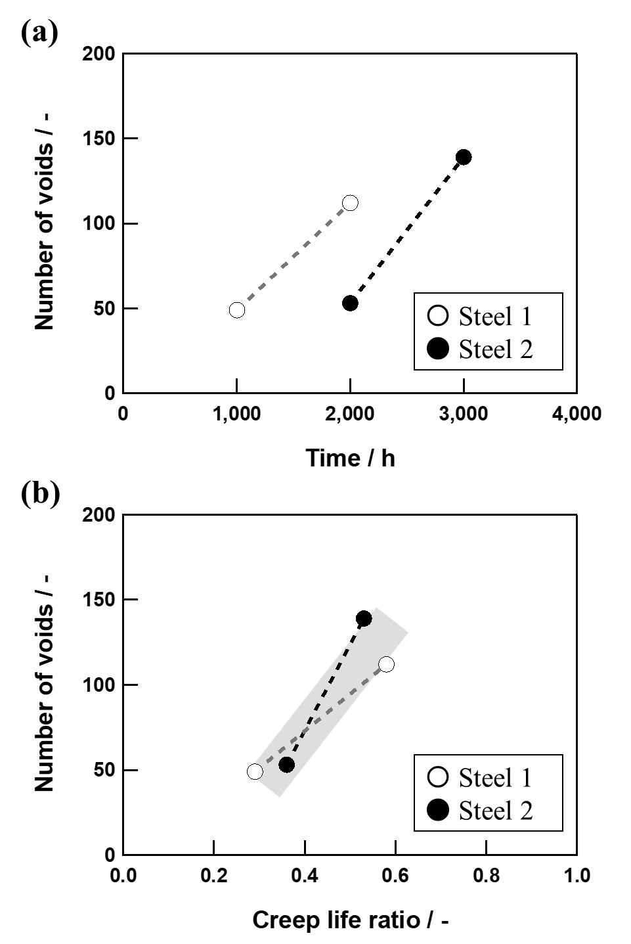
Fig. 9 Number of creep voids in FGHAZ versus (a) time and (b) creep life ratio at 650 °C, 50MPa.

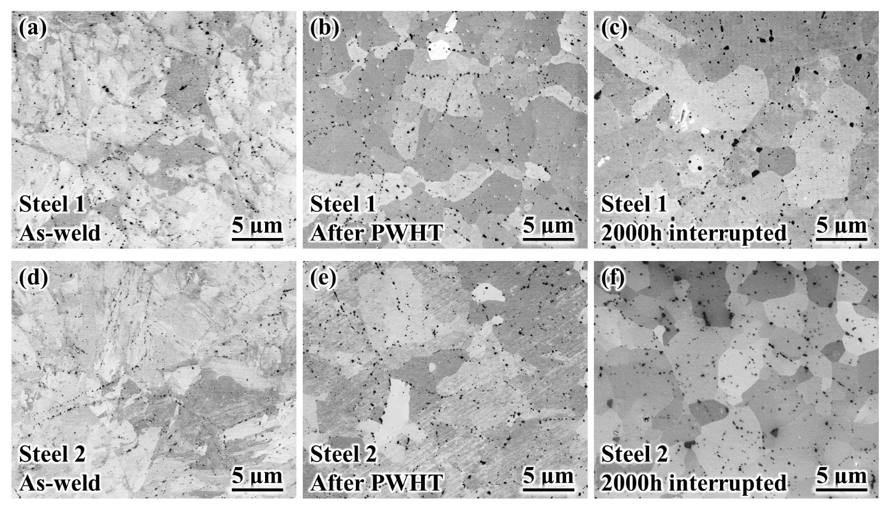
Fig. 10 SE images of the microstructures at FGHAZ in (a)-(c) Steel 1 and (d)-(f) Steel 2 welded joints. (a), (d) As-weld, (b), (e) after PWHT, and (c), (f) 2000 h interrupted at 650 °C, 50 MPa.

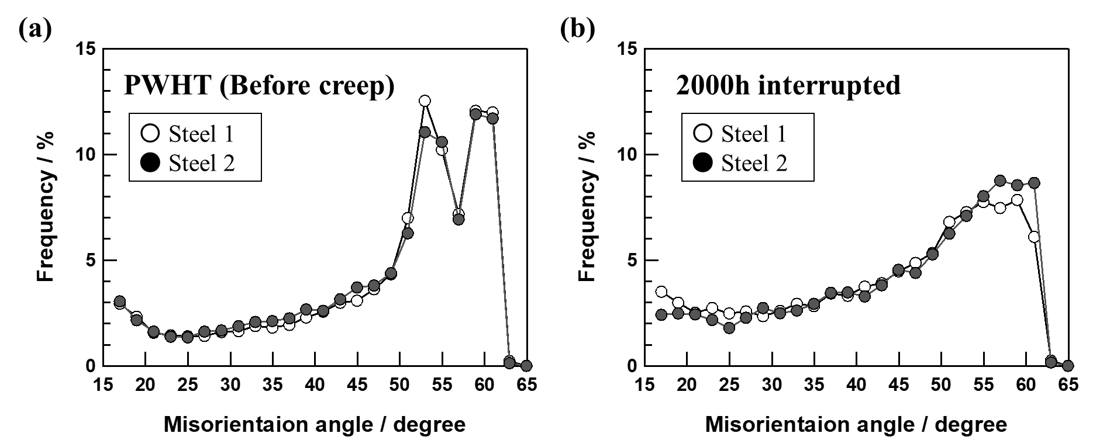
Fig. 11 Histograms for the misorientation angle of the high angle grain boundary (a) after PWHT and (b) 2000 h interrupted at 650 °C, 50 MPa.

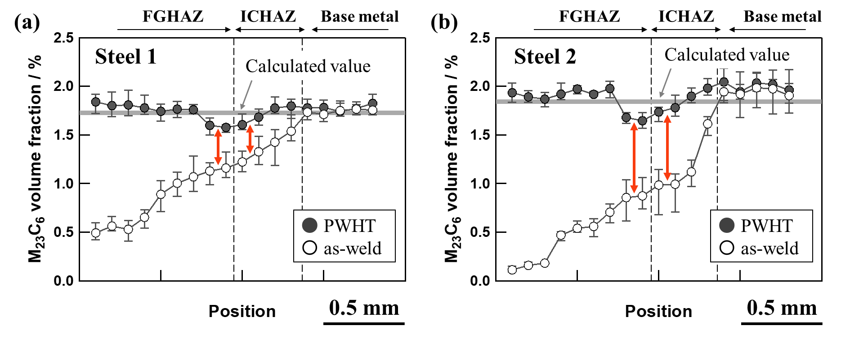
Fig. 12 Changes of M₂₃C₆ volume fraction in the direction across the weld line before (as-weld) and after PWHT in (a) Steel 1 and (b) Steel 2.

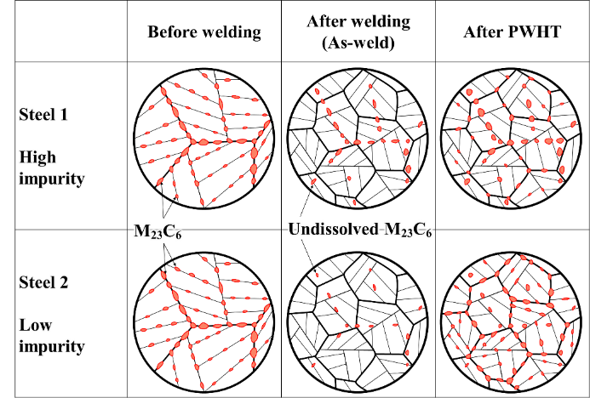
Fig. 13 Schematic illustration showing the differences in microstructural evolutions during welding and PWHT between Steel 1 and Steel 2.

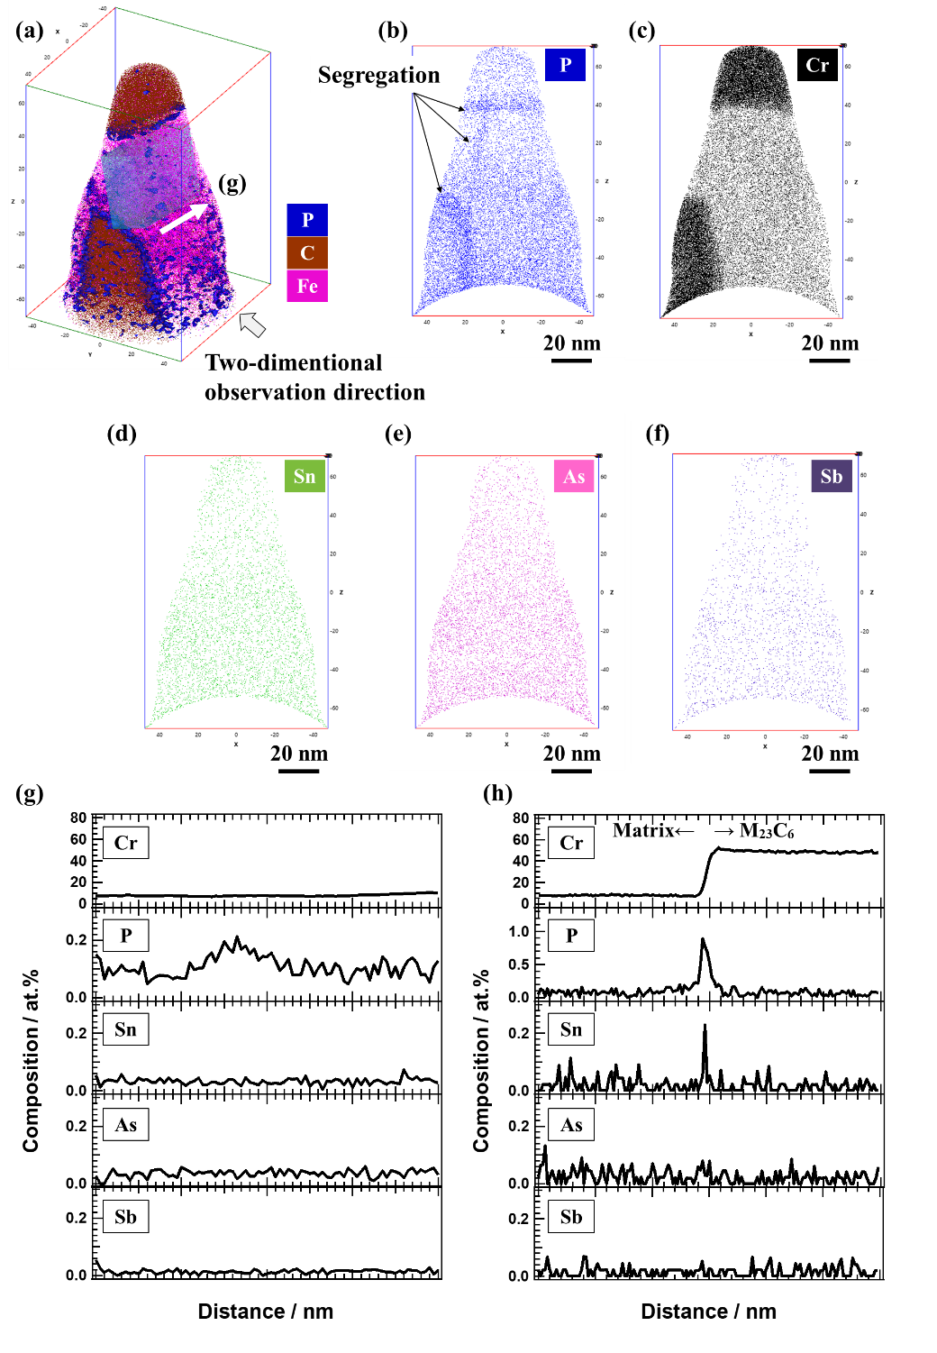
Fig. 14 APT results for (a) three-dimensional elemental map overlaying Fe, C, and P atoms, and two-dimensional elemental maps (b) P, (c) Cr, (d) Sn, (e) As, and (f) Sb. Concentration profiles (g) across PAGB along the column as shown in (a) and (h) across the M₂₃C₆ (top one) and matrix.

Table 1 Chemical requirements for product analysis by ASME SA-387/SA-387M Gr.91 steel¹ and chemical compositions of test materials (mass%).
Standard /  Test material | C | Si | Mn | P | S | Ni | Cr | Mo | V | Nb | Sol-Al | N | Sb | As | Sn | W | Ti | Cu | Zr | B | O | N/Al
SA-387/SA-387M Gr.91 Type 1  in ASME (2019) | 0.06-0.15 | 0.18-0.56 | 0.25-0.66 | ≤ 0.025 | ≤ 0.012 | ≤ 0.43 | 7.90-9.60 | 0.80-1.10 | 0.16-0.27 | 0.05-0.11 | ≤ 0.02 | 0.025-0.080 | - | - | - | - | ≤ 0.01 | - | ≤ 0.01 | - | - | -
SA-387/SA-387M Gr.91 Type 2  in ASME (2019) | 0.06-0.15 | 0.20-0.40 | 0.30-0.50 | ≤ 0.020 | ≤ 0.005 | ≤ 0.20 | 8.0-9.50 | 0.80-1.05 | 0.16-0.27 | 0.05-0.11 | ≤ 0.020 | 0.035-0.070 | ≤ 0.003 | ≤ 0.010 | ≤ 0.010 | ≤ 0.05 | ≤ 0.01 | ≤ 0.10 | ≤ 0.01 | ≤ 0.001 | - | 4.0 ≤
Steel 1 | 0.082 | 0.30 | 0.41 | 0.012 | 0.0006 | 0.11 | 8.45 | 0.94 | 0.20 | 0.080 | 0.008 | 0.052 | 0.008 | 0.019 | 0.018 | 0.03 | 0.001 | <0.01 | <0.001 | <0.0001 | 0.003 | 6.5
Steel 2 | 0.087 | 0.29 | 0.41 | 0.011 | 0.0005 | 0.09 | 8.49 | 0.93 | 0.20 | 0.074 | 0.007 | 0.052 | <0.001 | <0.001 | <0.001 | <0.01 | 0.001 | <0.01 | <0.001 | <0.0001 | 0.001 | 7.4

Table 2 Tensile tests results for Steel 1 and Stee 2 at room temperature and 650 °C.
Temperature | Sample | Yield stress / MPa | Tensile strength / MPa | Elongation / % | Reduction of area / %
Room temperature | Steel 1 | 584 | 724 | 21.8 | 73.6
 | Steel 2 | 579 | 722 | 22.6 | 75.7
650 °C | Steel 1 | 197 | 300 | 38.2 | 93.5
 | Steel 2 | 201 | 299 | 33.1 | 93.4

Highlights
- The creep rupture strength of the high-impurity-containing steel was inferior to that of the low-impurity-containing steel. “Impurity” refers to the three elements: Sb, As, and Sn.

- In the as-welded joint, higher amount of M₂₃C₆ carbide remained as undissolved particles at fine-grained heat affected zone (FGHAZ) in the high-impurity-containing steel.

- It was suggested that M₂₃C₆ dissolution at FGHAZ during welding was likely suppressed by impurities.

- The higher the amount of remaining undissolved M₂₃C₆, the lesser the pinning force due to the reduction of M₂₃C₆ re-precipitation on the grain boundaries during post-weld-heat-treatment.

- The degradation in the creep rupture strength by impurities was attributed to the accelerated progression of recovery process at FGHAZ during creep and subsequent creep void formation.

