Electrolyte Design for High Power Dual-ion Battery with Graphite Cathode for Low Temperature Applications
Yu Zhaoª, Hekang Zhuª, Lidan Xing^{b}, Denis Y. W. Yu^{a,c*}

ªSchool of Energy and Environment, City University of Hong Kong, 83 Tat Chee Avenue, Kowloon, Hong Kong S.A.R., P. R. China.
^{b}National and Local Joint Engineering Research Center of MPTES in High Energy and Safety LIBs, Engineering Research Center of MTEES (Ministry of Education), Research Center of BMET (Guangdong Province), and Key Lab. of ETESPG(GHEI), South China Normal University, Guangzhou 510006, China
^{c}Research Center for Energy and Environmental Materials (GREEN), National Institute for Materials Science, Tsukuba, Ibaraki 305-0044, Japan.

Tel: +81-29-8604168, E-mail addresses: yu.denis@nims.go.jp (Denis Y.W. Yu)

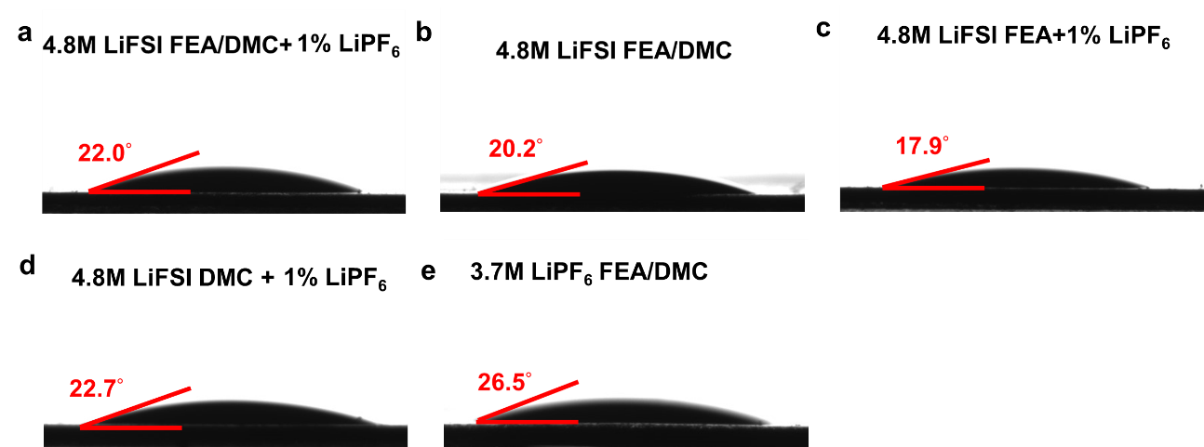
Figure S1. The contact angle of various electrolytes on the surface of PVdF separator.

Figure S2. The Nyquist plots of graphite||Li half cells using different electrolytes at 25 °C after 100 cycles at the discharged state.

Figure S3. The LSV scans of DMC and FEA pure solvents with a scan rate of 5 mV s⁻¹ with titanium as the working electrode.

Figure S4. The corrosion currents with constant potential of 5.1 V for 100 h in 4.8 M LiFSI FEA/DMC + 1% LiPF₆, 4.8 M LiFSI FEA/DMC, 4.8 M LiFSI FEA + 1% LiPF₆, and 4.8 M LiFSI DMC + 1% LiPF₆ electrolytes.

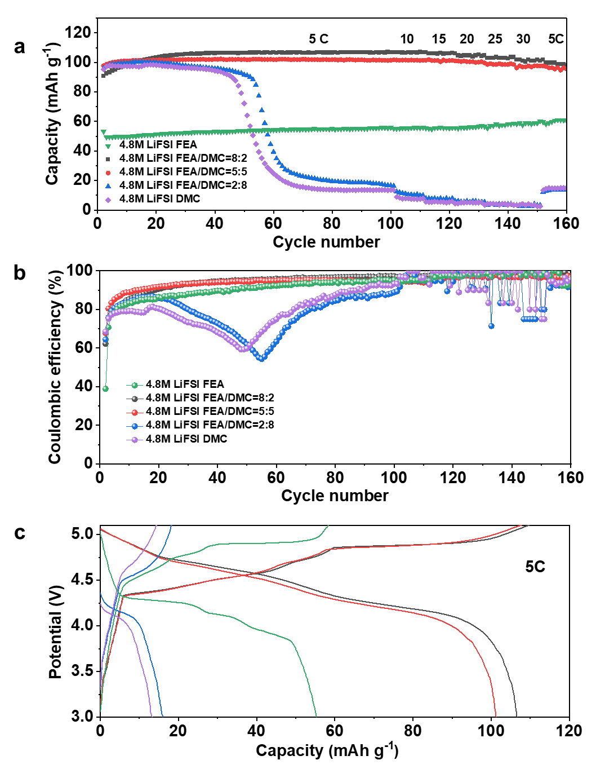
Figure S5. (a) Capacity of graphite cathode tested in 4.8 M LiFSI FEA/DMC electrolyte with different solvent ratios and (b) corresponding Coulombic efficiency; (c) charge and discharge curves of graphite with different electrolytes at 5 C (100th cycle).

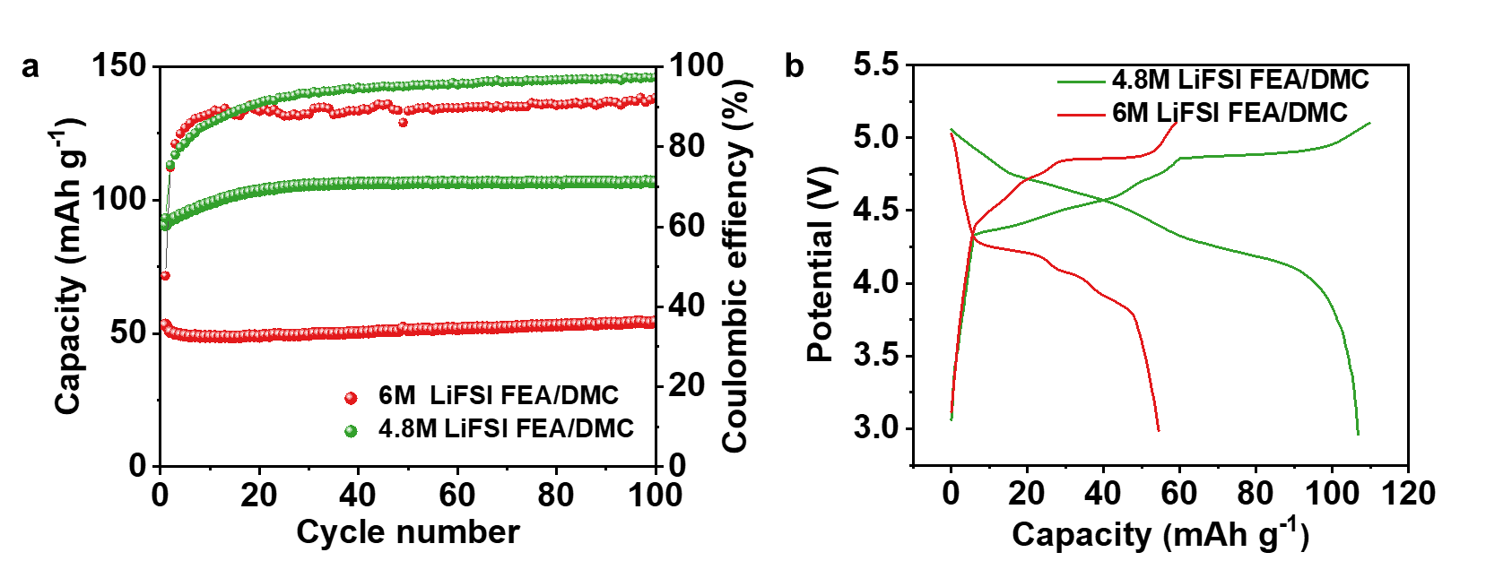
Figure S6. The electrochemical performances of graphite||lithium DIBs in FEA/DMC = 8:2 electrolyte with different LiFSI concentrations at room temperature. (a) Cycle performance at a 5 C current density and (b) charge and discharge profiles at the 100th cycle.

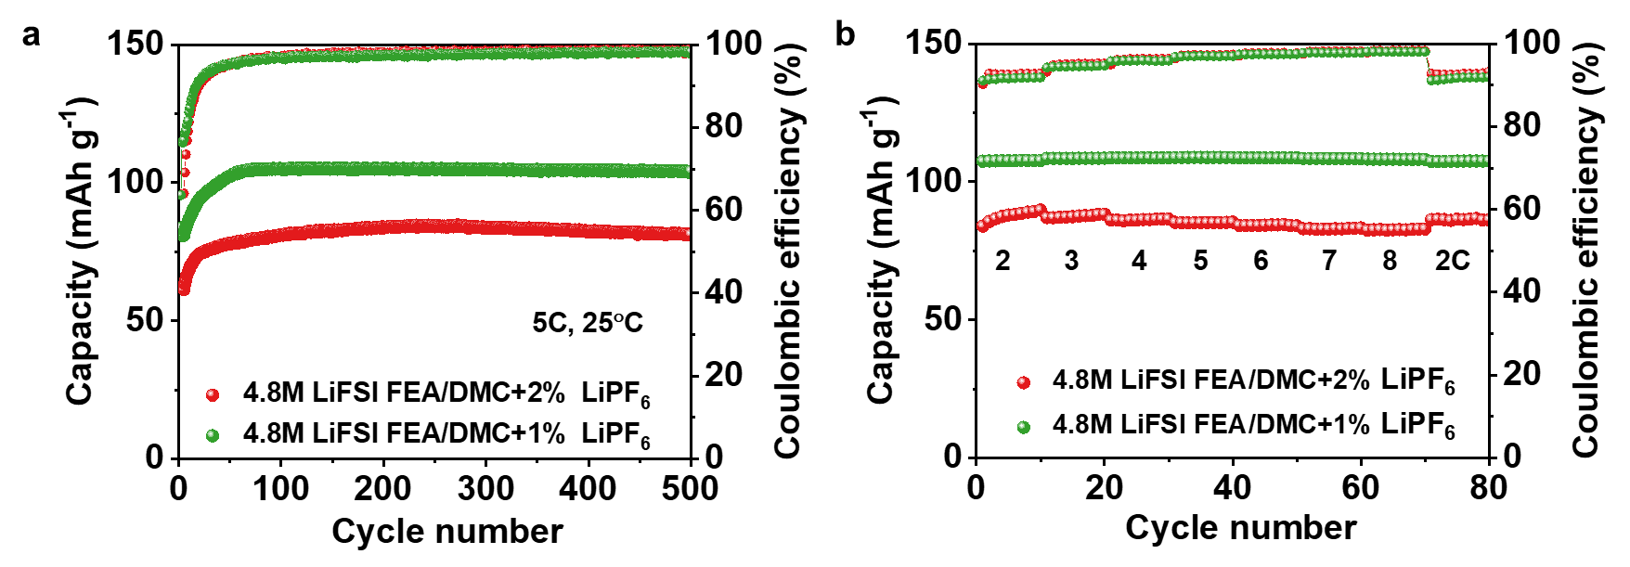
Figure S7. The effect of LiPF₆ content on the electrochemical performances of graphite||lithium DIBs at room temperature. (a) Cycle performance at 5 C current density; (b) rate capability of graphite cathode under various charge/discharge rates.

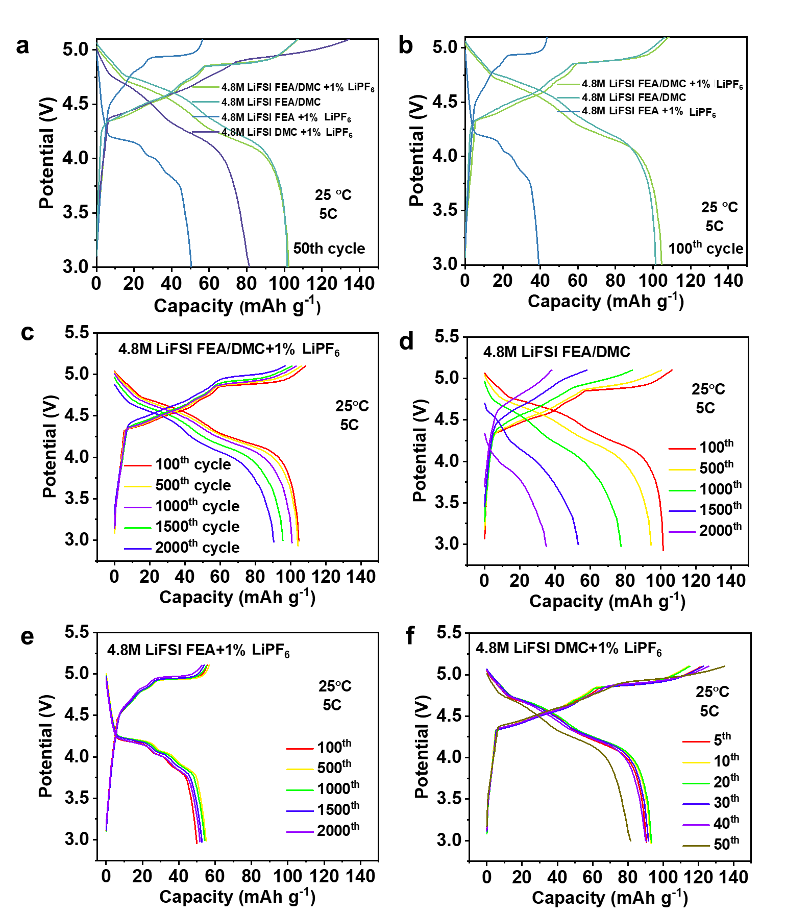
Figure S8. The charge-discharge profiles of graphite||Li half-cells using 4.8 M LiFSI-based electrolytes (a) at 50th cycle and (b) at 100th cycle. The charge-discharge curves of cells with (c) 4.8 M LiFSI FEA/DMC + 1% LiPF₆, (d) 4.8 M LiFSI FEA/DMC, (e) 4.8 M LiFSI FEA + 1% LiPF₆, and (f) 4.8 M LiFSI DMC + 1% LiPF₆ electrolytes at selected cycles.

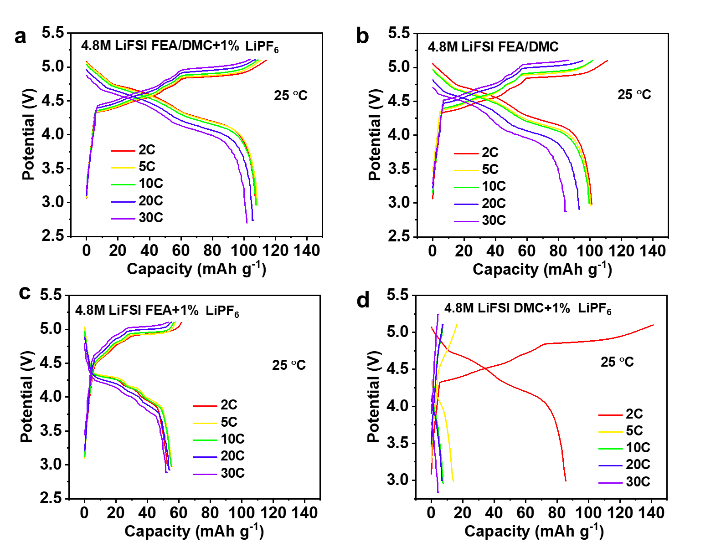
Figure S9. Capacity-voltage curves of graphite||Li cells under various current densities at room temperature (25 °C) in (a) 4.8 M LiFSI FEA/DMC + 1% LiPF₆ electrolyte, (b) 4.8 M LiFSI FEA/DMC electrolyte, (c) 4.8 M LiFSI FEA + 1% LiPF₆ electrolyte and (d) 4.8 M LiFSI DMC + 1% LiPF₆,

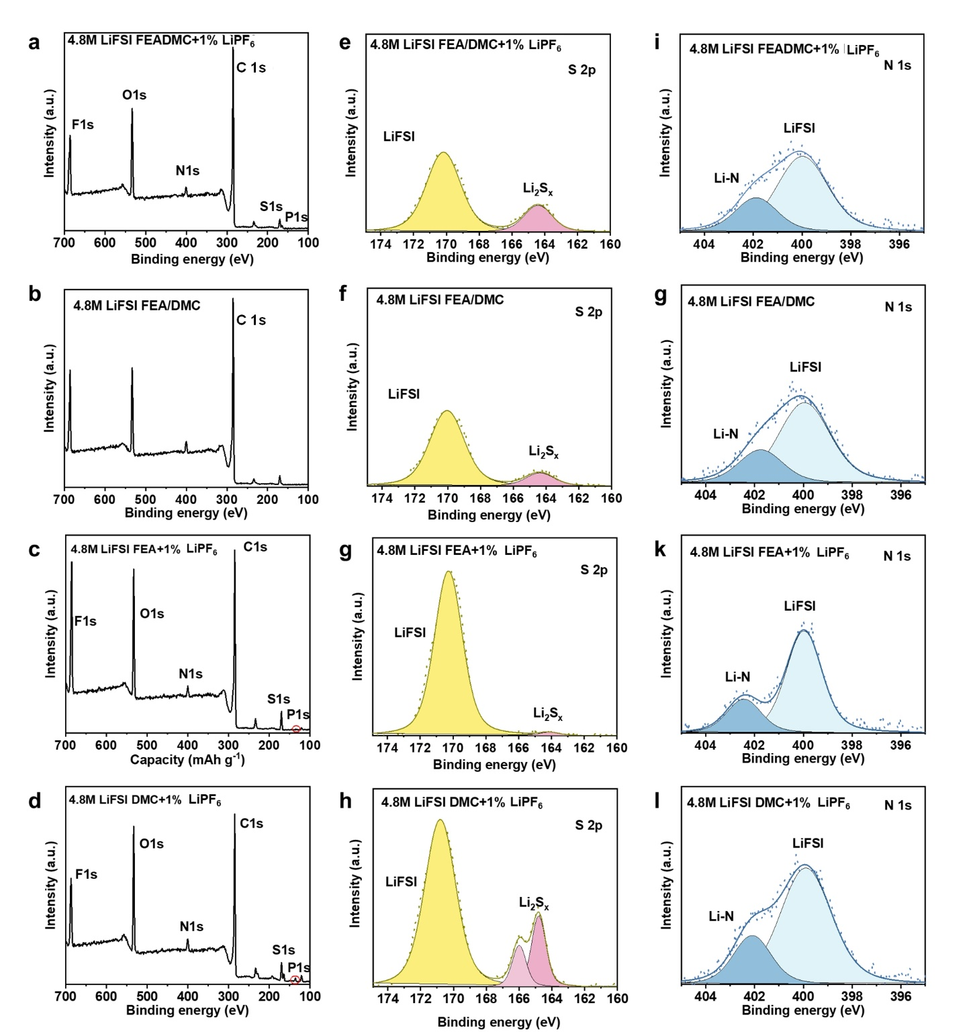

Figure S10. High-resolution X-ray photoelectron spectra of graphite cathode surface tested with different 4.8 M LiFSI-based electrolytes: (a-d) The full XPS spectra; (e-h) S 2p spectra; (i-l) N 1s spectra.

Table S1. Summary of the elemental composition (at%) on the graphite cathode surface in different electrolytes based on Figure 5h.

Electrolyte/Solvent | C | O | F | N | S | P
4.8 M LiFSI FEA/DMC + 1% LiPF₆ | 70.4 | 14.4 | 8.9 | 2.8 | 3.1 | 0.4
4.8 M LiFSI FEA/DMC | 71.7 | 13.3 | 9.7 | 2.9 | 2.4 | -
4.8 M LiFSI  FEA + 1% LiPF₆ | 62.7 | 16.4 | 14.6 | 2.5 | 3.5 | 0.3
4.8 M LiFSI DMC + 1% LiPF₆ | 61.2 | 18.2 | 9.3 | 4.3 | 5.9 | 1.1

Figure S11. The melting point of 3.7 M LiPF₆ FEA/DMC and 4.8 M LiFSI FEA/DMC + 1% LiPF₆ electrolytes.

Table S2. Summary of the electrochemical performances of reported dual-ion batteries at room temperature and low temperature.

Anion | Cathode||  anode | Electrolyte | Voltage range (V) | Specific discharge capacity (mAh g⁻¹) | Applied current density  (1C=100mA g⁻¹) | Temperature | Cycling capability (capacity retention/cycles) | Reference
This work | Graphite||Li | 4.8 M LiFSI-FEA/DMC + 1% LiPF₆ | 3.0-5.1 | 93.1 | 2 C | 25 °C | 94.1%/  2000 | This work
This work | Graphite||Li | 4.8 M LiFSI-FEA/DMC + 1% LiPF₆ | 3.0-5.1 | 88.0 | 2 C | 0 °C | 86.3%/500 | This work
This work | Graphite||Li | 4.8 M LiFSI-FEA/DMC + 1% LiPF₆ | 3.0-5.0 | 69.2 | 0.5 C | -30 °C | - | This work
Other works | Graphite||Li | 1 M LiFSI-EC/DEC  (1:1) | 3.0 - 5.1 | 60 | 0.1 C | 25 °C | ~99%/5 | [1]
Other works | Graphite||Li | 4 M  LiFSI-EC/DEC | 3.4 - 4.95 | 86 | 0.1 C | 25 °C | 87%/50 | [2]
Other works | Graphite||Li | 7.5 M LiFSI-EC/DMC | 3.0 - 5.2 | 94.0 | 2 C | 25 °C | 96.8%/500 | [3]
Other works | Graphite||Li | 5 M KFSI- EC/DMC | 3.0 - 5.25 | 90 | 1 C | 25 °C | 89%/300 | [4]
Other works | Graphite||Sn | 6.6 M KFSI-TMP | 3.0 - 5.35 | 100.8 | 3 C | 25 °C | 81%/400 | [5]
Other works | Graphite||Li | 4 M  LiTFSI-EC/DEC | 3.0 - 5.1 | 104 | 0.1 C | 25 °C | 82%/50 | [2]
Other works | Graphite||Li | 0.3 M LiTFSIPyr₁₄TFSI | 3.4 - 5.0 | 45 | 0.5 C | 25 °C | ~100%/50 | [6]
Other works | Graphite||Li | 2.7 M LiTFSI-DEC | 3.4 - 5.0 | 85 | 0.5 C | 25 °C | ~ 94%/30 | [7]
Other works | Graphite||Li | 1 M LiPF₆-MA/EMC (5:5) | 3.0 - 5.2 | 41 | 1 C | -25 °C | - | [8]
Other works | Graphite||Li | 1 M LiPF₆ MP | 3.0 - 5.2 | 40.2 | 2 C | -20 °C | - | [9]
Other works | Graphite|| Graphite | 2.0 M LiPF₆-MP/FEC (10:1) | 2.5 - 5.1 | 74.4 | 1 C | -40 °C | - | [10]
Other works | Graphite||PTPAn | 0.5 M NaPF₆-DEG/DME | 1.0 - 4.0 | 60 | 0.1 C | -40 °C | - | [11]

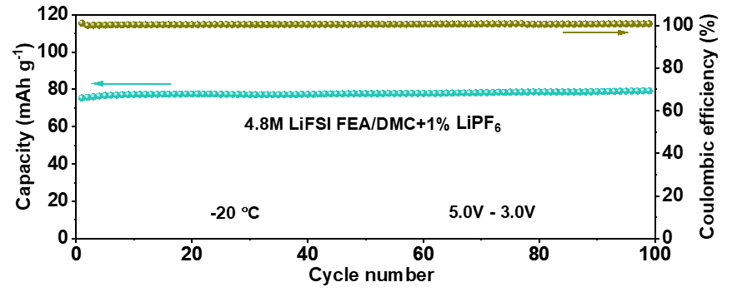
Figure S12. Long-term cycle performance of cells with 4.8 M LiFSI FEA/DMC + 1% LiPF₆ electrolyte at -20 °C at a current density of 0.5 C.

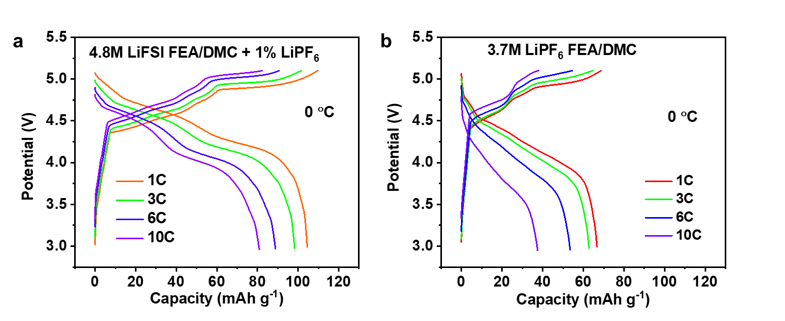
Figure S113. The charge-discharge curves of graphite||Li dual-ion half cells with 4.8 M LiFSI FEA/DMC + 1% LiPF₆ and 3.7 M LiPF₆ FEA/DMC electrolytes at different current densities at 0 °C.

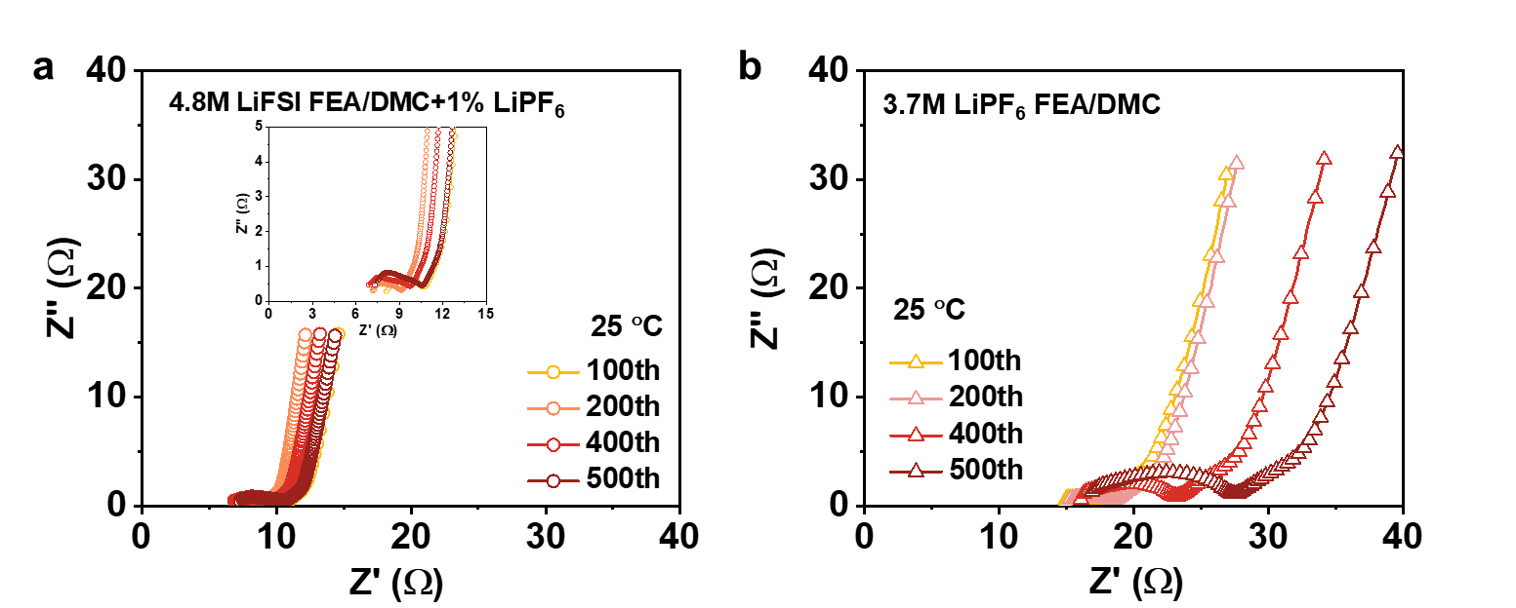
Figure S14. Nyquist plots of graphite||Li cells with (a) 4.8 M LiFSI FEA/DMC + 1% LiPF₆ electrolyte and (b) 3.7 M LiPF₆ FEA/DMC electrolyte at 25°C at discharged state after different number of cycles.

Table S3. The fitting data for EIS results of graphite||Li cells with 4.8 M LiFSI FEA/DMC + 1% LiPF₆ and 3.7 M LiPF₆ FEA/DMC electrolytes at different temperatures.

Electrolyte |  | 25 °C |  |  |  | 0 °C
Electrolyte |  | 100th | 200th | 400th | 500th | 100th | 200th | 400th | 500th
4.8 M LiFSI FEA/DMC + 1% LiPF₆ | R_{ohm} | 8.1 | 7.1 | 6.8 | 7.3 | 26.5 | 27.6 | 27.9 | 28.4
4.8 M LiFSI FEA/DMC + 1% LiPF₆ | R_{CEI} | 0.5 | 0.5 | 0.7 | 0.8 | 1.4 | 1 | 2.8 | 3.9
4.8 M LiFSI FEA/DMC + 1% LiPF₆ | R_{ct} | 0.7 | 0.4 | 0.5 | 0.6 | 4.9 | 4.3 | 3.0 | 2.7
3.7 M LiFSI FEA/DMC | R_{ohm} | 14.9 | 15.3 | 16.1 | 16.9 | 28.4 | 28.9 | 29.1 | 28.7
3.7 M LiFSI FEA/DMC | R_{CEI} | 0.6 | 0.7 | 1.0 | 1.1 | - | - | - | -
3.7 M LiFSI FEA/DMC | R_{ct} | 0.5 | 1 | 2.5 | 4.2 | 5092.6 | 5135.7 | 5135.8 | 5140.0

References
[1] T. Fukutsuka, F. Yamane, K. Miyazaki, T. Abe, Electrochemical intercalation of bis (fluorosulfonyl) amide anion into graphite, Journal of The Electrochemical Society, 163 (2015) A499, https://doi.org/10.1016/j.elecom.2019.01.015.
[2] V. Nilsson, A. Kotronia, M. Lacey, K. Edström, P. Johansson, Highly Concentrated LiTFSI–EC Electrolytes for Lithium Metal Batteries, ACS Applied Energy Materials, 3 (2020) 200-207, https://doi.org/10.1021/acsaem.9b01203.
[3] L. Xiang, X. Ou, X. Wang, Z. Zhou, X. Li, Y. Tang, Highly concentrated electrolyte towards enhanced energy density and cycling life of dual‐ion battery, Angewandte Chemie International Edition, 59 (2020) 17924-17930, https://doi.org/10.1002/anie.202006595.
[4] K.V. Kravchyk, P. Bhauriyal, L. Piveteau, C.P. Guntlin, B. Pathak, M.V. Kovalenko, High-energy-density dual-ion battery for stationary storage of electricity using concentrated potassium fluorosulfonylimide, Nature communications, 9 (2018) 1-9, https://doi.org/10.1038/s41467-018-06923-6.
[5] X. Ou, J. Li, X. Tong, G. Zhang, Y. Tang, Highly Concentrated and Nonflammable Electrolyte for High Energy Density K-Based Dual-Ion Battery, ACS Applied Energy Materials, 3 (2020) 10202-10208, https://doi.org/10.1021/acsaem.0c01993.
[6] K. Beltrop, P. Meister, S. Klein, A. Heckmann, M. Grünebaum, H.-. D. Wiemhöfer, M. Winter, T. Placke, Does Size really Matter? New Insights into the Intercalation Behavior of Anions into a Graphite-Based Positive Electrode for Dual-Ion Batteries, Electrochim. Acta, 209 (2016) 44-55, https://doi.org/10.1016/j.electacta.2016.05.012.
[7] A. Heckmann, J. Thienenkamp, K. Beltrop, M. Winter, G. Brunklaus, T. Placke, Towards high-performance dual-graphite batteries using highly concentrated organic electrolytes, Electrochimica acta, 260 (2018) 514-525, https://doi.org/10.1016/j.electacta.2017.12.099.
[8] L. Zhang, H. Fan, H. Wang, Methyl acetate–based solutions for dual-ion batteries, Electrochimica Acta, 342 (2020) 135992, https://doi.org/10.1016/j.electacta.2020.135992
[9] H. Fan, L. Qi, H. Wang, Hexafluorophosphate anion intercalation into graphite electrode from methyl propionate, Solid State Ionics, 300 (2017) 169-174, https://doi.org/10.1016/j.ssi.2016.12.032.
[10] J. Holoubek, Y. Yin, M. Li, M. Yu, Y.S. Meng, P. Liu, Z. Chen, Exploiting Mechanistic Solvation Kinetics for Dual-Graphite Batteries with High Power Output at Extremely Low Temperature, Angewandte Chemie International Edition, 58 (2019) 18892-18897, https://doi.org/10.1002/anie.201912167.
[11] J. Chen, Y. Peng, Y. Yin, Z. Fang, Y. Cao, Y. Wang, X. Dong, Y. Xia, A Desolvation-Free Sodium Dual-Ion Chemistry for High Power Density and Extremely Low Temperature, Angewandte Chemie International Edition, 60 (2021) 23858-23862, https://doi.org/10.1002/anie.202110501.

