Self-aligned patterning on β-Ga₂O₃ substrates via backside-exposure photolithography
Takayoshi Oshima
Research Center for Functional Materials, National Institute for Materials Science, Tsukuba, Ibaraki 305-0044, Japan
E-mail: OSHIMA.Takayoshi@nims.go.jp

β-Ga₂O₃ has not been patterned using backside-exposure lithography, despite its high potential applications in future power electronics and its transparency to conventional lithography light sources. Here, a patterned metal on a β-Ga₂O₃ substrate surface was used as an embedded photomask to demonstrate the applicability of backside-exposure lithography to β-Ga₂O₃ substrates. Self-aligned photoresist patterning, lift-off, and etching processes were demonstrated for an AZ5214E photoresist in both the positive and negative processing modes. The findings suggest that backside-exposure photolithography is a promising fabrication approach for future β-Ga₂O₃-based devices.

Backside-exposure photolithography (BEL) is a powerful self-alignment microfabrication technique that uses a patterned metallic layer as an embedded photomask. Substrates, transparent to lithography lights, such as the g-, h-, and i-lines (436, 405, and 365 nm, respectively), are a key requirement in BEL as the photo-illumination is applied from the reverse side of the substrate to enable accurate lithographic alignment of the metal pattern. ultraviolet-transparent glass and plastic substrates with optically flat front and back surfaces have been used in BEL^{1–10)} to fabricate various nanostructures, including self-aligned bottom-gates for thin film transistors,^{1–4)} nanoscale beam resonators,⁵⁾ metal wires⁶⁾ and rings^{6,7)}, and polymer-based nanopillars⁸⁾ and complex three-dimensional structures.^{9,10)}
Although monocrystalline wide-bandgap semiconductor substrates are transparent to conventional lithography lights, there have been few attempts to use backside-exposure lithography in the literature. β-phase gallium oxide (β-Ga₂O₃), gallium nitride (GaN), and silicon carbide (4H-SiC) single crystals are three of the most interesting wide-bandgap semiconductor scalable substrates, holding high potential for numerous technological applications.¹¹⁾ The superiority of β-Ga₂O₃ over GaN and 4H-SiC in terms of transparency to lithography lights was revealed by a closer examination of the transmission spectra of these three materials (both-side-polished substrates)^{12–14)} in conjunction with the normalized emission peak intensities of the g-, h-, and i-lines extracted from a typical emission spectrum of a high-pressure mercury lamp¹⁵⁾ [Fig. 1]. The transmittances of the GaN and 4H-SiC substrates exhibited decent values for the g- and h-lines between 16% and 68%, but they remarkably decreased below 2% for the i-line. In contrast, the β-Ga₂O₃ substrate maintained high transmittances to all three lines above 70%. Due to the possibility of using all g-, h-, and i-line sensitive photoresists, similar to the case of conventional front-side exposure photolithography, this optical response makes β-Ga₂O₃ substrates more alluring for using the full potential of BEL. Additionally, β-Ga₂O₃ has recently attracted considerable attention for its potential use in future power electronic applications.^{16–18)} To the author’s knowledge, no previous literature has been reported regarding lithography on β-Ga₂O₃ substrates using the BEL technique, despite the proven technological interest.
This study presents a set of typical preliminary experiments to demonstrate the validity and applicability of the BEL technique to β-Ga₂O₃ substrates for the exploration of novel self-aligned device fabrication processes.
The process flow for self-aligned photoresist patterning of 0.64 mm thick, both-side-polished, Sn-doped β-Ga₂O₃ (001) substrates with carrier concentrations of 4.9 × 10¹⁸ cm⁻³ (Novel Crystal Technology Inc., Japan) is illustrated in Fig. 2(a). Electron-beam (EB) evaporation was used to first deposit chromium (Cr) layers on the substrates’ front-side surface. Then, the Cr layers were patterned in stripes via maskless lithography (DL-1000, NanoSystem Solutions, Inc.) and subsequent wet etching in a 25-wt%-diammonium cerium (IV) nitrate (Kanto Chemical Co., Inc.) aqueous solution, as shown in the scanning electron microscopy (SEM) images in Fig. 2(b). The thickness of the Cr mask, the widths of the Cr-covered part, and the window (open) part were 150 nm, 2.5–3.0 µm, and 2.0–2.5 µm, respectively. Second, on the Cr-masked substrates, an image reversal photoresist (AZ5214E, Merck) was processed in positive and negative (image reversal) modes¹⁹⁾ as follows. Initially, surfaces were treated with hexamethyldisilazane (HMDS) (OAP, Tokyo Ohka Kogyo Co., Ltd.) before the deposition of the AZ5214E photoresist onto them through spin coating at 5000 rpm for 30 s. The resulting samples were then pre-baked at 105°C for 60 s on a hot plate. Furthermore, the substrates’ backsides were exposed using a conventional mask aligner (MA6/BA6, SÜSS MicroTec), which irradiated them with collimated light (18.0 mW cm⁻²) from a high-pressure mercury lamp while they were positioned face-down on a light-absorbing plate. Note that the incident light was orthogonal to the sample surface. The exposure time was set to 8 s for both processing modes. In the positive processing, the sample was developed in a 2.3-wt%-tetramethylammonium hydroxide (TMAH) developer (NMD-3, Tokyo Ohka Kogyo Co., Ltd.) for 90 s. In contrast, additional image reversal steps (including reversal baking at 120°C for 60 s and front-side flood exposure for 30 s) were conducted in the negative processing mode before the development step.
The results show that the BEL technique can successfully transfer the pattern of the Cr mask to the AZ5214E photoresist. In the positive processing mode, the developed photoresist remained over the Cr mask regions, resulting in self-aligned openings in the photoresist exposing the β-Ga₂O₃ substrate, as shown in Fig. 2(c). Inversely, as shown in Fig. 2(d), the β-Ga₂O₃ region was covered by the photoresist created in the negative processing mode. These results demonstrate the possibility of achieving self-aligned photoresist patterning using the BEL technique on β-Ga₂O₃ substrates.
Furthermore, self-aligned lift-off and etching processes were performed following the steps illustrated in Fig. 3(a), and various techniques for fabricating β-Ga₂O₃-based devices were investigated using the BEL approach. Here, samples were prepared by depositing SiO₂ layers (100 nm in thickness) on the above-described Cr-masked β-Ga₂O₃ substrates using the plasma-enhanced chemical vapor deposition method. For the self-aligned lift-off procedure, the protocol consists of an initial surface treatment with HMDS, followed by a spin coating with a positive photoresist (OFPR-800 (54cp), Tokyo Ohka Kogyo Co., Ltd.) at 5000 rpm for 30 s. The resulting sample was soft-baked at 90°C for 60 s. Then, the AZ5214E photoresist was spin-coated on the sample at 5000 rpm for 30 s, which was then pre-baked at 105°C for 60 s. Subsequently, a backside illumination was applied to the sample for 8 s, followed by a development process in the TMAH developer for 180 s. An Au/Cr bilayer (100 nm/ 50 nm in thickness) was deposited via EB evaporation at the last preparation stage. Because the bottom OFPR-800 layer was easily removed by acetone, the lift-off procedure was performed in acetone at room temperature and was completed in less than 5 min. For the self-aligned etching process, the protocol is slightly different. Following the initial surface treatment with HMDS, the sample was coated with the AZ5214E photoresist and processed in the negative mode as described above. Then, using a CHF₃/N₂ gas mixture and a plasma-based dry etching process, the SiO₂ layer was patterned, with the Cr mask layer acting as an etch stopper. Finally, the remaining photoresist mask was removed via O₂ plasma ashing.
BEL successfully achieved self-aligned lift-off and etching on the β-Ga₂O₃ substrates. In the lift-off process, BEL produced a positive photoresist mask on the Cr area with a desirable reverse-tapered sidewall profile, which enabled the deposition of a discontinuous Au/Cr film in the window area [Fig. 3(b)]. The small overlap length (~0.1 µm) observed between the deposited Au/Cr film, and the Cr mask indicated high self-alignment accuracy of the BEL technique [Fig. 3(c)]. The resulting pattern after the lift-off, demonstrating that the Au/Cr film selectively covered the window region, is shown in Fig. 3(d). BEL produced a photoresist mask with a negative-tapered sidewall profile in the window area to facilitate the selective etching of the SiO₂ layer in the Cr mask area during the etching process [Fig. 3(e)]. Here, although a larger overlap length (~1.0 μm) was observed between the remaining SiO₂ layer and Cr mask [Fig. 3(f)], the self-aligned etching was successful. It is important to note that altering the exposure dose (or exposure time) during the lithography process can control how much the self-aligned portions overlap.²⁰⁾ The patterned SiO₂ layer, selectively covering the window region similar to a passivation film, is observed in Fig. 3(g), showing the resulting pattern after the removal of the photoresist.
In summary, the findings presented in this study demonstrated the applicability of the BEL technique to β-Ga₂O₃ substrates owing to its high UV transparency. Furthermore, the BEL technique enabled self-aligned photoresist patterning applicable to lift-off and etching processes. Based on the present results, BEL is anticipated to be a powerful fabrication technique for future β-Ga₂O₃ semiconductor devices.

Acknowledgments
All experiments were performed at the Namiki Foundry and the Nanofabrication Open Facility (Project No. 22NM5110) of the National Institute for Materials Science.
References
1) D. B. Thomasson and T. N. Jackson, IEEE Electron Dev. Lett. 19, 124 (1998).
2) I-Chun Cheng, A. Z. Kattamis, K. Long, J. C. Sturm, and S. Wagner, IEEE Electron Dev. Lett. 27, 166 (2006).
3) U. Palfinger, C. Auner, H. Gold, A. Haase, J. Kraxner, T. Haber, M. Sezen, W. Grogger, G. Domann, G. Jakopic, J. R. Krenn, and B. Stadlober, Adv. Mater. 22, 5115 (2010).
4) D. A. Mourey, D. A. Zhao, and T. N. Jackson, IEEE Electron Dev. Lett. 31, 326 (2010).
5) Y. S. Lee, Y. H. Jang, Y. S. Bang, J. M. Kim, J. M. Kim, and Y. K. Kim, J. Electr. Eng. Technol. 4, 546 (2009).
6) N. J. Gottron and B. B. Yellen, J. Micromech. Microeng. 21, 075022 (2011).
7) A. R. Halpern and R. M. Corn, ACS Nano 7, 1755 (2013).
8) S. W. Lee, C. H. Lee, J. A. Lee, and S. S. Lee, Nanotechnology 24, 025301 (2013).
9) H. Sato, D. Yagyu, S. Ito, and S. Shoji, Sens. Actuat. A-Phys. 128, 183 (2006).
10) Y. K. Yoon, J. H. Park, and M. G. Allen, J. Microelectromech. Syst. 15, 1121 (2006).
11) S. Fujita, Jpn. J. Appl. Phys. 54, 030101 (2015).
12) The substrate was manufactured by Novel Crystal Technology, Inc. The carrier concentration and thickness are 4.9 × 10¹⁸ cm⁻³ and 0.64 mm, respectively.
13) Y. Oshima, T. Suzuki, T. Eri, Y. Kawaguchi, K. Watanabe, M. Shibata, and T. Mishima, J. Appl. Phys. 98, 103509 (2005). The substrate crystal was grown by hydride vapor phase epitaxy. The carrier concentration and thickness are 1 × 10¹⁸ cm⁻³ and 0.43 mm, respectively.
14) The substrate was manufactured by Xiamen Powerway Advanced Material Co., Ltd. The resistivity and thickness are 0.015–0.0028 Ωcm and 0.5 mm, respectively.
15) S. Mayama and K. Okubo, Light Edge, 15, 47-57 (1998).
16) A. J. Green, J. Speck, G. Xing, P. Moens, F. Allerstam, K. Gumaelius, T. Neyer, A. Arias-Purdue, V. Mehrotra, A. Kuramata, K. Sasaki, S. Watanabe, K. Koshi, J. Blevins, O. Bierwagen, S. Krishnamoorthy, K. Leedy, A. R. Arehart, A. T. Neal, S. Mou, S. A. Ringel, A. Kumar, A. Sharma, K. Ghosh, U. Singisetti, W. Li, K. Chabak, K. Liddy, A. Islam, S. Rajan, S. Graham, S. Choi, Z. Cheng, and M. Higashiwaki, APL Mater. 10, 029201 (2022).
17) J. Zhang, P. Dong, K. Dang, Y. Zhang, Q. Yan, H. Xiang, J. Su, Z. Liu, M. Si, J. Gao, M. Kong, H. Zhou, and Y. Hao, Nat. Commun. 13, 3900 (2022).
18) M. J. Tadjer, Science 378, 724 (2022).
19) M. A. Ryan, J. Microelectron. Eng. Conf. 1, 27 (1987).
20) S. Uchikoga, Y. Hiromasu, Y. Onozuka, T. Koizumi, M. Akiyama, M. Ikeda, and K. Suzuki, Jpn. J. Appl. Phys. 34, 486 (1995).

Figure captions
Fig. 1. Transmission spectra of both-sides-polished highly conductive Sn-doped β-Ga₂O₃ (001)¹²⁾, Si-doped GaN (0001)¹³⁾, and N-doped 4H-SiC (0001)¹⁴⁾ substrates. Normalized emission peak intensities of the g-, h-, and i-lines extracted from a typical emission spectrum of a high-pressure mercury lamp¹⁵⁾ are added to the plot.

Fig. 2. (a) Process flow of the self-aligned photoresist patterning by BEL. SEM images of (b) the Cr mask pattern, and the corresponding AZ5214E photoresist patterns processed in (c) the positive and (d) negative modes.

Fig. 3. (a) Process flow of self-aligned lift-off and etching processes using the BEL technique. (b) and (e) are SEM images of the samples’ cross-sections taken before lift-off and after etching. (c) and (f) are high-magnification SEM images corresponding to the dashed rectangle areas in (b) and (e), respectively. These cross-sections were exposed with focused ion beam milling after the deposition of carbon protective layers. (d) and (g) are surface SEM images after the lift-off and etching processes, respectively.

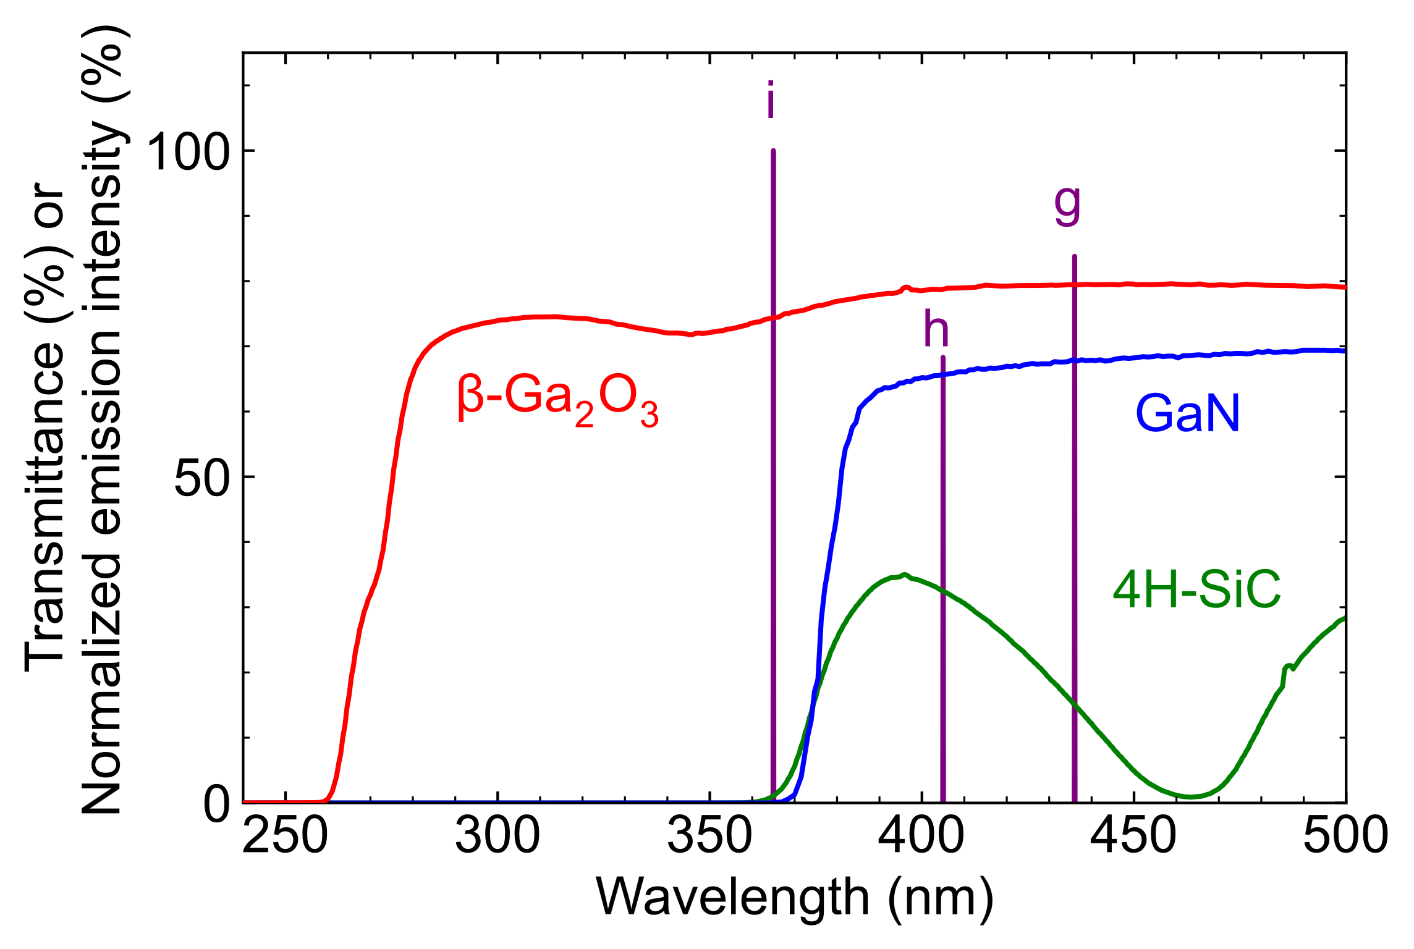
Fig. 1 (single column)

Fig. 2 (single column)
Fig. 3 (two columns)

