Effect of Co on twin formation and magnetic properties of Sm(Fe,Ti,V)₁₂ alloys
P. Tozman^{1*}, G. Hrkac², C. E. Patrick³, J. B. Staunton⁴, T. Saito¹, T. Sasaki¹, T. Ohkubo¹, H. Sepehri-Amin^{1*}
¹ National Institute for Materials Science, Tsukuba, Ibaraki 305-0047, Japan
²College of Engineering, Mathematics, and Physical Sciences, University of Exeter, Exeter, Devon, United Kingdom
³ Department of Materials, University of Oxford, Oxford OX1 3PH, United Kingdom
⁴ Department of Physics, University of Warwick, Coventry CV4 7AL, United Kingdom

Abstract

Transferring the excellent intrinsic magnetic properties of SmFe₁₂-based compounds to their extrinsic properties remains the main challenge in the development of high-performance SmFe₁₂-based permanent magnets. Twin formation is one of the reasons for the inability to achieve high coercivity and remanence. Here we have shown that the addition of Co in Sm(Fe_{1-x}Co_{x})₁₀₋₁₁M₁₋₂ alloys, where M=Ti and V, leads to an increase in twin density. Microstructural characterizations revealed that the atomic arrangement in the twin boundary changes depending on the stabilizing element, which directly influences the local intrinsic magnetic properties. Theoretical investigations showed that the critical grain size at which twin formation can be hindered by grain size reduction decreases when the stabilizer changes from V to Ti. This study shows that the alloy composition influences not only the intrinsic magnetic properties but also the twin formation energy and its grain size dependence, crucial for the design of SmFe₁₂-based permanent magnets.

Keywords: SmFe₁₂-based magnets; ThMn₁₂-type crystal structure; twin; microstructure; magnetic properties

* Corresponding authors: H. Sepehri-Amin (h.sepehriamin@nims.go.jp) and P. Tozman (pelin.tozman@tu-darmstadt.de)
Recent reports of the excellent intrinsic magnetic properties of SmFe₁₂-based compounds have highlighted their potential as next generation high performance permanent magnets that outperform Nd₂Fe₁₄B-based magnets [1-11]. The ability to adjust the composition in Sm(Fe, M)₁₂ provides phase stability while fine-tuning its intrinsic magnetic properties. For example, M=Zr, Co enhances the saturation magnetization (µ₀M_{s}) [3-6], and M=V can preserve the anisotropy field (µ₀H_{a}) while providing phase stability [7,10]. SmFe₁₂-based compounds exhibit a high magnetic anisotropy field (µ₀H_{a}) of ≈7.9-10.9 T and high saturation magnetization (µ₀M_{s}) of ≈1.43-1.52 T [8]. This could result in a high coercivity (based on Brown's paradox, H_{c} ~ 0.2–0.3×H_{a}) by separating 1:12 grains with a non-magnetic intergranular phase. The remanence can approach the saturation magnetization (M_{r} ≤ M_{s}) by aligning the magnetization of magnetic grains along the c-axis through texturing, leading to the development of a high-performance SmFe₁₂-based magnet. However, this has not been realized so far due to the major fundamental challenges in achieving the optimal microstructure, which require a deeper understanding and control of alloy design, defect engineering, and process parameters [8,12-14]. For example, the beneficial effect of Co on intrinsic magnetic properties does not always translate into an improvement in extrinsic magnetic properties in Sm(Fe,Co)₁₂-based compounds [5,14,15]. It is reported that ≈17 at.% of Co-substitution at the Fe sites in SmFe₁₁Ti enhances µ₀M_{s} from 1.14 T to 1.43 T in Sm(Fe_{0.8}Co_{0.2})₁₁Ti₁ with a slight improvement on µ₀H_{a} from 10.5 to 10.9 T [5,15]. However, the increase in coercivity due to Co substitution (≈10-16 at.%) in nanocrystalline ribbons and resin-bonded isotropic Sm(Fe,Co,Ti)₁₂-based magnets was only 0.1 T [16,17]. A large µ₀H_{c} of 1.26 T was achieved in the magnetically anisotropic powders prepared from (Sm,Zr)(Fe,Co,Ti)₁₂ monocrystalline particles [18]. Despite these results, the positive effects on the intrinsic magnetic properties have not been beneficial in obtaining good extrinsic magnetic properties in the anisotropic sintered magnets. For example, a small amount of Co addition in a Sm₈Fe_{73.5}Ti₈V₈Ga_{0.5}Al₂ sintered anisotropic magnet decreases µ₀M_{r} from 0.62 T to 0.6 T and µ₀H_{c} from 1.0 T to 0.55 T [14]. The reason for the lack of success in realizing sufficiently large coercivity in Sm(Fe,Co)₁₂-based sintered magnets remains an open question that could have intrinsic or extrinsic origins. Zhang et al. reported the reason for the coercivity degradation was the formation of undesired secondary phases such as the SmFe₂ phase [14]. However, they also observed a high density of twins in the microstructure of the Co-containing sintered magnet. It is an open question whether Co addition to the alloy changes the twin formation energy of the system and/or the critical grain size below which twin formation can be hindered. Answering this will benefit alloy design to develop SmFe₁₂-based magnets with a better control of defect density in the magnet, and the enhancement of coercivity and remanence. In this study, we investigate the role of Co on the intrinsic magnetic properties and twin formation of near single-phase Sm(Fe_{1-x}Co_{x})₁₀V₂ and Sm(Fe_{1-x}Co_{x})₁₁Ti₁ alloys.
Sm(Fe_{1-x}Co_{x})₁₀V₂ and Sm(Fe_{1-x}Co_{x})₁₁Ti₁ alloys for x = 0, 0.2, 0.4, and 0.6 were prepared by induction melting, adding an 20 wt.% excess of Sm to compensate for Sm evaporation. Unlike the Ti-stabilized alloys, the as-cast V-stabilized alloys did not show a single phase. Thus they were homogenized at 1313 K for 2 days under an Ar atmosphere, then quenched in water. Phase characterization was done by Rigaku SmartLab X-ray diffraction (XRD) with Cr-K_{α} (λ = 0.229 nm) radiation. The 20 μm size powers were embedded in Araldite glue and magnetically oriented under a 2 T field to determine easy and hard-axis magnetization directions. All the magnetic measurements were carried out using a 14 T Quantum Design Physical Property Measurement System (PPMS 14-T VSM) and a 7 T Quantum Design superconducting quantum interference device magnetometer (SQUID). The Curie temperature (T_{c}) was determined from thermomagnetic curves (M-T) measured at 0.05 T. The microstructure study was conducted using a Carl Zeiss Crossbeam 1540EsB scanning electron microscope (SEM) and FEI Helios Nanalob 650 SEM equipped with electron backscattered diffraction (EBSD). Molecular dynamics calculations were conducted using modified Morse and embedded-atom method potentials on supercell structures with crystallographic interfaces based on experimental inputs to analyze the effects of twinning and grain boundaries. The twin formation energies were calculated for various grain sizes of the alloys. This energy was then integrated into a multiple grain system with different interfaces to determine the lowest energy state, both with and without twin formation. This approach identified the conditions for twin formation as a function of grain size and composition. Ab initio calculations based on the disordered local moment picture implemented within the density functional theory (DFT) framework were used to calculate T_{c} and M_{s} [19-21]. This approach combines the statistical mechanics of the effective spins (local moments), and DFT, to describe the complementary evolution of electronic and magnetic structure as a variation of temperature. Strongly correlated 4f-electron effects are treated with a parameter-free, self-interaction correction approach which incorporates Hund's rules naturally [22]. In this way, temperature-dependent magnetic properties of the rare earth-Co₅ family [21] and Nd₂Fe₁₄B [23] have been described. The chemical disorder is described within the coherent potential approximation [24]. The all-electron HUTSEPOT code [25] was used for constructing the self-consistent one-electron potentials of DFT (available at hutsepot.jku.at.) The MARMOT code [26] was used for determining T_{c} and temperature-dependent magnetic properties (available at warwick.ac.uk/marmotcode). T_{c} and M_{s} were calculated by considering that Ti/V are in the 8i site and Co is on the 8f site. Lattice parameters a=0.85nm, c=0.47nm were used for all compositions.
The XRD patterns for all developed alloys are composed of tetragonal ThMn₁₂-type (I4/mmm) structure, commonly referred to as the 1:12 phase (Fig. S1). A trace amount of cubic α-Fe and SmFe₂ phases appear as a secondary phase for x = 0, 0.2, and for x = 0.4, respectively, in annealed Sm(Fe_{1-x}Co_{x})₁₀V₂. Fig. 1 shows the XRD patterns of magnetically aligned powders to detect the dependence of the easy magnetization direction on Co content. For Sm(Fe_{1-x}Co_{x})₁₁Ti₁ with x = 0, 0.2, and 0.4, the pronounced intensity of the (002) peak signifies that the easy magnetization direction of these compounds is oriented along the [002] direction, indicating a uniaxial magnetic alignment. As x increases to 0.6, the disappearance of the (002) peak and the co-existence of the (400) and (220) peaks indicate cone anisotropy [4,27⦌. On the other hand, for V-based alloys, the transformation from uniaxial anisotropy, marked by the presence of the (002) peak for x = 0 and 0.2, to planar anisotropy, indicated by the (400) peak at x = 0.6, occurs via an easy-cone anisotropy phase, where the (202) peak becomes intense alongside the (002) peak for x=0.4. The dominance of planar Co local anisotropy compared with axial local anisotropy of Fe was first suggested to be the reason for this change [3,4,15]. A deeper understanding has been achieved by determining the crystal field coefficient $A_{2}^{0}$ for Co-substitute SmFe12-based compounds, which plays a dominant role in the anisotropy constant, K₁. Refs [28,29] found that substituting Fe with Co on the 8j sites adjacent to the rare earth changes the sign of $A_{2}^{0}$ from negative to positive, due to the different charge distributions around Fe and Co atoms.

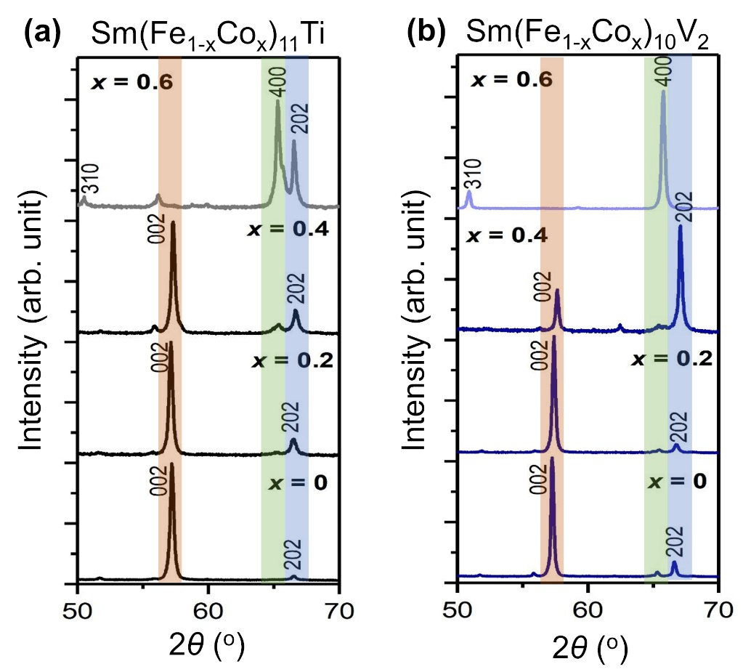
Fig. 1. XRD patterns of magnetically aligned (a) Sm(Fe_{1-x}Co_{x})₁₁Ti₁ and (b) Sm(Fe_{1-x}Co_{x})₁₀V₂ powders for x = 0,0.2, 0.4 and 0.6. The (002) peak, highlighted in orange, signifies uniaxial magnetic alignment, while the (400) peak, highlighted in green, corresponds to basal magnetic alignment. Additionally, the (202) peak, indicates the easy cone anisotropy occurs during the transition from uniaxial to planar anisotropy.

Fig. 2 shows the inverse pole figure (IPF) map of the 1:12 phase obtained from the SmFe₁₁Ti, Sm(Fe_{0.4}Co_{0.6})₁₁Ti, SmFe₁₀V₂ and Sm(Fe_{0.4}Co_{0.6})₁₀V₂ alloys. Due to the heat treatment of the V-stabilized alloys, they exhibit larger grain sizes than those of the Ti-stabilized alloys, making direct comparison between Ti- and V-based alloys difficult. However, it can be seen that the introduction of Co increases the formation of twins in both cases, as indicated by the black arrows. However, while there are several reports on the formation of twins in the 1:12 system and minimizing their density by reducing the grain size [30-32], there is little investigation on how the alloy composition can affect the twin density in the alloys.
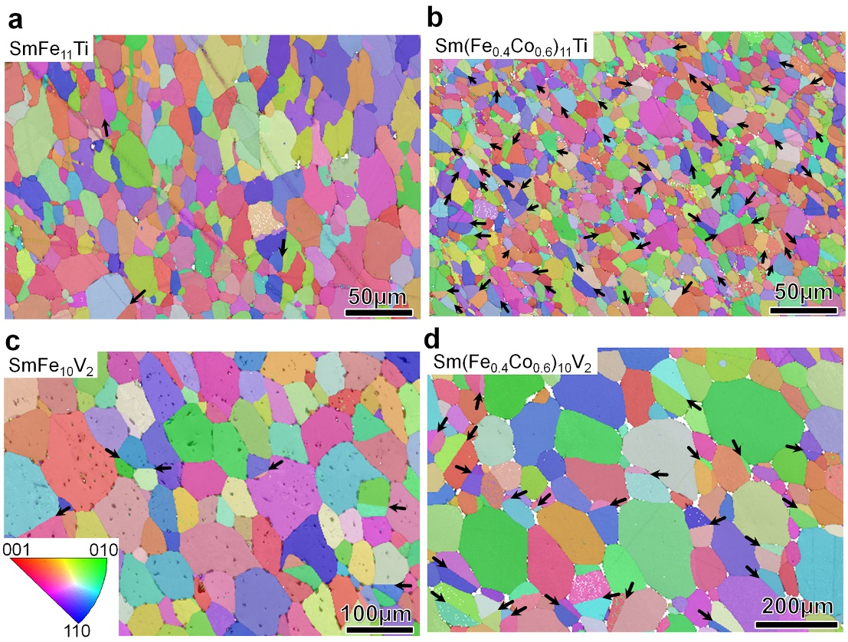
Figure 2: Inverse pole figure (IPF) maps obtained from SEM-EBSD analysis of the SmFe₁₂-based grains with ThMn₁₂ type crystal structure from (a) SmFe₁₁Ti, (b) Sm(Fe_{0.4}Co_{0.6})₁₁Ti, (c) SmFe₁₀V₂, and (d) Sm(Fe_{0.4}Co_{0.6})₁₀V₂ alloys.
It has been reported that twin planes in different types of alloys with ThMn₁₂-type crystal structure are {101} planes; for example in the Sm(Fe,Co,Ga,V,Ti)₁₂-based sintered magnets and SmFe₁₁Ti and NdFe₁₁Ti polycrystalline alloys [14,30,31]. Ener et al. reported that the twin plane contains more Sm than the 1:12 grains while Ti is depleted from the twin boundary in the SmFe₁₁Ti system [31]. Based on the composition obtained from atom probe tomography, Ener et al. speculated that the phase at the twin plane should be the 3:29 phase [31]. However, Zhang et al. did not detect any element segregation in the twin boundary region of Sm(Fe,Ti,V) ₁₂₋based compounds [14]. The question is whether the twin boundary region can be influenced by the composition of the alloy. We have investigated the twin boundary region in the Sm(Fe_{0.4}Co_{0.6})₁₁Ti and Sm(Fe_{0.4}Co_{0.6})₁₀V₂ alloys, as shown in HAADF-STEM images in Figure 3 (a,b). STEM-EDS maps were also obtained to demonstrate the distribution of constituent elements (Fig. 3(c,d)). The twin plane remains the same, {101} plane for both alloys with different stabilizers. However, the projection of atoms at the twin plane depends on the stabilizing element. As long as Ti is the only stabilizing element in the Sm(Fe_{0.4}Co_{0.6})₁₁Ti alloy, there is a displacement of Sm atoms in the twin plane and thus depletion of Ti as observed in Fig. 3(c). Although there is no comprehensive investigation of the atomic arrangement at the edge-on of the twin boundary, a similar feature was observed in the SmFe₁₂-based grains near the interface with the secondary phases observed by Srinithi et al. in a Sm(Fe,Co,Ti)₁₂-based system [33]. However, changing the stabilizing element from Ti to V results in the formation of a twin boundary region without any Sm atoms’ displacement in the twin boundary as shown in Fig. 3(d). This result is in agreement with the observation of Zhang et al. in a Sm(Fe,Ti,V)₁₂-based system [14]. Different atomic arrangements in the twin boundary region may lead to a change in the crystal field experienced by the Sm atoms, and hence a change in the local magnetocrystalline anisotropy. Although there are some prior studies on the crystal field fluctuations in the Sm(Fe,Ti)₁₂ lattice or the interior of SmFe₁₂ twin [24], further theoretical calculations are needed to predict the local crystal field at the observed twin boundary region. However, it is still an open question as to whether the change in atomic arrangement in the twin boundary is solely due to the composition of the alloys or whether post-annealing can modify the atomic arrangement of the twin boundary region, which can be further investigated in the future.
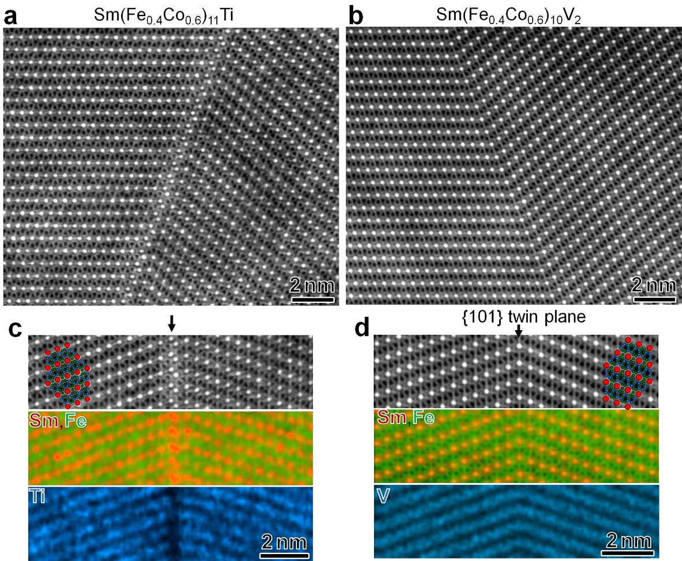
Figure 3: High-resolution high-angle annular dark-field (HAADF)-STEM images and STEM-EDS maps of constituent elements obtained from the twin boundary region of (a,c) Sm(Fe_{0.4}Co_{0.6})₁₁Ti and (b,d) Sm(Fe_{0.4}Co_{0.6})₁₀V₂ alloys.

Grain size reduction is reported to be the way to hinder twin formation in RE(Fe,M)₁₂- based systems, both experimentally [30] and through combined experimental and molecular dynamics simulations [31]. The question is whether the stabilizer element can change the grain size dependence on the twin formation energy. Molecular dynamics simulations were employed and the twin formation energy was calculated by comparing the total formation energy of Ti and V based 1:12 systems with and without twin-boundaries, as a function of grain size as shown in Fig. 4. The more negative twin formation energy in the Ti-stabilized alloys indicates easier twin formation compared to the V-stabilized alloys with comparable grain size. The critical grain size, below which twin formation energy becomes positive, is larger for SmFe₁₀V₂ compared to SmFe₁₁Ti₁. Therefore, use of V may be expected to increase the grain size range in which twinning is energetically unfavorable. Note that in these molecular dynamics simulations, the atomic arrangement was assumed to be identical for SmFe₁₀V₂ and SmFe₁₁Ti₁. Further investigation is needed to consider a different atomic arrangement in the twin boundaries, as was the case for the SmFe₁₁Ti₁ system, which may influence the grain size dependence of the twin formation energy.

Fig. 4. Calculated twin formation energy versus grain size for SmFe₁₁Ti (black) and SmFe₁₀V₂ (blue) alloys.

We have also studied experimentally and numerically how the addition of Co influences T_{c}, M_{s}, and K_{u} in Sm(Fe_{1-x}Co_{x})₁₀₋₁₁M₁₋₂ alloys, where M=Ti and V (Fig. 5 and Table 1). T_{c} is determined from M-T curves measured under a 500 Oe external magnetic field (Fig. S2). The substitution of Co in Sm(Fe_{1-x}Co_{x})₁₁Ti₁ leads to a monotonic increase in T_{c} from 590 K for x = 0 to 800 K to 933 K for x = 0.4. The T_{c} of Sm(Fe_{0.4}Co_{0.6})₁₁Ti₁ exceeds the measurement range, which is limited to 940 K. A similar increase is also observed in the calculations. However, the calculated T_{c} values are ~200 K larger than that of the experimental ones. This overestimate is reasonable for a first-principles theory in which a mean-field approximation is used to treat the statistical mechanics of the local moments (effective spins) on the Sm, Fe and Co sites [19-23].
On the other hand, Co did not have a large effect on the experimental T_{c}’s in Sm(Fe_{1-x}Co_{x})₁₀V₂ (table 1). T_{c} is determined principally by the 3d-3d exchange interactions within the transition metal sublattices, which are influenced by the arrangement and relative proportions of the late transition metals Fe and Co and the early transition metals Ti and V. The lattice parameters a and c of Sm(Fe_{1-x}Co_{x})₁₁Ti₁ are found to be larger than those of Sm(Fe_{1-x}Co_{x})₁₀V₂ (Fig. S3) but this variation has little effect on the first-principles computational results which capture the main trends measured experimentally. Substituting Co for Fe increases µ₀M_{s} from 1.25 T for x = 0 to its maximum of 1.46T for x = 0.4. Further increasing Co to x = 0.6 decreases µ₀M_{s} to 1.32 T. The effect of Co on the enhancement of µ₀M_{s} is not as dominant in V-stabilized compounds. µ₀M_{s} increases by only 6 % from 0.9 T for x = 0 to its maximum of 0.95 T for x = 0.2. Further Co substitution decreases µ₀M_{s} to 0.77 T and 0.71 T linearly for x = 0.4 and x = 0.6, respectively. A similar trend is reported for Sm(Fe_{1-x}Co_{x})₁₀V₂ in the literature [34]. Moreover, the calculated values are found to be consistent with the experimental results as is shown in Fig. 5.
The effective anisotropy constant K_{u} = 2 K₁ + 4 K₂ is deduced along the hard direction of magnetization by the Sucksmith-Thompson (ST) method which is a useful method for polycrystalline powders. The sign of K_{u} is determined from XRD patterns of magnetically aligned powders, whether it is uniaxial or basal [3,35]. However, it should be noted that the ST method deduces larger K₁ and K₂ values compared with anomalous Hall effect-torque measurements owing to the slight misalignment between the direction of the external magnetic field and the hard-axis [36]. Nevertheless, the trend of K_{u} upon the addition of Co for the Ti-stabilized and V-stabilized alloys does not change. It is found that the K_{u} value is increased by a small amount of Co substitution in Sm(Fe_{1-x}Co_{x})₁₁Ti₁ from 10.73 MJ/m³ for x = 0 to 12.52 MJ/m³ for x = 0.2 (17 at.%). A similar enhancement in K_{u} [3] and K₁ [15] has been reported for bulk Sm(Fe_{1-x}Co_{x})₁₁Ti₁ for x =0.1-0.2 (7.7 - 17 at.% of Co) , as well as in K_{u} for thin film Sm(Fe_{1-x}Co_{x})₁₂ with x = 0.2 (20 at. %) [36] and theoretical calculations on SmFe₁₁Co [37]. K_{u} decreases drastically from 8.24 MJ/m³ for x = 0 to 2.40 MJ/m³ for x = 0.2 and to 0.6 MJ/m³ for x = 0.4 in Sm(Fe_{1-x}Co_{x})₁₀V₂.
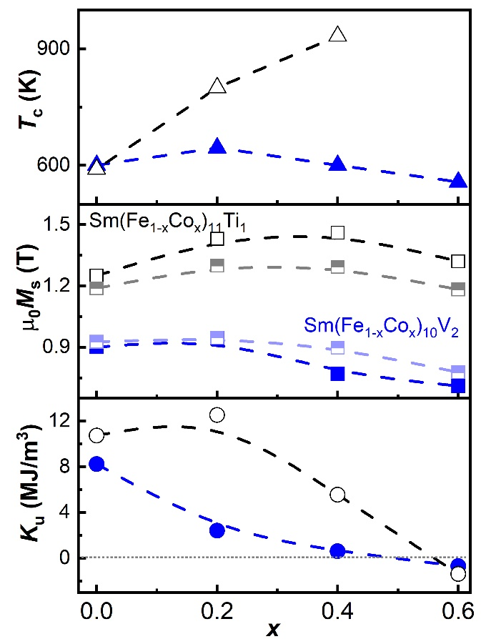

Fig. 5. The dependence of T_{c}, µ₀M_{s} and K_{u} on Co content in Sm(Fe_{1-x}Co_{x})₁₁Ti₁ (black) and Sm(Fe_{1-x}Co_{x})₁₀V₂ (blue) at 300 K. The calculated µ₀M_{s} values are represented with half-filled squares.

Table 1: µ₀M_{s}, K_{u}, and T_{c} of Sm(Fe_{1-x}Co_{x})₁₁Ti and Sm(Fe_{1-x}Co_{x})₁₀V₂ compounds measured experimentally and compared with the first-principles calculations.
Composition | µ₀M_{s} (T)  (Exp.) | µ₀M_{s} (T)  (Cal.) | K_{u} (MJ/m³) (Exp.) | T_{c} (K)  (Exp.) | T_{c} (K)  (Cal.)
SmFe₁₁Ti | 1.25 | 1.19 | 10.73±0.27 | 590 | 874
Sm(Fe_{0.8}Co_{0.2})₁₁Ti | 1.43 | 1.30 | 12.52±0.32 | 800 | 1016
Sm(Fe_{0.6}Co_{0.4})₁₁Ti | 1.46 | 1.29 | 5.54±0.58 | 933 | 1140
Sm(Fe_{0.4}Co_{0.6})₁₁Ti | 1.32 | 1.18 | -1.39±0.23 | - | 1179
SmFe₁₀V₂ | 0.90 | 0.93 | 8.24±0.27 | 600 | 634
Sm(Fe_{0.8}Co_{0.2})₁₀V₂ | 0.95 | 0.95 | 2.40±0.41 | 645 | 714
Sm(Fe_{0.6}Co_{0.4})₁₀V₂ | 0.77 | 0.90 | 0.60±0.07 | 600 | 753
Sm(Fe_{0.4}Co_{0.6})₁₀ V₂ | 0.71 | 0.78 | -0.71±0.17 | 557 | 820

In conclusion, we have shown how the alloy composition in the SmFe₁₂-based system can influence the twin formation energy. Based on XRD patterns of magnetically aligned powders and EBSD data, substitution of Co for Fe increases twin formation in both Ti- and V-stabilized alloys. However, differences in grain size and EBSD image locality make direct comparisons between alloys difficult. However, molecular dynamics simulations suggest that the twin formation energy is lower in the V-stabilized alloy than in the Ti-stabilized alloy for the same grain size. In addition, the atomic arrangement in the twin boundaries also depends on the type of stabilizing element. The enrichment of two monolayers of Sm and the depletion of Ti may have a more pronounced effect on the local anisotropy fields and thus on the coercivity observed in the SmFe₁₁Ti based system. While Co significantly enhances the intrinsic magnetic properties of SmFe₁₁Ti-based samples, its tendency to promote the twin formation may be a factor hindering the achievement of high µ₀H_{c} in Sm(Fe,Co,Ti)₁₂-based magnets. This work provides new insights into the influence of alloy composition in SmFe₁₂-based magnets, which should be designed not only in terms of intrinsic magnetic properties, but also in terms of defect density formation and its critical grain size below which twin formation can be suppressed.

This work was supported in part by the MEXT Program: Data Creation and Utilization-Type Material Research and Development Project (Digital Transformation Initiative Center for Magnetic Materials; JPMXP1122715503) and JSPS KAKENHI Grant Number JP23H01674 and JP21K14397, JST ERATO “Magnetic Thermal Management Materials” Grant Number JPMJER2201. UK Engineering and Physical Sciences Research Council Grant No. EP/W021331/1 (for advanced manufacturing aspects) and U. S. Department of Energy, Office of Basic Energy Sciences under Award Number DE SC0022168 (for atomic insight).

References:
[1] K. Ohashi, Y. Tawara, R. Osugi, M. Shimao, Magnetic properties of Fe‐rich rare‐earth intermetallic compounds with a ThMn₁₂ structure. J. Appl. Phys. 64 (1988) 5714-5716.
[2] B. P. Hu, H. S. Li, J. P. Gavigan, J. M. D. Coey, Intrinsic magnetic properties of the iron-rich ThMn₁₂-structure alloys R(Fe₁₁Ti); R= Y, Nd, Sm, Gd, Tb, Dy, Ho, Er, Tm and Lu, J. Condens. Matter. Phy., 1 (1989) 755.
[3] M. Solzi, R. H. Xue, L. Pareti, Magnetic anisotropy and first-order magnetization processes in Sm(Fe_{1−x}Co_{x})₁₀M₂ (M= Ti, Si) compounds, J. Magn. Magn. Mater. 88 (1990) 44-50.
[4]S.F. Cheng, V.K. Sinha, Y. Xu, J.M. Elbicki, E.B. Boltich, W.E. Wallace, S.G. Sankar, D.E. Laughlin, Magnetic and structural properties of SmTiFe_{11-x}Co_{x} alloys, J. Magn. Magn. Mater. 75 (1988) 330-338.
[5] P. Tozman, H. Sepehri-Amin, Y. K. Takahashi, S. Hirosawa, K. Hono, Intrinsic magnetic properties of Sm(Fe_{1-x}Co_{x})₁₁Ti and Zr-substituted Sm_{1-y}Zr_{y}(Fe_{0.8}Co_{0.2})_{11.5}Ti_{0.5} compounds with ThMn₁₂ structure toward the development of permanent magnets, Acta Mater. 153 (2018) 354-363.
[6] P. Tozman, Y. K. Takahashi, H. Sepehri-Amin, D. Ogawa, S. Hirosawa, K. Hono, The effect of Zr substitution on saturation magnetization in (Sm_{1-x}Zr_{x})(Fe_{0.8}Co_{0.2})₁₂ compound with the ThMn₁₂ structure, Acta Mater. 178 (2019) 114-121.
[7] A. M. Schönhöbel, R. Madugundo, O. Y. Vekilova, O. Eriksson, H. C. Herper, J. M. Barandiarán, G. C. Hadjipanayis, Intrinsic magnetic properties of SmFe_{12− x}V_{x} alloys with reduced V-concentration, J. Alloys Compd. 786, (2019) 969-974.
[8] P. Tozman, H. Sepehri-Amin, K. Hono, Prospects for the development of SmFe₁₂-based permanent magnets with a ThMn₁₂-type phase, Scripta Mater. 194 (2021) 113686.
[9] P. Tozman, H. Sepehri-Amin, T. Ohkubo, K. Hono, Intrinsic magnetic properties of (Sm,Gd)Fe₁₂-based compounds with minimized addition of Ti, J. Alloys Compd. 855 (2021) 157491.
[10] P. Tozman, T. Fukazawa, D. Ogawa, H. Sepehri-Amin, A. Bolyachkin, T. Miyake, S. Hirosawa, K. Hono, Y. K. Takahashi, Peculiar behavior of V on the Curie temperature and anisotropy field of SmFe_{12-x}V_{x} compounds, Acta Mater. 232 (2022)117928.
[11] T. Fukazawa, H. Akai, Y. Harashima, T. Miyake, First-principles investigation of Nd (Fe, M)₁₂ (M= K–Br) and Nd (Fe, Cr, Co, Ni, Ge, As)₁₂: Possible enhancers of Curie temperature for NdFe₁₂ magnetic compounds, Acta Mater. 226 (2022) 117597.
[12] T. Saito, F. Watanabe, D. Nishio-Hamane, Magnetic properties of SmFe₁₂-based magnets produced by spark plasma sintering method, J. Alloys Compd. 773 (2019) 1018-1022.
[13] K. Otsuka, M. Kamata, T. Nomura, H. Iida, H. Nakamura, Coercivities of Sm–Fe–M Sintered Magnets with ThMn₁₂-Type Structure (M= Ti,V), Mater. Trans. 62 (2021) 887-891.
[14] J. S. Zhang, X. Tang, A. Bolyachkin, A. K. Srinithi, T. Ohkubo, H. Sepehri-Amin, K. Hono, Microstructure and extrinsic magnetic properties of anisotropic Sm(Fe, Ti, V)₁₂-based sintered magnets, Acta Mater. 238 (2022) 118228.
[15] I. S. Tereshina, S. A. Nikitin, T. I. Ivanova, K. P. Skokov, Rare-earth and transition metal sublattice contributions to magnetization and magnetic anisotropy of R(TM,Ti)₁₂ single crystals., J. Alloys Compd. 275 (1998) 625-628.
[16] L. Schultz, K Schnitzke, J. Wecker, Magnetic hardening of Sm-Fe-Mo, Sm-Fe-V and Sm-Fe-Ti magnets, J. Magnet. Magnet. Mater. 83 (1990) 254.
[17] J. Wecker, M. Katter, K. Schnitzke, L. Schultz, Magnetic hardening of Sm‐Fe‐Ti alloys, J. Appl. Phys. 67 (1990) 4951.
[18] A. M. Gabay, G. C. Hadjipanayis, High-coercivity ThMn₁₂-type monocrystalline Sm–Zr–Fe–Co–Ti particles by high-temperature reduction diffusion, Scripta Mater. 196 (2021) 113760.
[19] B. L. Gyorffy, A. J. Pindor, J. Staunton, G. M. Stocks, H. Winter, A first-principles theory of ferromagnetic phase transitions in metals. J. Phys. F: Metal Phys. 15 (1985) 1337.
[20] J. B. Staunton, L. Szunyogh, A. Buruzs, B. L. Gyorffy, S. Ostanin, L. Udvardi, Temperature dependence of magnetic anisotropy: An ab initio approach, Phys. Rev. B 74 (2006) 144411.
[21] C. E. Patrick, J. B. Staunton, Temperature-dependent magnetocrystalline anisotropy of rare earth/transition metal permanent magnets from first principles: the light RCo₅ (R= Y, La-Gd) intermetallics, Phys. Rev. Mat. 3, (2019) 101401.
[22] C. E. Patrick, J. B. Staunton, Rare-earth/transition-metal magnets at finite temperature: Self-interaction-corrected relativistic density functional theory in the disordered local moment picture Phys. Rev. B 97 (2018) 224415.
[23] J. Bouaziz, C. E. Patrick, J. B. Staunton, Crucial role of Fe in determining the hard magnetic properties of Nd₂Fe₁₄B, Phys. Rev. B 107 (2023) L020401.
[24] C. E. Patrick, Y. Huang, L. H. Lewis, J. B. Staunton, Theory of Defect-induced Crystal Field Perturbations in Rare Earth Magnets, Phys. Rev. Lett. 132, (2024) 056703.
[25] M. Hoffmann, A. Ernst, W. Hergert, V. N. Antonov, W. A. Adeagbo, R. M. Geilhufe, H. Ben Hamed, Magnetic and Electronic Properties of Complex Oxides from First‐Principles, Physica Status Solidi (b) 257 (2020) 1900671.
[26] C. E. Patrick, J. B. Staunton, MARMOT: magnetism, anisotropy, and more, using the relativistic disordered local moment picture at finite temperature, Electronic Structure 4 (2022) 017001.
[27] J. Zhong, G. Tan, Q. Man, M. Ning, Y. Gao, X. Liu, and J. Pan, Optimisation of microwave absorption properties of Fe-substituted Y₂Co_{17−x}Fe_{x} soft-magnetic composites. J. Mater. Sci.: Mater. Electron. 32 (2021) 27849-27859.
[28] M.D. Kuz'min, M. Richter, K.H.J. Buschow, Iron-rich versus cobalt-rich ThMn₁₂-type intermetallics: a comparative study of the crystal fields, Solid State Commun. 113, 1999, 47-51.
[29] Y. Skourski, I. Tereshina, S. Wirth, H. Drulis, N. Mattern, D. Eckert, S. Nikitin, K.H., Muller, Magnetocrystalline anisotropy of SmFe_{11-x}Co_{x}TiH_{y}, IEEE trans. on magn., 38 (2002) 2931.
[30] F. Maccari, L. Schäfer, I. Radulov, L. Diop, S. Ener, E. Bruder, K. Skokov, O. Gutfleisch, Rapid solidification of Nd_{1+x}Fe₁₁Ti compounds: phase formation and magnetic properties, Acta Mater. 180 (2019) 15-23.
[31] S. Ener, K. P. Skokov, D. Palanisamy, T. Devillers, J. Fischbacher, G. G. Eslava, F. Maccari, L. Schäfer, L. V. Diop, I. Radulov, B. Gault, Twins–A weak link in the magnetic hardening of ThMn₁₂-type permanent magnets, Acta Mater. 214 (2021) 116968.
[32] F. Maccari, S. Ener, D. Koch, I. Dirba, K. Skokov, E. Bruder, L. Schäfer, O. Gutfleisch, Correlating changes of the unit cell parameters and microstructure with magnetic properties in the CeFe₁₁Ti compound, J. Alloys Compd. 867 (2021) 158805
[33] A. K. Srinithi, H. Sepehri-Amin, X. Tang, P. Tozman, J. Li, J. Zhang, S. Kobayashi, T. Ohkubo, T. Nakamura, K. Hono, Phase relations and extrinsic magnetic properties of Sm–(Fe, Co)–Ti–(Ga)-based alloys for ThMn₁₂-type permanent magnets, J. Magn. Magn. Mater. 529 (2021) 167866.
[34] M. Jurczyk, Magnetic and crystallographic properties of SmFe_{10− x}Co_{x}V₂ compounds. J. Less-Common Met. 162 (1990) 149-154.
[35] H. C. Herper, K. P. Skokov, S. Ener, P. Thunström, L. V. Diop, O. Gutfleisch, O. Eriksson, Magnetic properties of NdFe₁₁Ti and YFe₁₁Ti, from experiment and theory, Acta Mater., 242, (2023) 118473.
[36] D. Ogawa, Y. Takuya, X. D. Xu, Y. K. Takahashi, H. Tsuchiura, T. Ohkubo, S. Hirosawa, K. Hono, Magnetic anisotropy constants of ThMn₁₂-type Sm(Fe_{1–x}Co_{x})₁₂ compounds and their temperature dependence, J. Magn. Magn. Mater. 497 (2020) 165965.
[37] T. Yoshioka, H. Tsuchiura, P. Novák, Effect of element doping and substitution on the electronic structure and macroscopic magnetic properties of SmFe₁₂-based compounds, Phys. Rev. B, 105 (2022) 014402.

