Enhanced computing performance of MoS₂-based Raman-ion-gating reservoir achieved by combining reservoir states from current response and resonant Raman scattering

Yoshitaka Shingaya¹, Daiki Nishioka^{1,2}, Kazuya Terabe¹, and Takashi Tsuchiya¹

¹Research Center for Materials Nanoarchitectonics (MANA), National Institute for Materials Science (NIMS), 1-1 Namiki, Tsukuba, Ibaraki, 305-0044, Japan.
²International Center for Young Scientists (ICYS), National Institute for Materials Science (NIMS), 1-1 Namiki, Tsukuba, Ibaraki, 305-0044, Japan.

Corresponding author email: SHINGAYA.Yoshitaka@nims.go.jp

Abstract
Reservoir computing (RC) is promising for achieving low power consumption neuromorphic devices. In this study, we have developed an all-solid-state electric double layer (EDL) transistor using multilayer MoS₂ to realize high-performance physical reservoir computing (PRC). We have demonstrated high-performance of MoS₂-based Raman-ion-gating reservoir (MoS₂-RIGR), in which gate voltage-dependent resonant Raman scattering spectra of MoS₂ were used as computational resources in addition to drain and gate current responses. Our device achieved good performance such as >97% accuracy in various nonlinear waveform transformations and 97.8% accuracy in solving a second-order nonlinear dynamic equation. Information processing capacity was evaluated to elucidate the origin of the high performance of our system.

Keywords: physical reservoir computing, resonant Raman scattering, MoS₂, electric double layer transistor, Raman-ion-gating reservoir
While machine learning, such as deep learning and generative AI, have recently dramatically enriched and changed our lives, their huge power consumption has become a serious problem. The power consumption of machine learning is caused by the large number of sum-of-products operations involved in executing hierarchical neural networks^{1, 2}. In order to reduce the power consumption of these sum-of-products operations, research on neurocomputers based on crossbar arrays using resistive change elements (memristors) that utilize electrical resistance and spin has been progressing³⁻¹⁴. The power consumption reduction here is obtained by reducing the power consumption per sum-of-products operation. On the other hand, physical reservoir computing, a computational method that reduces the number of sum-of-products operations required for machine learning, has attracted much attention^{15, 16}. Physical reservoir computing (PRC) is a method that uses the non-linear response exhibited by materials and devices, termed as physical reservoirs, to physically implement the nonlinear transformation function (mapping function) in the reservoir computing scheme, while in the case of deep learning, such function is implemented in the hidden layer of deep learning using a large number of sum-of-product operations. The number of connection weights in the network is overwhelmingly small, and the number of sum-of-product operations and corresponding power consumption can be dramatically reduced because the number of connection weights that need to be updated during training is limited to the readout weights. PRC has been explored by focusing on various materials and devices such as optical circuits, soft bodies, nanowire networks and ion-gating device¹⁷⁻⁴⁰. We have recently demonstrated high-precision PRC using enhanced Raman scattering of single or few molecules⁴¹. Although it was possible to predict changes in blood glucose levels in diabetics using the temporal dynamics of Raman spectra of para-mercaptobenzoic acid (pMBA) molecules with respect to variation in local proton concentration, it was not feasible for integration due to the need to use a bulky aqueous solution cell.
This study attempted to realize high-performance PRC by focusing on an all-solid-state electric double layer (EDL) transistor using multilayer MoS₂. It is known that the Raman spectrum of MoS₂ is sensitive to the electron carrier density due to resonant Raman scattering effects originating from the band structure⁴², and enhancement of nonlinearity can be expected when combined with high-density EDL charging. Furthermore, as good bipolar transistor operation can be obtained by electron carrier doping with EDL effect, the drain and gate currents as well as the Raman spectra, can be used as computational resources. In this study, we developed the MoS₂-based Raman-ion-gating reservoir (MoS₂-RIGR), a solid-state device for highly efficient information processing using the spatiotemporal behavior of ions and electrons in the nano-region near the 2D material/lithium solid electrolyte interface and the information processing capacity is analyzed.
MoS₂-RIGR devices were fabricated with few-layer MoS₂ prepared from bulk MoS₂ single crystals by the exfoliation method. MoS₂ thin films were prepared on a flat surface of a 150 µm-thick Li ion-conductive glass ceramics (LICGC) substrate. Using an optical microscope, few-layer MoS₂ were selected and Ti/Au (5 nm/50 nm) electrodes were attached. Electrical measurements of the device were carried out at room temperature under vacuum conditions (17 Pa) in a vacuum chamber. The effects of humidity and temperature on device performance were discussed in supplementary section S6. Raman scattering spectra were obtained using a micro-Raman system simultaneously with electrical measurements. 632.8 nm and 532 nm lasers were used as excitation light. Please refer to the supplementary section S1 for experimental details. The scalability and stability of the device were discussed in the supplementary section S8.
Figure 1a shows a schematic diagram of the MoS₂-RIGR which operates in an electric double layer (EDL) mechanism fabricated in this study. Transition metal dichalcogenide (TMDC) thin film was used as a transistor channel material. We have adopted MoS₂ as a channel material from TMDCs because it is known that the Raman spectra of multi-layer thin films of MoS₂ give intense peaks and show gate voltage dependence⁴². The LiCoO₂ film and Pt film was deposited on the back of the LICGC substrate as a gate electrode. The LiCoO₂ is a mixed Li⁺ ion-electron conductor and it can supply (remove) Li⁺ ion to (from) MoS₂/LICGC interface. As shown in Figure 1a, by applying a positive bias to V_{G}, Li⁺ ions accumulate at the MoS₂/LICGC interface, and the positively charged Li⁺ ions on the LICGC side and the negatively charged electrons induced on the MoS₂ side form an EDL. Figure 1b shows an optical microscope image of the fabricated device. The channel width and channel length of the MoS₂ device are 5.5 µm and 3.6 µm, respectively (Fig. S1). The number of layers of the MoS₂ thin film was found to be five⁴³, since the frequency difference between the E¹_{2g} and A_{1g} peaks of the non-resonant Raman scattering spectrum is 24.4 cm⁻¹ as shown in Fig. S2. The effects of device dimensions on device performance were discussed in supplementary section S3. The transfer characteristics obtained using this device with V_{D} = 1.0 V are shown in Fig. 1c. Bipolar characteristics are obtained. The increase in I_{D} with increasing V_{G} in the range of 0 to 3.0 V indicates electron conduction and the increase in I_{D} with decreasing V_{G} in the range of 0 to -2.5 V indicates hole conduction. The carrier density at V_{G} = 2.5 V was estimated as 3.0×10¹² cm⁻² (please refer to the supplementary section S4). To avoid degradation of device performance, repeated gate voltage application was limited to 2.5V (please refer to the supplementary section S9). The hysteresis observed in the I_{D}-V_{G} curve is due to the slow relaxation of ions at the MoS₂/LICGC interface, which enhance short-term memory. The I_{D}-V_{D} curves were shown in the supplementary section S5. Figure 1d shows the gate voltage dependence of the Raman scattering spectra obtained by irradiating the channel center of the MoS₂ device with 632.8 nm excitation laser. The energy of 632.8 nm light is 1.96 eV, which is close to the energy of the A exciton in bulk MoS₂ (1.88eV) ⁴⁴. Therefore, the Raman scattering spectra obtained here are resonant Raman scattering spectra. In non-resonant Raman scattering, two peaks, E¹_{2g} and A_{1g}, are mainly observed, whereas in resonant Raman scattering, many peaks appear in addition to E¹_{2g} and A_{1g} because phonons at the Brillouin zone edge can also become observable. Figure 1e shows intensity of A_{2u} peak at 467 cm⁻¹ as a function of V_{G}. The peak intensity decreases with increasing V_{G}. This is because increasing V_{G} induces electrons in the conduction band of MoS₂. Figure 1f shows simplified electronic band structure of multilayer MoS₂. The absorption of 632.8 nm light occurs close to the K/K’ point due to resonant effect. The electrons induced by V_{G} first occupy the conduction band minimum at Λ valley and then the K valley as doping increases. This induces a Pauli blocking effect, which prohibits absorption at the K/K′ point and also reduces the exciton oscillator strength. Therefore, as the exciton oscillator strength decreases, the resonant Raman intensity becomes smaller and the peak intensity decreases. In this study, in addition to the drain current (I_{D}) and gate current (I_{G}), the resonant Raman scattering spectra showing the V_{G} dependence was also used as a computational resource to enhance the performance of the ion-gating reservoir.
A nonlinear waveform transformation task was performed to demonstrate the computational capability of the MoS₂-RIGR. Figure 2a illustrates the task, where the goal of this task is to generate sinusoidal (Sin), square (Square), π/2 phase-shifted triangular (Shift), and frequency-doubled triangular (2f) waveforms using a linear combination (Eq. 1) of readout weights W and the reservoir states X (in this case I_{D}, I_{G} and Raman spectrum) from a triangular wave input
$\begin{aligned}Y\left(k\right)=WX\left(k\right) \#\left(1\right)\end{aligned}$
where k and Y(k) are the discrete time step and reservoir output, respectively. Readout weights were trained by the ridge regression: W=TX^{T}(XX^{T}+λI)⁻¹ where λ (=5×10⁻⁴) and I are the ridge parameter and the identity matrix, respectively. This task requires nonlinearity and high dimensionality in the reservoir, by which the basic computational capability of the reservoir can be evaluated. The information processing performance of the device was evaluated based on the accuracy calculated from the normalized mean squared error (NMSE) of the task.
$$\begin{aligned}NMSE=\frac{\sum_{k=1}^{L}{{\left[T\left(k\right)-y\left(k\right)\right]}^{2}}}{\sum_{k=1}^{L}{{\left[T\left(k\right)\right]}^{2}}} \#\left(2\right)\end{aligned}$$
$$\begin{aligned}Accuracy=1-\sqrt{NMSE} \#\left(3\right)\end{aligned}$$
Where L is the data length. The input triangular wave for the task was converted into a 6.2 s/step and 20 steps/period voltage signal (0-2.5 V) and input to the gate electrode of the MoS₂-RIGR. Each step yielded 10 virtual nodes from I_{D} and I_{G}, resulting in 20 reservoir states. Please refer to supplementary section S10 for the purpose of employing virtual nodes. Additionally, 128 states were extracted from Raman spectra in the 275–667 cm⁻¹ range, totaling 148 reservoir states. The Raman spectral response of MoS₂ channel for time steps to the periodic triangular wave input is shown in Fig. 2b. It can be seen that the bright resonant Raman scattering peak including E¹_{2g} peak at 383 cm⁻¹, A_{1g} peak at 406 cm⁻¹ and A_{2u} peak at 467 cm⁻¹ exhibit periodic blinking by responding to the triangular wave input. Such Raman scattering peaks contribute to enhancing the system's information processing capability as additional artificial neurons placed in the wavenumber space. As shown in Figure 2c, MoS₂-RIGR accurately generated target waveforms, achieving 99.5% for “Sin”, 97.1% for “Square”, 98.1% for “Shift”, and 98.0% for “2f”. Figure 2d shows the results of comparing the accuracy in performing the nonlinear waveform transformation task with different constituents of the reservoir states. By including the reservoir state obtained from the Raman spectra as a computational resource, a significant improvement in accuracy has been observed. For the detailed discussion on the effects of inclusion of Raman signals, please refer to supplementary section S7.
We evaluated the performance of the subject MoS₂-RIGR with the more difficult task of solving a second-order nonlinear dynamic equation (Eq. 4), as shown in Fig. 3a. During training, the readout weights were optimized so that the reservoir output matches the target equation, and in the test phase, the reservoir outputs were compared with target for the untrained data.
$$\begin{aligned}y\left(k\right)=0.4y\left(k-1\right)+0.4y\left(k-1\right)y\left(k-2\right)+0.6u^{3}\left(k\right)+0.1\#\left(4\right)\end{aligned}$$
where u(k) is a uniform random input ranging from 0 to 0.5. In this task, we set λ to 0.02. The reservoir is required to have at least two steps of short-term memory and nonlinearity to express Eq. 4. We used inverted pulse method that the reservoir states obtained with inverted input were included for enhancing computing performance⁴⁵. Figure 3b shows the reservoir output and the target waveform during the training phase. Both waveforms are in good agreement, and the MoS₂-RIGR learned the second-order nonlinear equations with 98.1% accuracy. In the test phase, a dataset different from the one used in training was input to the MoS₂-RIGR, and its prediction output was compared to a target generated by Eq. 4. As shown in Fig. 3c, the target waveform and the predicted waveform of the MoS₂-RIGR were in good agreement, even using a dataset that was different from the one used in training, and the MoS₂-RIGR was able to predict the target waveform with an accuracy of 97.8%. Such an excellent predictive accuracy on the test dataset indicates that it possesses sufficient computational power to represent complex time series (constructed from past delays and their polynomials) described by Eq. 4. This also demonstrates the robustness of the MoS₂-RIGR in information processing and its high reproducibility in input-output characteristics. In the case of this task, including Raman spectra for reservoir state enhance performance as shown in Fig. 3d. 37% reduction was achieved in NMSE. This improvement is thought to result from the reservoir states derived from Raman spectra, which introduce effective features for information processing, thus augmenting representational capacity.
To elucidate the origin of computational performance improvement associated with Raman spectra, we evaluated the information processing capacity (IPC) of the device⁴⁶. IPC is an index of the reservoir’s computational power independent of tasks, characterizing the reservoir’s short-term memory and nonlinearity quantitatively. The IPC is calculated based on the accuracy of regression tasks, where the reservoir generates outputs for targets transformed by n-degree polynomials of the input (and its delays) ^{46, 47}. The total capacity C_{tot} is defined as the sum of the sub-capacities C_{n}​ for each degree n.
$$\begin{aligned}C_{tot}=\sum_{n}{C_{n}} \#\left(5\right)\end{aligned}$$
Generally, a reservoir with a high total capacity can perform well across various tasks, exhibiting high computational performance. For more details on the IPC calculation method, please refer to the supplementary section S2. Figure 3e shows the IPC with and without Raman spectroscopy included as part of the reservoir state. By including Raman spectroscopy, C_{tot} improved by 47%, which explains well with the observed performance improvement in Fig. 3d. Particularly, the enhancements in third- and sixth-order capacities directly explain the performance gains from adding Raman spectra (e.g., terms like u³(k) from the third term on the left side of Eq. 4, and terms like u³(k-1) and u³(k-1)×u³(k-2) from expansions of y(k-1) and y(k-1)×y(k-2) in Eq. 4). Furthermore, it is noteworthy that higher-order capacities above the seventh order emerged with the inclusion of Raman spectra. When expanding Eq. 4 for y, higher-order u-terms appear, making these high-order capacities particularly useful for accurately reproducing the intricacies of Eq. 4. The appearance of high-order capacities with Raman addition is attributed to the temporal dynamics of the Raman spectrum. As described in the previous section, the Raman scattering spectra of MoS₂ obtained here are enhanced by the resonant Raman scattering effect. The enhancement is significantly modulated by the electron injection to the conduction band, because Pauli blocking effect by injected electrons attenuate absorption of light. The complicated and steep response of the resonant Raman scattering spectra to the carrier injection contributes to the appearance of higher-order capacities. The temporal dynamics of the Raman spectrum provides characteristics fundamentally different from the current response to input, thus introducing new feature dimensions. This inclusion of distinct nonlinear dynamics introduces new axes in the high-dimensional space generated by the reservoir, enhancing the ability to extract input features and perform nonlinear transformations^{34, 48}. The total capacity of MoS₂-RIGR, including higher-order capacities, is approximately 19, which is high for an experimental PRC (for example, 5.6 for the spin torque oscillator⁴⁷ and around 8 for optoelectronic circuits⁴⁹). This high C_{tot} is the source of the MoS₂-RIGR's high performance in the second-order nonlinear dynamical system task shown in Fig. 3c, as well as in each waveform transformation task shown in Fig. 2d. For the detailed discussion on C_{tot} required for a practical device, please refer to supplementary section S11.
Figure 3f shows the performance of the subject MoS₂-RIGR compared with other physical reservoirs reported to date^{17, 22, 23, 33, 34, 41, 45, 50}. Our device is positioned within a high-performance class as a PRC due to its high accuracy in this task, even though it does not surpass the conventional diamond-based IGR or the spin-wave interference-RC. Furthermore, it is noteworthy that while conventional IGRs achieve high-dimensionality through multi-channel integration (and time-multiplexing) ^{33, 34, 45, 50-54}, our device achieves high dimensionality with only a single channel through vibrational mode detection based on Raman spectroscopy. This not only indicates potential for further performance improvements by increasing the number of channels but also demonstrates that the device can overcome geometric constraints, forming network structures far more extensive and high-dimensional than its physical structure would suggest.
Enhanced computing performance of the MoS₂-RIGR was demonstrated by temporal dynamics of electrical conduction and resonant Raman scattering spectra for multilayer MoS₂, achieved by LICGC solid electrolyte-based EDLT. The multiple peaks of the resonant Raman scattering spectra and the high sensitivity to electronic carrier density, which is related to the Pauli blocking effect among doped electronic carriers, helped enhance the high dimensionality of the MoS₂-RIGR as a dynamical system, leading to excellent information processing capability. The MoS₂-RIGR showed high accuracy in the nonlinear waveform transformation task with four types of target waveform. It demonstrated precise prediction capability in a second-order nonlinear dynamic equation task with 97.8% accuracy in the test phase. Evaluation of IPC evidenced that the high C_{tot} of 18.9 is obtained by the inclusion of Raman spectra with diverse dynamics and is attributed to the source of the MoS₂-RIGR's high performance in the tasks. Towards the development of high-performance and highly integrated machine learning circuits, there will be a severe restriction in the device volume as well as computation capability and power consumption. The present result indicates a promising way to obtain high dimensionality with small device volume by utilizing Raman spectroscopy. Combination with the present technique will help us to derive untouched information processing capability from nanomaterials in various forms, leading to innovative classes of neuromorphic devices based on the nanoarchitectonics principle ⁵⁵⁻⁵⁹.

Supplementary material
See the supplementary material for the experimental details; atomic force microscopy image; non-resonant Raman spectrum of MoS₂; IPC calculation method; device dimension dependence on calculation performance; carrier density of MoS₂; I_{D}-V_{D} characteristics and V_{D} dependence on calculation performance; effects of humidity and temperature on device performance; discussion on significant improvement in accuracy by inclusion of Raman signals; scalability and stability of the device; limiting factors of the present device; purpose of employing virtual nodes; C_{tot} required for a practical device.

Acknowledgement
This research was in part supported by JSPS KAKENHI Grant Number JP24KJ0229 (Grant-in-Aid for JSPS Fellows). A part of this work was supported by JST PRESTO Grant number, JPMJPR23H4. A part of this work was supported by "Advanced Research Infrastructure for Materials and Nanotechnology in Japan (ARIM)" of the Ministry of Education, Culture, Sports, Science and Technology (MEXT). Proposal Number JPMXP1224NM5282 and JPMXP1225NM5462.

Conflict of Interest
The authors declare no conflict of interest.

Data availability statement
The data that support the findings of this study are available from the corresponding author upon reasonable request.

References
¹ Y. LeCun, Y. Bengio, and G. Hinton, “Deep learning,” Nature 521, 436 (2015).
² C. C. Aggarwal, Neural networks and deep learning. (Springer, 2018).
³ S. H. Jo, T. Chang, I. Ebong, B. B. Bhadviya, P. Mazumder, and W. Lu, “Nanoscale memristor device as synapse in neuromorphic systems,” Nano Lett. 10, 1297 (2010).
⁴ S. Park, A. Sheri, J. Kim, J. Noh, J. Jang, M. Jeon, B. Lee, B. R. Lee, B. H. Lee, and H. Hwang, presented at the Technical Digest - International Electron Devices Meeting, IEDM, 2013.
⁵ D. Kuzum, R. G. D. Jeyasingh, B. Lee, and H. S. P. Wong, “Nanoelectronic programmable synapses based on phase change materials for brain-inspired computing,” Nano Lett. 12, 2179 (2012).
⁶ S. Kumar, J. P. Strachan, and R. S. Williams, “Chaotic dynamics in nanoscale NbO₂ Mott memristors for analogue computing,” Nature 548, 318 (2017).
⁷ M. Prezioso, F. Merrikh-Bayat, B. D. Hoskins, G. C. Adam, K. K. Likharev, and D. B. Strukov, “Training and operation of an integrated neuromorphic network based on metal-oxide memristors,” Nature 521, 61 (2015).
⁸ G. W. Burr, R. M. Shelby, S. Sidler, C. Di Nolfo, J. Jang, I. Boybat, R. S. Shenoy, P. Narayanan, K. Virwani, E. U. Giacometti, B. N. Kurdi, and H. Hwang, “Experimental demonstration and tolerancing of a large-scale neural network (165 000 synapses) using phase-change memory as the synaptic weight element,” IEEE Trans. Electron Devices. 62, 3498 (2015).
⁹ S. Choi, S. H. Tan, Z. Li, Y. Kim, C. Choi, P. Y. Chen, H. Yeon, S. Yu, and J. Kim, “SiGe epitaxial memory for neuromorphic computing with reproducible high performance based on engineered dislocations,” Nat. Mater. 17, 335 (2018).
¹⁰ K. Terabe, T. Tsuchiya, and T. Tsuruoka, “Atomic scale switches based on solid state ionics,” Adv. Phys. X 7, 2065217 (2022).
¹¹ P. Yao, H. Wu, B. Gao, S. B. Eryilmaz, X. Huang, W. Zhang, Q. Zhang, N. Deng, L. Shi, H. S. P. Wong, and H. Qian, “Face classification using electronic synapses,” Nat. Commun. 8, 15199 (2017).
¹² X. Yao, K. Klyukin, W. Lu, M. Onen, S. Ryu, D. Kim, N. Emond, I. Waluyo, A. Hunt, J. A. del Alamo, J. Li, and B. Yildiz, “Protonic solid-state electrochemical synapse for physical neural networks,” Nat. Commun. 11, 3134 (2020).
¹³ M. Sharad, C. Augustine, G. Panagopoulos, and K. Roy, “Spin-based neuron model with domain-wall magnets as synapse,” IEEE Trans. Nanotechnol. 11, 843 (2012).
¹⁴ S. Lequeux, J. Sampaio, V. Cros, K. Yakushiji, A. Fukushima, R. Matsumoto, H. Kubota, S. Yuasa, and J. Grollier, “A magnetic synapse: multilevel spin-torque memristor with perpendicular anisotropy,” Sci. Rep. 6, 31510 (2016).
¹⁵ G. Tanaka, T. Yamane, J. B. Héroux, R. Nakane, N. Kanazawa, S. Takeda, H. Numata, D. Nakano, and A. Hirose, “Recent advances in physical reservoir computing: A review,” Neural Netw. 115, 100 (2019).
¹⁶ K. Nakajima, “Physical reservoir computing-an introductory perspective,” Jpn. J. Appl. Phys. 59, 060501 (2020).
¹⁷ C. Du, F. Cai, M. A. Zidan, W. Ma, S. H. Lee, and W. D. Lu, “Reservoir computing using dynamic memristors for temporal information processing,” Nat. Commun. 8, 2204 (2017).
¹⁸ J. Moon, W. Ma, J. H. Shin, F. X. Cai, C. Du, S. H. Lee, and W. D. Lu, “Temporal data classification and forecasting using a memristor-based reservoir computing system,” Nat. Electron. 2, 480 (2019).
¹⁹ R. Midya, Z. R. Wang, S. Asapu, X. M. Zhang, M. Y. Rao, W. H. Song, Y. Zhuo, N. Upadhyay, Q. F. Xia, and J. J. Yang, “Reservoir computing using diffusive memristors,” Adv. Intell. Syst. 1, 1900084 (2019).
²⁰ Y. A. Zhong, J. S. Tang, X. Y. Li, B. Gao, H. Qian, and H. Q. Wu, “Dynamic memristor-based reservoir computing for high-efficiency temporal signal processing,” Nat. Commun. 12, 9 (2021).
²¹ J. Torrejon, M. Riou, F. A. Araujo, S. Tsunegi, G. Khalsa, D. Querlioz, P. Bortolotti, V. Cros, K. Yakushiji, A. Fukushima, H. Kubota, S. Yuasa, M. D. Stiles, and J. Grollier, “Neuromorphic computing with nanoscale spintronic oscillators,” Nature 547, 428 (2017).

²² W. Jiang, L. Chen, K. Zhou, L. Li, Q. Fu, Y. Du, and R. H. Liu, “Physical reservoir computing using magnetic skyrmion memristor and spin torque nano-oscillator,” Appl. Phys. Lett. 115, 192403 (2019).
²³ W. Namiki, D. Nishioka, Y. Yamaguchi, T. Tsuchiya, T. Higuchi, and K. Terabe, “Experimental demonstration of high‐performance physical reservoir computing with nonlinear interfered spin wave multidetection,” Adv. Intell. Syst. 5, 2300228 (2023).
²⁴ K. Nakajima, H. Hauser, T. Li, and R. Pfeifer, “Information processing via physical soft body,” Sci. Rep. 5, 11 (2015).
²⁵ H. O. Sillin, R. Aguilera, H. H. Shieh, A. V. Avizienis, M. Aono, A. Z. Stieg, and J. K. Gimzewski, “A theoretical and experimental study of neuromorphic atomic switch networks for reservoir computing,” Nanotechnology 24, 384004 (2013).
²⁶ X. J. Zhu, Q. W. Wang, and W. D. Lu, “Memristor networks for real-time neural activity analysis,” Nat. Commun. 11, 2439 (2020).
²⁷ J. Hochstetter, R. M. Zhu, A. Loeffler, A. Diaz-Alvarez, T. Nakayama, and Z. Kuncic, “Avalanches and edge-of-chaos learning in neuromorphic nanowire networks,” Nat. Commun. 12, 13 (2021).
²⁸ G. Milano, G. Pedretti, K. Montano, S. Ricci, S. Hashemkhani, L. Boarino, D. Ielmini, and C. Ricciardi, “In materia reservoir computing with a fully memristive architecture based on self-organizing nanowire networks,” Nat. Mater. 21, 195 (2022).
²⁹ E. C. Demis, R. Aguilera, K. Scharnhorst, M. Aono, A. Z. Stieg, and J. K. Gimzewski, “Nanoarchitectonic atomic switch networks for unconventional computing,” Jpn. J. Appl. Phys. 55, 1102B2 (2016).
³⁰ M. Nakajima, K. Inoue, K. Tanaka, Y. Kuniyoshi, T. Hashimoto, and K. Nakajima, “Physical deep learning with biologically inspired training method: gradient-free approach for physical hardware,” Nat. Commun. 13, 10487 (2022).
³¹ Y. Paquot, F. Duport, A. Smerieri, J. Dambre, B. Schrauwen, M. Haelterman, and S. Massar, “Optoelectronic reservoir computing,” Sci. Rep. 2, 287 (2012).
³² G. Van der Sande, D. Brunner, and M. C. Soriano, “Advances in photonic reservoir computing,” Nanophotonics 6, 561 (2017).
³³ D. Nishioka, T. Tsuchiya, W. Namiki, M. Takayanagi, M. Imura, Y. Koide, T. Higuchi, and K. Terabe, “Edge-of-chaos learning achieved by ion-electron- coupled dynamics in an ion-gating reservoir,” Sci. Adv. 8, ade1156 (2022).
³⁴ T. Wada, D. Nishioka, W. Namiki, T. Tsuchiya, T. Higuchi, and K.Terabe, “A redox-based ion-gating reservoir, utilizing double reservoir states in drain and gate nonlinear responses,” Adv. Intell. Syst. 5, 2300123 (2023).
³⁵ M. Takayanagi, D. Nishioka, T. Tsuchiya, M. Imura, Y. Koide, T. Higuchi, and K. Terabe, “Ultrafast-switching of an all-solid-state electric double layer transistor with a porous yttria-stabilized zirconia proton conductor and the application to neuromorphic computing,” Mater. Today Adv. 18, 100393 (2023).
³⁶ M. Akai-Kasaya, Y. Takeshima, S. Kan, K. Nakajima, T. Oya, and T. Asai, “Performance of reservoir computing in a random network of single-walled carbon nanotubes complexed with polyoxometalate,” Neuromorph. Comput. Eng. 2, 014003 (2022).
³⁷ H. Tanaka, M. Akai-Kasaya, A. TermehYousefi, L. Hong, L. X. Fu, H. Tamukoh, D. Tanaka, T. Asai, and T. Ogawa, “A molecular neuromorphic network device consisting of single-walled carbon nanotubes complexed with polyoxometalate,” Nat. Commun. 9, 2693 (2018).
³⁸ M. Cucchi, C. Gruener, L. Petrauskas, P. Steiner, H. Tseng, A. Fischer, B. Penkovsky, C. Matthus, P. Birkholz, H. Kleemann, and K. Leo, “Reservoir computing with biocompatible organic electrochemical networks for brain-inspired biosignal classification,” Sci. Adv. 7, eabh0693 (2021).
³⁹ Y. Usami, B. van de Ven, D. G. Mathew, T. Chen, T. Kotooka, Y. Kawashima, Y. Tanaka, Y. Otsuka, H. Ohoyama, H. Tamukoh, H. Tanaka, W. G. van der Wiel, and T. Matsumoto, “In-materio reservoir computing in a sulfonated polyaniline network,” Adv. Mater. 33, e2102688 (2021).
⁴⁰ S. H. Kan, K. Nakajima, T. Asai, and M. Akai-Kasaya, “Physical implementation of reservoir computing through electrochemical reaction,” Adv. Sci. 9, 2104076 (2022).
⁴¹ D. Nishioka, Y. Shingaya, T. Tsuchiya, T. Higuchi, and K. Terabe, “Few- and single-molecule reservoir computing experimentally demonstrated with surface-enhanced Raman scattering and ion gating,” Sci. Adv. 10, eadk6438 (2024).
⁴² X. Lu, M. I. B. Utama, X. Wang, W. Xu, W. Zhao, M. H. S. Owen, and Q. Xiong, “Gate-tunable resonant Raman spectroscopy of bilayer MoS₂,” Small 13, 1701039 (2017).
⁴³ C. Lee, H. Yan, L. E. Brus, T. F. Heinz, J. Hone, and S. Ryu, “Anomalous lattice vibrations of single- and few-layer MoS₂,” Acs Nano 4, 2695 (2010).
⁴⁴ X. Zhang, X. F. Qiao, W. Shi, J. B. Wu, D. S. Jiang, and P. H. Tan, “Phonon and Raman scattering of two-dimensional transition metal dichalcogenides from monolayer, multilayer to bulk material,” Chem. Soc. Rev. 44, 2757 (2015).
⁴⁵ Y. Yamaguchi, D. Nishioka, W. Namiki, T. Tsuchiya, M. Imura, Y. Koide, T. Higuchi, and K. Terabe, “Inverted input method for computing performance enhancement of the ion-gating reservoir,” Appl. Phys. Express 17, 024501 (2024).
⁴⁶ J. Dambre, D. Verstraeten, B. Schrauwen, and S. Massar, “Information processing capacity of dynamical systems,” Sci. Rep. 2, 514 (2012).
⁴⁷ S. Tsunegi, T. Kubota, A. Kamimaki, J. Grollier, V. Cros, K. Yakushiji, A. Fukushima, S. Yuasa, H. Kubota, K. Nakajima, and T. Taniguchi, “Information processing capacity of spintronic oscillator,” Adv. Intell. Syst. 5, 2300175 (2023).
⁴⁸ M. Inubushi and K. Yoshimura, “Reservoir computing beyond memory-nonlinearity trade-off,” Sci. Rep. 7, 10199 (2017).
⁴⁹ J. Pauwels, G. Verschaffelt, S. Massar, and G. Van der Sande, “Distributed Kerr non-linearity in a coherent all-optical fiber-ring reservoir computer,” Front. Phys. 7, 138 (2019).
⁵⁰ K. Shibata, D. Nishioka, W. Namiki, T. Tsuchiya, T. Higuchi, and K. Terabe, “Redox-based ion-gating reservoir consisting of (104) oriented LiCoO₂ film, assisted by physical masking,” Sci. Rep. 13, 21060 (2023).
⁵¹ D. Nishioka, T. Tsuchiya, M. Imura, Y. Koide, T. Higuchi, and K. Terabe, “A high-performance deep reservoir computer experimentally demonstrated with ion-gating reservoirs,” Communications Engineering 3 (2024).
⁵² T. Tsuchiya, D. Nishioka, W. Namiki, and K. Terabe, “Physical Reservoir Computing Utilizing Ion-Gating Transistors Operating in Electric Double Layer and Redox Mechanisms,” Adv. Electron. Mater. 10, 19 (2024).
⁵³ T. Tsuchiya, M. Takayanagi, D. Nishioka, W. Namiki and K. Terabe, “Electric double-layer effect in solid state ionics-based transistors and the application to neuromorphic computing,” In Interface Ionics: For All-Solid-State Batteries and Solid State Ionics Devices (pp. 513-523). (Springer Nature Singapore, Singapore, 2024)
⁵⁴ W. Namiki, D. Nishioka, T. Tsuchiya, T. Higuchi, and K. Terabe, “Magnetization vector rotation reservoir computing operated by redox mechanism,” Nano Lett. 24, 4383 (2024).
⁵⁵ D. Nishioka, T. Tsuchiya, T. Higuchi, and K. Terabe, “Enhanced synaptic characteristics of H_{x}WO₃-based neuromorphic devices, achieved by current pulse control, for artificial neural networks,” Neuromorphic Computing and Engineering 3, 034008 (2023).
⁵⁶ D. Nishioka, T. Tsuchiya, T. Higuchi, and K. Terabe, “Oxygen-tolerant operation of all-solid-state ionic-gating devices: Advantage of all-solid-state structure for ionic-gating,” Jpn. J. Appl. Phys. 59, SIIG09 (2020).
⁵⁷ M. Takayanagi, T. Tsuchiya, D. Nishioka, M. Imura, Y. Koide, T. Higuchi and K. Terabe, “Accelerated/decelerated dynamics of the electric double layer at hydrogen-terminated diamond/Li⁺ solid electrolyte interface,” Mater. Today Phys. 31, 101006 (2023)
⁵⁸ T. Tsuchiya, T. Nakayama, and K. Ariga, “Nanoarchitectonics intelligence with atomic switch and neuromorphic network system,” Appl. Phys. Express 15, 100101 (2022).
⁵⁹ T. Tsuchiya, K. Terabe, R. Yang, and M. Aono, “Nanoionic devices: Interface nanoarchitechtonics for physical property tuning and enhancement,” Jpn. J. Appl. Phys. 55, 1102A4 (2016).

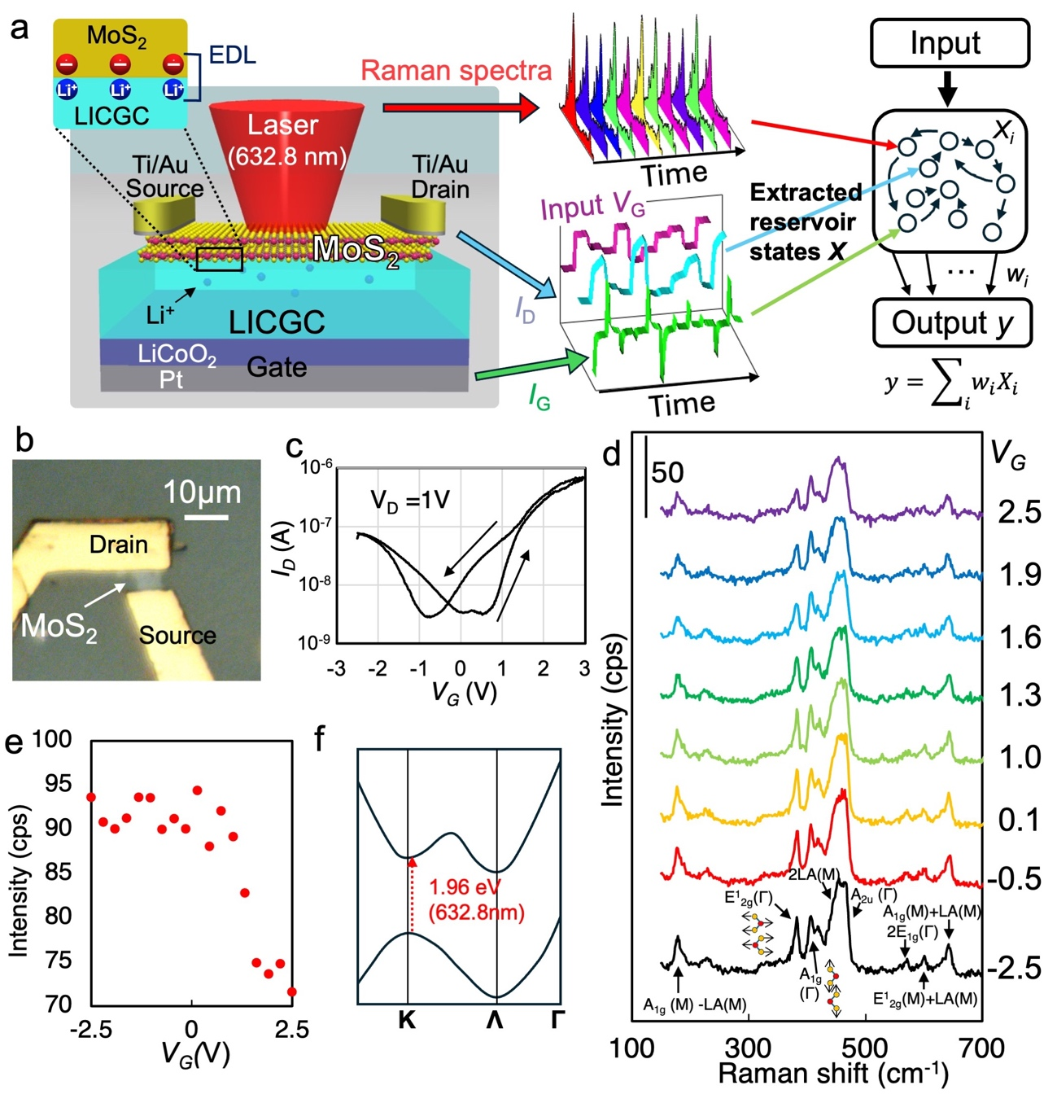
Figure 1. (a) Schematic diagram of MoS₂ ion-gating transistor. Inset shows electric double layer formed at the interface between MoS₂ and LICGC. (b) Optical microscope image of MoS₂ device. (c) I_{D} – V_{G} curve of MoS₂ transistor. (d) gate voltage dependent Raman scattering spectra from MoS₂ channel. (e) Intensity of A_{2u} peak at 467 cm⁻¹ in Raman spectra as a function of V_{G}. (f) Simplified electronic band structure of multilayer MoS₂.

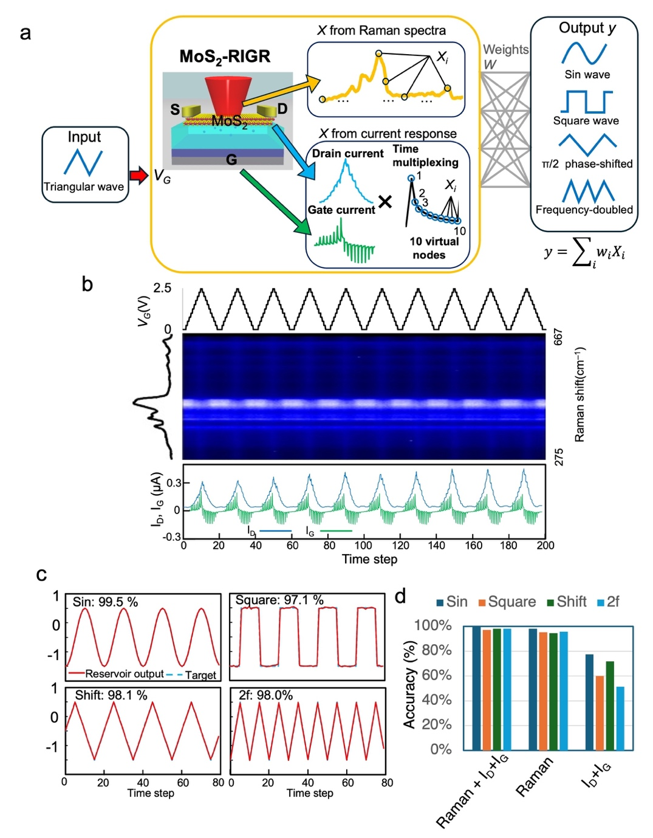
Figure 2. Nonlinear waveform transformation task. (a) Schematic of the nonlinear waveform transformation task calculated by MoS₂-RIGR. (b) Response of Raman spectra, I_{D} and I_{G} to triangular wave voltage application. (c) Results of the waveform transformation task using a sine wave, a square wave, a phase-shifted triangular wave, and a frequency-doubled triangular wave as the target waveform. The red line indicates the reservoir output and the blue dotted line indicates the target waveform. (d) Comparison of the accuracy in performing the nonlinear waveform transformation task with different constituents of the reservoir states.
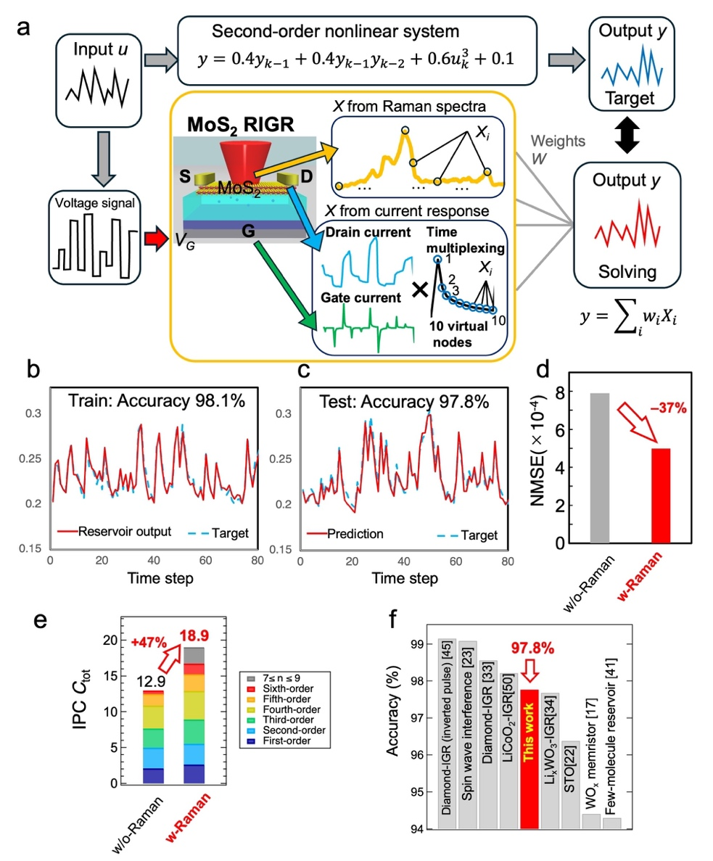
Figure 3. Second-order nonlinear dynamic equation task. (a) Schematic of task calculated by MoS₂-RIGR. Target and prediction waveforms of the second-order nonlinear dynamic equation at the (b) train phase and (c) test phase. (d) Comparison of NMSE with and without Raman spectra. (e) Comparison of total IPC with and without Raman spectra. (f) Performance of the subject MoS₂-RIGR compared with other physical reservoirs reported to date.

