(Nd,Sm,La)-Fe-B-based hot-deformed magnets with excellent comprehensive properties for variable-flux permanent magnet motors
A. K. Srinithi^{a,b}, Xin Tang^{a*}, H. Sepehri-Amin^{a,b}, T. Ohkuboª, K. Hono^{a,b}
ª National Institute for Materials Science, Tsukuba 305-0047, Japan
^{b} Graduate School of Science and Technology, University of Tsukuba, Tsukuba 305-8577, Japan

Abstract
An emerging motor type, the variable flux permanent magnet (VFPM) motor, has created a demand for permanent magnets with a new set of properties. These magnets must exhibit easily tunable magnetization, demanding for moderate coercivity values, low magnetizing fields, and flat first-order reversal curves (FORCs). In this work, we report that the doping of Sm and La in Nd-Fe-B-based hot-deformed magnet, followed by the Nd-Cu diffusion process, resulted in desirable magnetic properties, such as, a moderate coercivity (µ₀H_{c}) of 0.55 T, a low magnetizing field (µ₀H_{mag}) of 0.94 T and a high FORC flatness of 0.96, while maintaining a high remanence (µ₀M_{r}) of 1.3 T. The FORC flatness achieved in this work is the highest and the comprehensive properties are superior to the previously reported Nd-Fe-B magnets for VFPM motors. Microscopic investigations revealed that the high flatness of FORCs achieved in this hot-deformed magnet is attributed to the formation of Fe-lean thick intergranular phases realized by Nd-Cu grain boundary diffusion. The overall combination of the magnetic properties for the diffusion processed (Nd,Sm,La)-Fe-B magnet is excellent, in comparison with a commercially available Sm₂Co₁₇-type magnet, showing the promise of the former for use in VFPM motors.
* Corresponding author. Email address: Tang.Xin@nims.go.jp (Xin Tang).
- Introduction
Conventional permanent magnet (PM) motors have a rated speed at which their performance is most efficient. To enable higher speeds as required in electric vehicles, the back emf must be prevented from exceeding the source voltage, and this is achieved by introducing a flux-weakening current to counter the magnetic flux from the PM [1]. However, this flux-weakening current has the disadvantage of causing losses and reducing the efficiency of the motor at these high speeds. To address this limitation of the conventional motors, a variable flux permanent magnet motor (or memory motor) has been proposed, in which there is no need for a flux-weakening current; instead, the magnetization of the rotor PM is tuned by the stator current as desired by the speed condition [2-8]. In these VFPM motors, the drawback of the conventional PM motors can be overcome by maintaining the efficiency at a high level over the entire speed range, not just up to a rated speed. The permanent magnets used for this type of motor requires a new set of magnetic characteristics [4,8,9], and is referred here as “variable flux permanent magnets (VFPMs)”.
In the VFPM motors, the magnetization state of the rotor PM must be easily tuned by the stator current and to enable this, the coercivity (µ₀H_{c}) of the PM should be moderate (0.15 T to 0.65 T) and the first-order reversal curves (FORCs) must have a good flatness [7,9]. In addition, the magnetizing field (H_{mag}) of the PM should be low, preferably less than 1 T, in order to restore the initial magnetization while not contributing to a high electrical stress [9]. The basic criteria of high remanence (M_{r}) must also be considered for high efficiency [10]. All these desired properties need to be achieved in a highly textured anisotropic PM. For this purpose, the Sm₂Co₁₇-based magnet is currently the most suited material [4,6] as it has a good FORC flatness [11,12]. However, due to the low magnetization and high cost of Sm₂Co₁₇-based magnets, research on engineering the first-order reversal curves of Nd-Fe-B-based magnets for this application has emerged [8,9].
Table 1. Intrinsic magnetic properties (µ₀M_{s} and µ₀H_{A}) of LRE₂Fe₁₄B compounds [13-15]
 | Nd₂Fe₁₄B | Ce₂Fe₁₄B | La₂Fe₁₄B | Sm₂Fe₁₄B
µ₀M_{s} (T) | 1.61 | 1.17 | 1.38 | 1.52
µ₀ H_{A} (T) | 6.7 | 2.6 | 2.0 | --

Typically, the FORC flatness for the conventional Nd-Fe-B sintered magnets is poor because the magnetic domain walls move easily within the multidomain sized Nd₂Fe₁₄B grains; therefore, it is difficult to manipulate their magnetization under working conditions [9,16]. By reducing the grain size to approach the single-domain size, the FORC flatness can be improved by virtue of pinning effect on the domain walls at the grain boundaries, and this is achievable in hot-deformed or HDDR-processed magnets [8,9,17]. However, anisotropic hot-deformed Nd-Fe-B-based magnets usually have a coercivity above 1 T, which is too high for application as VFPMs [9,18,19]. To control the H_{c} within the desired range, the composition (and thus the anisotropy field, H_{A}) along with the microstructure must be engineered. The anisotropy field of the Nd₂Fe₁₄B-based compound can be reduced by substituting Nd with other light rare earth (LRE) elements, where LRE₂Fe₁₄B has low H_{A} values. However, substitution of Nd with LRE, e.g., La or Ce, generally results in a decrease in M_{s}. Hence, the search for a substitutional element that reduces the anisotropy field significantly with a minimal expense of M_{s} should be exploited as a strategy for the development of high-performance PMs for VFPM motor applications. It is expected from Table 1, that the substitution of Sm for Nd in Nd-Fe-B-based hot-deformed magnet could be a good approach. Recently, Sm substituted HDDR-processed Nd-Fe-B magnets was explored and found that µ₀H_{c} can be reduced to 0.4 T with a good flatness (evaluated by the flatness factor, F_{f}) of F_{f} =0.84 and a µ₀H_{mag} of 0.6 T; however, µ₀M_{r} of only 1.16 T was realized [8]. The M_{r} achieved in this case is not significantly higher than that of the Sm₂Co₁₇ magnets, making it difficult to replace the latter in practical applications. Another study showed that the (La,Ce)-substitution in hot-deformed Nd-Fe-B magnets can lead to a moderate coercivity of 0.44 T, while maintaining a good µ₀M_{r} of 1.26 T [9]. The work has showed that the hot-deformation process is a promising method to make Nd-Fe-B-based magnets suitable for VFPM motors. However, the FORC flatness factor was 0.75, which is lower compared to that of currently preferred Sm₂Co₁₇-based magnets, and the µ₀H_{mag} was 1.4 T, which is too high for VFPM motor application. These drawbacks in the magnetic properties of the previously reported hot-deformed Nd-Fe-B based magnets must be addressed for the practical application in VFPMs. Furthermore, the investigation of the magnetic properties at elevated temperatures, which is important for the operating conditions, has not been carried out in the previous studies.
In this work, the composition is tuned in the Nd-Fe-B-based system, and an excellent combination of magnetic properties for VFPM motors is achieved upon (Sm,La)-substitution for Nd in Nd-Fe-B hot-deformed magnets and by performing Nd-Cu eutectic grain boundary diffusion on this magnet. The comprehensive properties are found to be superior to those of the Sm₂Co₁₇ magnet, demonstrating that the Nd-Cu diffusion processed (Nd,Sm,La)-Fe-B magnet is promising as a variable flux permanent magnet. This work also provides an understanding of the microstructure dependence of the FORC flatness, and proposes additional FORC flatness factors for better evaluation.
- Experimental
Ingots with nominal compositions of R_{13.4}Fe_{76.3}Co_{4.5}Ga_{0.5}B_{5.3}, where R = Nd_{0.8}Sm_{0.2}, Nd_{0.8}Sm_{0.1}La_{0.1} and Nd_{0.8}Sm_{0.1}Ce_{0.1}, were prepared by induction melting and casting in an Ar atmosphere. The base composition was selected from Ref. [20]. These ingots were melt-spun at a surface wheel speed of 30 m/s to produce ribbons, which were hot-pressed after crushing. The hot-pressed pellet was then hot-deformed to achieve 75 % height reduction using the die-upset method. Detailed process conditions used for hot-deformation can be found in Ref. [20]. In addition, Nd₈₀Cu₂₀ ribbons were prepared by induction melting and melt spinning. Eutectic diffusion using 4 wt.% of the Nd-Cu ribbons on a selected hot-deformed magnet was performed at 923 K for 3 h as it is known to increase the coercivity [21-24].
A Carl-Zeiss Crossbeam 1540 EsB scanning electron microscope (SEM) was used to study the overall microstructure of the magnets. A Titan G2 80-200 transmission electron microscope (TEM) equipped with energy dispersive X-ray spectroscopy (EDS) was used to study the microstructure in detail. The B-H loops were measured using a 3 T B-H tracer at room temperature. The M-H hysteresis and FORCs were measured at room temperature and elevated temperatures up to 500 K, using a 7 T SQUID vibrating sample magnetometer (VSM) equipped with an oven.
- Results
  - Basic magnetic properties and microstructure of R-Fe-B-based hot-deformed (HD) magnets
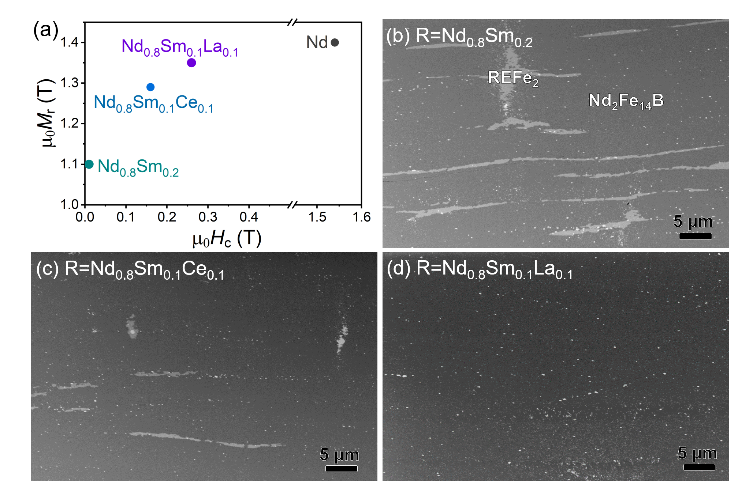
Fig. 1. (a) Remanence (µ₀M_{r}) and coercivity (µ₀H_{c}) plot, and BSE-SEM images of R-Fe-B hot-deformed magnets where (b) R= Nd_{0.8}Sm_{0.2}, (c) R=Nd_{0.8}Sm_{0.1}Ce_{0.1} and (d) R=Nd_{0.8}Sm_{0.1}La_{0.1}.
The µ₀M_{r} and µ₀H_{c} values for anisotropic hot-deformed magnets of the composition, R_{13.4}Fe_{76.3}Co_{4.5}Ga_{0.5}B_{5.3} where R = Nd [9], Nd_{0.8}Sm_{0.2}, Nd_{0.8}Sm_{0.1}Ce_{0.1} and Nd_{0.8}Sm_{0.1}La_{0.1}, are shown in Fig. 1(a). Without substitution of Nd, the coercivity and remanence were reported to be 1.54 T and 1.4 T, respectively [9]. The coercivity value of the Sm-substituted magnet is 0.04 T. This drastic reduction of µ₀H_{c} from 1.54 T for R=Nd to 0.04 T for R=Nd_{0.8}Sm_{0.2} is achieved because the magneto-crystalline anisotropy type of Sm₂Fe₁₄B is ‘basal’ [14]. However, this small coercivity is not suitable for VFPM motors, for which a moderate µ₀H_{c} ranging from ~0.15 T to ~0.65 T is required. The substitution of Ce and La along with Sm results in µ₀H_{c} values of 0.16 T and 0.25 T, and µ₀M_{r} values of 1.30 T and 1.35 T, for R=Nd_{0.8}Sm_{0.1}Ce_{0.1} and R=Nd_{0.8}Sm_{0.1}La_{0.1}, respectively. Fig. 1(b)-(d) shows low-magnification back scattered electron (BSE) SEM images of R=Nd_{0.8}Sm_{0.2}, Nd_{0.8}Sm_{0.1}Ce_{0.1} and Nd_{0.8}Sm_{0.1}La_{0.1} magnets. In the R=Nd_{0.8}Sm_{0.2} magnet, there is a large amount of inhomogeneously segregated REFe₂ phase with a lighter gray contrast, which does not occur in the R=Nd magnets [9]. The existence of this bulky REFe₂ phase could also be a reason for the too low coercivity. Fraction of this phase is reduced in the R=Sm_{0.1}Ce_{0.1} magnet, and eliminated in the R=Sm_{0.1}La_{0.1} magnet. As a result, the moderate coercivity and high remanence are achieved in the (Nd_{0.8}Sm_{0.1}La_{0.1})-Fe-B hot-deformed magnet. From here on, this article will focus on the R=Nd_{0.8}Sm_{0.1}La_{0.1} magnet because it exhibits both moderate H_{c} and high M_{r}.
  - Coercivity and microstructure of the (Nd_{0.8}Sm_{0.1}La_{0.1})-Fe-B-based magnets
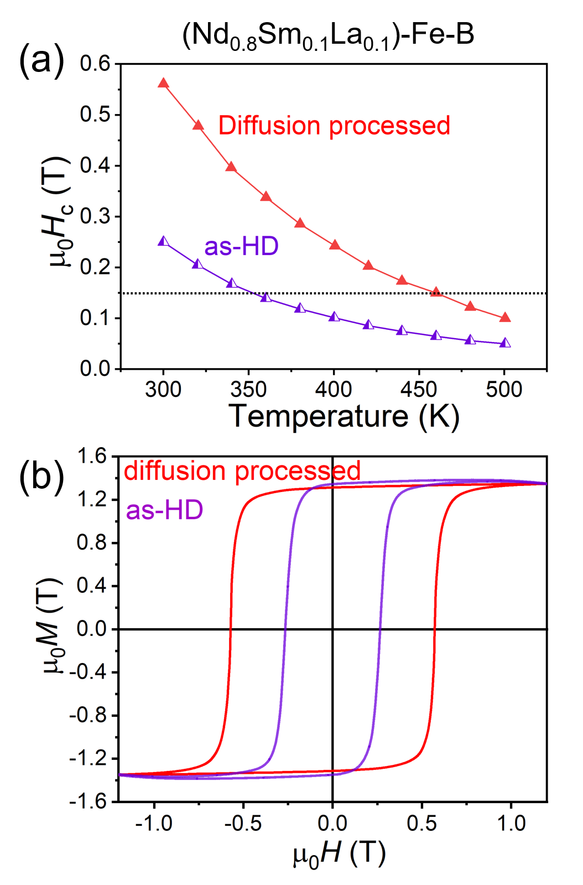
Fig. 2. (a) µ₀H_{c} vs. T and (b) M-H of hot-deformed (HD) and diffusion processed (Nd_{0.8}Sm_{0.1}La_{0.1})-Fe-B magnets.
For traction motor applications, the magnet temperature can be as high as 460 K [8]. At these elevated temperatures, the coercivity must be kept within the desired range. Although the room temperature coercivity of the (Nd_{0.8}Sm_{0.1}La_{0.1})-Fe-B magnet is acceptable for application, the elevated temperature coercivity is low (as shown in Fig. 2(a)). It can be seen that the µ₀H_{c} drops below 0.15 T at a temperature of ~350 K, making the magnet unsuitable for such applications. To overcome this, the eutectic diffusion process was performed using 4 wt.% Nd₈₀Cu₂₀ alloy, and the corresponding changes in the magnetic properties and microstructure were hence studied for the (Nd_{0.8}Sm_{0.1}La_{0.1})-Fe-B-based hot-deformed magnet.
Fig. 2(a) shows the H_{c} vs. temperature of the (Nd_{0.8}Sm_{0.1}La_{0.1})-Fe-B magnet before and after the eutectic diffusion process. The room temperature µ₀H_{c} increases from 0.25 T to 0.55 T upon diffusion of 4 wt.% of the Nd-Cu eutectic alloy. The diffusion processed magnet shows µ₀H_{c} values above 0.15 T up to an elevated temperature of 460 K, enabling its high-temperature operation. This shows that the diffusion process is necessary to keep the H_{c} within the desired range for the whole operating temperature range. Fig. 2(b) shows the M-H hysteresis for the as-hot-deformed (HD) and diffusion processed magnets. It can be seen that a high remanence of 1.3 T can be obtained even after the diffusion process, which is still higher than those of the previously reported moderate-H_{c} magnets [8,9] and those shown in Fig. 1. To understand the effect of the Nd-Cu diffusion on the microstructure, SEM and TEM observations were carried out.
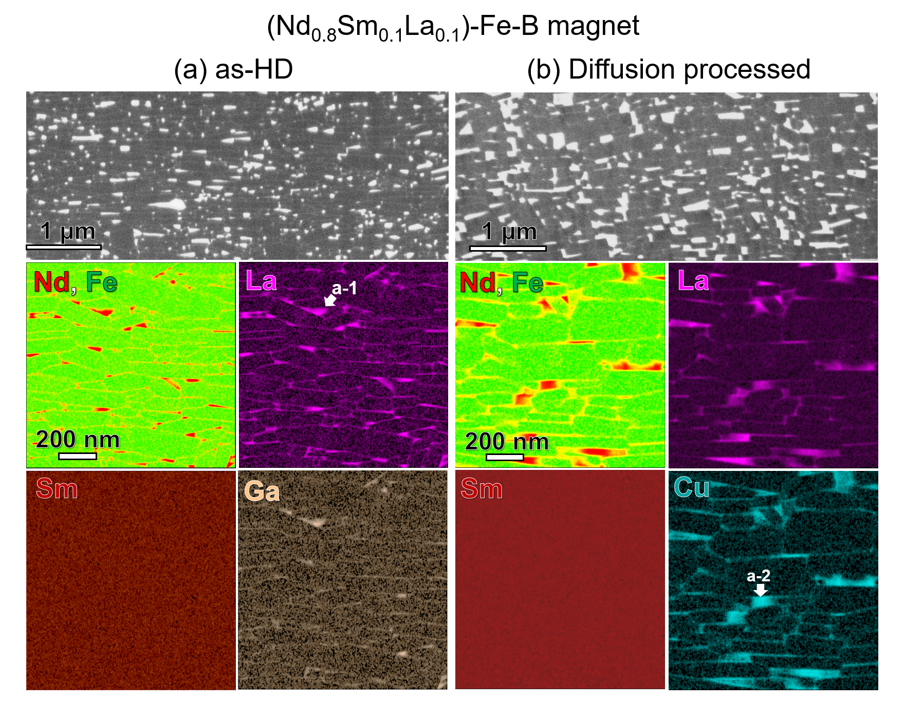
Fig. 3. BSE-SEM images and STEM-EDS maps of (a) as-HD and (b) diffusion processed (Nd_{0.8}Sm_{0.1}La_{0.1})-Fe-B magnets.
Figure 3(a) and (b) show the BSE-SEM and STEM-EDS results of the as-HD and diffusion processed (Nd_{0.8}Sm_{0.1}La_{0.1})-Fe-B magnet. The matrix phase is the 2:14:1 phase and the brightly imaged phases in the BSE-SEM images are the RE-rich phases. In the HD magnet, the matrix grains have the composition of (Nd_{0.79}Sm_{0.15}La_{0.06})₂Fe_{13.1}Co_{0.9}B, while the composition of the phases at the triple junctions is determined to be ~Nd_{34.4}Sm_{1.3}La₃₄Fe_{23.7}Co_{4.4}Ga_{2.2} in at.% (‘a-1’). It is noteworthy that Nd and La are enriched in the triple junction phases, while Sm concentration is almost uniform throughout the entire microstructure. This explains the relatively higher Sm content and lower La content in the matrix grains compared to the designed composition. The (Fe+Co) content is lean at the triple junction phases compared to the matrix phase composition. In the Nd-Cu diffusion processed magnet shown in Fig. 3(b), the chemical composition of the triple junction phases become richer in RE with the composition, Nd_{59.3}Sm_{2.9}La_{21.3}Fe_{3.0}Co_{9.1}Ga_{1.3}Cu_{3.1} in at.% (region a-2). Cu is enriched in the triple junction phases as well as in the intergranular phases as seen in the EDS map. The Fe+Co content in the triple junction phase of the as-HD magnet is around ~30 at.%, which has reduced to 10.4 at.% in the Nd-Cu diffusion processed magnet. These changes in the composition of the RE-rich triple junctions can influence the intergranular phase composition which is expected to make a dominant contribution to the coercivity increase upon diffusion.
Fig. 4. HAADF-STEM images and EDS maps and corresponding line profiles of intergranular phases in (a) as-HD and (b) diffusion processed (Nd_{0.8}Sm_{0.1}La_{0.1})-Fe-B magnets.
To further understand the effect of the Nd-Cu diffusion process on the coercivity, high magnification STEM-EDS analysis on the intergranular phases was carried out. The intergranular phases (IGPs) in the as-HD and diffusion processed magnets are shown in the HAADF-STEM images and STEM-EDS maps of Fig. 4. In the as-HD magnet, a thin (~1 nm) intergranular phase with (Fe+Co) content of ~50 at.% can be seen. The composition of this IGP is Nd_{31.6}Sm_{3.4}La_{10.1}Fe_{43.7}Co_{6.1}Ga_{5.1} (at.%). In the diffusion processed sample, there are thick IGPs with the composition, ~Nd_{44.6}Sm_{2.9}La_{19.6}Fe_{20.2}Co_{3.7}Ga_{4.6}Cu_{4.4} in at.%. The (Fe+Co) content is ~25 at.% in these IGPs which are enriched with Nd and La, while no significant Sm segregation is detected with respect to the matrix grains. Note that the total rare earth content in the IGPs increases from 45 at.% to 67 at.% after the diffusion process. The resulting reduction of (Fe+Co) contents from 50 at.% to 25 at.% in the IGPs is expected to weaken the exchange coupling between the Nd₂Fe₁₄B grains. This is the reason for the coercivity change from 0.25 T to 0.55 T, making these magnets suitable for elevated temperature use in traction VFPM motors. The RE-rich intergranular phase composition after the diffusion process not only increases the coercivity but also the flatness of the first-order reversal curves (FORCs), which will be discussed in the next section.

  - FORCs of (Nd_{0.8}Sm_{0.1}La_{0.1})-Fe-B-based and commercial Sm₂Co₁₇-based magnets
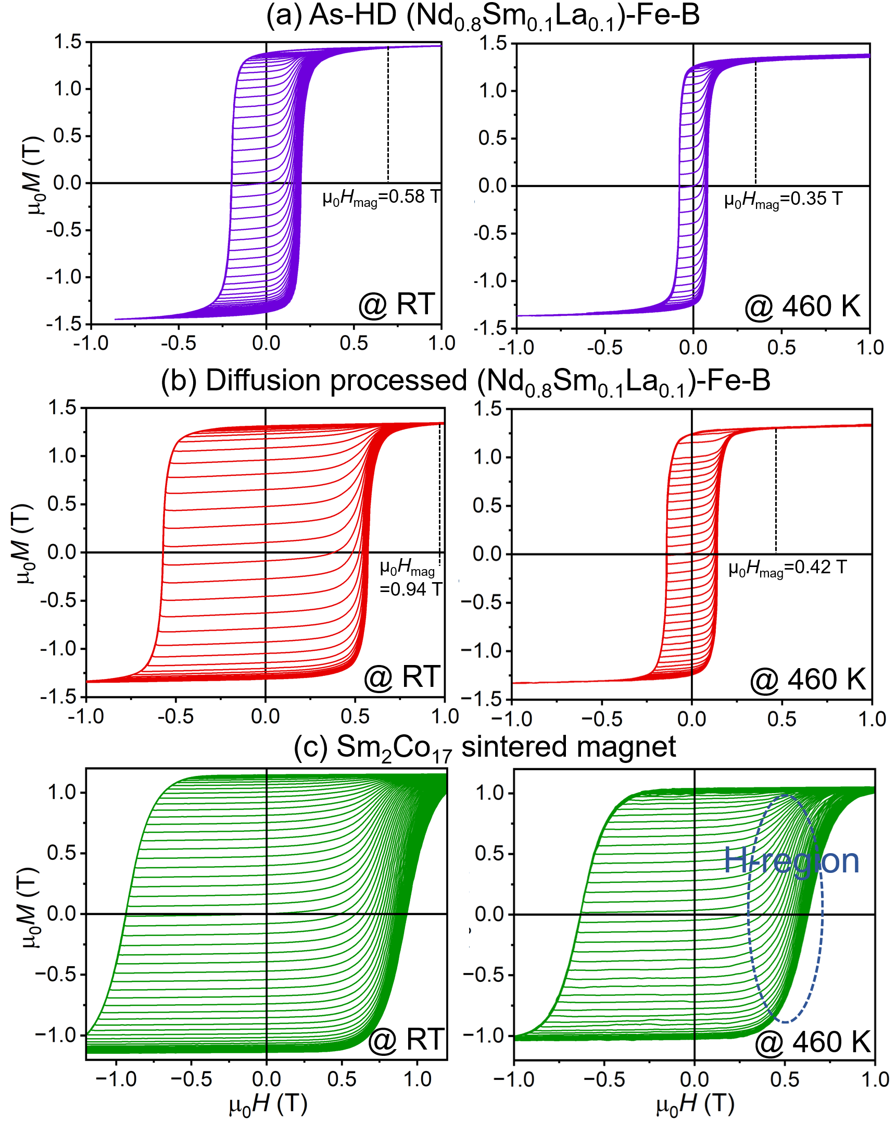
Fig. 5. FORCs measured at room-temperature and at 460 K for (a) as-HD, (b) diffusion processed (Nd_{0.8}Sm_{0.1}La_{0.1})-Fe-B and (c) commercial 28L grade Sm₂Co₁₇ magnets.
In order to evaluate the flatness of the FORCs and to understand the applicability of the (Nd_{0.8}Sm_{0.1}La_{0.1})-Fe-B magnets, the FORCs are analyzed and compared to that of the commercial Sm₂Co₁₇ sintered magnet. The Sm₂Co₁₇ sintered magnet was selected for comparison as this type of magnets is currently considered for VFPM motor applications due to the good flatness of their FORCs; note that the H_{c} and H_{mag} of this magnet have not been tailored for VFPM applications and can be tuned as needed.
The FORCs shown in Fig. 5 are M-(H_{r},H) curves which refer to a series of M-H loops with increasing reversal fields, H_{r}. The two main properties to be determined from the FORCs are the flatness factor and magnetizing field for evaluation of VFPMs. A low magnetizing field (H_{mag}) smaller than 1 T [8] is needed for VFPMs and is defined as the H_{r} at which the FORC becomes closed and symmetrical. At room temperature, the µ₀H_{mag} for the as-HD magnet is 0.58 T and that of the diffusion processed magnet is 0.94 T as marked in the Fig. 5 (a) and (b). At ~460 K, the µ₀H_{mag} becomes 0.35 T and 0.42 T for the as-HD and diffusion-processed magnets, respectively. It should be noted that the H_{mag} in this work is in a more desirable range than that in the previous report on HD magnets as VFPMs which had a µ₀H_{mag} of 1.4 T [9]. As the H_{mag} for the (Nd_{0.8}Sm_{0.1}La_{0.1})-Fe-B diffusion processed magnet is low and much less than 1 T at elevated temperatures, the initial magnetization can be restored with small stator currents, which is essential for practical application.
The flatness factor of the FORCs defined by Kajita et al. [8], F_{f}, is the ratio of field at half of the M_{s} (H_{0.5Ms}) to coercivity (H_{c}), in the remagnetization curve corresponding to H_{r}~H_{c}, i.e., F_{f}= H_{0.5Ms}/H_{c}. The flatness factors were determined to be 0.87 and 0.96 for the as-HD and diffusion processed (Nd_{0.8}Sm_{0.1}La_{0.1})-Fe-B magnets, respectively, and 0.79 for the sintered Sm₂Co₁₇ magnet. The low F_{f} value of the Sm₂Co₁₇-based magnets is due to a less sharp magnetization transition near the coercivity value in the remagnetization curve (marked as ‘H-region in Fig. 5). In order to exclude the influence of magnetization shape in the ‘H-region’ on the F_{f}, we slightly modify the definition of F_{f} to F₁= H_{0.1Ms}/H_{c}. In addition, the slope at H=0 (F₂=m_{H=0}) for the remagnetization curve corresponding to H_{r}=H_{c} is considered as an auxiliary flatness factor; i.e., F₂ must be low, while F₁ must be high to ensure a good flatness of the recoil curves.
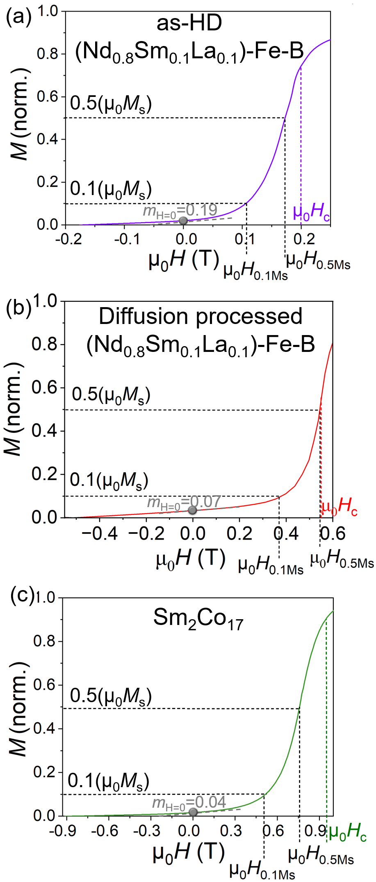
Fig. 6. Remagnetization curve corresponding to H_{r}~H_{c} of the FORCs for (a) as-HD and (b) diffusion processed (Nd_{0.8}Sm_{0.1}La_{0.1})-Fe-B, and (c) commercial 28L grade Sm₂Co₁₇ magnets.
Table 2. Flatness values for the different definitions at room temperature (RT) and 460 K (HT). F_{f} is defined in Ref. [8] and F₁ and F₂ are proposed in this work.
Sample | F_{f}=H_{0.5Ms}/H_{c} |  | F₁=H_{0.1Ms}/H_{c} |  | F₂=m_{H=0}
Sample | RT | HT | RT | HT | RT | HT
HD (Nd_{0.8}Sm_{0.1}La_{0.1})-Fe-B | 0.87 | 0.96 | 0.54 | 0.65 | 0.19 | 0.38
Diffusion processed (Nd_{0.8}Sm_{0.1}La_{0.1})-Fe-B | 0.96 | 0.99 | 0.67 | 0.74 | 0.07 | 0.22
Sm₂Co₁₇ | 0.79 | 0.81 | 0.52 | 0.51 | 0.04 | 0.06

The analysis of the FORCs was performed with the representative recoil curve, i.e., the recoil curve for H_{r}=H_{c}, and presented in Fig. 6 for the as-HD and diffusion processed (Nd_{0.8}Sm_{0.1}La_{0.1})-Fe-B magnets and the Sm₂Co₁₇ magnet at room temperature (RT); the same for elevated temperatures, is shown in Fig. S1. The flatness values estimated using the different definitions for room temperature and elevated temperatures are listed in Table 2. All flatness factors, F_{f}, F₁ and F₂, show that the diffusion processed magnet has a better flatness compared to the as-HD magnet both in RT and 460 K. The improvement of flatness in the diffusion processed magnet originates mainly from the diluted (Fe+Co) concentration in the intergranular phase (Fig. 4), because it can promote inter-grain exchange decoupling. This can cause strong pinning effect at the grain boundaries, making the remagnetization curves flatter. Further, we compare the flatness factors of diffusion-processed hot-deformed magnet with the commercially available Sm₂Co₁₇ magnet. The flatness factors, F_{f} and F₁, is higher for the diffusion processed magnets compared to the commercial Sm₂Co₁₇ magnet (Table 2 and Fig. 6), while the F₂ of the diffusion processed magnet is comparable to that of the Sm₂Co₁₇ magnet. At higher temperatures, the F_{f} and F₁ values become even better for the (Nd_{0.8}Sm_{0.1}La_{0.1})-Fe-B magnets. On the other hand, with increase in temperature, the flatness factors do not change significantly for the Sm₂Co₁₇-based magnet. Overall, the high F_{f}, F₁ values and comparable F₂ value of the diffusion processed (Nd_{0.8}Sm_{0.1}La_{0.1})-Fe-B magnet shows that it is a promising candidate for use in the VFPM motors.
In this work, the composition tuning to tailor the intrinsic magnetic properties, along with processing methods opted to control the microstructure, resulted in excellent first-order reversal properties with µ₀M_{r}=1.30 T, µ₀H_{c}=0.55 T, µ₀H_{mag}=0.94 T, and F_{f}=0.96, in the diffusion processed (Nd_{0.8}Sm_{0.1}La_{0.1})-Fe-B hot-deformed magnet. The origin of such a high flatness in this magnet can be explained by the reduced (Fe+Co) concentration in the intergranular phase. The additional flatness definitions in this work enables a fair comparison with the Sm₂Co₁₇-based magnet. The overall flatness values of the diffusion processed (Nd_{0.8}Sm_{0.1}La_{0.1})-Fe-B hot-deformed magnet (F_{f}=0.96, F₁=0.67, F₂=0.07) are better compared to the commercially preferred Sm₂Co₁₇ magnet (F_{f}=0.79, F₁=0.52, F₂=0.04), where the flatness definitions, F₁= H_{0.1Ms}/H_{c} and F₂=m_{H=0} are proposed in this work. Furthermore, the µ₀M_{r} is superior (1.3 T) for the (Nd_{0.8}Sm_{0.1}La_{0.1})-Fe-B magnet compared to the Sm₂Co₁₇ magnet (1.05 T). Therefore, the diffusion processed (Nd_{0.8}Sm_{0.1}La_{0.1})-Fe-B hot-deformed magnet with the excellent comprehensive properties is considered as a promising candidate for VFPM motor applications compared to the commercial Sm₂Co₁₇ magnet.
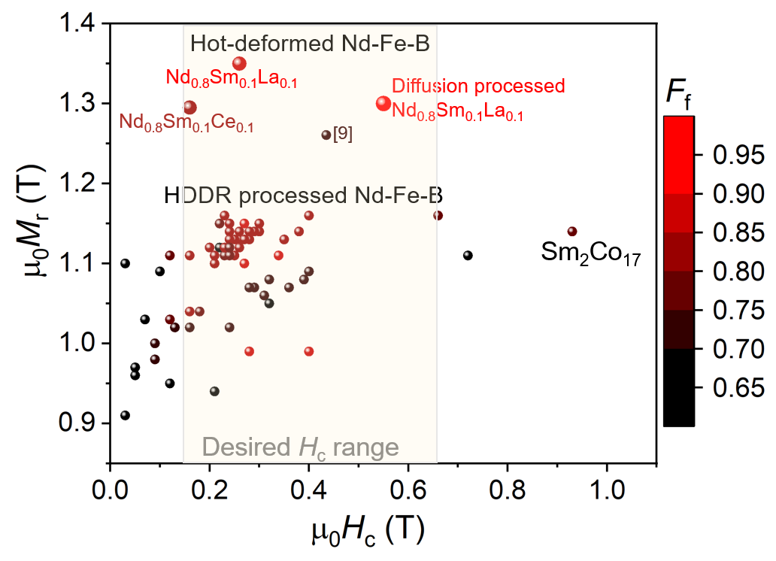
Fig. 7. (a) The magnetic properties, M_{r}, H_{c} and F_{f} of the magnets in this work in comparison with those in the literature [8,9,11].
The M_{r} vs. H_{c} diagram in Fig. 7 presents the H_{c}, M_{r} and F_{f} range for several Nd-Fe-B-based magnets. The HDDR-processed Nd-Fe-B magnets have an M_{r} comparable to that of the 28L commercial Sm₂Co₁₇-based magnet, while the hot-deformed Nd-Fe-B magnets have a higher M_{r}. In this work, the highest M_{r} for a moderate-coercivity Nd-Fe-B-based magnet has been achieved along with the excellent flatness of the FORCs compared to the literature. The better flatness and the high remanence compared to the Sm₂Co₁₇ counterpart, makes the hot-deformed and diffusion-processed (Nd,Sm,La)-Fe-B magnets a promising candidate for the variable flux PM motor applications. Future studies with motor prototypes using the (Nd,Sm,La)-Fe-B magnets can lead to practical application of these magnets.
Conclusions
Moderate coercivity, low magnetizing field (H_{mag}), flat FORCs (F_{f}) and high remanence (M_{r}) are the magnetic properties required for a permanent magnet that can suit variable flux permanent magnet motors. In this work, we employed intrinsic control of the Nd₂Fe₁₄B-based magnet to modify its anisotropy field by partial substitution for Nd with Sm and La, followed by microstructure engineering to tune the chemistry of intergranular phase. These efforts lead to achievement of excellent comprehensive magnetic properties (µ₀H_{c}=0.55 T, µ₀H_{mag}=0.94 T, F_{f}=0.96 and µ₀M_{r}=1.3 T) in a diffusion processed (Nd,Sm,La)-Fe-B hot-deformed magnet. Electron microscopy studies revealed that the combined substitution by Sm and La contributed to an RFe₂-free microstructure and the Nd-Cu diffusion treatment led to the modification of intergranular phase, thus leading to the superior combination of magnetic properties. In addition, these properties can be maintained within the desired range at high temperatures as required by the potential application. The magnet developed in this work was evaluated using the commercially preferred Sm₂Co₁₇ magnets as a benchmark material, and found that it outperforms the expensive Sm₂Co₁₇ magnet in terms of M_{r} as well as FORC flatness. Thus, we have demonstrated the suitability of the diffusion-processed (Sm,La)-doped Nd-Fe-B hot-deformed magnets for the variable flux permanent magnet motors.
Acknowledgments
This work was supported in part by the MEXT Program: Data Creation and Utilization-Type Material Research and Development Project (Digital Transformation Initiative Center for Magnetic Materials; JPMXP1122715503).
References:
[1] K. I. Laskaris and A. G. Kladas, Internal Permanent Magnet Motor Design for Electric Vehicle Drive, IEEE Trans. Ind. Electron., 57 (2010), pp. 138–145, 10.1109/TIE.2009.2033086.
[2] K. Sakai, H. Hashimoto, and S. Kuramochi, Principle of hybrid variable-magnetic-force motors, IEEE International Electric Machines & Drives Conference (IEMDC) (2011), pp. 53–58, 10.1109/IEMDC.2011.5994656.
[3] V. Ostovic, Memory motors-a new class of controllable flux PM machines for a true wide speed operation, Conference Record of the IEEE Industry Applications Conference. 36th IAS Annual Meeting (Cat. No.01CH37248), 4 (2001), pp. 2577–2584, 10.1109/IAS.2001.955983.
[4] N. Limsuwan, T. Kato, K. Akatsu, and R. D. Lorenz, Design and Evaluation of a Variable-Flux Flux-Intensifying Interior Permanent-Magnet Machine, IEEE Trans. Ind. Appl., 50 (2014), pp. 1015–1024, 10.1109/TIA.2013.2273482.
[5] A. Athavale, D. J. Erato, and R. D. Lorenz, Enabling driving cycle loss reduction in variable flux PMSMs via closed-loop magnetization state control, IEEE Energy Conversion Congress and Exposition (ECCE), (2017), pp. 1932–1939, 10.1109/ECCE.2017.8096031.
[6] H. Hua, Z. Q. Zhu, A. Pride, R. Deodhar, and T. Sasaki, Comparative Study on Variable Flux Memory Machines With Parallel or Series Hybrid Magnets, IEEE Trans. Ind. Appl., 55 (2019) pp. 1408–1419, 10.1109/TIA.2018.2879858.
[7] K. Sakai, K. Yuki, Y. Hashiba, N. Takahashi, K. Yasui, and L. Kovudhikulrungsri, Principle and Basic Characteristics of Variable-Magnetic-Force Memory Motors, IEEJ Trans. Ind. Appl., 131 (2011), pp. 53–60, 10.1541/ieejias.131.53.
[8] T. Kajita, S. Miyazaki, and K. Takeda, R-T-B-based magnet, motor and generator, US patent 2021 0242727 A1.
[9] X. Tang, H. Sepehri-Amin, A. Bolyachkin, T. Ohkubo, and K. Hono, (Nd,La,Ce)-Fe-B hot-deformed magnets for application of variable-magnetic-force motors, Acta Mater., 228 (2022), 117747, 10.1016/j.actamat.2022.117747.
[10] K. Suzuki and Y. Fujikawa, Magnetic Body, US patent 2013 0271249.
[11] K. Takeda, S. Miyazaki, and T. Kajita, Magnetic properties of Nd-Fe-B sintered magnet for the variable magnetic force motor, 1-20 A spring meeting of Japan Society of Powder and Powder Metallurgy, 2019.
[12] I. Panagiotopoulos, M. Gjoka, and D. Niarchos, Temperature dependence of the activation volume in high-temperature Sm(Co,Fe,Cu,Zr)z magnets, J. Appl. Phys., 92 (2002), pp. 7693–7695, 10.1063/1.1522836.
[13] S. Hirosawa, Y. Matsuura, H. Yamamoto, S. Fujimura, M. Sagawa, and H. Yamauchi, Magnetization and magnetic anisotropy of R₂Fe₁₄B measured on single crystals, J. Appl. Phys., 59 (1986), pp. 873–879, 10.1063/1.336611.
[14] H. Hiroyoshi, H. Yamauchi, Y. Yamaguchi, H. Yamamoto, Y. Nakagawa, and M. Sagawa, Magnetic anisotropy of Sm₂Fe₁₄B single crystal, Solid State Commun., 54 (1985), pp. 41–43, 10.1016/0038-1098(85)91029-4.
[15] S. Sinnema, R. J. Radwanski, J. J. M. Franse, D. B. de Mooij, and K. H. J. Buschow, Magnetic properties of ternary rare-earth compounds of the type R₂Fe₁₄B, J. Magn. Magn. Mater., 44 (1984), pp. 333–341, 10.1016/0304-8853(84)90261-0.
[16] K. Miyazawa, S. Okamoto, T. Yomogita, N. Kikuchi, O. Kitakami, K. Toyoki, D. Billington, Y. Kotani, T. Nakamura, T. Sasaki, T. Ohkubo, K. Hono, First-order reversal curve analysis of a Nd-Fe-B sintered magnet with soft X-ray magnetic circular dichroism microscopy, Acta Mater., 162 (2019), pp. 1–9, 10.1016/j.actamat.2018.09.053.
[17] T. Kajita, S. Miyazaki, and K. Takeda, R-T-B-based magnet, motor, and generator, US patent 2021 0242727 A1.
[18] R. Chen, X. Xia, X. Tang, and A. Yan, Significant Progress for Hot-Deformed Nd-Fe-B Magnets: A Review, Materials, 16 (2023) 13, 10.3390/ma16134789.
[19] K. Hioki, High performance hot-deformed Nd-Fe-B magnets (Review), Sci. Technol. Adv. Mater., 22 (2021), pp. 72–84, 10.1080/14686996.2020.1868049.
[20] X. Tang, H. Sepehri-Amin, M. Matsumoto, T. Ohkubo, and K. Hono, Role of Co on the magnetic properties of Ce-substituted Nd-Fe-B hot-deformed magnets, Acta Mater., 175 (2019), pp. 1–10, 10.1016/j.actamat.2019.05.064.
[21] K. Noguchi, C. Mishima, M. Yamazaki, H. Matsuoka, H. Mitarai, and Y. Honkura, Development of Dy-free NdFeB anisotropic bonded magnet (New MAGFINE), 1st International Electric Drives Production Conference, (2011), 10.1109/edpc.2011.6085539.
[22] H. Sepehri-Amin, T. Ohkubo, S. Nagashima, M. Yano, T. Shoji, A. Kato, T. Schrefl, K. Hono, High-coercivity ultrafine-grained anisotropic Nd–Fe–B magnets processed by hot deformation and the Nd–Cu grain boundary diffusion process, Acta Mater., 61 (2013), pp. 6622–6634, 10.1016/j.actamat.2013.07.049.

[23] H. Sepehri-Amin, T. Ohkubo, T. Nishiushi, S. Hirosawa, and K. Hono, Coercivity enhancement of hydrogenation–disproportionation–desorption–recombination processed Nd–Fe–B powders by the diffusion of Nd–Cu eutectic alloys, Scripta Mater. 63 (2010), pp. 1124-1127, 10.1016/j.scriptamat.2010.08.021.

[24] Xin Tang, R. Chen, W. Yin, J. Wang, X. Tang, D. Lee, A. Yan, Impact of Nd–Cu diffusion on microstructure and coercivity in hot pressed and die-upset nanocomposite magnets, Scripta Mater. 88 (2014), pp. 49-52, 10.1016/j.scriptamat.2014.05.014.
Tables

Table 1 Intrinsic magnetic properties (µ₀M_{s} and µ₀H_{A}) of LRE₂Fe₁₄B compounds [13-15]
 | Nd₂Fe₁₄B | Ce₂Fe₁₄B | La₂Fe₁₄B | Sm₂Fe₁₄B
µ₀M_{s} (T) | 1.61 | 1.17 | 1.38 | 1.52
µ₀ H_{A} (T) | 6.7 | 2.6 | 2.0 | --

Table 2 Flatness values for the different definitions at room temperature (RT) and 460 K (HT). F_{f} is defined in Ref. [8] and F₁ and F₂ are proposed in this work.
Sample | F_{f}=H_{0.5Ms}/H_{c} |  | F₁=H_{0.1Ms}/H_{c} |  | F₂=m_{H=0}
Sample | RT | HT | RT | HT | RT | HT
HD (Nd_{0.8}Sm_{0.1}La_{0.1})-Fe-B | 0.87 | 0.96 | 0.54 | 0.65 | 0.19 | 0.38
Diffusion processed (Nd_{0.8}Sm_{0.1}La_{0.1})-Fe-B | 0.96 | 0.99 | 0.67 | 0.74 | 0.07 | 0.22
Sm₂Co₁₇ | 0.79 | 0.81 | 0.52 | 0.51 | 0.04 | 0.06

Figures’ caption
Fig. 1: (a) Remanence (µ₀M_{r}) and coercivity (µ₀H_{c}) plot, and BSE-SEM images of R-Fe-B hot-deformed magnets where (b) R= Nd_{0.8}Sm_{0.2}, (c) R=Nd_{0.8}Sm_{0.1}Ce_{0.1} and (d) R=Nd_{0.8}Sm_{0.1}La_{0.1}.
Fig. 2: (a) µ₀H_{c} vs. T and (b) M-H of hot-deformed (HD) and diffusion processed (Nd_{0.8}Sm_{0.1}La_{0.1})-Fe-B magnets.
Fig. 3: BSE-SEM images and STEM-EDS maps of (a) as-HD and (b) diffusion processed (Nd_{0.8}Sm_{0.1}La_{0.1})-Fe-B magnets.
Fig. 4: HAADF-STEM images and EDS maps and corresponding line profiles of intergranular phases in (a) as-HD and (b) diffusion processed (Nd_{0.8}Sm_{0.1}La_{0.1})-Fe-B magnets.
Fig. 5: FORCs measured at room-temperature and at 460 K for (a) as-HD, (b) diffusion processed (Nd_{0.8}Sm_{0.1}La_{0.1})-Fe-B and (c) commercial 28L grade Sm₂Co₁₇ magnets.
Fig. 6: Remagnetization curve corresponding to H_{r}~H_{c} of the FORCs for (a) as-HD and (b) diffusion processed (Nd_{0.8}Sm_{0.1}La_{0.1})-Fe-B, and (c) commercial 28L grade Sm₂Co₁₇ magnets.
Fig. 7: (a) The magnetic properties, M_{r}, H_{c} and F_{f} of the magnets in this work in comparison with those in the literature [8,9,11].
Fig. S1: Remagnetization curve corresponding to H_{r}~H_{c} of the high-temperature FORCs for (a) as-HD and (b) diffusion processed (Nd_{0.8}Sm_{0.1}La_{0.1})-Fe-B, and (c) commercial 28L grade Sm₂Co₁₇ magnets.
Supplementary figures

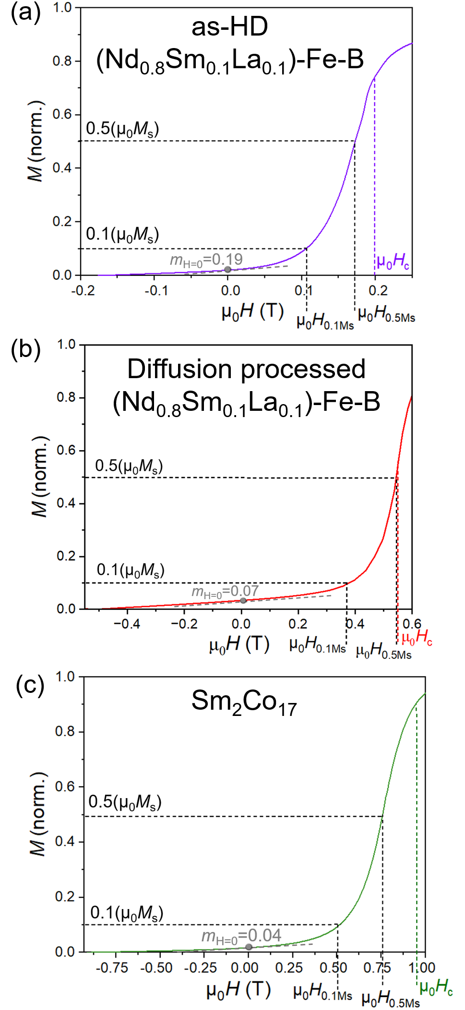
Fig. S1. Remagnetization curve corresponding to H_{r}~H_{c} of the high-temperature FORCs for (a) as-HD and (b) diffusion processed (Nd_{0.8}Sm_{0.1}La_{0.1})-Fe-B, and (c) commercial 28L grade Sm₂Co₁₇ magnets.

