Design of All-inorganic Sr₅(PO₄)₃Cl: Eu²⁺ Phosphor-in-Glass for Next Generation Violet-Chips-Excited Sunlight-like Healthy Lighting
Ziyu Heª, Guoqiang Yinª, Suiyuan Dongª, Guoying Zhao^{*a}, Yufeng Liuª, Bo Li^{b}, Hong-Tao Sun^{c}, Jingshan Houª, Feng Wang^{d}, Yongzheng Fang^{*a}
ª School of Materials Science and Engineering, Shanghai Institute of Technology, Shanghai 201418, PR China
^{b} Baotou Research Institute of Rare Earths, Baotou, 014030, China
^{c} Research Center for Materials Nanoarchitectonics (MANA), National Institute for Materials Science, 1-2-1 Sengen, Tsukuba, 305-0047, Japan
^{d} Department of Materials Science and Engineering, City University of Hong Kong, 83 Tat Chee Avenue, Hong Kong SAR, China
*Corresponding author
E-mail: zhaogy135@126.com (GY Zhao)
E-mail: fyz1003@sina.com (YZ Fang)
Abstract: To call for green and low-carbon lighting development strategy, sunlight-like health lighting has become the next generation of light-emitting diode (LED) trends. The conventional LEDs are deficient in the violet part and contain high-radiation blue light which is harmful to human eyes. The traditional organic phosphor and chip packaging mode leads to poor heat dissipation. Therefore, it cannot meet the human demand for high-quality, healthy lighting. In this study, a series of violet-excitable blue Sr₅(PO₄)₃Cl: Eu²⁺ (SPOC) phosphor-in-glass (PiG) films were prepared. The PiG film can not only compensate for the violet-yellow gap in the spectral component but also have excellent luminescence performance and reliability. Significantly, the lower co-sintering temperature (335 ℃) allows it to maintain 89% of the initial phosphor quantum efficiency. Relative to the initial state, PiG (E_{a} = 0.143 eV) at the optimal sintering temperature maintains a 34% higher resistance to thermal quenching than phosphor-in-silicon (PiS) at 175°C. This blue PiG-prepared color converter was remotely packaged with a violet chip to achieve a sunlight-like LED with a color rendering index of 96.3 and 100% color saturation. This research offers great potential for the development of next-generation sunlight-like health lighting.
Keywords: Blue Phosphor-in-Glass, Sunlight-like Healthy Lighting, Violet-Chips-Excited LEDs
1. Introduction
In response to the call for green development, high-quality sunlight-like W-led has become a new trend of "healthy green lighting" worldwide. In contrast to ordinary lighting, the light source spectrum of healthy lighting is close to the sunlight spectrum. Its CRI is higher, can fully restore the object's truest color, and can improve the problem of poor visual comfort of ordinary lighting^{[1]}. However, the current W-led technology mainly uses blue chips and yellow phosphor Y₃Al₅O₁₂:Ce³⁺ (YAG) encapsulated with organic resin^{[2-5]}. It faces some dilemmas. On the one hand, the blue light radiation from the chip is too high, easily leading to myopia and other pathologic hazards of the eye, but also in the human body's rhythms lead to insomnia and biological clock disorders^{[6-8]}. Moreover, the absence of LED spectral components leads to insufficient color rendering performance (CRI<80) ^{[9-11]}. In particular, the lack of a violet component has rarely been considered. On the other hand, when the organic package mode is faced with the increase of operating power and long-term use, the poor heat dissipation effect will lead to the aging, yellowing and light decay of the fluorescent material^{[12-14]}. This will affect the overall service life of the LED^{[15]}.
Compared with the current commonly used blue LED chips, violet LED chips (400-420 nm) have superior luminescence performance, and their external quantum efficiency (80%) is higher than that of blue LED chips (70 %)^{[16-18]}. The use of fluorescent materials in combination with violet chips not only reduces the peak value of blue light from the chip significantly but also makes the full spectrum of violet light excitation closer to the continuous spectrum of sunlight.^{[19-21]}. Therefore, as a trigger of a full spectrum light source, the violet chip has far-reaching application prospects. However, once the blue chip is abandoned, to ensure the continuity of the spectrum, the blue gap in the spectral component (400-480 nm) still needs to be made up. The blue component must both ensure excellent color purity and follow the healthy principle of reducing blue light peak. Today's reported fluorescent materials that can compensate for the cyan gap are still mainly focused on phosphors^{[22-24]}. Among them, the mature blue phosphor Sr₅(PO₄)₃Cl: Eu²⁺ (SPOC) shows extremely high luminous efficiency^{[25, 26]}. Although its luminous performance is better, it still faces the challenge of serious color decay caused by subsequent organic packaging^{[27]}. Therefore, to improve the reliability and heat dissipation of packaging modules, it is also crucial to abandon the use of organic resins in packaging^{[28, 29]}.
Currently, to overcome the inherent problems of organic resins, inorganic color converters such as glass that can crystallize to form phosphor phases (phosphor glass ceramics), glass networks containing reactive ions in bulk glass phosphors, and quantum-dot glass have been proposed^{[30-33]}. Nonetheless, they face difficulties in controlling the crystallinity of phosphor within the glass phase, low quantum efficiency, and very poor thermal stability, respectively^{[34-36]}. However, as an inorganic fluorescent conversion material, phosphor-in-glass (PiG) film has a high thermal conductivity and adjustable high refractive index by changing the type and ratio of phosphor and glass matrix^{[37-39]}. At the same time, the PiG film on a quartz glass substrate effectively diffuses the heat accumulated on the fluorescent layer, thus making its thermal stability and luminescence performance more excellent^{[40, 41]}.
However, SPOC phosphors are relatively unstable at high temperatures. It experiences a time-dependent decrease in photoluminescence (PL) intensity at temperatures of 450 °C or above^{[42]}. Moreover, it decomposes easily at high temperatures to form Sr₃(PO₄)₂ and Sr₅(PO₄)₃Cl bidirectional structures^{[43]}. Therefore, PiG with SPOC as the luminescent center requires the selection of a glass matrix with a low melting temperature to ensure the stability of the fluorescent phase. Most current precursor glasses are sintered at temperatures above 500 °C^{[44-46]}. Suitable glass components can reduce their glass transition temperature. TeO₂ in lead-free tellurite glasses has Te-O-Te bonds that are easily broken during glass formation and have a lower phonon energy, which helps to lower its melting temperature^{[47, 48]}. The introduction of sodium ions into the glass network can play a role in reducing the viscosity of the glass, and thus reduce the overall melting temperature of the glass^{[49]}. The right amount of boron ions can reduce the expansion coefficient of the glass and improve the thermal and chemical stability^{[50]}.
Based on these considerations, the violet-excitable blue SPOC phosphor was selected in this study, and a series of PiG films with H₂BO₃-TeO₂-ZnO-Na₂CO₃ as the glass matrix, different sintering temperatures, and different numbers of coating layers were prepared. When the optimum low-temperature co-sintering temperature is 335℃, the luminescence performance and weather resistance of blue PiG (SPOC-PiG) are better than phosphor-in-silicone (PiS). The combination of a violet chip with this blue PiG film not only reduces blue light radiation from conventional blue chips but also achieves electroluminescence with excellent color purity. And finally, the red-green fluorescent layer is coated again on top of the blue PiG. By adjusting the ratio of each component, a sunlight-like LED with a CRI of 96.3 was achieved.
2. Experimental section
2.1 The precursor glass matrix and PiG films were prepared
Precursor glasses were prepared by melt quenching. The raw materials H₂BO₃ (GR), TeO₂ (99.99%), ZnO (AR), and Na₂CO₃ (AR) for the tellurite glass matrix were first weighed according to the molar ratio of 40:50:10:10 and mixed thoroughly in an agate mortar. The mixed powder was then poured into an alumina crucible and placed in a muffle furnace for melting at 950 °C for 25 min to obtain a molten glass melt. The melt is then poured into preheated brass molds. It is cooled and ground to a powder. Secondly, the organic slurry was prepared by weighing 1:10 of the geraniol and ethyl cellulose into a magnetic stirrer, weighing 1 gram(1g) and 10 gram (10g) respectively, and stirring uniformly at a speed of 700 r/min for 12 h. The viscosity was tested to be 2380 mPa·s using a viscometer at 30 RPM. Subsequently, tellurite glass powder (1g) and blue phosphor SPOC (0.1g) were weighed 10:1 by mass and ground in an onyx mortar to produce a mixed powder. According to the mass percentage of 1:1 weighing mixed powder (1g) and organic slurry (1g), the two are in a beaker stirring the mix to get a mixed slurry spare. Finally, a quartz glass substrate with r_{Φ}=20 mm was selected and placed on top of the mold, and the mixed slurry was scraped onto the glass substrate with a scraper. The thickness is controlled by the number of scraping coats. It was then dried in an oven at 120 °C for 5h and transferred to a muffle furnace at 315 °C to 335 °C for 12 minutes at low temperature. A series of blue PiG films were fabricated and their luminescent properties were investigated.
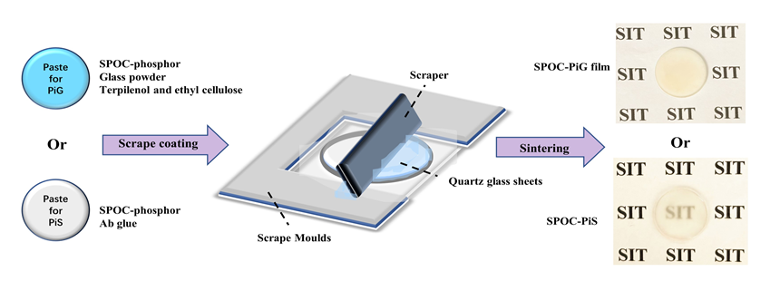
Phosphor-in-silicone (PiS) was also prepared as a control group. The ab glue (a:b = 1:1, a total weight of 1g) and the blue phosphor SPOC (0.1g) are mixed according to the mass percentage of 10:1, and mixed evenly in the magnetic stirrer. The PiS samples were then prepared by preheating in an oven at 100 °C for 20 min and then held at 120 °C for 5 h. As shown in Fig. 1.
Fig. 1. Scrape-coated preparation of PiG films and PiS samples
2.2 Characterization
Photoluminescence (PL), photoluminescence excitation (PLE), external quantum efficiency (EQE), and temperature-dependent emission spectra were measured on a Hitachi F-7000 xenon discharge lamp spectrometer (F-7000, Hitachi, Japan). Transmission spectra were determined with a UV-visible near infrared spectrophotometer (UH4150, Hitachi, Japan). X-ray powder diffraction (XRD) patterns were obtained on an XRD spectrometer (TD-3500, Dandong). Transmission electron microscopy (TEM) was used to analyze the interfacial situation and microstructure. Scanning electron microscopy (SEM) was used to analyze their elemental composition (Gemini Sigma 360, Zeiss, Germany) and to measure the film thickness (Quattro S, Thermo Fisher, Czech Republic). The internal quantum efficiency (IQE) was measured with a fluorescence quantum yield spectrometer (FLS920, Edinburgh Instruments, UK). Fluorescence microscopy images were taken on a fluorescence microscope (Axioscope 5, Zeiss, Germany). The PiG films were mounted on a 400-405 nm violet LED chip and placed in an integrating sphere to measure their luminescence performance. They include electroluminescence (EL) emission spectra, chromaticity color coordinates (CIE), correlated color temperature (CCT), color rendering index (CRI) and general color rendering index (Ra) were measured in an integrating sphere (HAAS-2000, EVERFINE, China).
3. Results and discussion
3.1 Microstructure and luminescence properties of PiG films
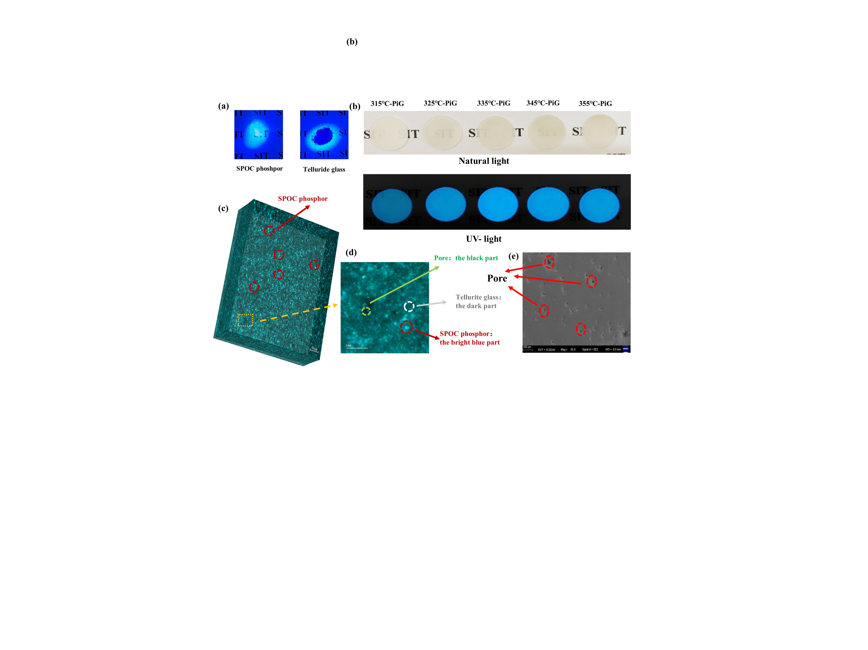
In this study, a TeO₂-based glass system is used as the glass matrix for PiG, which tends to have much higher nonlinear optical properties than silicate and metal oxide systems^{[51-53]}. The lone pair of electrons in Te⁴⁺, the empty d₀ orbitals, and the high polarizability formed by Te⁴⁺ itself make high refractive index tellurite glasses compatible with a wide range of phosphors^{[54]}. Moreover, the B₂O₃ component of the tellurite glass matrix acts as an auxiliary glass network former, which enhances its stability^{[48]}. Fig. 2(a) shows the tellurite glass powder and SPOC phosphor under near-UV light irradiation. SPOC phosphors emit a bright blue light. It has better color purity than other commercial blue powders and provides a good luminescent basis for the subsequent preparation of PiG films^{[55]}. Fig. 2(b) demonstrates the PiG films at different sintering temperatures. It can be observed that the luminescence of the PiG film is superior at 335 °C (335 ℃-PiG), and as the sintering temperature increases the film has a phenomenon of surface darkening and weakened luminescence. It is hypothesized that this is due to the increase in temperature leading to an increase in phosphor lattice defects or lattice instability^{[56, 57]}. High temperatures intensify atomic thermal vibrations, disrupting the stable coordination environment of Eu²⁺ in the Sr₅(PO₄)₃Cl lattice, altering the electron cloud distribution, and inhibiting the 4f-5d leaps, leading to a decrease in luminescence intensity^{[58-61]}.Fig. 2 (c, d) shows that the phosphors in the PiG films are uniformly dispersed in the glass network at a sintering temperature of 335 °C, and even luminescence can be achieved. In Fig. 2(e), it can be observed that there are some air holes dispersed on the surface of PiG, and these moderate air holes are conducive to the scattering and reflection of light, which enhances the color uniformity of the light-emitting device and the effectiveness of light extraction^{[62]}.
Fig. 2 (a) Tellurite glass powder and SPOC phosphor under near-UV light irradiation. (b) SPOC-PiG films with different sintering temperatures under natural light and near-UV irradiation. (c,d) 3D schematic of SPOC-PiG (scale bar, 50 μm) and its corresponding local details (scale bar, 100 μm). (e) Surface map of SPOC-PiG under SEM (scale bar, 200 μm).
In Fig. 3(a) XRD plot, it is observed that the diffraction peaks of the SPOC-PiG film are consistent with the diffraction peaks of the SPOC phosphor standard card PDF#00-016-0666. This indicates that the fluorescent phase in PiG remains largely intact. The bumps in the 20°-30° range originate from the tellurite glass phase. The tellurite glass phase does not have impurity peaks beyond its characteristic peaks. Compared with the PiS sample of SPOC (SPOC-PiS), it is obvious that the fluorescence phase characteristic peak of PiG is stronger. This suggests that the tellurite glass matrix has a role in protecting the phosphor structure from destruction during the sintering of PiG. It is more indicative of the poor heat dissipation of the organics and the heat build-up leading to the damage of the fluorescent phase in the PiS. Fig. 3(b) shows the PiG film with excitation peaks from 300-425 nm. The emission peak under 400 nm violet excitation corresponds to 450 nm blue light, which is attributed to the 4f-5d jump of Eu²⁺ in the fluorescent phase itself. This inorganic color conversion layer provides ideas for replacing blue light in conventional blue light chips. Moreover, the excitation and emission spectra of the PiG film are consistent with those of the phosphor, indicating that it can effectively guarantee the luminescence performance of the initial phosphor. Fig 3(c) shows the transmittance of PiG films analyzed for different numbers of scrape coatings and sintering temperatures. As the thickness of the scrape coat increases, the overall transmittance of the film tends to decay. Among them, PiG films with more than three layers of scrape coatings have the fastest transmittance degradation. With the increase in temperature, the attenuation of film transmittance is even more sharply accelerated after the sintering temperature is greater than 335 ℃. Appropriate control of the sintering temperature can minimize residual porosity and associated light scattering, thereby increasing light transmission^{[63, 64]}. In Fig. 3(d), it is shown that the overall transmittance of the quartz sheet substrate is maintained at around 90 %. At 400 nm, the best transmittance is achieved for the 335 °C-PiG in which 3 layers are scraped and coated (around 50 %). As a color converter, the high transmittance PiG film reduces backward scattering, thus improving light extraction efficiency and reducing light loss^{[65]}. Excessive film thickness is detrimental to light transmission. Fig 3(f) further observes that as the sintering temperature of the PiG film increases, its luminescence intensity also shows an overall decaying trend. Until the coating thickness is increased to 3 layers, the luminescence intensity of the films with sintering temperatures in the range of 315-345 °C decays only slowly. Once the thickness of the scrape coating reaches 4 layers, the luminous intensity of the PiG film starts to decrease sharply at 335 °C. This stems from the fact that the risk of thermal degradation and chromatic aberration in the deposited layer increases with the thickness of the film. Therefore, appropriate film scrape coating thickness is necessary to achieve sufficiently strong blue light emission. The critical thickness of 3 layers, where PiG decays sharply in both aspects, was selected as the optimal number of scrape coatings by a comprehensive evaluation of transmittance and luminescence intensity.
Next, by XRD observation of PiG with different sintering temperatures, the characteristic peaks of the fluorescent phase in 335 °C-PiG (subsequent 335 °C-PiG all refer to PiG with 3 layers of scrape coatings) are the most excellent, as shown in Fig. 3(e). The diffraction peak is shifted to a small angle direction as the sintering temperature increases. This is because the increase in temperature causes the material to expand and the crystal spacing to become larger. However, the overall shift of the characteristic peaks to the right is presumed to be due to the physical abrasion of the phosphor against the glass powder during the film-making process. The IQE of PiG is maximum at the sintering temperature of 335 °C, reaching 83.4 %. A lower sintering temperature (around 315 °C) reduces erosion during co-sintering as shown in Fig. 3(g). Too high a sintering temperature is detrimental to the structural stability of the phosphor and increases the possibility of bursting, leading to a decrease in the quantum efficiency of the PiG film. The PiG internal and external quantum efficiencies at 335 °C maintained 89 % and 79 % of the initial phosphor, respectively. This fully inorganic fluorescent conversion layer not only exhibits superior internal and external quantum efficiencies to other inorganic conversion materials but also achieves the substitution of the blue spectrum from the blue light chip, which has never been proposed for other inorganic conversion materials, as shown in Table 1. The excellent luminescence performance further strengthens the idea of 335 °C as the optimal sintering temperature for PiG.

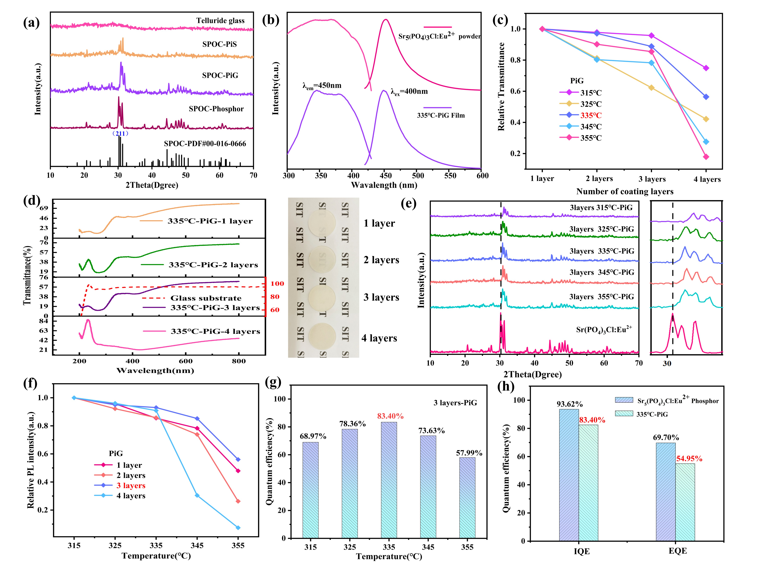
Fig. 3 (a) XRD of different samples of SPOC and glass powder. (b) PL and PLE of SPOC phosphor and PiG films. (c) Relative transmittance of PiG films at different number of scrape coatings. (d) Transmittance and sample plots of 335 °C-PiG films with different number of scrape coatings. (e) XRD of PiG films at each sintering temperature. (f) Relative PL intensity of PiG films with different number of scrape coatings. (g) Internal quantum efficiency of 3 layers PiG films at different temperatures. (h) Internal and external quantum efficiencies of SPOC phosphors and PiG films.
Table 1. Comparison of internal and external quantum efficiencies of various inorganic color conversion materials
Inorganic color converters | Composite | Spectral range (peak wavelength) | IQE | EQE | Ref
Phosphor in glass | Sr₅(PO₄)₃Cl:Eu²⁺/ H₂BO₃-TeO₂-ZnO-Na₂CO₃ | 420-600nm (450nm) | 83.4% | 54.95% | This work
Phosphor in glass | YAG:Ce³+/SiO₂-Na₂O-Al₂O₃-CaO | 480-680nm (536nm) | 68% | - | ^{[66]}
Phosphor in glass | Sr₄Al₁₄O₂₅:Eu²⁺/SiO₂-Al₂O₃-Na₂O-CaO-Eu₂O₃ | 550-725nm  (612nm) | 60.4% | - | ^{[67]}
Phosphor in glass | CASN:Eu²⁺/ZnO-B₂O₃-BaO-Al₂O₃ | 550-800nm  (640nm) | 43% | - | ^{[68]}
Phosphor glass ceramic | Ce³⁺/SiO₂ -Al₂O₃ -Y₂O₃ | 480-730nm  (550nm) | ≈28% | - | ^{[69]}
Phosphor glass ceramic | Eu³⁺/SiO₂-Al₂O₃-Y₂O₃-CaCO₃-ZnO | 400-750nm  (428nm) | 43.3% | - | ^{[70]}
Bulk glass phosphors with reactive ions | SiO₂/(Gd,Pr)PO₄ | 300-330nm  (311.9nm) | 0.98% | 0.91% | ^{[71]}
Glasses with quantum dots | Gd³⁺/CsPbBrI₂/ B₂O₃-SiO₂-ZnO | 500-750nm  (≈ 650nm) | 37% | - | ^{[72]}
Glasses with quantum dots | Dy³⁺/CsPbBr₃/ Na₂CO₃-ZnO-H₃BO₃-SiO₂-BaCO₃ | 450-600nm  (≈517nm) | 35.9% | - | ^{[73]}
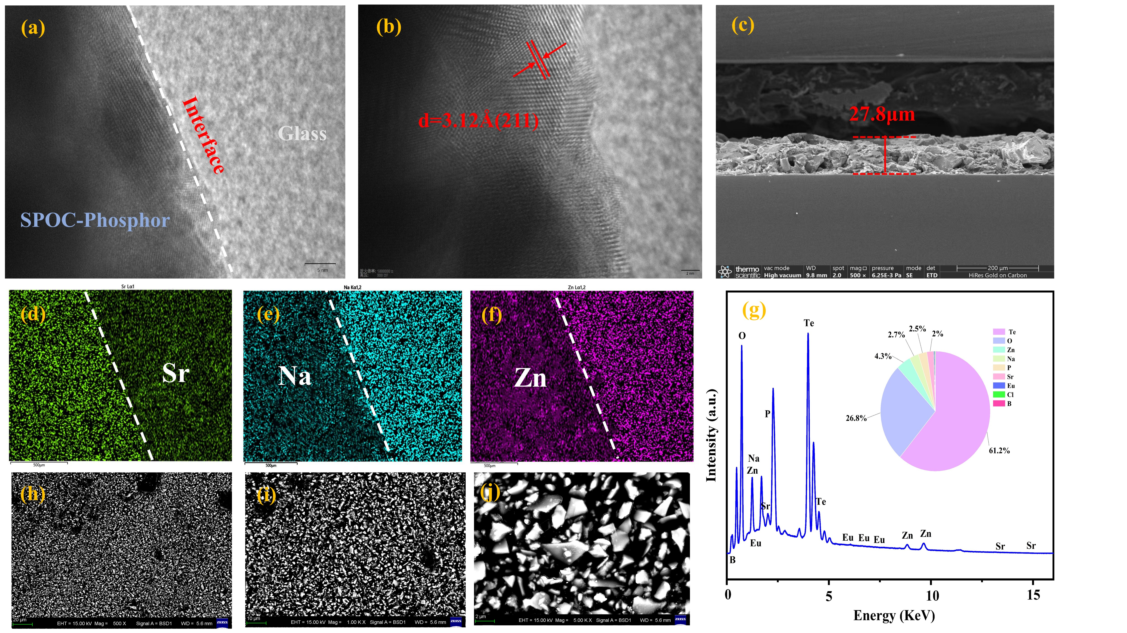
The boundary line between the crystalline and amorphous phases of 335°C-PiG is well defined as shown in Fig. 4(a). SEM Fig. 4 (d-f) shows a clear elemental difference between the tellurite glass and SPOC phosphor, and no significant elemental diffusion region is observed. This indicates that there is no serious interaction between the SPOC phosphor and the glass. The crystal face spacing d = 3.12 Å (211) of PiG was measured in Fig. 4(b). In the standard card PDF#00-016-0666, 221 has a grain spacing of 2.94Å. It was further shown that PiG films expand the material with increasing sintering temperature, leading to larger lattice spacing. Fig. 4(c) again identifies a thickness of 27.8 μm for the PiG film with 3 layers scraped and coated at the optimum sintering temperature of 335 °C. The content of each element in the PiG sample can be seen in Fig. 4(g), and it is obvious that the proportion of borotellurite is much larger than that of the phosphor component. The PiG film then reduces the production cost compared to phosphor glass ceramic that require 100% phosphor and high temperature operation, and the luminescence performance and stability are not inferior to that of the corresponding pure phosphor.
Fig. 4 (a, b) Interfacial maps of 335 °C-PiG films under TEM. (c) Thickness of the 335 °C-PiG film with three layers scraped under SEM (scale bar, 200 μm). (d-g) Elemental analyses of 335 °C-PiG films under SEM. (h-i) Backscatter plots of 335°C-PiG films under SEM.
3.2 Thermal quenching characteristics and moisture resistance of PiG films
Luminescence thermal stability is one of the main requirements of color conversion layers for their LED applications, and in this study, PiG is analyzed in comparison with PiS. Fig. 5 (a-d) shows the thermal stability tests of 335°C-PiG and PiS under 400 nm excitation, respectively. As the temperature gradually increased from 25 °C to 275 °C, it was obvious that the attenuation degree of PL intensity of PiG film was much lower than that of PiS. This is due to the poor heat dissipation of the organic resin, and the accumulation of heat enhances the PiS non-radiative jump and thus the luminescence intensity is weakened. Along with the temperature increase, the full-width at half-maximum (FWHM) variations of the two are not very different, but the PiS undergoes a more serious blueshift phenomenon. This implies that the Stokes shift change (∆S) is greater for PiS than that for PiG, which suggests that PiG films are more reliable for color stability in high-temperature applications.
The 3D contour plots of PL intensity as in Fig. 5(e, f) show more intuitively that the luminescence performance of PiG films is largely superior to that of PiS at the same high temperature. Fig 5(g) quantifies the data, with 335°C-PiG retaining 83% of its initial luminescence intensity at 175°C. In contrast, the luminous intensity of PiS has decayed to less than 50% (49%) of its initial value at 548 K under high-temperature pressure. It is shown that the coating of the inorganic glass matrix in the PiG film makes the phosphor more stable, and the heat build-up of the organic resin in PiS seriously affects the luminescence of the fluorescent phase. Compared with the PiG (YAG-PiG) prepared from the conventional yellow phosphor YAG applied to blue light chips, this blue PiG film under a borotellurite glass matrix further demonstrates its excellent thermal stability.
As shown in Table 2, the luminescence performance was compared with that of the PiS samples prepared with the corresponding phosphors, and the ability of SPOC-PiG to maintain the initial value was much better than that of the other PiGs. According to the classical theory of thermal quenching, the strength with temperature can be quantified by the expression^{[74, 75]}.
${I_{T}}/{I_{0}}={[1+Aexp(-E_{a}/kT)]}^{-1}$ (1)
Where I_{T} denotes the luminous intensity of the sample at temperature T, I₀ denotes the luminous intensity of the sample at the initial temperature, A is a pre-exponential factor, E_{a} is the thermal activation energy and k is the Boltzmann constant (Fig. 5(h)). The thermal activation energy of PiG is 0.143 eV, which exceeds the thermal activation energy of PiS of 0.085 eV. This is due to the effective protection of the phosphor by the glass matrix, which protects the fluorescent phase from the external thermal decomposition of the organic resin and thus improves its thermal-burst characteristics^{[76, 77]}. To explain the excellent thermal quenching property of PiG, a schematic diagram of the grouping is shown in Fig. 5(i). Excited state electrons reach higher energy levels with increasing temperature. When they are above the intersection of the excited and ground state potential energy curves, the excited state electrons will release energy as phonons into the lattice before returning to the ground state, which results in a luminescent thermal quenching^{[78]}. ∆R (the displacement between the equilibrium positions of the base and excited state parabolas) is related to ∆S can be estimated according to the formula ΔS=2(S-1)hv$∝$(ΔR)^{2[79]}. In the formula, S is the Huang-Rhys parameter and hv is the phonon energy. Then the larger ΔS is, the larger ΔR is. ΔR will be smaller due to the rigidity of the coordination environment around the luminous center^{[24]}. And the smaller ΔR is, the smaller ΔS is, the larger E_{a} is, the better the luminous thermal stability is ^{[24]}. Therefore, it is speculated that PiG film is more rigid than PiS due to the coating of the inorganic glass matrix in PiG film. Furthermore, the ΔS of the PiG film is smaller and the E_{a} is larger, which improves the luminescent thermal stability.
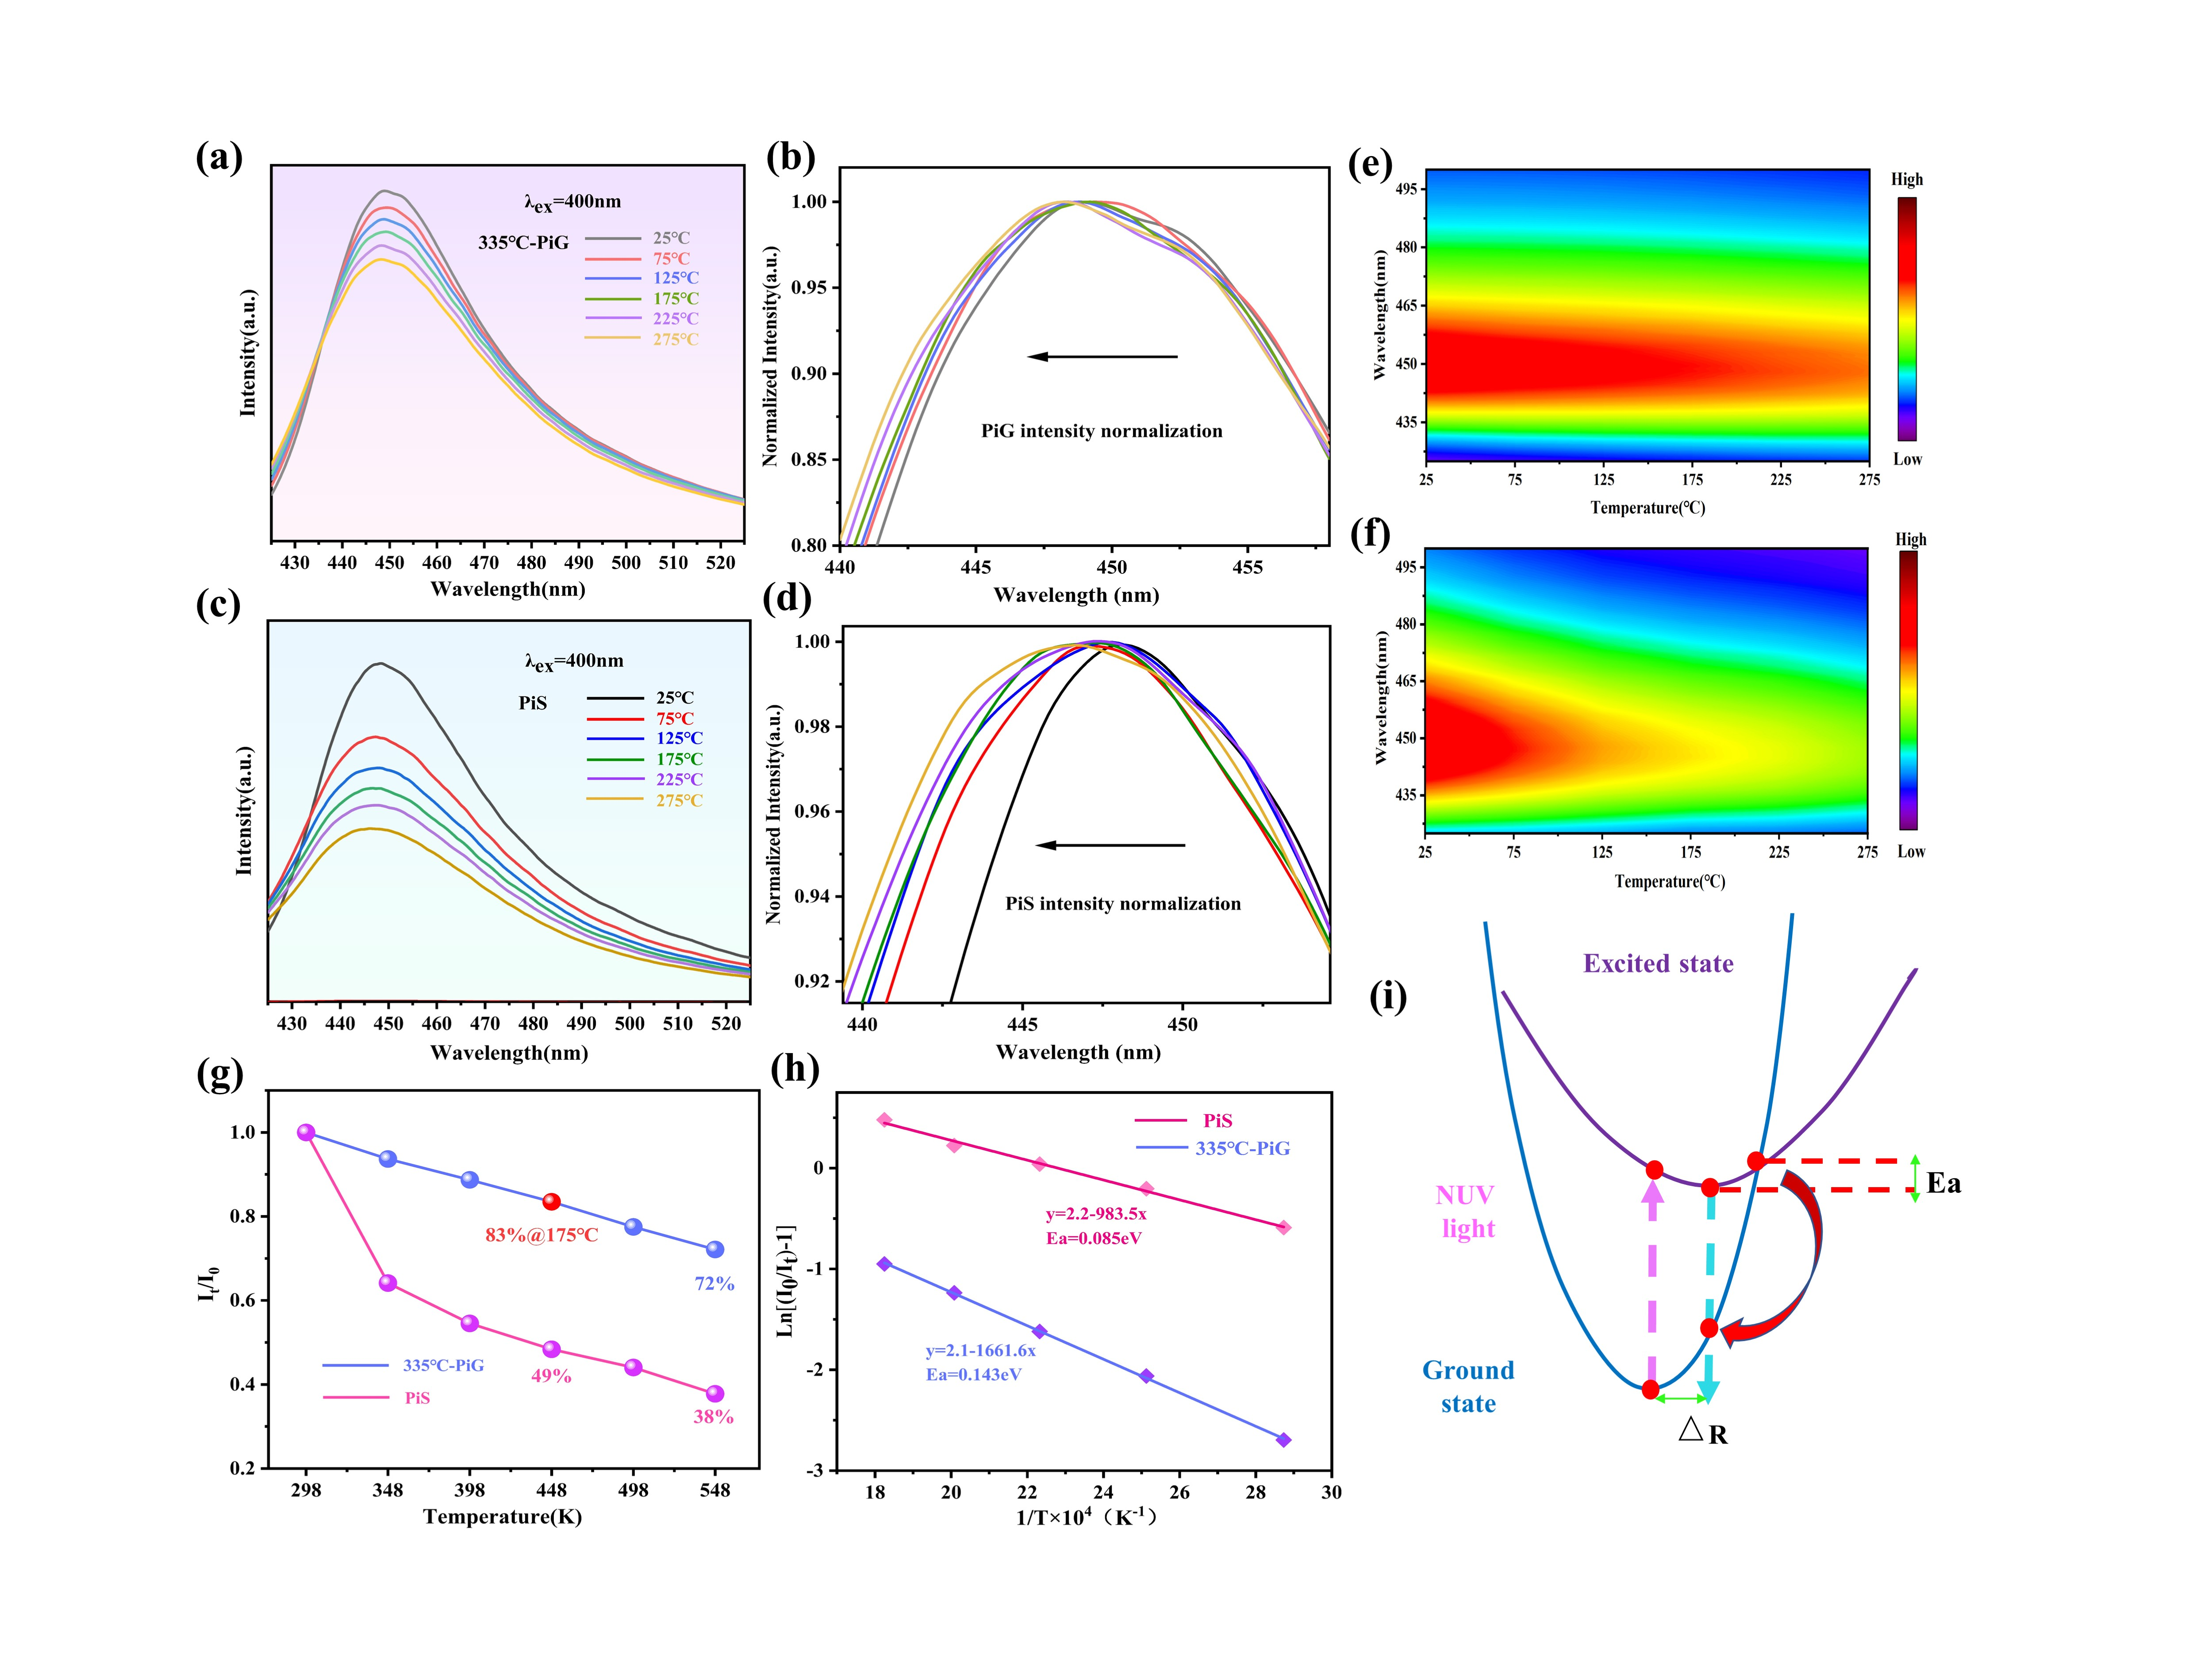
Fig. 5 (a, b) shows the PL intensity at 335°C-PiG with temperature increase and its corresponding blue shift. (c, d) shows the PL of PiS with temperature increase with its corresponding blue shift. (e) 3D contours of the PL intensity of 335°C-PiG with temperature increase. (f) 3D contours of the PL intensity of PiS with temperature increase. (g) Temperature dependence of integrated luminescence intensity of two samples. (h) Calculation of thermal quenching activation energy E_{a} for two samples based on the data in (g). (i) Schematic diagram of coordinates explaining thermal quenching behavior.
Table 2 Comparison of thermal quenching properties of different PiG samples with corresponding PiS
PiG | Phosphor | System of glass | Application | Thermal  Stability（comparison with corresponding PiS at 175℃） | Ref
1 | Sr₅(PO₄)₃Cl:Eu²⁺ | H₂BO₃-TeO₂-ZnO-Na₂CO₃ | Viole-excited  (400-405nm) Sunlight-like LED | Relative to the initial PL intensity, PiG retained 34% more than PiS | This work
2 | YAG: Ce³⁺ | SiO₂-B₂O₃ -RO (R=Zn, Ba)-R₂O (R=Na, K, Li)-Al₂O₃. | Blue-excited w-LED | Relative to the initial PL intensity, PiG retained about 12% more than PiS | ^{[80]}
3 | YAG: Ce³⁺ | Sb₂O₃-B₂O₃-TeO₂-ZnO-Na₂O-La₂O₃- BaO | Blue-excited  (460nm)  w-LED | Relative to the initial PL intensity, PiG retained about 4.3% more than PiS | ^{[81]}
4 | YAG: Ce³⁺ | SiO₂-B₂O₃-RO(R=Ba,Zn) | Blue-excited(452nm)  w-LED | Relative to the initial PL intensity, PiG retained about 0.03% more than PiS. | ^{[82]}
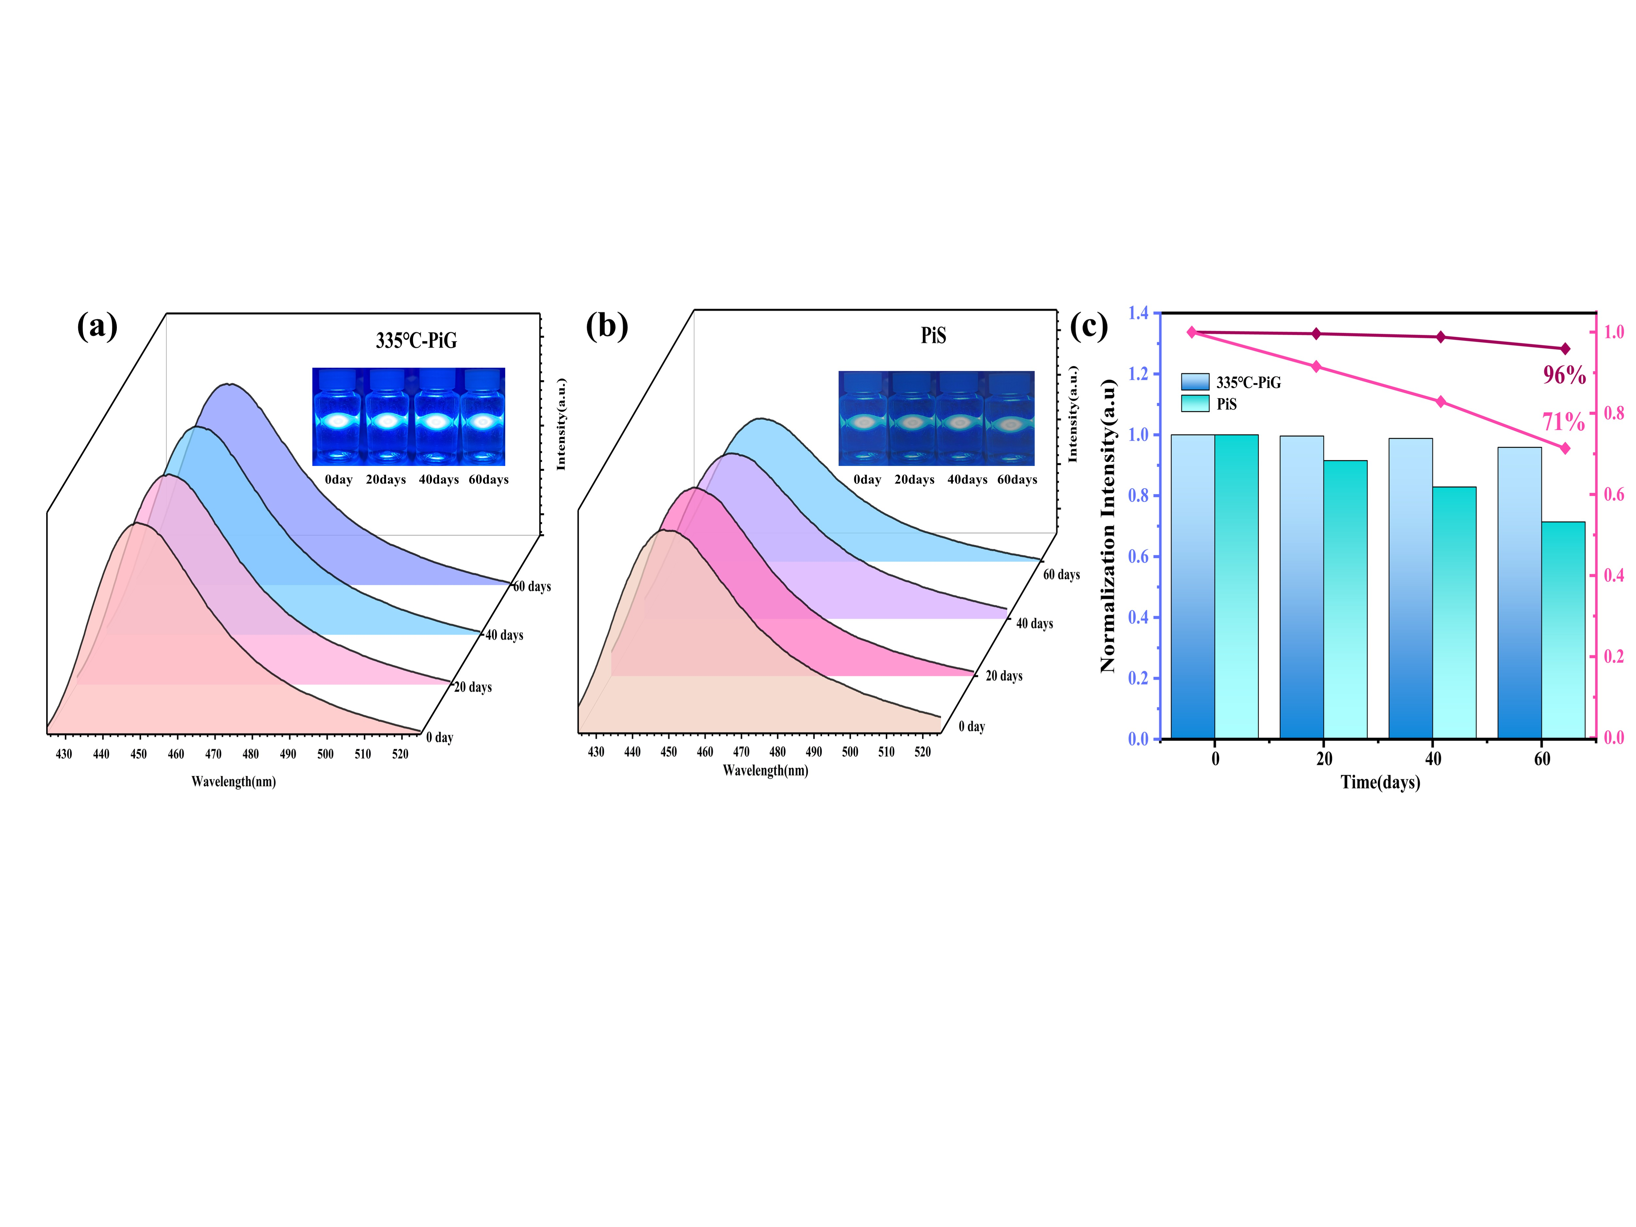
Both PiG films and PiS were immersed in deionized water for 0 to 60 days to observe their moisture resistance properties. The luminescence intensity of the 335 °C-PiG film is observed to be consistently superior to that of PiS in Fig. 6(a,b). With the increase of immersion time, the PL intensity of PiG film basically remains unchanged, while the luminescence intensity of PiS has an obvious decaying trend. The moisture resistance properties of the two samples were quantified as shown in Fig. 5(c). The luminescence intensity of PiG remained 96% of the initial value when both were immersed for up to 60 days. In contrast, the luminescence performance of the PiS sample was severely affected, maintaining only 71% of the initial value. This further illustrates the effective protection of the SPOC phosphor by the borotellurite glass matrix, which reduces the environmental erosion of the fluorescent phase. This provides a viable solution to the problems of aging and corrosion caused by organic resin encapsulation.
Fig. 6 (a, b) Variation of PL luminescence intensity with immersion time for 335°C-PiG films and PiS. (c) Comparison of relative luminescence intensity between PiG and PiS moisture resistance tests.
3.3 Electroluminescent properties of PiG films
To evaluate the practical applicability of SPOC-PiG (the number of scrape coatings are all 3 layers) and the corresponding PiS, in this study, they are laminated with the light-out surface of a 20mA, 400nm violet chip to observe the electroluminescence characteristic properties. Fig 7(a, b) shows that with the increase of sintering temperature, the CRI of SPOC-PiG film increases first and then decreases. The CRI and luminescence intensity of the PiG films reached the maximum at the sintering temperature of 335°C. The color purity of the 335°C-PiG film is closest to that of the PiS sample. Due to the high sintering temperature, there will be ion exchange at the interface of the fluorescence phase and glass phase, resulting in thermal erosion of phosphor, which is not conducive to the light extraction of PiG film^{[83]}. The optimum sintering temperature of SPOC-PiG was again determined to be 335℃. The electroluminescence spectra of the 335°C-PiG film can be observed with distinct violet and blue bands, producing a bright blue light (Fig. 7(c)). Compare this to the EL spectrum of a conventional 20 mA, 450 nm blue LED chip. It is obvious that the blue wave crest of the blue chip is significantly greater than that of the blue light from 335℃-PiG, that is, the blue light radiation from the traditional blue LED chip is more serious. Then the use of the blue PiG film as the fluorescent conversion layer of the LED, to a certain extent, not only ensures the blue spectrum of excellent color purity but also reduces the blue radiation from the chip, effectively reducing the risk of blue light harm.
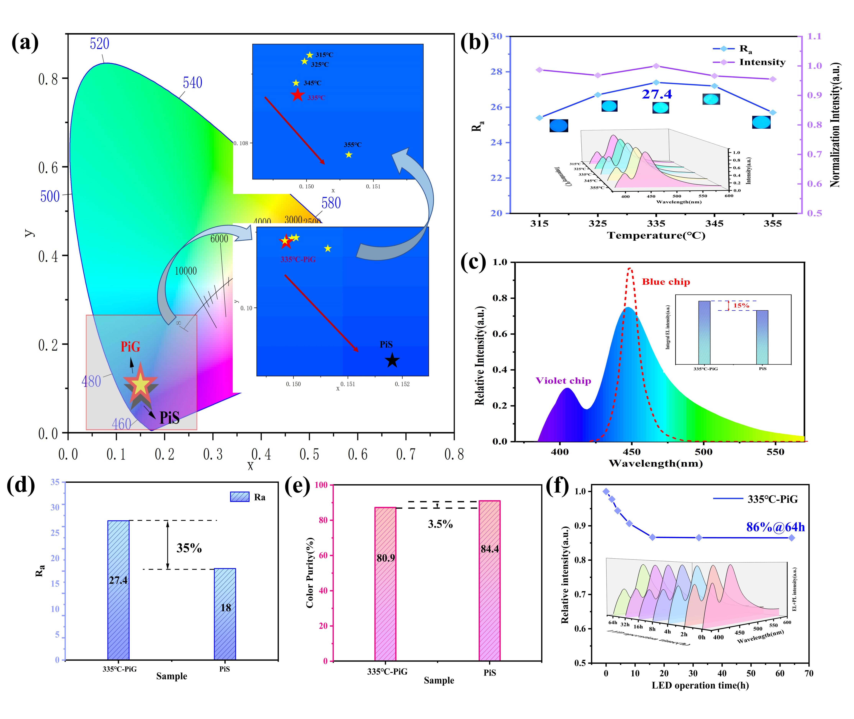
In addition, the EL intensity of 335-PiG and PiS is further quantified in the illustration in Fig 7 (c), and it is obvious that the luminescence performance of PiS is inferior. The CRI of PiS is 35% smaller than that of 335-PiG (Fig 7 (d)), however, although the color purity of PiS is better, the color purity of 335℃ -PiG is only 3.5% different from that of PiS (Fig 7 (e)). With a color purity not far from that of PiS containing organic pastes, 335°C-PiG lays the foundation for the next generation of fully inorganic color conversion materials with its excellent CRI. This is due to the effective protection of the phosphor by the glass matrix in 335°C-PiG. This is different from the damage of the fluorescent phase due to poor heat dissipation of the organic resin in PiS. And the suitable sintering temperature for preparing PiG films reduces the ion exchange and thermal erosion at the interface between the fluorescent phase and the glass phase^{[84-86]}. While PiS does not have such a suitable sintering temperature optimization process, its organic resin is susceptible to aging, yellowing and light degradation as long as it is exposed to high temperatures. Meanwhile 335°C-PiG reduces the loss in light propagation and improves the light extraction rate under the optimal film thickness, which also has a positive effect on enhancing its color rendering index. PiS, on the other hand, has no advantage in thickness control and related performance balance, which affects its color rendering index. In this study, the light aging test was carried out on 335°C-PiG with 20 mA continuous 64 h LED current (Fig 7 (f)). The decomposition of phosphor particles occurred on the photoluminescent surface, and the overall luminous intensity decreased with the increase of current transmission time. But its peak wavelength and FWHM remain essentially the same. After 64h, the EL intensity of 335 °C-PiG still maintained 86% of the initial value.
Fig. 7 (a) CIE coordinates of PiG films and PiS samples at different sintering temperatures. (b) Ra of PiG films with their normalized EL intensities at different sintering temperatures. (c) Relative EL intensity of 335°C-PiG and blue LED chip, inset shows the EL normalized intensity of 335°C-PiG and PiS. (d) Ra of 335°C-PiG and PiS. (e)Color purity of 335°C-PiG and PiS. (f) When the operating current of the violet chip is 20 mA, the relative luminous intensity of EL+PL of 335℃-PiG changes with the change in LED illumination time.
To further evaluate the performance of 335°C-PiG in LED applications, this blue PiG film was combined with a 400 nm violet chip. And again, a red-green fluorescent layer was coated on top of the 335°C-PiG film to prepare a sunlight-like LED device, and the schematic diagram of the device is shown in Fig. 8(f). As shown in Fig. 8(a), part of the violet light emitted from the LED chip is absorbed by the 335°C-PiG, which is converted into the blue spectrum. Accompanied by different ratios of green (Sr,Ba)₂SiO₄: Eu²⁺ and red (Sr,Ca)AlSiN₃: Eu²⁺ phosphor layers, the spectral ratios of sample 3 are the most harmonized. In Fig. 8(b), it can be observed that the color coordinates of this inorganic color conversion layer can be continuously adjusted along the saddle line as the red phosphor ratio increases. And the color coordinates of sample 3 reached (0.3282,0.3515). The CCT of the samples continued to trend towards warmer light during the adjustment along the saddle line, but the CRI reached an optimum of 96.3 at sample 3, as shown in Fig. 8(c). Table 3 compares this study with the PiG applied to other LED chips, and even more so, it demonstrates a superb CRI, which offers great possibilities for the development of full-spectrum light sources. The color fidelity (Rf) of samples 1-4 is maintained above 90%, and the color saturation (Rg) of sample 3 reaches 100%. This demonstrates that this sunlight-like LED device achieves an extremely high level of color reproduction and color accuracy, providing a high-quality visual experience. Interestingly, when the power of sample 3 is continuously increased, its CRI is basically unchanged, and it is maintained above 95. However, the CCT has a trend of increasing, which is speculated to be due to the high LED junction temperature caused by high power, which affects the color temperature^{[87, 88]}.
In Fig 8 (g-i) it can be observed that the physical object in the light of sample 3 is the clearest and has the best visual performance. Fig 8(j) normalized comparison of the electroluminescence spectra of traditional W-led and sample 3 shows that this study is more consistent with the sun-like spectra of health lighting. It largely compensates for the concavity of the spectrum and achieves excellent luminescent performance while reducing radiation from blue light chips. This study lays a solid foundation for the development of the next generation of sunlight-like health-lighting LEDs.
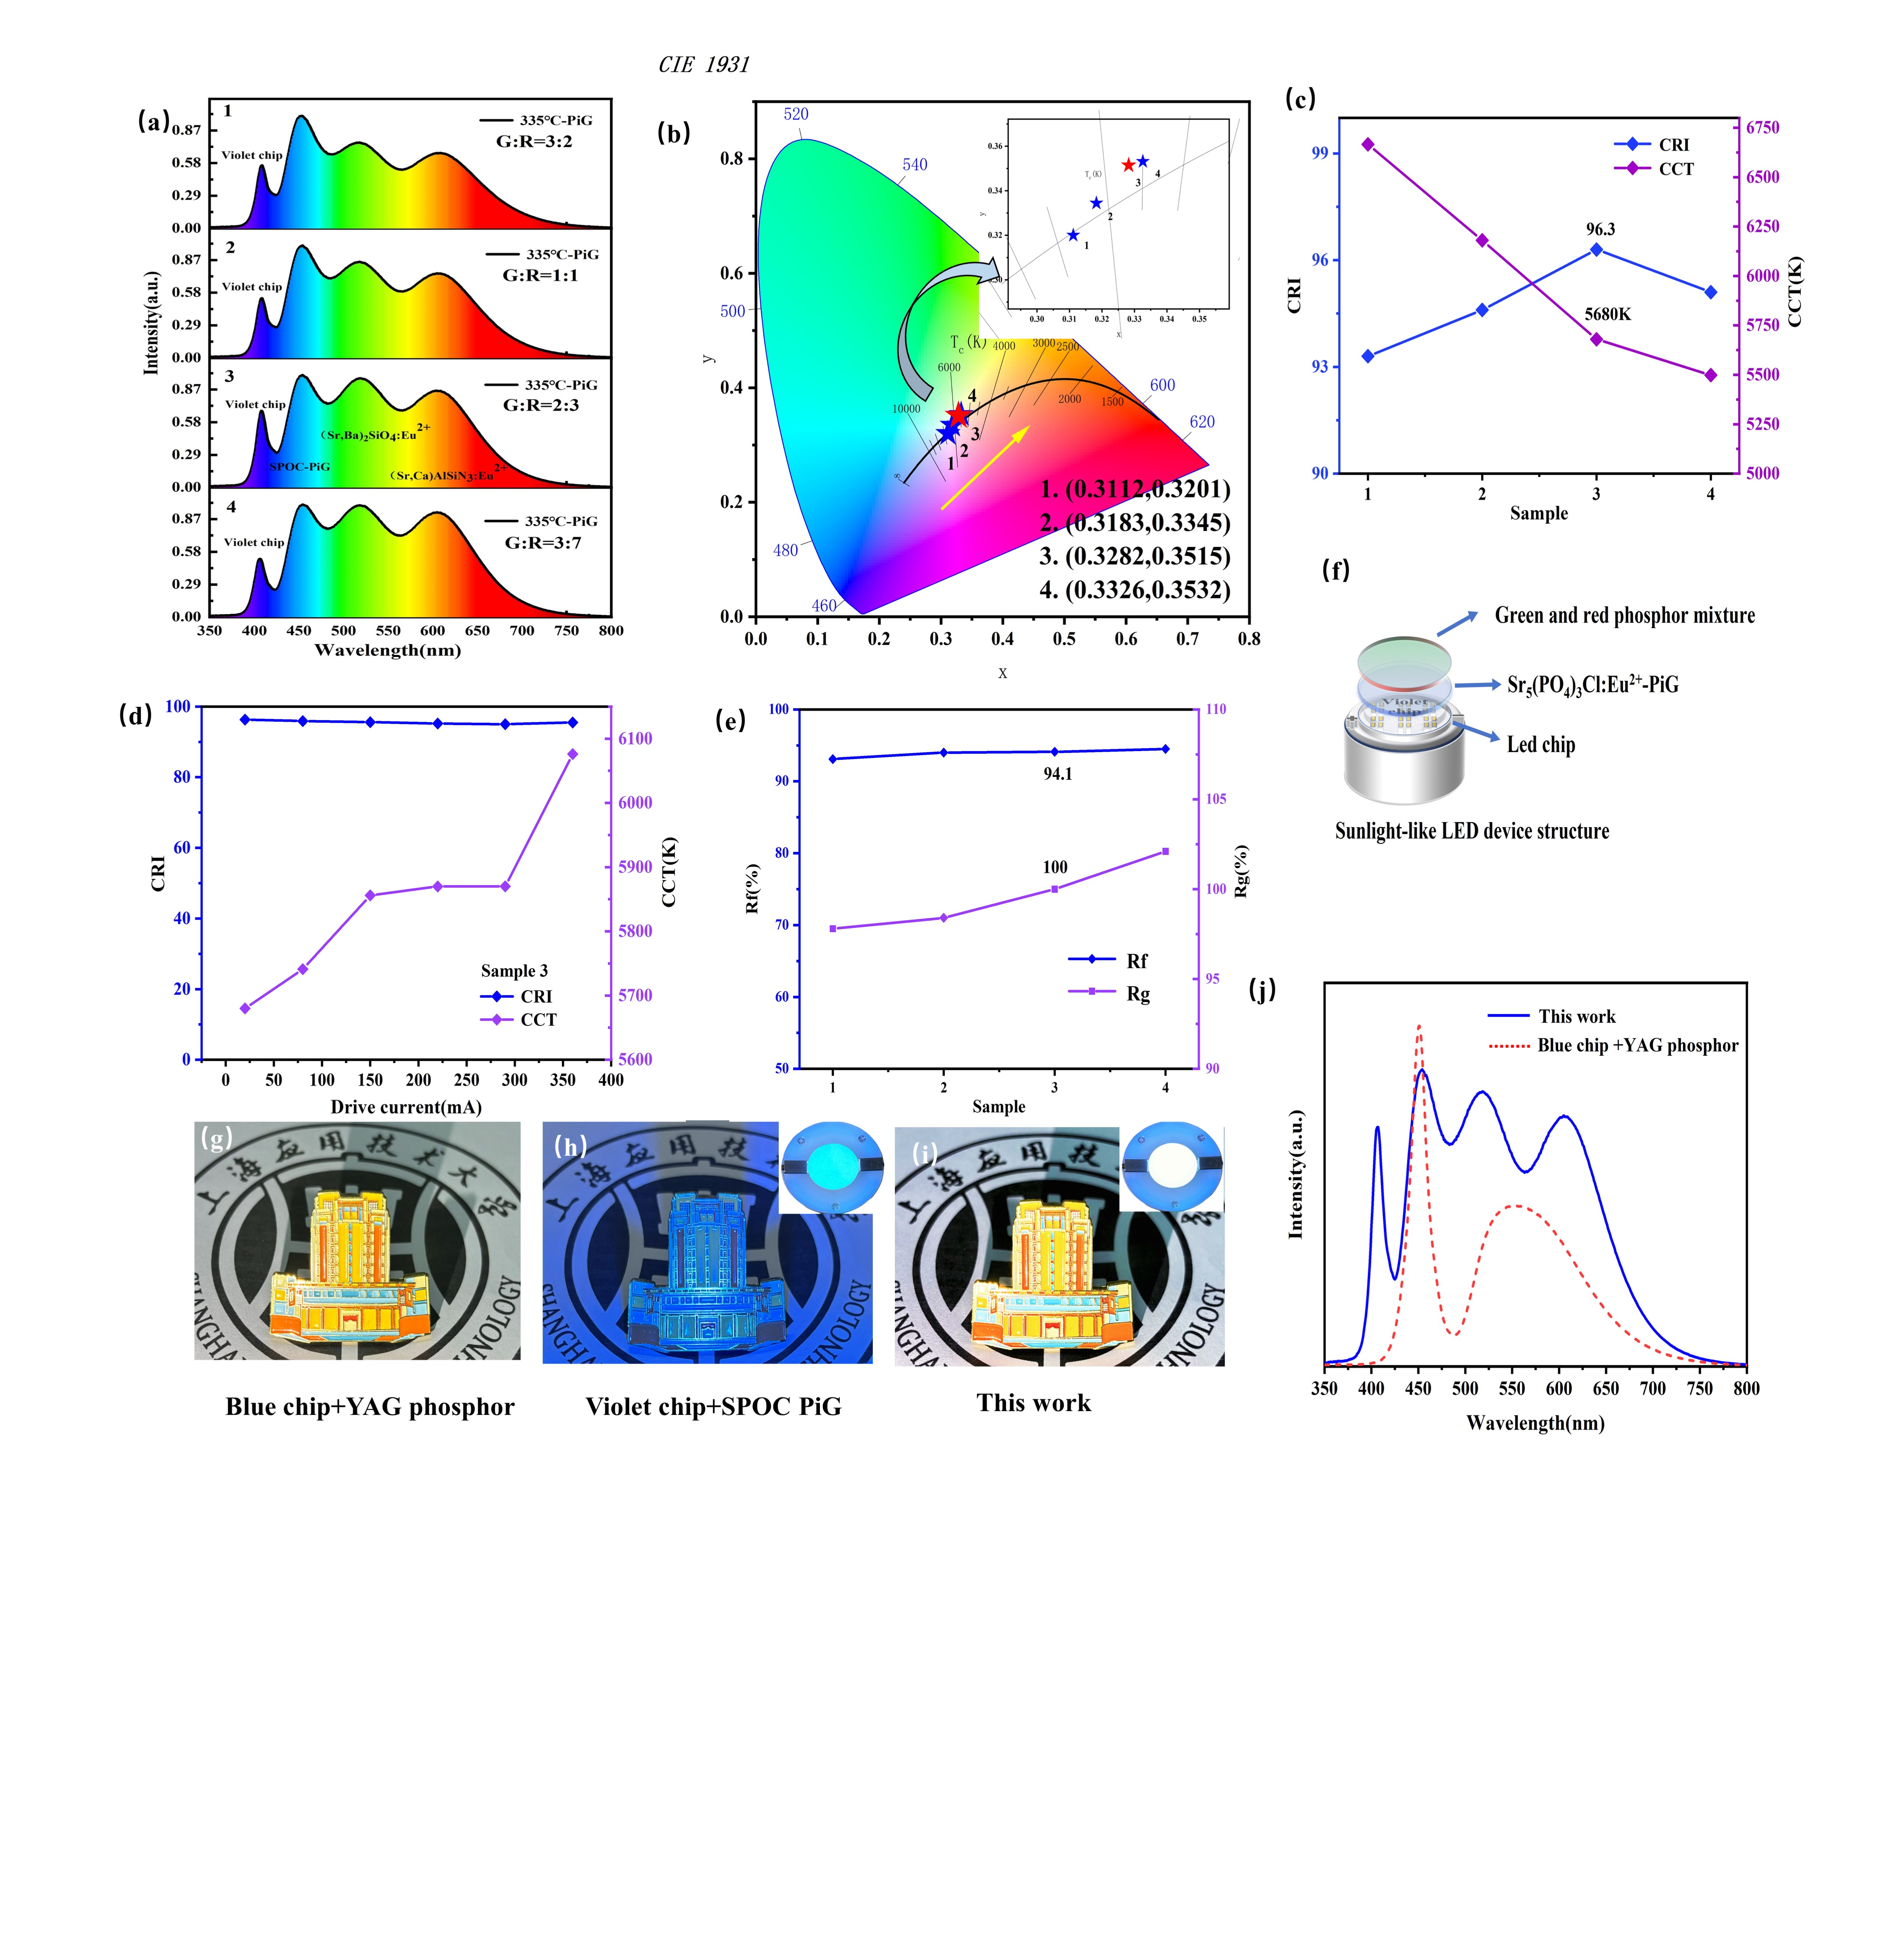
Table 3 Comparison of CCT and CRI of PiG applied to different LED chips
Sample | LED chip | PiG | Composite component | CCT | CRI | Chromaticity coordinates | Ref
1 | Violet chip | Sr₅(PO₄)₃Cl:Eu²⁺-PiG | Green and red phosphor mixture layer | 5680K | 96.3 | (0.3282,0.3515) | This work
2 | Blue chip | YAG: Ce³⁺-PiG | Red-PiS | 4363K | 96.1 | (0.367,0.372) | ^{[40]}
3 | Blue chip | YAG: Ce³⁺-PiG | CaAlSiN₃:Eu²⁺-PiG | 3764K | 85.2 | - | ^{[89]}
4 | Blue chip | (Sr,Ca)AlSiN₃:Eu²⁺-PiG | YAG ceramic | - | 81.7 | - | ^{[90]}
5 | UV chip | (CaAlSiN₃:Eu2⁺)-  (β-SiAlON: Eu²⁺)- (Sr₅(PO₄)₃Cl:Eu²⁺)-PiG | - | - | 85 | (0.3306, 0.3297) | ^{[91]}
6 | n-UV chip | Ca₉Gd(PO₄)₇:Eu²⁺,Mn²⁺-PiG | - | 3283K | - | (0.397,0.352) | ^{[92]}
7 | n-UV chip | Ca₂NaMg₂V₃O₁₂: Eu³⁺-PiG | - | 4179K | 90 | （0.35,0.38） | ^{[93]}
Fig. 8 (a) Spectra of four different ratios of green-red phosphor layers with 335°C-PiG (samples 1-4). (b) CIE coordinate plots of samples 1-4. (c) CRI and CCT of samples 1-4. (d) Sample 3 was excited by a 400nm chip and continuously transported currents of different intensities (0-400mA), and the variation trend of CRI and CCT was observed. (e) Rg and Rf of samples 1-4. (f) Schematic diagram of a sunlight-like healthy lighting LED device. (g-i) Physical comparisons under different types of light. (j) Spectrogram comparison of sample 3 with traditional white light illumination.
4. Conclusion
In this study, a series of violet-excitable blue Sr₅(PO₄)₃Cl: Eu²⁺-PiG films were prepared using a low-temperature co-sintering technique. SPOC phosphors were combined with a low melting point, high refractive index tellurite glass, and scrape-coated on top of a quartz glass substrate. The optimum sintering temperature was 335°C and the optimum number of scrape coatings was 3 layers. The internal and external quantum efficiencies of 335°C-PiG can be maintained at 89% and 79% of the initial phosphor, respectively. The thermal activation energy of 335℃-PiG (0.143 eV) is higher than that of PiS (0.085 eV), showing good thermal stability. In the water stability test, its luminous intensity remained smoothly at 96% of the initial state when immersed in deionized water for 60 days. With the increase of the running time of the 20mA 400nm LED current, its luminous intensity at 64h is still maintained at 86% of the initial state. In this study, a violet chip was utilized as an excitation source for LEDs in combination with an all-inorganic color conversion layer 335°C-PiG. It not only reduces the blue light radiation from conventional blue chips but also avoids the problem of heat build-up in organic packages. This blue PiG was recombined with a red-green fluorescent layer to prepare sunlight-like healthy lighting with a CRI of 96.3 and an Rf of 100%. In a word, the w-led adopts a violet chip and prepares the all-inorganic color conversion layer that can make up for the blue depression, and realizes the sunlight-like LED with excellent luminous performance and good stability. The PiG films prepared in this study have significant advantages in the field of sunlight-like healthy lighting, which can not only effectively reduce the harm of blue light, but also extend the service life of the lighting equipment with its excellent stability and luminescence performance, reduce the maintenance cost, and provide a key technical support for the large-scale promotion of sunlight-like healthy lighting
Acknowledgments
Yongzheng Fang acknowledges financial support from the National Key Research and Development Program (No. 2021YFB3500500)，the National Natural Science Foundation of China (No. 51472162) and the National Foreign Experts Program (G2023013005L). Guoying Zhao acknowledges financial support from Science and Technology Talents Development Fund for Young Middle-aged Teachers Fund, Collaborative Innovation Fund (No. XTCX2022-03) of Shanghai Institute of Technology and Development of key technologies for the preparation and application of high-performance rare earth fluorescent block materials (No. BFXT-2022-D0046). Yufeng Liu acknowledges financial support from National Natural Science Foundation of China (No. 62275161, U2141240).
Data Availability Statement
The data that support the findings of this study are available on request from the corresponding author. The data are not publicly available due [state restrictions such as privacy or ethical restrictions].

References
[1] Y. Shao, H. Cai, F. Zhao, S. Liu, Z. Song, Q. Liu. Efficient violet-light-excitable blue-cyan phosphor for full-spectrum lighting. Org. Chem. Front. 2022, 9(21): 5590-5596.
[2] S. Khan, W. Khan, W. Khan, D. Khan, S. Saeed, S. Badshah, M. Ikram, T. Saleh. Eu³⁺, Sm³⁺ deep‐red phosphors as novel materials for white light‐emitting diodes and simultaneous performance enhancement of organic–inorganic perovskite solar cells. Small. 2020, 16(25): 2001551.
[3] A. Raja, G. Annadurai, V. Sivasubramani, K. Ramachandran, R. Kamesh, V. Govindan, P. Vijayakumar, V. Siva, P. Ramasamy. Synthesis, crystal structure, and luminescence properties of RbCaF₃: Eu³⁺ orange-red emitting phosphors for white light emitting diodes. Ceram. Int. 2023, 49(7): 11393-11401.
[4] S. Liang, M. Shang, H. Lian, K. Li, Y. Zhang, J. Lin. An efficient rare-earth free deep red emitting phosphor for improving the color rendering of white light-emitting diodes. J. Mater. Chem. C. 2017, 5(11): 2927-2935.
[5] S. Ye, F. Xiao, Y. Pan, Y. Ma, Q. Zhang. Phosphors in phosphor-converted white light-emitting diodes: Recent advances in materials, techniques and properties. Mater. Sci. Eng. Rep. 2010, 71(1): 1-34.
[6] V. Hipólito, J. M. Coelho, Blue light and eye damage: a review on the impact of digital device emissions, in: Photonics, MDPI, 2023, pp. 560.
[7] N. A. Wong, H. Bahmani. A review of the current state of research on artificial blue light safety as it applies to digital devices. Heliyon. 2022, 8(8).
[8] J. Kurek, A. Gadomska, R. Gorzyński, J. Molczyk-Sieńczak, M. Garstka, H. Dominik, Z. Czudy, W. Pawęska, J. Radwański, M. Polatowska. Blue light emitted from digital devices-impact on our sleep. Journal of Education. 2023, 40(1): 68-82.
[9] V. Bachmann, C. Ronda, A. Meijerink. Temperature quenching of yellow Ce³⁺ luminescence in YAG: Ce. Chem. Mater. 2009, 21(10): 2077-2084.
[10] S. Zhu, X. Zhang, W. Li, M. Liu, L. Cheng, X. Mi, L. Lu. Phase transformation and luminescence properties of Y_{2. 94}Al_{5-x}Ga_{x}O₁₂: 0.06 Ce³⁺ phosphors. Ceram. Int. 2019, 45(4): 4964-4971.
[11] Z. Liu, L. Zhang, J. Kang, T. Zhou, S. Chen, P. Yang, B. Sun, Y. Li, H. Chen. Barcode-structured YAG: Ce/YAG: Ce, Mn ceramic phosphors for variable CCT and high CRI LED/LD lighting. Opt. Express. 2023, 31(15): 24914-24925.
[12] J. Kim, S. Song. Protective sol–gel coating on silicate phosphor used in light emitting diodes. Appl. Surf. Sci. 2011, 257(6): 2159-2163.
[13] P. Pust, V. Weiler, C. Hecht, A. Tücks, A. S. Wochnik, A. K. Henß, D. Wiechert, C. Scheu, P. J. Schmidt, W. Schnick. Narrow-band red-emitting Sr [LiAl₃N₄]: Eu²⁺ as a next-generation LED-phosphor material. Nat. Mater. 2014, 13(9): 891-896.
[14] Y. Tian. Development of phosphors with high thermal stability and efficiency for phosphor-converted LEDs. J Sol State Light. 2014, 1: 1-15.
[15] J. Zhong, D. Chen, Y. Zhou, Z. Wan, M. Ding, Z. Ji. Stable and chromaticity-tunable phosphor-in-glass inorganic color converter for high-power warm white light-emitting diode. J. Eur. Ceram. Soc. 2016, 36(7): 1705-1713.
[16] H. Chen, T. Seto, Y. Wang. An efficient blue phosphor with high thermal stability for lighting and optical pressure sensor applications. Org. Chem. Front. 2022, 9(8): 1644-1654.
[17] D. Böhnisch, J. Rosenboom, A. García-Fuente, W. Urland, T. Jüstel, F. Baur. On a blue emitting phosphor Na₃RbMg₇(PO₄)₆: Eu²⁺ showing ultra high thermal stability. J. Mater. Chem. C. 2019, 7(20): 6012-6021.
[18] M. Krames, O. Shchekin, R. Mueller Mach, G. Mueller, L. Zhou, G. Harbers, M. Craford. Status and future of high-power light-emitting diodes for solid-state lighting. J. Disp. Technol. 2007, 3(2): 160-175.
[19] H. Ji, P. Li, W. Fu, Z. Li, Z. Ge. The application of wide spectrum low peak blue light technology in health TV display. J. Soc. Inf. Disp. 2022, 30(7): 567-573.
[20] J. Jou, S. Shen, M. Tang, P. Chen, S. Chen, Y. Wang, C. Chen, C. Wang, C. Hsieh, C. Lin, OLED-based physiologically-friendly very low-color temperature illumination for night, in: CURR OPT PHOTONICS, 2012,116-130.
[21] J. Jou, Z. He, Y. Su, Y. Tsai, C. Wu. Approach for fabricating healthy OLED light sources with visual quality and energy-saving character. Org. Electron. 2016, 38: 396-400.
[22] Q. Zhang, X. Wang, Y. Wang. Design of a broadband cyan-emitting phosphor with robust thermal stability for high-power WLED application. J. Alloys Compd. 2021, 886: 161217.
[23] L. Sun, B. Devakumar, J. Liang, S. Wang, Q. Sun, X. Huang. A broadband cyan-emitting Ca₂LuZr₂(AlO₄)₃: Ce³⁺ garnet phosphor for near-ultraviolet-pumped warm-white light-emitting diodes with an improved color rendering index. J. Mater. Chem. C. 2020, 8(3): 1095-1103.
[24] Y. Shao, H. Cai, F. Zhao, S. Liu, Z. Song, Q. Liu. Efficient violet-light-excitable blue-cyan phosphor for full-spectrum lighting. Inorg. Chem. Front. 2022, 9(21): 5590-5596.
[25] L. Li, R. Yang, Z. Du, K. Zou, X. Zhang. Luminescent research of Sr₅(PO₄)₃ Cl: Eu₂₊ blue phosphor used for electron beam excitation. Chin. Sci. Bull. 2003, 48: 1558-1560.
[26] S. Dhoble. Preparation and characterization of the Sr₅(PO₄)₃Cl: Eu²⁺ phosphor. Applied Physics. 2000, 33(2): 158.
[27] J. Zheng, Q. Cheng, S. Wu, Z. Guo, Y. Zhuang, Y. Lu, Y. Li, C. Chen. An efficient blue-emitting Sr₅(PO₄)₃ Cl: Eu²⁺ phosphor for application in near-UV white light-emitting diodes. J. Mater. Chem. C. 2015, 3(42): 11219-11227.
[28] N. Narendran, Y. Gu. Life of LED-based white light sources. J. Disp. Technol. 2005, 1(1): 167.
[29] W. J. Chung, Y. H. Nam. A review on phosphor in glass as a high power LED color converter. ECS J. Solid State Sci. Technol. 2020, 9(1): 016010.
[30] S. Fujita, A. Sakamoto, S. Tanabe. Luminescence characteristics of YAG glass–ceramic phosphor for white LED. IEEE J. Sel. Top. Quantum Electron. 2008, 14(5): 1387-1391.
[31] A. Rocha, L. Andrade, S. Lima, A. Farias, A. Bento, M. Baesso, Y. Guyot, G. Boulon. Tunable color temperature of Ce³⁺/Eu ^{2+, 3+} co-doped low silica aluminosilicate glasses for white lighting. Opt. Express. 2012, 20(9): 10034-10041.
[32] K. Han, W. B. Im, J. Heo, W. J. Chung. A complete inorganic colour converter based on quantum-dot-embedded silicate glasses for white light-emitting-diodes. Chem. Commun. 2016, 52(17): 3564-3567.
[33] D. Chen, S. Yuan, X. Chen, J. Li, Q. Mao, X. Li, J. Zhong. CsPbX₃ (X= Br, I) perovskite quantum dot embedded low-melting phosphosilicate glasses: controllable crystallization, thermal stability and tunable emissions. J. Mater. Chem. C. 2018, 6(25): 6832-6839.
[34] S. Bae, Y. Choi, W. Im, K. Lee, W. Chung. Rare earth doped silicate-oxyfluoride glass ceramics incorporating LaF₃ nano-crystals for UV-LED color conversion. Opt. Mater. 2013, 35(11): 2034-2038.
[35] T. Nakanishi, S. Tanabe. Novel Eu²⁺-Activated Glass Ceramics Precipitated With Green and Red Phosphors for High-Power White LED. IEEE J. Sel. Top. Quantum Electron. 2009, 15(4): 1171-1176.
[36] P. Babu, K. H. Jang, E. S. Kim, L. Shi, H. J. Seo, F. Rivera-López, U. Rodriguez-Mendoza, V. Lavin, R. Vijaya, C. Jayasankar. Spectral investigations on Dy³⁺-doped transparent oxyfluoride glasses and nanocrystalline glass ceramics. J. Appl. Phys. 2009, 105(1): 332-339.
[37] Y. Kim, S. Kim, F. Iqbal, H. Yie, H. Kim. Effect of transmittance on luminescence properties of phosphor-in-glass for LED packaging. Opt. Express. 2015, 23(3): A43-A50.
[38] X. Zhang, J. Liu, J. Liu, Y. Peng, J. Li, T. Shi. Reliable and efficient phosphor-in-glass-based chip-scale packaging for high-power white LEDs. IEEE Trans. Electron Devices. 2021, 68(9): 4473-4477.
[39] P. Zheng, S. Li, L. Wang, T. L. Zhou, S. You, T. Takeda, N. Hirosaki, R. J. Xie. Unique color converter architecture enabling phosphor-in-glass (PiG) films suitable for high-power and high-luminance laser-driven white lighting. ACS Appl. Mater. Interfaces. 2018, 10(17): 14930-14940.
[40] Y. Peng, Q. Sun, J. Liu, H. Cheng, Y. Mou. Fabrication of stacked color converter for high-power WLEDs with ultra-high color rendering. J. Alloys Compd. 2021, 850: 156811.
[41] R. Zhang, B. Wang, W. Zhu, C. Li, H. Wang. Preparation and luminescent performances of transparent screen-printed Ce³⁺: Y₃Al₅O₁₂ phosphors-in-glass thick films for remote white LEDs. J. Alloys Compd. 2017, 720: 340-344.
[42] M. Buffolo, C. De Santi, M. Albertini, D. Carbonera, G. A. Rizzi, G. Granozzi, G. Meneghesso, E. Zanoni, M. Meneghini. Reliability of blue-emitting Eu²⁺-doped phosphors for laser-lighting applications. Materials. 2018, 11(9): 1552.
[43] L. Ha, N. Tu, N. Quang, C. Thang, P. Vuong, D. Viet, N. Hung, N. Kien, T.-T. Duong, N. Lien. Effect of doping concentration and sintering temperature on structure and photoluminescence properties of blue/red emitting bi-phase Eu³⁺/Eu²⁺-doped Sr₅(PO₄)₃Cl/Sr₃(PO₄) ₂ phosphors. Mater. Res. Express. 2018, 5(7): 076516.
[44] R. Wei, L. Wang, P. Zheng, H. Zeng, G. Pan, H. Zhang, P. Liang, T. Zhou, R. Xie. On the luminance saturation of phosphor-in-glass (PiG) films for blue-laser-driven white lighting: Effects of the phosphor content and the film thickness. J. Eur. Ceram. Soc. 2019, 39(5): 1909-1917.
[45] P. Zheng, S. Li, L. Wang, T. L. Zhou, S. You, T. Takeda, N. Hirosaki, R.-J. Xie. Unique color converter architecture enabling phosphor-in-glass (PiG) films suitable for high-power and high-luminance laser-driven white lighting. ACS Appl. Mater. Interfaces. 2018, 10(17): 14930-14940.
[46] Z. Wang, J. Zou, C. Zhang, M. Shi, B. Yang, Y. Li, H. Zhou, Y. Liu, M. Li, X. Qian. High color rendering index of warm WLED based on LuAG: Ce³⁺ PiG coated CaAlSiN₃: Eu²⁺ phosphor film for residential lighting applications. J MATER SCI-MATER EL. 2018, 29: 8767-8773.
[47] R. Kaur, R. Kaur, A. Khanna, F. González, Structural and thermal properties of vanadium tellurite glasses, in: AIP Conference Proceedings, AIP Publishing, 2018.
[48] Y. Peng, Y. Mou, H. Wang, Y. Zhuo, H. Li, M. Chen, X. Luo. Stable and efficient all-inorganic color converter based on phosphor in tellurite glass for next-generation laser-excited white lighting. J. Eur. Ceram. Soc. 2018, 38(16): 5525-5532.
[49] P. Nosella, Universidade de São Paulo, Escola de Engenharia de São Carlos: os primeiros tempos: 1948-1971, Editora da UFSCar, 2000.
[50] V. Bhatia, D. Kumar, A. Kaur, D. Singh, A. Singh, S. Singh, Investigation of optical and physical properties of zinc sodium bismuth borate glass system, in: IOP Conference Series: Materials Science and Engineering, IOP Publishing, 2021. 012073.
[51] I. Grelowska, M. Reben, B. Burtan, M. Sitarz, J. Cisowski, A. Knapik, M. Dudek. Structural and optical study of tellurite–barium glasses. J. Mol. Struct. 2016, 1126: 219-225.
[52] J. Hrabovský, M. Buryi, V. Babin, K. Ridzoňová, K. Paurová, D. John. Correlated EPR and optical study of charge trapping phenomena in tellurite glasses. The role of barium oxide. J. Non-Cryst. Solids. 2023, 620: 122596.
[53] M. Mhareb, Y. Alajerami, M. Sayyed, K. Mahmoud, T. Ghrib, M. K. Hamad, Q. Drmosh, N. Sfina, M. Almessiere. Morphological, optical, structural, mechanical, and radiation-shielding properties of borosilicate glass–ceramic system. Ceram. Int. 2022, 48(23): 35227-35236.
[54] H. Chen, H. Lin, J. Xu, B. Wang, Z. Lin, J. Zhou, Y. Wang. Chromaticity-tunable phosphor-in-glass for long-lifetime high-power warm w-LEDs. J. Mater. Chem. C. 2015, 3(31): 8080-8089.
[55] J. Zheng, Q. Cheng, S. Wu, Z. Guo, Y. Zhuang, Y. Lu, Y. Li, C. Chen. An efficient blue-emitting Sr₅ (PO₄)₃ Cl: Eu²⁺ phosphor for application in near-UV white light-emitting diodes. J. Mater. Chem. C. 2015, 3(42): 11219-11227.
[56] C. Zhang, J. Lin. Defect-related luminescent materials: synthesis, emission properties and applications. Chem. Soc. Rev. 2012, 41(23): 7938-7961.
[57] J. Qiao, L. Ning, M. S. Molokeev, Y.-C. Chuang, Q. Liu, Z. Xia. Eu²⁺ site preferences in the mixed cation K₂BaCa(PO₄)₂ and thermally stable luminescence. J. Am. Chem. Soc. 2018, 140(30): 9730-9736.
[58] P. Dang, W. Wang, H. Lian, G. Li, J. Lin. How to obtain anti‐thermal‐quenching inorganic luminescent materials for light‐emitting diode applications. Advanced Optical Materials. 2022, 10(6): 2102287.
[59] Y. H. Kim, P. Arunkumar, B. Y. Kim, S. Unithrattil, E. Kim, S.-H. Moon, J. Y. Hyun, K. H. Kim, D. Lee, J.-S. Lee. A zero-thermal-quenching phosphor. Nat. Mater. 2017, 16(5): 543-550.
[60] Y. H. Kim, H. J. Kim, S. P. Ong, Z. Wang, W. B. Im. Cation-size mismatch as a design principle for enhancing the efficiency of garnet phosphors. Chem. Mater. 2020, 32(7): 3097-3108.
[61] H. Liu, H. Liang, W. Zhang, Q. Zeng, D. Wen. Improving the thermal stability and luminescent efficiency of (Ba, Sr)₃SiO₅: Eu²⁺ phosphors by structure, bandgap engineering and soft chemistry synthesis method. Chem. Eng. J. 2021, 410: 128367.
[62] G. Liu, Z. Tian, Z. Chen, H. Wang, Q. Zhang, Y. Li. CaAlSiN₃: Eu²⁺ phosphors bonding with bismuth borate glass for high power light excitation. Opt. Mater. 2015, 40: 63-67.
[63] B.-N. Kim, K. Hiraga, K. Morita, H. Yoshida, T. Miyazaki, Y. Kagawa. Microstructure and optical properties of transparent alumina. Acta Mater. 2009, 57(5): 1319-1326.
[64] R. Boulesteix, A. Maitre, J.-F. Baumard, Y. Rabinovitch, F. Reynaud. Light scattering by pores in transparent Nd: YAG ceramics for lasers: correlations between microstructure and optical properties. Opt. Express. 2010, 18(14): 14992-15002.
[65] Y. Mou, D. Chen, B. Tian, J. Zhao, Y. Peng, H. Cheng, X. Wang. High-Quality Laser-Driven White Lighting Enabling by Collecting Backward Emission Light of Phosphor-in-Glass Film. IEEE Trans. Electron Devices. 2024.
[66] L. Chen, W. Cheng, C. Tsai, Y. Huang, Y. Lin, W. Cheng. High-performance glass phosphor for white-light-emitting diodes via reduction of Si-Ce³⁺: YAG inter-diffusion. Opt. Mater. Express. 2013, 4(1): 121-128.
[67] J. Deng, W. Li, H. Zhang, Y. Liu, B. Lei, H. Zhang, L. Liu, X. Bai, H. Luo, H. Liu. Eu³⁺‐doped phosphor‐in‐glass: a route toward tunable multicolor materials for near‐UV high‐power warm‐white LEDs. Adv. Opt. Mater. 2017, 5(3): 1600910.
[68] Q. Zhu, X. Xu, L. Wang, Z. Tian, Y. Xu, N. Hirosaki, R. Xie. A robust red-emitting phosphor-in-glass (PiG) for use in white lighting sources pumped by blue laser diodes. J. Alloys Compd. 2017, 702( 17): 193-198.
[69] S. Fujita, A. Sakamoto, S. Tanabe. Luminescence characteristics of YAG glass-ceramic phosphor for white LED. IEEE J. Sel. Top. Quantum Electron. 2008, 14(5): 1387-1391.
[70] H. Karimi, Y. Zhang, S. Cui, R. Ma, G. Li, Q. Wang, J. Zhao, X. Qiao, J. Du, X. Fan. Spectroscopic properties of Eu-doped oxynitride glass-ceramics for white light LEDs. J. Non-Cryst. Solids. 2014, 406: 119-126.
[71] M. Suda, R. Nakagawa, K. Kanamura, K. Kajihara. Sol-gel-derived transparent silica-(Gd, Pr)PO₄ glass-ceramic narrow-band UVB phosphors. Dalton Trans. 2018, 47(35): 12085-12091.
[72] Q. He, Y. Zhang, Y. Yu, Y. Chen, M. Jin, E. Mei, X. Liang, L. Zhai, W. Xiang. Ultrastable Gd³⁺ doped CsPbBrI₂ nanocrystals red glass for high efficiency WLEDs. Chem. Eng. J. 2021, 411: 128530.
[73] Y. Zhu, B. Yang, Q. Lu, L. Zhang, Y. Zhao, B. Xia, S. Mei, M. Shi, Y. Li, R. Hu. Stable Dy-doped CsPbBr₃ quantum dot glass with enhanced optical performance. J. Non-Cryst. Solids. 2022, 575: 121224.
[74] S. Li, L. Wang, Q. Zhu, D. Tang, X. Liu, G. Cheng, L. Lu, T. Takeda, N. Hirosaki, Z. Huang. Crystal structure, tunable emission and applications of Ca_{1-x} Al_{1-x}Si_{1+x} N_{3-x}O_{x}: RE (x= 0-0.22, RE= Ce³⁺, Eu²⁺) solid solution phosphors for white light-emitting diodes. J. Mater. Chem. C. 2016, 4(47): 11219-11230.
[75] Y. Chen, B. Liu, C. Shi, G. Ren, G. Zimmerer. The temperature effect of Lu₂SiO₅: Ce³⁺ luminescence. Nuclear Instruments and Methods in Physics Research Section A: Accelerators, Spectrometers, Detectors and Associated Equipment. 2005, 537(1-2): 31-35.
[76] Y. Wang, L. Wang, S. Bao, L. Xu, J. Zhang, Y. Liang, L. Wang, X. Liang, W. Xiang. High-performance and heat-resistant Ce: YAG phosphor in glass for laser lighting. J. Alloys Compd. 2022, 921: 166083.
[77] H. Wang, Y. Mou, Y. Peng, Y. Zhang, A. Wang, L. Xu, H. Long, M. Chen, J. Dai, C. Chen. Fabrication of phosphor glass film on aluminum plate by using lead-free tellurite glass for laser-driven white lighting. J. Alloys Compd. 2020, 814: 152321.
[78] C. Dou, F. Zhao, S. Liu, Z. Song, Q. Liu. Achieving efficient violet-light-excited blue phosphors by nitridation for violet-chip-based full-spectrum lighting. Org. Chem. Front. 2023, 10(8): 2430-2437.
[79] B. Henderson, G. F. Imbusch, Optical spectroscopy of inorganic solids, Oxford University Press, 2006.
[80] Y. Peng, R. Li, S. Wang, Z. Chen, L. Nie, M. Chen. Luminous properties and thermal reliability of screen-printed phosphor-in-glass-based white light-emitting diodes. IEEE Trans. Electron Devices. 2017, 64(3): 1114-1119.
[81] R. Zhang, H. Lin, Y. Yu, D. Chen, J. Xu, Y. Wang. A new‐generation color converter for high‐power white LED: transparent Ce³⁺: YAG phosphor‐in‐glass. Laser Photonics Rev. 2014, 8(1): 158-164.
[82] Y. Lee, J. Lee, J. Heo, W. Im, W. Chung. Phosphor in Glass with Pb-Free Silicate Glass Powders as Robust Color-Converting Materials for White LED Application. Opt. Lett. 2012, 37(15): 3276-3278.
[83] D. Chen, W. Xiang, X. Liang, J. Zhong, H. Yu, M. Ding, H. Lu, Z. Ji. Advances in transparent glass–ceramic phosphors for white light-emitting diodes-A review. J. Eur. Ceram. Soc. 2015, 35(3): 859-869.
[84] Z. Yu, J. Zhao, Q. Wang, Y. Mou, M. Chen, Y. Peng. Laser spot associated high-saturation phosphor-in-glass film for transmissive and reflective high-brightness laser lighting. Journal of Advanced Ceramics. 2023, 12(9): 1821-1832.
[85] N. T. P. Loan, N. D. Q. Anh. The effectiveness of MgCeAl₁₁O₁₉: Tb³⁺ phosphor in enhancing the luminous efficacy and color quality of multi-chip white LEDs. International Journal of Electrical and Computer Engineering 2020, 10(5): 4631-4638.
[86] Y. Peng, Z. Yu, J. Zhao, Q. Wang, J. Liu, B. Sun, Y. Mou, M. Chen. Unique sandwich design of high-efficiency heat-conducting phosphor-in-glass film for high-quality laser-driven white lighting. Journal of Advanced Ceramics. 2022, 11(12): 1889-1900.
[87] T. Li, T. G. Wang, J. M. Chen, X. C. Ni, E. Mariam, X. W. Zhao. Effect of substrate temperature on the optical and electrical properties of NiO: Cu/ZnO pn heterojunctions. Guangdianzi Jiguang/Journal of Optoelectronics Laser. 2016, 27(4): 386-391.
[88] J. Adam, New correlations between electrical current and temperature rise in PCB traces, in: IEEE, 2004, pp. 292-299.
[89] Y. Peng, R. Li, H. Cheng, Z. Chen, H. Li, M. Chen. Facile preparation of patterned phosphor-in-glass with excellent luminous properties through screen-printing for high-power white light-emitting diodes. J. Alloys Compd. 2017, 693: 279-284.
[90] H. Zhang, Y. Li, J. Ling, J. Yang, M. Jin, W. Xu, Y. Zhou, M. Hong. (Sr, Ca) AlSiN₃: Eu²+ phosphor-in-glass and YAG ceramic composites for high CRI and high-power white LEDs. ACS Appl. Mater. Interfaces. 2023, 49(14): 23871-23877.
[91] S. Yi, W. J. Chung, J. Heo. Phosphor‐in‐fluorescent‐glasses for high color rendering white light emitting diodes. J. Am. Ceram. Soc. 2017, 100(6): 2378-2381.
[92] X. Zhang, J. Yu, J. Wang, C. Zhu, J. Zhang, R. Zou, B. Lei, Y. Liu, M. Wu. Facile preparation and ultrastable performance of single-component white-light-emitting phosphor-in-glass used for high-power warm white LEDs. ACS Appl. Mater. Interfaces. 2015, 7(51): 28122-28127.
[93] D. Pasinski, J. Sokolnicki. Nitridated Ca₂NaMg₂V₃O₁₂: Eu³⁺ vanadate garnet phosphor-in-glass. MATERIALS. 2020, 13(13): 2996.

