Enhancing silicon photodetector performance through spectral downshifting using core-shell CdZnS/ZnS and perovskite CsPbBr₃ quantum dots
Kumaar Swamy Reddy Bapathi ^{a,b,c}, Mostafa F. Abdelbar ^{c,d}, Wipakorn Jevasuwan ^{c}, Qinqiang Zhang ^{c}, Pramod H. Borse ^{b} Sushmee Badhulika* ª, Naoki Fukata* ^{c}
ª Department of Electrical Engineering, Indian Institute of Technology Hyderabad, Kandi, Sangareddy, Hyderabad, India
^{b} Centre for Solar Energy Materials, International Advanced Research Centre for Powder, Metallurgy & New Materials, Balapur, Hyderabad, India
^{c} Research Centre for Materials Nanoarchitectonics, National Institute for Materials Science, Tsukuba, Japan
^{d} Institute of Nanoscience & Nanotechnology, Kafrelsheikh University, 33516 Kafrelsheikh, Egypt

Graphical Abstract
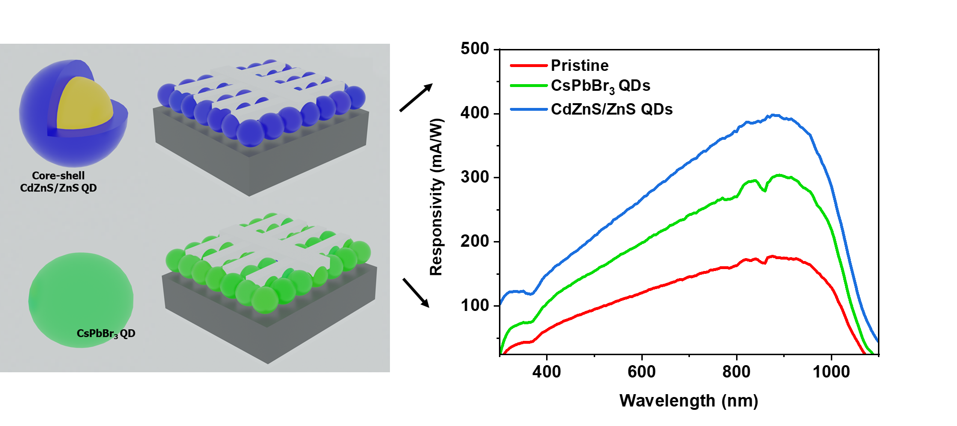

Abstract
Silicon (Si) photodetectors do not efficiently capture photons in the UV region: this has been a major impediment to their application in several areas. However, quantum dots (QDs), which convert higher-energy photons into lower-energy photons via spectral downshifting, have emerged as promising candidates for enhancing the UV response of silicon photodetectors. In this study, we investigate the performance of Si photodetectors in the form of sensitized perovskite (CsPbBr₃) quantum dots and compare them with core-shell (CdZnS/ZnS) quantum dots for spectral downshifting applications. Using monolithic integration of quantum dots over the silicon photodetector surface, we systematically analyze their electrical and optical characteristics to elucidate the impact of quantum dot structures on device performance. Spectral responsivity measurements reveal a significant enhancement in detector performance over a broad spectral range (300 nm - 1100 nm) after sensitization with quantum dots. Reflectance studies suggest that apart from spectral downshifting, the quantum dot layers act as anti-reflection coatings, contributing to overall performance enhancement. Additionally, current-voltage characteristics indicate the formation of a space charge region at the Si-quantum dot interface, further enhancing device performance. Further opto-electronic testing demonstrates the superior performance and stability of CdZnS/ZnS core-shell QD-sensitized devices compared to perovskite CsPbBr₃ QD-devices. Our study provides valuable insights into the design and optimization of Si photodetectors with improved sensitivity and extended spectral response.
Keywords: quantum dots, spectral downshifting, photodetectors, solution-processed, silicon

1. Introduction
The field of optoelectronics has seen significant advancements in recent years, driven by the exploration of novel materials and structures, aiming to enhance the performance of photodetectors. Silicon (Si) photodetectors, although in wide use due to their compatibility with standard semiconductor fabrication processes, are inefficient at capturing photons in certain spectral ranges, particularly in the UV region, owing to limited absorption and high thermalization losses.[1–3] Si photodetectors also suffer from high reflectance over a broad spectral range due to their extremely smooth surfaces. To decrease the reflectance of the Si surface, chemical etching is often employed to generate nanoscale features on the surface that effectively increase the light optical path in the Si and decrease reflectance. However, chemical etching generates a high density of defect states that adversely affect device performance by acting as recombination centers. Several strategies are currently being applied to improve UV response, such as tandem architectures and hot carrier harvesting.[4–7] However, neither of these techniques simultaneously addresses the challenge of high reflectance and poor UV response.
Spectral downshifters such as quantum dots are increasingly being employed to improve the performance of Si-based photodetectors and solar cells. Quantum dots allow the simultaneous decreasing of reflectance and raising of the efficiency of conversion of UV photons. Spectral downshifting, a process that involves converting higher-energy photons to lower-energy ones, thus provides a promising avenue for addressing the inherent limitations of Si photodetectors.[8–10]
Spectral downshifting involves converting incident photons to longer-wavelength photons that can be more effectively absorbed by the semiconductor material. Quantum dots (QDs) have emerged as versatile nanomaterials with unique optical properties that make them ideal candidates for spectral downshifting applications.[11] When quantum dots absorb photons, electrons in the quantum dots are excited to higher energy levels. The energy of the absorbed photons is typically higher than the energy of the emitted photons. However, due to various relaxation processes, such as non-radiative recombination and phonon interactions, the excess energy can be dissipated, leading to a shift in the emitted spectrum to lower energies. This spectral downshifting process can be effectively employed for extending the response range of Si photodetectors into the UV region. When the dimensions of the quantum dots are below the Bohr exciton radius, quantization effects become significant.[12]
In this study, we focus on developing a monolithic integration approach by depositing a layer of QDs over a Si photodetector's surface and assessing the device's performance after sensitization with QDs. Conventional materials such as Si QDs, carbon QDs, and rare earth element-doped QDs have been employed for downshifting applications.[13–18] The structure and the size of the quantum dots have profound effects on the excitation and relaxation mechanism, which in turn dictates the absorption and emission characteristics.[19] Perovskite quantum dots are attracting growing research interest in the opto-electronics community owing to their impressive photoelectronic properties such as their high absorption coefficient, tunable band gap and ease of solution-processibility. Cesium-based all-inorganic perovskite QDs have been at the forefront of recent research due to their inherent ambient stability. In this investigation, we employ these CsPbBr₃ all-inorganic perovskite quantum dots as a spectral downshifting layer for Si photodetectors and assess their performance in comparison with core-shell CdZnS/ZnS QDs.
The aim of this study is to systematically compare the performance of Si photodetectors sensitized with core-shell and perovskite QDs as downshifting layers. Through a comprehensive analysis of their electrical and optical characteristics, we seek to provide valuable insights into the impact of QD structure on the enhancement of Si photodetector performance. The outcomes of this study are anticipated to assist with the design and optimization of next-generation optoelectronic devices that will show improved sensitivity and extended spectral response. To our knowledge, this is the first study to explicitly investigate the CsPbBr₃ perovskite quantum dots as a spectral downshifting layer in Si-based photodetectors.
2 Materials & Methods
2.1 Materials
N-type Si Wafers (280 µm thick and 1 - 10 Ω) were bought from Aki Electronics. Cadmium oxide (CdO 99.9%), zinc acetate, octadecene (95%), oleic acid (90%), and oleyamine (90%), cesium carbonate, PbBr₂, and trioctylphosphine (TOP, 99%) were bought from Sigma Aldrich.
2.2 Instrumentation
X-ray diffraction studies were conducted using a Philips X-ray diffraction meter. The topography and high-resolution imaging of the quantum dots were captured through a JEOL 2100 transmission electron microscope (TEM). A Hitachi SU-8000 scanning electron microscope (SEM) was employed to examine the surface morphology of the films. The absorption and reflectance spectra of the samples were recorded using a Shimadzu UV-2450 UV-Vis-NIR spectrophotometer. A Bunkoukeiki BQE 100-F Spectral response measurement unit was utilized to measure the responsivity and EQE of the detectors. For recording the temporal response and I-V measurements of the detector, a Bunkoukeiki BSD-60Z monochromator was employed. Electrical characterization was carried out using a Keithley 2400 SourceMeter Unit (SMU). A silicon single-crystal S1337-1010BQ photodiode from Hamamatsu Photonics served as the reference for the calibration of light sources. Photoluminescence studies were conducted using the Quantaurus-Tau C11367 PL measurement unit.
2.3 Synthesis of CdZnS/ZnS quantum dots
Two stock solutions of sulfur were prepared. Stock-1 contained 1.6 mmol of sulfur in 2.4 ml of ODE, and Stock-2 contained 4 mmol of sulfur in 5 ml of OA. The precursors for the CdZnS core were prepared in a three-neck flask, to which 1 mmol of CdO, 10 mmol of zinc acetate, and 7 ml of OA were added and thoroughly mixed. The mixture was then heated to 150 ˚C in an argon atmosphere, and 15 ml of ODE was introduced. The temperature of the mixture was then increased to 310 ˚C, and Stock-1 Sulfur solution was injected and the temperature maintained at 310 ˚C for 12 minutes to foster the growth of CdZnS cores.
Following this, the Stock-2 sulfur solution was injected, and the mixture was kept at 310 ˚C for 3 hours to facilitate the growth of ZnS shells. Upon completion of the reaction, the quantum dot (QD) solution was precipitated by adding ethanol and then centrifuged multiple times (10,000 rpm). The resulting centrifuged QD powder was dispersed in toluene and re-precipitated with ethanol. This step was repeated three times. The resultant CdZnS/ZnS QD powder was stored at 5 ˚C for future use.
2.4 Synthesis of CsPbBr₃ quantum dots
CsPbBr₃ QDs were synthesized using the hot-injection technique. Two stock solutions were prepared. Stock-1 was created in a 3-neck flask by combining 0.16 g Cs₂CO₃, 0.5 ml of oleic acid (OA), and 6 ml of octadecene (ODE). The mixture was stirred thoroughly and degassed at 120 ˚C under vacuum for 1 hour. The temperature was then raised to 150 ˚C under a nitrogen atmosphere and maintained until the Cs₂CO₃ had completely dissolved. Simultaneously, Stock-2 was prepared in another 3-neck flask with 0.108 g PbBr₂ and 6 ml ODE. This mixture was dried at 120 ˚C under vacuum for 1 hour. To this mixture, 1.5 ml of OA and 2 ml of trioctylphosphine (TOP) were injected at 120 ˚C under a nitrogen atmosphere. After complete dissolution of PbBr₂, the mixture was maintained at 190 ˚C. Stock-1 solution was rapidly injected into Stock-2, and the resulting mixture was allowed to cool in a water bath after 1 minute. The obtained QD solution underwent multiple centrifugation cycles using toluene and ethanol. The final CsPbBr₃ QD powder was dried at 60 ˚C and stored in a refrigerator for future use.
2.5 Fabrication of a quantum dot-sensitized Si photodetector
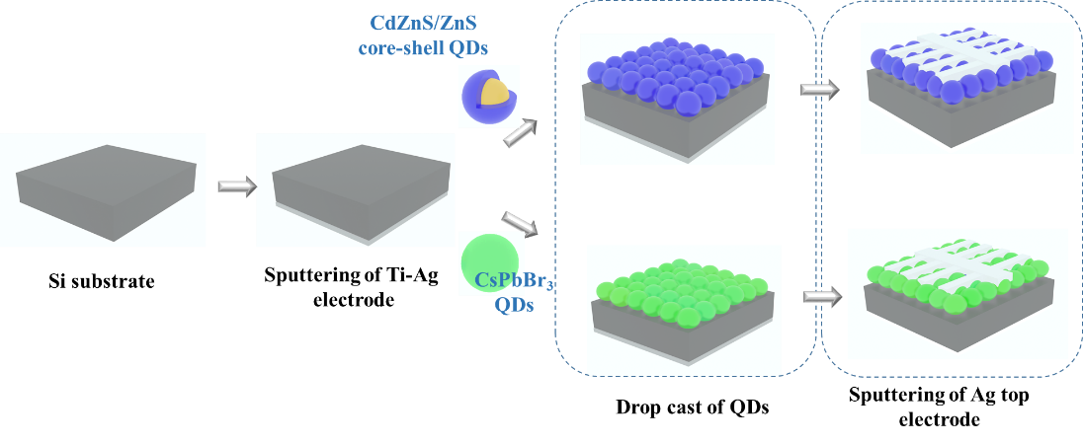
Single-side polished N-type Si (100) wafers were used to fabricate the photodetector device. Si wafers were diced using a mechanical abrasive dicing machine into 1.5 cm x 1.5 cm pieces. The diced Si substrates were thoroughly cleaned using DI water, piranha solution, acetone, ethanol and isopropyl alcohol under sonication. The cleaned Si substrates were purged in an N₂ stream. Titanium (50 nm) and Ag (200 nm) were deposited using sputtering to create the rear electrode. To deposit QDs, the QD powder was initially dispersed in toluene and sonicated for 30 minutes until well dispersed. 25-µL aliquots of the prepared QD solution were then drop-cast onto the Si substrate and the solvent allowed to evaporate naturally. To study the influence of number of QD cycles on the device performance, the number of QD cycles was varied from one to four. After the deposition and natural drying of the drop-casted QD film, the Si substrates were dried at 130 ˚C for 1 minute. Later, a finger-patterned 250 nm-thick Ag top electrode was deposited by sputtering onto the QD-deposited Si substrate. Figure 1 shows a schematic representation of the device fabrication scheme.
Figure 1. Schematic representation of QD-sensitized Si photodetector fabrication.
3 Results & Discussion
3.1 Structural and Composition Analysis
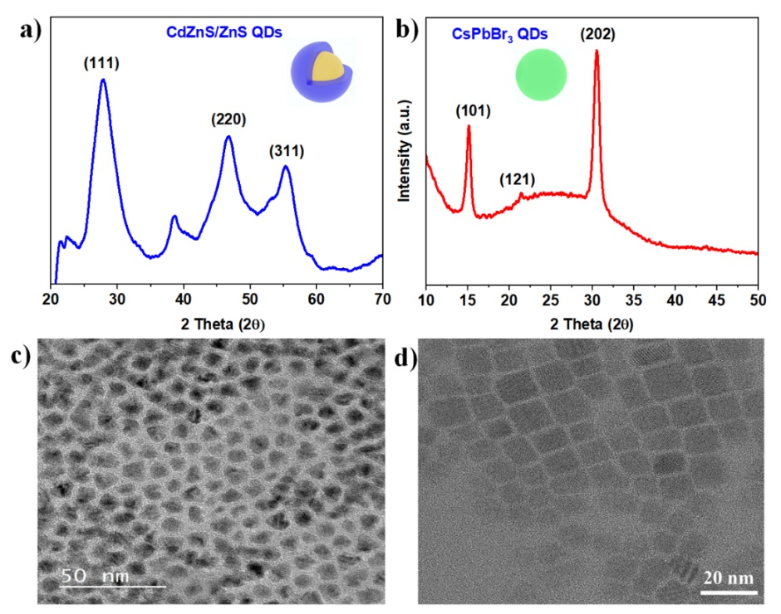
First, to confirm the formation and the crystal structure of the CdZnS/ZnS and CsPbBr_{3,} X-ray diffraction studies were carried out on the QD thin films. Figure 2a shows the XRD spectrum of the CdZnS/ZnS QDs, which shows the presence of four peaks related to the ZnS phase.[20,21] No peaks corresponding to CdS were observed, which suggests that the Cd remained as a dopant in the ZnS lattice. The peaks observed at 27.86˚, 38.63˚, 46.93˚ and 55.44˚, correspond to the (111), (200), (220) and (311) planes of ZnS. XRD spectra of the CsPbBr₃ QDs are shown in Figure 2b, which reveals the presence of three major peaks corresponding to the cubic CsPbBr₃ phase.[22] The peaks at 15.08˚, 21.28˚, and 30.55˚ are assigned to the (101), (121) and (202) planes. The sharp diffraction peaks of the CsPbBr₃ indicate the comparatively high crystallinity of the QDs.
Figure 2. XRD spectra of a) CdZnS/ZnS core-shell QDs and b) CsPbBr₃ QDs. TEM image of c) CdZnS/ZnS core-shell QDs and d) CsPbBr₃ QDs
To confirm the size and morphology of the synthesized QDs, imaging using TEM is carried out as shown in Figure 2c and 2d. TEM imaging reveals that the CdZnS/ZnS QDs are obliquely shaped and have non-equiaxial dimensions. (Figure 2c). The CdZnS/ZnS QDs have a mean particle size of ~9 nm, with variation in the range of 5 - 12 nm. Figure 2d shows a TEM image of the CsPbBr₃ QDs, which reveals that the QDs have assumed a uniformly distributed highly symmetrical shape. The average QD dimension along the long axis is estimated to be ~10 nm, with the size being distributed in the range of ~5 nm to 12 nm. As per the literature, CsPbBr₃ QDs have a Bohr exciton radius of 7 nm.[12] The size distribution curves of both CdZnS/ZnS QDs and CsPbBr₃ QDs are shown in Figure S1. Thus, as-synthesized CsPbBr₃ QDs are expected to show quantum confinement effects. These TEM images clearly reveal the size and shape of the QDs and confirm the low-dimensional structures of the synthesized QDs. It is worth noting that both the CdZnS/ZnS and CsPbBr₃ QDs show polydispersity, ranging in size from 5 nm to 13 nm. Typically, polydispersity in QD size results in a broader absorption and emission spectra, which is highly desirable for photon-harvesting devices.[23]
Although the TEM images of CdZnS/ZnS QDs revealed the size and shape of the QDs, the core-shell structure was not clear. Therefore, to clearly visualize the core-shell structure and confirm the spatial distribution of the elemental composition, high resolution-TEM imaging and concurrent EDAX mapping were performed. Figure 3 shows a scanning TEM (STEM) image and the corresponding elemental mapping. As seen in Figure 3a, the lighter region in the center of the particle is the CdZnS core and the slightly darker outer region is the ZnS shell. The core and shell thickness are roughly estimated to be 6 nm and 2 nm, respectively. In the cumulative elemental mapping of the QDs, yellow, red and blue correspond to Cd, Zn and S, respectively. It can be seen that the Cd is mostly distributed in the center of the QDs, whereas both the Zn and S are evenly distributed throughout the QDs. This result strongly suggests that the core of the QD is composed of CdZnS and the shell is made up of ZnS. The corresponding EDAX energy spectrum of the QD particle is included in the supplementary information, which also confirms the presence of elemental Cd, Zn and S (Figure S2).
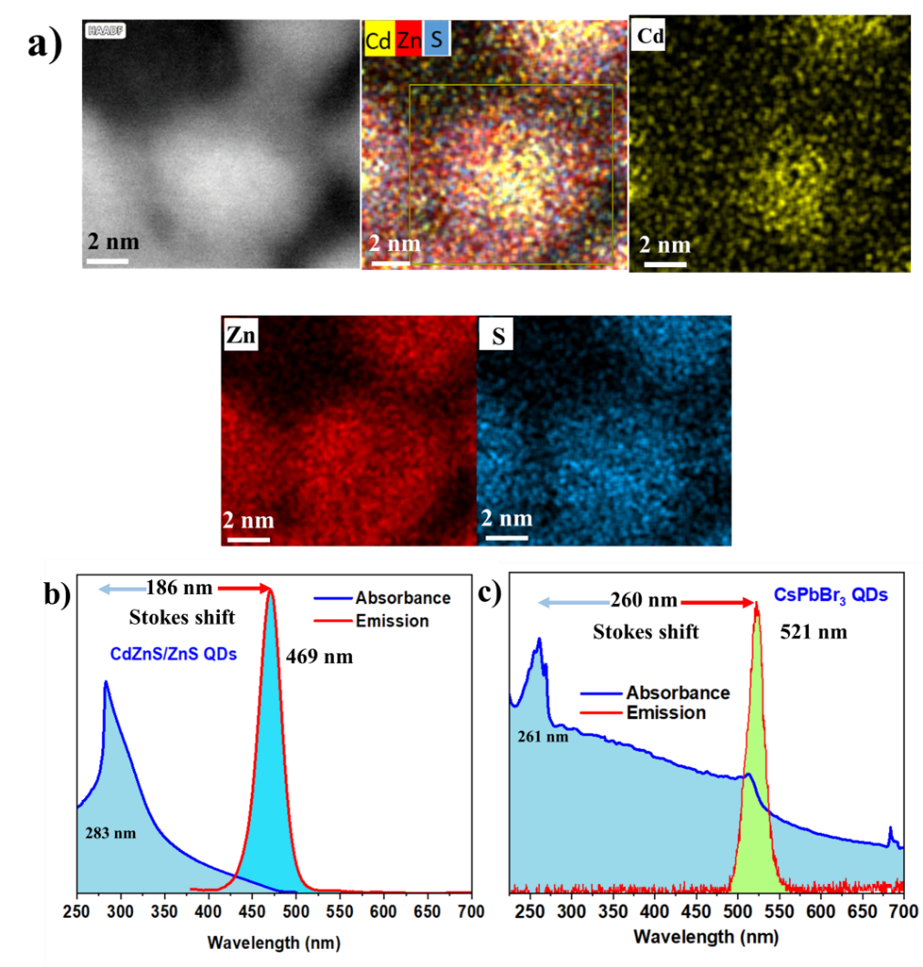
Figure 3. a) STEM image and EDAX mapping of CdZnS/ZnS core-shell QDs. Absorbance and Emission spectra of b) CdZnS/ZnS core-shell QDs and c) CsPbBr₃ QDs.

3.2 Optical Characteristics
QDs exhibit distinctive optical properties such as tunable absorption and emission characteristics. The absorption spectrum of the CdZnS/ZnS QDs reveals a prominent peak at approximately 283 nm, lying in the UV region (Figure 3b). The absorption peak of the core-shell QDs is closely dependent on the core material, which in our case is CdZnS. Due to the comparatively lower thickness of the shell layer, the contribution from the shell is minimal. However, the shell structure imparts the QDs with notably enhanced stability and photoluminescent properties.[24–26] The emission spectrum exhibits a sharp peak at 469 nm, reflecting the characteristic fluorescence of the QDs. A large Stokes shift of 186 nm is obtained. The colloidal solution of the CdZnS/ZnS dispersed in toluene appears colorless under ambient light, as the absorption peak lies in the deep UV range (283 nm). Under illumination with UV light, the CdZnS/ZnS colloidal solution appears blue, corresponding to the emission peak of 469 nm. Images of CdZnS/ZnS colloidal QD solution under ambient light and UV light are provided in the supplementary information (Figure S3a-b). The observed absorption and emission peaks are evidence of the successful downshifting of the UV photons (283 nm) to low-energy visible photons (469 nm), highlighting the potential utility of these quantum dots in spectral downshifting applications. Precise control over the spectral characteristics, coupled with the benefits conferred by the core-shell design, positions these CdZnS/ZnS QDs as applicable to downshifting in photodetectors.
The absorption spectrum of CsPbBr₃ (Figure 3c) reveals the broad range of significant absorption from 200 nm to 520 nm, with a distinct and prominent peak centered at 261 nm and a shoulder peak around 510 nm. The absorption peak of CsPbBr₃ observed at significantly lower wavelength (261 nm) is attributed to the quantum confinement effect. Quantization effects lead to confinement of the electrons and thus resulting in increased energy spacing between electronic levels. The emission spectrum reveals sharp a PL peak centered around 521 nm, corresponding to visible (green) light. Thus, the observed absorption and emission spectra demonstrate that the CsPbBr₃ quantum dots absorb light over the broad wavelength range of UV-Vis (200 - 520 nm) and downshift absorbed high-energy photons to low-energy photons, demonstrating the applicability of the CsPbBr₃ QDs to spectral downshifting. The colloidal solution of the CsPbBr₃ QDs dispersed in the toluene shows a yellowish-green color under ambient light owing to the broad absorption observed in the absorbance spectrum. However, under UV light illumination, the CsPbBr₃ QDs appear to be bright green in color. Images of CsPbBr₃ colloidal quantum dot solutions under ambient light and UV light are provided in the supplementary information (Figure S3c-d).
In summary, the absorption and emission spectra reveal that both CdZnS/ZnS core-shell QDs and CsPbBr₃ QDs absorb high-energy photons and emit the absorbed photons as low-energy photons by the spectral downshifting process. The synthesized CdZnS/ZnS core-shell QDs and CsPbBr₃ QDs can therefore be employed for downshifting applications in photodetectors.
3.3 Optimization of QD film deposition
As discussed in the earlier section, optical studies have demonstrated the ability of both the CdZnS/ZnS core-shell QDs and CsPbBr₃ QDs to downshift high-energy photons. Hence, both these QDs are applied on Si photodetectors as a downshifting layer. The sensitization of the Si with QDs is carried out by drop-casting a layer of QD colloidal solution and allowing it to dry naturally. In a QD-sensitized device, the number of layers of QDs have a profound effect on the functionality of the QD thin film with respect to photon interaction and device performance. The number of deposition cycles of QDs determines the surface coverage, uniformity and QD packaging density. With each cycle, the QDs contribute to the overall coverage, potentially leading to a uniform film. The number of deposition cycles also dictates the packaging density of the QDs, which in turn affects the charge transport process. Studying and optimizing the number of deposition cycles of QD drop casting is necessary to attain devices with the desired performance. Hence, in our case, QD drop-cast cycles were varied from one to four and device performance was evaluated in comparison with a pristine Si detector.
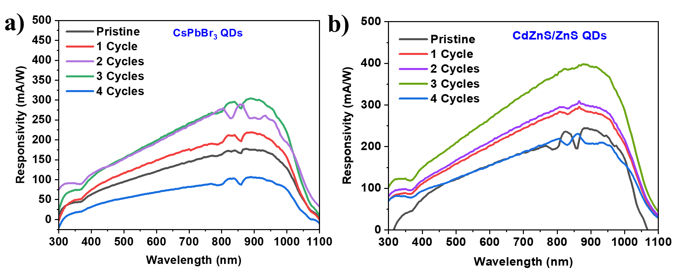
Figure 4 shows the spectral responsivity of the pristine Si photodetectors and devices sensitized with CdZnS/ZnS and CsPbBr₃ QDs with varied drop-cast cycles. Responsivity is the ratio of the photocurrent generated in the detector to the photon intensity incident on the detector. Responsivity is a key figure-of-merit that denotes the efficiency at which the incident photons are contributing to photocurrent generation in the device.[27] The spectral responsivity of the detectors was measured in the range of 300 nm to 1100 nm, covering a broad spectrum of UV, visible and NIR photons. It is evident that the pristine device shows a broad response over the entire measured range, with the response of the detector peaking in the range of 900 - 950 nm (150 mA/W). The device shows minimal response in the UV range (300 - 400 nm - 25 mA/W) and a very meagre response at around 1100 nm (12 mA/W). The peak response of the detector occurring at around 900 - 950 nm is due to the narrow band gap of Si (1.1 eV) and, as expected, below the bandgap (<1100 nm), the response is near zero. The poor response of the detector in the UV region can be largely attributed to thermalization losses. Figure 4a shows the responsivity of the CsPbBr₃ QD-sensitized devices with varied drop-cast cycles. It can be seen that with the deposition of the CsPbBr₃ QDs, the responsivity of the detector improves over the entire 300 -1100 nm spectrum. The detector shows the maximum increase in responsivity of up to 304 mA/W for the 3-cycle example, whereas after four deposition cycles, the performance has fallen drastically below that of the pristine device. Similarly, with the CdZnS/ZnS core-shell QDs, the device shows an improvement in performance over the entire spectrum (Figure 4b). The maximum increase in detector responsivity (391 mA/W) is obtained with three deposition cycles. It should be noted that the device sensitized with the CdZnS/ZnS QDs shows somewhat higher performance than the CsPbBr₃-sensitized device. Figure S4 shows the external quantum efficiency (EQE) of the pristine Si photodetectors and devices sensitized with CdZnS/ZnS and CsPbBr₃ QDs with different numbers of drop-cast cycles. The EQE also shows a performance trend that mirrors the spectral responsivity
Figure 4. Spectral responsivity of a) CsPbBr₃ QD-sensitized and b) CdZnS/ZnS core-shell QD-sensitized Si detectors with different numbers of drop-cast cycles.

During the downshifting process of the QDs, high-energy photons (UV) are typically converted into low-energy (Vis-NIR) photons. In our study, as seen in the optical absorption and emission spectrum, CdZnS/ZnS QD downshift 250 nm - 350 nm photons to low energy 450 nm - 500 nm photons (Figure 3b). Similarly, CsPbBr₃ QDs downshift ~250 nm - 500 nm photons to 520 nm photons. Hence, with the sensitization of the Si detector with the QDs, the responsivity is expected to be enhanced in only a narrow spectral range. However, the detector response was enhanced over the entire spectral range of 300 nm to 1100 nm. This interesting observation suggests that in addition to the downshifting process, there must be unidentified optical phenomena that contribute to the overall enhancement seen in detector responsivity. To shed more light on the mechanism of enhancement of QD sensitized detectors, we carried out reflectance studies and SEM imaging of the QD-sensitized silicon.
Silicon usually possess high reflectance due to its smooth surface.[28] The deposition of QDs, depending on the morphology and packing arrangement of the QD film, can slightly increase the roughness of the Si surface. To study this, reflectance measurements were performed on pristine and QD-sensitized Si substrates as shown in Figure 5. Figure 5a shows the reflectance spectra of pristine and CsPbBr₃ QD-sensitized Si substrates. It can be seen that the pristine Si substrates have a higher reflectance; however, with the deposition of CsPbBr₃ QDs, the reflectance is slightly decreased over the entire spectrum. With a further increase in the number of deposition cycles, reflectance is further decreased. Deposition of QDs, therefore, raises surface roughness, and with the increment in the number of deposition cycles, the surface roughness is further increased.[29] Similarly, with CdZnS/ZnS core-shell QDs, the surface reflectance is significantly decreased by the drop-casting of QDs (Figure 5b). The reflectance decreases up to three deposition cycles and increases again from the fourth deposition cycle. It is important to note that the magnitude of decrease in the reflectance of CdZnS/ZnS-sensitized Si substrate is significantly higher than that of the CsPbBr₃-sensitized Si substrates. The reflectance values of the QD-sensitized Si substrates at different wavelengths are tabulated and included in the Supplementary Information. The step observed at 850 nm in reflectance is due to the switching of the detector of the UV-Vis-NIR spectrophotometer system. The spectrophotometer uses distinct detectors for different spectrum of light. For the range of UV and Visible, typically Si based detectors are used. However, beyond the visible range >850 nm, generally PbS or InGaAs is used for detection [30]. This change in the photodetector causes a step in the reflectance curve.
In summary, the reflectance measurements reveal that the reflectance of the Si substrates is significantly reduced after the drop-casting of the QDs due to increased roughness. Thus, the anti-reflection effect of QD layers, apart from the intrinsic spectral downshifting effect, also contributes to broad spectral (300 nm -1100 nm) responsivity enhancement.
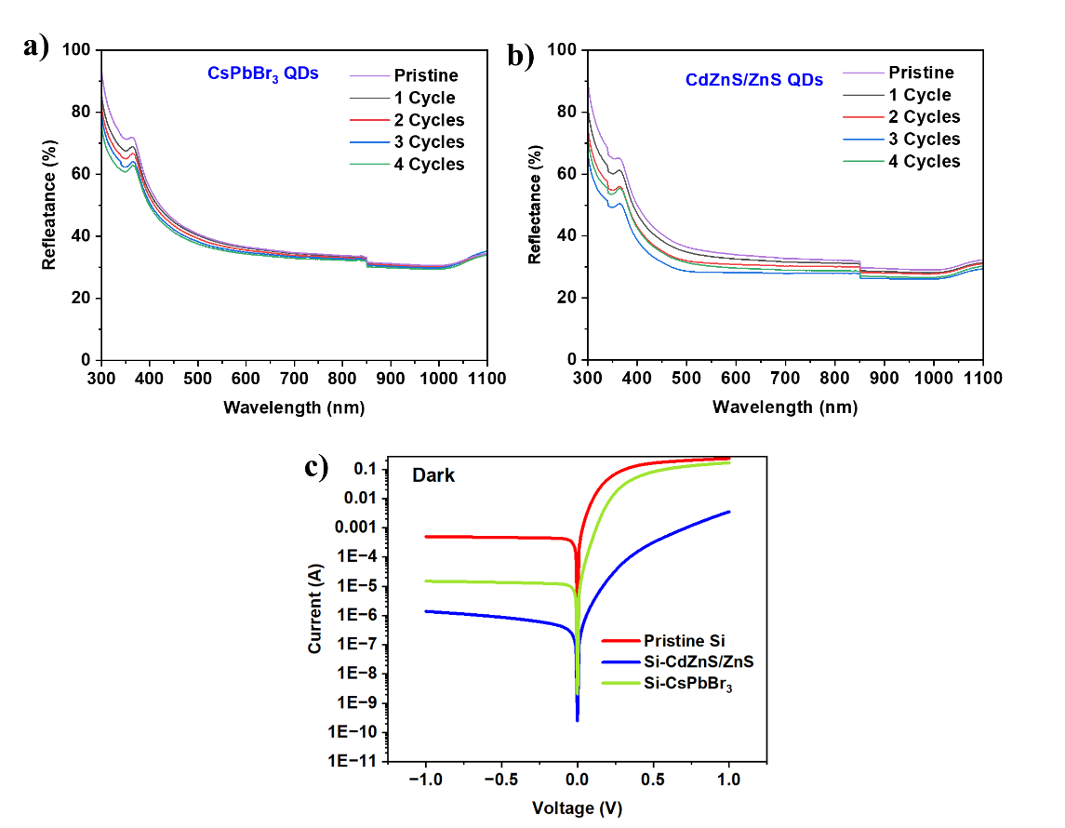
However, it is interesting to note that the CdZnS/ZnS QDs result in a significantly lower reflectance than seen with the CsPbBr₃ QDs. To probe the reason behind this phenomenon, SEM imaging of both QD films on Si substrate was carried out, as shown in the Figure S5. Because three drop-casting cycles showed the best performance, the same 3-cycle sample was used for SEM imaging. Figure S5b-c, SEM image of the CsPbBr₃ QD-sensitized Si substrate, reveals that the QDs are agglomerated/nucleated in the form of randomly distributed islands, rather than forming a continuous film. In contrast, Figure S5a, SEM image of the CdZnS/ZnS core-shell QD-sensitized Si device, shows that the QDs have formed highly continuous films with few minor defects. Overall, the CdZnS/ZnS QDs seems to have formed films with comparatively uniform coverage of the Si substrate. However, the CsPbBr₃ QDs show poor coverage due to island formation, allowing most of the Si substrate to remain exposed. This substantiates the significant difference seen in reflectance between CdZnS/ZnS core shell QDs and CsPbBr₃ QDs.
Figure 5. Reflectance of Si substrates sensitized with a) CsPbBr₃ QDs and b) CdZnS/ZnS core-shell QDs. c) Dark I-V measurements of pristine and QD-sensitized detectors
Apart from the downshifting process and anti-reflection effect, the space charge region generated at the Si-QDs is expected to contribute to enhanced photon harvesting. When QDs of sufficient thickness are deposited as a thin film on Si, band bending occurs at the interface, leading to the formation of heterojunctions.[31–34] The current-voltage relation (I-V) of the pristine and QD-sensitized detectors were studied to gain insight into the formation of the space charge region in the detectors. I-V characteristics were studied in the voltage range of –1 V to +1 V under dark conditions. Figure 5c shows the I-V relation on a logarithmic scale, which reveals that all the detectors exhibit a rectifying junction. Dark current is a relevant parameter of a semiconducting device, as it reflects the magnitude of band bending and space charge in the device. As seen in the I-V curves, the pristine devices show a high reverse saturation current of 497 µA, whereas the detectors with CsPbBr₃ and CdZnS/ZnS QDs show a much lower dark current of 14.84 µA and 1.38 µA, respectively. The decrease in the dark current after sensitization with QDs indicates the possibility of band bending at the Si-QD interface and subsequent space charge region formation [35]. I-V relation therefore reveals that the sensitization of Si with QDs leads to the formation of a space charge region, which might be a contributing factor to the spectral responsivity enhancement seen in Figure 3a and 3b.
In summary, our optical absorption and emission studies have revealed the capability of the QDs to downshift high-energy photons to low-energy photons. The QDs act as a downshifting layer in the Si photodetector. Spectral responsivity measurements reveal that QD sensitization significantly enhances the detector’s performance. However, interestingly, the device performance shows an improvement over the entire spectral range. Probe reflectance measurements revealed that the QD layer also acts as an anti-reflection layer. Further, the I-V characteristics of detectors under dark conditions have indicated the formation of a space charge region in the device due to desirable band bending at the interface between the Si and QDs. In brief, the observed broad spectral responsivity enhancement in detectors with QD sensitization is the result of the combined effects of the downshifting process, the anti-reflection effect of QD thin film and space charge region formation at the Si-QD interface.
As seen in earlier studies, for both CsPbBr₃ QDs and CdZnS/ZnS QDs, the 3-cycle samples showed the best performance. These optimized QD-sensitized detectors were subjected to further opto-electronic testing to identify and assess their photodetection performance.
3.4 I-V Characteristics and temporal responses of the optimized devices
I-V characteristics of both QD-sensitized devices were first studied under dark and illuminated conditions (320 nm, 600 nm, and 900 nm). Both the devices exhibited rectifying heterojunctions, owing to the Schottky barrier between the Si and Ag electrode. This is explained in greater detail in the Mechanism section below. The detectors showed a significant increase in current under light illumination, indicating the generation of photocurrent in the detector. Figure 6a shows the I-V characteristics of the CsPbBr₃ QD-sensitized device, in which the detector has shown a response to 320 nm, 600 nm and 900 nm photons. The shift in the illumination I-V curves with respect to the dark I-V indicates the response of the device under zero bias. Similarly, Figure 6b shows the I-V curves of the CdZnS/ZnS QD-sensitized detector, which reveal the response of the device to illumination. However, it should be noted that the CdZnS/ZnS QD-sensitized detector shows a significantly higher photocurrent than the CsPbBr₃ QD-sensitized detector.
Photocurrent linearity is an important parameter for certain detector applications, such as light intensity monitoring, astronomical imaging, LiDAR, autonomous vehicles, and industrial inspections.[36,37] To study the photocurrent linearity of the detectors, photocurrent is measured at multiple light intensities and plotted.[38,39] High linearity of the photocurrent indicates that the detector can respond proportionally to a wide range of light intensities. Figure 6c shows the photocurrent plotted versus light intensity (0.1 - 2 mW/cm²) of the CsPbBr₃ QD detector at different wavelengths (320 nm, 600 nm and 900 nm). It can be seen that the photocurrent varies linearly with the intensity at under 320 nm. However, under illumination with wavelengths of 600 nm and 900 nm, the photocurrent exhibits a sub-linear relation. On the other hand, the photocurrent for the CdZnS/ZnS core-shell QD detector varies linearly at all wavelengths (Figure 6d). The sub-linear photocurrent trend seen in the CsPbBr₃ device reveals the presence of defect and trap states in the CsPbBr₃ QDs. Typically, CsPbBr₃ QDs possess large defect densities due to halide ion vacancies and interstitial impurities.[40,41] Detectivity is a key figure-of-merit that determine the capability of the detector to show response towards weak light intensities. Detectivity is inversely related to the noise equivalent power of the detector. Detectivity is estimated using the formula:
$$Detectivity= D^{*}=\frac{R}{{\left(\frac{2ⅇI_{dark}}{A}\right)}^{0⋅5}}$$
I_{dark} is the current in the device under no illumination, A is device active area, e is charge of electron, R is responsivity.
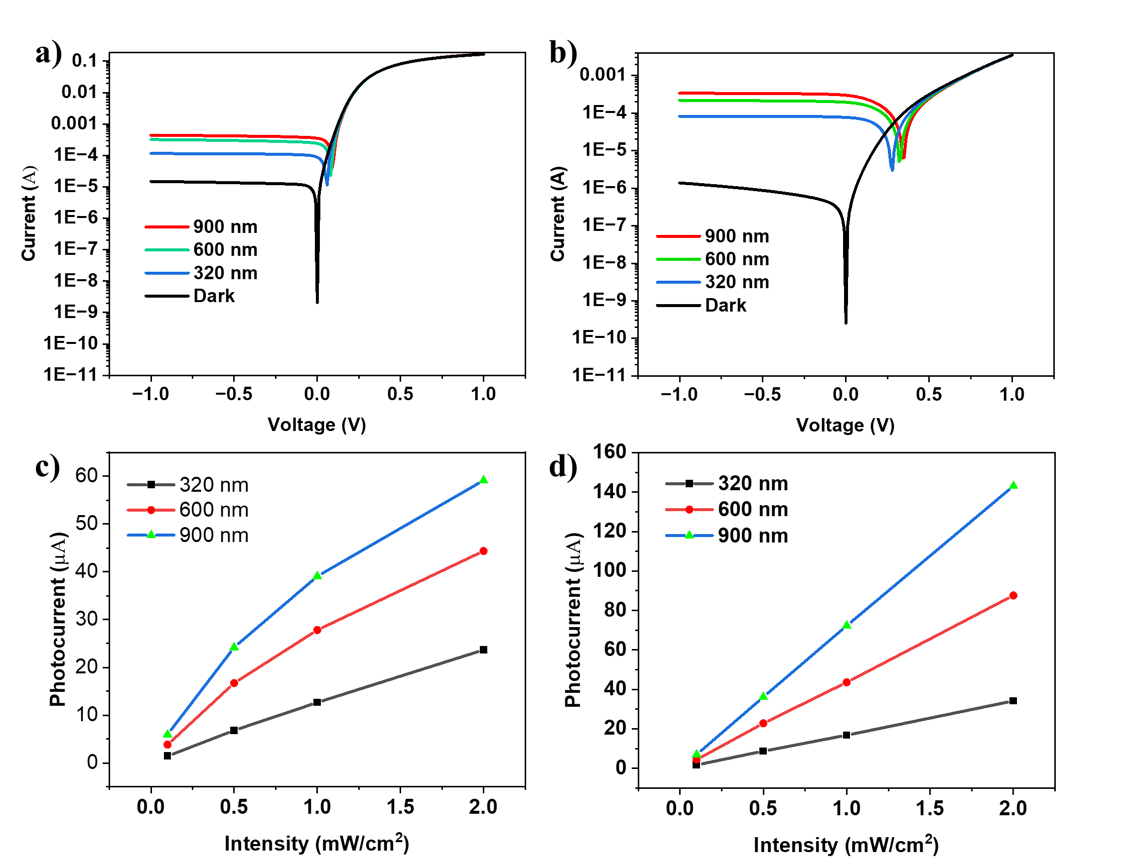
Detectivity was calculated at varied intensities from 0.1 mW/cm² to 2 mW/cm², as shown in the Figure S6. Peak detectivity of 1.17 x 10¹³ jones and 1.37 x 10¹³ jones are obtained for CsPbBr₃ QDs and CdZnS/ZnS QDs based detector, respectively. Detectivity is decreasing with the increase in light intensity for the CsPbBr₃-based devices. However, the CdZnS/ZnS QDs based detectors show no significant change in the detectivity towards the light intensity. Trap states related to the halide vacancies in CsPbBr₃ is likely to contribute to the observed non-linearity [42,43].
Figure 6. I-V characteristics of a) CsPbBr₃ QD and b) CdZnS/ZnS core-shell QD detectors under dark and illuminated conditions. Photocurrent vs Intensity plot of c) CsPbBr₃ QD and d) CdZnS/ZnS core-shell QD detectors.
The temporal response of a photodetector refers to the device's ability to detect changes in light intensity over time. It characterizes the speed at which the photodetector responds to variations in incident light. The temporal response is a crucial parameter in applications where the detection of fast or time-varying optical signals is essential. Rise and fall times can be estimated from the temporal response curve. The rise time is the time taken by the photodetector to respond to an increase in light intensity. Similarly, the fall time is the time taken to respond to a decrease in light intensity. Shorter rise and fall times indicate faster temporal response.[44,45] Figure 7a-c shows the temporal response of the CsPbBr₃ QD-sensitized device to light at 320 nm, 600 nm and 900 nm. The detector shows photocurrent of 32.5 µA, 88 µA and 128 µA at 320 nm, 600 nm and 900 nm, respectively. The rise/fall times are estimated to be 82/82 ms (320 nm), 82/69 ms (600 nm) and 75/82 ms (900 nm). Figure 7d-f shows the temporal response of the CdZnS/ZnS QD-sensitized detector. Photocurrent values are calculated to be 34.5 µA, 89 µA and 140 µA to 320 nm, 600 nm and 900 nm, respectively. The rise/fall times are estimated to be 82/152 ms (320 nm), 89/97 ms (600 nm) and 75/137 ms (900 nm). The fast rise/fall time of a few microseconds suggests that this detector can be used for applications such as spectroscopy, light intensity monitoring and fire alarms.
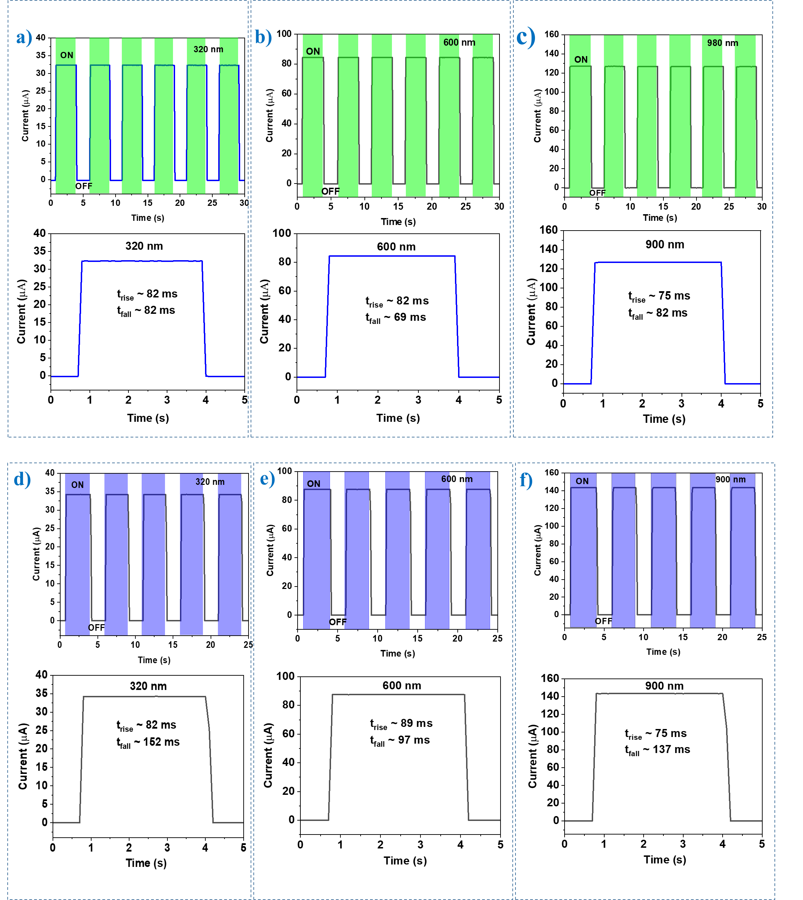
Figure 7. Temporal response and enlarged view of CsPbBr₃ QD-sensitized Si detectors at a) 320 nm, b) 600 nm and c) 900 nm. Temporal response and enlarged view of CdZnS/ZnS core-shell QD-sensitized Si detectors at d) 320 nm, e) 600 nm and f) 900 nm.

3.5 Photocycle stability
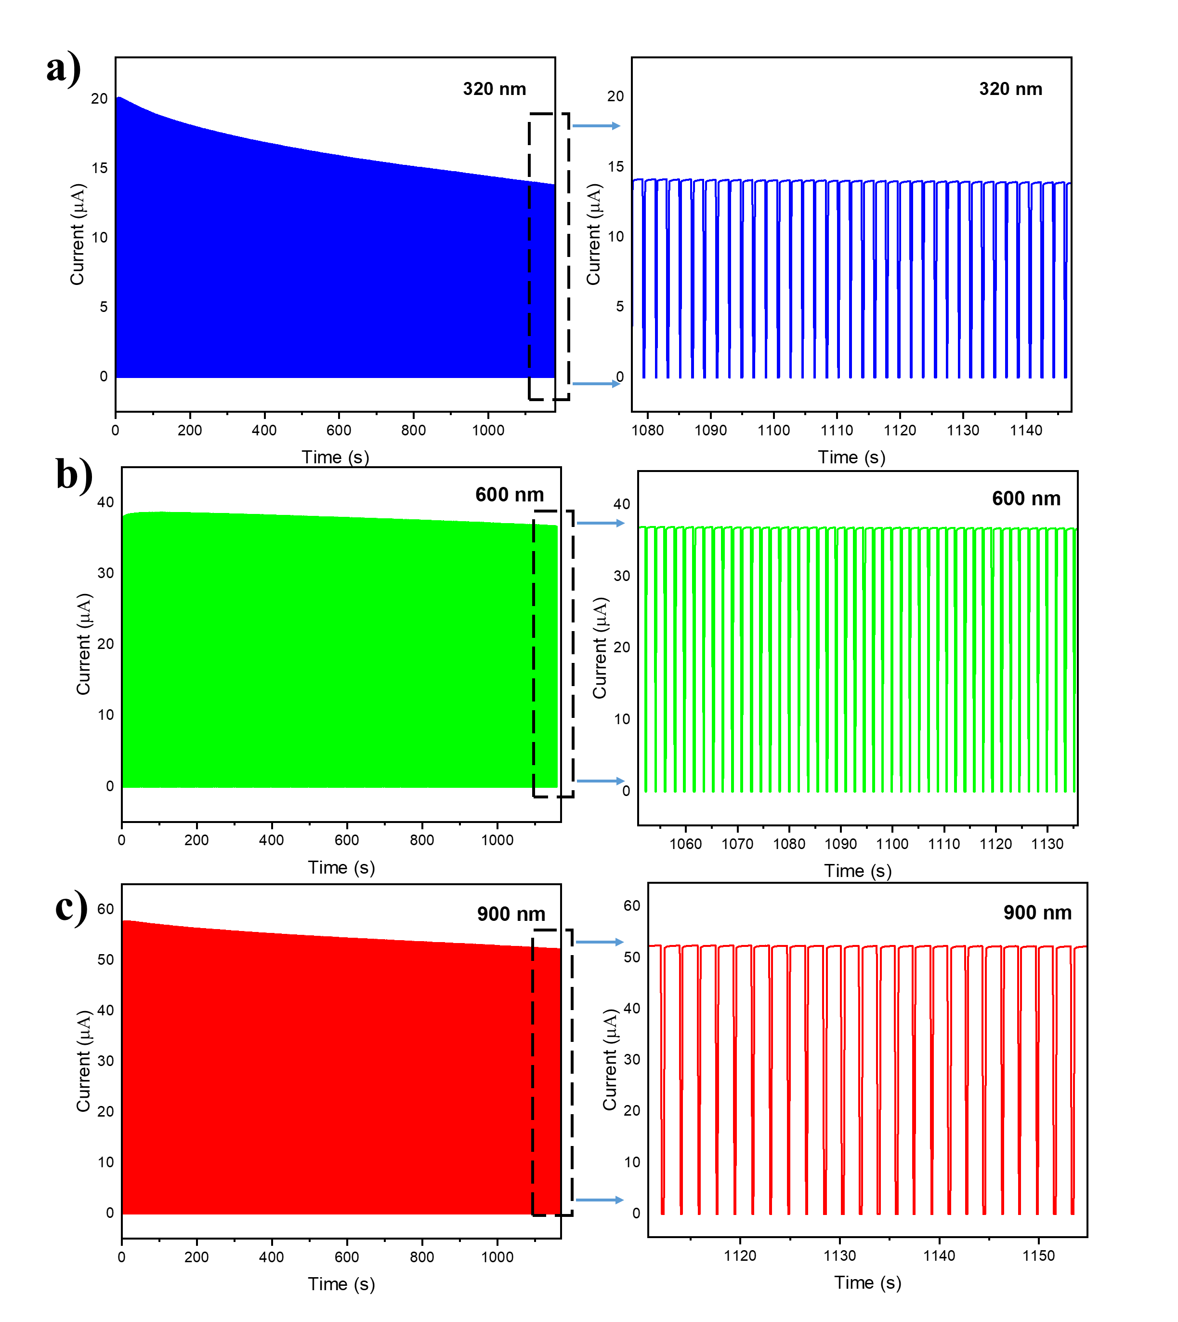
For any photodetector to be deployed for practical applications, the device must possess high photocycle stability over repeated illumination cycles, without any hysteresis, baseline drift or saturation in the photocurrent. To assess the photocycle stability, the temporal response of the detectors was recorded over 500 illumination cycles under the illumination of multiple wavelengths (320 nm, 600 nm and 900 nm). Figure 8 shows the photocycles of the CsPbBr₃ QD detectors under multiple wavelengths. The detector shows significant decay in the photocurrent with the subsequent photocycle, revealing the poor photocycle stability of the CsPbBr₃-based device. In contrast, the CdZnS/ZnS core-shell QD-based devices exhibit excellent photocycle stability without any significant decay in the photocurrent values, even after 500 cycles (Figure 9) [20,46].
Figure 8. Photocycle stability of CsPbBr₃ QDs-sensitized Si detector under a) 320 nm, b) 600 nm and c) 900 nm.
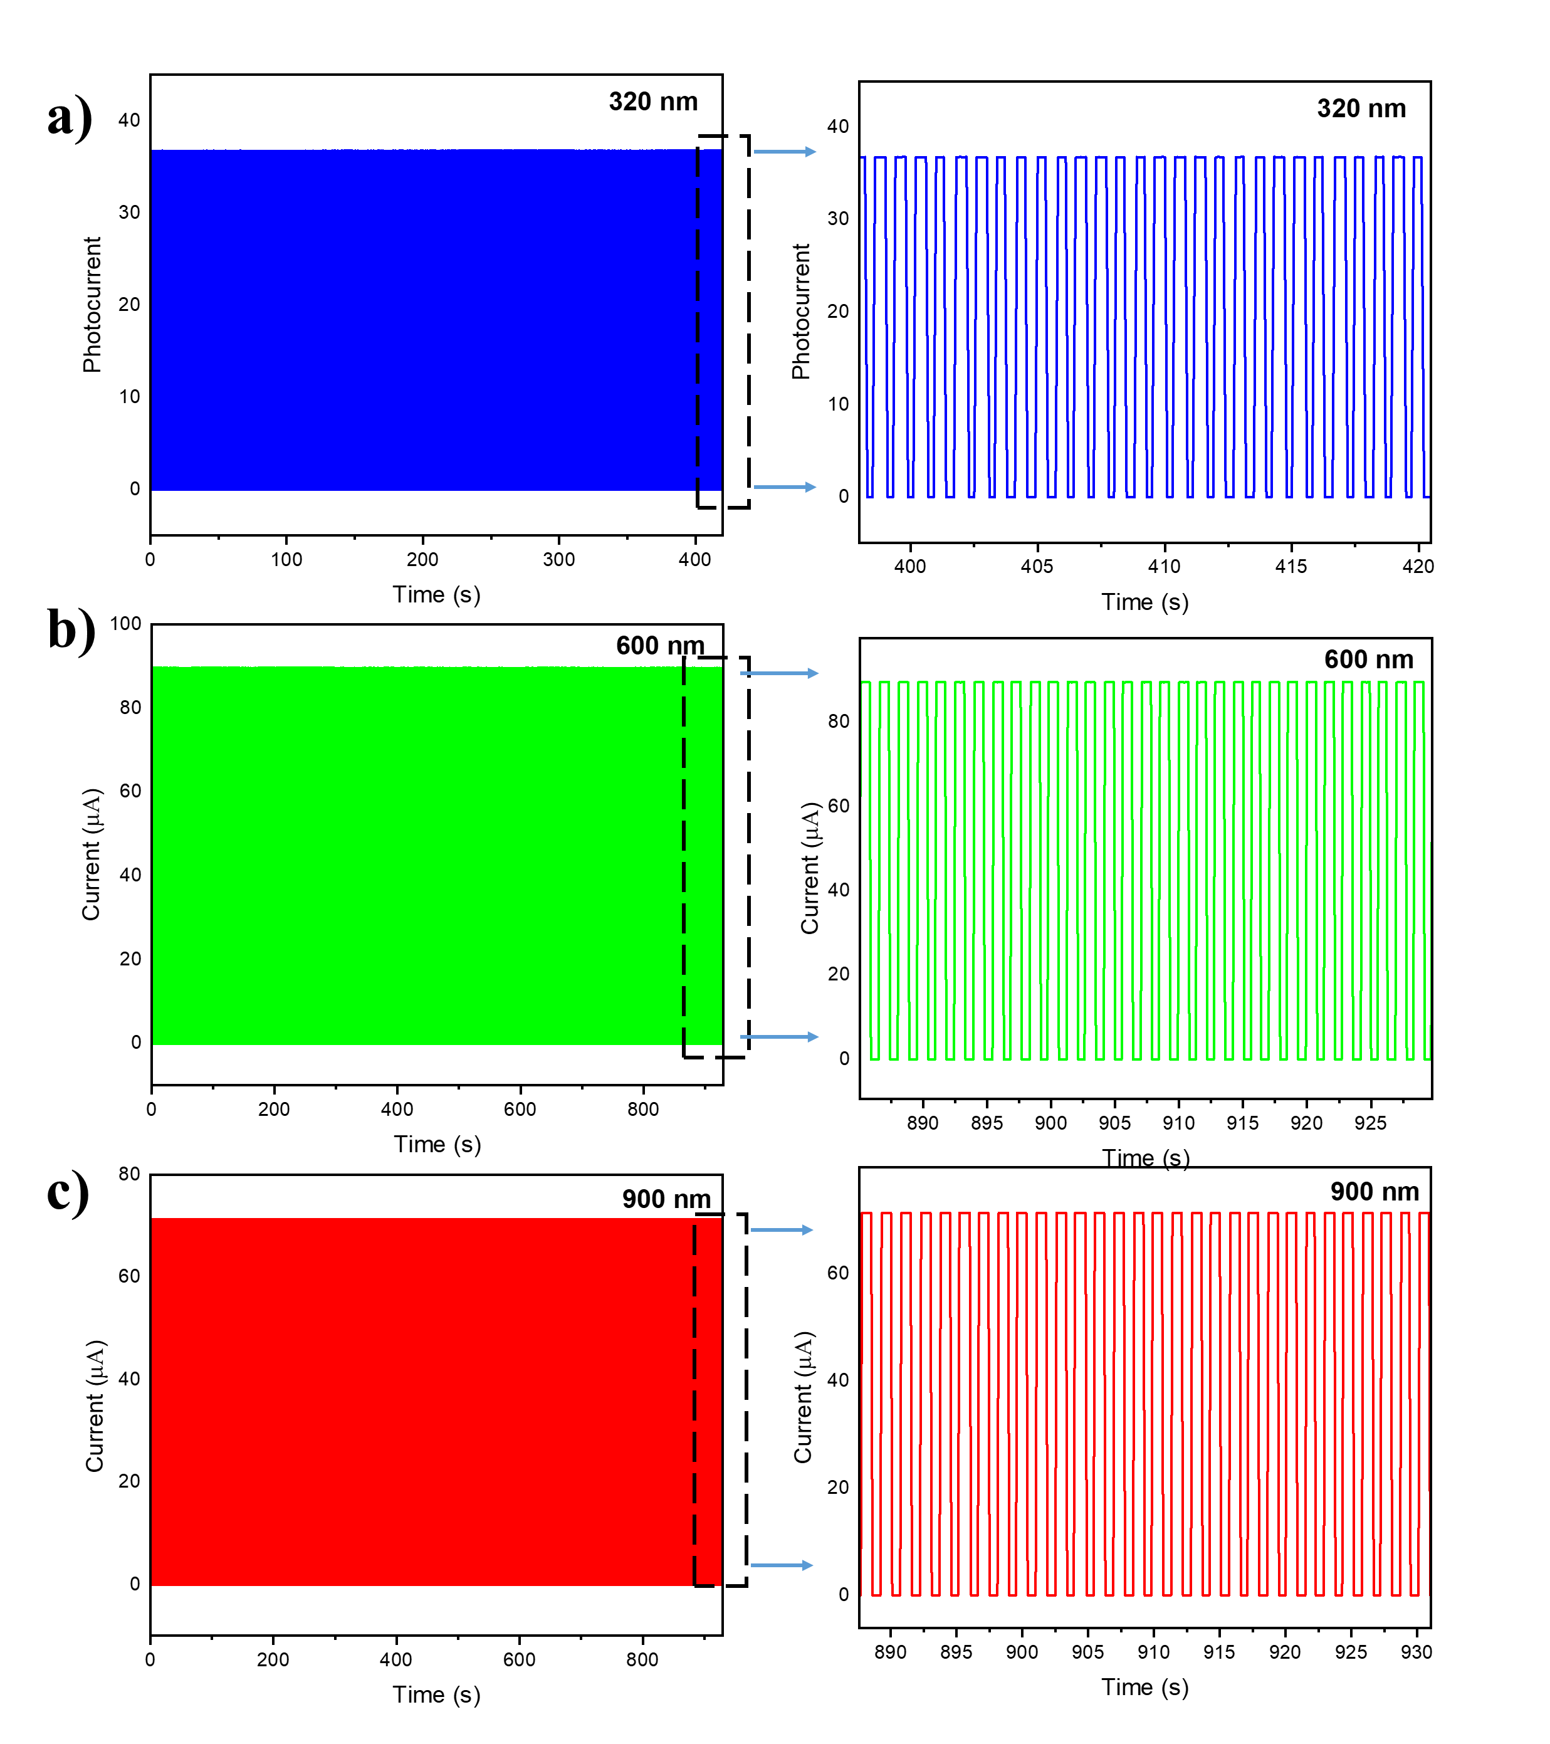
Figure 9. Photocycle stability of CdZnS/ZnS core-shell QDs-sensitized Si detector under a) 320 nm, b) 600 nm and c) 900 nm.

3.6 Mechanism of photodetection in QD-sensitized Si photodetector
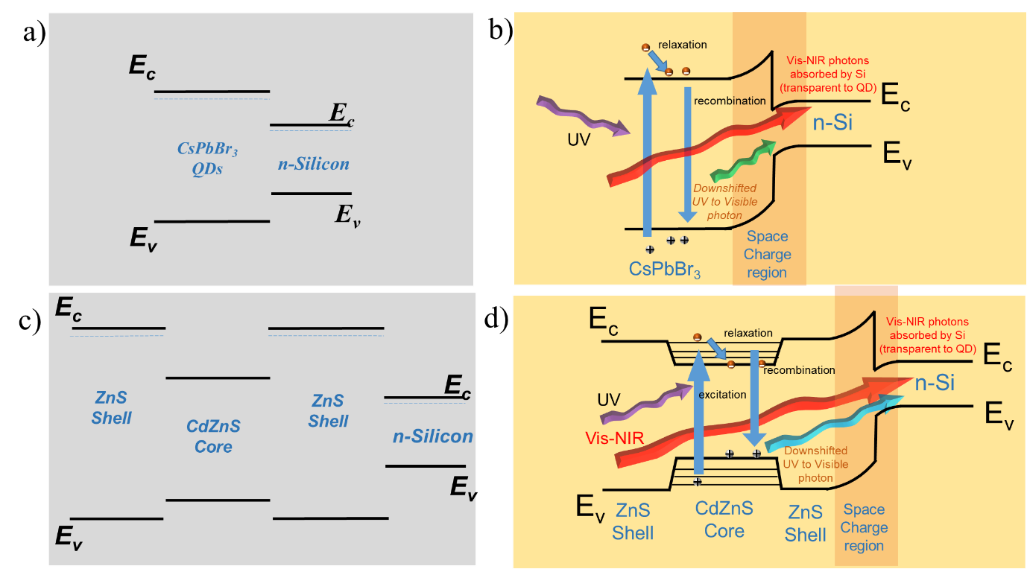
To explain the functioning of the Si photodetector and its performance enhancement after QD sensitization, the band diagram of Si-QDs was constructed and illustrated as shown in Figure 10. Silicon has a valence band at 4.08 eV and a conduction band at 5.2 eV.[47] The Fermi level of Si lies at 4.3 eV, as the doping density of the used Si wafer is 10¹⁵ cm^{–3}. Ti and Ag are deposited to form the rear and front electrodes. Titanium has a work function of 4.3 eV, and that of Ag is around 4.7 eV. Due to the different band energy levels between Si and the electrodes, Schottky junctions are formed at both M-S interfaces. The Fermi level of Si and the work function of Ti both lie at 4.3 eV, so there is no potential barrier at the interface. However, the Si-Ag interface gives rise to a potential barrier due to the different band energy levels.[34] Upon illumination with light, photocarriers are generated in the device, and the built-in potential at the Si-Ag interface drives the electrons towards the Si-Ti interface. The electrons are collected and separated at the Ti, as there is no potential barrier at the Si-Ti interface. The holes are collected at the Ag electrode. Thus, under illumination, the generated photoelectrons and photoholes are collected at the Ti and Ag electrodes, respectively, giving rise to a photocurrent.
Figure 10. Band diagram of CsPbBr₃ QDs and Si a) before contact and b) after contact. Band diagram of CdZnS/ZnS QDs and Si c) before contact and d) after contact.
Figures 10a and 10c show the band energy level alignments of Si and the QDs before coming into contact. Owing to the contrasting band energy levels, both the CdZnS/ZnS QDs and CsPbBr₃ QDs form a type-I heterojunction with Si. As seen in Figures 10a and 10c, the valence band and conduction band of Si lie within the bandgap of both QDs, which leads to the formation of a type-I heterojunction. With the CsPbBr₃ QDs, when they are in contact with the Si, the Fermi levels equilibrate, giving rise to band bending at the interface, as shown in Figure 10b. A conduction band cusp is formed at the interface. Owing to band bending, a space-charge region devoid of mobile charge carriers is generated at the interface. As discussed earlier, the decrease in the dark current seen in the I-V curves is likely due to the formation of this space charge region (Figure 6b). As per the reported values in the literature, the CsPbBr₃ QDs have a valence band and conduction band lying at 5.5 eV and 3.1 eV, respectively, with a bandgap of 2.4 eV. Photons with energy above the bandgap, when incident on the CsPbBr₃ QDs, are absorbed and excited to higher energy states above the conduction bands. The excited photoelectrons instantaneously relax to the bottom of the conduction band by non-radiative energy transfer. Due to the barrier between the CB of CsPbBr₃ QDs and the CB of Si, the relaxed photoelectrons are blocked from reaching the Si. As there is no pathway for the photoelectrons to be collected, they recombine with the holes, emitting a downshifted photon with lesser energy. This re-emitted photon is absorbed by the Si and gives rise to photocurrent in the device. Thus, when high-energy photons such as UV are absorbed by the QDs, the photons are downshifted to low-energy photons and are absorbed by Si, adding to the photocurrent.
With the CdZnS/ZnS core-shell QDs, the downshifting process differs slightly from that of the CsPbBr₃ QDs. The ZnS shell has a higher bandgap value than that of the CdZnS (Figure 10c). A type-I band alignment is formed based on the relative energy levels between the ZnS shell and the CdZnS core. When the CdZnS/ZnS QDs are drop-cast onto the Si substrate, the core-shell structure causes the ZnS shell to comes into contact with the Si. Another type-I band alignment is formed between the ZnS shell and the Si substrate, as shown in Figure 10d. As evident in the absorption spectrum (Figure 3c), the CdZnS/ZnS QDs exhibit significant absorption in the UV region (<350 nm). When UV photons are incident on the Si-CdZnS/ZnS QD device, they are absorbed by the CdZnS core and are excited to higher energy level states above the conduction band. The excited carriers relax to the bottom of the conduction band via the non-radiative process. By virtue of the type-I alignment between CdZnS and ZnS, the electrons are blocked from being collected at the electrodes. With no subsequent pathway along which to move, the excited carriers readily recombine to emit a downshifted photon in the visible range. The re-emitted photon is absorbed by the underlying Si and contributes to the photocurrent. Thus, the UV photons are downshifted by the CdZnS/ZnS QDs and are absorbed by the Si. Because the CdZnS/ZnS QDs are transparent in the visible range, the visible photons are directly absorbed by the Si, generating photocurrent.
Table 1. Comparison of our fabricated detector with other quantum dot-based detectors
S.No | Architecture | Technique | Spectral Range | Responsivity | Rise/Fall Time | Detectivity  (Jones) | Bias | Ref
1 | Ti-Au/ZnO/CsPbBr₃ /p-GaN:Mg/Ni-Au@Sapphire | Pulsed Laser Deposition | 250-550 nm | 40 mA/W | 480/320 ms | 2.03 x 10¹² | 0V | [48]
2 | Au/GQDs/ZnO-GaN/AlN/Si | MBE/Hydrothermal | 200-600 nm | 227 A/W | 159/ 68 ms | 7 × 10¹¹ | 1V | [49]
3 | Ag/CQDs/Si/Al | Hydrothermal/Drop-cast | 300-900 | 389 mA/W | 26 / 56 µs | 3.53 x 10¹³ | 0V | [50]
4 | Au/CsPbBr₃ QDs/Au@ Si | Recrystallization process/Spin coat | 300-550 nn | 25 mA/W | 0.2 / 1.3 ms | 4.56 x 10⁸ | 8V | [51]
5 | ITO/ZnO NRs/CsPbIBr₂/  spiro-OMeTAD/Ag | Chemical bath / Spin coating | 450 nm | 140 mA/W | 12/38 ms | 7.0 x 10¹¹ | 1V | [52]
6 | Ag/CsPbBr₃ QD/ZnO NRs/Ag | Hydrothermal/hot-injection/Drop-cast | 365 nm | 320 mA/W | >1s | 1.75 × 10¹³ | 10V | [53]
7 | Au/N-GQDs/WSe₂/Au@Si | Chemical Vapor Deposition | 405 nm | ~10 A/W | ~0.5 / 0.5 s | - | 0V | [54]
8 | Ag-VO₂-Ag | Vapor transfer process | 360-400 nm | 7069 A/W | 126 ms | 1.5 × 10¹⁴ | 4V | [55]
9 | Au-ZnO-CNTs-Au | Atomic Layer deposition | 365 nm | - | 48 / 640 s | - | 5V | [56]
10 | Au-SnO₂-Au | Thermal Evaporation | 365 nm | - | >1 s | - | 5V | [57]
11 | Ti-Ag/Si-CdZnS/ZnS QDs/Ag | Hot-injection/Drop-cast | 300-1000 nm | 391 mA/W | 75/ 82 ms | 1.37 x 10¹³ | 0V | This  work
12 | Ti-Ag/Si-CsPbBr₃ QDs/Ag | Hot-injection/Drop-cast | 300-1000 nm | 304 mA/W | 75/137 ms | 1.17 x 10¹³ | 0V | This work

Our fabricated CdZnS/ZnS and CsPbBr₃ QDs-based Si photodetector is compared with the other QDs/Perovskites based photodetectors in the literature, as shown in Table 1. In one report, a heterojunction between CsPbBr₃ thin film and GaN was fabricated using pulsed laser deposition and employed for photodetection. [48] Although the device exhibited self-powered photodetection capability, the spectral response was limited to 250 - 550 nm, owing to GaN’s wide bandgap; the device also exhibited a minimal response of 40 mA/W. In another report, a CsPbBr₃ based MSM photoconductor was fabricated. [51] The device fabrication approach employed simple recrystallization for the deposition of CsPbBr₃ thin film; however, due to the absence of built-in potential, the detector operated at a significantly high potential of 8 V and showed poor responsivity of 25 mA/W. In another study, the researchers employed 2D WSe₂ as a photoactive layer, sensitized with nitrogen-doped graphene quantum dots.[54] The detector showed an impressive responsivity of 10 A/W, but the response time was high, in the range of 500 ms, owing to the photogating effect. The synthesis procedure also employed chemical vapour deposition, which has poor scalability. In another investigation, heterojunctions of ZnO-GaN, functionalized with graphene QDs, were employed as a photodetector that showed excellent responsivity of 227 A/W. [49] However, molecular beam epitaxy was employed for the fabrication of GaN, which makes the device fabrication extremely complex, and the detector’s spectral response was limited to the UV-Visible region owing to its wide bandgap characteristic of its GaN-ZnO heterostructure.
Our study applied monolithic integration of core-shell CdZnS/ZnS QDs and perovskite CsPbBr₃ QDs with Si. The CdZnS/ZnS QDs and CsPbBr₃ QDs-sensitized detectors showed a broad spectral response from 300 nm to 1100 nm, and an impressive peak spectral responsivity of 400 mA/W and 300 mA/W, respectively. The broad spectral response of the detector is due to both the silicon and QD layers. Both the QD-sensitized detectors showed fast rise times of under 100 ms. This shows the potential of the fabricated devices for use in high speed broadband applications. Hot injection was used to synthesize the QDs, a well-established and scalable technique for mass production of QDs. A simple drop-casting process was used for the sensitization of Si with QDs. This simple and scalable device fabrication technique, combined with CMOS compatibility, makes our fabricated Si-QD detectors potentially useful for emerging applications such as machine vision and on-chip photonic integrated circuits.

4. Conclusions
This work explores the utilization of QDs as a downshifting layer to enhance the performance of Si photodetectors, particularly in capturing photons in the UV region. In a systematic investigation, our study compares the effectiveness of core-shell CdZnS/ZnS QDs and perovskite CsPbBr₃ QDs in improving spectral responsivity and overall device performance. Optical characterization revealed the ability of CdZnS/ZnS and CsPbBr₃ QDs to downshift high-energy photons to lower-energy photons, widening the spectral response of Si photodetectors. Device opto-electronic testing demonstrated that sensitizing Si photodetectors with QDs led to significant enhancements in spectral responsivity across a broad range of wavelengths. Further analysis revealed the enhanced spectral responsivity to be not solely due to the downshifting effect of QDs but also likely a result of the anti-reflective properties of the QD layers and the formation of a space charge region at the Si-QD interface. Reflectance measurements and current-voltage (I-V) characteristics provided insights into the mechanisms underlying the observed performance enhancements. Both types of QDs had the effect of improving device performance; however, CdZnS/ZnS QDs conferred superior performance in terms of responsivity and stability compared to CsPbBr₃ QDs. Core-shell CdZnS/ZnS QDs, by virtue of their protective shell, exhibited better photostability and lower non-radiative recombination than the non-core shell Perovskite CsPbBr₃ QDs.
Credit Authorship
Fukata Naoki: Writing - original draft, Supervision, Resources, Project administration, Funding acquisition. Bapathi Kumaar Swamy Reddy: Writing - original draft, Investigation. Abdelbar Mostafa F: Writing - review & editing, Validation, Investigation. Jevasuwan Wipakorn: Writing - review & editing, Validation. Borse Pramod H: Writing - review & editing, Investigation. Badhulika Sushmee: Writing - review & editing, Supervision, Investigation.
Declaration of Competing Interests
The authors declare that they have no known competing financial interests or personal relationships that could have appeared to influence the work reported in this paper.
Data Availability Statement
Data will be made available on request.
Acknowledgements
KSRB would like to thank National Institute for Material Science (NIMS) for extending experimental and financial support for the carrying out this research work through International Cooperative Graduate Programme (ICGP). KSRB would also like to acknowledge Director, ARCI (DST, India lab) for support.
Supplementary Information
EDS Spectrum of CdZnS/ZnS core-shell, SEM images of QD films on Si, EQE of QD-sensitized detectors, Photocycle stability

REFERENCES
[1] R. Vaillon, O. Dupré, R.B. Cal, M. Calaf, Pathways for mitigating thermal losses in solar photovoltaics, Sci. Rep. 8 (2018) 13163. https://doi.org/10.1038/s41598-018-31257-0.
[2] D.K. Ferry, V.R. Whiteside, I.R. Sellers, Pathways to hot carrier solar cells, J. Photonics Energy 12 (2022) 022204. https://doi.org/10.1117/1.JPE.12.022204.
[3] L. Xu, W. Liu, H. Liu, C. Ke, M. Wang, C. Zhang, E. Aydin, M. Al-Aswad, K. Kotsovos, I. Gereige, A. Al-Saggaf, A. Jamal, X. Yang, P. Wang, F. Laquai, T.G. Allen, S.D. Wolf, Heat generation and mitigation in silicon solar cells and modules, Joule 5 (2021) 631–645. https://doi.org/10.1016/j.joule.2021.01.012.
[4] Y. Zhang, X. Jia, S. Liu, B. Zhang, K. Lin, J. Zhang, G. Conibeer, A review on thermalization mechanisms and prospect absorber materials for the hot carrier solar cells, Sol. Energy Mater. Sol. Cells 225 (2021) 111073. https://doi.org/10.1016/j.solmat.2021.111073.
[5] H. Esmaielpour, B.K. Durant, K.R. Dorman, V.R. Whiteside, J. Garg, T.D. Mishima, M.B. Santos, I.R. Sellers, J.-F. Guillemoles, D. Suchet, Hot carrier relaxation and inhibited thermalization in superlattice heterostructures: The potential for phonon management, Appl. Phys. Lett. 118 (2021) 213902. https://doi.org/10.1063/5.0052600.
[6] X. Li, Q. Xu, L. Yan, C. Ren, B. Shi, P. Wang, S. Mazumdar, G. Hou, Y. Zhao, X. Zhang, Silicon heterojunction-based tandem solar cells: past, status, and future prospects, Nanophotonics 10 (2020) 2001–2022. https://doi.org/10.1515/nanoph-2021-0034.
[7] S. Akhil, S. Akash, A. Pasha, B. Kulkarni, M. Jalalah, M. Alsaiari, F.A. Harraz, R.G. Balakrishna, Review on perovskite silicon tandem solar cells: Status and prospects 2T, 3T and 4T for real world conditions, Mater. Des. 211 (2021) 110138. https://doi.org/10.1016/j.matdes.2021.110138.
[8] M.F. Abdelbar, M. Abdelhameed, M. Esmat, M. El-Kemary, N. Fukata, Energy management in hybrid organic-silicon nanostructured solar cells by downshifting using CdZnS/ZnS and CdZnSe/ZnS quantum dots, Nano Energy 89 (2021) 106470. https://doi.org/10.1016/j.nanoen.2021.106470.
[9] M.F. Abdelbar, M. El-Kemary, N. Fukata, Downshifting of highly energetic photons and energy transfer by Mn-doped perovskite CsPbCl3 nanocrystals in hybrid organic/silicon nanostructured solar cells, Nano Energy 77 (2020) 105163. https://doi.org/10.1016/j.nanoen.2020.105163.
[10] C. Krishnan, T. Mercier, T. Rahman, G. Piana, M. Brossard, T. Yagafarov, A. To, M. E. Pollard, P. Shaw, D. M. Bagnall, B. Hoex, S. A. Boden, P. G. Lagoudakis, M.D. B. Charlton, Efficient light harvesting in hybrid quantum dot–interdigitated back contact solar cells via resonant energy transfer and luminescent downshifting, Nanoscale 11 (2019) 18837–18844. https://doi.org/10.1039/C9NR04003J.
[11] S.M. Geyer, J.M. Scherer, N. Moloto, F.B. Jaworski, M.G. Bawendi, Efficient Luminescent Down-Shifting Detectors Based on Colloidal Quantum Dots for Dual-Band Detection Applications, ACS Nano 5 (2011) 5566–5571. https://doi.org/10.1021/nn2010238.
[12] C.-Y. Chang, K.P.O. Mahesh, T.-Q. Chen, W.-L. Hong, Y.-M. Lin, W.-C. Tseng, W.-S. Chen, C.-L. Hsu, S.-F. Horng, Y.-C. Chao, White-light-emitting diodes based on blue and green quantum-confined CsPbBr3 perovskite quantum dots and red CdSe quantum dots without ion-exchange issues, J. Mater. Chem. C 11 (2023) 7311–7319. https://doi.org/10.1039/D3TC00929G.
[13] T. Subramani, J. Chen, Y.-L. Sun, W. Jevasuwan, N. Fukata, High-efficiency silicon hybrid solar cells employing nanocrystalline Si quantum dots and Si nanotips for energy management, Nano Energy 35 (2017) 154–160. https://doi.org/10.1016/j.nanoen.2017.03.037.
[14] P. Kumar, S. Dua, R. Kaur, M. Kumar, G. Bhatt, A review on advancements in carbon quantum dots and their application in photovoltaics, RSC Adv. 12 (2022) 4714–4759. https://doi.org/10.1039/D1RA08452F.
[15] T. Lv, Y. Tang, H. Fan, S. Liu, S. Zeng, W. Liu, Carbon quantum dots anchored on the anti-reflection silica layer as solid luminescence down-shifting materials in solar panel encapsulation, Sol. Energy Mater. Sol. Cells 235 (2022) 111450. https://doi.org/10.1016/j.solmat.2021.111450.
[16] R. Rajeswari, N. Islavath, M. Raghavender, L. Giribabu, Recent Progress and Emerging Applications of Rare Earth Doped Phosphor Materials for Dye-Sensitized and Perovskite Solar Cells: A Review, Chem. Rec. 20 (2020) 65–88. https://doi.org/10.1002/tcr.201900008.
[17] M. Dutta, L. Thirugnanam, P.V. Trinh, N. Fukata, High Efficiency Hybrid Solar Cells Using Nanocrystalline Si Quantum Dots and Si Nanowires, ACS Nano 9 (2015) 6891–6899. https://doi.org/10.1021/acsnano.5b03268.
[18] M. Abdelhameed, W. Jevasuwan, T. Subramani, J. Chen, N. Fukata, Efficiency enhancement of Si nanostructure hybrid solar cells by optimizing non-radiative energy transfer from Si quantum dots, Nano Energy 82 (2021) 105728. https://doi.org/10.1016/j.nanoen.2020.105728.
[19] Quantum Dot Solar Cells. Semiconductor Nanocrystals as Light Harvesters | The Journal of Physical Chemistry C, (n.d.). https://pubs.acs.org/doi/abs/10.1021/jp806791s (accessed February 6, 2024).
[20] K.-H. Lee, J.-H. Lee, H.-D. Kang, C.-Y. Han, S.M. Bae, Y. Lee, J.Y. Hwang, H. Yang, Highly fluorescence-stable blue CdZnS/ZnS quantum dots against degradable environmental conditions, J. Alloys Compd. 610 (2014) 511–516. https://doi.org/10.1016/j.jallcom.2014.05.052.
[21] Y. Yang, L. Su, N. Feng, A. Liu, X. Xing, M. Lu, W. Yu, Balanced Charge Transport and Enhanced Performance of Blue Quantum Dot Light-Emitting Diodes via Electron Transport Layer Doping, Nanotechnology 32 (2021). https://doi.org/10.1088/1361-6528/abff8c.
[22] P. Ahirwar, R. Kumar, Synthesis and investigation of CsPbBr3 perovskite quantum dot thin-film on FTO substrate, Chem. Phys. Lett. 810 (2023) 140180. https://doi.org/10.1016/j.cplett.2022.140180.
[23] S.A. Tovstun, A.V. Gadomska, M.G. Spirin, V.F. Razumov, Extracting the homogeneous and inhomogeneous linewidths of colloidal quantum dots from the excitation-emission matrix, J. Lumin. 252 (2022) 119420. https://doi.org/10.1016/j.jlumin.2022.119420.
[24] M. Chern, T.T. Nguyen, A.H. Mahler, A.M. Dennis, Shell thickness effects on quantum dot brightness and energy transfer, Nanoscale 9 (2017) 16446–16458. https://doi.org/10.1039/C7NR04296E.
[25] X. Liu, Y. Jiang, F. Fu, W. Guo, W. Huang, L. Li, Facile synthesis of high-quality ZnS, CdS, CdZnS, and CdZnS/ZnS core/shell quantum dots: characterization and diffusion mechanism, Mater. Sci. Semicond. Process. 16 (2013) 1723–1729. https://doi.org/10.1016/j.mssp.2013.06.007.
[26] M.A. Hines, P. Guyot-Sionnest, Synthesis and Characterization of Strongly Luminescing ZnS-Capped CdSe Nanocrystals, J. Phys. Chem. 100 (1996) 468–471. https://doi.org/10.1021/jp9530562.
[27] B. Kumaar Swamy Reddy, S. Panda, E. Ramasamy, G. Veerappan, P.H. Borse, S. Badhulika, Exploring the impact of electron transport layer thickness and morphology on perovskite infiltration and photoresponse in HTM-free self-powered photodetector, Sol. Energy 265 (2023) 112106. https://doi.org/10.1016/j.solener.2023.112106.
[28] M. Abdelhameed, M.F. Abdelbar, A.B. El Basaty, W. Jevasuwan, K. Dai, K. Shinotsuka, Y. Hatta, N. Fukata, Current transport characterization and photovoltaic performance of Si nanopencil-based Schottky junction assisted with VOx as a hole-injection layer, Micro Nanostructures 176 (2023) 207519. https://doi.org/10.1016/j.micrna.2023.207519.
[29] T. Bartschmid, F.J. Wendisch, A. Farhadi, G.R. Bourret, Recent Advances in Structuring and Patterning Silicon Nanowire Arrays for Engineering Light Absorption in Three Dimensions, ACS Appl. Energy Mater. 5 (2022) 5307–5317. https://doi.org/10.1021/acsaem.1c02683.
[30] E.P. Mukhokosi, S.B. Krupanidhi, K.K. Nanda, Band Gap Engineering of Hexagonal SnSe2 Nanostructured Thin Films for Infra-Red Photodetection, Sci. Rep. 7 (2017) 15215. https://doi.org/10.1038/s41598-017-15519-x.
[31] X. Xiao, K. Xu, M. Yin, Y. Qiu, W. Zhou, L. Zheng, X. Cheng, Y. Yu, Z. Ning, High quality silicon: Colloidal quantum dot heterojunction based infrared photodetector, Appl. Phys. Lett. 116 (2020) 101102. https://doi.org/10.1063/1.5140255.
[32] A.G. Pattantyus-Abraham, I.J. Kramer, A.R. Barkhouse, X. Wang, G. Konstantatos, R. Debnath, L. Levina, I. Raabe, M.K. Nazeeruddin, M. Grätzel, E.H. Sargent, Depleted-Heterojunction Colloidal Quantum Dot Solar Cells, ACS Nano 4 (2010) 3374–3380. https://doi.org/10.1021/nn100335g.
[33] P.C.J. Clark, N.K. Lewis, J.C.-R. Ke, R. Ahumada-Lazo, Q. Chen, D.C.J. Neo, E.A. Gaulding, G.F. Pach, I. Pis, M.G. Silly, W.R. Flavell, Surface band bending and carrier dynamics in colloidal quantum dot solids, Nanoscale 13 (2021) 17793–17806. https://doi.org/10.1039/D1NR05436H.
[34] K.S.R. Bapathi, M.F. Abdelbar, W. Jevasuwan, P.H. Borse, S. Badhulika, N. Fukata, Cumulative effect of spectral downshifting, anti-reflection and space-charge region formation in enhancing the spectral response of self-powered silicon photodetectors on sensitisation with CdZnS/ZnS core-shell quantum dots, Nano Energy 122 (2024) 109277. https://doi.org/10.1016/j.nanoen.2024.109277.
[35] K.-W. Ang, J.W. Ng, G.-Q. Lo, D.-L. Kwong, Impact of field-enhanced band-traps-band tunneling on the dark current generation in germanium p-i-n photodetector, Appl. Phys. Lett. 94 (2009) 223515. https://doi.org/10.1063/1.3151913.
[36] C. Bao, Z. Chen, Y. Fang, H. Wei, Y. Deng, X. Xiao, L. Li, J. Huang, Low-Noise and Large-Linear-Dynamic-Range Photodetectors Based on Hybrid-Perovskite Thin-Single-Crystals, Adv. Mater. 29 (2017) 1703209. https://doi.org/10.1002/adma.201703209.
[37] Z. Ji, G. Cen, C. Su, Y. Liu, Z. Zhao, C. Zhao, W. Mai, All-Inorganic Perovskite Photodetectors with Ultrabroad Linear Dynamic Range for Weak-Light Imaging Applications, Adv. Opt. Mater. 8 (2020) 2001436. https://doi.org/10.1002/adom.202001436.
[38] J. Euvrard, A. Revaux, A. Kahn, D. Vuillaume, Photocurrent deviation from linearity in an organic photodetector due to limited hole transport layer conductivity, Org. Electron. 76 (2020) 105450. https://doi.org/10.1016/j.orgel.2019.105450.
[39] B. Tabbert, A.O. Goushcha, Linearity of the Photocurrent Response with Light Intensity for Silicon PIN Photodiode Array, in: 2006 IEEE Nucl. Sci. Symp. Conf. Rec., 2006: pp. 1060–1063. https://doi.org/10.1109/NSSMIC.2006.356029.
[40] J. Wang, Y. Xu, S. Zou, C. Pang, R. Cao, Z. Pan, C. Guo, S. Hu, J. Liu, Z. Xie, Z. Gong, Effective defect passivation of CsPbBr3 quantum dots using gallium cations toward the fabrication of bright perovskite LEDs, J. Mater. Chem. C 9 (2021) 11324–11330. https://doi.org/10.1039/D1TC01077H.
[41] S. He, N. Kumar, H. Beng Lee, K.-J. Ko, Y.-J. Jung, J. Il Kim, S. Bae, J.-H. Lee, J.-W. Kang, Tailoring the refractive index and surface defects of CsPbBr3 quantum dots via alkyl cation-engineering for efficient perovskite light-emitting diodes, Chem. Eng. J. 425 (2021) 130678. https://doi.org/10.1016/j.cej.2021.130678.
[42] G. Tong, M. Jiang, D.-Y. Son, L. Qiu, Z. Liu, L.K. Ono, Y. Qi, Inverse Growth of Large-Grain-Size and Stable Inorganic Perovskite Micronanowire Photodetectors, ACS Appl. Mater. Interfaces 12 (2020) 14185–14194. https://doi.org/10.1021/acsami.0c01056.
[43] X. Song, X. Liu, D. Yu, C. Huo, J. Ji, X. Li, S. Zhang, Y. Zou, G. Zhu, Y. Wang, M. Wu, A. Xie, H. Zeng, Boosting Two-Dimensional MoS2/CsPbBr3 Photodetectors via Enhanced Light Absorbance and Interfacial Carrier Separation, ACS Appl. Mater. Interfaces 10 (2018) 2801–2809. https://doi.org/10.1021/acsami.7b14745.
[44] K.S. Reddy B, S. Veeralingam, P.H. Borse, S. Badhulika, Synchronous enhancement of responsivity, response time and, spectral range in solution processed CdS photodetector upon modification with PEDOT:PSS, J. Alloys Compd. 919 (2022) 165775. https://doi.org/10.1016/j.jallcom.2022.165775.
[45] Passivation-free high performance self-powered photodetector based on Si nanostructure-PEDOT:PSS hybrid heterojunction - ScienceDirect, (n.d.). https://www.sciencedirect.com/science/article/pii/S0169433223026727 (accessed January 2, 2024).
[46] Y. Fu, D. Kim, W. Jiang, W. Yin, T.K. Ahn, H. Chae, Excellent stability of thicker shell CdSe@ZnS/ZnS quantum dots, RSC Adv. 7 (2017) 40866–40872. https://doi.org/10.1039/C7RA06957J.
[47] S. Thiyagu, C.-C. Hsueh, C.-T. Liu, H.-J. Syu, T.-C. Lin, C.-F. Lin, Hybrid organic–inorganic heterojunction solar cells with 12% efficiency by utilizing flexible film-silicon with a hierarchical surface, Nanoscale 6 (2014) 3361–3366. https://doi.org/10.1039/C3NR06323B.
[48] Y. Huang, L. Zhang, J. Wang, X. Chu, D. Zhang, X. Zhao, X. Li, L. Xin, Y. Zhao, F. Zhao, Enhanced photoresponse of n-ZnO/p-GaN heterojunction ultraviolet photodetector with high-quality CsPbBr3 films grown by pulse laser deposition, J. Alloys Compd. 802 (2019) 70–75. https://doi.org/10.1016/j.jallcom.2019.06.215.
[49] L. Goswami, N. Aggarwal, R. Verma, S. Bishnoi, S. Husale, R. Pandey, G. Gupta, Graphene Quantum Dot-Sensitized ZnO-Nanorod/GaN-Nanotower Heterostructure-Based High-Performance UV Photodetectors, ACS Appl. Mater. Interfaces 12 (2020) 47038–47047. https://doi.org/10.1021/acsami.0c14246.
[50] P.-H. Hsiao, Y.-C. Lai, C.-Y. Chen, Dual-sized carbon quantum dots enabling outstanding silicon-based photodetectors, Appl. Surf. Sci. 542 (2021) 148705. https://doi.org/10.1016/j.apsusc.2020.148705.
[51] Y. Dong, Y. Gu, Y. Zou, J. Song, L. Xu, J. Li, J. Xue, X. Li, H. Zeng, Improving All‐Inorganic Perovskite Photodetectors by Preferred Orientation and Plasmonic Effect, Small 12 (2016) 5622–5632. https://doi.org/10.1002/smll.201602366.
[52] H. Wang, P. Zhang, Z. Zang, High performance CsPbBr3 quantum dots photodetectors by using zinc oxide nanorods arrays as an electron-transport layer, Appl. Phys. Lett. 116 (2020) 162103. https://doi.org/10.1063/5.0005464.
[53] J.-F. Tang, Y.-D. Sie, Z.-L. Tseng, J.-H. Lin, L.-C. Chen, C.-L. Hsu, Perovskite Quantum Dot–ZnO Nanowire Composites for Ultraviolet–Visible Photodetectors, ACS Appl. Nano Mater. 5 (2022) 7237–7245. https://doi.org/10.1021/acsanm.2c01145.
[54] D.A. Nguyen, H.M. Oh, N.T. Duong, S. Bang, S.J. Yoon, M.S. Jeong, Highly Enhanced Photoresponsivity of a Monolayer WSe2 Photodetector with Nitrogen-Doped Graphene Quantum Dots, ACS Appl. Mater. Interfaces 10 (2018) 10322–10329. https://doi.org/10.1021/acsami.7b18419.
[55] J.M. Wu, W.E. Chang, Ultrahigh Responsivity and External Quantum Efficiency of an Ultraviolet-Light Photodetector Based on a Single VO2 Microwire, ACS Appl. Mater. Interfaces 6 (2014) 14286–14292. https://doi.org/10.1021/am503598g.
[56] Y.-H. Lin, P.-S. Lee, Y.-C. Hsueh, K.-Y. Pan, C.-C. Kei, M.-H. Chan, J.-M. Wu, T.-P. Perng, H.C. Shih, Atomic Layer Deposition of Zinc Oxide on Multiwalled Carbon Nanotubes for UV Photodetector Applications, J. Electrochem. Soc. 158 (2010) K24. https://doi.org/10.1149/1.3522764.
[57] Y.-H. Lin, M.-W. Huang, C.-K. Liu, J.-R. Chen, J.-M. Wu, H.C. Shih, The Preparation and High Photon-Sensing Properties of Fluorinated Tin Dioxide Nanowires, J. Electrochem. Soc. 156 (2009) K196. https://doi.org/10.1149/1.3223984.


Mr. B Kumaar Swamy Reddy obtained his B.Tech (Nano Science & Technology) from Anna University, Chennai in 2018 and is currently pursuing his Ph.D. from the Indian Institute of Technology, Hyderabad and International Advanced Research Center for Powder Metallurgy and New Materials, Hyderabad. His PhD research is focussed on fabricating photodetectors employing solution-processed semiconducting nanostructures. He has hands-on experience in synthesis of chalcogenides, perovskites, quantum dots, Si nanostructures and metal oxides.

Dr. Mostafa Abdelbar is a visiting researcher at National Institute for Material Science (NIMS), Tsukuba, Japan. He got his Ph.D in materials science and engineering from the University of Tsukuba, Japan. He works as a lecturer at Institute of Nanoscience & Nanotechnology, Kafrelsheikh University, Egypt. His research focus on fabrication of high efficiency and low-cost Si nanowire solar cells.


Dr. Wipakorn Jevasuwan, Ph.D. in Electrical Engineering; now she is a researcher in Research Center for Materials Nanoachitectronics (MANA) at National Institute for Materials Science (NIMS) in Japan. Her past research experiences related to VLSI circuit design, amorphous and multicrystalline silicon-based solar cells, InP quantum dot, III-V MISFET and high-k gate stacked development. Currently, her research focus on Si and Ge NWs and core-shell NW structures for FET and solar cell applications. Basic research on functional semiconducting nanomaterials together with material development, device fabrication and characterization are her main research activities.


Dr. Qinqiang Zhang, received his Ph.D. in Mechanical Engineering from Tohoku University, Japan. Now he is the postdoctoral researcher of Nanostructured Semiconducting Materials Group, Research Center for Materials Nanoarchitectonics (MANA), National Institute for Materials Science (NIMS), Japan. His research is focused on low-dimensional semiconducting materials, device fabrication and characterization, and first-principles calculation methods.


Dr Pramod H. Borse has a Ph.D. in Physics from Pune University. Presently, he is working as a Scientist-G in DST, India lab. i.e. International Advanced Research Center for Powder Metallurgy and New Materials (ARCI), Hyderabad, India. He has undertaken research activities in the frontier areas such as Nanomaterial synthesis of semiconductor and oxide systems, Solar energy materials, Solar Hydrogen production materials, X-ray based nano-film processing, Photocatalysis, Thermoelectric material, Condensed Matter Physics etc. He has also developed opto- electronic and gas sensors for commercial applications.

Dr. Sushmee Badhulika obtained her B.Tech (Electrical Engineering) from National Institute of Technology, Rourkela, India in 2007 and her M.S and Ph.D from the Department of Electrical Engineering, University of California, Riverside, USA in 2009 and 2011 respectively. She is currently a Professor in the Dept. of Electrical Engineering at IIT, Hyderabad. Her research interests include Flexible nanoelectronics, Wearable electronics, sensors, supercapacitors and Applied electrochemistry.


Dr. Naoki Fukata is a Field Director, a Principal Investigator (PI) and Group Leader of Nanostructured Semiconducting Materials Group, Research Center for Materials Nanoarchitectonics (MANA), National Institute for Materials Science (NIMS), Japan. He is also a Professor of University of Tsukuba. He received his Ph.D. in engineering from University of Tsukuba. He worked at Tohoku University as an Associate Professor and then a Lecturer at University of Tsukuba. He is working at NIMS from 2005. His research group is focused on the functionalization of semiconducting nanomaterials such as nanowire for the applications of next-generation high speed transistors and high efficiency solar cells.

