Ultraprecise anisotropy mapping of Young’s modulus in single-crystal diamond via mechanical resonance
${\text{Zhaozong Zhang}}^{1,a}$, Grace Wong², Zilong Zhang¹, $\text{Wen Zhao}\text{1}$, $\text{Guo Chen}$¹, $\text{Satoshi Koizumi}$¹, and ${\text{Meiyong Liao}}^{1,b*}$
¹Reserach Center for Electronic and Optical Materials, National Institute for Materials Science, Tsukuba, Ibaraki 305-0044, Japan
²Department of Materials, University of Oxford, Oxford OX1 2JD, UK
^{a)} Electronic mail: ZHANG.Zhaozong@nims.go.jp
^{b)} Authors to whom correspondence should be addressed: meiyong.liao@nims.go.jp

ABSTRACT
The exceptional stiffness of diamond is strongly anisotropic due to its crystal structure, yet experimental quantification of Young’s modulus along different orientations remains limited. Here, we present a direct measurement of elastic anisotropy in microwave plasma chemical vapor deposition (MPCVD) single-crystal diamond (SCD) by analyzing the resonance frequencies of cantilevers aligned along distinct crystallographic directions. The measured Young’s modulus exhibited a minimum value of 1085 ± 21 GPa along the <100> direction and a maximum value of 1189 ± 22 GPa along the <110> direction. The compliance constants derived from the MPCVD-SCD differ substantially from previously reported values for natural diamonds and are more consistent with first-principles theoretical values. This method enables precise determination of orientation-dependent stiffness, revealing significant variation in Young’s modulus across crystallographic axes. These insights are critical for the design of diamond-based micro- and nano-mechanical systems as well as other high-precision devices, where directional elasticity strongly influences performance.

Microelectromechanical systems (MEMS) are essential for modern technologies, serving as the basis for sensors, actuators, and resonators in fields ranging from communications to biomedical devices. As performance demands increase, particularly for operation in extreme environments, ultra-wide bandgap (UWBG) semiconductors are promising. Among the UWBG semiconductors, single-crystal diamond (SCD) offers a unique combination of properties, exceptionally high Young’s modulus, outstanding thermal conductivity, chemical inertness, and low thermal expansion, that surpass conventional MEMS materials such as silicon ¹⁻⁵. These attributes make diamond MEMS highly attractive for next-generation devices, including ultra-stable resonators ⁶, magnetic sensors ⁷ and temperature sensors ⁸ capable of reliable operation under high temperature and radiation conditions ⁸⁻¹². Recent advances in chemical vapor deposition (CVD) now enable the fabrication of high-quality SCD films with controlled crystallographic orientation and thickness, opening opportunities for high-performance MEMS components with unprecedented robustness and functionality ¹³⁻¹⁷.
Young’s modulus plays a critical role in the design, modeling, and analysis of MEMS devices under both static and dynamic conditions, as it determines the extent to which structures bend under force or actuation¹⁸⁻²³. Despite diamond’s nearly ideal mechanical behavior, its elastic properties, particularly Young’s modulus, have shown significant variation in numerous studies, ranging from ~900 GPa to over 1200 GPa ¹⁸⁻²². The large spread in reported values is primarily attributed to the anisotropic nature of diamond’s elastic properties, arising from its cubic crystal structure ²⁴⁻²⁶ as well as the quality of diamond. This anisotropy means that the effective Young’s modulus of an SCD-based MEMS device can vary significantly with its orientation relative to the crystal axes. Klein and Cardinale, for example, theoretically analyzed the anisotropic behavior based on the elastic stiffness constants ¹⁹, while several experimental studies have reported Young’s modulus variations in CVD diamond for a limited set of crystallographic orientations ^{20, 22, 23, 27}. However, most theoretical predictions rely on ab initio calculations ^{26, 28} or elastic constants measured in natural type IIa/IIb diamond ^{18, 29, 30}, which may differ substantially from practical microwave plasma CVD (MPCVD)-grown SCD. Moreover, prior experimental work has largely focused on averaged in-plane Young’s modulus within specific planes—typically (110) or (100)—without providing sufficient information to extract reliable elastic constants of high-quality MPCVD-grown SCD ^{12, 19, 23}. Thus, a comprehensive, orientation-resolved experimental evaluation of Young’s modulus for technologically relevant SCD remains lacking.
In this study, we fabricated a “wagon-wheel” structure comprising circular-array SCD microcantilevers on a (001)-oriented diamond substrate, where the cantilever orientations span from 0° to 360° in 15° increments, with 0° corresponding to the ⟨100⟩ direction and 45° corresponding to the ⟨110⟩ direction. By using resonance-based non-contact measurements, we experimentally characterized the orientation-dependent variation of Young’s modulus. The measured Young’s modulus exhibited a minimum value of 1085 ± 21 GPa along the <100> direction and a maximum value of 1189 ± 22 GPa along the <110> direction. The measured values show a variation trend consistent with theoretical predictions¹⁹, validating the anisotropy of Young’s modulus in SCD. Based on the experimental results, we extracted the elastic constant of high-quality MPCVD-grown SCD, which differ substantially from previously reported values for natural diamond and are more consistent with first-principles theoretical values. These results highlight the critical importance of crystallographic orientation in the accurate design and analysis of diamond-based MEMS.
SCD MEMS cantilever resonators were fabricated using a smart-cut method from a high-quality SCD epilayer grown on an ion-implanted (001)-oriented SCD substrate with a nominally cut-off angle of 0°. ³¹. Firstly, ion implantation was performed on a high-pressure high-temperature (HPHT) type-Ib diamond substrate to form a subsurface graphitized carbon layer, which served as a sacrificial layer for forming freestanding SCD structures. The homoepitaxial SCD layers were then grown on the ion-implanted HPHT diamond substrate using an MPCVD system. Photolithography was employed to pattern the cantilever geometry, followed by the deposition of a 50 nm-thick aluminum layer as a mask for reactive ion etching (RIE) in oxygen plasma. After pattern transfer, the metal mask and the underlying graphite layer were selectively removed by wet etching with sulfuric and nitric acids, resulting in the formation of SCD cantilevers within the implanted region—a process commonly referred to as the release of the cantilever ³¹. As a result, two types of SCD cantilever resonators were fabricated on the same (001)-oriented diamond substrate. Resonator-Ⅰ consisted of cantilevers with lengths ranging from 50 to 190 μm, with a uniform thickness of approximately 1.41 μm and a width of 10 μm, as illustrated in Fig. 1(a) and (b). Resonator-Ⅱ featured a “wagon-wheel” structure composed of circle-array SCD microcantilevers, where the cantilever orientations span from 0° to 360° in 15° increments as shown in Fig. 1(c). The 0° direction of the cantilever was aligned parallel to the [010] crystallographic direction of the diamond substrate, with an orientation tolerance of less than ±1.0°. Each cantilever in resonator-Ⅱ was 100 μm long, 10 μm wide, and 1.41 μm thick.
The resonance properties of the cantilevers were characterized using an optical interferometric velocity and displacement technique by utilizing the Doppler effect of a focused He-Ne laser (633 nm) ³². A radio frequency (RF) signal generated by a lock-in amplifier was used to actuate the cantilevers, while a laser Doppler vibrometer (LDV) detected their out-of-plane resonance responses ³³. The frequency spectra were obtained by applying the Fast Fourier Transformation procedure to the velocity signals. All measurements were conducted in a high-vacuum chamber maintained below 10⁻⁴ Pa to minimize air damping losses at room temperature.
(a)
(c)
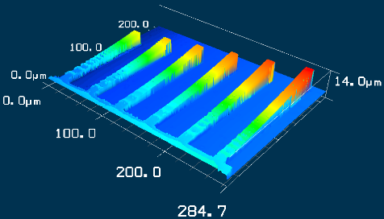
(b)
Figure 1. (a) Optical microscope image and (b) 3D laser microscope image of the Resonator-Ⅰ with cantilevers of varying lengths. (c) Resonator-Ⅱ with “wagon-wheel” SCD cantilever structure.
Elasticity is the relationship between the stress $σ$ and the strain $ε$ in a material. Hooke’s law describes this relationship in terms of compliance S or stiffness C: ¹⁹
$σ=Cε$ (1)
$ε=Sσ$ (2)
For isotropic uniaxial cases, stiffness C can be represented by a single value of Young’s modulus E. For cubic crystals, such as diamond, by considering the energy of the strained crystal and the effect of the crystal symmetry, the elastic behavior can be described using the following ¹⁹:
$\left[\begin{matrix}σ_{1} \\ σ_{2} \\ σ_{3} \\ σ_{4} \\ σ_{5} \\ σ_{6}\end{matrix}\right]=\left[\begin{matrix}c_{11} & c_{12} & c_{12} & 0 & 0 & 0 \\ c_{12} & c_{11} & c_{12} & 0 & 0 & 0 \\ c_{12} & c_{12} & c_{11} & 0 & 0 & 0 \\ 0 & 0 & 0 & c_{44} & 0 & 0 \\ 0 & 0 & 0 & 0 & c_{44} & 0 \\ 0 & 0 & 0 & 0 & 0 & c_{44}\end{matrix}\right]\left[\begin{matrix}ε_{1} \\ ε_{2} \\ ε_{3} \\ ε_{4} \\ ε_{5} \\ ε_{6}\end{matrix}\right]$ $\left[\begin{matrix}ε_{1} \\ ε_{2} \\ ε_{3} \\ ε_{4} \\ ε_{5} \\ ε_{6}\end{matrix}\right]=\left[\begin{matrix}s_{11} & s_{12} & s_{12} & 0 & 0 & 0 \\ s_{12} & s_{11} & s_{12} & 0 & 0 & 0 \\ s_{12} & s_{12} & s_{11} & 0 & 0 & 0 \\ 0 & 0 & 0 & s_{44} & 0 & 0 \\ 0 & 0 & 0 & 0 & s_{44} & 0 \\ 0 & 0 & 0 & 0 & 0 & s_{44}\end{matrix}\right]\left[\begin{matrix}σ_{1} \\ σ_{2} \\ σ_{3} \\ σ_{4} \\ σ_{5} \\ σ_{6}\end{matrix}\right]$ (3)
where $c_{11}$ and $c_{44}$ represent the longitudinal and shear stiffness, respectively, while $c_{12}$ describes the coupling between normal stresses and strains in orthogonal directions, without a direct physical interpretation. Similarly, $s_{11}$ corresponds to the normal strain under uniaxial stress in the same direction, $s_{12}$​ describes the normal strain induced by stress in a perpendicular direction, and $s_{44}$​ represents the shear strain per unit shear stress. Therefore, three independent elastic constants are required to fully describe the elastic behavior of cubic materials. The stiffness constants for SCD in different study are given in Table Ⅰ ^{18, 29, 30, 34-38}. Most reported stiffness constants have been obtained through Brillouin scattering, ultrasonic measurements on natural type I/II diamonds, or ab initio calculations based on density functional theory. Experimental studies on the elastic stiffness constants of high-quality homoepitaxial MPCVD-grown SCD remain scarce.
TABLE Ⅰ Reported elastic stiffnesses of diamond.
Reference | C₁₁ (GPa) | C₁₂ (GPa) | C₄₄ (GPa) | S₁₁ (TPa⁻¹) | S₁₂ (TPa⁻¹) | S₄₄ (TPa⁻¹)
Ref. ¹⁸ | 1076.4$±$0.2 | 267±50 | 600$±$20 | 0.9521 | -0.0992 | 1.7319
Ref. ²⁹ | 1080.4 | 127.0 | 576.6 | 0.9491 | -0.0998 | 1.7343
Ref. ³⁰ | 1079$±$5 | 124$±$5 | 578$±$2 | 0.9493 | -0.0978 | 1.7301
Ref. ³⁴ | 1104 | 148 | 593 | 0.9354 | -0.1106 | 1.6863
Ref. ³⁵ | 1097.5 | 115.5 | 598.2 | 0.9298 | -0.08853 | 1.6717
Ref. ³⁶ | 1155$±$20 | 267$±$50 | 600$±$20 | 0.9481 | -0.1780 | 1.6667
Ref. ³⁷ | 1146±4.8 | 178±46 | 562±3.7 | 0.9106 | -0.1224 | 1.7794
Ref. ³⁸ | 1078.33 | 126.59 | 577.35 | 0.9508 | -0.0999 | 1.7321

For cubic crystals such as diamond, the Young’s modulus along an arbitrary crystallographic direction, n=[$h, k, l$] can be calculated using the following expression: ^{19, 39}
${ E}_{hkl}=1/{\{s}_{11}-2[\left(s_{11}-s_{12}\right)-\frac{1}{2}s_{44}](m^{2}n^{2}+n^{2}p^{2}{+m}^{2}p^{2})\}$ (4)
Here, the terms m, n, and p are the direction cosines between the crystallographic direction vector [$hkl$] and the X, Y, and Z axes, respectively. In the specific case of the (001) crystal plane, the direction cosines can be expressed as [m, n, p] = [$cosφ, sinφ, 0]$, where $φ$ is the angle between the crystallographic direction and the [100] direction. Therefore, for the (001) crystal plane, Equation (4) simplified to：
$E_{hkl}=1/{\{s}_{11}-[\left(s_{11}-s_{12}-s_{44}/2\right)\sin^{2}2φ]/2\}$ (5)
In the case of (001)-plane diamond, based on the data provided in Table I, the quantity $s_{11}-s_{12}-\frac{1}{2}s_{44}$ is always larger than 0. As a result, the Young’s modulus reaches its maximum along the ⟨110⟩ direction (i.e., at 45°) and its minimum along the ⟨100⟩ direction (i.e., at 90°). Using Equation (5), the directional dependence of Young’s modulus in the (001) plane is calculated and plotted in Fig. 2, where the angle is referenced to the [100] crystallographic direction.
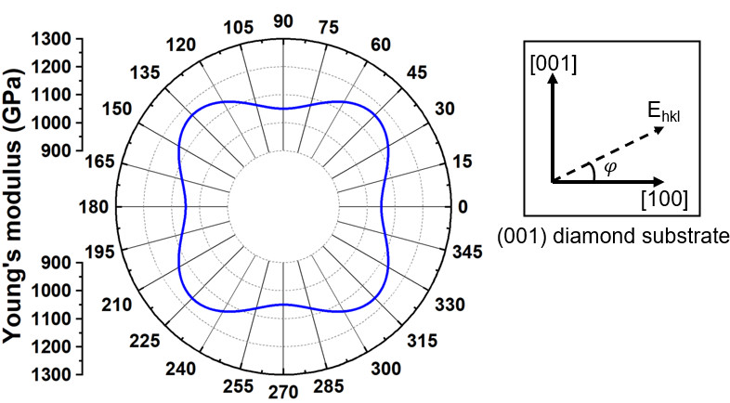
Figure 2. Simulated values of Young’s Modulus using constants reported by H. McSkimin et al. ³⁰ plotted versus orientation in the (001)-plane of diamond.

We first estimated the Young’s modulus of SCD along the <100> direction at room temperature by measuring the length-dependent resonance frequencies of the cantilevers in Resonator-I. Fig. 3 shows that the resonance frequency scales as well as the law of 1/L², which exhibits excellent agreement with the Euler-Bernoulli theory: ²⁰
$f=k\frac{t}{L^{2}}\sqrt{\frac{E}{ρ}}$ (6)
where k represents an isotropic resonance mode-dependent constant, typically 0.162 for a cantilever in the first order of the out-of plane resonance mode; E and ρ denote Young’s modulus and mass density of the cantilever material, respectively. L and t represent the cantilever dimensions in length and thickness, respectively. The agreement between the experimental results and theoretical fitting validates the thin-beam approximation and indicates the high reproducibility of the current fabrication process for mechanical SCD resonators.

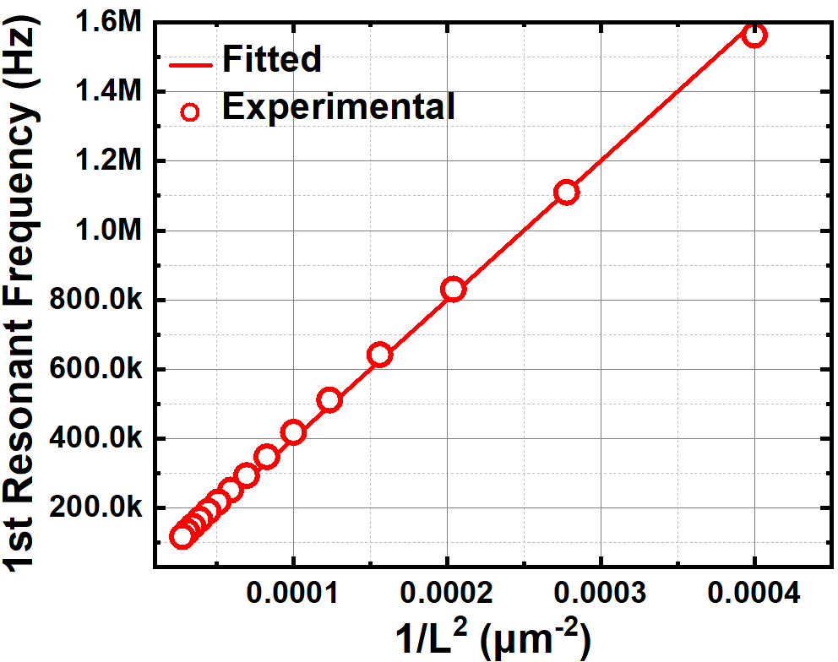
Figure 3. Dependence of measured resonance frequencies on cantilevers length 1/L² at RT.

Given that the thickness of the cantilever is approximately 1.41 μm, the Young’s modulus E in <100> direction was estimated to be around 1078 GPa through least-squares fitting of the measured resonance frequencies in Resonator-I using equation (6). Note that the strain in the cantilevers was not taken into account for the fitting. The evaluated Young’s modulus is consistent with previously reported values for <100> oriented SCD ²⁰. This agreement supports the accuracy of the present measurement and highlights the reliability of resonance-based non-contact methods for evaluating the elastic properties of SCD.
To investigate the anisotropy of Young’s modulus in SCD, measurements on resonance frequency were conducted using Resonator-II. The orientation-dependent resonance frequencies are shown in Fig. 4(a). Using Eq. (6), the Young’s modulus for each crystallographic direction was calculated. Figure 4(b) shows a polar plot of the experimentally measured anisotropy of Young’s modulus (black curve), along with the theoretical anisotropic behavior (blue curve) simulated using Eq. (5). As shown in Fig. 4(b), the experimental results exhibit a clear anisotropic trend, with a minimum Young’s modulus of 1085 ± 21 GPa along the <100> direction and a maximum of 1189 ± 22 GPa along the <110> direction. This variation is slightly larger than the theoretically predicted anisotropy of the Young’s modulus. The discrepancy between our measured values and theoretical predictions may arise from the fact that theoretical calculations are based on the elastic constants derived from natural diamonds, which typically exhibit higher residual stress, crystal defects, and other imperfections. Based on the Hershey–Kröner–Eshelby averaging method, ¹⁹ the average Young’s modulus in the (001) plane is calculated to be 1136 GPa. This value agrees well with previously reported data on (001)-oriented SCD, ^{23, 27} further confirming the reliability and accuracy of our experimental measurements.
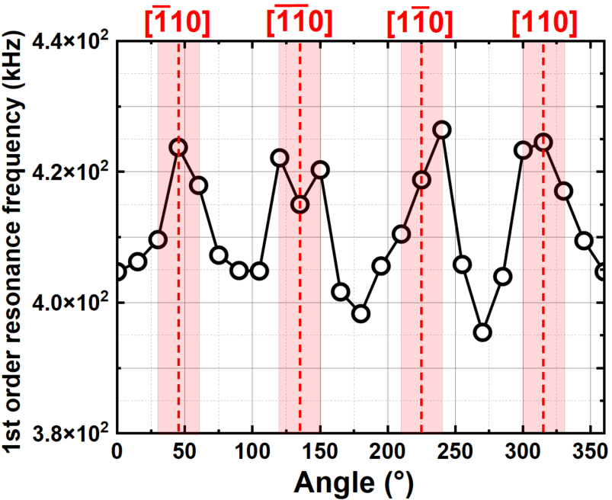
(b)
(a)
Figure 4. (a) Orientation dependent 1st order resonance frequency. (b) Theoretical (blue line), fitting (red line), and measured (black line) values of anisotropic Young’s modulus in the (001)-plane of diamond.

Therefore, for practical high-quality SCD, the elastic constants should require refinement. By fitting the orientation-dependent Young’s modulus using equation (5), we obtained S₁₁=0.9225 TPa⁻¹ and S₁₂ + S₄₄/2=0.7435 TPa⁻¹. In this study, the (001)-oriented SCD alone is insufficient to uniquely determine the individual values of S₁₂ and S₄₄; therefore, additional measurements on (111)- and/or (110)-oriented SCD are necessary to accurately extract these elastic constants in the future. To qualitatively assess the compliance constants obtained in this study, we compare our results with previously reported values shown in Table Ⅰ ^{18, 29, 30, 34-38} by plotting them together in Fig. 5(a) and (b). It is evident that all compliance constants​ derived from our MPCVD-grown SCD are lower than those reported for natural diamonds. The discrepancy in compliance constants is most likely attributed to the higher crystalline quality and lower defect density of the MPCVD-grown SCD, whereas natural diamonds may contain residual impurities or lattice imperfections. According to Raman spectroscopy results (not shown here), the FWHM of the Raman peak of the SCD cantilever is approximately 1.74±0.02 cm⁻¹, whereas that of the HPHT diamond substrate is about 2.00±0.02 cm⁻¹, indicating superior crystallinity of the MPCVD-grown SCD epilayer. Moreover, the fitted compliance constants closely match those obtained from first-principles calculations based on density function theory using generalized gradient approximation or local density approximation exchange-correlation functionals ^{34, 35}, thereby confirming the validity and reliability of the extracted compliance constants. By substituting the fitted compliance constants into Eq. (5), the orientation-dependent Young’s modulus was recalculated and plotted as the red curve in Fig. 4(b). The recalculated curve shows excellent agreement with the experimentally measured data (black curve). These newly estimated elastic constants thus provide a more accurate and practical description of the elastic behavior of high-quality MPCVD-grown SCD.
(b)
(a)
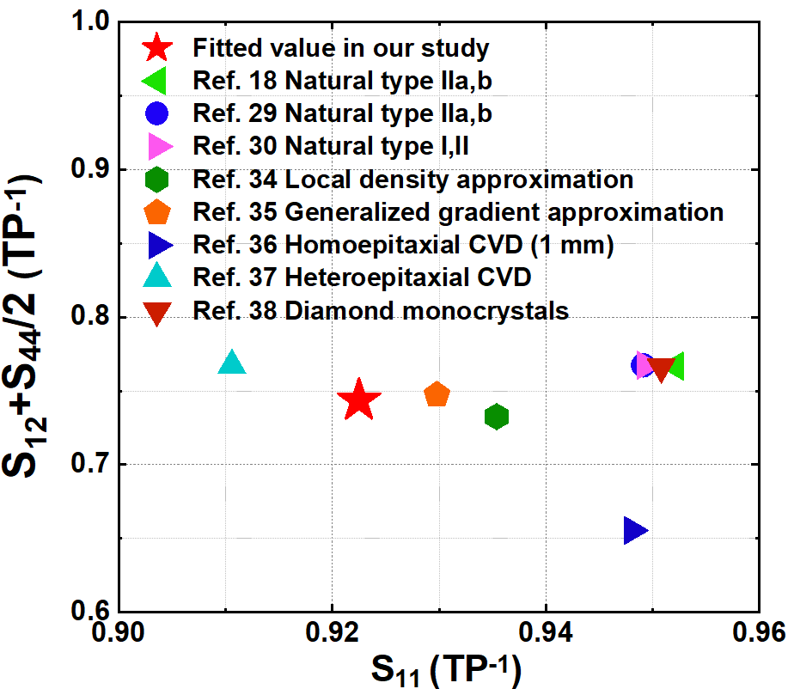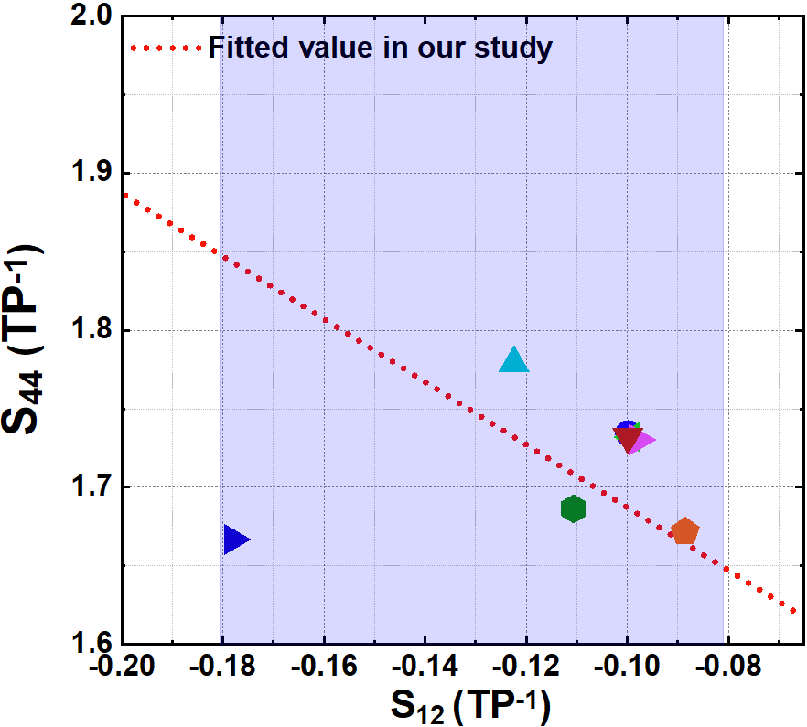
Figure 5. Comparison of the fitted compliance constants (a) S₁₁ and S₁₂​+​ S₄₄​​/2 (b) S₁₂ and S₄₄​​ obtained in this study with previously reported values. ^{18, 29, 30, 34-38} The shaded blue region in Fig. 5(b) indicates the more plausible range of S₁₂ and S₄₄​ values.
In conclusion, we experimentally characterized the anisotropy of Young’s modulus in MPCVD-grown single-crystal diamond (SCD) within the (100) plane using a “wagon-wheel” cantilever array spanning 0°–360°. The modulus ranged from 1085 ± 21 GPa along ⟨100⟩ to 1189 ± 22 GPa along ⟨110⟩, providing more precise orientation-resolved data than previously reported for natural diamonds. From these measurements, we extracted reliable compliance constants for high-quality SCD. Our results emphasize the critical role of elastic anisotropy in the design and modeling of SCD-based MEMS devices. This study provides a practical foundation for engineering diamond components with optimized mechanical behavior for advanced technological applications.

Acknowledgements
This work was supported by JSPS KAKENHI (Grant Number 24H00287) and ARIM (JPMXP1225NM5307) sponsored by the Ministry of Education, Culture, Sports, and Technology (MEXT) of Japan and Council for Science, Technology and Innovation(CSTI), Cross-ministerial Strategic Innovation Promotion Program (SIP), ministerial Strategic Innovation Promotion Program (SIP), the 3rd period of SIP “Ultimate Diamond” (Funding agency :NIMS).

1. M. J. Burek, D. Ramos, P. Patel, I. W. Frank and M. Lončar, Applied Physics Letters 103 (13) (2013).
2. A. V. Sumant, O. Auciello, M. Liao and O. A. Williams, MRS Bulletin 39 (6), 511-516 (2014).
3. Z. Zhang, K. Gu, M. Toda and M. Liao, Applied Physics Letters 126 (10) (2025).
4. P. Ovartchaiyapong, L. Pascal, B. Myers, P. Lauria and A. Bleszynski Jayich, Applied Physics Letters 101 (16) (2012).
5. P. Qu, P. Jin, G. Zhou, Z. Wang and Z. Wang, Journal of Semiconductors 45 (9), 090501 (2024).
6. W. Zhao, G. Chen, K. Gu, M. Toda, Y. Koide and M. Liao, APL Materials 13 (4) (2025).
7. Z. Zhang, W. Zhao, G. Chen, M. Toda, S. Koizumi, Y. Koide and M. Liao, Advanced Functional Materials 33 (27), 2300805 (2023).
8. W. Zhao, G. Chen, T. Teraji, Y. Koide, M. Toda and M. Liao, Advanced Materials, e02012 (2025).
9. O. Auciello, J. Birrell, J. A. Carlisle, J. E. Gerbi, X. Xiao, B. Peng and H. D. Espinosa, Journal of Physics: Condensed Matter 16 (16), R539 (2004).
10. G. Chen, Z. Zhang, Y. Koide, S. Koizumi, Z. Huang and M. Liao, Diamond and Related Materials 138, 110240 (2023).
11. E. Kohn, P. Gluche and M. Adamschik, Diamond and Related Materials 8 (2-5), 934-940 (1999).
12. V. I. Kleshch, R. R. Ismagilov, V. V. Mukhin, A. S. Orekhov, P. Poncharal, S. T. Purcell and A. N. Obraztsov, Applied Physics Letters 122 (14) (2023).
13. R. S. Sussmann, CVD diamond for electronic devices and sensors. (John Wiley & Sons, 2009).
14. G. Chen, S. Koizumi, Y. Koide and M. Liao, Accounts of Materials Research 5 (9), 1087-1096 (2024).
15. R. J. Nemanich, J. A. Carlisle, A. Hirata and K. Haenen, Mrs Bulletin 39 (6), 490-494 (2014).
16. Z. Zhang, K. Gu, G. Chen, M. Imura and M. Liao, Functional Diamond 4 (1), 2346085 (2024).
17. R. Zulkharnay and P. W. May, Functional Diamond 4 (1), 2410160 (2024).
18. M. Grimsditch and A. Ramdas, Physical Review B 11 (8), 3139 (1975).
19. C. A. Klein and G. F. Cardinale, Diamond and Related Materials 2 (5-7), 918-923 (1993).
20. M. Liao, M. Toda, L. Sang, S. Hishita, S. Tanaka and Y. Koide, Applied Physics Letters 105 (25) (2014).
21. H. McSkimin and W. Bond, Physical Review 105 (1), 116 (1957).
22. X. Shen, K. Wu, H. Sun, L. Sang, Z. Huang, M. Imura, Y. Koide, S. Koizumi and M. Liao, Diamond and Related Materials 116, 108403 (2021).
23. S.-F. Wang, Y.-F. Hsu, J.-C. Pu, J. C. Sung and L. Hwa, Materials Chemistry and Physics 85 (2-3), 432-437 (2004).
24. S. Bhagavantam and J. Bhimasenachar, Proceedings of the Royal Society of London. Series A. Mathematical and Physical Sciences 187 (1010), 381-384 (1946).
25. R. Krishnan, V. Chandrasekharan and E. Rajagopal, Nature 182 (4634), 518-520 (1958).
26. M. Núñez Valdez, K. Umemoto and R. M. Wentzcovitch, Applied Physics Letters 101 (17) (2012).
27. Y.-Y. Chang, S. D. Jacobsen, M. Kimura, T. Irifune and I. Ohno, Physics of the Earth and Planetary Interiors 228, 47-55 (2014).
28. N. Mounet and N. Marzari, Physical Review B—Condensed Matter and Materials Physics 71 (20), 205214 (2005).
29. E. Zouboulis, M. Grimsditch, A. Ramdas and S. Rodriguez, Physical Review B 57 (5), 2889 (1998).
30. H. McSkimin and P. Andreatch Jr, Journal of Applied Physics 43 (7), 2944-2948 (1972).
31. M. Liao, S. Hishita, E. Watanabe, S. Koizumi and Y. Koide, Advanced Materials 22 (47), 5393-5397 (2010).
32. G. Chen, Z. Zhang, K. Gu, L. Sang, S. Koizumi, M. Toda, H. Ye, Y. Koide, Z. Huang and M. Liao, Applied Physics Express 17 (2), 021001 (2024).
33. W. Zhao, G. Chen, Z. Zhang, S. Koizumi and M. Liao, Diamond and Related Materials, 112592 (2025).
34. A. Hmiel, J. Winey, Y. Gupta and M. Desjarlais, Physical Review B 93 (17), 174113 (2016).
35. F. Zhi-Jian, J. Guang-Fu, C. Xiang-Rong and G. Qing-Quan, Communications in Theoretical Physics 51 (6), 1129 (2009).
36. P. Djemia, A. Tallaire, J. Achard, F. Silva and A. Gicquel, Diamond and related materials 16 (4-7), 962-965 (2007).
37. Z. H. Shen, A. M. Lomonosov, P. Hess, M. Fischer, S. Gsell and M. Schreck, Journal of Applied Physics 108 (8) (2010).
38. A. Migliori, H. Ledbetter, R. G. Leisure, C. Pantea and J. B. Betts, Journal of applied physics 104 (5) (2008).
39. M. A. Hopcroft, W. D. Nix and T. W. Kenny, Journal of microelectromechanical systems 19 (2), 229-238 (2010).

