A Cationic Polymeric Interface Enabling Dendrite-free and Highly Stable Aqueous Zn-metal Batteries

Qiaohui Duanª, Kaiming Xueª, Xin Yinª, Denis Y. W. Yu^{a,b,}*

ª School of Energy and Environment, City University of Hong Kong, 83 Tat Chee Avenue, Kowloon, Hong Kong S.A.R
^{b} Center of Super-Diamond and Advanced Films (COSDAF), City University of Hong Kong, 83 Tat Chee Avenue, Kowloon, Hong Kong S.A.R.

* Corresponding author
Email: denisyu@cityu.edu.hk
Address: YEUNG G5702, Tat Chee Ave, Kowloon, Hong Kong SAR, People’s Republic of China

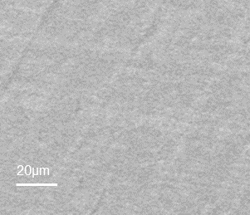
Figure S1. (a) SEM of bare Zn foil; (b) EDX spectrum of PILZ@Zn.
Figure S2. Plot of apparent tracer mobility vs. displacement from the surface in surface zeta potential tests and the linear fitting.
Figure S3. Symmetrical Zn-Zn stripping-plating of PILZ@Zn electrodes with different PILZ coating thicknesses.

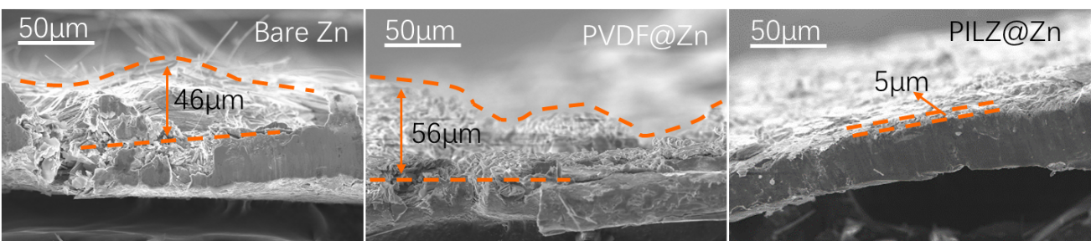
Figure S4. Cross-section SEM images of the bare Zn, PVDF@Zn and PILZ@Zn electrodes after symmetrical Zn-Zn stripping-plating for 100 h.

Figure S5. Surface zeta potential of PILZ@Zn electrode upon symmetrical Zn-Zn stripping-plating tests after different number of hours.

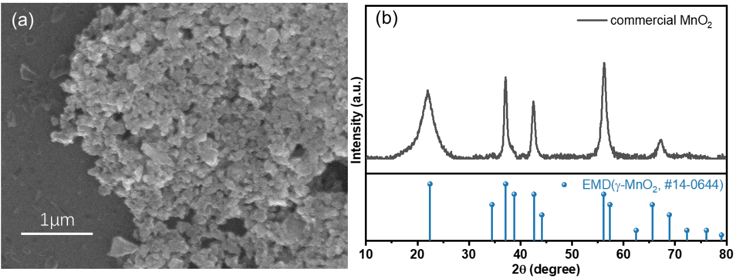
Figure S6. (a) SEM, (b) XRD of the ball-milled commercial MnO₂.

 | Bare Zn | PVDF@Zn | PILZ@Zn
Tracer zeta potential (mV) | 6.1 | -22.8 | 50.2
Intercept of fitting curve (mV) | 6.0 | 20 | 21.7
Surface zeta potential (mV) | +0.1 | -42.8 | +28.5
Fitting R² | 0.87 | 0.99 | 0.98
Table S1. Calculation of surface zeta potential of the electrodes.

*Surface zeta potential = - intercept + tracer zeta potential

Table S2. Comparison of this work with other previously reported cycling performance of symmetrical cells with Zn electrodes.
Cell configurations | Electrolyte | Current density (mA cm⁻²) | Areal capacity (mAh cm⁻²) | Cycle life (h) | Reference
Cu mesh substrate + PAM electrolyte additive | 1 M ZnSO₄ + 0.5 M Na₂SO₄ + 1 g L⁻¹ polyacrylamide | 1 | 1 | 180 | [1]
Ce³⁺ and La³⁺ electrolyte additive | 1M ZnSO₄ + 0.01 M Ce₂(SO₄)₃ | 1 | 1 | 400 | [2]
PAN coating on Zn | 2M Zn(OTf)₂ | 1 | 1 | 1100 | [3]
Bis-tris electrolyte additive | 2 M ZnSO₄ + 0.1M Bis-tris | 1 | 1 | 1200 | [4]
Zn-Al alloy | 2M ZnSO₄ | 0.5 | 0.5 | 2000 | [5]
Eutectic Zn(ClO4)₂-MSM electrolyte | Zn(ClO₄)₂·6H₂O-MSM (1:2 in mol) | 1 | 0.25 | 2000 | [6]
PILZ coating on Zn | 1M ZnSO₄ | 1 | 1 | 2000 | This work

Table S3. Comparison of this work with other previously reported uniform Zn deposition.
Cell configuration | Testing condition | Uniform Zn deposition (mAh cm⁻²) | Reference
PA layer on Ti | 0.2 mA cm⁻², 15 h | 3 | [7]
Zn(H₂PO₄)₂ electrolyte additive | 1 mA cm⁻², 3 h | 3 | [8]
ZIF layer on Zn | 5 mA cm⁻², 1 h | 5 | [9]
MGA layer on Zn | N/A | 5 | [10]
Glucose electrolyte additive | 5 mA cm⁻², 80 min | 6.7 | [11]
PILZ layer on Cu | 10 mA cm⁻², 2 h | 20 | This work

*N/A: not mentioned

Reference:
[1] Q. Zhang, J. Luan, L. Fu, S. Wu, Y. Tang, X. Ji, H. Wang, The three‐dimensional dendrite‐free zinc anode on a copper mesh with a zinc‐oriented polyacrylamide electrolyte additive, Angewandte Chemie, 131 (2019) 15988-15994.
[2] Y. Li, P. Wu, W. Zhong, C. Xie, Y. Xie, Q. Zhang, D. Sun, Y. Tang, H. Wang, A progressive nucleation mechanism enables stable zinc stripping–plating behavior, Energy & Environmental Science, 14 (2021) 5563-5571.
[3] P. Chen, X. Yuan, Y. Xia, Y. Zhang, L. Fu, L. Liu, N. Yu, Q. Huang, B. Wang, X. Hu, An Artificial Polyacrylonitrile Coating Layer Confining Zinc Dendrite Growth for Highly Reversible Aqueous Zinc‐Based Batteries, Advanced Science, 8 (2021) 2100309.
[4] M. Luo, C. Wang, H. Lu, Y. Lu, B.B. Xu, W. Sun, H. Pan, M. Yan, Y. Jiang, Dendrite-free zinc anode enabled by zinc-chelating chemistry, Energy Storage Materials, 41 (2021) 515-521.
[5] S.-B. Wang, Q. Ran, R.-Q. Yao, H. Shi, Z. Wen, M. Zhao, X.-Y. Lang, Q. Jiang, Lamella-nanostructured eutectic zinc–aluminum alloys as reversible and dendrite-free anodes for aqueous rechargeable batteries, Nature Communications, 11 (2020) 1-9.
[6] M. Han, J. Huang, X. Xie, T.C. Li, J. Huang, S. Liang, J. Zhou, H.J. Fan, Hydrated Eutectic Electrolyte with Ligand‐Oriented Solvation Shell to Boost the Stability of Zinc Battery, Advanced Functional Materials, (2022) 2110957.
[7] Z. Zhao, J. Zhao, Z. Hu, J. Li, J. Li, Y. Zhang, C. Wang, G. Cui, Long-life and deeply rechargeable aqueous Zn anodes enabled by a multifunctional brightener-inspired interphase, Energy & Environmental Science, 12 (2019) 1938-1949.
[8] X. Zeng, J. Mao, J. Hao, J. Liu, S. Liu, Z. Wang, Y. Wang, S. Zhang, T. Zheng, J. Liu, Electrolyte design for in situ construction of highly Zn2+‐conductive solid electrolyte interphase to enable high‐performance aqueous Zn‐ion batteries under practical conditions, Advanced Materials, 33 (2021) 2007416.
[9] X. Liu, F. Yang, W. Xu, Y. Zeng, J. He, X. Lu, Zeolitic imidazolate frameworks as Zn2+ modulation layers to enable dendrite‐free Zn anodes, Advanced Science, 7 (2020) 2002173.
[10] J. Zhou, M. Xie, F. Wu, Y. Mei, Y. Hao, L. Li, R. Chen, Encapsulation of Metallic Zn in a Hybrid MXene/Graphene Aerogel as a Stable Zn Anode for Foldable Zn‐Ion Batteries, Advanced Materials, 34 (2022) 2106897.
[11] P. Sun, L. Ma, W. Zhou, M. Qiu, Z. Wang, D. Chao, W. Mai, Simultaneous regulation on solvation shell and electrode interface for dendrite‐free Zn ion batteries achieved by a low‐cost glucose additive, Angewandte Chemie, 133 (2021) 18395-18403.

