Chladni and Fractal Dynamics dual mode marker to map Cancer Cell Nucleus disintegration phases

Parama Dey, Anup Singhania, AjaiKumar Kunnumakkara, Subrata Ghosh, Jonathan Hill, Anirban Bandyopadhyay, Please put all names related

¹Cancer Biology Laboratory, Department of Biosciences and Bioengineering, Indian Institute of Technology Guwahati (IITG), Assam-781039, India
²International Center for Materials and Nanoarchitectronics (MANA), Research Center for Advanced Measurement and Characterization (RCAMC), National Institute for Materials Science, 1-2-1 Sengen, Tsukuba, Ibaraki 3050047, Japan
³Department of Electronics and Electrical Communication Engineering Indian Institute of Technology, Kharagpur, 721302, India
⁴Chemical Science and Technology Division, CSIR-North East Institute of Science and Technology, NEIST, Jorhat, Assam 785006, India
⁵Academy of Scientific and Innovative Research (AcSIR), CSIR-NEIST Campus, Jorhat, Assam 785006, India

Abstract: Conventional cancer drugs are small molecules targeting specific pathways. We introduced PCMS, a 25 kDa supermolecule combining sensors, S molecular motors, M and switching molecules C within a 4th generation PAMAM structure P. PCMS identifies and deactivates cancer cell nucleus dynamics. A decade ago, we demonstrated its programmable, clock-like interactions among S-C-M components. In this study, we captured images of fractal patterns formed by chromosomal compartments and created a theoretical model of their fractal dynamics. We showed that the nucleus behaves like a cavity, producing resonance effects similar to Chladni patterns. When the external agent PCMS interacts with this cavity, it generates a fractal pattern. We identified & mapped five key phase transitions that ultimately lead to the breakdown of cancer cell nuclei.

Introduction:
Fractal analysis has emerged as a valuable tool for quantifying cancer cell morphology and nuclear characteristics. Studies have shown that the fractal dimension (FD) of chromatin increases during carcinogenesis and tumor progression, serving as a potential diagnostic and prognostic marker (Metze, 2013; Metze, Konradin 2019). Fractals are widely studied in cancer for medical physiology, pathophysiology and pathology (V.A. Dobrykh, 2020; Pantić, Igor; 2022; Baish J. W., 2000).
Asymptotic fractal analysis of nuclear profiles has demonstrated significant differences between normal and malignant cells, with parameters such as c, L, and Bm effectively discriminating between the two (Landini & Rippin, 1993; Landini & Rippin, 1996). This approach has shown promise in various cancers, including oral squamous cell carcinomas and multiple myelomas (Metze, 2013). Additionally, lacunarity measurement, which characterizes the distribution of gaps in fractals, has been extended to analyze cancer cell lines with irregular shapes, providing successful discrimination based on vacuole morphology (Borys et al., 2008). Fractal analysis can be used to efficiently estimate the geometrical complexity and irregularity of lung cancer cell structures and tumor growth (Lennon, 2015). These fractal-based techniques offer potential molecular diagnostic applications for cancer prognosis and quantitative analysis of nuclear pleomorphism.
Fractal analysis is based on Chromosomes that are not randomly distributed within the nucleus but occupy discrete sub-nuclear domains (Iwasaki et al., 2015), with active genes preferentially located in the periphery of these territories (Kurz et al., 1996). Thus, when territories interact, translocations and transcription-dependent associations are developed (Branco & Pombo, 2006). Furthermore, the distinct volumes and shapes of chromosome territories, such as the X chromosome territory, indicate functional roles for these territories (Eils et al., 1996; George et al., 2020). These studies focus solely on the natural progression of cancer cells within living systems. To our knowledge, no prior research has tracked drug effects on chromosomal territories. This study marks the first in a series where we aim to report on this novel approach. It uniquely measures Chladni patterns within chromosomal territories, revealing how cavity effects create basic fractal patterns, followed by fractal pattern analysis to separate drug effects from the cell's natural self-similarity. Interchromosomal domain (ICD) spaces, DNA-free channels between chromosome territories, are key to nuclear organization (Verschure et al., 1999). These channels respond to cellular resonance, forming Chladni patterns, mapping that help us filter cooperative, logical interactions between ICDs and preferential genes.
Protocol of the study:
Cancer cells display altered chromatin structures that impact gene expression. To investigate morphological effects of these changes, we used a well-known molecular nanobot, PCMS, engineered to monitor pH and motor activity within cancer cell nuclei, see its molecular structure in Figure 1a (Ghosh S, (2018); S. Ghosh, S. (2015). 1pM PCMS was introduced into lung cancer cells, cultured in vitro and tracked via fluorescence confocal microscopy, see materials and methods for details. The fluorescent image shows loops as compartments, our image processing algorithm (see methods for details) identifies the changes. In Figure 1b, we have put two images. Three chromosomal territories (CTs) are shown with an arrow (Szczepińska, T., Rusek, A., & Plewczynski, D. (2019)). The simulators are design to detect the loop structures. In the 3 CTs below we could see that as a function of time, the loops are condensing (Ramos-Alonso, L., 2023; Toné, S., Sugimoto, 2007). These images are last phases before the final phase we identified as point of no return, interphase state is a mystery (Rosa, A. and Everaers, R. (2008)). Not all cells undergo cell death. After PCMS is added, the nucleus of cancer cells show five major phase transitions after that the nucleus is disintegrated. However, there is a point after 3 CT formation, when we find that cell nucleus returns to initial state. We have explained this situation in Figure 1c. One interesting aspect of this plot is that those cells that would undergo a destruction under PCMS, becomes 200% larger in size, this particular largely expanded nuclear phase is what we define as point of no return.
Chromosomal territories (CTs) are a fundamental aspect of nuclear architecture, representing distinct regions within the nucleus where specific chromosomes are located (Cremer & Cremer, 2010). These territories are crucial for organizing genetic material within the cell. Research indicates that CTs have a spatially constrained structure, with heterochromatic foci limiting long-range transformations of CTs, while euchromatic foci undergo positional oscillations, influencing local changes in chromosome shape (Maya-Mendoza & Jackson, 2017).
Five phases of a cancer cell nucleus:
We have identified five phase transitions where we see the interplay of ICDs and CTs as shown in Figure 1d.
In the first phase, filamentary structures, form hairlike threads spread all over the nucleus. If we do not add PCMS in the culture plate, the random filamentary distributions would remain the same for 18 hours maximum we observed. However, when 50$μl$ of 1pM PCMS is added, we see the formation of three large compartments. We call it phase 1 (image number 7/22). In different cell culture plates, the shape of the compartments is different, but, covered areas remain within $±10$%, as we studied 8 culture plates. Therefore, the energetics involved in the formation of these compartments are consistent over different culture plates, experimental methods. Then, after some time, the cells spontaneously undergo a phase transition and 3 CTs disappear and 2 CTs form. We were interested to know if only one CT disappears and instead of 3, we get 2, consequently, we get phase 2 (image number 10/22). The answer is negative. All three CTs disappear and then two new CTs form. This is why we find that in Figure 1b, the 3 CTs condense and disintegrates into filaments. Once again, we checked surface area coverage of two CTs over 8 culture plates made in different experiments, and we found that total surface area coverage for pair of CTs vary $±10$%. Chromosomal topology often determines nuclear architecture (Berríos, S. (2017).
The CT pairs disappear and a large nearly circular CT forms with ICDs branching out like a radiating lines or corona from this nearly circular CT, in phase 3. This higher order chromatin structure carries an interesting physics as well as biology (Fudenberg, G. and Mirny, L. (2012)). Two experimental observations we would like to point out. First, accurately select the center of nucleus to build a pair of nearly circular cavities, and second, formation of corona connecting inner cavity to the external cavity. Therefore, the nucleus appears nearly two times bigger than the phase 2. Once the nucleus attains phase 3, this is point of no return described in the Figure 1b. We have observed several cells where phase 3 formation fails and the nucleus jumps from phase 2 to the normal state where filamentary structures are randomly distributed all over the nucleus. Therefore, phase 4 is a step towards disintegration of nucleus. Deformation in nucleus has been studied extensively as it reflects vital cellular functionality (Awazu, A. (2015)).
In phase 4, the corona like structure of ICDs that link inner circular CT to the external CT starts disappearing. Initially, the connecting lines fall part, primarily they delink from the external ring, and then, we see to isolated CT rings. In the final phase 5, gaps or discontinuities develop in the perimeter of outer ring and it shrinks to regain continuity. Similarly, both outer and inner rings acquire irreparable damage, the ICDs leak out from the nucleus to the cell cytoplasm and nucleus gets disintegrated.
For analyzing fractal dynamics and Chladni pattern, we have divided the whole 50 minutes experiments into 22 parts and these 22 images were analyzed using a series of already established protocols. In this study, the difference in approach from conventional studies is that we are adding an external agent and that agent is triggering low entropy, highly symmetric structures step by step in the cell. Therefore it is utmost essential that we identify the Chladini pattern that naturally generates in a cavity at different resonances. Undoubtedly, our repeated observations have shown that external agents and unique cellular functions trigger unique distributions of CT and ICDs. Not spontaneous transitions that is a marker for the presence of external agents’ functional activity in the cell.
Chladini pattern analysis:
Figure 2 illustrates a detailed Chladini pattern analysis of 17 lung cancer cells examined prior to the addition of PCMS. The analysis provides insights into the structural organization and complexity of the cellular architecture. We have used Sobel or Canny edge detection to identify the filaments and it helps in finding correct loops. Chladini pattern algorithm relies on the detection of a correct boundary. Panel 2(a) quantifies the density of loops or strings per unit area, using a color scale to represent values, with a maximum of 1, indicating the extent of spatial filament arrangement. Here we find that ~50% of the structures are homogeneously distributed in the nucleus before injecting PCMS.
Panel 2b maps out the distribution of filament lengths, measuring the number of pixels used along the filament length and color-coding these values to show variations in average filament length or inter-compartmental distances (ICDs). In panel 2c, the analysis differentiates large loop structures from smaller ones, emphasizing the presence and distribution of these structural elements. Applied wavelet transform for multiscale analysis to capture features of the Chladni patterns across different scales, it accounts for complexity of the pattern. This method is useful for detecting both large and small-scale features in the image. Panel 2d focuses on regions where loops and filaments are intertwined, using a color scale to signify areas of high and low intertwinement, reflecting the complexity of the cellular network.
Chladni patterns have distinct lines and areas where filaments or loops accumulate, so contour detection trace the outlines of nodal regions.Panel 2e evaluates the degree to which filamentary structures form completed loops, with brighter colors indicating more circular, completed formations. Loops are homogeneously distributed all over the nucleus in majority of the cells.
Chladni patterns are often symmetric. We have applied symmetry detection methods like Hough Transforms and Radon Transforms to detect radial symmetry and circular nodal lines in the image. Finally, panel 2f examines the symmetry of these structures, identifying areas of order and disorder, where red regions denote asymmetry and blue regions signify symmetry, providing a visual representation of structural uniformity and complexity in the cancer cells. Entropy that is associated with symmetry is a regulator of mammalian chromosomes (Finan, K.,2010).
Figure 3 shows a detailed Chladni pattern analysis on 17 lung cancer cells, focusing on structural changes over time in response to PCMS. The analysis involved capturing high-resolution images of each cell just before the introduction of PCMS, followed by monitoring the cells over a 50-minute duration. This time window was divided into 22 equal intervals, yielding 22 sequential snapshots per cell. From these, six key snapshots were analyzed to illustrate different Chladni patterns, and four representative snapshots were selected to evaluate variations in density, complexity, number of patterns, and average area of the structures.
Panel a of Figure 3 demonstrates the nearly periodic oscillation of loop and filamentary structures' density. This periodic behavior could be attributed to the regular communication between the lung cancer cells and the PCMS agent, suggesting a resonance-like interaction of chromosomal territories (Szczepińska, T., Rusek, A., & Plewczynski, D. (2019)). Interestingly, panel b, which represents structural complexity, closely mirrors the oscillatory trends seen in panel a. This similarity is expected, as the complexity of the patterns is directly influenced by the density of the filamentary structures, highlighting the interconnected nature of these two parameters.
In contrast, panel 3 c, depicting the number of Chladni patterns, reveals a distinct behavior. Unlike density and complexity, the number of patterns does not follow a periodic trend. Instead, there is a marked increase in the number of patterns just before the complete disintegration of the nucleus. This surge suggests a sudden destabilization or fragmentation phase, indicating that the cellular structure is nearing collapse.
Panel 3 d presents the average area of the Chladni patterns, which shows a continuous decline over time. This trend indicates a progressive contraction of the structural features within the nucleus. However, a noteworthy observation occurs during phase four, where a large structure briefly forms before the rapid disintegration of the nucleus. This phase could represent a critical transition, where the nucleus temporarily reorganizes before breaking down entirely under the influence of PCMS. Together, these observations provide valuable insights into how Chladni pattern dynamics and resonance interactions relate to the structural integrity and disintegration process in lung cancer cells, shedding light on the underlying physical mechanisms at play.
Fractal analysis:
Fractal analysis of cancer cell is a routine study (Lennon, Frances E., 2015). However, the detailed analysis presented in Figure 4 offers critical insights into the self-organization and dynamic structural behavior of lung cancer cells in response to PCMS. By segmenting and labeling self-similar objects within the nucleus, we identified 160 distinct compartments across a cluster of 17 lung cancer cells. The initial segmentation process involved converting images to grayscale, which facilitated accurate compartment detection. Colors were then assigned based on compartment areas, revealing a diverse and complex distribution of compartmental symmetries within the cell cluster. This initial distribution provides a baseline for understanding how structural features evolve over time. The shapes of chromosomal territories evolve as a function of time and change in shape is associated with gene density (Sehgal, N., 2015).
Our observations revealed a fascinating trend: as PCMS is introduced, the assigned colors for segmented compartments display a coordinated and progressive change across a subset of cells. This phenomenon of evolving symmetry highlights a level of collective emergence, where localized structural transformations appear synchronized across multiple cells. Figure 2f illustrates this collective behavior, suggesting that structural changes are not isolated but rather interconnected, potentially mediated by cellular communication or shared biophysical constraints (Heymans O. 2000).
Furthermore, the phase transitions induced by PCMS, as depicted in Figure 1d, underscore the complexity of these interactions. During early transitions, we see that the nuclei of these cells undergo coordinated reorganization, influencing both the compartmental distribution and the filamentary structures within. This collective reconfiguration implies a potential phase-driven mechanism where neighboring cells respond in unison, adjusting their structural components and symmetry patterns in a way that could have significant implications for understanding cancer cell dynamics and the impact of therapeutic agents like PCMS. Such findings open avenues for exploring how phase transitions and compartmental symmetries contribute to cancer progression and treatment responses.
Figure 5 presents a comprehensive analysis of the temporal evolution of fractal patterns in lung cancer cells following the introduction of PCMS. The study focuses on understanding how compartmental and filamentary structures within the cells dynamically change over a 50-minute period, divided into 22 equal time intervals. Panel (a) illustrates the significant transformation in the symmetry distribution and the number of compartments over time. Initially, upon PCMS addition, there is a substantial increase in the number of compartments and filamentary structures. However, as PCMS interacts with the cell nucleus, these initially fragmented components undergo an organized restructuring, leading to a dramatic reduction in the number of compartments. This observation underscores a critical transition from a chaotic to a more ordered and unified architecture. Translocations in oncogenic human cancer has been a point of interest and here we have seen abundant onsets of such translocations of CTs (Zheng, J. (2013).
Panel (b) captures the variation in fractal dimension as a function of time ((Etehadtavakol M.,2010; Dumansky Y.V, 2012)), reflecting the evolving structural complexity of the cancer cells. The fractal dimension significantly decreases as PCMS acts, signifying a shift from intricate, self-similar patterns to a more simplified and unified structure. This reduction highlights the PCMS-induced formation of a unique, singular architecture within the cells, emphasizing a loss of complexity and a movement towards structural uniformity.
Panel (c) provides insights into the lacunarity of the cellular patterns, which serves as a measure of texture and gap distribution. Lacunarity is a measure of how texture or fractal structures fill space and describes the gaps or holes within the fractal (Borys et al., 2008). A low lacunarity indicates homogeneity, while a high lacunarity indicates heterogeneity. The data reveal periodic fluctuations in lacunarity, with pronounced peaks just before the nuclear disintegration. This spike in lacunarity indicates increased heterogeneity and instability in the structural arrangement, acting as a precursor to the cell's ultimate breakdown. The rippling effect seen in the lacunarity graph emphasizes the unstable and transitional state of the cells, culminating in a dramatic disintegration phase. Collectively, these findings suggest that PCMS induces significant reorganization and destabilization of cellular architecture, with distinct fractal and spatial patterns emerging as key indicators of the cells' response and eventual collapse.
Conclusion
Our study demonstrates the power of fractal analysis in understanding the morphological changes and structural dynamics of lung cancer cells under the influence of a molecular nanobot, PCMS. By employing advanced imaging and segmentation techniques, we captured detailed temporal evolutions of compartmental and filamentary structures over a 50-minute period. The introduction of PCMS induced significant phase transitions within the nucleus, marked by a shift from highly fragmented, chaotic configurations to more organized and unified architectures, as evidenced by variations in fractal dimension, lacunarity, and Chladni pattern dynamics.
We observed that the number of compartments initially spiked before reorganizing into larger, cohesive structures, highlighting the cellular reorganization process. The fractal dimension decreased over time, indicating a reduction in structural complexity and a transition toward singular, simplified architectures. Lacunarity measurements revealed critical instability moments, with peaks preceding nuclear disintegration, underscoring the progressive breakdown of the cellular network. These findings suggest that PCMS not only disrupts cancer cell nuclei but also orchestrates a series of organized phase transitions that ultimately lead to cell collapse. The synchronization of compartmental transformations across multiple cells indicates potential collective behavior mediated by shared biophysical constraints or cellular communication.
Overall, this work introduces a novel approach to tracking drug effects on chromosomal territories and emphasizes the significance of fractal and Chladni pattern analysis in cancer research & clinical neuroscience (John, Ann M. 2015). The insights gained here open new avenues for developing targeted cancer therapies that exploit the structural vulnerabilities of cancer cells, offering a promising diagnostic and prognostic toolset for future applications.

Materials and methods
Cell lines: Human lung adenocarcinoma cell line A549, ovarian carcinoma cell line OVMAMA were obtained from Riken cell bank, Japan and JCRB cell bank, Japan, respectively. Human osteosarcoma cell line MG-63 and cervical carcinoma cell line HeLa were gifted by NIMS, Japan. Normal lung fibroblasts Wi-38 and bone marrow derived mesenchymal stem cells UE6E7T-1 were obtained from Riken cell bank, Japan and JCRB cell bank, Japan, respectively. A549, MG-63, HeLa, and UE6E7T-1 cells were cultured in Dulbecco's Modified Eagle Medium (DMEM) (Gibco, USA); OVMANA and Wi-38 were cultured in Minimum Essential Medium (MEM) (Gibco, USA), and supplemented with 10% heat-inactivated fetal bovine serum (FBS) (Nichirei, Japan) and 1% Penstrep (Gibco, USA). The cells were maintained in a CO₂ incubator at 37°C and 5% CO₂.
Confocal microscopy: Cancer and normal cells were seeded at a density of 2000 cells/500μL media in the four chambers of 35 mm quadrant plates and maintained under optimum conditions for 24 hours.
For staining the nucleus, live cells were incubated with DAPI, a fluorescent dye that selectively binds to the minor grooves of the adenine-thymine (A-T) regions of double stranded DNA. A working stock of 1μg/ml DAPI was prepared in distilled water. The cells were rinsed properly with PBS and then 200 μL of 1μg/ml DAPI was added to the cells and incubated in dark at room temperature for 10 mins. Next, DAPI was discarded, cells were rinsed with 1 x PBS to remove excess DAPI. 200 μL of Invitrogen™ Live Cell Imaging Solution was added to the cells. The cells were treated with different concentration of PCMS and observed under Leica TCS SP5 confocal microscope.
For staining the RNA, SYTO™ RNASelect™, which is a green fluorescent cell-permeant nucleic acid staining dye that selectively stains RNA, was used. This dye exhibits bright green fluorescence when bound to RNA (absorption/emission maxima ∼490/530 nm), but only a weak fluorescent signal when bound to DNA. To prepare 1 mL of the labeling solution, a 5 μM intermediate stock was prepared by adding 1 μL of the 5 mM stock solution to 1 mL of the medium, mixing and then adding 100 μL of the 5 μM intermediate stock to 900 μL of the medium. This 500 nM labeling solution was pre-warmed at 37°C prior to application to the cells. Cells were rinsed with 1 x PBS and then 200 μL of pre-warmed 500 nM of the dye is added to the cells and incubated for 10 mins at 37°C. 200 μL of Invitrogen™ Live Cell Imaging Solution was added to the cells. The cells were treated with different concentration of PCMS and observed under Leica TCS SP5 confocal microscope.
Chladini & Fractal analysis simulator development:
We developed a Python-based software that enables users to upload fluorescence images over time and perform two core analyses: fractal analysis and Chladni pattern analysis. The fractal analysis tool (Bubnov R.V., 2011.) applies multiple scientific protocols to examine the complex, self-similar structures of CT, ICD within cancer cell nucleus. Key methods include the Box-Counting method (Karperien A.L., 2016), Hausdorff Dimension, and Lacunarity Analysis, each providing unique metrics, such as fractal dimensions (Metze, Konradin 2019) and spatial heterogeneity. Advanced techniques like the Wavelet Transform and Multifractal Analysis allow detailed examination of structural variations in loops and strings, offering insights into texture and roughness as variables. Mosaic analysis reveals intracellular dynamics (Landini G., 2000). Loop geometry and curved lines of CTs and ICDs were treated as separate objects, image processing protocols were fine tuned for them separately (Dey P. 2005).
The Chladni pattern analysis module identifies resonant patterns within cellular structures by detecting nodal lines formed in response to vibrational forces as nuclear membrane acts as a cavity. Key steps involve preprocessing images to grayscale, smoothing noise, and using edge detection algorithms to enhance pattern visibility. Wavelet based analysis were intensively used (Ramirez-Cobo P., 2013). Tools like Radon and Fourier Transforms aid in detecting symmetry and periodic structures characteristic of Chladni patterns. Additionally, machine learning techniques, such as template matching and feature extraction, enhance recognition of known Chladni shapes. Combining fractal and Chladni analyses allows for nuanced tracking of compartmental to cellular interactions and resonance effects among CTs & ICDs, the local changes in symmetry and collective symmetry of a cluster of cells were analysed in a single shot image processing.

References:
Awazu, A. (2015). Nuclear dynamical deformation induced hetero- and euchromatin positioning. Physical Review E, 92(3). https://doi.org/10.1103/physreve.92.032709
Baish, J. W., & Jain, R. K. (2000). Fractals and cancer. Cancer Research, 60, 3683-3688.
Berríos, S. (2017). Nuclear architecture of mouse spermatocytes: chromosome topology, heterochromatin, and nucleolus. Cytogenetic and Genome Research, 151(2), 61-71. https://doi.org/10.1159/000460811
Borys, P., Krasowska, M., Grzywna, Z. J., Djamgoz, M. B., & Mycielska, M. E. (2008). Lacunarity as a novel measure of cancer cell behavior. Bio Systems, 94(3), 276-281.
Branco, M., & Pombo, A. (2006). Intermingling of chromosome territories in interphase suggests role in translocations and transcription-dependent associations. PLOS Biology, 4(5), e138. https://doi.org/10.1371/journal.pbio.0040138
Bubnov, R. V., & Melnyk, I. M. (2011). The methods of fractal analysis of diagnostic images. Initial clinical experience. № 3-4, 108-113.
Cremer, T., & Cremer, M. (2010). Chromosome territories. Cold Spring Harbor Perspectives in Biology, 2(3), a003889. https://doi.org/10.1101/cshperspect.a003889
Dey, P. (2005). Basic principles and applications of fractal geometry in pathology: a review. Analytical and Quantitative Cytology and Histology, 27(5), 284-290.
Dobrykh, V. A., Sedakov, V. O., Теn, Т. К., Uvаrova, I. V., & Mamrovskaya, T. P. (2020). Fractal analysis in biology and medicine. Dalʹnevostočnyj medicinskij žurnal. DOI:10.35177/1994-5191-2020-4-85-92
Dumansky, Y. V., Lyakh, Y. E., Gorshkov, O. G., Gurianov, V. G., & Prihodchenko, V. V. (2012). Fractal dimensionality analysis of normal and cancerous mammary gland thermograms. Chaos, Solitons and Fractals, 45, 1494-1500.
Eils, R., Dietzel, S., Bertin, E., Schröck, E., Speicher, M., Ried, T., … & Cremer, T. (1996). Three-dimensional reconstruction of painted human interphase chromosomes: active and inactive x chromosome territories have similar volumes but differ in shape and surface structure. The Journal of Cell Biology, 135(6), 1427-1440. https://doi.org/10.1083/jcb.135.6.1427
Etehadtavakol, M., Lucas, C., Sadri, S., & Ng, E. Y. K. (2010). Analysis of breast thermography using fractal dimension to establish possible difference between malignant and benign patterns. Journal of Healthcare Engineering, 1(1), 27-43.
Finan, K., Cook, P., & Marenduzzo, D. (2010). Non-specific (entropic) forces as major determinants of the structure of mammalian chromosomes. Chromosome Research, 19(1), 53-61. https://doi.org/10.1007/s10577-010-9150-y
Fudenberg, G., & Mirny, L. (2012). Higher-order chromatin structure: bridging physics and biology. Current Opinion in Genetics & Development, 22(2), 115-124. https://doi.org/10.1016/j.gde.2012.01.006
George, P., Kinney, N., Liang, J., Onufriev, A., & Sharakhov, I. (2020). Three-dimensional organization of polytene chromosomes in somatic and germline tissues of malaria mosquitoes. Cells, 9(2), 339. https://doi.org/10.3390/cells9020339
Ghosh, S., Chatterjee, S., Roy, A., Ray, K., Swarnakar, S., Fujita, D., & Bandyopadhyay, A. (2015). Resonant oscillation language of a futuristic nano-machine-module: eliminating cancer cells & Alzheimer Aβ plaques. Current Topics in Medicinal Chemistry, 15, 534-541.
Ghosh, S., Roy, A., Singhania, A., Chatterjee, S., Swarnakar, S., Fujita, D., & Bandyopadhyay, A. (2018). In-vivo and in-vitro toxicity test of molecularly engineered PCMS: a potential drug for wireless remote-controlled treatment. Toxicology Reports, 5, 1044-1052. https://doi.org/10.1016/j.toxrep.2018.10.011
Heymans, O., Fissette, J., Vico, P., Blacher, S., Masset, D., & Brouers, F. (2000). Is fractal geometry useful in medicine and biomedical sciences? Medical Hypotheses, 54(3), 360-366.
Iwasaki, O., Corcoran, C., & Noma, K. (2015). Involvement of condensin-directed gene associations in the organization and regulation of chromosome territories during the cell cycle. Nucleic Acids Research, 44(8), 3618-3628. https://doi.org/10.1093/nar/gkv1502
John, Ann M., et al. (2015). The utility of fractal analysis in clinical neuroscience. Reviews in the Neurosciences, 26, 633-645.
Karperien, A. L., & Jelinek, H. F. (2016). Box-counting fractal analysis: A primer for the clinician. In A. Di Ieva (Ed.), The Fractal Geometry of the Brain (pp. 13-44). New York: Springer.
Kurz, A., Lampel, S., Nickolenko, J., Bradl, J., Benner, A., Zirbel, R., … & Lichter, P. (1996). Active and inactive genes localize preferentially in the periphery of chromosome territories. The Journal of Cell Biology, 135(5), 1195-1205. https://doi.org/10.1083/jcb.135.5.1195
Landini, G., & Iannaccone, P. M. (2000). Modeling of mosaic patterns in chimeric liver and adrenal cortex: algorithmic organogenesis? FASEB Journal, 14(5), 823-827.
Landini, G., & Rippin, J. W. (1993). An “asymptotic fractal” approach to the morphology of malignant cell nuclei. Fractals, 1, 326-335.
Landini, G., & Rippin, J. W. (1996). Quantification of nuclear pleomorphism using an asymptotic fractal model. Analytical and Quantitative Cytology and Histology, 18(2), 167-176.
Lennon, F. E., et al. (2015). Lung cancer—a fractal viewpoint. Nature Reviews Clinical Oncology, 12, 664-675.
Maya-Mendoza, A., & Jackson, D. (2017). Labeling DNA replication foci to visualize chromosome territories in vivo. Current Protocols in Cell Biology, 75(1). https://doi.org/10.1002/cpcb.19
Metze, K. (2013). Fractal dimension of chromatin: potential molecular diagnostic applications for cancer prognosis. Expert Review of Molecular Diagnostics, 13, 719-735.
Metze, K., et al. (2019). The fractal dimension of chromatin - a potential molecular marker for carcinogenesis, tumor progression, and prognosis. Expert Review of Molecular Diagnostics, 19, 299-312.
Pantić, I., et al. (2022). Application of fractal and textural analysis in medical physiology, pathophysiology, and pathology. Medicinska istraživanja.
Ramirez-Cobo, P., & Vidakovic, B. (2013). A 2D wavelet-based multiscale approach with applications to the analysis of digital mammograms. Computational Statistics and Data Analysis, 58(2), 71-81.
Ramos-Alonso, L., Holland, P., Le Gras, S., Zhao, X., Jost, B., Bjørås, M., Barral, Y., Enserink, J. M., & Chymkowitch, P. (2023). Mitotic chromosome condensation resets chromatin to safeguard transcriptional homeostasis during interphase. Proceedings of the National Academy of Sciences of the United States of America, 120(4), e2210593120. https://doi.org/10.1073/pnas.2210593120
Rosa, A., & Everaers, R. (2008). Structure and dynamics of interphase chromosomes. PLOS Computational Biology, 4(8), e1000153. https://doi.org/10.1371/journal.pcbi.1000153
Sehgal, N., Fritz, A., Morris, K., Torres, I., Chen, Z., Xu, J., … & Berezney, R. (2014). Gene density and chromosome territory shape. Chromosoma, 123(5), 499-513. https://doi.org/10.1007/s00412-014-0480-y
Szczepińska, T., Rusek, A., & Plewczynski, D. (2019). Intermingling of chromosome territories. Genes Chromosomes and Cancer, 58(7), 500-506. https://doi.org/10.1002/gcc.22736
Toné, S., Sugimoto, K., Tanda, K., Suda, T., Uehira, K., Kanouchi, H., Samejima, K., Minatogawa, Y., & Earnshaw, W. C. (2007). Three distinct stages of apoptotic nuclear condensation revealed by time-lapse imaging, biochemical and electron microscopy analysis of cell-free apoptosis. Experimental Cell Research, 313(16), 3635-3644. https://doi.org/10.1016/j.yexcr.2007.06.018
Verschure, P., Kraan, I., Manders, E., & Driel, R. (1999). Spatial relationship between transcription sites and chromosome territories. The Journal of Cell Biology, 147(1), 13-24. https://doi.org/10.1083/jcb.147.1.13
Zheng, J. (2013). Oncogenic chromosomal translocations and human cancer (review). Oncology Reports, 30(5), 2011-2019. https://doi.org/10.3892/or.2013.2677

Acknowledgement: Parama Dey acknowledges National Institute for Materials Science (NIMS) for awarding the International Cooperative Graduate Program (ICGP) Fellowship under the “Indian Institute of Technology Guwahati - NIMS Cooperative Graduate Program”. Prof. Ajaikumar B. Kunnnumakkara acknowledges professional development fund (BSBE/ABK/PDF) for supporting the present work.
Author contributions: A.B. and A.K. planned the research; A.S., and S. G. synthesized the PCMS molecule; P.D cultured the cancer cell, imaged intake of PCMS, J.H reviewed the cancer cell work and PCMS synthesis, A.B and P.D wrote the paper.
Supporting online materials:
Conflict of Interest declaration: Authors declare that they have no conflict of interest

Figure 1 PCMS and five phases in lung cancer cells: (a) The PCMS molecular structure, with components labeled as P = PAMAM, C = Controller, M = Molecular Motor, and S = Sensor. (b) White arrows highlight compartments within a lung cancer cell. (c) Temporal variation of the cancer cell nucleus is shown, with the red plot indicating instances where the nucleus reverts to its original shape, suggesting potential resistance to destruction. (d) Five phases of chromosome compartmentalization within the cancer cell nucleus are presented, with the top row showing schematics and the bottom row displaying corresponding fluorescence images, scale bar is 2$μm$. Phases 4 and 5 represent points of no return.
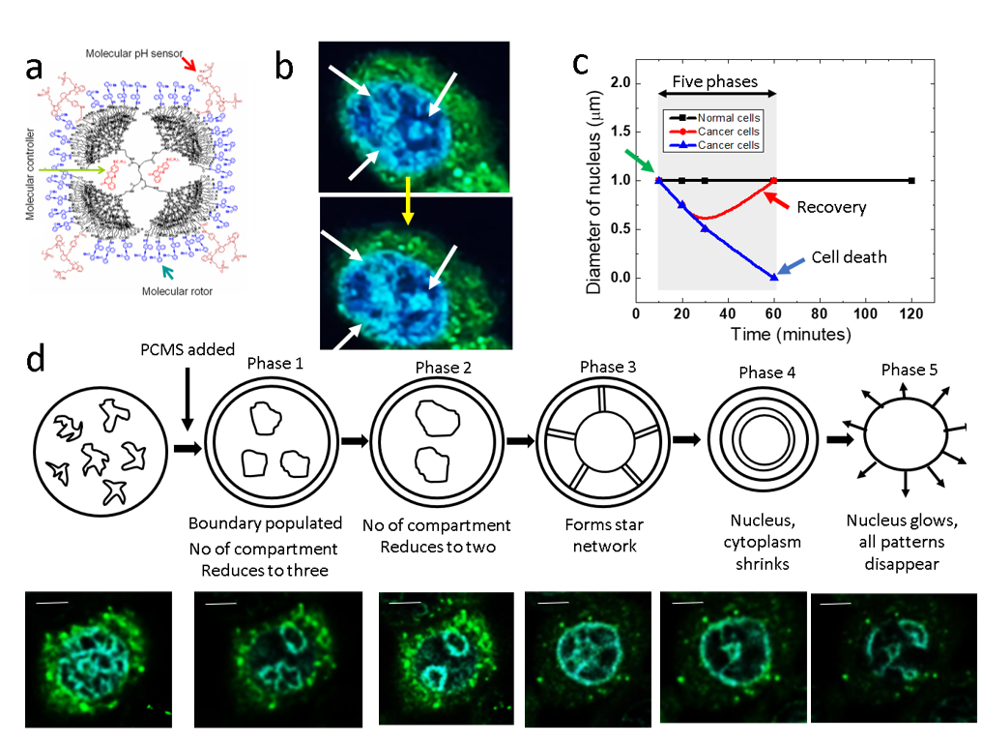

Figure 2. Snapshot of Chladini pattern analysis live feed:. Chladini pattern analysis of 17 lung cancer cells observed before the addition of PCMS. Panel (a) shows the number of loops or strings per unit area relative to the total area, with a maximum value of 1, represented by a color scale. In panel (b), the distribution of filament length is depicted by the number of pixels along their length, color-coded to show average filament length or inter-compartmental distances (ICDs). Panel (c) highlights large loop structures in comparison to smaller loop structures, while panel (d) displays regions with intertwined loops and filaments, with a color scale indicating high and low intertwinement. Panel (e) assesses the completion percentage of filamentary loops, with bright colors marking more circular structures. Finally, panel (f) presents the degree of symmetry, with red regions indicating asymmetry and blue regions representing symmetry.
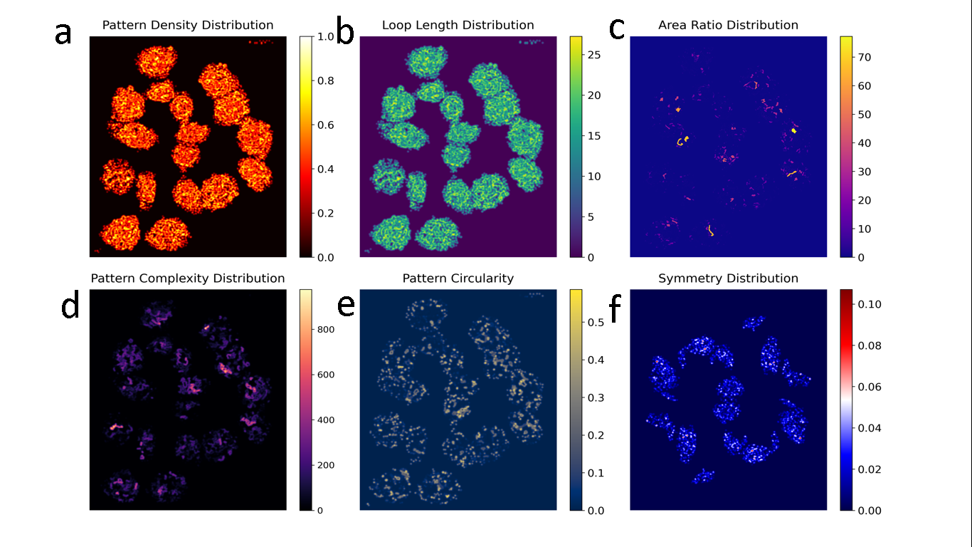

Figure 3. Chladini pattern analysis on 17 lung cancer cells: Seventeen lung cancer cells are zoomed in just before PCMS addition, followed by Chladni pattern analysis on each cell. The 50-minute duration is divided into 22 intervals, capturing 22 snapshots at equal time points. As illustrated in Figure 2, six snapshots show different Chladni patterns, with four selected here to plot variations in density (panel a), complexity (panel b), number of patterns (panel c), and average area.
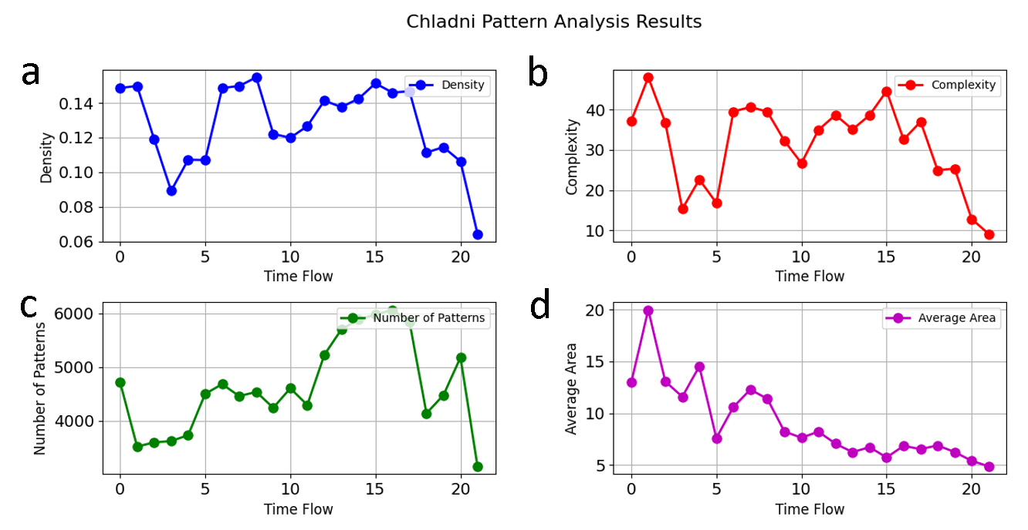

Figure 4. Segmenting and labeling self-similar objects: Seventeen lung cancer cells are zoomed in just before PCMS addition, and Chladni pattern analysis is performed on each cell. (a) The image is converted to grayscale for analysis (left). Each "compartment" represents a closed area; a total of 160 objects are detected (right). Based on compartment areas, colors are assigned, revealing an initial distribution of compartmental symmetries within the cancer cell cluster.
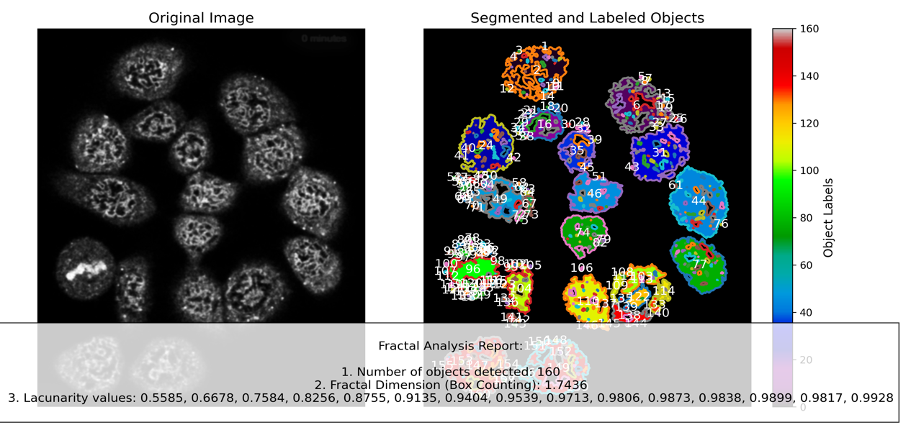

Figure 5. Temporal evolution of fractal pattern: Seventeen lung cancer cells are zoomed in just before PCMS addition, and Chladni pattern analysis is performed on each cell. (a) After PCMS is introduced, the compartmental structure of each cell changes over time. The total duration of 50 minutes is divided into 22 equal intervals, producing 22 snapshots. Upon PCMS addition, the symmetry distribution of each cell transforms. The changes in compartmental shapes and symmetry across cells are significant, with the number of compartments varying non-linearly, as shown in panel (a). (b) Fractal dimension varies as a function of time, indicating structural complexity changes. (c) Lacunarity peaks just before nuclear disintegration, displayed by ripples in the graph.
