This is the peer reviewed version of the article, which has been published in final form at https://onlinelibrary.wiley.com/doi/10.1002/macp.202100433. This article may be used for non-commercial purposes in accordance with Wiley Terms and Conditions for Use of Self-Archived Versions. This article may not be enhanced, enriched or otherwise transformed into a derivative work, without express permission from Wiley or by statutory rights under applicable legislation. Copyright notices must not be removed, obscured or modified. The article must be linked to Wiley’s version of record on Wiley Online Library and any embedding, framing or otherwise making available the article or pages thereof by third parties from platforms, services and websites other than Wiley Online Library must be prohibited.

Impact of telechelic polymer precursors on the viscoelastic properties of vitrimers

Yasuyuki Nakamura*, Mizuki Tenjimbayashi, Akinori Moriya, and Masanobu Naito

Dr. Y. Nakamura, Dr. M. Naito
Data-driven Polymer Design Group, Research and Services Division of Materials Data and Integrated System (MaDIS), National Institute for Materials Science (NIMS), 1-2-1 Sengen, Tsukuba, Ibaraki 305-0047, Japan.
E-mail: NAKAMURA.Yasuyuki@nims.go.jp

Dr. M. Tenjimbayashi
International Center for Materials Nanoarchitectonics (MANA), National Institute for Materials Science (NIMS), 1-1 Namiki, Tsukuba, Ibaraki 305-0044, Japan

A. Moriya
National Institute of Technology, Numazu College, 3600 Ooka, Numazu, Shizuoka 410-8501, Japan

Keywords: crosslinked polymer, vitrimer, controlled radical polymerization, viscoelastic property

Abstract
The viscoelastic property of vitrimers, which belong to a group of covalent bond adaptable networks, is one of the most critical properties during the applications of these materials. Herein, we report the significant effect of the network architecture of the crosslinked polymers, particularly the arrangements of crosslinks and chains, on the viscoelastic property, which is determined directly from the structure of the precursor polymers. The systematic investigation revealed that vitrimers from telechelic polymers with reactive groups at the chain ends showed a sharp elastic modulus decrease. Furthermore, these polymers demonstrated highly fluid-like behavior at elevated temperature and fast stress relaxation, compared to vitrimers from random copolymers that have similar chain length and number of crosslinking groups.

1. Introduction
Crosslinked polymer materials, represented by thermosets and elastomers, are indispensable in modern society because of their stiff, durable, rubbery, and beneficial properties. In recent years, the demand for the sustainability of polymer materials has been rapidly increasing. Therefore, the lack of re-processability and recyclability in crosslinked polymers is the critical drawback to overcome. Covalent adaptable networks (CANs) have been attracting growing interest as a promising solution for this drawback.^{[1–3]} Although CAN is a stable crosslinked polymer, it becomes malleable and recyclable at elevated temperatures due to the exchange reactions of covalent adaptable bonds inside the crosslink network. Therefore, understanding and developing the method to control the characteristic properties of CANs are essential to extend the field of these polymeric materials.
Among CANs, an associative CAN, known as vitrimer, has been extensively studied. In vitrimers, a degenerative cleavage and bond formation occur via an intermediate or a transition state.^{[4–6]} The density of the crosslinks in such a reaction does not change in principle. This feature results in the gradual change of viscosity or modulus of the material depending on the temperature.
Recently, various vitrimers with different chemical reaction types were developed, including transesterification,^{[7–9]} boronate,^{[10,11]} olefin^{[12,13]} or silyl ether metatheses,^{[14,15]} diketoneamine transamination,^{[16]} and disulfide exchange.^{[17]} The component and/or the formation of a network also has variation such as the condensation of low molecular weight molecules or the crosslinking of polymer chains.^{[11,15,18–20]} The incorporation of vitrimer chemistry into polymer materials adds functionalities and improves the properties such as the creep resistance,^{[15,21]} self-healing ability,^{[10,22]} and shape-memory effect^{[23,24]}. For example, we recently reported that incorporating disulfide bond into epoxy adhesive enhanced the strength at a high temperature and added chromophoric indicating functionality for strength.^{[25,26]}
The attractive feature of engaging the vitrimer chemistry and the crosslinked polymer is that it can compensate for the disadvantage of classical crosslinked polymers and add malleability and recyclability, thereby maintaining the substantial properties of the original polymer. To achieve the required properties as vitrimer materials, controlling the viscoelasticity and stress relaxation behavior depending on the thermal condition are fundamental. For example, rapid and large change of elasticity (or viscosity) to the temperature make recycling and reprocessing easier.
The change in the bond exchange reaction involving the type and amount of the functional group and/or the catalyst is a reasonable way to control the property. However, the disadvantage of this factor is that they affect other properties of the crosslinkedcross-linked polymer, such as chemical stability and mechanical properties.
Another essential factor is the architecture of the network, particularly the crosslink density, chain arrangement around the crosslinks, and chain length.^{[27–33]} This factor does not change the chemical components of the crosslinked polymer (structure of repeating unit and functional groups in the chain), and therefore it is expected to affect only the thermal behavior of the vitrimers. Nicolaÿ reported a high crosslink density for boronate vitrimers, which resulted in slow stress relaxation.^{[31]} Avérous reported a similar correlation for imine vitrimers, while in more detail, they showed that the effect of crosslink density on the stress relaxation diminished beyond a certain crosslink density.^{[33]} In contrast, Hayashi reported the opposite tendency, particularly a high crosslink density for epoxy vitrimers well-designed for the study that results in fast stress relaxation.^{[32]} Although we have to consider the difference in the main chain chemical structure and the functional group, further investigations should be necessary for the conclusion.
The network architecture of crosslink polymer is definitively dependent on the structure of the precursor polymers, in particular the positions of the reactive groups. Generally, readily available polymers with a different arrangement of the reactive group are limited. A common copolymer with the reactive groups at random positions in the chain (random copolymer) and a telechelic polymer with the reactive groups only at the chain ends should be the first choice as the starting material of the crosslinked polymers. Although the synthesis of vitrimers from telechelic polymers has been reported in previous studies,^{[34,35]} its effect on the viscoelasticity of the resulting vitrimer has not been clarified. Thus, clarifying the effect of telechelic or random (co)polymers as the precursor gives helpful information for the option of the precursor polymer, design, and technique to achieve vitrimers with tailor-made properties.
In this study, to focus on the difference in the arrangement of reactive group, more specifically at the chain ends or a random position, we investigated the effect of the precursor polymer structure by employing telechelic polymer and a random copolymer with similar chain length and number of reactive groups (2) to avoid the other factors affecting the network architecture. Such precursor polymers with well-defined structures are available via a controlled polymerization technique. The viscoelastic properties of the vitrimer from these precursors were significantly different at the high temperature at which the bond exchange reaction was activated. The vitrimers from telechelic polymer showed a much larger decrease in the elastic modulus, highly fluid-like behavior and faster stress relaxation than those from random copolymers.

2. Results
One of the crosslinked polymer networks, designated as TN_{n} (where n indicates the molecular weight of the precursor polymer), was prepared from telechelic polymers with reactive groups for crosslinking only at both chain ends (Figure 1), with narrow molecular weight distribution (Ð). The other crosslinked polymer network, designated as RN_{n}, was prepared from polymers with similar number average molecular weight (M_{n}) and Ð as that of the polymers used for TN; however, the two reactive groups were located at random positions in the chain (that is, random copolymer). In principle and ideally, the difference in their network architectures is represented as follows: (a) the chain length between the crosslinks is uniform in TN and not in RN; (b) the number of chains around the crosslink is more in RN than TN; (c) TN does not have dangling chains, while RN has dangling chains. Along with these differences coming from the precursor structures, the heterogeneity in the synthetic polymer should affect their property.^{[36]}
Polystyrene (PSt) networks with epoxy crosslink group were employed in this study, wherein the bond exchange occurred through transesterification in the presence of a catalyst.^{[8,9]} The precursor polymers for TN were synthesized using atom transfer radical polymerization (ATRP)^{[37–39]} of styrene and following radical coupling reaction, which was an effective method to obtain telechelic and symmetric polymers (Figure 2a).^{[40–45]} The radical coupling efficiency over 90% (Figure 2b) indicated the formation of a telechelic polymer. The quantitative deprotection of the tert-butyl group by the treatment with aqueous HCl in 1,4-dioxane was confirmed by ¹H NMR spectra by the disappearance of the signals of tert-butyl group around 1.2 ppm (Figure 2c). The synthesized CO₂H telechelic PSt had number average molecular weights (M_{n}) of 3500~8600 and narrow molecular weight distributions (Ð ≤ 1.16) (Table 1).
The precursor polymers for RN were synthesized by the random copolymerization of styrene and tert-butyl methacrylate by ATRP, followed by the chain end reduction and hydrolysis of the ester groups (Figure 2d). The molecular weights of the polymers were almost identical to the telechelic polymers (Table 1). The average number of CO₂H groups in one polymer chain, 2.0–2.2, was determined by GPC and ¹H NMR analyses (Figure S1 in supporting information, SI). Based on the reactivity ratio in the copolymerization (Figure S2 in SI), CO₂H groups were incorporated at random positions in the chain. Compared to the telechelic PSt, the copolymer could contain chains with CO₂H groups of more or less than two. However, the present study accepts the effect of this inhomogeneity on the network architecture and vitrimer properties as a part of the effect of the precursor polymer structure.
The synthesis of a crosslinked polymer using the telechelic polymer of M_{n} = 5300 was investigated with various mixture ratios of polymer, bisphenol-A diglycidyl ether (BADGE), and 1,5,7-triazabicyclo[4.4.0]dec-5-ene (TBD) as a base catalyst (Figure 1a) by following the reported method.^{[8,46,47]} The mixture was heated at 170 °C for 24 h to give a polymer network of TN₅₃₀₀. The formation of the crosslinked polymer was confirmed by swelling into CHCl₃, and the gel fraction was determined. After screening the reaction conditions, the mixture with the ratio of PSt_{Mn=5300}/BADGE/TBD = 1/1.5/0.4 (mol ratio) gave the crosslinked polymer in the highest gel fraction of 93% (Table S1 in SI). The gel fractions of TN from different molecular weight precursors were also high (89-93%). The crosslinked polymer networks RN_{n} were synthesized from the corresponding random copolymers under similar reaction conditions. The gel fractions were slightly lower (84-88%) than those of the corresponding TN_{n}, which could be attributed to the existence of the precursor polymers with a reactive group of less than two.
Under the optimized condition of synthesis, the molar ratio of the epoxide group in BADGE was 1.5 times to the carboxylic acid group in PSt. Thus, a self-reaction occurred between the BADGE epoxide and BADGE-derived hydroxyl group formed through epoxide opening to form crosslinking group in the network. Poutrel et al. reported that in carboxylic acid-epoxide vitrimer synthesis catalyzed by TBD, the reaction between the carboxylic acid and epoxide proceeded before the reaction between the hydroxyl group and epoxide in such off-stoichiometric condition.^{[46]} Based on the feeding ratio, the probable network structure of the TN and RN contained a dimeric BADGE-derived group as the crosslinking group (Figure 1a). The IR spectroscopic analysis of the synthesis of TN and RN exhibited the shift of C=O vibrational signal to higher wavenumber, corresponding to the reaction of CO₂H in PSt with epoxide in BADGE to form ester (Figures S3-4 in SI). The epoxide consumption was difficult to quantify in IR analysis due to the overlapping of the characteristic signal and the PSt signal (Figure S5 in SI). Therefore, the formation of the BADGE-derived crosslinking group was confirmed by analyzing the BADGE-derived compound in the network. The decomposition of the networks by methanolysis of ester linkage to split PSt and BADGE-derived compounds reveals that the dimeric BADGE-derived compound is the main component along with the oligomeric BADGE in a small amount, indicating the structure of the network shown in Figure 1a and 1c (R² = H) (section 4, SI).

The obtained vitrimer RN and TN were reversely molded at high temperatures. RN was molded at 220 °C, while TN was molded at either 180 or 200 °C. Figure 3a shows the molding of the TN sample and its swelling behavior in 1,2-dichlorobenzene. The swollen TN became soft and almost fluid-like upon heating at 160 °C. The sample gradually dispersed into the solvent when the temperature was further increased. Such dispersion or dissolution of vitrimer was also reported in recent studies.^{[31,33]} Breuillac et al. reported that the dissolution of the vitrimer was a change from the crosslinked polymer to a branched polymer with a loop-rich structure. We analyzed the dissolved polymer by GPC and found the polymer fraction with M_{n} ~ 80000 for TN₈₆₀₀ corresponding to approximately 9-meric structure of the original PSt on average (Figure S9 in SI). Conversely, RN did not show fluid-like behavior or dissolution into the solvent. Furthermore, the swelling ratio, crosslink density, and correlations with the chain length (molecular weight) differed in RN and TN (Figure 3b and 3c). The correlation between crosslink density and M_{n} of the precursor is reasonable because the precursor chains have two (or two on average) functional groups regardless of the chain length.
With respect to the bulk behavior of the samples, we determined that TN₈₆₀₀ adopted a fluid state and changed the shape to minimize interfacial energies; simultaneously, RN₈₅₀₀ maintained the original shape after 1600 s of heating. These dynamics were quantified by a time-lapsed contact angle measurement (Figure 4a). The contact angle of TN₈₆₀₀ was 90° at heating time t = 0 s, which subsequently increased to 104° at t = 20 s owing to the fluidic deformation and finally decreased to 66° owing to the spread-wetting (Figure 4b),^{[48]} indicating that the fluidic change of the network occurred via dynamic bond exchange. Additionally, the contact angle of RN₈₅₀₀ was consistent at approximately 90° throughout the experiment because the network did not show fluidity in the time scale although it became soft. The fluidic-like behavior of TN at high tempearute was also demonstrated by a mending experiment showing a self-healing property (Figure 5). The cut specimen of TN₅₃₀₀ was brought into contacted on a hot plate and heated, then the resulting specimen was loaded to evaluate the repair.

Next, we investigated the remarkably different rigid-to-fluid behavior of TN and RN by rheological measurements. The temperature-sweep measurements of the three RN (Figure 6a) showed almost identical temperature profiles of shear storage modulus (G’), exhibiting the peak of tanδ at approximately 110 °C. This peak corresponds to the glass transition of PSt and rubber plateau regime at over 160 °C (DSC analysis and the temperature sweep up to 230 °C are shown in Figure S10, Figure S11, and Table S2 in SI). The observation of the rubber plateau is typical of the reported thermoset-based and vinyl polymer-based vitrimers.^{[11]}
The temperature-sweep analysis of TN (Figure 6b) showed a significant dependence of storage modulus on the precursor chain length (molecular weight). The moduli of TN were almost similar at a temperature below T_{g} of PSt. In contrast, the results showed a large decrease of modulus with increased temperature for all TN, and loss tangent, tanδ, value exceeding 1 for TN₅₃₀₀ and TN₈₆₀₀ at >140 °C. These results indicate that TN is more viscous than elastomeric at high temperatures, consistent with the bulk observation shown in Figure 4. The similar results were obtained in the frequency-sweep measurement at different temperature and the preparation of a master curve (Figure S17). While RN showed rubbery character, TN showed viscous and fluidic character at low frequency region.

The viscoelastic property was further studied by the stress relaxation measurements (Figure 6c and 6d). Because the viscosity of TN decreased with increased temperature, the measurements were performed at the temperatures without a bulk deformation of the sample. The relaxation of TN was quite fast and the decay of the modulus started just after the imposition of strain. In addition, the linear correlation between the log-log plot of time and G(t) indicated a power-law behavior. Thus we estimated “the apparent relaxation time (τ)” of TN determined as the time G(t) falls to its 1/e. On the other hand, the relaxation of RN at the same temperature range with TN was too slow to estimate τ, and thus the higher temperature was applied for the measurements of RN. The relaxation curves of RN were analyzed by exponential functions. The relaxation of TN was much faster than that of RN, and the relaxation time of TN were apparently 10⁴–10⁵ times smaller than the τ of RN, even at more than 80 °C lower temperature as summarized in Table 1. The correlation of the relaxation time (τ) and chain length (M_{n}) of the precursor polymer showed the decrease of τ with the increase of M_{n} (Figure S13 in SI). The low crosslink density of the network from the long precursor chain explains this result.
The activation energies of relaxation E_{a} were calculated from the Arrhenius plot using the obtained τ values (Figure 6e and 6f; Figure S14 and S16 in SI). The plot between the M_{n} of the precursor polymer and E_{a} showed a linear correlation for both RN and TN, wherein the effect of the molecular weight (the chain length) on E_{a} was opposite (Figure 7). The activation energies of TN were also estimated by the time-temperature superposition of the relaxation curves (Figure S18), while the applicability of the superposition to vitrimer is discussed in recent papers.^{[49,50]} The plot between E_{a} and M_{n} showed the similar tendency, while there was a significant difference between the activation energies determined in different method. Although the reason is unclear, the detail relaxation mechanism might be related.

3. Discussion
The rheological measurements with temperature-sweep and stress relaxation showed significant differences between TN and RN. The most remarkable feature is the continuous decrease of modulus in TN with increasing temperature and the observation of power-law behavior, similar to non-crosslinked polymers. Snyder et al. observed the continuous decrease of modulus at elevated temperature in imine-vitrimers from gradient copolymer and speculated that the phenomenon might be due to the slipping of the chains in the low crosslink density segment.^{[51]} Our network polymers have low crosslink density, and thus a similar phenomenon may be responsible for the decrease in the modulus at high temperatures. This feature is related to that of TN, which exhibited low viscosity and even a spontaneous flow at high temperatures (Figure 4), fast stress relaxation, and low activation energy of relaxation compared to RN (Figure 7). The structural differences between TN and RN related to these results are the number of chains around the bond-exchanging group and the uniformity of the network architecture. As shown in Figure 1a, the expected number of chains around the crosslinking BADGE group is more in RN (right, and R = PSt in Figure 1b) and less in TN (left, and R = H in Figure 1b). Thus, the steric hindrance hampers the approach of the reactive group to the bond-exchanging group, resulting in a slow exchange reaction.
The difference between E_{a} of RN and TN is significant, indicating the different macromolecular behavior at high temperatures. In the Arrhenius-type analysis of the relaxation time, E_{a} and the pre-exponential factors are largely different between RN and TN. Although there is no clear explanation for the mechanism at present, the difference in the stress relaxation process might be explained by both factors. With respect to the effect of chain length on E_{a}, the high E_{a} of TN₈₆₀₀ indicates a kinetically unfavorable stress relaxation process due to the slow bond exchange reaction. The probable mechanism is proposed in Figure 8. In TN with long chains, the efficient bond (chain) exchange is hampered by the long distance between a reactive and bond exchangeable groups. However, the exchange of long chains results in the large microscopic flow of the network when the reaction occurs. The experimental results, wherein TN₈₆₀₀ has the largest E_{a} and the lowest viscosity at high temperatures, indicate that the large microscopic flow is significant in the bulk viscoelastic behavior (Figure 4). Conversely, RN from the long chains showed low E_{a}, while the viscoelastic behavior is unaffected by the chain length. Because of the highly hindered and restricted environment around the crosslinks (Figure 1a, right), the flexibility of chains related to the long chain length could be favorable for the stress relaxation. Thus, the viscoelastic behavior is defined by a combination of factors, including the network architecture, although E_{a} is the important indicator to quantify the property of vitrimers.

4. Conclusion
In conclusion, this study determined the significant effect of the network architecture, which was directly ascertained by the structure of precursor polymers, on the viscoelastic property of vitrimers of crosslinked polymers. While the chemical structure, number of the functional group of crosslinks, and chain length of the component polymer were identical, the vitrimers prepared from telechelic polymer showed remarkably different viscoelastic properties than the vitrimers prepared from random copolymers with functional groups. The sharp and large decrease of viscosity and storage modulus at elevated temperatures in TN is attributed to their macromolecular architecture involving network structure uniformity and crosslink density. The effect of chain length of precursor polymer on the viscoelastic property of vitrimers prepared from telechelic polymers is remarkable, indicating the possible tuning of the property without changing the functional group. This knowledge will facilitate advances in designing these polymer materials with tailor-made properties for various applications.
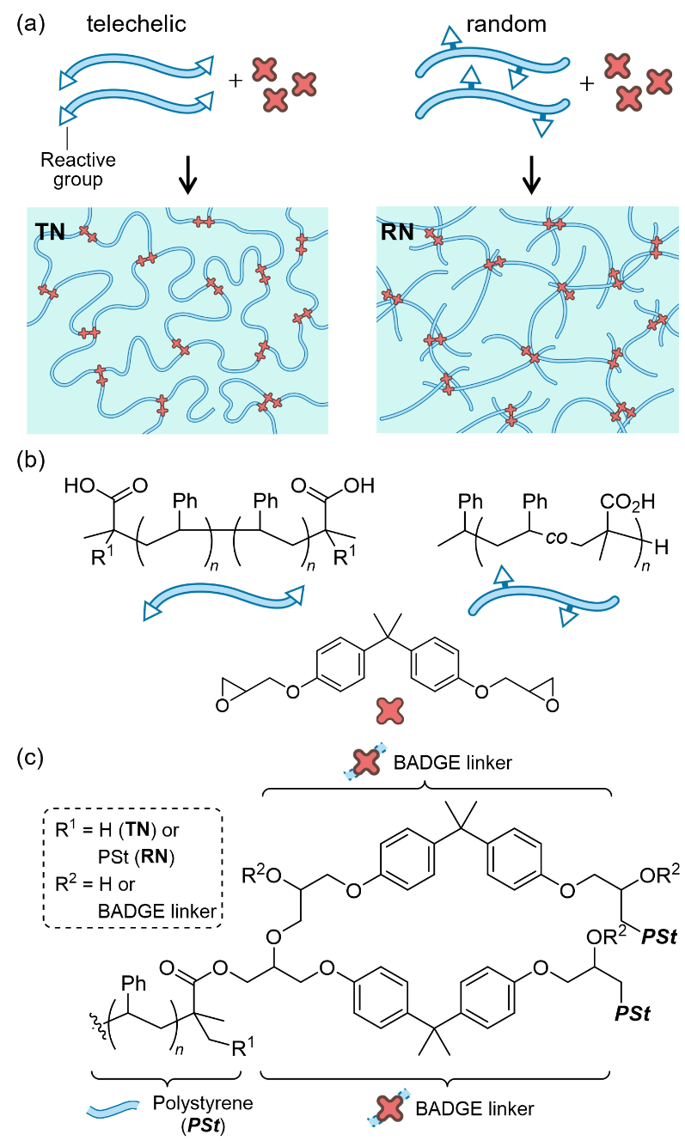
Figure 1. (a) A schematic representation of the crosslinked polymer networks prepared from a telechelic polymer (left) and a polymer with reactive groups at random position (a random copolymer, right), and (b and c) the chemical structures of the precursors and the network in this study. The expected structures from telechelic polymer/BADGE = 1/1.5 feeding ratio are drawn in (a).

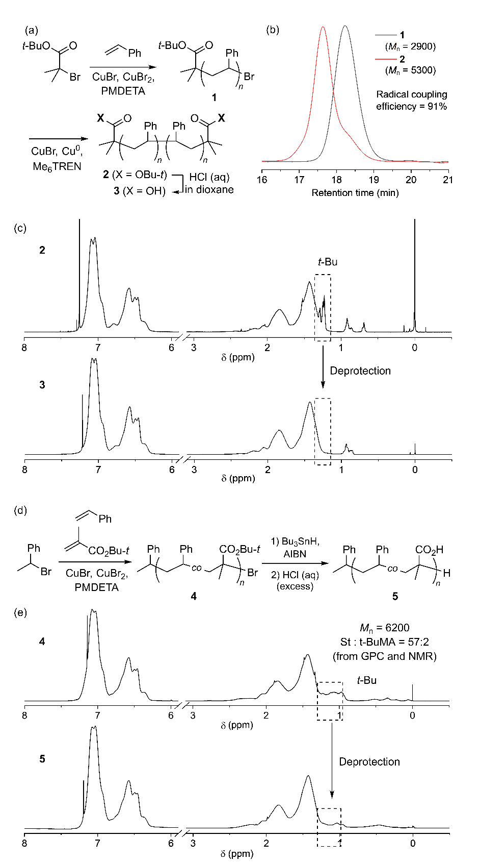
Figure 2. Synthesis and structure characterization of the precursor polymers for TN and RN. (a and d) Synthetic schemes for telechelic and random (co)polymers, respectively. (b) GPC profiles of radical coupling reaction of 1. (c and e) ¹H NMR spectra of the deprotection reaction of 2 or 4. The signal of tert-butyl group at approximately 1.2 ppm disappeared after the reaction.

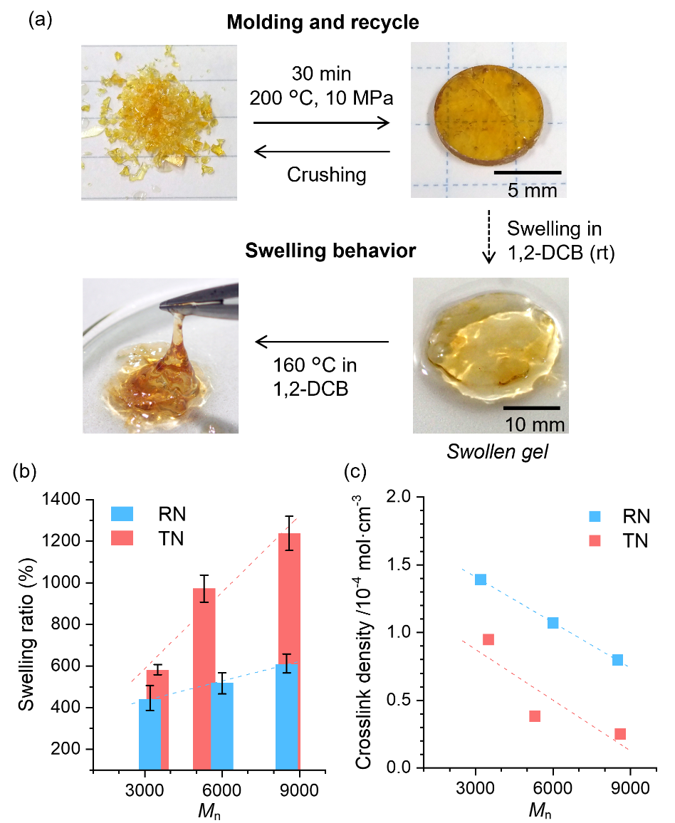
Figure 3. (a) Recyclable molding of TN₅₃₀₀ sample under heat and pressure, and the swelling behavior in 1,2-dichlorobenzene (DCB). (b and c) Correlation between the molecular weight (M_{n}) of the precursor polymer and the swelling ratio or the crosslink density.

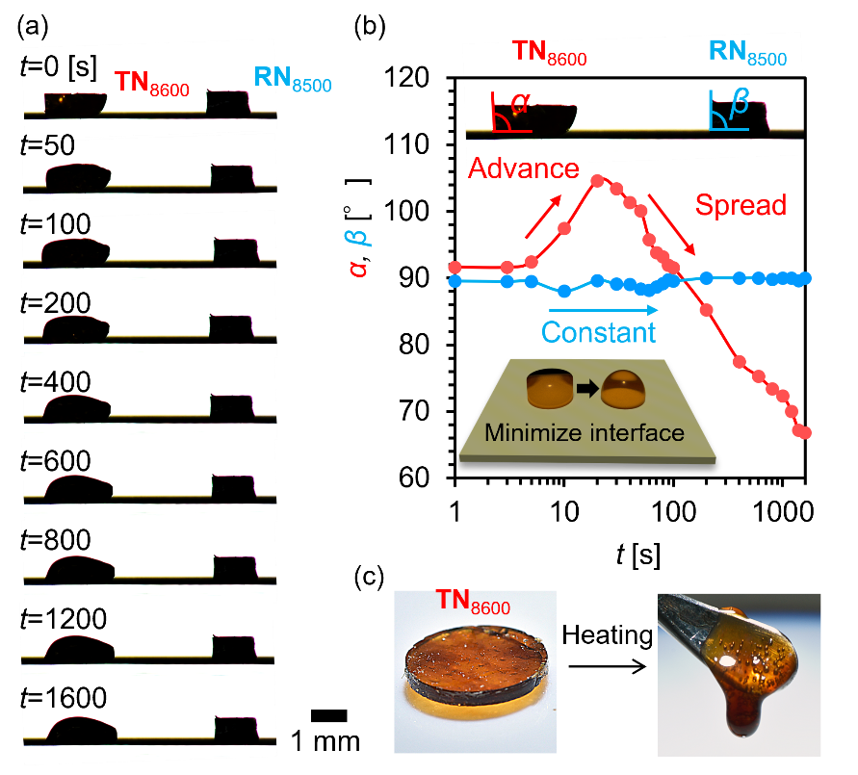
Figure 4. (a) Heat-triggered rigid-to-fluid change of networks. (a) Time-lapse images of dynamic deformations of TN₈₆₀₀ and RN_{8500.} Here, we placed the square-shaped samples of TN₈₆₀₀ and RN₈₅₀₀ on a heated substrate and observed their shape changes. (b) Their contact angle variations over time at approximately 200 °C. (c) Observation of the fluidic behavior of TN₈₆₀₀.

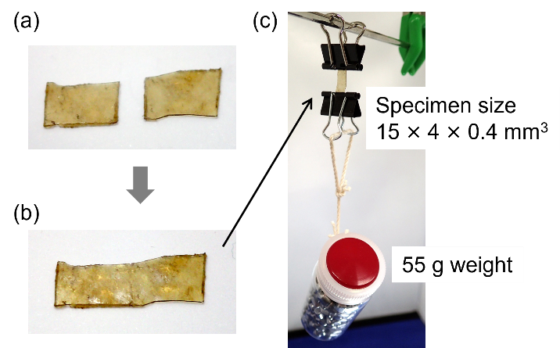
Figure 5. Photographic sequence of mending experiment. (a) cut sample, (b) mended sample after heating, and (c) a loading test for mended sample.

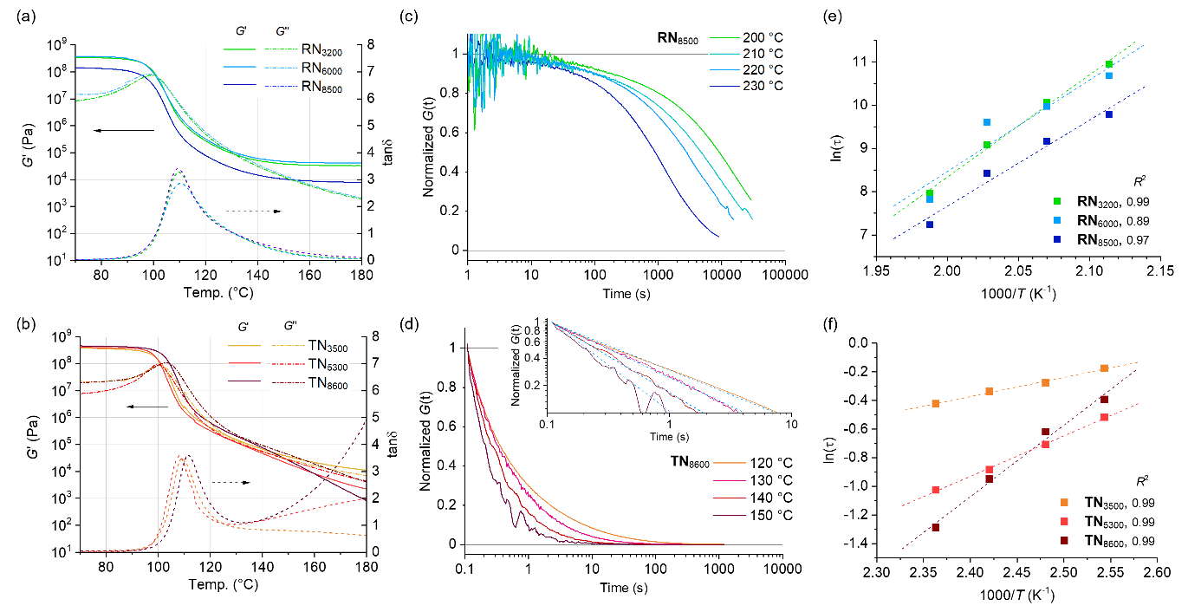
Figure 6. (a and b) Rheological analysis of the crosslinked polymer networks RN (a) and TN (b) with temperature-sweep. (c and d) Normalized stress relaxation curves at different temperatures for RN₈₅₀₀ (c) and TN₈₆₀₀ (d). For other samples, see Figure S12 and S15. (e and f) Correlation between ln(τ) versus 1000/T for RN (e) and TN (f). τ: relaxation time in sec, T: temperature in Kelvin. For estimating τ, see section 8 of SI.

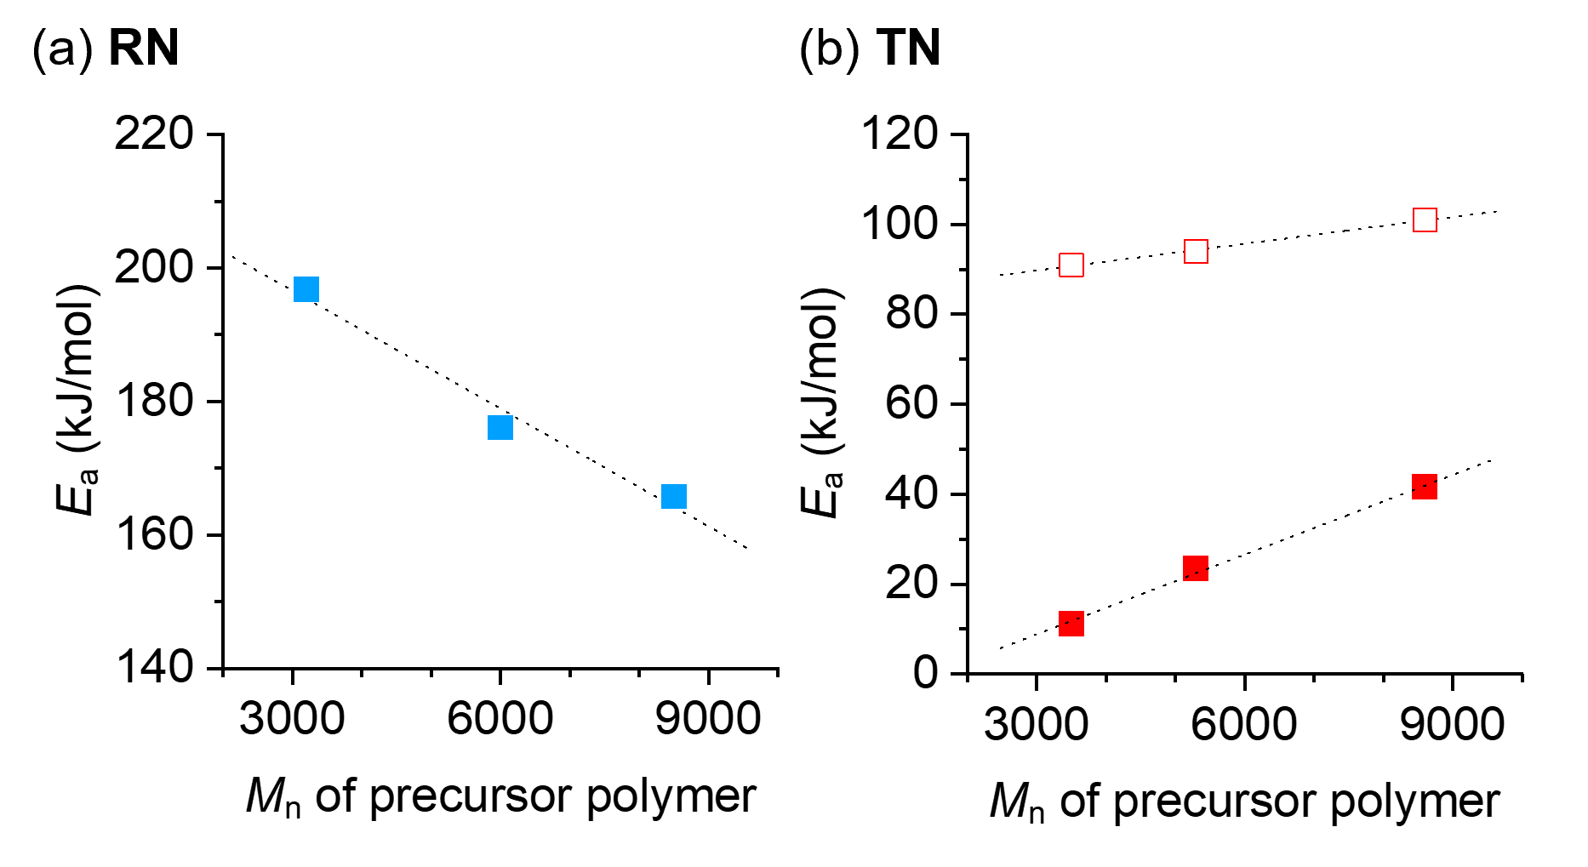
Figure 7. Correlation between the molecular weight of precursor polymer (M_{n}) and the activation energy of relaxation (E_{a}) of crosslinked polymer networks RN (a) and TN (b) determined by the relaxation time τ obtained from the time G(t) falls to its 1/e (filled square). Open squares in (b) show E_{a} estimated by time-temperature superposition of relaxation curves.

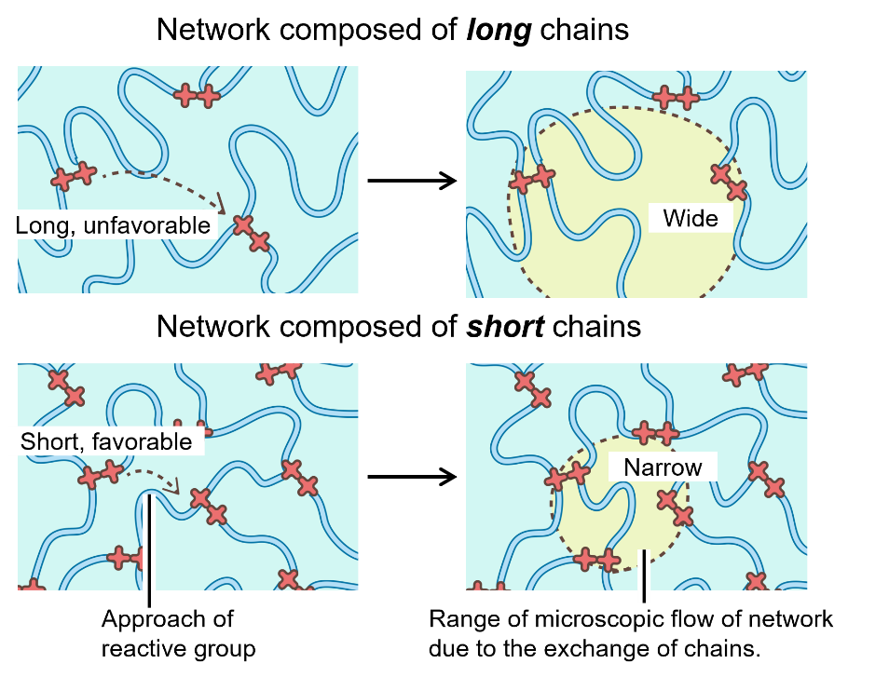
Figure 8. Illustration of the proposed mechanism of the chain length effect on the viscoelastic properties of crosslinked polymer networks via bond (chain) exchange reactions.

Table 1. Synthesis and analysis of viscoelastic properties of crosslinked polymers.
Network | Precursor  M_{n} (Ð) | Swelling  ratio (%) | Crosslink density  (10⁻⁴ mol cm⁻³) | G’ (GPa, 70 °C) | τ (sec, 120 °C) | τ (sec, 200 °C) | E_{a} (kJ/mol)
TN₃₅₀₀ | 3500 (1.13) | 582 ± 24 | 0.946 | 0.378 | 0.840 | - | 11.2
TN₅₃₀₀ | 5300 (1.16) | 972 ± 65 | 0.382 | 0.402 | 0.596 | - | 23.5
TN₈₆₀₀ | 8600 (1.12) | 1240 ± 83 | 0.249 | 0.459 | 0.674 | - | 41.6
RN₃₂₀₀ª | 3200 (1.14) | 446 ± 60 | 1.48 | 0.344 | - | 5.18×10⁴ | 193
RN₆₀₀₀ ª | 6000 (1.10) | 517 ± 51 | 1.13 | 0.372 | - | 4.36×10⁴ | 172
RN₈₅₀₀ ª | 8500 (1.17) | 613 ± 46 | 0.837 | 0.143 | - | 1.78×10⁴ | 166
^{a)} Average numbers of CO₂H in one chain were 2.1, 2.0, and 2.2 in RN₃₂₀₀, RN₆₀₀₀, and RN₈₅₀₀, respectively, as determined by ¹H NMR analysis (Figure S1 in SI).

Supporting Information
Supporting Information is available from the Wiley Online Library or from the author.

Acknowledgements
The authors thank Dr. Keitaro Sodeyama and Dr. Masato Sumita for helpful discussions.

Received: ((will be filled in by the editorial staff))
Revised: ((will be filled in by the editorial staff))
Published online: ((will be filled in by the editorial staff))

References
[1] W. Zou, J. Dong, Y. Luo, Q. Zhao, T. Xie, Adv. Mater. 2017, 29, 1606100.
[2] P. Chakma, D. Konkolewicz, Angew. Chem. Int. Ed. 2019, 58, 9682–9695.
[3] J. M. Garcia, M. L. Robertson, Science 2017, 358, 870–872.
[4] G. M. Scheutz, J. J. Lessard, M. B. Sims, B. S. Sumerlin, J. Am. Chem. Soc. 2019, 141, 16181–16196.
[5] W. Denissen, J. M. Winne, F. E. Du Prez, Chem. Sci. 2016, 7, 30–38.
[6] M. Guerre, C. Taplan, J. M. Winne, F. E. Du Prez, Chem. Sci. 2020, 11, 4855–4870.
[7] D. Montarnal, M. Capelot, F. Tournilhac, L. Leibler, Science 2011, 334, 965–968.
[8] M. Capelot, M. M. Unterlass, F. Tournilhac, L. Leibler, ACS Macro Lett. 2012, 1, 789–792.
[9] J. P. Brutman, P. A. Delgado, M. A. Hillmyer, ACS Macro Lett. 2014, 3, 607–610.
[10] O. R. Cromwell, J. Chung, Z. Guan, J. Am. Chem. Soc. 2015, 137, 6492–6495.
[11] M. Röttger, T. Domenech, R. van der Weegen, A. Breuillac, R. Nicolaÿ, L. Leibler, Science 2017, 356, 62–65.
[12] Y.-X. Lu, F. Tournilhac, L. Leibler, Z. Guan, J. Am. Chem. Soc. 2012, 134, 8424–8427.
[13] Y.-X. Lu, Z. Guan, J. Am. Chem. Soc. 2012, 134, 14226–14231.
[14] Y. Nishimura, J. Chung, H. Muradyan, Z. Guan, J. Am. Chem. Soc. 2017, 139, 14881–14884.
[15] C. A. Tretbar, J. A. Neal, Z. Guan, J. Am. Chem. Soc. 2019, 141, 16595–16599.
[16] P. R. Christensen, A. M. Scheuermann, K. E. Loeffler, B. A. Helms, Nat. Chem. 2019, 11, 442–448.
[17] J. Canadell, H. Goossens, B. Klumperman, Macromolecules 2011, 44, 2536–2541.
[18] T. Stukenbroeker, W. Wang, J. M. Winne, F. E. Du Prez, R. Nicolaÿ, L. Leibler, Polym. Chem. 2017, 8, 6590–6593.
[19] J. J. Lessard, L. F. Garcia, C. P. Easterling, M. B. Sims, K. C. Bentz, S. Arencibia, D. A. Savin, B. S. Sumerlin, Macromolecules 2019, 52, 2105–2111.
[20] F. Caffy, R. Nicolaÿ, Polym. Chem. 2019, 10, 3107–3115.
[21] J. J. Lessard, G. M. Scheutz, S. H. Sung, K. A. Lantz, T. H. Epps, B. S. Sumerlin, J. Am. Chem. Soc. 2020, 142, 283–289.
[22] W. Niu, X. Cao, Y. Wang, B. Yao, Y. Zhao, J. Cheng, S. Wu, S. Zhang, X. He, Adv. Funct. Mater. 2021, 31, 2009017.
[23] G. Zhao, Y. Zhou, J. Wang, Z. Wu, H. Wang, H. Chen, Adv. Mater. 2019, 31, 1900363.
[24] W. Miao, W. Zou, B. Jin, C. Ni, N. Zheng, Q. Zhao, T. Xie, Nat. Commun. 2020, 11, 4257.
[25] H.-Y. Tsai, Y. Nakamura, T. Fujita, M. Naito, Mater. Adv. 2020, 1, 3182–3188.
[26] H.-Y. Tsai, Y. Nakamura, W.-H. Hu, T. Fujita, M. Naito, Mater. Adv. 2021, 2, 5047–5051.
[27] K. Yu, P. Taynton, W. Zhang, M. L. Dunn, H. J. Qi, RSC Adv 2014, 4, 48682–48690.
[28] D. J. Fortman, J. P. Brutman, G. X. De Hoe, R. L. Snyder, W. R. Dichtel, M. A. Hillmyer, ACS Sustain. Chem. Eng. 2018, 6, 11145–11159.
[29] M. Hayashi, R. Yano, A. Takasu, Polym. Chem. 2019, 10, 2047–2056.
[30] J. P. Brutman, D. J. Fortman, G. X. De Hoe, W. R. Dichtel, M. A. Hillmyer, J. Phys. Chem. B 2019, 123, 1432–1441.
[31] A. Breuillac, A. Kassalias, R. Nicolaÿ, Macromolecules 2019, 52, 7102–7113.
[32] M. Hayashi, R. Yano, Macromolecules 2020, 53, 182–189.
[33] R. Hajj, A. Duval, S. Dhers, L. Avérous, Macromolecules 2020, 53, 3796–3805.
[34] M. Guerre, C. Taplan, R. Nicolaÿ, J. M. Winne, F. E. Du Prez, J. Am. Chem. Soc. 2018, 140, 13272–13284.
[35] Y. Spiesschaert, C. Taplan, L. Stricker, M. Guerre, J. M. Winne, F. E. Du Prez, Polym. Chem. 2020, 11, 5377–5385.
[36] P. Hiemenz C., T. Lodge P., Polymer Chemistry, Second Edition, CRC Press, Boca Raton, 2007.
[37] K. Matyjaszewski, T. P. Davis, Handbook of Radical Polymerization, Wiley-Interscience, New York, 2002.
[38] K. Matyjaszewski, M. Möller, Chain Polymerization of Vinyl Monomers, Elsevier BV, Amsterdam, 2012.
[39] C. Boyer, N. A. Corrigan, K. Jung, D. Nguyen, T.-K. Nguyen, N. N. M. Adnan, S. Oliver, S. Shanmugam, J. Yeow, Chem. Rev. 2016, 116, 1803–1949.
[40] T. Sarbu, K.-Y. Lin, J. Ell, D. J. Siegwart, J. Spanswick, K. Matyjaszewski, Macromolecules 2004, 37, 3120–3127.
[41] C.-F. Huang, Y.-A. Hsieh, S.-C. Hsu, K. Matyjaszewski, Polymer 2014, 55, 6051–6057.
[42] C.-F. Huang, J. Aimi, K.-Y. Lai, Macromol. Rapid Commun. 2017, 38, 1600607.
[43] A. Debuigne, M. Hurtgen, C. Detrembleur, C. Jérôme, C. Barner-Kowollik, T. Junkers, Prog Polym Sci 2012, 37, 1004–1030.
[44] Y. Nakamura, T. Arima, S. Tomita, S. Yamago, J. Am. Chem. Soc. 2012, 134, 5536–5539.
[45] Y. Nakamura, T. Arima, S. Yamago, Macromolecules 2014, 47, 582–588.
[46] Q.-A. Poutrel, J. J. Blaker, C. Soutis, F. Tournilhac, M. Gresil, Polym. Chem. 2020, 11, 5327–5338.
[47] There are discussions about the state of TBD after the heating, however, the control experiment without the catalyst did not show reprocessability indicating the role and the activity of TBD.
[48] D. Quéré, Annu. Rev. Mater. Res. 2008, 38, 71–99.
[49] R. G. Ricarte, F. Tournilhac, M. Cloître, L. Leibler, Macromolecules 2020, 53, 1852–1866.
[50] R. G. Ricarte, S. Shanbhag, Macromolecules 2021, 54, 3304–3320.
[51] R. L. Snyder, C. A. L. Lidston, G. X. De Hoe, M. J. S. Parvulescu, M. A. Hillmyer, G. W. Coates, Polym. Chem. 2020, 11, 5346–5355.

The selection of the precursor polymer structures, telechelic polymer or random copolymer, greatly affects the viscoelastic properties of vitrimers. Vitrimers from telechelic polymers exhibited a sharp decrease in elastic modulus and highly fluid-like behavior, which are largely different from vitrimers prepared from random copolymers that even have similar chain length and number of crosslinking groups.

Y. Nakamura*, M. Tenjimbayashi, A. Moriya, M. Naito

Impact of telechelic polymer precursors on the viscoelastic properties of vitrimers

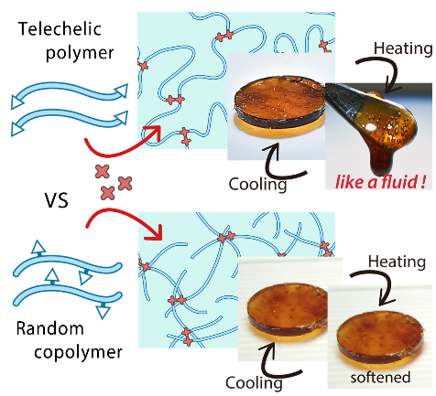

Supporting Information

The impact of using telechelic polymers as the precursor on the viscoelastic properties of vitrimers

Yasuyuki Nakamura*, Mizuki Tenjimbayashi, Akinori Moriya, and Masanobu Naito

Table of contents

- General information
- Synthetic procedures
- Swelling experiment and crosslink density
- IR analysis of the network
- Study of the network structure by the cleavage of crosslinks
- Dissolusion of crosslinked polymers
- DSC analysis of the network
- Rheological measurements

- General information

Materials. Unless otherwise noted, chemicals obtained from commercial suppliers were used as received. Styrene and tert-butyl methacrylate were passed through activated alumina short column before use. 1,4-Dioxane was dried over a molecular sieve 4A. CuBr was purified by washing with glacial acetic acid, followed by 2-propanol, and then dried under vacuum. Azobisisobutyronitrile (AIBN) was recrystallized from methanol.

Instrumental analyses. ¹H (400 MHz) NMR spectra were measured with JEOL ECS-400 for a CDCl₃ solution of sample and are reported in ppm (δ) from internal Me₄Si. Gel permeation chromatography (GPC) was performed with Viscotek TDA 302 equipped with polystyrene mixed gel columns at 40 °C using RI and viscosity detectors, and THF or DMF as eluents. The GPC was calibrated with PSt standards. IR spectra were recorded on JASCO FT/IR-6100 with ATR attachment. Differential scanning calorimetry (DSC) was measured on Shimadzu DSC-60Plus under nitrogen atmosphere. The sample was heated at 250 °C for 10 min to erase thermal history, then cooled down, and the temperature cycle was applied at a rate of 10 °C/min. Rheological measurements were carried out on Anton Paar MCR 302 rheometer equipped with 8 mm parallel plate geometry.

Contact angle measurement
The contact angle was measured by tangent method one of the image analyses obtained from the time-lapsed side view images of our vitrimers on heated substrate.¹

¹ K. Liu, M. Vuckovac, M. Latikka, T. Huhtamäki, R. H. A. Ras, Science 2019, 363, 1147–1148.

Mending experiment
The specimen of TN₅₃₀₀ with the size of 15 × 4 × 0.4 mm³ was cut into two pieces. The pieces were brought into contacted on a stainless plate on a hot plate, and heated for 5 min at 160 °C. After heating, the mended specimen was fixed by binders, and a load of 55 g was applied. A higher temperature for repairing resulted in the deformation of the specimen because of the fluidic character of TN₅₃₀₀.

- Synthetic procedures

Synthesis of polystyrene (PSt) with chain end tert-butyl ester group.
Styrene was bubbled with nitrogen gas prior to use. A solution of styrene (65 mL, 0.56 mol), tert-butyl 2-bromoisobutyrate (0.76 mL, 4.1 mmol), CuBr (0.58 g, 4.1 mmol), CuBr₂ (45 mg, 0.20 mmol), and N,N,N',N'',N''-pentamethyldiethylenetriamine (PMDETA, 0.85 mL, 4.1 mmol) was heated at 70 °C for 160 min under a nitrogen atmosphere. An aliquot of the reaction mixture was taken, and the copper was removed by passing through alumina. The conversion of the monomer (21%) was determined by ¹H NMR spectroscopy, and M_{n} (2900) and Ð (M_{w}/M_{n}, 1.10) of the resulting PSt were determined by using GPC. The reaction mixture was passed through alumina to remove the copper, and washed with ethyl acetate and aqueous NH₄Cl, and water. The organic phase was dried over MgSO₄, and the solvent and remaining styrene monomer were removed under reduced pressure. The obtained PSt (11.5 g) was directly used in the next procedure.

Reductive radical coupling reaction of PSt.
A solution of Br-terminated PSt (11.5 g, synthesized in the above procedure, ca. 4.1 mmol), CuBr (0.58 g, 4.1 mmol), Cu(0) (1.3 g, 0.02 mol), tris(2-dimethylaminoethyl)amine (Me₆-TREN) (2.2 g, 8.1 mmol) and toluene (100 mL, deoxygenated by a nitrogen bubbling) was heated at 70 °C for 6 h under nitrogen atmosphere. An aliquot of the reaction mixture was taken and the copper was removed by passing through alumina. M_{n} (5000) and Ð (1.17) of the resulting PSt was determined by using GPC. The radical coupling efficiency (91%) was estimated by the peak resolution method. The reaction mixture was passed through alumina to remove the copper. The solvent and remaining styrene monomer were removed under reduced pressure. The obtained PSt was directly used in the next procedure.

Synthesis of CO₂H telechelic PSt.
A solution of telechelic PSt (11 g, synthesized in the above procedure) and 1,4-dioxane (120 mL) was added aqueous conc. HCl (2 mol/L, 70 mL). The resulting mixture was heated at 80 °C and stirred for 14 h. An aliquot of the reaction mixture was taken, and the disappearance of the signal of tert-butyl group on the chain ends was confirmed in ¹H NMR analysis. The resulting mixture was cooled down, added ethyl acetate, and washed with water for four times. The combined ethyl acetate phase was further washed with aqueous NaHCO₃ solution and water. The organic phase was dried over MgSO₄, and the solvent was removed under reduced pressure to afford CO₂H telechelic PSt (10.7 g). M_{n} (5300) and Ð (1.16) were determined by using GPC.

Synthesis of Poly(styrene-co-tert-butylmethacrylate).
Styrene and tert-butyl methacrylate were bubbled with nitrogen gas prior to use. A solution of styrene (12 mL, 0.10 mol), tert-butyl methacrylate (0.58 mL, 3.6 mmol), (1-bromoethyl)benzene (0.10 mL, 0.73 mmol), CuBr (0.10 g, 0.73 mmol), CuBr₂ (8.1 mg, 0.036 mmol), and PMDETA (0.15 mL, 0.73 mmol) was heated at 80 °C for 120 min under a nitrogen atmosphere. An aliquot of the reaction mixture was taken, and the copper was removed by passing through alumina. The conversion of the styrene monomer (36%) was determined by ¹H NMR spectroscopy, and M_{n} (6200) and Ð (M_{w}/M_{n}, 1.09) of the resulting copolymer was determined by using GPC. The reaction mixture was passed through alumina to remove the copper, and washed with ethyl acetate and aqueous NH₄Cl, and water. The organic phase was dried over MgSO₄, and the solvent and remaining styrene monomer were removed under reduced pressure. The obtained copolymer (3.5 g) was directly used in the next procedure.

Hydrolysis of poly(styrene-co-tert-butylmethacrylate).
A solution of Br-terminated poly(styrene-co-tert-butylmethacrylate) (3.1 g, 0.58 mmol), AIBN (9.5 mg, 0.058 mmol), Bu₃SnH (0.17 mL, 0.64 mmol) and toluene (20 mL, deoxygenated by a nitrogen bubbling) was heated at 75 °C under a nitrogen atmosphere for 16 h. The resulting solution was slowly poured into a vigorously stirred methanol. The precipitated polymer was collected by a suction filtration and dried under reduced pressure. The obtained end-reduced copolymer was dissolved in 1,4-dioxane (30 mL). The solution was added aqueous conc. HCl (2 mol/L, 16 mL). The resulting mixture was heated at 80 °C for 14 h. An aliquot of the reaction mixture was taken, and the disappearance of the signal of tert-butyl group on the chain ends was confirmed in ¹H NMR analysis. The resulting mixture was added ethyl acetate, and washed with water for four times. The combined ethyl acetate phase was further washed with aqueous NaHCO₃ solution and water. The organic phase was dried over MgSO₄, and the solvent was removed under reduced pressure to afford poly(styrene-co-methacrylic acid) (3.0 g). M_{n} (6000) and Ð (1.10) were determined by using GPC.

Determination of average number of CO₂H group in poly(styrene-co-methacrylic acid)
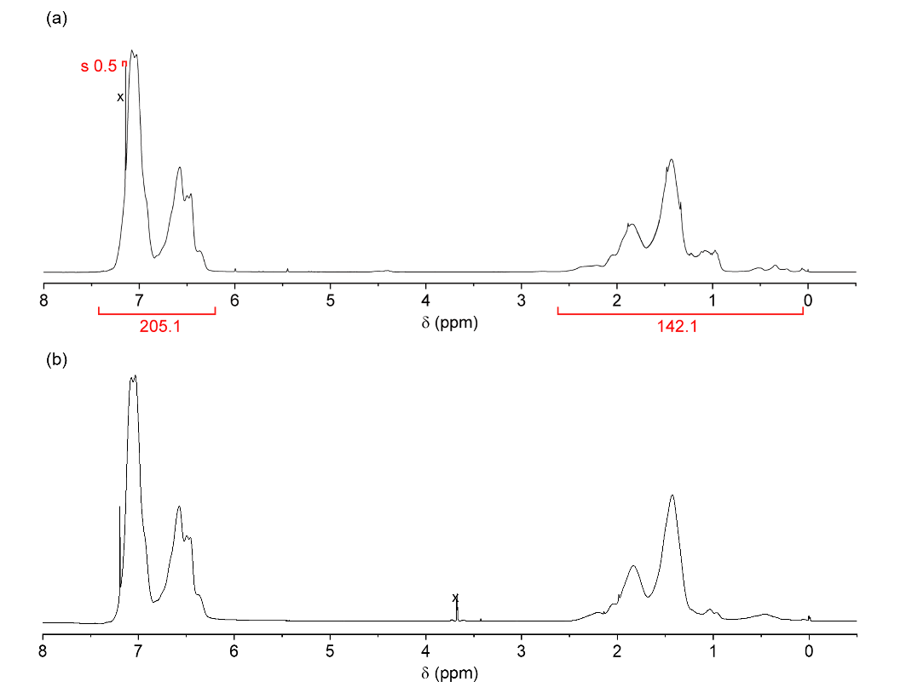
Figure S1. ¹H NMR spectra of (a) poly(styrene-co-tert-butyl methacrylate) after the polymerization and (b) poly(styrene-co-methacrylic acid) after the chain end reduction and hydrolysis. In the spectrum (a), the number of tert-butyl methacrylate unit in an obtained polymer chain was calculated from the area of signals in aromatic region (5H, styrene unit) and aliphatic region (3H, styrene-derived unit, and 14H, tert-butyl methacrylate-derived unit). The influence of the solvent signals was removed before the calculation. The determined composition ratio was styrene/tert-butyl methacrylate = 96.6/3.6. Number of total monomer unit in a chain was estimated to be 59 from the determined M_{n}, and thus the number of tert-butyl methacrylate unit in a chain was 2.01. The number of tert-butyl methacrylate unit in the copolymer is identical to the number of CO₂H group in poly(styrene-co-methacrylic acid) after hydrolysis.

Kinetics of the copolymerization of styrene and tert-butyl methacrylate.
A solution of styrene (12 mL, 0.10 mol), tert-butyl methacrylate (0.58 mL, 3.6 mmol), (1-bromoethyl)benzene (0.10 mL, 0.73 mmol), CuBr (0.10 g, 0.73 mmol), CuBr₂ (8.1 mg, 0.036 mmol), and PMDETA (0.15 mL, 0.73 mmol) was heated at 80 °C for 120 min under a nitrogen atmosphere. An aliquot of the reaction mixture was taken, and the copper was removed by passing through alumina. The conversions of both monomers were determined by ¹H NMR spectroscopy. The observed comparable rate of the conversion of both monomers indicated the random sequence of the monomer unit in the synthesis of poly(styrene-co-tert-butyl methacrylate).
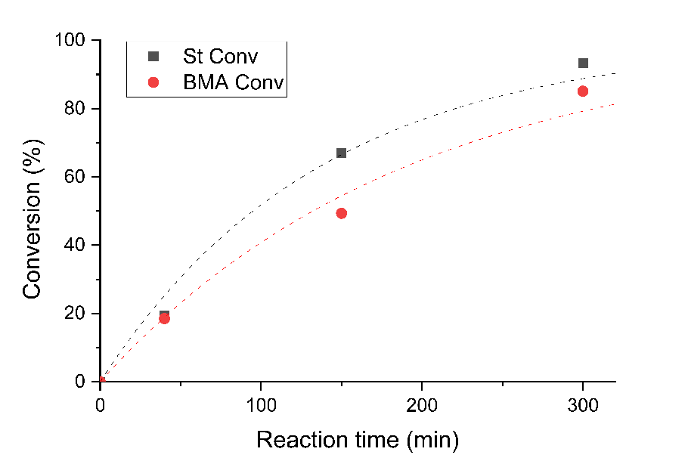
Figure S2. Kinetic plot of the copolymerization of styrene and tert-butyl methacrylate. The similar rate of the increase of monomer conversion for each monomer indicate the random (statistical) composition of resulting polymer based on the monomer feeding ratio.

Synthesis of crosslinked polymers.
A solution of CO₂H telechelic PSt (Mn = 5300, 700 mg, 0.13 mmol), bisphenol A diglycidyl ether (BADGE, 64 mg, 0.19 mmol) in 1,4-dioxane was added a solution of 1,5,7-triazabicyclo[4.4.0]dec-5-ene (TBD, 6.9 mg, 0.050 mmol) in dichloromethane. The resulting solution was poured on PTFE dish, and heated at 100 °C for 10 h, and was further heated at 170 °C for 24 h in an oven. The resulting crosslinked polymer was collected, and a portion (50 mg) was soaked in chloroform. The mixture was slowly stirred for 24 h. The resulting gel (solid fraction) was filtered by suction filtration, and the solvent of the filtrate was removed under reduced pressure. From the weight of the residue (3.7 mg) and the weight of the soaked crosslinked polymer, the yield of the crosslinked polymer (gel fraction) was determined to be 93% (TN₅₃₀₀).
Other crosslinked polymers from different molecular weights and polymer structures were prepared in the same manner, and the determined yields of crosslinked polymers were 91 and 89% for TN₃₅₀₀ and TN₈₆₀₀, and 88, 84, 84% for RN₃₂₀₀, RN₆₀₀₀ and RN₈₅₀₀, respectively.

Table S1. Synthesis of crosslinked polymer from telechelic polymers (T) and random copolymers (R) as the precursor.
Run | Precursor (1 eq.) | BADGE (equiv) | TBD (equiv) | Yield (%)
 | M_{n} (Ð)
1 | T, 5300 (1.16) | 1 | 0.2 | <10
2 |  | 1.5 | 0.1 | 49
3 |  | 1.5 | 0.2 | 91
4 |  | 1.5 | 0.4 | 93
5 |  | 1.5 | 0.8 | 80
6 |  | 3 | 0.2 | 88
7 |  | 8 | 0.2 | 49
8 | T, 3500 (1.13) | 1.5 | 0.4 | 91
9 | T, 8600 (1.12) | 1.5 | 0.4 | 89
10 | R, 3200 (1.14) | 1.5 | 0.4 | 88
11 | R, 6000 (1.10) | 1.5 | 0.4 | 84
12 | R, 8500 (1.17) | 1.5 | 0.4 | 84

- ATR-IR analysis of polymer networks
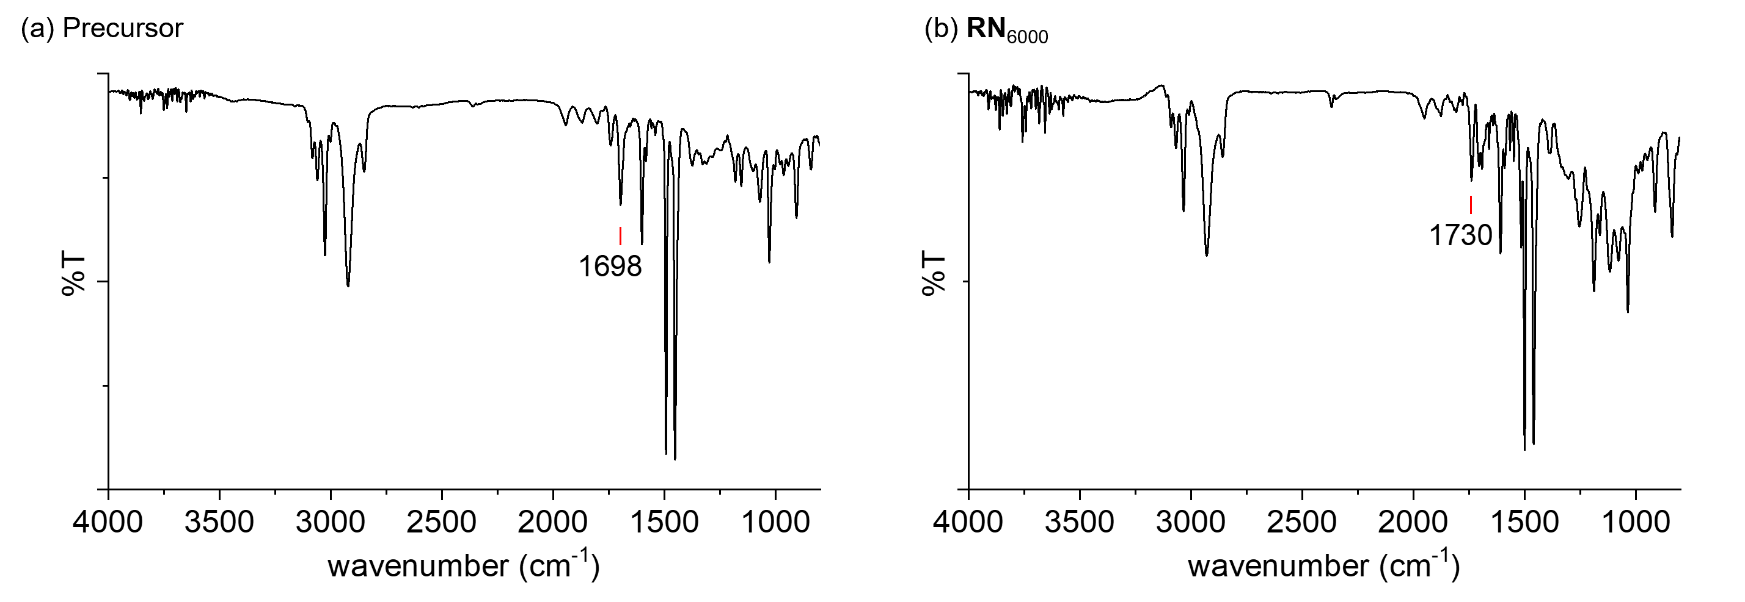
Figure S3. IR spectra of the precursor polymer poly(St-co-methacrylic acid) (a) and resulting crosslinked polymer RN₆₀₀₀. After the network formation, C=O vibration signal of carbonyl group shifted higher wavenumber.

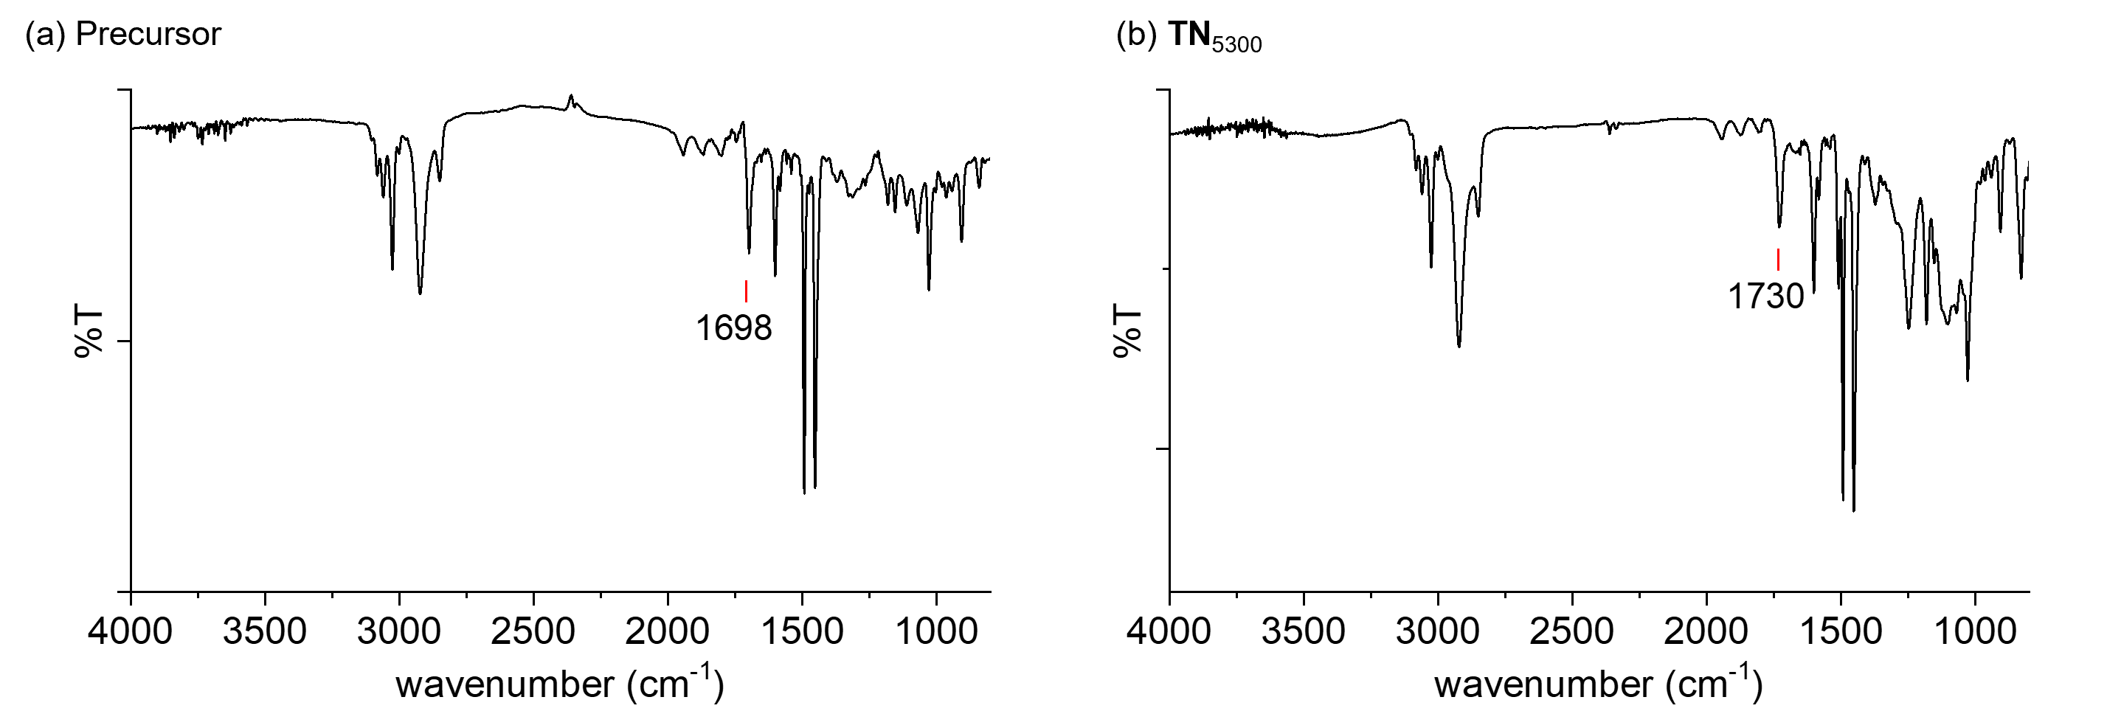
Figure S4. IR spectra of the precursor polymer CO₂H telechelic PSt (a), resulting crosslinked polymer TN₅₃₀₀ (b)

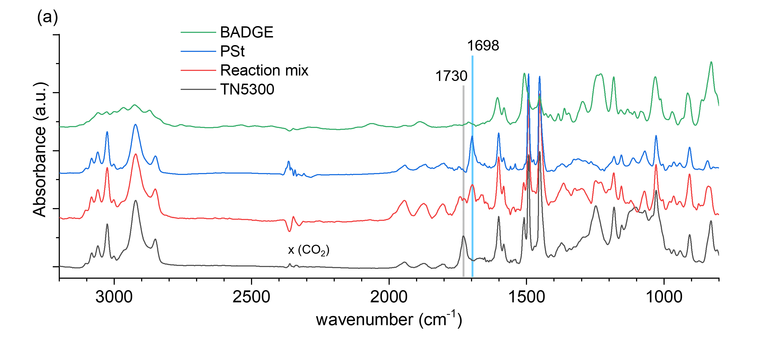
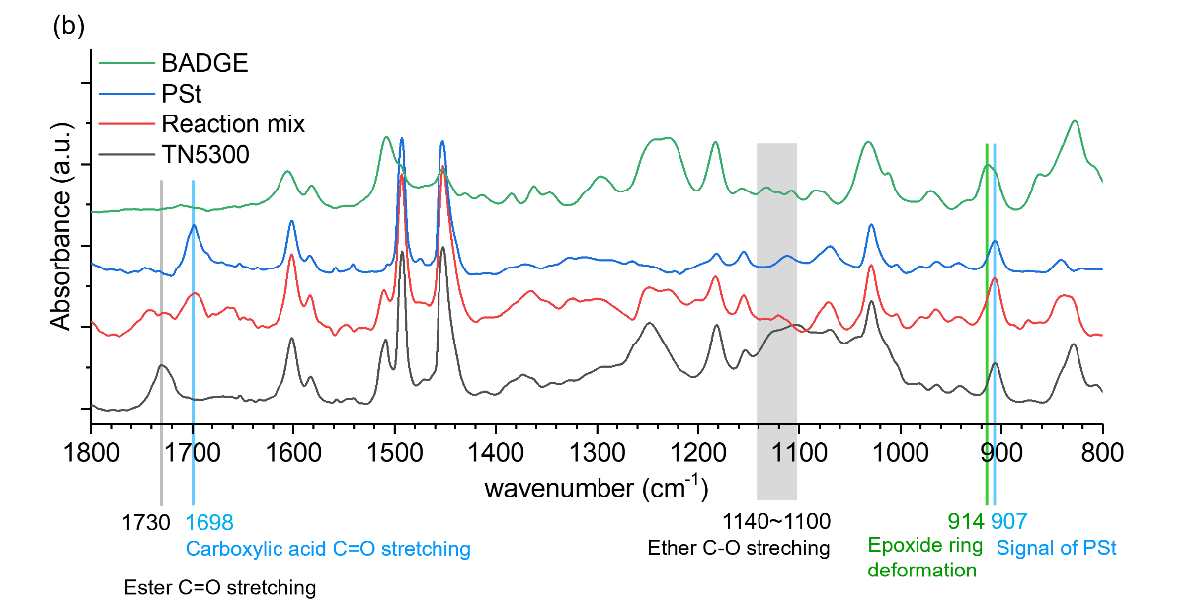
Figure S5. Comparison of the IR spectra of BADGE, precursor polymer, and the sample before (i.e. the reaction mixture) and after crosslinking in the preparation of TN₅₃₀₀ (the experiment batch is different from that in Figure S4). (a) 800-3200 cm⁻¹ and (b) 800-1800 cm⁻¹ range. The signal of C=O stretching of carboxylic acid group at 1698 cm⁻¹ in the reaction mixture was disappered and C=O stretching of ester group at 1730 cm⁻¹ was observed in TN5300. The signal of epoxide ring deformation at 914 cm⁻¹ overlapped to a signal of polystyrene at 907 cm⁻¹.

- Study of the network structure by the cleavage of crosslinks
Scheme S1. Cleavage of crosslinked network TN by methanolysis. The reaction of RN is the same manner.

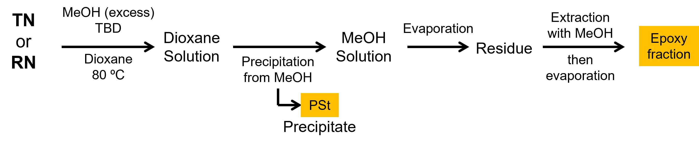
Scheme S2. Experimental procedure of the separation of polystyrene and epoxy fraction from the decomposition reaction mixture. To avoid a loss of any compounds, separated PSt and the epoxy fraction was analyzed without further purification.

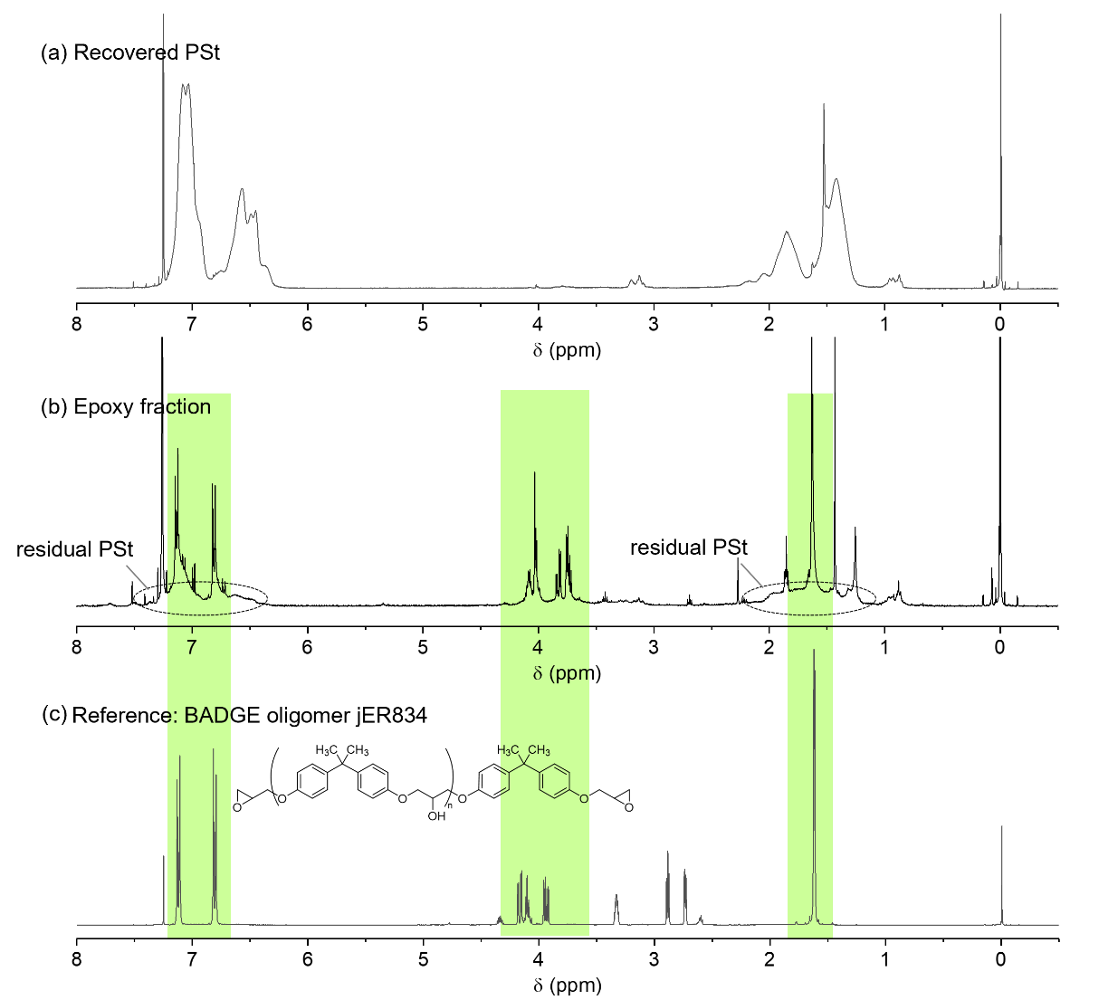
Figure S6. ¹H NMR spectra of recovered polystyrene (a), the epoxy fraction (b) and a commercial BADGE oligomer (c, jER834 from Mitsubishi Chemical, epoxy equivalent =230~270) as a reference. In the spectrum of the epoxy fraction, the presence of signals corresponding to BADGE oligomeric structure and the absence of epoxide signals (2.7-3.3 ppm in the spectrum of jER834) were confirmed. In addition, the epoxy fraction was found to still include little PSt after repeated separation of PSt using MeOH.

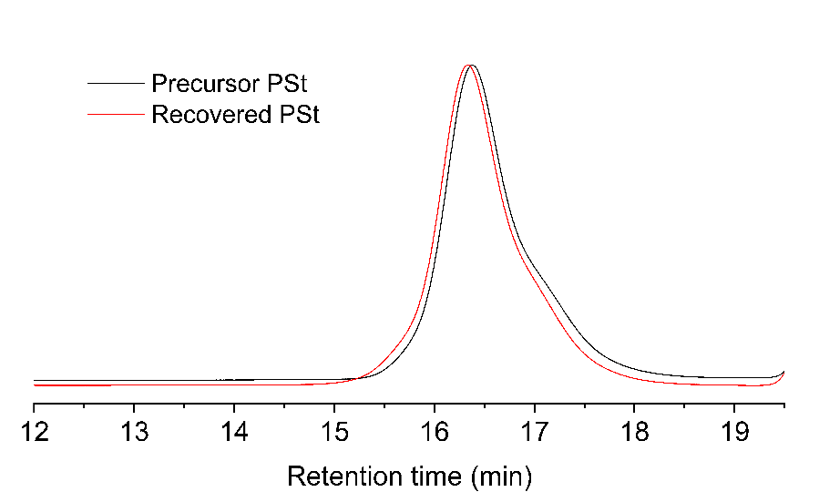
Figure S7. GPC analysis of the recovered polystyrene fraction. Essentially identical polystyrene was recovered through the cleavage of the network. A little difference of the retention time should be due to the functional group of chain ends (CO₂H for the precursor, and CO₂Me for the recovered PSt).

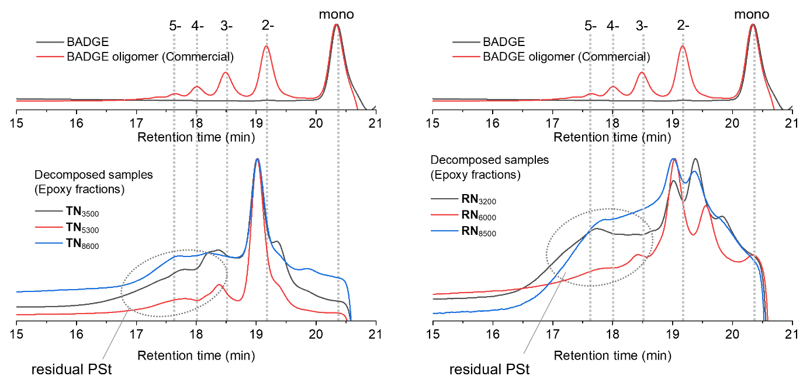
Figure S8. GPC analysis of the recovered epoxy fraction (bottom), and BADGE and a commercial BADGE oligomer (jER834) (top). Even after the fractionation of polystyrene, a signal of residual polystyrene overlapped. In the analysis of the epoxy fractions from TN, dimeric compound was observed as the main component, along with higher oligomers in a small amount. In the analysis of those from RN, the dimeric compound was the main component, and a signal at the longer retention time besides the signal identical to that in TN was observed. Although the identification of the signal is unclear, these results might reflect the difference of the network structures in TN and RN depending on the precursor polymer structures.

- Dissolusion of crosslinked polymers
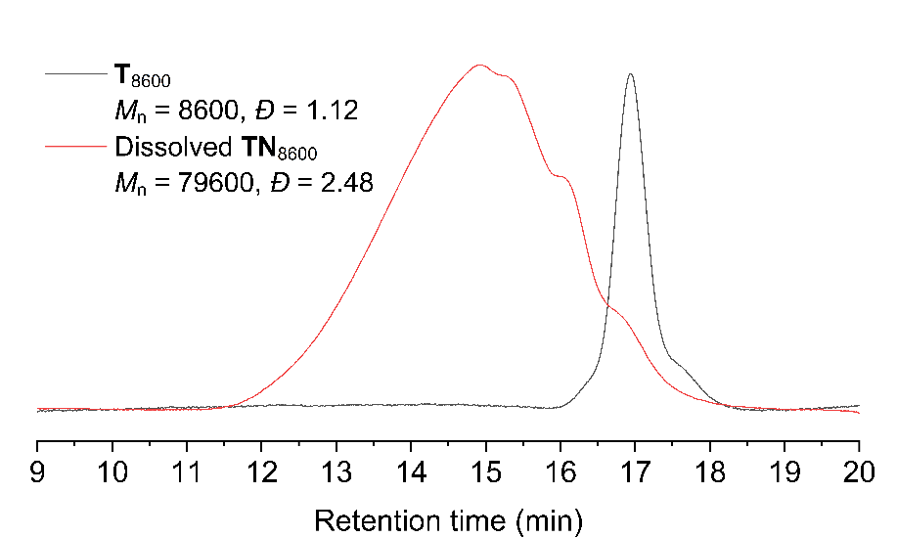
Figure S9. GPC analysis of the dissolution of TN₈₆₀₀ in 1,2-dichlorobenzene at high temperature.

- Swelling experiment and crosslink density

The swelling ratio was calculated from the weight of the swollen sample and the initial dry sample after a swelling in 1,4-dioxane for 36 h at room temperature. The crosslink density (ν) was calculated based on Flory-Rehner equation:
$\text{n}={-\left[\text{ln}\left(1-V_{\text{r}}\right)+V_{\text{r}}+χV_{\text{r}}\right]}/{V_{\text{slv}}\left({V_{\text{r}}}^{\frac{1}{3}}-\frac{2V_{\text{r}}}{f}\right)}$ … (1)
$$V_{\text{r}}={V_{\text{pol}}}/{V_{\text{pol}}+V_{\text{slv}}}={\frac{W_{\text{dry}}}{ρ_{\text{pol}}}}/{\left\{\frac{W_{\text{dry}}}{ρ_{\text{pol}}}+\frac{W_{\text{swol}}-W_{\text{dry}}}{ρ_{\text{slv}}}\right\}}$$
$=1/{\left\{\frac{W_{\text{dry}}}{ρ_{\text{pol}}}+\frac{W_{\text{swol}}-W_{\text{dry}}}{ρ_{\text{slv}}}\right\}\frac{ρ_{\text{pol}}}{W_{\text{dry}}}}=1/{\left\{1+\left(\frac{W_{\text{swol}}-W_{\text{dry}}}{W_{\text{dry}}}\right)\frac{ρ_{\text{pol}}}{ρ_{\text{slv}}}\right\}}=1/{\left\{1+\left(\frac{W_{\text{swol}}}{W_{\text{dry}}}-1\right)\frac{ρ_{\text{pol}}}{ρ_{\text{slv}}}\right\}}$ …(2)
$χ=β+\left(V_{\text{slv}}/RT\right)∙\left(δ_{\text{slv}}-δ_{\text{pol}}\right)$ …(3)

where f is the junction functionality, W_{dry} and W_{swol} is the weights of dry and swollen polymer samples, ρ_{pol} and ρ_{slv} are the densities of polymer (polystyrene) and solvent (1,4-dioxane), β is the entropic contribution, R is the gas constant, δ_{pol} and δ_{slv} are the solubility parameters of polymer and solvent. f = 3 and f = 6 were used for TN and RN, respectively, depending on their ideal structures based on the feeding ratio of carboxylic acid functionalized polystyrenes and BADGE. Because the polymer composing the network are considered as the copolymer of styrene and BADGE (epoxy), we used the solubility parameter of the copolymer calculated as δ_{pol}² = p_{PSt} δ_{PSt}² + p_{epoxy} δ_{epoxy}². The solubility parameters of each polymer are referring Mark, J. E. Polymer Data Handbook, Oxford Univ Press, 1999.

- DSC analysis of crosslinked polymers
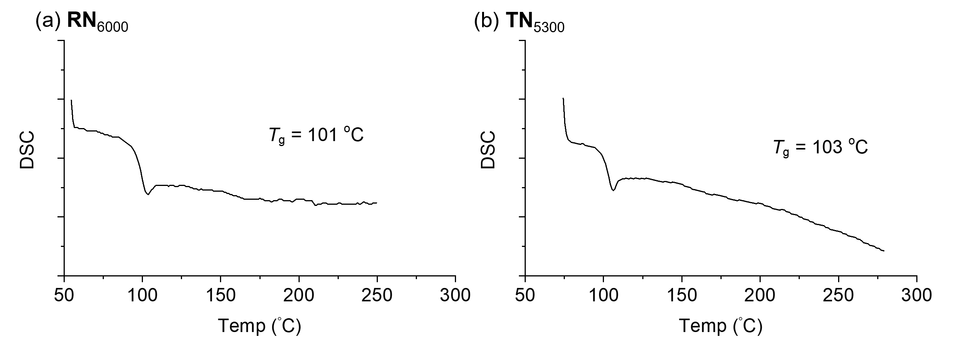
Figure S10. DSC analyses of synthesized crosslinked polymers. The observed DSC signals are corresponding to the glass transition of polystyrene.

Table S2. Glass transition temperature of synthesized crosslinked polymers
Crosslinked polymer | T_{g} (°C) |  | Crosslinked polymer | T_{g} (°C)
RN₃₂₀₀ | 98 |  | TN₃₅₀₀ | 100
RN₆₀₀₀ | 101 |  | TN₅₃₀₀ | 103
RN₈₅₀₀ | 99 |  | TN₈₆₀₀ | 102

- Rheological measurements

The temperature sweep measurements were performed in the linear viscoelastic range with dynamic oscillatory mode with a frequency of 1 Hz and a temperature rate of 3 °C/min. The stress relaxation measurements were carried out with 3% strain and the evolution of stress was monitored. The relaxation modulus G(t) was normalized by the initial relaxation modulus G₀ which is at 1 sec after the application of the strain for RN. In the meareument of TN, because the decay started just after the imposition of the strain (which needs ~0.1 sec), the initial modulus was taken at the time of t ~ 0.1 sec. For measurements of RN, the modulus at 1 sec was determined after a noise reduction treatment to diminish the noise in the early time region. For measurements of TN, the modulus at ~0.1 sec (0.107 or 0.109 sec, depending on the machine recording timing) was determined based on the power-law fitting of the relaxation decay curve. The G(t) values in 0.1-1 sec range for RN were identical. The relaxation times constant (τ) were obtained at the time G(τ) = G₀/e following the equation G(t) = G₀ exp(-t/τ). For the estimation of τ for TN, exponential fitting was used. For the measurements in which the relaxation was slow, the τ was estimated using a fitting curve based on Kohlrausch-Williams-Watt equation.
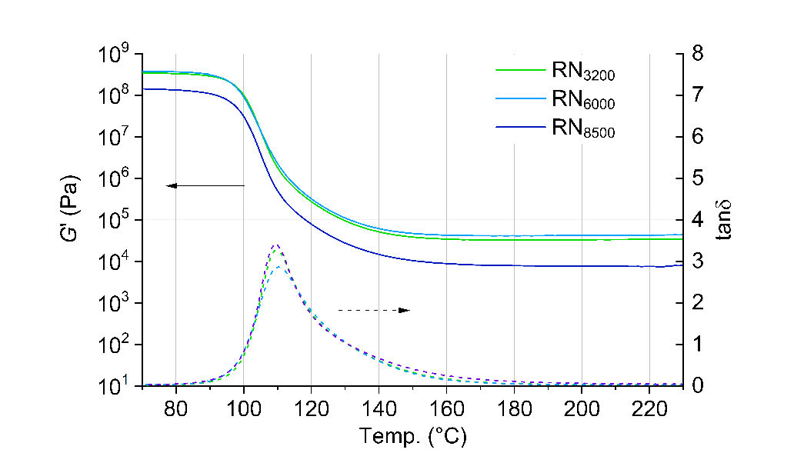
Figure S11. Rheological analysis of crosslinked polymer networks RN with temperature-sweep up to 230 °C.

Table S3. Parameters for KWW fitting
$$G\left(t\right)=\text{exp}\left[-{\left(t/τ\right)}^{β}\right]$$

 | RN₃₂₀₀ |  |  | RN₆₀₀₀
Temp (°C) | τ | β |  | τ | β
200 | 5.18×10⁴ | 0.665 |  | 4.36×10⁴ | 0.507
210 | 2.36×10⁴ | 0.523 |  | - | -
220 | - | - |  | 1.49×10⁴ | 0.433

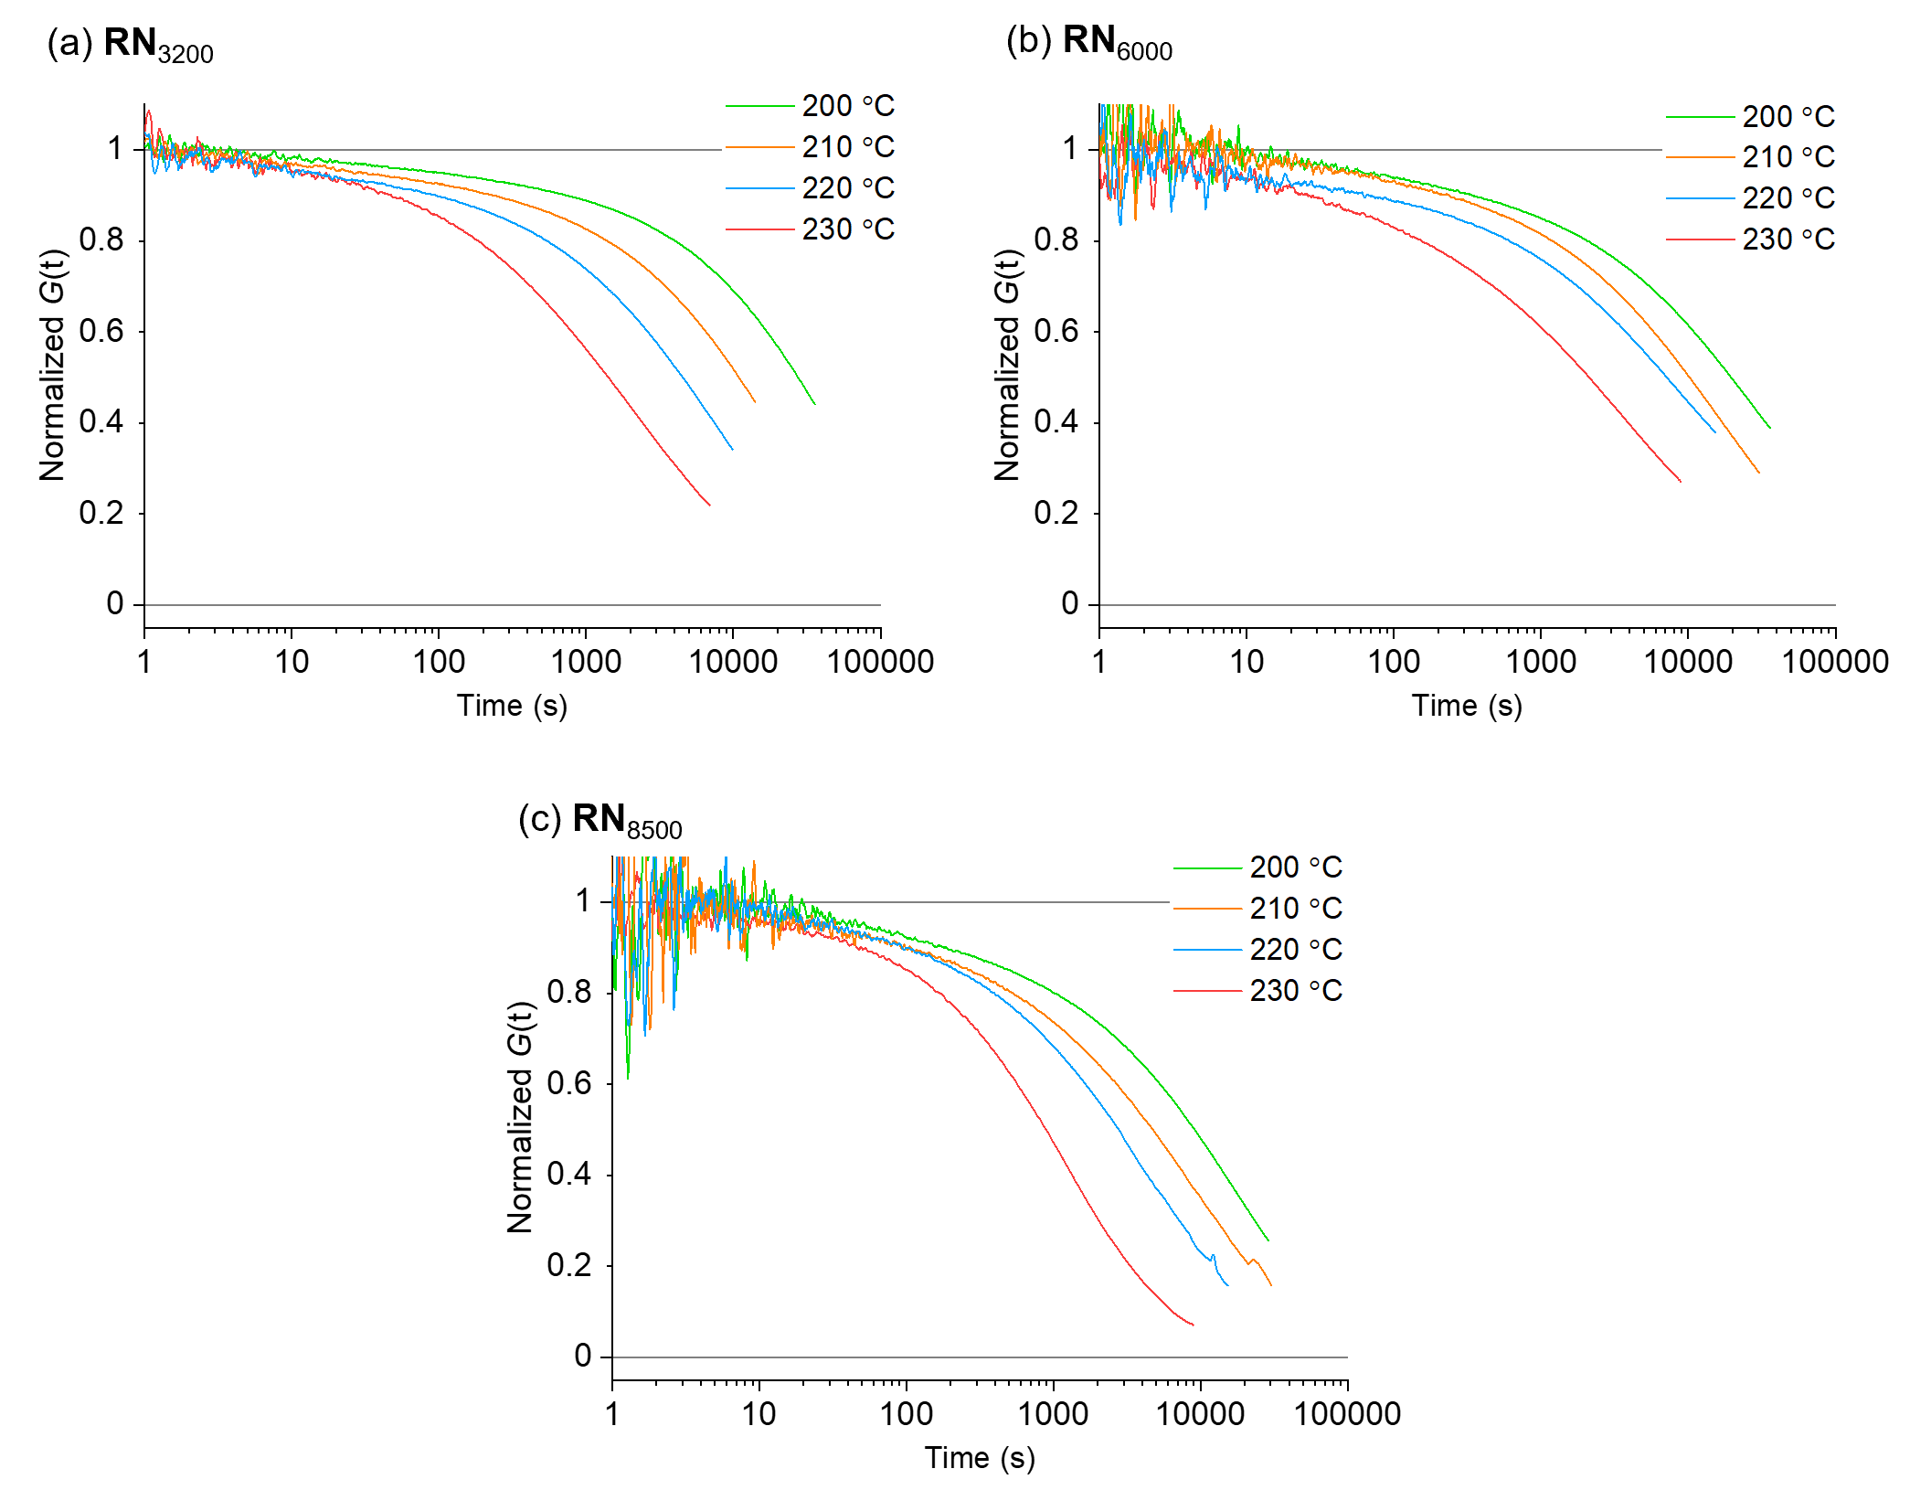
Figure S12. Normalized stress-relaxation curves at different temperatures for RNs. (a) RN₃₂₀₀, (b) RN₆₀₀₀, (c) RN₈₅₀₀.

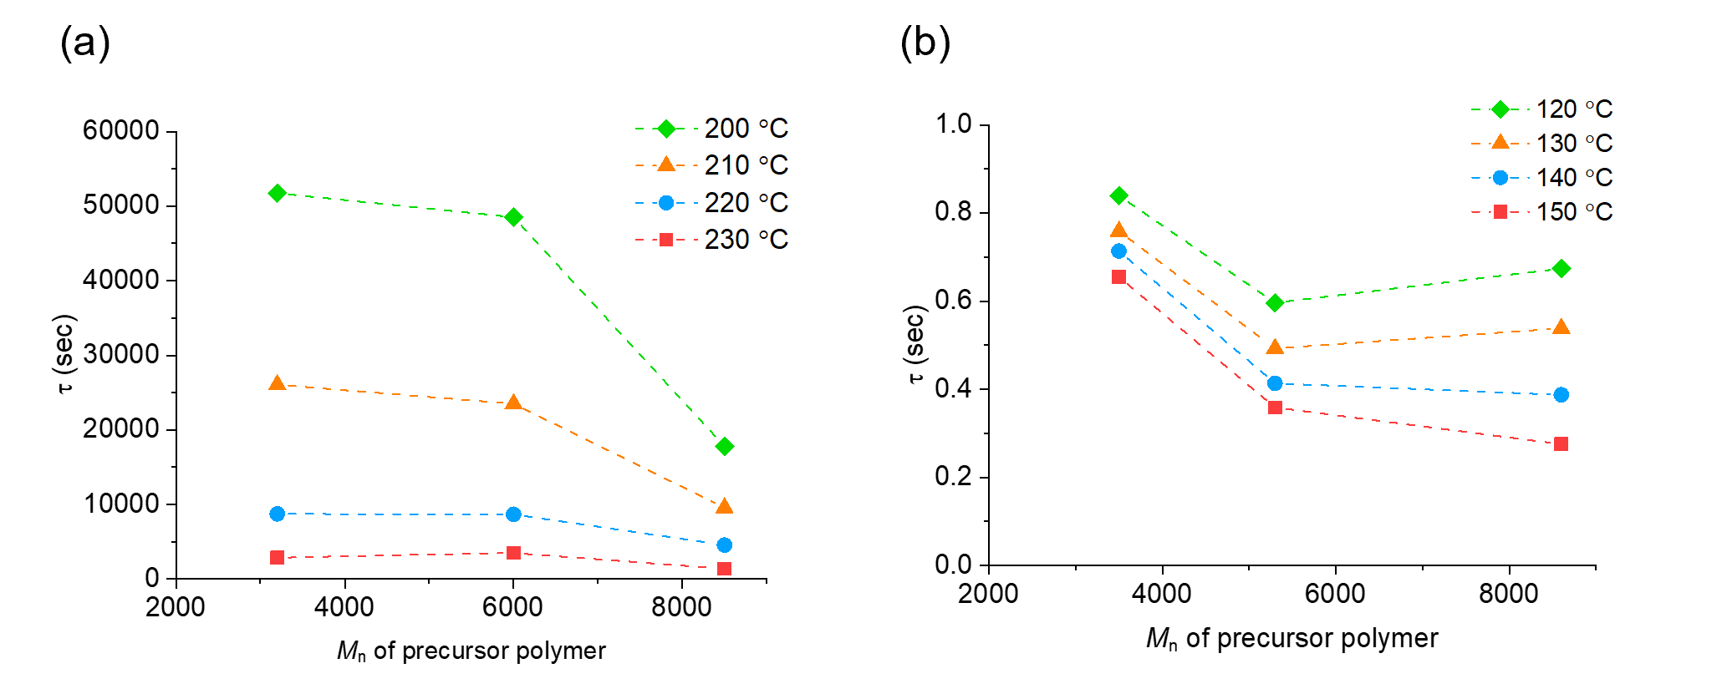
Figure S13. The effect of the molecular weight (M_{n}) of precursor in the correlation between the temperature and the relaxation time (τ). (a) RN and (b) TN.

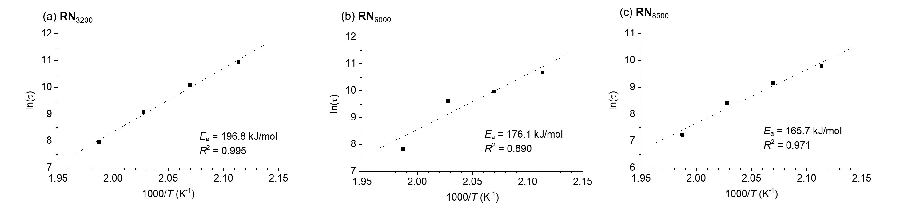
Figure S14. Correlation between ln(τ) versus 1000/T (τ: relaxation time, T: temperature in Kelvin) for RNs. (a) RN₃₂₀₀, (b) RN₆₀₀₀, (c) RN₈₅₀₀. Arrhenius activation energy of relaxation and the correlation factor are shown. Pre-exponential factors (lnτ₀, y-intercept) in the analysis were -39, -34, -33 for RN₃₂₀₀, RN₆₀₀₀, RN₈₅₀₀, respectively.

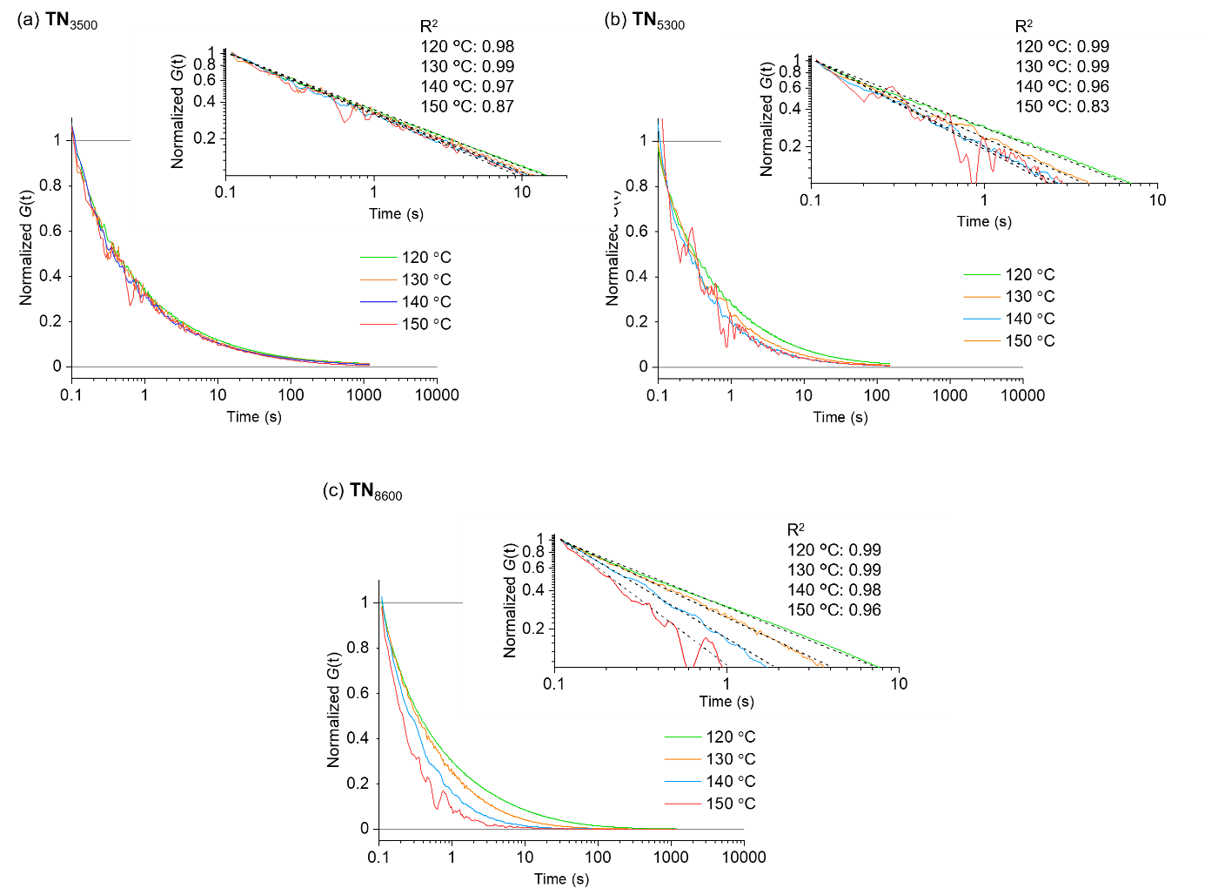
Figure S15. Normalized stress-relaxation curves at different temperatures for TNs. (a) TN₃₂₀₀, (b) TN₅₃₀₀, (c) TN₈₆₀₀.

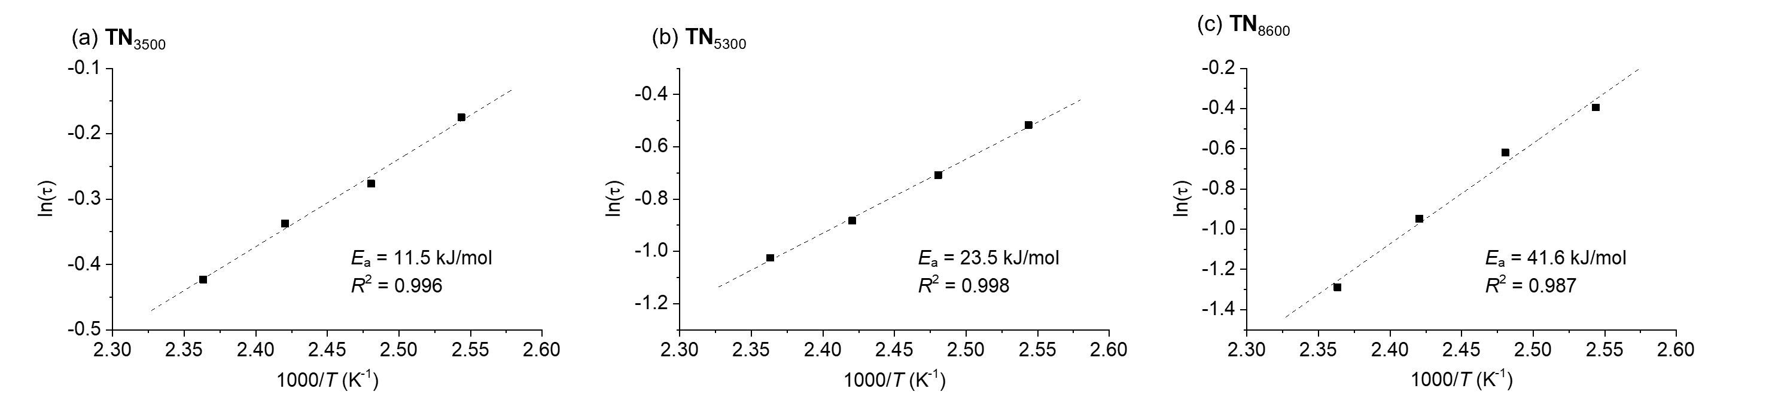
Figure S16. Correlation between ln(τ) versus 1000/T (τ: relaxation time, T: temperature in Kelvin) for TNs. (a) TN₃₂₀₀, (b) TN₅₃₀₀, (c) TN₈₆₀₀. Arrhenius activation energy of relaxation and the correlation factor are shown. Pre-exponential factors (lnτ₀, y-intercept) in the analysis were -3.6, -7.7, -13 for TN₃₂₀₀, TN₅₃₀₀, TN₈₆₀₀, respectively.

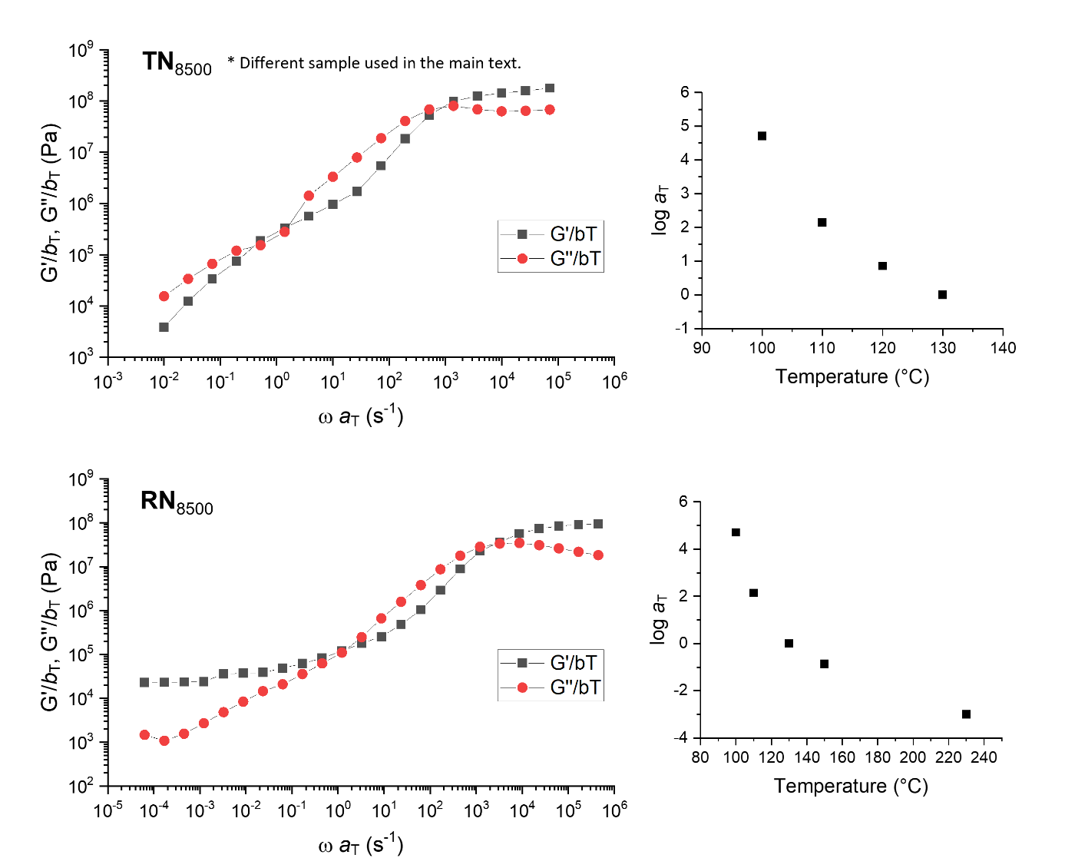
Figure S17. Preliminary result of the preparation of master curves for TN₈₅₀₀ and RN₈₅₀₀ by frequency sweep measurements at differente temperatures.

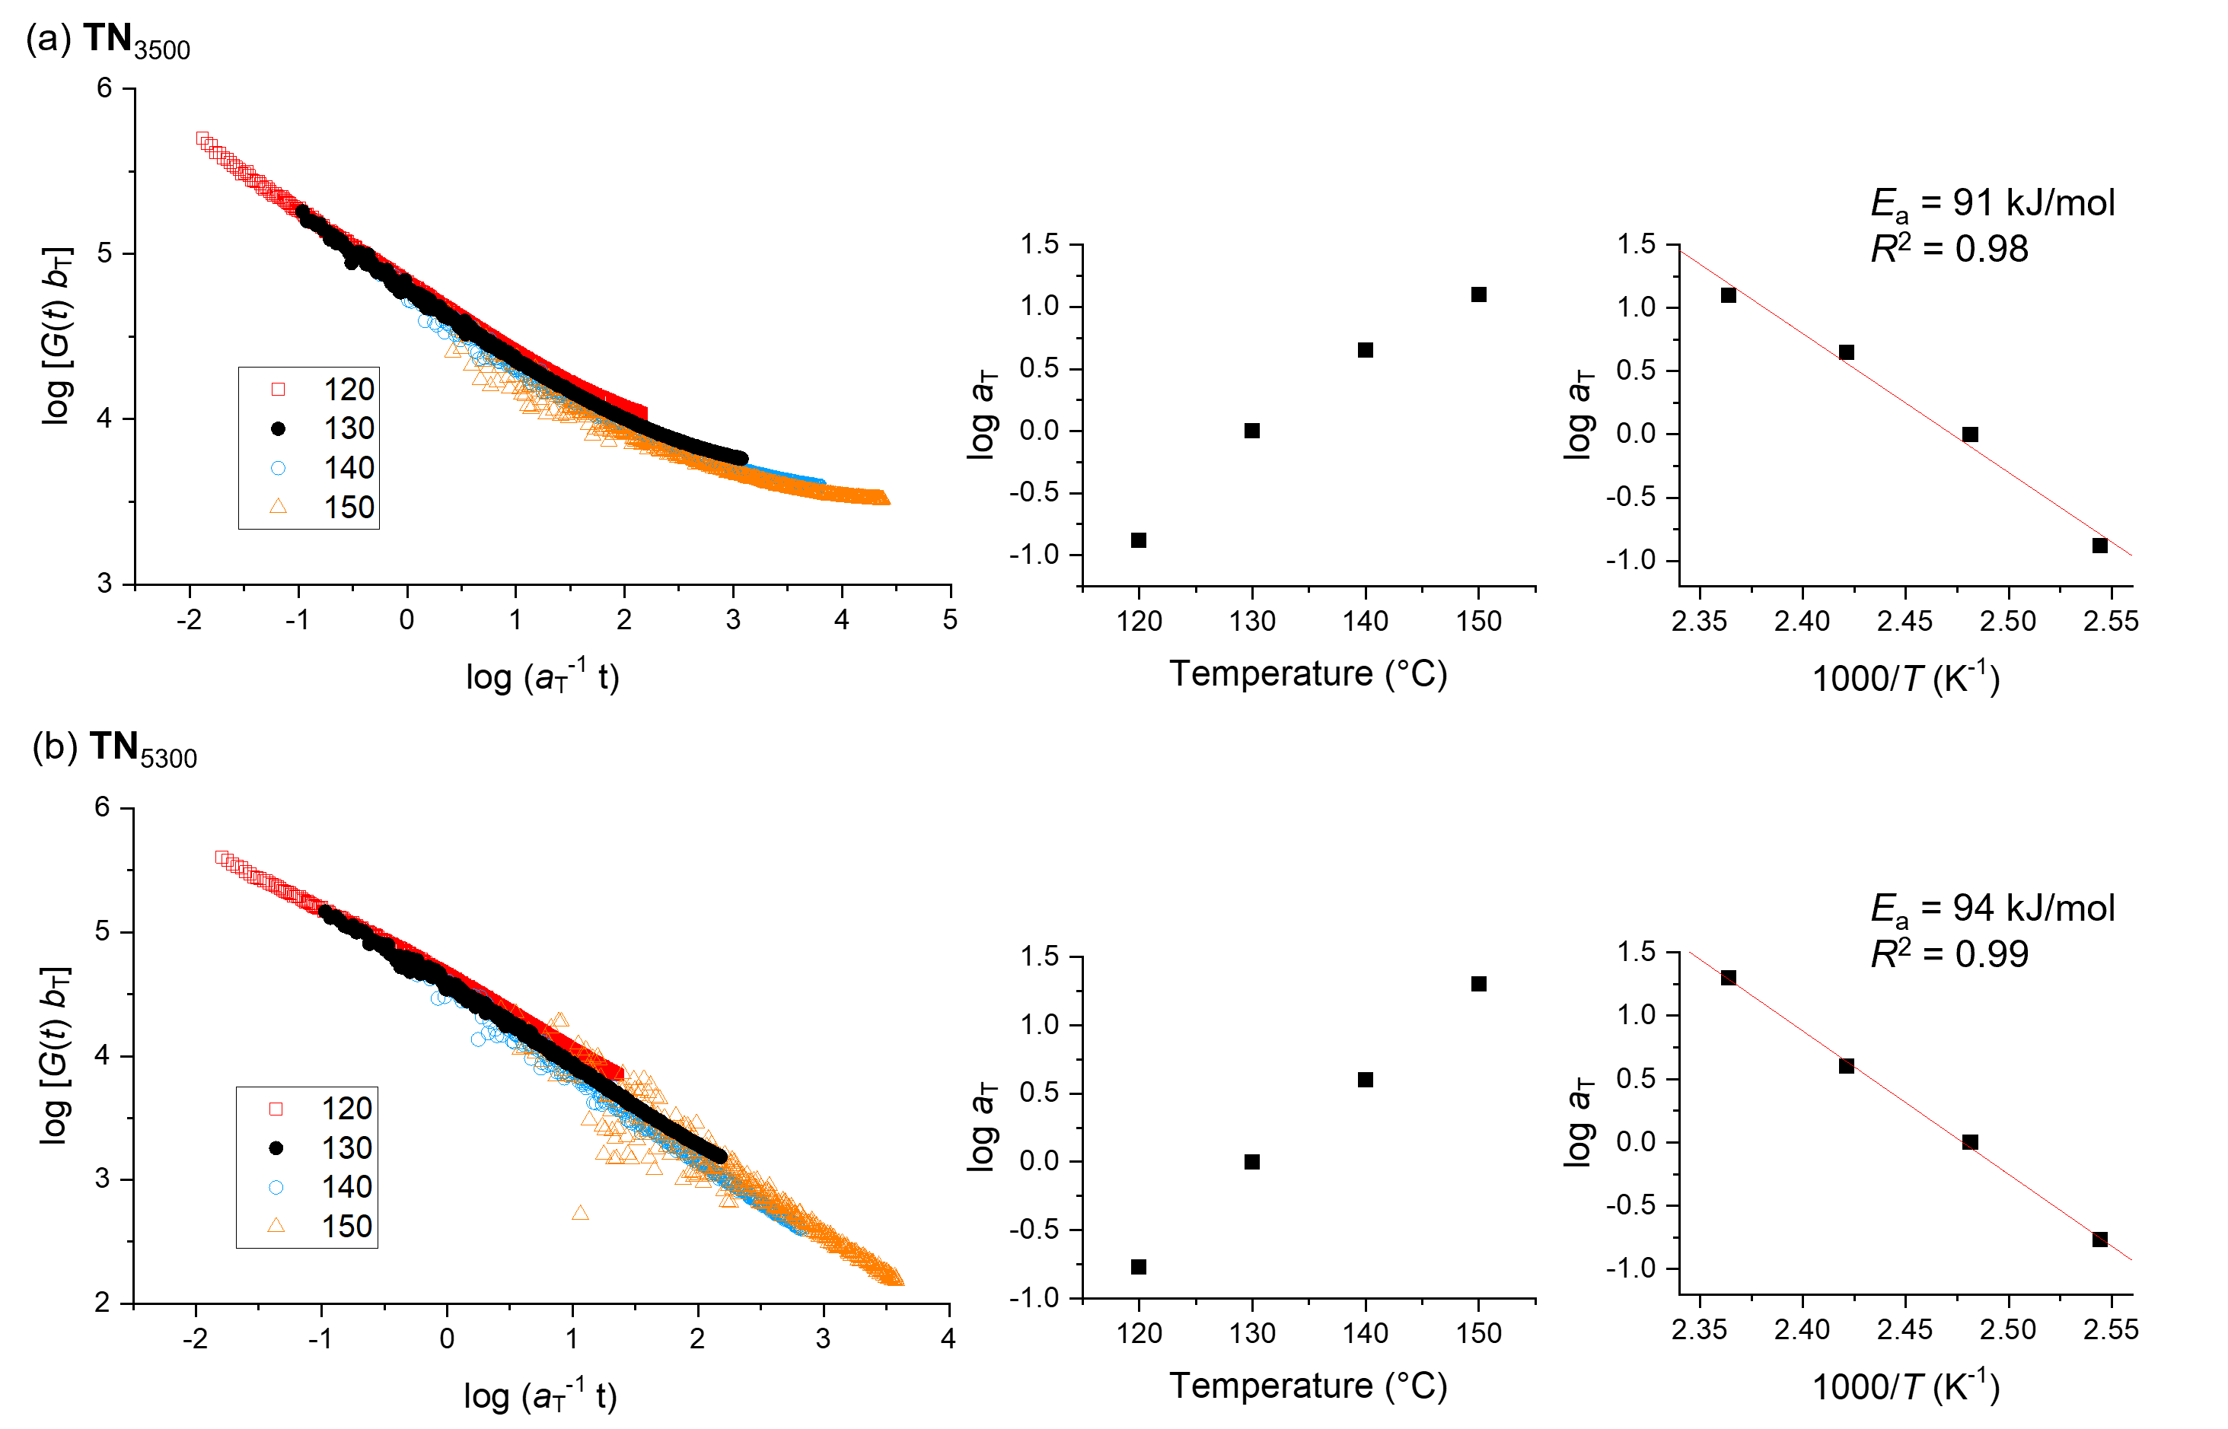
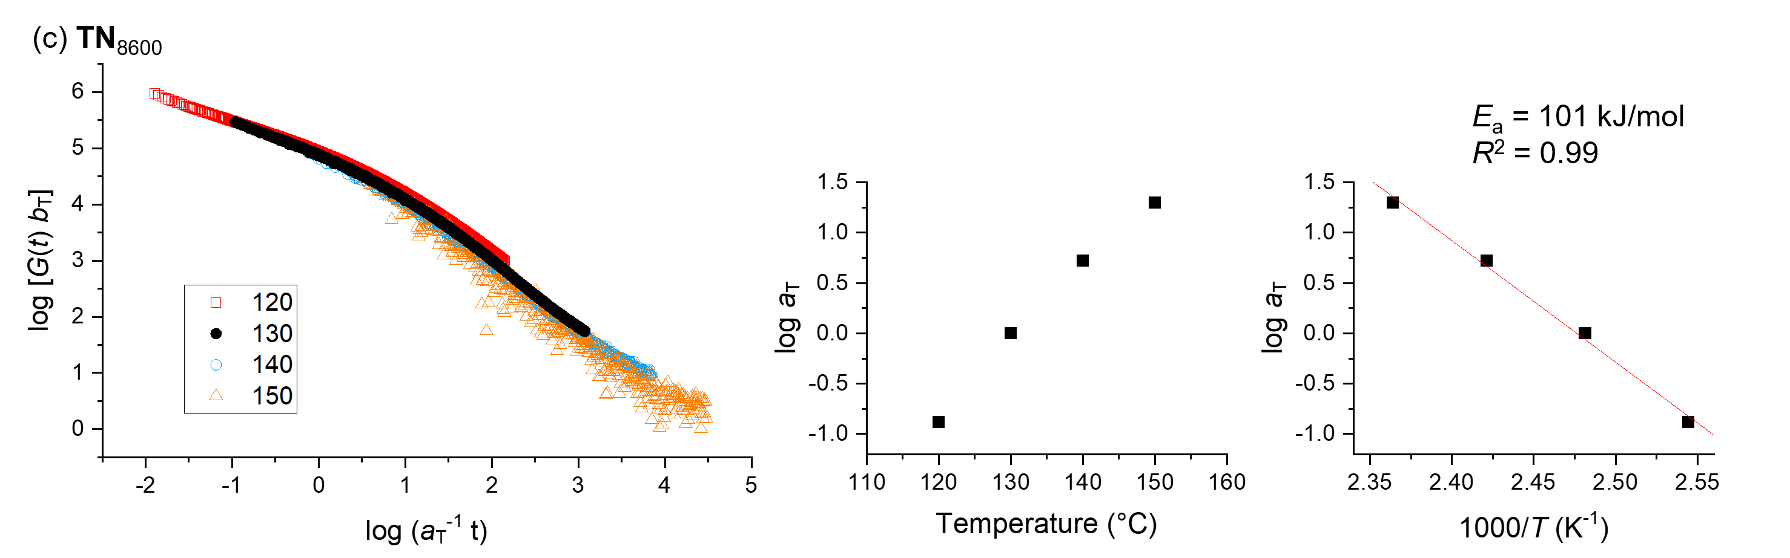
Figure S18. Preliminary result of the preparation of master curves for TN by stress relaxation measurements at differente temperatures.

