Frequency Stability of Higher Order Modes Diamond MEMS Resonator

Wen Zhao, Keyun. Gu, Guo Chen, Zilong Zhang, Satoshi Koizumi, Yasuo Koide, Meiyong Liao*
National Institute for Material and Science

- Introduction
Diamond has been manifested to be an extreme material for MEMS devices, such as high quality (Q) factor over 1million at room temperature and high-reliability magnetic sensor up to 500ºC [1-2]. Frequency stability is a key parameter to determine the resolution of the MEMS resonant-type sensors. The sensing precision relies on the resonance frequency and Q factor. A high frequency means a high band width, which can be achieved by changing the device dimensions. However, the Q factor will suffer from degradation. In this work, we propose the use of high-order mode resonance for sensing applications, which can maintain the device mass and increase the band width simultaneously. We analyze the frequency stability of the high-order mode resonance of diamond MEMS cantilevers. It is shown that the higher-order mode resonance improves the frequency stability.

2. Experiments
The fabrication of the single-crystal diamond (SCD) MEMS cantilever resonators was performed by the smart cut method developed in our lab [3], as shown in Fig. 1 (a). A Laser Doppler vibrometer (LDV) was used to measure the out-of-plane displacement and velocity (Fig.1(b)). The SCD cantilevers were actuated by the radio frequency (RF) signal from a lock-in amplifier, which was equipped with a phase lock loop (PLL) to investigate the frequency stability. All the measurements were conducted in a high-vacuum chamber with a pressure below 10⁻⁴ Pa at room temperature.

3. Results
The resonance frequencies and Q factor of the out-of-plane vibration are f₁=174.894 kHz, Q₁=14696 for the 1st mode, f₂=1087.301 kHz, Q₂=11409 for the 2nd mode, and f₃=3018.438 kHz, Q₃=8261 for the 3rd mode. Increasing the AC voltage enhances the resonance amplitude and all frequency responses exhibit good linearity in amplitude in the investigated actuation RF voltages. Fig.2 illustrates the Allan analysis for the first three modes. At the band width (BW)=1Hz, the detection (system) noise from the facility dominates over the thermomechanical noise at low frequencies (<0.1Hz). When enlarging the bandwidth at 100Hz, the thermomechanical noise starts to dominate over the detection noise during the evolution of Allan derivation. For the BW lower than the resonator decay time, the detection noise limit is even smaller. Higher-order resonance modes with higher frequencies improve the minimum frequency variation or stability. Therefore, the high-order mode resonances open an avenue for enhancing the minimal detection capability and sensing resolution in MEMS sensors without changing the device dimensions.

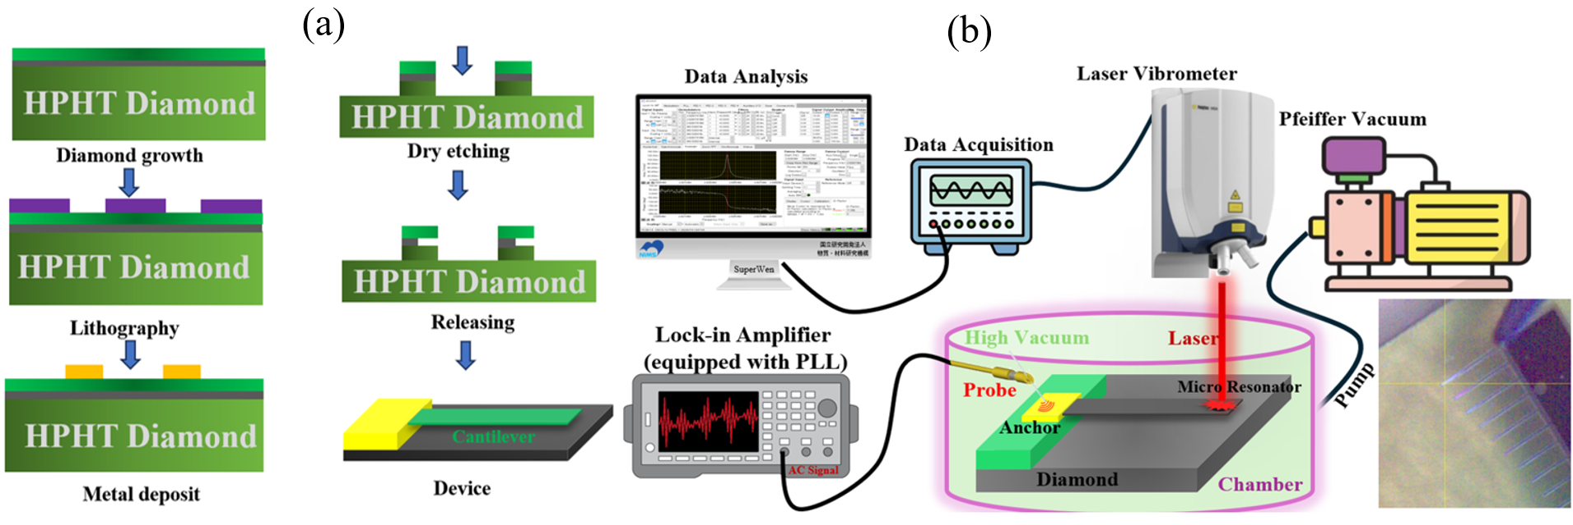
Fig.1 (a) Fabrication procedure of SCD MEMS; (b) Schematic setup for measuring the resonance frequency of the SCD MEMS cantilevers.

Fig.2 Allan derivation with the same signal-to-noise ratio in the frequency response for the first three modes at various bandwidths (a) BW=1Hz, (b) BW=100Hz.

4. Conclusion
In this work, we demonstrated a higher-order mode SCD MEMS cantilever resonator. By tracking the resonance frequency fluctuation with time, we analyzed the first three resonance frequency stability using Allan derivation. It was revealed that the higher the mode order, the better the frequency ability. Operating the diamond sensor at higher-order modes, due to the improved frequency stability, provides a high potential for high-precision sensing applications.

References
[1] H. Sun, M. Liao et al, Phys. Rev. Lett. 125, 206802(2020).
[2] Z. Zhang, M. Liao et al, Adv. Fun. Mater. 33, 2300805 (2023).
[3] M. Liao et al, Adv. Mat. 22, 5393 (2010).

