Grain size dependence of <hkl> intergranular lattice strain generated by plastic deformation in ferritic steel

Yo Tomota ^{a*}, Hongxing Li ^{b}, Noriyuki Tsuchida ^{c}, Wu Gong ^{d}, Stefanus Harjo ^{d},
Takahito Ohmura ^{e}

ª Graduate School of Science and Engineering, Ibaraki University, 4-12-1, Nakanarusawa, Hitachi, Ibaraki, 305-0047, Japan
^{b} National Institute for Materials Science, 1-2-1, Sengen, Tsukuba 305-0047, Japan (now at Ma-tek Co.)
^{c} Graduate School of Engineering, University of Hyogo, 2167 Shosha, Himeji, Hyogo, 671-2280, Japan
^{d} J-PARC Center, Japan Atomic Energy Agency, 2-4, Shirakata, Tokai, Naka-gun, Ibaraki, 319-1195, Japan
^{e} National Institute for Materials Science, 1-2-1, Sengen, Tsukuba 305-0047, Japan
*Corresponding author. E-mail address: yo.tomota.22@vc.ibaraki.ac.jp (Y. Tomota)

Abstract
The uniaxial deformation behavior of low-carbon ferritic steels with grain sizes of 0.47 μm and 1.5 μm was investigated using in situ neutron diffraction measurements under both tensile and compressive loading. The analysis focused on the evolution of <hkl> lattice (elastic) strains, originating from anisotropy in <hkl> elastic moduli and differences in plastic flow among grains. Such plastic strain incompatibilities produce <hkl> intergranular lattice strains (or stresses), which persist after unloading. The experiments revealed substantial residual <hkl> intergranular lattice strains following both tensile and compressive plastic deformation. Transmission electron microscopy confirmed the grain-size dependence of dislocation structures formed during plastic flow, suggesting that plastic relaxation near grain boundaries becomes increasingly constrained with grain refinement. Overall, the results demonstrate that the magnitude of residual <hkl> intergranular lattice strains increases as grain size decreases from several tens of micrometers down to 0.5 μm.

Key words: Fine-grained ferritic steel; Uniaxial deformation; Neutron diffraction measurement; <hkl> intergranular lattice strain; Grain size effect

- Introduction
Polycrystalline metals and alloys exhibit heterogeneous plastic deformation due to the difference in the elastic moduli and Schmid factors of <hkl> grains-families oriented variously with respect to the loading direction [1, 2]. Unlike a single crystal material, an individual grain within a polycrystal material is elastoplastically deformed under the constriction by its adjacent grains, where compatibility conditions must be maintained at the grain boundaries. Plastic misfit strains, for example, caused by piled-up dislocations at the grain boundaries, yield long-range internal stresses, where high local internal stresses are partially relaxed by the occurrence of the secondary slip in the same grain and/or the generation of a slip in the adjacent grain. Even after such plastic relaxation occurs, the mean internal stress can remain in an individual <hkl> grain, which is known as “<hkl> intergranular stress (lattice strain)” or “Type II stress (strain)” [3, 4]. Therefore, in the uniaxial deformation of a polycrystalline alloy, the mean stress and relevant mean elastic strain in a certain grain oriented along the <hkl> direction with respect to the loading direction differs from grain to grain. Based on the elastoplastic deformation data of single crystals, the stress–strain curve of a polycrystal material has been computed using an elastoplastic self-consistent (EPSC) micromechanics model [1, 2]. However, the internal stress distribution inside an individual grain known as “Type III stress” is not taken into consideration, i.e., only the <hkl> intergranular stresses, which are the values averaged for all <hkl> oriented grains (<hkl> grains family), have been tailored during deformation. Hence, the influence of grain size on the <hkl> intergranular stress cannot be discussed by this method.
To consider the effect of the grain size on plastic flow, a polycrystal material has been modeled as a composite of the work-hardened boundary layer (A_{GB}) and grain interior (A_{G}), as illustrated in Fig. 1.
Fu et al. [5] proposed that the elastic anisotropy effects, grain boundary sources for dislocation emission, and the activation of multi-slip systems in a polycrystal are responsible for the formation of a work-hardened layer along the grain boundary (A_{GB}). They claimed that such a composite modeling explained the change in the slope of the Hall–Petch plot [6, 7] with a change in the grain size from submicron to several tens of microns, and the occurrence of grain boundary sliding in a nanocrystalline regime (e.g., 26 nm) in copper and iron. From the viewpoint of <hkl> intergranular lattice strain or stress, the occurrence of the second and third slips would relax high internal stresses locally. If grain boundary sliding became a dominant plastic deformation mode, <hkl> intergranular stress would hardly be generated. A model for the grain size dependent work hardening has been developed by Sinclair et al. [8], in which the work hardening arises from a combination of kinematic and isotropic hardening. The kinematic hardening is considered to arise mainly from the long-range internal stress, whereas the isotropic hardening would be due to dislocation–dislocation and/or dislocation–grain boundary interaction affected by dynamic recovery. Their model showed good agreements with the experimental flow curves for copper with grain sizes ranging from 2 to 50 μm.
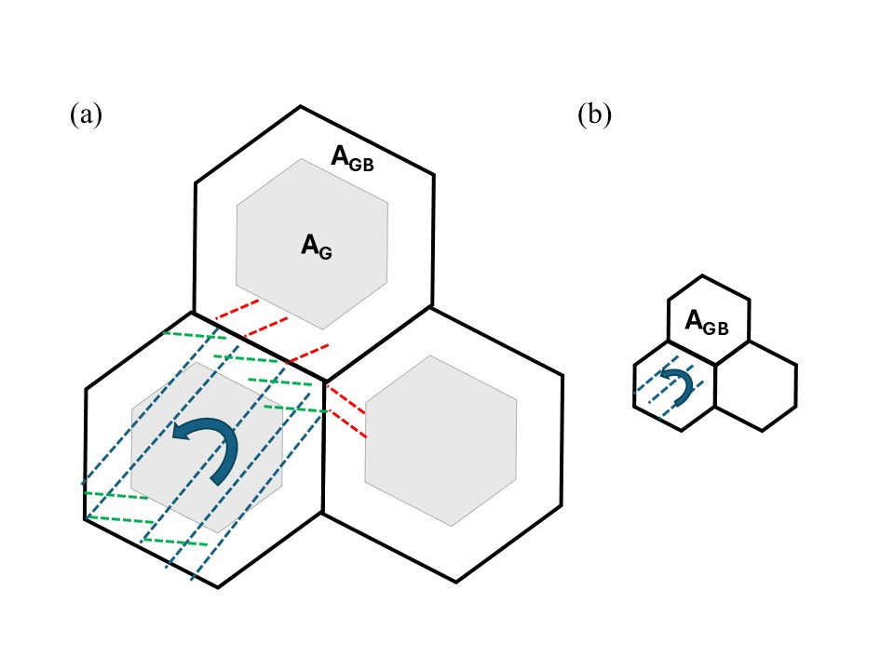
Fig. 1 Schematic illustration of a grain subjected to plastic deformation preferentially in a polycrystalline metal drawn referring to Fu et al. [5]: (a) coarse-grained sample and (b) ultrafine grained sample. Here, A_{G} and A_{GB} stand for grain interior region and grain boundary-affected region, respectively.
In past experimental studies, heterogeneous plastic deformation has frequently been observed by employing optical microscopy, scanning electron microscopy coupled with electron backscatter diffraction (EBSD) [9-11], digital image correlation (DIC) analysis [12, 13] or electron channeling contrast imaging (ECCI) [12, 14]. Here, it should be noted that the specimen surface is in a plane stress condition, which is different from that inside; therefore, the globally averaged information of a bulk sample cannot be correctly evaluated by these methods. A grain located at the surface is not three-dimensionally constrained by the surrounding grains. Contrary to these methods, in situ neutron diffraction (ND) during tensile deformation provides the changes in bulk-averaged <hkl> lattice (elastic) strains. Clausen et al. revealed that the results of ND showed excellent agreement with those calculated by the EPSC model for face-centered cubic (FCC) metals [1]. For engineering stress measurements by diffraction methods, sufficiently many grains should be monitored to obtain the globally averaged information [15]. Synchrotron high-energy X-ray diffraction is also a powerful tool, although it can only be used in the case of fine-grained material because of its small beam size, or it is necessary to oscillate a loading machine in order to increase the number of target-illuminating grains for engineering alloys [16]. In contrast, ND with a beam size of several millimeters has been employed for engineering materials with a grain size of a few to several tens of microns. Meanwhile, the importance of Type III stress has been experimentally emphasized by Hayashi et al. [17]. They demonstrated the distribution of Type III elastic strains in individual grains using 3D microbeam synchrotron X-ray measurement, although such an advanced method can only be applied to a thin specimen of a coarse-grained material. Synchrotron X-ray and neutron beams should be utilized complementarily. For example, the stress condition of a certain grain embedded in a polycrystalline material is now understood by in situ neutron and synchrotron diffractions coupled with micromechanics computation. In addition, the dislocation densities in <hkl> oriented grains families are different from each other in a plastically deformed specimen of a polycrystalline material. This has been qualitatively revealed by transmission electron microscopy (TEM) observation [18–20] and quantitatively determined by the convolutional multiple whole profile (CMWP) fitting method [21, 22] for ND data [23–25].
In this study, therefore, specimens with ferrite grain sizes of 0.47 μm and 1.5 μm were prepared through thermomechanical processing of a commercially available low-carbon steel and investigated by in situ ND measurements during tensile and compressive deformations at ambient temperature. Their microstructures and the effects of the temperature and strain rate on the tensile properties have already been reported elsewhere [26–32]. This paper focuses on the magnitude of <hkl> intergranular lattice strains formed by plastic deformation in fine-grained steels.

- Experimental procedures
2.1 Specimens preparation
The chemical composition of the steel used in this study was 0.16C-0.41Si-1.43Mn-0.014P-0.004S- 0.027Al-0.01Cu-0.028N in mass% and the balance was Fe (JIS-SM490). To prepare fine-grained specimens, a complex thermo-mechanically controlled process using caliber rolling was developed at the National Institute for Materials Science [26, 27]. Specimens with a ferrite grain size of 1.5 μm were prepared by annealing at 1173 K for 3.6 ks → rolling at 973 K by 45.8% in area reduction → rolling at 823 K by 89.8% → quenching in water (hereafter referred to as the “1.5 μm specimen”). Specimens with a grain size of 0.47 μm were prepared by annealing at 1173 K for 3.6 ks → rolling at 773 K by 91% → rolling at 723 K by 43.8% → annealing at 743 K for 3.6 ks → quenching in water (hereafter referred to as the “0.47 μm specimen”). As reference, specimens with a ferrite grain size of 46.2 μm were prepared by annealing at 1423 K for 5.4 ks followed by furnace cooling.
Tensile specimens with a parallel gauge portion of 5 mm in width, 50 mm in length, and 2 mm in thickness were prepared using a spark cutting machine along the rolling direction. Cylindrical specimens with 7 mm in diameter and 10 mm in length for compression tests were also prepared along the rolling direction by spark cutting.

2.2 Microstructure characterization and hardness test
The microstructures were observed using scanning electron microscopy (SEM: JSM-7000F JEOL) and electron back scatter diffraction (EBSD) with an acceleration voltage of 20 kV. To observe dislocation structures of the tensile deformed specimens through transmission electron microscopy (TEM), thin foils were cut from the gauge regions, polished mechanically to approximately 60 μm thick using 2000 grit waterproof silicon carbide paper and then twin-jet-polished in a 100 ml HCLO₄ + 900 ml CH₃COOH solution at a voltage of 15 V at ambient temperature. The dislocation structures were observed under a low-angle annular dark-field scanning transmission electron microscopy (LAADF-STEM) mode with a camera length of 40 cm and spot size of 1 nm using a TEM (JEOL 2100F) operated at 200 kV. The thickness of a thin foil was measured by tilting the thin foil edge parallel to the observation beam using a SEM (JSM-7000F, JEOL). The dislocation density ρ for the TEM samples was estimated using the line-intercept method, where the dislocation density was calculated as the number of intersection points divided by the total length of the random lines.
Vickers hardness tests were performed on the planes prepared by sectioning specimens perpendicular to the tensile direction. The specimens were mechanically polished and finished using electrolytic polishing in the aforementioned solution at a voltage of 40 V at an ambient temperature to remove the damaged surface layer. The Vickers hardness tests were performed at a peak load of 25g. The microstructures and Vickers indents were observed using SEM/EBSD, operated at an acceleration voltage of 20 kV and a scanning step size of 0.08 μm. Grain boundaries were classified according to their misorientation angles: boundaries with angles ≥ 15°were defined as high-angle grain boundaries (HAGBs), while those with angles < 15°were considered low-angle grain boundaries (LAGBs).

2.3 In situ neutron diffraction measurements during uniaxial loading
Fig. 2 illustrates three kinds of in situ neutron diffraction measurements during deformation, using an engineering neutron diffractometer, Takumi (BL19) at the Materials and Life Science Experiment Facilities (MLF) of the Japan Proton Accelerator Research Complex (J-PARC) [33, 34]. As illustrated in Fig. 2a, tensile tests were performed at room temperature, where a tensile tester (Yonekura Co. Ltd, Osaka, Japan) was set such that the angle between the tensile direction and the neutron incident beam direction became 45°. An incident beam slit with dimensions of 5 mm (width) × 10 mm (height) was employed, and a pair of radial collimators (viewing width; 5 mm) was adopted.” Since the parallel part of the tensile specimen has a width of 5 mm and a thickness of 2 mm, and the specimen was horizontally aligned 45°to the incident beam, the gauge volume is approximately 7 mm×5 mm×2 mm (approximately 7 mm×5 mm× 5 mm for compression test). During deformation, in situ ND profiles were recorded at the two orthogonally installed detector banks: the relative scattering vectors became either parallel to the loading direction (S-bank) or transverse (N-bank). The external load was increased in a step-by-step manner, holding for 180 s at the beginning of the elastic deformation regime, followed by deformation at a constant crosshead speed of 0.01 mm/min (initial strain rate of 1.4×10⁻⁵ /s). As shown in Fig. 2b, tensile loading was interrupted (ceased) and unloaded. Compression tests were performed with similar cross head control shown in Fig. 2c. The data recorded with an event-mode were time-sliced and analyzed using Z-Rietveld software (version 1.1.2) [35, 36] inputting the crystal information of body centered cubic structure (BCC: space group Im3). Ex situ ND measurements were also carried out for specimens deformed by 4% in tension to obtain profiles with good statistical reliability. The obtained diffraction profiles were analyzed using convolutional multiple whole profile (CMWP) fitting software to determine the dislocation density [21, 22].
Fig. 2 Loading patterns for in situ neutron diffraction measurements (the 1.5 μm specimens).

- Experimental results
3.1 Microstructure and hardness
The microstructures of these specimens consist of ferrite and cementite, as reported in our previous reports [26–29]. The average ASTM grain sizes of these specimens, as determined from SEM observations, were approximately 1.5 μm and 0.47 μm, respectively. In these specimens, nearly spherical and tiny cementite particles were scattered mostly at the ferrite grain boundaries. The microstructure of the reference sample with a ferrite grain size of 46.2 μm consisted of ferrite and pearlite [30–32].
Fig. 3 shows the IPF maps for three directions, ND, TD, and RD, parallel to the tensile direction. The Vickers indent is observed in the central region of each micrograph showing HV190 for the 1.5 μm specimen and HV 290 for the 0.47 μm. As observed, the shape of grain is elongated in the indent region suggesting the occurrence of plastic flow by dislocation motion.
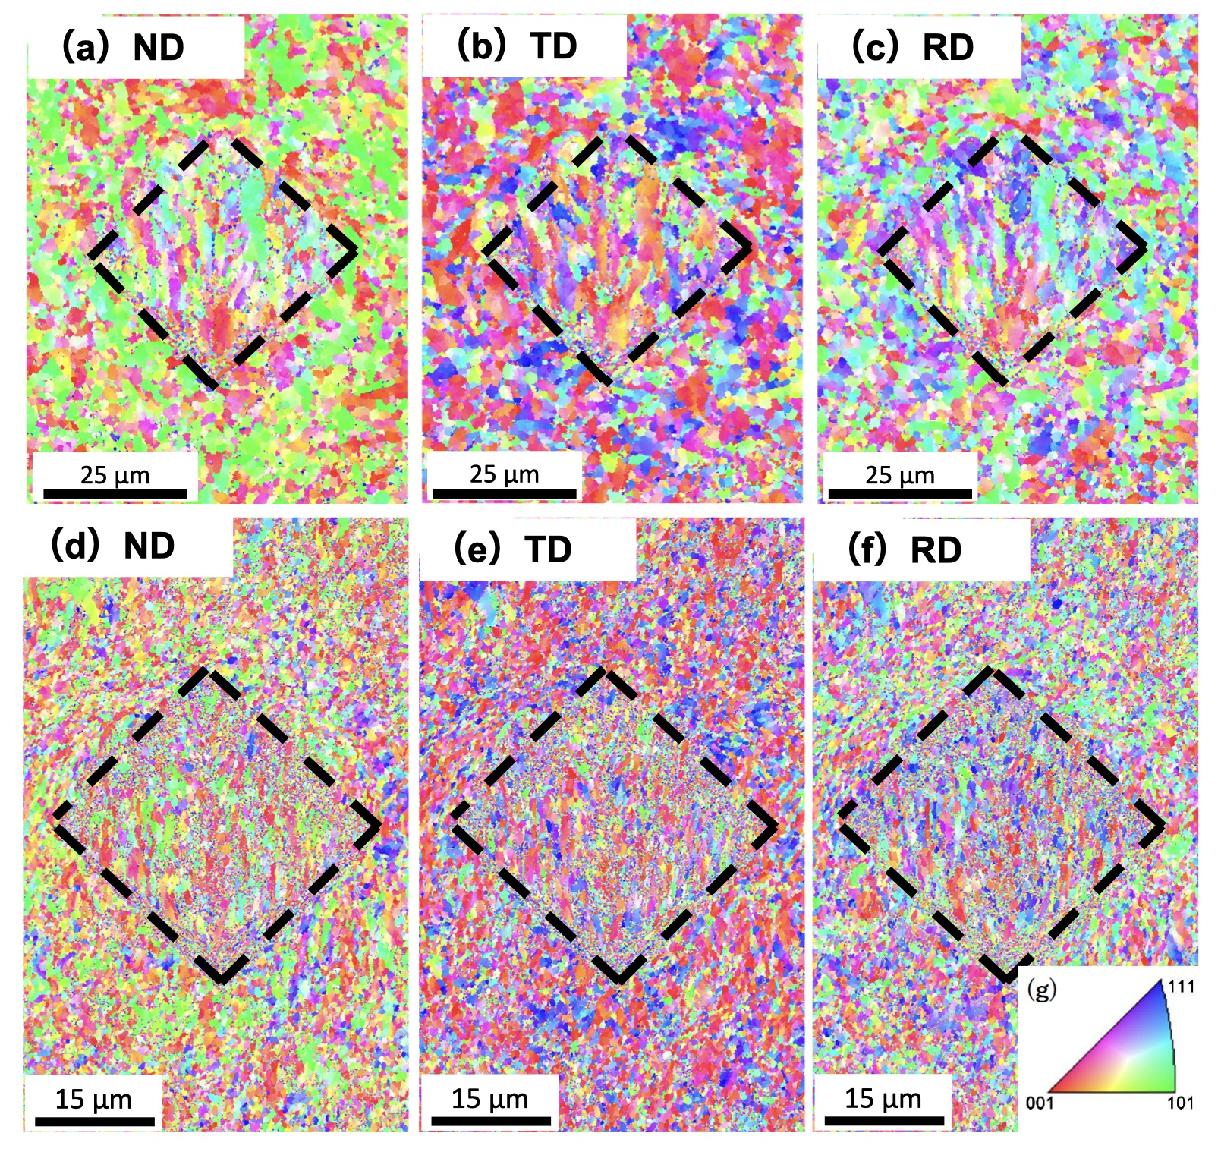
Fig. 3 Inverse pole figure (IPF) maps of the 1.5 μm specimen ((a)-(c)) and 0.47 μm specimen ((d) -(f)), where (a) and (d) are corresponding to ND, (b) and (e) RD, and (c) and (f) TD, respectively and (g) crystal orientation color scale. Vickers indentation was made in the central region of each micrograph (indent area: 589.4 μm² (1.5 μm ) and 343.2 μm² (0.47 μm ), respectively). These EBSD IPF maps were obtained after the application of a cleanup procedure (Grain Dilation with a tolerance angle of 5° and a minimum grain size of 2 pixels).
3.2 Tensile behavior
Nominal (engineering) stress–strain curves of the three specimens are depicted in Fig. 4. In tensile tests, discontinuous yielding occurred in all specimens. The Lüders strain becomes larger with a decrease in grain size, which corresponds to the reduction in the work-hardening rate after the Lüders deformation, as demonstrated by Tsuchida et al. [37]. As shown in Fig. 2b, tensile loading was interrupted (ceased) and unloaded to examine the residual <hkl> intergranular strains. The compression flow curves were not satisfactorily accurate because the gauge length was too short and hence, the deformation was macroscopically inhomogeneous without showing an apparent Lüders deformation as observed in the tensile test. However, some complementary insights could be obtained from the results of in situ ND measurements.

3.3 Results of in situ neutron diffraction during loading and unloading
Examples of the obtained ND diffraction profiles are presented in Fig. 5, where the measured intensities and fitting results using the Z-Rietveld software are plotted as a function of the scattering vector, q (= 4πsinθ*/λ, where θ* is half the diffraction angle and λ is the neutron wavelength). As would be postulated from these profiles obtained from the two orthogonal directions (loading and its transverse), a <110> fiber texture is present. This fiber texture developed mainly during the caliber rolling process. In this study, the texture effect hindered complete clarification of the grain size effect, but as will be mentioned later, the obtained results helped answer the question pointed out in the Introduction section for the evolution of intergranular stress in submicron materials.
Here, the <hkl> lattice strain, $ε_{hkl}$, was calculated from the change in the {hkl} lattice plane spacing, $d_{hkl}$, of the grains-family oriented <hkl> with respect to the relevant scattering vector. Employing the {hkl} lattice plane spacing before loading, $d_{hkl}^{0}$, as a reference value, the <hkl> lattice strain, $ε_{hkl}$, is determined by
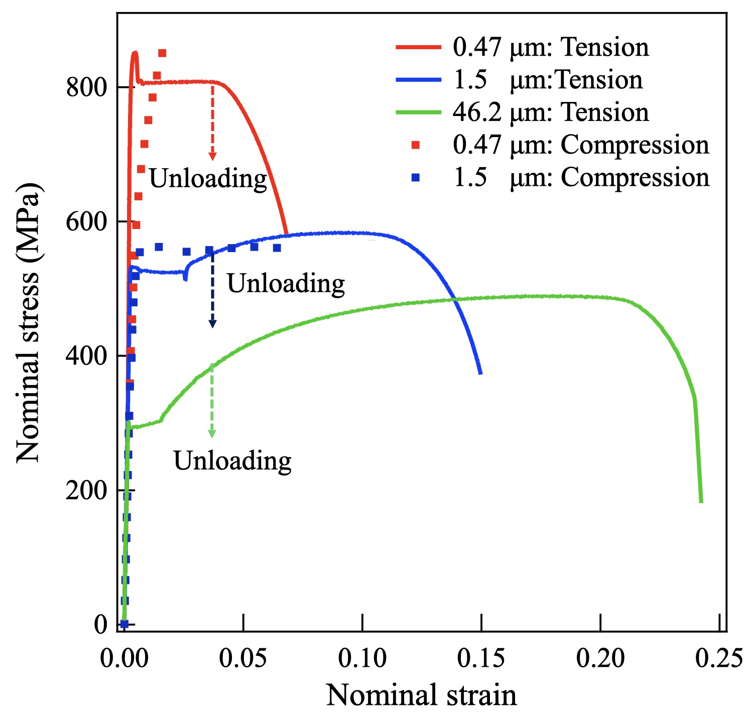
Fig. 4 Nominal stress-strain curves of tested steels.
$ε_{hkl}=\left(d_{hkl}-d_{hkl}^{0}\right)/d_{hkl}^{0}$ ------------------------------------ (1)
Figs. 6 and 7 show the changes in the <110> and <200> lattice strains during the tensile and compressive deformation of the 0.47 μm and 1.5 μm specimens, respectively. These two orientations were chosen to clearly demonstrate the trend of changes in <hkl> lattice strains with deformation: <110> oriented grains with respect to the tensile direction are elastically harder and preferentially deform plastically. On the other hand, <100> oriented grains are elastically the softest. Young’s modulus along <110> is much higher than that along <100> [3, 4], so the <110> oriented grains-family bears a higher stress in elastic deformation, leading to earlier yielding. Looking at the stress–strain curves of Fe single crystals reported by Keh [38], the work hardening rate in the <100> oriented crystal is much higher than that in the <110> oriented crystal. These are the main reasons for employing these two crystal orientations in order to discuss why the <hkl> lattice strains deviate from the relevant elastic lines after yielding.
Fig. 5 Diffraction profiles obtained for the 0.47 μm sample before loading: (a) loading direction and (b) transverse direction.
In Figs. 6a and 7a, the changes in$ε_{hkl}$in the tensile (load) and transverse (trans.) directions are plotted as a function of the external stress. The tensile deformation can be divided into four stages: (1) elastic deformation only, (2) microyielding, (3) Lüders deformation, and (4) uniform deformation (necking started before completion of the Lüders deformation in the 0.47 μm specimen). At stage (1), <hkl> lattice strains are proportional to the external stress, where their slopes are corresponding to their <hkl> elastic moduli. That is, the strain increases in the tensile direction reflecting Young’s modulus, whereas it decreases in the transverse direction reflecting Poisson’s effect with an increase in the applied stress. In stages (2) to (4), the plastic flow preferentially occurred in the <110> oriented grains-family compared with <200> and the misfit plastic strain between the <110> and <200> grains-families caused the <hkl> intergranular stresses/lattice strains. In the elastoplastic deformation regime of stages (2) to (4), the <200> lattice strain was always larger than that of <110> in the tensile direction. Here, the <hkl> intergranular strain can be determined from the deviation of the measured strain from the relevant elastic lines. As can be seen in case of tension for the tensile direction (Figs. 6a and 7a) , the <110> intergranular lattice strain is negative (see arrow “A” in Fig. 7a), whereas the <200> intergranular lattice strain is positive (“B”). Therefore, stress partitioning between the <110> and <200> oriented grains, i.e., the generation of the <hkl> intergranular lattice strain is experimentally observed in the fine-grained steels used in this study.
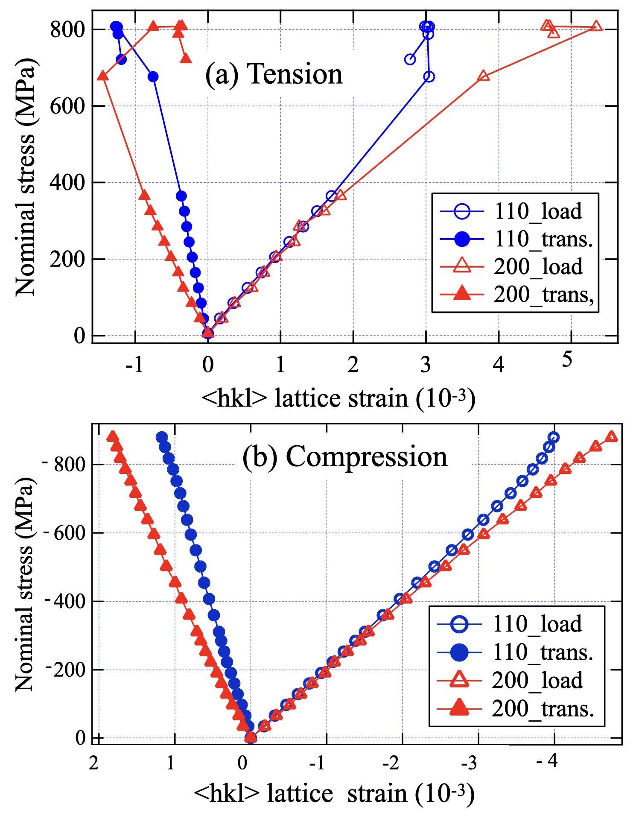
Fig. 6 Changes in <hkl> lattice strains with loading for the 0.47 μm specimen: (a) tension and (b) compression (note the directions of the vertical and abscissa axes).
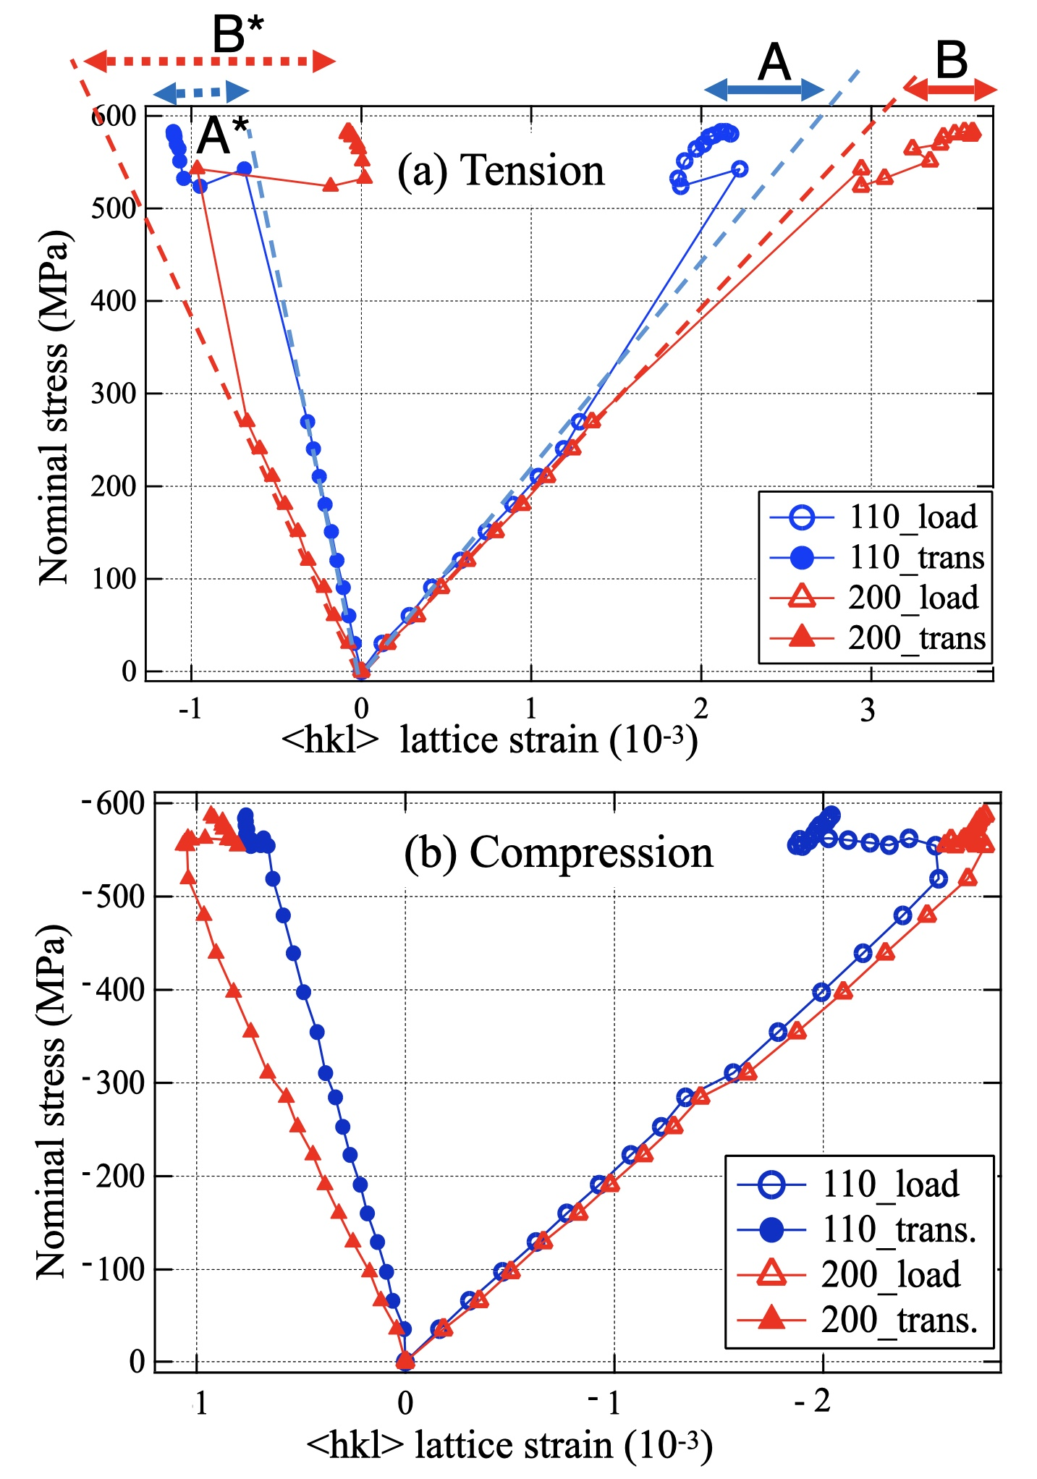
Fig. 7 Evolution of <hkl> lattice strains with loading for the 1.5 μm specimen: (a) tension and (b) compression (note the directions of the vertical and abscissa axes).
Figs. 6b and 7b show the results of the compression deformation. Note that the signs of the horizontal and vertical axes are opposite to those in Figs. 6a and 7a to easily compare the trends in the loading and transverse directions. The changes in the <hkl> lattice and intergranular strains are similar to those for the tensile deformation. Therefore, grain-ordered heterogeneous deformation behavior is observed in both tensile and compressive deformation. Initially, the relationship between the applied stress and the <hkl> lattice strain was linear, indicating a purely elastic deformation, and its slope corresponded to the “<hkl> diffraction elastic modulus”. In general, regarding the elastic inhomogeneity effect in a body-centered cubic (BCC) crystal, Young’s modulus along <110> is higher than that along <200> [3, 4], but these are very close in the present specimens. The data at the initial 10 tensile loading steps for the 0.47 μm specimen are replotted in Fig. 8 and linear fittings were made to determine the diffraction Young’s modulus (a) and the Poisson’s ratio (b). The determined values were compared with those of another ferritic steel (ultra-low-carbon (ULC) steel; see Fig. S1) with a weaker texture as shown in Table 1. Also presented in this table are the diffraction elastic moduli predicted by the Krӧner model, which is assumed to be texture-free. As can be seen, the results for the ULC steel determined by the same instrument and method are nearly identical to those calculated by the Krӧner model. Therefore, the results of the present 0.47 μm and 1.5 μm specimens are believed to be affected by their texture.
Although the deformation behavior of the present specimens was influenced by the texture, the deviation from the elastic deformation line, i.e., the generation of <hkl> intergranular lattice strain can be clearly recognized after the onset of plastic flow, as seen in Figs. 6 and 7. The amount of deviation is illustrated in Fig. 7a, labelled A and A* for <110> and B and B* for <200>, respectively. This deviation is believed to arise from the misfit plastic strain among grains in the polycrystalline material,
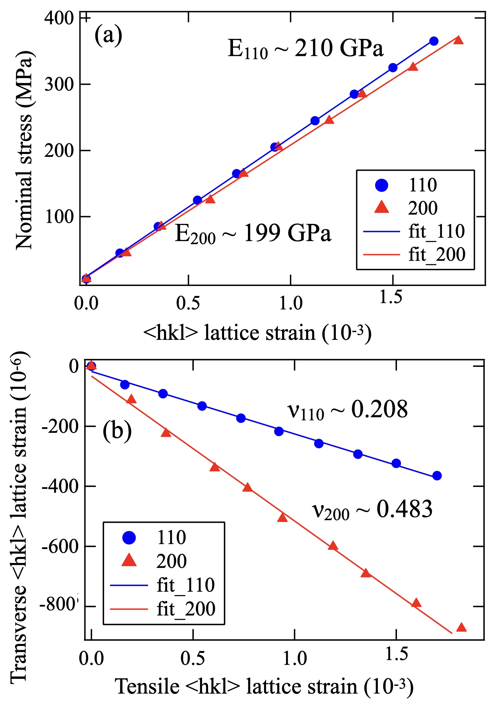
Fig.8 Determination of diffraction elastic moduli for the 0.47 μm specimen from the ND data obtained by tensile loading: (a) Young’s modulus and (b) Poisson’s ratio.
Table 1 Diffraction elastic moduli determined by neutron diffraction measurements for ferritic steels.
Sample  (grain size) | Diffraction Young’s modulus of hkl (GPa) |  | Diffraction Poisson’s ratio of hkl
Sample  (grain size) | 110 | 200 | 110 | 200
0.47 μm | 210.1 | 199.1 | 0.21 | 0.48
1.5 μm | 202.7 | 195.9 | 0.24 | 0.48
42.6 μm | 231.3 | 182.7 | 0.23 | 0.38
ULC* | 232.5 | 175.8 | 0.23 | 0.31
Krӧner model** | 222.5 | 173.3 | 0.28 | 0.33
* Unpublished work for an ultra low carbon steel by the present authors (see supplementary material)
**After Table 5.9 (p. 230) in M.T. Hutchings, P.J. Withers, T.M. Holden, T. Lorentzen: Introduction to the characterization of residual stress by neutron diffraction Taylor & Francis Co., (2004) [4].

which is postulated mostly to persist when unloaded; the residual <hkl> intergranular lattice strain. In the loading direction, the <200> lattice strain is higher than that extrapolated from the Young’s modulus line, whereas <110> is lower. Similar trends are found for the compression deformation. This implies that the plastic flow preferentially occurred in <110> oriented grains compared with <200> oriented grains, even during the Lüders deformation. In the case of continuous yielding, such strain partitioning occurs gradually with an increase in external stress [1], but in this case, it happened suddenly at the yielding. The absolute magnitude of the <110> lattice strain deviated to a smaller value from the relevant Young’s modulus line, indicating that the plastic flow preferentially takes place in these grains even during the Lüders deformation. Although the trend observed in the transverse direction looks complicated, it is basically similar to the elastic strain partitioning behavior observed in the case of continuous yielding. After completion of the Lüders deformation, both the <110> and <200> lattice strains increased with an increase in the applied stress, which is the same behavior observed in coarse-grained ferritic steels [39, 40].

- Discussion
4.1 Effect of grain size on <hkl> intergranular strain generated with plastic deformation
The <hkl> intergranular stress is considered to persist as residual stress after unloading. Here, the tensile loading and unloading flow curve and relevant <110> lattice strains for the 0.47 μm specimen are plotted in Fig. 9. As seen, the residual <110> intergranular lattice strain can be found after unloading. During unloading, its magnitude would decrease a little due to compressive plastic deformation, that is, Bauschinger effect. The detailed changes in the <hkl> lattice strains with unloading for the 0.47 μm specimen are shown in Fig. 10, where the data obtained at the step-unloading stages in Fig. 2b are plotted. The initial elastic deformation lines at the step-loading stages are also plotted to show the relevant elastic modulus. In Fig. 10a, the unloading line for <110> is parallel to that of the loading line, but a slight deviation from the elastic line is observed for <200>. This is believed to be caused by the backward plastic flow during unloading, i.e., the Bauschinger effect, which is obviously found in the <200> lattice strain. A similar deviation for <200> is confirmed in the transverse results. Such a sensitive change would be attributed to the low Young’s modulus for <100>.
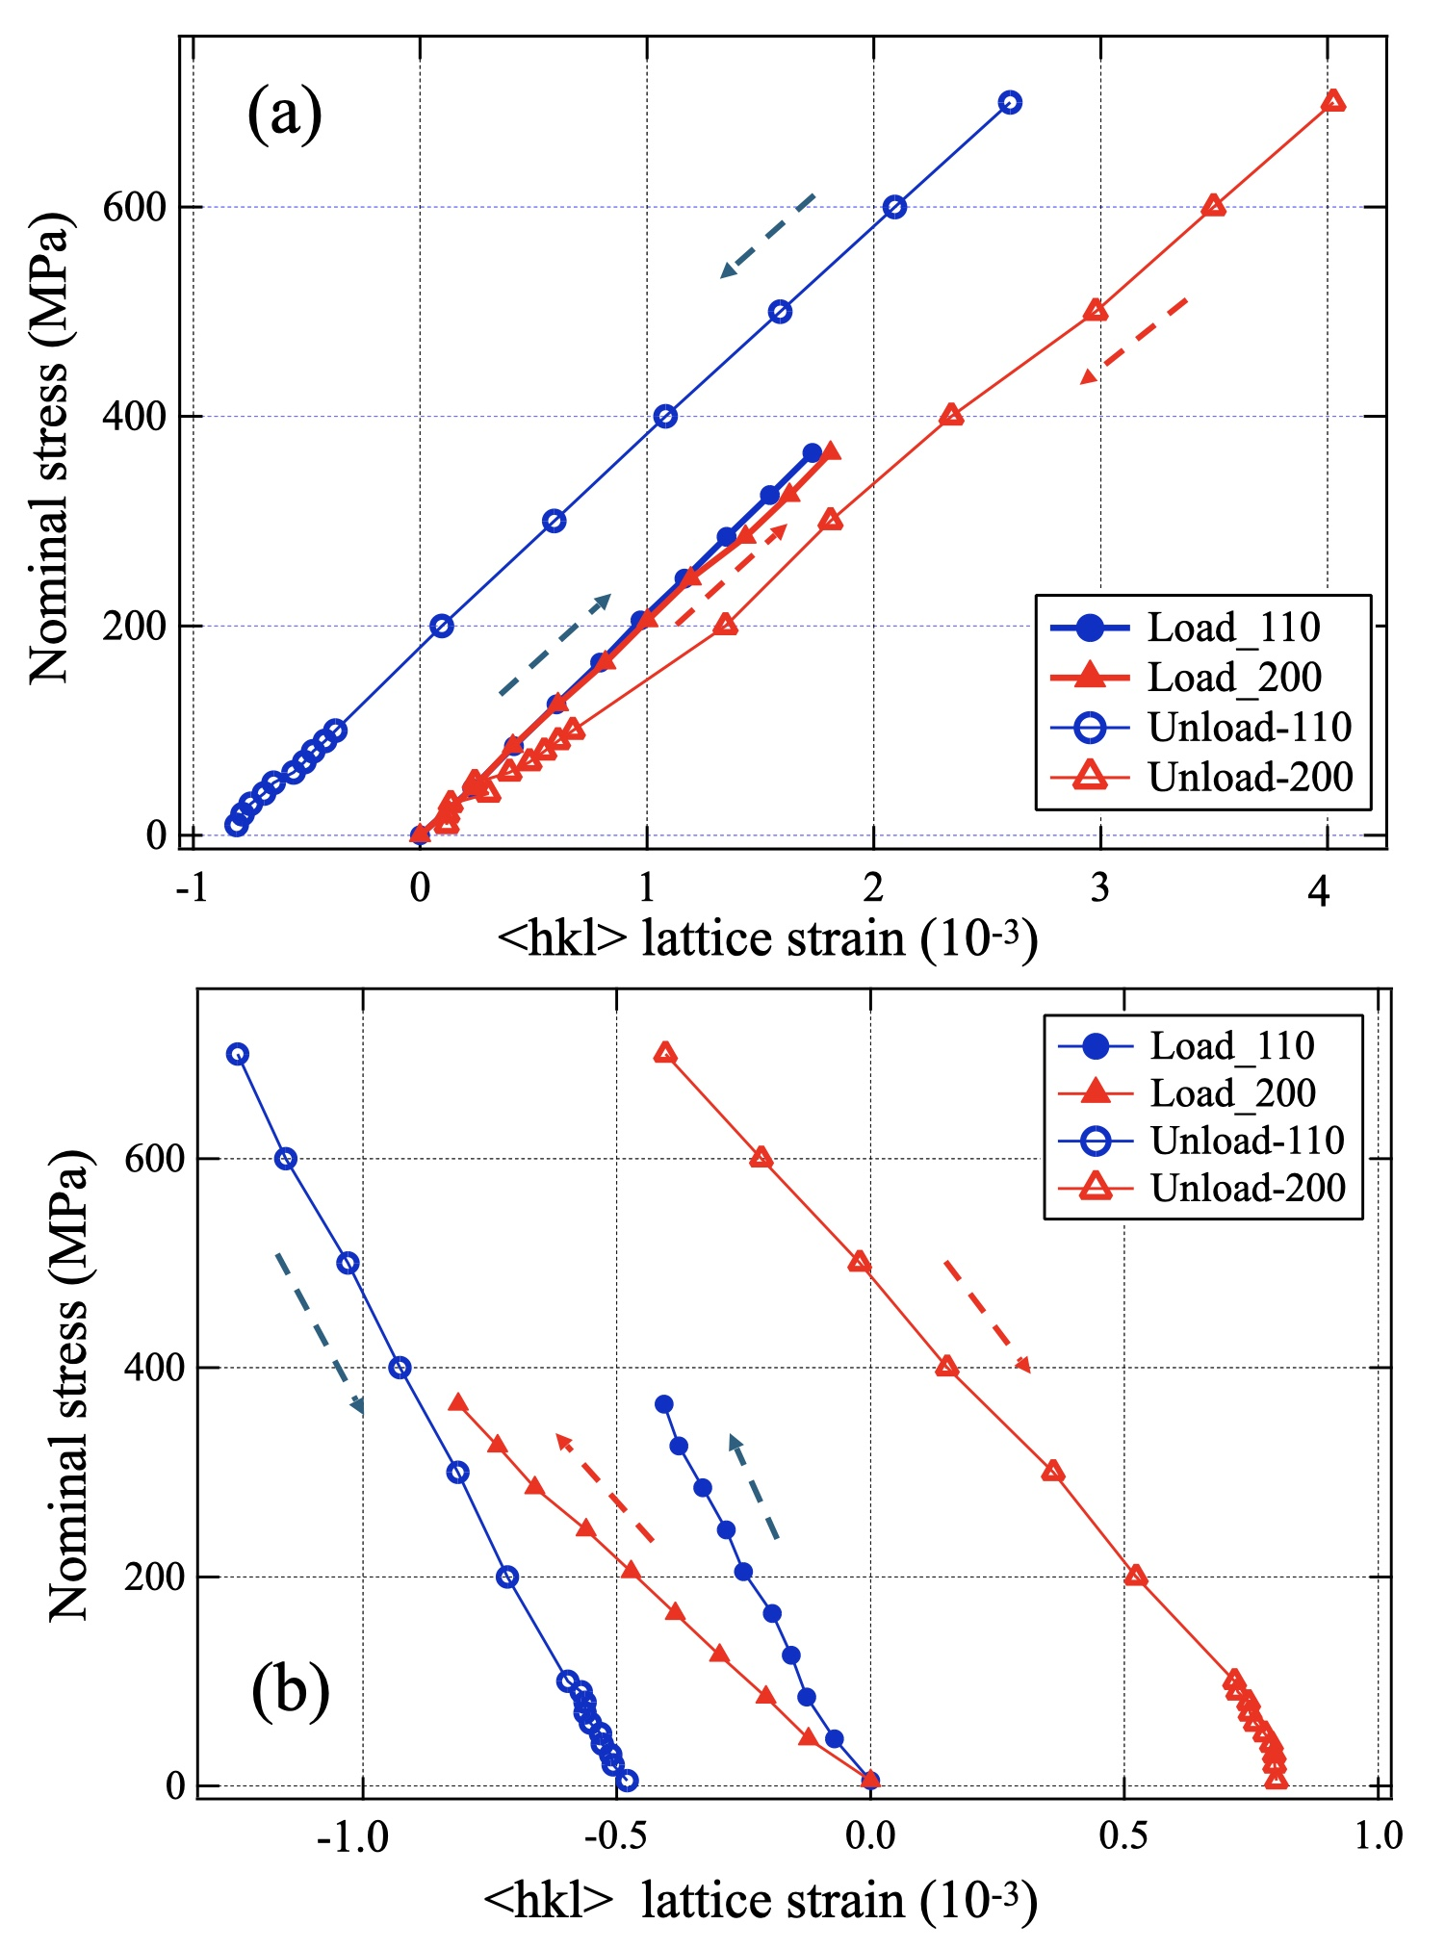
Fig. 10 Changes in <hkl> lattice strains during loading and unloading after 4% tensile straining for the 0.47 μm specimen: (a) tensile (loading) direction and (b) transverse direction.
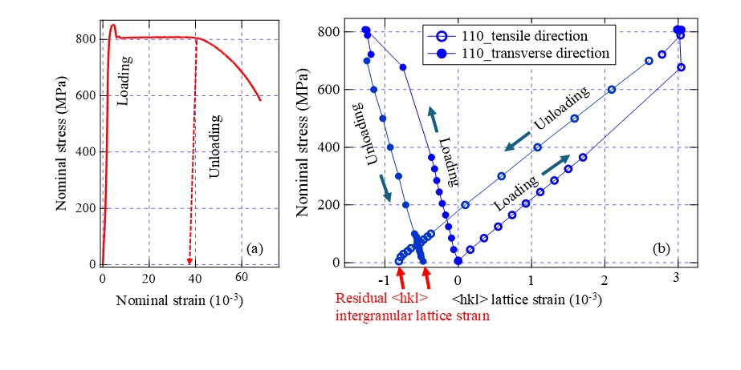Fig. 9 Changes in <hkl> lattice strain during tensile loading and unloading for the 0.47 μm specimen: (a) stress-strain curve and (b) changes in <110> lattice strain.
In order to compare the magnitude of the <hkl> intergranular stress, the tension-unloading test was additionally performed for the 46.2 μm specimen and the obtained results are presented in Fig. 11, in which (a) and (b) are the results obtained during loading and unloading, respectively. For simple comparison with literature data, the residual <110> intergranular lattice strain along the loading direction was employed as “representative value.” In some literatures, the residual strain was neither measured nor described. In such cases, the numerical value was estimated based on the deviation from the elastic line such as A, B in Fig. 7a. In Fig. 11a, the absolute value of the <110> intergranular lattice strain yielded in the loading direction was summarized as a function of the reverse square root of the grain size (d). Here, the data from literatures [32, 39–41] were also plotted with those of the present study. It was found that the absolute magnitude of the <110> intergranular lattice strain increases with a decrease in the grain size down to 0.47 μm. Since Adachi et al. [42] observed little deviation from a linear elastic line during the plastic deformation of their ultrafine grained IF steel, the absolute magnitude of the <hkl> intergranular lattice strain would decrease with further grain refinement, suggesting a change in the deformation mechanism from a dislocation slip to grain boundary sliding [43] or an unknown mechanism. Zheng et al. reported that grain boundary sliding occurred in ultrafine-grained Mg at 298 K (room temperature) resulting in the inverse Hall–Petch relationship below a grain size of 0.6 μm [44, 45]. Interestingly, such grain boundary sliding was suppressed at 77 K, maintaining the normal Hall–Petch relationship [6, 7] even in ultrafine-grained Mg with a grain size of 0.6 μm [45]. They also measured the residual <hki,l> intergranular lattice strain along the loading direction after tensile straining by ND and found that the absolute magnitude of the <hki,l> intergranular lattice strain was larger in the 0.6 μm Mg than in the 2.5 μm Mg at 77 K. Contrary to the case of the 77 K deformation, the absolute magnitude was much smaller in the 0.6 μm Mg at 298 K compared with that in the 2.5 μm Mg [45]. In other words, the introduction of grain boundary sliding results in a decrease in the absolute value of the <hkl> intergranular lattice strain as suggested by the dashed line in Fig. 12a. The transition grain size must be different in the Mg and the present steel, influenced by the normalized test temperature (T/Tm, where T is the testing temperature and Tm is the melting temperature), strain rate, and chemical composition. To check the Hall–Petch relationship for the studied steel, the yield strengths are plotted as a function of d^{−0.5} in Fig. 12b, in which the slope shows a similar value reported for general ferritic steels [46–48]. This suggests that the 0.47 µm specimen deformed plastically by dislocation motion, suggesting that the transition of the deformation mechanism would occur at a smaller grain size for the present steel. To date, plastic deformation of polycrystal materials has been understood in terms of micromechanics models and crystal plasticity finite element method (CP-FEM) simulations based on slip deformation, in which the effect of the grain size has not been directly discussed. In the case of ultrafine-grained materials with a grain size of around 1 μm investigated in the present study, these models or computations would require modification; the absorption of dislocations into the grain boundaries and further evaluation of high <hkl> intergranular stresses need to be taken into consideration. The <hkl> intergranular stress is considered to result in the transient softening in the Bauschinger tension–compression test. That is, the Bauschinger effect suggests the magnitude of <hkl> intergranular stress as indirect experimental evidence. Bouaziz and Aouafi measured the Bauschinger effect in a ferritic steel having grain sizes ranging from 22.5 to 3.5 μm using a forward-reverse shear test and found that the back stress increased when the grain size of the material decreased [49]. The grain size dependence of the Bauschinger effect in pure Al was qualitatively discussed in terms of the back stress arising from the formation of a dislocation pile-up against the grain boundary during plastic deformation reported by Gao et al. [50]. They changed the grain size from 6.0 to 0.56 μm and concluded that the smaller the grain size becomes, the larger the back stress. These results support the conclusion of this paper: the <hkl> intergranular stress becomes larger with a decrease in the grain size down to approximately 0.5 μm.
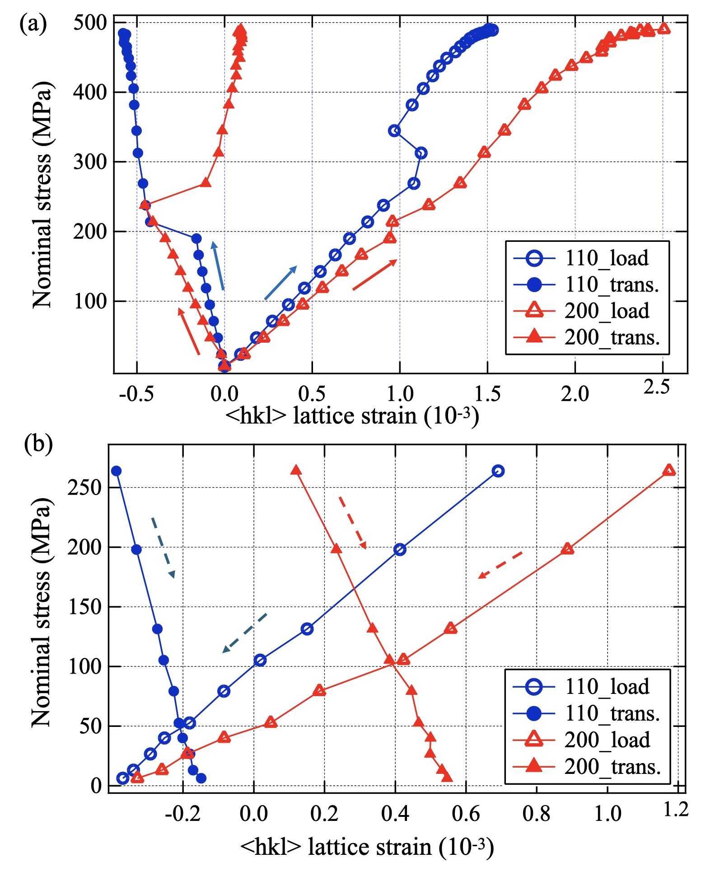
Fig. 11 Evolution of <hkl> lattice strains with tensile loading (a) and unloading (b) after deformation of 4% for the 42.6 μm specimen.
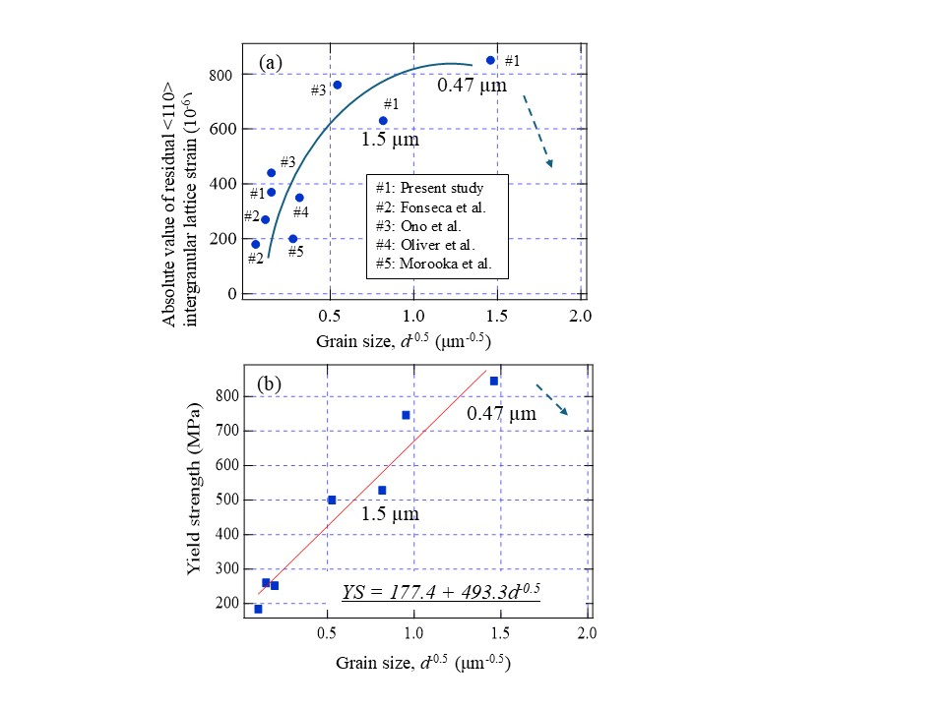
Fig.12 Effects of grain size on (a) the absolute magnitude of residual <110> intergranular lattice strain along the loading direction after tensile straining of 4% and (b) yield strength which were measured for the present steel heat-treated variously to change the ferrite grain size [30-32]. The occurrence of grain boundary sliding below a critical grain size would change the trends as illustrated by arrows.

4.2 Dislocation densities in plastically deformed specimens
To confirm the occurrence of slip by dislocation in the 0.47 μm specimen, the diffraction profiles obtained before and after 4% tensile straining were analyzed using CMWP fitting method and an example of fit results is presented in Fig. 13. The intensity was plotted logarithmically, so that tiny peaks for the cementite phase were found before the deformation in (a), whereas the peaks were scarcely observed after the deformation in (b). The 110 intensity is found to increase with tensile deformation, suggesting crystal rotation associated with dislocation motion. Because the 411 and 330 peaks overlapped each other, the fitting was performed for 8 peaks from 110 to 400. The dislocation density and crystallite size determined by fitting are presented in Table 2. As seen, the dislocation density increased slightly, and the crystallite size decreased due to tensile deformation. Similar results were obtained for the 1.5 μm specimen. Because the diffraction profiles were influenced by the texture and a
Table 2 Dislocation densities determined by the CMWP fitting for neutron diffraction profiles and TEM observations and crystallite sizes by the CMWP fitting for three specimens before and after 4% tensile deformation.
Fig. 13 Results of CMWP fitting for diffraction profiles in the tensile direction obtained for the 0.47 μm specimen: (a) before deformation and (b) after 4% deformation.
Sample, condition | Dislocation density (nm⁻²) |  | Crystallite size  (nm)
Sample, condition | CMWP | TEM | Crystallite size  (nm)
1.5 μm, before | 0.000309 | 0.000167 | 275.8
1.5 μm, deformed | 0.000415 | 0.000297 | 59.3
0.47 μm, before | 0.000346 | 0.000280 | 113.5
0.47 μm, deformed | 0.000632 | 0.000115 | 46.2

small amount of cementite, a more sophisticated fitting technique is required for a precise evaluation. However, the present results indicate that the deformation mechanism in the present specimens was basically dislocation motion accompanying large <hkl> intergranular stress generation and crystal rotation. Adachi et al. [16] studied the change in dislocation density during tensile deformation by in situ synchrotron X-ray diffraction using an ultrafine-grained copper prepared by sever deformation. According to their results, the dislocation density decreased at the beginning of the tensile deformation, then increased slightly, and then remained nearly constant; that is, it hardly changed during the deformation.
Fig. 14 shows dislocation microstructures observed by TEM for specimens before deformation and after 4% tensile deformation in the 1.5 μm and 0.47 μm specimens. In Fig. 14b (1.5 μm), dislocation cells are likely to be formed by the arrangements of dislocations during plastic deformation, which is not found in Fig. 14d (0.47 μm). To quantify the misorientation within these dislocation cells, Kernel Average Misorientation (KAM) maps of the two specimens after Vickers indentation are presented in Fig. 15, where (a) shows that the misorientation across the dislocation cell walls is typically less than 2 degrees. In Fig. 14d, dislocations are concentrated in the vicinity of grain boundaries, suggesting the existence of locally high internal stress field. Such characteristic characters are reported by the present authors by in situ TEM observations for an ultrafine grained IF steel prepared by the ARB process [51], in which dislocation absorption into grain boundaries was directly observed. Dislocation densities calculated as the number of intersection points divided by the total length of the random lines [52] are tabulated in Table 2. The values are a little smaller than those estimated by CMWP for ND profiles. The above mentioned in situ TEM observation during compressive loading revealed that the preexisting dislocations moved towards the grain boundaries and were absorbed there. After that, new dislocations were emitted from a grain boundary and travelled to the opposite boundary. Fig. 14 suggests that the plastic relaxation in the vicinity of grain boundaries becomes harder with decreasing grain size, resulting in generation of higher <hkl> intergranular stress. Ashby proposed a work hardening mechanism employing the concept of statistical dislocation density, $ρ_{s}$, and GN dislocation density, $ρ_{G}$, for dispersion-hardened crystals [53], claiming that the long-range internal stress generated by the primary slip is relaxed by the secondary slip from the very beginning of the deformation and that dislocation–dislocation interaction becomes the main origin of the work hardening at higher strains (larger than 1%). Afterwards, he expanded this idea to general plastically nonhomogeneous materials including polycrystal single-phase alloys [54]. Mughrabi proposed two roles that the GN dislocations accompany: misorientation and/or long-range internal stress [55]. Hirth pointed out the complicated roles of grain boundaries for interaction with dislocations as a barrier to dislocation motion (dislocation pile-up), sink, and source of emission [56]. Several studies have theoretically and/or experimentally discussed the interaction between dislocations and grain boundaries [57–60]. Zhang et al. [61] proposed that most grain boundaries in nanocrystalline materials contain lattice dislocations with a high density. Therefore, the deformation mechanism of ultrafine-grained material is still unclear. The present study offers experimental evidence that the absolute magnitude of <hkl> intergranular stress induced by plastic deformation in low-carbon steel increases with a decrease in the grain size down to at least 0.47 μm. When grains are smaller, dislocation motion in the vicinity of grain boundaries becomes more constrained. This reduced ability to accommodate plastic strain leads directly to the buildup of higher intergranular strains/stresses. The present experimental results would support this explanation as follows:
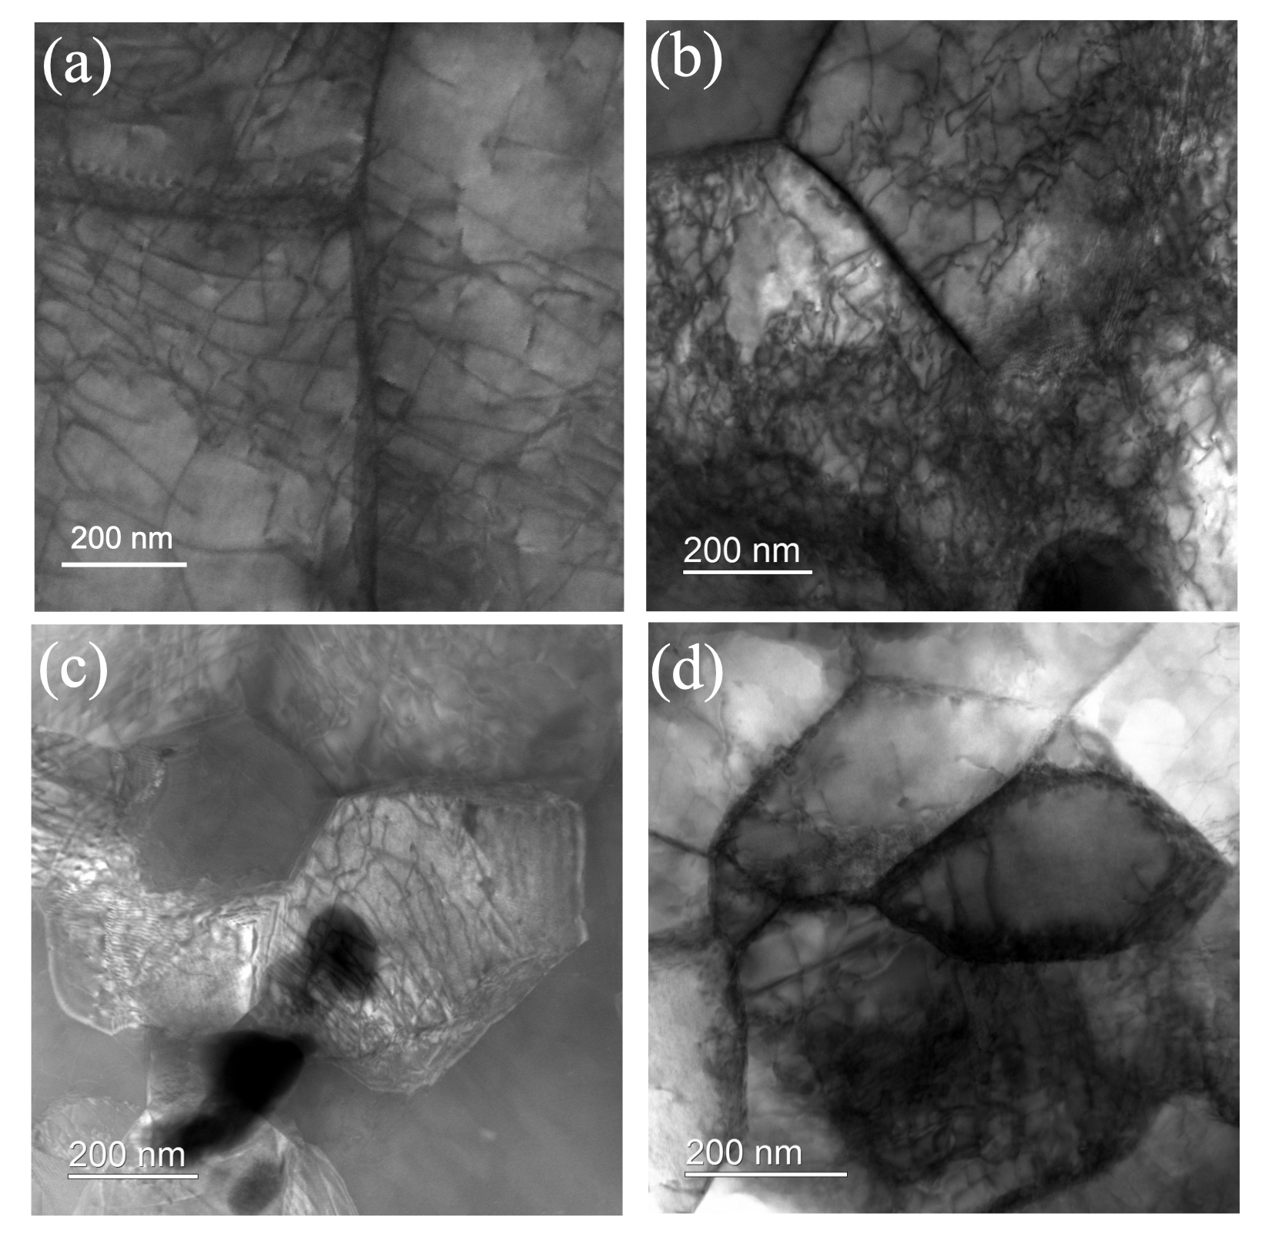
Fig. 14 Scanning Transmission Electron Microscopy (STEM) micrographs acquired in Low-Angle Annular Dark-Field (LAADF) mode, illustrating the microstructure of the specimens before and after 4% tensile deformation. (a) 1.5 μm grain size, undeformed; (b) 1.5 μm grain size after 4% tensile deformation; (c) 0.47 μm grain size, undeformed; (d) 0.47 μm grain size after 4% tensile deformation.
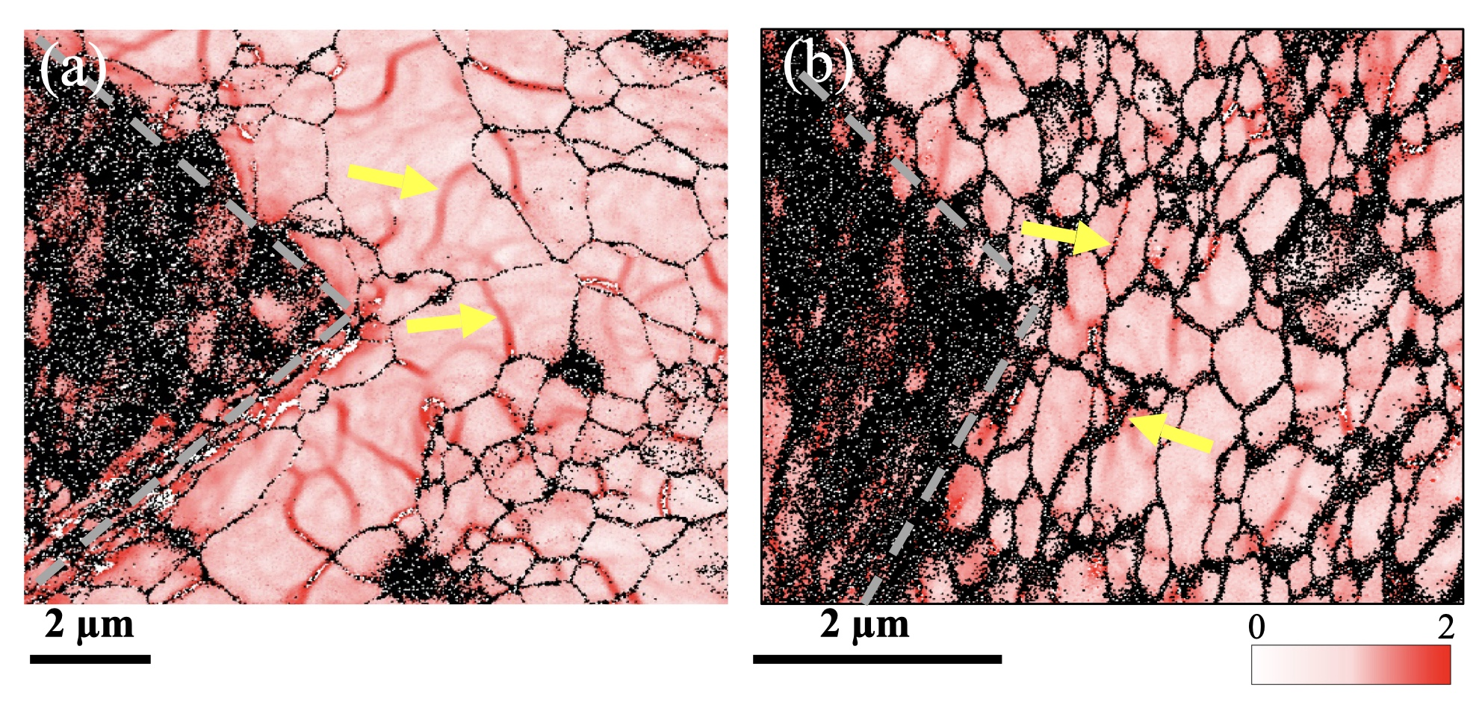
Fig. 15 Kernel Average Misorientation (KAM) maps of two specimens with average grain sizes of 1.5 μm (a) and 0.47 μm (b), obtained after Vickers indentation. The color scale represents local misorientation angles ranging from 0° to 2°, indicating the degree of plastic deformation and geometrically necessary dislocation (GND) density. The dashed line outlines the shape of the indenter mark.
(1) Dislocation density: As found in Table 2, CMWP fitting results show an increase in overall dislocation density (including both grain interiors and boundaries) with deformation. In contrast, TEM observations indicate a decrease in observable dislocation density within the grain interiors for the 0.47 μm specimen after deformation (Fig. 14c and 14d). This apparent contradiction highlights a key mechanism: in smaller grains, dislocations are more readily absorbed and stored at the grain boundaries.
(2) Geometrically Necessary Dislocations (GNDs): In KAM maps of the two specimens after Vickers indentation shown in Fig. 15, the 0.47 μm specimen exhibits a higher density of GNDs at its grain boundaries. GNDs are crucial for accommodating lattice curvature and strain gradients, especially near interfaces. A higher GND density at grain boundaries directly implies greater strain incompatibilities between neighboring grains and that dislocation motion is more severely constrained in these regions. This indicates that plastic deformation cannot easily proceed locally, making strain/stress relaxation more difficult.
It has been reported that the drastic change in mechanical properties with a change in the grain size is observed below approximately 1.0 μm [62–65], where the interaction between dislocations and grain boundaries becomes a key issue for elucidating the underlying mechanism. Many TEM observations have suggested the triple roles of grain boundaries in terms of interactions with dislocations: barriers against dislocation motions, sinks, and emissions for dislocations. In 1972, Hirth published a comprehensive review on “boundaries as sources and sinks for dislocations” [56]. Grain boundary dislocations can act as sources for lattice dislocations by 1/3[111]_{gb} = 1/2[110] + 1/6[-1-12]_{gb} where “gb” refers to the grain boundary in a body-centered cubic (BCC) alloy. Many simulations using molecular dynamics (MD) have been developed to elucidate the interaction between grain boundaries and dislocations [66, 67]. Zhang et al. reported that most grain boundaries contain lattice dislocations with a high density in plastically deformed alloys based on the results of high-resolution TEM observation, X-ray line broadening analysis, and MD simulation [61]. Hence, it is important to revisit the deformation behavior of ultrafine-grained ferritic steel with a ferrite grain size of around 1.0 μm, paying attention to the interaction between the dislocations and grain boundaries, and the <hkl> intergranular stress. Adachi et al. [42, 68] reported that <hkl> intergranular lattice strains were hardly observed by in situ ND during the tensile deformation of an IF steel with a grain size of 0.32 μm prepared by high-pressure torsion. According to a report by Cheng et al. [43], no detectable <hkl> intergranular lattice strains were found by in situ ND during the tensile deformation of nanocrystalline copper suggesting that the plastic deformation mechanism changes with a decrease in the grain size down to several tens of nanometers. Thus, the grain size dependence of the intergranular stress in a plastically deformed alloy is now open for discussion.

4. Conclusions
The uniaxial deformation behavior of low-carbon steel with a grain size of approximately 1 μm was investigated using in situ neutron diffraction (ND) during both tensile and compressive loading. The study focused on the evolution of <hkl> intergranular lattice strain (stress). The main findings are summarized as follows.
(1) The evolution of <hkl> intergranular lattice strains during plastic deformation was confirmed in specimens with grain sizes of 0.47 μm and 1.5 μm under both tension and compression loading conditions using ND.
(2) The absolute magnitude of the residual <110> intergranular lattice strain after 4% tensile strain in ultrafine-grained specimens was greater than in coarse-grained counterparts, suggesting that plastic relaxation near grain boundaries becomes increasingly constrained as grain size decreases.
(3) Transmission electron microscopy observations showed the influence of grain size on dislocation structure developed by plastic deformation. The interaction between dislocations and grain boundaries including dislocation-absorption into grain boundaries must be related with the underlying mechanism.

CRediT authorship contribution statement
Yo Tomota: Writing – original draft, Methodology, Investigation, Formal analysis, Conceptualization. Hongxing Li : Methodology, Investigation, Conceptualization. Writing – review & editing Noriyuki Tsuchida: Writing – review & editing, Methodology, Sample preparation. Wu Gong: Writing – Writing – review & editing, Methodology. Stefanus Harjo: Writing – review & editing, Methodology, Investigation. Takahito Ohmura: Writing – review & editing.

Data availability
Data will be made available on request.

Declaration of Competing Interest
The authors declare that they have no known competing financial interests or personal relationships that could have appeared to influence the work reported in this paper.

Acknowledgements
The steel samples used in this study were prepared at the National Institute of Materials Science (NIMS). The ND measurements were performed by the J-PARC MLF program (2012P0102 and 2014P0102). We would like to thank Prof. Y. Todaka of Toyohashi University of Technology for helpful discussion and Mr. A. Sugawara (student at Ibaraki University) for his experimental assistance.

References
[1] B. Clausen, T. Lorentzen, T. Leffers, Self-consistent modelling of the plastic deformation of f.c.c. polycrystals and its implications for diffraction measurements of internal stresses, Acta Mater., 46(1998), 3087-3098.
[2] J.W. Hutchinson, Elastic-plastic behavior of polycrystalline metals and composites, Proc. Roy. Soc. Lond., A319 (1970), 247-272.
[3] M.E. Fizpatrick, A. Lodini, Analysis of Residual Stress by Diffraction using Neutron and Synchrotron Radiation, (2003) , Taylor & Francis.
[4] M.T. Huchings, P.J. Withers, T.M. Holden. T. Lorentzen, Introduction to the Characterization of Residual Stress by ND, CRC Press, Taylor & Francis, New York, (2005).
[5] H.H. Fu, D.J. Benson, M.A. Meyers, Analytical and computational description of effect of grain size on yield stress of metals, Acta Mater., 49(2001), 2567-2582.
[6] E. O. Hall, The deformation and ageing of mild steel: III discussion of results, Proc. Phys. Soc. London. B 64 (1951) 747-753.
[7] N. J. Petch, The cleavage strength of polycrystals, Iron Steel Inst. 174 (1953) 25-28.
[8] C.W. Sinclair, W.J. Poole, Y. Bre´chet, A model for the grain size dependent work hardening of copper, Scripta Mater., 55 (2006) 739–742
[9] M. Umezaki, Y. Murata, K. Nomura, K. Kubushiro, Quantitative analysis of dislocation density in an austenitic steel after plastic deformation, J. Japan Inst. Met. Mater., 78(2014), 218-224.
[10] M. Ojima, Y. Adachi, S. Suzuki, Y. Tomota, Stress partitioning behavior in a FCC alloy evaluated by in situ / ex situ EBSD-Wilkinson method, Acta Mater., 59(2011), 4177-4185
[11] J. Jiang, T.B. Britton, A.J. Wilkinson, Mapping type III intergranular residual stress distributions in deformed copper polycrystals. Acta Mater., 61(2013), 5895-5904.
[12] F. Roters, P. Eisenlohr, L. Hantcherli, D.D. Tjahjanto, T.R. Bieler, D. Raabe, Overview of constitutive laws, kinematics, homogenization and multiscale methods in crystal plasticity finite-element modeling: Theory, experiments, applications, Acta Mater., 58 (2010), 1152-1211.
[13] T. Nakada, M. Nishiyama, N. Koga, T. Tsuchiyama, S. Takaki, Hierarchical Strain Distribution Analysis Formed in DP Steel Using a Combination of Metallographic Image and Digital Image Correlation Method, Tetsu-to-Hagané, 100(2014), 1238-1245.
[14] I. Gutierrez-Urrutia, D. Raabe, Dislocation density measurement by electron channeling contrast imaging in a scanning electron microscope, Scripta Mater., 66(2012), 343-346.
[15] For example, JSME-SD-5-02: The standard of X-ray residual stress measurements, (2002), Jpn Soc. Mater, Sci. (in Japanese).
[16] H. Adachi, Y. Miyajima, M. Sato, N. Tsuji, Evaluation of dislocation density for 1100 aluminum with different grain size during tensile deformation by using in-situ X-ray diffraction technique, Mater. Trans., 56(2015), 671-678.
[17] Y. Hayashi, D. Setoyama, Y, Hirose, T. Yoshida, H. Kimura, Intragranular three-dimensional stress tensor fields in plastically deformed polycrystals, Science, 366(2019), 1492-1496.
[18] N. Hansen, X. Huang, Microstructure and flow stress of polycrystals and single crystals, Acta Mater., 46(1998), 1827-1836.
[19] X. Huang, A. Borrego, W. Pantleon, Polycrystal deformation and single crystal deformation: dislocation structure and flow stress in copper, Mater. Sci. Eng. A., 319–321 (2001) 237–241.
[20] X. Huang, G. Winther, Dislocation Structures. Part 1. Grain Orientation Dependence, Phil. Mag., 87(2007), 5189-5214.
[21] T. Ungár, J. Cubicza, G. Ribárik, A. Borbély, Crystallite size distribution and dislocation structure determined by diffraction profile analysis: principles and practical application to cubic and hexagonal crystals, J. Appl. Cryst., 34 (2001) 298-310.
[22] G. Ribárik, T. Ungár, Characterization of the microstructure in random and textured polycrystals and single crystals by diffraction line profile analysis, Mater. Sci. Eng. A, 528 (2010) 112-121.
[23] T. Ungár, A.D. Stoica, G. Tichy, X.L.Wang, Orientation-dependent evolution of the dislocation density in grain populations with different crystallographic orientations relative to the tensile axis in a polycrystalline aggregate of stainless steel, Acta Mater., 66(2014), 251-261.
[24] Y. Tomota, M. Ojima, S. Harjo, W. Gong, S. Sato, T. Ungár, Dislocation densities and intergranular stresses of plastically deformed austenitic steels, Mater. Sci. Eng. A, 743, (2019), 32-39.
[25] J. Quinta da Fonseca, E.C. Oliver, P.S. Bate, P.J. Withers, Evolution of intergranular stresses during in situ straining of IF steel with different grain sizes, Mater. Sci. Eng. A, 437(2006), 26-32.
[26] N. Tsuchida, Y. Tomota, K. Nagai, Tensile properties obtained by static tensile tests in ultrafine-grained ferrite-cementite steels, Tetsu-to-Hagané, 89(2003), pp.1170-1177.
[27] N. Tsuchida, Y. Tomota, K. Nagai, Tensile deformation behavior at high strain rate for ultrafine-grained ferrite-cementite steels, Tetsu-to-Hagané, 90(2004), 1043-1049.
[28] N. Tsuchida, H. Masuda, Y. Harada, K. Fukaura, Y. Tomota, K. Nagai, Effect of ferrite grain size on tensile deformation behavior of a ferrite-cementite low carbon steel, Mater. Sci. Eng. A, 488(2008), 446-452.
[29] N. Tsuchida, K. Fukaura, K. Nagai, Y. Tomota, Mechanical Properties Predictions of Ferrite-Cementite Steels with Various Ferrite Grain Sizes using the Kocks-Mecking Model, ISIJ Int., 48-7(2008), pp.1020-1025.
[30] N. Tsuchida, T. Ono, Y. Tomota, K. Nagai, Effect of temperature, strain rate and ferrite grain size on tensile flow stress for ferrite-pearlite steel, Trans. Japan Soc. Mech. Eng. A, 68-675(2002), 1547-1552.
[31] N.Tsuchida, Y.Tomota, K. Nagai:, High-Speed Deformation for an Ultrafine-Grained
Ferrite-Pearlite Steel, ISIJ Int., 42 (2002), 1594-1596.
[32] T. Ono, Y. Tomota, P. Lukas, D. Lugovvy, D. Neov, N. Tsuchida, K. Nagai, In Situ ND during Tensile Straining of a Fine-Grained Ferrite-Pearlite Steel, Mater. Sci. Technology，20(2004),121-125.
[33] A. Moriai, S. Torii, H. Suzuki, S. Harjo, Y. Morii, M. Arai, Y. Tomota, T. Suzuki, Y. Akiniwa, H. Kimura, K. Akita, Development of engineering diffractometer at J-PARC, Physica B, 385-386(2006) 1043-1045.
[34] S. Harjo, T. Ito, K. Aizawa, H. Arima, J. Abe, A. Moriai, T. Iwahashi, T. Kamiyama, Current status of engineering materials diffractometer at J-PARC, Mater. Sci. Forum, 681(2011). 443-448. http://dx.doi.org/10.4028/www.scientific.net/MSF.681.443
[35] R. Oishi, M. Yonemura, Y. Nishimaki, S. Torii, A. Hoshikawa, T. Ishigaki, T. Morishima, K. Mori, T. Kamiyama, Rietveld analysis software for J-PARC, Nucl. Instruments and Methods Phys. Sect. A 600 (2009) 94-96.
[36] R. Oishi-Tomiyasu, M. Yonemura, T. Morishima, A. Hoshikawa, S. Torii, T. Ishigaki, T. Kamiyama, Application of matrix decomposition algorithms for singular matrices to the Pawley method in Z-Rietveld, J. Appl. Cryst., 45 (2012) 299-308.
[37] N. Tsuchida, Y. Tomota, K. Nagai, K. Fukaura, A simple relationship between Lüders elongation and work-hardening rate at lower yield stress, Scripta Mater., 54(2006), 57-60.
[38] A.S. Keh, Work Hardening and Deformation Sub-structure in Iron Single Crystals Deformed in Tension at 298K, Phil. Mag., 12(1965), 9-30.
[39] E.C. Oliver, M.R. Daymond, P.J. Withers, Interphase and intergranular stress generation in carbon steels, Acta Mater., 52(2004), 1937-1951.
[40] J.Q. da Fonseca, E.C. Oliver, P.S. Bate, P.J. Withers, Evolution of intergranular stresses during in situ straining of IF steel with different grain size, Mater. Sci. Eng. A, 437(2006), 26-32.
[41] S. Morooka, Y. Tomota, T. Kamiyama, Heterogeneous Deformation Behavior Studied by In Situ Neutron Diffraction during Tensile Deformation for Ferrite, Martensite and Pearlite Steels, ISIJ Int., 48(2008), 525-530.
[42] N. Adachi, H. Sato, Y. Todaka, T. Suzuki, Mechanical properties and plastic deformation behavior of severely deformed pure Fe, Procedia Manufacturing, 15(2018), 1495-1505.
[43] S. Cheng, A. D. Stoica, X.-L. Wang, Y. Ren, J. Almer, J. A. Horton, C. T. Liu, B. Clausen, D. W. Brown, P. K. Liaw, L. Zuo:, Deformation Crossover: From Nano- to Mesoscale, Phys. Rev. Lett., 103, 035502 (2009) DOI:https://doi.org/10.1103/PhysRevLett.103.035502.
[44] R. Zheng, J.P. Du, S. Gao, H. Somekawa, S. Ogata, N. Tsuji, Transition of dominant deformation mode in bulk polycrystalline pure Mg by ultra-grain refinement down to sub-micrometer, Acta Mater. 198 (2020) 35–46
[45] R. Zheng, W. Gong, J.P. Du, S. Gao, M. Liu, G. Li , T. Kawasaki, S. Harjo, C. Ma, S. Ogata, N. Tsuji, Rediscovery of Hall-Petch strengthening in bulk ultrafine grained pure Mg at cryogenic temperature: A combined in-situ neutron diffraction and electron microscopy study, Acta Mater., 238(2022), 118243.
[46] R.W. Armstrong, 60 Years of Hall-Petch: Past to Present Nano-Scale Connections, Mater. Trans., 55 (2014), 2–12.
[47] K. Takeda, N. Nakada, T. Tsuchiyama, S. Takaki, Effect of interstitial elements on Hall-Petch coefficient of ferritic iron, ISIJ Int., 48(2008), 1122-1125.
[48] S. Takaki, D. Akama, N. Nakada, T. Tsuchiyama, Effect of grain boundary segregation of interstitial elements on Hall-Petch coefficient (overview), Mater. Trans., 55(2014), 28-34.
[49] O. Bouaziz, A. Aouafi, S. Allain, Effect of grain refinement on the mechanical behaviour of steels: Evolution of isotropic hardening and kinematic hardening, Mater. Sci. Forum, 584 (2008) 605–609.
[50] S. Gao, K. Yoshino, D. Terada, Y. Kaneko, N. Tsuji, Significant Bauschinger effect and back stress strengthening in an ultrafine graine d pure aluminum fabricate d by severe plastic deformation process, Scripta Mater., 211 (2022) 114503.
[51] H,G. Li, S. Gao, Y. Tomota, S. Ii, N. Tsuji, T. Ohmura, Mechanical response of dislocation interaction with grain boundary in ultrafine-grained interstitial free steel, Acta Mater., 206 (2021), 116621, https://doi.org/10.1016/j.actamat.2021.116621
[52] D.M. Norfleet, D.M. Dimiduk, S.M. Polasik, M.J.Mills Uchic, Dislocation structures and their relationship to strength in deformed nickel microcrystals, Acta Mater., 56(2008), 2988-3001.
[53] M.F. Ashby, Work hardening of dispersion-hardened crystal, Phil. Mag., 14(1966), 1157-1178.
[54] M.F. Ashby, The deformation of plastically non-homogenous materials, Phil. Mag., 21(1970), 399-424.
[55] H. Mughrabi, Dual role of deformation-induced geometrically necessary dislocations with respect to lattice plane misorientations and/or long-range internal stresses, Acta Mater., 54(2006), 3417-3427.
[56] J.P. Hirth, The influence of grain boundaries on mechanical properties, Metall. Trans., 3(1972), 3047-3067.
[57] M. Kato, Thermally activated dislocation depinning at grain boundary in nanocrystalline and ultrafine-grained materials, Mater. Sci. Eng. A, 516(2009), 276-282.
[58] Y. Aoyagi, T. Tsuru, T. Shimokawa, Crystal plasticity modeling and simulation considering the behavior of dislocation source of ultrafine-grained metal, Int. J. Plasticity, 55(2014), 43-57.
[59] V. Borovikov, M.I. Mendelev, A.H. King, Effect of grain boundary disorder on dislocation emission, Materials Letters, 237(2019), 303-305.
[60] C.H. Hung, Y. Bai, N. Tsuji, M. Murayama, Grain size altering yielding mechanisms in ultrafine grained high-Mn austenitic steel: Advanced TEM investigation, J. Mater. Sci. & Tech.,86(2021), 192-203.
[61] Z. Zhang, E. Odor, D. Franks, B. Joni, G. Ribarik, G. Tichy, S.H. Nandam, J. Nisenk, M. Preuss, T. Ungar, Dislocation in grain boundary regions: the origin of heterogenous microstrains in nanocrystalline materials, Metall. Mater. Trans. A, 51A(2020), 513-530.
[62] N. Tsuji, Y. Ito, Y, Saito, Y. Minamino, Strength and ductility of ultrafine grained aluminum and on produced by ARB and annealing, Scripta Mater., 47(2002), 893-899.
[63] N. Kamikawa, X. Huang, N. Tsuji, N. Hansen, Strengthening mechanisms in nanostructured high-purity aluminium deformed to high strain and annealed, Acta Mater., 57 (2009), 4198–4208.
[64] S. Gao, A. Shibata, M. Chen, N. Park, N. Tsuji, Correlation between continuous/ discontinuous yielding and Hall-Petch slope in high purity iron, Mater. Trans., 55(2014), 69-72.
[65] Y. Tomota, A. Narui, N. Tsuchida, Tensile Behavior of Fine-Grained Steels, ISIJ Int. 48(2008), 1107-1112
[66] A. Hasnaoui, P.M. Derlet, H.Van Swygenhoven, Interaction between dislocations and grain boundary under an indenter – a molecular dynamics simulation, Acta Mater., 52(2004), 2251-2258.
[67] N. Gao, D. Perez, G.H. Lu, Z.G. Wang, Molecular dynamics study of the interaction between
nanoscale interstitial dislocation loops and grain boundary in BCC iron, J. Nuclear Materials, 498(2018), 378-386.
[68] Y. Todaka, Y. Miki, M. Umemoto, C. Wang, K. Tsuchiya, Tensile property of submicron-crystalline pure Fe produced by HPT-straining, Materials Science Forum, 584-586 (2008), 97-602.

