Supporting Information

In-situ Photopolymerization of Smectic B Liquid-Crystalline Electrolytes from Mesogenic Phosphate–Diacrylate/Ionic Liquid Complexes for High-Performance Soft Ionic Actuators

Chengyang Liu^{1,2} and Masafumi Yoshio*^{1,2,3}

¹ Research Center for Macromolecules and Biomaterials, National Institute for Materials Science, 1-2-1 Sengen, Tsukuba, Ibaraki 305-0047, Japan.
² Graduate School of Chemical Sciences and Engineering, Hokkaido University, Kita 13, Nishi 8, Kita-ku, Sapporo, Hokkaido 060-8628, Japan.
³ Japan Science and Technology Agency, PRESTO, 4-1-8 Honcho, Kawaguchi, Saitama, 332-0012, Japan

Prof. Dr. M. Yoshio
E-mail: YOSHIO.Masafumi@nims.go.jp

Experimental Section
1. Synthesis of PPO
Synthesis of 1: Trifluoromethanesulfonic acid anhydride (11.2 g, 40.0 mmol) was added slowly to a dry pyridine solution of 4-(trans-4-pentylcyclohexyl)phenol (8.22g, 33.4 mmol) at 0 °C, followed by stirring for 2 hours at room temperature. The reaction mixture was then extracted with EtOAc and washed with saturated brine and 5% aqueous hydrochloric acid. The organic phase was collected, dried over anhydrous MgSO₄, and filtered. After solvent removal under reduced pressure, the crude product was purified by silica gel column chromatography using a gradient elution from n-hexane to EtOAc (100:0 to 80:20), affording compound 1 as a colorless liquid in 76% yield.
Synthesis of 2: In a microwave glass vial, compound 1 (1.14 g, 3.01 mmol), 4-(4,4,5,5-tetramethyl-1,3,2-dioxaborolan-2-yl)anisole (0.85 g, 3.61 mmol), Pd(PPh₃)₄ (0.17 mg, 0.15 mmol), and K₂CO₃ (1.25g, 9.03 mmol) were combined with deionized water (4 mL) and 1,4-dioxane (6 mL). The mixture was degassed by bubbling argon for 4 minutes and then sealed. After microwave irradiation at 150 °C for 30 min, the mixture was extracted with chloroform and washed with water. The combined organic layer was collected and concentrated under reduced pressure. The crude product was purified by silica gel column chromatography using n-hexane as the eluent, yielding compound 2 as a white solid in 67% yield.
Synthesis of 3: To a solution of compound 2 (0.68 g, 2.06 mmol) in 20 mL of CH₂Cl₂, a 1M solution of BBr₃ in CH₂Cl₂ (2.1 mL) was added dropwise at 0 °C with stirring. The reaction mixture was then gradually warmed to room temperature and stirred for an additional 2 hours. Subsequently, the reaction mixture was slowly poured into a large volume of water. After the disappearance of white fumes, NaCO₃ was added to adjust the pH. The resulting mixture was extracted with EtOAc and CHCl₃ and washed with water three times. The combined organic layers were dried over anhydrous MgSO₄ and filtered. After solvent removal using a rotary evapolator, the crude product was purified by silica gel column chromatography with a gradient elution from n-hexane to EtOAc (10:0 to 5:1), yielding compound 3 as a white solid in 89% yield.
Synthesis of 4: A mixture of compound 3 (0.54 g, 1.68 mmol), 6-chloro-1-hexanol (0.340 g, 2.52 mmol), K₂CO₃ (0.84 g, 6.09 mmol), and TBAI (62.08 mg, 0.17 mmol) in DMF was stirred at 80 °C for 20 hours under an argon atmosphere. The reaction mixture was then extacted with EtOAc and washed with a saturated aqueous solution of NH₄Cl. The combined organic layers was collected, dried over MgSO₄, and filtered. After solvent removal under reduced pressure, the residue was purified by silica gel chromatography with a gradient elution from n-hexane to EtOAc (100:0 to 50:50), affording compound 4 as a white powder in 95% yield.

2. Ionic Conductivity Measurement
Electrochemical impedance spectroscopy (ESI) was performed using an Autolab electrochemical workstation over a frequency range of 10² to 10⁷ Hz to determine the ionic conductivities of the liquid crystal complexes of PPO/IL(50) and PPO/EMImTFSI(50)/DA, as well as photopolymerized electrolyte films placed between comb-shaped gold electrodes. The ionic conductivity (σ) was calculated using the formula σ = l/(R_{b}·S), where l denotes the distance between the electrodes, R_{b} is the bulk resistance of the electrolyte, and S is the electrode area. The temperature-dependent ionic conductivity (σ) was fitted by the Arrhenius equation: σ = σ₀e^{(−Ea/RT)} , where R is the gas constant (8.314 JK⁻¹mol⁻¹), T is temperature in Kelvin, σ₀ is the pre-exponential factor, and E_{a} is the activation energy.

3. Preparation of PEDOT:PSS Electrode Film
Aqueous solution of PEDOT:PSS was mixed with ethylene glycol (6 % in volume) and vigorously stirred to ensure homogeneity. A 1.7 mL aliquot of the resulting mixture was cast onto a 5 cm × 5 cm glass substrate, with the coating region confined using three stacked layers of polyimide tape. The substrate was then placed on a precisely leveled hot stage and dried at 85 °C for 4 hours. Following drying, deionized water was gently used to release the film, which was then placed onto a Teflon plate. The film was subsequently dried at 110 °C for 4 hours. The final PEDOT:PSS film achieved a uniform thickness of approximately 5.5 μm and exhibited an electrical conductivity of 500 ± 50 S cm⁻¹.

4. Fabrication of Actuators
Two PEDOT:PSS films, each measuring 3 mm × 15 mm, were cut to size. The LC electrolyte membrane was trimmed to a slightly larger size than the PEDOT:PSS electrodes to prevent electrical short circuits. A sandwich structure was formed by interposing the LC membrane between two PEDOT:PSS electrodes. The assembled actuator was placed between two layers of glassine paper and gently pressed to ensure good interfacial contact between the electrodes and the electrolyte, taking care not to damage or crush the LC electrolyte membrane.

5. Actuation Performance Test
The actuator was fixed at one end between two stainless steel clamps, with copper foil used as the current collector. Electrical signals, either AC square waves or DC voltages, were provided by a function generator (YOKOGAWA FG400, 30 MHz) and delivered to a potentiostat (Hokuto Denko HAL3001A) for actuation. The actuator’s bending displacement was monitored using a laser displacement sensor (Keyence LK-HD500) equipped with a digital data logger (HIOKI MR8880). Voltage, current, displacement, and force signals were simultaneously recorded using a digital data logger (HIOKI MR8880). Photographs and videos of the actuator's motion were captured with a USB microscope camera (Sanwa Supply, 400-CAM058, Japan). The blocking force was quantified with a load cell (KYOWA LTS-50GA) connected to an instrumentation amplifier (KYOWA WGA-680A). The peak-to-peak strain (ε) of the actuator was calculated using the following equation: ε = 2δd × 100 / (δ² + L²), where δ is the peak-to-peak displacement (mm), d is the actuator thickness (mm), and L is the distance from the clamped edge to the laser measurement point.

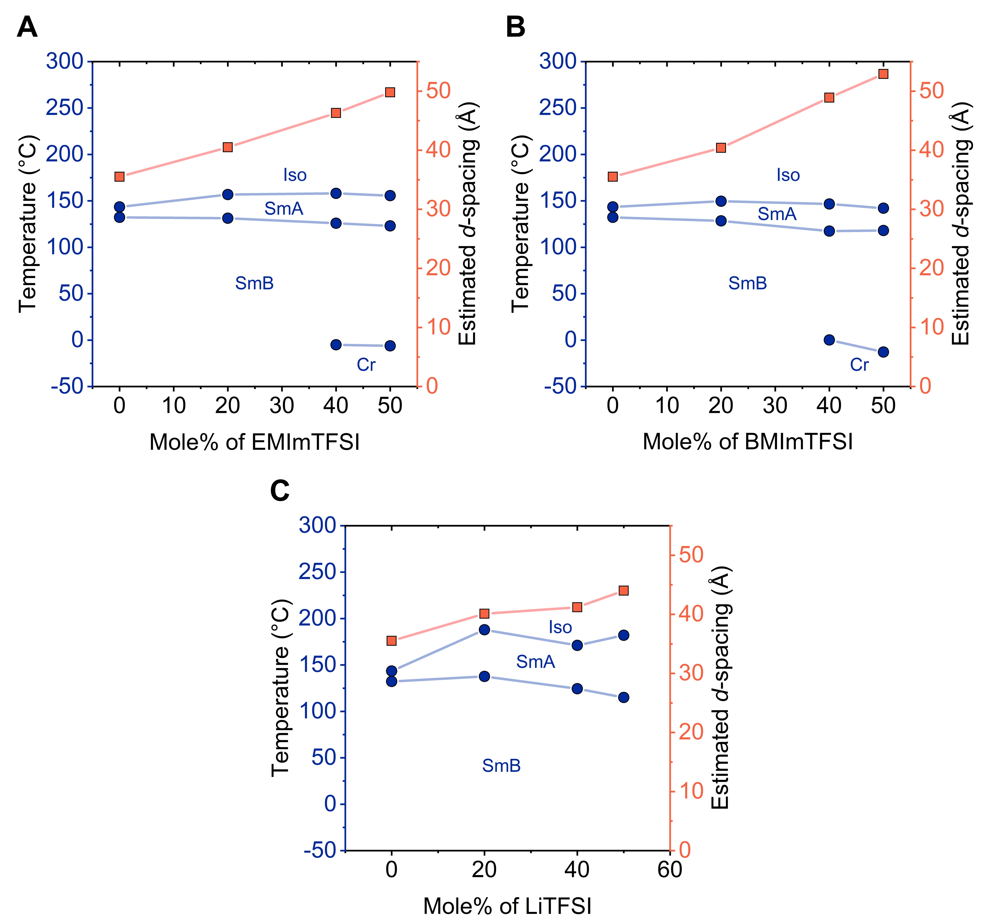
Figure S1. Phase transition temperature profiles (blue lines) and estimated d-spacing values calculated from XRD patterns in the room-temperature SmB phase (red lines) for (A) PPO/EMImTFSI(50), (B) PPO/BMImTFSI(50), and (C) PPO/LiTFSI(50), respectively.
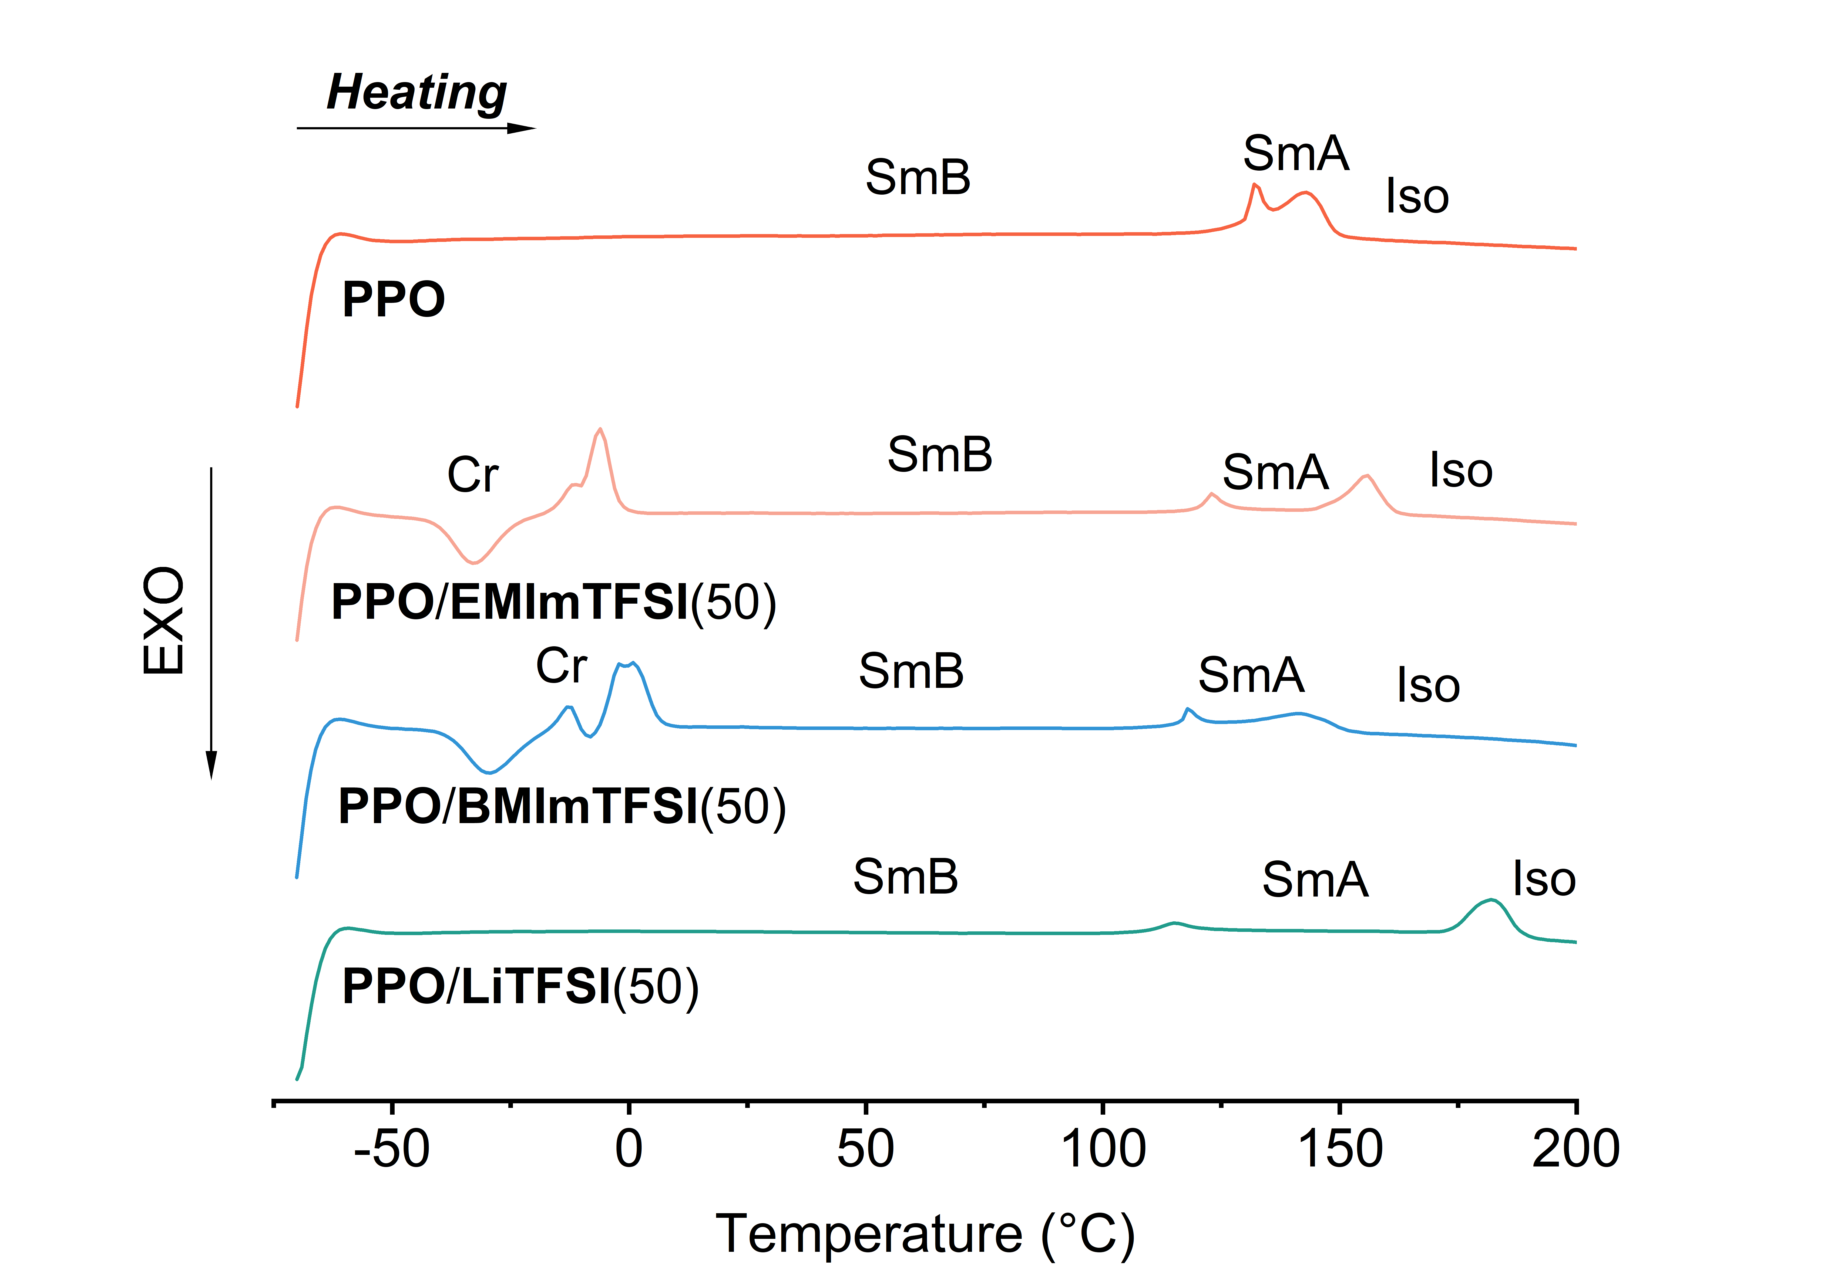
Figure S2. DSC curves of the second heating cycle for PPO, PPO/EMImTFSI(50), PPO/BMImTFSI(50), and PPO/LiTFSI(50).

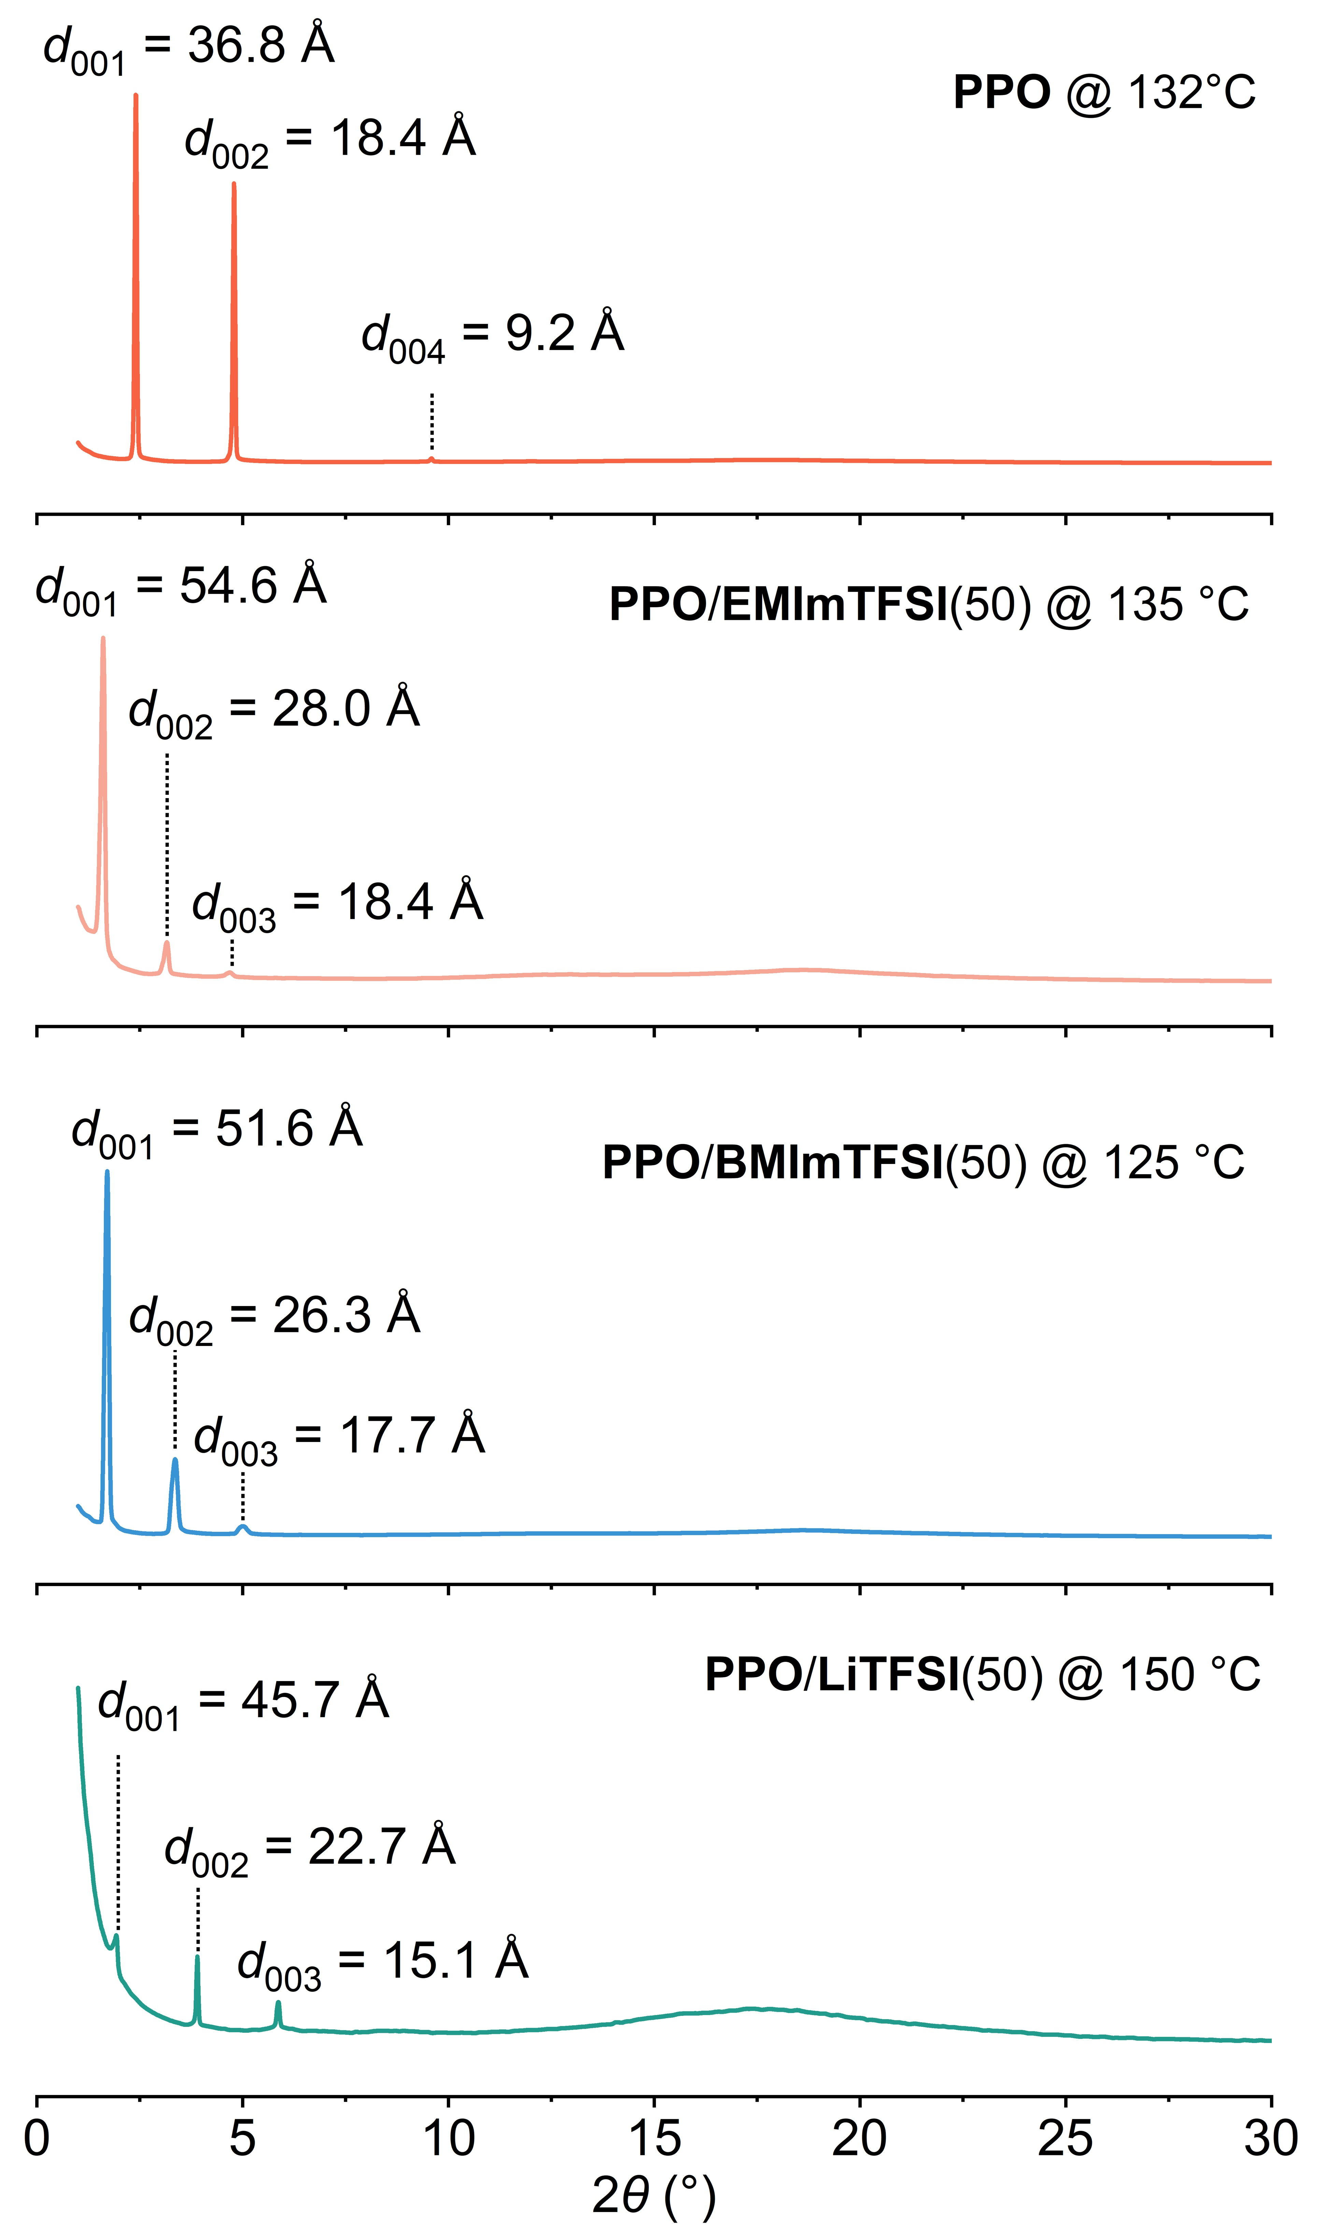
Figure S3. XRD patterns of PPO, PPO/EMImTFSI(50), PPO/BMImTFSI(50), and PPO/LiTFSI(50) measured within their respective SmA phase temperature ranges.

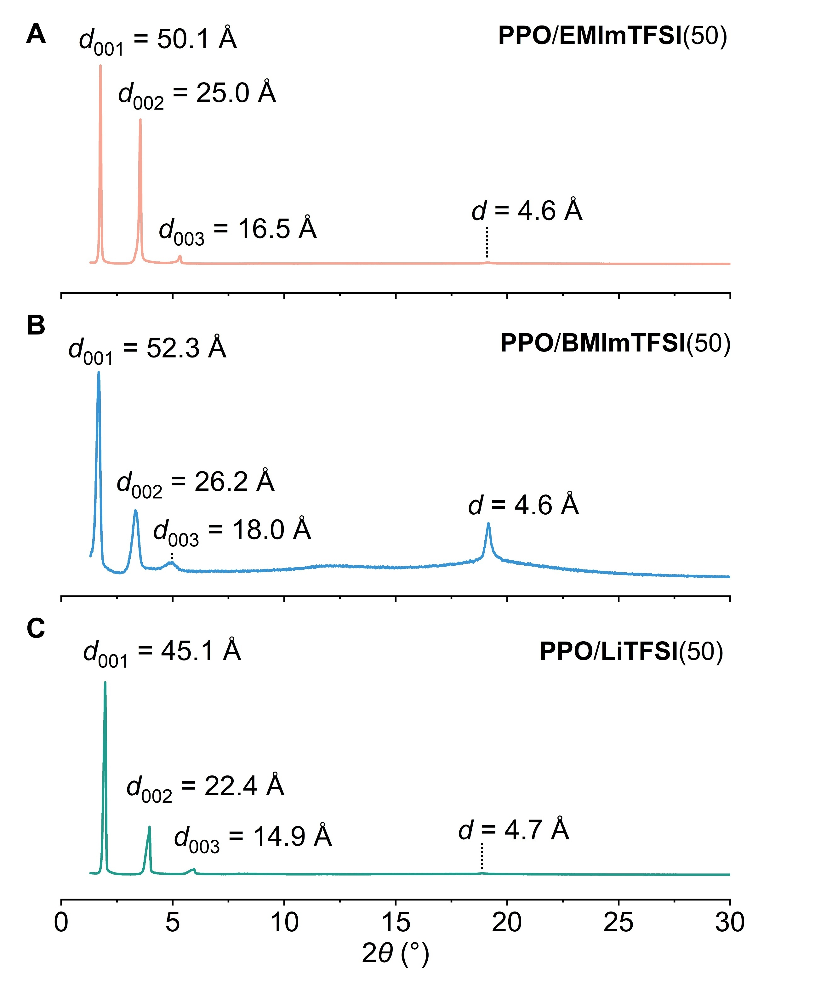
Figure S4. XRD patterns of (A) PPO/EMImTFSI(50), (B) PPO/BMImTFSI(50), and (C) PPO/LiTFSI(50) at room temperature.

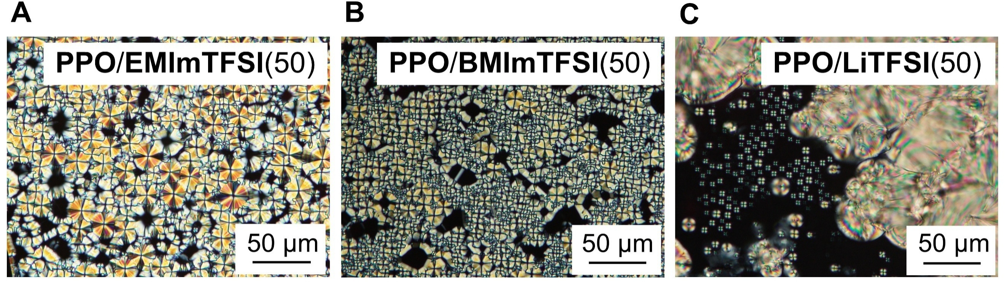
Figure S5. Polarized optical microscope (POM) images of A) PPO/EMImTFSI(50), (B) PPO/BMImTFSI(50), and (C) PPO/LiTFSI(50).

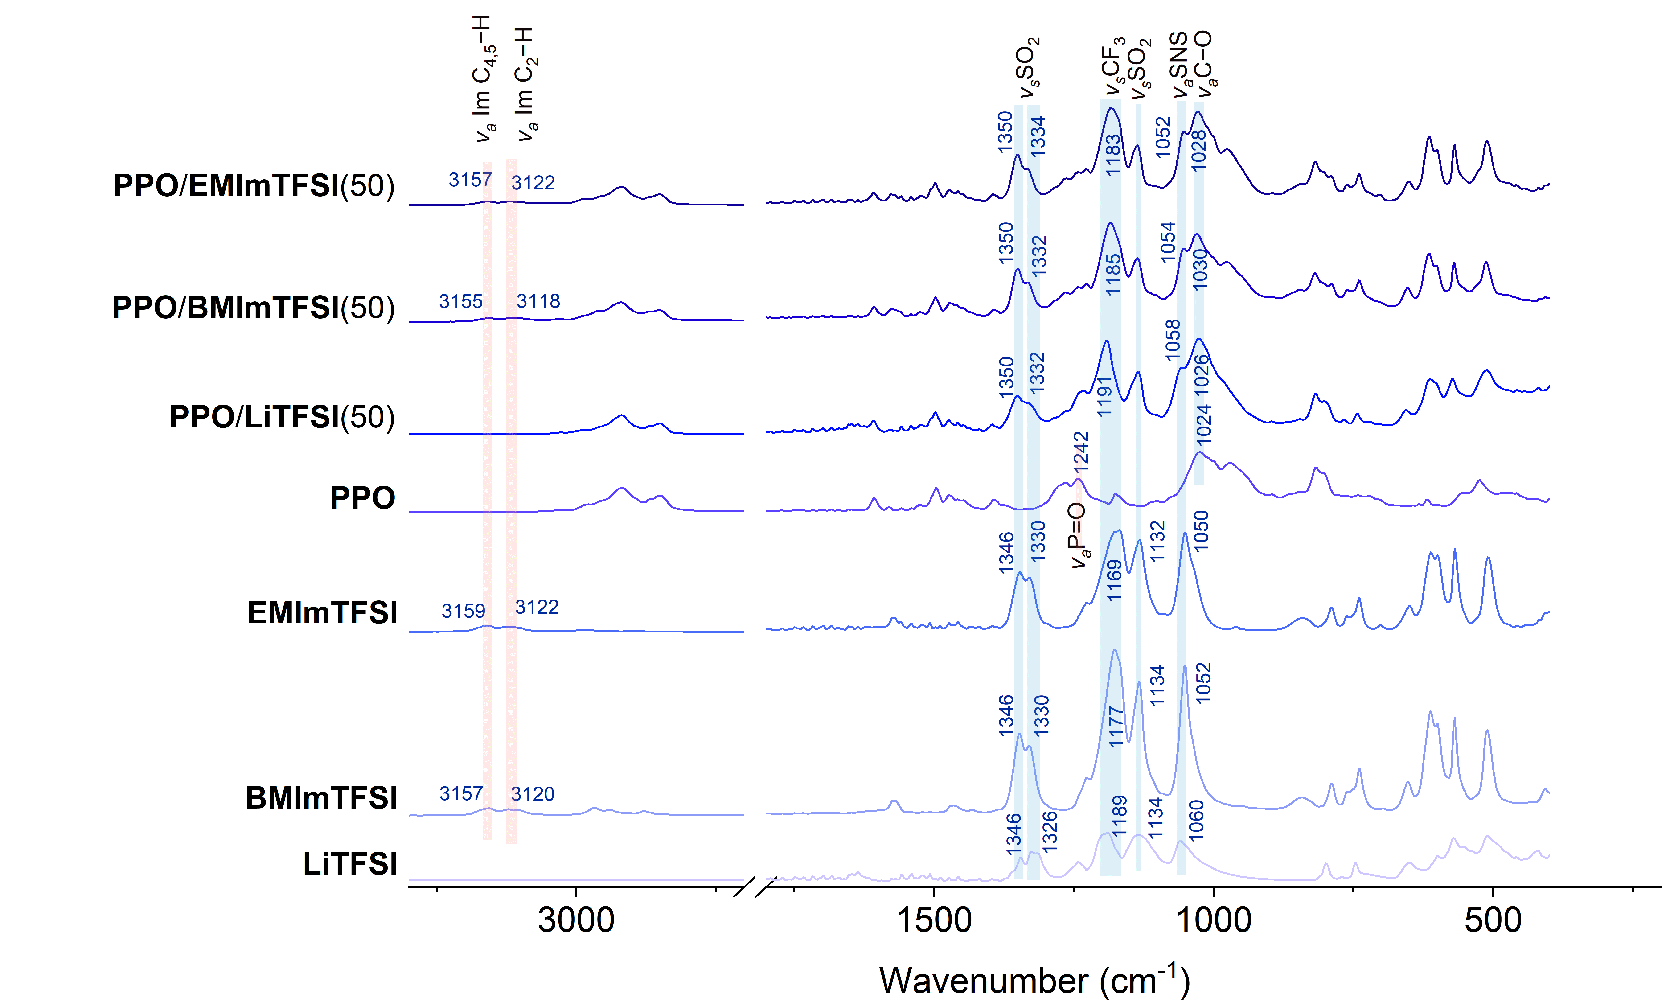
Figure S6. FT-IR spectra of LiTFSI, BMImTFSI, EMImTFSI, PPO, PPO/LiTFSI(50), PPO/BMImTFSI(50), FPO/EMImTFSI(50) at ambient temperature.

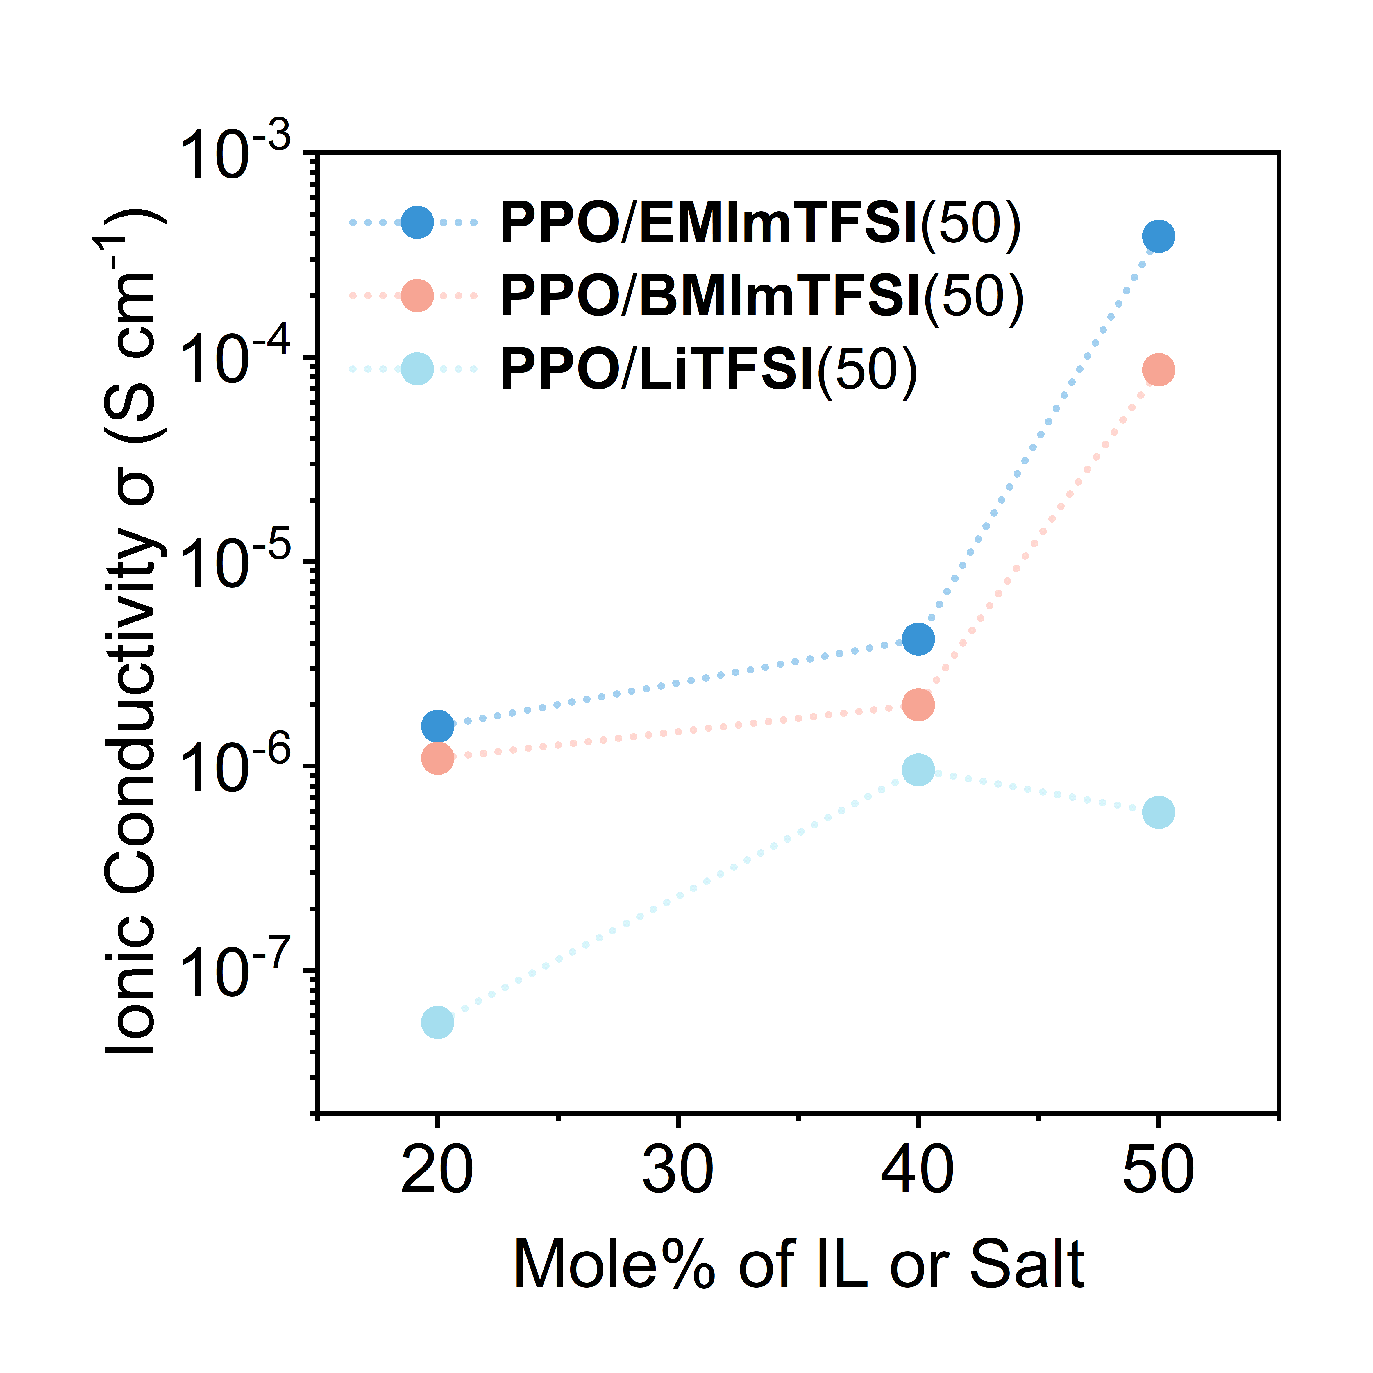
Figure S7. Ionic conductivities of PPO/EMImTFSI, PPO/BMImTFSI, and PPO/LiTFSI as a function of ionic species content.

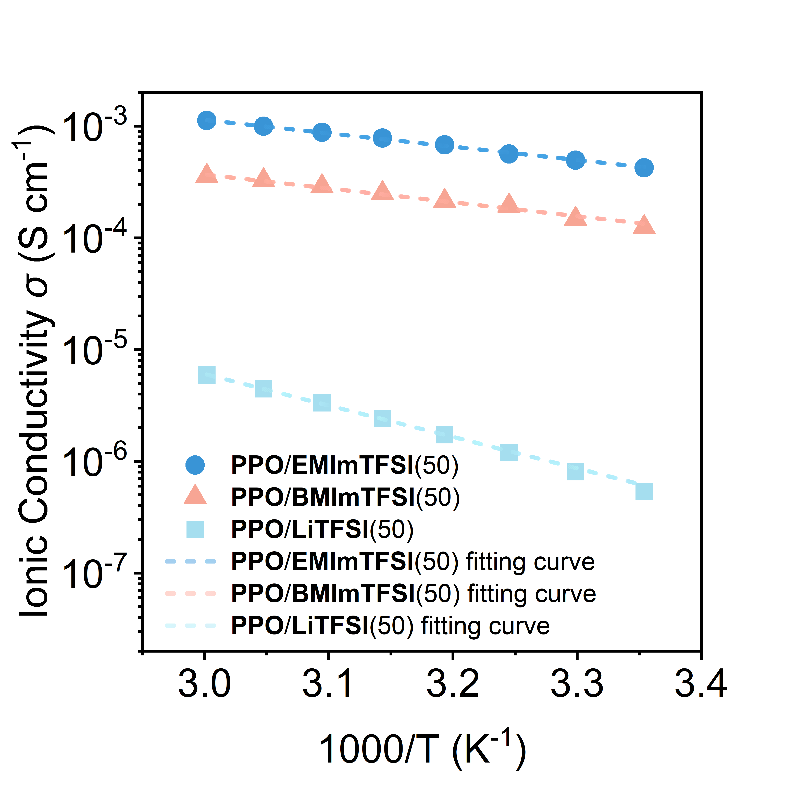
Figure S8. Ionic conductivities of PPO/EMImTFSI(50), PPO/BMImTFSI(50), and PPO/LiTFSI(50) measured in the temperature range of 25–60 °C (298.15–333.15 K). Dash lines represent Arrhenius fits to the experimental data.

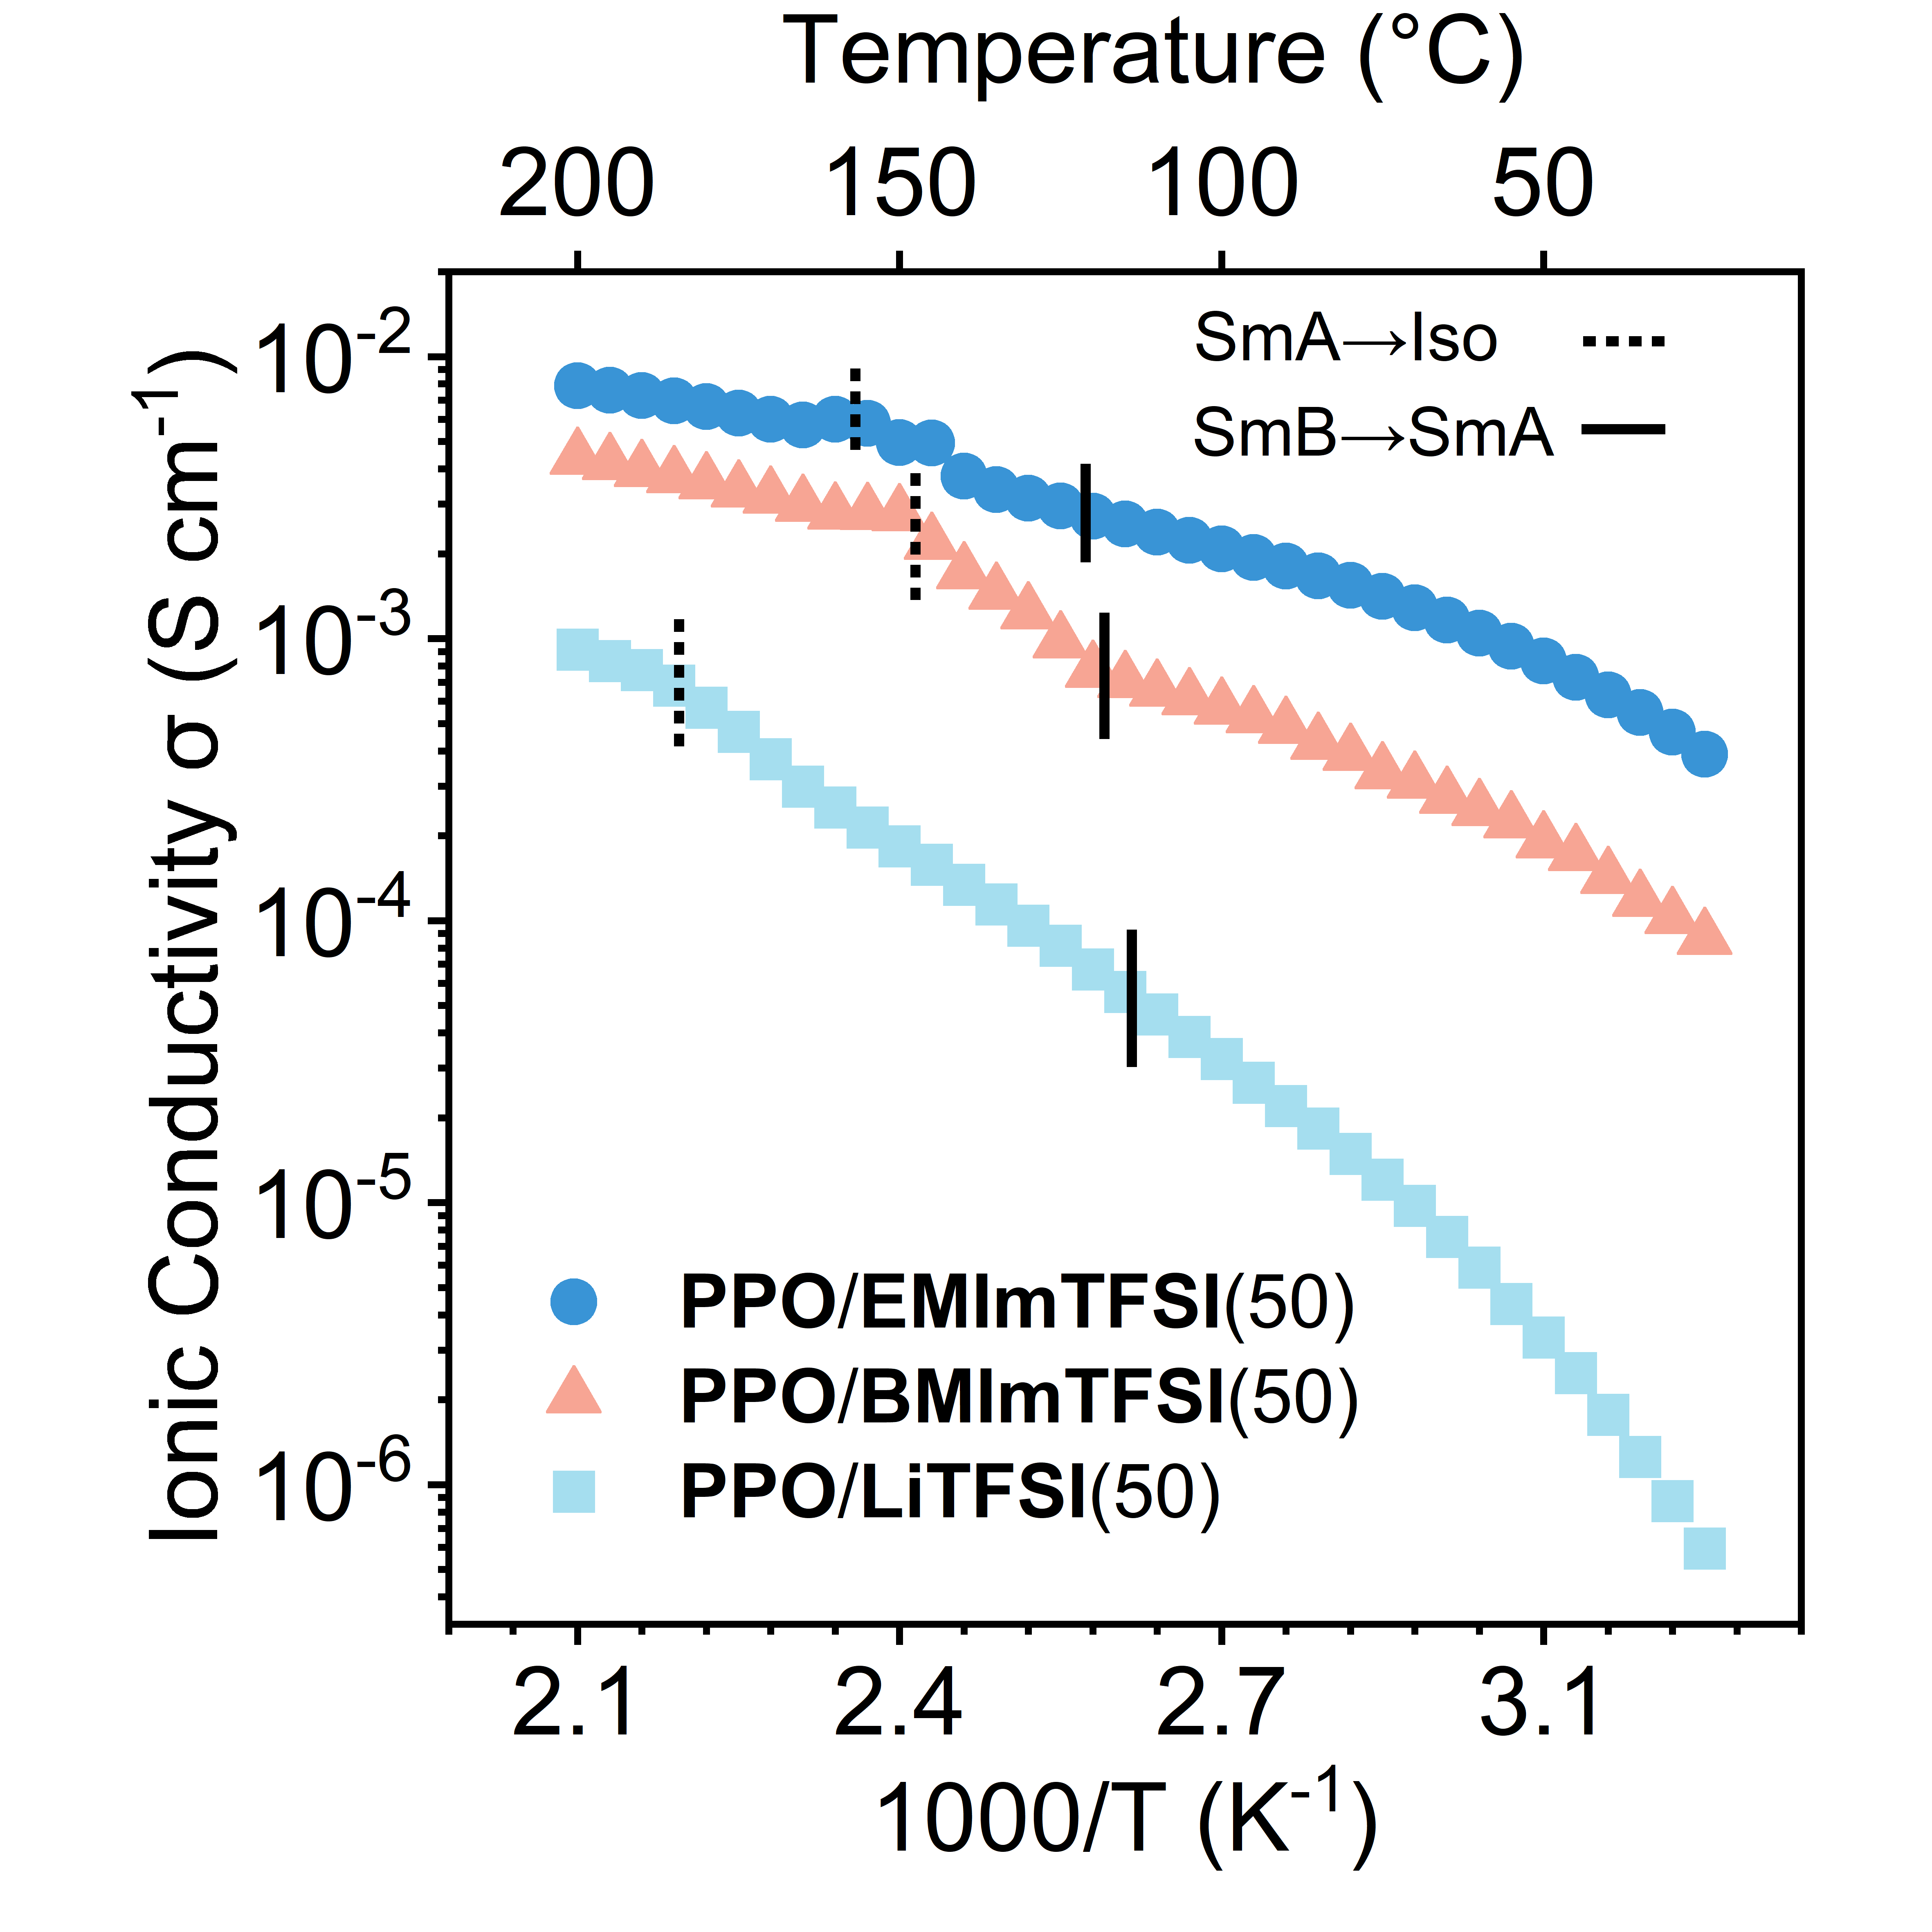
Figure S9. Temperature-dependent ionic conductivities of PPO/EMImTFSI(50), PPO/BMImTFSI(50), and PPO/LiTFSI(50) measured from 25 to 200 °C.
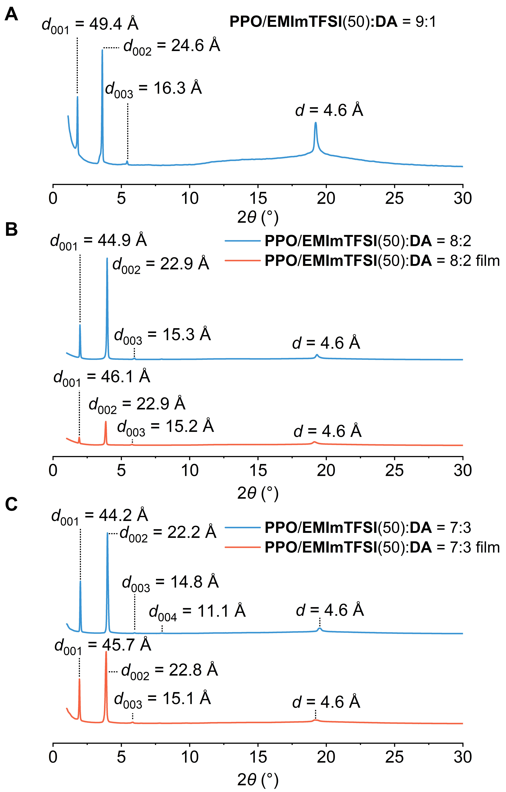

Figure S10. XRD patterns of LC mixtures with varying ratios of DA to PPO/EMImTFSI(50) at room temperature, shown before and after polymerization.

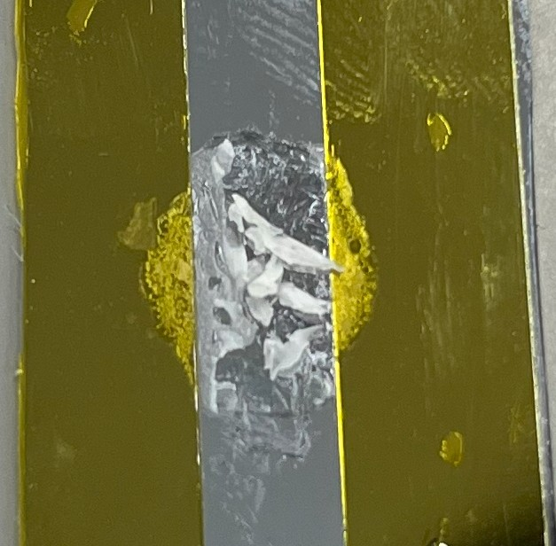
Figure S11. Photograph of the LC/polymer composite based on PPO/EMImTFSI(50):DA = 9:1, obtained after UV irradiation within the gap between polyimide tapes on a substrate.
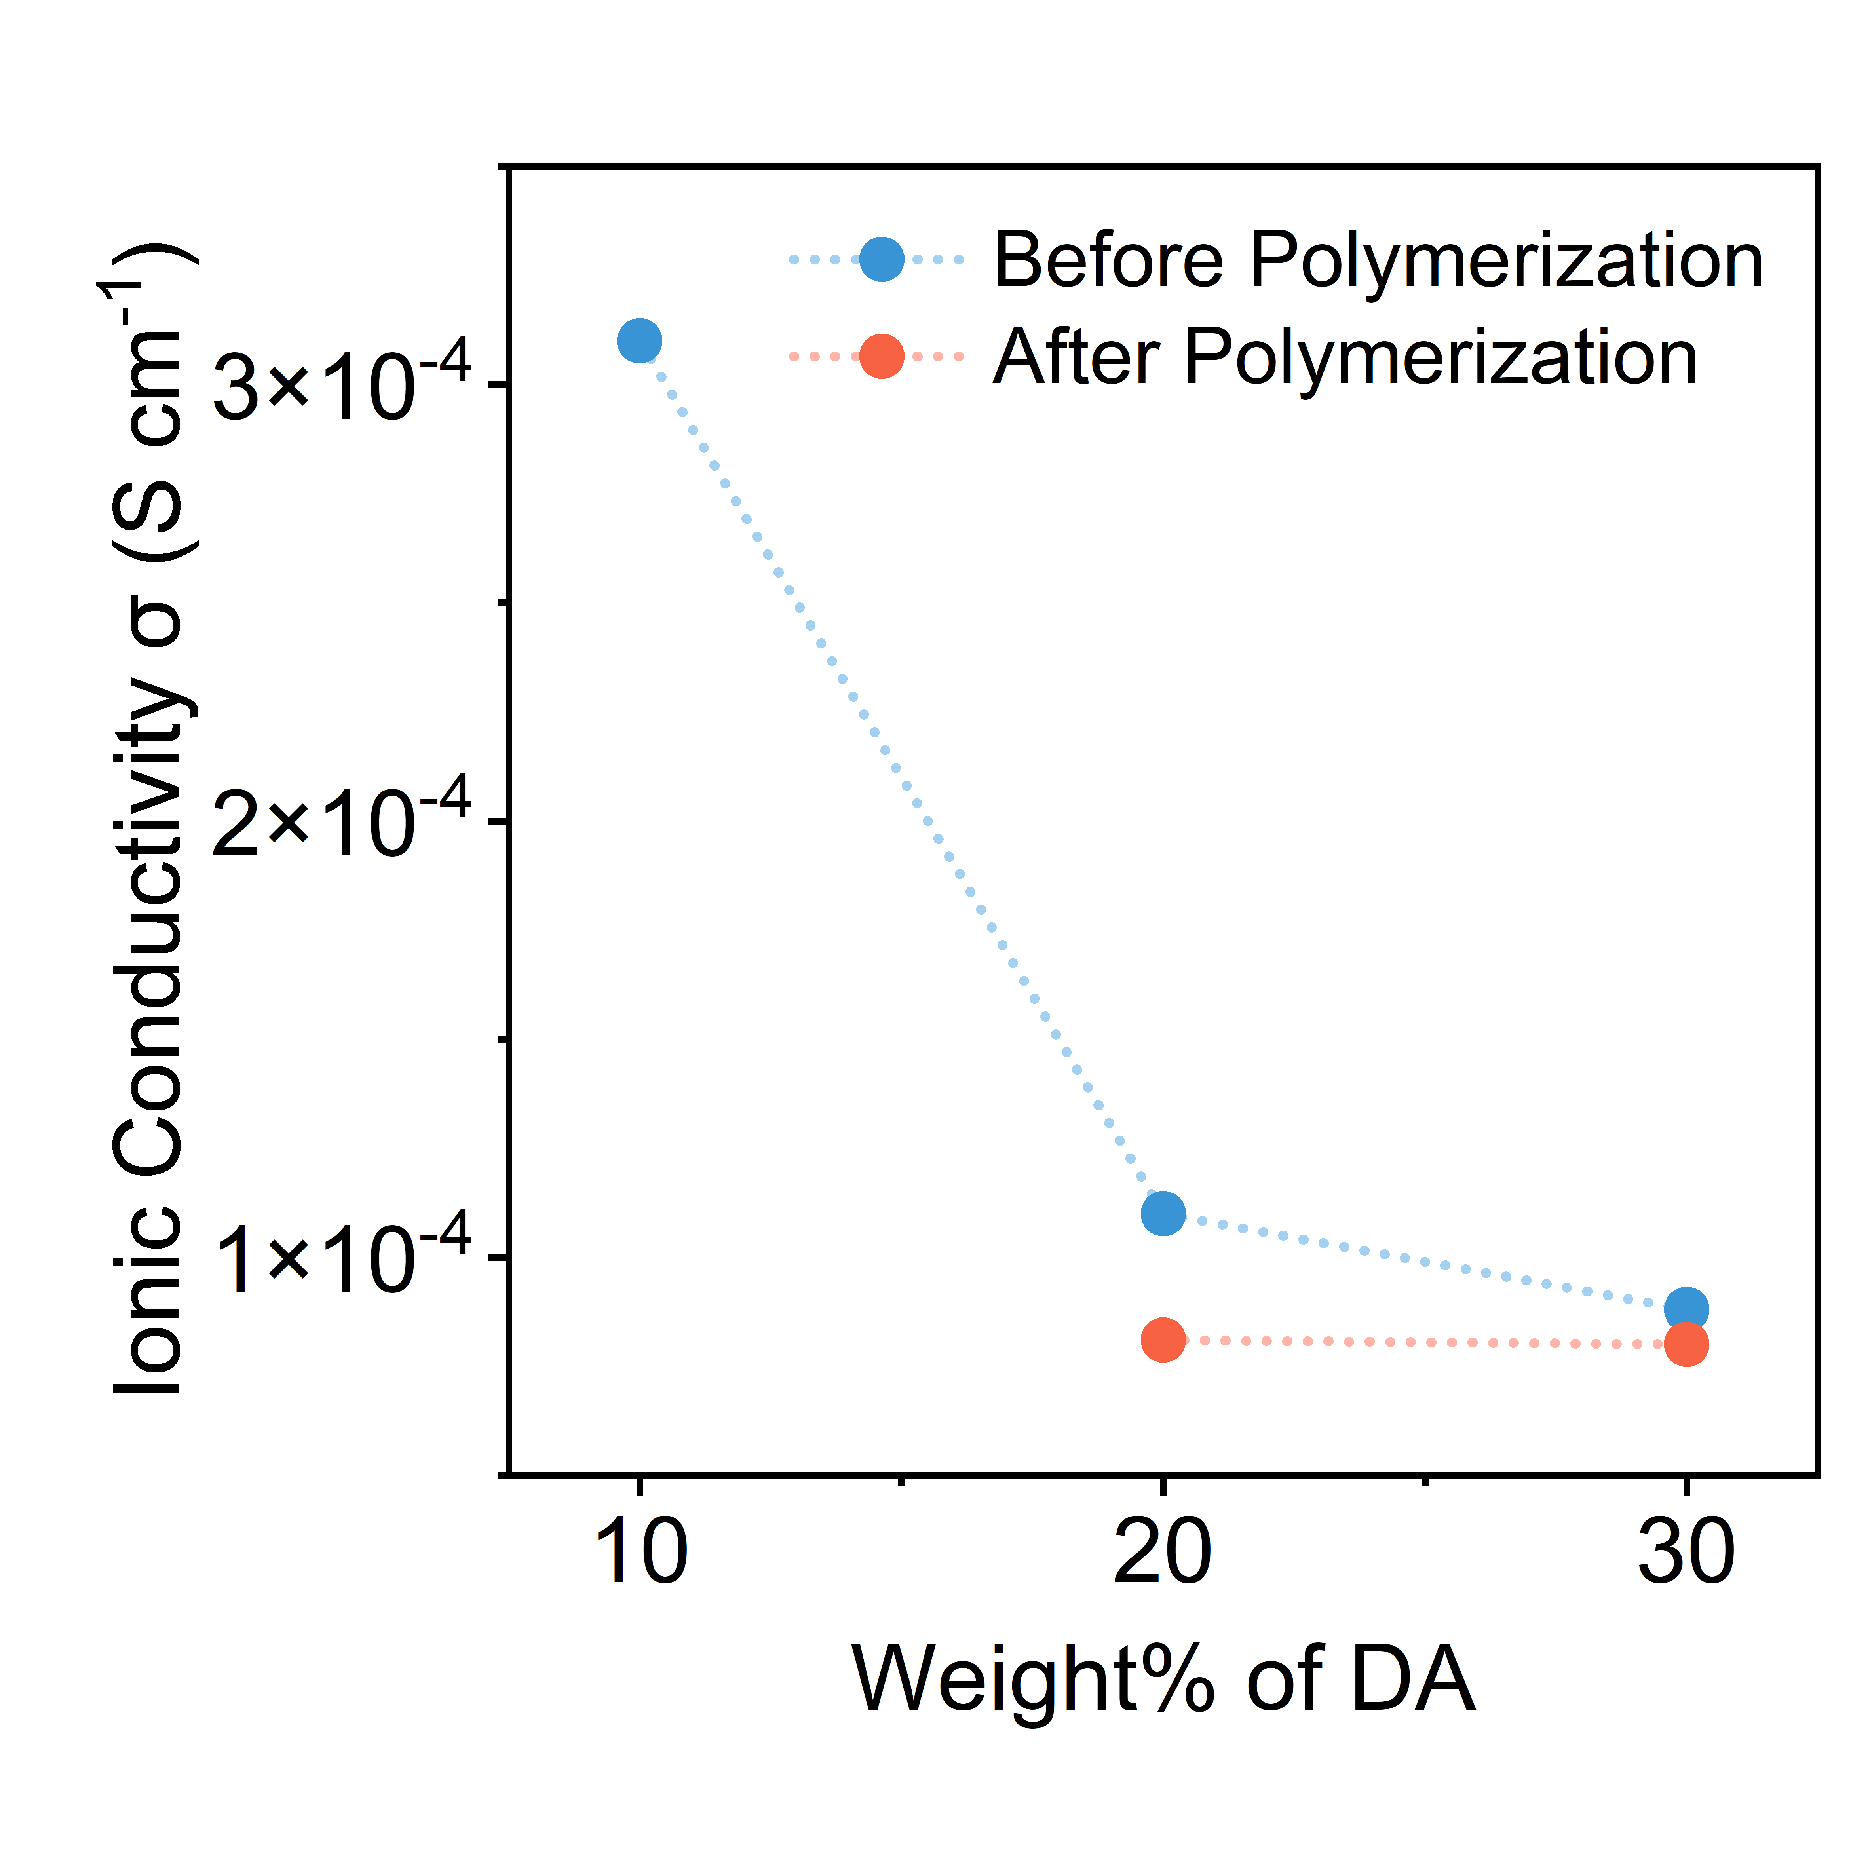
Figure S12. Ionic conductivity of LC mixtures with varying ratios of DA to PPO/EMImTFSI(50), shown before and after polymerization.
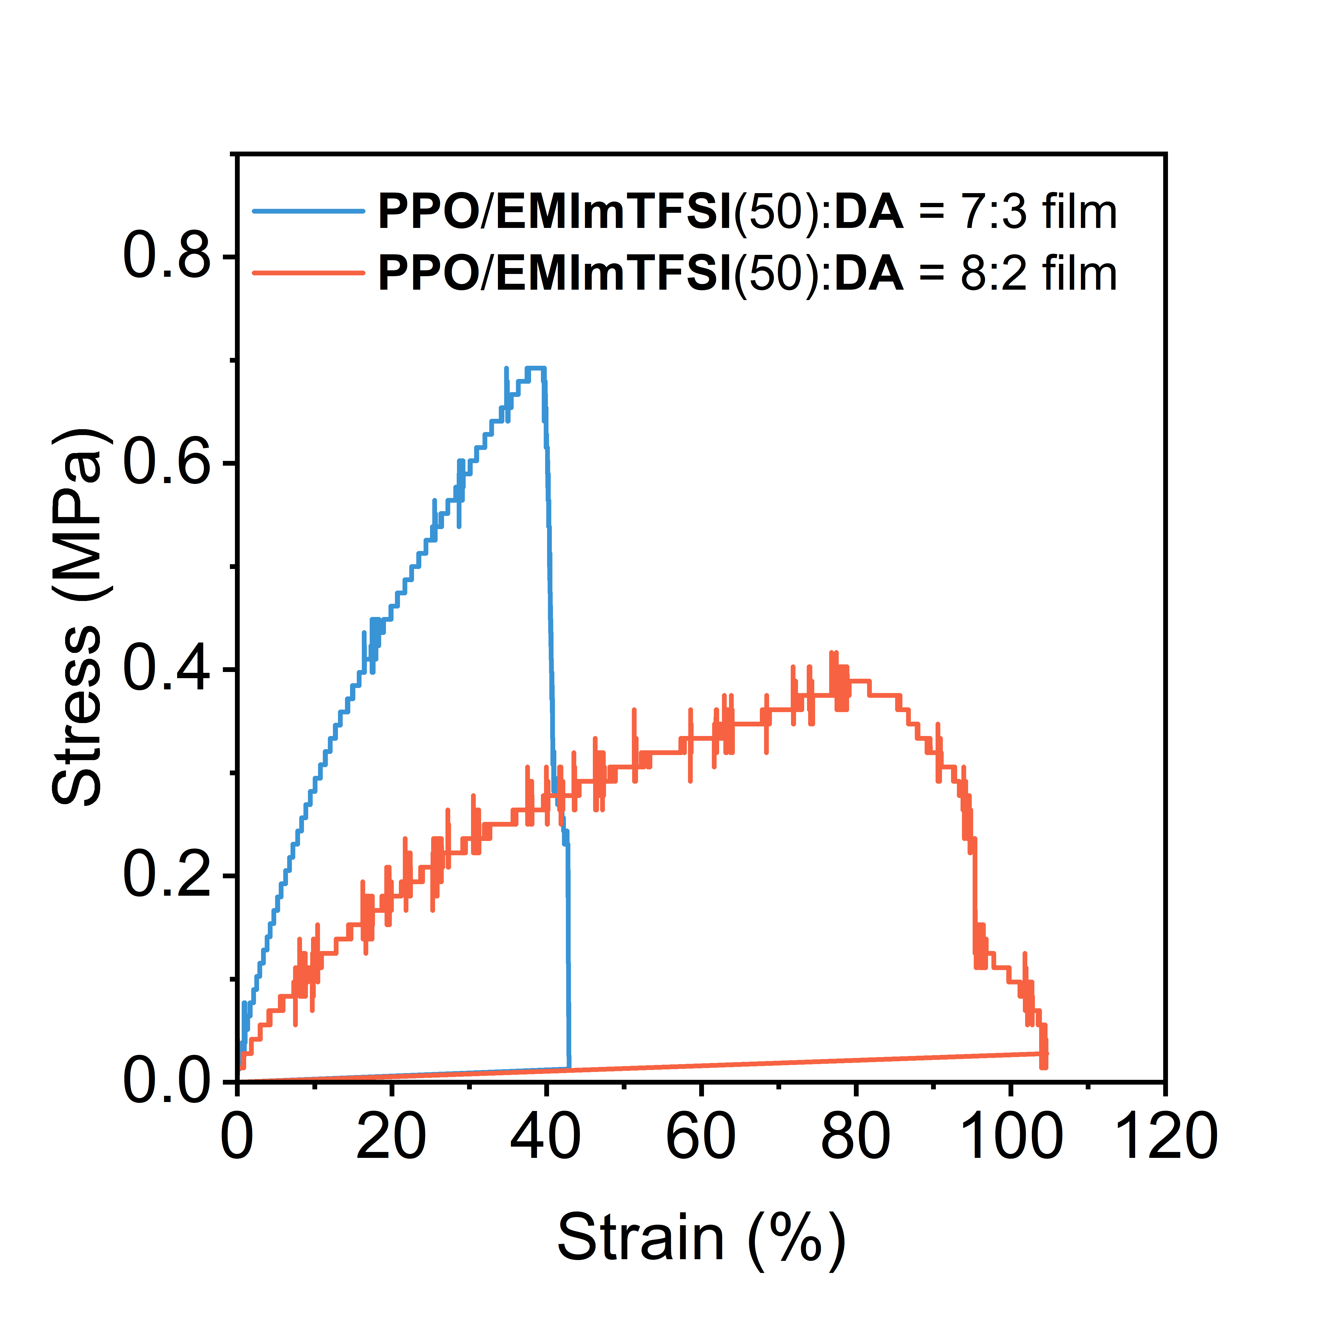
Figure S13. Tensile stress–strain curves of PPO/EMImTFSI(50):DA films with different DA contents.

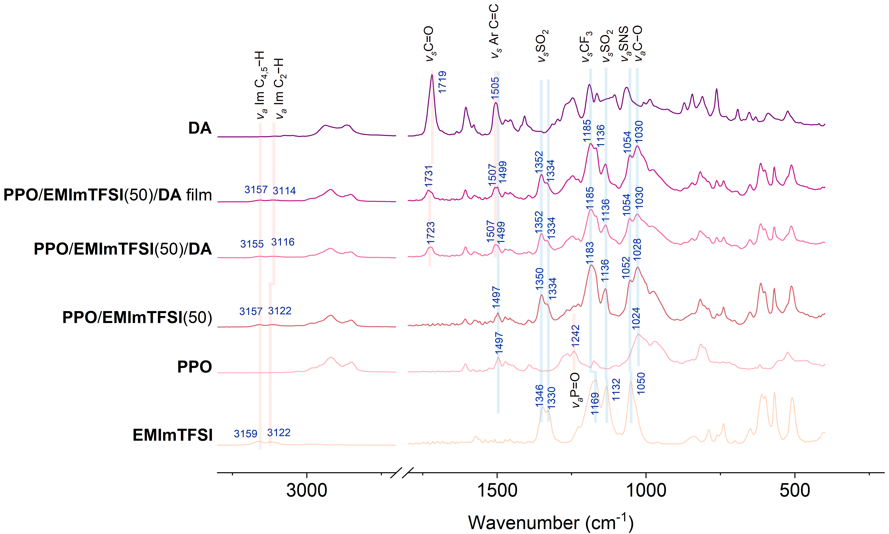
Figure S14. FT-IR spectra of EMImTFSI, PPO, PPO/EMImTFSI(50), PPO/EMImTFSI(50)/DA, the photopolymerized FPO/EMImTFSI(50)/DA film, and uncured DA at ambient temperature.

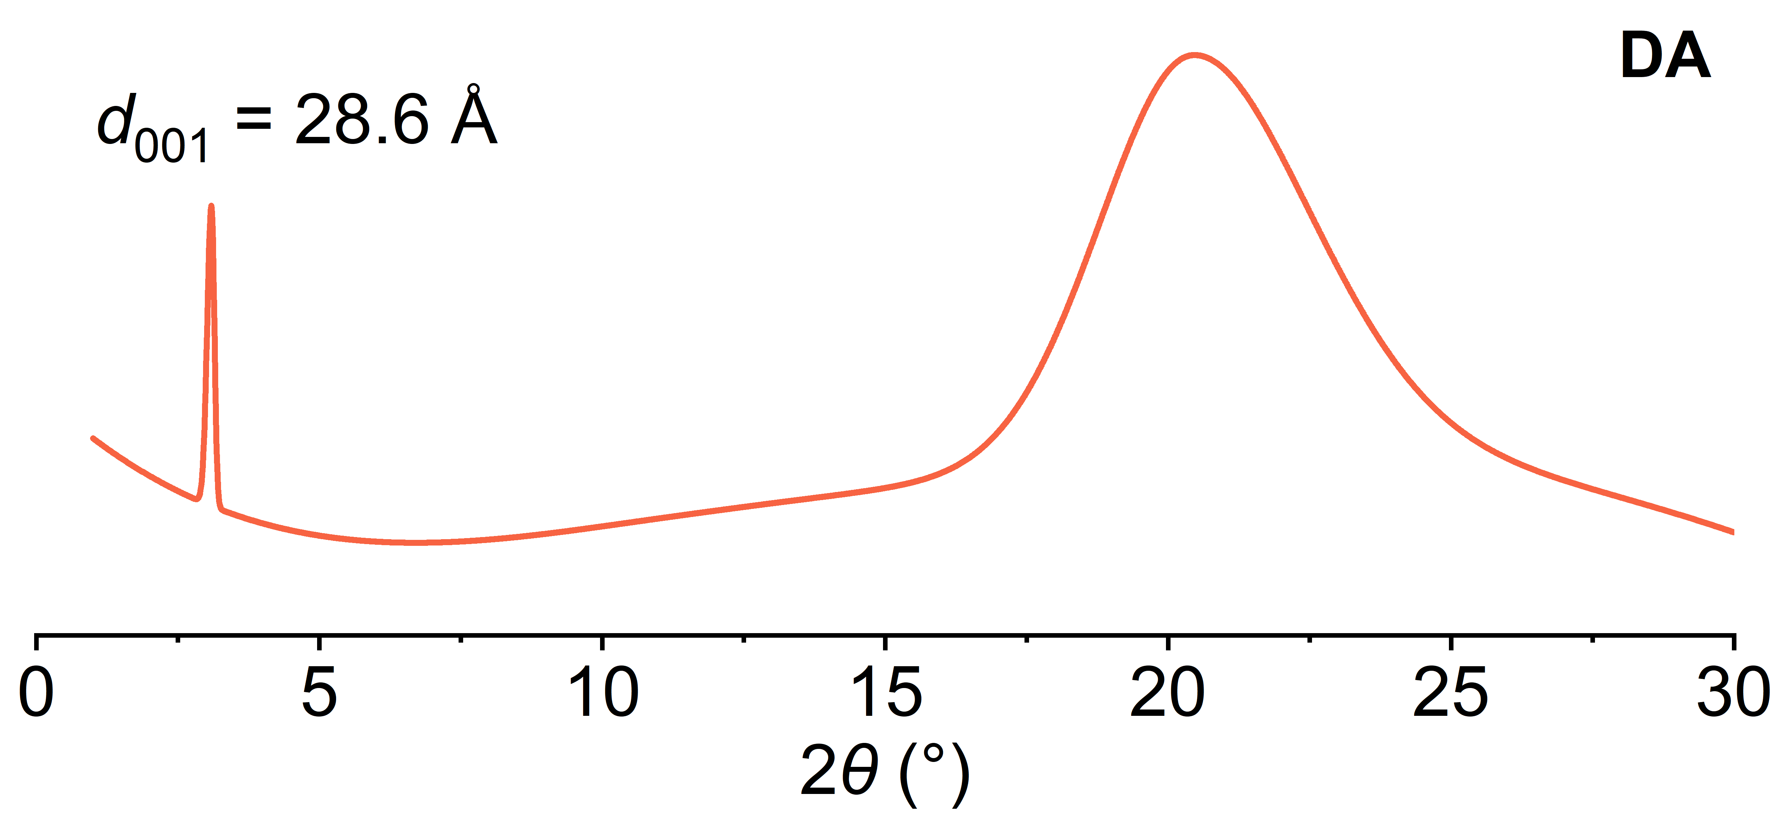
Figure S15. XRD pattern of DA compound at room temperature.

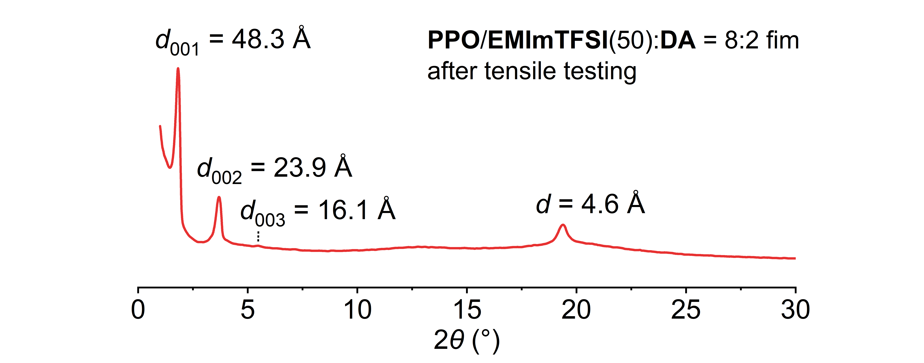
Figure S16. XRD pattern of PPO/EMImTFSI(50):DA = 8:2 after tensile testing.

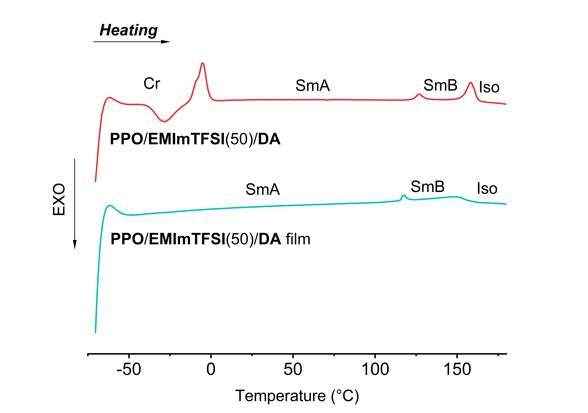
Figure S17. DSC curves of the second heating cycle for the unpolymerized PPO/EMImTFSI(50)/DA mixture and the polymerized PPO/EMImTFSI(50)/DA film.

